Lipid based Vesicles: Formulation and loading of Antihypertensive drug Atenolol
^{1*}Rachana Sharma, ²Uma Sharma
^{1,2}School of Studies in Chemistry and Biochemistry, Vikram University, Ujjain, M.P., India, 456010
^{1*}Parul Institute of Applied Sciences, Parul University, Vadodara, Gujarat, India, 391760
e-mail id.- sharmarachana385@gmail.com
Abstract: The term ‘vesicles’ is used to define spherical or ellipsoidal single or multicompartment, closed bilayer structures irrespective of their chemical structure. Liposomes are microscopic, small artificial vesicles of spherical shape that can be formed from cholesterol and natural non-toxic phospholipids in an aqueous media resulting in closed bilayer structures. In the present work, lipid-based vesicles were synthesized (by soy lecithin and cholesterol) and loaded with antihypertensive model drug Atenolol by using Rotatory-evaporator. The synthesized liposomes were further evaluated by Fourier Transform Infra-red spectroscopic analysis, particle size distribution, zeta potential and Scanning Electron Microscopic (SEM) analysis. Mean particle size obtained was 121.6nm by Dynamic Light Scattering (DLS), Zeta potential value is found to be -40.98 mV with well-defined multilamellar vesicular morphology by SEM analysis.

Key Words: Vesicles, Liposomes, Lipid-based vesicles, Antihypertensive drug, Atenolol

Corresponding Author*
Dr. Rachana Sharma*
School of Studies in Chemistry and Biochemistry, Vikram University, Ujjain, M.P., India, 456010
Parul Institute of Applied Sciences, Parul University, Vadodara, Gujarat, India, 391760
e-mail id.- sharmarachana385@gmail.com

I. Introduction: Vesicles composed of naturally occurring or synthetic phospholipids are called liposomes. However, vesicles formed completely from synthetic polymers surfactants are called surfactant vesicles¹and those formed from amphiphilic polymers are called polymerosomes²⁻³. The basic structure of the vesicle (as shown in Fig.1) generally consists of a hollow sphere comprising aqueous solution in the core enclosed by a bilayer membrane called lamellae⁴. Such morphology with an aqueous core is suitable for encapsulation of therapeutic molecules such as drugs, proteins, DNA, peptides, etc. while the membrane can easily surround hydrophobic drugs. These structural features of liposomes offer great possibilities of loading both hydrophilic as well as hydrophobic drugs and thus are in more demand for therapeutic applications ⁵.
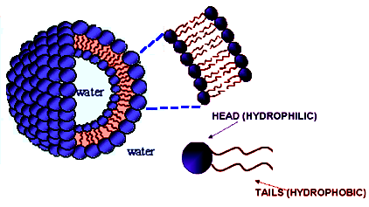
Fig. 1 Schematic of lipid-based vesicles (Liposomes) with a hydrophilic head and a hydrophobic tail (buried within the bilayer)
(A) Historical Perspective of Vesicles:. The formation of multilamellar structures called “myelin figures” upon swelling of dried phospholipids in water was firstly reported by Stoeckenius in 1959⁶. Further Bangham and his co-workers showed that phospholipids in presence of suitable solvents give rise to bilayered structures to form either multilamellar or unilamellar vesicles capable of entrapping ions in their aqueous interiors and through his membrane model Bangham gained popularity⁷⁻⁸. Properties of liposomes were further investigated by electron micrography ⁹, nuclear magnetic resonance (NMR) ¹⁰, electron paramagnetic resonance (EPR) ¹¹ by IR and Raman spectroscopy¹²⁻¹³.
Today liposomes are being explored for their use in various fields such as mathematics and theoretical physics for the topology of two-dimensional surfaces floating in a 3-D continuum, biophysics for properties of cell membranes and channels, catalysis, photosynthesis, colloids, and biology¹⁴. Ambisome TM, a parental amphotericin B-based liposomal product was first introduced followed by several other products which are either at the stage of clinical trials or are already in the market. Some of them are enlisted in the following Table-1.
Table-1 Various Marketed Formulations of Lipid-based Vesicles (Liposomes) ¹⁵
S.No. | Product | Company | Drug
 | AmbisomeTM | NeXstar Pharmaceuticals, Inc., CO | Amphotericin B
 | AmphocilTM | Sequus Pharmaceuticals, Inc., C.A. | Amphotericin B
 | DoxilTM | Sequus Pharmaceuticals, Inc., C.A. | Doxorubicin
 | DaunoXomeTM | NeXstar Pharmaceuticals, Inc., CO | Daunorubicin
 | EpaxelTM | SSI (Swiss Serum Institute), Switzerland | Hepatitis- A Vac.

(B) Mechanism of Vesicle formation: Formation of Lipid-based vesicles or liposome, closed bilayered structures formed after self-assembly is a natural process that requires some contribution of energy in the form of heat, physical agitation, sonication, etc. The thermodynamic phase property and self-assembly characteristics of amphipathic phospholipids promote entropically driven segregation of hydrophobic regions into spherical bilayers which prevents unfavourable interactions between solvent (water) and long fatty acid hydrocarbon chains leading to a state of lower energy and thus more stability¹⁶. Additionally to attain a most stable state these bilayer sheets start folding themselves to form closed sealed bilayered vesicles adjoining a central aqueous core as depicted in the Fig. 2.
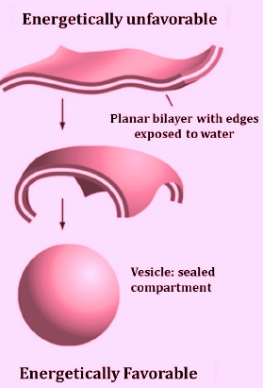
Fig. 2 Mechanism of Vesicle Formation
(C) Classification of Vesicles: Vesicles are mostly classified based on their size and number of bilayers (lamella) Unilamellar vesicles consists of a single bilayer (Fig.3). Based on their mean diameter, they are divided into small unilamellar vesicles (SUVs: 20-100 nm), large unilamellar vesicles (LUVs: 100-500 nm), and giant unilamellar vesicles (GUVs: 0.5 – 100μm). Multilamellar vesicles (MLVs) possess a membrane composed of several bilayer shells and multivesicular vesicles (MVVs) are large or giant vesicles encapsulating smaller vesicles inside¹.
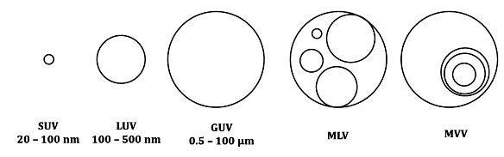
Fig.3 Structural classes of vesicles- small unilamellar vesicles (SUV), large unilamellar vesicles (LUV), giant unilamellar vesicles (GUV), multilamellar vesicles (MLV), and multivesicular vesicles (MVV) ¹

(D) Structural Components of Lipid-based Vesicles or Liposomes:
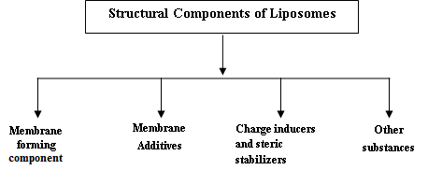
(D.1) Membrane forming components - Phospholipids: bilayer formers
Phospholipids are the major components of the biological membranes are considered as the building blocks of liposomes. The phospholipids show tubular structure with two acyl chains attached to a polar head which on hydration results in a bilayered membrane. Two types of phospholipids viz. phosphodiglycerides and sphingolipids along with their corresponding hydrolysis products are used¹⁷.
Classification of Phospholipids: Negatively charged phospholipids- e.g. Dipalmitoyl phosphatidylcholine (DPPC), Dipalmitoyl phosphatidyl acid, Distearoyl phosphatidyl choline , Dioleoyl phosphatidyl choline, etc. Neutral phospholipids e.g. Sphingomyeline, Phosphatidyl-ethanolamine, and Phosphatidylcholine (Soy lecithin and some positively charged phospholipids.
(D.2) Membrane Additives (Sterols): Cholesterol is the most common sterol (Fig.4), occupies empty spaces present between the phospholipid molecules, setting them more strongly into the structure ¹⁸, an amphipathic molecule that inserts itself into the membrane with its hydroxyl groups arranged towards the aqueous phase and aliphatic chain oriented parallel to acyl chain of the phospholipid molecules. Cholesterol, by making the membrane more ordered increases the transition temperature of the system thus provides both physical and biological stability¹⁹.
Fig.4 Chemical Structure of Cholesterol
(D.3) Steric Stabilizers and Charge inducers: Dicetylphosphate, diacylglycerol, stearylamine, solulan C-24, etc. are most commonly used to provide either a positive or a negative surface charge, and are also beneficial in reducing aggregation as neutral liposomes undergo aggregation very easily.
(D.4) Other substances: When the drugs are fragile and easily undergo oxidation then antioxidants such as tocopherol, butylated hydroxyl toluene and stabilizers are used, and sometimes preservatives are added to increase the shelf-life of liposomal formulations²⁰.

(E) Methods of preparation of liposomes⁴ can be summarized with the help of following chart.
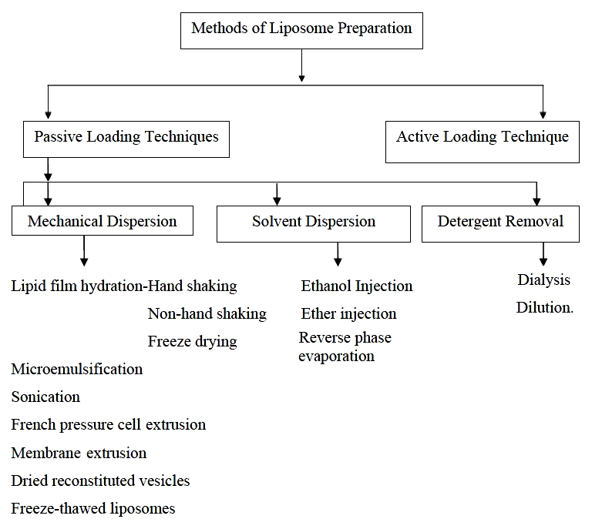
(F) Advantages of Lipid-based vesicles or liposomes⁴:
- Offer selective passive targeting to tumor tissue e.g. Liposomal Doxorubicin.
- Enhance efficacy and therapeutic index of the drug (Actinomycin-D).
- Due to encapsulation, liposomes are more stable.
- Possess biocompatibility, biodegradability, non-toxicity, flexibility, and non-immunogenicity for systemic and non-systemic administrations
- Cause reduction in toxicity of the encapsulated agent (Amphotericin B, Taxol).
- Protect sensitive tissues from exposure of toxic drugs.
- Provide flexibility to couple with site-specific ligands in achieving active targeting²⁰⁵.
(G) Disadvantages of Lipid-based vesicles or Liposome ⁴
- High production cost
- May cause leakage or fusion of encapsulated drug/molecule
- Phospholipids may experience hydrolysis and oxidation like reaction
- Short half-life
- Low solubility
Beta blockers were first invented by the Nobel Prize winner Sir James Black in 1958, where he confirmed that by blocking the cardiac β-receptors, these agents could cause inhibitory effects on the sinus node (chronotropic effect), atrioventricular node (dromotropic effect), and myocardial contractility (inotropic effect) ^{21,22}.
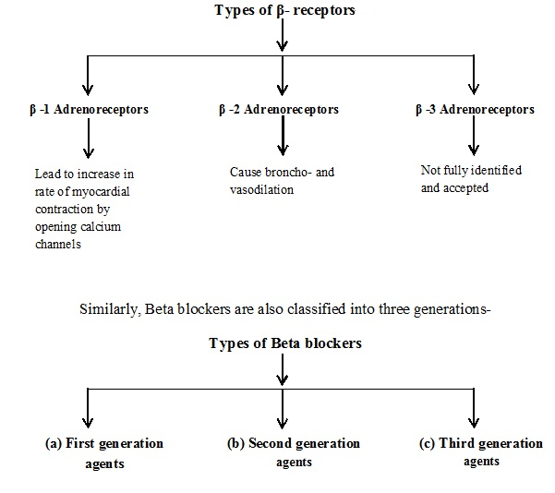
(H) The First-generation agents such as Propranolol (propanolol or beta-propanolol), Sotalol, Timolol, and Nadolol non-selectively block β -1 and β -2 receptors causing effects on heart rate, conduction, and contractility and tend to cause smooth muscle contraction.
(I) The Second-generation agents or Cardioselective agents–Atenolol, Bisoprolol, Celiprolol, and Metoprolol comes under this category. These agents not only block β -1 receptors in low doses but are also capable of blocking β -2 receptors in higher doses. Such selective approach of action of these agents makes them desirable in patients with chronic lung diseases²³ or those with insulin-requiring diabetes mellitus. Among all these Bisoprolol is a highly cardio selective agent.
(J) The Third generation agents show vasodilatory properties. Their actions may be both selective (nebivolol) or non-selective (carvidolol and labetolol).

Beta-blockers are used extensively and are standard therapy for hypertension, angina, post-myocardial infarction tachyarrhythmias, and congestive heart failure ²⁴. All currently available beta-blockers, as a common structural feature, possess an amino-alkanol or isopropylaminopropoxy side chain (a major element for their pharmacological and therapeutic activity) and an aromatic group varying in structure for different drugs, e.g., phenyl in the case of bisoprolol, atenolol and metoprolol and naphthyl in the case of propanolol. This latter aromatic group which could be called the modulator of the pharmacological activity also determines the pharmacokinetic properties of these drugs. The amino-alkanol side chain contains an asymmetric carbon atom, resulting in the existence of a d- and l-enantiomers²⁵.

Out of the above mentioned beta-blockers we have used selective beta-blocker atenolol as model drug. It has been already reported that atenolol²⁶and propanolol exhibit low bioavailability and shorter half-life relative to bisoprolol²⁷.
Atenolol (Brand name-Tenormin®), IUPAC name - 2-[4-[2-hydroxy-3-(propan-2-ylamino) propoxy] phenyl] acetamide, is a cardioselective β-1 adrenoceptor blocker (Fig.5). The maintenance of the constant plasma level of a cardiovascular drug is important in ensuring the desired therapeutic response. Since the half-life of atenolol is 6–7 h, multiple doses are required to maintain a constant plasma concentration for good therapeutic response and improved patient compliance which in turn causes side effects including bradycardia, severe hypotension with shock, acute heart failure, hypoglycaemia, etc. In addition to this, depression and confusion, nightmares, hair loss, runny or blocked nose, indigestion, constipation, and dry mouth effects are also observed²⁸⁻²⁹.

(K) Properties:
- Atenolol is a relatively polar, lipid-soluble hydrophilic drug and is excreted by the only kidney and exhibits low brain permeation³⁰.
- Atenolol is mainly used in the treatment of cardiovascular disorders including- angina, hypertension, acute myocardial infarction, arrhythmias, coronary heart diseases etc^{26, 31}.
- It has a pKa value equals to 9.6, leading to its ionization in the stomach besides intestine and hence keeps a poor bioavailability (~55%) of the given dose and it is not increased even after the administration of the drug in solution form ^{26, 32}.
- Atenolol is generally unaffected by metabolism in liver, and thus is eliminated by renal excretion which makes it different from propanolol or metoprolol.

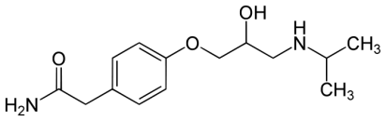

Fig.5 Chemical Structure of Atenolol

II. Experimental Section
(A) Materials and Method:
Materials: Chemicals used for the experimental work were of A.R. grade. Soy lecithin (Phosphatidylcholine, Sigma Aldrich), Cholesterol (Sigma Aldrich), Atenolol drug as gift sample.
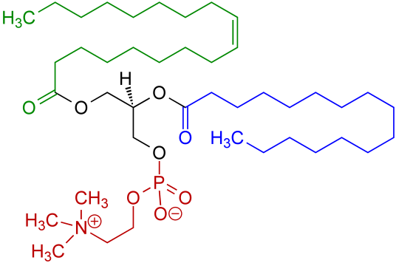
Fig.6 Chemical structure of Soy lecithin
Preparation of Atenolol-loaded Vesicles (Lipid-based) Method: The preparation of atenolol-loaded vesicles is explained as below-
(B) Preparation of Antihypertensive drug Atenolol-loaded Vesicles (Lipid-based): For the preparation of vesicles loaded with atenolol drug, firstly vesicles (lipid-based) were prepared by using rotatory evaporator under following two steps-

Step I: 35 mg Phosphatidylcholine (Soy lecithin or soya PC) and 15 mg cholesterol were dissolved in 5ml chloroform and flask was rotated so that a thin lipid film was formed on the inner wall of a rotatory flask which was kept in vacuum to remove the solvent completely.
Step II: 2 ml aqueous solution of atenolol (2.5 mg/mL, w/v) was added to hydrate and disperse the lipid layer by reverse rotation of flask. The obtained solution containing vesicles (lipid-based) was kept overnight under lyophilisation and were characterized further.
The synthesis of vesicles (lipid-based) was done using a rotatory evaporator and in order to confirm their formation following characterization techniques were employed in support of synthesis.

III. Physicochemical Characterization of prepared vesicles
The physicochemical characterization of prepared lipid based vesicles was done using FT-IR Spectroscopy, Zeta Potential and Particle size measurement, and SEM Analysis.

(A) FT-IR analysis: FT-IR spectra of drug and drug-loaded vesicles were recorded by using Potassium bromide (KBr) pellets on FT-IR –Jasco FT/IR-4600 in the range of 4000-200 cm-¹, at ITL Labs Pvt. Ltd., Indore (M.P.). Results are shown in Table-2 and Fig. 7-8.

(B) Zeta Potential and Particle size measurement: Particle size and zeta potential of drug-loaded vesicles were determined by using Malvern Zeta Sizer Nano ZS and Nano Plus at Parul Institute of Pharmacy, Vadodara, Gujarat and UGC-DAE Consortium of Scientific Research, Indore,(M.P.) respectively. The measurements were carried out using a suspension of nanoparticles in deionized water and the results are shown in Fig. 9-10.

(C) Determination of Surface Morphology by SEM: The morphological characteristics of drug-loaded vesicles were determined by Scanning Electron Microscopy(SEM) at UGC-DAE Consortium of Scientific Research, Indore (SEM- JEOL-JSM-5600 ) and Central University, Gandhinagar, Gujarat (Model –EVO 18, Carl Zeiss, UK) at an acceleration voltage of 20 kV and 6.0 kV respectively. The prepared dried nanoparticles were mounted on a metal stub. Results are shown in Fig. 11.

In order to confirm the formation of lipid-based vesicles, the above characterization techniques were employed and the results were obtained in terms of size, shape, and morphology, etc. The detailed interpretation is given in the following results and discussion section.
IV. Results and Discussion:
Physicochemical Characterization of nanoparticles: The physicochemical characterization of liposomes loaded with atenolol has been performed by FT-IR, DLS (particles size measurement), Zeta potential, and SEM analysis.
(A) FT-IR analysis: IR spectral analysis of atenolol and vesicles loaded with atenolol were performed to determine the interactions between drug and lipid and their characteristic peaks are shown in Table-2. The FT-IR spectrum of Atenolol drug (Fig.7) shows peaks at 3362.28 cm⁻¹ corresponding to O-H stretching, at 3174.26 cm⁻¹ indicating N-H stretching ,at 2965.02 cm⁻¹ showing C-CH₃ stretching, at 1581 cm⁻¹ responsible for C=C aromatic stretching ,at 1732.1 cm⁻¹ indicative of C=O stretching and 1637.22 cm⁻¹ corresponding to O=C-NH₂ stretching³³. The interaction between polymer and drug can be predicted by the shifting or disappearance of the frequency of characteristic peaks. FT-IR spectrum of atenolol-loaded vesicles (Fig.8) shows characteristic peaks of both polymer and drug. It is observed from the FT-IR spectrum of atenolol-loaded vesicles, a change in frequency in peak attributed to O-H stretching of atenolol from 3362.28 cm⁻¹ to 3383.5 cm⁻¹ is observed. It is assumed that electrostatic interaction/Hydrogen bonding between the amine group present on the drug and the Phosphoric group available on soy lecithin is responsible for frequency shift. Similarly, a small shift in C=O stretching is also observed from 1637.27 cm⁻¹ to 1658.48 cm⁻¹.
(B) Zeta Potential and Particle size measurement: Particle size and zeta potential are two important properties of drugs/drug products that differ in their dissolution rate, physical stability, and in vivo future. The polydispersity index (PDI) and Zeta potential of nano-dispersions are indicative of the closeness of size distribution and stability of the systems. The average particle size of atenolol loaded vesicles is found to be 121.6 nm. In this study, polydispersity index <0.5 i.e., 0.28 indicates that lipid-based vesicles show narrow size distribution.
The value of zeta potential offers information about the strength of the prepared nanoparticles suspension and is greatly affected by the particle’s surface charge. Particles with more positive or negative zeta potentials form colloidal suspension with high stability and thus the particles repel each other resulting in reduction of particle aggregation⁵⁸. Zeta potential value is found to be -40.98 mV indicative of high stability. The negative value of zeta potential may be due to the residual phosphate groups of soy lecithin and free hydroxyl groups present on the surface of the drug.
(C ) Determination of Surface Morphology by SEM: Well-defined multilamellar vesicular morphology of drug-loaded vesicles is observed through SEM analysis indicating that the hydrophilic drug has been successfully entrapped inside the polymer matrix. The SEM micrographs reveal the presence of well-identified multilamellar vesicles that consists of concentric phospholipid bilayers.
V. Conclusion
The studies in present work reveals that lipid-based vesicles can be successfully employed as a nano drug carrier and can become a good candidate in the field of drug delivery. The zeta potential results are also indicative of maximum stability and compatibility of the drug with the polymer along with IR studies which show some interactions between the drug and polymer. SEM results are also in agreement of the synthesis and successful loading of the Atenolol drug on the vesicles.
Acknowledgement: Authors are highly thankful to Dr. Shubha Jain, Retired Professor and Head, School of Studies in Chemistry and Biochemistry, Vikram University, Ujjain (M.P.) for her never-ending guidance and support, Parul University, Vadodara (Gujarat) for providing analysis facility(zeta potential and DLS). Dr. Gunaodhar S. Okram and Dr. D.M. Phase, Mr. Vinay Ahire (SEM), UGC-DAE CSR, Indore (M.P.), for providing lab facilities and Central University, Gandhinagar (Gujarat) for SEM analysis.

Figures and Tables

Table-2 Characteristic IR frequencies of Atenolol drug and SLC-ATE vesicles
Samples | Characteristic IR Peaks in cm⁻¹
Samples | O-H and  N-H Stretching | O=C-NH₂ stretching
Atenolol Drug | 3362.28 | 1637.22
SLC-ATE Vesicles/Liposomes | 3383.5 | 1658.48

Table-3 Zeta potential and Particle Size measurement SLC-ATE vesicles

S.No. | Sample name | DLS Particle size (nm) | PDI | Zeta potential (mV)
1 | SLC-ATE Vesicles | 121.6 | 0.287 | -40.98

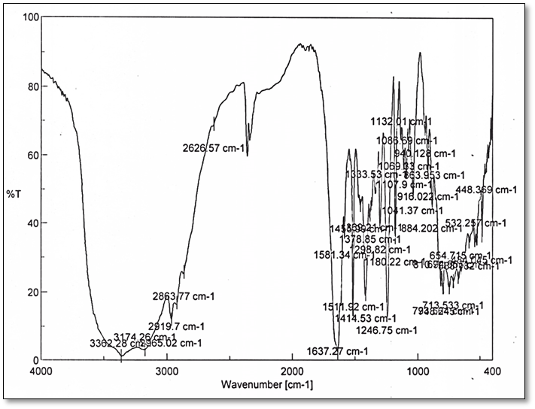

Fig.7 FT- IR Spectrum of Atenolol drug

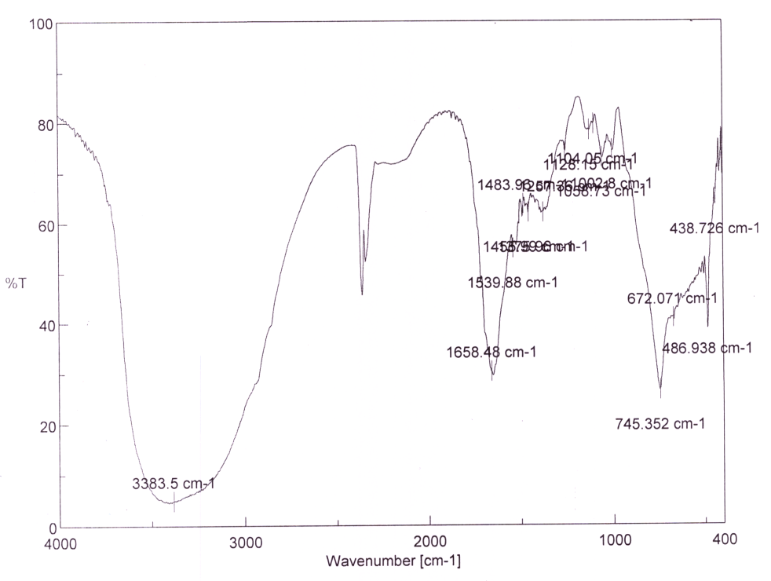
Fig.8 FT-IR Spectrum of Atenolol- loaded Vesicles

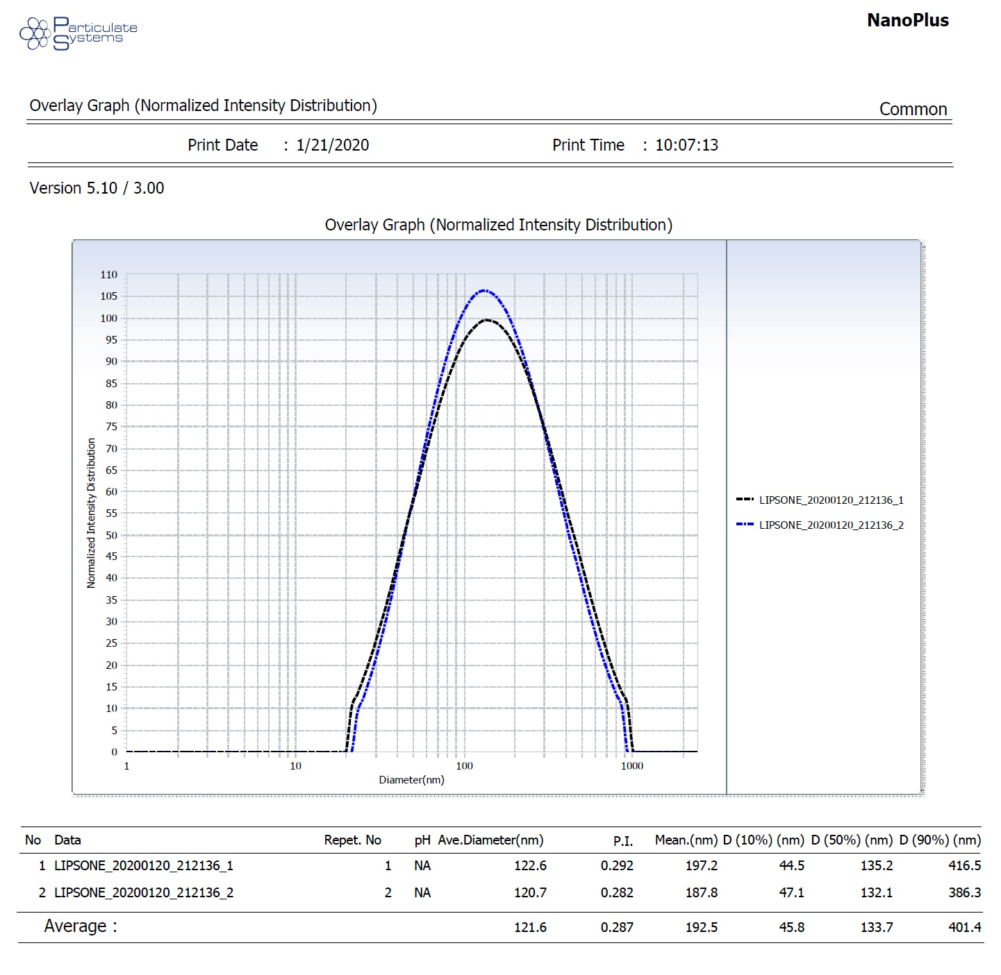
Fig. 9 Particle size of SLC-ATE Vesicles by DLS
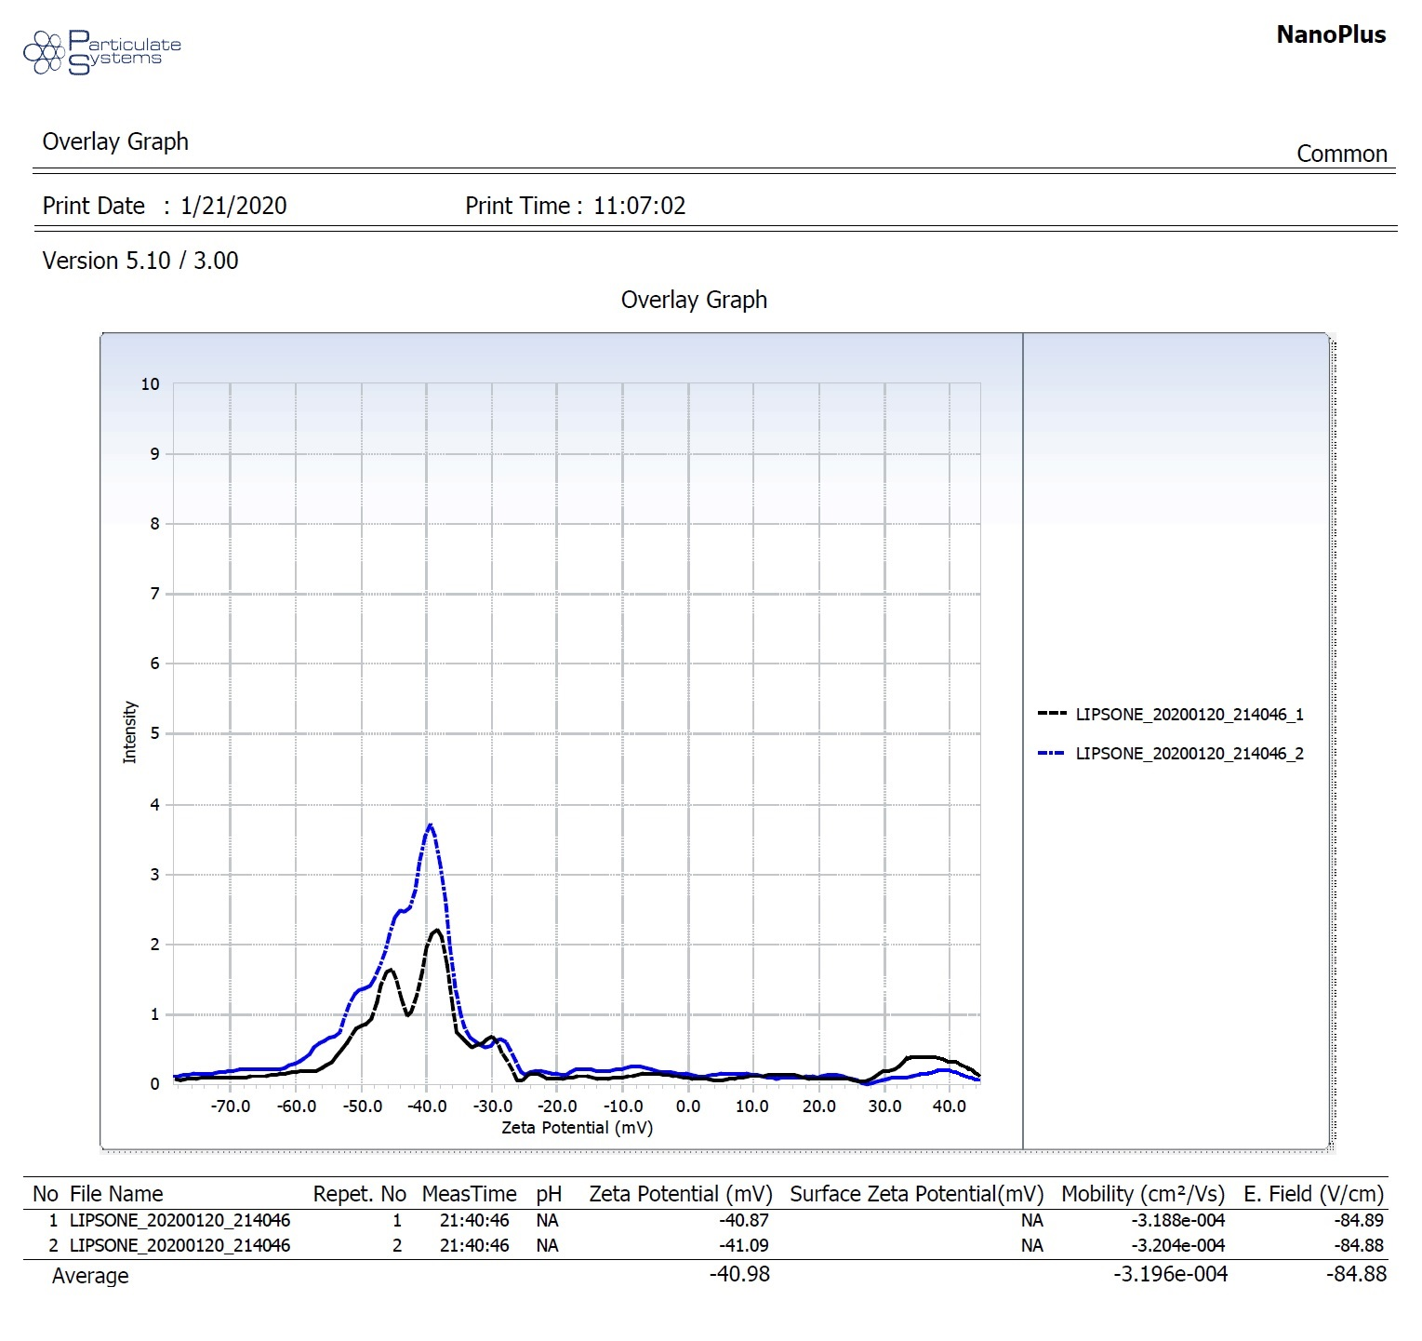
Fig.10 Zeta potential of SLC-ATE Vesicles

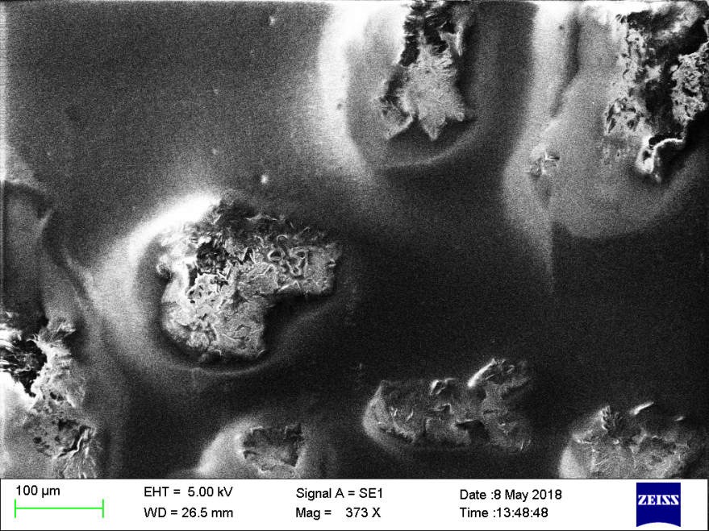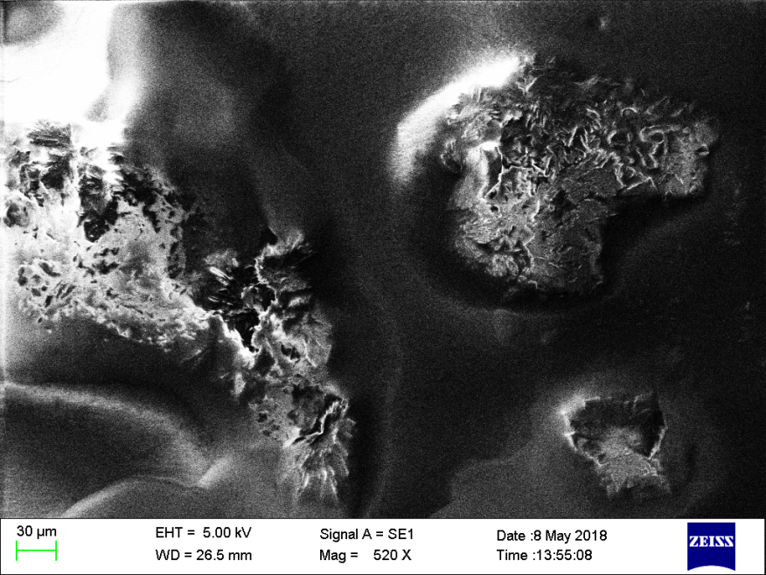
- (b)

Fig. 11 (a ) and (b) SEM images of SLC-ATE vesicles

VI. References

- Khaleel B.S., Syed M.M., Dhandayuthabani R., Sugantha K.V., Mater. Today Proc., (2020), 36(2), 357-363.
- Vinson J.A., Al Kharrat H., Andreoli L., Phytomedicine, (2005), 12(10), 760–765.
- Chen W., Lu Z., Viljoen A., Hamman J., Planta Med.,(2009), 75(6), 587-95.
- Fendler J.H., Acc. Chem. Res. (1980 a), 13, 7-13.
- Helfrich W., J. Phys. Condens. Matter (1994), 6(23A), A79.
- Battaglia G., Ryan A., Nature Mater., (2005), 4(11), 869–876.
- Akbarzadeh A., Rezaei-Sadabady R., Davaran S. et al., Nanoscale Res. Lett., (2013), 8,102.
- Discher D. E., Eisenberg A., Science, (2002), 297, 967-973.
- Stoeckenius W., J. Biophys. Biochem. Cytol.,(1959), 5, 491-505.
- Bangham A.D., Standish M.M., Watkins J.C., J. Mol. Biol., (1965), 13, 238-252.
- Bangham A.D., Prog. Biophy.Mol. Biol., (1968), 18, 25-29.
- Zingsheim H.P.,Plattner H., Electron microscopic methods in membrane biology. Methods Membr. Biol., (1976), 7,111-114.
- Petersen N.O., Chan S.I., Biochemistry, (1977), 16, 2657-2667.
- Hubbell W.L., McConnell H.M., J. Am.Chem. Soc., (1971), 93,334-326.
- Wallach D.F.H., Verma S.P., Fooksen J., Biochim Biophys Acta, (1979), 559, 153-208.
- Pink D.A., Green T.J., Chapman D., Biochemistry, (1980), 19, 349-356.
- Sharma V. K., Mishra D., Sharma A., Srivastava B., Int. J. Curr. Pharm. Rev. Res., (2010), 1, 6–16.
- Lasic D.D., Tibitech, (1998), 16, 307-321.
- Chrai S.S., Murari R., Ahmad I., Bio. Pharm., (2001), 11, 10-14.
- Eibl H., Chem. Phys. Lipids., (1980), 26(4), 405-429.
- Weiner N., Martin F., Riaz M., Drug Develop. Ind. Pharm., (1989), 15, 1523-1554.
- Szoka F., Papahadjopoulos D., Annu. Rev. Biophys. Bioeng., (1980), 9, 467-508.
- Mezei M., Liposomes and the skin. In: Gregoriadis G., Florence A.T., Patel H.M., (Eds.), Liposomes in Drug Delivery, Harwood Academic Publishers, (1993), 125-135.
- Albouaini K., Andron M., Alahmar A., Egred M., Int. J. Chron. Obstruct. Pulmon. Dis., (2007), 2(4), 535-540.
- Kalinowski L., Dobruchi L.W., Szczepanska-Konkel M. et al., Circulation, (2003), 107, 2747–2752.
- Wellstein A., Palm D., Belz G. et al., Eur. Heart J., (1987), 8(Suppl. M), 3–8.
- Packer M., Coats A.J., Fowler M.B., et al. N. Engl. J. Med., (2001), 344(22), 1651-1658.
- Wilson A.G., Brooke O.G., Lloyd H.J., Robinson B.F., Br. Med. J., (1969), 4(5680), 399-401.
- Mcainsh J., Simpson W.T., Holmes B.F., Young J., Ellis S.H., Biopharm. Drug. Dispos. (1980), 1(6), 323-332.
- McDevitt D.G., Eur. Heart J. Suppl M, (1987), 9-14.
- Mehvar R., Brocks D.R., J. Pharm. Pharm. Sci., (2001), 4,185-200.
- Gunjal P.T., Shinde M.B., Gharge V.S., Pimple S.V., Gurjar M.K., Shah M.N., Indian J Pharm Sci., (2015), 77(5),563-572.
- Bhowmik A., Ahmed T., Sultana S. et al., J. App. Pharm. Sci., (2013), 3 (09),103-108.
- Dehdashti B., Amin M.M., Gholizadeh A. et al., J. Environ. Health. Sci. Engineer. (2019), 17, 281–293
- Melander A., Stenberg P., Liedholm H., et al., Eur. J. Clin. Pharmacol., (1979), 16, 327-330.
- Chourasiya V., Bohrey S., Pandey A., Mater. Discover., (2016), 5, 1–13.

List of Abbreviations

S.No. | Abbreviation | Meaning
1 | SLC | Soy lecithin
2 | ATE | Atenolol
3 | SLC-ATE | Atenolol loaded Soy lecithin vesicles

