FICUS ELASTICA L. (MORACEAE) PROP ROOTS AGAINST MOSQUITO LARVAE!

* R. Muralidharan and Rajarajan. R

*Assistant Professor
DG Vaishnav College
Chennai, India
poonam123.73@rediffmail.com
ABSTRACT
Ficus elastic L., (Moraceae) an tree native to has been utilized in traditional medicinal practices such as Ayurveda, Unani and Siddha. This plant was studied for its larvicidal activity. Test concentrations of 1000,750, 500,250 µg of hexane, chloroform:methanol [1:2] were investigated for activity against the fourth instar larvae of Aedes aegypti and Culex quinquefasciatus The chloroform:methanol [1:2] extract showed 91% mortality after 48 hrs of incubation against the Aedes, LC50 of 0.302 followed by 0.219 and 0.214 for 750,500, and 250 µl concentrations respectively. This article leads to possible extracts and their role in the near future as eco-friendly natural pesticide to control mosquito larvae..
KEYWORDS: Aedes, larvicidal, Culex, root ,natural pesticides
INTRODUCTION
A larvicide is a type of insecticide used to control mosquitoes indoors and outdoors .They work by killing mosquito larvae before they can grow into adults. The market is flodded with Citronella, eucalyptus, neem and pepper mint oil derived from natural resources help in commercially formulated repellent. Cymbopogon citratus [1] Eucalyptus globulus [2] Azadirachta indica [3] and Mentha piperita [4]. this study was undertaken to assess the larvicidal potential of Ficus elastica against Aedes aegypti and Culex quinquefasciatus C. quinquefasciatus transmits.Ecofriendly plant products- in the market increased the quest to control the vectors. Plant products are promising and effective known to have insecticidal properties [5,6].
MATERIALS AND METHOD
COLLECTION OF PLANT MATERIAL
Guru Nanak college campus was the site for collection during the month of March identified and authenticated by botanist of Plant Biology . A voucher specimen was maintained in the department and numbered 101 PBPBT 2021, roots were then shade dried and powdered in a mortar and pestle..
EXTRACT PREPARATION
100 ml of solvents hexane, Chloroform:methanol (1:2) and ethanol for 48 hrs separately were subjected to 10 gms of the experimental plant material. Extract then filtered evaporated under vacuum until completely dry and used for further assay.
REARING OF AEDES AEGYPTI AND CULEX QUINQUEFCIATUS LARVAE
Eggs of Aedes aegypti were procured from the Central Research Medical Entomology Institute at Madurai, Tamilnadu, India. The egg rafts of Aedes were kept in the tray at 29±1 °C. After a day of incubation the first instar larvae emerged. The nutrient (sterilized yeast powder and dog biscuit in 1:1 ratio) were added to enhance the growth of larvae. But in this present study the fourth instar larvae were used. Culex quinquefasciatus were maintained at 27 ± 2 °C and 70 ± 5% relative humidity and provided with 10% sucrose in laboratory conditions.
LARVICIDAL BIOASSAY
Larvicidal activity was determined according to WHO protocol [7]. The larval mortality of fourth instar of Aedes and Culex was observed. The surviving larvae at the end of 24 and 48 hours were recorded and the percent mortality was calculated by the formulae [8].
Percentage of mortality = (Number of dead larvae/Total number of larvae) x 100.
LETHAL CONCENTRATION
The LC50 was calculated by a Probit analysis, Percentage Mortality = mean ±SD [9].
STATISTICAL ANALYSIS
Software SPSS (Statistical Package for Scientific Studies) was used for statistical significance - data obtained.
RESULTS AND DISCUSSION
Neem Azal popular in India has replaced all chemical insecticides, neem leaves and fruits [10 and 11] against larvae and pupae of Culex pipiens mosquito in the Republic of Algeria . Hexane extratcs of Cyperus rotundus were effective against Culex quinquefasciatus was reported by Sharma, Selection of a mosquito repellent cannot be based on any one test against a single insect because mosquito responses to repellents vary within and among species [12] Alkaloids from plant sources can act as larvicide, repellent and ovipositor attractant as observed by many researchers [13 and 14]. This present study showcases the effect of prop root of Ficus trees being prevalent in rice fields control population of insects and pests hence this study to access its activity.Stem leaves are used but prop root being used for its activity is one of its kind in the present study.
Figure 1: Experimental Plant
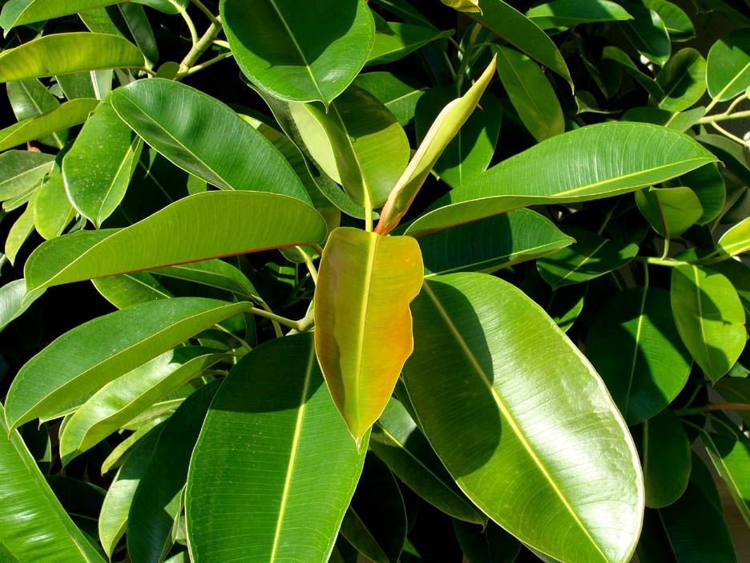
Figure 2 : Prop Roots of the Experimental Plant
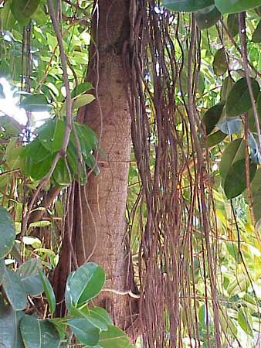
REFERENCES
- Thorsell W, Mikiver A, Malander I, Tunón H. Efficacy of plant extracts and oils as mosquito repellents. Phytomedicine 1998; 5(4):311–323.
2. Collins DA, Brady JN, Curtis CF. Assessment of the efficacy of Quwenling as a mosquito repellent. Phytotherapy Research 1993; 7(1):17–20.
3. Sharma VP, Ansari MA, Razdan RK. Mosquito repellent action of neem (Azadirachta indica) oil. American Mosquito Control Association Journal 1993; 9:359–360.
4. Ansari MA, Vasudevan P, Tandon M, Razdan RK. Larvicidal and mosquito repellent action of peppermint (Mentha piperita) oil. Bioresource Technology 2000; 71(3):267–271.
5. Pankaj T, Anita S. Assessment of larvicidal properties of aqueous extracts of four plants Against Culex quinquefasciatus larvae. Jordan Journal of Biological Sciences 2010; 3(1):1-6.
6. Larvicidal Activity of Edible Plant-Derived Essential Oils Against the Pyrethroid Susceptible and -Resistant Strains of Aedes aegypti (Diptera: Culicidae). Journal of Vector Ecology 2010; 35(1):106-115.
7. World Health Organization. Instructions for determining the susceptibility or resistance of mosquito larvae to insecticides. WHO/VBC 1981; 81:807-962.
8. Abbott WS. A method for computing the effectiveness of an insecticide. J Econ Entomol 1925; 18:265-7
9. Finney DJ. Probit analysis. Cambridge: Cambridge University Press, 1971. 12. Trease GE, Evans WC. Pharmacognosy, Edn 14th, Brown Publication, 1989.
10. Harborne JB. Phytochemical method, Edn 3rd. Chapman and Hall, London, 1983, 135- 203.
11. Sofowora AO. Traditional Medicine and Medicinal Plants in Africa. Edn 2, University of Life Press, 1993, 320.
12. Rutledge LC, Collister DM, Meixsell VE, Eisenberg GHC. Comparative sensitivity of representative mosquitoes (Diptera: Culicidae) to repellents. Journal of Medical Entomology 1983; 20:506–510.
13. Sharma VP, Ansari MA, Razdan RK. Mosquito repellent action of neem (Azadirachta indica) oil. American Mosquito Control Association Journal 1993; 9:359–360.
14. Singh N, Kulshrestha VK, Gupta MB, Bhargava KP. A pharmacological study of Cyperus rotundus. Indian Journal of Medical Research 1970; 58:103–109.

TABLE1: EFFICACY OF FICUS AGAINST MOSQUITO LARVAE

SERIAL  NUMBER | MOSQUITO LARVAE (FOURTH INSTAR LARVAE ) | % MORTALITY AT 1000 µG/mL CONCENTRATION
SERIAL  NUMBER | MOSQUITO LARVAE (FOURTH INSTAR LARVAE ) | CONCENTRATION | DURATION | EFFICIANCY
1 | Aedes aegypti | 1 | 24 | 85
1 | Aedes aegypti | 10 | 24 | 90
1 | Aedes aegypti | 100 | 24 | 100
1 | Aedes aegypti | 1000 | 24 | 100
1 | Aedes aegypti | 1 | 48 | 65
1 | Aedes aegypti | 10 | 48 | 80
1 | Aedes aegypti | 100 | 48 | 100
1 | Aedes aegypti | 1000 | 48 | 100
2 | Culex quinquefasciatus | 1 | 24 | 85
2 | Culex quinquefasciatus | 10 | 24 | 90
2 | Culex quinquefasciatus | 100 | 24 | 100
2 | Culex quinquefasciatus | 1000 | 24 | 100
2 | Culex quinquefasciatus | 1 | 48 | 65
2 | Culex quinquefasciatus | 10 | 48 | 80
2 | Culex quinquefasciatus | 100 | 48 | 100
2 | Culex quinquefasciatus | 1000 | 48 | 100

