NSKE (NEEM SEED KERNEL EXTRACT) ON SOLANUM NIGER --- ORGANIC PESTICIDE

Dr. R. Muralidharan and Rajarajan R.
*Assistant Professor
DG Vaishnav College
Chennai,India

ABSTRACT
The market is flooded with chemical pesticides a need for a natural which is more promising than a chemical one. Neem Seed Kernel Extract (NSKE) is a potential pesticide currently used at a dosage of 1 litre/sqhectar. Increases the yield and controls the disease infections a plant tonic.

Key words: NSKE., pesticide,solanum nigrum,plant tonic

INTRODUCTION
In organic farming fertilizers such as compost manure, green manure (Neem kernel) are utilised. It originated early in the 20th century in reaction to rapidly changing farming practices.Organic farms provide a “win-win” (high yield and low variability) for environmental sustainability, while conventional farming provided a high crop yield with low variability.
The traditional and sustainable farming practices were advocated and analysed by Howard, an agricultural researcher for their adoption in the West [1].
Solanum nigrum Linn., commonly named as brinjal is a common edible medicinal herb of the Solanaceae family widely distributed in temperate to tropical regions of Europe, Asia, and America. Mainly applicable in the treatment of cancers, leucorrhea, sore throat, toothache, dermatitis, eczema, carbuncles, and furuncle [2].

MATERIALS AND METHOD
PREPARATION OF NEEM SEED KERNEL EXTRACT -NSKE
Neem kernel nearly 5 kilograms is grinded and subjected to 10 liters of distilled water for one day. When it turns milky white Khadi 200g detergent soap is added stirred with a wooden Planck. Later filtered and stored for nearly seven days (Figure 6). Always use freshly prepared Neem seed kernel extract (NSKE).The solution is sprayed after 3.30 pm to get effective results [4].
Extract preparation
NSKE stock solution was prepared by dissolving in water, 2:1 v/v.
Nano capsules were prepared by dissolving in 10ml of silver nitrate solution.
Experimental plant: Brinjal Solanum nigrum L

Leaf spot is caused by Cercospora melongenae which is currently controlled by a chemical agent :Ridomet 1 gm/L

Application method
Various concentrations such as 1, 10, 100, 1000 µg/L with the stock solution having NSKE: water, 2:1 v/v were applied as a foliar spray.The results are tabulated and recorded in Table 1.

RESULTS
Efficacy of Neem seed kernel extract on the Solanum nigrum is effective on fungus. (Table1) controlled by the Neem seed kernel extract within 24 hours interval and at a concentration of 100µL.

REFERENCES
1.Ramesh P, Singh M, Subba RA. Organic farming: Its relevance to the Indian context. Current Scientist. 2005; 88(4): 561-568.
2.Teng F., Yuan C. P., Wang P. Study on antioxidant activity of extracts from Solanum nigrum L.berries and analysis of the active ingredients. J. Anhui Agric. Sci. 2014 :42 (19), 6217–6219.
3.Bhowmik PK, Matsui T, Ikeuchi T, Suzuki H. Changes in storage quality and shelf life of green asparagus over an extended harvest season. Postharvest Biol Technol. 2002; 26(3):323-328.
4.Ley SV, Denholm AA, Wood A. The chemistry of azadirachtin. Na Prod Rep.1993;10(2)109-115.

Figure1: Infected plant with Cercospora melongenae

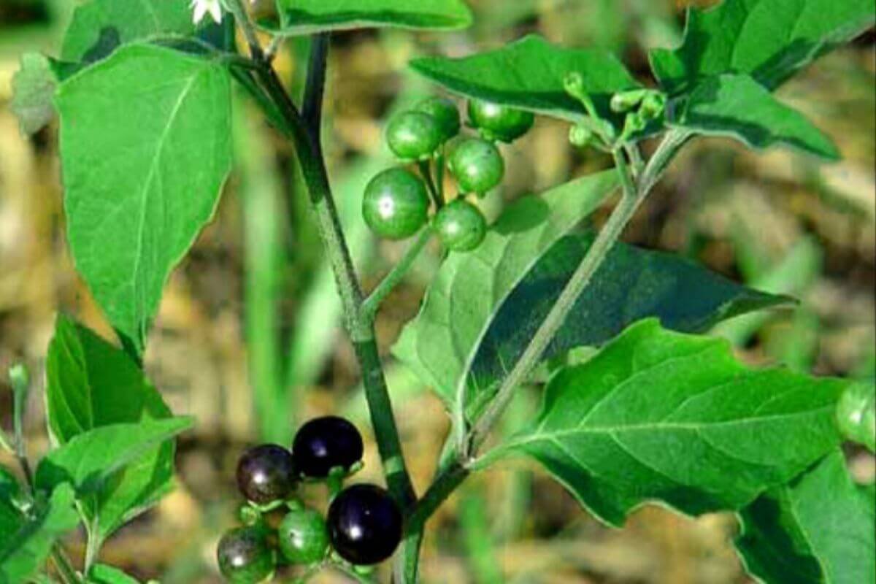

Figure 2 : Leaf spot by causal organism

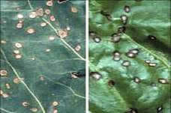

Figure3 : Preparation Of NSKE
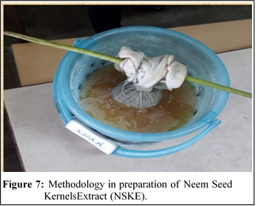

Table1: EFFICACY OF NSKE NANOCAPSULE ON BRINJAL PLANT AFFECTED BY CERCOSPORA MELONGENAE

S.No | Concentration of the extractµL | Time Interval(Hours) | Rate of control% | Positive Control  Ridomet 1gm/lStock%
1 | 100 | 24 | 95 | 100
2 | 100 | 48 | 90 | 100
3 | 1000 | 48 | 85 | 100
4 | 100 | 72 | 80 | 100
5 | 1000 | 72 | 85 | 100

