A Review Paper on Self-Driving Car Using Machine Learning and Artificial Intelligence
Neha Jain,jainneha818@gmail.com
Department Of Computer Science & Engineering, SRGI, Jabalpur
Richa shukla ,rsichasharma68@gmail.com
Department Of Computer Science & Engineering, SRIST, Jabalpur
Deepesh Tamrakar,deepesh.tamrakar@gmail.com
Department Of Computer Science & Engineering, SRGI, Jabalpur

ABSTRACT
A self-driving car is one that can sense its environment and avoid traffic and other obstacles with little assistance from a human. In spite of years of discussion and development, TESLA has successfully produced this most recent emerging technology in the automobile sector. Recently, these vehicles have started to show up on worldwide markets for usage in both private and public transportation (taxis, etc.). Waymo, UBER, Nissan, and Nvidia are just a few of the businesses taking part in the product development. With this kind of vehicle, all forms of motor transportation are more effective, safe, and secure. Human error may also be prevented when driving is done safely. The project's goal is to make the process go more quickly.
Keywords: Artificial Intelligence, Machine Learning, Human Input, Self Driving Car.
I. Introduction
The concept of creating an autonomous vehicle from scratch in this paper is focused in particular on a self-driving radio control car. The model must be able to drive autonomously on a course and demonstrate the ability to make lane changes, among other manoeuvres. The entire process of creating such a vehicle will be covered by the project, from the initial RC car model and embedded hardware platform through the end-to-end machine learning pipeline required for automated data collecting, labeling, and model training [1]. The decision to concentrate on this problem was primarily driven by the quickly developing state of applied artificial intelligence (AI) and the projected effects of autonomous vehicles on humanity's future, together with improved road safety, reduced traffic, and autonomous mobility for non-drivers and low-income individuals. It is anticipated that autonomous vehicles would be essential to the most difficult human-planned projects, such as space exploration. Such an autonomous car might have been built without the expense of high-priced labs or in-depth research thanks to the quick development of AI and deep learning (DL) frameworks and methodologies. Currently, a number of private businesses and academic institutions are concentrating on the creation of autonomous vehicles and how they will fit into the existing rules, laws, and regulations. [2].
The advantages of autonomous vehicles and improvements to quality of life include safer and less congested roads, less parking, and fewer cars per person, as well as up to several thousand dollars in annual travel savings. time, fuel efficiency, parking advantages, and collision expenses. The area of autonomous cars is only getting started and will have a substantial long-term influence on society in terms of both the financial and ethical repercussions, given the above and the well-known advent of artificial intelligence. One of the reasons why the topic of this paper was chosen is because the field has to be made more publicly available to academics and students if it is to develop via increased discussion on important topics and avoid stagnating in a winter of autonomous cars [3].
II. Approaches In Machine Learning

A. The algorithm used in supervised learning requires external support. To create training and testing datasets, the provided input database is used. The training database is used to predict or categories the output variable. During database training, algorithms try to learn specific shapes, and they subsequently use these learnt patterns on the testing database to get results in estimating. [4].
B. Unsupervised learning, a machine learning technique, can identify certain traits in the input data. When a new database is presented, it uses traits that have been previously learnt to identify the data class. For both feature reduction and clustering, it is often advised. [4].
C Reinforcement learning for action-based decision-making Idea learning also goes by the name of reinforcement learning. To improve the value of the outcomes at the intended outcome or favourable scenario, decisions are made in this learning process, and then actions are taken. However, the student is unfamiliar with the material. After being presented with the situation, it learns to choose the best course of action. Both the present and the future are impacted by the choice or action the learner makes. Reinforcement learning only uses two situations: delayed results and looking for patterns through trial and error. [5].

III. Algorithms for Machine Learning Used in Self-Driving Cars
Features are extracted using SIFT, or scale-invariant feature transform.

SIFT algorithms search for objects by analyzing photos. For example, the three points of a triangle symbol are entered as features. An car may then swiftly recognize the sign using those criteria [6].
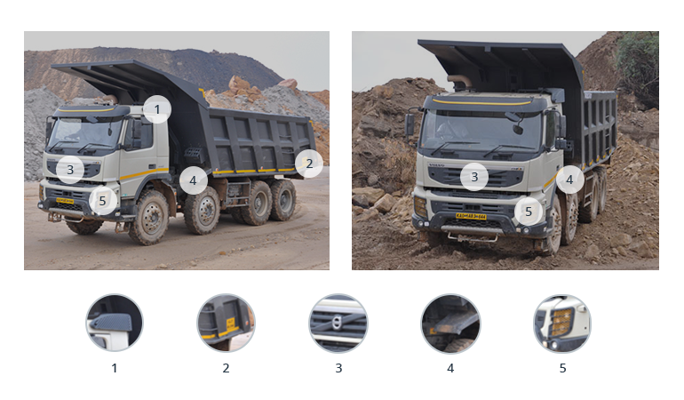
b. Data categorization using AdaBoost
This application collects and organises data to enhance vehicle performance and learning. It combines numerous low-performing classifiers to produce a single high-performing classifier for enhanced decision-making [6].
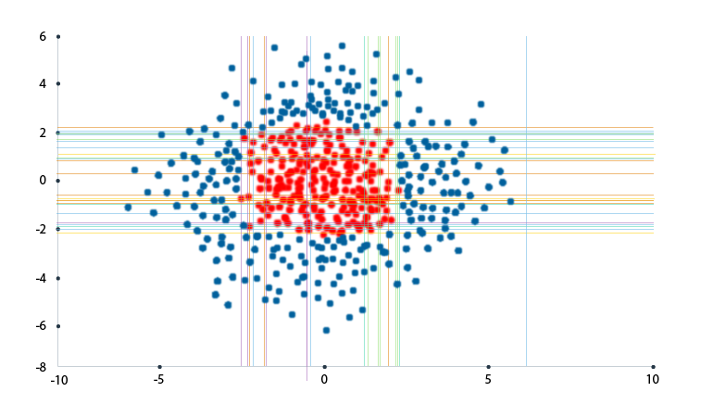
TextonBoost, which recognises objects
The TextonBoost approach, like AdaBoost, improves learning using textons by utilising information from shape, context, and appearance (micro-structures in images). It assembles visual data that contains recurrent components [7].
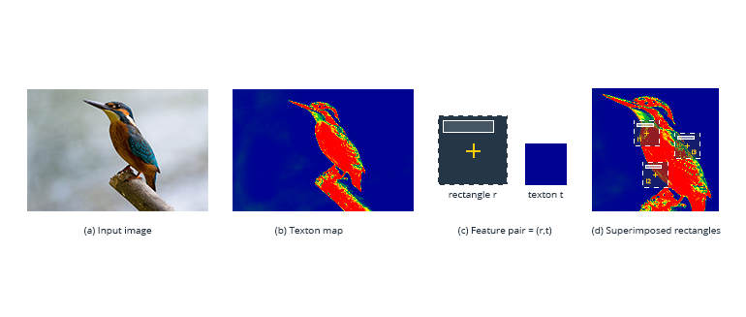
c. An oriented gradients histogram (HOG)
HOG makes it simpler to examine a cell—where an object is located—and ascertain how it shifts or moves. [7]
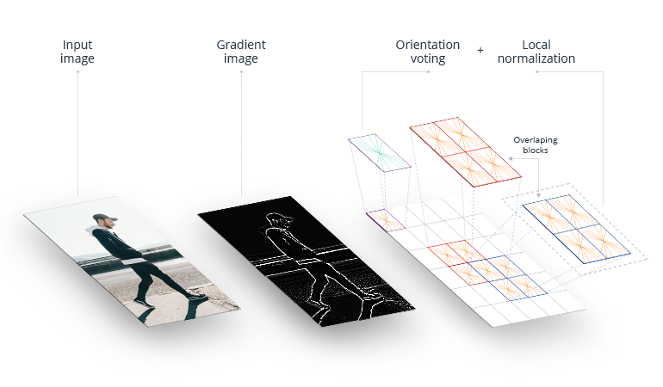
e. YOLO (You Only Look Once)
This algorithm detects and groups objects, such as people, plants, and cars. It assigns distinctive characteristics to each kind of object it groups in order to make objects easier for the car to recognise. YOLO is effective at categorising and recognising goods [8].
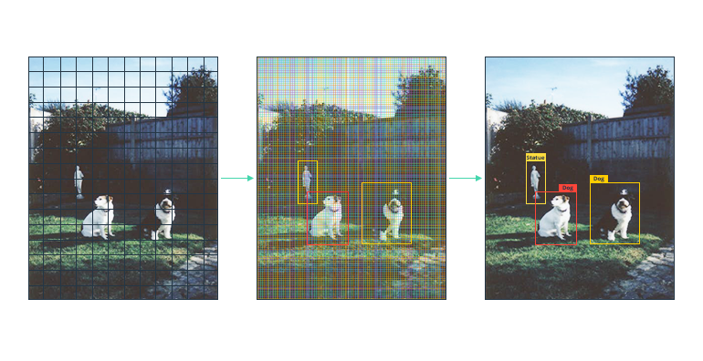
f. Summary
Algorithms for machine learning enable self-driving vehicles. They allow a car to gather data about its surroundings from cameras and other sensors, comprehend it, and decide what to do. Machine learning allows even cars to learn to perform these tasks as well as (or better than) people [8].
IV. LITERATURE SURVEY
A. George Hotz, Eder Santana, and the University of Florida used a driving simulator to learn.
The self-driving car artificial intelligence technique utilised by Comma.ai is based on an agent that mimics driver actions and anticipates manoeuvres by modelling impending traffic circumstances. This essay is an illustration of one of our research strategies for driving simulation. the one where we simulate is the one we use. Here, utilising generative adversarial networks with both classical and learning cost functions, we investigate variation auto encoders for embedding road frames. [9]
B. Learning for Self-Driving Cars from Start to End, NVIDIA Collaborations, Mariusz Bojarski, and Davide Del Testa. In order to translate front-facing camera data straight from raw pixels to driving commands, they used a convolution neural network (CNN). This end-to-end approach proved to be quite successful. On local roads with or without lane markings, on highways, and with the least amount of training data from people, the computer learns to drive in traffic. Also, it functions in dimly light areas like parking lots and gravel roads. [9]
C. The Perception of 3D Vision in Self-Driving Cars Lionel Heng, Christian Häne, and the University of Trier in Germany used a multi-camera system. Cameras are a crucial exteroceptive sensor for self-driving automobiles due to their accessibility, small size, ability to function in a range of weather situations, and capacity to provide appearance information about the surroundings. They may be used for many different things, such as visual navigation and obstacle detection. The whole 360-degree field of vision around the automobile may be recorded with a surround multi-camera system. To lower the number of cameras needed for surround perception, we employ fisheye cameras. Common vision pipelines are therefore available for 3D mapping, visual localization, obstacle detection, etc. [10].
V. CONCLUSION
Self-driving vehicles are the main development in the automatable sector in the future, therefore this project focuses on making improvements in road safety and commuting and substantially lowering accidents and human errors through continuous learning by the system. The way that people with disabilities and the blind travel will change thanks to this programmeable to drive independently. Our solution may be used as the basis for mobile applications, enabling consumers to request a car through an app and produce a completely autonomous vehicle once the law has been approved (totally autonomous vehicles are currently illegal, but they will soon become the norm for transportation).
VI.FUTURE SCOPE
Future autonomous vehicles offer a lot of promise. Automakers are working quickly to improve the accuracy and security of their autonomous models. Using a large number of cameras and sensors improves accuracy. Future delays can be avoided by designing a system where each car is connected to surrounding vehicles.
VII .REFERENCES
[1].Raivo Sell, Anton Rassõlkin, Mairo Leier, Juhan-Peep Ernits, “Self-driving car ISEAUTO for research and education”in 19th international conference on Research and Education in Mechatronics (REM), IEEE, 2018, pp: 111-116.
[2] T. Banerjee, S. Bose, A. Chakraborty, T. Samadder, Bhaskar Kumar, T.K. Rana, “Self Driving Cars: A Peep into the Future”, IEEE, 2017, pp: 33-38.
[3] Qudsia Memon, Muzamil Ahmed and ShahzebAli, “Self Driving and Driver Relaxing Vehicle”, in IEEE 2016, pp: 170-174.
[4] U. o. M. Centre for Sustainable Systems, "Autonomous Vehicles Factsheets," 2018.
[5] 3D Visual Perception for Self-Driving Cars using a Multi-Camera System, Christian Häne, Lionel Heng, University of Trier, Germany.
[6] Artificial Intelligence: A Modern Approach Stuart J. Russel and Peter Norvig.
[7] A dynamic k-means based clustering algrothim using fuzzy logic for CH selection and data transmission based on machine learning https://doi.org/10.1007/500500-023-07964-w 14 march 2023.
[8]”.DDos attack detection using cross domain challenges and research “, IJEAT vol9.issue 1pp.2373-2382, Oct 2019, scopus indexed.
[9] Student Performance Prediction using Machine Learning by Havan Agrawal , Harshil Mavani . International Journal of Engineering Research & Technology (IJERT) ISSN: 2278-0181 IJERTV4IS030127 www.ijert.org l. 4 Issue 03, March-2015 .
[10] M. Chen, W. Saad, C. Yin, and M. Debbah, “Echo state networks for proactive caching in cloud-based radio access networks with mobile users,” IEEE Transactions on Wireless Communications, vol. 16, no. 6, pp. 3520–3535, 2017.

