Guardians of Biodiversity: Unveiling the Plant Diversity and Structural Dynamics of Maruthi Mala Hills, Kollam District, Kerala
Dr Sofia S*
* Assistant Professor, Dept. of Botany, Fatima Mata National College (Autonomous), Kollam, Kerala.

ABSTRACT
Ecology is the inter-relationship between organisms with their physical environment and the fluxes of matter and energy through biological system. Complex interrelationships of the organisms and the environment and with each other form the subject matter of ecology. A mixture of species which live in a habitat and are held together by common ecological tolerance, form a community. Phytosociological studies are necessary for protecting the biodiversity and natural plant communities. These are very essential components for understanding the changes accomplished in the past and future. The environmental safety of a country depends on the health of its forest area as it is the forest ecosystems which allocate disparate share to the world’s biodiversity. Phytosociological studies are essential for protecting the natural plant communities and biodiversity as well as understanding the changes experienced in the past and continuing on in to the future. Most of the developed countries have these basic studies and defined with the help of vegetation maps. However, most of these forests are under immense anthropogenic disturbances and require careful management intervention to maintain overall biodiversity and sustainability. In the present investigation studies were carried out on Phytosociological and species diversity in Kollam district of Kerala State. The main purpose of the Phytosociological analysis is to understand floristic vegetation characteristics, to estimate the species richness and diversity which is existing in the study area.
Key Words: Phyto sociology, Biodiversity, Species, Density, Frequency

Introduction
Ecology is the interrelationship between organisms and their physical environment and the flows of matter and energy through biological systems. The complex relationships between organisms and their environment and each other form the subject of ecology. A mixture of species living in one habitat and held together by a shared ecological tolerance forms a community. Not all of these species are equally important, but only a few invasive species which, through their size and growth, alter the habitat and control the growth of other species in the community. These are referred to as dominant species (Abohassan et al., 2020). The study of the plant community requires knowledge of the structure and composition of individual species.
Every living organism in an ecosystem depends on and must interact with the abiotic and biotic components of the environment. Abiotic components include basic inorganic elements and components such as water and carbon dioxide, calcium and oxygen, carbonates and phosphates, and a range of organic compounds, the byproducts of the activity or death of organisms. Biotic factors include plants, animals, and microbes, all of which interact in a fundamentally energy-dependent way. Ecology is mainly concerned with the directional influence of abiotic and biotic factors on the growth, distribution, behavior and survival of organisms (Stone and Frayer, 2018).
Phytosociological studies are needed to protect biodiversity and natural plant communities (Rahees et al., 2019). These are very essential components for understanding the changes that have taken place in the past and in the future (Hamzaoglu, 2006; Rao et al., 2020). A country's environmental security depends on the health of its forest cover (Curtis and McIntosh, 2020), since it is forest ecosystems that account for varying proportions of the world's biodiversity (Batles et al., 2001). Achieving forest sustainability is critical to biodiversity conservation (Gamble, 1936). It has been demonstrated that the long-term sustainability of forest ecosystems largely depends on plant diversity and its plant sociological properties. Most of the world's forests today are subject to severe human disturbance and require careful management interventions to maintain overall biodiversity and sustainability (Kumar et al., 2019).
As plants provide food and habitat for other organisms (Das et al., 2020), the total diversity of the forest is a factor dependent on plant diversity. The overall strength of the forest lies in its plant composition and therefore information about its composition, diversity and ecological aspects is of prime importance in conservation planning and implementation. Tree species control the growth of other vascular plants because they control the availability of sunlight on the forest floor. Analysis and estimation of tree diversity, which uncovers combinations of physical habitat, vegetation, physiology, species composition and community relationships, are useful data sets in forest management interventions (Battles et al., 2018). Personal changes in communities and ecosystems should be documented and used as baseline data for predicting the impact of disruptions, such as methods of restoration and harvesting in diversity and richness of flora (Sarkar, 2021).
In contrast to the current build-up of biodiversity, biodiversity in the hidden part of the range has been steadily declining due to human activities (Krishnamoothy et al., 2019). It is useful to study the characteristics, taxonomy, relationships and distribution of plant communities and to describe the population dynamics of each species and the relationships between species within the community. To understand the changes experienced in the past in natural plant communities and through biodiversity conservation, biogeographical studies on the future are essential. Most of the developed countries have these basic studies (Hamzaoglu. 2018) and are defined using tree maps (Tel et al., 2020). However, most of these forests are under heavy anthropogenic disturbance and require careful management interventions to maintain overall biodiversity and sustainability (Kumar et al., 2020). In the present investigation phytosociological and species diversity was studied in Kollam district of Kerala state. The main objective of phytosociological analysis is to understand the floristic vegetation characteristics, to estimate the species richness and diversity present in the study area.The ecological role of Maruthi mala plants is the protection of water bodies, the conservation of wildlife species through their natural habitats and the natural purification of polluted systems through natural decomposition to promote the purification and stability of the environment (Chandran, et al., 2020) They serve as breeding grounds for birds which are mammals and birds. Although the plant consists of thick and closely packed trees, it plays an important role in carbon cycling and reduces the amount of CO2 in the atmosphere. The reservoirs stored here help increase humidity which leads to a cooling effect inside the area. Some ecosystems reduce the risk of forest fires due to their ability to retain water by conserving water bodies such as ponds or rivers. Soil physicochemical properties in Maruthi Mala Hills have been shown to improve due to accumulation of litter in the soil (Santana et al., 2021).
Plant diversity and structural dynamics are essential aspects of understanding the ecological richness and conservation needs of any region. In this context, the present study delves into the intriguing landscape of Maruthi Mala Hills, located in Kollam District, Kerala. These hills are renowned for their unique ecosystem, comprising a wide variety of flora and intricate structural dynamics that play a pivotal role in sustaining the local biodiversity.
Maruthi Mala Hills, situated in the picturesque region of Kollam District, Kerala, have long been recognized as an ecological hotspot due to their diverse range of plant species and the ever-changing patterns of their structural composition. The area's ecological significance stems from its diverse altitudinal gradients, varied soil types, and distinct microclimatic conditions, providing a conducive environment for numerous plant species to thrive.
Understanding the plant diversity and structural dynamics of Maruthi Mala Hills is imperative for several reasons. Firstly, it contributes to our knowledge of Kerala's unique biodiversity, enriching our understanding of the ecological intricacies present in this Western Ghats region. Secondly, gaining insights into the structural dynamics of plant communities allows us to assess the health and stability of the ecosystem and identify potential vulnerabilities to environmental changes.
This study aims to comprehensively document the plant diversity present in Maruthi Mala Hills and explore the structural patterns of its vegetation. By employing rigorous field surveys and advanced analytical techniques, we seek to identify dominant plant species, measure their abundance, and investigate the factors influencing their distribution and coexistence.
The findings of this research are expected to contribute significantly to the fields of ecology, biodiversity conservation, and environmental management. Furthermore, the information gathered will aid in formulating effective conservation strategies and sustainable land use practices for Maruthi Mala Hills, safeguarding its unique plant diversity and preserving the delicate balance of its structural dynamics.
Through this study, we hope to shed light on the importance of preserving natural habitats like Maruthi Mala Hills, not only for the benefit of the local ecosystem and flora but also for the overall well-being of the community and the planet. By recognizing and conserving the intricate interplay of plant diversity and structural dynamics, we take a step closer to promoting harmonious coexistence between nature and humanity.
Maruthi Mala Hills (Muttara Hills)
Maruthi Mala Hills or Muttara Hills is located in a village called Muttara. It is a small village in the Kottarakkara block of Kollam district in Kerala, India. It is located 24 km east of the district headquarters Kollam, 3 km from Kottarakkara, 65 km from the state capital Thiruvananthapuram. The entire area of ​​Maruthi Mala hill is spread over more than 37 acres of land, which consists of trees as well as birds. Maruthi Mala Hills is one of the eco tourist places in Kollam district of Kerala and has a densely diverse ecosystem.
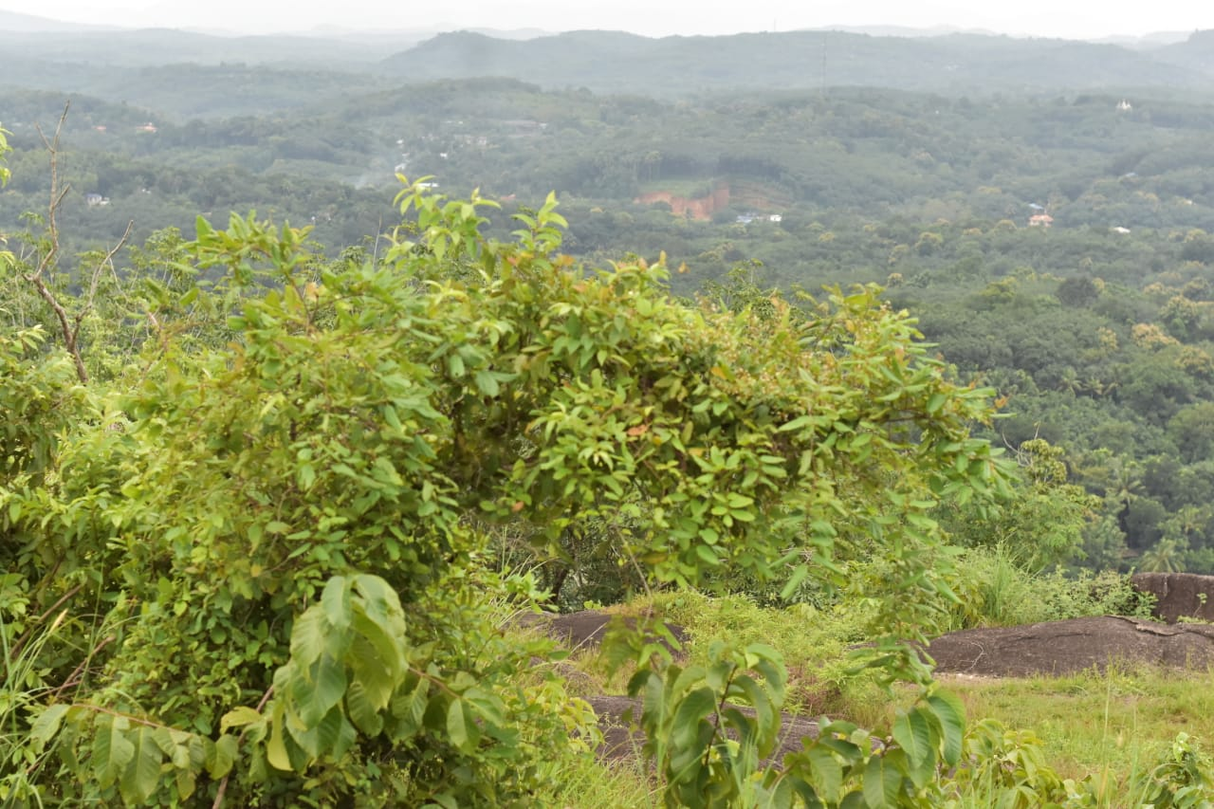
Figure 1.1: Study Site – Maruthi Mala Hills
The dominant plant species found here are Phyllanthus emblica, L., Eupatorium odoratum, L., Mimosa pudica, L., Premna odorata, Frac., Leucas aspera, L. There is no doubt that these will influence their performance in productive ecosystems. Heavy metal-mediated pollution affects the development and biochemical activities of soil microorganisms that can directly or indirectly affect other plants and animals in the ecosystem.
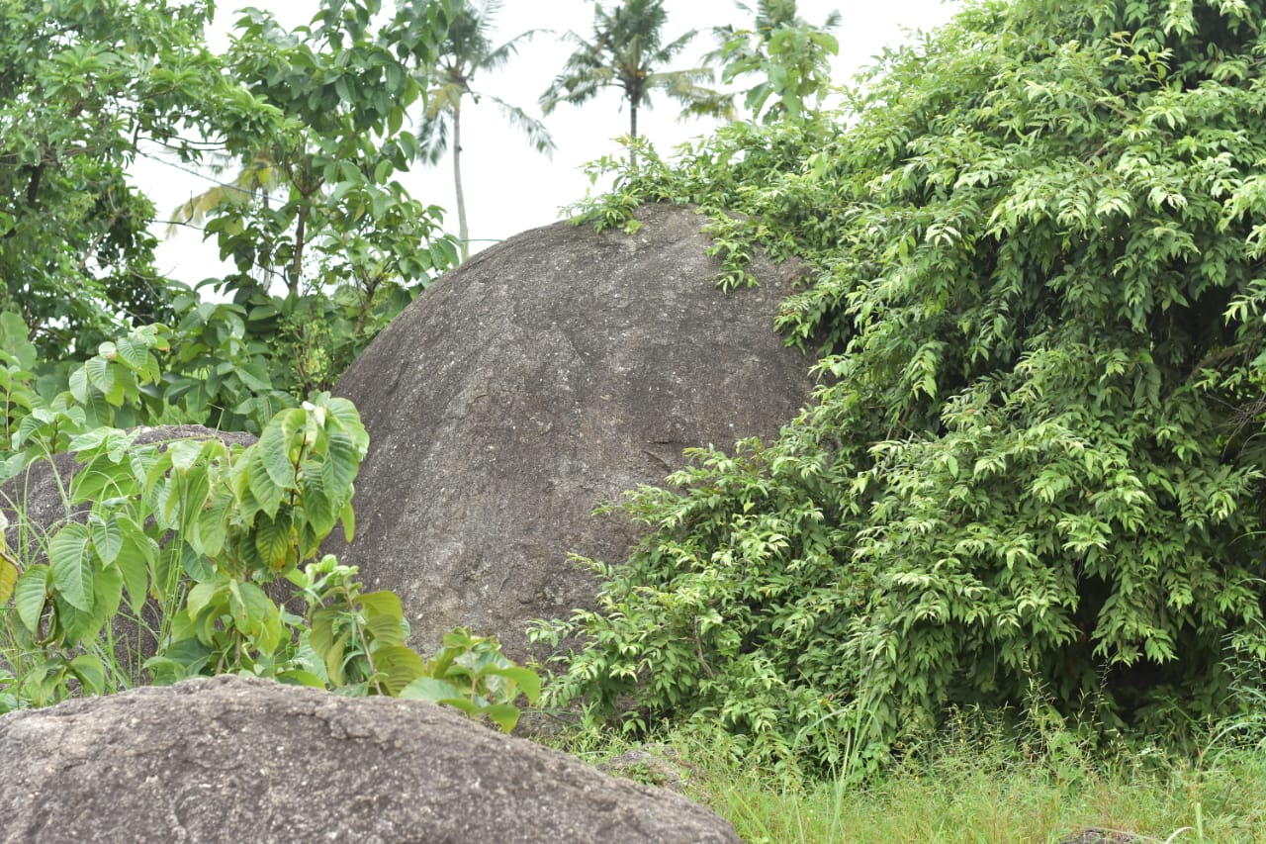
Figure 1.2: Study Site – Maruthi Mala Hills
This study includes the Floristic and Phytosociological analysis of Maruthi Mala Hills, Kollam District, Kerala. Floral study includes the analysis of general floristic composition of vegetation of the respected area. Phytosociological analysis includes the Standard Phytosociological methods and Diversity Indices.
1.1. Objectives
1. To analyse the present status of vegetation in Maruthi Mala Hills
2. To develop Phytosociological inventory of the flora

Review of Literature
Plants are taxonomically diverse assemblages of several unrelated angiosperm families with several adaptations (Hogarth, 2019; Abeysinghe et al., 2020). Forests constitute the world's most productive and biologically important ecosystem and they provide structural habitat for plants and animals (Alongi, 2021).Floristic inventories and diversity assessments are essential for understanding the status of diversity and the conservation of biodiversity. Inventory and diversity studies are carried out at various levels all over the world to fill the gap in biodiversity knowledge.
A study of the diversity of economically important plants along the coast of central Kerala was conducted by Jonathan et al. (2019). They studied the highest frequency and density for Ocimum tenuiflorum, L. and the highest abundance for Capsicum annum, L. The results showed the suitability of indigenous plants for plantation, cultivation and horticulture production in beach sites.
Ramya et al. (2020) conducted a phyto-social study in the tropical moist deciduous forest of Manar Beit and identified nineteen tree species belonging to 13 families. Pongamia pinnata, L. and Terminalia arjuna, L. showed the most important quality index that defines the dominant species. Community indices such as Shannon diversity, Simpson index, Margaleff index, Menhinick's index and evenness of community tree species evenness indicate the biodiversity status of tree species and Dalbergia latifolia, L. and Santalum album, L. Species become endangered category and these species were observed in the ecological survey of sample plots.
A phytosociological study on the diversity (Uddin et al., 2020) of plants in a natural and protected subtropical forest of Manipura and recorded a total of 79 species of trees and shrubs belonging to 35 families. Quantitative characteristics such as frequency, density, basal area, important value index (IVI), distribution pattern were evaluated. Schima wallichii, Lantana camara, L., were the dominant tree and shrub species in a natural forest.
Anwar et al. (2020) conducted a phytosociological study in the Peruvian mountain rain forest. They created a cluster using the Sorensen index to know the similarity and parallelism of the bioclimatic conditions and they established different communities and phytosociological units for Peru. They described seven associations, which were collected in the new class Saurauio peruvianae- Condaminetalia corymbosae in the new class Morello pubescentis, Myrsinetea coriaceae and two associations were described between Pruno rigidae-Oreopanacetea floribundae.
A phytosociological study of the weed community present in organic and traditional vegetable growing systems in the state of Alagoas in Brazil was carried out by Usharani et al. (2018). Quantitative characteristics such as frequency, density, abundance, relative frequency, relative density, similarity index (SI) and significance index (IVI) were assessed for each species. 299 weed species have been identified and grouped into 11 botanical families such as Amaranthaceae, Asteraceae, Commelinaceae, Cyperaceae, Euphorbiaceae, Malvaceae, Molluginaceae, Phyllantaceae, Poaceae, Rubiaceae and Solanaceae.
Kunwar et al. (2020) reported a phytosociological study in Darchula and Baitadi districts of Kailash Sacred Landscape Nepal to know how people use plant resources in the context of plant and habitat availability and accessibility and crop diversity. Plant availability was assessed using phytosociological indicators, and accessibility was tested using plant use values ​​with reference to site-specific explanatory variables. The use value of plants was influenced by ecological indicators, such as Shannon diversity and species richness, and cultural indicators, such as preference for specific products and recognition, and varied across use categories, such as medicinal and non-medicinal.
A study on the vegetation of the Wadi al-Kuf nursery reserve areas, west-northwest of Hebron-Palestine, was conducted by Kunev et al. (2020). They reported the existence of 82 species, of which 16 are endemic and ninety plants distributed in the area. Braun-Blanquet method analysis and phytosociological studies were used, and land classification for Salvador Rivas Martinez was used to analyze bioclimatic and physical factors of climate. They collected 300 samples of different plant species and in statistical treatment they reported two major groups in clusters; Group (A), represents climate influenced forests, copses and high scrubland and group (B), represents climate influenced pine copses.
Manzoor and Jazeeb (2021) conducted a vegetation study in four rural Village Common Forests (VCF) of Khagrachori district, Chittagong Hill Tracts, Bangladesh. They used a quadratic method (10x10 m) for each VCF over three sites at the base, middle and top of the hill, and they reported 124 species belonging to 44 families. The Significance Index (IVI) indicated that Oroxylum indicum was the dominant species. The values ​​of the Shannon-Wiener Diversity Index (H′), the Simpson Index (Ds) and the Uniformity Index (EI) VCF were also noted. Eight Least Concerned (LC) and three Threatened (T) species of the country live in the VKF of Khagrachor district. The dominant family was Euphorbiaceae, followed by Moraceae and Rubiaceae.
Timub et al. (2020) reported a phytosociological study of wheat crop weeds under edaphic change in Tehsil Raja District Swabi, Khyber Pakhtunkhwa, Pakistan. They used 200 quadrats (1x1 m) in 20 randomly selected wheat fields. Analytical quantitative characters such as density, frequency and cover were calculated for each weed species and 20 weed communities were recognized based on the highest importance of the three leading species. The total importance value of the three dominant species and the remaining associated species were also noted, and Sorensen's index was used to study the similarity between weed communities.
Patel (2021) carried out a phytosociological study of some weeds in agriculture crop field in Sami Taluka, Patan District of Gujarat, India. Density, frequency and abundance were used to know the distribution of plant species. They reported 47 weeds plant species belonging to 45 genera and 21 families. Abundance, Density, Frequency were used as the ecological parameters for finding the distribution of plant species. There were 40 species belongs to Dicotyledonous and 7 species belongs to Monocot, Asteraceae is the leading plant family with 8 number of plant.
Patel (2020) conducted a phytosociological analysis of tree species of Sebhargog region of reserve forest of Vadgam Taluka, Banaskantha District of Gujarat, India. They reported 34 tree species, and Acacia nilitica L., Butea monosperma L., Acacia chundra L., is the most dominant in this area and Delonix regia (Bojer ex Hook.) Refin., Morinda tomentosa Lam. and Moringa oleifera Lam. are the minimum number in this area. Relative Frequency (RF), Relative Density (RD), Abundance (A), Importance Value Index (IVI), Girth at breast height (GBH) were used as the ecological parameters for finding the distribution of plant species.
Huma et al. (2019) reported a phytosociological classification of the Peruvian vegetation. They reported 218 associations belong to 34 phytosociological classes and four of them are described for the first time. In addition, 5 new orders, and 7 new alliances are also described. Phytosociological plot accompanied by an abundance dominance index were used for the phytosociological study.

Materials and Methods
Ecosystems of Kerala have indigenous characteristics compared to the ecosystem of other regions. An attempt has been made in the present study to unlock the ecological imbalance of ecosystem in Maruthi Mala Hills, Kollam District through scrutinising structural dynamics and diversity, which will help to provide guidance for conservation and scientific management of the locations.
3.1. Ecological Studies
3.1.1 Study Area
The study site Maruthi Mala Hills in Kollam District, Kerala, the southwest cost of India. Sampling location is shown in Fig. 3.1.1. Maruthi Mala Hills is situated between 8⁰57’18” N and 76⁰45’30” E.
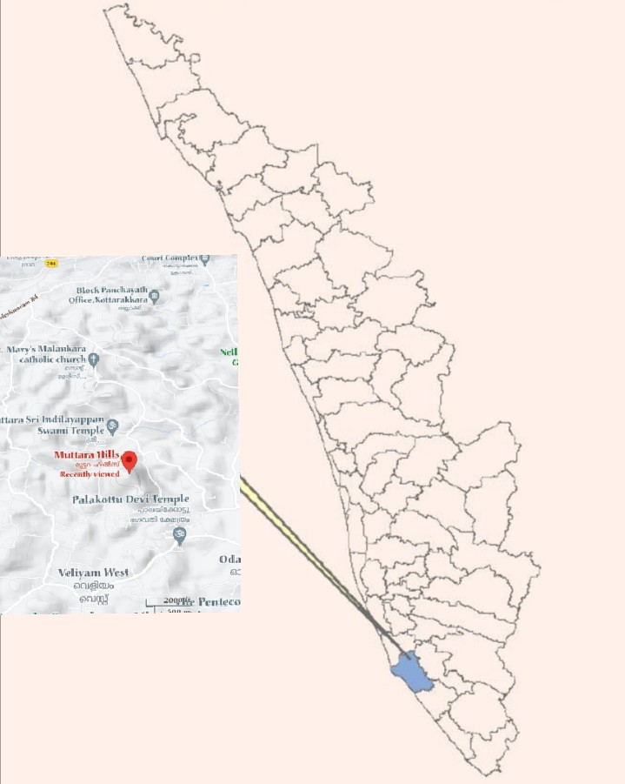
Figure. 3.1.1: Selected Study Site

    - Phytosociology of Plants
The distribution patterns of plants in Maruthi Mala Hills studied using species area estimation and quadrat analysis. The main purpose of the phytosociological analysis is to understand the floristic vegetation, to estimate the species richness and diversity, existing in the studied site. Phytosociological studies were carried out using quadrat method. The value of percentage frequency, frequency class, density, abundance, relative frequency, relative density, Importance Value Index (IVI) and Various Diversity Indices were calculated by using formula given by Misra and Puri (1973).
- Density.
Density =Total number of individuals of a species in all quadrats
Total number of quadrats studied
- Frequency (%).
Frequency (%) = Number of quadrats in which the species occurred
Total number of quadrats studied X 100
- Abundance.
Abundance = Total number of individuals of a species in all quadrats
Total number of quadrats in which the species occurred
- Importance Value Index
IVI = Relative frequency + Relative abundance + Relative density

- Relative density.
Relative density = Number of individual of the species
Number of individual of all the species X 100
- Relative frequency.
Relative frequency = Number of occurrence of the species
Number of occurrence of all the species X 100
- Relative abundance.
Relative abundance = = Total no.of species
Total no.of individual of all species recorded x100
Species richness, diversity and dominance indices
Species richness, diversity and dominance were analysed by using the methods of Margalef's index of richness, Shannon's diversity index, Simpson's index of dominance and Pielou’s Evenness Index.

- Margalef’s index of richness
‘Margalef’s index of richness’ (Dmg)
Dmg = (S-1)/ In N
Where,
S = Total number of species.
N = Total number of individuals.
- Shannon–Weaver index of diversity
H’ = – Σ pi In pi
Where, H’ = Shannon index of diversity
pi = the proportion of important value of the ith species ( pi =ni / N, ni is the important value index of ith species and N is the important value index of all the species).
- Simpson index of Dominance
D = Σ ( pi)2
Where, D = Simpson index of dominance
pi = the proportion of important value of the ith species ( pi = ni / N, ni is the important value index of ith species and N is the important value index of all the species).
- Pielou’s Evenness Index

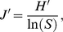
Where, J’ = Pielou’s evenness Index
H′ represents the observed value of Shannon index
S is the total number of species observed.
Observation and Results
Plant diversity inventories in ecosystems have mostly been focused on trees, shrubs and herbs because these species diversity is an important aspect of forest ecosystem diversity. Long-term ecological research sites have become fundamental tools in the study of community and ecosystem dynamics in ecosystems worldwide. Phytosociological analysis of natural vegetation is recognized as an efficient and appropriate method to select out useful plant species from natural communities.
4.1. Plant Vegetation
The Plant vegetation of the studied site was analysed to assess the composition and distribution pattern of species. The common plant species observed in Maruthi Mala Hills was Phyllanthus emblica, L., Mimosa pudica, L., Premna odorata, Franc., Eupatorium odoratum, L.
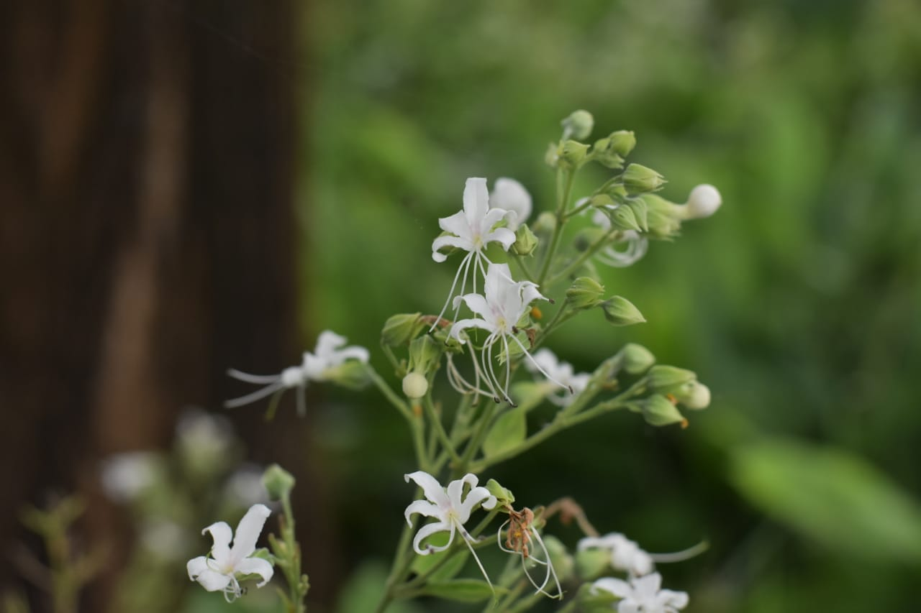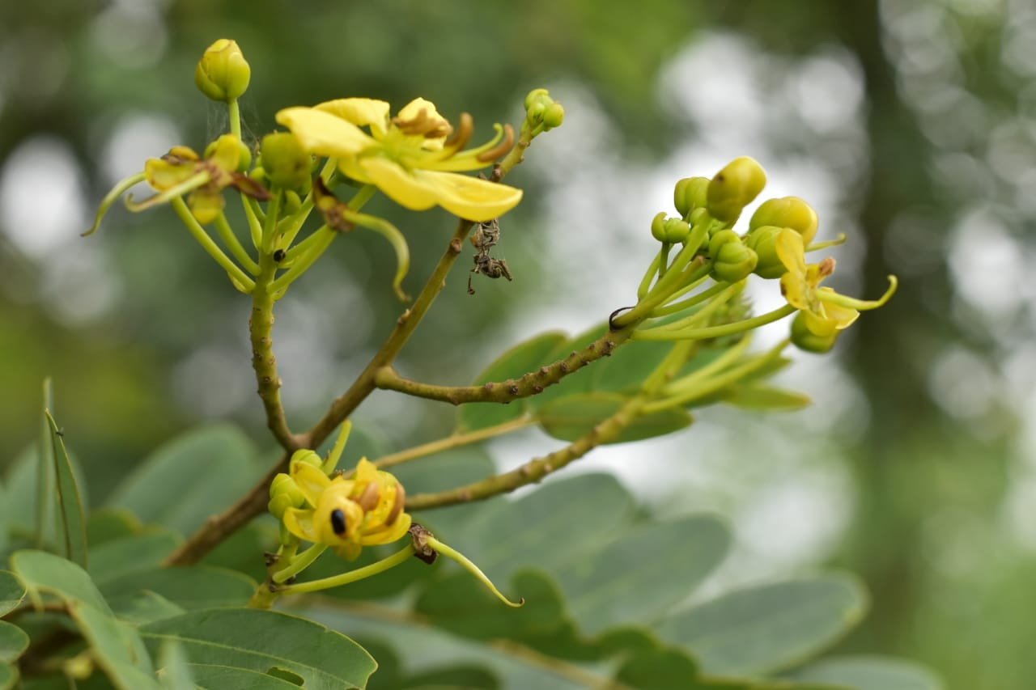
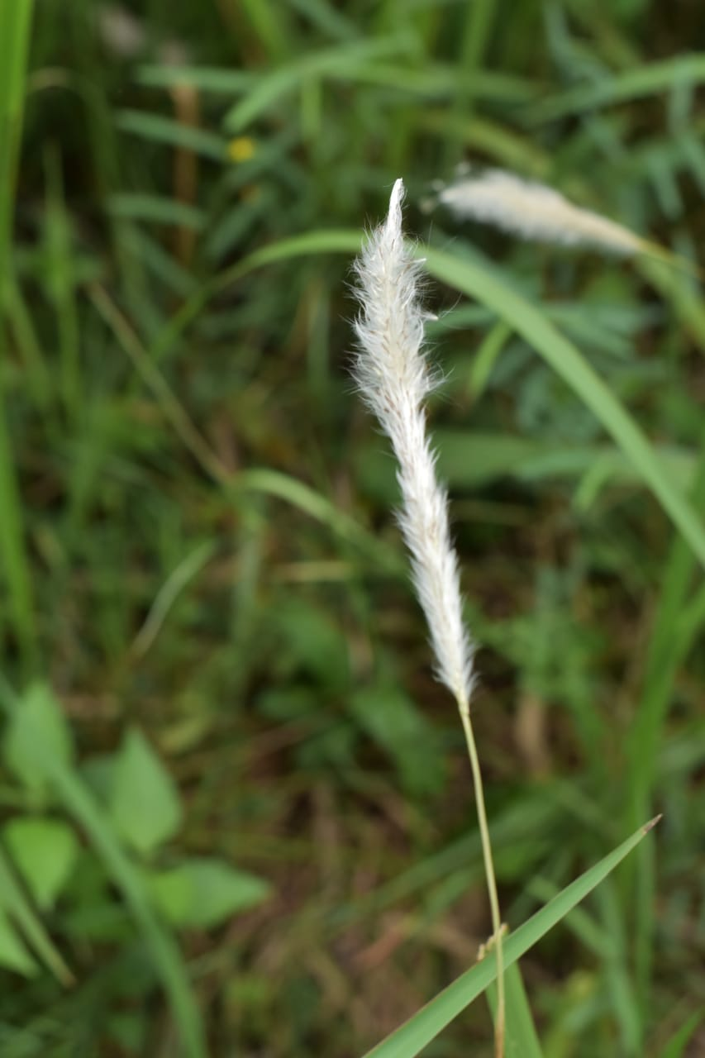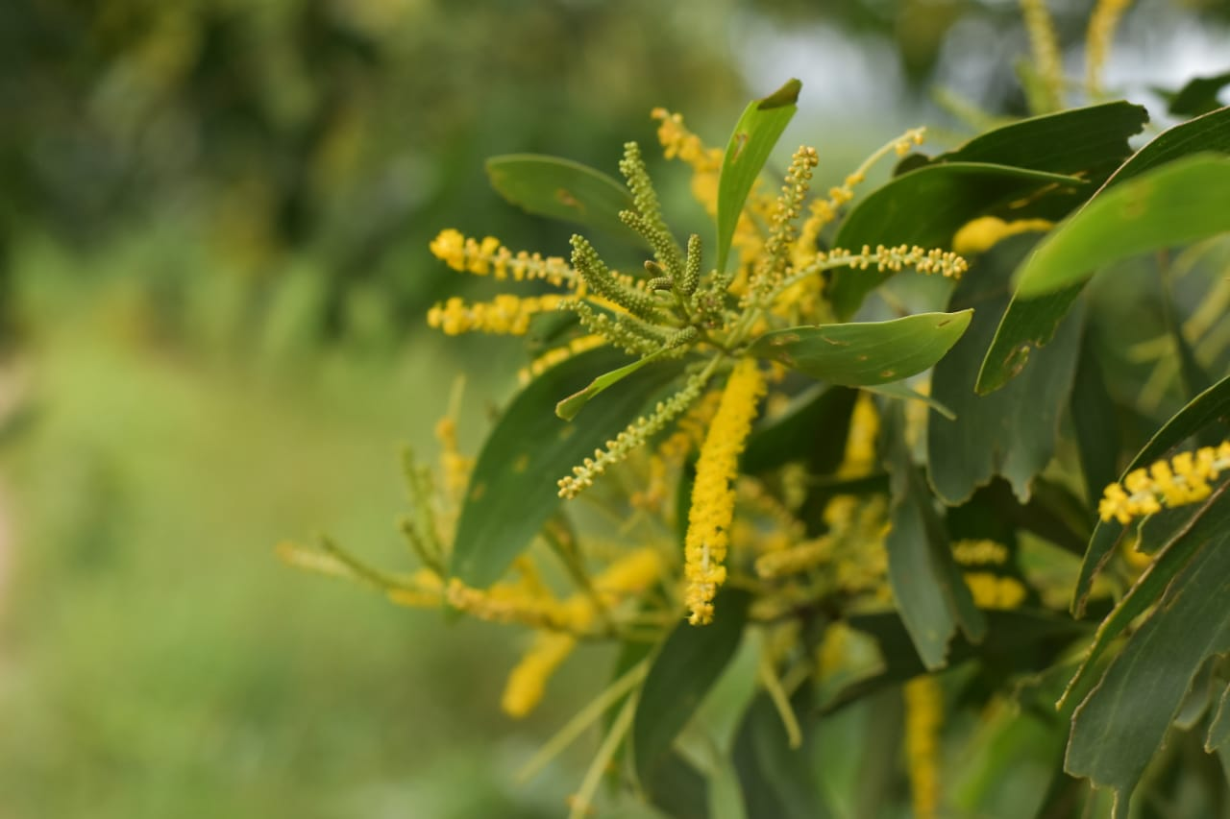
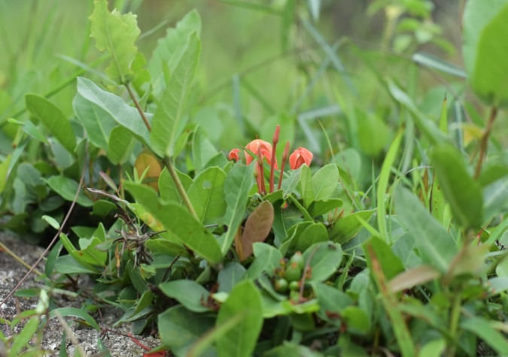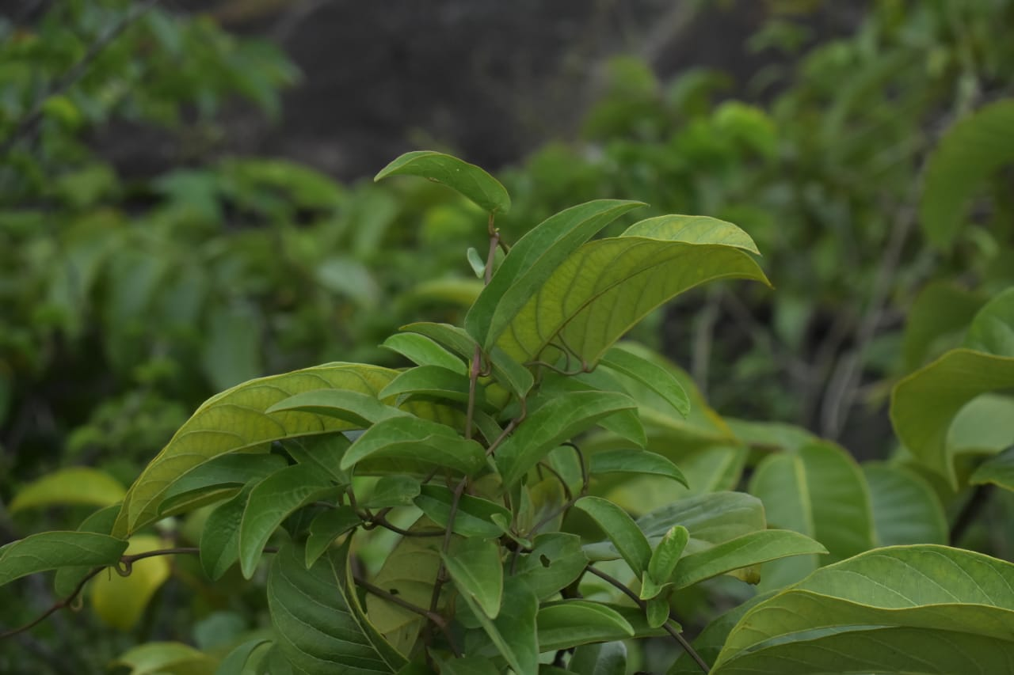
Plate 4.1. Selected plant species of Maruthi Mala Hills
  - Floral Composition
The plant species were found in association with ferns, grasses and herbaceous weeds of different angiosperm families in the studied site. 46 species were found in Maruthi Mala Hills. These 46 species are distributed over 45 genera and 21 families. The observations are depicted in table 4.2.1 with their morphological appearance.
Table 4.2.1: Plants with their Families and Habit
Sl No. | Botanical Name | Family | Habit
1 | Sesbania spp. (Scop. ) | Fabaceae | Tree
2 | Melastoma malabathricum (Linn) | Melastomataceae | Shrub
3 | Crotalaria retusa(Linn) | Fabaceae | Shrubby herb
4 | Bambusa bambos (Voss ,Linn) | Poaceae | Culms
5 | Alfalfa(Linn) | Fabaceae | Herb
6 | Leucas aspera (Willd) | Lamiaceae | Herb
7 | Calycopteris floribunda (Roxb., Lam.,Poir.) | Combretaceae | Climbing shrub
8 | Wrightia religiosa(Teijsm, Binn., Hook. f.) | Apocynaceae | Shrub
9 | Tephrosia purpurea(Pers.) | Fabaceae | Shrub
10 | Ziziphus jujuba(Mill. ) | Rhamnaceae | Shrub
11 | Adiantum aureum(Linn) | Pteridaceae | Fern
12 | Desmodium paniculatum (Linn,DC.) | Fabaceae | Climber
13 | Eulobus californicus(Nutt.,Torr.,A.Gray) | Ongraceae | Herb
14 | Phyllanthus emblica(Linn) | Phyllanthaceae | Tree
15 | Eupatorium odoratum(Linn,R.M. king,H.Rob) | Asteraceae | Shrub
16 | Mimosa pudica(Linn) | Fabaceae | Herb
17 | Cassia fistula(Linn) | Fabaceae | Tree
18 | Morinda tinctoria(Roxb.) | Rubiaceae | Tree
19 | Ixora coccinea(Linn) | Rubiaceae | Shrub
20 | Diospyros ebenum (J.Koenig) | Ebenaceae | Tree
21 | Terminalia catappa(Linn) | Combretaceae | Tree
22 | Ficus religious(Linn) | Moraceae | Tree
23 | Canthium spinosum (OK) | Rubiaceae | Shrub
24 | Acacia auriculiformis(A.Cunn. ex Benth) | Fabaceae | Tree
25 | Adananthera pavonina(Linn) | Fabaceae | Tree
26 | Millettina pinnata(Panigrahi) | Fabaceae | Tree
27 | Hemidesmus indicum(R.Br.) | Apocynaceae | Shrub
28 | Senna occidentalis(Link.) | Fabaceae | herb
29 | Naregamia alata(Wight&Arm) | Meliaceae | Shrub
30 | Sonneratia alba(Sm.) | Lythraceae | Tree
31 | Ichnocarpus frutescens (W. T.Aiton) | Apocynaceae | Shrub
32 | Premna odorata(Blanco) | Lamiaceae | Shrub
33 | Ficus bengalensis(Linn) | Moraceae | Tree
34 | Psidium guajava(Linn) | Myrtaceae | Tree
35 | Canthium coromandelicum(Linn) | Rubiaceae | Shrub
36 | Gmelina arborea (Roxb.) | Lamiaceae | Tree
37 | Pedalium murex, L.(Linn) | Pedaliaceae | Herb
38 | Cassia mimosoides(Hemsl.) | Fabaceae | Shrub
39 | Memecylon umbellatum (Burm.) | Melastomataceae | Shrub
40 | Ceratotheca sesamoides (Endl.) | Pedaliaceae | Herb
41 | Tuenera ulmifolia(Linn) | Passifloraceae | Shrub
42 | Rhynchosia minima(Linn, DC.) | Fabaceae | Herb
43 | Holarrhena pubescens (Wall., G. Don) | Apocynaceae | Tree
44 | Bignonia peltata, B.Otto & A.Dietr. (Govaerts) | Bignoniaceae | Tree
45 | Bridelia micrantha(Hochst.,Baill) | Phyllanthaceae | Tree
46 | Phyllodium pulchellum(Linn,Desv.) | Fabaceae | Shrub

  - Phytosociological Studies
The Phytosociological Studies were carried out at Maruthi Mala Hills. Vegetation consists of 45 genera and 46 species belonging to 21 families. List of families along with the number of genera and species found are depicted in table 4.3.1. The data of the most common species at the studied site with their percentage frequency, density, abundance, relative frequency, relative density, relative abundance and IVI value of the species are given in table 4.3.2.
Table 4.3.1: List of families along with the number of genera and species
Sl No. | Name of Family | No. of Genera | No. of Species
1 | Fabaceae | 13 | 14
2 | Rubiaceae | 4 | 4
3 | Lamiaceae | 3 | 3
4 | Poaceae | 1 | 1
5 | Melastomaceae | 2 | 2
7 | Combretaceae | 2 | 2
8 | Apocynaceae | 4 | 4
9 | Rhamnaceae | 1 | 1
10 | Pteridaceae | 1 | 1
11 | Onagraceae | 1 | 1
12 | Phyllanthaceae | 2 | 2
13 | Asteraceae | 1 | 1
14 | Ebenaceae | 1 | 1
15 | Moraceae | 2 | 2
16 | Meliaceae | 1 | 1
17 | Lythraceae | 1 | 1
18 | Myrtaceae | 1 | 1
19 | Pedaliaceae | 2 | 2
20 | Passifloraceae | 1 | 1
21 | Bignoniaceae | 1 | 1

Table 4.3.2: List of most common species of plants at Maruthi Mala Hills
Sl. No. | Plant species | F/RF | A/RA | D/RD | IVI
1 | Sesbania spp. (Scop. ) | 75/6.3 | 4.8/32 | 3.6/0.73 | 69.4
2 | Melastoma malabathricum (Linn) | 87.5/3.69 | 2.4/18 | 2.1/0.47 | 40.5
3 | Crotalaria retusa(Linn) | 75/5.21 | 4/26 | 3/0.64 | 57.3
4 | Bambusa bambos(Voss ,Linn) | 75/5.21 | 4/26 | 3/20.64 | 57.3
5 | Alfalfa(Linn) | 62.5/2.6 | 2.4/13 | 1.5/0.33 | 28.6
6 | Leucas aspera(Willd) | 93/9.13 | 5.25/46 | 5.25/1.06 | 10.5
7 | Calycopteris floribunda (Roxb., Lam.,Poir.) | 62.5/2.6 | 2.4/13 | 1.5/0.33 | 28.6
8 | Wrightia religiosa(Teijsm, Binn., Hook. f.) | 50/3.69 | 4.25/18 | 2.1/0.46 | 40.5
9 | Tephrosia purpurea(Pers.) | 75/2.17 | 1.6/11 | 1.25/0.27 | 23.9
10 | Ziziphus jujuba(Mill. ) | 75/3.04 | 2.3/15 | 1.75/0.42 | 33.4
11 | Adiantum aureum(Linn) | 75/5.06 | 3.8/25 | 2.8/0.6 | 55
12 | Desmodium paniculatum (Linn,DC.) | 62.5/3.04 | 2.8/15 | 1.75/0.42 | 33.4
13 | Eulobus californicus(Nutt.,Torr.,A.Gray) | 78/5.28 | 3.4/26 | 3/0.64 | 57.3
14 | Phyllanthus emblica(Linn) | 97/11.9 | 8.1/60.9 | 6.8/1.42 | 31.68
15 | Eupatorium odoratum(Linn,R.M. king,H.Rob) | 87.5/5.25 | 5/38 | 4.3/1.02 | 83.68
16 | Mimosa pudica(Linn) | 86/10.2 | 6.7/52 | 5.8/1.19 | 22.5
17 | Cassia fistula(Linn) | 62.5/3.69 | 3.4/18 | 2.1/0.45 | 40.5
18 | Morinda tinctoria(Roxb.) | 62.5/3.69 | 3.4/18 | 2.1/0.45 | 40.5
19 | Ixora coccinea(Linn) | 62.5/3.69 | 3.4/18 | 2.1/0.45 | 40.5
20 | Diospyros ebenum (J.Koenig) | 62.5/2.82 | 2.6/14 | 1.6/0.34 | 31.6
21 | Terminalia catappa(Linn) | 75/4.34 | 3.3/22 | 2.5/1.37 | 37.8
22 | Ficus religious(Linn) | 50/1.52 | 1.75/17 | 9.6/2.07 | 16.74
23 | Canthium spinosum (OK) | 62.5/3.91 | 3.6/19 | 2.25/0.48 | 42.9
24 | Acacia auriculiformis(A.Cunn. ex Benth) | 62.5/2.39 | 2.2/12 | 1.37/0.22 | 26.3
25 | Adananthera pavonina(Linn) | 75/3.69 | 2.8/18 | 2.1/0.45 | 40.5
26 | Millettina pinnata(Panigrahi) | 50/2.39 | 2.75/12 | 1.37/0.29 | 26.3
27 | Hemidesmus indicum(R.Br.) | 62.5/2.39 | 2.2/12 | 1.37/0.29 | 26.3
28 | Senna occidentalis(Link.) | 75/2.39 | 1.8/12 | 1.37/0.29 | 26.3
29 | Naregamia alata(Wight&Arm) | 75/3.91 | 3/19 | 2.25/0.27 | 42.9
30 | Sonneratia alba(Sm.) | 62.5/3.69 | 3.4/18 | 2.12/0.48 | 40.5
31 | Ichnocarpus frutescens (W. T.Aiton) | 87.5/4.33 | 2.8/22 | 2.5/0.52 | 47.91
32 | Premna odorata(Blanco) | 100/3.47 | 7.6/67 | 7.6/1.63 | 48.1
33 | Ficus bengalensis(Linn) | 62.5/2.82 | 2.6/14 | 1.62/0.34 | 31
34 | Psidium guajava(Linn) | 75/2.61 | 2/13 | 1.5/0.29 | 28.68
35 | Canthium coromandelicum(Linn) | 62.5/2.82 | 2.8/15 | 1.75/0.38 | 31.2
36 | Gmelina arborea (Roxb.) | 62.5/3.26 | 3/16.6 | 1.87/0.4 | 35.92
37 | Pedalium murex, L.(Linn) | 62.5/3.47 | 5.3/17.7 | 2/3.4 | 38.24
38 | Cassia mimosoides(Hemsl.) | 75/3.91 | 3/19.9 | 2.25/2.19 | 43.08
39 | Memecylon umbellatum (Burm.) | 37.5/1.73 | 2.6/18.8 | 1/0.88 | 19.06
40 | Ceratotheca sesamoides (Endl.) | 75/3.47 | 2.6/17.7 | 2/0.4 | 38.24
41 | Tuenera ulmifolia(Linn) | 62.5/2.61 | 2.4/13.3 | 1.5/0.37 | 28.74
42 | Rhynchosia minima(Linn, DC.) | 62.5/2.82 | 2.6/14.4 | 1.62/0.44 | 31.08
43 | Holarrhena pubescens (Wall., G. Don) | 62.5/2.39 | 2.2/12.1 | 1.37/0.37 | 26.32
44 | Bignonia peltata, B.Otto & A.Dietr. (Govaerts) | 75/4.13 | 3.1/21 | 2.37/0.16 | 45.5
45 | Bridelia micrantha(Hochst.,Baill) | 75/6.52 | 4.6/33.2 | 3.75/0.66 | 71.84
46 | Phyllodium pulchellum(Linn,Desv.) | 75/4.24 | 3.3/22.1 | 2.5/0.48 | 47.82
(A-abundance, F-Frequency, D-Density, RA-Relative Abundance, RF-Relative Frequency, RD-Relative Density, IVI-Important Value Index)
Most number of plants observed in Fabaceae family with 14 species, followed by Apocyanaceae and Rubiaceae with for 4 species each. Other than this there is Lamiacae which is seen to have 3 species. Plants from Melastomataceae, Phyllanthaceae, Combretaceae, Pedaliaceae and Moraceae families is seen to have 2 species each in the given habitat. Poaceae, Bignoniaceae, Rhamnaceae, Passifloraceae, Pteridaceae, Ongracaeae, Asteraceae, Myrthaceae, Ebenaceae, Meliaceae, Lyranthraceae was found to be in an abundance of one each.
From the collected samples, the frequency was highest in Premna odorata (100), Phyllanthus emblica (97) and lowest in Adiantum aureum (75), Ziziphus jujuba (75). The relative frequency was observed the most in Phyllanthus embilca (11.9), Leucas aspera (10.2) and lowest in Terminalia catappa (4.39), Eupatorium odoratum (5.25).
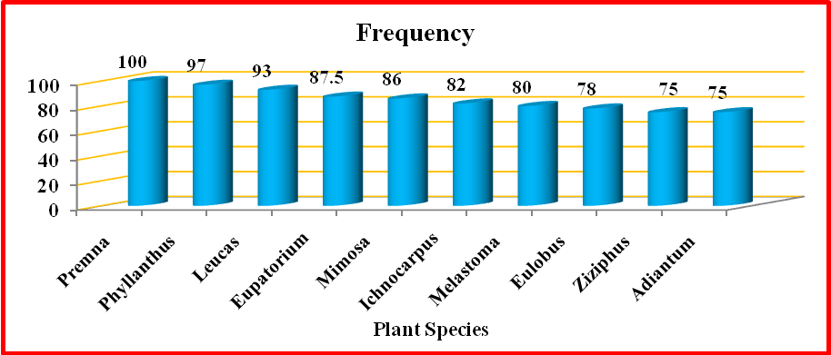
Fig. 4.3.1: Frequency of Selected plant species
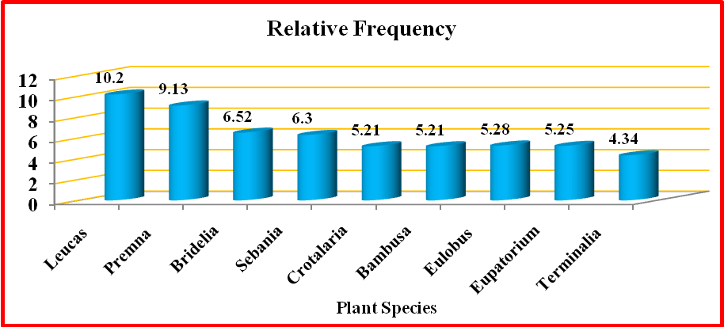
Fig. 4.3.2: Relative Frequency of Selected plant species
Abundance was maximum in Phyllanthus emblica (8.1), Premna odorata (7.6) and minimum in Bambusa bambos (4), Crotalaria retusa (4). Relative abundance of the isolates was most observed in Phyllanthus emblica (60.9), Premna odortata (67) and lowest observed in Adianthum aureum (25), Bambusa bambos (26).
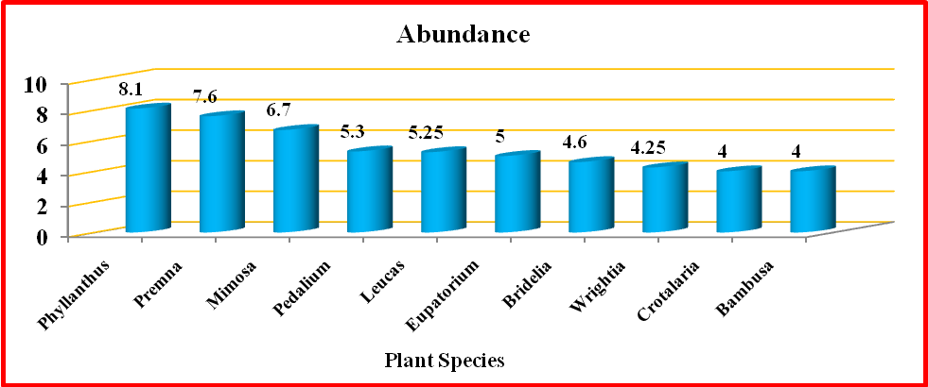
Fig. 4.3.3 : Abundance of Selected plant species
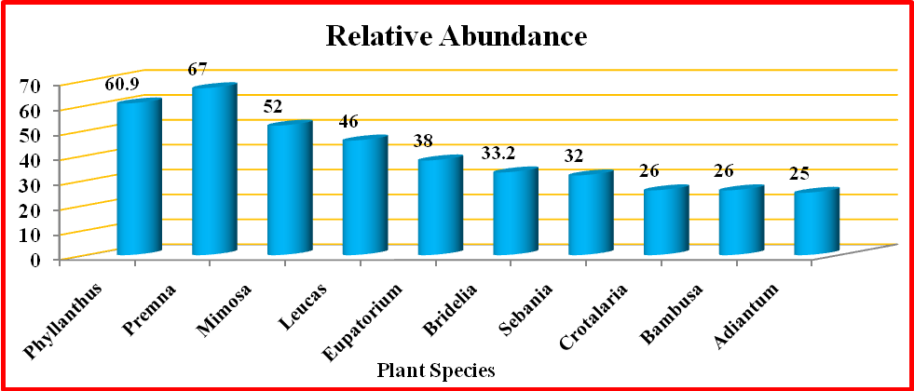
Fig. 4.3.4 : Relative Abundance of Selected plant species
Ficus religiousa (9.6), Premna odorata (7.6) is the most densely seen species in Maruthi Mala Hills. Likewise, Bambusa bambos (3) and Crotalaria retusa (3) with lowest density. Pedalium murex (3.4), Cassia fistula (2.19) have the highest relative density and Bridelia micrantha (0.66) and Eupatorium odortam (1.02) has the lowest relative density.
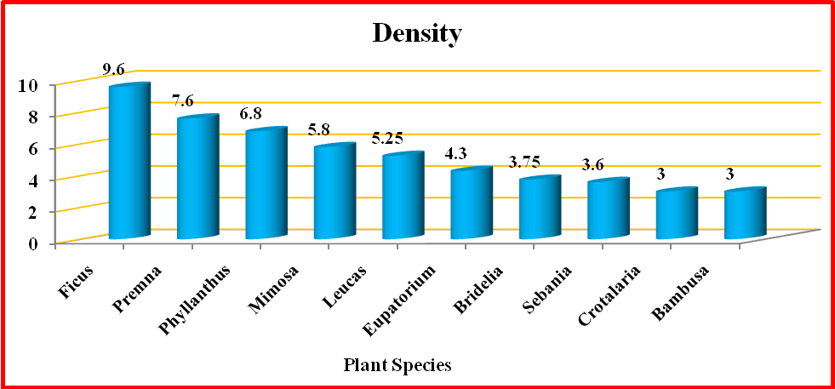
Fig. 4.3.5 : Density of Selected plant species
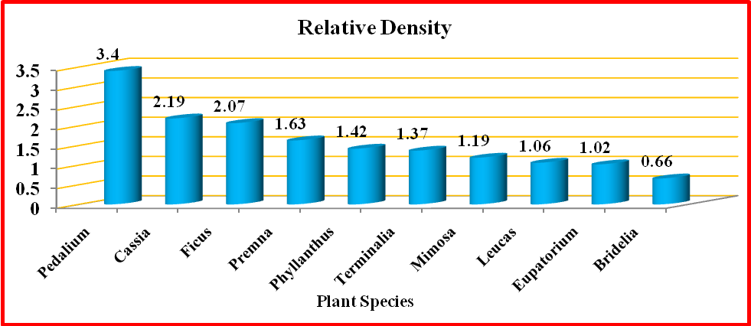
Fig. 4.3.6: Relative Density of Selected plant species
Eupatorium odoratum (83.68) and Bridelia micrantha (71.84) has the most abundant IVI value while Cassia mimosoides (43.08) and Bignonia peltata (45.5) has the lowest IVI value
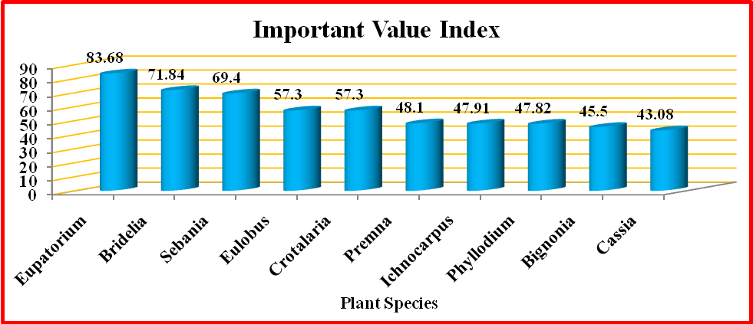
Fig. 4.3.7: Important Value Index of Selected plant species
Diversity indices of plants in the studied site showed that the highest Shannon Weiner index (3.36), Simpson's index (27.73), Margalef's (4.93) and Pielon's (1.46) Indices Diversity indices are shown in Figure 4.2.9.
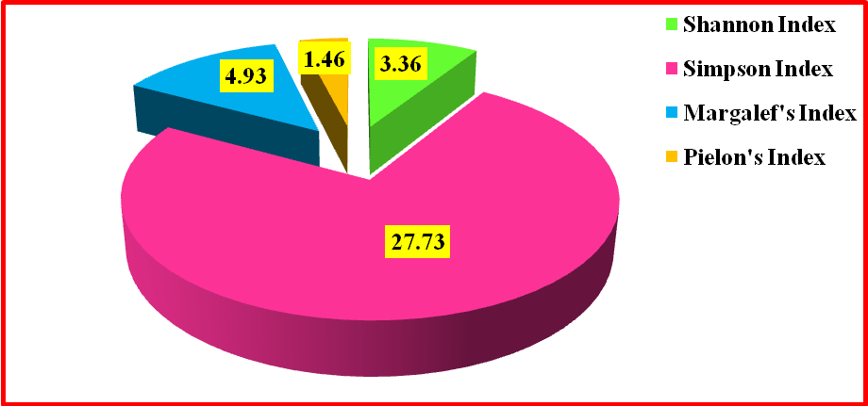
Fig. 4.3.8 : Diversity Indices of Selected plant species

Discussion
Flora of a region is considered as an essential part of the environment that determines the wealth of ecosystem and human health. It is highly recommended that, proper utilization of plant resources of a country, state, district, small areas like taluks and villages, has been helpful to maintain the availability and richness of the flora. The floral diversity is an important activity to assess the existing flora. Urbanisation affects the natural flora and fauna that imposes to document the existing biodiversity that enable to conserve them from the extinction. Urbanization, habitat fragmentation, anthropological pressures, and pollution are the profound reasons for the destruction of the natural vegetation in the rural and aboriginal areas which is considered as an important component of the healthy environment.
Floristic survey of Udumal pet Taluk of Tiruppur District, Tamil Nadu was done by different researchers to document the flora existing in the different habitats in the rural areas. The different species present in this region are Selaginella wightii Hieron., Marsilea quadrifolia L., Azolla sp., Marchantia sp., Funararia sp. and a few fungus were documented. The habit of the species recorded from the study area is broadly classified under four categories viz., herbs, shrubs, climbers and trees. This region is the main source of electricity generated through wind mills and wind turbines. The occurrence of wind mills, affect the natural vegetation as well as cultivated fields (Radha et al., 2020). Flora is a compiled checklist of plant species developing in any geographic region. The geological and Ecological varieties zone of the world support various types of floristic composition. The natural forest lost which clearly demonstrates a decrease in the quantity of species and hereditary decent variety of population.
Another study about the Floristic diversity and ecological characteristics of flora of Kharawo Talash, Dir lower, Khyber Pakhtunkhwa, Pakistan recorded a total of 165 medicinal plants mostly wild plants belonging to 129 genera and 79 families. This area is rich in floral diversity and very important medicinal plants are growing, but due to forest cutting, over exploitation, lake of awareness there is a great loss of important medicinal resources. One of the main reason of extinction of plants is the too much uprooting of medicinally valuable plant species by unqualified and inexperienced local people. Soil erosion, loss of habitat and in proper functioning of ecosystem is also due to extinction of important wild medicinal plant species (Hazrat et al., 2020). Globally, tropical forests harbour two thirds of terrestrial species, while covering only approximately 5% of the global surface.
Biodiversity hotspots are characterized by a high number of endemic species, high species richness, and increased habitat loss. Causes of deforestation are the expansion of agricultural land-use, logging, and mining activities at high rates for the last three decades. The different consequences of population fragmentation for species are caused by different life history traits such as, gene flow, dispersal strategy, mating system, degree of isolation, and tree density of populations. Using Amplified Fragment Length Polymorphism marker, the genetic diversity of 112 dominant plant species was assessed in four different land-use systems in Sumatra: old growth tropical lowland rainforest, jungle rubber, rubber plantation, and oil palm plantation.
In general, the tree dominating systems of forest and jungle rubber showed higher diversity levels of the two groups. Results at a-level (within plot) indicate highest values for jungle rubber, lowest for oil palm plantation. The b-level (within land-use system) showed the highest genetic differentiation for jungle rubber and the lowest for forest. At c- level (within region), the differentiation among all fragment pools was lower than that of the a- and b-levels. The a-level genetic diversity calculations based on the Shannon Index were moderate and differ little among all four land-use systems. For the forest, 38% (13 species of 34) of the tree species were dominant in more than one plot, in jungle rubber 24% (8 species of 33), and in the two plantation systems it is 45% (19 species of 42). The influence of each index is intensified by the unique number of AFLP loci, abundance, and particular genetic differentiation of each species. Shannon Index values were calculated for each species separately and only changed for the species occurring in more than one plot/land-use system/region, which increased the variance within each land-use system with increasing spatial scale. In this project, several species with a high variation in fragment number were compared, which can lead to a bias using the Shannon Information Index. It is important to conserve natural ecosystem which depends on human intervention and management. Genetic diversity of plants is not only important for the survival of the plant species itself, but also influences other levels of organization and dynamics within the ecosystem (Breidenbach et al.,2018).
Saikat Mondal et al. (2019) studied to produce an account of the inventory of plant species, phytosociology characteristics and determination of species diversity of vegetation of Gunjan Ecological Park pit lake, West Bengal, India. The study site deserves special mention for its floristic composition. Since, the presence of all life forms of plants is one of the characteristic features of forest and may form the bulk of the forest flora and have immense functional values. The community was composed of as many as 100 species of 90 genera from 41 families of which 16 species are trees, 58 are herbs, 11 are shrubs and 15 climber species were recorded. The study also reflects about the aquatic flora, composed of 13 families, 13 genus and 14 species. A total of 5 randomly selected sites have been taken for vegetation analysis. At each site 10 quadrats (1x1 m) were laid. Individuals of shrubs, herbs, climbers and tree seedlings were enumerated within each quadrat. The distribution pattern of the species was studied following Whit ford’s index and diversity parameters were determined using the Shannon-Weaver information function.
Taxonomic survey of the embankment flora reflects the dominance of dicotyledonous plants, whereas aquatic flora shows equal proportion of monocotyledonous and dicotyledonous plants. Present study reflected mean density is highest in trees whereas shrubs species shows lowest value. In terms of importance value Senna siamea (IVI: 41.91) was the dominant tree species whereas Borassus flabellifer (IVI: 6.14) was the least dominant tree species. Shannon diversity index value of tree, herbs, shrubs and climbers species are 2.537, 3.724, 1.992 and 2.149 respectively. Mean species richness value of tree, herb, shrub and climbers are 3.364, 3.247, 2.513 and 2.977 respectively, whereas, the mean evenness index of tree, herb, shrub and climbers are0.045, 0.018, 0.067 and 0.048 respectively. Correlation studies between different phytosociological parameters of tree species shows that density is positively correlated with frequency and IVI in case of tree, herbs, shrubs and climber species. The correlation between frequency and IVI also shows positive relation in tree, herb, shrub and climbers species. The distribution patterns of the species are influenced by the different physico-chemical parameters of water and soil.
Harikesh, et al. (2020) assessed floristic diversity and vegetation structure in three different community forests of southwest Haryana which is a part of tropical dry deciduous forests. A total of 76 plant species belonging to 37 families in the form of 11 trees, 13 species of shrubs, 46 species of herbs, and 6 species of climbers are documented from all three sites. Poaceae was the most specious family in three sites. . The highest tree diversity was recorded in Bhera forest followed by Daya and Dhanger. Regarding understory, the forest of Daya has a greater diversity than Bhera and Dhanger forests. Phytosociological studies are crucial for understanding the studies of any ecosystem. It also helps in understanding species interactions, ecosystem processes as well as services and change exerted various natural and anthropogenic disturbances. In an ecosystem, plant species assemble in a particular manner which helps in vegetation mapping or quantification and evaluation. In the present study, it was found that the community forest of Daya site, Hisar is rich in plant diversity as revealed by its vegetation analysis in comparison to the other two sites i.e., Dhanger site and Bherasite. The number of species was greater in the community forests of Daya, Hisar . A total of 7 tree species were recorded in the community forest at Daya, which was dominated by Salvadora oleoides (IVI-71.47), the community forest at Bhera was dominated by Ailanthus excelsa (IVI 87.69) and the community forest at Dhanger was dominated by Salvadora oleoides (IVI 117.57).
It was found that density showed a positive correlation with the A/F ratio, Simpson index (Cd) and Margalef index (d) while it was found to be negatively correlated with the basal area (BA), Shannon Weiner index (H’) and Pielou index(E).y. The high-value of B.A. in Daya site is due to the high density of Capparis decidua which was absent in the other two sites. The Shannon-Weiner (H’) index of trees for all three sites varies from 1.23 to 1.902 which falls in the range of 0.67 to 4.05 reported in tropical forests of the Indian subcontinent. On the other hand, the concentration of dominance (Simpson’s index) in the present study is out of the reported range of 0.08-0.27 in other forests. In the present study, Cd for tree species varies from 0.156 to 0.323 for all three sites. However, Cd for herbs was found to be much lower while higher for shrubs and climbers, as compared to tree species in all three sites. This indicates the dominance of species in shrubs and climbers while diversity among trees and herbs. With these values of diversity indices, it shows how the sites have lost tree species under the influence of man-made and ecological factors.
Due to the extinction of plant and animal species, climate change, air pollution, advances in technology and industry, development of agricultural and urban lands, and changing human attitudes toward species, ecosystems, and landscapes, biodiversity has become a more attractive topic for researchers over the last decade. Humans are changing the landscape so dramatically that a million species of plants and animals are now at risk of extinction. One clear example is the priority society places on maximizing economic profits without considering the environmental consequences for future generations. Continuous assessments of biodiversity at different scales and prediction of its status provide the basis for various management measures such as conservation of natural areas. Considering that the purpose of presenting different indices is to cover the weak points or correct the older diversity indices, so with proper classification of indices and awareness of their strengths and weaknesses, to a large extent, we can be successful in selecting, using, and analyzing the results of these indices. However, their use can justify the reduction of factors, such as land-use change and climate change. Conservation management must be developed around the world to address the threats to biodiversity caused by habitat degradation, habitat disruption, and overexploitation. These measures certainly require strong regional, national, and international laws and regulations (Mehdi Heydari, 2020).
The central thesis of plant ecology is that climate determines the global distribution of vegetation. Within a vegetation type, edaphic variation control, patterns of plant diversity and distributions. Quantification of the relationship between edaphic variation and plant diversity is necessary for predicting responses to future environmental change. Edaphic variation provides an ideal platform for studying the relative importance of assembly mechanisms that drive diversity patterns and represents an untapped resource for parsing out the impact of multiple interacting factors (Catherine M. Hulshof, 2020).
The results provide valuable insights into the plant diversity and structural dynamics of Maruthi Mala Hills in Kollam District, Kerala. The data showcases the abundance and distribution of various plant species along with their Importance Value Index (IVI), which is a key metric for assessing the ecological significance of each species within the ecosystem.
Sesbania spp. (Scop.): Sesbania species emerge as a dominant plant with a relatively high Importance Value Index (IVI) of 69.4. This indicates their significant contribution to the overall ecological structure of Maruthi Mala Hills. Their high frequency (F/RF) and relative abundance (A/RA) reinforce their importance in the ecosystem.
Melastoma malabathricum (Linn): Melastoma species demonstrate a considerable IVI of 40.5, indicating their substantial presence in the area. While their frequency and relative frequency are relatively high, their dominance (D/RD) value suggests that they are not as dominant as Sesbania species.
Eupatorium odoratum (Linn, R.M. king, H. Rob): Eupatorium odoratum exhibits a remarkably high IVI of 83.68, making it one of the most ecologically significant species in Maruthi Mala Hills. Its high dominance (D/RD) value suggests that it plays a critical role in shaping the vegetation structure.
Bridelia micrantha (Hochst., Baill): Bridelia micrantha also emerges as a significant species with a high IVI of 71.84. Its dominance in the area, reflected in the dominance value, further underscores its ecological importance.
Premna odorata (Blanco): Premna odorata shows a substantial IVI of 48.1, indicating its noteworthy contribution to the plant diversity and structural dynamics of the hills.
Overall, the study reveals a diverse range of plant species in Maruthi Mala Hills, with certain species displaying higher ecological importance and dominance. These results are crucial for understanding the overall health and resilience of the ecosystem. The reference to the data source or publication provided with the table allows readers to access more detailed information and validation of the results presented.
The findings of this study can serve as a valuable baseline for conservation efforts, guiding the implementation of sustainable management practices and ensuring the preservation of the rich plant diversity and structural dynamics in Maruthi Mala Hills for future generations.

Summary and Conclusion
The present study “Plant Diversity and Structural Dynamics of Maruthi Mala Hills, Kollam District, Kerala, India“ was carried out to analyse the current status of floral diversity at Maruthi Mala hills. Flora of a region is considered as an essential part of the environment that determines the wealth of ecosystem and human. Floral diversity has an important activity to assess the existing flora. Among the plant samples collected from Maruthi Mala Hills, there are erect, spreading plant, ferns, shrubs, herbs, trees etc. In the quadrats study, the most number of plants observed were in Fabaceae with 14 species. The topography of the area is hilly terrain. The investigation showed that the plant species of this area were highly threatened by the population pressure and urbanisation.
The phytosociological studies revealed that Phyllanthus emblica, L. was the dominating species and also has maximum abundance at Muttara hills. Phytosociological characters like abundance, frequency and density were highly influenced by the biotic stress at the study site. The quantitative characters and their relative values had a pivotal role as indicators of anthropogenic disturbances, so this study helps to identify the repercussions of human activities to native plant species of Maruthi Mala hills. The analysis about the various species of plants in the area gave us a wide range of idea about the critical resources to be conserved in the near future. It is possible not only by the positive interaction of people but also the government need to take steps to supervise Maruthi Mala Hills and should transform it into an ecologically important Eco-Tourism Spot.

References
1.Abbas Hussain Shah,Ghulam Mujtaba Shah, Khalid Rasheed Khan, Khanda Amber, Manzoor Hussain, Mujtaba Shah.2019.A Comprehensive Survey of Floristic Diversity Evaluating The Role of Institutional Gardening In Conservation of plant. International Journal of Bioscience,14 (3).325-339
2. Abeysinghe P.D., 2020. Antibacterial Activity of some Medicinal Mangroves against Antibiotic Resistant Pathogenic Bacteria. Indian Journal of Pharmaceutical Sciences. 72 (2):149-282.
3. Abohassan, R.A., Okia, C.A., Agea, J.G., Kimondo, J.M., McDonald, and M.M., 2020. Perennial biomass production in arid mangrove systems on the Red Sea coast of Saudi Arabia. Environ. Res. J. 6 (1), 22—31
4. Alongi, D.M., 2021. Mangrove forests: resilience, protection from tsunamis, and responses to global climate change. Estuarine, Coastal and Shelf Science. 76: 1–13.
5. Ana Cano Ortiz etal2020.Phytosociological study, diversity and conservation status of the cloud forest in the Dominian republic plants 9,741.1-30
6. Ana Claudia Araiyo, Neil Brummit, Timothy Harris.2020. Areas of plant diversity-What do we know Plants, People, Planet,3(1).33-34
7. Anushka shah.2020. Modern Technology For Sustainable Forest Management in India.382.
8. Anwar, M., Akhtar, N., & Khalid, S. 2020. 63. Phytosociological study of weeds of wheat crop under edaphic variation: A case study from district Swabi, Khyber Pakhtunkhwa, Pakistan. Pure and Applied Biology (PAB), 9(1), 640-649.
9. Arun Christy and Binu Thomas. 2020. Phytodiversity of chasmophytic habitats at Olichuchattam Waterfalls, Kerala, India. Journal of Threatened Taxa, 12(9).16099- 16109
10. A.Vel Murugan. 2019. Coastal Floral Diversity and its significance. Coastal Ecosystem of the Tropics – Adaptive Management. 73-89
11. Batles, J.J., A.J. Shlinsky, R.H. Barret, R.C. Heald and B.H. Allen-Diaz. 2018. The effects of forest management on plant species diversity in a Sierran conifer forest. Forest Ecology and Management 146. 211–222
12. Bin Yang etal .2020.Contributions to the flora of Myanmar from 2000 – 2019.plant diversity 42.292-301
13. Biodiversity hotspots . 2021. ENVIS Centre, Ministry of Environmental and Forest, Govt. of India
14. Breidenbach et al. 2018. Genetic Diversity of Dominant PlantSpecies in Tropical Land-Use SystemsIn Sumatra, Indonesia .Tropical Conservation Science,11.1–14
15. Catherine M. Hulshof et al. 2020. The edaphic control of plant diversity. Global Ecol. Bio. Geogr. 00:1–17
16. Chandran, M. V., Gopakumar, S. and Mathews, A. 2020. Comparative phytosociological assessment of three terrestrial ecosystems of Wayanad Wildlife Sanctuary, Kerala, India. Journal of Threatened Taxa, 12(5).15631-15645.
17. Curtis J.T and Mclntosh R.P. 2020. The interrelations of certain analytic and synthetic phytosociological characters. Ecology, 31(3).435-455.
18. Das, D., B.K. Pramanik and S.K. Mollay.2020. A Model Classical Ecological report on Vegetaton dynamics in Gorumara Natonal Park in West Bengal, India. International Journal Pharmacy & Biomedical Research, 2(2).1–14.
19. Debnath Palit, Saikat Mondal.2019.Inventory of Plant Species, Phytosociology and Species Diversity of Gunjan Ecological Park Pit Lake, West Bengal, India. International Journal Of Scientific Research,8(2).1990-2006
20. Dr. Sincy Joseph. 2021.Ethnobotanical Survey of Medicinal Plants in Urdhook hills, Kuttiady, Kozhikode District, Kerala. IJCRT. 9.2320-2882
21. Gamble J.S. 1936. Flora of the presidency of Madras, Adland and Son Ltd. 1-3
22.Guillaume Papuga ORCID Icon. 2019.Variation in floral morphology in a hybrid complex of Cyclamen in Sardinia.51-61
23. Hamzaoglu, E. 2019. Phytosociological studies on the steppe communities of East Anatolia. Ekoloji 15(61): 29–55.
24. Hamzaoglu E. 2018. The steppe vegetation of Dinek Mountain (kirikkale) Gazi University Journal of Science.17.1-13.
25. Harikesh et al. 2020. Floristic diversity and vegetation Analysis of the community forests of South-West Haryana, India.Current Botany, 11. 51-59
26. Harikesh, Himanshi, Somveer Jakhar. 2020. Floristic diversity and vegatation analysis of the community forests of south-west Haryana, India. Research article, 11.51-59
27. Hazrat et al.2020; Floristic diversity and ecological characteristics of Flora of Kharawo Talash, Dir lower, Khyber Pakhtunkhwa, Pakistan. BIOSCIENCE RESEARCH, 17(2).681-687
28. Hogarth, P.J., 2019. The Biology of Mangroves and Sea grasses. – University press Inc. Oxford, New York
29. Huma Qureshi, Muhammed GULBAZ Arshad and Yamin Bibi, (2019). Invasive flora of Pakistan: a critical analysis, Interational Journal of Biosciences, 4(1):407-424.
30. Jashanpreet Kaur, Rajni Sharma, Pushp Sharma. 2020.Florastic Composition and distribution pattern of herbaceous plant diversity in fallow lands of the central district of Punjab, India. Journal of Threatened taxa 12, 15864-15880
31. Jeeshna M V.2020. Floristic and Phytosociological Studies of The Sacred Groove, Kayyath Nagam Kavu, Kannur District Kerala, India. Research in Plant Science,8(1).1-6
32. Jihang Huang et al. 2020. Floristic Composition and plant diversity in distribution areas of native species congeneric with Betulahalophila in Xinjiang, Northwest China. Nature Conservation 42.1–17.
33. Jonathan, M.P., Srinivasalu, S., Thangadurai, N., Ayyamperumal T., Armsrtrong- Altrin, J.S., Ram-Mohan, V., 2019. Contamination of Uppanar River and Coastal Waters off Cuddalore, Southeast Coast of India. Environ. Geol. 53, 139–1404.
34. Kamble, V.V. and R.B. Yele. 2020. Floristic Survey of Monocotyledonous Plants from Man Tehsil of Satara District (Maharashtra) India. Journal of Global Biosciences,9(4).7149-7159
35. Krishnamurthy, Prakash YL, Nanda HM, Krishnappa A, Dattaraja HS, and Suresh HS,. 2019. Vegetation structure and floristic composition of a tropical forests in Bhadra Wildlife Sanctuary , Karnataka, India. Tropical Ecology,51(2). 235-246.
36. Kumar A, Bruce G.M, Ajai S. 2019. Tree species diversity and distribution patterns in tropical forests of Garo Hills. Current Science. 91:1370-81
37. Kunev, G., Tzonev, R., Tsiripidis, I., &Pachedjieva, K. 2020. Phytosociological study of submontane genistoid scrub communities from the South eastern Balkans. Acta Botanica Croatica, 79(2).
38. Kunwar, R. M., Fadiman, M., Thapa, S., Acharya, R. P., Cameron, M., and Bussmann, R. W. 2020. Plant use values and phytosociological indicators: implications for conservation in the Kailash Sacred Landscape, Nepal. Ecological Indicators, 108, 105679.
39. Leandro T. A. Vieira et al.2019.A biogeographic and evolutionary analysis of the flora of the North-eastern cerrado, Brazil. Plant ecology and diversity,12.478-488.
40.Manzoor, J., &Jazib, M. J. (2021). Distribution Pattern and Phytosociological study of Trees Associated with Agroforestry in Poonch District of Jammu and Kashmir, India. Journal of Bioresource Management, 8(1), 8.
41. Md. Ashikur Rahman Laskar, Tahidul Islam.2021.Floral diversity of abandoned mansions and the influence of soil properties on these unique vegetation. Research Square 1,1-23
42. Mehdi Heydari, et al. 2020. Biodiversity, a review of the concept, measurements, opportunities and challenges. Journal of Wildlife and Biodiversity. X-X
43. Minchen,Xue-Yong Zhao,Xiao-An Zuo.2019.Comparative Pollen Limitation And Pollinator Activity Of Carragana Korshinskii Kom In Natural And Fragmen Habitats. Science of The Total Environment,654.1056-1063
44. Mukunda Dev Behera, Soumit Kumar Behera, Subrat Sharna.2019.Recent Advances In Biodiversity And Climate Change Studies In India. Biodiversity and Conservation,28.1943-1951
45. Nikhil Agnihotri, Sippy Dassani, T.K Sharma. 2020. Present status and conservation strategies of biodiversity in India. International Research Journal On Advanced Science Hub,2.2582-4376
46. Nisreen Husain, Touseef Hussain Trak, Deepti Chauhan. 2020. Florastic diversity of Jammu and Kashmir, India. International Journal of Advanced Science and Technology, 29,2358-2386.
47. Pankaj Sharma etal.2014.Floristic Diversity and Distribution Pattern of Plant Communities along Altitudinal Gradient in Sangla Valley, Northwest Himalaya.The scientific world journal.2014, 1-11
48.Patel, A. H. (2021). Phytosociological analysis of tree species of Sebhargog region of reserve forest of Vadgam Taluka in North Gujarat, India. Life sciences leaflets, 132, 1-9.
49. Patel, A. S. (2020). 3. Phytosociological study of some weeds in agriculture crop field in Sami Taluka by S D Patel and HM ANT. Life sciences leaflets, 123, 29-TO.

50. Pathiyil Arabhi, Maya Chandrasekharan Nair. 2019. Seasonal vegetation shift and wetland dynamics inVulnerable granitic rocky outcrops of Palghat Gap of Southern Western Ghats, Kerala, India. Journal of Threatened Taxa11(12) :14518–14526
51. Peter Raven, Mathis Wackernagel.2020.Maintaining biodiversity will define our long term success. Plant Diversity,42.211-220
53. Radha, R. Nagaraj, C. Udhayavani, K. Sivaranjani. 2020.A survey on the floral diversity of rural areas in Udumalpet Thaluk, Tiruppur district, Tamilnadu, India. Bangladesh J. Plant Taxon, 27.137-152
54. Pratikshya Kandel. 2019. Plant diversity of the Kangchenjunga Landscape, Eastern Himalayas. Plant Diversity,41.153-165
55. Qing Tang. 2019. Full-Length Reference Floral Transcriptome of Boehmeria tricuspis Provides Insights into Apomeiosis and Polyploidy Genomics. International journal of genomics.1-13
56. Radha .2020. A survey on the floral diversity of rural areas in Udumalpet Taluk, Tirupur District, Tamil Nadu, India. Bangladesh J. Plant Taxon, 27(1): 137‒152
57. Rahees N, Kiran M, and Vishal V. 2019. Phytosociological analysis of mangrove forest at Kadalundi-Vallikkunnu community reserve, Kerala. Inter J Sci Tech Vol. 3:2154–2159
58. Ramya, E. K., and Mownika, S. S. S. 2020. Phytosociological assessment of tree vegetation in tropical moist deciduous forest of veerakkal area, Nilgiris, Western Ghats, India. Indian Journal of Ecology, 47(2), 480-484.
59. Rao, S.D., P.P. Murthy and O.A. Kumar 2020. Plant biodiversity and phytosociological studies on tree species diversity of Khammam District, Telangana State, India. Journal of Pharmaceutcal Sciences and Research 7(8): 518–522.
60. Richard T. Corlett. 2016. Plant Diversity in a Changing World: Status, Trends, and Conservation Needs. Plant Diversity 38.10-16
61. Richard T. Corlett.2020. Safeguarding our future by protecting biodiversity. Plant Diversity 42.221-228
62. Saikat Mondal et al. 2019.Inventory of Plant Species, Phytosociology and Species Diversity ofGunjan Ecological Park Pit Lake, West Bengal, India. IJSRR 2019, 8(2).1990-2006
63. Sanjay Singh Chauhan. 2018. Phytosociological Analysis Of The Flora Of Madhav National Park, Shivpuri [M.P.]. Original Research Paper,School of Studies in Botany, Jiwaji University, Gwalior. (M.P), India 7: 2277 – 8160
64. Sanjeet kumar, Raj kumari, Supriya devi. 2020.Floral diversity of Sambhav, Nayagrah, Odisha, India, Ambika Prasad. Research foundation.
65. Santana, J. P., da Rocha, P. A., da Silva Oliveira, E. V., Prata, A. P. N., and Ribeiro, A. S. 2021. Phytosociology of the shrub-arboreal stratum of the Ibura National Forest, North eastern Brazil: are 35 years sufficient to promote the regeneration of a forest fragment?. Neotropical Biology and Conservation, 15, 89.
66. Sarkar, A.K. 2021. Ecological Studies of Tree Vegetaton of Ramshai Forest Range, Gorumara Natonal Park, India. Research Journal of Biological Sciences 5(7): 53–59.
67. Saujanendra Swain, Suhita Chakrabarty, Zomuankima, Vanlalh Mangaia. 2020. Domestication of wild plant diversity in home gardens for culinary and curative use by the tribal women farmers in Mizoram, India. Biodiversity international journal, 4.155-159
68. Shanmugam et al. 2016. Floral Diversity of Vaigai River in Thiruppuvanam Region of Sivagangai District, Tamil Nadu, Southern India. Int. J. Curr. Res. Biosci. Plant Biol. 2016, 3(2): 96-105
69.Sukumaran et al. 2018. Phytosociological studies of the sacred groove of Kanyakumari district, Tamilnadu, India. Tropical plant research, 5(1). 29 – 40
70. Stone W. C and Frayer J. R. A., 2018. A Botanical study of pasture mixtures. Sci., Aric., Vol. 15:777-805.
71. Sukumaran, S., Brintha, T.S.S. &Jeeva, S. 2019. Diversity of flowering plants in Kurusumala of Thiruvananthapuram district, Kerala, India. I3 Biodiversity. 3, 303.
72.Taranisen Panda, Bikram Kumar Pradhan, Rabindra Kumar Mishra, SrustiDhar Rout, Raj Ballav Mohanty. 2020.Angiosperm diversity in Bhadrak region of Odisha, India. Journal of threatened taxa 12.15326-15354
73.Tarun Kumar Thakur . 2020.Land use land cover change detection through geospatial analysis in an Indian Biosphere Reserve. Trees, Forests and People, 2.100018
74. Tel AZ, TatliA.and Varol,O. 2020. Phytosociological structure of Nemrut Mountain (Adiyaman/Turkey). Turkish Journal of Botany. 34: 417-434.
75.Tiimub, B. M., Kuffour, R. A., Tiimob, R. W., Kuuyeni, C. A., Tiimob, E. L., and Tiimob, E. N. 2020. Sacred groves as potential ecotourism sites at Tolon and Diare in Northern Region, Ghana. Journal of Sustainable Tourism and Entrepreneurship, 1(3), 195-215.
76. Uddin, M. N., Hossain, M. M., Karim, M. S., Siriwong, W., & Boonyanuphap, J. 2020. The phytosociological attributes of village common forests in Chittagong Hill Tracts, Bangladesh. Songklanakarin Journal of Science & Technology, 42(4).
76. Usharani, L., Sophia, M., Behera, N., & Gupta, A. (2018). Studies on the life form and biological spectrum of Konthoujam Sacred Grove in Manipur, India.
77. Velmurugan Ayyamet al .2019.Coastal Ecosystems of the Tropics – Adaptive Management.Costal region of tropics .80-599.

