**Wetland Phytoresources and their Socio-economic Utilization**

**\*Satikanta Sahoo1, S.P. Mohapatra1, M.K. Jena2 and B.K. Sahoo3**

1. Dept. of Botany, N.C. (Autonomous) College, Jajpur - 755 001

2. Section of Applied Entomology, Dept. of Plant protection, Warsaw University, Poland

3. Department of Botany, S.G. College, Kanikapada, Jajpur-755 011

Satikanta84@gmail.com

**ABSTRACT**

Wetlands are the transitional zone between aquatic and terrestrial ecosystem. It include bog, fen, marsh, peat land, moor, swamp, river, stream banks, bottom land or mangrove forest etc. It is considered as the kidney of the landscape. The wetland flora include all taxonomic group that ranges from algae to angiosperm. These plants plays an important role in wetland ecosystem. They have significant socio-economic value. They support millions of people by providing them good and service. These plants are used by local people as food, medicine, fodder, ethnoveterinary practice, agriculture, biofertilizer, organic manure, fibre, fuel, food plate, ornamental, ritual works, packaging, thaching of house, preventing soil erosion, bio remediation and making of toy, boat, crown, basket, mat, handicrafts, rope. As these plants have a wide range of utilization, most of them have attained commercial status. They are cultivated and sold in the market. These plants also help to maintain ecological balance and native biodiversity in this area. Now-a-days aquatic plants become rare in wild condition due to over exploitation, pollution load, mushrooming of industries, interference of invasive and alien species, anthropogenic pressure and other socioeconomic developmental activities. Hence their conservation is very urgent.

***Key Words*: Wetland plant, Phytoresources, Conservation**

**Introduction**

Wetlands are the transitional zone between two habitats i.e. land and water. It is characterized by swampy or marshy areas. It is found in all climatic conditions all over world. It may be fresh water wetland or marine water wetland. Wetlands include bog, fen, marsh, peat land, moor, swamp, river, stream banks, bottom land or mangrove forest areas that may be wet around the year or during certain periods of time (Masarirambi *et al*. 2010). It is estimated that, wetland occupies 8 million Km2 which is 6.4 percent of the earth’s surface. Out of which tropic and subtropic include about 5 million Km2 (MAweb.org, 2005). Wetlands exhibit enormous diversity according to their genesis, geographical location, water regime and chemistry, dominant plants and soil or sediment characteristics. Because of their transitional nature, the boundaries of wetlands are often difficult to define. Wetland do, however, share a few attributes common to all forms (National Wetland Atlas: Orissa, 2010). Wetlands filter sediments and nutrients from the landscape hence called as kidney of the landscape (Mitch and Gosselink, 2000). It provide shelter for wide range of flora and fauna. The plants grows in such area are called wetland plants. These plants are adapted morphologically and anatomically to water or waterlogged habitat. These plants are the important biotic components which play the role of producer in aquatic ecosystem and as such maintain ecological balance in nature (Sahoo & Nayak 2022). The wetland plants include all taxonomic group that ranges from algae to angiosperm. These plants plays an important role in wetland ecosystem. Wetland plants play a vital role in the lives of rural and tribal people. These phytoresources are collected from wetland ecosystem in different time. They have significant socio-economic value. They support millions of people by providing them goods and services. Man depends on wetlands for most of the needs. Hence most of the human civilization arose around the wetland system (Swapna *et al.* 2011).

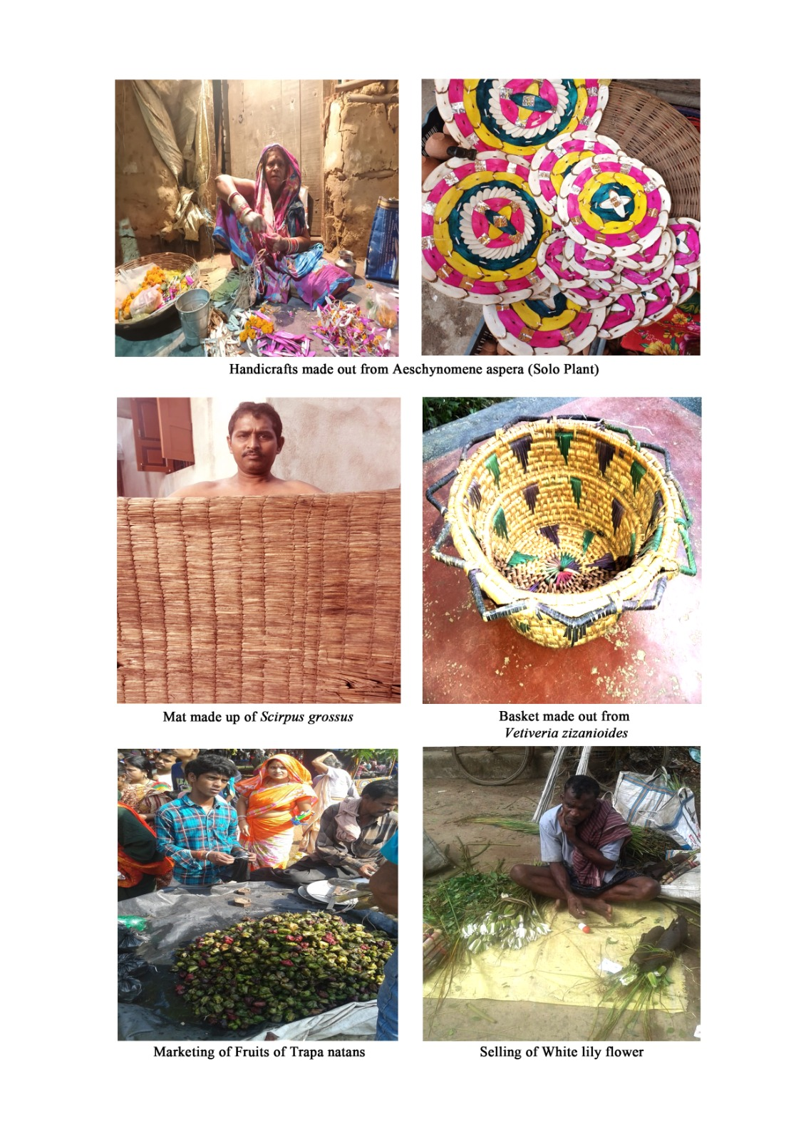

**Table- 1 Socio economic uses of plants and their parts (Mishra and Panda, 2013)**

|  |  |  |  |  |
| --- | --- | --- | --- | --- |
| **Sl. no** | **Purpose** | **Plant Name** | **Family** | **Parts used** |
| 01 | Bio fertilizer | *Azolla pinnata* | Azollaceae | Whole Plant |
| 02 | Basket and handicrafts | *Vetiveria zizanioides* | Poaceae | Stem |
| 03 | Broom | *Eragrostis ciliaris* | Poaceae | Stem |
| 04 | Chain | *Coix aquatica* | Poaceae | Seed |
| 05 | Decorative material | *Vetiveria zizaniodes* | Poaceae | Stem |
| 06 | Fencing | *Ipomoea carnea* | Convolvulaceae | Stem |
| 07 | Food plate | *Nelumbo nucifera* | Nymphaceae | Leaf |
| 08 | Fuel | *Aeschynomene indica*  *Aeschynomene aspera*  *Ipomoea carnea* | Fabaceae  Fabaceae  Convolvulaceae | Stem  Stem  Stem |
| 09 | Hair darkening | *Eclipta prostrata* | Asteraceae | Leaf |
| 10 | Mat | *Cyperus articulates*  *Cyperus imbricatus*  *Scirpus grossus* | Cyperaceae  Cyperaceae  Cyperaceae | Stem  Stem  Stem |
| 11 | Ornamental and  Ritual works | *Lindernia anagalis*  *Nymphaea nouchali*  *Nymphaea pubescens*  *Leucas aspera*  *Nelumbo nucifera*  *Sesamum orientale* | Scrophulariaceae  Nymphaceae  Nymphaceae  Lemnaceae  Nymphaceae  Pedaliaceae | Whole Plant  Flower  Flower  Flower  Flower  Seed |
| 12 | Organic manure | *Alternanthera ficoides*  *Eichhornia crassipes*  *Isachne globosa*  *Spirodela polyrhiza* | Amaranthaceae  Pontederiaceae  Poaceae  Lemnaceae | Whole Plant  Whole Plant  Whole Plant  Whole Plant |
| 13 | Phytoremediation | *Lemna minor* | Lemnaceae | Whole Plant |
| 14 | Packaging | *Nelumbo nucifera*  *Hydrilla verticillata* | Nymphaceae  Hydrocharitaceae | Leaf  Whole Plant |
| 15 | Rope making | *Saccharum spontaneum* | Poaceae | Culm |
| 16 | Soil binder | *Alternanthera ficoides*  *Cyperus articulates*  *Panicum repens* | Amaranthaceae  Cyperaceae  Poaceae | Whole Plant  Whole Plant  Whole Plant |
| 17 | Thatching | *Typha angustata*  *Vetiveria zizanioides* | Typhaceae  Poaceae | Whole Plant  Whole Plant |
| 18 | Toy, boat and crown | *Aeschynomene aspera* | Fabaceae | Stem |

**Conclusion**

Wetlands are the natural ecosystem which are the only solution of pollution and climate change around the globe. Wetlands are the unique ecosystem in which large number of plants and animals are inhabits. It plays an important role in water purification and provide us. Local people are very much close to the nearest water bodies for daily activities and to meet their needs like food, fodder, fuel etc. Beside this, they are economically dependent on this ecosystem. The water bodies gradually sinks due to different activities like pollution load, mushrooming of industries and other socioeconomic developmental activities.Ultimately the socioeconomic status of local people is also affected. Hence their restoration and conservation is very urgent. Further more study and is needed in this context to explore more ideas on these aquatic phytoresources.

**References**

Masarirambhi M.T., Manyasti A.M. and Mhazo N. 2010. Distribution and utilization of wetlands in Swaziland, *Res J Env Earth Sci*, 2(3),147-153.

Millennium ecosystem assessment, ecosystem and human wellbeing, 2005. A framework for assessment, <http://www.MAweb.org>.

Mishra M.K. and Panda A. 2013. *Illustrated Wetland plants and their Utilization*,International Book Distributor, Derhadun..

Mitsch, W.J. and Gosselink, J.G. 2000. Wetland 3rd Edn, John Wiley and Sons, Inc, New York, USA.

National Wetland Atlas Orissa, 2010. SAC/EPSA/AFEG/NWIA/ATLAS/28/2010, Space

Application Centre (ISRO), Ahmedabad, India.

Sahoo S. and Nayak R.K. 2022. Studies on Invasive Alien Aquatic species in Jajpur District

of Odisha, India. *Eco. Env. & Cons*.28; pp (S309-S312).

Swapna M.M., Prakashkumar R., Anoop K.P., Manju C.N. and Ranjith N.P. 2011. A review on the medicinal and edible aspects of aquatic and wetland plants of India, *Journal of Medicinal Plants Research*, 5(33), 7153-7176.