Genetic improvement of natural enemies (predators, parasitiods and entomopathogens)
M.V. Matti¹, Anandmurthy. T² and Poornima. Matti³
^{1,2}Ph.D, Department of Agricultural Entomology,
³Scientist, AICRP Cotton, ARS, Dharwad
UAS, Dharwad, Corresponding Email.id:muttumatti@gmail.com

Editors Id- IIPER1676108001
Subject: Applications with Technology Support
Introduction
The biological environment of all living organisms has two parts: external and internal. Much of pest control, biological or otherwise, has to do with the external environment and how to control or adapt to the pest (such as increased mortality).
Advantages of biopesticides include safety for non target organisms and the environment and non toxicity for animals. Some of the limitations of biopesticides, such as slow action, limited range, and lack of risk in the field, can be overcome by a variety of strategies that include genetic control. Genetic engineering can improve understanding of organism biology and pathogenicity, as well as providing ways to improve specific pesticide products.
Genetic engineering is now widely used in many areas of agriculture (including pest control). Growth potential, short lifespan, and relative ease of growth are advantages that can be used to control pests. Equally important is the enormous genetic plasticity of insects (see evolution of resistance) and their genetics, resulting both in the native breed and from the various mutagens exposed to them.
Pest problems in agriculture have changed dramatically in the first decade of the 21st century due to changes in ecosystems and technology. Biological pest control is accepted as an effective, environmentally friendly, efficient, economical and social pest control method. Its purpose is to prevent pests by using crop pests or natural enemies of other pests (parasites, predators and pathogens). It creates an attempt to exploit natural enemies by introducing new species into the environment or increasing the efficiency of existing species (Sankaran, 1986). The first successful introduction of natural enemies in India was the ladybug Cryptolaemus monrouzieri (Muls.), which was brought from Australia in 1898 (Rao et al., 1971).
Natural enemies’ genetic alteration of plant beetles promises to increase their effectiveness in agricultural crops. Enemy gene enhancement work completed for
- Climatic tolerances improvement
- Host searching capability modifications
- Pesticide resistance
- No resting stage
Monogenic traits (controlled by a single gene) are easily replaced by polygenic traits. Application of this biocontrol agent appears to be a suitable method to control the pest in the field.
Artificial Selection:
Genetic engineering of predators and parasitoids:
To increase their effectiveness as biocontrol agents of arthropod natural enemies, genetic engineering requires the identification of beneficial effects, the genes that influence these behaviors, and the development of ideas for incorporating them into natural enemies so that genes can work. It is necessary to teach and transfer it to generations firmly.
The importance of genetic diversity was first observed by Clausen (1936), who pointed out that the ability and safety of beneficial organisms are not necessarily constant throughout their usual consequences.
Simmonds (1963) and Messenger and Van den Bosch (1971) drew attention to some of the disadvantages and difficulties of laboratory selection. For example, due to the complexity of the environment, the fact that beneficial organisms may not be compatible is often impossible to determine ex situ and therefore cannot be addressed in chamber testing. Lack of knowledge of the genetic basis for the inheritance of essential traits in beneficial organisms makes intelligence directed reproduction difficult and lengthy. Sufficient genetic diversity must be achieved to ensure that the traits necessary for selection are available.
Case Studies:
Breeding options for beneficial strains have been undertaken with some success by many workers.
In a classic study, Wilkes (1942) succeeded in influencing the spawning temperature preference of some species of the parasitic D. fuscipennis. Choose 9°C for one type and 25°C for the other. Wilkes (1947) improved his laboratory by doubling the average number of offspring per female, reducing male sterility from 35% to 2%, and reducing changes in growth, development and maturation of the adult D. fuscipennis strain.
Simmonds (1947) had similar success by selecting the species Acetidae, Masrus (Aenoplex) carpocapsae (Cushman), which resulted in a high rate of female pregnancies.
High temperature tolerant Trichogramma:
It has been reported that the survival and viability of T. chilonis decreased at temperatures above 32°C (Jalali and Venkatesan, 2005). T. chilonis strains named TcUPI and TcUP2 have been found to be tolerant of high temperatures such as 32 to 40 ºC and have high biological potential (65% female, 116 fertility). These organisms can be used to control diabetes in tropical climates (NAIP-ICAR 2012).
Singh and Shenhmar (2008) reported that the genetic improvement (by selection) of high fever resistant T. chilonis strains and native Ludhiana strains search for hosts up to 10 and 8 m from the launch site.
Monocrotophos resistant Green lace wing, Chrysoperla carnea:
The same strain has been shown to be resistant to other insecticides such as dimethoate, acephate, phosphamide and mephedenate (Patel and Yadav, 2000).
Genetically manipulated predatory mite, Metaseialus occidentalis:
Metaseialus occidentalis is an insect species best suited to warm climates (80° to 110°F) and lowland soils in the interior valleys of California, USA. However, it does not do well in the cold parts of the coast, instead it enters diapause. In California, the predatory insect Metaseialus occidentalis has successfully evolved through selective breeding to gain resistance to carbaryl and permethrin. Multiresistant western M. occidentalis strains were also obtained by cross examination and further selection. Savings of between $60 and $110 per hectare can be achieved using this strain. For many phytoi species, genetic improvement includes selection for improved fertility, temperature tolerance, non-diapause, and insect resistance (Hoy, 1984).
Carbaryl resistant parasitoid Aphytis melinus:
Spollen and Hoy (1992) reported in 1989 that carbaryl resistant strains from McFarland and Valencia orange groves in Springville, CA were as tolerant to carbaryl residues as test selected (R) strains. Bioanalysis studies showed that the surrounding A. melinus population developed resistance to carbaryl in these vineyards. Given the high tolerance of endemic A. carbaryl. Although the occurrence and recovery of type R in the Melinus population could not be confirmed in the two vineyards.
Hybridization:
Development of Hybrid Trichogammatid:
Hybrid T. chilonis strains have been developed to tolerate high temperatures and repeated pesticides. The induction of temperature tolerance (32 to 38 °C) in T. chilonis species resistant to multiple insecticides was performed for their survival and hosting of C. cephalonica eggs.
Hybrid Chrysoperla carnea:
Patel and Yadav (2000) studied heterosis and heterosis prediction for some important traits in C. carnea hybrids. As Simmonds (1963) stated, there are some limitations in the use of reproductive techniques. Due to the complexity of the natural environment, it is difficult to determine the exact number of beneficial organisms ex situ and therefore cannot be determined in the laboratory. In addition, the lack of genetic information for the inheritance of essential traits in beneficial organisms makes breeding a difficult and long-term task.

Recombinant DNA (rDNA) techniques
While mutagenesis and recombinant DNA technology promise new technologies in genetic improvement, performance improvement through heterosis remains largely unexplored. Research is needed to understand how to identify positive factors for improvement, facilitate change, maintain the power of disease control, and contain disease outbreaks. Regulations for the release of arthropod species manipulated by recombinant DNA methods should be established.
DNA sequencing in predatory mite M. occidentalis:
Due to gene duplication and triploidization, the mitochondrial genome is "small", only 25 kb. By comparison, the nuclear genome is small at 88 Mb. These animals have been genetically modified for use in agriculture, creating strains that cannot winter diapause or are resistant to many pesticides and can be genetically modified using recombinant DNA techniques. Sequencing the nuclear genome will provide information that could improve genetic engineering.

Genetic engineering in Bacillus thuringiensis:
Regional limitations of Bt include poor performance in local conditions requiring repeated spraying and the spread of large spores. To address both situations, two approaches have been adopted, both involving the development of pathogens unconventional for insects. Bacterias would be killed and the encapsulated ICP improved storage and did not contain Bt spores. Disruption of the spoOA gene, which plays a role in the initiation of sporulation, prevents sporulation. As a result of this process, mutant bacteria can be taken continuously, do not produce spores, and the pesticide is partially protected by encapsulation in the cells.
Genetic engineering in entomopathogenic fungi:
A major limitation of the use of entomopathogenic bacteria such as Beauveria bassiana and Metarhizium anisopliae is that effective control depends on the soil involved after spore application.
Genetically engineered Metarhizium anisopliae:
The gpd promoter of Aspergillus nidulans can direct expression. Four mutants were selected, each containing 3 to 6 copies of the prl gene. Although the prl gene is normally only expressed during cuticle development, prl is produced by the recombinant fungus in the hemocoel of Lepidopteran larvae infected with the recombinant fungus. Infection with recombinant bacteria causes partial hydrolysis of hemolymph proteins and extensive melanization of the larvae.
Genetic engineering in entomopathogenic nematodes:
Importance of genetic engineering to improve properties and overcome the main limitations of entomopathogenic nematodes (Sterni and Heterogynematodes) such as susceptibility to environmental stresses, extreme temperatures, solar radiation and desiccation is being evaluated. Entomopathogenic nematodes are closely related to bacteria of the genus Pathogenus (family: Enterobacteriaceae). This symbiotic relationship is unique because each nematode species carries its own type of infection. There are differences in nematode virulence, drying tolerance, host finding ability and temperature performance, so classical selection can be used to correct this disadvantage (Gaugler and Hashmi, 1996).

Genetic engineering in entomopathogenic virus:
The host specificity of wild baculoviruses makes them ideal products of integrated pest management (IPM), but their insecticidal application is limited to host plants. Voluntary resistance to malnutrition media (Smith et al., 2000)
Autographa californica nuclear polyhedrosis virus (AcMNPV) and corn caterpillar NPV (HzSNPV) recombinant viruses were developed to express insect selective virulence.
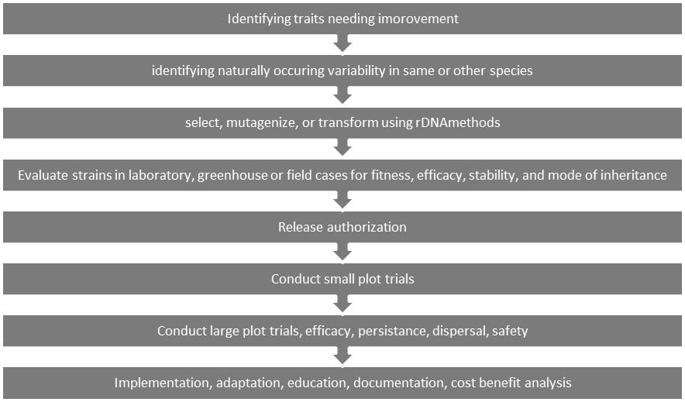
Fig 1: Methods of developing genetically modified natural enemy
Conclusions
Although the use of livestock and parasites is not harmful to the environment, their effectiveness is limited in many respects. Its effectiveness may contribute to its use as a pest control agent. Its effectiveness may contribute to use as an insect control agent. Different characteristics of biological diseases, such as reduced growth, reproduction, sex change, increased temperature and humidity, changes of hosts or habitats, can improve the outcomes of natural enemies. Natural enemy is identified as a good biological control agent, their limitation is influenced by an important gene available through selection, mutagenesis or cloning, health and wellness controls, and disease releases.

References:
Clausen, C.P. (1936). Insect parasitism and biological control. Annals Entomol. Soc. America, 29 : 201–223.
FICCI, (2013). (Federation of Indian Chambers of Commerce and Industry) Knowledge and strategy paper released at 3rd national agrochemicals conclave July, 2013. Indian Agrochemicals Industry. Pp17.
Gaugler, R and Hashmi, S. (1996). Genetic engineering of an insect parasite. Genetic Engineering Principles and Methods. pp.135-157.
Headley, J.C. and Hoy, M.A. (1987). Benefit/cost analysis of an integrated mite management program for almonds. J. Econ. Entomol., 80 (3) : 555–559
Hoy, M. A. (1984). Genetic improvement of a biological control agent: multiple pesticide resistance and nondiapause in Metaseialus occidentalis (Nesbitt) (Phytoseiidae). Proceedings VI International Congress of Acarology, Edinburgh, 1982, Acarology VI, Volume 2. D. A. Griffiths and C. E. Bowman, editors, Ellis Horwood Ltd., Halsted Press, New York New York. pp.673-679.
Messenger, P.S. and Van Den Bosch, R. (1971). The adaptability of introduced biological control agents. In: Huffaker, C.B. (eds Biological Control. Plenum Press, New York) pp. 68-92.
Patel, I.S and Yadav, D.N. (2000). Standardization of bioassay technique for developing genetically improved monocrotophos resistant strain of green lacewing, Chrysoperla scelestes Banks. Pest Management and Economic Zoology. 8: 47-51.
Rao, V.P., Gandhi, M.A., Sankaran, T and Mathur, K.C. (1971). A review of the biological control of insects and other pests in South-east Asia and the Pacific regions; Commonwelth Inst. Boil. Control. Tech. Commun. No. 6 149 pp.
Smith, C.R., Heinz, K.M., Christopher, G. Sansone, and Flexner, J.L. (2000). Impact of Recombinant Baculovirus Field Applications on a Nontarget Heliothine Parasitoid, Microplitis croceipes (Hymenoptera: Braconidae). Journal of Economic Entomology. 93: 1109-1117.
Sankaran, T. (1986). Current status and future projections of biological control of insect pests in India. Proc. Indian natn Sci. Acad. 52: 108-116.
Simmonds, F.J. (1947). Improvement of the sex-ratio of a parasite by selection. Canadian Entomologist, 79 : 41-44.
Simmonds, F.J. (1963). Genetics and biological control. The Canadian Entomol., 95: 561-567.
Singh, S and Shenhmar, M. (2008). Host searching ability of genetically improved high temperature tolerant strain of Trichogramma chilonis ishii in sugarcane. Annals of Plant Protection Sciences. 16: 107-110.
Singh, S and Shenhmar, M. (2008). Host searching ability of genetically improved high temperature tolerant strain of Trichogramma chilonis ishii in sugarcane. Annals of Plant Protection Sciences. 16: 107-110.
Spollen, K.M and Hoy, M.A. (1992). Genetic improvement of an arthropod natural enemy: Relative fitness of a carbarylresistant strain of the California red scale parasite Aphytis melinus DeBac. Biological Control. 2: 87-94.
Wilkes, A. (1947). The effects of selective breeding on the laboratory propagation of insect parasites.Proceeding of Royal Society of London Series B, 134 : 227-245.

