IoT Based Automatic Fish Feeder Using Mobile Application

P.Agnes Alex Rathy
Assistant Professor
Department of Information Technology,
St.Xavier’s Catholic College of Engineering
India
G.Geo Jenefer
Assistant Professor
Department of Information Technology
St.Xavier’s Catholic College of Engineering
India

ABSTRACT

An IoT based automatic fish feeder with a mobile application is a system that aims to automate the process of feeding fish in an aquarium or fish pond. The system consists of a Node MCU microcontroller, temperature sensor, pH sensor, ESP 32 CAM module, fish feeder setup, and a Blynk IoT application. The temperature and pH sensors monitor the water quality and send the data to the Node MCU, which processes the data and triggers the fish feeder setup to dispense the appropriate amount of fish food. The ESP 32 CAM module provides a live video stream of the fish tank or pond to the mobile application, which can also be used to monitor the water quality and adjust the feeding schedule. The Blynk IoT application allows the user to control and monitor the system remotely from anywhere with an internet connection. This system provides convenience and peace of mind for fish owners who want to ensure their fish are being fed properly and their environment is healthy.

Keywords— IoT(Internet of Things),Fish Feeder, Blynk Application.

INTRODUCTION

The Internet of items (IoT) is a network of actual physical items, or "things," that have been outfitted with sensors, software, and other technologies for the purpose of transferring data to and from other systems and devices through the internet. From everyday household goods to cutting-edge industrial equipment, these devices come in all shapes and sizes. Analysts predict that by 2020, there will be 10 billion connected IoT devices, and by 2025, there will be 22 billion. Currently, there are around 7 billion connected IoT devices. As one of the most important 21st-century technologies, IoT has recently come into its own. With the advent of embedded devices, it is now possible to use the internet to connect commonplace items like thermostats, baby monitors, and kitchen appliances, enabling seamless communication between people, machines, and other things. In the hyperconnected environment of today, digital technologies can record, watch, and alter every contact between connected things. Even if the physical and digital worlds overlap, they coexist. IoT has been an idea for some time, but only recently has it come to fruition as a result of numerous recent technological developments.

An IoT-based automatic fish feeder is a system that leverages the Internet of Things (IoT) technology to automate the process of feeding fish in an aquarium or fish pond. The system consists of an automatic feeder device that dispenses fish food at predetermined intervals, a sensor system that monitors the feeding behavior of fish, and a cloud-based platform that collects and analyzes data from the sensors. The system is designed to provide a convenient and efficient way of feeding fish, without the need for manual intervention. It is ideal for fish enthusiasts who have busy schedules or are unable to tend to their fish on a regular basis. The automatic feeder can be programmed to dispense a specific amount of fish food at set intervals, ensuring that the fish are fed consistently and in the appropriate amount.

The sensor system is used to monitor the feeding behavior of fish and gather data on their feeding problem addressed by an IoT-based automatic fish feeder is the need for a convenient and efficient way to feed fish in an aquarium or fish pond without the need for manual intervention. Many fish enthusiasts have bus sched patterns. This information is then used to adjust the feeding schedule and the amount of food dispensed, ensuring that the fish are getting the right amount of nutrition. The cloud- based platform provides a centralized location for data storage and analysis. It allows users to monitor the feeding behavior of their fish in real-time, view historical feeding patterns, and make adjustments to the feeding schedule as needed. Overall, an IoT-based automatic fish feeder is a valuable tool for fish enthusiasts who want to provide optimal care for their fish without the need for manual intervention. It is a convenient, efficient, and effective way to ensure that fish are fed consistently and in the right amount, leading to healthier and happier fish.

LITERATURE REVIEW

The presence of pets has always been a source of enjoyment for people, but in the busy world of today, it may be challenging to properly care for pets, especially fish, which demand more attention. Owners of fish who go on vacation may overfeed or underfeed their fish, depending on the situation. Water quality—including temperature, PH level, and other factors—is another factor. So, in order to address the aforementioned problems, a solution is offered in this article. The system that is suggested consists of two parts. The first is for fish eating, while the second is for water feature and level monitoring [12].
In aquaculture, fish are still typically fed by hand, which results in an inaccurate feed dose being administered. Many fish farms still feed their fish by hand, which results in an imbalance between the amount of feed and the number of fish in the farm. The goal of this research is to create an Internet of Things (IoT) fish feeder and assess how effective using smart feeders in place of manual feeding is for fish farming. A smart feeder for fish food may gauge the amount of food being dispensed in accordance with the demands of the fish, providing the fish with the appropriate amount of food. In order to assess the effectiveness of automatic fish feeding, this study examined the practice. The System Usability Scale (SUS), a measure for assessing a system's usability, was employed in this study. In order to assess the effectiveness of using automatic fish feed against manual feeding, respondents were given questionnaires in the form of questions. The calculation using the SUS approach yielded a result of 61.25. The score is "Grade D" overall, with an adjective rating that falls under the "OK" rating group. It may be inferred from the findings of the research that feeding using a smart feeder is more efficient than manual feeding.
An android smartphone can be used to control the smart Fish Feeder, an autonomous fish feeder. With the help of this program, fish owners may quickly change the feeding plan to correspond with the appropriate feed dose and to schedule aquarium cleaning. Some criteria, such as temperature and feeding interval, are used while designing a fish feeder. Interviews with traders in ornamental fish were used to gather data. The information was also gathered through literature reviews that bolster problem-solving theory. The system is interpreted using the Laravel framework, with Firebase serving as the DbMS. As a front end, Android communicates with users directly. The arduino micro-controller and prototype feeding apparatus are used to develop automatic fish feeding systems[22].
The inability of Indonesia's fisheries sector to be sustainable is both a strategic concern and a significant overall challenge. This study will look into how Industry 4.0 should be implemented in the fisheries industry and what will happen when this smart feeder technology is used. Our value proposition is to simplify pond feed management for farmers and boost the financial benefit of feed purchases. In order to implement an automatic ordering system when it is anticipated that the feed would run out, this project intends to create an automatic feed machine for fishponds the feedstock in the storage is combined with that[4].
The goal of this research is to improve the pellet dispensing system while also lowering labor costs. Following that, it was suggested that this research be used to develop a PIC microcontroller application for an automatic fish feeder system. In order to manage fish eating behavior, a gadget was designed that integrates mechanical and electrical systems. The main components of this gadget are a pellet storage former, a stand, a DC motor, and a microprocessor. Located beneath the pellet storage, a DC motor controls the pellets. Then, a control system was connected to this apparatus so that the fish may be fed at the proper cycle time, as needed or predetermined by the user. This gadget used a timer to regulate the rotation of the motor connected to the sphere forming, which dispensed the pellets into the water[14].
It is essential to handle the offered meals. The system will be automated as part of this research in an effort to reduce manual labor and shorten labor hours. This has to do with a system that feeds fish at specific times and in specific amounts. The working concept's fundamental notion is to control the amount of food delivered to a fish tank unit at specified times. The original, which mixes mechanical and electrical components, uses a servo motor to rotate in stages, which lowers labor expenses while producing precisely the right amount of food at the right moment. This makes the system precise by assisting in the distribution of food equally around the body of water and allowing the fish to feed themselves after a day[13].
The majority of automatic fish feeders have difficulty managing the release of fish food. The ideal dosage of fish food is allegedly determined by the total weight of the fish. If fish are fed when they are not hungry, the feed will be wasted. An effective fish feeding system is described in this research. In order to categorize feeding behaviors, we observed changes in water ripples brought on by fish movement during times of hunger. We then fed the fish based on their weight and the daily requirements. The automatic fish feeding system will take input from the water ripples produced by gasping behavior. The detection of water ripples uses a gyroscope sensor. The contributions made by this paper are as follows: Fish activity is measured by two different methods: 1) a completely automated fish feeding system that manages feeding for a fish tank, and 2) a method based on gasping behavior. The following conclusions are reached as a result of experiments. It was successful to design a prototype system that can automatically feed fish. The daily average amount of fish feed released by the system's design has complied with the recommended daily feeding rate depending on fish weight[18].

Due to the low cost of microcontrollers, automatic feeders continue to be the most effective alternative to feeding fish by hand. They are also the most affordable and precise way. The goal of the study is to create a project that uses a timer to automatically dispense feed according on user preferences and alerts the owner via GSM when the feeding procedure is complete. To determine whether a design works as intended, prototypes are utilized. It was established through testing and development that the project's design was efficient and effective. based on the outcome of the assessment. The application's proponents discovered that the vast majority of responders concurred that it had been successful[9].

PROPOSED SYSTEM

The proposed system aims to overcome the limitations of traditional automatic fish feeders by incorporating IoT technologies to provide more precise control over feeding schedules and real-time monitoring of fish health. The NodeMCU is a microcontroller board that serves as the brains of the system, receiving data from sensors and controlling the fish feeder setup. A temperature sensor is used to monitor water temperature, which is a critical factor in determining feeding schedules and fish health. The ESP32 CAM is a camera module that allows for real-time monitoring of fish behavior and feeding activity. A pH sensor is used to monitor water quality, which can affect fish health and feeding schedules. The fish feeder setup includes a motor, dispenser, and hopper to dispense the appropriate amount of fish food at the desired intervals.
The Blynk IoT application is used to remotely monitor and control the system, allowing users to adjust feeding schedules and receive alerts if any parameters fall outside of preset ranges. The temperature and pH sensors collect data on water conditions and send it to the NodeMCU, which uses this data to determine the appropriate feeding schedule. The ESP32 CAM provides real-time monitoring of fish behavior and feeding activity, which can be viewed on the Blynk application. The fish feeder setup dispenses the appropriate amount of food at the desired intervals, as controlled by the NodeMCU. Users can remotely adjust feeding schedules and receive alerts if any parameters fall outside of preset ranges, allowing for more precise and efficient fish feeding.

The prerequisites for setting up an IoT-based automatic fish feeder system are as follows:
Automatic fish feeder device: An automatic fish feeder device is required to dispense fish food into the aquarium or fish pond. The device should be compatible with the IoT system and have programmable feeding schedules and portion sizes.
Sensor system: A sensor system is required to monitor the feeding behavior of fish and gather data on their feeding patterns. The sensor system should be compatible with the automatic fish feeder device and IoT platform.
IoT platform: An IoT platform is required to collect and analyze data from the automatic feeder device and sensor system. The platform should provide real- time monitoring, data analysis, and optimization capabilities.
Power supply: A reliable and stable power supply is required to ensure continuous operation of the automatic fish feeder device, sensor system, and IoT platform.
Proper fish food: It is essential to use the proper fish food that meets the nutritional requirements of the fish. The type of fish food used should be compatible with the automatic feeder device and portion sizes should be determined according to the needs of the fish. It is essential to have basic knowledge and experience in setting up and maintaining an IoT-based automatic fish feeder system. This includes understanding the technology involved, proper installation and setup, and troubleshooting any issues that may arise.

A. BLOCK DIAGRAM

The block diagram for the proposed system consists of Node MCU, temperature sensor, ESP 32 CAM, pH sensor, fish feeder setup, and Blynk IoT application. The fish feeder setup includes a container that stores the fish feed and a motor that dispenses the feed into the water at the appropriate time. Node MCU is a microcontroller that controls the fish feeder setup. It is connected to various sensors and actuators to monitor and control the fish feeder system. The temperature sensor measures the water temperature in the fish tank or pond. It sends the data to Node MCU for further processing. The pH sensor measures the pH level of the water in the fish tank or pond. It sends the data to Node MCU for further processing. The ESP 32 CAM is a camera module that captures images or videos of the fish tank or pond. It sends the data to Node MCU for further processing. Blynk is a mobile application that allows users to monitor and control the fish feeder system from anywhere using a smartphone. It communicates with Node MCU over the internet using Wi-Fi or mobile data.

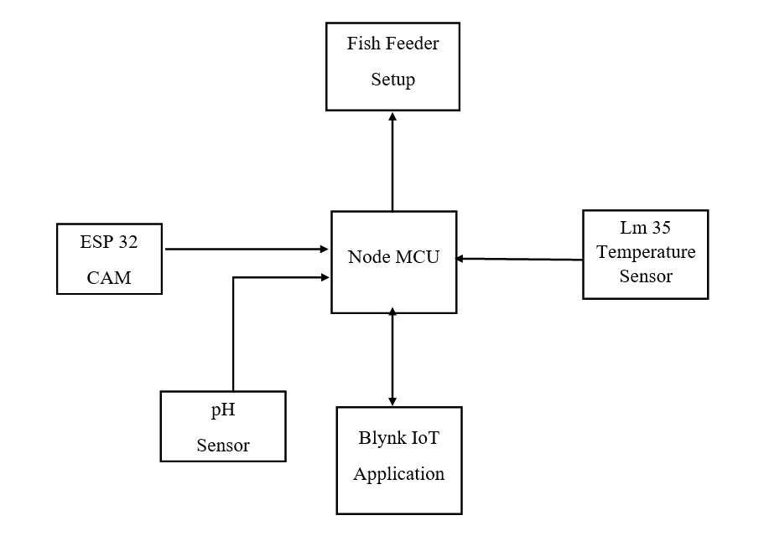

Figure.1. Block diagram of IoT Based Automatic Fish Feeder with Mobile Application

B. ADVANTAGES

Easy monitoring: With the mobile application, users can easily monitor and control the fish feeding process, ensuring that the fish are fed on time and the right amount of food is dispensed.
Automatic feeding: The system is designed to automatically feed the fish based on predefined feeding schedules, which helps to ensure that the fish are fed regularly and reduces the chances of over or underfeeding.
Accurate feeding: The system uses sensors to measure the temperature and pH level of the water, which helps to ensure that the fish are fed the right amount of food that matches the current environmental conditions.
Cost-effective: The system is designed using cost-effective components such as Node MCU, ESP 32 CAM, and pH sensors, making it a more affordable solution compared to some other automated fish feeding systems.
Easy to use: The Blynk IoT application provides an easy-to-use interface for controlling and monitoring the system, making it accessible to users of all technical backgrounds.
Improves fish health: By providing regular and accurate feeding, the proposed system helps to ensure that the fish are healthy and well-fed, which can result in improved growth rates and overall health.

C. APPLICATIONS

Home aquariums: The system can be used by individuals who have home aquariums to automatically feed their fish and monitor the water temperature and pH levels remotely.
Commercial fish farms: The system can be implemented in commercial fish farms to automate the feeding process and ensure that the fish receive the right amount of food at the right time. The remote monitoring capabilities of the system can also help farmers identify any potential issues with the water quality or feeding process.
Research and educational settings: The system can be used in research and educational settings to study the feeding behavior of fish and monitor the water conditions to understand their effects on fish health and behavior.

RESULTS AND DISCUSSION

The performance and functionality of the system should be presented based on the experiment or implementation. The results can include the accuracy of the sensors used such as the temperature and pH sensors, and the reliability of the automatic fish feeder in terms of feeding frequency and the amount of food dispensed. The system's response time to user commands via the mobile application can also be discussed in this section.The findings from the results should be analyzed, and the strengths and weaknesses of the system should be evaluated. For instance, the accuracy and reliability of the sensors used in the system can be compared with those of other sensors available in the market. The response time of the system can be discussed in terms of the impact it has on the fish and how to optimize the system's response time to avoid overfeeding or underfeeding the fish. Furthermore, the potential impact of the system on the environment can be evaluated, particularly in terms of reducing food wastage and the overall impact on the fish's health and growth. Overall, the IoT based automatic fish feeder with mobile application should provide a comprehensive analysis of the system's performance and potential impact, along with potential areas of improvement for future research.

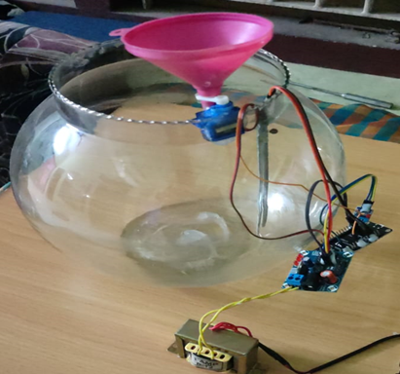
Figure. 2. IoT Based Automatic Fish Feeder

CONCLUSION

The proposed system for IoT-based automatic fish feeder with a mobile application has several advantages over traditional fish feeding methods. It provides the ability to monitor and control fish feeding remotely using a mobile application, ensuring timely and accurate feeding, reducing wastage of fish feed, and minimizing human intervention. The system utilizes advanced technologies such as IoT, machine learning, and computer vision to provide real-time data and analysis of the fish tank conditions, enabling the user to make informed decisions about fish feeding and maintenance. The integration of the ESP 32 CAM module allows for real-time monitoring of fish behavior and health, helping to detect any issues early on and prevent fish diseases. The pH sensor helps to maintain the optimal pH level in the fish tank, which is crucial for fish health and growth. The temperature sensor ensures that the water temperature is at the right level, which is also important for fish health. The fish feeder setup ensures that the fish are fed the right amount of food at the right time, based on the data collected from the various sensors. Overall, the proposed system offers a reliable, efficient, and convenient solution for fish feeding and maintenance in aquaculture.

REFERENCES
- Emmanuel Gbenga Dada, Nnoli Chukwukelu Theophine, Adebimpe Lateef Adekunle “Arduino UNO Microcontroller Based Automatic Fish Feeder”, The Pacific Journal of Science and Technology, Volume 19. Number 1, pp. 168-174 ,May 2018.
- H. C. Wei et al., “Improvement of automatic fish feeder machine design,” J. Phys. Conf. Ser., vol. 914, p. 012041, 2017.
- Heather Marsden ,“Automatic fish feeder” ,Electronic Systems News,Volume: 1985 , Issue: 1 , Spring 1985.
- Hidayatul Nur Binti Hasim, Mritha Ramalingam, Ferda Ernawan, Puviarasi R.“Developing fish feeder system using Raspberry Pi”, IEEE 3rd International Conference on Advances in Electrical, Electronics, Information, Communication and BioInformatics (AEEICB17), pp.no: 246 – 250,2017
- Jui-Ho Chen, Wen-Tsai Sung and Guo-Yan Lin, “Automated Monitoring System for the Fish Farm Aquaculture Environment” IEEE International Conference on Systems, Man, and Cybernetics,Vol No.57, Sec. 2,pp.no:1161-1166,2016.
- K. Krishna Kishore ; P. Vamsi Krishna ; D. Srikanth,“An Automatic Fish Feeding for Aquaculture”, Third International Conference on Sensing, Signal Processing and Security (ICSSS),2017
- K.Sinduja, S.Sofia Jenifer, M.Sri Abishek, B.Sivasankari “ Embedded System Based Automated Control System for the Poultry Farm”, International Research Journal of Engineering and Technology (IRJET) e-ISSN: 2395 - 0056 Volume: 03 Issue: 03, Mar-2016
- Liu Xingqiao, Geng Jiao, Ji Feng, Zhao Dea,“Using MATLAB Image Processing to Monitor the Health of Fish in Aquiculture”, 27th Chinese Control international Conference proposed in IEEE, pp.no: 677 – 680,2008.
- M Olaniyi, A. F. Salami, O. O. Adewumi, O. S. Ajibola “Design of Intelligent Poultry Feed and Water Dispensing System With Fuzzy Logic Control Technique”, Control Theory and Informatics ISSN 2224-5774, Vol.4, No.9, 2014
- M. Ali, M. Zolkapli,,“The design and development of automatic fish feeder system using PIC microcontroller”, IEEE Control and System Graduate Research Colloquium (ICSGRC),2012
- M. H. B. M. JAMAL, “Modeling and Control of The Fish Feeder System” ,Universiti Tun Hussein Onn Malaysia, 2013.
- MZH Noor, AK Hussian, Mohammad Farid Saaid, MSAM Ali, Maizatul Zolkapli,” The design and development of automatic fish feeder system using PIC microcontroller”,IEEE control and system graduate research colloquium,pp. 343-347,2012
- Manoj M “Automatic Fish Feeder” International Journal of Advances in Science Engineering and Technology, ISSN: 2321-9009, Volume- 3, Issue-3, Special Issue Sept.-2015.
- Md. Nasir Uddin, Mm Rashid, Mg Mostafa, Belayet H, Sm Salam, Na Nithe, Mw Rahman & A Aziz “Development of Automatic Fish Feeder” ,2016.
- Mohd Nor Azni, M.N.H,Vellasami. L, Zianal. A.H, Mohammed.F.A, Mohd Daud.N.N, Vejasegaran.R, N.W.Basharudin, Jusoh.M, Ku Azir.N.F, P.L.Eh Kan, “Home Automation System with Android Application”,3rd International Conference on Electronic Design (ICED), pp.no:299-303,2016.
- N. Onwuka, Achonu O. Adejo and Ibrahim U. Joseph,“Design and Construction of a Microcontroller-based Automatic Fish Feeding Device ”, the 26th Annual Conference & fair of the Fisheries Society of Nigeria, pp.no: 11 – 15,2011.
- O. Ogunlela and A. A. Adebayo, “Development and Performance Evaluation of an Automatic Fish Feeder,” J. Aquac. Res. Dev., vol. 7, no. 2, pp. 7–10, 2016.
- Prashant Singh, Amit Kumar Sharma, Payal Sood, Paramdeep Singh. “Remote Controlled and GSM Based Automatic Fish Feeder”. IJEEE, Vol. 2, Issue 2 e-ISSN: 1694-2310 | p-ISSN: 1694-2426, April, 2015.
- Ricardo Yauri Rodriguez, Milton Rios Julcapoma, Rubén Acosta Jacinto, “Network monitoring environmental quality in agriculture in agriculture and pisciculture with low power sensor node based on zigbee and GPRS technology”, XXIII international congress on electronics, electrical engg. and computing (INTERCON), pp.no:1-6,2016.
- S. Nirwan, R. Swarnakar, A. Jayarajan, and P. Shah, “The Development of Automatic Fish Feeder System Using Arduino Uno,” Int. J. Mod. Trends Eng. Res., vol. 4, no. 7, pp. 64–68, 2017.
- S.Kayalvizhi,Koushik Reddy G, Vivek Kumar P, VenkataPrasanth N,“Cyber Aqua Culture Monitoring System Using Ardunio And Raspberry Pi”, IJAREEIE(international journal of advanced research in electrical, electronics, and instrumentation engineering), Vol: 4, Issue No: 5, pp.no:4554 – 4558,2015.
- Sabari Akilesh K, Savitha V, Vinithra N, Dhanasekar J, “Smart Fish Feeder”,International Journal of Scientific Research in Computer Science, Engineering and Information Technology, Volume 2 | Issue 2 | ISSN : 2456-3307, pp.111-115,2017.
- T. Ani, M. G. F. Cueto, N. J. G. Diokno, and K. R. R. Perez, “Solar Powered Automatic Shrimp Feeding System,” ,Asian Pacific J. Multidiscip. Res., vol. 3, no. 5, pp. 152–159, 2015.
- Y. Atoum, S. Srivastava, and X. Liu, “Automatic Feeding Control for Dense Aquaculture Fish Tanks,” ,IEEE Signal Process. Lett., pp. 1–5, 2015.

