Renewable Energy Sources: A Sustainable Path to a Greener Future
Jyoti Verma, Hemlata Pant, Deepanjana Padhi, Anuradha Yadav, Nidhi Gupta & Aditya Sharma
Department of Zoology, CMP Degree College, University of Allahabad, Prayagraj-211001
Email id- dr.jyotiverma@ymail.com, padhideepanjana@gmail.com
Abstract
Renewable energy sources and technologies hold tremendous promise in addressing the persistent energy challenges faced by developing nations. Countries like India can effectively tackle energy shortages by harnessing wind energy, solar energy, geothermal energy, ocean energy, biomass energy, and fuel cell technology. These energy sources are derived from natural resources that are continuously replenished and have minimal environmental impact. In contrast to finite fossil fuels that contribute to climate change, renewable energy offers a sustainable and cleaner alternative to meet energy demands. Presently, approximately 33% of India's primary energy consumption is sourced from renewable energy. The country is making notable strides in adopting responsible renewable energy practices, striving towards decarbonization, cleaner air, and a more sustainable future. With robust government support and an increasingly favorable economic landscape, India has emerged as a leading player in the world's most attractive renewable energy markets.
Key-words: wind energy, solar energy, biomass energy, fuel cell technology, sustainability, climate change,
Introduction
Electricity generation sources such as coal, oil, and natural gas have contributed significantly to global greenhouse gas emissions, accounting for approximately one-third of the total. Elevating living conditions while providing greener and more consistent electrical supply has become crucial. Over 79% of the primary energy used in the world today comes from fossil fuels, with the transport sector accounting for a significant 57.7% of this amount, a figure that is steadily decreasing. An essential prerequisite for promoting a country's economic development is meeting the rising energy demands.
Surprisingly, India ranks fourth internationally in terms of carbon emissions, accounting for about 6.65% of all emissions, after China (26.73%), the US (14.36%), and the EU (9.66%). The world's natural balance will be disturbed as a result of climate change. Intended Nationally Determined Contributions (INDCs), which aim to keep the rise in the global temperature well below 2°C, have been submitted under the UNFCCC and the Paris Agreement in recognition of the seriousness of the issue.
It has become imperative for policymakers and planners to look into alternative energy sources due to the rising demand for conventional energy and the depletion of natural resources. In order to dramatically reduce carbon emissions, improve air quality, and build a more sustainable society, renewable energy sources are derived from regenerative sources that don't deteriorate over time. These resources support global economic growth and increase energy security. A chemical storehouse for solar energy, modern biomass is a byproduct of photosynthesis. Surprisingly, renewable energy accounts for 18% of global final energy consumption. The World Energy Council predicts that by 2030, the world's demand for power will have peaked.
A startling 74% of India's energy demand is satisfied by the use of coal and oil, which has a tremendous impact on the country's energy landscape. Due to the nation's dependence on coal, significant amounts of coal have been imported: 171 million tonnes in 2013–2014, 215 million tonnes in 2014–2015, 195 million tonnes in 2015–16, and 213 million tonnes in 2017–18. Alternative electrical sources need to be investigated immediately. For the country to be guided towards sustainable growth and to avoid the catastrophic effects of climate change, this transition to renewable energy technology is essential. The provision of sustainable energy solutions with low emissions depends critically on renewable energy sources. These technologies have the ability to significantly meet electricity demand while lowering emissions, which is a widely held belief. With the promotion of energy conservation and the adoption of renewable energy sources including solar, wind, biomass, waste, and water, India has gradually evolved towards a more sustainable energy paradigm.

Types of Renewable Energy Sources
Biomass Energy: The use of biomass as an energy source has recently attracted growing interest and presently makes up around 14% of the world's total final energy consumption. According to projections, biomass might make up 15–50% of the primary energy used globally by 2050, signalling a huge shift towards renewable fuels. The development of renewable energy has been a priority for many countries, with biomass emerging as a key element of a diverse and sustainable energy matrix.
Contrary to fossil fuels, biomass-derived energy has the distinct advantage of being a renewable resource because it doesn't contribute to the atmospheric release of carbon dioxide, the main greenhouse gas. Despite having a meagre 1% conversion efficiency, estimates from throughout the world imply that photosynthesis produces an astounding 220 billion dry tonnes of biomass per year. The range of biomass sources available for energy production includes a variety of materials, from firewood gathered from farms and natural forests to forestry and agricultural products grown specifically for energy production.
India has enormous promise in this area because of its wealth of biomass resources. The capacity of the country includes 2,700 MW from waste-to-energy projects, 16,881 MW from agro-residues and plantations, and 5,000 MW from bagasse cogeneration. Over Rs. 600 million has been invested in India's biomass energy sector, which yearly produces more than 5,000 million units of power.
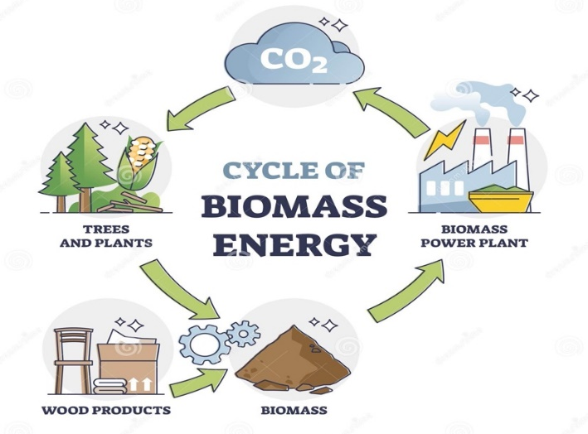

(Fig-1: Biomass Energy)
Ref: https://www.123rf.com/photo_172711954_cycle-of-biomass-energy-as-direct-combustion-in-power-plant-outline-diagram.html
2.Hydropower Energy:
Hydropower is the ideal renewable energy source since it converts the kinetic and latent energy in water into both mechanical and electrical energy through the production of electricity from water. These two types of energy can be used to power textile machines and water mills. This energy source uses the kinetic energy of moving water, typically from rainfall and river movement.
A number of states in India, including Bihar, Punjab, Uttaranchal, Karnataka, Uttar Pradesh, Sikkim, Jammu and Kashmir, Gujarat, and Andhra Pradesh, have strategically placed primary hydroelectric power projects. The hydropower landscape includes small hydropower plants (SHP) with station capacity up to 25 megawatts (MW), among other scales. roughly 11% of India's hydroelectric potential, which is believed to be roughly 15,000 MW, has already been used. The Ministry of New and Renewable Energy (MNRE), which permitted the installation of 523 projects with a combined 1705 MW of installed electricity, actively encourages the development of SHP projects across the country. In addition, there are now being built 205 SHP projects with a total capacity of 479 MW.
At the moment, hydropower dominates the contribution of renewable energy to the electricity sector. Its usefulness depends on the predictability of regional rainfall patterns, and its performance may be affected by droughts brought on by climate change and changes in ecosystems that affect these patterns. Local ecosystems may suffer as a result of the construction of hydroelectric infrastructure. Small-scale hydropower is becoming more popular as a greener option in light of these factors, and it particularly works well for communities located in isolated and ecologically vulnerable places.
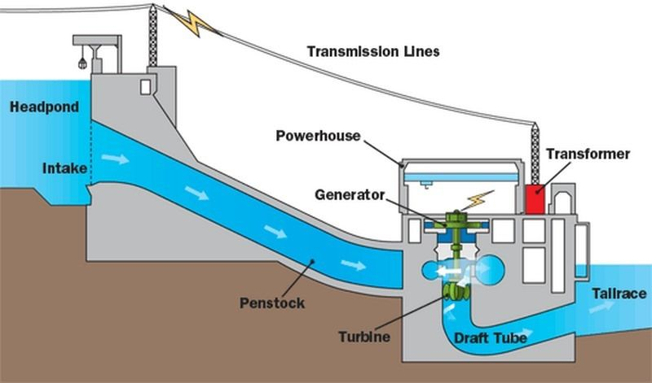

(Fig-2: Hydropower Energy)
Ref: https://studiousguy.com/hydroelectric-power-plant-working-principle/
3.Wind Energy:
Intricate interactions between the Earth's rotating dynamics, the sun's thermal effect, oceanic and polar cooling, temperature differences between land and water, and the interactions of geographical features like mountains and impediments all contribute to the development of wind energy. These numerous processes control the universal force of wind. The abundance of wind energy is not consistent, however, as different places see fluctuations in its supply.
In locations where wind energy density exceeds a threshold of at least 400 W/m2 at a height of 30 metres above the terrain, wind resources can be most effectively harnessed. The Centre for Wind Energy Technology, working with state-level nodal organisations, furthers the pursuit of this potential through the Resource Assessment Programme. The Andaman and Nicobar Islands, Andhra Pradesh, Gujarat, Karnataka, Kerala, Lakshadweep, Madhya Pradesh, Maharashtra, Orissa, Rajasthan, Tamil Nadu, Uttaranchal, and West Bengal are among the 13 states and union territories covered by a network of 211 wind monitoring stations where it has been noted that the annual average wind power density exceeds 200 W/m2 at a height of 50 metres. These figures provide as evidence of the country's diverse wind energy potential. Cumulatively, India's wind energy capacity holds promise, with estimates projecting its potential to soar to 45,000 MW. This potential stands as a testament to both the intricate ballet of natural forces and the country's commitment to embracing renewable energy sources.
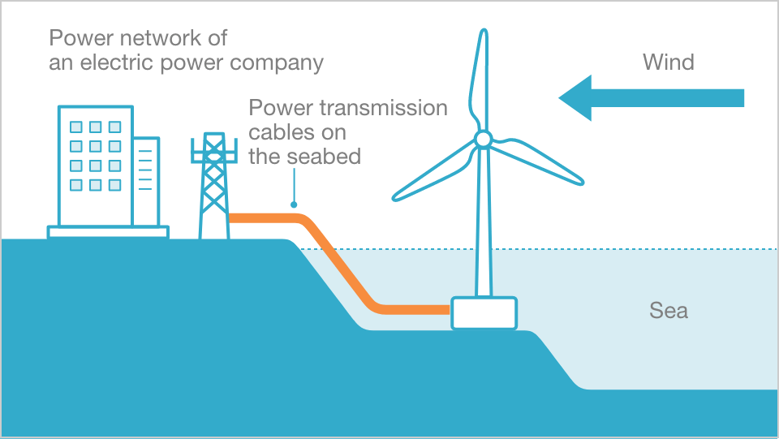

(Fig-3: Wind Energy)
Ref: https://www.jre.co.jp/english/business/offshore-wind-power/
4.Solar Energy:
A mosaic of potential energy sources is created by solar energy, a plentiful and eternal gift from the sun, which manifests in both direct (sunlight) and indirect (wind, biomass, hydro, ocean, etc.) manifestations. This dynamic energy manifests as warmth and illumination and extends its usefulness along two different paths. The thermal pathway makes use of solar heat for a variety of tasks, including cooking, drying, heating water, purifying water, and more. Parallel to this, the photovoltaic pathway converts light into power, providing off-grid areas with a flexible resource for lighting, pumping, communication, and electrification.
The sun's embrace bestows a radiant daily solar radiation of 4–7 kWh per square metre across the majority of India, along with roughly 250–300 days with significant amounts of sunshine each year. Notably, the northeastern parts have a very minor solar input, whereas the expanse of western Rajasthan receives the most annual solar radiation.
On June 30, 2008, the Prime Minister launched the National Action Plan on Climate Change (NAPCC), marking a significant step towards sustainable practises. This framework, which is a cornerstone of the Ministry's extensive solar energy programme, includes both solar thermal and solar photovoltaic technology. This project, which is sometimes recognised as one of the biggest in the world, aims to take advantage of India's significant solar energy potential, which is expected to be in the region of 20 to 35 MW/km2 of solar thermal energy.
India's solar energy potential includes water heating systems, which are thought to have a vast 140 million m2 collecting area. The state provides financial support for solar concentrator technologies as well as devices for drying and heating air using the sun. Aiming to improve energy efficiency, the Ministry promotes solar buildings in recognition of the critical role that solar efficiency plays in the larger context of energy. Notably, the state of Himachal Pradesh actively promotes the incorporation of passive solar design principles into the construction of buildings. The Solar Photovoltaic Programme (SPV), promoted by the Ministry, has greatly changed rural and remote areas over the past 20 years, promoting electrification and empowerment. The Ninth Plan period saw a nationwide effort to demonstrate and adopt SPV technology, which serves as evidence of this ambitious program's accomplishment.
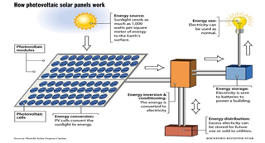
(Fig-4: Solar Energy)
Ref: https://www.linkedin.com/pulse/mechanisms-solar-panels-saeid-azizi/
5.Geothermal Energy:
The extraction of absorbed heat from subsurface sources is necessary to produce geothermal energy, which is derived from heat stored inside the Earth. The Earth's core, mantle, and crust all produce and store enormous amounts of thermal energy. Geothermal energy currently contributes 10,000 MW globally, with room for expansion even in India. A total of seven different geothermal provinces in India, found through research by the Geological Survey of India, contain about 340 hot springs. These provinces stand out in particular along the west coast in states like Gujarat and Rajasthan and along a west-southwest-east-northeast axis that runs from the coast to Bangladesh's western border, forming a notable presence in the 1500 km-long Himalayan range.
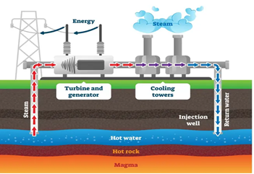
(Fig-5: Geothermal Energy)
Ref: https://xeero.io/geothermal-energy/
6.Solar Thermal Technology:
Solar thermal technologies, especially solar water heating system, solar cookers and solar production systems are the most commercialized technologies among renewable energy technologies in India. Policies are set to provide further impetus spread of solar technology.
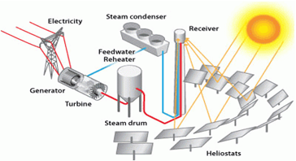
(Fig-6: Solar Thermal Energy)
Ref: https://www.energy.gov/eere/solar/power-tower-system-concentrating-solar-thermal-power-basics
7.Biogass Energy:
Biogas is a substitute energy source that is mostly made from biological waste. Since more than 30 years ago, India has supported the use of biogas, which is mostly made from animal waste, notably cow dung. A clean fuel alternative is biogas, which is produced by the anaerobic digestion of various organic wastes, including animal, agricultural, residential, and industrial waste. This technology has advanced rural cooking techniques, improving the gastronomic experience and providing social and environmental advantages including reducing indoor pollution. Over 3.7 million biogas stations have been installed since December 2004 as part of the National Biogas Programme, with capacities ranging from 1 to 6 cubic metres. This program's ultimate objective is to establish biogas stations in approximately 12 million households that possess sufficient livestock to ensure a consistent supply of organic matter for the production of biogas.
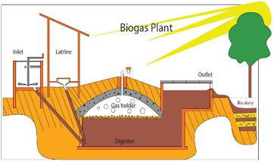
(Fig-7: Biogas Energy) Ref; https://www.build-a-biogas-plant.com/biogas-digester-plans/
8.Hydrogen Energy:
The development of hydrogen power is now in its infancy. The funding of research projects covering all facets of hydrogen energy technology advancement is being helped by emerging and renewable energy sources. The future challenges for India in this area include a significant decrease in the cost of producing hydrogen, improvements in production efficiency using a variety of techniques, the development of small, affordable storage solutions, the establishment of a thorough hydrogen distribution system, the development of hydrogen combustion engines, and the optimization of efficiency in various kinds of fuel cell systems.
To direct efforts in research, development, and demonstration across many areas of hydrogen energy technology, a strategic roadmap has been drawn forth. With the implementation of one million hydrogen-powered cars and the installation of 1,000 megawatts of combined hydrogen-based power generation capacity across the country, this plan has big goals.
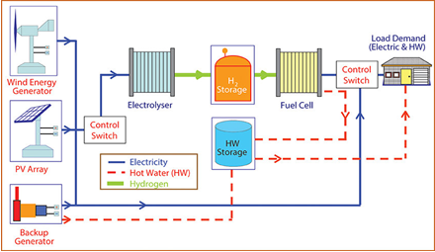
(Fig-8: Hydrogen Energy)
Ref: https://www.researchgate.net/figure/Overall-concept-of-a-hydrogen-renewable-energy-system-for-distributed-power-generation_fig4_266951079

Environmental Sustainability
Addressing energy shortages is essential for maintaining economic growth and raising living standards. While increasing supply is a simple solution, it's important to recognise two other equally important factors: environmental sustainability and social development. The current model of economic expansion has resulted in serious environmental consequences, many of which come from the energy sector, including air pollution, significant waste output, ecological degradation, and the acceleration of climate change.

Additionally, the effect on social advancement cannot be ignored. A number of societal issues, such as poverty, deteriorating health, unemployment, and inequality, are made worse by the lack of adequate access to energy services. Oil is still a crucial energy source in today's economic environments. Even while several Asian nations continue to consume more oil than any other nation in the world, the United States still leads the pack. The Republic of Korea comes in sixth, followed by China, Japan, and India. Natural gas's importance is also expanding as a result of its improved fuel efficiency.

Water pollution and the growing amount of waste being disposed of, notably hazardous nuclear waste, are two more urgent environmental issues. Over-reliance on ecologically sensitive places is concerning in rural communities. For cooking, heating, and lighting, biomass fuels are a common choice for rural residents. Overuse of these resources may cause habitat loss, biodiversity loss, and watershed damage. Notably, the majority of energy used to produce heat, electricity, and transportation involves burning fossil fuels, which account for around 70% of all greenhouse gas (GHG) emissions.

Nations have a variety of options for reducing their emissions of greenhouse gases, some of which have small, zero, or even negative costs. These tactics include energy efficiency improvements, energy management techniques, greener manufacturing and consumption procedures, and lifestyle modifications. Accepting greener and more effective technology contributes to further reducing the effects of climate change. In the long run, nations can support their decision-making with incentives based on scientific evidence that promote a greener, more energy-efficient economy while also increasing everyone's access to modern energy services.

1.Climetic changes:
Climate change, as a result of global warming caused greenhouse gases, especially carbon dioxide (CO2) produced during the burning of fossil fuels has caused significant changes ecosystems and leads to nearly 150,000 additional deaths every year. This increase is mainly due to unsustainable use fossil fuels and land use change.
2.Clean Development Mechanism:
The Kyoto Protocol's Clean Development Mechanism (CDM) was created to assist poor nations in achieving sustainable development by supporting initiatives that reduce greenhouse gas emissions and produce emission credits (certified emission reduction, or CER) for industrialised nations. The CDM is utilised by many nations in the region. This clause in the Kyoto Protocol was first put up as a bilateral method by which industrialised nations might invest in clean technologies in developing nations and receive certified emission reductions (CER). For recipient developing countries, this can increase returns projects by up to 12% for wind, water and geothermal projects and by 15-17% for biomass and municipal waste projects (UNEP).

Current Energy Policies
1. National Electricity Policy, 2005:
The National Electricity Policy aims to achieve a number of goals, including ensuring that everyone has access to electricity, meeting energy demand, addressing peak shortages, maintaining a rolling reserve capacity, guaranteeing a consistent and high-quality energy supply adhering to established standards, promoting efficiency and affordability, increasing per-person electricity availability to over 1000 units by 2012, and improving the financial viability of the electricity sector.

2. The Electricity Act, 2003:
The National Electricity and Tariff Policy must be developed and released on a regular basis by the Central Government in coordination with state governments and power development bodies, according to Sections 3, subsections 1 and 2. Utilisation of resources including coal, natural gas, nuclear materials, water, and renewable energy sources will be maximised under this policy framework. According to Section 4, the Central Government must develop and publish the national strategy after consulting with the State Governments.

3. Tariff Policy, 2006:
The appropriate Commission is entrusted with calculating the minimum percentage of energy acquisition from diverse sources, taking into account the availability of resources in the region and its potential influence on retail pricing, in accordance with the provisions of Section 86, subsection 1, clause e) of the act. It can take some time before unconventional technologies become gradually cost-effectively competitive with conventional sources. As a result, the relevant commission will set preferential pricing for the procurement of distribution businesses.
4. National Rural Electrification Policy, 2006:
The National Rural Electrification Policy is focused on achieving a number of objectives, including providing all households with access to electricity by 2009, supplying power consistently and reliably at affordable rates, and ensuring a minimum consumption of 1 unit per household per day by 2012. Off-grid solutions based on freestanding systems may be used to provide power for settlements or homes where grid connection is impractical or expensive. State governments are required to create and disseminate a rural electrification plan within a time frame of six months that outlines the specific procedures for delivering electrification.
Committees
1. District Advisory Committees (DACs):
These committees have aided in the formation of a strong local network for support of renewable energy, encouraging the fusion of renewable energy programmes with other developmental agencies. The cooperative endeavour is currently supported by 550 DACs operating throughout the districts of the nation.
2. Rajiv Gandhi Akshay Urja Diwas (Rajiv Gandhi Renewable Energy Day):
The nation-wide celebration of "Rajiv Gandhi Akshay Urja Diwas" took place on August 20, 2006, the deceased Sh. Rajiv Gandhi's birthday. The purpose of this event is to raise awareness about renewable energy on a large scale at the federal, state, and local levels.

3. Renewable Energy Clubs:
Through the creation of Renewable Energy (RE) clubs in engineering colleges and technological institutes across the nation that are recognized/approved by the AICTE, a programme has been designed to support the investigation of renewable energy resources. These organisations aim to inform and raise awareness among young and aspiring scientists about various facets of emerging and renewable energy technology.

4. Akshay Urja Shops:
District-wide openings of Akshay Urja stores have made it easy for people to access equipment and systems for renewable energy. The goal of these businesses is to actively promote the use of renewable energy sources by the general population, helping them meet their energy needs for lighting, cooking, and power generating.

The Future of Renewable Energy in India
The integrated energy strategy report has emphasised how important it is to diversify energy sources and fully capitalise on domestic supply potentials. In all sectors, the committee has placed a major emphasis on increasing the use of renewable resources. By 2031–2022, it is anticipated that renewable energy sources would contribute significantly to energy production, amounting to 60,000 MW. Renewable energy sources are anticipated to be crucial in promoting social inclusion and encouraging growth among marginalised communities as the timeline moves forward to 2031–2022. Over the next 25 years, it is projected that investments in the renewable energy sector will total about Rs. 300 billion. The Ministry of New and Renewable Energy (MNRE) has firmly integrated within its mission the goals of enhancing energy security and elevating the share of clean energy for improved energy availability.

India must make a determined effort to increase the importance of renewable energy sources in upcoming energy systems because of the country's dual concerns of environmental sustainability and energy security. A wide range of technological sophistication and commercial viability define the renewable energy technology landscape. Renewable energy is on the rise in India, and a variety of obstacles still need to be cleared before these technologies can have a significant impact on society as a whole. Stakeholders like enterprises, industries, government agencies, and consumers are actively tackling these obstacles. India is faced with the combined issues of environmental sustainability and energy security, necessitating a deliberate effort to increase the importance of renewable energy sources in upcoming energy systems. Various levels of technological sophistication and commercial feasibility can be found in the landscape of renewable energy technologies. In India, the trajectory of renewable energy is growing, and stakeholders including enterprises, industries, governmental organisations, and consumers are actively tackling a variety of difficulties that must be addressed before these technologies can have a significant impact on society.
Conclusion
The main drivers behind the energy policies of countries around the world are energy security, economic expansion, and environmental protection. Everyone agrees that there is a pressing need to step up efforts to promote renewable energy sources, especially given the rising cost of oil. In order to address issues with energy security, economic growth despite rising energy prices, competitiveness, healthcare costs, and environmental degradation, it is crucial to support renewable energy technology. There is a persistent commitment to the expansion of renewable energy, according to the National Action Plan on Climate Change (NAPCC) and other trustworthy sources.
This commitment is made evident through a number of particular actions, including supporting the adoption, advancement, and fundamental study of renewable energy technologies. This agenda includes overcoming obstacles to the development and commercialization of technologies for biomass, hydropower, solar, and wind. Supporting the development of direct biomass combustion and biomass gasification technologies, as well as promoting the expansion of tiny wind energy generators, is equally important. A strategic move to mainstream renewable energy in the domestic electricity system is the strengthening of the regulatory and tariff framework.

Since renewable energy is expected to account for around 5% of the composition of power by the year 2032, there is a greater emphasis on speeding its deployment. The gradual adoption of alternative fuels, in particular biofuels, into the energy mix is intended to work in concert with more traditional fuels like diesel and petrol, primarily for transportation-related uses. In conclusion, renewable energy offers a number of benefits and has the potential to significantly contribute to the country's energy mix, consequently reducing expenses on the social, economic, and environmental fronts. According to the predicted trajectory, in the ensuing years, the proportion of renewable energy in the total production capacity will increase.
References:
- https://www.twi-global.com/technical-knowledge/faqs/renewable
- https://www.un.org/en/climatechange/what-is-renewable-energy#:~:text=Renewable%20energy%20is%20energy%20derived,plentiful%20and%20all%20around%20us.
- https://energsustainsoc.biomedcentral.com/articles/10.1186/s13705-019-0232-1#Sec5
- file:///Users/sourindrasuman/Downloads/RenewableenergyinIndia.pdf
- http://eagri.org/eagri50/ENVS302/pdf/lec02.pdf
- https://www.researchgate.net/publication/317561674_An_Introduction_to_the_Renewable_Energy_Resources
- http://eagri.org/eagri50/AENG352/lec02.pdf
- https://www.eia.gov/energyexplained/renewable-sources/
- https://www.nationalgrid.com/stories/energy-explained/what-is-green-energy

