BIOREACTORS : DESIGN, TYPES & APPLICATIONS
Dr. Tanmay Ghosh
Assistant Professor,
Department of Microbiology,
Dinabandhu Andrews College, Raja SC Mallick Road,
Baishnabghata, South 24 Parganas,
Kolkata 700084, West Bengal, India.

Abstract
The bioreactor is a verifiable contraption known since old times. Old collectible societies had the option to tackle bioengineering configuration challenges for down to earth purposes, for example, wine and brew mentioning from simple experience and observable facts. This made ready for the evolvement of biotechnological processes, basically for readiness and creation of food items The idea that infinitesimal life is an immense modern asset came slowly to man and with some opposition from the laid out logical society itself. Anarray of basic logical advances prepared for the unfurling of indus-preliminary biotechnology. Developing comprehension of the instruments of infections and its exchange with cell science upheld the development.The bioreactor is the core of any biochemical interaction as it gives a climate to microorganisms to get ideal development and produce metabolites for the biotransformation and bioconversion of substrates into helpful products.The reactors can be designed or made in light of the development necessities of the organic entities utilized. Reactors are machines that can be made to change organic based materials into advantageous items. They can be utilized for the creation of different proteins and other bio-catalysis processes.A bioreactor is a kind of maturation vessel that is utilized for the development of different synthetics and organic responses. It is a shut holder with satisfactory plan for air circulation, unsettling, temperature and pH control, and channel or flood vent to eliminate the waste biomass of refined microorganisms alongside their items.
keywords: bioreactor,production, products
Introduction

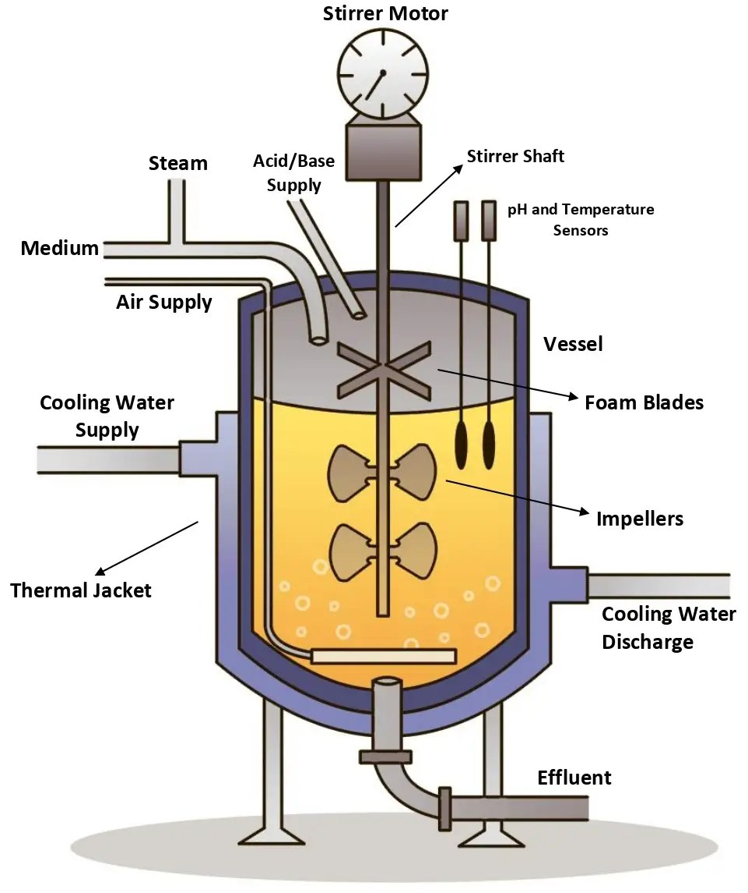
Bioreactors can extensively be defined as a vessel, sent to use the action of a natural impetus to accomplish an ideal synthetic change. Bioreactor for the most part gives a biomechanical and a biochemical climate that controls supplement and oxygen move to the cells and metabolic items from the cells . It could likewise be defined as a designed gadget intended for ideal development and metabolic movement of the organic entity through the activity of biocatalyst, protein or microorganisms and cells of creature or plants .The natural substance could be a natural or an inorganic synthetic compound or even complex material. The result of transformation might incorporate Pastry specialist's yeast, single cell protein, starter societies, creature feed and so forth or essential metabolites (for example amino acids, natural acids, nutrients, polysaccharides, ethanol, and so forth) and optional metabolites (for example anti-infection agents and so on.). Bioreactors can be utilized for bioconversion or biotransformation items (steroid biotransformation, L-sorbitol and so on), compounds (amylase, lipase, cellulase and so on), recombinant items (a few immunizations, chemicals, for example, insulin and development chemicals and so on.). Differed bioreactor plans have been created to take care of a wide exhibit of substrate items and biocatalysts (Prezi.com). Bioreactors vary from traditional compound reactors to the degree that they backing and control organic substances. As the organic entities are more delicate and less steady than synthetics, bioreactor frameworks should be sufficiently strong to give a more serious level of command over process upsets and pollutions .The bioreactor conditions ought to be positive for the living microorganisms to display their action under dened conditions. This requires a progression of extraordinary highlights in the response designing of biocatalytic cycles . Keeping up with the ideal organic action and limiting undesired exercises are sure difficulties as organic life forms, by their inclination, would transform and subsequently adjust natural chemistry of the response or actual properties of the creature . The term bioreactor is frequently utilized interchangeably with fermenter, which is a sort of bioreactor involving a living cell as the biocatalyst. Aging is alluded to the development of microorganisms on food, under either vigorous or anaerobic circumstances . Fermenters are comprised of glass, glass fascinating compounds, hardened steel, glass-lined steel, plastic tanks furnished with checks. These are utilized for the development of specific unadulterated societies of microscopic organisms, parasites and yeast, creation of chemicals and a wide range of matured items. The spans of the bioreactor can shift broadly from the microbial cell (few mm3) to shake ask (100-1000 ml) to lab scale fermenter (1 - 50 L) to direct even out (0.3 - 10 m3) to establish scale (2 - 500 m3) for huge volume modern applications . There are a few parts of biotechnological processes, which require exceptional consideration in planning a bioreactor. The response rate, cell development, and handle strength rely upon the natural circumstances in the bioreactor. The bioreactor's circumstances like gas (for example air, oxygen, nitrogen, carbon dioxide) ow rates, temperature, pH and broke down oxygen levels and disturbance speed/dissemination rate, froth creation, and so on should be firmly observed and controlled (Chen H.C. et.al, 2006).
The bioreactor gives a reasonable development climate to the development and generation of microbes and elevates the microorganisms to create the items individuals need. [ The fundamental rule of the Bioreactor is to make the gas very much scattered in the fluid stage so the materials can be blended all the more uniformly, and the lopsided other fluid can be equitably suspended or completely emulsified; so the strong particles can be equally suspended in the fluid phase. Fermentation tanks are continually being updated with the improvement of the times. From conventional maturation industry to current aging industry, and afterward to microbial designing. It has not just turned into a significant mainstay of the biotechnology business yet additionally has become much more impressive when joined with hereditary designing innovation. Later on, fermenters will be all the more generally utilized, and clients ought to apply them all the more sanely and scientifically. Biological Bioreactors are broadly utilized in dairy items, refreshment bioengineering, drug, almost negligible difference synthetic and different enterprises, and dairy items and cocktails.
Types of Fermentations Innovations
Innovations (new idea, device or process) are the application of better solutions that meet new requirements, in articulated needs or existing market needs. Fermentation types are classified into different classes:
- Based on various aspects like based on feeding substrate to fermenter.
- Based on need of supply of aeration
- Based on need of light etc.
- In view of taking care of substrate to fermenter: There is Cluster maturation; Continuous, fermentation and Took care of group aging are the key modes. In cluster maturation, each material for cycle of maturation including substrate, inoculum and all the interaction boundaries are set and filled in a fermenter and the interaction is set on and until the all out cycle reaches a conclusion neither substrate is added into fermenter nor item is removed from fermenter. It’s a shut framework. In nonstop maturation, the substrate is added persistently to the fermenter at a proper rate which keeps up with the organisms at logarithmic development stage and the items that are shaped are taken out all the while and here we find development related items. In took care of bunch mode we track down the two methods of tasks of clump and ceaseless modes, where substrate is added at fixed time spans during the maturation cycle .
- In light of need of supply of air circulation: There are vigorous aging and anaerobic maturation. Vigorous maturations: some huge scope aging cycles are done in presence of oxygen consuming circumstances where, the items present in fermenter are fomented with the assistance of fomenter and with the assistance of spargers by constraining cleaned air into the fermenter. There are a few kinds of Microbial cell vigorous bioreactors: CSTR (suspended cells, precisely unsettled) and Carrier fermenter (Suspended cells, pneumatically disturbed). Anaerobic maturation: aside from extreme need and presence of instigator and sparger to supply air circulation, rest of the design of the fermenter is basically as same as vigorous aging. Be that as it may, the presence of instigator is made impulse for the even circulation f temperature, pH, thickness, supplements and so on along the medium in the fermenter. Anaerobic bioreactions are utilized in applications, for example, ethanol creation, winemaking, lager preparing and wastewater treatment.
- In view of need of light: There are Photo fermentation (just photosynthetic microscopic organisms can go through) and Dull aging. Photofermentation is a course of change of natural substances to other utilizable energy intensifies following a progression of biochemical responses completed by a particular gathering of microbes named Photosynthetic microorganisms, which just returns within the sight of light. Dull maturation all around it is like that of photofermentation, yet needing light, dim maturation needn't bother with any light to start the responses and a broadened gathering of organisms are associated with dim maturation.

Bioreactor Design and Operations
Planning a bioreactor framework includes mechanical, electrical and bioprocess designing. The plan cycle ought to be coordinated so that frameworks can be utilized under the strictest of guidelines. Various new cycles are being created. One includes the utilization of disengaged compounds as opposed to entire cells to do a synthetic change. The benefit is that this interaction doesn't expect taking care of the exceptional necessities of living cells. Notwithstanding, proteins, as well, can go through changes and, in this way, require deciding the ideal circumstances to communicate their reactant action. An unexpected issue is that utilizing detached catalysts is oftentimes a costly endeavor for a solitary use application. Subsequently, long response times might be fundamental assuming expense factors require that costly catalysts should be utilized exclusively in low focuses. There are different drawbacks to their utilization, as well, for example, the need to eliminate the protein from the item once the ideal bioreaction has occurred. Immobilized chemical innovation is currently effectively settling a portion of these challenges. With the chemical immobilized in a bed or cylinder, the arrangement of substrate for change is then gone through for transformation to item. The item is persistently gathered as gushing from the bioreactor. The plan and activity of an immobilized framework is like that of cycles utilizing heterogeneous catalysis. Heterogeneous frameworks empower item recuperation at lower partition costs than do relating homogeneous frameworks. Gas-fluid strong reaching bioreactors have been examined with various immobilized catalyst frameworks. Chemical immobilization can take a wide range of structures and it has been concentrated on a scope of supports. The strategy utilized in a specific application relies upon the qualities of the compound, its framework, the substrate and the bioreactor liquid. Compounds might be upheld on a lattice type or customary mass_xfffe_transfer structure, exemplified in a film, upheld by gel or silica-determined frameworks, on macroporous particle trade pitches, or on other polymeric backings. One framework that presently utilizes this innovation is the stream bed bioreactor. Similar to specific kinds of biofilters generally utilized for emanation control, this framework includes a screen onto which the protein is stuck and immobilized, and through which the substrate arrangement is passed for transformation. Layers and empty strands have been pursued for immobilized bioreaction frameworks. A model is empty strands with enzymesincorporated into their walls. The dispersion of the substrate through the cylinder wall permits contact with the gelled chemical and transformation into item. Ensuing dispersion of the item gives the detachment important to its recuperation. Affected by the differential tension across the cylinder wall, the item courses through to within the cylinder, at last to be gathered at a multitube header.
A decent bioreactor configuration ought to address further developed efficiency, approval of wanted boundaries towards getting reliable and more excellent items in a financially savvy way. The plan and method of activity of a bioreactor relies upon the development of creature, ideal circumstances expected for wanted item arrangement, item esteem and its size of creation. The viable bioreactor is to control and decidedly inuence the natural response and should forestall unfamiliar pollution. The capital venture and working expense are likewise significant variables to be considered in bioreactor plan. During the maturation, monoseptic conditions, ideal blending in with low, uniform shear rates ought to be kept up with in the meantime. Aculture can be circulated air through by one, or a blend, of the accompanying strategies: surface air circulation, direct sparging, backhanded as well as film air circulation, medium perfusion, expanding the halfway strain of oxygen and expanding the air pressure . Satisfactory mass exchange (oxygen), heat move, obviously dened ow condition and suitable taking care of substrate keeping away from under or going too far would should be kept up with in a bioreactor. Appropriate inventory of suspension of solids, sufcient substrate, salts for sustenance, nutrients and so on ought to be guaranteed with water accessibility and oxygen (for high-impact processes). Gas development item and side-effect evacuation should be dealt with. The traits of a bioreactor ought to follow plan prerequisites, for example, sanitization, basic development and estimating, process control gadgets, directing methods, increase, exibility in tasks, similarity with upstream and downstream cycles, antifoaming measures and so on are fundamental variables .The essential elements of a bioreactor incorporate headspace volume, fomenter framework, oxygen conveyance framework, froth control, temperature and pH control framework, testing ports, cleaning and disinfection framework and lines for charging and purging the reactor . These are momentarily depicted as follows:
Headspace volume: The functioning volume of a bioreactor is the negligible part of its complete volume taken up by the medium, organisms, and gas bubbles and remaining volume is known as the headspace. By and large, the functioning volume will be ~70-80% of the absolute reactor volume. This, be that as it may, relies upon the pace of froth arrangement during the reactor .
Agitator framework comprises of an outer power drive, impeller and the bafes for extraordinary blending and expanded mass exchange rates through the mass fluid and air pocket limit layers. It gives sufficient shear conditions expected to separating of air pockets (srmuni.ac.in). Most microbial maturations utilize a Rushton turbine type impeller.
Air delivery system consists of a compressor, inlet air, sterilization system, air sparger and exit air sterilization system to avoid contamination.
Foam control framework is a fundamental component of bioreactor as unreasonable froth development prompts hindered air leave lters and develops tension in the reactor.
Temperature control framework includes temperature tests, heattransfer framework (coat, curl). Warming is given by electric radiators and steam created in boilers and cooling is given by cooling water delivered by cooling pinnacles or refrigerants like smelling salts.
pH control framework utilizes killing specialists to control pH; these ought to be non-destructive, non-harmful to cells when weakened in the medium. Sodium carbonate is usually utilized in limited scope bioreactor.
Sampling ports are used to inject nutrients, water, salts etc. in bioreactors and also for collecting samples .
Cleaning and sterilization framework is critical to stay away from pollution. Warm disinfection by steam is favored choice for practical and huge scope sanitizations of gear. Sanitization by compound substances is for the most part liked for heat-touchy hardware.
Charging & emptying lines are used for input of reactants and withdrawal of products in the bioreactor.
Types of Bioreactor System used in Bioprocess Technology
There are mainly three types of reactions involved in fermentation process i.e. batch, continuous and semi-continuous or fed-batch depending on the feeding strategy of the culture and the medium into the bioreactor . Customary bunch blended tank reactors (STRs) and constantly mixed tank reactors (CSTRs) have existed for quite a long time and are still broadly taken on in the synthetic and bioprocessing industry for creation because of their effortlessness). Other bioreactors, which have exceptional plan and functional qualities are photograph bioreactors, rotational drum reactors, fog bioreactor, film bioreactor, stuffed and uidized bed bioreactors, bubble section and carrier bioreactors and so on. These have been created to take care of utilization explicit cycles.
- Stirred Tank Bioreator
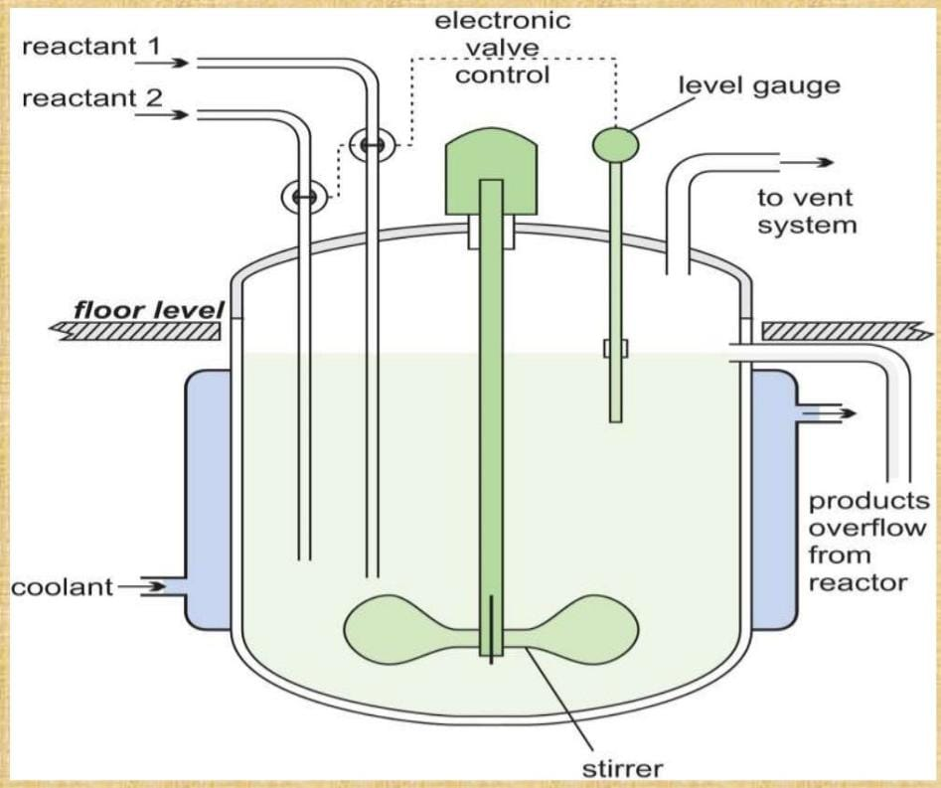
The Consistent Mixed Tank bioreactor is the old style plan nevertheless the most broadly utilized bioreactor. Most creation offices and FDA endorsed creation processes for biopharmaceuticals depend on the stirredtank bioreactors. The scale-up process from research facility to creation estimated frameworks is consequently founded on this designas well. This barrel shaped bioreactor utilizes a top or base mounted pivoting blending framework. The perspective firatio is typically between 3-5. . In Constant Mixed Tank Bioreactor, the items in the vessel never again differ with time, this applies to the hold up of miniature life forms and the convergence of the parts of the medium in the fermentor. Consistent state conditions can be accomplished by either Chemo static or Turbid static standards whichis used to control the stream rate. Both these strategies have been utilized practically speaking, however the previous is clearly the less difficult from each view point.

- Bubble Column Bioreactor
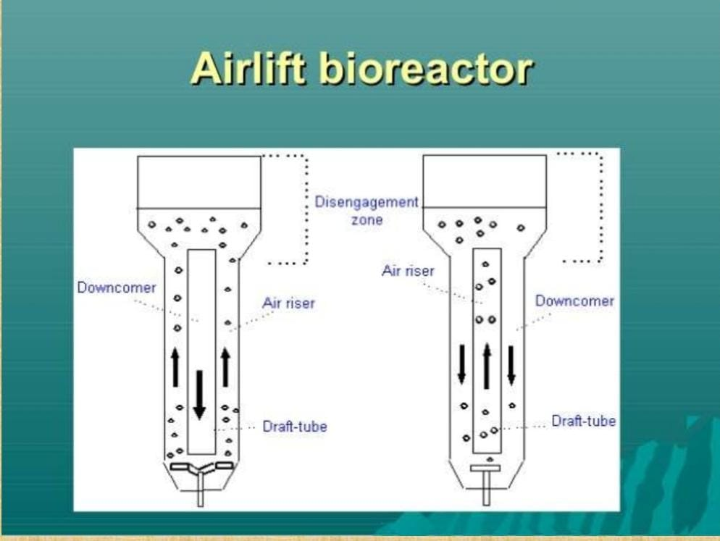
Bubble column bioreactors are tall column bioreactors where gas is introduced in the bottom section for mixing and aeration purposes. The vessel utilized for bubble segment bioreactors is generally barrel shaped with a viewpoint proportion of 4-6. Gas is sparged at the base through punctured lines or plates or metal permeable spargers.. O2 move, blending and other execution factors are affected fundamentally by gas stream rate and rheological properties of the fluid.Mixing and mass exchange can be improved by setting punctured plates or vertical confounds in the vessel.
- Air Lift Bioreactor
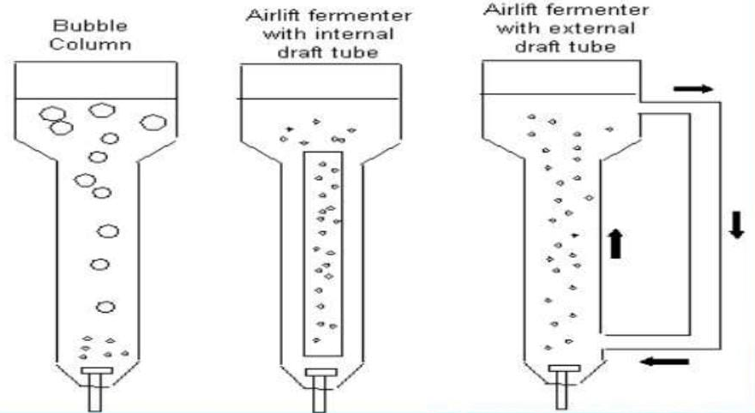
Air-lift bioreactors are similar to bubble column reactors, but differ by the fact that they contain a draft tube. draft tube is always an inner tube (this type of air-lift bioreactor is called “air-lift bioreactor with an internal loop”) or an external tube (called “air-lift bioreactor with an external loop”), which improves circulation and oxygen transfer and equalizes shear forces in the reactor. Inner circle transport bioreactor has a solitary compartment with a focal draft tube that makes inside fluid flow channels. These bioreactors are straightforward in plan, with volume and course at a decent rate for maturation. Outside circle
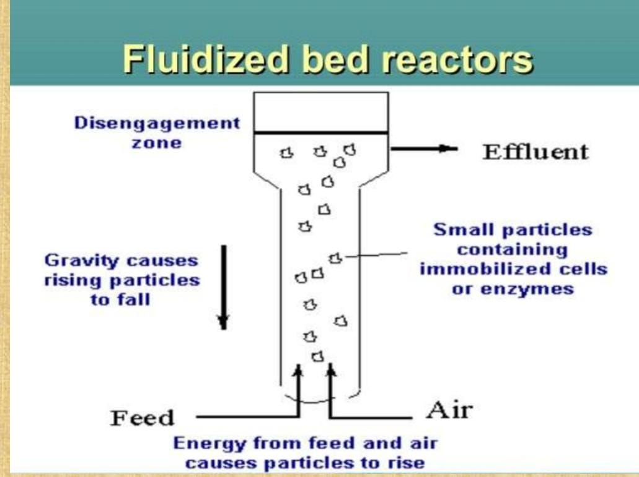
airdrop bioreactor has an outer circle so the fluid courses through isolated free channels. These reactors can be reasonably adjusted to suit the prerequisites of various maturations. As a general rule, the carrier bioreactors are more productive than bubble sections, especially for additional denser suspensions of microorganisms. This is essentially in light of the fact that in these bioreactors, the blending of the items is better contrasted with bubble sections.

- Fluidized Bed Bioreactor
Fluidized bed bioreactor is tantamount to bubble segment bioreactor aside from the top position is extended to lessen the speed of the liquid. The plan of the fluidized bioreactors (extended top and restricted response section) is with the end goal that the solids are held in the reactor while the fluid streams out. These bioreactors are reasonable for use to do responses including liquid suspended biocatalysts like immobilized chemicals, immobilized cells, and microbial herds.
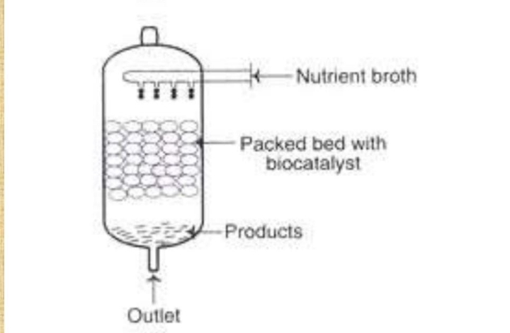
- This is a trait of beds of standard particles suspended in an up streaming fluid stream. On the off chance that an extra gas stage is involved, there is a propensity for the particles in the bed to turn out to be less equitably distributed.The fermentor comprises of an upward chamber with a viewpoint proportion is 10:1.At the highest point of the pinnacle a separator gave to prompt the gas bubbles delivered by the response, to blend and escape from the fluid phase.There are two significant highlights of the beds of blended molecule sizes:(i) The expansion in porosity from the base to the highest point of the bed, and(ii) The diminished molecule development when contrasted and beds containing particles of consistent size.

- Packed bed Bioreactor
A bed of solid particles, with biocatalysts on or within the matrix of solids, packed in a column constitutes a packed bed bioreactor. The solids utilized might be permeable or non-permeable gels, and they might be compressible or unbending in nature. A supplement stock streams ceaselessly over the immobilized biocatalyst. The items acquired in the stuffed bed bioreactor are delivered into the liquid and eliminated. While the progression of the liquid can be vertically or descending, down stream under gravity is liked.
The grouping of the supplements (and in this way the items shaped) can be expanded by expanding the stream pace of the supplement stock. In view of unfortunate blending, it is fairly challenging to control the pH of stuffed bed bioreactors by the expansion of corrosive or antacid. Notwithstanding, these bioreactors are liked for bioprocessing innovation including item hindered responses. The stuffed bed bioreactors don't permit aggregation of the items to any huge degree.

- Photo Bioreactors
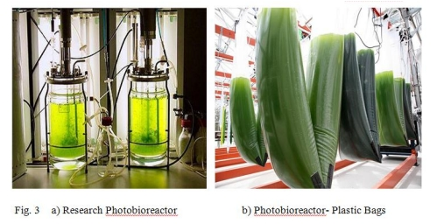
These are the bioreactors specialized for fermentation that can be carried out either by exposing to sunlight or artificial illumination. Since artificial illumination is expensive, only the outdoor photo-bioreactors are preferred. They are generally used for the cultivation of photosynthesizing organism (plants, algae and bacteria). Industrial scale photo bioreactors can also be open pond systems; as are more delicate to ecological impacts. They are comprised of glass or all the more normally straightforward plastic The variety of cylinders or level boards is light getting frameworks (sunlight based recipients). The way of life can be circled through the sun powered recipients by techniques, for example, utilizing radial siphons or transport siphons. It is fundamental that the cells are in constant course without shaping silt. Further satisfactory entrance of daylight ought to be kept up with. The cylinders ought to likewise be cooled to forestall climb in temperature. Photograph bioreactors are generally worked in a constant mode at a temperature in the scope of 25-40°C. Microalgae and Cyanobacteria are regularly utilized. The creatures develop during sunlight while the items are delivered during night. Certain significant mixtures are delivered by utilizing photograph bioreactors e.g., p carotene, asthaxanthin.

- Stem Cell Bioreactors
A new improvement is the undifferentiated organism bioreactor. Undeveloped cells are exceptionally engaging for regenerative medication, drug screening and biomedical applications. These cells have limitless self restoration limit and exceptional capacity to deliver mature cells with specific capabilities, like platelets, nerve cells or cardiovascular muscle. In any case, the real number of cells that can be gotten from accessible contributors is extremely low. One potential answer for the age of important quantities of cells is proportional up the way of life of these cells in vitro .A few joint exploration programs among industry and colleges are zeroing in on the improvement of undifferentiated organism bioreactor frameworks. Applikon Biotechnology has partaken in a few of these tasks and has fostered various fruitful plans .
- Hollow Fiber Catridges
Empty strands are little cylinder like channels fixed into a cartridge shell with the goal that cell culture medium siphoned through the finish of the cartridge will move through within the fiber, while the cells are become outwardly of the fiber. Empty filaments give an enormous measure of surface region in a little volume. Cells develop close by the strands at densities of more noteworthy than 1 × 108 for every ml. Empty fiber cell culture is the main means to culture cells at in vivo like cell densities. Cell culture at high densities can accomplish a 10 to 100 time’s higher convergence of emitted item contrasted and exemplary bunch processes .The versatility of the empty fiber framework is restricted, nonetheless, thus these kinds of bioreactor are for the most part utilized at the lab scale. More modest empty fiber bioreactors are frequently utilized for choice and enhancement of cell lineprior to moving forward to bigger cell refined frameworks (Gramer and Britton, 2000). As of late, empty fiber bioreactors have been tried as original stages for the business creation of high titer flu An infection.
- Rocking Bag Bioreactors
This framework depends on the shaking movement of the bioreactor holder to blend a fluid volume contained in aplastic pack. This sort of bioreactor is principally utilized for cell development, because of the low oxygen move rates and restricted cooling limit of such frameworks .In general, Bioreactors are the necessary part for the improvement of many new high-esteem items and the substitution of existing synthetic based ware processes. The appropriate choice and plan of the bioreactor will decide the ideal business bioprocess and the comparing capital venture. The bioreactor ought not be viewed as a detached unit, yet as a feature of an incorporated unit activity with both upstream (planning) and downstream (partitions) unit tasks.
Factors Affecting Bioreactor Performance
Several factors can affect bioreactor performance, including −
Oxygen Supply: Microorganisms require oxygen for breath and development. The bioreactor should give sufficient oxygen to help ideal development and production.There are various reports concentrating on the impacts of oxygen fixation or oxygen move on microbial maturation. Albeit the oxygen utilization of plant and creature cells is lower than that of microorganisms, restriction in oxygen move is likewise frequently aconstraining factor for cell societies at high cell thickness. Keeping a reasonable oxygen focus in the way of life stock is equallyimportant. The ideal DO focus might be different for cell development and item arrangement.
Nutrient Supply: Microorganisms require nutrients, such as carbon, nitrogen, and phosphorus, for growth and production. The bioreactor must provide adequate nutrients to support optimal growth and production.
Temperature: Microorganisms have an ideal temperature range for development and creation. The bioreactor should keep up with the temperature inside the ideal range.In a customary microbial maturation process, when the ideal not set in stone, it will ordinarily be kept up with all through the entire maturation process. This, nonetheless, may not generally be the situation for mammalian cell culture processes. In mammalian cell culture process, an enormous part of the protein item is combined during the postgrowth stage. Since the cell feasibility drops rapidly after the cell thickness approaches most extreme, the development of cells at diminished temperatures has been proposed to further develop bunch culture exhibitions. It has been reliably detailed that a lessening in development temperature prompts delayed culture suitability. Notwithstanding, a culture temperature under 37 °C ordinarily restrains cell development. An idea of two phases is hence proposed: a development stage and a creation stage. During the primary stage, the temperature leaning toward cell proliferation(e.g., 37 °C) is utilized to get a high cell thickness. In the subsequent stage, temperature is diminished to decelerate the drop in cell feasibility. This methodology, nonetheless, isn't clear as temperature is likewise an exceptionally basic boundary for protein blend. The impact of diminished temperature on heterologous protein creation of mammalian cells changed among various examinations. An ideal temperature exists for every individual cell culture process.
pH: Microorganisms have an ideal pH range for development and creation. The bioreactor should keep up with the pH inside the ideal range.Different organic frameworks have different ideal pH ranges. Most microorganisms develop best between pH 5 and 7. During maturation, pH can change. As the cells develop, metabolites are delivered into the medium; substrate utilization likewise causes pH change. Various scientists have examined the impact of pH on the development energy of microorganisms, enzymatic exercises, and item synthesis.In creature cell culture processes, culture pH is much of the time constrained by the expansion of a soluble reagent, like NaHCO3 or NaOH, to kill the acidic impacts of lactate and CO2 creation during cell development. One more plan for pH control in creature cell culture process is CO2 expansion. CO2 is added to a sodium bicarbonate-containing medium to control the pH. As a rule, utilizing CO2 to control pH is basic and productive. Notwithstanding, it might lead to the accompanying issues: in high-cell-thickness cell societies, a high pace of CO2 creation will restrict controllability by CO2 expansion, CO2 sparging can diminish the oxygen supply and upset DO control, and, on account of high lactate focuses or during times of quick lactate creation, the restricted buffering limit of the bicarbonate framework might become deficient. Creature cells are more delicate to changes in pH than microorganisms. A little change in culture pH can significantly impact the cell development, digestion, and creation union.
Agitation: Agitation provides mixing and aeration to the culture. The bioreactor must provide adequate agitation to prevent settling and maintain optimal oxygen transfer.
Sterility: Contamination can negatively impact bioreactor performance. The bioreactor must be maintained in a sterile environment to prevent contamination.
Product Toxicity: Some products can be toxic to microorganisms. The bioreactor must be designed to handle the toxic products and prevent their accumulation.
Mixing: In bioreactors, satisfactory blending is fundamental to guarantee the sufficient stockpile of supplements and to forestall the aggregation of poisonous metabolites. For a bioreactor intended for a suspension framework, blending time is a basic boundary to be examined and evaluated.It was found that the presence of biomass essentially diminished the blending productivity, even at low stock consistency levels. The greatness of this impact relies upon the sort of biomass and its focus and morphology. In aging or cell culture processes, blending has frequently been assessed regarding natural execution, for example, cell development rate and efficiency. The control of temperature, pH, and substrate fixation relies upon great blending in the bioreactor.Although it is not difficult to keep a homogeneous condition in a limited scale reactor, blending frequently becomes one of the imperatives during increase. In enormous scope bioreactors, unfortunate blending frequently prompts bothersome fixation slopes and a decline in mass exchange proficiency. In shear-delicate natural frameworks, for example, creature and plant cell societies and filamentous parasitic fermentation,mixing can't be upgraded just by expanding tumult power on the grounds that over the top unsettling can make mechanical harm living cells. There are various reports on the impact of blending on organic execution in the writing.

Applications
Industrial Biotechnology:
The field of modern biotechnology has been filling quickly lately, and bioreactors are a fundamental piece of this advancement. Bioreactors are particular vessels utilized in the creation of bioproducts like chemicals, anti-microbials, and biofuels. These gadgets give a controlled climate that permits microorganisms, plant cells, or creature cells to develop and duplicate in huge amounts. Along these lines, bioreactors have upset the development of numerous items that were beforehand hard to get on a modern scale.In modern biotechnology, bioreactors are utilized for many applications. For instance, they can be utilized to deliver biofuels from sustainable assets like corn, sugarcane, and green growth. They can likewise be utilized to fabricate chemicals that are utilized in food handling, materials, and paper creation. What's more, bioreactors are utilized to deliver anti-toxins and different medications that are utilized in medication. With the assistance of bioreactors, the modern creation of these items has become more productive and cost-effective.One of the benefits of utilizing bioreactors in modern biotechnology is that they give a profoundly controlled climate to the development of microorganisms. This implies that the circumstances inside the vessel can be upgraded for the development of explicit types of microorganisms or different organic entities. The utilization of bioreactors additionally lessens the gamble of defilement and guarantees that the end result is reliable with regards to quality.
Environmental Biotechnology:
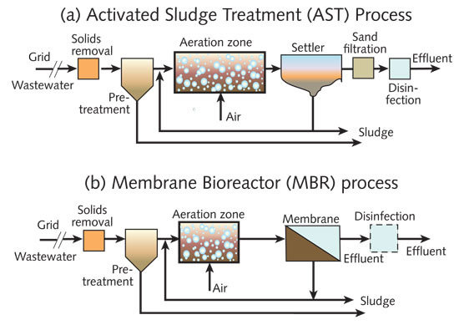
Ecological biotechnology is a quickly developing field that utilizes biotechnology to tackle natural issues. Ecological biotechnology is tied in with tracking down reasonable answers for natural challenges.One of the fundamental motivations behind ecological biotechnology is in the treatment of modern waste. Bioreactors are utilized to get squander by utilizing microorganisms separate poisons. As modern waste is a significant wellspring of contamination, it tends to be troublesome and costly to discard appropriately. Ecological biotechnology offers an economical answer for this issue by utilizing bioreactors to treat unsafe waste. The microorganisms in the bioreactor separate the toxins in the waste, transforming them into innocuous substances. This cycle is considerably more reasonable than conventional strategies for garbage removal, for example, landfilling or incineration.Biotechnology is likewise utilized in natural remediation, which alludes to the most common way of tidying up contaminated destinations. This can incorporate eliminating impurities from soil or groundwater, or tidying up spills and holes. Bioremediation is a kind of ecological remediation that utilizes microorganisms to separate contaminations. Bioremediation can be utilized to tidy up locales debased with oil, pesticides, or different poisons.
Cell Culture(Growing And Culturing Cells):
The utilization of bioreactors has been especially helpful in refined cells, including foundational microorganisms. Foundational microorganisms are a kind of cell that can separate into different sorts of particular cells in the body. The utilization of bioreactors is especially gainful in refined undifferentiated cells because of their remarkable necessities for development and separation. Bioreactors give an optimal climate to undifferentiated organisms to develop and separate, permitting scientists to deliver enormous amounts of these cells for use in exploration and helpful applications.One benefit of utilizing bioreactors for cell culture is that they consider more prominent command over the development climate. For example, the supplement supply can be definitively checked and changed in accordance with guarantee ideal development conditions for the cells .Moreover, bioreactors give a sterile climate, lessening the gamble of tainting, which is basic while refined stem cells.Another benefit of utilizing bioreactors is that they can be effortlessly increased or down in light of the requirements of the trial or application. This permits specialists to deliver huge amounts of cells for use in clinical preliminaries or different applications.
Tissue Engineering In Medical Applications:
Tissue designing is a field that has acquired huge consideration in the clinical business as of late. It includes the making of practical tissues and organs from cells, biomaterials, and biochemical factors.The interaction of tissue designing requires a controlled climate that can emulate the body’s normal circumstances to advance cell development and tissue development. This is where bioreactors come in. Bioreactors give the client a controlled climate for the development of cells or tissues. They are utilized widely in tissue designing to make utilitarian tissues for clinical applications.The utilization of bioreactors has opened up new roads in medication and medication testing, especially in the field of regenerative medication like transplantation. Bioreactors are currently being utilized to foster tissues like skin, bone, ligament, and organs like the liver and heart.Bioreactors offer a few benefits over customary tissue culture techniques. They give a more controlled climate, which considers better guideline of cell development and separation. Bioreactors additionally take into consideration the consistent inventory of supplements and oxygen to cells, which is basic for their development and endurance. By giving a more regular habitat to cell development, bioreactors can deliver tissues with further developed usefulness and better caliber, which blows away what we could do 100 years back.
Food And Beverage Industries:
Bioreactors have turned into a fundamental apparatus in the food and refreshment industry, especially in the assembling of aged items. Maturation is an interaction that has been utilized for a really long time to create different food and refreshment items like lager, wine, yogurt, cheddar, and bread. Nonetheless, the utilization of bioreactors has changed the manner in which individuals play out the maturation cycle. Bioreactors give a more exact and controlled climate for the particular microorganisms expected to develop and deliver the ideal item – cheddar, yogurt, etc.The utilization of bioreactors not just permits command over unambiguous temperatures, pH, and oxygen levels that are basic for microorganism development, yet the utilization of bioreactors fundamentally works on the productivity and consistency of the maturation cycle, bringing about better returns of excellent products.Bioreactors can be tweaked to suit various sorts of microorganisms and maturation processes. For instance, some bioreactors are intended for high-impact maturation while others are intended for anaerobic aging. The capacity to modify bioreactors has made it workable for food and drink makers to create new and imaginative items that were unrealistic previously.

Pharmaceutical Industry:
The medication business is conceivably of the principal business in the world, at risk for finding and conveying new drugs that can help a large number of people. One of the most fundamental pieces of this industry is the bioreactor, which expects a basic part in the formation of vaccinations, antibodies, and other medication products.Bioreactor holders are adequately colossal to allow the improvement of microorganisms, cells, and tissues while controlling the environment. In the medication business, these bioreactors grant specialists to convey gigantic measures of dynamic trimmings that can be used to make life-saving prescriptions like vaccinations and hostile to contamination specialists. Bioreactors are particularly huge in the advancement of antibodies Vaccinations are basic for thwarting the spread of powerful ailments, and they work by animating the body's safe structure to make antibodies that can avoid contaminations and minute living beings. To convey vaccinations, analysts need to turn out to be extraordinarily colossal measures of the diseases or microorganisms that cause the ailment in one restricted controlled environment. This is where bioreactor vessels end up being valuable. Another critical utilization of bioreactors in the medication business is in the improvement of antibodies. Antibodies are proteins that can see and bind to express particles, similar to those found on the external layer of illness cells or contaminations. Predominantly of these antibodies inside the bioreactor vessel, scientists can create drugs that can target and demolish harmful development cells or diseases without harming strong cells.Most lately, bioreactors were for the most part drawn in with the advancement of acquiring the SARS-CoV-2 vaccination. Bioreactors were used to cultivate two sorts of Coronavirus inoculations. The two associations that utilized bioreactors to encourage the SARS-CoV-2 neutralizer were Pfizer-BioNTech and Moderna.Stainless steel bioreactors are principal for creating gigantic measures of viral mRNA during the time spent developing first in class vaccinations like the SARS-CoV-2 immunizer. This kind of immune response can't be created in single-use bioreactors, as they can't offer the wide mixing and air dissemination expected for mRNA age and E.coli advancement.
Researching The Behavior Of Cells:
Bioreactors can assist with investigating the way of behaving of cells and figure out their metabolic pathways. By concentrating on these pathways, researchers can acquire understanding into how cells capability and what cycles are engaged with their development and development.Metabolic pathways are the series of compound responses that happen inside a cell to keep up with life. These responses are fundamental for processes like energy creation, protein combination, and the breakdown of side-effects. Bioreactors give a controlled climate to concentrating on these pathways by permitting scientists to control the circumstances inside the reactor. By controlling elements like temperature, pH, and supplement levels, researchers can see how cells answer changes in their current circumstance and how these progressions influence metabolic pathways.The conduct of cells is one more essential area of exploration that bioreactors work with. By establishing a climate that intently imitates the circumstances inside the body, bioreactors permit us to concentrate on how cells answer various upgrades. This data is especially important in drug improvement, as it can assist researchers with distinguishing expected focuses for new treatments. For instance, a bioreactor could be utilized to concentrate on how disease cells answer various centralizations of chemotherapy drugs, permitting specialists to distinguish the best treatment choices for patients.
Conclusion
Bioreactors have been utilized for a really long time to deliver a scope of helpful biomolecules and other high-esteem items. They give the valuable chance to screen and control natural circumstances ceaselessly all through the way of life/response period alongside the additional benet of keeping a shut framework. They are basic and vital piece of the improvement of many new cycles. The legitimate choice and plan of the bioreactor tending to high handle efciencies would decide the monetary reasonability of bioprocess and its comparing capital venture. Reasonable cycle designing computation strategies have been created to give a quantitative comprehension of mass exchange. Inventive systems for gas move, upkeep of pH, sensors and actuators identifying temperature, ideal taking care of and cell quantication and so on are significant instruments for process designing. As bioreactors are exceptionally subject to temperature control, it is crucial for select the reasonable temperature control gadget in view of the specic prerequisites of every application by computing the intensity load. The sort of bioreactor would rely on the morphology of cells, shear resistance, development and creation conduct of the way of life. In Indian setting, creating different bioprocesses with nitty gritty examinations on response energy; mass exchange and so on accepts basic significance particularly towards increasing the cycle by planning and manufacturing reasonable bioreactors. The specialization in process and mechanical plan and creation of bio-handling gear at the post-graduate biotechnology designing examinations would go quite far in creating native capacity of the country.

References
1) Chisti, Y. (2006). Bioreactor design. Basic Biotechnology: Third Edition, m, 181–200. https://doi.org/10.1017/CBO9780511802409.009
2) Ghosh, B., Bhattacharya, D., & Mukhopadhyay, M. (2018). Use of Fermentation Technology for Value-Added Industrial Research. Principles and Applications of Fermentation Technology, August, 141–161. https://doi.org/10.1002/9781119460381.ch8
3) Jaibiba, P., Vignesh, S. N., & Hariharan, S. (2020). Working principle of typical bioreactors. In Bioreactors. INC. https://doi.org/10.1016/B978-0-12-821264-6.00010-3
4)Mandenius, C.-F. (2016). Challenges for Bioreactor Design and Operation. Bioreactors, 1–34. https://doi.org/10.1002/9783527683369.ch1
5)Muniraj, I. K., Desikan, R., & Subburamu, K. (2019). Perspectives and Prospects of Fermentation Technology. Advances in Food Bioproducts and Bioprocessing Technologies, July 2020, 217–232. https://doi.org/10.1201/9780429331817-10
6)Kuila A and Sharma V (2018). In Principles and Applications of Fermentation Technology. https://doi.org/10.1002/9781119460381
7) Rose, A. H. (1985). Principles of fermentation technology. In Trends in Biotechnology (Vol. 3, Issue 9). https://doi.org/10.1016/0167-7799(85)90016-2
8) Singh, J., Kaushik, N., & Biswas, S. (2014). Bioreactors – Technology & Design Analysis. April 2016, 27–36.
9) Spier, M. R., Vandenberghe, L. P. D. S., Medeiros, A. B. P., & Soccol, C. R. (2011). Application of different types of bioreactors in bioprocesses. In Bioreactors: Design, Properties, and Applications (Issue February 2016).
10) Viswalingam, K., & Solomon, F. E. (2013). A Comparative Study on Bio Reactors. Indian Journal of Economics and Development, May, 104–107
11) Zhong, J. J. (2010). Recent advances in bioreactor engineering. Korean Journal of Chemical Engineering, 27(4), 1035–1041. https://doi.org/10.1007/s11814-010-0277-5.

