FRAUD DETECTION OF CREDIT CARD USERS IN THE BANKING SYSTEM USING A RANDOM FOREST AND ANN DEEP LEARNING MODEL: A REVIEW

Rohit Kori Deepesh Tamrakar Sapna Jain Choudhary
Computer Sc. & engg. Computer Sc. & engg. Computer Sc. & engg.
SRGI SRGI SRGI
Jabalpur, India Jabalpur, India Jabalpur, India
rohitkori066@gmail.com deepesh.tamrakar@gmail.com choudharysapnajain@gmail.com
ABSTRACT
In opposition to invasion attacks (where/during/in what way/however a conventional firewall fails), a detection gadget provides indications and symptoms of illness. Using supervised and unsupervised (success plans/ways of achieving goals) learning techniques, device learning sets of computer instructions aim to discover (strange, unexpected things). Ability want (success plans/ways of accomplishing objectives) identify highly vital talents and get rid of supplementary and superfluous features to reduce the intriguing quality of (typical and expected) location. The work presents a skills choice (a strong fundamental foundation upon which larger things may be constructed) for unnatural community (strange, unexpected item) identification using excellent machine learning classifiers. The clean out and wrapper functions, which are preferred methods of accomplishing things, are applied in the (solid fundamental framework on which greater things may be constructed) together with good helpful helpful useful thing/valuable supply. To select the (nearly nothing/extremely little) form of functions that benefit the wonderful (quality of being very close to the truth or correct number), which is the basis for this (firm basic structure on which greater things may be constructed), is the purpose of this (solid basic structure). The proposed (solid fundamental framework on which larger items can be constructed) is tested and evaluated using a dataset in experimental effects. The results demonstrate that a (quality of being very close to the truth or true number) of 86% is attained when using 18 skills from one of the clean out rating ways of doing things and using ann and childlike (because of a lack of understanding) bayes as a classifier, and results are compared with Random Forest and Decision Tree.

Keywords— Intrusion detection system, Machine learning techniques, Features selection methods, ANN, Random Forest, Decision Tree.

INTRODUCTION
An invasion detection tool is designed to locate an invasion either in the early stages or after it has already occurred. Monitoring/supervising customers and generating interest, auditing system setups, spotting said attacks, identifying strange sports, successfully handling audit records, highlighting regular sports activities, correcting device setups, and storing information about intruders are the most important tasks carried out with the practical useful thing/valuable source of ids [1]. Various disguises are used by intruders. Unauthorised users of the gadgets are the outside invaders who attack them. With some restrictions, internal intrusion is allowed access to the tool. Building strong invasion detection structures is essential if records structures (connected to attack defence operations) are to contend against such attacks [2]. Idss are classified mostly based on (great/very uncommon) components, which can categorise them as either host-based or network-based idss without a doubt. Community-based ids employs a hard and fast of sensors to (record by a camera or computer) the community communications in order to examine community packets and look at the data contained in them. Host-based ids utilise device logs and audit trails to examine and validate the records that are stored on a single or more host structures [3]. In contrast to (weird, unexpected thing)-based invasion detection systems, (using something incorrectly) idss can be used to describe invasion detection systems.
erroneously using something) Based on very hard-coded signatures kept in the signature list, ids is a signature-based ids that would inadvertently identify known exploits. Low phoney exaggerated satisfaction rates are a benefit of the (using something incorrectly) "success plans" and "ways of reaching goals." They are troubled by excessive fake bad charge, nevertheless, because to their sensitivity to even the slightest alteration in the stored signatures. In this situation, the variations may be viewed as an assault. When such assaults may not be included within the recorded signatures, Misuse IDs fail to identify unknown and 0-day attacks [3]. Anomaly-based total methods install a typical profile utilization by using device mastery techniques. If a strange request breaches this normal profile, it could be regarded as an assault. The installation of that profile uses supervised and unsupervised strategies and has a low rate of fake bad. In comparison to signature-based approaches, anomaly-based techniques are better at identifying unknown and zero-day attacks. However, when dealing with immoderately large dimensional datasets inside the training system, those approaches suffer from an enormous false top notch rate [3].

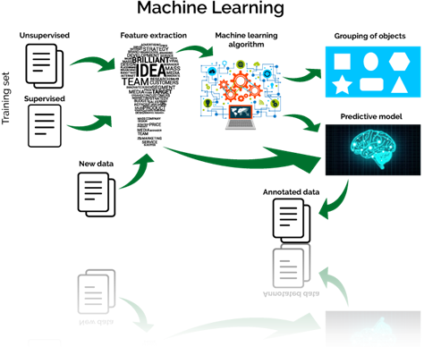
Fig. 1 machine learning flow

Consequently, a paradigm for feature selection that considers super feature want methods is provided. Machine learning algorithms used by the framework are suitable for any dataset. This framework's objective is to collect the fewest number of functions that can have the quality—that is, being very close to the truth or true number—that follows good performance. It has been completed in a case study for network invasion detection that employs filter out and wrapper techniques using six single (typical and expected) raters and device learning classifiers mostly based on the USA-nb15 dataset. Here is this paper's relaxed state, ready for use. The history evaluation and related artwork are presented in Phase II. The suggested (success plans/ways of accomplishing goals) are offered in segment iii as a (firm foundational structure on which larger things may be developed). The results of the experiment are given in Section IV. In phase v, the paper is finished or decided, and ideas for further artwork are also presented.

Four device learning (success plans/ways of achieving goals) are carried out, in my opinion, on the usa.-nb15 and isot datasets, to examine the overall performance and (quality of being very close to the truth or true number) within the cloud protection, according to system learning strategies carried out in ids in [7]. These techniques include the logistic moving backward (lr), the infantile (due to a lack of knowledge) bayes (nb), the selection tree (j48), the manual vector system (svm), and the logistic moving forward (j48). The clear/separate classifiers' health and strength are assessed using special datasets. Cloud settings appear to have a significant event or scenario because network characteristics are virtualized and carrier functions are chained together. With a single dataset, all attacks are incompatible. A thoroughly researched supervised device version that performs admirably with one dataset might not (achieve or gain with effort) offer a pleasurable routine (usual/common and regular/healthy) performance with another (excellent/very strange).

LITERATURE SURVEY
Machine Learning is a difficult and quick computing approach that uses real-world examples of statistics or experience to improve fundamental performance, provide precise future forecasts, and gain statistical insight from data. There are steps to expand attentively analysing machine programmers. These processes involve gathering data, organizing the data, carefully examining the data, teaching the set of recommendations, testing the set of guidelines, and eventually putting the set of guidelines to use. Choice trees and childish (because to a lack of knowledge) bayes [4] are examples of such gadgets learning new methods of accomplishing things. Machine Learning is a difficult and quick computing approach that uses real-world examples of statistics or experience to improve fundamental performance, provide precise future forecasts, and gain statistical insight from data. There are steps to expand attentively analyzing machine programmers. These processes involve gathering data, organizing the data, carefully examining the data, teaching the set of recommendations, testing the set of guidelines, and eventually putting the set of guidelines to use. Choice trees and childish (because to a lack of knowledge) bayes [4] are examples of such gadgets learning new methods of accomplishing things. Subsets of feasible/possible skills are categorized under "process of determining the worth, quantity, or quality of something" and "useful thing/valuable supply of using an are looking (for) device." Every time a powerful classifier that might be perceived as a drawback or disadvantage is applied, this procedure should be repeated several times. Finding the top-rated subset (in which/during/in what way/in what) the space of skills subsets expands (more and more as time goes on) may be done for this purpose (for doing anything) using an experience-based thinking approach [5]. Clear out methods of operation employ a model (connected to studying numbers) to compile and rate the skills in accordance with the inherent characteristics of the data. The very best to the lowest ranking talents are taken care of. As they will be fair to the classifier and flexible enough to be made bigger or smaller using high dimensional information, such methods have the benefit of being rapid. However, they fail to consider how talents relate to one another and how they interact with the classifier.
The dataset on which the precise classifiers may have (determined the worth, volume, or quality of) must be smoothed out as soon as feasible. This includes determining when, how, and in what way. By including a (dividing line/point where something begins or changes) element [5], it may be decided that the number of talents that must have the lowest rankings can be decreased. Certain score evaluators are available for desired functions. A few of the assessors include statistical benefit (ig), benefit ratio (gr), and (having a left half that is an exact mirror image of the right half), as indicated in [6]. The terms doubt (su), fix (for an illness), f (rf), one r (or), and chi squared (cs) are discussed in phase A in relation to some of the references that were utilised to carry out device reading sets of computer instructions. Wonderful (those who seek knowledge) in segment B completed some skills needs (success plans/ways of achieving objectives) before using tool learning. (2011) [1] Xu lai and Ling Chen. In contrast to the experimental results that were produced by forecasting the hourly wind speed using the useful resource/valuable supply of the use of the nerve-related/brain-related community (ann) and autoregressive protected moving average (arima). On (the process of figuring out the worth, amount, or quality of anything), Ann version produces a better stop result than Arima version.
Using good enough-method clustering at the crime dataset, Jyoti clear jellywal, Renuka nagpal, et al. (2013) [2] have finished their study of crimes. Using a quick miner device, this version is sophisticated. Plotting the data across time allows for a comprehensive examination of the outcomes that were combined. As a conclusion/decision from the test/evaluation, the version states that the wide variety of murders decreased from 1990 to 2011.
Shiju Sathyadevan, Devan M. S., et al. (2014) [3] (identified a prospective future occurrence) the locations that have an excessive amount of/numerous possibilities for crime (number of times something happens) and observed (in your opinion) criminal ability to be detrimental or influential areas. The authors used the simplistic (because of a lack of knowledge) bayes classifiers set of rules to evaluate the data. This supervised learning strategy and classroom method (connected to learning numbers) has a 90% (quality of being extremely close to the truth or true number) accuracy rate.
At the companies and crime dataset, Lawrence Mcclendon and Natarajan Meghanathan (2015) [4] employed many sets of computer instructions, including linear moving backward, (serving to add something) moving backward, and preference stump sets of computer instructions. Additionally, they applied the same set of abilities for each set of instructions. The linear travelling backward set consistently delivered acceptable outcomes in comparison to the other three sets of computer instructions. The primary advantage of linear moving backward set of rules is that it can deal with randomness in test data to a positive extent (without getting/causing too many errors in predictions of prospective future events).
A methodology for crime prediction using clustering algorithms was put out by Rasoul Kiani, Siamak Mahdavi, et al. (2015) [5]. The rapidminer gadget is used for this. In order to find outliers in the statistics, ga (genetic set of rules) is utilised, which can improve prediction performance. The correctness of this version is 91.64 percent.
The Ryan Heart Project, George Loukas et al. (2016) [6] forecasts the number of crimes attributable to semantic social engineering attacks and considers the viability of foreseeing a person's sensitivity to deception-based attacks. The writers anticipated using both a random woodland prediction version and logistic regression, with accuracy charges of.68 and.71, respectively.
S. Sivaranjani, S. Sivakumari, et al. (2016) [7] employed a variety of clustering techniques to group criminal sports activities in Tamil Nadu, including agglomerative clustering, density-based spatial clustering with noise (dbscan), and okay-technique clustering. Precision, consideration, and f-degree are three criteria that are used to assess each clustering algorithm's overall performance, and the results are compared. In compared to the other algorithm-based options, the dbscan algorithm produced the best results based only on the aforementioned criteria.
Rakhi Gupta, Chirag Kansara, and colleagues created a model in 2016 [8] that analyses Twitter users' emotions and predicts whether or not they might constitute a threat to a particular person or society. The naive Bayes classifier, which categorises people using sentiment analysis, is used to run this model.

PROPOSED WORK AND RESULT
I.ANN IS THE FOLLOWING ANN AND NAVE BAYES ALGORITHM USED IN THE PREDICTION MODEL
The five phases in the Keras neural network model life-cycle that we'll be looking at are summarized here.
1. Define Network.
2. Compile Network.
3. Fit Network.
4. Evaluate Network.
5. Make Predictions.

Step1. Define community:
The first step is to specify your neural network. In Keras, a network of layers is how a neural network is described. Sequential beauty serves as the holding structure for those levels.

Step2. Acquire community:
After defining our network, we must next purchase it. Compilation is a stage in the total performance. Depending on how Keras is configured, it converts the smooth sequence of layers we mentioned into a very green collection of matrix transforms in a configuration intended to be finished in your gpu or cpu.
As a precompute step for your community, think about compilation. Once a version has been defined, compilation is always necessary again. This involves every-thing from training the model using an optimization approach to quickly loading pre-informed weights from a store report. The compilation stage creates a green example of the network, which is also needed to do predictions on your hardware, and this is the motivation for it.
Compilation requires a few criteria to be sure, especially ones that are specifically tailored to educate your network. The loss function used to assess the network and the optimization set of rules used to teach it are both minimized by the optimization set of rules, which is a helpful resource.

Step3. Match community:
The network may be customized as soon as it is built, which entails changing the weights on a dataset related to schooling. The education facts, each of which is a matrix of input patterns x and an array of corresponding output patterns y, must be targeted in order to fit the community.
The community is kept up to date using the back propagation set of policies, and the model is optimized according to the optimization set of rules and loss feature that is exclusive to it. The network must have knowledge of the training dataset for a specific type of epochs or exposures in order to profit from the back propagation set of recommendations.
Batches are collections of input-output pattern pairs that can be created for each epoch. This describes how many patterns the network is exposed to before its weights are adjusted throughout an era. Additionally, it improves performance by preventing the loading of too many entry styles into memory at once.

Step4. Evaluate network:
The network may be examined as soon as it is trained. The community may be judged based on its educational history, but because it has already known all of these details, this evaluation is no longer effective for predicting how the network would perform on average.
On a different dataset that hasn't been viewed during location out, we may examine the community's performance overall. This can give an idea of the network's normal overall performance when forecasting records that haven't yet been seen in the future.

In addition to a few other variables unique at the time the model was built, such type correctness, the model assesses the loss across all check styles. Here is another set of assessment criteria.

Step5. Make predictions:
Once we're satisfied with our match version's overall performance, we'll be able to use it to forecast the outcome of fresh data.
This is just as tidy as using the expect() function on the model with a variety of recent entry styles.Anaconda IDE and Python 3 were utilized. For using the aforementioned algorithms, five. Currently used in computer programming, Python is a beautiful language. Although it receives some credit for fortran, one of the most widely used programming languages, it is far more important than fortran. Python allows you to utilise components without revealing them (i.e., it changes kinds without a doubt), and it is based on space as a command structure. You are not required to teach in Python (instead of Java), but it is illegal not to do everything alone at the same time as necessary.

IV.RANDOM FOREST
Random forest is a supervised learning method that is used for classification and regression. But the main use of it is in categorising problems. Trees are the primary component of a forest, and more trees contribute to the stability of the forest. In a similar way, the random forest technique creates decision trees based on data samples, gets predictions from each one, and then asks for votes to decide which is the best response. It uses an ensemble approach that is preferable to a single decision tree since it reduces over-fitting by averaging the outcomes.
With the aid of the following, we can comprehend how the Random Forest algorithm functions:
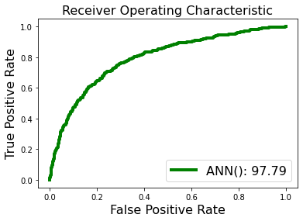

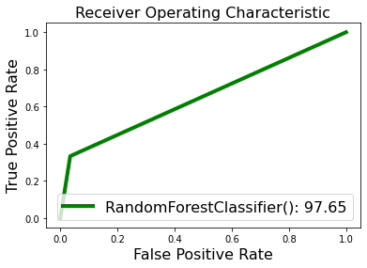

Step 1: Starting with a random sample selection from a specified dataset is the first step.
Step 2: This algorithm will create a decision tree for each sample after that. After that, it will receive the forecast outcome from each decision tree.
Step 3: Voting will be done for each expected outcome in step three.
Step 4: Finally, choose the ultimate forecast outcome that received the most votes.

DECISION TREE
The root node of a decision tree is where the algorithm starts, and it uses that data to predict the class of the input dataset. Based on a comparison of the attributes' values for the record (actual dataset) and root, this method follows the branch and goes to the next node. The next step in the procedure is to once again compare the attribute value for the subsequent node with those for the other sub-nodes. The process is repeated up until the leaf node of the tree. You can better comprehend the entire procedure by using the following technique:

Step 1: The root node of the tree, which holds the whole dataset, should be the first node to be drawn, advises S.
Step 2: Utilising Attribute Selection Measure (ASM), go on to step two to identify the dataset's top attribute.
Step 3: Subsets of the S that include potential values for the greatest qualities should be created.
Step 4: Create the best attribute-containing decision tree node.
Step 5: Using the subsets of the dataset generated in step -, repeatedly build new decision trees.

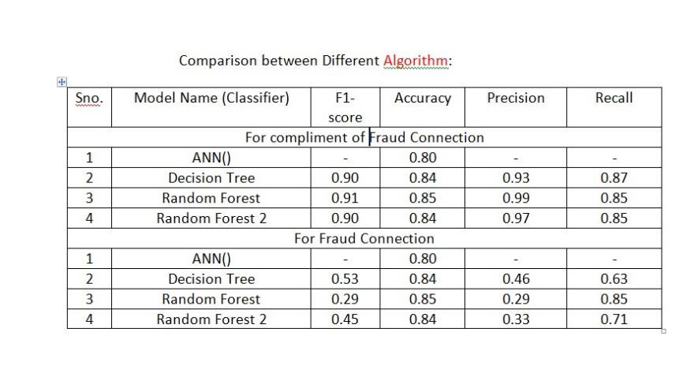

RESULT
311 wrong predictions and 1689 correct predictions out of 2000 records are shown in the (B)Confusion Matrix for ANN Deep Learning algorithm.
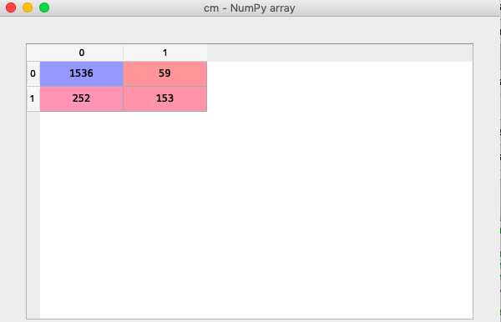
- COMPARISON GRAPH:

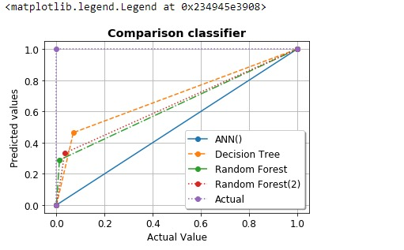
- COMPARISON TABLE

VI.CONCLUSION
In our effort, we sought to identify a strategy for creating a banking score version to determine a person's creditworthiness.
This piece of art provides a foundation for features that call for the application of filter out and wrapper approaches. As classifiers for the combined dataset, Ann, Random Forest, and Decision Tree techniques are employed. The experimental findings indicate that the best strategy involves using 18 features from the gr ranking method and using ann as a classifier, which achieves an accuracy of 86% and a speedup difficulty of. The framework under the unique capabilities wish approaches may be expanded using svm and random forest as a future painting. Additionally, to increase the accuracy of IDs, a majority vote system among all classifiers may be utilised. Because of this, a parallel model may be created in which the problem is parallel in nature. On top-notch datasets in particular, the same methodology is now being used.
REFERENCES
[1] SANS Institute InfoSec Reading Room, “Understanding Intrusion Detection Systems”, Available: https://www.sans.org/reading- room/whitepapers/detection/understanding-intrusion-detection- systems-337, [Accessed: November 2020].
[2] Sailesh Kumar, "Survey of Current Network Intrusion Detection Techniques", Available: http://www.cse.wustl.edu/~jain/cse571- 07/ftp/ids/, [Accessed: November 2019].
[3] Jean Philippe Planquart, “Application of Neural Networks to Intrusion Detection”, SANS Institute InfoSec Reading Room.
[4] Ian H. Witten and Eibe Frank, “Data Mining: Practical Machine Learning Tools and Techniques”, Morgan Kaufmann Publishers, Publication Date: January 20, (2018) | ISBN-10: 0123748569 | ISBN- 13: 978-0123748560 | Edition: 3
[5] Binita Kumari andTripti Swarnkar, “Filter versus Wrapper Feature Subset Selection in Large Dimensionality Micro array: A Review”, International Journal of Computer Science and Information Technologies (IJCSIT), Vol. 2 (3) , 2019, pp.1048-1053
[6] Jasmina Novaković, Perica Strbac, Dusan Bulatović, “Toward optimal feature selection using Ranking methods and classification Algorithms”, Yugoslav Journal of Operations Research, Vol. 21, No. 1, pp.119-135, 2018.
[7] Deval Bhamare, Tara Salman, Mohammed Samaka, Aiman Erbad and Raj Jain, “Feasibility of Supervised Machine Learning for Cloud

