Dr. Harmeet Kaur

Principal

SGGS College of Education

Beghpur Kamlooh,Mukerian

**A Study Occupational Stress and Job Burnout among Primary School Teachers of Hoshiarpur District**

**Key words: Occupational stress, Job Burnout, Primary Teachers**

**INTRODUCTION**

The Globalization and Privatization of the education system in different countries and in India forced the education system especially school education, to be more competent so as to produce the betterment in knowledge, skills and competencies which are essential for survival. In this tune, the Indian education system has under gone rapid changes in terms of expansion, privatization, marketization, curricular reforms and pedagogical innovations. These changes have challenged the school education in terms of quality education, shortage of teachers of high caliber, ineffective teaching methods, outmoded curricular and evaluation system, lack of appropriate reading material, poor infrastructure facilities etc. Further, the increasing role played by latest knowledge, skills, innovations, and research in economic growth and development, the emergence of the information society and the need for quality education results in increased pressure on education system and teachers in particular. These factors in - tern adversely affects the quality of our education system and creates various stressors and strain in teachers which further deteriorates their performance. Continues stress leads to strain which in turn make the individual or teachers to burnout in their workplace.

**Occupational stress** is stress related to one's job. Occupational stress often stems from unexpected responsibilities and pressures that do not align with a person's knowledge, skills, or expectations, inhibiting one's ability to cope. Occupational stress can increase when workers do not feel supported by supervisors or colleagues, or feel as if they have little control over work processes.

Stress is defined in terms of its physical and physiological effects on a person, and can be a mental, physical or emotional strain. It can also be a tension or a situation or factor that can cause stress. The concept of stress was first introduced in the Life sciences by Hans Selye in 1936. It was derived from the Latin word ‘stringere’; it meant the experience of physical hardship, starvation, torture and pain. Hans Selye, 1974 defined stress as “the non-specific response of the body to any demand placed upon it”.

**JOB BURNOUT**

Psychology today describes burnout as "a state of chronic stress that leads to physical and emotional exhaustion, cynicism, detachment, and feelings of ineffectiveness and lack of accomplishment." Teachers are usually high achievers who like to work hard and are always looking for ways to improve. These traits are commendable but can mean that educators fall prey to perfectionism and don't leave enough time for rest and recuperation.

**STATEMENT OF THE PROBLEM**

**A Study Occupational Stress and Job Burnout among Primary School Teachers of Hoshiarpur District**

**OBJECTIVES OF THE STUDY**

The present study was based on the following objectives:

* + - 1. To compare the level of occupational stress among male and female teachers of private primary schools.
      2. To compare the level of occupational stress among rural and urban teachers of private primary schools.
      3. To compare the level of occupational stress among rural and urban male teachers of private primary school.
      4. To compare the level of occupational stress among rural and urban female teachers of private primary school.
      5. To compare the level of job burnout among rural and urban teachers of private primary schools.
      6. To compare the level of job burnout among male and female teachers of private primary schools.
      7. To compare the level of job burnout among rural and urban male teachers of private primary schools.
      8. To compare the level of job burnout among rural and urban female teachers of private primary school.

**HYPOTHESES OF THE STUDY**

The present study was based on the following hypotheses:

1. There will be no significant difference of occupational stress among male and female teachers of private primary schools.
2. There will be no significant difference of occupational stress among rural and urban teachers of private primary schools.
3. There will be no significant difference of occupational stress among rural and urban male teachers of private primary schools.
4. There will be no significant difference of occupational stress among rural and urban female teachers of private primary schools.
5. There will be no significant difference of job burnout among rural and urban teachers of private primary schools.
6. There will be no significant difference of job burnout among male and female teachers of private primary schools.
7. There will be no significant difference of job burnout among rural and urban male teachers of private primary schools.
8. There will be no significant difference of job burnout among rural and urban female teachers of private primary schools.

**RESEARCH METHODOLOGY**

**Hypotheses 1**

**There will be no significant difference of occupational stress among male and female eachers of private primary schools.**

**Mean, Standard deviation and t-value of occupational stress among male and female teachers of private primary schools**

|  |  |  |  |  |  |  |
| --- | --- | --- | --- | --- | --- | --- |
| **Occupational Stress** | **Gender** | **N** | **Mean** | **Standard deviation** | **t-value** | **Remarks** |
| **Female** | 100 | 110.73 | 9.59 | 2.846 | Significant |
| **Male** | 100 | 114.43 | 8.77 |

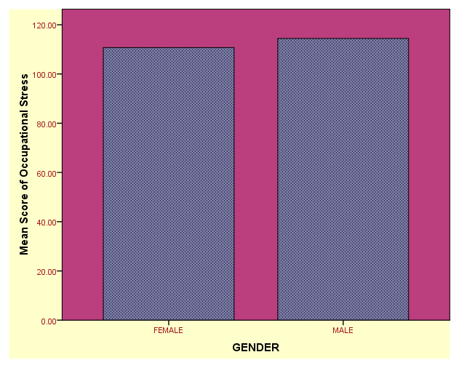

**Hypothesis 2**

**There will be no significant difference of occupational stress among rural and urban teachers of private primary schools**.

**Mean, Standard deviation and t-value of occupational stress among rural and urban teachers of private primary schools**

|  |  |  |  |  |  |  |
| --- | --- | --- | --- | --- | --- | --- |
| **Occupational Stress** | **Area** | **N** | **Mean** | **Standard deviation** | **t-value** | **Remarks** |
| **RURAL** | 100 | 112.79 | 9.37 | 0.317 | Not  Significant |
| **URBAN** | 100 | 112.37 | 9.37 |

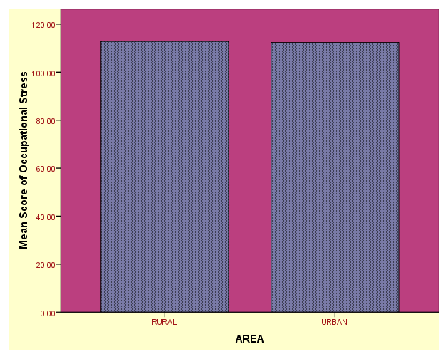

**Hypothesis 3**

**There will be no significant difference of occupational stress among rural and urban male teachers of private primary schools**.

**Mean, Standard deviation and t-value of occupational stress among rural and urban male teachers of private primary schools**

|  |  |  |  |  |  |  |
| --- | --- | --- | --- | --- | --- | --- |
| **Occupational Stress(male)** | **AREA** | **N** | **Mean** | **Standard deviation** | **t-value** | **Remarks** |
| RURAL | 50 | 115.40 | 9.36 | 1.107 | Not  Significant |
| URBAN | 50 | 113.46 | 8.11 |

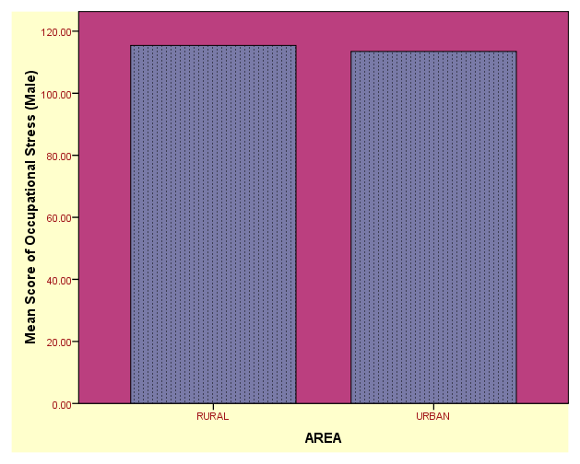

**Hypothesis 4**

**There will be no significant difference of occupational stress among rural and urban female teachers of private primary schools**.

**Mean, Standard deviation and t-value of occupational stress among rural and urban female teachers of primary schools.**

|  |  |  |  |  |  |  |
| --- | --- | --- | --- | --- | --- | --- |
| **Occupational**  **Stress (Female)** | **AREA** | **N** | **Mean** | **Standard deviation** | **t-value** | **Remarks** |
| **RURAL** | 50 | 110.18 | 8.71 | 0.571 | Not  Significant |
| **URBAN** | 50 | 111.28 | 10.46 |

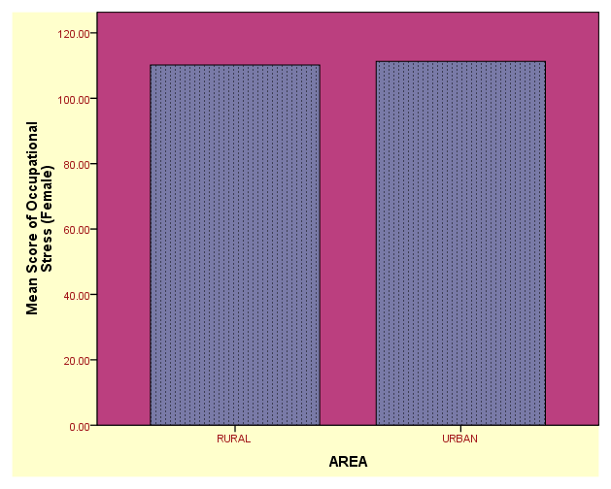

**Hypothesis 5**

**There will be no significant difference of job burnout among rural and urban teachers of private primary schools.**

**Mean, Standard deviation and t-value of job burnout among rural and urban teachers of private primary schools**

|  |  |  |  |  |  |  |
| --- | --- | --- | --- | --- | --- | --- |
| **Job Burnout** | **AREA** | **N** | **Mean** | **Standard deviation** | **t-value** | **Remarks** |
| **RURAL** | 100 | 91.62 | 13.12 | 3.658 | Significant |
| **URBAN** | 100 | 86.04 | 7.77 |

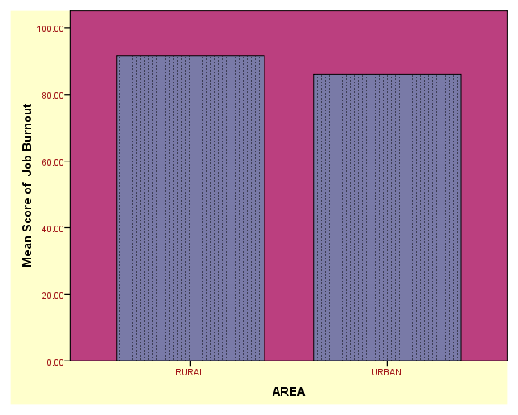

**Hypothesis 6**

**There will be no significant difference of job burnout among male and female teachers of private primary schools.**

**Mean, Standard deviation and t-value of job burnout among male and female teachers of private primary schools**

|  |  |  |  |  |  |  |
| --- | --- | --- | --- | --- | --- | --- |
| **Job Burnout** | **Group** | **N** | **Mean** | **Standard deviation** | **t-value** | **Remarks** |
| **FEMALE** | 100 | 88.42 | 11.46 | 0.521 | Not Significant |
| **MALE** | 100 | 89.24 | 10.80 |

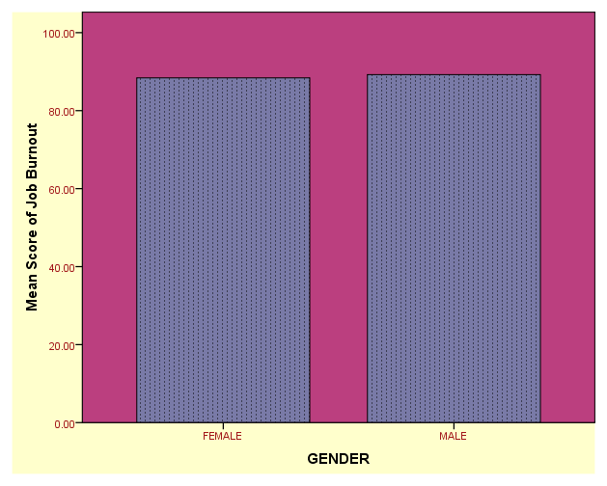

**Hypothesis 7**

**There will be no significant difference of job burnout among rural and urban male teachers of private primary schools**.

**Mean, Standard deviation and t-value of job burnout among rural and urban male teachers of private primary schools**

|  |  |  |  |  |  |  |
| --- | --- | --- | --- | --- | --- | --- |
| **Job**  **Burnout (male)** | **AREA** | **N** | **Mean** | **Standard deviation** | **t-value** | **Remarks** |
| **RURAL** | 50 | 92.18 | 13.02 | 2.814 | Significant |
| **URBAN** | 50 | 86.30 | 6.97 |

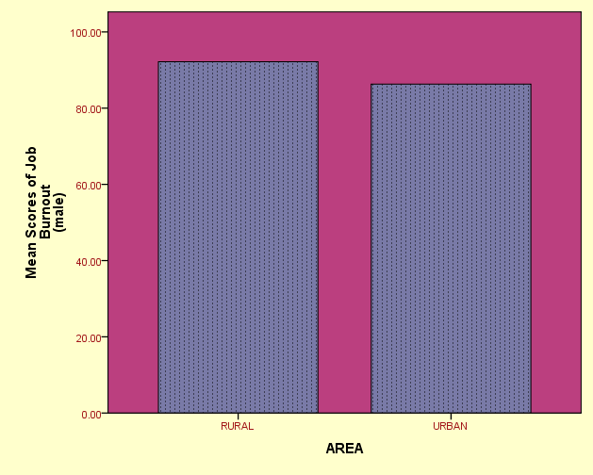

**Hypothesis 8**

**There will be no significant difference of job burnout among rural and urban female teachers of private primary schools**.

Mean, Standard deviation and t-value of job burnout among rural and urban female teachers of primary schools

|  |  |  |  |  |  |  |
| --- | --- | --- | --- | --- | --- | --- |
| **Job**  **Burnout**  **(female)** | **AREA** | **N** | **Mean** | **Standard deviation** | **t-value** | **Remarks** |
| **RURAL** | 50 | 91.06 | 13.33 | 2.356 | Significant |
| **URBAN** | 50 | 85.78 | 8.56 |

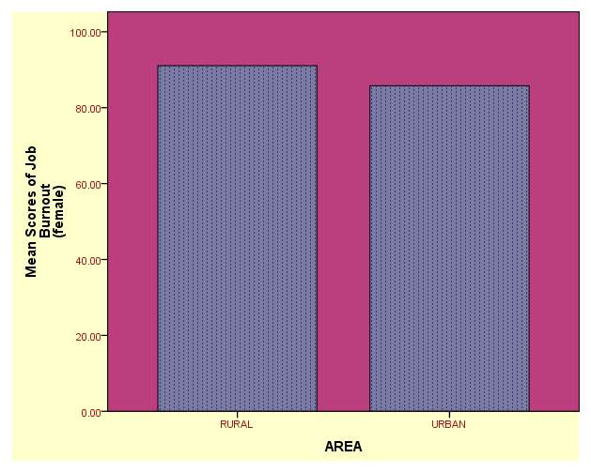

**REFERENCES**

**Agarwal, G. (2018).** Demographical study on occupational stress among faculty members with special reference to business schools in India. *International Journal of Business Studies*, 3(4), 74.

**Arora, S. (2013).** Occupational stress and health among teacher educators. *International Journal of Advanced Research in Management and Social Sciences*, 2(8), 1- 13.

**Chopra, R., & Gartia, R. (2009).** Accountability of secondary school teachers in relation to their occupational stress, *Edu Tracks*,8(7), 41 – 43.

**Droogenbroeck, F. V., Spruyt, B., & Vanroelen, C. (2014).** Burnout among senior teachers: investigating the role of workload and interpersonal relationships at work. *Teaching and Teacher Education*,43,99 – 109.

**Dagar, N.,& Mathur, M.,(2016).** Burnout among school teachers of Haryana, *International Journal of Educational Planning & Administration.*6(1),45-48

**Heinemann, L.V., & Heinemann, T. (2017).** Burnout research: Emergence and scientific investigation of a contested diagnosis. *SAGE Open*, 1 – 12.

**Kamboj, M., (2017).** A Study of occupational stress among female teachers working in secondary school in Rewa district, Madhya Pradesh, *International Journal of Advanced Educational Research,* 2(3), 62-65.

**Kaur. S. (2011)** Comparative Study of Occupational Stress among Teachers of Private and Govt. School in Relation to their Age, Gender and Teaching Experience, Research Scholar, Singhania University, Rajasthan, India. *International Journal of Educational Planning & Administration,* 1(2), 151-160.

**Koutsimani, P., Montgomery, A & Georganta, k. (2019)** The Relationship Between Burnout, Depression, and Anxiety: A Systematic Review and Meta-Analysis, 10: 284.

**Kwug, S.H. & Kim, M. H. (2009)**. The study on the effects of organizational members’ job burnout. *Journal of Business and Economic Research*,7(7), 63 – 64.

**Martin, V. P. (2007).***A study of job satisfaction in relation to occupational stress of professionals.* (Ph.D). Dr. MGR Educational and Research Institute (Deemed University). Maduravoyal. Chennai. India.

**Mohajan, H.K. (2012).** The occupation stress and risk of it among the employees, *International journal of Mainstream Social Science*,2(2), 17-34.

**Nettam, V., Mandava, P., Singruja, G. S., Ganupapanta, V. R., Yelchuri, H., & Peddu, R. (2018).** Comparision of stress, burnout and its association among post graduate orthodontic and undergraduate students in India. *Indian Journal of Dental Sciences*, 10(2), 66 – 71.