Interfacial tension on molecular interaction in n-ethyl-2-pyrrolidone with ethanolamine/ diethanolamine and triethanolamine systems

Anjali Awasthi*

Department of Physics, Babu Banarasi Das University, Lucknow-226 028, U. P., India
*E. mail address: anjaliawasthi1883@gmail.com

Abstract:
The surface tension of binary mixtures of n-ethyl-2-pyrrolidone with ethanolamine, diethanolamine, and triethanolamine was calculated using theoretical models including the Sudgen method, Hildebrand-Scott theories for ideal solutions (HSIS), extensions of Guggenheim's equation (HSEG), Volume Fraction Statistics, Auerbach relation, and Sanchez method at temperatures ranging from 293.15 K to 313.15 K. An equation based on the Redlich-Kister polynomial was used to correlate the excess surface tension using theoretical models. In addition, surface tension measurements were used to determine surface entropy, surface enthalpy, and lyophobicity factor.

Keywords: Surface tension; n-ethyl-2-pyrrolidone; alkanolamines; models; lyophobicity

1. Introduction
Interfaces play an apparent role in every aspect of our lives. The development in the surface chemistry domain has produced innumerable possibilities across a wide range of fields, such as pharmaceuticals, biotechnology, and biomedical science, where interfaces play a critical role. Understanding surface tension is crucial for overcoming obstacles and creating intriguing, better-performing goods. In a specific dimension, surface characteristics and their adaptation are crucial because surface science addresses chemical reactions at an interface between two phases. This paper discusses how surface tension is used to investigate intermolecular interactions existing between solute-solute, solute-solvent and solvent-solvent molecules in binary mixtures of n-ethyl-2-pyrrolidone with ethanolamine/ diethanolamine and triethanolamine.
There is typically a significant distinction in compositions across the liquid's bulk region and the surface region owing to an enrichment of molecules with lower surface tension in the surface region. Surface enrichment is exposed to the relationship between the geometry, dimension, orientation, and length of the chain of the molecule [1-3]. For the absorption of carbon dioxide during the gas purification process, N-ethyl-2-pyrrolidone is an appropriate solvent. The use of tertiary amines, such as ethanolamine, diethanolamine, and triethanolamine, to remove carbon dioxide and acid gases is made possible by their high absorption capacity and little power regeneration costs [4, 5].
As a follow-up of our prior studies [6–15], this paper states the surface tension values of binary blends of n-ethyl-2-pyrrolidone with ethanolamine, diethanolamine, and triethanolamine using a variety of theoretical models, including the Sudgen method [16], Hildebrand-Scott theories for ideal solutions (HSIS), and Hildebrand-Scott theories extensions of Guggenheim's equation (HSEG) [17], as well as the Volume Fraction Surface tension experimental data were collected from the literature [21]. Using theoretical models, excess surface tension E was calculated and fitted to the Redlich-Kister polynomial equation [22]. Additionally, the extended Langmuir model was used to determine surface entropy S^{S}, enthalpy H^{S} per unit surface area and lyophobicity β for the systems under study.

2. Theory

Using six distinct theoretical models at various concentrations and temperatures, the present work estimates the surface tension of binary mixtures of n-ethyl-2-pyrrolidone with ethanolamine, diethanolamine, and triethanolamine.
Surface tension models:
2.1 Sudgen [16] revised the MacLeod’s equation [23] using parachor P, a temperature independent parameter [24, 25] to obtain the surface tension of liquid mixtures.

2.2 Hildebrand and Scott proposed the HSIS model [17].

2.3 The HSEG model was proposed [17] using Guggenheim's ideal solution equation and taking into account the molecules' various sizes. It is believed that the HSIS and HSEG models fit quasi-spherical molecules effectively.

2.4 Volume Fraction statistics was projected by Goldsach and Sarvas [18] to attain the values of surface tension.

2.5 Auerbach relation gives the simplest expression for calculating surface tension as [19]:

^{3/2} (1)

2.6 Sanchez method uses the values of isothermal compressibility β_{T} and density ρ of the liquid to deduce surface tension as [20]:

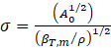 (2)

where,
(3)

(4)

(5)

The excess values of surface tension using the six different methods were calculated and fitted to the Redlich-Kister polynomial equation as [22]:
(6)
where, represent Redlich-Kister coefficients and refers to the standard deviation.

Interfacial thermodynamics:
According to the thermodynamic equation given by Clapeyron to determine the surface enthalpy per unit surface area and surface entropy per unit surface area HS for liquid mixes as a result of interface creation is as follows [26–29]:
(7)
(8)
Surface tension of binary liquid mixtures is revealed by the extended Langmuir model [30] which depends on the bulk composition. According to this paradigm, the surface is a thin membrane with a definite thickness. At a state of equilibrium, the relationship between the volume fraction of the solute in this layer and its bulk volume fraction and lyophobicity is as follows:
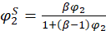 (9)
where, is a measure of lyophobicity of the component 2 (ethanolamine/ diethanolamine/ triethanolamine) with respect to the component 1 (n-ethyl-2-pyrrolidone), is bulk volume fraction of the component 1. The slope of 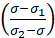 versus 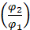 gives the value of lyophobicity β [30].

3. Results and discussion:

The surface tension of binary mixtures of EP with MEA/ DEA and TEA were estimated using theoretical models viz., Sudgen method, HSIS model, HSEG model, Volume Fraction Statistics, Auerbach relation and Sanchez method at temperatures 293.15 K to 313.15 K over the whole composition range and listed in Tables 1-3, respectively. The values of surface tension using all the six models are found to decrease linearly with composition as well as temperature. The excess surface tension using the theoretical models were fitted to Redlich-Kister polynomial equation and shown as Figs. 1-7, for all the binary systems. The Redlich-Kister coefficients and standard deviation are listed in Table 4. The average percentage deviations APDs from the six theoretical models are also listed in Table 5. The values of surface entropy S^{S} and surface enthalpy H^{S} per unit surface area are plotted as a function of concentration of EP (Fig. 8). The values of lyophobicity factor β at 293.15 to 313.15 K for the three binaries are recorded in Table 6.
Figures 1-7 display the variation of excess surface tension with increasing concentrations of EP at varying temperatures and atmospheric pressure for the three binary systems. The values of are found to be non-linear and negative over the entire composition range for EP with MEA/ DEA mixtures using all the methods except Auerbach relation which shows an S-shaped trend. For EP + TEA system, shows a negative and nonlinear trend using Sudgen, Auerbach an and Sanchez method while an S-shaped profile is observed using HSEG and HSIS models while positive variations are observed using volume fraction statistics at all temperatures. In the mixture EP + MEA/ DEA/ TEA, becomes less negative as the chain length of the aminoalcohols increase.
The excess surface tension primarily rests on the two key features i.e., the surface region and the bulk region. The close proximity of surface and bulk behaviour affects the surface tension of liquid mixtures which consequently can be examined in terms of the intermolecular interaction and structural effects occurring during mixing. The physical effects and dipolar–dipolar interaction suggest a negative contribution to the excess surface tension values, but some stronger interactions like chemical associations may affect the surface thermodynamics such as structural changes of the component species, attraction or repulsion between the unlike molecules, credited to stronger interactions lead to a positive contribution [31, 32]. Such interactions can cause the more surface-active component to remain in the bulk phase leading to positive excess surface tension values [33].
It has been experimentally observed that the magnitude of the interaction of EP with TEA is stronger than the interaction of EP with DEA and MEA. On the basis of available data, it is suggested that the magnitude of hydrogen bonding between EP and TEA having three hydroxyl (-OH) functions makes the developed system more stable. Thus, three molecules of EP are involved per molecule of TEA in the formation of the developed structures. An alternative possibility is the formation of hydrogen bonds between HO- and -OH groups. Since, EP possesses an α-hydrogen atom in its molecular architecture, the generated enol will be more reactive. Since, enols are more reactive than -C=O, this possibility seems more likely. Extent of bonding with DEA involves only two molecules and for MEA only one and therefore gives comparatively weaker interactions. It appears that the basicity of the amino alcohols contributes negligibly in deciding the magnitude of interactions.
The average percentage deviation APDs obtained for all the binary systems (Table 5) show the applicability of Sudgen, HSEG, HSIS, volume fraction statistics, Auerbach and Sanchez method being in good agreement with the experimental findings.
Surface entropy measures the discrepancy in entropy or disorder per unit surface area due to the formation of an interface and is equal to the negative temperature coefficient of surface tension. Figure 8 reveals that the surface entropy increases linearly with increasing concentration of EP for EP + DEA and EP + TEA systems but decreases almost steadily with composition for EP + MEA system. Surface enthalpy is the total surface free energy needed to spread the surface and the latent heat required to sustain isothermal state. If the plot of surface enthalpy against composition is a protruding curve, then physical effects are prevalent in the binary system. However, if surface enthalpy versus composition is a concave curve, a chemical hetero-association is ubiquitous in the binary system. The surface enthalpy is almost linearly decreasing with the composition of EP for EP + MEA system (Fig. 8). shows a concave curve for EP + DEA and EP + TEA systems which is indicative of the formation of EP -DEA/ TEA aggregates at surface formation [31]. The tendency of or for the EP + MEA system is almost linear, which suggests there is no aggregate complex formation rather weak interactions dominate [34].
The lyophobicity factor affects the nature of surface tension. Examining the behaviour of surface phase in the binary liquid mixtures require a possible complex formation between the EP and MEA/ DEA/ TEA molecules in the liquid phase. Subsequently, the molecules with lower surface tension move towards the free surface of the liquid. The lyophobicity of the surfactant molecules MEA/ DEA/ TEA with respect to EP molecule exposes it to be adsorbed by the surface (Table 6). Generally, values of exemplify the equal affinity of the surfactant molecules for both the bulk phase region and the surface, though confides to the greater affinity of the surfactant molecules for the surface. Table 6 shows confirming the greater affinity of MEA/ DEA/ TEA for the surface. The value of is highest for MEA followed by DEA and TEA. The probable reason for this may be due to the increased hydrocarbon chain in aminoalcohol molecules [35]. In addition, the self-association of monomers decrease with the increase in the hydrocarbon chain [31, 35].

4. Conclusions

Using six theoretical models, the excess surface tension for combinations of n-ethyl-2-pyrrolidone and ethanolamine, diethanolamine, and triethanolamine was calculated in the temperature range from 293.15 to 313.15 K. The downward, nonlinear pattern of supports the existence of particular intermolecular interactions between the constituents of the binary liquid combination. Additionally, the surface enthalpies and entropies per unit surface area were calculated. Using the extended Langmuir model, the lyophobicity of the surfactants MEA, DEA, and TEA was calculated, demonstrating their higher surface affinities.

Conflict of Interest: The author declares no potential conflict of interest.

Funding: The present work is not financially aided by any government, commercial or non-profitable sector.
Author Contribution: Conceptualization; Data curation; Formal analysis; Investigation; Software; Validation; Visualization; Writing – original draft; Writing – review & editing.

References:

[1] R. L. Schmidt, H. L. Clever, Thermodynamics of liquid surfaces: Adsorption at the binary hydrocarbon liquid—vapor interface J. Coll. Int. Sci. 26 (1968) 19-25, https://doi.org/10.1016/0021-9797(68)90266-X

[2] K. A. Connors, J. L. Wright, Dependence of surface tension on composition of binary aqueous-organic solutions, Anal. Chem. 61 (1989) 194-198, https://doi.org/10.1021/ac00178a001

[3] M. E. R. Libreros, A. Trejo, Gas solubility of CO2 in aqueous solutions of N-methyldiethanolamine and diethanolamine with 2-amino-2-methyl-1-propanol, Fluid Phase Equilib. 218 (2004) 261-267, https://doi.org/10.1016/j.fluid.2003.12.012

[4] H. A. Rangwala, B. R. Morrell, A. E. Mather, F. D. Otto, Absorption of co2 into aqueous tertiary amine/mea solutions, Can. J. Chem. Eng. 70 (1992) 482, https://doi.org/10.1002/cjce.5450700310

[5] M. S. Shannon, A. C. Irvin, H. Liu, J. D. Moon, M. S. Hindman, C. H. Turner, J. E. Bara, Chemical and Physical Absorption of SO2 by N-Functionalized Imidazoles: Experimental Results and Molecular-level Insight, Ind. Eng. Chem. Res. 54 (2015) 462-471, https://doi.org/10.1021/ie503752h

[6] A. Awasthi, Ultrasonic Speeds, Molar Isentropic Compressions and FTIR analysis of aqueous solutions of 2-dialkylaminoethanols from 293.15 to 313.15 K, Phys. Chem. Liqs. 60 (2022) 33-46, https://doi.org/10.1080/00319104.2021.1907844

[7] V. Verma, A. Awasthi, A. Awasthi, Physicochemical investigations of polyethylene glycols with N, N-Dimethylacetamide, J. Chem. Thermodyn. 141 (2020) 105948, https://doi.org/10.1016/j.jct.2019.105948
[8] A. Awasthi, V. Verma, R. K. Tiwari, A. Awasthi, Nonlinear ultrasound propagation in formamide + 2-methoxyethanol/2-ethoxyethanol solvent systems at temperatures ranging from 303.15 to 323.15 K, J. Math. Chem. 58 (2020) 2291-2312, https://doi.org/10.1007/s10910-020-01181-8
[9] R. K. Tiwari, V. Verma, A. Awasthi, S. K. Trivedi, P. K. Pandey, A. Awasthi, Comparative study of acoustic non-linearity parameter in binary mixtures of N,N-dimethylacetamide with Polyethylene Glycols at different temperatures, J. Mol. Liqs. 343 (2021) 117707, http://dx.doi.org/10.1016/j.molliq.2021.117707
[10] M. Kumar, R. K. Tiwari, V. Verma, A. Awasthi, A. Awasthi, Physicochemical parameters of the binary mixtures of formamide/N-methylformamide with 2-chloroethanol at different temperatures, Phys. Chem. Liqs. 59 (2021) 795,https://doi.org/10.1080/00319104.2020.1815019
[11] A. Awasthi, R. Srivastava, V. K. Pandey, V. Verma, A. Awasthi, Thermochim. Acta 668 (2018) 40,
[12] V. K. Pandey, A. Awasthi, R. Srivastava, A. Awasthi, J. Mol. Liqs. 219 (2016) 186,
[13] A. Awasthi, A. Awasthi, Acoustic, volumetric, and spectroscopic studies of formamide with 2-alkoxyethanols at different temperatures, J. Chem. Thermodyn. 53 (2012) 144-151,
[14] A. Awasthi, A. Awasthi, Intermolecular interactions in formamide + 2-alkoxyethanols: Viscometric study, Thermochim. Acta 537 (2012) 57-64,
[15] A. Awasthi, B. S. Tripathi, A. Awasthi, Applicability of corresponding-states group-contribution methods for the estimation of surface tension of multicomponent liquid mixtures at 298.15 K, Fluid Phase Equi. 287 (2010) 151-154,
[16] S. Sugden, CXLII.—A relation between surface tension, density, and chemical composition J. Chem. Soc. 125 (1924) 1177,
[17] J. H. Hildebrand, R. L. Scott, Solubility of Nonelectrolytes (Reinhold Pub. Corp., New York) (1950)
[18] D. E. Goldsack, C. D. Sarvas, Volume fraction statistics and the surface tensions of non-electrolyte solutions, Can. J. Chem. 59 (1981) 2968,
[19] R. Auerbach, Experientia 4 (1948) 473,
[20] I. C. Sanchez, J. Chem. Phys. 79 (1983) 405,
[21] A. Blanco, A. G. Abuin, D. G. Diaz, J. M. Navaza, O. L. Villaverde, J. Chem. Eng. Data 58 (2013) 653,
[22] O. Redlich, A. T. Kister, Algebraic Representation of Thermodynamic Properties and the Classification of Solutions, Ind. Eng. Chem. 40 (1948) 345-348,
[23] D. B. MacLeod, On a relation between surface tension and density, Trans. Faraday Soc. 19 (1923) 38,
[24] O. R. Quayle, The Parachors of Organic Compounds. An Interpretation and Catalogue, Chem. Rev. 53 (1953) 439-589,
[25] D. L. Hammick, L. W. Andrew, CVI.—The determination of the parachors of substances in solution, J. Chem. Soc. 754 (1929)
[26] A. Adamson, Physical Chemistry of Surfaces (5th ed., J. Wiley & Sons, New York, p. 53 (1990)
[27] K. Motomura, Thermodynamic studies on adsorption at interfaces. I. General formulation, J. Coll. Interface Sci. 64 (1978) 348-355,
[28] R. S. Hansen, Thermodynamics of interfaces between condensed phases¹, J. Phys. Chem. 66 (1962) 410-415,
[29] J. Glinski, G. Ghavepeyer, J. K. Platten, Surface properties of diluted aqueous solutions of 1,2-pentanediol, sJ. Chem. Phys. 111 (1999) 3233,
[30] A. Pineiro, P. Brocos, A. Amigo, J. G. Fadrique, M. G. Lemus, Extended Langmuir Isotherm for Binary Liquid Mixtures, Langmuir 17 (2001) 4261-4266,
[31] N. G. Tsierkezos, A. C. Filippou, J. Chem. Thermodyn. 38 (2006) 952,
[32] J. Glinski, G. Chavepeyer, J K Platten, J. Chem. Phys. 104 (1996) 8816,
[33] V. P. Gregorio, D. Montano, B. Giner, C. Lafuente, F. M. Royo, J. Chem. Thermodyn. 41 (2009) 553,
[34] Y. Yi-Yang, Yi-Min Zhu, Jin-Long Peng, Jin-Can Chen, Pei-Pei Feng, Zhong-Qi Huang, J. Chem. Thermodyn. 41(2009) 1000,
[35] Y. Maham, A. E. Mather, Surface thermodynamics of aqueous solutions of alkylethanolamines Fluid Phase Equi. 182 (2001) 325-336,

Table 1: Values of Surface tension for EP (1) + MEA (2) system.
 | Sudgen | HSEG | HSIS | Volume fraction | Auerbach | Sanchez
x₁ | σ (dyne cm⁻¹)
293.15 K
0.0000 | 49.7 | 49.7 | 49.7 | 49.7 | 49.7 | 49.7
0.1000 | 48.4 | 47.0 | 47.9 | 47.7 | 44.6 | 47.6
0.2002 | 46.7 | 44.8 | 46.2 | 45.9 | 42.8 | 45.8
0.2999 | 45.1 | 43.0 | 44.6 | 44.3 | 41.5 | 44.2
0.4002 | 43.6 | 41.6 | 43.1 | 42.9 | 40.4 | 42.9
0.4999 | 41.9 | 40.4 | 41.6 | 41.5 | 39.5 | 41.6
0.5996 | 40.5 | 39.4 | 40.3 | 40.3 | 38.6 | 40.5
0.7002 | 39.3 | 38.5 | 39.1 | 39.2 | 38.0 | 39.4
0.7999 | 38.3 | 37.8 | 38.1 | 38.2 | 37.6 | 38.4
0.8997 | 37.3 | 37.1 | 37.2 | 37.3 | 37.2 | 37.4
1.0000 | 36.5 | 36.5 | 36.5 | 36.5 | 36.5 | 36.5
303.15 K
0.0000 | 47.8 | 47.8 | 47.8 | 47.8 | 47.8 | 47.8
0.1000 | 46.5 | 45.2 | 46.2 | 45.9 | 42.9 | 45.7
0.2002 | 44.9 | 43.2 | 44.6 | 44.2 | 41.1 | 44.0
0.2999 | 43.9 | 41.5 | 43.0 | 42.7 | 39.8 | 42.5
0.4002 | 41.9 | 40.1 | 41.6 | 41.3 | 38.7 | 41.2
0.4999 | 40.3 | 39.0 | 40.2 | 40.0 | 37.8 | 40.0
0.5996 | 38.9 | 38.0 | 38.9 | 38.9 | 36.9 | 38.9
0.7002 | 37.8 | 37.2 | 37.8 | 37.8 | 36.3 | 37.9
0.7999 | 36.9 | 36.4 | 36.8 | 36.9 | 35.9 | 37.0
0.8997 | 36.0 | 35.8 | 35.9 | 36.0 | 35.5 | 36.1
1.0000 | 35.2 | 35.2 | 35.2 | 35.2 | 35.2 | 35.2
313.15 K
0.0000 | 47.1 | 47.1 | 47.1 | 47.1 | 47.1 | 47.1
0.1000 | 45.7 | 44.5 | 45.4 | 45.2 | 41.3 | 44.9
0.2002 | 44.1 | 42.4 | 43.8 | 43.4 | 39.5 | 43.1
0.2999 | 42.5 | 40.7 | 42.2 | 41.9 | 38.2 | 41.6
0.4002 | 41.0 | 39.3 | 40.7 | 40.5 | 37.2 | 40.3
0.4999 | 39.4 | 38.1 | 39.3 | 39.2 | 36.2 | 39.1
0.5996 | 38.0 | 37.1 | 38.0 | 38.0 | 35.2 | 38.0
0.7002 | 36.9 | 36.2 | 36.9 | 36.9 | 34.7 | 36.9
0.7999 | 35.9 | 35.5 | 35.8 | 35.9 | 34.3 | 36.0
0.8997 | 35.0 | 34.8 | 34.9 | 35.0 | 33.9 | 35.1
1.0000 | 34.2 | 34.2 | 34.2 | 34.2 | 34.2 | 34.2

Table 2: Values of Surface tension for EP (1) + DEA (2) system.
 | Sudgen | HSEG | HSIS | Volume fraction | Auerbach | Sanchez
x₁ | σ (dyne cm⁻¹)
293.15 K
0.0000 | 47.4 | 47.4 | 47.4 | 47.4 | 47.4 | 47.4
0.1000 | 45.9 | 45.7 | 45.9 | 46.0 | 47.9 | 45.8
0.2005 | 44.5 | 44.2 | 44.5 | 44.7 | 46.0 | 44.3
0.3001 | 43.2 | 42.8 | 43.2 | 43.5 | 44.4 | 43.0
0.4002 | 42.0 | 41.6 | 42.0 | 42.4 | 42.8 | 41.9
0.4999 | 40.8 | 40.5 | 40.8 | 41.3 | 41.5 | 40.8
0.6000 | 39.8 | 39.5 | 39.8 | 40.2 | 40.4 | 39.8
0.7001 | 38.8 | 38.6 | 38.8 | 39.2 | 39.4 | 38.9
0.8001 | 37.9 | 37.8 | 37.9 | 38.3 | 38.5 | 38.0
0.8995 | 37.2 | 37.1 | 37.2 | 37.4 | 37.7 | 37.2
1.0000 | 36.5 | 36.5 | 36.5 | 36.5 | 36.5 | 36.5
303.15 K
0.0000 | 46.6 | 46.6 | 46.6 | 46.6 | 46.6 | 46.6
0.1000 | 45.0 | 44.8 | 45.0 | 45.2 | 46.4 | 44.9
0.2005 | 43.5 | 43.2 | 43.6 | 43.8 | 44.5 | 43.4
0.3001 | 42.2 | 41.8 | 42.2 | 42.5 | 42.8 | 42.0
0.4002 | 40.9 | 40.5 | 40.9 | 41.3 | 41.3 | 40.8
0.4999 | 39.7 | 39.4 | 39.7 | 40.2 | 40.0 | 39.6
0.6000 | 38.6 | 38.3 | 38.6 | 39.1 | 38.8 | 38.6
0.7001 | 37.6 | 37.4 | 37.6 | 38.0 | 37.8 | 37.7
0.8001 | 36.7 | 36.6 | 36.7 | 37.0 | 36.9 | 36.8
0.8995 | 35.9 | 35.9 | 35.9 | 36.1 | 36.0 | 36.0
1.0000 | 35.2 | 35.2 | 35.2 | 35.2 | 35.2 | 35.2
313.15 K
0.0000 | 46.0 | 46.0 | 46.0 | 46.0 | 46.0 | 46.0
0.1000 | 44.3 | 44.2 | 44.4 | 44.5 | 45.0 | 44.2
0.2005 | 42.8 | 42.5 | 42.9 | 43.1 | 43.1 | 42.6
0.3001 | 41.4 | 41.0 | 41.4 | 41.7 | 41.4 | 41.2
0.4002 | 40.1 | 39.7 | 40.1 | 40.5 | 39.9 | 39.9
0.4999 | 38.8 | 38.5 | 38.8 | 39.3 | 38.5 | 38.7
0.6000 | 37.7 | 37.4 | 37.7 | 38.2 | 37.3 | 37.7
0.7001 | 36.7 | 36.5 | 36.7 | 37.1 | 36.2 | 36.7
0.8001 | 35.8 | 35.6 | 35.7 | 36.1 | 35.4 | 35.8
0.8995 | 34.9 | 34.9 | 34.9 | 35.1 | 34.4 | 35.0
1.0000 | 34.2 | 34.2 | 34.2 | 34.2 | 34.2 | 34.2

Table 3: Values of Surface tension for EP (1) + TEA (2) system.
 | Sudgen | HSEG | HSIS | Volume fraction | Auerbach | Sanchez
x₁ | σ (dyne cm⁻¹)
293.15 K
0.0000 | 46.3 | 46.3 | 46.3 | 46.3 | 46.3 | 46.3
0.1001 | 45.6 | 45.1 | 44.9 | 44.4 | 45.3 | 45.3
0.2000 | 44.9 | 43.9 | 43.7 | 42.9 | 44.3 | 44.2
0.3000 | 44.1 | 42.8 | 42.5 | 41.6 | 43.3 | 43.2
0.4004 | 43.1 | 41.7 | 41.4 | 40.5 | 42.4 | 42.2
0.5001 | 42.3 | 40.6 | 40.4 | 39.6 | 41.6 | 41.3
0.6002 | 41.3 | 39.7 | 39.4 | 38.8 | 40.7 | 40.3
0.7002 | 40.2 | 38.7 | 38.6 | 38.1 | 39.8 | 39.3
0.8000 | 39.0 | 37.9 | 37.8 | 37.5 | 38.9 | 38.4
0.8998 | 37.7 | 37.2 | 37.1 | 37.0 | 38.0 | 37.4
1.0000 | 36.5 | 36.5 | 36.5 | 36.5 | 36.5 | 36.5
303.15 K
0.0000 | 45.6 | 45.6 | 45.6 | 45.6 | 45.6 | 45.6
0.1001 | 44.8 | 44.3 | 44.1 | 43.6 | 44.1 | 44.5
0.2000 | 44.0 | 43.0 | 42.8 | 42.0 | 43.1 | 43.4
0.3000 | 43.2 | 41.8 | 41.5 | 40.7 | 42.1 | 42.3
0.4004 | 42.1 | 40.6 | 40.3 | 39.6 | 41.1 | 41.2
0.5001 | 41.2 | 39.5 | 39.3 | 38.6 | 40.3 | 40.2
0.6002 | 40.2 | 38.5 | 38.3 | 37.7 | 39.3 | 39.2
0.7002 | 39.0 | 37.5 | 37.4 | 37.0 | 38.3 | 38.1
0.8000 | 37.8 | 36.7 | 36.6 | 36.3 | 37.4 | 37.2
0.8998 | 36.5 | 35.9 | 35.9 | 35.7 | 36.4 | 36.2
1.0000 | 35.2 | 35.2 | 35.2 | 35.2 | 35.2 | 35.2
313.15 K
0.0000 | 44.8 | 44.8 | 44.8 | 44.8 | 44.8 | 44.8
0.1001 | 44.0 | 43.5 | 43.3 | 42.8 | 43.1 | 43.6
0.2000 | 43.2 | 42.2 | 41.9 | 41.2 | 42.1 | 42.5
0.3000 | 42.3 | 40.9 | 40.6 | 39.9 | 41.0 | 41.4
0.4004 | 41.2 | 39.8 | 39.5 | 38.7 | 39.9 | 40.3
0.5001 | 40.3 | 38.6 | 38.4 | 37.7 | 39.0 | 39.2
0.6002 | 39.2 | 37.6 | 37.4 | 36.9 | 37.9 | 38.2
0.7002 | 38.1 | 36.6 | 36.4 | 36.1 | 36.9 | 37.2
0.8000 | 36.8 | 35.7 | 35.6 | 35.4 | 35.8 | 36.2
0.8998 | 35.5 | 34.9 | 34.9 | 34.8 | 34.9 | 35.2
1.0000 | 34.2 | 34.2 | 34.2 | 34.2 | 34.2 | 34.2

Table 4: Coefficients (B_{i}) and standard deviations (SD) for σ^{E} using Redlich-Kister Equation
T (K) | B₀ | B₁ | B₂ | B₃ | B₄ | SD
σ^{E}
 | EP (1) + MEA (2)
293.15 | -16.1038 | 11.2594 | -2.9549 | 1.1573 | 3.0589 | 0.1107
303.15 | -15.7121 | 8.9766 | -1.8445 | 0.9130 | 2.0782 | 0.2226
313.15 | -19.1246 | 6.9804 | -0.3620 | 1.3832 | 0.0686 | 0.3019
 | EP (1) + DEA (2)
293.15 | -11.5166 | 4.6850 | -0.0372 | 0.0596 | -0.9272 | 0.1441
303.15 | -10.5753 | 7.3106 | -2.5591 | -0.0903 | 2.9147 | 0.2602
313.15 | -11.7922 | 7.5365 | -1.8318 | 0.6759 | 0.7604 | 0.2583
 | EP (1) + TEA (2)
293.15 | -5.6616 | 1.8817 | 0.4421 | -0.2284 | -0.8932 | 0.1123
303.15 | -4.2463 | 3.1159 | -1.0920 | -0.0257 | 1.5323 | 0.1224
313.15 | -4.3283 | 1.4569 | -0.5934 | 0.2971 | 0.6840 | 0.1409
Sudgen
 | EP (1) + MEA (2)
293.15 | -11.5911 | 14.3018 | -3.2144 | 1.2108 | 3.0413 | 0.1367
303.15 | -7.4092 | 2.7868 | -1.2541 | 0.0166 | 1.8883 | 0.0978
313.15 | -7.3439 | 1.1291 | -0.9458 | 0.3921 | 1.3165 | 0.1673
 | EP (1) + DEA (2)
293.15 | -7.0700 | 5.0447 | 0.1075 | 0.0003 | -1.1406 | 0.1636
303.15 | -5.8394 | 7.4325 | -2.3745 | -0.1357 | 2.6806 | 0.2492
313.15 | -6.7242 | 7.4391 | -1.9615 | 0.6395 | 1.0619 | 0.2496
 | EP (1) + TEA (2)
293.15 | -9.0700 | 1.4291 | 0.1776 | -0.0821 | -0.3175 | 0.1099
303.15 | -7.4097 | 2.7887 | -1.2580 | 0.0149 | 1.8950 | 0.0978
313.15 | -7.3441 | 1.1303 | -0.9487 | 0.3907 | 1.3209 | 0.1672
HSEG
 | EP (1) + MEA (2)
293.15 | -5.2866 | 6.5594 | -2.5576 | 1.1690 | 2.6166 | 0.1218
303.15 | -5.5930 | 4.8593 | -1.6321 | 0.8498 | 1.9853 | 0.2512
313.15 | -8.9465 | 2.9307 | 0.0151 | 1.3365 | -0.3267 | 0.2845
 | EP (1) + DEA (2)
293.15 | -5.6731 | 3.8512 | 0.0028 | 0.0697 | -0.9232 | 0.1407
303.15 | -4.4458 | 6.3845 | -2.4237 | -0.1781 | 2.6962 | 0.2413
313.15 | -5.3840 | 6.4860 | -1.7015 | 0.6939 | 0.4997 | 0.2385
 | EP (1) + TEA (2)
293.15 | -2.6623 | 2.7466 | 0.5972 | -0.2922 | -1.1847 | 0.1243
303.15 | -0.6901 | 3.6365 | -1.1100 | -0.0283 | 1.5025 | 0.1062
313.15 | -0.8759 | 1.9773 | -0.5574 | 0.3476 | 0.6026 | 0.1447
HSIS
 | EP (1) + MEA (2)
293.15 | -10.2193 | 12.5526 | -2.8760 | 1.0997 | 2.9744 | 0.1151
303.15 | -10.4735 | 10.1437 | -1.9631 | 0.9613 | 2.2053 | 0.2211
313.15 | -13.6958 | 8.0610 | -0.6036 | 1.4206 | 0.4884 | 0.3212
 | EP (1) + DEA (2)
293.15 | -7.0700 | 5.0447 | 0.1075 | 0.0003 | -1.1406 | 0.1636
303.15 | -5.7419 | 7.6711 | -2.7749 | -0.1491 | 3.2989 | 0.2688
313.15 | -6.6802 | 7.7725 | -2.0527 | 0.7229 | 1.1024 | 0.2235
 | EP (1) + TEA (2)
293.15 | -1.5569 | 2.0032 | 0.3338 | -0.2783 | -0.6474 | 0.1145
303.15 | 0.3117 | 2.8256 | -1.2742 | -0.0839 | 1.8039 | 0.1358
313.15 | 0.0527 | 1.2522 | -0.1933 | 0.2501 | 0.0675 | 0.1366
Volume Fraction
 | EP (1) + MEA (2)
293.15 | -9.8276 | 10.3059 | -2.7062 | 1.1278 | 2.7501 | 0.1227
303.15 | -9.8185 | 7.9161 | -1.7950 | 0.8780 | 2.0424 | 0.2091
313.15 | -13.3770 | 5.9013 | 0.0942 | 1.4064 | -0.5720 | 0.2846
 | EP (1) + DEA (2)
293.15 | -8.8706 | 4.3840 | 0.2159 | -0.0267 | -1.3064 | 0.1276
303.15 | -7.6965 | 6.8923 | -2.3134 | -0.0374 | 2.5204 | 0.2727
313.15 | -8.5813 | 6.8990 | -1.9004 | 0.7378 | 0.9017 | 0.2493
 | EP (1) + TEA (2)
293.15 | 1.5889 | -0.5479 | 0.5869 | -0.3063 | -0.9984 | 0.1054
303.15 | 2.9207 | 0.5533 | -0.6369 | -0.0840 | 1.0676 | 0.1389
313.15 | 2.7493 | -1.2986 | -0.3860 | 0.2223 | 0.5212 | 0.1221
Auerbach
 | EP (1) + MEA (2)
293.15 | -1.5871 | 1.7769 | -0.8543 | -0.6379 | 1.9164 | 0.0906
303.15 | -0.7954 | 0.6940 | 0.3560 | -0.5822 | 0.9357 | 0.1609
313.15 | -1.2579 | -1.4779 | 2.7428 | -0.3457 | -1.3282 | 0.2304
 | EP (1) + DEA (2)
293.15 | -9.7974 | 7.4044 | -1.8316 | 1.1255 | -0.5651 | 0.1717
303.15 | -6.8918 | 9.1920 | -3.7292 | 0.8924 | 3.1979 | 0.2438
313.15 | -5.4207 | 9.4300 | -2.3222 | 1.5139 | 1.0730 | 0.2818
 | EP (1) + TEA (2)
293.15 | -6.2919 | -0.4069 | 0.2128 | -0.4164 | -0.9964 | 0.0919
303.15 | -3.5555 | 0.9525 | -0.9181 | -0.3193 | 1.4753 | 0.1456
313.15 | -2.0401 | 1.0029 | -0.1712 | 0.1258 | 0.7749 | 0.1864
Sanchez
 | EP (1) + MEA (2)
293.15 | -10.2001 | 8.4782 | -2.6794 | 1.1979 | 2.7948 | 0.1357
303.15 | -9.6935 | 6.4457 | -1.6574 | 0.7949 | 1.9219 | 0.2118
313.15 | -12.9318 | 4.1249 | 0.2572 | 1.2676 | -0.6833 | 0.2847
 | EP (1) + DEA (2)
293.15 | -6.9706 | 3.2849 | 0.3243 | 0.1397 | -1.3912 | 0.1323
303.15 | -5.4893 | 6.0565 | -2.6984 | -0.1211 | 3.1222 | 0.2683
313.15 | -6.3207 | 6.1770 | -1.7819 | 0.6393 | 0.7112 | 0.2577
 | EP (1) + TEA (2)
293.15 | -5.1401 | 1.4045 | 0.6593 | -0.1108 | -1.2372 | 0.0897
303.15 | -3.3822 | 3.0034 | -1.1767 | -0.0277 | 1.5934 | 0.1145
313.15 | -3.2286 | 1.2508 | -0.7981 | 0.2508 | 1.0092 | 0.1359

Table 5: Average Percentage Deviations (APD) between experimental surface tension and theoretical models
T (K) | Average Percentage Deviations (APD)
 | Sudgen | HSEG | HSIS | Volume fraction | Auerbach | Sanchez
 | EP (1) + MEA (2)
293.15 | 5.22 | 2.61 | 4.59 | 4.44 | 0.09 | 4.51
303.15 | 5.02 | 2.56 | 4.53 | 4.21 | 0.66 | 4.12
313.15 | 6.02 | 3.65 | 5.74 | 5.48 | 1.61 | 5.26
 | EP (1) + DEA (2)
293.15 | 2.84 | 2.41 | 2.86 | 3.57 | 5.43 | 2.81
303.15 | 2.86 | 2.35 | 2.84 | 3.57 | 4.30 | 2.76
313.15 | 3.50 | 2.94 | 3.47 | 4.21 | 3.22 | 3.30
 | EP (1) + TEA (2)
293.15 | 3.38 | 0.94 | 0.56 | 0.61 | 2.70 | 1.88
303.15 | 3.01 | 0.49 | 0.08 | 1.03 | 1.47 | 1.47
313.15 | 3.02 | 0.46 | 0.05 | 1.00 | 0.43 | 1.38

Table 6: Lyophobicity factor (β) for the binary systems

T (K) | Lyophobicity factor β
 | EP (1) + MEA (2) | EP (1) + DEA (2) | EP (1) + TEA (2)
293.15 | 2.67 | 2.63 | 2.03
303.15 | 2.31 | 2.30 | 2.05
313.15 | 2.36 | 3.25 | 2.04

Fig. 1: Variation of excess surface tension, against mole fraction, x₁ of EP for (a) EP + MEA (b) EP + DEA and (c) EP + TEA at T= 293.15 K (○), 303.15 K (•), 313.15 K (▲) and 323.15 K (×). The solid lines represent values calculated from Redlich-Kister equation.

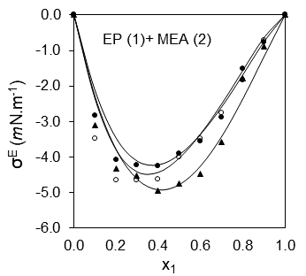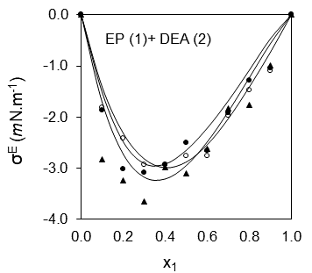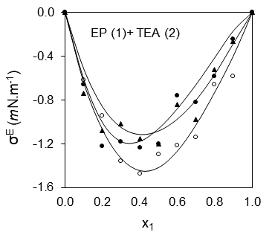

Fig. 2: Variation of excess surface tension, (Sudgen method) against mole fraction, x₁ of EP for (a) EP + MEA (b) EP + DEA and (c) EP + TEA at T= 293.15 K (○), 303.15 K (•), 313.15 K (▲) and 323.15 K (×). The solid lines represent values calculated from Redlich-Kister equation.

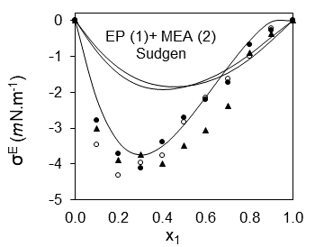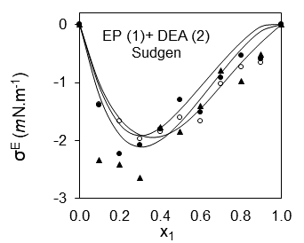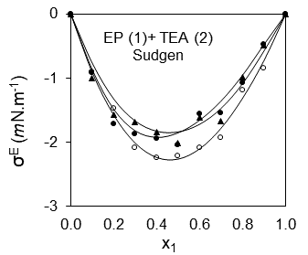

Fig. 3: Variation of excess surface tension, (HSEG method) against mole fraction, x₁ of EP for (a) EP + MEA (b) EP + DEA and (c) EP + TEA at T= 293.15 K (○), 303.15 K (•), 313.15 K (▲) and 323.15 K (×). The solid lines represent values calculated from Redlich-Kister equation.

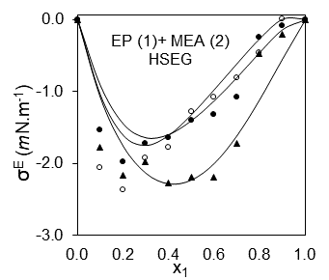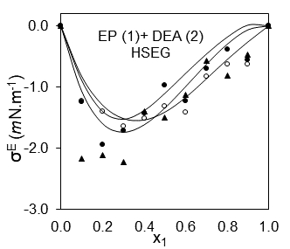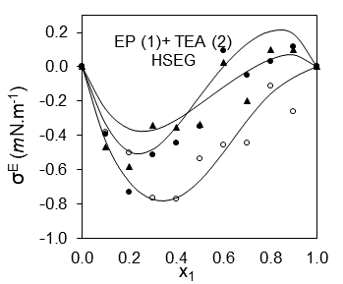

Fig. 4: Variation of excess surface tension, (HSIS method) against mole fraction, x₁ of EP for (a) EP + MEA (b) EP + DEA and (c) EP + TEA at T= 293.15 K (○), 303.15 K (•), 313.15 K (▲) and 323.15 K (×). The solid lines represent values calculated from Redlich-Kister equation.

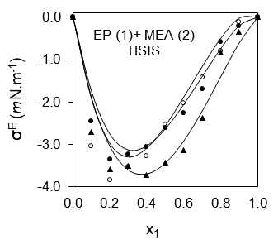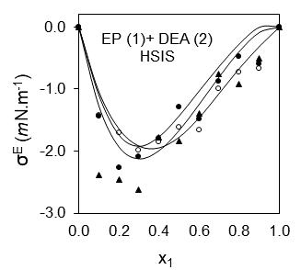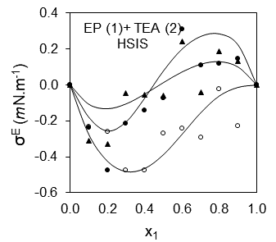

Fig. 5: Variation of excess surface tension, (Volume fraction) against mole fraction, x₁ of EP for (a) EP + MEA (b) EP + DEA and (c) EP + TEA at T= 293.15 K (○), 303.15 K (•), 313.15 K (▲) and 323.15 K (×). The solid lines represent values calculated from Redlich-Kister equation.

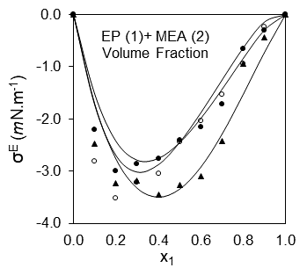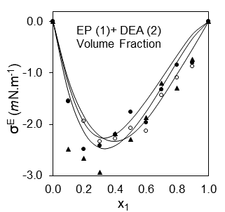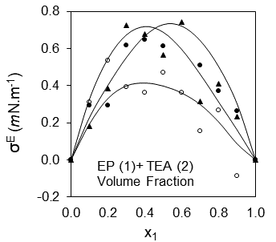

Fig. 6: Variation of excess surface tension, (Auerbach) against mole fraction, x₁ of EP for (a) EP + MEA (b) EP + DEA and (c) EP + TEA at T= 293.15 K (○), 303.15 K (•), 313.15 K (▲) and 323.15 K (×). The solid lines represent values calculated from Redlich-Kister equation.

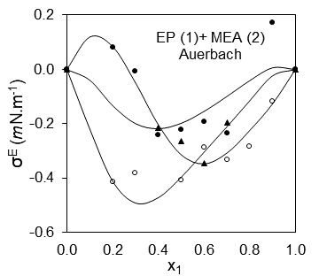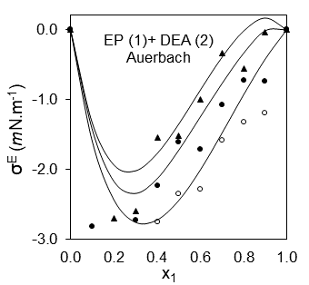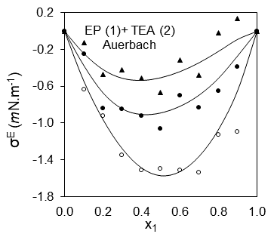

Fig. 7: Variation of excess surface tension, (Sanchez) against mole fraction, x₁ of EP for (a) EP + MEA (b) EP + DEA and (c) EP + TEA at T= 293.15 K (○), 303.15 K (•), 313.15 K (▲) and 323.15 K (×). The solid lines represent values calculated from Redlich-Kister equation.

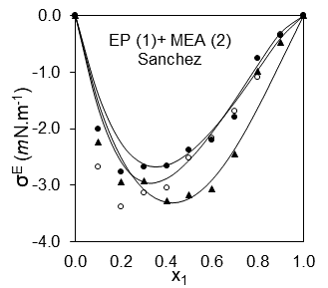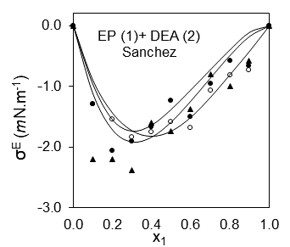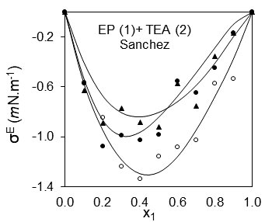

Fig. 8: Variation of Surface entropy, and Surface enthalpy against mole fraction, x₁ of EP for (a) EP + MEA (○) (b) EP + DEA (■) and (c) EP + TEA (Δ).

