Urban farming: Concept and Prospects in relation to Indian Agriculture and Architecture

Susmita Das¹ and Teesha Majumder²

¹Assistant Professor, Department of Agronomy, Faculty of Agriculture, Sri Sri University, Cuttack, 754 006, Odisha

²Assistant Professor, Symbiosis School of Architecture, Urban Development, and Planning, SSPU, Kiwale, Pune
Corresponding author: Susmitadas282@gmail.com

Abstract

The globe at present is impacted by a constant increase in population percentage, which leads to urbanization, facilitated by industrialization and shrinkage in agricultural land. Presently, a significant distinction exists between urban and rural communities. As a result of this rising population's predisposition to relocate to cities in search of better prospects and living conditions, cities are becoming chaotic. To support this rising population, the building of shelter, infrastructure, and food security has become a critical need in recent years. Thus, land acquisition is an essential procedure conducted by the government and other development organizations to support infrastructure developments. The majority of this land acquisition is advancing to rural areas, taking up profitable farmland and affecting the farming industry. On the other hand, as cities become more influential factors, younger generations have reduced interest in agriculture, referring to the profession as unprofitable, contributing to farm labor shortages during peak growing seasons. The majority of nations are likely to suffer from food shortages and scarcity in the foreseeable future. As a result, reorganization of the method used to produce food is a crucial requirement at this juncture. Agritecture, an ideology in urban agriculture, is a potential technology or system that supports urbanization and fulfills the need of excess agricultural output. This article will focus on the various possibilities of interaction between agriculture and architecture that may boost the city's basic necessities and support ecosystems, particularly in urban settings. The untapped opportunity in developing physical structures for agricultural output is required to be exploited in order to accelerate urban and rural growth on environmental, social, and financial levels.

Keywords: Urban Agriculture, Vertical Farming, Food Security, Agritecture, Hydroponics

- Introduction

Shelter and food establish a sense of security in communal living. Simultaneously architecture and agriculture supply us with food and a place to live, so both of them supply us with a sense of security [1]. As a result of the demographic shift, every city is rapidly expanding and being revamped to fit more individuals within the city via architectural interventions [2]. At the moment, urban areas account for about 3% of the world's entire land mass. According to global demographic trends, 7.6 billion is the current global population and by 2030, 8.6 million is projected, and 9.80 billion by 2050. According to FAO statistics, by 2030, 60 percent of people in nations that are developing would most likely live in cities. The geographical region of 3,287,240 sq. km, India takes up for only 2.4 percent of the globe's total space while supporting and sustaining a population equal to 16.9 percent of the world's population [3]. India's population, which is currently 1.3 billion, by 2024 is predicted to outgrow China's population by 1.4 billion [4]. Food is the basic essential in our lives. Land resources for agriculture are currently diminishing as a consequence of growing urbanization [5]. The possible increase in global population has been depicted in Figure 1.

Urbanization disrupts the ecology, environment, and economy. Soil fertility difficulties, nutrient scarcity, and agricultural yield decline are the current key threats to food security [6]. Traditional plant-growing techniques necessitate an enormous amount of area, duration, and labor. Plowing the soil and planting the seed has disrupted the natural biodegrading process, releasing the absorbed CO2 into the environment and warming the surface of the earth. Intensive farming provides a sufficient production of food influencing soil’s nutritional content and fertilizer efficiency [7]. Heavy tractors have compressed the soil, reducing rainfall penetration and transpiration, impeding groundwater's natural disposal, creating surface run-off, and raising the likelihood of floods [8]. To be able to maintain urban growth, there is an explosive expansion of large-scale infrastructures such as hospitals, schools, roads, dams, and airport construction, yet it is additionally imperative to investigate methods used to produce food. To ensure its cultivation and dispersion across a broader area, farming methods and techniques must be used [9] hence there is a need for the development of innovation in agricultural production methods as there is pressing concern regarding sustainable food sources. [10].

Urban agriculture has been a successful and effective approach for making the most of unoccupied underutilized open spaces and structures in urban settings, as a means of creating revenue and employment opportunities and overseeing groundwater resources in cities. The phrase 'Urban Agriculture' is described as "the practice of cultivating, processing, and providing food in an urban area where a city's domain of impact (social, economic, and ecological) tends to crash down directly on its population. Organic farming benefits the environment by recycling urban trash and reducing reliance on synthetic chemicals, as well as reducing food miles, water management, and mitigating the urban heat island effect [11], as well as a reduction in carbon emissions connected with food transportation [12].
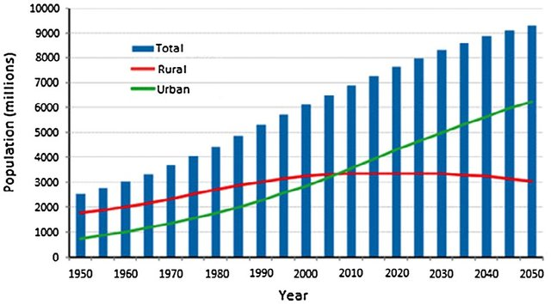

Figure 1: Projected global population growth in urban and rural areas from 1950 to 2050 (Source: Musa et al. 2016)

It can be a source of leisure activities in urban living while contributing to society's psychological health and mental well-being. Economic benefits include increased food supply [14], increased income per capita, and job creation [15].
Considering this in mind, this particular chapter discusses the concept of agricultural extension in urban areas via architectural designs and alterations. The structures have underutilized horizontal and vertical spaces that could be used for farming. The goal of this chapter is to identify the appropriate locations required to conduct such actions.
The following goals must be established:
a) To create a link between farmland and cities.
b) Gaining knowledge of the different aspects of urban agriculture.
c) Identifying the structural typology and offering design strategies for integration in urban agriculture

- To develop a connection between agriculture and cities

The following represent a number of the positive aspects of urban farming:
a) It shortens the gap between food and the table.
b) Urban garbage can be turned into fertilizer and manure.
b) Despite traditional non-tropical farming, indoor farming may grow crops throughout the year at a higher rate of productivity.
d) To a certain extent, the unemployment problem can be remedied.
e) Reducing the usage of chemical fertilizers and pesticides, as well as taking further measures towards urban composting.
f) Decentralize food production by providing beneficial opportunities for individuals to learn about and interact with food production systems.
g) Reducing dependency on rural agriculture and allowing time for the land to recover.

- Present concepts

Henry Gordon-Smith created the word 'Agritecture' in 2011 [16]. The art, science, and commerce of incorporating agriculture into the built environment are known as Agritecture. It incorporates appropriate construction and sustainable urban farm concepts into the design of buildings [17, 18, 19, and 20]. Such integration can create environmental, social, and economic balance in society. Their interrelation has been depicted in Figure 2. Agritecture reuses and recycles water and nutrients generates less waste, and necessitate less to no soil media, however, other interesting aspects of a structure's layout such as balconies, rooftops, backyards, blank façades, lobbies, window sills, site landscaping, and other structural components are also considered. On the contrary, while developing urban farms, agriculturalists and entrepreneurs sometimes overlook key design aesthetics and social integration. It offers numerous advantages, including agro-tourism, affordable food, no food transportation costs to cities, healthier diets and lifestyles, reintroduction of seasons and natural cycles of life, cleaner air, and greater attachment to regions.
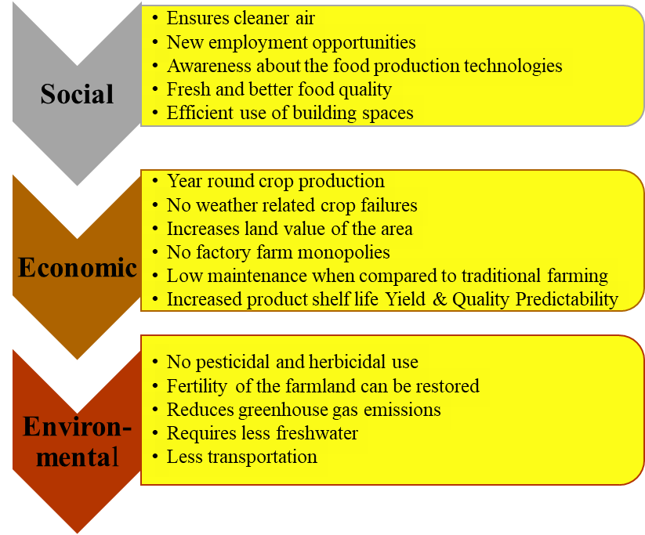

Figure 2: Agritecture in relation to sustainable development
This approach is also based on India's urban transformation agenda, which meets two key sustainable development goals: zero waste and zero pollution, hunger (SDG-2) and sustainable cities and communities (SDG-11). It is observed that UA has been gaining wider acceptability in Indian cityscapes, in recent times [21].

- Need of Agritecture in recent times

It is an opportunity for our cities and agricultural systems to mix, as the primary explanations for the necessity to employ architectural thinking when developing agriculture for the built environment are as follows:
- Agricultural land acquisition for infrastructural growth
- Migration of farmers to cities
- Weather uncertainty and protected agriculture

  - Agricultural land acquisition for infrastructural growth

More than half of India's population lives in rural areas and relies on agriculture for their livelihoods. However, following economic liberalization in 1991, India's attention has shifted to accelerating the growth of other industries, paving the way for the country's exceptional economic success. India currently has the world's sixth-largest economy, with a GDP close to 7.1 percent [22]. Including the several forthcoming initiatives supported by the Government of India in urban regions, India is expected to add 300 million new urban people by 2050, with the goal of building 100 new cities during this time period [23]. The challenge for the country is to advance in its development to balance and support these population increases. India subsequently began substantial infrastructure development, resulting in an increase in the number of publicly-funded urban projects. Throughout the last decade, the government's focus has switched to improving the infrastructure sector, which serves as one of the main generators of India's economic growth [22]. Land purchase is becoming increasingly popular because of a means to encourage development and infrastructure initiatives. Major urban initiatives, such as urban housing, urban transportation, urban watershed management, water supply and sanitation, and urban solid waste management, necessitate significant land acquisition. In some of the nations where private land ownership is permitted, forced land acquisition refers to the government's right and action to take property not owned by it for public purposes. [24]. The government has been purchasing private land for various infrastructure projects under the Right to Fair Compensation and Transparency in Land Acquisition, Rehabilitation, and Resettlement Act, 2013. Under Section 26 of the Land Acquisition Act, the government has also started compensating landowners. The suggested minimum compensation is usually based on the monetary value of the land and multiples of the market value. There are certain issues with the recent land acquisition act. According to the most recent revision, approval is not required for government initiatives that end up resulting in the forcible eviction of landowners without adequate substitute plans for their rehabilitation and resettlement. Previously, multi-cropped farmland could not be bought for any reason, but the most recent modification enables the acquisition of multi-cropped irrigated property for security and social infrastructure projects [25]. Many government projects, such as the Mumbai-Ahmedabad Bullet Train project, the Delhi-Mumbai industrial corridor, and the thermal power plant in Godda, Jharkhand, are intended to acquire agricultural lands in India. This demonstrates that ALAFU has had significant consequences on Indian agriculture.

  - Migration of farmers to cities

Depending on their land investments, our country's farmers are classified as large (more than 10 hectares), medium (4-10 hectares), semi-middle (2-4 hectares), small (1-2 hectares), and marginal (less than one hectare). As many as 69% of agricultural households own less than a hectare of farmland, considering farming a risky choice for a profession. Because there are few non-agricultural occupations in villages, they are being forced to migrate to cities. Cities additionally benefit them by providing greater employment alternatives, possibilities for learning, and improved infrastructure. The upcoming generation of agriculturalists is shifting away from traditional agricultural sectors and towards smart technology-based agriculture or other nonagricultural sectors, which are the most influential drivers for migration [26]. This constant flight of young generations from rural areas to cities has culminated in the present disparity between food and existence, as well as labour shortages during peak seasons of seeding, harvesting, and other agricultural operations. In accordance to the International Labor Organization [27], agricultural sector employment in the world fell from 250 million jobs in 2004 to 215 million jobs in 2016 due to the loss of approximately 40 million jobs in agriculture during the same period [28]. Agricultural distress has been widely reported over the last two decades, with low agrarian production, farmer indebtedness, crop failure, and land acquisition for development [3, 29]. To address this developing challenge, one alternative is to grow food within the city, together with the requisite architectural modifications for agro-productive urban spaces.

  - Weather uncertainty and protected agriculture

The unpredictable nature of the weather is one of the most serious issues confronting agriculture. Changes in weather patterns can cause damage to crops, lower yields, delays, and, ultimately, lower revenue. As a result, farmers must prepare for uncertain weather and adjust crop cultivation techniques to climate change. Super cyclones, torrential rains, and drought collectively lately ravaged numerous exposed fertile regions and flooded thousands of farmlands, destroying hectares of agricultural and horticulture crops. The most crucial periods for the crop are germination and harvesting. Stagnant water delivers enormous harm and irreversible agricultural losses. Drought is another factor that contributes to the no or incorrect proliferation of plants owing to water scarcity.

The process of cultivating crops in a controlled environment is known to be regulated farming. This means that temperature, humidity, light, and other elements can be adjusted to meet the needs of the crop. Construction of buildings that strategically plan urban sites for cultivation can supply a wide range of urban ecosystem services. Our cities will become more adaptable to weather-related difficulties. The construction sector may see a shift in the design of buildings' exteriors and interiors [30, 31].

- To understand the various aspects of urban agriculture

- Introducing agriculture into architecture

Archaeologists believe that the existence of creatures of all kinds is dependent on food, and food is dependent on agriculture. An archaeological study suggests the availability of seeds and storage bins in the Near East that predates the creation of towns, which is critical to agricultural development. For instance, stone crushers and boxes containing fragments of barley seeds from about 11,300 to 11,175 BC were discovered during an archaeological excavation at Dhra, Jordan [32]. The presence of these containers for storage demonstrates that cities were successfully linked with agricultural practices. Another example claims that the "lost city" of the Incas of Machu Picchu, established around 1430 AD, was predominantly practiced terrace agriculture with gravity as a source of water. The Aztecs, one of Mexico's earliest civilizations, developed a unique form of constructing islands or 'floating gardens' known as chinampas. The aforementioned was 30m by 2.5m mud-covered braided grass strips floating in water [33]. Aztec's agricultural yield increased from two to three each year thanks to this type of irrigation technology. The Babylonian Hanging Garden was astonishingly elegant and in proficient ratios, recalling the relationship between gardens and constructed forms. In a similar vein, archaeological proof indicates that corn, beans, squash, tomatoes, and chili peppers were commonly produced plants in Aztec floating gardens [34]. Around the end of the sixteenth century, there was virtually enough food produced in the valley of Mexico's five lakes to supply the 200,000 inhabitants of the city [33]. It is clear from the facts that the local environment and availability of resources had a significant impact on city planning, but somewhere along the line, cities have forgotten the value of incorporating nature into their growth. Consequently, incorporating modern building techniques and agricultural spaces can make urban life more sustainable. Consequently, Winston Churchill was precise when he said, "There isn't anything incorrect with shift, as long as it is in an appropriate path."

- To understand the various aspects of urban agriculture

Based on the size of the procedure, the type of product produced, the variety of cultivation techniques, and the material used for cultivation, urban agriculture may be divided into a wide range of varieties [35]. To mention a few, these include container gardening, rooftop gardening, vertical farming, street landscaping, greenhouse gardening, using wasteland for gardening, urban beekeeping, and mushroom farming. In these farms, nutrients, air quality, humidity, and lighting are typically carefully regulated to fulfill precisely what is needed for the crop being produced for the best plant growth. Yet, a significant barrier to the implementation of vertical farming in India is the extremely high initial cost of infrastructure for a large-scale farm.

- Vertical farming

The unique idea of "Vertical Farming" was created in collaboration by American microbiologist Dickson Despommier and Malaysian architect Ken Yeang in the era of the expanding urban-rural distribution network problem. Vertical farming is the practice of growing crops on vertical levels within a structure in a city or urban area, with the levels specifically made to hold the crops in question. A very contemporary kind of urban agriculture, vertical farming relies on the greenhouse-like notion of enhancing the incoming sunlight. In general, the infrastructure setup costs are very high, but once they are in place, there are considerably easier to operate than farms on the ground. The concept of vertical farming has primarily spread among wealthy nations like Singapore, Japan, and the US [36] wherein the floors are designed to accommodate certain crops.

In addition to specialized vertical space architecture, this kind of cultivation also requires an appropriate growing medium, a balanced ratio of solar radiation, and artificial illumination inside the building. In comparison to traditional farming methods, vertical farming uses 95% less water. The improved crop output per area used is the main benefit of vertical farming methods. In comparison with traditional farming, which yields about 2-3 kg per square meter, investigations from Sky Green Vertical Farming, one of the first low-carbon hydraulic-driven vertical farms in Singapore, agreed on an average yield of 30 kg of vegetables per day, or 6-7 kg per square meter in a month. This explains why farming vertically produces greater yields per unit of land used [37]. For this kind of farming, the preferred crops include primarily leafy vegetables like lettuce, kale, collard greens, chives and mint, coriander, basil, oregano, thyme, parsley, tomato, strawberry, radish, spinach, etc. Triton Food Works remains cultivating hydroponically on more than 200,000 square feet of land in India. It generates more than 700 tons of residue-free fruits and vegetables annually using hydroponics. Additionally, the company conserves about 22 crore litres of water annually and grows the same amount of food on 10,000 square feet of land as opposed to 800,000 square feet in conventional agriculture. Vertical farming reduces environmental pollutants and creates a lesser carbon impact. The three main techniques—hydroponics, aeroponics, and aquaponics—are typically used in vertical agricultural systems [38]. Vertical farming can be done on walls, in lofty flats, and even in dilapidated ancient structures. The goal in this situation is to increase the minimum area that can be used to grow vegetables [28].

Hydroponics

Under "Hydroponics" circumstances, which do not require soil, plants are fertilized with nutrient-rich submerged water. Chemical fertilizers and insecticides are not necessary with this approach. The idea envisions the growing and direct selling of fruits, vegetables, medicinal plants, plants that produce fuel, and additional plant products in urban areas. The most popular crops in this method are vegetables like tomatoes, lettuce, cucumber, kale, spinach, beans, peppers, capsicum, radish, ginger, and peppermint as well as medicinal plants like chives and basil. Dill, mint, cannabis, strawberries, and cabbage are some of the additional best-paying crops to cultivate in a hydroponic farm. There are different operating systems or setup options. The deep-water culture (DWC) system is the most practical of them all. The wick technique works well for crops that need little water. The timer in the ebb and flow system makes it easier for people to schedule the water according to their specific requirements.
It has been shown that with the right establishment, plants mature 25% more quickly and produce up to 30% or more than when grown in soil. Hydroponics consistently needs water, but how much is contingent upon how many plants are being cultivated [39]. A minimum of 1.5 to 2 liters per plant is needed for small plants, 3 to 5 liters per plant for medium-sized plants, and about 10 liters per plant for larger ones.

Aeroponics

In contrast to hydroponics, this method of growing plants without soil as a media keeps the plant roots hanging in the air and irrigates them with a nutrient-rich mist. This technology utilizes 90% less water than hydroponic systems, making it the most effective vertical farming system available. In comparison to other types of hydroponic systems, a higher concentration of oxygen in the root zone promotes quicker and better plant growth. Additionally, crop yields improve by 45 to 75% while fertilizer use is reduced by 60% [39]. Cucumbers, tomatoes, okra, melons, strawberries, brussels sprouts, fennel bulbs, leafy green vegetables, pumpkins and gourds, herbs, peas, beans, peppers, carrots, radish, leeks, blueberries, potatoes, and ginger are among the crops that have already undergone aeroponic testing.

Aquaponics

It incorporates hydroponics—the development of agricultural or horticultural crops in media without soil and aquaculture, i.e the breeding of fish or crustaceans in a tank or pond into one ecosystem. Fish raised in aquariums produce waste that is rich in nutrients the fact that is able to be used as a fertilizer supplement to help plants develop in grows trays. This water is recycled again into the fish tank once all the wastes have been broken down and utilized as nutrients by the plants [40]. It is claim that an aquaponic system is a fruitful, Unique and environmentally friendly fish and vegetable farming technique [41]. The system of operation that is transforming agriculture in the midst of drought, loss of soil fertility, and climate change. In comparison to saltwater fish, freshwater fish are more in demand in industrialized nations on a daily basis. Nevertheless, due to tangible improvements in design and application that have significantly increased both fish and crop output capacities and production efficiencies [42], efficient energy systems, and wastewater recycling systems [43], the methodology is quickly evolving from an essential backyard technology to industrial-scale production. Water circulation between RAS and hydroponics units in arid areas can produce an impressive 95–99% water reuse efficiency rate [44]

- Rooftop farming

A single-family or a group of families cultivating vegetables and herbs on the roof of a house or a condominium to supply what they require as well as the requirements of the community. The intention in this instance is to make use of the unused rooftop space and lessen reliance on the markets [35]. Rooftop cultivation has five primary goals [45].

- To elevate the quality of urban living,
- For social-educational objectives
- For innovative thinking,
- To enhance a building's physical appearance
- To generate income

Numerous Chinese researches have shown that growing leafy vegetables on rooftops can be profitable for investors. An annual yield of 6310 kg of green vegetables was produced by a 150 square metre screen house with bi-layer production, and on average, a farmer's revenue increased by up to 162% [46]. States like Kerala in India deal with problems like insufficient food supplies. While the state demands three million tons of vegetables annually, it barely produces 30–40% of its own food in spite of having adequate rain and sunshine. Most of it originates from Karnataka and Tamil Nadu, two nearby states. Today, each of the state's 14 districts has more than 20,000 rooftop farmers who contribute to food production [47]. North America and Europe are where you'll find the majority of this rooftop farming. The least amount of these constructions is found in South America. Furthermore, rooftop gardening can reduce the temperature on the roof as well as the room below the roof garden by up to 4.44 ⁰C compared to conventional roofs in tropical nations like India by altering the microclimate of the surroundings [28].

The soil should be porous and have enough moisture for retaining water as part of the building specifications for a rooftop garden. Mulching-covering the soil with organic or inorganic materials - proves to be particularly successful because these soils are immediately exposed to sunshine. Rooftop gardens or landscaped roof spaces cannot be larger than 15,625 square feet (1452 square metre) in one area, with a maximum length or breadth of 125 feet (38 metre). A number of components make up the multilayer system used by roof gardens [49].

- roof deck water resistance
- To prevent the roots from penetrating into the concrete roof, a second protective layer is installed.
- Setting up drain cells
- After drain cells have been installed
- Installing the geotextile sheet as a filter layer
- The sheet is covered with the substrate, which is then leveled.
- Design and planting
- Vegetation after planting.

- Urban beekeeping

Urban beekeeping is the practice of maintaining bee colonies in and around urban gardens or peri-urban settings for pollination and the production of honey, wax, and other products from the bee colony. In densely populated urban regions, a significant proportion of people mostly engage in this as a form of entertainment. Effective beekeeping depends on making the right hive choices, especially in urban environments. As a result of human-induced factors including intensive agriculture, pesticide use, urbanization, and climate change, bee populations are declining globally. Honey bees identified in India that can be trained in bee boxes include Apis cerana indica (Indian hive bee), Apis mellifera (European bee), and Melipona irridipennis (stingless bee). Wild honey bees include Apis dorsata (rock bee) and Apis florea (small bee). However, wild pollinators additionally have a key part in pollination [50].
Bee farming increases pollination and raises crop output. To increase harvests through bee pollination, bee colonies can be kept in peri-urban regions in lobbies, balconies, verandas, and rooftop gardens. Cities' glass structures and tightly spaced concrete roads absorb heat, raise temperatures and change the local climate, making it difficult for bees to survive. Through a multi-location study, it was discovered that choosing hives with six frames was more suited for urban beekeeping, where the energy requirements for tasks like the colony's comb production may have been lowered [51].

- Street landscaping or streetscape

A planning discipline known as landscape design tries to create human settlements of various sizes while considering the availability of natural resources like flora, water, air, minerals, etc. From the perspective of urban design, road landscaping is a crucial component of landscape planning. At the regional level, the focus is on land use and where to situate settlements in relation to natural resources. Designing the landscape for communal living is an example of how landscape planning may be performed up to the site planning level. For example, Vegetable gardening is possible in the unused space next to the roadways, vacant lots next to public roadways, garden streets in the neighbourhood, etc., are all locations that are cultivated primarily for educational, recreational, or aesthetically pleasing purposes. The veggies grown here can be sold locally or at the markets close by [52].

When designing a landscape, factors including the area's terrain, vegetation, natural drainage patterns, wind directions, temperature, and humidity are taken into consideration. According to the road hierarchy, the landscape ought to be appropriately designed for the road. The width of the road and the height of neighbouring structures should be proportionate to the height, spread, and bulk of the trees. Different herbs, flowers, and fruits can be grown below flyovers (Figure 3.a and 3.b). Regional and interstate routes are more wind-exposed than urban roadways that are surrounded by structures. Here avenue planting, a part of horticulture need to be well versed to choose the perfect tree species season and terrain wise. Due to the additional land availability, suburban roads in North America and Europe are already practicing streetscape design. It ought to provide attractive views for the drivers. Row plantations and collections of trees can be employed on roadways. Road users can see the surrounding countryside through gaps in the clusters. The right of way can be altered by modifying the walkways and medians without altering the width of the carriageway. Regional highways should be constructed with animal protection in mind.
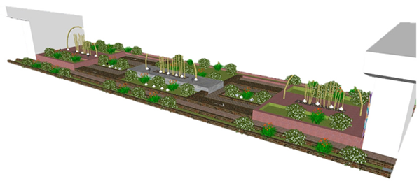
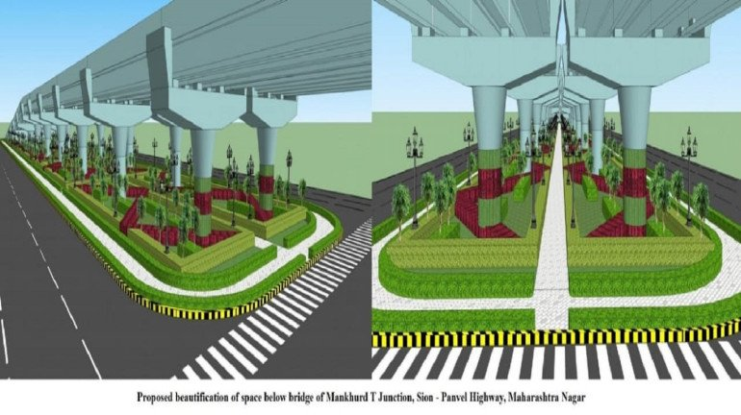
Figure 3.b: Proposed landscape design below the bridge of Mankhund T Junction, Sion-Panvel Highway, Maharashtra, Source: Mumbai Live

Figure 3.a: Space under the Unkal Cross flyover is designed to elevate visitors' experience, Source: Directorate of Urban Land Transport, Govt. of Karnataka

The right of way can be altered by modifying the walkways and medians without altering the width of the carriageway. Regional highways should be constructed with animal protection in mind. The orientation should be taken into consideration by the road plantation. For maximum sun protection, tall trees with dense foliage should be placed on the southern side. Thick shrubs should be placed closely together in the west because of low sun rays. The roads may instead be slightly curvy. Additionally, it improves the driving experience [53].

- Wasteland Utilization

Old buildings, educational facilities, and government-owned fallow areas can all be given to interested farmers for the growth of fruits, vegetables, or flowers. Farmers make more money by selling their products locally since they spend less on transportation and commissions. The farmers who are without land gain greatly from this procedure.
Wastelands are formed by water erosion, wind erosion, marshy land, and saline or alkali soil. Wastelands caused by wind are sand dunes, sandbar, coastal, sand etc. Those caused by humans include mile spoils, shifting cultivation, and industrial wastelands. In India, out of the 329 million hectares of land, about 113.3 M ha of land subjected to water erosion [54] and about 5334 million tonnes (16.4 tonnes ha⁻¹) of soil is being detached annually due to various reasons, in which about 29% of soil loss is carried away by the river into the sea, 10% into the reservoirs that lead to reservoir sedimentation [55] and remaining 61% gets displaced from one location to another [56]. It can be predicted in the near future that cultivated area will see a major shift from soil to soil less growing media due to this unmanageable wastelands.

- To identify the typology of structures suggesting the design methods for integration in urban agriculture

The integration of structures and urban agriculture in cities is one of the most vital steps toward sustaining our civilization. In the 1973 film Soylent Green, set in a then-futuristic 2022, filmmaker R. Fleisher envisions a congested New York ravaged by the effects of climate change, where the natural ecosystem is approaching extinction. The harsh environment has pushed away the seasons, creating only a persistent, scorching summer. The most significant challenge of mankind, based on Fleisher's anti-utopian worldview, is the challenge of acquiring food, that can only be available in the kind of man-made nutritional bars called "Soylent green." Fleisher's dismal vision of the foreseeable future from 50 years ago has now become a contemporary reality [57]. Presently, agriculture and urban planning involves dealing with the issue of urbanization, which has ended up resulting in space constraints and a disparity between output and consumption in space and pattern [58]. Recent studies show a rising demand for substitute food markets with local identification, natural, healthy, and reliable products. Such agricultural engagement in the urban system will bring about a change and will differentiate such farming from its rural version [59].

- Building space management

Space distribution in architecture plays a crucial part in the utilisation and usage of land for project construction, which takes place for four categories of building typologies, namely residential, commercial, industrial, and institutional, as well as the present state and patterns in urban food system planning, indicating that sustainable production and consumption are additionally significantly associated with spatial layout [58]. It has been observed that following 2005, agricultural practices became more common in cities as a result of both the trend of food localization and the subject of sustainable development [59]. Thus, several urban planning ideas, most notably Continuous Productive Urban Landscapes (CPULs), Agrarian Urbanism (or Agriculture Urbanism), Food Urbanism, and Food-Sensitive Planning and Urban Design (FSPUD) [60] exist to impact and integrate urban agriculture rituals into urban spatial frameworks [61]. All of the aforementioned theories' fundamental approaches involve spatial typology of multi-scale urban agriculture aiming at harmonizing and merging various urban locations within the framework of a sustainable infrastructure [58]. Thus, the various spaces of urban structures should be designed in such a manner that the entire urban space can be transformed into the contemporary vision of Ebenezer Howard's garden city idea, of setting up an environment that echoes the relationship of humans with the environment, on an extremely tailored form, accessible to all of the inhabitants [62].

Building Integrated Agriculture (BIA) is a form of ‘Agritecture’ where soilless farming is propagated through designed built spaces giving economic value to local farmers and is different then urban greens of parks, garden and urban wastelands. Building-Integrated Agriculture (BIA) is a category of Zero Acreage Farming (Z Farming) and can be defined as the exercise of placing advanced off-soil greenhouse systems, such as hydroponics, aeroponics, and aquaponics, in and around buildings to take advantage of the beneficial relationships among the built environment and the farming system as a whole. Rooftops, double-skin facades, balconies, and corridor spaces within urban structures are some of the spaces that could be designed to be used for agricultural productions (Figure 3). This strategy in advance, permits opportunities to capitalize on resource-efficiency synergies between buildings and farms [57].

Agriculture embedded structures in urban areas will be more focused on organic farming and the use of cutting-edge technology, whereas industrial agriculture creates extensive mono-cultural zones where large amounts of artificial herbicides and pesticides are typically utilized, leading to desertification of agricultural soils, depletion and pollution of critical water resources, and biodiversity loss [58]. Due to the inclusion of agriculture into structures, there are expansions of green regions in the cities to improve air quality, and partial reliance on urban agriculture decreases emissions of greenhouse gases. In this sense, BIA should be perceived not merely as an association with food activity, but also as a tool for architects and experts to promote sustainable development and green building design of future city. This corresponds to an obvious chance for planners, architects, and engineers to use soilless agricultural systems to generate a fresh urban metabolism [64].

Restaurants, coffee shops, clubs, and pubs can create structures to generate food in their own niches where they can grow their own kitchen herbs. These special areas can be built at the entrance or in any interior space where customers are able to observe and interact with them, resulting in a highly profitable business. The fundamental concept of this new approach to Urban Agriculture is relatively simple: plants require light, air, water, heat, and nutrients, and soil is unnecessary; the roots can acquire the essential mineral nutrients essential to plant growth from the nutrient solution [58].

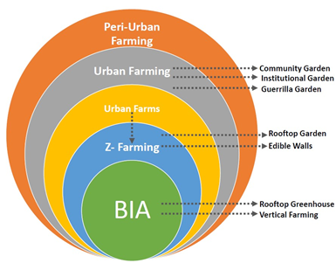

Figure 1: Building-Integrated Agriculture (Source: M. D’Ostuni et al. 2022).

b. Light management

The urban forms in the high-density areas are subjected to varied quantities of photosynthetically active radiation (PAR) due to their shape, direction, self-shadowing effects, and shadowing effects of nearby objects. Aside from optimal crop growth conditions such as carbon dioxide, nutrients, humidity, temperature, and water, which are relatively constant at the structure's scale, effective detection of soil-based farming, micro-locations (specific site at a specific level) in a structure necessitates an evaluation of its dependence on sunlight. Common building resources such as heat, water, clean air and light may be utilised to incorporate agriculture with existing and new structures and converted into a sustainable circuit. PAR sensors are extremely useful tools for rapidly recognising these specific zones within a building. The amount of solar exposure is primarily controlled by geographic location, orientation, and surrounding objects that create (self-) shadowing [66].

Before using artificial lighting, the most essential consideration is the presence of the amount of natural light. When considering natural illumination, four aspects must be considered: seasons, time of day, building orientation, and shadows cast by existing buildings. Most agricultural plant species require at least 3 hours of direct sunlight per day, while optimal results occur in a 6 to 7-hour range of sunlight. As a result, a comprehensive design analysis of the entire site and building spaces is essential for offering optimum light penetration to expanding areas such as internal spaces or vacant facades [33]. Today various technologies are present in the market. Companies like Sun Central Inc. specialize in natural light penetration within buildings, whose light systems automatically track, collect and concentrate sunlight before guiding it to a maximum of 20 meters within a space. The restaurant and pub design readapt Sun Central’s system to a vertical orientation through a series of skylights and reflective surfaces within the light duct which is raised high enough to avoid the shadows of neighboring buildings as explained in Figure 4. A simple solution that employs exceptionally reflecting ducts to allow sunlight inside the space may result in significant energy savings. There aren't any mechanical components involved, and no power is necessary. Through external collectors, mirror ducts accumulate maximum sunlight. Light passes into horizontal reflecting ducts within the artificial ceiling before exiting through ceiling apertures over a user. Such light is normally glare-free. Light shelves are extremely reflecting structures that reflect sunlight far into space. This can assist decrease the need for artificial illumination during the day time and reach the plants [67]. These ducts continue down the columns and reflect sunlight onto the plants growing from an aeroponic system linked to the concrete girders. These light beams also brighten the restroom sinks, staff room, and front reception desk area of the restaurant. Because architecture and agriculture have been incorporated here, farmers must be coached by agriculturists to train the plants to bend around the curves so that there is no opportunity for nutritional water to pour downwards the stem, and vegetation can be cultivated inverted in an aeroponic system [33].

In Interior living spaces with the accurate setup, an aeroponics or hydroponics system of different dimensions and flexibility can be employed as a barrier wall, balconies, or in designated locations. These arrangements can also be relocated throughout the area and placed in different residential complexes.

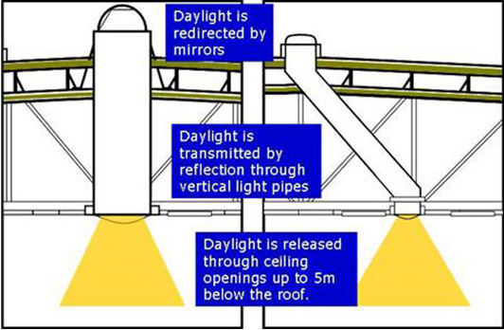

Figure. 4: Channelization of light through skylight for urban farming (Source: Zeb Brochure 2010)

c. Roof space management

There are strategies for designing roof shapes and shading that efficiently manage and manipulate sunlight to penetrate inside the built forms based on the varying radiation exposure over the seasons (Figure 5). Roofs are typically underused areas that hold service apparatus such as HVAC and water storage systems. Rooftops of large supermarkets and commercial business centers can incorporate agricultural systems, where residents visit on a daily basis to buy fresh fruits and vegetables. The majority of the rooftop of such huge built spaces is exposed to sunlight and remain unutilized, raising the warmth within the structures. As a result, a green roof is one of the finest ways to reduce interior temperature conditions while also assisting in the integration of the concept of Agritecture into urban constructions. Roofs are part of the architectural outlines.

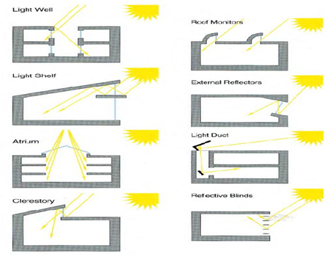

Figure. 5: Different styles of windows and overhands to control light inside buildings (Source: Andr3ws Blog, 2010)

d. Building exterior management

To accommodate agricultural practices, exterior facades of the buildings can be designed in steps giving space for farming (Figure 6). There are several ways of including urban farming in a structure. One of the options for agritecture is vertical farming. Vertical farming is an unconventional and might be a more sustainable farming method. This is beneficial because certain amounts of the water used can be recycled and reused. Furthermore, losses from evaporation are decreased. It also takes up a smaller footprint (especially on the ground) and has no or little impact on the natural soils in the area. For instance, a 10.76 square foot of vertical farm floor space yields roughly the same amount of vegetable crops as 538 square foot of traditionally farmed land. Vertical farms regulated environments facilitate the cultivation of crops throughout the year round [68].

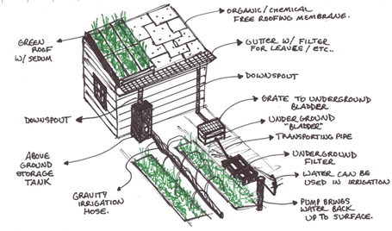

Figure 6. Green Roof Detail Drawing (Source: Strautz, 2011)
In office areas, specialized air duct systems with biofilters (ferns and mosses) can be used. These conduits actively suck air in via plants, where helpful bacteria breakdown air pollutants. The clean air is subsequently transported to the spaces via the ducts. These air ducts make use of existing infrastructure by attaching to or suspending concrete beams and girders. The bio-filter is expected to remove 50% of air compounds every system pass.
Commercial, industrial, and institutional parking lots can be converted into urban farms using a series of aeroponic 'tree' systems. The columns can be designed with concrete platform at the beam level and made suitable for cultivation, which columns after design looks like ‘trees’ (Figure 7). These 'trees' are metal cylinders that support an aeroponic cultivation platform. During non-parking hours, the ready-to-harvest aeroponic platforms are lowered to table height, allowing residents to pick up their newly harvested products [33]. As described in this article that rising urbanization and its concomitant sprawl, particularly in the global south, are challenging the sustainability of agriculture even at the urban fringe these kinds of small-scale integrations of Agricultural cultivation solution through structural design have the potential to alter the concept of inhabitants towards Agriculture and Urban built form in cities.

- Present global status

Urban agriculture also contributes to local trade development, creating full-time employment and additional sources of income. For instance, in Ghana, urban farmers produce most of the exotic vegetables for the region, such as lettuce and spring onions, and supply them to urban markets [65]. Even this concept of integration agriculture into structures has increased the income of people two to three times more than the average income earned from rural farming.

Architecture and Urban Planning history suggest the concept of incorporating vegetation into architecture is not something new; for instance, the Ford Foundation headquarters was built in 1968 by Kevin Roche and John Dinkeloo partners, where the primary internal entrance section of the office arrangement was created with an amphitheatrically shaped garden hence where the value of land is huge to leave space for urban greenery in traditional form there architectural designed spaces helped foster the emergence of urban green consciousness and was the first step towards a structured approach for implementing prospective urban green areas into built forms. Examples include the alteration of Manhattan's usual quarter-buildings by various forms of urban agricultural productions, as well as farms on the rooftops of Hong Kong skyscrapers developed by the inhabitants themselves, demonstrating the efficacy of the association of architecture and agriculture [62].

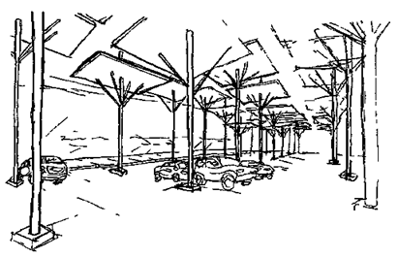
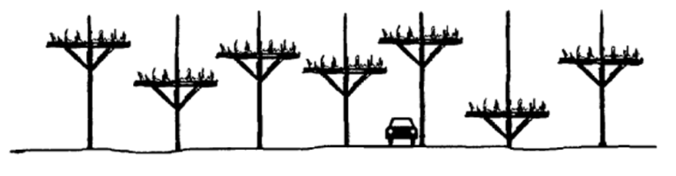

Figure 7. Series of aeroponic 'tree' systems suitable in parking lots (Source: Marcynuk, 2011)

vi) Future prospects of Agritecture

- Once this concept of Agritecture gets its acceptance in the cities by the urban planners, designers, farmers, and agriculturalists, and then more technological advancement may come up which will help to spread the idea among the inhabitants of the cities in India and worldwide. Initial set-up cost may be bear through subsidy from Government.

- There is a significant possibility for Agritecture in residential flats, as vacant façades, balconies, and rooftops can be fully harnessed for food production. Even builders or investors can be suggested to contribute certain floor plates within the structure for indoor agricultural operations in exchange for certain attractive FAR (floor area ratio) concessions.

- Various NGOs, and SHGs may take the initiative of training, empowering and holding awareness campaign about the technical know-how to empower the urban or peri-urban localites or young entrepreneurs or several stakeholders or investors to increase per capita income and contribute to food production equally.

- In the coming days, ‘Agritecture’ may be taken up as a course in architectural studies, management studies and agricultural sciences that will cater the need of human resource, managing agribusiness and production technology of urban agriculture respectively.

