Nanotechnology: A Boon for the Scientific Domain

Indu Sindhu and Anshul Singh
Department of Chemistry
Baba Mastnath University Rohtak, India-124021
Email: indusindhu22@gmail.com, anshul9008@gmail.com

Abstract
Nanoscience is an integrative field that comprises chemical science, physics, biology, and engineering fields and deals with their synthesis, properties, and applicability to future trends. Nanotechnology mainly includes particles having sizes at the nanoscale (one billionth of a meter) and examining their physical and chemical properties at the nanoscale. The properties of nanomaterials differ considerably from those of bulk materials. In this chapter, we have listed the applications of nanomaterials in various areas as reported by the scientific community. The nanoparticles exhibit applicability in the food industry as packaging material, electronics items such as chips, devices, and displays, and in the medicinal field to detect cancer and its treatment. Another interesting application is in tissue engineering, remediation of pollution, and in agricultural areas as nanopesticides and nanofertilizers. The applications of nanotechnology in various sectors are tremendously expanding, resulting in a rise in the global market for nanomaterials. With the help of nanotechnology, everyday products become more functional and efficient, which enhances our quality of life.
Keywords: Nanotechnology, Applications, Nanomaterials, Bio-sensors, Bio-nanocomposites.

Graphical Abstract
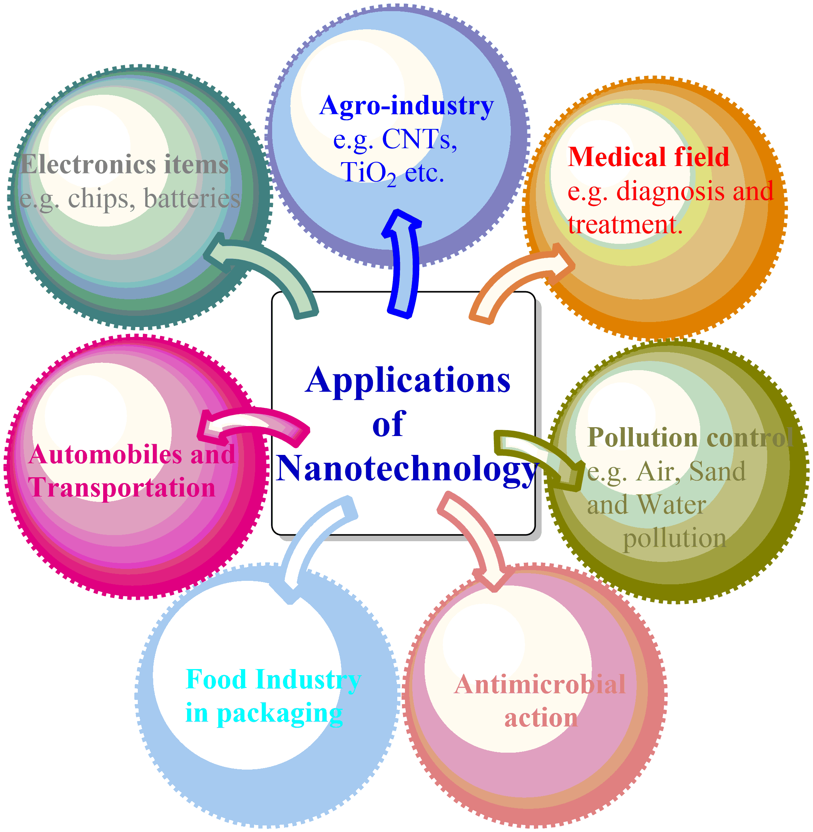

I. Introduction

Material science, a scientific field consisting of chemistry, biology, and physics, deals with atoms and particles comprised to form materials and finding their applicability for future utilities. The growing interest of young scientific minds in material science and nanotechnology is due to their extensive applications in various fields and their implementation rising rapidly with every passing day. Chemical and material science is about the synthesis of new compounds, materials and gathering information about their structural and physical properties with the help of modern computational techniques. In the word nanotechnology, the term nano here refers to “one billionth” of something (small size particles, particles at the nanoscale). Nanotechnology describes the use of molecules and atoms to synthesize and assemble novel materials but limits their dimensions (size) to the nanoscale [1]. The term nanotechnology was introduced in 1974 by Norio Taniguchi in a research paper titled “Basic Concepts of Nanotechnology”. Material science and Nanotechnology have vast areas of research employment in the fields of nanomedicines, manufacturing, energy production, electronic devices, and the food industry [2]. The implementation of nanoparticles is in carbon nanotubes, which are a hundred times more efficient than steel, possess lower dimensions, and can be potentially used as semiconductors [3-4]. Silica is also a nanomaterial that exhibits anticorrosive properties. The nanobiotechnology branch emphasizes the utilization of nanoparticles in the field of medicine, such as in the treatment of hazardous diseases like cancer [5]. The broad application area of nanomaterial is not limited to this, but they exhibit remarkable applications in the food industry with their significant role in food production, packaging, agricultural areas to produce new food products, solar and fuel cells to provide an environment-friendly atmosphere by deteriorating harmful pollutants and heavy metals [6-8]. Nanotechnologies have enormous promise for solving global problems like insufficient energy supply, climate change, and lethal illness. Nanotechnology has the potential to revolutionize the generation, storage, and conservation of energy. Nanomaterials, for instance, can be utilized to increase the effectiveness of solar panels, improve battery performance, and create more effective lighting systems. Research in this field may result in developments that will help to placate the escalating demand for renewable energy sources. Nanotechnology has the potential to help mitigate the effects of climate change [9]. For instance, nanomaterials can be used to create strong, lightweight materials for automobiles that use less fuel, to cut pollutants from industrial operations, and to boost building energy efficiency. Nanotechnology’s tiny size can give them unusual features and to evaluate the safety of nanomaterials and develop suitable rules for their usage, it is important to undertake a detailed toxicological investigation. Along with technological improvement, it is imperative to comprehend the possible negative impacts on human health that nanomaterials may have. Overall, nanotechnology has a lot of potential for solving global concerns, but in order to fully realize this promise there is a need to maintain the safety and ethical standards [10]. Nanotechnology and nanomaterials have in fact become a swiftly mounting area of study with enormous potential for many other industries, including building and infrastructure. It is possible to advance and improve infrastructure building by utilizing the unique properties of nanoscale materials.
Understanding materials and their behaviour at the nanoscale is a crucial component of nanoscience. Materials can vary considerably in properties when they are condensed to the nanoscale, resulting in novel phenomena and uses. For instance, materials that are ordinarily insulators at larger dimensions can display other fascinating properties at the nanoscale, such as becoming conductors. Nanoscience is crucial in numerous broad domains, especially nanoelectronics, nanomedicine, and nanomaterials, in addition to fundamental research. By enabling new technologies and applications, including faster and more effective electronics, targeted medication delivery systems, and lightweight and strong materials, nanotechnology has the potential to revolutionize multiple fields.
Typically, nanoscience encompasses a wide range of scientific fields, covering physics, chemistry, materials science, biology, and engineering. It entails comprehending the fundamental concepts governing interactions at the nanoscale, exploring unique nanoscale phenomena and properties, inventing cutting-edge tools for manipulation and characterization, and deploying this knowledge for manufacturing novel technologies and materials.

II. Application of material science and nanotechnology

- Agro-industry

Nanofertilizers provide micronutrients to plants like S, Ca, Mg, N and K and also supply macronutrients such as Zn, Fe, and Mn that result in enhanced growth of food crops and plants and thereby increase their production rate [9]. Their non-hazardous nature, efficiency, and environment-friendly core make them superior to conventional fertilizers. Due to their small size (nanosize), they have a higher penetration tendency and supply nutrients to plants by absorbing them from the soil [11]. This phenomenon can overcome the nutrient deficiency in food crops by the use of nanofertilizers and make the food crops more beneficial to human beings in terms of nutrient because nutrients deficiency can cause malnutrition in humans, leading to the risk of various diseases like low mental and physical health [12].
Nanopesticides have better effectiveness in comparison to toxic pesticides, which not only harm the soil but also affect human health. Toxic pesticides pass through leaching, and cause eutrophication, and produce harmful effects on aquatic animals. The nanomaterials used in the form of carbon nanotube and metal oxide are the best alternatives if used correctly, along with natural compounds [13]. Another application of nanoparticles (NPs) is in seed germination, growth, and development. TiO₂ and SiO₂ nanoparticles are reported in the literature to enhance plant growth; however, the exact mechanism of action is not entirely explained; reports advocate the entry of NPs into seeds, activating enzymes, and enhancing their rate of germination and growth. For e.g., crops like Spinach, peanut, potato, wheat, tomato, and mustard growth gets amplified eventually after the addition of TiO₂, multiwalled carbon nanotubes, and metal oxides [14-15]. A recent study on fenugreek plants recommends that after addition of CuO, there is a considerable increase in the percentage of seed germination, development, and content of chlorophyll in plants [16]. But prescribed doses should be used; otherwise, high quantities result in a decrease in the length of roots and biomass [17].
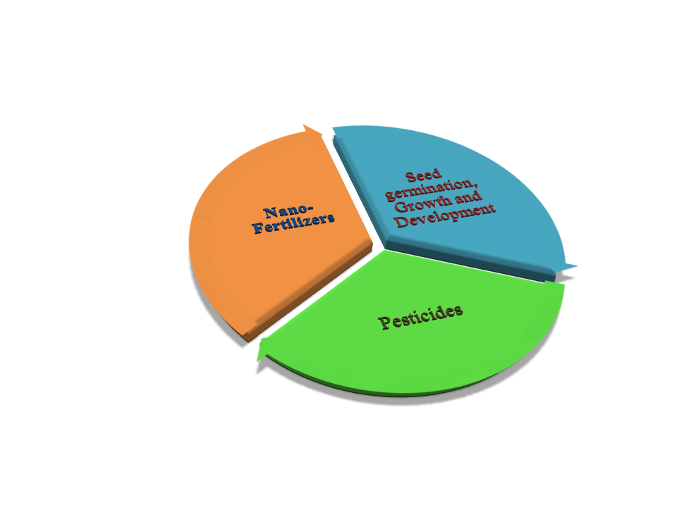
Figure 1: Application in agro-industry
- Bio-medical applications

Covid-19 detection

The respiratory syndrome coronavirus-2 (SARS COV-2) has caused a worldwide public health emergency. Early research revealed that the virus is transmitted predominately by respiratory droplets in close contact. A recent study; however, has shown that viruses can survive in aerosols for several hours, increasing the potential for airborne transmission. As a result, air purifiers’ contribution to reducing COVID-19 transmission has drawn considerable attention. Utilizing nanofibers is one such strategy that can successfully catch and stop the spread of airborne viruses like COVID-19. In the detection of COVID-19 viral infection, biosensors are the type of sensors that are sensitive, inexpensive, and efficient. Aptamer-based nanobiosensors can diagnose infections even if a patient doesn’t have any symptoms. The spike protein S1 of SARS COV-2 forms an aptamer for these nanobiosensors, and it furnishes results very quickly and accurately [18]. This viral infection mainly spreads through aerosols. Ag-based nanoparticles can be effective when used in face masks as they can immobilize and kill the virus on surfaces. In a similar way, two dimensional carbides and nitrides are hydrophilic in nature and can strongly bind to amino acids and kill these viral agents or inactivate them; hence, they can be potentially used on the surfaces of PPE and face masks that block the entry of viruses [19].

Cancer treatment

Nowadays, inorganic and organic NPs are widely synthesized, but among them, carbon-based NPs can be successfully used for the treatment of cancer by providing a site-specific drug delivery system. Several NPs like graphene oxides, nanorods, nanotubes, and quantum dots that are less toxic can be utilized as suitable candidates for biomedical applications. Nanomedicine, the field of nanotechnology, has supremacy over other cancer treatments due to its efficient target drug delivery system and controlled release of drugs at the target site [20]. These materials are also dominant over other standard drugs as they have lesser chances of degradation before reaching the site of action and also diminish the probable side effects.
Gold NPs are suitable for their uses in medicines because of their properties of stability, target drug delivery system, and effectiveness against liver cancer, breast cancer, pancreatic cancer, lung cancer, and ovarian cancerous cells [21]. Similarly, Ag NPs are reported to be effective in cancer treatments such as ovarian cancer, lung cancer, colon cancer, and breast cancer [22]. The metal oxides are also reported to have significant antitumor effects due to their non-toxic nature, unreactivity towards other chemicals, and easily modifiable surfaces. Iron oxide NPs are clinically used for cancer detection and therapy as iron oxide nanoparticles can reach the target site more efficiently when loaded with drug under an external magnetic field. They release the drug at the active site, and increase the rate of action of the drug without causing any harm to the neighboring (normal) cells [23]. Several iron oxide nanoparticles have been reported to be effective against various cancerous cells, like prostate cancer, gastric cancer, lung cancer, and ovarian cancer. Zn NPs, CuO NPs, TiO₂ NPs and CeO have been recently used in the biomedical field and are effective against colon cancer, breast cancer and ovarian cancer [24-25]. Quantum dots are semiconducting in nature and, when lighted with UV light, can locate specific cells and biological activity by providing a spectrum of bright colors. These quantum dots are widely employed in magnetic resonance imaging technique (MRI) [26].
These NPs were also used to increase the temperature of cancerous cells & kill them, a process termed as hyperthermia. These metal based nanoparticles can be used as radiotherapeutic agents in cancer radiotherapy by increasing the radiation dose to the effective site so that the maximum dose is supplied to tumor cells and is non-toxic to normal cells [27]. Au, Ag, Pt, TiO₂ and ZnO are employed in radiotherapy while phototherapy is the technique that involves the use of Au NPs for laser killing of cancerous cells [28]. But the most important thing to keep in mind is to regulate the temperature gradient to avoid any risk to non-cancerous cells. Au NPs are used for the detection of prostate cancer by optical imaging and positron imaging tomography (PET) techniques [29]. Through their anticancer properties, metal based nanoparticles have demonstrated promise in the treatment of a variety of malignancies, and the accuracy of medication administration has increased due to controlled-release systems that are activated by elements such as pH, temperature and electromagnetic radiation. Although preclinical studies have shown encouraging outcomes, several metal-based formulations have not yet been used in clinical settings due to worries about their toxicity.
Palladium nanoparticles (Pd NPs) have been investigated for their possible therapeutic uses in the domains of photothermal therapy (PTT) and photodynamic therapy (PDT) for the treatment of cancer. Palladium nanoparticles have unique characteristics that make them desirable for these medical procedures. One of the major characteristics permitting them to function as efficient photoabsorbers is their considerable absorption of light in the near infra-Red (NIR) band. Compared to other parts of the electromagnetic spectrum, NIR light is capable of reaching deeper into biological tissues, making it compatible with non-invasive cancer treatment. In photothermal therapy, Pd NPs are capable of photothermal conversion, which is the conversion of absorbed NIR light into heat. Pd NPs quickly absorb the light energy when exposed to an NIR laser, which causes the tissue in the immediate vicinity to heat up. Aside from stimulating the immune system to strengthen the anti-tumor response, this localized hyperthermia can have a number of other effects, including the death of tumor cells and damage to the blood vessels supporting the tumor. Pd NPs have the potential to function as photosensitizers in photodynamic treatment. Photosensitizers are chemicals that, when activated by light of a particular wavelength, can produce reactive oxygen species (ROS). PdNPs can generate ROS when exposed to NIR light, which can oxidatively harm cancer cells and ultimately cause their demise. Overall, the Pd NPs and NIR laser irradiation combination presents a potential strategy for targeted cancer therapy. A precise and localized treatment can be accomplished with the application of NIR light and the selective accumulation of Pd NPs in tumor tissues, causing the least amount of harm to the healthy surrounding tissues. To fully comprehend the potential of Pd NPs in cancer therapy and to address any potential toxicity or side effects connected with their use, further research is still required, which is vital to emphasize. Pt NPs, or platinum nanoparticles, have shown inherent cytotoxic action, which means they can stop tumor growth. On the other hand, the nanoparticles can be functionalized, or changed, with particular molecules or ligands to increase their specificity and efficacy in targeting cancer cells.

Antimicrobial and antioxidant properties
Nanoparticles can be successfully utilized as antimicrobial agents; for example ZnO nanoparticles reduce (stop) the action of Staphylococcus aureus bacteria [30]. This mechanism of action involves attachment to the bacterial surface and produces reactive oxygen species (ROS) that lead to the death of bacteria [31]. Silver nanoparticles exhibit antibacterial action against gram negative bacterial strains E. coli and P. aeruginosa and inhibit their growth. In addition to this, copper nanoparticles are also effective against E. coli and B. subtilis bacteria as reported in studies. Another well-known example is that iron oxide NPs and SiO₂ display antimicrobial action, and several mechanisms of action were reported for different strains, such as disruption of cell membranes, protein inactivation, and effects on cell permeability [32]. The capacity of antioxidants to reduce oxidative stress has garnered a lot of attention. When there is a buildup of oxidants, such as reactive oxygen and nitrogen species (RNS), and the antioxidant defenses to neutralize them are out of balance, oxidative stress results. This imbalance causes a net rise in the amounts of ROS and RNS, which can harm DNA, proteins, lipids, cell membranes, and subcellular organelles; cellular function is hampered as a result. By interacting with crucial cellular constituents and upsetting their structure and function, these reactive species have the ability to initiate and spread cellular harm. These nanoparticles can also be employed as the anti-oxidant agents by disrupting production of free radicals by supplying electrons [33]. Antioxidants and their impact on oxidative stress are currently the subjects of ongoing research with the aim of deeper comprehension of their mechanisms of action and potential applications in therapy. It is now being investigated if antioxidant-rich diets, dietary supplements, and antioxidant-based interventions work as efficient ways of combating oxidative stress and its detrimental effects on health.

Figure 2: Bio-medical uses of nanoparticles in various fields

Tissue engineering

Tissue engineering is the technique to reconstruct or repair damaged organs or tissues, and NPs can play a vital role in tissue engineering, as reported in the literature. Nanoparticles display applications in periodontal related diseases like rheumatoid arthritis, diabetes, and cardiovascular disease by providing a new coating for implants and being utilized in toothpaste and personal care products [34]. It displays remarkable action in skin tissue engineering, bone tissue engineering, and neural tissue engineering. The function and regulation of nanoparticles with cells closely resemble cells regulation & functioning; with the first step involving the interaction of cell surface with NPs. Ag, Au, and TiO₂ are utilized for bone tissue engineering due to their mechanical properties, and AuNPs can be excellent sources of cell differentiation. In addition, nanomaterials such as nanocellulose, which consists of cellulose-based nanoscale structures, are utilized for wound dressing materials and skin treatment diseases. CeO₂ NPs have the ability to heal wounds fully in 14 days with no side effects. Nanographene oxides, another nanomaterial, are economical and have properties for healing wounds [35].

- Pollution remediation

Air quality gets worse these days, and it is harmful to humans and poses a more severe risk to asthmatic patients. Nanotechnology based materials are particularly well suited for such processes due to their improved characteristics, effectiveness, and high surface area-to-volume ratio, which frequently leads to increased reactivity. Environmental remediation involves utilizing diverse methods, such as adsorption, absorption, chemical reactions, and filtration, to remove contamination from environmental media such as soil, water, and air. Another important factor to bear in mind is that while employing the utilization of nanomaterials, it is crucial to clean up pollution so that these nanomaterials do not become new sources of pollution. While designing new NMs for remediation, important factors that are taken into account are target-specific capture, economical, non-toxicity, and easy synthesis. Nanotechnology can play a significant role in transforming harmful gases into non-toxic, harmless gases. Nanocatalysts like Manganese oxide NPs and Gold NPs can be successfully implemented by virtue of their capability to convert CO gas to CO₂ (harmless) gas. Carbon nanotubes with single wall play a major role in air purification, and this nano remediation is a judicious and an upgraded approach than the originally employed conventional methods [36].
Another ongoing research area of nanotechnology applications is in water purification and treatment of waste water; carbon nanotubes, graphene, iron, and other metal oxides are reported to have potential applications in the treatment of contaminated water. Zero valent iron and bimetallic iron are good examples of materials used to remediate pollution. Dechlorination of water can be done by palladized iron and nickel NPs and various other nanoparticles like TiO₂, ploy amidvamine, and carbon nanotubes, which are reported to deteriorate heavy metals from contaminated water. A nano-membrane is developed by the scientists, which entails cross-linked polymers and NPs that repels organics, bacteria and contaminants present in water, apart from this nanoparticle are also used in the removal of wastes from soil, including solid and liquid wastes [37]. In the area of water filtration, nanotechnology has actually demonstrated considerable potential. Nanomaterials could be beneficial for a variety of applications, including the treatment of wastewater, owing to their small size and durable reactivity. Nanomaterials can be created and modified to have particular qualities that improve their efficacy in eliminating impurities from water. The capacity of nanotechnology to remove heavy metals from wastewater is a key benefit for water purification. In order to keep water quality high, heavy metals must be removed because they are a major threat to both human health and the environment. Heavy metals can be catalytically degraded, absorbed, or adsorbed by nanomaterials, which efficiently lowers their concentration in water to acceptable levels. Nanotechnology can aid in the removal of dangerous germs and viruses from water, in addition to heavy metals. Heterogeneous photocatalysis, which uses photocatalytic nanomaterials, has demonstrated effectiveness in the elimination of bacteria from water. These nanomaterials can successfully kill bacteria and viruses as well as Streptococcus mutans, Escherichia coli, and others when exposed to light. Additionally, it is advantageous from a financial and sustainability standpoint to produce nanomaterials using ecologically benign methods. Overall, the use of nanotechnology for water purification approaches offers an opportunity of more efficient and economical wastewater treatment, heavy metal removal, and disinfection of pathogenic bacteria. It is pertinent to understand that more studies and research are still required to improve these nanomaterial-based technologies and assure their stable application on larger scales.

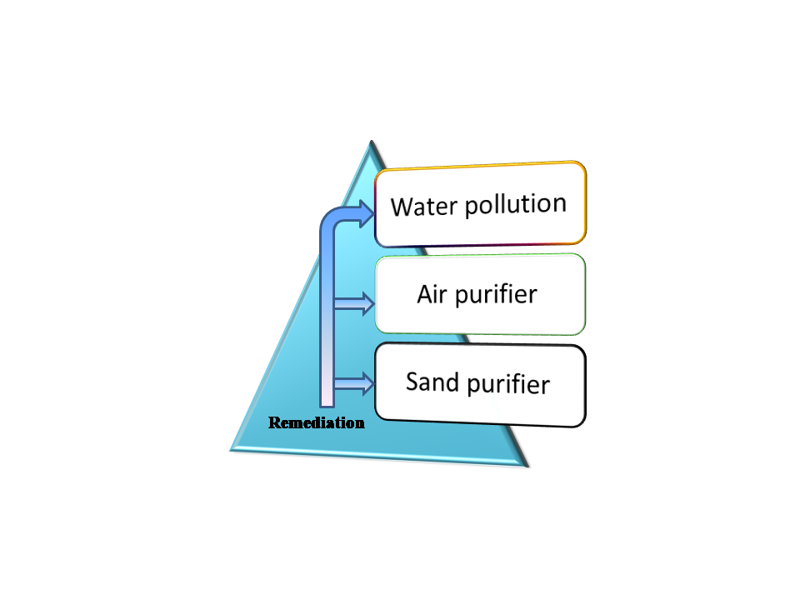
Figure 3: Nanoparticles application in pollution remediation
- Food packaging

NT (nanotechnology) is an emerging research topic in the food industry because of its novel applications in food safety and packaging at a low cost. It is a necessary step to protect food from dust, microorganisms, and other environmental contamination. Nano composites are polymer matrixes with organic or inorganic fillers and are termed as biohybrids. These nanoparticles and nano composites which display remarkable features like antimicrobial action, biocompatibility, biodegradability, cost effectiveness, and environmental affability [38]. On the basis of the matrix used, it can have a particulate, elongated, or layered structure that is efficiently used for food packaging purposes. These NPs possess optical and barrier properties, which are useful to protect food items from photodecomposition and oxidation. Other extensively used nano composites were silver NPs, which display antimicrobial activity towards a broad range of pathogens and are hence widely studied for purification of water and air, drug delivery, biosensors, and the food packaging industry. Copper NPs are another type of NP that is effective, but their high doses can cause harmful effects on aquatic animals therefore they are less studied. The gold nanoparticles are eventually researched due to their medicinal, antibacterial, and non-toxic nature, but they are not economical in nature. The nano composites having effective antimicrobial properties and being non-toxic to humans are sulphur NPs, which are excellent materials for packaging because of their ability to block UV rays. Titanium oxide is a type of metal oxide widely used as a food coloring agent due to its non-toxic nature and economical properties. On similar grounds, Mg NPs display antibacterial properties, are non-hazardous, and are hence successfully employed in food packaging materials [39]. Nano clay is used for food packaging because of its powerful mechanical and thermal characteristics [40]. The incorporation of nanotechnology in the food domain has opened up fresh prospects for enhancing food durability and nutrient content, thus assisting customers. One noteworthy accomplishment in this field is the nano scale synthesis of nutrients, which optimizes their stability and effectiveness during various phases of food preparation. The commercial availability of nano-encapsulated active compounds fetches about uses in a wide range of food products, including beverages, meat and cheese. In the production of sausages and processed meats, for example, when the addition of various additives is required to optimize the manufacturing process, retain color, and increase flavor, nano-encapsulation provides a more efficient and targeted delivery of chemicals. This not only enhances overall food quality but also diminishes the need for inefficient chemicals. These nano-encapsulated chemicals can be used as preservatives in all sorts of food products, extending shelf life and nutritional value. Researchers are still investigating the possible advantages and safety concerns of using nanotechnology in the food sector, which is still a developing subject.

- Electronics

Graphene and carbon nanotubes have been used in manufacturing transistors, new displays, batteries, solar cells, lubricants, paints, biosensing, memory chips used in smartphones, antimicrobial keyboards, conductive inks for printed electronics, and thumb drives. Nanomaterials possess great mechanical properties, and their light weight makes them exhibit a high reaction rate. Scientists are much more focused on nanomaterial synthesis and exploring their properties and applications in the modern era. MXenes exhibit great electrical, optical, biodegradability, and mechanical properties which makes them competent enough to be utilized in the sensors, catalysts, and electromagmetic materials [41]. In fact, the field of memory and data storage technologies has undergone a technological revolution. The special qualities of nanoscale materials and architectures have given rise to a number of novel uses. A potential development in memory technology is carbon nanotube-based crossbar memory, commonly referred to as nano-RAM. It makes use of carbon nanotubes as a platform for data storage, offering a potential substitute for conventional transistor-based electronic memory architectures. Memristor components have drawn a lot of interest as possible flash memory alternatives. Memristors are a good choice for future memory technologies since they have benefits like non-volatility and quicker switching rates [5]. Nanomaterials are substances that can be used to create capacitors with varying thicknesses while keeping the same capacitance layer in place. Thus, it is possible to create capacitor libraries or capacitors with variable capacitance density. Due to their use in microwave technology, nanoscale ferrite components find use in both the commercial and military sectors. Composite nanofibers have a lot of promise for use in eco-friendly optical and electrical components such as flat panel displays, sensors, and light-emitting diodes (LEDs). Various nanofibers are ideal for various applications since they have distinctive qualities and capabilities. Nanomaterials may be utilized to create optical switches, which are essential parts of technologies like communication networks. Additionally, laser diodes, antistatic coatings, and filter conductivity are all used in nanomaterials.

- Electrochemical field

Recently, nanoparticle applications have been found in electrochemical fields to detect heavy metals, in new electrode materials, and in field-effect transistors. Literature claims the use of carbon nanotubes, nanoparticles, and graphene materials for electrodes and heavy metal detection such as Zn, Cd, and Cu. Another type of nanoparticle, metal nanostructure, possesses the characteristic of detecting heavy metals through alloy formation. The advantage of these materials over others is that they are non-toxic and adaptable for various analyses [42].
- Automobiles & transportation

Nanomaterials are widely employed to construct light weighted automobiles by improving its size to mass ratio, stability and wash resistance properties. For e.g. carbon nanotubes are excellent substitute of steel in automobiles parts and displays high thermal stability and better arrangement. In paint industry, ZnO, TiO₂ nanoparticles reflect UV rays and dust; hence proves to be proficient materials in paint industry. The combination of nanomaterials along with coating film of automobiles provides a scratch resistant finishing touch to automobiles. Apart from this, NMs are utilized for storage of hydrogen in the fuel cells [39].

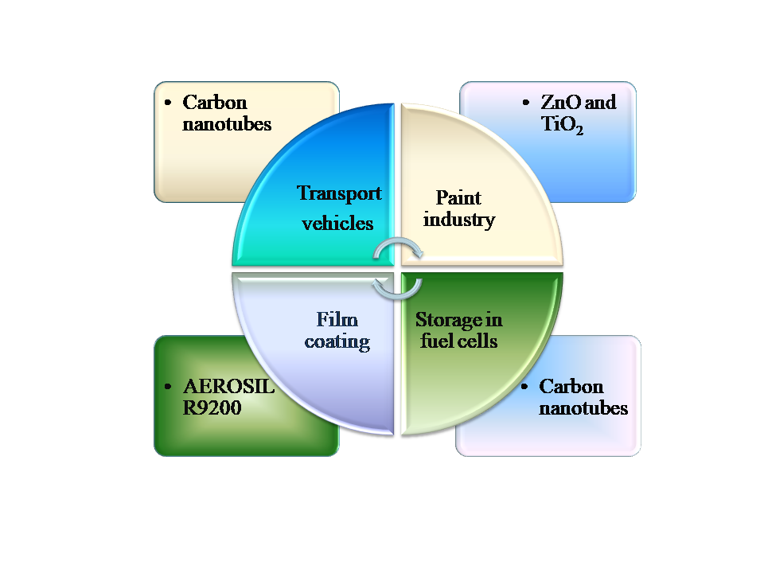

Figure 4: Applications of nanomaterials in automobiles & transportations

- Oil and Petroleum industry

Nanoparticles can function as catalysts in various chemical reactions; for example, Ag and Au NPs display catalytic action in dye degradation processes [43]. These nanoparticles increase the rate of reaction, consume minimum time, and reduce the amount of Pt used for reaction, thereby making the reaction more economical in nature. These particles are capable of converting nitrogen gas into ammonia due to their high surface area and small size. For enhanced oil recovery (EOR) applications, nanoparticles were studied on a lab scale as performance enhancers for polymers, surfactant flooding processes, emulsion stabilizers, etc. Silica nanoparticles have drawn the greatest interest among the many types of nanoparticles in the realm of EOR applications [44]. Carbon quantum dots can be successfully implemented as tracers in crude oil, tracing out pollutants and other contaminants. Researchers have found uses for nanoparticles as anti-corrosive agents in pipelines and to help solve the problem of oil leakage. Other applications of nanoparticles as nanomembranes play a crucial role in carbon dioxide capture, storage, gas separation, and oil purification. The nanoparticles are used as demulsifiers in downstream processes and exhibit better effectiveness than conventional emulsifiers due to their salient features, i.e., non-toxicity, high thermal conductivity, large surface area, and pollution resistance [45].
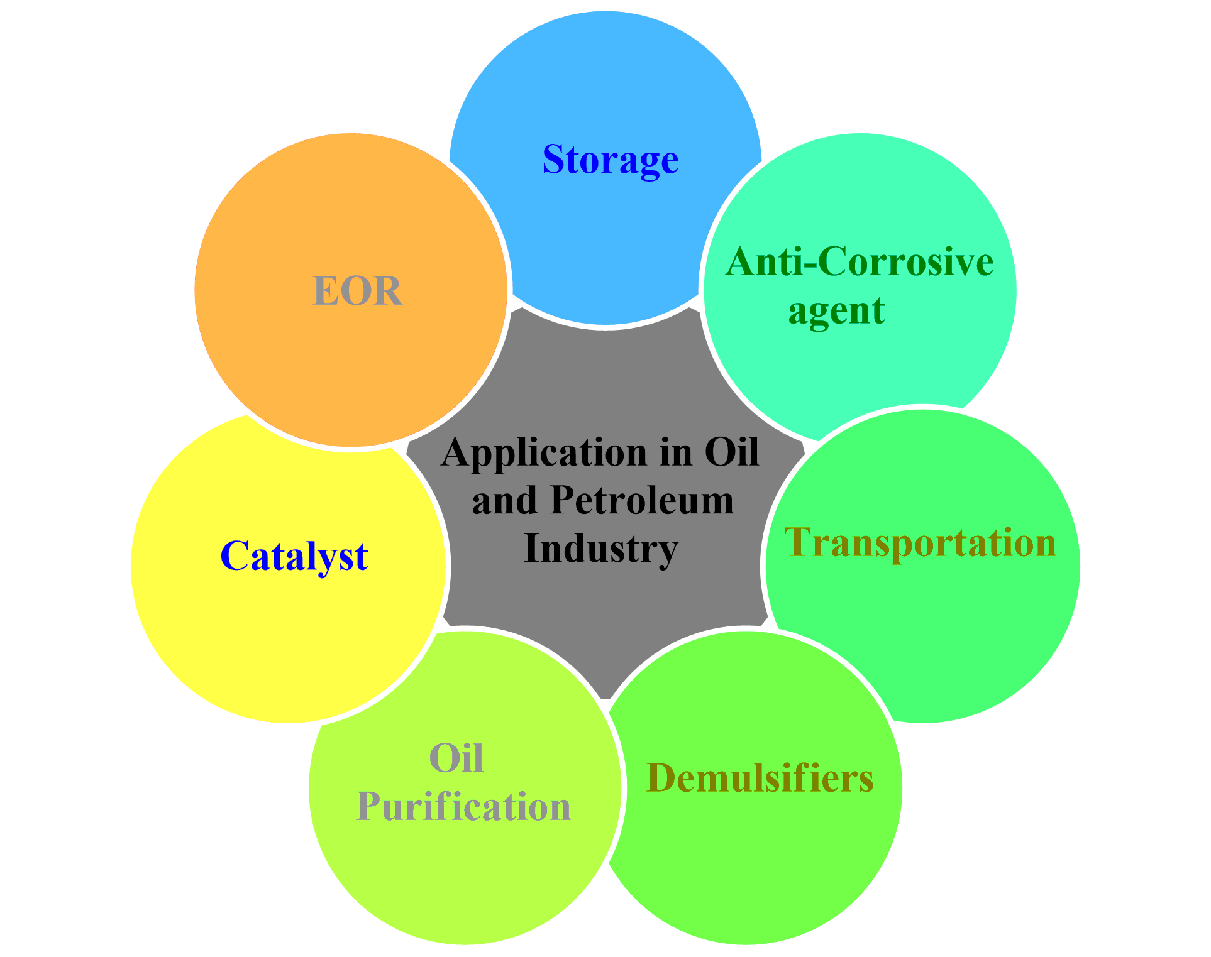

Figure 5: Application of nanoparticles in oil industries

Conclusion

Nowadays, the scientific community is much more focused on nanotechnology and materials sciences because of their speedy development and their mindboggling applications in numerous fields. The nanomaterials display potential activity from the industrial area to the biomedical field in different ways. The nanomaterials are economical and non-toxic, thereby proving more efficient in the chemistry, biology, and engineering research fields. Their numerous applications in electronic devices such as transistors, semiconductors, and smartphones will make a significant contribution in the immediate future. Current studies in biology, electronic storage, and sensors show the increasing extent of application of nanomaterial development. Nanomaterials have enormous potential in biomedicine for targeted medication delivery, imaging, and diagnostics. They may mitigate negative effects as well as enhance therapy effectiveness. The special characteristics of nanomaterials are advantageous for electronic storage devices, including batteries and supercapacitors. The energy storage capacity, charge-discharge rates, and stability of nanoscale materials are all improved. The goal of ongoing research is to improve these characteristics and create energy storage technologies that are more effective and long-lasting. Additionally, nanomaterials are essential to sensor technologies because they allow the creation of highly sensitive and selective sensors by utilizing their outstanding surface-to-volume ratio and customized characteristics. These sensors have been used in security, healthcare, and environmental monitoring, among others. This continuous advancement in nanomaterials has a useful impact on numerous research fields such as electronics, the medical field, communication technology, and energy production. In order to boost the effectiveness and performance of the products or process and lower the cost to expand availability, this technology is being tested for a range of novel applications. Nanotechnology holds enormous potential for the future because of its effectiveness and lack of negative effects on the environment.

REFERENCES

- M. Nasrollahzadeh, S.M. Sajadi, M. Sajjadi and Z. Issaabadi, An introduction to nanotechnology, Interface Science and Technology, 28; 2019.
- B. Bhushan, Springer handbook of nanotechnology, Technology & Engineering, Springer Science & Business Media, 2010.
- S.S. Yattinahalli, S.B. Kapatkar, S.N. Mathad, Review of Nanoscience Materials and its applications, Research J. Engineering and Tech. 7(3); 2016.
- X. Hu, On the size effect of molybdenum disulfide particles on tribological performanc, Ind. Lub. Trib. 57(6); 255, 2005.
- S.K. Bera, Materials science and nanotechnology: Prospectud and future, Int. J. Multidisc. Edu. Res. 10; 8(2), 2021.
- S. Mobasser, AA. Firoozi , Review of Nanotechnology Applications in Science and Engineering, J. Civil Eng. Urban, 6 (4); 84-93, 2016.
- P. Roy, M. Choudhury, Environmental susceptibility and nanowaste. In: Waste Recycling Technologies for Nanomaterials Manufacturing, Springer, (ed. M. ASH and A. GAM), 65–87, 2021.
- S. Rasalingam, R. Peng, and R.T. Koodali, Removal of hazardous pollutants from wastewaters: applications of TiO2-SiO2 mixed oxide materials, J. Nanomater. 617405; 1–42, 2014.
- F. Simonis, S. Schilthuizen, Nanotechnolgy innovation oppurtunities for tomorrow’s defence, TNO Sci. & Indus. 2006.
- S. Logothetidis, Nanostructured Materials & their Applications, Nanosci. & Tech. 2012.
- D.P. Singh, G. Packirisamy, Applications of nanotechnology to combat the problems associated with modern food, J. Sci. Food Agric. 2022.
- D.M. Singh, C. Gautam, P.O. Prakash, M.H. Mohan, G. Prakasha, V. Vishwajith, Nanofertilizers is an way to increase nutrients use efficiency in crop production, Int. J. Aricul. 9(2); 3831-3833, 2017.
- S. Thakur, T. Thakur, R. Kumar, Bio-Nanotechnology and its Role in Agriculture and Food Industry, J. Mol. Genet. Med. 12; 1–5, 2018.
- X. Zhao. H. Cui, Y. Wang, C. Sun, B. Cui, Z. Zeng, Development strategies and prospectus of nanobased pestoicides formulation, J. Agric. Food Chem. 66(26); 6504-6512, 2018.
- J. Banerjee, C. Kole, Plant nanotechnology: an overview concepts, strategies and tools, Plant Nanotech. 1-14, 2016.
- K.M. Manjaiah, R. Mukhopadhyat, R. Paul, S.C. Datta, P. Kumarraja, Clay minerals sand zeolites for environmentally sustainable agriculture, Elsevier, 309-329, 2018.
- S.S. Hojjat, H. Hojjat, Effect of nanosilver on seed germination and seedling growth in fenugreek seed, ETP Int. J. Food Eng. 1(2); 106–110, 2018.
- M.N. Disfani, A. Mikhak, M.Z. Kassaee, A. Maghari, Effects of nano Fe/SiO₂ fertilizers in germination and growth of barley and maize, Arch Argon Soil Sci. 63(6); 817-826, 2017.
- W. Carsten, M. Carriere, L. Fusco, I. Capua, J.A. Regla-Nava, M. Pasquali, J.A. Scott, F. Vitale, M. A. Unal, C. Mattevi, D. Bedognetti, A. Merkoçi, E. Tasciotti, Ac. Yilmazer, Y. Gogotsi, F. Stellacci, L.G. Delogu, Towards nanotechnology- enabled approaches against the covid-19 pandemic, ACS Nano. 14; 6383−6406, 2020.
- E.R. hitzky, M. Darder, B. Wicklein, C.R. Garcia, R.M. Sampedro, G. Real, P. Aranda, Nanotechnology responses to covid-19, Adv. Healthcare Mater. 9; 2000979, 2020.
- D.N. Paduraru, D. Ion, A.G. Niculescu, F. Musat, O. Andronic, A.M. Grumezescu, A. Bolocan, Recent developments in metallic nanomaterials for cancer therapy, diagnosing and imaging applications, Pharma. 14; 435, 2022.
- R.E. Renitta, I. Smitha, C.S. Sahithya, A.V. Samrot, S. Abirami, S. Dhiva, D.A. Anand, Synthesis, Characterization, and Antibacterial Activity of Biosynthesized Gold Nanoparticles. Biointerface Res. Appl. Chem. 11; 9619–9628, 2021.
- E.O. Mikhailova, Silver Nanoparticles: Mechanism of Action and Probable Bio-Application, J. Funct. Biomater. 11; 84, 2020.
- M. Ramazanov, A. Karimova, H. Shirinova, Magnetism for Drug Delivery, MRI and Hyperthermia Applications: A Review, Biointerface Res. Appl. Chem. 11; 8654–8668, 2021.
- N. Wiesmann, W. Tremel, J. Brieger, Zinc oxide nanoparticles for therapeutic purposes in cancer medicine, J. Mater. Chem. B 8; 4973–4989, 2020.
- S. Jayakodi, V.K. Shanmugam, Green Synthesis of CuO Nanoparticles and its Application on Toxicology Evaluation, Biointerface Res. Appl. Chem. 10; 6343–6353, 2020.
- S. Mobasser, A.A. Firoozi, Review of nanotechnology applications in science and engineering, J. Civil Eng. Urb. Vol. 6(4); 2016.
- S. Pinel, N. Thomas, C. Boura, M.Barberi-Heyob, Approaches to physical stimulation of metallic nanoparticles for glioblastoma treatment, Adv. Drug Deliv. Rev. 138; 344–357, 2019.
- A.-G.Niculescu, A.M. Grumezescu, Photodynamic Therapy—An Up-to-Date Review, Appl. Sci. 11; 3626, 2021.
- M. Pretze, , N.P.V.D. Meulen, C. Wängler, R. Schibli, B. Wängler, Targeted 64 Cu-labeled gold nanoparticles for dual imaging with positron emission tomography and optical imaging, J. Label. Compd. Radiopharm. 62; 471–482, 2019.
- B, Ramalingam, T. Parandhaman, S.K. Das, Antibacterial effects of biosynthesized silver nanoparticles on surface ultrastructure and nanomechanical properties of gram-negative bacteria; E.Coli, P. Aeruginosa, ACS Appl. Mater. Interfaces. 8(7); 4963-4976, 2016.
- P. Gupta, S.P. Authimoolam. J.Z. Hilt, T.D. Dziubla, Querecentin conjugated poly(betaaminoesters) nanogels for treatment of cellular oxidative stress, Acta Biomater. 27; 194-204, 2015.
- H.A. Foster, I.B. Dittal, S. Varghese, A. Steele, Photocatalytic disinfection using titanium oxide: spectrum and mechanism of antimicrobial activity, Appl. Microbial Biotech. 90(6); 1847-1868, 2011.
- J.T. Seil, T.J. Webster, Antimicrobial application of nanotechnology: methods and literature, Int. J. Nanomed. 2767-1781, 2012.
- X. Zheng, P. Zhang, Z. Fu, S. Meng, L. Dai, H. Yang, Applications of nanomaterials in tissue engineering, RSC Adv. 11; 19041, 2021.
- L. N. Fu, J. Zhang and G. Yang, Carbohydr. Polym. 92; 1432–1442, 2013.
- M. Chen, D.W. Goodman, Catalytically active gold: from nanoparticles to ultrathin films, Acc Chem Res 39; 739–746, 2006.
- S. Das, B. Sen. N. Debnath, Recent trends in nanomaterials applications in environmental monitoring and remediation, Env. Sci. Pollut. Res. 2015.
- Y.S. Fadhil, Applications of nanotechnology in food processing and packaging, Mest. J. Agricul. 50(3); 27-36. 2022.
- K. Y. Perera, S. Jaiswal, A.K. Jaiswal, A review on nanomaterials and nanohybrids based bio-nanocomposites for food packaging, Food Chem. 376; 131912, 2022.
- N.M. Mubarak, M. Khalid, R. Walvekar, Contemporary nanomaterials in material engineering applications, Eng. Mat. ISBN 978-3-030-62760-7, Springer Nature Switzerland 2021.
- J. Song, S. Min, S. Kim, S. Ahn, Multi-functionalization strategies using nanomaterials: A review and case study in sensing applications, Int. J. Prec. Eng. Manufac. Green Tech. 9; 323-347, 2022.
- G. Aragay, A. Merkoci, Nanomaterials applications in electrochemical detection of heavy metals, Electrochim. Acta 84; 49-61, 2012.
- V. Suvith, D. Philip, Catalytic degradation of methylene blue using biosynthesized gold and silver nanoparticles, Spectrochim. Acta Part A Mol. Biomol. Spectrosc. 118; 526-532, 2014.
- Y. Khan, H. Sadia, S.Z.A. Shah, M.N. Khan, A.A. Shah, N. Ullah, M.F. Ullah, H.Bibi, O.T. Bafakeeh, N.B. Khedher, S.M. Eldin, B.M. Faghl, M.I. Khan, Classification, synthetic and characterization approaches to nanoparticles and their applications in various fields of nanotechnology: A review, Catalysts 12; 1386, 2022.

