An Effective Method of Insider Threat Anomaly Detection Using ArcSight Intelligence

Ms.S.Ranichandra^{1,}Arul Selvam P², Rajagopal T K P³

¹Associate Professor, Department of Computer Science
Dhanalakshmi Srinivasan College of Arts and Sciencefor Women (Autonomous),
Perambalur-621212, Tamil Nadu, India.
¹raniresearch2023@gmail.com

^{2, 3} Assistant Professor, Department of Computer Science and Engineering,
Hindusthan College of Engineering and Technology, Coimbatore, Tamil Nadu, INDIA
¹arulselvamme@gmail.com, ²tkprgrg@gmail.com,

Abstract: Threats go unreported for months or years, it can be challenging to identify them. Security teams must move swiftly and precisely to identify, analyze, and respond to these potentially harmful assaults, whether the insider is a malevolent employee or a contractor with compromised credentials. A significant cyber security concern for businesses, organizations, and government institutions is the insider threat. Insider threat detection is difficult because of imbalanced data, a lack of ground truth, and potential changes in user behavior. This study recommended ArcSight Intelligence, a user and entity behavioral analytics solution powered by unsupervised machine learning employs data science and advanced analytics to identify the most dangerous actors and actions taking place within organization. Intelligence first defines the typical behavior of organizational entities using the data from company, and then, using advanced analytics, it finds the unusual behaviors that could indicate potential dangers like hacked accounts, insider threats, or other cyber threats.
Keywords: Insider threats, User behavior analysis, Anomaly detection, unsupervised learning, ArcSight intelligence, Security

1. Introduction
Threats occur when authorized individuals or workers of organizations carry out evil deeds. These individuals may be knowledgeable with the organization's structure, valuable assets, and security levels. As a result, identifying and reducing insider threats is extremely difficult [1]. Insider threats make up one-fourth of all cyber-attacks that U.S. firms have experienced, according to recent reports [2]. Insider threat attacks were experienced by federal agencies annually [3]. assaults also increased in frequency recently [4].
Theft of trade secrets or other intellectual property, the release of classified information, the theft of personal information and IT system sabotage are common dangers brought on by hostile insiders [5]. The fact that malevolent insiders have permission to access the organization's systems and networks presents a significant problem in detecting insider threats. Furthermore, information on insider threat actions is frequently scarce and poorly documented [6]. Another difficulty in adopting detection solutions is collecting, processing, and analyzing numerous sources of organizational data, including as network traffic, authentication logs, web, and email histories, for the purpose of identifying malevolent insiders and other potential threats. Another strategy is anomaly detection, which focuses on using unsupervised machine learning (ML) techniques and various data representations with temporal information to find indications of unusual behaviors that could signify insider threats [7].
In this paper, proposed ArcSight intelligence method, a user- and entity-behavioral analytics solution that leverages data science and advanced analytics to pinpoint the most dangerous individuals and activities taking place within company. Intelligence first defines the typical behavior of organizational entities using the data from company, and then, using advanced analytics, it finds the unusual behaviors that could indicate potential dangers like hacked accounts, insider threats, or other cyber threats. Intelligence does the following to identify potential threats: a) unsupervised machine learning techniques are used to automatically create user profiles and baselines. b) Active monitoring of account access patterns and actions on associated entities against defined baselines helps identify anomalies. c) Applying a risk score to each entity based on the anomalies detected. d) Displaying anomalies prioritized by the user risk score in a user-centric, interactive dashboard. As a result, intelligence greatly reduces the amount of threats that go unnoticed and improves a security analyst's capacity to quickly look into all reported anomalies.
The remaining parts of the essay are arranged as follows. The associated literature is compiled in Section 2. The proposed anomaly detection strategy is introduced in Section 3. While Section 5 goes into further detail about the findings and draws parallels, Section 4 describes the experiments in detail and offers the evaluation results. Section 6 presents a conclusion and ideas for future research.

2. Related Work
Organizations and cyber security companies have recently begun to pay more and more attention to research on insider threat identification and mitigation. The CERT Insider Threat Center and U.S. National Cyber security and Communications Integration Center have published guides to detect and best practices to counter insider attacks in businesses [5], [8]. provided 20 guidelines for firms to use to prevent insider threats in [5] along with case studies of inappropriate behavior. Insider threats are defined, taxonomies, and categorized in recent studies by Homoliak et al. [1] and Liu et al. [9], which also give an overview of the countermeasures.
Based on their capacity to learn from large amounts of data to detect anomalous / malicious behaviors of insiders, machine learning techniques have been applied in the detection of insider threats following the successes in ML applications for intrusion detection and anomaly detection tasks [7], [10]. The majority of the suggested methods are built around anomaly detection. The graph-based technique [11, 12], Hidden Markov Model [13, 14], one class-SVM [15], and deep learning-based auto encoders and recurrent networks [16, 18] are a few noteworthy directions in anomaly detection for insider threat. The insider threat problem is modeled using behavioral and psychological observations in [19], and this framework enables analysts to reason using user data and build hypothesis trees to describe potential insider risks. Additionally combinations of models and ensemble techniques have been employed to enhance detection performance in intrusion detection applications [20, 21].
Since many hostile operations are also carried out via insider accounts, lateral movement identification is a problem that is strongly tied to insider threat detection. Threat actors utilize lateral movement as a strategy in advanced persistent threats to access their intended targets by passing across accounts and systems of the victim organization that have been compromised.
3. Research Methodology
Unsupervised learning is then utilized to train models for anomaly detection utilizing the retrieved data. The ML techniques used are described. The detection model assigns scores for anomalies after training. Data samples with high anomaly scores (i.e., above a threshold) can be marked for further investigation of potential malicious behaviors based on a decision threshold that is generated based on a chosen research budget.
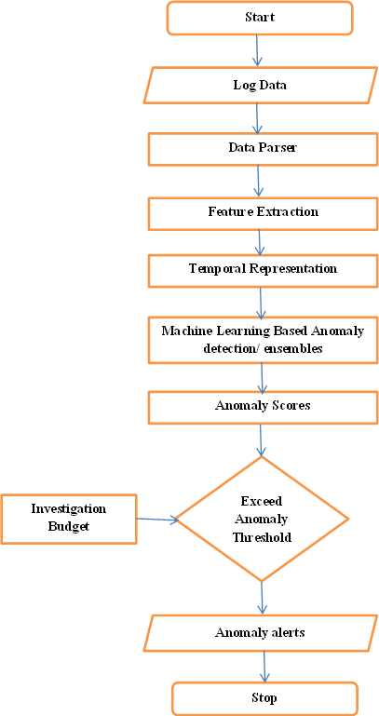
Figure 1: Overview of the proposed anomaly detection system
The idea behind anomaly detection based on unsupervised learning is that malicious behavior is frequently uncommon and differs from typical user behavior, which makes up the vast majority of the data gathered [7], [26]. A trained anomaly detection algorithm may thus collect the typical data and identify aberrant behaviors as outliers even while no label information is employed. A threshold of anomaly scores defines outliers detected by the anomaly detection model. The investigation budget (IB), or the amount (%) of data the security analyst can review for evidence of malicious behavior, is changed in this study to test various thresholds [7], [27]. This depicts the human resources that are available for reviewing the top-ranked data examples, post-training the detection system, and carrying out the required responses.
- Temporal Information in Data Pre-processing
The data pre-processing step is carried out based on aggregated user activity data, such as daily or weekly, and assumes that common monitoring data in businesses, such as web access, email, and file access logs. These time frames for data aggregation are chosen to create data instances that provide a comprehensive perspective of users' activities across a day or a week [28]. Depending on each organization's human resources for inspecting anomaly warnings and requirements for rapid detection, daily or weekly data may be chosen during deployment. Additionally, more granular data, such as sessions of user activity, could be collected [28]. In the unsupervised anomaly detection context, where false alarms are inevitable, this may not be advantageous in terms of the use of human resources because extracting fine-grained data increases the data count and hence increases the burden to analyze anomaly alerts [7].
The user's activities are then broken down into days or weeks and given numerical features. The data is used to extract two main categories of features: I frequency features, which are counts of various user actions over the course of a day or week, such as the number of external emails received or the number of times a user accessed a file after work hours, and (ii) statistical features, which are the mean and standard deviation of changing statistics, such as email size and file size. In order to give ML algorithms context, user information, such as the user's role and user-user relationship, is included wherever practical in the extraction process. [28] Provides additional information on the method for extracting numerical features with various information to represent PC, action's time or email/HTTP categories from log files.
- Data representation using temporal information
Data representation techniques using temporal information, taking advantage of the fact those insiders are essentially regular employees before they start committing malevolent acts [5]. The objective is to show how user behavior has changed or trended over time. This could perhaps show changes in the behavior of nefarious insiders. A data point is concatenated or compared to a time window containing the most recent data for the same user in this method.
The method compares a user's actions to only his or her most recent and pertinent behaviors across a period of time. This may be more effective than first normalizing all instances of data for each user because concept shift and drift are probable in user behaviors [29]. Additionally, because process each data instance across a temporal frame, our method is always ready to use in live stream learning, which is essential. Additionally, point out that in our work, the emphasis is on using the time window to provide a baseline comparison for each new data instance, as opposed to extracting time series data from a time window, where all data points in the window contribute similarly to the result.
1) Concatenation: Inspired by the use of shift register and taps for representing time in data for intrusion detection [30], introduce data examples to anomaly detection algorithms as concatenation of W consecutive data instances of the same user (abbreviated as CW ). The idea is to encourage the learning algorithms to construct comparisons/arithmetic operations between each user data instance and its previous records. In this data representation form, a data instance GC at time C is adjoined with W − 1 most recent instances to form a data point for anomaly detection.
- Unsupervised Machine Learning for Anomaly Detection
This work employs four popular ML methods for anomaly detection with different underlying concepts: Auto encoder (AE), Isolation Forest (IF), Lightweight On-Line Anomaly Detection (LODA), and Local Outlier Factor (LOF).
1) Auto encoder (AE): A multi-layer neural network that compresses and reconstructs data is known as an AE. An example of an AE with three concealed layers is shown in Fig. 3. There are d neurons in each of the input and output layers (d is the number of dimensions). At the output layer, AE reconstructs each data dimension j from the input x into a corresponding dimension of r. The input data is compressed (encoded) into h dimensions by AE using hidden layers to enforce a "bottleneck" architecture (middle hidden layer size: h h<< d), and it is then reconstructed at the output layer. The cost function used to train AE is minimization of the aggregated reconstruction error.
Post training, the lossy compression produced by AE essentially captures the lower-dimensionality representation of the majority of training data at the middle hidden layer. Assuming that normal user data constitute the majority of the training data, it is expected that AE shows a higher reconstruction error for anomalies [31], which may represent malicious insider behaviors. Thus, for each data instance, the AE anomaly score is deﬁned as the Euclidean distance between x and r. To construct AE models in this work, the hidden layers and the output layer take the form of rectiﬁed linear [32] and sigmoid act4. Experiments and Results
Outline the datasets and experiments used in this part to test the suggested approach for identifying insider threats. It outlines the datasets and data pre-processing methods with temporal representations in specific detail. Both the experimental conditions and the findings are reported.
- Datasets
For the creation and testing of insider threat mitigation strategies, the CERT insider threat datasets are available to the general public [36], [37]. In three threat scenarios, CERT R4.2 simulates a corporation with 1000 employees, of which 70 are nefarious insiders. This makes it possible for us to run more adaptable experiments for anomaly detection and to provide more insight into the behaviors of the models. However, the most recent CERT dataset is R6.2. There are only five malicious insiders (five danger scenarios, each with a sin the much larger organization with 4000 people. As a result, the detection task in CERT R6.2 is significantly more difficult.
The CERT datasets are made up of information about users, company structures, and user activity logs (log on/off, email, web, file, and thumb drive connect). Daily and weekly numerical features, or original data representations, are retrieved from the log files using the procedure described. The data is then produced using several temporal representations, as shown Table II. The most recent two or three data instances for each user are linked in a concatenation representation. The window size value F is set to 7 days and 30 days for day data and 30 days and 60 days for week data in percentile and mean/median difference representations (4 weeks and 8 weeks). Original data representation (Org) is used as a baseline in the experiments. The last thing want to point out is that each malicious insider in the CERT data fits into one of the five most common insider threat scenarios: data exfiltration, intellectual property theft, IT sabotage, etc. You may read more about the danger scenarios in [36].
Additionally, this work also uses the LANL dataset [38, 40, 41] and the TWOS dataset [39] for evaluation. Log files gathered over 58 consecutive days make up LANL. The logs include information about the authentication, DNS, and network flow of real users that has been anonymized. The dataset also includes red team (attacking) authentication, but no more details are provided. Solely use authentication and the LANL dataset's processing logs in this article. These events are gathered from desktops, servers, and active directory servers that run Windows. 30 days of the logs are extracted to user-day numerical data due to the dataset's constraints. Then, LANL data is subjected to temporal representations with a window size of 7 days. Similar to the previous example, the TWOS dataset offers anonymized authentication, mouse, keystroke, email, and network captures from a student competition with the intention of simulating insider threats from both masqueraders and traitors. There are 24 competitors in six teams competing over the course of five days, including 12 masqueraders and 1 traitor. Can only extract features from authentication, mouse, and keystroke activity using the specified timestamps. Data instances comprising 30 minutes of activities are retrieved using temporal representations based on a time span of one day due to the dataset's short duration and small size.
Table 1 displays the number of both legitimate and malicious users as well as the statistics of the employed data for each kind. The temporal representation abbreviations for each dataset in this work are listed in Table 2.
TABLE 1. Summary of the Datasets. Sc: Insider Threat Scenario. Malicious User Counts are in Parenthesis
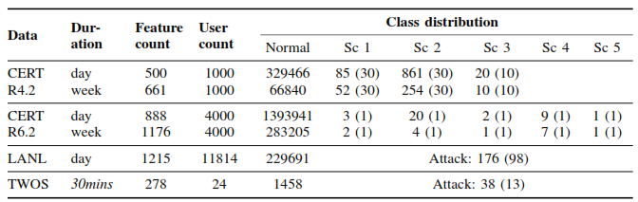
TABLE 2. Temporal Representation Abbreviations for Each Dataset
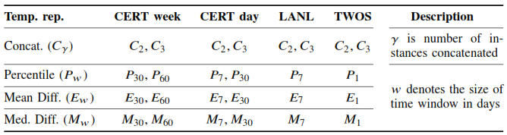

- Experiment Settings
Randomly choose a number of users nu whose data from the first nw Weeks is used to train the anomaly detection systems. The amount of data used to train the models to simulate computation and practical constraints is essentially within the control of nu and nw: Only a small portion of the data gathered prior to training can be utilized. Except where otherwise noted, all subsequent experiments make use of training data from 200 randomly chosen users (2000 for LANL data) during the first half of the dataset's lifespan (nw = 37 for CERT and 2 for LANL). Because of the restrictions of the TWOS dataset, nu = 24 and nw = 1. Since the training process is label free (unsupervised), test results are reported on the entire dataset. In each condition, the experiments are conducted ten times, and the mean findings are presented.
1) Performance metrics: ROC and AUC metrics are used in this study to assess the effectiveness of the insider threat detection process. AUC (Area under the Curve) condenses ROC into a single numerical statistic for model comparison. ROC (Receiving Characteristic Curve) shows the relationship between Detection Rate (DR) and False Positive Rate (FPR) under various decision thresholds (i.e., various investigation budgets).
DR=True Positive/TruePositive+FalseNegative
- Detection Results
Tables 3 and 4 illustrate the findings of instance-based anomaly detection using various IBs. Instance-based and user-based ROCs on R4.2 week data and R6.2 day data with various temporal data formats are shown in Figures 4 and 5. Given that the findings were obtained in an unsupervised scenario with relatively little training data, the overall performance of the auto encoder and percentile representation is highly encouraging (a small set of only 200 unidentified users in 37 weeks, for CERT data). On CERT R4.2, the method only needed to look into 1% of the most out-of-the-ordinary cases (1% IB) in order to identify 77% of the malicious users. Additionally, of the 70 harmful insiders, nearly 100% are found at merely 5% IB. The differences between reporting results based on data instances and users are depicted in figure 2, where the AUC achieved on user-based results may be higher and the differences between temporal data representations are more obvious.

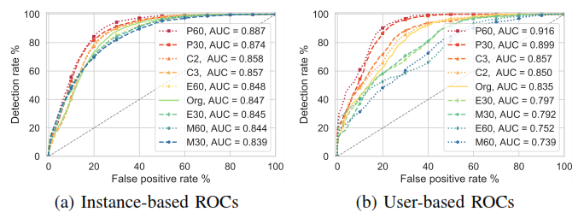
Figure 2. ROCs of AE on R4.2 week data with different representations
Observe that the distribution of all used datasets is dominated by normal data (Table 1). As a result, the FPR (normal data incorrectly flagged) produced at each IB is quite comparable to the IB; for instance, at 1% IB, FPRs vary from 0.96% to 0.99% on CERT R4.2 week data. Additionally, a suitable IB can be chosen based on deployment circumstances because IB represents various human resource levels for looking into anomaly detection output, i.e. varying volumes of flagged data. For instance, using CERT R4.2 day data (Table 1), 1%, 5%, and 10% IBs correspond to 3300, 16500, and 33000 alerts, respectively, or roughly 7 and 33 and 66 alerts per day throughout the course of the dataset.
TABLE 3. Instance Based Anomaly Detection Results with Different Investigation Budgets on CERT Datasets
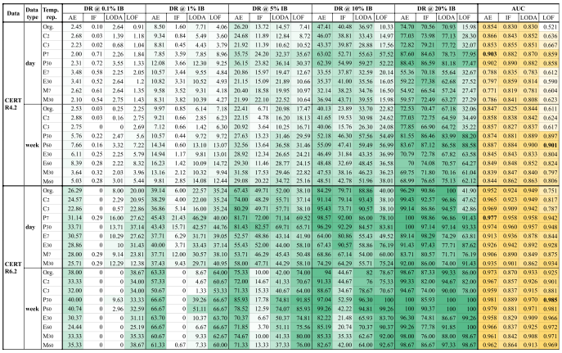

TABLE 4. Instance Based Anomaly Detection Results with Different Investigation Budgets on LANL and TWOS Datasets. The Unit of DR is Percent (%)
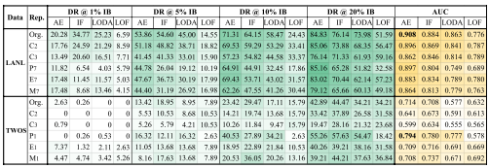
5. Implementation
  - Managing Users
Users who want to access Intelligence must have a working user ID and password. a) The Administrative Tenant (tenant ID: adm), which is in charge of overseeing all tenants and users, is one of Intelligence's two default tenants. b) The Intelligence Analytics users' desired adjustments can be made by the Default Tenant (tenant ID or 0). The duties in this area include: Adding New Users, Changing a User's Role, and Changing the Default System Admin User in Intelligence.

    - Creating New Users in Intelligence
When designing users for Intelligence take into account the following: a) Ensure that the Username field in Intelligence contains the user's email ID used for Security, Risk & Governance (SRG). As a result, Intelligence and SRG can both log in using a single login. Intelligence can only be accessed by registered SRG users. b) Aside from the default System Admin user of Intelligence, when a user accesses Intelligence for the first time while already registered in SRG, Intelligence creates that user with a User role in the Default Tenant. Therefore, must create a similar user account in Intelligence before the user logs in give an existing SRG user a different role in Intelligence.
    - Modifying a User’s Role
To modify a user's role in Intelligence: a) Log in to Intelligence as a System Admin user. b) If not presented with the Tenants page, click Settings and select Tenants. c) In Default Tenant, double-click the Role for the desired user and then click the down arrow to see the list of roles for the user. d) Select the required role. e) Press Enter or click anywhere in the page to save the selection.
    - Changing the Default System Admin User
To change the default System Admin user: a) Launch the CDF Management Portal on port 5443. b) Log in with the following credentials: User name: admin Password: the password provided during CDF installation. c) Click three dots symbol and then click Reconfigure. d) Click Intelligence and modify the email ID in the Intelligence System Admin Email ID field. e) Click Save.
  - Administering Intelligence for End Users
There are many tasks that can perform as the Intelligence Administrator to ensure that the Analytics end users have access to the information they need, when they need it. These tasks include: a) Modifying Intelligence Analytics Configuration. b) Enabling Windowed Analytics. c) Managing Bots and Bot-like Users. d) Tuning the Analytics. e) Deleting Elasticsearch Data.

    - Modifying Intelligence Analytics Configuration
Intelligence runs Analytics according to the Analytics configuration properties set during deployment. However, can modify any of the Analytics configurations, such as enabling Analytics to run on newly ingested data and scheduling when need Analytics to run and also run Analytics on demand.
    - Enabling Windowed Analytics
Intelligence is set up by default to perform Analytics in batch mode. When new data is added, Analytics is applied to both the fresh and old data. Although performing analytics on all of data on a regular basis wastes system resources, it is useful when first deploy intelligence (for testing and validation purposes) and can instead activate Windowed Analytics.
When enable windowed analytics, Intelligence is configured to only execute analytics on data that has just been ingested, as defined by the date of the most recent analytics run and the data's timestamp. Intelligence recognizes the data it has already evaluated, and then only the new data is subjected to Analytics. The revised, current Analytics results are then combined with the previous results to generate for the complete data set.
Windowed Analytics improves performance and stability by enabling the system to aggregate and analyze smaller, more regular-sized data sets than batch mode, especially as the overall amount of data in system keeps expanding.
    - Managing Bots and Bot-like Users
Internet bots, or Web robots, are software applications that run automated tasks. If organization has system bot activity, this activity because of the exceptional speed with which the activity occurs will likely generate Intelligence Risky Hours in Analytics. Intelligence identifies those system users it deems to be bots, and strips them from the Matrix of Anomalies & Violations.
There is often very real difficulty identifying those system users that are bots and those that are live humans, based on the user activity alone. Security team should work with to identify those system users that are truly bots, and those that are not.
Configure Intelligence to remove the real bots from the Analytics after they have been located. Similarly, if users that resemble bots but are not bots have been removed from Analytics and can configure Intelligence to ensure that these users are restored.
    - Tuning the Analytics
After have had the opportunity to explore the Intelligence Analytics and investigate the leads identified in the Intelligence Dashboard, may want to fine-tune the importance applied by the Analytics to the events in source data.
For example, perhaps due to the nature of business, employees have never not once accessed the corporate information systems outside of the standard 9:00 am to 5:00 pm work hours. In this scenario, should an employee one day access corporate information system outside of the standard work hours, the potential for that access to be a risk to organization could be much more significant than it would be in an organization in which employees routinely access the corporate systems at any hour. As a result, might want to increase the importance of the group of anomalies in the anomaly family, User worked in an unusual hour. When increase the importance of this anomaly family, anomalies of this type that are identified in the Analytics will have a higher risk score than they would have using the default importance level.
Fine-tune the importance of individual anomalies, or grouped anomaly families, on the Anomalies page of the Intelligence user interface.
    - Deleting Elasticsearch Data
Make careful to remove Elasticsearch indices that are more than 90 days old in order to clear up disc space. Either the raw events or the analytics results data of the indices can be deleted and could also remove both. As a result, the Intelligence dashboard only shows data that is up to 90 days old.
  - Understanding Users and Other Entities in Intelligence
Intelligence uses advanced analytical models to measure behavior and to quantify risks. These models range from cluster models, which group together users and assets based on specific behavioral vectors, to volumetric anomaly models, rare activity models, and other higher-order models. Many different behavioral vectors are tracked and measured, which reduces the ability for malicious users or compromised accounts to "fake" normal behavior.
The Intelligence models are true advanced behavioral models: they don't rely on binary rules or arbitrary thresholds. Rather, these models measure the probability that an observed action is truly anomalous and represents a true potential risk. Using this type of approach leads to a continuous, prioritized list of risks, and helps improve the efficiency of IT security teams and their tools.
Since intelligence machine learning models are being used, no further configuration is needed for the analytical models to operate. Intelligence gains an understanding of what constitutes typical behavior for the entities within business through observation, and it starts quantifying anomalous behavior right away. Setting thresholds, creating rules, or performing configurations are not necessary.
The output of Intelligence Analytics is presented via an interface that offers flexible multi-entity historical data exploration and at-a-glance actionable information on current risk.
  - Understanding the Intelligence Dashboard
The Intelligence Dashboard is a user-centric, interactive dashboard that provides information on the top risky entities and behaviors occurring in organization. It displays the Intelligence Analytics results, allows visually explore the results and the underlying raw data, and take appropriate actions immediately. With the help of the Overall Risk page, can view the overall risk status of organization. With the help of the Entities page and can explore the risky entities grouped by their type. With the help of the Explore page, determine the types of risky activities occurring within organization. With the help of the Event Viewer and can explore the events that contributed to the risky activities.
    - Exploring the Overall Risk Page
When first log in to Intelligence it taken to the Overall Risk page. This page allows seeing, at a glance, the overall risk status of organization. For example, in the figure 3 immediately see:
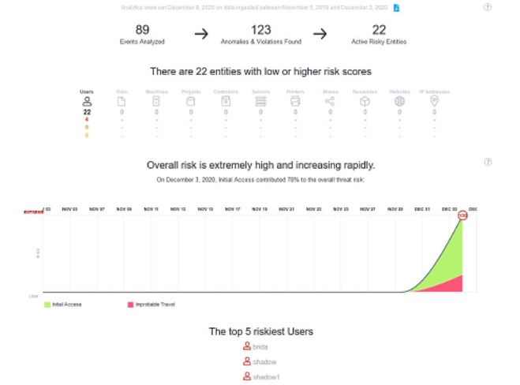
Figure 3. Overall Risk Analysis
    - Exploring the Entities Page
The Entities page lists the entity risk scores, ranks them according to their risk scores in descending order, and also includes trending data, the name of the entity, the kind of possible threat it poses, and the most pertinent anomaly that Intelligence has discovered. The most pertinent risky action in the system determines the potential threat kinds.
    - User-Defined Tags
Link user-defined tags to a single entity, a group of entities, or multiple entities at once on the Entities page. Additionally and can add new tags and remove any obsolete ones.
    - Exploring the Explore Page
The Explore page starts when choose an entity, and the entity's name is filtered there. Here, all Anomalies & Violations related to that entity within the chosen time frame are displayed. Use the search filter at the top of the Explore page to locate or filter another entity. Use the information on the Explore page to identify the kinds of risky behaviours taking place within firm. The Contribution to Risky by Threat graph, the Matrix of Anomalies & Violations, the Top Risky Users and the Anomalies & Violations panels are all included on the Explore page and are automatically displayed.
    - Exploring Raw Events
When click an item in the Anomalies & Violations panel, a dialog box appears that provides additional context about the anomaly or violation. To see the events that triggered the risky activity, in the top right of the dialog box, click Explore Raw Events. This launches a pre-populated query in Event Viewer, where can further explore the events.
Event Viewer provides security practitioners with a quick way to explore the context around the raw events that triggered the anomaly. This can include expanding the time range, changing filter options, or any other grid oriented data.
  - Viewing Reports
Look at reports that provide more information on risky actors and their actions. Look at the Intelligence Analytics results and act right away with the help of reports.
    - CSV Reports
Get the Anomalies & Violations' raw data via CSV reports and can learn more about an entity's behavior through a CSV Report. For instance, a user entity CSV Report might include details about the user's username, country of origin, and actions taken. When select the Events option and then click the CSV symbol next to the date, a CSV report will be downloaded. Up to 10,000 records may be included in the CSV Report.
    - PDF Reports
Information can be exported to a PDF file once an investigation has produced enough evidence to justify escalation, allowing incident response to start right away. On the Overall Risk page, next to the date at the top of the page, click the PDF icon to create a PDF report for organizational risk. From the Explore page, click a user entity name to access the Entity Details panel. Next, click the PDF icon next to the entity name to get a PDF report for that user entity. With the help of this report and can immediately distribute the investigation's findings without having to manually produce any other documents. The report contributes to knowledge of what behaviors are typical and hazardous for any entity.

6. Discussions and Comparisons
For testing purposes in this section, CERT R6.2 is used as it exhibits more malicious insider threat instances and more closely approximates real-world settings (only 5 malicious insiders). Examine the anomaly detection output provided by the suggested system under various scenarios and demonstrate how security analysts can use this information to further go into and spot malicious behavior. Results for each insider threat scenario are reported, along with comparisons to previous publications in the literature.
- Detection performance on insider threat scenarios
The results of the detection of harmful insiders utilizing AE and week data with P representation are shown in Table 5 for CERT R6.2. The chart also includes detection delays (at 10% IB), which represent the interval between the first malicious action and the moment the malicious user is discovered. The table demonstrates that with the suggested system, cases 1, 3, and 4 may be easily detected with just 0% to 0.04% FPR (or 0.04 to 0.15% normal users labeled incorrectly). Less than 5% (0.32%) of the users' harmful activity is found overall. Additionally, scenarios 1 and 3 can be immediately identified.
Threat scenarios have FPRs of 3.07% and 8.36%, respectively, but are far more difficult to identify. A system analyst will need to examine more than 1000 users at a UFPR of 26.46% in order to locate the fraudulent user MBG3183. These scenarios are depicted in far less intrusive and malicious a manner than the other three [36]. A member of a team that has been devastated by layoffs, for instance, uploads documents to Drop box with the intention of using them for personal advantage. This explains why these two scenarios performed less well in the detection tests because it would be simple to mistake them for routine routines.
TABLE 5. Detection Performance on Specific Insider Threat Scenarios DD: Detection Delay
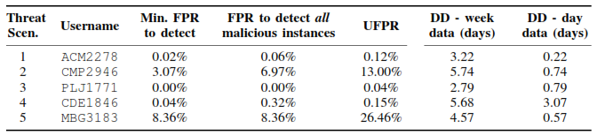

- Robustness of the trained models
In order to find new anomalies on a different CERT dataset (R4.2), employ an anomaly detection model trained on one for this research (R6.2). This experiment can be viewed as using an anomaly detection model from one firm for a different one because CERT R6.2 is a more recent version with modified generative models and a greater size [36]. Figure 4 displays user-based AUCs from AE models trained on the original and P data representations using CERT R6.2 week data. The figure demonstrates that an anomaly detection model tested on CERT R6.2 (UAUC=0.908) and trained using CERT R4.2 data with P30 representation may get extremely good AUC. The outcome (UAUC=0.511) is noticeably better than that of a model trained on the original data format using R4.2. This proves the suggested system's robustness while using percentile data representation. According to the findings, modeling user data points in percentile representation incorporates the temporal information from the user's prior data instances and improves model generalization.
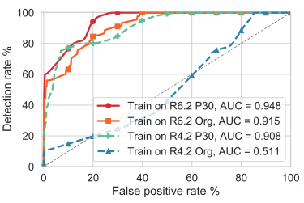

- CONCLUSION
The proposed system automatically creates user profiles and baselines using unsupervised machine learning techniques, actively monitors account access patterns and actions on the associated entities against defined baselines to detect anomalies, assigns a risk score to each entity based on the anomalies detected, and displays anomalies prioritized by the user risk score in a user-centric, interactive dashboard to aid Security Analysts in investigating the highest risks first. As a result, intelligence greatly reduces the amount of threats that go unnoticed and improves a security analyst's capacity to quickly look into all reported anomalies.

REFERENCES
- I. Homoliak, F. Toffalini, J. Guarnizo, Y. Elovici, and M. Ochoa, “Insight into insiders and IT: A survey of insider threat taxonomies, analysis, modeling, and countermeasures,” ACM Computing Surveys, vol. 52, no. 2, pp. 30:1–30:40, Apr. (2019).
- CSO, CERT Division of SEI-CMU, U.S. Secret Service, and KnowBe4, “The 2018 U.S. state of cybercrime survey,” IDG, Tech. Rep., 2018. [Online]. Available: https://www.idg.com/tools-for-marketers/ (2018)-u-s-state-of-cybercrime.
- Crowd Research Partners, “2018 insider threat report,” CA Technologies, Tech. Rep., (2018), https://crowdresearchpartners.com/ insider-threat-report.
- R. Campagna, “Enterprise insider threats on the rise,”https://www.cyberdefensemagazine.com/enterprise-insider-threats-on-the-rise/
- M. L. Collins et al., “Common sense guide to mitigating insider threats, fifth edition,” The CERT Insider Threat Center, Tech. Rep., (2016), CMU/SEI-2015-TR-010.
- A. Azaria, A. Richardson, S. Kraus, and V. S. Subrahmanian, “Behavioral analysis of insider threat: A survey and bootstrapped prediction in imbalanced data,” IEEE Transactions on Computational Social Systems, vol. 1, no. 2, pp. 135–155, Jun. (2014).
- Duc C. Le and Nur Zincir-Heywood, “Anomaly Detection for Insider Threats Using Unsupervised Ensembles,” Copyright (c) (2021) IEEE. Personal use is permitted. For any other purposes, permission must be obtained from the IEEE by emailing pubs-permissions@ieee.org.
- National Cybersecurity and Communications Integration Center, “Combating the insider threat,” (2014), https://www.us-cert.gov/ security-publications/Combating-Insider-Threat.
- L. Liu, O. De Vel, Q.-L. Han, J. Zhang, and Y. Xiang, “Detecting and Preventing Cyber Insider Threats: A Survey,” IEEE Communications Surveys & Tutorials, (2018).
- A. L. Buczak and E. Guven, “A survey of data mining and machine learning methods for cyber security intrusion detection,” IEEE Communications Surveys & Tutorials, vol. 18, no. 2, pp. 1153–1176, (2016).
- F. Liu et al., “Log2vec: A Heterogeneous Graph Embedding Based Approach for Detecting Cyber Threats within Enterprise,” in ACM SIGSAC Conference on Computer and Communications Security, (2019).
- P. Parveen, J. Evans, B. Thuraisingham, K. W. Hamlen, and L. Khan, “Insider threat detection using stream mining and graph mining,” in IEEE Third International Conference on Privacy, Security, Risk and Trust, (2011), pp. 1102–1110.
- T. Rashid, I. Agrafiotis, and J. R. Nurse, “A new take on detecting insider threats,” in Int. Workshop on Managing Insider Security Threats, (2016).
- D. C. Le and N. Zincir-Heywood, “Evaluating insider threat detection workflow using supervised and unsupervised learning,” in IEEE Security and Privacy Workshops (SPW), (2018).
- M. Aldairi, L. Karimi, and J. Joshi, “A trust aware unsupervised learning approach for insider threat detection,” in IEEE Int. Conf. on Information Reuse and Integration for Data Science, (2019), pp. 89–98.
- A. Tuor, S. Kaplan, B. Hutchinson, N. Nichols, and S. Robinson, “Deep learning for unsupervised insider threat detection in structured cybersecurity data streams,” in AAAI Workshop on Artificial Intelligence for Cyber Security, (2017).
- J. Matterer and D. Lejeune, “Peer group metadata-informed LSTM ensembles for insider threat detection,” International Florida Artificial Intelligence Research Society Conference, pp. 62–67, (2018).
- L. Liu, C. Chen, J. Zhang, O. De Vel, and Y. Xiang, “Unsupervised insider detection through neural feature learning and model optimisation,” in Lecture Notes in Comp. Sci., vol. 11928 LNCS. Springer, (2019).
- P. A. Legg, O. Buckley, M. Goldsmith, and S. Creese, “Automated insider threat detection system using user and role-based profile assessment,” IEEE Systems Journal, vol. 11, no. 2, (2017).
- T. E. Senator et al., “Detecting insider threats in a real corporate database of computer usage activity,” in ACM SIGKDD Conf. (KDD), (2013).
- B. Bose, B. Avasarala, S. Tirthapura, Y. Y. Chung, and D. Steiner, “Detecting insider threats using radish: A system for real-time anomaly detection in heterogeneous data streams,” IEEE Systems Journal, (2017).
- A. Brown, A. Tuor, B. Hutchinson, and N. Nichols, “Recurrent neural network attention mechanisms for interpretable system log anomaly detection,” in Proceedings of the First Workshop on Machine Learning for Computing Systems, (2018), pp. 1–8.
- S. Zhao, R. Wei, L. Cai, A. Yu, and D. Meng, “Ctlmd: Continuous temporal lateral movement detection using graph embedding,” in International Conference on Information and Communications Security. Springer, (2019), pp. 181–196.
- H. Bian, T. Bai, M. A. Salahuddin, N. Limam, A. Abou Daya, and R. Boutaba, “Uncovering lateral movement using authentication logs,” IEEE Transactions on Network and Service Management, (2021).
- D. C. Le and N. Zincir-Heywood, “Exploring adversarial properties of insider threat detection,” in IEEE Conference on Communications and Network Security (CNS), (2020).
- “Big data in network anomaly detection,” in Encyclopedia of Big Data Technologies, , S. Sakr and A. Zomaya, Eds. Springer International Publishing, (2018), pp. 1–9.
- “Exploring anomalous behaviour detection and classification for insider threat identification,” International Journal of Network Management, Mar. (2020).
- D. C. Le, N. Zincir-Heywood, and M. I. Heywood, “Analyzing data granularity levels for insider threat detection using machine learning,” IEEE Transactions on Network and Service Management, vol. 17, no. 1, pp. 30–44, (2020).
- M. I. Heywood, “Evolutionary model building under streaming data for classification tasks: opportunities and challenges,” Genetic Programming and Evolvable Machines, vol. 16, no. 3, pp. 283–326, (2015).
- H. G. Kayacik, N. Zincir-Heywood, and M. I. Heywood, “On the capability of an som based intrusion detection system,” in International Joint Conference on Neural Networks, Jul. (2003), pp. 1808–1813.
- C. C. Aggarwal, Outlier Analysis, 2nd ed. Springer Publishing, (2016).
- X. Glorot, A. Bordes, and Y. Bengio, “Deep sparse rectiﬁer neural networks,” in Int. Conf. on Artiﬁcial Intelligence and Statistics, (2011), pp. 315–323.
- F. T. Liu, K. M. Ting, and Z.-H. Zhou, “Isolation-based anomaly detection,” ACM Trans. Knowl. Discov. Data, vol. 6, no. 1, Mar. (2012).
- T. Pevný, “Loda: Lightweight on-line detector of anomalies,” Machine Learning, vol. 102, pp. 275–304, (2016).
- M. M. Breunig, H.-P. Kriegel, R. T. Ng, and J. Sander, “Lof: Identifying density-based local outliers,” SIGMOD Rec., vol. 29, no. 2, p. 93–104, May (2000).
- CERT and ExactData, LLC, “Insider Threat Test Dataset,”https://resources.sei.cmu.edu/library/asset-view.cfm?assetid=508099.
- J. Glasser and B. Lindauer, “Bridging the gap: A pragmatic approach to generating insider threat data,” in IEEE SPW, (2013).
- A. D. Kent, “Cybersecurity Data Sources for Dynamic Network Research,” in Dynamic Networks in Cybersecurity. Imperial College Press, Jun. (2015). [Online]. Available: https://csr.lanl.gov/data/cyber1/
- A. Harilal et al., “The wolf of sutd (twos): A dataset of malicious insider threat behavior based on a gamiﬁed competition.”JoWUA, vol. 9, no. 1, pp. 54–85, (2018). [Online]. Available: https://github.com/ivan-homoliak-sutd/twos
- T K P Rajagopal, M Venkatesan, 2022, "Energy efficient server with dynamic load balancing mechanism for cloud computing environment", Wireless Personal Communications, vol. 122, no. 4, pp. 3127-3136, (2022).
- T K P Rajagopal, M Venkatesan, A Rajivkannan, 2019, "An improved efficient dynamic load balancing scheme under heterogeneous networks in hybrid cloud environment", Wireless Personal Communications, vol.111, no. 3, pp. 1837-1851,(2019).
- OM Soundararajan, Y Jenifer, S Dhivya, TKP Rajagopal, "Data security and privacy in cloud using RC6 and SHA algorithms", Networks and Communication Engineering, vol. 6, no.5, pp. 202-205.(2014).
- M Kamarunisha, S Ranichandra, TKP Rajagopal, "Recitation of load balancing algorithms in grid computing environment using policies and strategies an approach", International Journal of Scientific & Engineering Research, vol.2 no3, pp. 1-8. (2011).
- Arul Selvam P, Tamije Selvy P, "Improved Classification Model in Handling Insider Threat through Supervised Machine Learning Techniques", NeuroQuantology, vol.20 no10, pp. 7787-7793. (2022).

