Suppositories
Suppositories: Definition, types, advantages and disadvantages, types of bases, methods of preparations. Displacement value & its calculations, evaluation of Suppositories.

Suppositories are semisolid dose forms of medication intended for insertion into cavities of the body other than the mouth. They can be placed into the vagina, ear, nose, or rectum. To release the medication, they will either melt or dissolve in the bodily fluid.
Types:
1. Rectal suppositories: These have a systemic impact and are intended to be inserted into the rectum. These are typically manufactured from Theobroma oil and come in a range of sizes to suit the need of babies, kids, and adults. They have a torpedo or cone form.
2. Vaginal suppositories are intended to be inserted into the vagina. The term "Pessaries" also refers to these suppositories, which can be conical, rod-shaped, or wedge-shaped and weigh between 4 and 8 grams. Vaginal pills and vaginal capsules are available these days.
replaced the suppositories used vaginally.
- "Urethral bougies" are urethral suppositories, which are intended to be inserted into the urethra. These are cylindrical forms that are long, thin, and have a rounded end to make insertion easier. They range in weight from 2-4g.
4. Nasal suppositories, also referred to as "Nasal Bougies" and similar to urethral suppositories, are intended for insertion into the nasal cavity. These always have a glycero gelatin foundation and are thin and cylindrical in shape. They weigh about 1g and are roughly 9–10 cm long.
5. Ear suppositories (sometimes referred to as "Aurinaria") are inserted into the ear. Theobroma oil is typically used as the basis instead of these. These weigh roughly 1g and have a thin, long, cylindrical shape.

The Advantages of suppositories

1) To induce a local effect of the medication included in the base, they are placed into bodily cavities.
2) These are placed inside the rectum to have an immediate, direct effect on the rectum.
3) Suppositories don't leave behind stains or itchy skin.
4) Suppositories are a type of medication dosage unit.
5) These are simple to provide to youngsters, the elderly, and unconscious patients who have trouble swallowing pills.
6) Total bioavailability is obtained and no residue is left behind like a pill.

7) These are practical methods of administering medications that upset the stomach and produce vomiting and drug destruction in the stomach's acidic gastric juice.
8) Suppositories' pharmacological ingredients steadily elicit a persistent impact.
9) These are used to deliver the medication contained in the base locally by inserting them into bodily cavities.

Disadvantages

1) Suppositories are absorbing inconsistently and inappropriately
2) Installation could result in an eructation reaction
3) This method cannot be used to administer irritating medicines
4) When a medicine is administered by putting a suppository into a bodily cavity, the patient feels embarrassed.
5) These are difficult to prepare.
6) The suppositories must be kept at a low temperature between 100 and 200C. These must be kept in a refrigerator, which is expensive for people with little financial resources.

Different Bases
Three general categories can be used to classify suppository bases:
- Fatty bases
- Water soluble and water miscible bases
- Emulsifying Bases

A) Theobroma oil: made from the crushed, roasted seeds of Theobroma cacao, this solid is yellowish white in color. It also goes by the name cocoa butter.
1) It has a butter-like consistency and a melting point between 30 and 350 °C.
2) It consists of a mixture of stearic, oleic, palmitic, and other fatty acid glyceryl esters.
3) Theobroma oil is regarded as the most acceptable base for rectal suppositories but is not suitable for pessaries, nasal, or urethral suppositories because after melting it tends to leak out of the cavities. Theobroma oil melts at body temperature and releases the medication for quick absorption.
4) It is imperceptible to mucus secretions
When heated, it easily liquefies, and when cooled, it quickly settles.

Disadvantages

Although cocoa butter offers the majority of the characteristics of an ideal suppository basis, it nevertheless has the following drawbacks.
- It demonstrates the polymorphism phenomenon.
Ex: When theobroma oil is melted and cooled, depending on the melting temperature, the rate of cooling, and the mass size, it solidifies into various crystalline shapes.
- It degrades and melts in hot water. When it solidifies, it has a propensity to adhere to the sides of the mould.
- It is possible for bodily cavities to leak when melted.
- It is reasonably expensive.
- It cannot mix with bodily fluids.
- When lactic acid and cocoa butter are combined, liquefaction of the chloral hydrate occurs. In order to get around this issue, beeswax can be added.
- Emulsified Theobroma oil: This can be used as a basis when adding significant amounts of aqueous solutions. Emulsified Theobroma oil suppositories are made using 5% glyceryl monostearate, 10% lunette wax, 2-3% cetyl alcohol, 4% beeswax, and 12% spermaceti.
- Hydrogenated oils: These are made by heating a variety of vegetable oils, including palm, coconut, cottonseed, and arachis oil, to high temperatures. Because it has a variety of advantages over Theobroma oil, it is utilized as a replacement for it.
These are
- They generate colorless, odorless, and elegant suppositories
- They are resistant to oxidation.
- Do not require lubrication of the mold
- Do not influence the solidifying point when overheated,
- They have strong emulsifying and water absorbing capacities.
Disadvantages:
- The suppositories become brittle when quickly cooled in a refrigerator when melted.
- They are more fluid than theobroma oil, which causes more additional ingredients to settle out. By including a thickening agent, such as bentonite or magnesium stearate, this problem can be solved.
II. Bases that are water soluble and water miscible:
- Glycerogelatin base: This is a glycerin and water mixture that has been stiffened with gelatin. The base can be used to make any kind of suppositories, although it's most frequently utilized to create pessaries.

Translucent, glycerogelatin-based suppositories have a tendency to dissolve or disperse slowly in bodily cavities and release medication. The base is therefore preferred to a fatty base. For suppositories containing boric acid, chloral hydrate, bromides, iodide, and iodoform, this base works well. The bases for suppository are one of the two forms of gelatin to prevent adverse reactions.
Type A, also known as Pharmagel A, is created through acid hydrolysis. It has an isoelectric point between 7.0 and 9.0 and is useful for acidic medications due to its acidic nature.
Type B, often known as Pharmagel B, is a type of alkaline medication with an isoelectric point. 4.7 to 5.0
Disadvantages:
- Many medications don't mix well with gelatin.
Ex: tannic acid, ferric chloride, and gallic acid,
- There is a greater potential for bacterial and mold growth.
- The suppositories must therefore be preserved with an
appropriate preservative.
- Since suppositories made with glycerogelatin are hygroscopic,
special storage containers are needed.
- They exert a physiological effect. For instance, glycerol
suppository B.P.
- They are more challenging to prepare and manage.
- Soap-glycerin suppositories: Instead of gelatin, either curd soap or sodium stearate is used in glycerogelatin bases, which renders the base sufficiently firm to manufacture high-quality suppositories. The action of glycerin being evacuated is assisted by soap. The main drawback of this basis is that it absorbs a lot of moisture. As a result, suppositories made with this base need to be sealed in waxed paper or tin foil to keep out airborne contaminants.
C) Polyethylene glycols: Carbowaxes and polyglycols are popular names for polyethylene glycol polymers. Depending on their molecular weight, these carbowaxes have different physical characteristics. Liquids have molecular weights under 1000, whereas solids that resemble wax have molecular weights beyond 1000.
Advantages:
- They are physiologically inert
- Non-irritating,
- Chemically stable
- Do not promote bacterial or mold growth.
- Because they don't melt in the human cavity but instead disintegrate slowly over a long period of time,
- They offer extended effect.
- They don't adhere to the mold's side.
- The physical characteristics of the base can be altered in accordance with polymers with low and high melting points.
Disadvantages
- They need particular storage conditions because they are hygroscopic.
- They are incompatible with some medications, such as tannins and phenols etc.
- It is good solvent characteristics can cause the drug to be retained in the liquefied base rather than the body, which would reduce the drug's therapeutic efficacy.
III. Emulsifying Bases
These bases are synthetic, and the market offers a variety of exclusive synthetic bases.
- Witepsol: These are composed of saturated vegetal fatty acid triglycerides with different amounts of partial esters. To be used in hot climes, some bees wax is added in small amounts. It is important to avoid fast cooling the witepsol-based suppositories in order to avoid brittleness and fracture. To produce high-quality suppositories, the mold must also be well lubricated.
B) Massa estarinum: This solid is white, brittle, and nearly tasteless. It is made up of a mixture of mono, di, and triglycerides of saturated fatty acids. Its melting point ranges from 33.5 to 350 C, and although it comes in many grades, grade B is the most frequently used.
C) Massuppol: To increase its ability to absorb water, a little amount of glyceryl monostearate has been added to glyceryl esters, primarily those of lauric acid.
Advantages:
- They quickly solidify
- They are non-irritating
- They don't require mold lubrication
- Overheating has no effect on the base's physical characteristics.
- They are less likely to get rancid
- white, odorless, clean, and appealing suppositories, and can hold quite a bit of water.
Disadvantages
They should not be quickly refrigerated in a refrigerator because they become brittle. They melt quickly and are not particularly viscous, so the medications mixed into the base settle down quickly.
Suppositories' preparation techniques
Any of the following techniques can be used to prepare the suppositories.
- Rolling technique
- Fusion or Hot Process
3) Cold compression method

1. Rolling Technique: The rolling method is a traditional way to make suppositories. The base of the suppository is rolled, and the final shape is applied with the hand. Nowadays, this approach is not employed.
2. Fusion or Hot Process : This technique is frequently used to make suppositories for administration. The suppository foundation is melted, the medication is added, and a greased mold is filled with the mixture. Suppositories are created after cooling and are taken out of the suppository mould.
There are many different types and sizes of suppository molds available on the market for commercial use. It is possible to utilize a suppository mould for dispensing that has 6–12 cavities in the desired form and size. Stainless steel, nickel copper alloy, brass, aluminum, or plastic are the typical materials used to make these molds.
The screw in the middle of the plates must be removed in order to open the suppository mold lengthwise. When suppositories are cleaned, lubricated, and removed, the mold is opened. The mold is cleaned by removing the plates, soaking them in hot water with detergent, and then completely drying the mold.
After that, the lubricant is applied, and extreme caution must be used to prevent damage to the interior of the mould's cavities. Following the application of the lubricant, extreme caution must be exercised to prevent any scratches from appearing on the interior surfaces of the mold's cavities, as this will result in the production of suppositories with an uneven surface.
Lubrication of the Mould: If a cocoa butter or glycerol-gelatin basis is used to make suppositories, the suppository mould must be lubricated.
With the use of a brush or a gauze swab, the lubricant should be applied. Because the cotton fibers separate from cotton wool, it should not be used. By closing the mold and setting it inverted on a white tile, excessive lubrication can be drained.

Mould calibration: Typically, a standard mold with a one-gram capacity is utilized. Because the weight varies but the size of the suppository produced by a certain mould remains constant, the calibration of the mould is required. This is caused by the fact that the densities of various bases and medications vary. Therefore, the mold needs to be adjusted for each particular base and medication.
Displacement Value
The amount of a medicine needed to displace one part of the base is known as the drug's displacement value.
Method of Preparation
- The mold should be well cleaned and lubricated with a suitable lubricant before being kept on ice inverted to cool and drain any extra oil.
- If an emulsifying base or synthetic base is employed, the mould's lubricant is not necessary.
- Heat the china dish in a water bath, then pour the necessary amount of base to it after accounting for the medication's displacement value.
- Prepare two more suppositories in case there is unavoidable waste during preparation.
- When the bottom third of the base has melted, remove the china dish from the water bath and stir vigorously until the entire mass has melted. The method avoids the base overheating.
- Put the measured amount of powdered medication that will be combined with the suppository base on an ointment tile. Pour about half of the melted base over it.
- It should be carefully blended with a flexible spatula before being transferred to the china dish and thoroughly stirred to create a homogeneous mixture.
- For the mass to become pourable, warm the china dish over the water bath for a few seconds while stirring continuously.
- Fill the cavities of the suppository mold that is above the ice with the melted substance. Because cocoa butter expands during cooling and hollows develop at the top of the final suppositories, it is important to completely fill each cavity in order to avoid this problem.
- When pouring the bulk into the cavities, care must be given to ensure that the medication is evenly distributed throughout all of the suppositories.
- Once the mass has been evenly distributed, trim off any extra with a sharp razor or blade.
- Keep the mold in a cold area or over ice for about 15 minutes. The suppositories can be removed by opening the mold.
- Wrap each suppository in wax paper after softly wiping it off with a clean cloth or piece of filter paper.

- Cold compression method: Since heating and stirring the base with the medication are not necessary, the approach is advantageous for thermolabile and insoluble medicines.
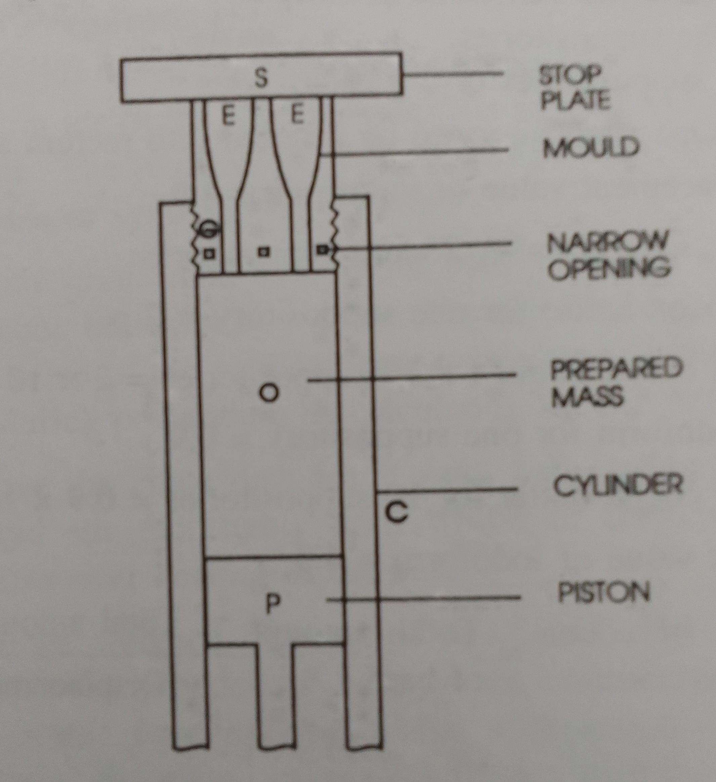
Cold Compression Machine

- The cocoa butter is grated, the components are combined with an equal amount of the grated butter, and then the leftover grated butter is blended with the medication. Provisions are made for unavoidable preparation-related waste.
- On hand- or power-operated compression machines, the prepared mass is compressed. The prepared mass is inserted into a mold using piston "P."
- As the mass threads enter the mold "G," they are crushed until a homogeneous fused mass is created. Additional pressure is applied to force the suppositories out when the retaining stop plate "S" is removed. The diagram depicts how the machine functions.
- The molds have a variety of cavities and varied diameters. To prevent heat from compression from making the mass overly fluid, the mass and the compression cylinder of the machine may be cooled.
- The procedure is inappropriate for suppositories with a glycerogelatin base or any other base whose preparation requires melting.
Displacement value
It is described as the amount of medication needed to replace one part of base.
The volume of a suppository produced by a specific mold is uniform, but its weight will vary since the medication's densities typically range from the base material's density, which was used to calibrate the mould. It is necessary to account for the change in mass density brought on by additional medications in order to make suppositories that are consistent and correct in weight. The displacement value of the medication is taken into account for this purpose.
The table provides the displacement values of some of the medications used in suppositories in relation to cocoa butter.

S.No | Name of the medicament | Displacement value
1 | Castor oil, Tannic acid, Resorcinol | 1
2 | Aminophylline, Boric acid, chloral hydrate, cocaine Hcl | 1.5
3 | Iodoform | 4
4 | Zinc oxide | 5
Following are some methods for calculating a certain medication's displacement value:
6 suppositories containing a g of Throbroma oil or base should be prepared and weighed.
Prepare and weigh 6 suppositories with, let's say, a 40% medication content.
Determine how much Theobroma oil is in the prescription suppositories.
60/100xb = c g

Calculate the amount of medicament present in the medicated suppositories
40/100xb = d g

Calculate the amount of Theobroma oil displaced by d g of the medicament = (a-c) g

Displacement value of the medicament = d/a-c
Calculations
Example 1: Determine the displacement value of zinc oxide in Theobroma oil suppositories made in a 1g mold and containing 40% zinc oxide. Eight suppositories weigh 11.74 g.
Ans:- Weight of 8 Theobroma oil-containing suppositories is equal to
1 x 8 = 8 g.
8 suppositories containing 40% zinc oxide each weigh 11.74 g.
Theobroma oil content in 8 suppositories is 60/100x11.74, or 7.044g.
The amount of medication in 8 suppositories is equal to
40/100x11.74, or 4.696g.
Theobroma oil displacement by 4.696g of drug is 8-7.044=0.956g.
Evaluation of Suppositories
Following are evaluation methods
1. Appearance
2. Uniformity of weight
3. Melting range test
4. Liquefaction test
5. Breaking test
6. Dissolution test
1. Appearance: The suppository's internal and external surfaces should be uniform in appearance when cut lengthwise and visually inspected. Satisfactory division and dispersion of suspended material is required to meet the standard. In order to determine the absence of fissuring, pitting, exudation, and movement of the active components, surface appearance and color can often be checked.
2. Weight uniformity: 20 suppositories are weighed for this test, and the average weight is determined. After that, each suppository is weighed separately and the weight is recorded. The weight fluctuation may occur if certain cavities are under filled and others are overfilled. No suppository should differ from the average weight by more than 5%, with the exception of two that should not deviate by more than 7.5%.
3. Melting Range Test: Also known as the macro melting range test, this test determines how long it takes for the entire suppository to melt while submerged in a water bath of a set temperature. In contrast, the micro melting range test uses a capillary tube to evaluate the melting range for just the fat basis. A USP Tablet Disintegration Apparatus is the instrument often used for determining the melting range of the complete suppository. The time it takes for the entire suppository to dissolve or scatter in the surrounding water is monitored after it has been fully submerged in the continual water bath.
4. The liquefaction test: This test is also known as the softening time test, was created by Krowcynski and is an additional helpful test for finished suppositories. It consists of a U-tube that is partially submerged in a water bath with a set temperature. The suppository is held in place in the tube by a constriction on one side. The amount of time it takes for a glass rod to pass through the suppository and into the constriction is measured as the softening time. As a quality control check, this can be done at a range of temperatures between 35.5 and 37⁰C. It can also be examined as a gauge of physical stability over time.
5.Breaking Test: The breaking test is a method for determining how fragile or brittle suppositories are. Brittleness of suppositories is a problem for which numerous solutions have already been outlined. The test equipment is a double-walled chamber where the test suppository is put. Pumping water heated to 37°C through the double wall chamber while the suppository is housed in the dry inner chamber supports a disc that is connected to a rod. Another disc with weights attached is attached to the other end of the rod. At 1 minute intervals, 600g are placed on the platform to conduct the test. The breaking threshold is reached when 200g of weight are added and the suppository collapses. The weight at which the suppository collapses is the breaking point or the force that determines the brittleness or fragility of the suppository. The test is completed by placing 600g on the platform at 1 minute intervals.
6. Dissolution Testing: Due to melting distortion and dispersion in the dissolution media, testing for the rate of in-vitro drug material release from suppositories has traditionally presented a challenging problem. A wire mesh basket or a membrane to separate the sample chamber from the reservoir have both been used in an effort to limit the change in mass or the medium interface.
References:
1) Anisel C., Allen L.V.,Popovich N.G. Eighth edition “Semisolid dosage forms” Pharmaceutical Dosage Forms and Drug Delivery Systems, Lippincott Williams and Wilkins, Philadelphia 2005.
2) Chater S.J., Cooper and Gunn Dispensing Pharmacy For Pharmaceutical Students. 12thEdition. 2006. CBS Publication. 192-231.
3) Jani G. K., Dispensing Pharmacy. 3rd Edition. 2003-04. B.S. Shah Publication.
4) Aulton M. E., Pharmaceutics the Science of Dosage Form Design: 1st Edition. 1995. ELBS Churchill Livingstone.
5) Barry B. W., Dermatological Formulations. Vol. 18. 1983. Marcel Deckker Inc. 296-340.
6) Mehta RM Dispensing Pharmapharmacy Vallabh Prakashan, New Delhi
7) Martin AN(1993) Physical Pharmacy, Baltimore, MD: Lippincott, Williams and Wilkins.

