A Novel Slotted MIMO Antenna for 5G Millimeter Wave Applications

Chandrasekhar Rao Jetti¹ | Gayatri Konni Tanimki² | Akhila Yadlapalli³
Associate Professor, | UG Student, | UG Student,
Department of ECE | Department of ECE | Department of ECE
Bapatla Engineering College, Bapatla | Bapatla Engineering College, Bapatla | Bapatla Engineering College, Bapatla
Andhra Pradesh-522102, India | Andhra Pradesh-522102, India | Andhra Pradesh-522102, India
jettychandu@gmail.com | gayatrikonni198@gmail.com | akilay285@gmail.com
Sai Sindhu Raja⁴ | Karthikesh Yangala⁵ | Sai Teja Sanaka⁶
UG Student, | UG Student, | UG Student,
Department of ECE | Department of ECE | Department of ECE
Bapatla Engineering College, Bapatla | Bapatla Engineering College, Bapatla | Bapatla Engineering College, Bapatla
Andhra Pradesh-522102, India | Andhra Pradesh-522102, India | Andhra Pradesh-522102, India
rajasaisindhu01@gmail.com | karthikeshyangala100@gmail.com | saitejasanaka@gmail.com

Abstract - A unique miniature two-element MIMO (multiple-input multiple-output) antenna for 5G mm-Wave n257, n258, and n262 band applications is proposed. The antenna, with dimensions of 4.8 mm × 12 mm × 0.508 mm, is made on the dielectric material Rogers RT/duroid 5880 (tm), which has a dielectric loss tangent of 0.0009 and a relative permittivity of 2.2. The suggested antenna has a slotted ground at the bottom and two U-shaped radiating elements on top of the dielectric material. A 50-ohm microstrip line feed is used to excite the radiating elements. A rectangular strip of 1.3 mm × 0.2 mm and a couple of rectangular slots are added to each radiating patch to improve impedance performance. A U-shaped element enables the first operating band at 26.8GHz from 26.3 to 27.50GHz. Etching hexagonal slots into the ground plane creates the second operating band at 48.7GHz, which spans 48.1 to 49.45GHz. The suggested MIMO antenna's isolation is improved by a rectangular slot on the ground plane and radiating elements that are orthogonally positioned. The results manifests that the suggested antenna is well suited for 5G mmwave applications.

Index Terms - 5G mm-Wave, impedance isolation and multiple input multiple output (MIMO).

I. Introduction
Due to the growing spread of wireless communication networks, there is an increasing demand for very high data rates with extremely low latency and bandwidths in portable device applications. In comparison to the present 4G system, fifth generation (5G) mobile communication technology has various advantages, including higher transmission rates (data rates), greater spectrum efficiency, and less latency. 5G technology offers ten times the data rate of 4G networks, as well as superior device connectivity and stability. To facilitate 5G, the FCC divided the frequency spectrum into three bands: low-band, sub-6 GHz band, and mm-wave band [2]. There is an excess of spectrum available in mm-wave frequency ranges greater than 24 GHz, allowing for extremely large capacity, extremely high throughput, and extremely low latency. As a result, several antenna designs for 5G mm-wave are being introduced [10]. Multiple input multiple output (MIMO) is a promising solution for 5G applications. MIMO technology has the potential to improve data transfer rates and spectrum efficiency while requiring no extra spectrum or transmission power. A MIMO system employs multiple antennas at both ends of the communication channel. In MIMO systems, mutual coupling is possible because antenna elements are spaced closely together [11]. Hence, it is challenging to increase isolation or decrease mutual coupling between antennas that are close together. To enhance the isolation or reduce the mutual coupling in MIMO antenna systems, numerous studies have already been carried out. The previously stated antennas provide good isolation, but they are not small enough, and the antenna designs are intricate. As a result, a simple, compact MIMO antenna with isolation enhancement is required for 5G mm-wave communication. For 5G mm-wave applications in the n257, n258 and n262 bands, the disclosed invention proposed a new, small, isolation-enhanced 2-element MIMO antenna.
This research introduces a unique 26.8/48.7GHz compact MIMO antenna for 5G mm-wave applications. The antenna is fed by a 50-ohm microstrip feedline and comprises 12 x 4.8 x 0.508 mm³. The antenna consists of two orthogonally positioned elements on top of a dielectric substance, and on the bottom is a ground with tiny hexagonal and rectangular slots. The antenna has good impedance matching and isolation properties and operates at 26.8 GHz and 48.7 GHz. The antenna design, the findings, and the conclusions are covered in the following sections.

II. Proposed Dual Band mm-wave Antenna Design
The dual-band U-shaped MIMO antenna's ideal geometry for 5G mm-wave applications is depicted in Fig.1. Ansoft HFSS was used to do simulations, dimension optimization, and the proposed antenna design. The 50-ohm microstrip line is fed by the MIMO antenna, which has dimensions of 12 × 4.8 × 0.508 mm³ and is developed on a Rogers RT/duroid 5880 (tm) substrate. The substrate's thickness is 0.508mm, its loss tangent is 0.0009, and its dielectric constant is 2.2. The proposed antenna consists of a slotted ground at the bottom and two U-shaped elements placed orthogonally on top of the substrate. Two rectangular slots (1.465 mm × 0.325 mm and 0.78 mm × 0.325 mm) are added to each radiating patch to improve the MIMO antenna's impedance performance. Resonance was created in the 26.8 GHz band, which spans from 26.3GHz to 27.5GHz, using the rectangular slots. A pair of hexagonal slots with a dimension of 2.8 × 2.425 mm² each were etched from the ground plane in order to achieve the second resonant band at 48.7 GHz from 47.6 GHz to 50.1 GHz. Fig.2(a). shows the proposed MIMO's impedance matching characteristics (S11 & S22 parameters). It is observed that the antenna operates with good impedance matching at 26.8 GHz and 48.7 GHz (S11<-10dB). In this study, two techniques are employed to produce high isolation between antenna ports or minimal mutual coupling between radiating parts. These techniques include the orthogonal arrangement of U-shaped elements and the use of a small, rectangular ground slot (4.7 × 0.3 mm²). Fig.2(b). shows the suggested MIMO antenna's isolation parameters (S12 & S21). Throughout the working bands, the aerial provides enhanced isolation of more than 26 dB, as can be seen.
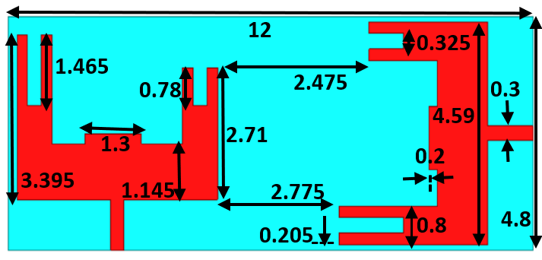
(a)
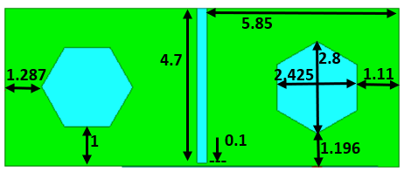
(b)
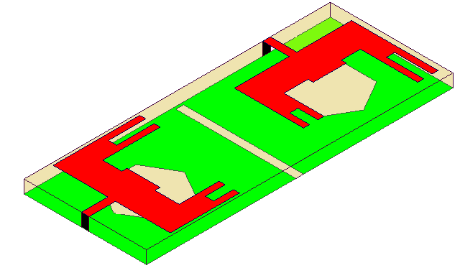
(c)
Fig.1. Proposed dual band mm-wave antenna with dimensional parameters; (a) top view, (b) bottom view and (c) dimetric view.
III. Results AND DISCUSSION
Fig.2. displays the suggested dual-band mm-wave MIMO antenna S-parameters, comprising S11, S12, S21, and S22 results. The proposed antenna has good impedance matching behaviour (S11 and S22-10dB) and operates at two mm-wave bands, namely 26.8 GHz and 48.7 GHz. The MIMO antenna in Fig.2(b). also offers strong isolation at the 26.8 GHz and 48.7 GHz bands, S12, S21>26dB. How effectively an antenna's impedance is matched is determined by a test known as the voltage-standing wave ratio (VSWR). The lower the VSWR, the better the impedance matching. The suggested antenna's VSWR is 1.26 at 26.8 GHz and 1.19 at 48.7 GHz, as shown in Fig.3.
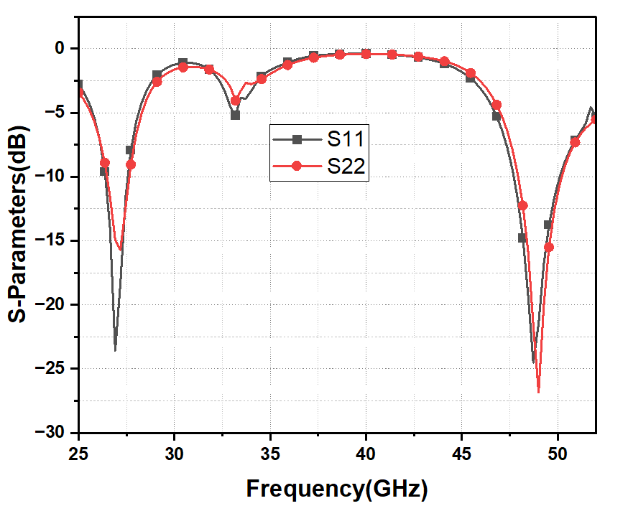
(a)
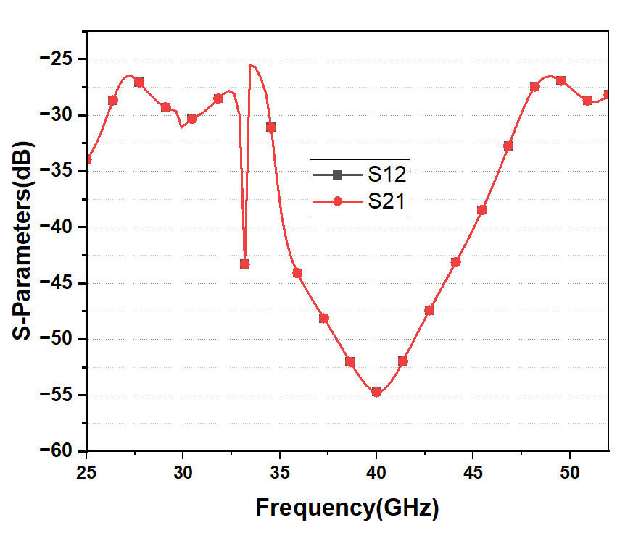
(b)
Fig.2. Proposed dual band mm-wave antenna S-parameter results; (a) return loss, (b) mutual coupling.
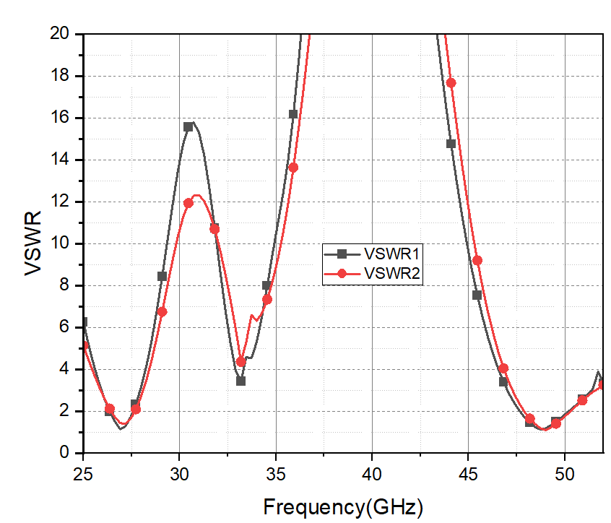
Fig.3. Proposed dual band mm-wave antenna VSWR plot

One of the most important properties of any antenna is its radiation performance. It determines the type of field, its strength, and its direction of propagation. Fig.4. depicts the 2-D radiation patterns in the E- and H-planes at 26.8 GHz and 48.7 GHz. At the operating bands, the antenna provides omnidirectional H-plane patterns and bidirectional E-plane patterns. The peak gain results of the suggested configuration are shown in Fig.5. Peak gains of 7.1 dBi at 26.8 GHz and 5.4 dBi at 48.7 GHz are noted.

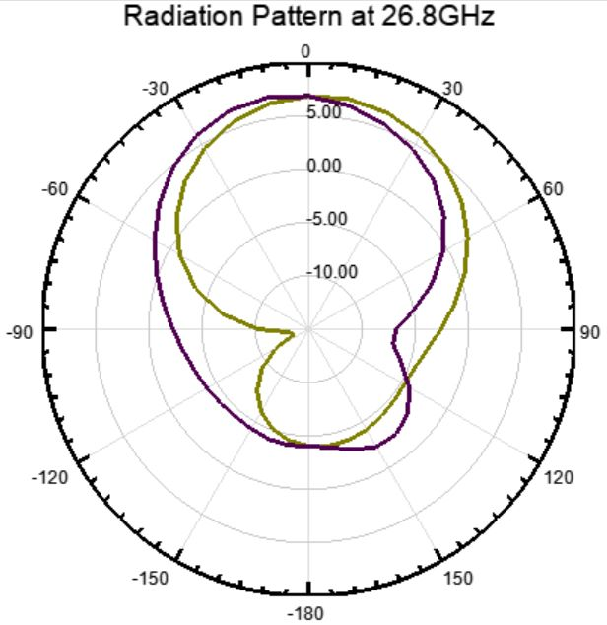

(a)

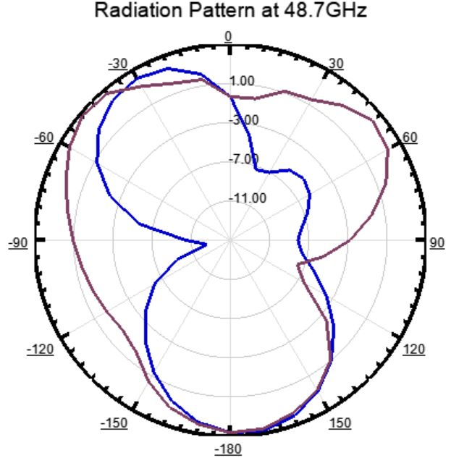
(b)
Fig.4. Proposed dual band mm-wave antenna radiation patterns at (a) 26.8 GHz, (b) 48.7GHz
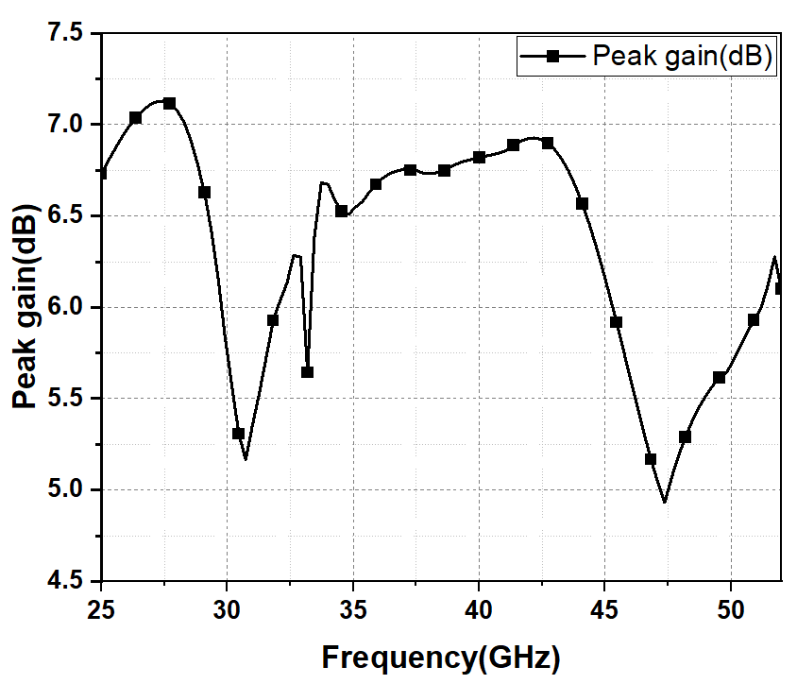
Fig.5. Proposed dual band mm-Wave Antenna Peak Gain

At both resonating frequencies, the surface current distribution patterns for the proposed antenna are examined in Fig.6. The current density function at 26.8 GHz is shown in Fig.6(a) and (b). Along the feed as well as the left side of the antenna patch, the current fluctuation is at its maximum. The first resonant band corresponds to the length of the existing path. In a similar manner, Fig.6(c) and (d), displays the surface current density of the second resonant frequency band at 48.7 GHz. The provided figure makes it clearly evident that the current density is greater on the same and opposite sides of the feeding arrangement.

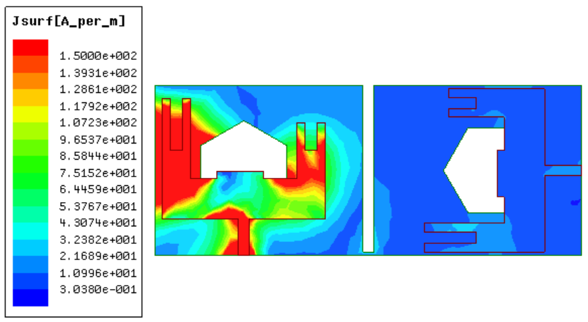
(a)
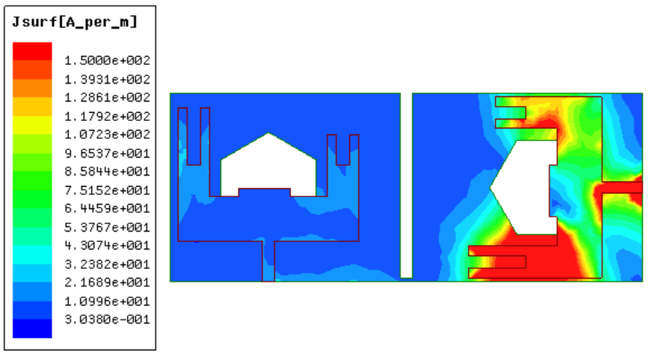
(b)
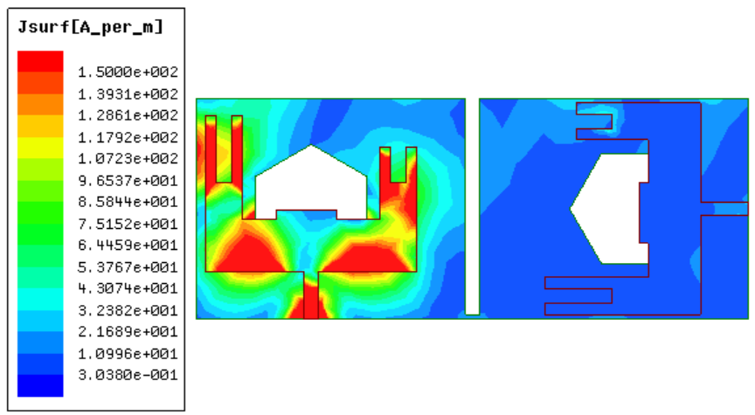
(c)
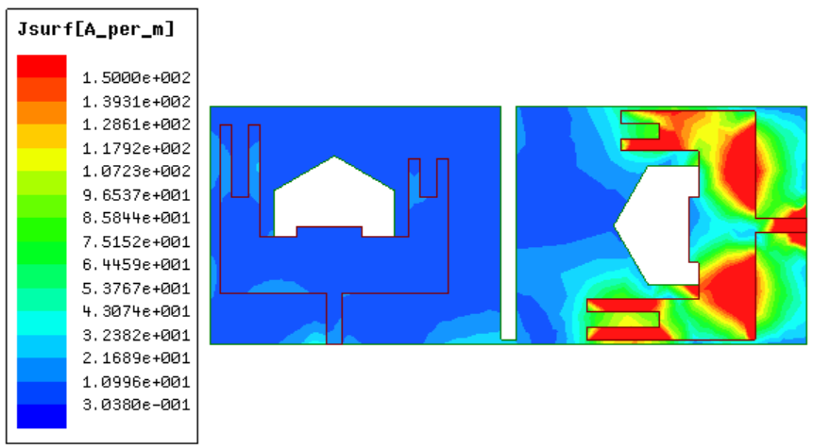
(d)
Fig.6. Proposed dual band mm-wave Antenna Surface Currents When: (a) Port-1 is excited at 26.8GHz, (b) Port-2 is excited at 26.8GHz, (c) Port-1 is excited at 48GHz and (d) Port-2 is excited at 48GHz
IV. Conclusion
In this study, a portable dual-band MIMO antenna for 5G mm-wave wireless communication is presented. The antenna, which measures 12 x 4.8 x 0.508 mm³, is constructed of Rogers RT/duroid 5880 (tm) dielectric material and is driven by a 50-ohm microstrip line. The proposed antenna comprises of a slotted ground at the bottom and two orthogonally positioned elements on top of the substrate. A rectangular slot on each radiating element and hexagonal slots on the ground plane are employed to induce resonances at 26.8 GHz and 48.7 GHz, respectively. In order to achieve port isolation, the antenna elements are placed orthogonally. Moreover, a little rectangular opening in the ground is used to significantly enhance isolation. The antenna exhibits omnidirectional radiation patterns, strong isolation of more than 26dB, peak gains of 7.1 dBi at 26.8 GHz, and 5.4 dBi at 48.7 GHz. Diversity performance parameters for the proposed structure include return loss <-10dB and VSWR <2. The results firmly depict that the recommended design is a good fit for 5G mm-wave applications.
References
- Sabek, A. R., Ali, W. A., & Ibrahim, A. A. (2022). Minimally coupled two element MIMO antenna with dual band (28/38 GHz) for 5G wireless communications. Journal of Infrared, Millimeter, and Terahertz Waves.
- FCC Takes Steps to Make Millimeter Wave Spectrum Available for 5G, Federal Communications Commission, 2019
- Rappaport, T.S., Xing, Y., MacCartney, G.R., Molisch, A.F., Mellios, E. and Zhang, J., “Overview of millimeter wave communications for fifth-generation (5G) wireless networks with a focus on propagation models”, IEEE Transactions on antennas and propagation, 65(12), pp.6213-6230, 2017.
- Niu Y, Li Y, Jin D, Su L, Vasilakos AV., “A survey of millimeter wave communications (mm-Wave) for 5G: opportunities and challenges”, Wireless networks. 2015 Nov; 21 8:2657-76.
- Dong, P., Zhang, H., Li, G. Y., Gaspar, I. S., & NaderiAlizadeh, N. (2019). Deep CNN-based channel estimation for mm-Wave massive MIMO systems. IEEE Journal of Selected Topics in Signal Processing
- Soltani, S. and R. D. Murch, “A compact planar printed MIMO antenna design,” IEEE Trans. Antennas Propag., Vol. 63, 1140-1149, 2015.
- Aliakbari, H., Abdipour, A., Costanzo, A., Masotti, D., Mirzavand, R., & Mousavi, P. (2017). ANN‐based design of a versatile millimetre‐wave slotted patch multi‐antenna configuration for 5G scenarios. IET Microwaves, Antennas & Propagation
- Hussain, Niamat, Wahaj Abbas Awan, Wael Ali, Syeda Iffat Naqvi, Abir Zaidi, and Tuan Tu Le., “Compact wideband patch antenna and its MIMO configuration for 28 GHz applications,” AEU-International Journal of Electronics and Communications 132, 153612, 2021.
- Ali, Wael, Sudipta Das, Hicham Medkour, and Soufian Lakrit., “Planar dual-band 27/39 GHz millimeter-wave MIMO antenna for 5G applications,” Microsystem Technologies 27, 1 283-292, 2020.
- Jetti, C.R. and Nandanavanam, V.R., “Trident-shape strip loaded dual band-notched UWB MIMO antenna for portable device applications,” AEU-International Journal of Electronics and Communications, 83, pp.11-21, 2018.
- Ikram, Muhammad, Yifan Wang, Mohammad S. Sharawi, and Amin Abbosh. “Dual band circular MIMO antenna system for 5G wireless devices,” In 2018 IEEE International Symposium on Antennas and Propagation & USNC/URSI National Radio Science Meeting, pp. 247–248.IEEE, 2018.
- Sabek AR, Ali WA, Ibrahim AA. “Minimally Coupled Two-Element MIMO Antenna with Dual Band (28/38 GHz) for 5G Wireless Communications”, Journal of Infrared, Millimeter, and Terahertz Waves. 2022 May 19:1-4.
- Roh, W., Seol, J. Y., Park, J., Lee, B., Lee, J., Kim, Y., ... & Aryanfar, F. (2014). Millimeter-wave beamforming as an enabling technology for 5G cellular communications: Theoretical feasibility and prototype results. IEEE communications magazine.
- Mneesy, T. S., Hamad, R. K., Zaki, A. I., & Ali, W. A. (2020). A novel high gain monopole antenna array for 60 GHz millimeter-wave communications. Applied Sciences, 10(13), 4546.
- Ibrahim, A. A., & Ali, W. A. (2021). High gain, wideband and low mutual coupling AMC-based millimeter wave MIMO antenna for 5G NR networks. AEU-International Journal of Electronics and Communications, 142, 153990.

