Nanoparticles in Plant Disease Management
C. Sangeetha and M. Nivedha
Department of Plant Pathology, Centre for Plant Protection Studies
Tamil Nadu Agricultural University, Coimbatore -641 003
Tamil Nadu, India

Nanotechnology has emerged as a promising field in agriculture, offering potential solutions for combating plant diseases effectively and sustainably. Plant pathogens pose a significant threat to agricultural productivity, leading to substantial crop losses globally. Farmers heavily rely on pesticides like insecticides, fungicides, and herbicides, which provide availability, quick action, and reliability. These pesticides also harm for non-target organisms, soil health and developing resistance. Moreover, around 90% of applied pesticides are lost during or after the use, highlighting the need for environmental friendly, effective, and cost-efficient alternatives. In this context, nanoscience with its unique properties and versatility shows promise in addressing these challenges and revolutionizing disease management in agriculture. By leveraging nanoparticles, researchers aim to develop innovative approaches for plant disease control that minimize environmental impact, enhance efficacy, and improve sustainability.
Nanoparticles
Nanoparticles are ultrafine particles with dimensions typically ranging from 1 to 100 nanometers. They exhibit unique properties and behavior compared to their bulk counterparts, primarily due to their high surface area-to-volume ratio and quantum effects at the nanoscale. Nanoparticles can be classified into different categories based on their composition and structure. Some common types include metal nanoparticles (e.g., gold, silver and platinum), metal oxide nanoparticles (e.g., titanium dioxide, zinc oxide), carbon-based nanoparticles (e.g., carbon nanotubes, graphene), semiconductor nanoparticles (e.g., quantum dots), and polymeric nanoparticles. Each type has its specific characteristics and potential applications.
Nano pesticides, which encapsulate active ingredients within nanoparticles, offer several advantages such as improved stability, controlled release, reduced environmental impact, and enhanced efficacy. The targeted delivery of pesticides to plant pests minimizes non-target effects and reduces the amount of chemicals needed for pest and disease control. These nanoparticles can be applied through spray application or by drenching/soaking onto seeds, foliar tissue, or roots. When used as carriers, nanoparticles offer several advantages, including improved shelf-life, enhanced solubility of pesticides with low water solubility, reduced toxicity, cost and environmental risks associated with excessive pesticide use to target the pest. The nanoparticles can directly interact with pests, disrupt their life cycles, inhibit their growth, or induce toxic effects. The use of nanoparticles as carriers for dsRNA enables the efficient and precise delivery of RNAi molecules to silence specific genes in pests, providing a promising approach for pest control.
Green synthesis of nanoparticles
Green-synthesis has many advantages compared to chemical and physical methods: it is non – toxic and pollution free. Green-synthesized nanoparticles with antimicrobial properties offer a sustainable approach to combat plant pathogens in agriculture. Bio synthesis of nanomaterial can be achieved by using plant extract, beneficial microbes and their enzymes and proteins. These nanoparticles, derived from plant extracts through eco-friendly methods, often contain natural antimicrobial compounds. They can effectively inhibit the growth of pathogens, reducing the reliance on chemical fungicides (Shreyash et al., 2021). Green synthesis of nanoparticles is an environmental friendly process that avoids toxic chemicals, minimizes waste generation, and is cost-effective compared to chemical and physical methods. The synthesis conditions can be adjusted to produce nanoparticles with desired properties, making them suitable for various agricultural applications.
Antimicrobial mechanism of nanoparticles
Nanoparticles exhibit antimicrobial activity through physical damage, reactive oxygen species (ROS) generation, ion release, disruption of biofilms, antibacterial peptides, and modulation of the immune response. These mechanisms involve interactions with microbial cells, causing membrane disruption, oxidative stress, metabolic disruption, biofilm disruption, membrane interaction with antimicrobial peptides, and immune system modulation. The specific mechanisms vary depending on nanoparticle properties and microorganisms targeted. Additionally, the concentration and exposure time of nanoparticles also play a role in their antimicrobial activity.
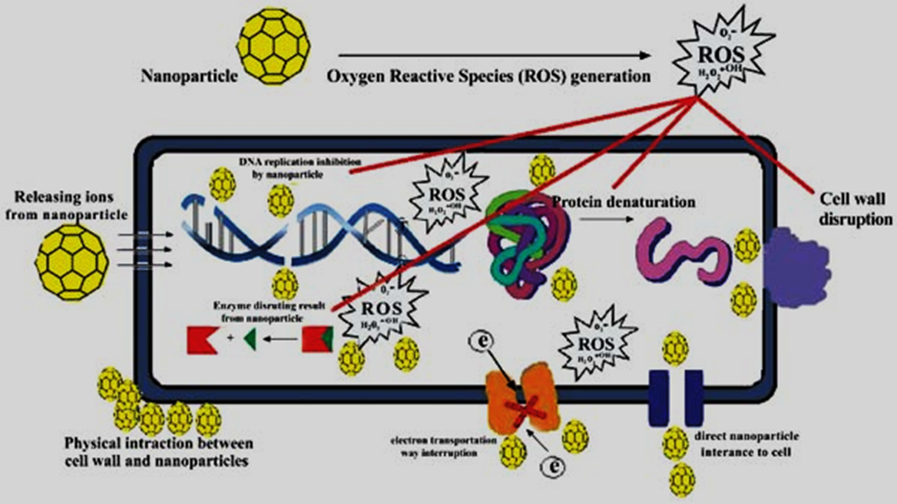
Hoseinzadeh et al.,2017
Nanoparticles as Protectants
Nanoparticles act as protectants in plant disease management through various mechanisms. Some nanoparticles possess inherent antimicrobial properties, capable of directly killing or inhibiting pathogens, while others enhance the plant's defense mechanisms by stimulating the production of antimicrobial compounds or bolstering the plant's immune response. Additionally, nanoparticles can provide physical barriers that prevent pests from damaging plant tissues by forming a protective film on leaves, reducing insect attachment or pathogen entry. Micro nutrients in nano-form (CuSO₄ and Na₂B₄O₇) exhibited the low disease incidence and severity for rust disease of Pisum sativum. Other nutrients like manganese and zinc particles inhibited the damping off and charcoal rot diseases in sunflower. Moreover, nanoparticles serve as sensors, detecting early signs of pests and diseases and triggering targeted responses, allowing for timely intervention and reducing the need for extensive pesticide applications. The development of nanoparticle-based formulations holds promise for sustainable and efficient crop protection, reducing reliance on conventional pesticides and minimizing the environmental impact associated with their use.
Nanoparticles in Plant disease management
1. Silver nanoparticles (AgNPs) are effective in plant disease management due to their broad-spectrum antimicrobial properties. They inhibit pathogen growth by disrupting cellular processes and damaging cell walls or membranes. AgNPs suppress the development of fungal pathogens and stimulate plant defense responses. Silver nanoparticles have shown antifungal inhibition of Alternaria alternata, Sclerotinia sclerotiorum, Rhizoctina solanai (Krishnaraj et al., 2012). The Silver nanoparticles and Polyvinylpyrrolidone (AgNPs/PVP) showed fungicidal activity against molds and yeasts such as Candida krusei, C. albicans, C. glabrata, C. tropicalis and Aspergillus brasiliensis. The mixture of PVP and Ag nanoparticles exhibited sound anti-fungal effects against microorganisms (Bryaskova et al. 2011).
2. Sulphur nanoparticles
Sulfur is a well-known fungicide used in conventional agriculture, and nanoparticles offer a more targeted and efficient delivery mechanism. Sulfur nanoparticles have demonstrated efficacy against a wide range of plant diseases caused by fungi, including powdery mildew, downy mildew, and gray mold. They have been shown to inhibit spore germination, disrupt fungal cell membranes, and interfere with fungal enzymatic activities, leading to the suppression of pathogen growth and disease development. They can activate plant defense genes, increase the production of defense-related compounds, and promote the development of physical barriers in the plant tissues. Cao et al. (2021) used elemental Sulphur nanoparticles for the management of fungal pathogen Fusarium oxysporum f. sp. lycopersicion tomatoes which decreased the disease incidence by 47.6% and increased tomato shoot biomass by 55.6% after 10 weeks of application.
3. Copper nanoparticles (CuNPs) have broad-spectrum antimicrobial activity and are commonly used as fungicides in agriculture. They inhibit the growth of fungal pathogens by disrupting their cellular processes and damaging their cell membranes. CuNPs have been shown to effectively control diseases caused by fungi, including powdery mildew, downy mildew, and bacterial spot. Copper nanoparticles at aconcentration of 200 mg/L were inhibitory to Pseudomonas syringe, whereas the particle was not biocidal against Rhizobium spp. and Trichoderma harzianum in comparison.
4. Zinc nanoparticles (ZnO NPs) with fungicides worked against two patho-fungi Botrytis cinerea and Penicillium expansum. Anti-fungal activity of ZnO NPs can be observed under Scanning Electron Microscopy (SEM) and Raman Spectroscopy to highlight any changes in cellular and morphological composition of fungal hyphae. This particle produced alteration in the hyphae of B. cinerea and prohibited the asexual growth of P. expansum which ultimately became reason of losing fungal propagation (He et al. 2011). ZnO NPs may affect cell functions and increased the nucleic acid contents. The increase of nucleic acid may due to stress response of fungal hyphae. The increase of carbohydrates may be due to the self-protecting mechanism against ZnO NPs. The deformed structures of the hyphal cells may be due to excessive accumulation of nucleic acid and carbohydrates. On the other hand, the bacterial cells may also release liquids from membrane and caused changes in the membrane permeability of bacterial cells (Brayner et al., 2006).
5. Titanium dioxide nanoparticles (TiO2NPs) have photocatalytic properties and can generate reactive oxygen species (ROS) when exposed to light. These ROS have antimicrobial effects and can suppress the growth of pathogens. TiO2NPs have been explored for their potential in controlling plant diseases, such as bacterial blight and gray mold.
6. Gold nanoparticles (AuNPs) have unique physicochemical properties and are being investigated for their antimicrobial activity in plant disease management. AuNPs have shown inhibitory effects against bacterial and fungal pathogens, including those causing bacterial wilt and root rot. The gold nanoparticle - based dipstick technique suited the detection ofnumerous toxins in environmental and food samples and canbe used for rapid examination of pesticides on the site (Lisa et al. 2009). Khater et al., (2019) successfully developed an electrochemical sensing platform for the sensitive and selective detection of Citrus Tristeza Virus (CTV) nucleic acid. The platform utilized a screen-printed carbon electrode (SPCE) that was modified with electrodeposited gold nanoparticles (AuNPs).
7. Chitosan nanoparticles (CSNPs) are a promising tool in plant disease management. They have antimicrobial properties and stimulate plant defenses against pathogens. CSNPs can disrupt pathogen cell walls, inhibit their growth, and activate the plant's immune response. They also improve nutrient uptake, enhance plant growth, and can carry other beneficial compounds. CSNPs are environmentally friendly and have low toxicity.Chitosan nanoparticle exhibited antifungalactivity in vitro and could protect the finger millet plantsfrom blast disease caused by Pyricularia grisea
8. Silica nanoparticles (SiNPs) offer effective protection against plant pathogens. They have antimicrobial properties, disrupting pathogen cell membranes and inhibiting their growth. SiNPs also trigger plant defense responses, reducing disease severity. They act as a physical barrier and enhance the efficacy of fungicides. SiNPs improve plant growth, nutrient uptake, and stress tolerance. They are environmentally friendly and have low toxicity. Silica-silvernanoparticles reportedly have antifungal activity against Botrytis cinerea, Rhizoctonoa solani, Collectotrichum gloeosporioides.
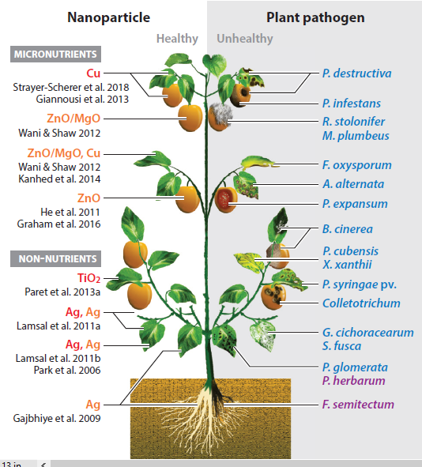
Elmer et al.,2018

Nano-biosensors
Nano-biosensors have emerged as valuable tools for the detection of plant pathogens. These biosensors utilize nanomaterials and biological recognition elements to detect the presence of specific pathogens or their associated biomarkers. Here are some examples of nano-biosensors used in plant pathogen detection:
- Quantum Dot (QD) Biosensors: Quantum dots are semiconductor nanocrystals that emit fluorescent light at specific wavelengths. They can be functionalized with antibodies, aptamers, or other biological recognition elements to selectively bind to target pathogens or their biomarkers. The interaction between the quantum dots and the target molecules leads to changes in fluorescence intensity, enabling the detection and quantification of the pathogens.QD biosensors offer high sensitivity for early pathogen detection, reducing the reliance on broad-spectrum pesticides. They can be tailored for multiplex detection, monitoring multiple pathogens simultaneously. In a study by Safarpouret al., (2012) a sensor based on QD-FRET (Quantum Dot-Förster Resonance Energy Transfer) was successfully used to identify Polymyxabetae, the primary vector of Beet necrotic yellow vein virus (BNYVV) that infects beet plants. Majumderet al. (2020) employed cadmium selenide (CdSe) QDs as signal amplifiers to enhance the detection of banana bunchy top virus, resulting in improved and accurate detection capabilities.
- Carbon Nanotube (CNT) Biosensors: Carbon nanotubes are cylindrical structures made of carbon atoms. They possess unique electrical and optical properties that can be exploited for biosensing applications. CNT biosensors can be functionalized with specific antibodies or DNA probes to capture and detect pathogen-specific biomolecules. The binding of the target molecules to the nanotubes induces changes in their electrical conductivity or optical properties, allowing for sensitive and selective detection.A recent study by Tran et al. (2020) showcased the use of a single-walled carbon nanotubes-based chemo-resistive biosensor for the detection of a secreted protein biomarker associated with citrus Huanglongbing (HLB).
- Gold Nanoparticle (AuNP) Biosensors: Gold nanoparticles are widely used in biosensing due to their unique optical properties and ease of functionalization. AuNP biosensors can be functionalized with antibodies, DNA probes, or aptamers to recognize and bind to target pathogen biomarkers. The binding event leads to changes in the colour or optical properties of the nanoparticles, providing a visual or spectroscopic signal for pathogen detection (Cho et al., 2013).
- Magnetic Nanoparticle Biosensors: Magnetic nanoparticles, such as iron oxide nanoparticles, can be functionalized with specific biomolecules to capture and concentrate target pathogens or their biomarkers from complex samples. The captured pathogens can be detected using various techniques, including molecular methods or optical detection methods.
- Nanodiagonastic Kit: is used as a small box for measuring important tasks in plants. A smart kit useful for detection of plant pathogens and it help the farmers to prevent the wide spread diseases. Nanodiagonastic kit contained four myco-sensors which can detect the of ZEA, T-2/HT-2, DON and FB1/ FB2 myco-toxins on only one strip used for cereals like wheat, barley and corn. This kit is quick, easier and less expensive for detection of fungal attack on crops. There are other purposes, efficient, specific about antigen and antibodies, nucleotide sequence in which nano kit can be used. Moreover, it can also detect particular gene target, isolation and purification of specific genes. But nano kit has not fully checked practically for the plant pathogen detection in field conditions. More extensive research work is needed in this field (Khiyami et al., 2014).
These nano-biosensors offer advantages such as high sensitivity, specificity, and rapid detection. They can be used for the early detection of plant pathogens, enabling timely intervention and disease management. Ongoing research is focused on further improving the sensitivity, stability, and cost-effectiveness of nano-biosensors to facilitate their practical application in plant disease diagnostics.

Nanoparticle-Enabled Imaging Techniques
Nanoparticles, such as quantum dots or fluorescent nanoparticles, can be used in conjunction with imaging techniques to visualize pathogens within plant tissues. Nanoparticle-enabled imaging techniques, such as nanoparticle-based fluorescence imaging, magnetic resonance imaging (MRI), surface-enhanced Raman spectroscopy (SERS), and plasmonic imaging, offer enhanced sensitivity and specificity in detecting plant pathogens. These techniques utilize functionalized nanoparticles to generate fluorescent, magnetic, or enhanced signals for the sensitive and non-destructive visualization of pathogens in plant samples. They enable the detection of pathogens at low concentrations, provide specificity through target-specific probes or antibodies, and allow for repeated monitoring of pathogen dynamics.
Nanoparticles for Stimulating Plant Defense Responses:
Nanoparticles have shown the potential in stimulating plant defense responses, contributing to enhanced plant resistance against pathogens and pests. By interacting with plants at the nanoscale level, nanoparticles can trigger specific physiological and biochemical changes that activate the plant's defense mechanisms. One key mechanism is the induction of reactive oxygen species (ROS) production, serving as signaling molecules that initiate a cascade of defense responses, including the activation of defense-related genes and the synthesis of antimicrobial compounds. Nanoparticles can also act as elicitors, stimulating the production of plant defense hormones such as salicylic acid (SA), jasmonic acid (JA), and ethylene (ET), which coordinate various defense responses.Furthermore, nanoparticles can indirectly promote plant defense responses by improving nutrient uptake and enhancing plant vitality.
Nanoparticle-Mediated RNA Interference (RNAi)
RNAi is a natural cellular mechanism that regulates gene expression by degrading or inhibiting the translation of target messenger RNA (mRNA). Nanoparticle-mediated RNA interference (RNAi) is a powerful technique that utilizes nanoparticles to deliver small RNA molecules, such as small interfering RNA (siRNA) or short hairpin RNA (shRNA), into cells or organisms for gene silencing purposes. Nanoparticles serve as carriers or delivery vehicles for the efficient transportation of RNA molecules into target cells or tissues. They protect the RNA from degradation and facilitate its entry into cells, overcoming barriers such as cell membranes or intracellular compartments. Moreover, the controlled release properties of nanoparticles can enable sustained RNAi effects over an extended period.
Despite its potential in controlling plant diseases, there are challenges in nanoparticle-mediated RNAi including optimizing delivery efficiency, minimizing off-target effects, ensuring biocompatibility and safety, and addressing potential immune responses.
Nanoparticles for Vaccine Development
Nanoparticles have emerged as promising tools for vaccine development, offering effective delivery systems for antigens. Antigens can be encapsulated or adsorbed onto the surface of nanoparticles, protecting them from degradation and improving their stability. Nanoparticles facilitate the delivery of viral antigens or coat proteins, triggering an immune response in plants. This approach provides protection and reduces the severity of viral infections. Each nanoparticle type offers unique advantages in terms of stability, biocompatibility, and immunogenicity, allowing for tailored vaccine design and optimization.
Conclusion
Nanotechnology is an emerging technology in Agriculture throughout the world. The use of nanoparticles in agriculture aims to reduce applications of plant protection products, minimize nutrient losses and increase yields. While nanotechnology shows promise in disease management, further research is needed to optimize its efficacy, safety, and practical implementation in field conditions. Nanoparticles have the potential to transform the field of plant disease management. Their ability to detect pathogens, stimulate plant defenses, and deliver antimicrobial agents offers new avenues for protecting plant health and ensuring global food security. By advancing our understanding of nanoparticle applications and addressing their challenges, we can harness their benefits to create more effective and sustainable strategies in plant disease management. Integrating nanotechnology into plant disease management strategies can lead to more effective and sustainable approaches for combating fungal, bacterial, and viral diseases in agriculture.

Reference:
Brayner, R., Ferrari-Iliou, R., Brivois, N., Djediat, S., Benedetti, M. F., & Fiévet, F. (2006). Toxicological impact studies based on Escherichia coli bacteria in ultrafine ZnO nanoparticles colloidal medium. Nano letters, 6(4), 866-870.
Bryaskova, R., Pencheva, D., Nikolov, S., & Kantardjiev, T. (2011). Synthesis and comparative study on the antimicrobial activity of hybrid materials based on silver nanoparticles (AgNps) stabilized by polyvinylpyrrolidone (PVP). Journal of chemical biology, 4, 185-191.
Cao, B., Zhao, Z., Peng, L., Shiu, H. Y., Ding, M., Song, F., & Huang, Y. (2021). Silver nanoparticles boost charge-extraction efficiency in Shewanella microbial fuel cells. Science, 373(6561), 1336-1340.
Cho, I. H., & Irudayaraj, J. (2013). In-situ immuno-gold nanoparticle network ELISA biosensors for pathogen detection. International journal of food microbiology, 164(1), 70-75.
Elmer, W., Ma, C., & White, J. (2018). Nanoparticles for plant disease management. Current Opinion in Environmental Science & Health, 6, 66-70.
Khater, M., De La Escosura-Muñiz, A., Quesada-González, D., & Merkoçi, A. (2019). Electrochemical detection of plant virus using gold nanoparticle-modified electrodes. Analyticachimicaacta, 1046, 123-131.
Khiyami, M. A., Almoammar, H., Awad, Y. M., Alghuthaymi, M. A., & Abd-Elsalam, K. A. (2014). Plant pathogen nanodiagnostic techniques: forthcoming changes?. Biotechnology & Biotechnological Equipment, 28(5), 775-785
Krishnaraj, C., Ramachandran, R., Mohan, K., & Kalaichelvan, P. T. (2012). Optimization for rapid synthesis of silver nanoparticles and its effect on phytopathogenic fungi. Spectrochimica Acta Part A: Molecular and Biomolecular Spectroscopy, 93, 95-99.
He, L., Liu, Y., Mustapha, A., & Lin, M. (2011). Antifungal activity of zinc oxide nanoparticles against Botrytis cinerea and Penicillium expansum. Microbiological research, 166(3), 207-215.
Lisa, M., Chouhan, R. S., Vinayaka, A. C., Manonmani, H. K., & Thakur, M. S. (2009). Gold nanoparticles based dipstick immunoassay for the rapid detection of dichlorodiphenyltrichloroethane: an organochlorine pesticide. Biosensors and Bioelectronics, 25(1), 224-227.
Majumder, S., Bhattacharya, B., Singh, P. K., Johari, S., Singh, B., & Rahman, R. (2020). Impedimetric detection of Banana bunchy top virus using CdSe quantum dots for signal amplification. SN Applied Sciences, 2, 1-7.
Safarpour, H., Safarnejad, M. R., Tabatabaei, M., Mohsenifar, A., Rad, F., Basirat, M., & Hasanzadeh, F. (2012). Development of a quantum dots FRET-based biosensor for efficient detection of Polymyxabetae. Canadian Journal of Plant Pathology, 34(4), 507-515.
Shreyash, N., Bajpai, S., Khan, M. A., Vijay, Y., Tiwary, S. K., & Sonker, M. (2021). Green synthesis of nanoparticles and their biomedical applications: A review. ACS Applied Nano Materials, 4(11), 11428-11457.
Tran, T. T., Clark, K., Ma, W., & Mulchandani, A. (2020). Detection of a secreted protein biomarker for citrus Huanglongbing using a single-walled carbon nanotubes-based chemo resistive biosensor. Biosensors and Bioelectronics, 147, 111766.

