BIOFUEL
Mahenthiran R  Department of Microbiology, Dr. N.G.P. Arts and Science College,  Corresponding author: Assistant professor, Department of Microbiology, Dr.N.G.P. Arts and Science College,  Coimbatore- 641048, Tamil Nadu, India.  e-mail: mahenthiran@drngpasc.ac.in | Sudhiksha P S  Department of Microbiology, Dr. N.G.P. Arts and Science College,  Department of Microbiology, Dr.N.G.P. Arts and Science College,  Coimbatore- 641048, Tamil Nadu, India.  e- mail:  sudhikshasethupathy@gmail.com | Srimukie M  Department of Microbiology, Dr. N.G.P. Arts and Science College,  Department of Microbiology, Dr.N.G.P. Arts and Science College,  Coimbatore- 641048, Tamil Nadu, India.  e- mail: srimukiebiologybiology@gmail.com | Rubavani E P  Department of Microbiology, Dr. N.G.P. Arts and Science College,  Department of Microbiology, Dr.N.G.P. Arts and Science College,  Coimbatore- 641048, Tamil Nadu, India.  e- mail: rubaperiyasamy366@gmail.com | Arunavarsini K  Department of Microbiology, Dr. N.G.P. Arts and Science College,  Ph.D. Scholar, Department of Microbiology, Dr.N.G.P. Arts and Science College,  Coimbatore- 641048, Tamil Nadu, India.  e-mail:  arunvarsini@gmail.com
ABSTRACT
The chapter describes the history, types, generations, production, advantages, disadvantages, and importance of biofuel. Biofuel is a renewable resource used as an alternative fuel that is produced from organic matter and waste from plants and animals in a short period of time. Biofuel plays an important role as an alternative fuel for diesel, petrol, or other fossil fuels mainly used for transportation in our society. The main reason for using biofuel instead of other fuel sources is that the emission of greenhouse gases like carbon dioxide produced by others leads to global warming. Biofuel can also be used to generate heat and electricity. It may exist in three different states: solid, liquid, and gas. It is also cost-effective and environmentally friendly. Biomass is directly converted into liquid fuels called biofuels. Knowledge of history,Generation, production, and uses are important to know about biofuel and explore its facts in our society.
Key words: biofuel, biomass, alternative fuel, renewable sources, organic matters
OBJECTIVE OF THE STUDY
- The main objective of biofuel is to reduce the import of normal fuels like gasoline and diesel from foreign countries.
- To reduce the emissions that are harmful to the environment and to people's health.
- To improve the supply of affordable fuels. Replacing biofuels with gasoline and controlling environmental degradation It also increases rural income.
- To reduce greenhouse gas emissions.
I. INTRODUCTION
Biofuel is a type of hydrocarbon fuel produced from living organisms, most often plants and plant-derived materials. The plant fixes carbon dioxide in the atmosphere by undergoing photosynthesis to produce polysaccharides, such as hemicellulose and cellulose. Carbon dioxide does not increase because biofuel is derived from plant-derived polysaccharides; this refers to the concept of carbon neutrality. Thus, the use of biofuel is an effective way to fight against global climate change by reducing carbon dioxide emissions.
The most common biofuels in use today are ethanol and biodiesel, which are made from various plant parts and animal fat. The raw material used to produce biofuel is called feedstock. Stimulating the use of biofuel in transportation in developing nations like India will assist in lowering the cost of importing crude oil. Biofuels play a strategic role in India and align well with the initiatives of the government. A national policy was made by the Ministry of New and Renewable Energy in 2009. The government gave authorization for the direct sale of biodiesel to all consumers to blend it with high-speed diesel within the bounds of the norms established by the BIS (Bureau of Indian Standards). World Biofuel Day is celebrated on August 10 to raise awareness among society about the unconventional sources of fuel that could work as an alternative fuel.
II. REVIEW OF LITERARURE
Biofuels in solid form have been used ever since man discovered fire. Wood was the first form of biofuel used by the ancients for cooking food and heating. There is plenty of evidence to prove that humans began to use biomass energy between 230,000 and 1.5 million years ago. Rudolph Diesel was the first person to develop biodiesel in 1890. He used pure vegetable oil in the diesel engines instead of petroleum diesel where it was not available.In the 1970s and 1980s, the EPA (Environmental Protection Agency), situated in the United States, suggested that the fuel used should be free from sulfur dioxide, carbon monoxide, and nitrogen oxides. In 1998, the Environmental Protection Agency allowed commercial production of biofuel, which was used as an alternative source to other petroleum and fossil fuels. In 2010, the production of biofuel reached up to 105 billion liters (about 27738060000 gal) around the world. In 2011, European countries were the largest producers of biodiesel, with almost 53%. The International Energy Agency set a goal to reduce the use of gasoline and coal as fuel. As well, they planned to switch to biofuels until 2050.

III. EVOLUTION OF INDIAN BIOFUELS
In 1975, India began examining the practicability of blending ethanol with gasoline and set up six technical committees and four study groups. In 1980, the Indian Oil Corporation conducted a trail on 15 passenger cars and 21 two- and four-wheelers by using 10% and 20% anhydrous ethanol blends. In 2000, the Ministry of Petroleum and Natural Gas laid the foundation for a pilot project in three oil depots covering 350 petrol stations to study the aspects of blending ethanol with gasoline and its uses. In 2002, the government ordered 5% of ethanol to be blended in nine states and four union territories with a rupee 0.75 excise duty exemption. A committee was constituted for the development of biofuels. In 2003, the Committee decided to strengthen the ongoing program of blending ethanol with gasoline and launch a national mission in biodiesel on jatropha plantations (1G). In 2004, there was a problem created in India related to the feedstock supply of molasses that forced the Indian government to suspend the mandatory blending of ethanol into gasoline. In 2005, the recovery in sugar and molasses production resulted in the resumption of interest in the ethanol program. Then the Indian government fixes the price of ethanol to be purchased by oil companies at Rs 18.25 per liter. In 2007, the National Biofuel Draft Policy became known. A biofuel mission focusing mainly on the program and jatropha plants that were already launched. In 2009, the National Biofuel Policy was launched. In 2018, the GOBAR DHAN scheme was established. It mainly focuses on managing and converting cow dung, cattle dung, and solid wastes to useful biogas, bio-CNG, and compost. This keeps villages clean and increases the income of rural households. In 2019, the Pradhan Mantri Ji-VAN Yojana was established. The main objective of this scheme is to boost research and development in the 2G ethanol sector. The National Policy on Biofuel was further amended in June 2022; its objective is to reduce the import of petroleum products by increasing the production and usage of biofuels. The policy replaced India's 2009 National Biofuel Policy. Building on the review of the National Biofuel Policy, India published a "road map for ethanol blending’’ from 2020 to 2025.
IV. SOURCES OF BIOFUELS
The process of producing of biofuel uses a variety of sources. The sources can be obtained out of organic molecules and used for production. Below is a list of some of the organic compounds:
A. Cellulose
Cellulose was detected preferentially in switchgrass and trees, which is generally a fiber utilized to produce biofuel. For cellulose fuel, corn stalks were used, which were raw materials for other industries. As we use cellulose as biofuel, our first process is to break down the sucrose compound. At present, the procedure for cellulose fuel is not perfect, and scientists and technologists are continuously trying to improve the technology for production. Because the compound cellulose was more prevalent in society and was continuously harvested. Cellulose is regarded as one of the best biofuels because it burns cleanly.
B. Corn
In the US, the current largest biofuel used is corn. It is more stable and suitable compared to petroleum. Production has multiple advantages as well; the byproduct was used as feed for cattle. The corn was smashed, and the byproduct can be used as food for cattle. It is the only source that can use its byproduct to feed the animals. The waste from the production was also used in multiple ways. The corn source was the best; it was easy, and the time required was shorter than others.
C. Methane
Methane was biogas, which was obtained from microbes. The environment's air has methane by its nature. In other countries, the buses were running on the gas obtained naturally by methane. The popularity of biofuel increased in the following months. Microbes produce methane by decomposing foods like organic matter, composting materials, and many landfill products.It is also produced by the dumps, which were surrounded by methane. Methane is a gas that burns cleaner compared to other biofuels.To handle methane, gas stations are required, which are more famous in other countries. Methane was provided as a suitable solution but was not considered the best biofuel.
D. Soy
Soy is one of the best biofuels for relatively easy and inexpensive procedures compared to others. It is one of the famous biofuels that was used for several years. The production of biofuel from soy was easy, as it is made by squeezing oil seeds. After that, the oil was used as biofuel for jet engines and as biodiesel. Soybean crops are a dietary food for many people. It's not provided widely as much as products related to corn, or it is more valuable than the other.
E. Algal oil
The problems faced by other fuels can be overcome here, as it was grown in water. It is a long-term demand for energy, as it is growing faster than other resources. They can overcrowd one another because of their fastest-growing ability. It can't synthesize light and do photosynthesis, which causes major die-offs. At present, there are no commercial producers of biofuel from algae, and the technology has not been developed to control and prevent algal growth.
V. GENERATION OF BIOFUELS
Based on the source material used, biofuels are categorized into four different types of generations. They are,
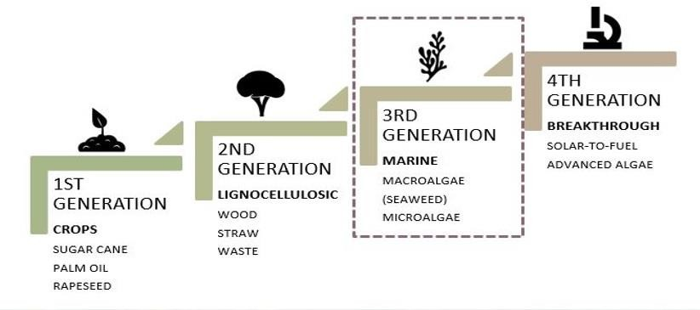
Figure 1: Generations of biofuel.
Image reference: http://surl.li/kmwvg
A. First generation biofuels:
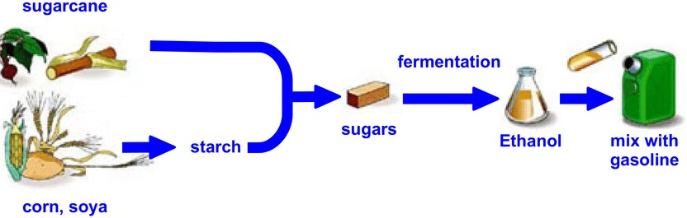
Sources such as soybeans, canola, rapeseed, and palm were used for the first generation.The interaction problems between water management and the human food chain, including supply, cause the promotion of first-generation biofuels. Stocks like starch, sugar, and vegetable oil were used. Bioethanol was produced from the fermentation of compressed grains with high sugar levels. The biodiesel was produced by compression of seeds into the other production of vegetable oil. The first-generation biofuels are biodiesel, biogas, bioalcohols, syngas, and vegetable oil.
Figure 2 Process of first generation
Image Reference: http://surl.li/kmxct

B. Second generation biofuels
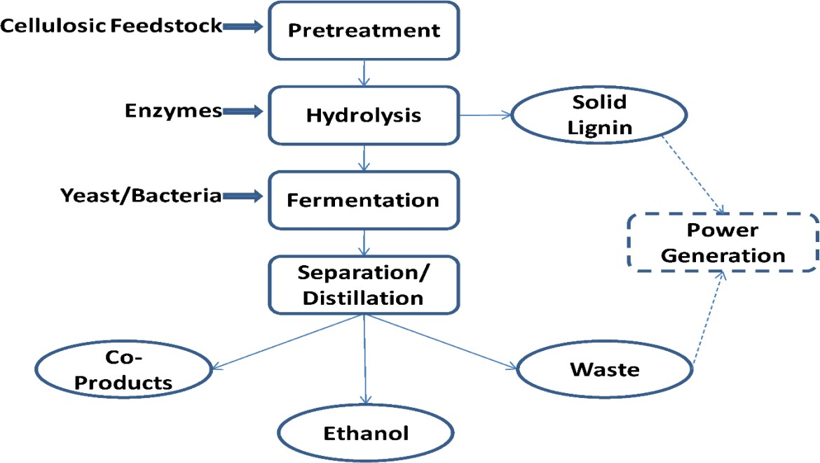
Cellulosic biofuel and waste biomass, called nonfood crops, are used in the second generation. The other name was Advanced Biofuels 3. The source of non-food crops is the only difference between the first and second generations of biofuels. If food crops are added in the second generation, they must contain their complete food purpose. As waste vegetable oil is not consumed by humans, it falls under first-generation biofuels. In the first generation of biofuel, virgin vegetable oil was used as a source. Different methods of technology were introduced to extract energy from them.

Figure: 3 Process of second generation
Image Reference: http://surl.li/kmxkw

C. Third generation biofuels
The biofuel produced from algae was termed third-generation biofuels. In later times, the algae will fall under second-generation biofuels. More advantages were found in algae. The term oilgae was also used to refer to third-generation biofuels. The low cost and high yielding production were seen here, as it gives 30% more energy than first-generation biofuels.
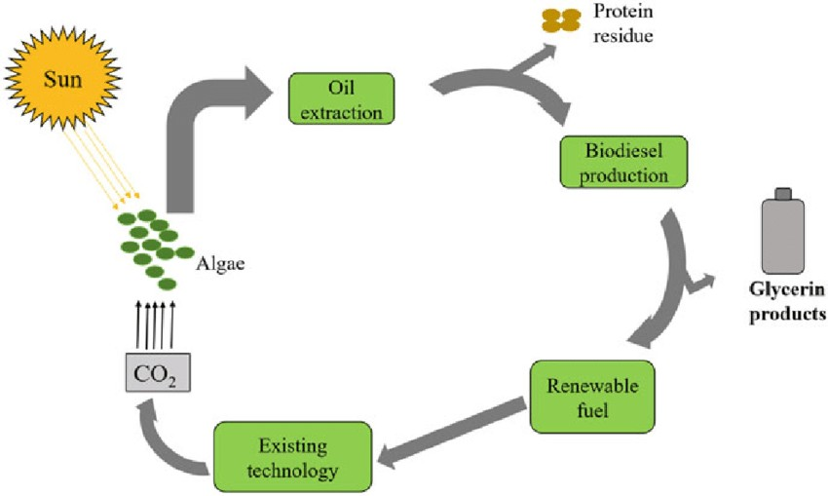
Figure: 4 Process of third generation
Image Reference: http://surl.li/kmxvc

D. Fourth generation biofuels

Agricultural products such as corn or sugarcane are made into biofuel for first-generation biofuels. Cellulosic biomass was used to make second-generation biofuels. Third and fourth generation biofuels required the technology of algae biofuels. In fourth-generation biofuels, engineered algae were used for production.
VI. TYPES OF BIOFUELS
As biofuels have advantages, the types of biofuels may be recognized and categorized. Some of the types are:
A. Biodiesel
Biodiesel is produced from animal fats, vegetable oils, and waste cooking oils. It is a renewable and biodegradable fuel. Compared to others, it has low toxicity and is safer to use. It does not need diesel engine modifications. It was mostly used in vehicles and diesel engines. It was produced by the biochemical process transesterification." It was a less harmful gas compared to another biodiesel.
B. Biogas
The biowaste is digested anaerobically, which is done in the absence of air. After the process, the resulting gas was termed biogas, normally containing carbon dioxide and methane. Commonly used for automobiles, is healthy. It is a valuable fuel. It is mostly obtained from digested products, mainly organic matter such as cow dung and sewage, which were filled in digesters. It is obtained for a period of 10 days (about 1 and a half weeks) to a few weeks, which is allowed for digestion.

C. Bioethanol
The sugars and starches are fermented to give ethyl alcohol, which is termed bioethanol. It is a substitute for gasoline. Products like wood, straw, and even household waste can be transferred into ethyl alcohol. The demand for ethanol increased day by day. New technologies were improved and used to fulfill the demand commercially. The sugar crop was mainly used in ethanol production, which accounts for about 60%. The use of ethanol has a wide range of applications in cosmetic production, the pharmaceutical industry, and alcoholic beverage production. It is one of the most important organic chemicals used by humans. It is also the oldest synthetic chemical made from organic compounds.
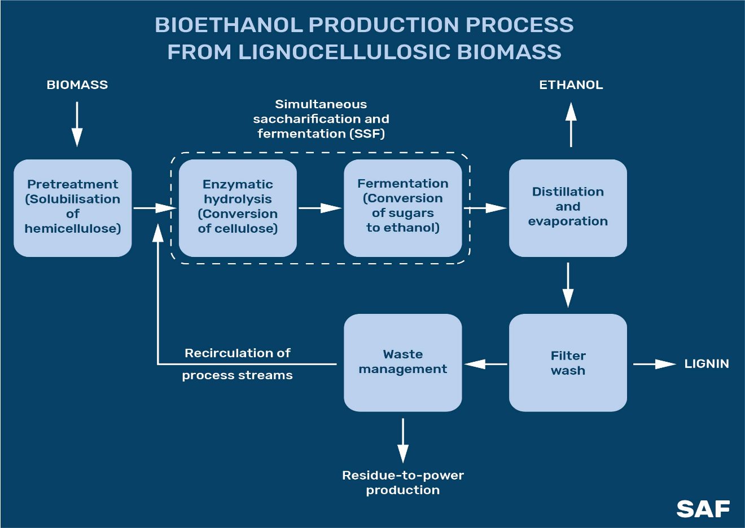
Figure: 5 Production of bioethanol
Image Reference: http://surl.li/kmyff

VII. PROCESS OF BIOFUEL
Biomass can be directly converted into liquid fuels, known as biofuels. They are mainly used to overcome transportation fuel needs. The commonly used biofuels are ethanol and biodiesel.
A. Ethanol
Ethanol (CH3CH2OH) is a fuel which can be obtained from different plant materials, which is known as "biomass." Ethanol is an alcohol used for blending purpose with gasoline to increase the octane production and reduce carbon monoxide and other smog- emissions. The common blend of ethanol is (10% ethanol, 90% gasoline) approved for use in most conventional gasoline-powered vehicles up to E15 (15% ethanol, 85% gasoline). Some vehicles, are known as flexible fuel vehicles, are designed to run on E85 (a gasoline- ethanol blend containing 51%–83% ethanol, depending on geography and season), an alternative fuel with much higher ethanol content than regular gasoline. Roughly 97% of gasoline in the US contains ethanol. Most of the ethanol is made from plant starches and sugars, mainly corn starch in the US but scientists are focusing on developing modern technologies that would allow for the use of cellulose and hemicelluloses.

B. Biodiesel
Biodiesel is a clear liquid fuel obtained from vegetable oils and animal fats and is a cleaner burning replacement for petroleum- based diesel fuel. It is nontoxic and biodegradable, produced by combining alcohol with vegetable oil and animal fat. Biodiesel is used as a fuel compression-ignition (diesel) engine. Biodiesel can be blended with petroleum diesel in percentage, including B100 (pure biodiesel) and, the most common blend, B20 (a blend containing 20% biodiesel and 80% petroleum diesel).
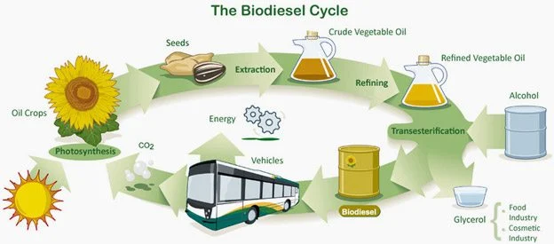
Figure: 6 The biodiesel cycle
Image Reference: http://surl.li/kmyiy

VIII. ADVANTAGES AND DISADVANTAGES OF BIOFUELS

A. Advantages of biofuels
- Energy source – The main benefits of biofuels is energy source
- Reduce the dependency for fuels from other foreign countries
- Avoids pollution of the atmosphere
- Positive Economic impact
- Reduction of green house gas
- Sustainability
- Engine performance – high quality
- Alternative for petrol and diesel
- The future can be based on mainly biofuels

B. Disadvantages of biofuels:
- It affects the life cycle
- Cost efficiency of Laboure and it needs large space for storage purpose.
- High amount of water consumption, mainly in dry Culturing biomass for biofuel increases the demand for agricultural land.
CONCLUSION OF THE STUDY
Biofuels are mainly used for heating purposes, power consumption, electric sources, and transport purposes. Biofuels are produced from many sources, such as crops, sugarcane, plant sources, vegetables, etc. It can be mainly implemented when petrol and diesel are in short supply. It’s an alternative to gasoline and diesel. However, it can be mainly based on feedstock, so it may affect biodiversity. Liquid biofuels can be less effective than normal fuels in the global supply of transport because electrical markets are more effective than agriculture. It reduces pollution in the environment. So it’s better to use biofuels rather than normal fuel. Biofuels also involve the production of ethanol, methanol, biodiesel, and methane. Each production has its own characteristics in its own way. Especially ethanol, an organic solvent that is currently used for industrial purposes, whereas biodiesel is used in transportation as it controls and prevents various environmental damage. Biofuels are an alternative source for one of the solar and wind energy sources.
REFERENCE
[1] Abdeshahian P, Lim JS, Ho WS, Hashim H. Lee CT. Potential of biogas production from farm Animal waste in Malaysia. Renew Sust Energ Rev. 2016;60:714-23.
[2] Dias MOS, Ensinas AV, Nebra SA, Filho RM, Rossell CEV, Maciel MRW. Production of bioethanol and other bio-based Materials from sugarcane bagasse: integration to Conventional bioethanol production process. Chem Eng Res Des 2009;87:1206e16.
[3] Use of algae as biofuel sources Ayhan Demirbas Sirnak University, Engineering Faculty, Sirnak, Turkey Sila Science, Trabzon, Turkey.Article history:Received 22 September 2009.Accepted 1 June 2010 Available online 26 June 2010.
[4] L. Rosgaard, A.J. de Porcellinis, J.H. Jacobsen, N.U. Frigaard, Y. Sakuragi, Bioengineering of carbon fixation, biofuels, and biochemicals in cyanobacteria and plants, Journal of Biotechnology, 162 (2012) 134-147.
[5] U.S.D.oAgriculture, U.S. Ethanol: An examination of policy, production, use, distribution, and market interactions, United States Department of Agriculture, Washington D.C., U.S., 2015, pp. 87.
[6] J.M. Bergthorson, M.J. Thomson, A review of the combustion and emissions properties of advanced transportation biofuels and their impact on existing and future engines, Renewable and Sustainable Energy Reviews, 42 (2015) 1393-1417.
[7] Ahmad AL. Yasin NHM, Derek CJC, Lim JK. Microalgae as a sustainable energy source for biodiesel production: a review. Renew Sust Energ Rev. 2011:15:584-93.
[8] Alam M. Hasan M. Feasibility study of biogas energy in Bangladesh (Doctoral dissertation)Daffodil International University, 2017.
[9] Alonso DM, Bond JQ, Dumesie JA. Catalytic conversion of biomass to biofuels. Green Chem. 2010:12:1493-513
[10] Antoni D. Zverlov VV. Schwarz WH. Biofuels from microbes. Appl Microbiol Biotechnol.2007;77(1):23-35.T.
[11] Mizik, G. Gyarmati.Economic and sustainability of biodiesel production—a systematic literature review.F.
[12] Saladini, N. Patrizi, F.M. Pulselli, N. Marchettini, S. Bastianoni, G. Fyoor.Emergy evaluation of first, second and third generation biofuels.
[13] A.N. Oumer, M.M. Hasan, A.T. Baheta, R. Mamat, A.A. Abdullah. A review on Bio-based liquid fuels as a source of renewable energy.
[14] Demirbas, A. (2009). “Political, economic and Environmental impacts of biofuels: A review”. Applied Energy86:$1085117.doi:10.1016/j.apenergy.2009.04.03.
[15] Knothe, Gerhard (2010), Biodiesel and renewable diesel: A comparison, Progress in Energy and Combustion Science.
[16] Evans, G. “Liquid Transport B iofuels – Technology Status Report”, National Non-Food Crops Centre, 2008-04-14.Retrieved on 2009-05-11.
[17] Research paper on The Effects of biofuel production on selected local Communities in Nigeria by B. O. Balogun and A. T. Salami.
[18] Acheampong E, Campion BB (2014). The Effects of Biofuel Feedstock Production on Farmers’ Livelihoods in Ghana: The Case of Jatropha curcas. Sustainability 6:4587-4607.
[19] Agbro EB. Ogie NA (2012). A Comprehensive Review of Biomass Resources and Biofuel Production Potential in Nigeria. Res. J. Eng.Appl. Sci. 1(3):149-155.
[20] Aguilar LB, Campos HM, Leyva IR, Gutierrez HL, Esquivel RS,Hernandez FS (2011). Global Social and Economic Impact on TheUse of Biofuels and Recommendations for Sustainability. Glob. J. Res. Eng. (B) XI(V).
[21] Andrade R, Miccolis A (2010). Biodiesel in the Amazon. Working paperNo. 113. Centre for International Forestry Research (CIFOR), Bogor, Indonesia and the World Agroforestry Centre, Nairobi, Kenya. Gressel .

