IoT BASED MULTI LANGUAGE (ML) SMART NOTICE BOARD USING ANDROID APP

Dr. K. Rasadurai, M.E Ph.D
Professor, Department of ECE,
Kuppam Engineering College, Kuppam-517425, AP India.
* Email: krasadurai@gmail.com, https://orcid.org/0000-0003-4969-1845

Abstract— Notice Board is the primary thing in any institution / organization or public utility places like bus stations, railway stations and parks, but changing the data in the notice board day-to-day is a difficult process. A separate person is required to manage this notices. Few of the common problems in handling the current notice board is printing documents and then physically going to the location of the board and changing a notice as well as organizing them. It takes time and it is manual. In this project, we propose entirely new concept of smart notice board based on Internet of Things (IoT) and Wi-Fi, that make the process of posting notices very efficient and easy process. The proposed system reduces the manpower and time. In this system, the user can write the data from anywhere in the world to the Notice Board from an android mobile. The android application is developed by using Massachusetts Institute of Technology MIT app inventor. The user can send a text message or a voice message to display it in the Notice board. Whenever a new notice is updated the speaker announces an alert message “Hello everyone, a new message is displayed”. This will reduce the time to update the data as well as it will efficiently transfers the data to the notice board.
Keywords— IoT, MIT App, Smart Notice Board

Introduction (Heading 1)
The main purpose to design this IoT based smart notice board using android app is to interface it with user mobile phones for displaying the latest information. In other words, the user can easily send the message or information for displaying from remote areas. Now a day’s individuals like wireless connection because they can interact with people easily and it require less time. The main objective of this paper is to develop a smart notice board that display message sent from the user and to design a simple, easy to install, user friendly system, which may receive and display notice in a very specific manner which will help the user to simply keep the track of notice board each day and every time he/she uses the system.
In earlier days people used the paper as the medium to convey any message. The paper material, which is made of pulp of the tree, will be scarce after few years. It is mandatory to save the trees by employing digital technology rather than the conventional method. Printing a paper requires the quantitative manpower. This conventional method is very costly. An alternative to this conventional method is efficient to use the digital media and digital technology.
Notice boards play a vital role in conveying the messages to many people at the same time. Notice boards are used in Institutions, Organizations and many public places. In earlier days printed paper is used to display on a notice board. These conventional notice boards are not so interactive for the modifications in the message which is to be conveyed. Also requires huge amount of resources and manpower.
A smart notice board can be replaced in place of conventional notice board to make more interactive and adaptable. Here in which reduces the manpower and resources. The smart notice board uses the digital technology and the electronic components/modules. It is implemented to display the notice or message which is more convenient for the administrator in terms of displaying, modifying and viewing of the notices/messages.

Internet of Things (IoT)

IoT
The Internet of Things (IoT) is a system of interconnected devices that communicate with each other over the internet. In this project, IoT is used to connect the Smart Notice Board to the internet, enabling it to be remotely controlled and updated.
The ESP8266 is used as a Wi-Fi module that allows the notice board to connect to the internet. It provides a way to receive and send data between the notice board and the Android app. With IoT, the user can remotely update the notice board with important information and notifications without being physically present.
Moreover, the IoT technology in this project enables the notice board to receive data from external sources, such as weather forecasts or news updates. With this feature, the notice board can display real-time information and keep the user informed about the latest news and events.
The IoT technology used in this project provides an efficient way to manage and control the Smart Notice Board. With its connectivity features, the notice board can be updated and controlled from anywhere in the world, making it an ideal solution for modern homes and workplaces.
Improved Efficiency: IoT technology in the Smart Notice Board improves its efficiency as it can be controlled remotely. This eliminates the need for manual updates and makes the process more efficient.
Real-time Updates: IoT technology enables the notice board to receive real-time updates, such as weather updates or news alerts, which can be displayed on the notice board. This helps keep the user informed and up-to-date on the latest information.
Cost-Effective: IoT technology makes the Smart Notice Board cost-effective as it eliminates the need for a dedicated computer or a human operator to manage and update the notice board.
Enhanced User Experience: The IoT technology in the Smart Notice Board enhances the user experience by providing a user-friendly interface that allows the user to control the display settings and receive notifications. This makes the notice board more interactive and engaging.
Future-proofing: With IoT technology, the Smart Notice Board is future-proofed, as it can be updated and upgraded with new features and functionalities as technology advances. This ensures that the notice board remains relevant and useful for years to come.

Problem Statement
The problem statement for using an IoT-based smart notice board using an Android app is that traditional notice boards are inefficient and time-consuming to update, especially in large organizations. It is also challenging to ensure that the intended audience receives the message, leading to miscommunication and inefficiency. Additionally, traditional notice boards cannot be updated in real-time, leading to outdated information being displayed for an extended period.
The major problems are:
• Traditional notice boards are often ineffective due to various reasons such as the delay in updating notices, difficulty in accessing them, limited visibility, and the cost of printing and paper waste. This can result in miscommunication, missed deadlines, and a lack of awareness.
• Now-a-days a separate person is needed to stick the information on the notice board. It will lead to loss of time as well as usage of manpower.
• Traditional notice boards are often static, require manual updating, and can be easily overlooked or ignored by the intended audience.
• Additionally, traditional notice boards may not be accessible to everyone, such as those with visual impairments.
The traditional notice boards are slowly losing their significance in the modern world. They lack the ability to convey real-time information and require manual efforts for updating them. In order to overcome these limitations, an IoT-based smart notice board using an Android app has been proposed. However, several challenges and issues need to be addressed to make this technology feasible and effective.

existing system
In the current situation the notice boards are being managed manually through papers or any other devices. This is a time taking task to put up notices on the notice board. This wastes a lot of resources like paper, printer ink, man power and also time.

Wireless Notice Board Using Bluetooth And Arduino
The existing system is based on GSM technology so it requires SIM card to send the messages on notice board. In the existing system is also holds international roaming capability of GSM, so we can send message to receiver from anywhere of the world and requires extra charges. The drawbacks of this type of systems are: as there is no password any one can send the message to display and also when there is a network problem the GSM doesn’t work.
Communication devices such as mobile handsets and related wireless innovations have become ubiquitous/common. Multiple domains in the field of Communication and Embedded devices are being increasingly explored. The use of cell phones has rapidly increased now a days. Developments in communication technologies have led to the growth of dense networks. As a means of communication, notice boards are widely trendy with its applications ranging from schools, colleges, hospitals to major organizations. Notice boards effectively tackle the global problem of deforestation by conveying messages at large without the use of paper. Such innovative measures will go a long way in adapting the damage to the environment.
GSM technology aims in reducing the complexity for sending a message by incorporating SMS (Short Message Service) technology. This technology can be used in public areas such as hospitals, schools, multiplexes and buildings to improve the security system and also to spread awareness in an emergency. The objective of this is to analysis the various proposals and technologies of a SMS controlled wireless display board that may eventually replace with the presently used paper based and programmable notice boards.

Wireless Notice Board Using Bluetooth And Arduino Units

- This method consists of power supply, Arduino UNO, LED module, Bluetooth HC-05 and mobile application. After uploading the program in Arduino UNO, we will give them external power supply. Due to that all functions of equipment’s are on. At that time, we will pass the notice/SMS which we want using mobile. Then this notice/SMS will receive by Bluetooth. And by using Arduino this notice/SMS will display on digital notice board.
Funded by NEWGEN IDEC, Kuppam Engineering College
- This system in this project has many upcoming applications in educational institutions and organizations, crime prevention, traffic management, railways, advertisements etc. Been user friendly, long range and faster means of conveying information are major bolsters for this application.
- By using this methodology, we can enhance the security system and also make awareness of the emergency situations and avoid many dangers.

Proposed System
An IoT-based smart notice board using an Android app system is a project that utilizes various hardware components such as Arduino Uno, ESP8266 NodeMCU, and P10 LED display to create a smart notice board that can be remotely controlled through an Android app. The Arduino Uno is a microcontroller board that serves as the brain of the project. It receives commands from the ESP8266 NodeMCU through a serial connection and controls the P10 LED display to display text. The ESP8266 NodeMCU is a Wi-Fi module that connects the notice board to the internet. It receives commands from the Android app through a Wi-Fi connection and sends them to the Arduino Uno.
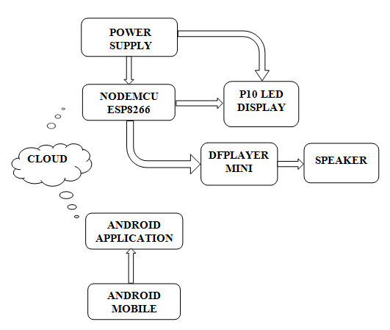
Fig.1. Block Diagram
The P10 LED display is a matrix of LED modules that can display text and graphics. It is controlled by the Arduino Uno through a protocol called the HUB75 interface.
The Android app is the user interface of the project. It allows the user to send text and graphics to the notice board from a remote location. The app sends the commands to the ESP8266 NodeMCU, which then relays them to the Arduino Uno.
The overall system architecture of the project involves the Android app communicating with the ESP8266 NodeMCU over Wi-Fi. The NodeMCU then sends the commands to the Arduino Uno, which controls the P10 LED display to show the desired text.
Overall, the IoT-based smart notice board using Android app system with Arduino Uno, ESP8266 NodeMCU, and P10 LED display is a useful and innovative project that can be used in a variety of settings, including offices, schools, and public places. It provides a simple and effective way to display information remotely, making it easy for users to keep up with important announcements and updates.

A. Simulators for Arduino .
The powerful simulators for Arduino is prospoed, Example: Autodesk Eagle (recommended), Proteus, Autodesk Circuits, and Virtronics Simulator for Arduino, Electrify,Fritzing, and VBB4Arduino – Virtual Breadboard for Arduino.

INCLUDEPICTURE "E:\\var\\folders\\21\\qmt4cpvn3md2w4nlgszh905r0000gn\\T\\com.microsoft.Word\\WebArchiveCopyPasteTempFiles\\page12image12794288" \* MERGEFORMATINET INCLUDEPICTURE "E:\\var\\folders\\21\\qmt4cpvn3md2w4nlgszh905r0000gn\\T\\com.microsoft.Word\\WebArchiveCopyPasteTempFiles\\page12image12794288" \* MERGEFORMATINET INCLUDEPICTURE "E:\\var\\folders\\21\\qmt4cpvn3md2w4nlgszh905r0000gn\\T\\com.microsoft.Word\\WebArchiveCopyPasteTempFiles\\page12image12794288" \* MERGEFORMATINET INCLUDEPICTURE "E:\\var\\folders\\21\\qmt4cpvn3md2w4nlgszh905r0000gn\\T\\com.microsoft.Word\\WebArchiveCopyPasteTempFiles\\page12image12794288" \* MERGEFORMATINET INCLUDEPICTURE "E:\\var\\folders\\21\\qmt4cpvn3md2w4nlgszh905r0000gn\\T\\com.microsoft.Word\\WebArchiveCopyPasteTempFiles\\page12image12794288" \* MERGEFORMATINET INCLUDEPICTURE "E:\\var\\folders\\21\\qmt4cpvn3md2w4nlgszh905r0000gn\\T\\com.microsoft.Word\\WebArchiveCopyPasteTempFiles\\page12image12794288" \* MERGEFORMATINET INCLUDEPICTURE "E:\\var\\folders\\21\\qmt4cpvn3md2w4nlgszh905r0000gn\\T\\com.microsoft.Word\\WebArchiveCopyPasteTempFiles\\page12image12794288" \* MERGEFORMATINET INCLUDEPICTURE "E:\\var\\folders\\21\\qmt4cpvn3md2w4nlgszh905r0000gn\\T\\com.microsoft.Word\\WebArchiveCopyPasteTempFiles\\page12image12794288" \* MERGEFORMATINET INCLUDEPICTURE "E:\\var\\folders\\21\\qmt4cpvn3md2w4nlgszh905r0000gn\\T\\com.microsoft.Word\\WebArchiveCopyPasteTempFiles\\page12image12794288" \* MERGEFORMATINET INCLUDEPICTURE "E:\\var\\folders\\21\\qmt4cpvn3md2w4nlgszh905r0000gn\\T\\com.microsoft.Word\\WebArchiveCopyPasteTempFiles\\page12image12794288" \* MERGEFORMATINET INCLUDEPICTURE "E:\\var\\folders\\21\\qmt4cpvn3md2w4nlgszh905r0000gn\\T\\com.microsoft.Word\\WebArchiveCopyPasteTempFiles\\page12image12794288" \* MERGEFORMATINET INCLUDEPICTURE "E:\\var\\folders\\21\\qmt4cpvn3md2w4nlgszh905r0000gn\\T\\com.microsoft.Word\\WebArchiveCopyPasteTempFiles\\page12image12794288" \* MERGEFORMATINET INCLUDEPICTURE "E:\\var\\folders\\21\\qmt4cpvn3md2w4nlgszh905r0000gn\\T\\com.microsoft.Word\\WebArchiveCopyPasteTempFiles\\page12image12794288" \* MERGEFORMATINET INCLUDEPICTURE "E:\\var\\folders\\21\\qmt4cpvn3md2w4nlgszh905r0000gn\\T\\com.microsoft.Word\\WebArchiveCopyPasteTempFiles\\page12image12794288" \* MERGEFORMATINET INCLUDEPICTURE "E:\\var\\folders\\21\\qmt4cpvn3md2w4nlgszh905r0000gn\\T\\com.microsoft.Word\\WebArchiveCopyPasteTempFiles\\page12image12794288" \* MERGEFORMATINET INCLUDEPICTURE "E:\\var\\folders\\21\\qmt4cpvn3md2w4nlgszh905r0000gn\\T\\com.microsoft.Word\\WebArchiveCopyPasteTempFiles\\page12image12794288" \* MERGEFORMATINET 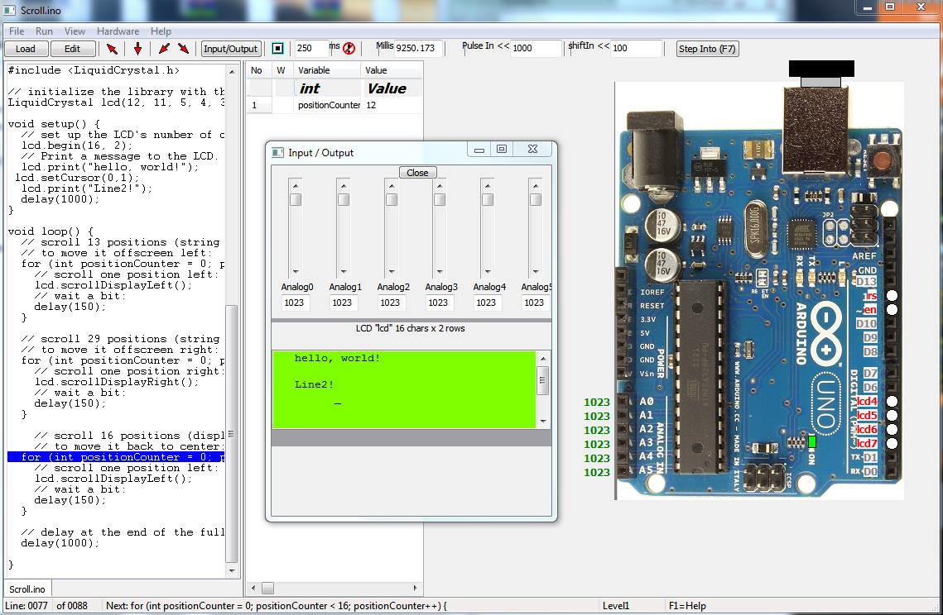

INCLUDEPICTURE "E:\\var\\folders\\21\\qmt4cpvn3md2w4nlgszh905r0000gn\\T\\com.microsoft.Word\\WebArchiveCopyPasteTempFiles\\page12image12794704" \* MERGEFORMATINET INCLUDEPICTURE "E:\\var\\folders\\21\\qmt4cpvn3md2w4nlgszh905r0000gn\\T\\com.microsoft.Word\\WebArchiveCopyPasteTempFiles\\page12image12794704" \* MERGEFORMATINET INCLUDEPICTURE "E:\\var\\folders\\21\\qmt4cpvn3md2w4nlgszh905r0000gn\\T\\com.microsoft.Word\\WebArchiveCopyPasteTempFiles\\page12image12794704" \* MERGEFORMATINET INCLUDEPICTURE "E:\\var\\folders\\21\\qmt4cpvn3md2w4nlgszh905r0000gn\\T\\com.microsoft.Word\\WebArchiveCopyPasteTempFiles\\page12image12794704" \* MERGEFORMATINET INCLUDEPICTURE "E:\\var\\folders\\21\\qmt4cpvn3md2w4nlgszh905r0000gn\\T\\com.microsoft.Word\\WebArchiveCopyPasteTempFiles\\page12image12794704" \* MERGEFORMATINET INCLUDEPICTURE "E:\\var\\folders\\21\\qmt4cpvn3md2w4nlgszh905r0000gn\\T\\com.microsoft.Word\\WebArchiveCopyPasteTempFiles\\page12image12794704" \* MERGEFORMATINET INCLUDEPICTURE "E:\\var\\folders\\21\\qmt4cpvn3md2w4nlgszh905r0000gn\\T\\com.microsoft.Word\\WebArchiveCopyPasteTempFiles\\page12image12794704" \* MERGEFORMATINET INCLUDEPICTURE "E:\\var\\folders\\21\\qmt4cpvn3md2w4nlgszh905r0000gn\\T\\com.microsoft.Word\\WebArchiveCopyPasteTempFiles\\page12image12794704" \* MERGEFORMATINET INCLUDEPICTURE "E:\\var\\folders\\21\\qmt4cpvn3md2w4nlgszh905r0000gn\\T\\com.microsoft.Word\\WebArchiveCopyPasteTempFiles\\page12image12794704" \* MERGEFORMATINET INCLUDEPICTURE "E:\\var\\folders\\21\\qmt4cpvn3md2w4nlgszh905r0000gn\\T\\com.microsoft.Word\\WebArchiveCopyPasteTempFiles\\page12image12794704" \* MERGEFORMATINET INCLUDEPICTURE "E:\\var\\folders\\21\\qmt4cpvn3md2w4nlgszh905r0000gn\\T\\com.microsoft.Word\\WebArchiveCopyPasteTempFiles\\page12image12794704" \* MERGEFORMATINET INCLUDEPICTURE "E:\\var\\folders\\21\\qmt4cpvn3md2w4nlgszh905r0000gn\\T\\com.microsoft.Word\\WebArchiveCopyPasteTempFiles\\page12image12794704" \* MERGEFORMATINET INCLUDEPICTURE "E:\\var\\folders\\21\\qmt4cpvn3md2w4nlgszh905r0000gn\\T\\com.microsoft.Word\\WebArchiveCopyPasteTempFiles\\page12image12794704" \* MERGEFORMATINET INCLUDEPICTURE "E:\\var\\folders\\21\\qmt4cpvn3md2w4nlgszh905r0000gn\\T\\com.microsoft.Word\\WebArchiveCopyPasteTempFiles\\page12image12794704" \* MERGEFORMATINET INCLUDEPICTURE "E:\\var\\folders\\21\\qmt4cpvn3md2w4nlgszh905r0000gn\\T\\com.microsoft.Word\\WebArchiveCopyPasteTempFiles\\page12image12794704" \* MERGEFORMATINET INCLUDEPICTURE "E:\\var\\folders\\21\\qmt4cpvn3md2w4nlgszh905r0000gn\\T\\com.microsoft.Word\\WebArchiveCopyPasteTempFiles\\page12image12794704" \* MERGEFORMATINET 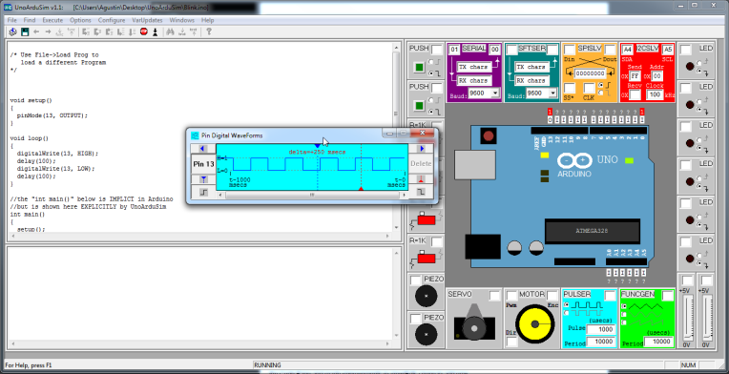
Fig.2. PIN & Output Waveforms

B. ThingSpeak
Thing Speak is an IOT analytic platform service that allows you to aggregate,visualize and analyze live data streams in the cloud. Thing Speak provides instant visualizations of data posted by your devices to Thing Speak. With the ability to execute MATLAB code in ThingSpeak you can performon line analysis and processing of the data a sit comes in. Thingspeak is often used for prototyping and proof of concept IoT systems that require analytic

STEPS To Create Smart Notice Board App Using Mit App Inventor

Step 1: Open a Gmail account in case you don’t have one.
Step 2: Open the link https://appinventor.mit.edu/ and log in to your Gmail account.

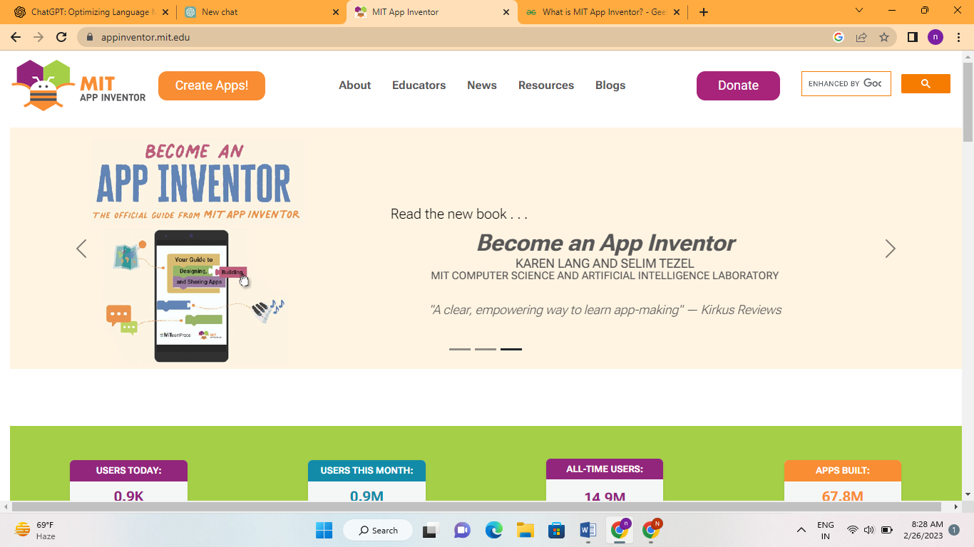
Fig 3: MIT app inventor
Step 3: Click on create new apps. The below interface opens.
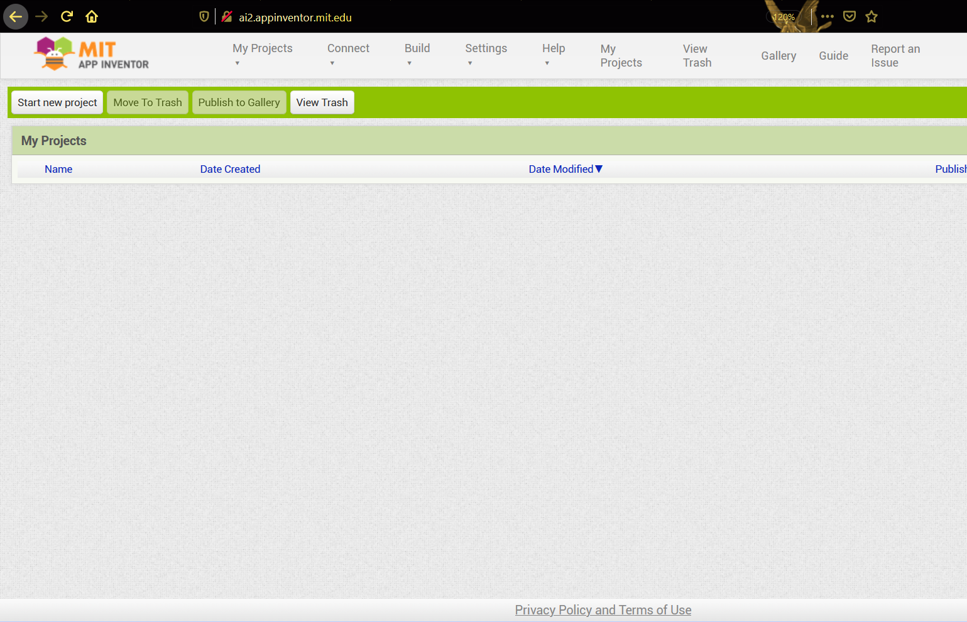
Fig 4: Starting a new project

Step 4: To start the app-building click on “Start New Project”. Give the title name and click on OK. Here I given app name as “iNotify”.
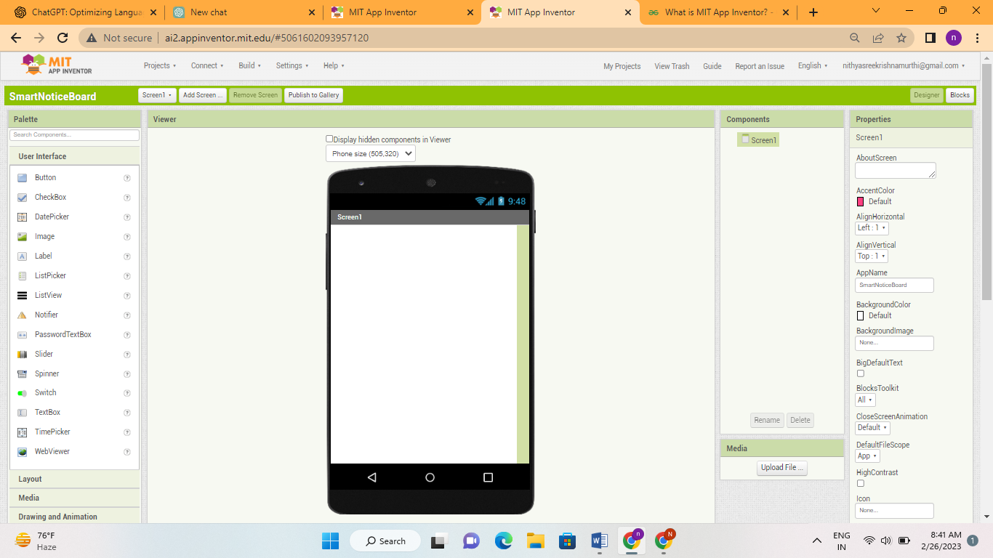
Fig 5: Layout of the application

Step 5: First add a background image as shown below from the Properties. Click on a background image and upload a required image.
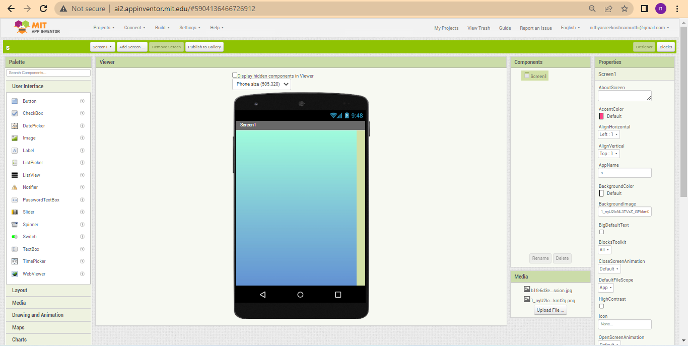
Fig 6: Adding a background image

Step 6: Creating a Home page i.e. Welcome To Smart Notice Board.
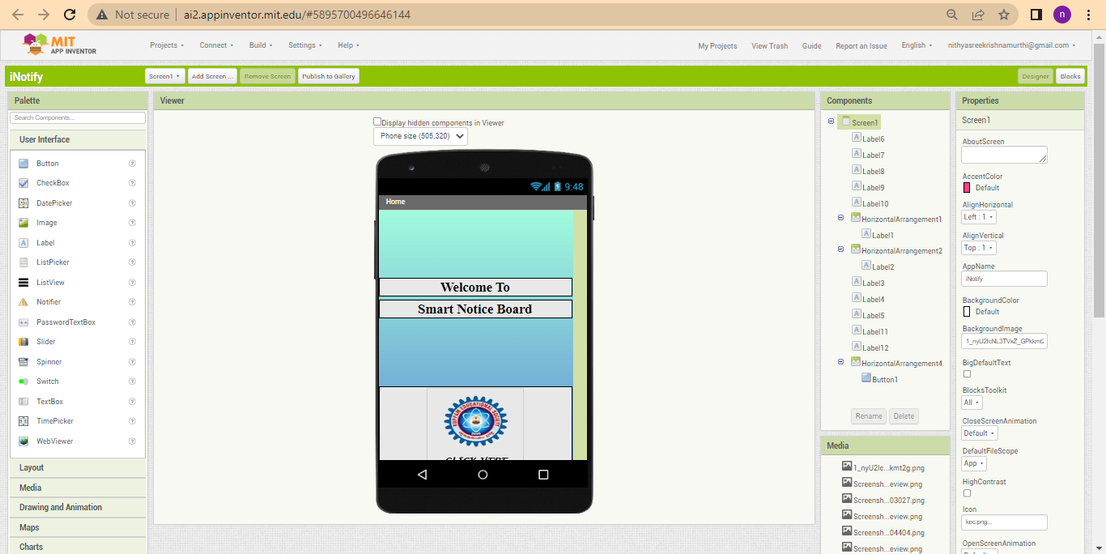
Fig7:Homepage

Step 7: Adding login and password for privacy protection.
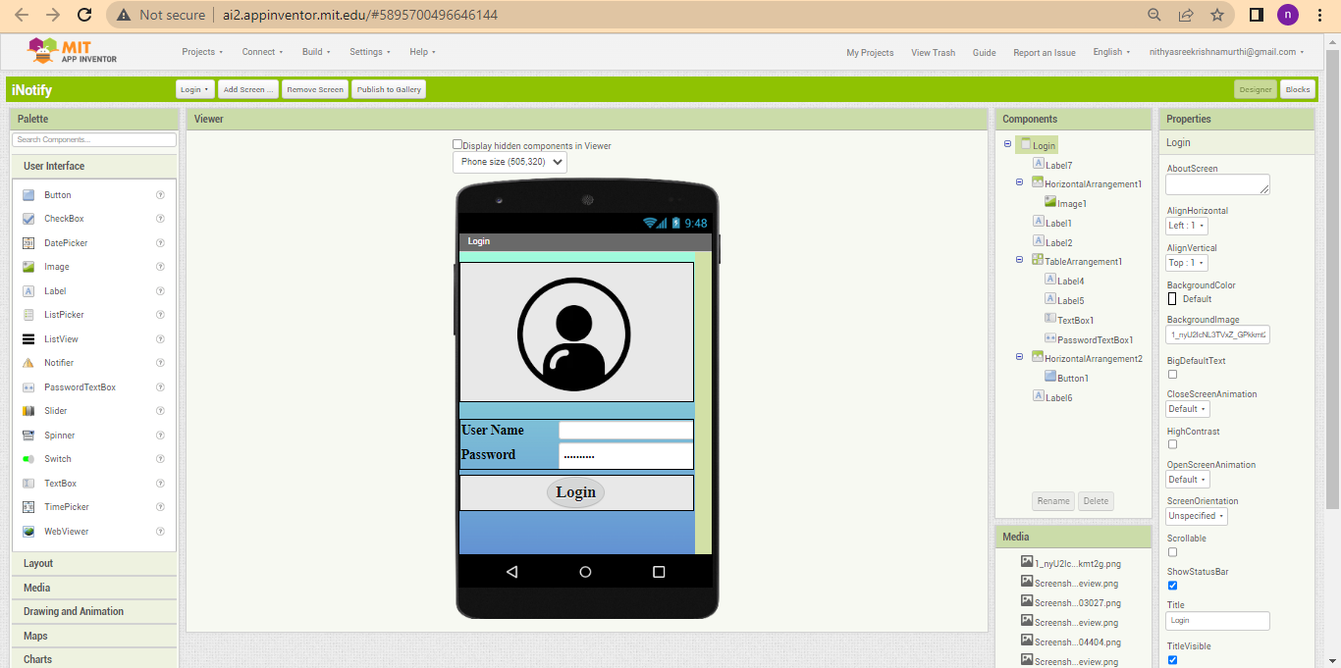
Fig 8:Login and password

Step 6: Add a label by dragginglabel from the user interface and type the label name as kuppam engineering college. Change the font style to serif, font size to 21 and text alignment to center and width to fill parent as shown in below figure.
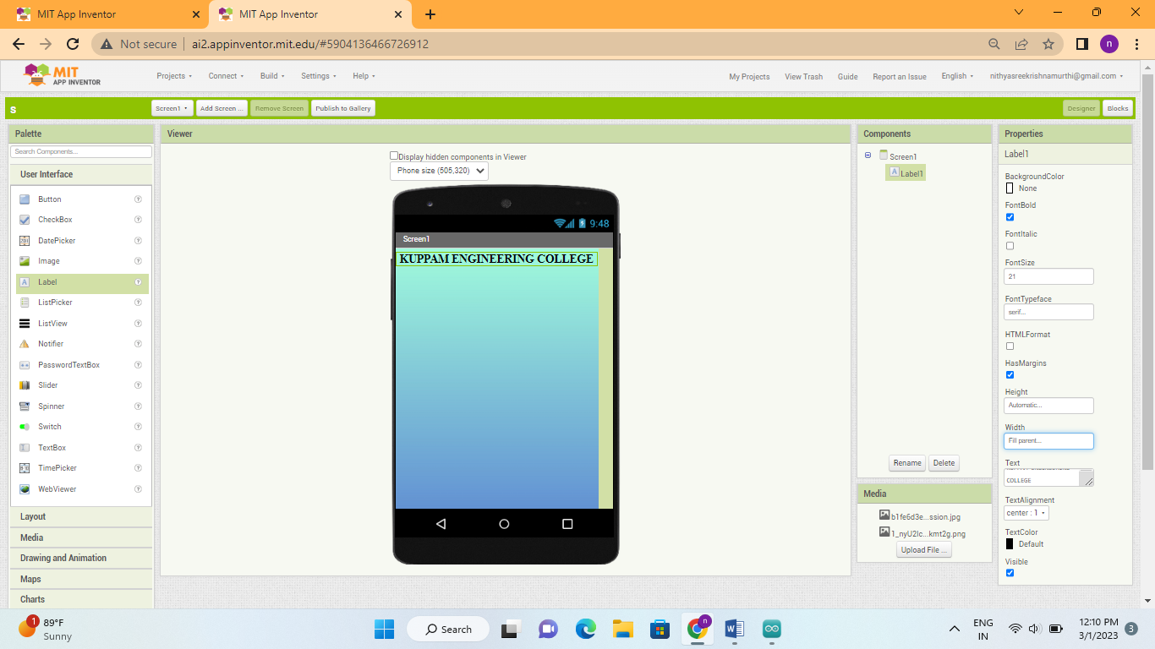
Fig9: Adding a label “KUPPAM ENGINEERING COLLEGE”

Step 7: Add two labels by dragging label from the user interface and type the label2 name as “IoT based smart notice board”, and label3 as “using android app” .Change the font style to serif, font size to 21 and text alignment to center and width to fill parent from properties as shown in below figure.

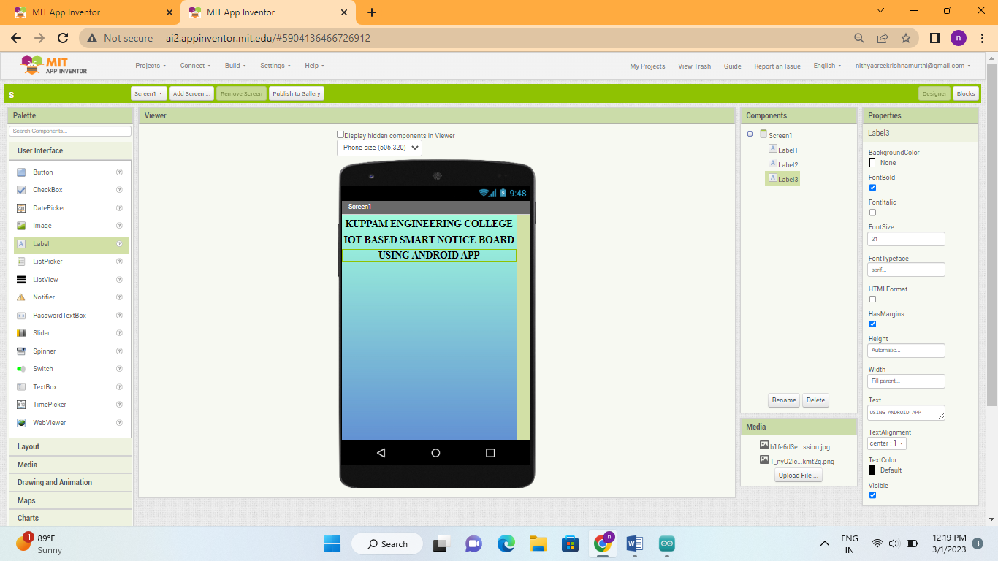
Fig 10: Adding a label “IoT BASED SMART NOTICE BOARD USING ANDROID APP”

Step 8: Add a label by dragging label from the user interface and type the label4 name as “Text message” .Change the font style to serif, font size to 18 and text alignment to left as shown in below figure.
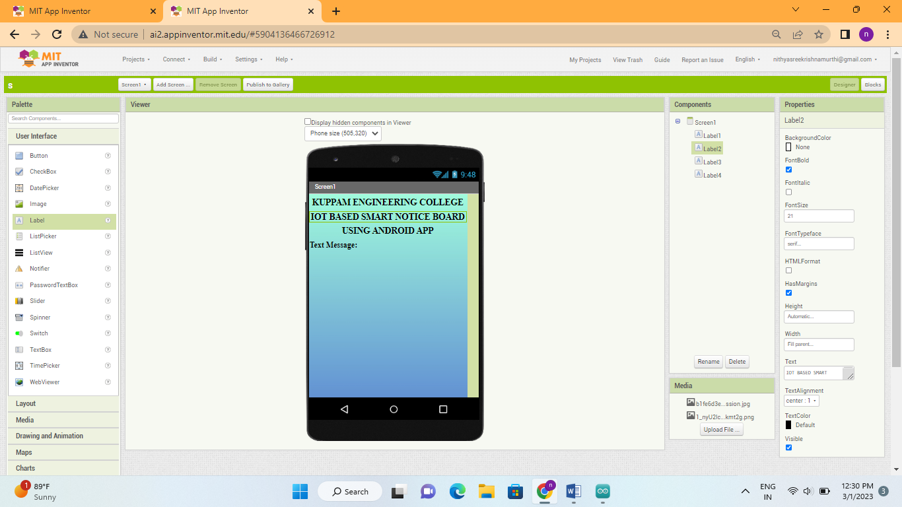
Fig 11: Adding a label “Text Message”

Step 9: Add a text box by dragging text box from the user interface. Change the width to fill parent, click on multi line check box, give height as 25% and hint as Enter a message to display as shown in below figure.
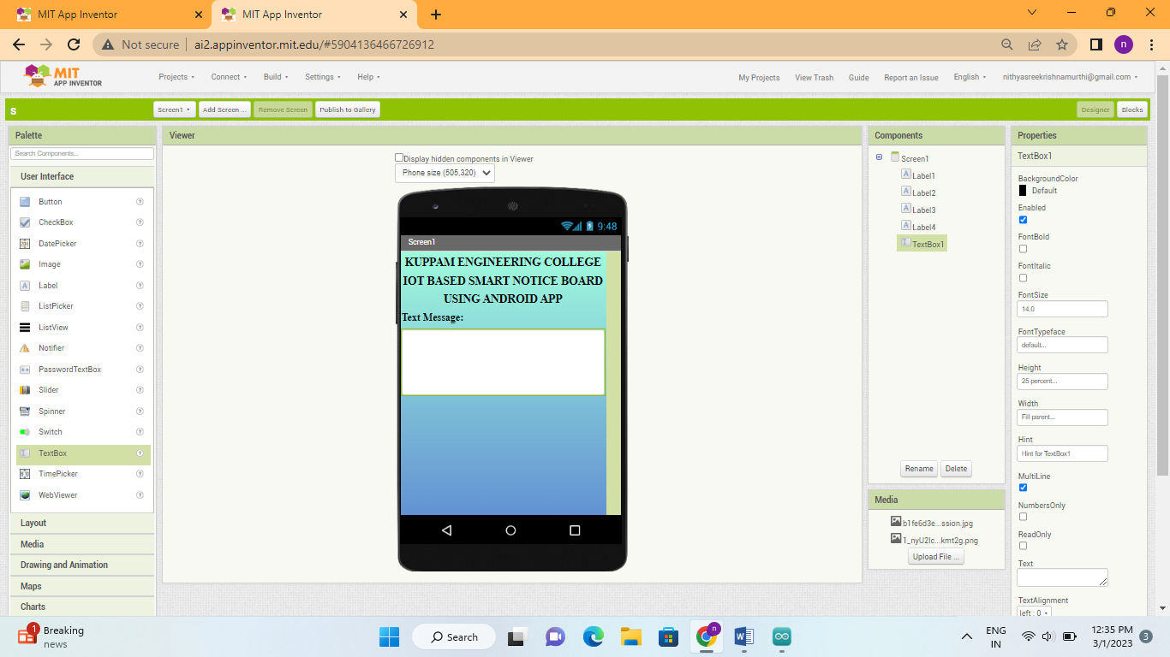
Fig 12: Adding a label “Text Box”

Step 10: Add a horizontal alignment and add a button by dragging button from the user interface and type the button name as “Send”. Change the horizontal align to center and width to fill parent, also change the button width as 50% and shape as rounded.
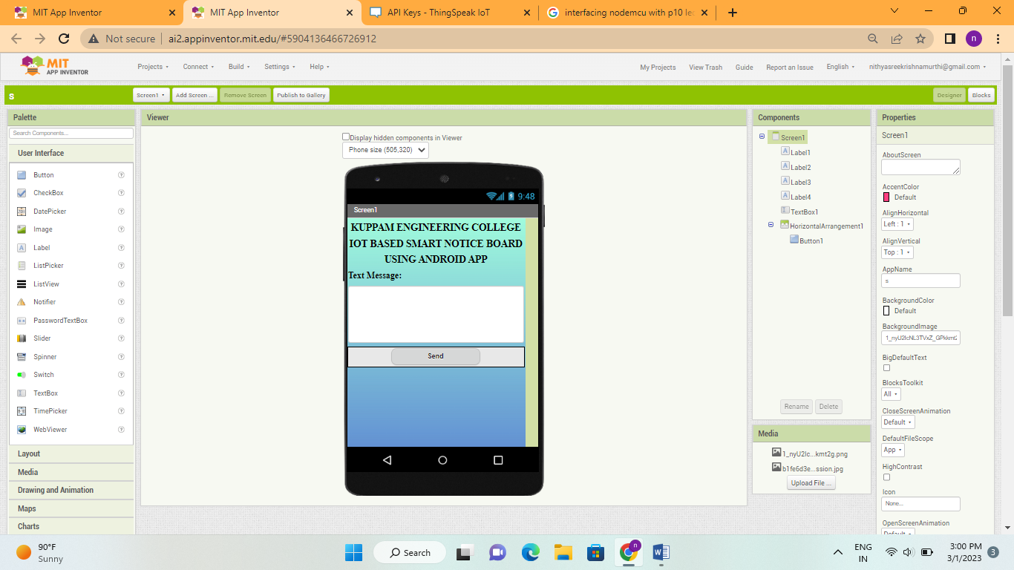
Fig 13: Adding a button to send data through IoT

Step 11: Add a label by dragging label from the user interface and type the label5 name as “Voice message” .Change the font style to serif, font size to 18 and text alignment to left as shown in below figure.
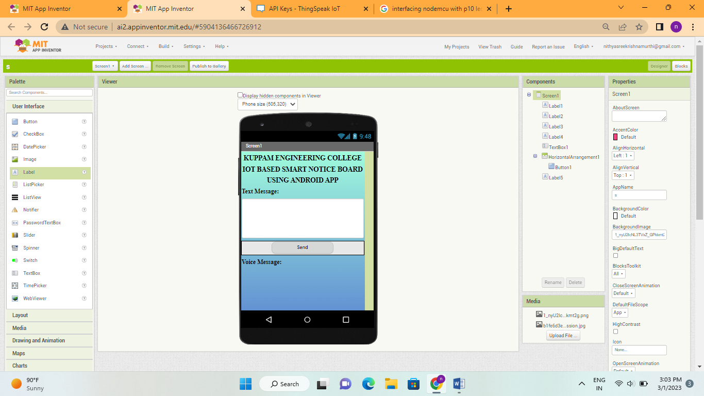
Fig 7.14: Adding a label “Voice Message”

Step 12: Add a horizontal alignment and add a button by dragging button from the user interface. Change the horizontal align to center, height to 25% and width to fill parent, also change the button height to 25%, width as 50% and add a microphone as an image for a symbolic recognition.
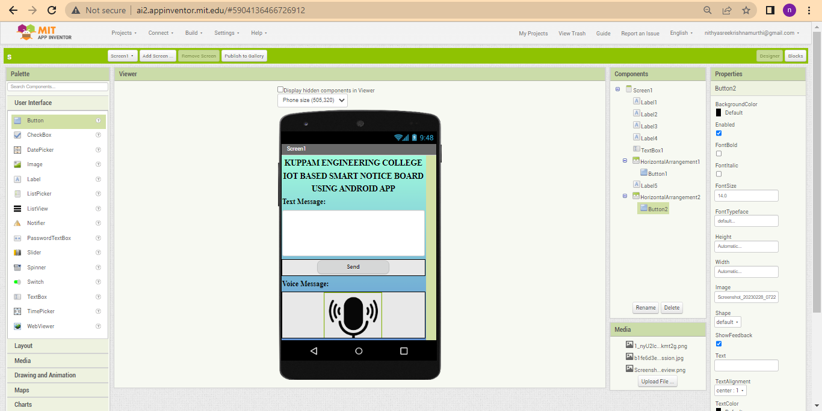
Fig 15: Adding a button and a microphone image for “Voice Message”

Step 13: For the proper functioning of app add the required blocks and write a channel feed API request from Thing Speak server to the buttons (calling the web url to get the text data and speech recognizer result) to access the given text data, voice data as shown in below figure.
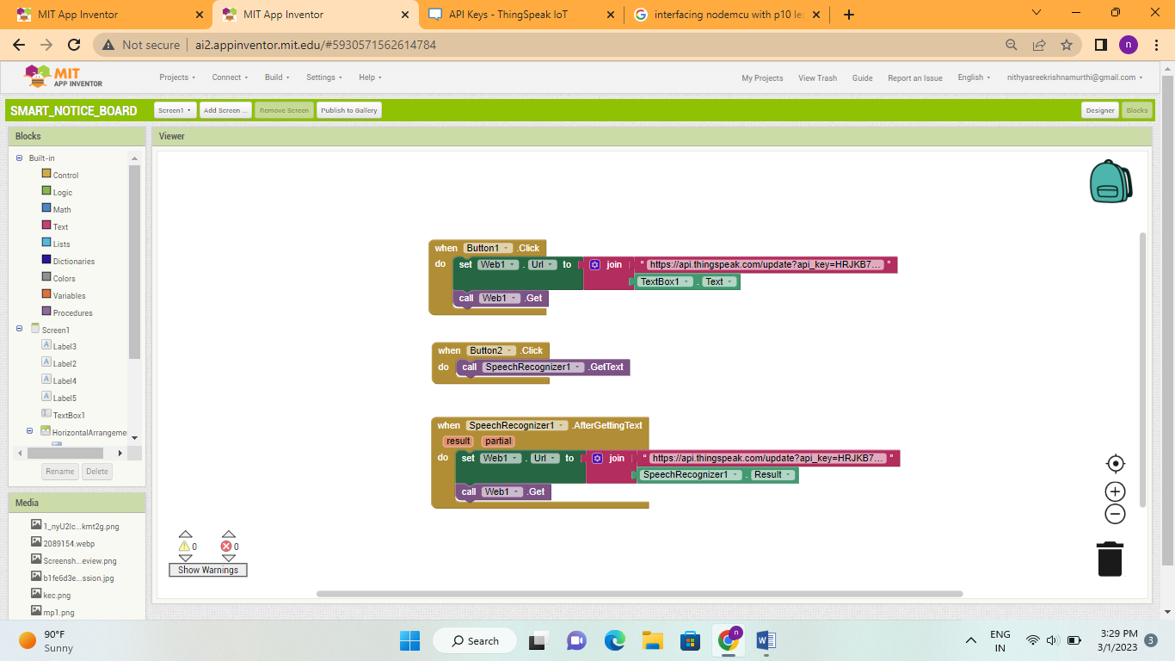
Fig 16: Adding necessary blocks for proper functioning

Step 14: To connect your mobile device, choose “Connect” and “AI Companion” from the top menu.
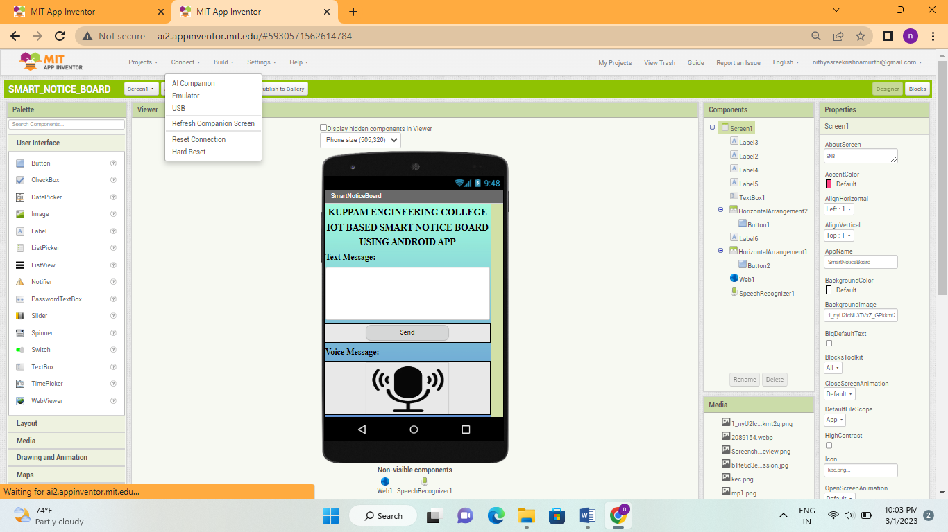
Fig .17: Open AI Companion

Step 15:Now to connect the MIT AI2 App on your device and desktop/laptop scan the QR code or type the 6-digit code which is appearing on your PC screen.
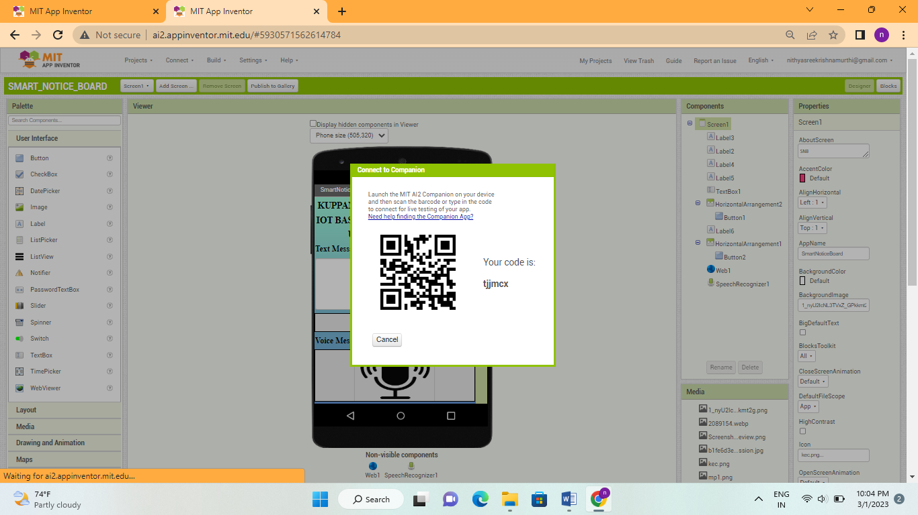
Fig 18: Use QR code
Step 14: Now you can see the “SMART NOTICE BOARD” app titled as “iNotify” in your smart phone.
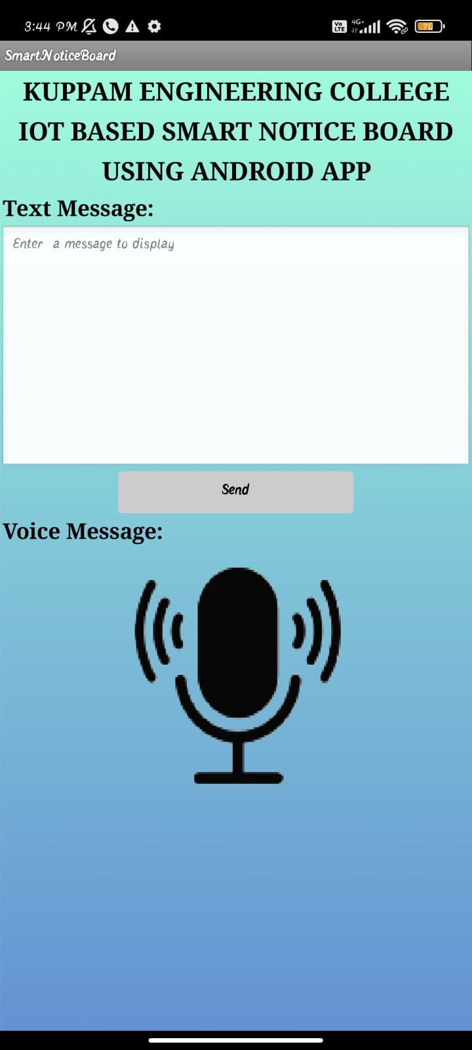
Fig 19: Smart Notice Board app(iNotify) in smart phone

V. RESULT OF ANDROID APPLICATION

The Android Application (iNotify) is designed by using MIT app inventor. The app can send both the text and voice messages. It is ensured with high end security using user name and password feature. So, that only authorized persons can send the data to the P10 LED display. The app consists of three screens named as Home, Login, and Message. The below figure shows the Home screen which has the welcome message as “Welcome To Smart Notice Board” and the college logo with CLICK HERE as text, when the user press the logo it will direct to the Login screen.

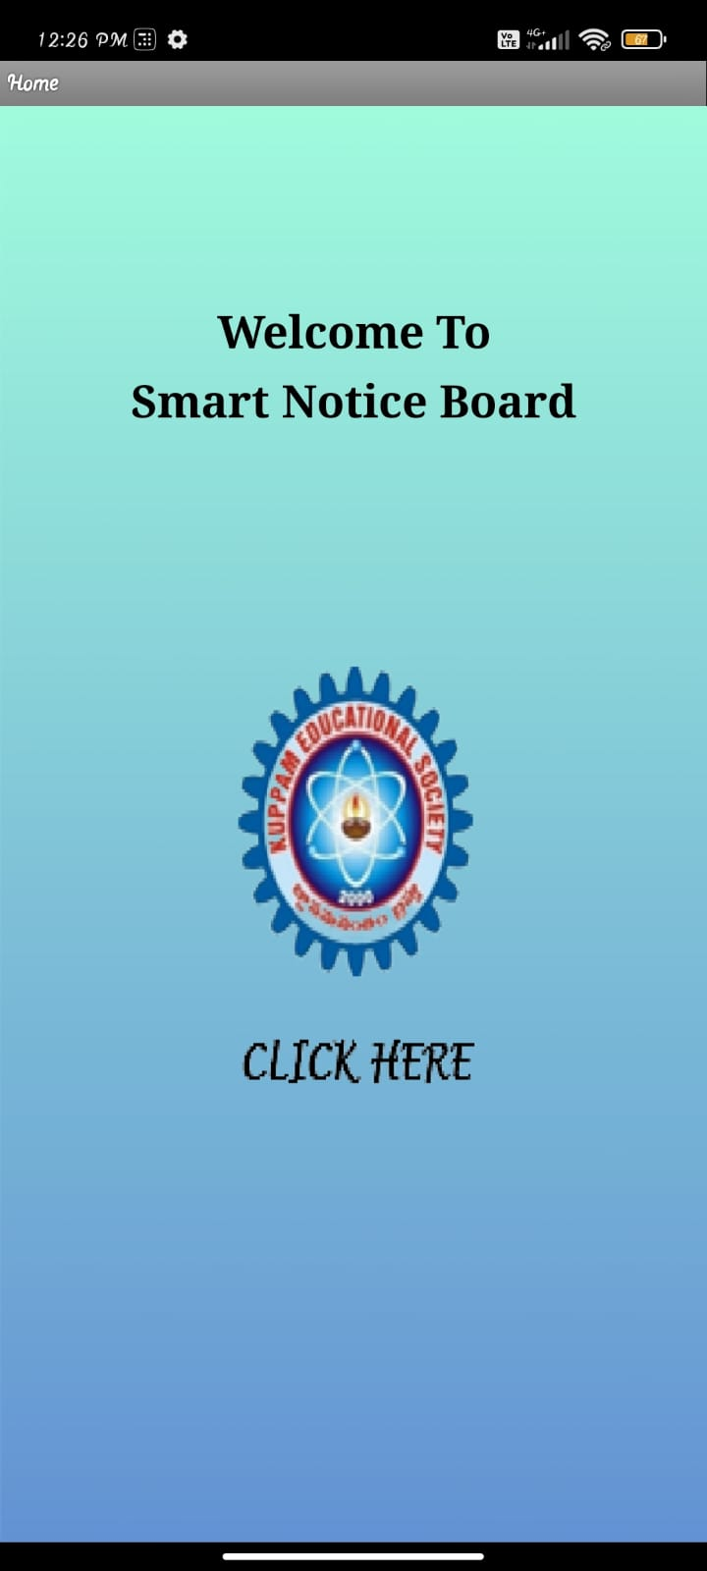
Fig 20: Home screen

The Login screen consists of User Name and Password. When the user name and password entered is correct it will direct to the Message screen. If the username and password is wrong then it will display “Wrong Username or Password”.

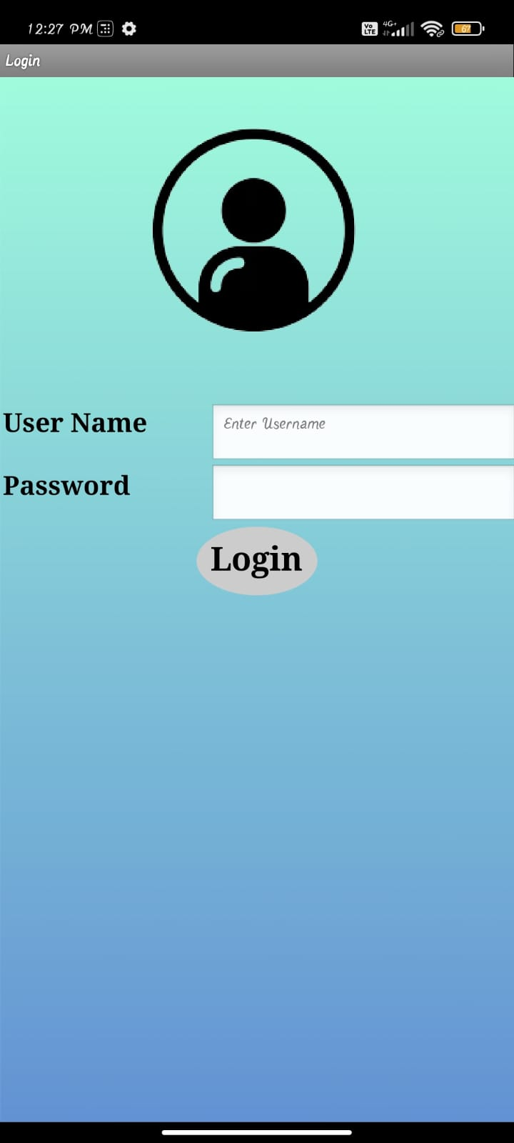
Fig 21: Login screen
In the message screen the user can send both the text message and voice message which should be displayed on the P10 LED display.

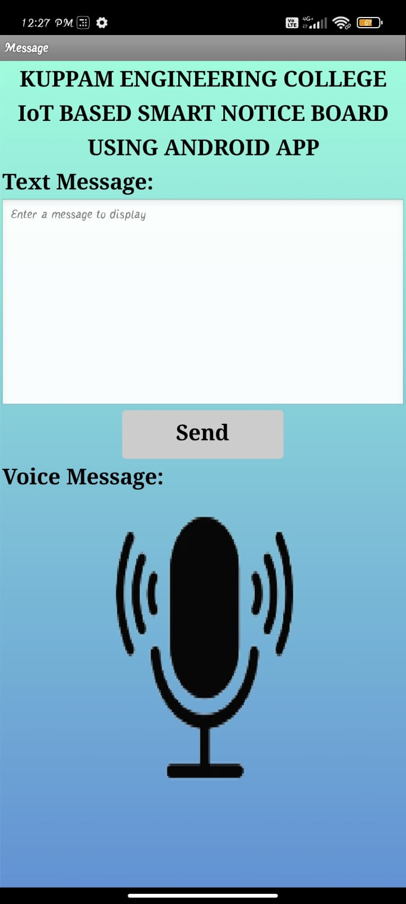
Fig 22: Message screen

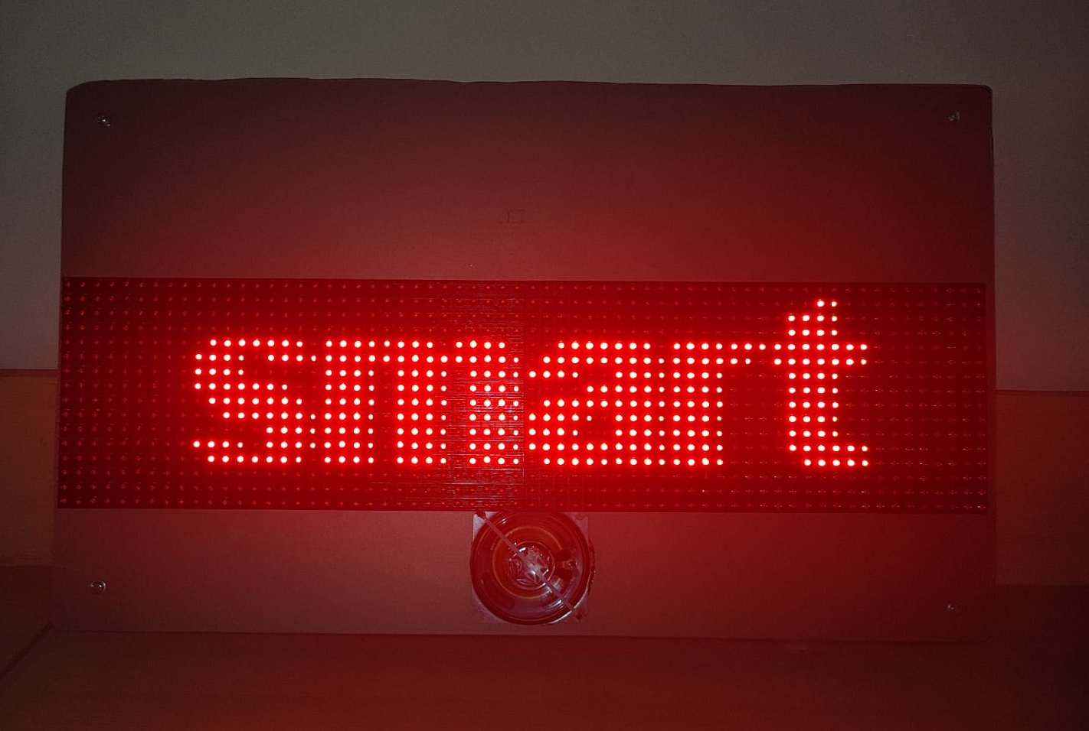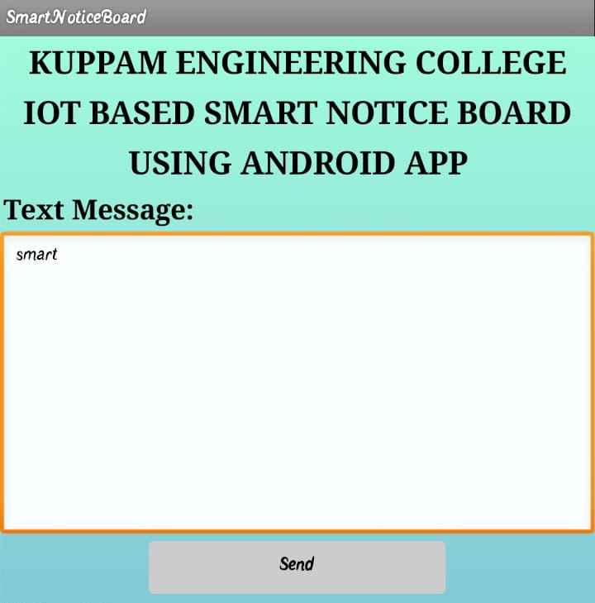
Fig 23: Updating the Notice Board with text message “smart”

Sending a text message “smart” through the android app iNotify.
Sending a voice message “ECE” through the android app iNotify. Whenever the data is sent from the android app it is updated on the LED display through the read API key given in the NODEMCU and write API key given in the android app.

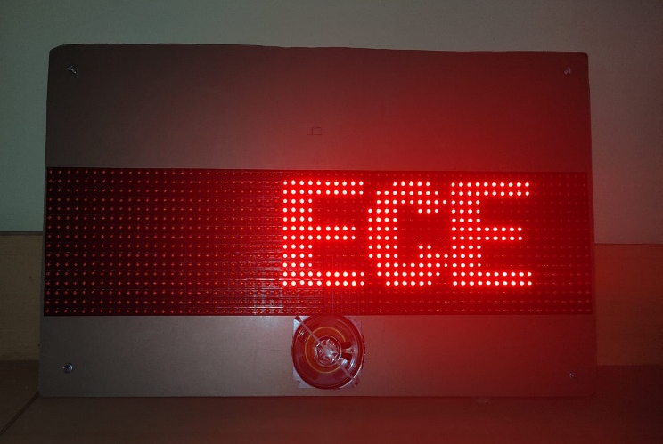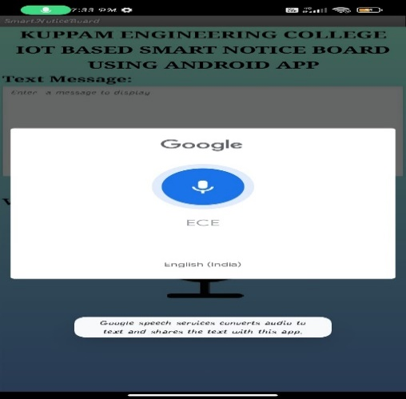
Fig 24: Updating the Notice Board with voice message “Engineering”

conclusion
An IoT-Based Smart Notice Board Using an Android App is a highly innovative and effective way of displaying information in public places such as schools, colleges, hospitals, and corporate offices. This system provides a highly interactive and user-friendly way of displaying information, announcements, and important messages to a large audience in real-time.The use of IoT technology allows for seamless communication between the notice board and the Android app, enabling users to easily update and manage the content on the board remotely. Overall, the IoT-based smart notice board using an Android app is an excellent example of the power of technology to improve communication and enhance the way we interact with information in public spaces.

Future Scope
The future scope for an IoT-based smart notice board using an Android app is vast and exciting. Here are a few potential future developments that could enhance the functionality and usefulness of this technology:

Integration with voice assistants: With the increasing popularity of voice assistants, such as Amazon's Alexa and Google Home, it is possible that smart notice boards could integrate with these devices to provide a hands-free, voice-controlled experience.

Text to Speech: The information displayed on the P10 LED display can be converted into the voice message, so that it is useful to the blind people.

References

- F. Kamdar, A. Malhotra, and P. Mahadik, “Display Message on Notice Board using GSM,”Ripublication.com.[Online].Available: https://www.ripublication.com/aeee/024_pp%20%20827-832.pdf.
- N. Jagan, M. Reddy, and G. Venkareshwarlu, “Wireless electronic display board using gsm technology,”Iraj.in.[Online].Available :http://www.iraj.in/journal/journal_file/journal_pdf/1-10-139036896650-54.pdf.
- Researchgate.net.[Online].Available:https://www.researchgate.net/publication/288313286_Design_and_implementation_of_digital_notice_board_using_power_line_communication.
- V. Ghumde, M. Taikar, D. Morey, and R. Waghmare, “Electronic Notice Board,” Ijariie.com. [Online].Available :http://ijariie.com/AdminUploadPdf/Electronic_Notice_Board_ijariie8048.pdf.
- Ijedr.org. [Online]. Available: https://www.ijedr.org/papers/IJEDR1702022.pdf.
- J. B. Upadhye and M. Karishma, “SMART NOTICE BOARD.” .
- S. Shah, “Message Displayed on LCD Screen using GSM and Bluetooth Technology.” .
- A. Gupta, R. Borkar, S. Gawas, S. Joshi, and B. E. Students, “Gsm based wireless notice board,” Ijtra.com.[Online].Available: https://www.ijtra.com/special-issuedownload.php?paper=gsm-based-wireless-notice-board.
- Researchgate.net.[Online].Available:https://www.researchgate.net/publication/305421736_GSM_based_Smart_home_and_digital_notice_board.
- M. Journals, “Gsm based led scrolling display board,” 2013.

