Nanotechnology: A Boon for the Scientific Domain

Indu Sindhu and Anshul Singh
Department of Chemistry
Baba Mastnath University Rohtak, India-124021
Email: indusindhu22@gmail.com, anshul9008@gmail.com

Abstract
Nanoscience is an integrative field constitutes chemical science, physics, biology and engineering field and deals with their synthesis, properties and their applicability in future trends. Nanotechnology mainly includes particles having sizes in nanoscale (one billionth of a meter) and examined their physical and chemical properties at nanoscale. The properties of nanomaterials differ considerably from large size bulk materials. In this article, we have listed the applications of nanomaterials in various areas as reported by scientific community. The nanoparticles exhibit applicability in food industry as packaging material, electronics items as chips, devices, displays and in medicinal field to detect cancer and its treatment. Another interesting application is in tissue engineering, remediation of pollution and in agricultural areas as nanopesticides and nanofertilizers. The applications of nanotechnology in various sectors are tremendously expanding, resulting in rise in global market for nanomaterials. With the help of nanotechnology, everyday products become more functional and efficient, which enhances our quality of life.
Keywords: Nanotechnology, Applications, Nanomaterials, Bio-sensors, Bio-nanocomposites.

Graphical Abstract
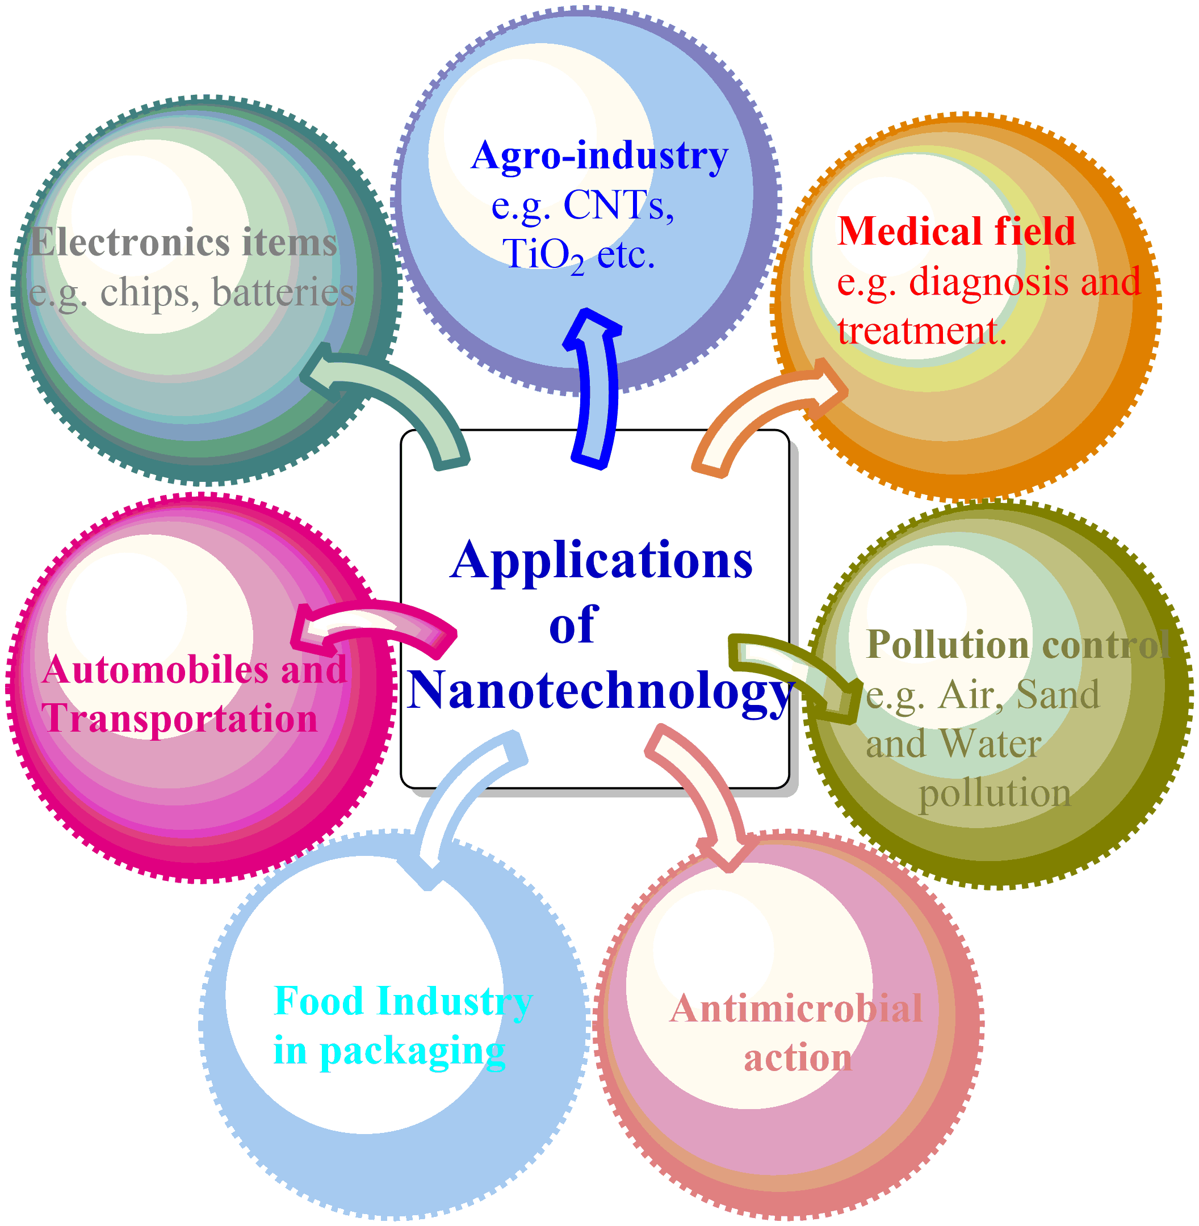

I. Introduction

Material science is the scientific field consisting of chemistry, biology and physics, deals with atoms and particles comprised to form materials and their applicability for future utilities. The growing interest of young scientific minds in material science and nanotechnology field of research due to their extensive applications in various fields and their implementation rises rapidly every day that passes. Chemical and material science is about synthesis of new compounds and materials and to gathering information about their structural and physical properties with the sake of modern computational techniques. In the word nanotechnology, nano term here refers to “one billionth” of something (small size particles, particles at nanoscale). Nanotechnology describes the uses of molecules, atoms to synthesize, assembling novel materials but limit their dimensions (size) up to nanoscale [1]. The term nanotechnology was introduced in 1974 by Norio Taniguchi in a research paper having titled “Basic Concepts of Nanotechnology”. Material science and Nanotechnology have vast areas of research employment in fields of nano-medicines, manufacturing, energy production, electronic devices food industry [2]. The implementation of nanoparticles are in carbon nanotubes which is hundred times more efficient than steel and possesses lower dimensions and can be potentially used as semiconductors [3-4]. Silica is also a nanomaterial exhibits anticorrosive properties. The nanobiotechnology branch emphasizes utilization of nanoparticles in field of medicine such as in treatment of hazardous disease cancer [5]. The broad application area of nanomaterial not limited to this but they exhibit remarkable application in food industry in food production, packaging, agricultural area to produce new food products and solar, fuel cells to provides environment friendly atmosphere by deteriorating harmful pollutants and heavy metals [6-8]. Nanotechnologies have enormous promise for solving global problems like insufficient energy supply, climate change, and lethal illness. Nanotechnology has the potential to revolutionize the generation, storage, and conservation of energy. Nanomaterials, for instance, can be utilized to increase the effectiveness of solar panel, better battery performance, and create more effective lighting systems. Research in this fiels may result in improvements that will help satisfy the rising demand for renewable energy sources. Nanotechnology has the potential to help mitigate the effects of climate change [9]. For instance, nanomaterials can be used to create strong, lightweight materials for automobiles that use less fuel, to cut pollutants from industrial operations, and to boost building energy efficiency. Nanotechnology tiny size can give them unusual features and possible hazards; to evaluate the safety of nanomaterials and develop suitable rules for their usage, it is important to undertake detailed toxicological investigation. Along with technology improvement, it is imperative to comprehend the possible negative impacts on human health that nanomaterials may have. Overall, nanotechnology has a lot of potential for solving global concerns; but, in order to fully realize this promise while maintaining safety and ethical standards [10]. Nanotechnology and nanomaterials have in fact become a fast expanding area of study with enormous potential for many other industries, including building and infrastructure. It is possible to take use of the special qualities that materials with a nanometer or smaller scale portray to considerably progress and enhance infrastructure construction.
Understanding materials and their behavior at the nanoscale is a crucial component of nanoscience. Materials can vary considerably in properties when they are condensed to the nanoscale, resulting in novel phenomena and uses. For instance, materials that are ordinarily insulators at larger dimensions can display other fascinating properties at the nanoscale, such as becoming conductors. Nanoscience is crucial in numerous broad domains, especially nanoelectronics, nanomedicine, and nanomaterials, in addition to fundamental research. By enabling new technologies and applications including faster and more effective electronics, targeted medication delivery systems, and lightweight and strong materials, nanotechnology has the potential to revolutionize multiple fields.
Typically, nanoscience encompasses a wide range of scientific fields, covering physics, chemistry, materials science, biology, and engineering. It entails comprehending the fundamental concepts governing interactions at the nanoscale, exploring unique nanoscale phenomena and properties, inventing cutting-edge tools for manipulation and characterization, and deploying this knowledge for manufacturing novel technologies and materials.

II. Application of material science and nanotechnology

- Agro-industry

Nanofertilizers provides micronutrients to plants like S, Ca, Mg, N, K and also supply macronutrients such as Zn, Fe and Mn that result in enhanced growth of food crops/plants and increase their production rate [9]. Their non-hazardous nature, efficiency and environment friendly core make them superior over conventional fertilizers. Due to their small size (nanosize), they have more penetration tendency and supply nutrients to plants by absorbing from soil [11]. This phenomenon can overcome the nutrient deficiency in food crops by the use of nanofertilizers and makes the food crops more beneficial to human beings in terms of nutrient because nutrients deficiency can causes malnutrition in humans leading to risk of various diseases like low mental and physical health [12].
Nanopesticides give better effectiveness in comparison to those toxic pesticides which not only harm the soil but also affect human health. Toxic pesticides are passes with leaching and cause eutrophication and produce harmful effects on water animals. The nanomaterials use in form of carbon nantube and metal oxide are the best alternative if used correctly along with natural compounds [13].
Another application of nanoparticles (NPs) is in seed germination, growth and development. TiO₂, SiO₂ nanoparticles are reported in literature to enhance plant growth however the exact mechanism of action is not explained entirely; reports advocate entry of NPs into seeds, activating enzymes and enhancing their rate of germination and growth. For e.g. crops like Spinach, peanut, potato, wheat, tomato and mustard growth get amplified eventually after addition of TiO₂, multiwalled carbon nanotubes and metal oxides [14-15]. Recent study on fenugreek plants recommends that after addition of CuO, it increases the percentage of seed germination, development and content of chlorophyll in plants [16]. But prescribed doses should be used otherwise high quantity resulting in decreasement in lengths of roots and biomass [17].
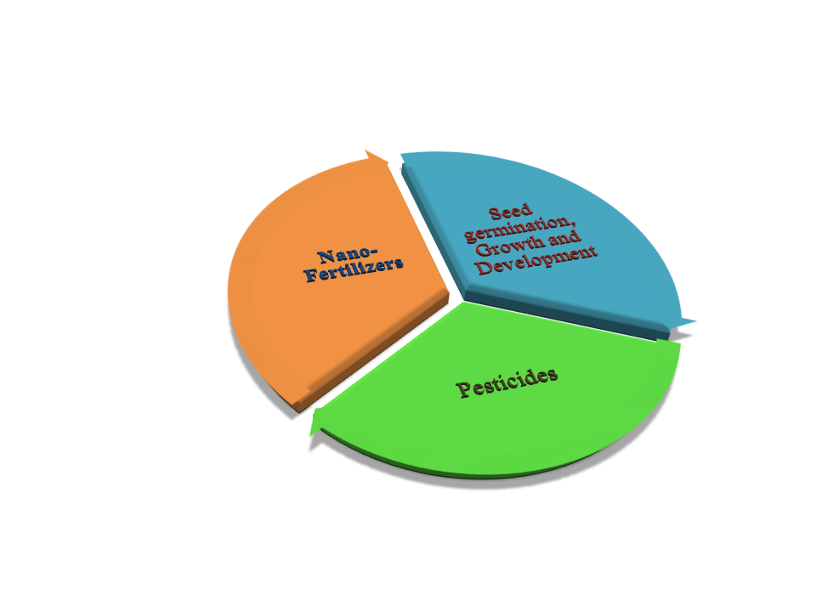
Figure 1: Application in agro-industry
- Bio-medical applications

Covid-19 detection

The respiratory syndrome coronavirus 2 (SARS COV-2) has caused a worldwide public health emergency. Early research revealed that the virus transmits predominately by respiratory droplets in close contact. Recent study however has shown virus can survive in aerosols for several hours, increasing the potential of airborne transmission. As a result, air purifiers’ contribution to reducing COVID-19 transmission has drawn considerable attention. Utilizing nanofibres is one such strategy that can successfully catch and stop the spread of air borne viruses like COVID-19. In detection of Covid-19 viral infection, biosensors are the type of sensors that are sensitive, inexpensive and efficient. Aptamer-based nano-biosensor can diagnose infection even if a patient doesn’t have any symptoms. The spike protein S1 of SARS COV-2 formed aptamer for these nano-biosensors and it furnishes results very fast and accurately [18]. This viral infection mainly spreads through aerosols, Ag based nanoparticles can be effective when used in face masks they can immobilize and kills the virus on surfaces. In a similar way two dimensional carbides and nitrides are hydrophilic in nature and can strongly bind to amino acids and kill these viral agents or inactivate them; hence it can be potentially used on surfaces of PPE and face masks that block entry of virus [19].

Cancer treatment

Nowadays, inorganic and organic NPs are widely synthesized but among them carbon based NPs can be successfully used for treatment of cancer by providing site specific drug delivery system. Several NPs like graphene oxides, nanorods, nanotubes and quantum dots that are less toxic; can be a suitable candidate for biomedical applications. Nanomedicines is the field of nanotechnology have supremacy over other cancer treatments due to efficient target drug delivery system and controlled release of drugs at target site [20]. These materials are also dominant over other standard drugs, by decreasing the chance of degradation of drug before reaching the site of action and also diminished side effects.
Gold NPs are suitable for their uses in medicines having properties stability, target drug delivery system, and effective against liver cancer, breast cancer, pancreatic cancer, lung cancer and ovarian cancerous cells [21]. Similarly, Ag NPs are reported to be effective in cancer treatment such as ovarian cancer, lung cancer, colon cancer and breast cancer [22]. The metal oxides also reported to have significant antitumor effect due to their non-toxic nature, unreactivity towards other chemicals and easily modifiable surfaces. Iron oxide NPs are clinically used for cancer detection and in its therapy; iron oxide nanoparticles can reach target site more efficiently when loaded with drug under external magnetic field and release drug at active site and increasing the rate of action of drug without causing any harm to neighbouring (normal) cells [23]. Several iron oxide nanoparticles reported to be effective against various cancerous cells like prostate cancer, gastric cancer, lung cancer and ovarian cancer. Zn NPs, copper oxide NPs, TiO₂ NPs, CeO have been recently used in biomedical field and effective against colon cancer, breast cancer and ovarian cancer [24-25]. Quantum dots are semiconducting in nature and when lighted with UV light, can locate specific cells and biological activity by providing spectrum of bright colors. These quantum dots are widely employed in magnetic resonance imaging technique (MRI) [26].
These NPs were also used to increase the temperature of cancerous cells & kill them and the process termed hyperthermia. These metal based nanoparticles can be used as radiothereuptic agents in cancer radiotherapy by increasing the radiations to effective site so that the maximum dose is supplied to tumor cells and non-toxic to normal cells [27]. Gold, Silver, Pt, TiO₂, ZnO are employed in radiotherapy, phototherapy is the technique involves use of Au NPs for laser killing of cancerous cells [28]. But there is one most important thing keeps in mind is to regulate temperature gradient to avoid any risk to non-cancerous cells. Au NPs used for detection of prostate cancer by optical imaging and positron imaging tomography (PET) techniques [29]. Through their anticancer properties, metal based nanoparticles have demonstrated promise in the treatment of a variety of malignancies and accuracy of medication administration has increased due to controlled-release systems that are activated by elements such as pH, temperature, electromagnetic radiation. Although preclinical studies have shown encouraging outcomes, several metal-based formulations have not yet been used in clinical setting due to worries about their toxicity.
Palladium nanoparticles (Pd NPs) have been investigated for their possible therapeutic uses in the domains of photothermal therapy (PTT) and photodynamic therapy (PDT) for the treatment of cancer. Palladium nanoparticles have unique characteristics that make them desirable for these medical procedures. One of the major characteristics permitting them to function as efficient photoabsorbers is their considerable absorption of light in the Near InfraRed (NIR) band. Compared to other parts of the electromagnetic spectrum, NIR light is capable of reaching deeper into biological tissues, making it compatible with non-invasive cancer treatment. In photothermal therapy, Pd NPs are capable of photothermal conversion, which is the conversion of absorbed NIR light into heat and Pd NPs rapidly absorb the light energy when exposed to a NIR laser, which causes localized heating of the material. In photothermal therapy, Pd NPs are capable of photothermal conversion, which is the conversion of absorbed NIR light into heat. Pd NPs quickly absorb the light energy when exposed to an NIR laser, which causes the tissue in the immediate vicinity to heat up. Aside from stimulating the immune system to strengthen the anti-tumor response, this localised hyperthermia can have a number of other effects, including the death of tumour cells and damage to the blood arteries supporting the tumor. Pd NPs have the potential to function as photosensitizers in photodynamic treatment. Photosensitizers are chemicals that, when activated by light of a particular wavelength, can produce reactive oxygen species (ROS). PdNPs can generate ROS when exposed to NIR light, which can oxidatively harm cancer cells and ultimately cause their demise. Overall, the Pd NPs and NIR laser irradiation combination present a potential strategy for targeted cancer therapy. A precise and localized treatment can be accomplished with the application of NIR light and the selective accumulation of Pd NPs in tumor tissues, causing the least amount of harm to healthy surrounding tissues. To fully comprehend the potential of Pd NPs in cancer therapy and to address any potential toxicity or side effects connected with their use, further research is still required, and it is vital to emphasize. Pt NPs, or platinum nanoparticles, have shown inherent cytotoxic action, which means they can stop tumour growth. On the other hand, the nanoparticles can be functionalized, or changed, with particular molecules or ligands to increase their specificity and efficacy in targeting cancer cells.

Antimicrobial and antioxidant properties
Nanoparticles can be successfully utilized as antimicrobial agents; for e.g. ZnO nanoparticles reduces (stops) the action of Staphylococcus aureus bacteria [30]. This mechanism of action is attachment to bacterial surface and produces reactive oxygen species (ROS) that leads to death of bacteria [31]. These particles can also employed as anti-oxidant agents by disrupting production of free radicals by supplying electrons [32]. Silver nanoparticles exhibits antibacterial action against E. coli, P. aeruginosa gram negative bacterias and inhibits the growth. In addition to this, copper nanoparticles are also effective against E. coli and B. subtilis bacteria as reported in studies. Another well known example, iron oxide NPs, SiO₂ display antimicrobial action and several mechanism of action was reported for different strains such as disruption of cell membranes, protein inactivation and effect on cell permeability [33]. The capacity of antioxidants to reduce oxidative stress has garnered a lot of attention. When there is a buildup of oxidants, such as reactive oxygen, nitrogen species (RNS), and the antioxidant defenses to neutralize them are out of balance, oxidative stress results. This imbalance causes a net rise in the amounts of ROS and RNS, which can harm DNA, proteins, lipids, cell membranes, and subcellular organelles; cellular function is hampered as a result. By interacting with crucial cellular constituents and upsetting their structure and function, these reactive species have the ability to initiate and spread cellular harm. Antioxidants and their impact on oxidative stress are currently the subjects of ongoing research with the aim of deeper comprehension of their mechanisms of action and potential applications in therapy. It is now being investigated if antioxidant-rich diets, dietary supplements, and antioxidant-based interventions work as efficient ways of combating oxidative stress and its detrimental effects on health.

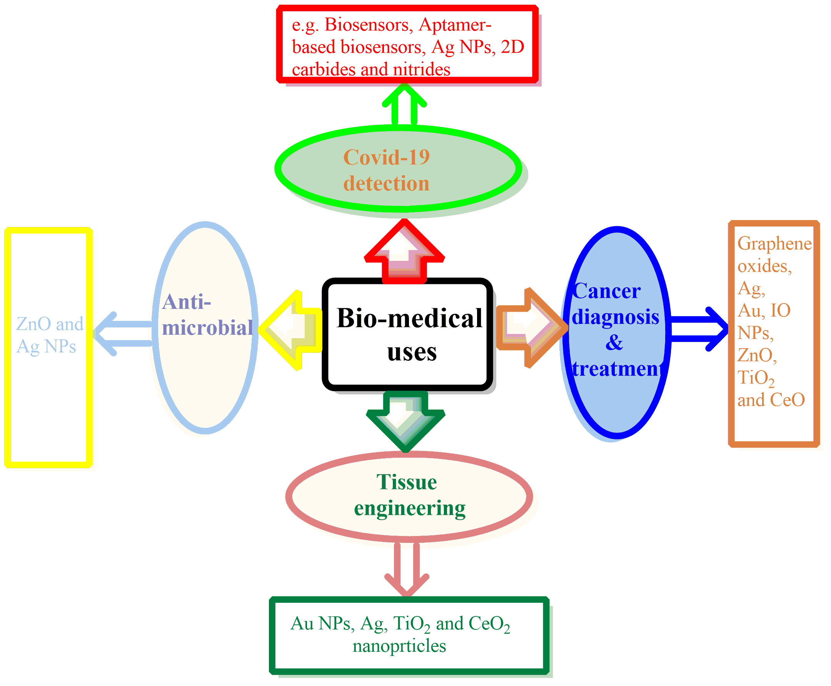
Figure 2: Bio-medical uses of nanoparticles in various fields

Tissue engineering

Tissue engineering is the technique to reconstruct or repair damaged organs or tissues and NPs can plays a vital role in tissue engineering as reported in literature. Nanoparticles displays applications in periodontal related diseases like rhemutoid arthritis, diabetes and cardiovascular disease by providing new coating for implants and utilized in toothpaste and personal care products [34]. It displays remarkable action in skin tissue engineering, bone tissue engineering, neural tissue engineering. The function and regulation of nanoparticles with cells is closely resembles to cells regulation & functioning , first steps involves surface interaction with NPs. Ag, Au & TiO₂ are utilized for bone tissue engineering due to their mechanical properties and AuNPs can be excellent source of cell differentiation. In addition, nanomaterials nanocellulose consists of cellulose-based nanoscale structure, utilized for wound dressing materials and skin treatment diseases. CeO₂ NPs have properties to heal wounds fully in 14 days with no side effects. Nanographene oxides scaffolds another nanomaterials are economical and properties in healing the wounds [35].

- Pollution remediation

Air quality get worsen these days and it is harmful to human beings and more severe risk to asthmatic patients. Nanotechnology based materials are particularly well suited for such process due to their improved characteristics, effectiveness and high surface area to volume ratio which frequently leads to increased reactivity. The environmental remediation is utilizing diverse methods, such as adsorption, absorption, chemical reaction and filtration to remove contamination from environmental media such as soil, water and air. One more important factor keep in mind, while employing utilization of nanomaterials, it is crucial to clean up pollution and do not become new sources of pollution. While designing new NMs for remediation, important factors that taken into account factors lik target specific capture, economical, non-toxicity and easy synthesis. The nanotechnology can play a significant role to transform harmful gases into non toxic harmless gases. Nanocatalysts like Maganese oxides NPs, Au (Gold) NPs can be implemented successfully by virtue of their capability to convert CO gas to CO₂ (harmless) gas. Carbon nanotubes having single walled play a major role in air purification and this nanoremediation is reasonable and better approach than conventional methods [36].
Another ongoing research area on nanotechnology application in water purification and treatment of waste water; carbon nanotubes, graphene, iron & other metal oxides reported to have potential applications in treatment of contaminated water. The zero valent iron and bimetallic iron was good example used to remediate pollution. Dechlorination of water can be done by palladized iron and nickel NPs and various other nanoparticles like TiO₂, ploy amidvamine, carbon nanotubes reported to deteriorate heavy metal from contaminated water. A nanomembrane developed by scientists which consists of cross linked polymers and NPs that repels organics, bacterias and contaminants present in water and nanoparticles were also used in removal of wastes from soil included treatment of solid and liquid wastes [37]. In the area of water filtration, nanotechnology has actually demonstrated considerable promise. Nanomaterials could be beneficial for a variety of applications, including the treatment of wastewater, owing to their small size and durable reactivity. Nanomaterials can be created and modified to have particular qualities that improve their efficacy in eliminating impurities from water. The capacity of nanotechnology to remove heavy metals from wastewater is a key benefit for water purification. In order to keep water quality high, heavy metals must be removed because they are a major threat to both human health and the environment. Heavy metals can be catalytically degraded, absorbed, or adsorbed by nanomaterials, which efficiently lowers their concentration in water to acceptable levels. Nanotechnology can aid in the removal of dangerous germs and viruses from water in addition to heavy metals. Heterogeneous photocatalysis, which uses photocatalytic nanomaterials, has demonstrated effectiveness in the elimination of bacteria from water. These nanomaterials, which can successfully kill bacteria and viruses as well as Streptococcus mutans, Escherichia coli, and others, when exposed to light, create reactive oxygen species. Additionally, it is advantageous from a financial and sustainability standpoint to produce nanomaterials utilizing ecologically benign methods. Nanomaterials have recently become more widely available for employment in an assortment of applications, such as water treatment, Overall, the use of nanotechnology to water purification approaches offers an opportunity of more efficient and monetary wastewater treatment, heavy metal removal, and disinfection of pathogenic bacteria. It is pertinent to understand that more studies and research are still required to improve these nanomaterial-based technologies and assure their stable application on larger scales.

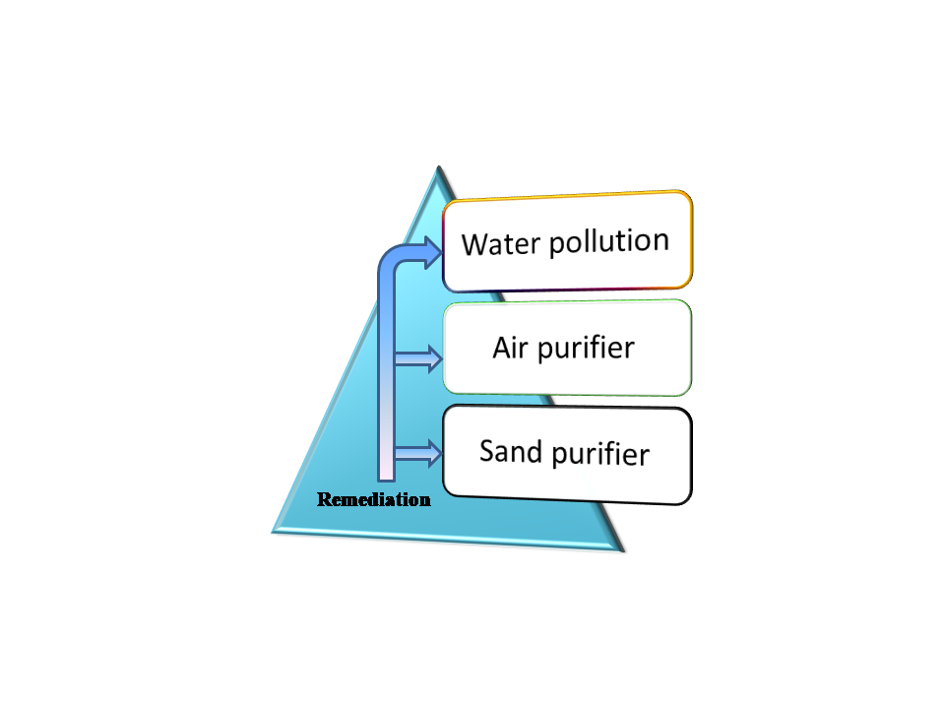
Figure 3: Application in remediation

- Food packaging

NT (nanotechnology) is an emerging research topic in food industrial area because of their novel applications in food safety and packaging at low cost. It is necessary step to protect food from dust, microorganisms and other environmental contaminations. Nanocomposites are a polymer matrix with organic/inorganic fillers and termed as biohybrids. These nanoparticles/nanocomposites display remarkable features like antimicrobial action, biocompatiblity, biodegradablity, cost effectiveness and environment friendly [38]. On basis of matrix used it can be particulate, elongated and layered structure; efficiently used for food packaging purposes. These NPs possess optical and barrier properties, useful to protect food items from photodecomposition and oxidation. Other extensively used nanocomposites was silver NPs displays antimicrobial activity towards a broad range of pathogens; hence widely studied for purification of water/air, drug delivery, biosensors and in food packaging industry. Copper NPs are another type of NPs are effective but its high doses can cause harmful effects on aquatic animals; that why less studied. The gold nanoparticles are eventually researched due to their medicinal, antibacterial properties and non-toxic in nature; but not economical in nature. The nanocomposites having effective antimicrobial properties and non toxic to humans is sulphur NPs, excellent material for packaging by their action of blocks UV rays. Titanium oxide is the type of metal oxide, used broadly as food coloring agents due to its non-toxic nature and economical properties. On similar grounds, Mg NPs displays antibacterial properties and non hazardous and hence successfully employed in food packaging materials [39]. Nanoclay is used for food packaging because of its powerful mechanical and thermal characteristics and for food quality and safety monitoring in food, gold nanoparticles are used [40]. The incorporation of nanotechnology in the food domain has opened up fresh prospects for enhancing food durability and nutrient content, thus assisting customers. One noteworthy accomplishment in this field is the nanoscale synthesis of nutrients, which optimizes their stability and effectiveness during various phases of food preparation. The commercial availability of nano-encapsulated active compounds brings about uses in a wide range of food products, including beverages, meat, and cheese. In the production of sausages and processed meats, for example, when the addition of various additives is required to optimize the manufacturing process, retain color, and increase flavor, nano-encapsulation provides a more efficient and targeted delivery of chemicals. This not only enhances overall food quality but also diminishes the need for inefficient chemicals. These nano-encapsulated chemicals can be used as preservatives in all sorts of food products, extending shelf life and nutritional value. Researchers are still investigating the possible advantages and safety concerns of using nanotechnology in the food sector, which is still a developing subject.

- Electronics

Graphene & carbon nanotubes have been used in manufacturing transistors, new displays, batteries, solar cells, lubricants, paints and biosensing, memory chips used in smartphones, antimicrobial keyboards, conductive inks for printed electronics and thumb drives. Nanomaterials possess great mechanical properties and light weight makes them to exhibits high reaction rate. Scientists much focused on nanomaterials synthesis and exploring their properties and applications in modern era. MXenes exhibits great electrical, optical, biodegradability and mechanical properties due to these properties can be imported in sensors, catalyst and electromagmetic materials [41]. In fact, the field of memory and data storage technologies has undergone a revolution in technology. The special qualities of nanoscale materials and architectures have given rise to a number of novel uses. A potential development in memory technology is carbon nanotube-based crossbar memory, commonly referred to as nano-RAM. It makes use of carbon nanotubes as a platform for data storage, offering a potential substitute for conventional transistor-based electronic memory architectures. Memristor components have drawn a lot of interest as possible Flash memory alternatives. Memristors are a good choice for future memory technologies since they have benefits like non-volatility and quicker switching rates [5]. Nanomaterials are substances can be used to create capacitors with varying thicknesses while keeping the same capacitance layer in place. Thus it renders it possible to create capacitor libraries or capacitors with variable capacitance density. Due to their use in microwave technology, nanoscale ferrite components find use in both the commercial and military sectors. Composite nanofibers have a lot of promise for use in eco-friendly optical and electrical components such flat panel displays, sensors, and light-emitting diodes (LEDs). Various nanofibers are ideal for various applications since they have distinctive qualities and capabilities. Nanomaterials may be utilised to create optical switches, which are essential parts of technologies like communication networks. Additionally, laser diodes, antistatic coatings, and filter conductivity all use nanomaterials.

- Electrochemical field

Recently nanoparticles applications are found in electrochemical field to detect heavy metals, new electrode material and in field effect transistors. Literature claims use of carbon nanotubes, nanoparticles, graphene materials for electrodes and heavy metal detection such as Zn, Cd and Cu. Another type of nanoparticles metal nanostructure possesses the characteristic of detection of heavy metals through alloy formation. The advantage of these materials over others is non-toxic and adaptable for various analyses [42].

- Automobiles & transportation

Nanomaterials are widely employed to construct light weighted automobiles by improves its size to mass ration, stability, wash resistance properties. For e.g. carbon nanotubes are excellent substitute of steel in automobiles parts and displays high thermal stability, better arrangement. In paint industry, ZnO, TiO₂ nanoparticles reflect UV rays, dust; hence efficient materials in paint industry. The combination of nanomaterials along with coating film of automobiles provides a scratch resistant finishing touch to automobiles. Apart from this, NMs are utilized for storage of hydrogen in fuel cells [39].
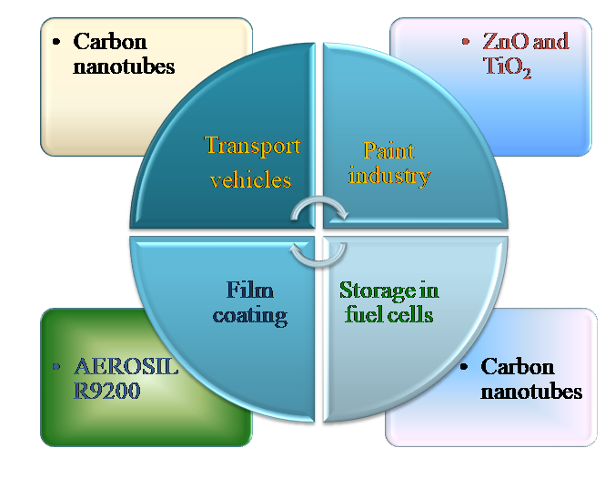
Figure 4: Applications in automobiles & transportations
- Oil and Petroleum industry

Nanoparticles can function as catalyst in various chemical reactions; for e.g. Ag, Au NPs display catalytic action in dye degradation process [43]. These nanoparticles increase the rate of reaction, consume minimum time and reduce the amount of Pt used for reaction; hence making the reaction more economical in nature. These particles are capable in conversion of nitrogen gas into ammonia due to their high surface area and small size. For enhanced oil recovery (EOR) applications, nanoparticles were studied on a lab scale as performance enhancers for polymers and surfactant flooding processes and emulsion stabilizers etc. Silica nanoparticles have drawn the greatest interest among the many types of nanoparticles in the realm of EOR applications [44]. Carbon quantum dots can be successfully implemented as tracers in crude oil; tracing out the pollutants amount and other contaminants. Researchers have found uses of nanoparticles as anti-corrosive agent in pipelines and help to solve problem of oil leakage. Other applications of nanoparticles as nanomembrane, plays a crucial role in carbon dioxide capture, storage, gas separation and in oil purification. The nanoparticles display use as demulsifiers in downstream process and exhibit better effectiveness than conventional emulsifiers due to salient features i.e. non-toxic, high thermal conductivity, large surface area and pollution resistance [45].
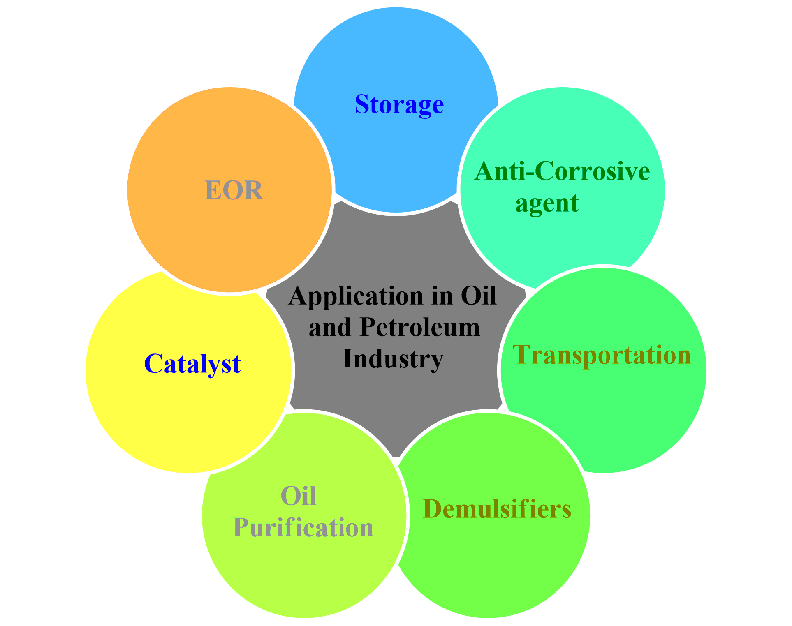
Figure 5: Application of nanoparticles in oil industries

Conclusion

Nowadays, scientific community has much focused on nanotechnology and materials sciences; as consequence of their fast development and their uses in various fields. The nanomaterials display potential activity from industrial area to biomedical field in different ways. The nanomaterials are economical and non-toxic making them more efficient in chemistry, biology and engineering research field. Their numerous applications in electronic devices such as in transistors, semiconductors and smartphones display significant contribution in immediate future. Current studies in biology, electronic storage, and sensors show the increasing extent of application of nanomaterial development. Nanomaterials have enormous potential in biomedicine for targeted medication delivery, imaging, and diagnostics. They may mitigate negative effects as well as enhance therapy effectiveness. The special characteristics of nanomaterials are advantageous for electronic storage devices including batteries and supercapacitors. The energy storage capacity, charge-discharge rates, and stability of nanoscale materials are all improved. The goal of ongoing research is to improve these characteristics and create energy storage technologies that are more effective and long-lasting. Additionally, nanomaterials are essential to sensor technologies; allow creation utilizing highly sensitive and selective sensors by utilising their outstanding surface-to-volume ratio and customized characteristics. These sensors have been used in security, healthcare, and environmental monitoring, among others. This continuous advancement in nanomaterial has useful impact on numerous research fields such as electronics, medical field, communication technology and energy production. In order to boost the effectiveness and performance of the products or process and lower the cost to expand availability, this technology is being tested for a range of novel applications. Nanotechnology holds enormous potential for the future because of its effectiveness and little negative effects on the environment.

REFERENCES

- M. Nasrollahzadeh, S.M. Sajadi, M. Sajjadi and Z. Issaabadi, An introduction to nanotechnology, Interface Science and Technology, 28; 2019.
- B. Bhushan, Springer handbook of nanotechnology, Technology & Engineering, Springer Science & Business Media, 2010.
- S.S. Yattinahalli, S.B. Kapatkar, S.N. Mathad, Review of Nanoscience Materials and its applications, Research J. Engineering and Tech. 7(3); 2016.
- X. Hu, On the size effect of molybdenum disulfide particles on tribological performanc, Ind. Lub. Trib. 57(6); 255, 2005.
- S.K. Bera, Materials science and nanotechnology: Prospectud and future, Int. J. Multidisc. Edu. Res. 10; 8(2), 2021.
- S. Mobasser, AA. Firoozi , Review of Nanotechnology Applications in Science and Engineering, J. Civil Eng. Urban, 6 (4); 84-93, 2016.
- P. Roy, M. Choudhury, Environmental susceptibility and nanowaste. In: Waste Recycling Technologies for Nanomaterials Manufacturing, Springer, (ed. M. ASH and A. GAM), 65–87, 2021.
- S. Rasalingam, R. Peng, and R.T. Koodali, Removal of hazardous pollutants from wastewaters: applications of TiO2-SiO2 mixed oxide materials, J. Nanomater. 617405; 1–42, 2014.
- F. Simonis, S. Schilthuizen, Nanotechnolgy innovation oppurtunities for tomorrow’s defence, TNO Sci. & Indus. 2006.
- S. Logothetidis, Nanostructured Materials & their Applications, Nanosci. & Tech. 2012.
- D.P. Singh, G. Packirisamy, Applications of nanotechnology to combat the problems associated with modern food, J. Sci. Food Agric. 2022.
- D.M. Singh, C. Gautam, P.O. Prakash, M.H. Mohan, G. Prakasha, V. Vishwajith, Nanofertilizers is an way to increase nutrients use efficiency in crop production, Int. J. Aricul. 9(2); 3831-3833, 2017.
- S. Thakur, T. Thakur, R. Kumar, Bio-Nanotechnology and its Role in Agriculture and Food Industry, J. Mol. Genet. Med. 12; 1–5, 2018.
- X. Zhao. H. Cui, Y. Wang, C. Sun, B. Cui, Z. Zeng, Development strategies and prospectus of nanobased pestoicides formulation, J. Agric. Food Chem. 66(26); 6504-6512, 2018.
- J. Banerjee, C. Kole, Plant nanotechnology: an overview concepts, strategies and tools, Plant Nanotech. 1-14, 2016.
- K.M. Manjaiah, R. Mukhopadhyat, R. Paul, S.C. Datta, P. Kumarraja, Clay minerals sand zeolites for environmentally sustainable agriculture, Elsevier, 309-329, 2018.
- S.S. Hojjat, H. Hojjat, Effect of nanosilver on seed germination and seedling growth in fenugreek seed, ETP Int. J. Food Eng. 1(2); 106–110, 2018.
- M.N. Disfani, A. Mikhak, M.Z. Kassaee, A. Maghari, Effects of nano Fe/SiO₂ fertilizers in germination and growth of barley and maize, Arch Argon Soil Sci. 63(6); 817-826, 2017.
- W. Carsten, M. Carriere, L. Fusco, I. Capua, J.A. Regla-Nava, M. Pasquali, J.A. Scott, F. Vitale, M. A. Unal, C. Mattevi, D. Bedognetti, A. Merkoçi, E. Tasciotti, Ac. Yilmazer, Y. Gogotsi, F. Stellacci, L.G. Delogu, Towards nanotechnology- enabled approaches against the covid-19 pandemic, ACS Nano. 14; 6383−6406, 2020.
- E.R. hitzky, M. Darder, B. Wicklein, C.R. Garcia, R.M. Sampedro, G. Real, P. Aranda, Nanotechnology responses to covid-19, Adv. Healthcare Mater. 9; 2000979, 2020.
- D.N. Paduraru, D. Ion, A.G. Niculescu, F. Musat, O. Andronic, A.M. Grumezescu, A. Bolocan, Recent developments in metallic nanomaterials for cancer therapy, diagnosing and imaging applications, Pharma. 14; 435, 2022.
- R.E. Renitta, I. Smitha, C.S. Sahithya, A.V. Samrot, S. Abirami, S. Dhiva, D.A. Anand, Synthesis, Characterization, and Antibacterial Activity of Biosynthesized Gold Nanoparticles. Biointerface Res. Appl. Chem. 11; 9619–9628, 2021.
- E.O. Mikhailova, Silver Nanoparticles: Mechanism of Action and Probable Bio-Application, J. Funct. Biomater. 11; 84, 2020.
- M. Ramazanov, A. Karimova, H. Shirinova, Magnetism for Drug Delivery, MRI and Hyperthermia Applications: A Review, Biointerface Res. Appl. Chem. 11; 8654–8668, 2021.
- N. Wiesmann, W. Tremel, J. Brieger, Zinc oxide nanoparticles for therapeutic purposes in cancer medicine, J. Mater. Chem. B 8; 4973–4989, 2020.
- S. Jayakodi, V.K. Shanmugam, Green Synthesis of CuO Nanoparticles and its Application on Toxicology Evaluation, Biointerface Res. Appl. Chem. 10; 6343–6353, 2020.
- S. Mobasser, A.A. Firoozi, Review of nanotechnology applications in science and engineering, J. Civil Eng. Urb. Vol. 6(4); 2016.
- S. Pinel, N. Thomas, C. Boura, M.Barberi-Heyob, Approaches to physical stimulation of metallic nanoparticles for glioblastoma treatment, Adv. Drug Deliv. Rev. 138; 344–357, 2019.
- A.-G.Niculescu, A.M. Grumezescu, Photodynamic Therapy—An Up-to-Date Review, Appl. Sci. 11; 3626, 2021.
- M. Pretze, , N.P.V.D. Meulen, C. Wängler, R. Schibli, B. Wängler, Targeted 64 Cu-labeled gold nanoparticles for dual imaging with positron emission tomography and optical imaging, J. Label. Compd. Radiopharm. 62; 471–482, 2019.
- B, Ramalingam, T. Parandhaman, S.K. Das, Antibacterial effects of biosynthesized silver nanoparticles on surface ultrastructure and nanomechanical properties of gram-negative bacteria; E.Coli, P. Aeruginosa, ACS Appl. Mater. Interfaces. 8(7); 4963-4976, 2016.
- H.A. Foster, I.B. Dittal, S. Varghese, A. Steele, Photocatalytic disinfection using titanium oxide: spectrum and mechanism of antimicrobial activity, Appl. Microbial Biotech. 90(6); 1847-1868, 2011.
- P. Gupta, S.P. Authimoolam. J.Z. Hilt, T.D. Dziubla, Querecentin conjugated poly(betaaminoesters) nanogels for treatment of cellular oxidative stress, Acta Biomater. 27; 194-204, 2015.
- J.T. Seil, T.J. Webster, Antimicrobial application of nanotechnology: methods and literature, Int. J. Nanomed. 2767-1781, 2012.
- X. Zheng, P. Zhang, Z. Fu, S. Meng, L. Dai, H. Yang, Applications of nanomaterials in tissue engineering, RSC Adv. 11; 19041, 2021.
- L. N. Fu, J. Zhang and G. Yang, Carbohydr. Polym. 92; 1432–1442, 2013.
- M. Chen, D.W. Goodman, Catalytically active gold: from nanoparticles to ultrathin films, Acc Chem Res 39; 739–746, 2006.
- S. Das, B. Sen. N. Debnath, Recent trends in nanomaterials applications in environmental monitoring and remediation, Env. Sci. Pollut. Res. 2015.
- Y.S. Fadhil, Applications of nanotechnology in food processing and packaging, Mest. J. Agricul. 50(3); 27-36. 2022.
- K. Y. Perera, S. Jaiswal, A.K. Jaiswal, A review on nanomaterials and nanohybrids based bio-nanocomposites for food packaging, Food Chem. 376; 131912, 2022.
- N.M. Mubarak, M. Khalid, R. Walvekar, Contemporary nanomaterials in material engineering applications, Eng. Mat. ISBN 978-3-030-62760-7, Springer Nature Switzerland 2021.
- J. Song, S. Min, S. Kim, S. Ahn, Multi-functionalization strategies using nanomaterials: A review and case study in sensing applications, Int. J. Prec. Eng. Manufac. Green Tech. 9; 323-347, 2022.
- G. Aragay, A. Merkoci, Nanomaterials applications in electrochemical detection of heavy metals, Electrochim. Acta 84; 49-61, 2012.
- V. Suvith, D. Philip, Catalytic degradation of methylene blue using biosynthesized gold and silver nanoparticles, Spectrochim. Acta Part A Mol. Biomol. Spectrosc. 118; 526-532, 2014.
- Y. Khan, H. Sadia, S.Z.A. Shah, M.N. Khan, A.A. Shah, N. Ullah, M.F. Ullah, H.Bibi, O.T. Bafakeeh, N.B. Khedher, S.M. Eldin, B.M. Faghl, M.I. Khan, Classification, synthetic and characterization approaches to nanoparticles and their applications in various fields of nanotechnology: A review, Catalysts 12; 1386, 2022.

