COMPUTER AIDED DIAGNOSIS SYSTEM FOR DIABETIC RETINAL FUNDUS IMAGE CLASSIFICATION USING DEEP LEARNING

D MADHUSUDAN¹
Assistant Professor, Department of Electronics and Communication Engineering,
St. Peter’s Engineering College, Hyderabad, Telangana, India.
Email:madhusudan.d@stpetershyd.com¹

Abstract— In order to diagnose diseases, medical image processing heavily relies on artificial intelligence (AI). Diabetic retinopathy (DR), an eye condition, is brought on by diabetes. For diabetics, the development of clots, lesions in the area of the retina that is sensitive to light is a problem. Vision loss results from harmed blood vessels. The majority of patients can avoid losing their vision by receiving DR therapy in a timely manner. To make therapy recommendations, it is crucial to categorize the severity of DR. Segmentation comes next in the suggested method after pre-processing of retinal fundus pictures. The maximum primary curvature approach is used to remove blood arteries. The techniques utilized to get rid of the incorrectly segmented sections include adaptive histogram equalization and morphological opening.

Keywords— DR, MCP, CNN, Gaussian Filtering, Morphological Opening, NDPR, PDR.

Introduction
Nowadays, diabetes affects a large number of individuals, and diabetic patients must deal with a medical disease known as diabetic retinopathy (DR). The most typical reason for vision impairment in persons of working age is DR. The two types of DR are Non-Proliferative Diabetic Retinopathy (NPDR), a milder variant, and Proliferative Diabetic Retinopathy (PDR), a more severe version. When NPDR first develops, patients have fuzzy vision, but as the disorder worsens, new blood vessels begin to sprout in the retina, affecting eyesight. Abnormal blood arteries are the cause of blood clots in the retina.

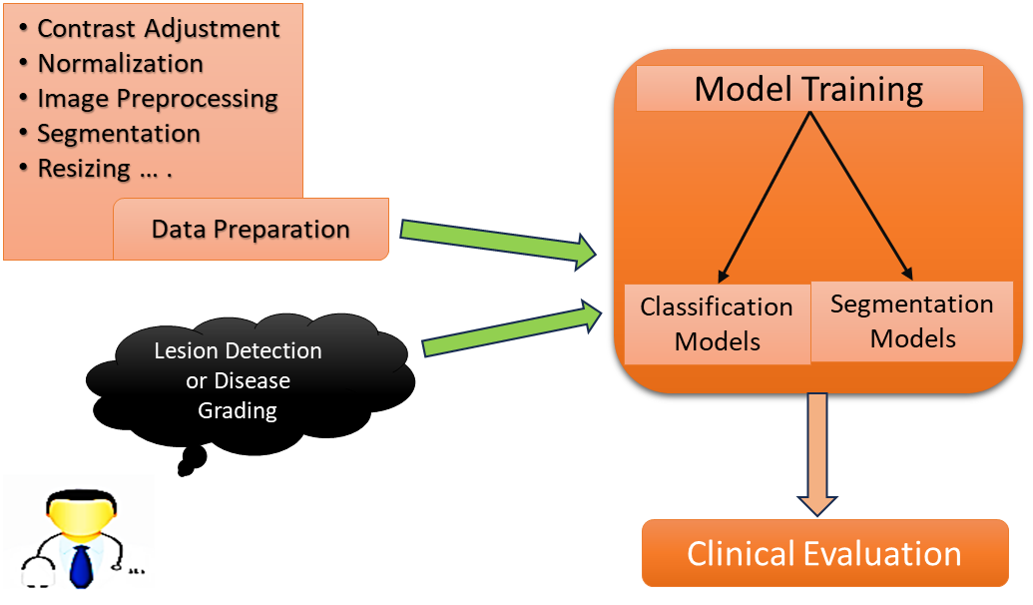
Fig 1: Analysis pipeline of fundus images
The main cause of DR is damage to the blood vessels. Microaneurysms and hemorrhages are signs of vessel blockage and lesion development. A skilled ophthalmologist can currently identify diabetic retinopathy by manually evaluating fundus images. Therefore, to accurately diagnose the disease, a DR system needs to be automated.

The following are the steps to identify Diabetic Retinopathy:
1. Image Pre-processing
2. Image Segmentation
3. Convolution Neural Networks (CNN) algorithm

Literarture Survey
"Segmentation with pre-processing and post-processing" has been proposed by Santosh et al. in [1]. In this approach, input pre-processing comes first, followed by post-processing, before segmentation. Maximal main curvature is used for post-processing, which is quicker and produces amazing accuracy with less segmentation procedures. Therefore, in order to achieve optimum accuracy, maximal primary curvature alone is insufficient; additional segmentation techniques must be used, as described in our proposed work. To extract retinal image vessels for retinal image analysis, Gehad et al. presented the "blood vessel segmentation approach" in [2]. It uses k-means clustering to enhance the image and mathematical morphology to boost blood vessels while reducing background noise. The DRIVE dataset was used to evaluate this methodology, which yielded a 95.10 percent accuracy. The accuracy was satisfying but k-means cannot handle the noisy data and the number of clusters should The accuracy of this approach, which was tested using the DRIVE dataset, was 95.10 percent. Although the accuracy was satisfactory, k-means cannot handle noisy data, and the number of clusters needs to be specified upfront. The segmentation method in the suggested model can deal with any kind of noise. R.Manjula et al. "employed image processing techniques to enhance and measure the dimensions of the retinal blood vessels" in [3]. The Gaussian method, mathematical morphology, and multi-scale analysis approach are the three segmentation techniques that are used. Thick and thin blood veins can be distinguished using the Gaussian approach. It is a more successful strategy, but it only works on thick vessels. Although it is more efficient, it can only be used on thick vessels. Mathematical morphology provides extremely accurate detection of thin vessels. The multi-scale analytic technique recognizes both thick and thin vessels without any noise. Since it focuses more on vessel size, this technique has less precision than the maximal primary curvature technique. Improved contrast in retinal images is achieved by using adaptive histogram equalization, which Memari et al. used in their "automatic retinal vessel segmentation that utilizes fuzzy c-means clustering" in [4]. The noise is condensed using a mathematical morphological technique and matching filters Gabor and Frangi. The original blood vascular network is extracted using fuzzy-c methods. For segmentation refinement, an integrated level set approach is applied. The accuracy of this approach was 96.1% on average. But fuzzy-c clustering takes more iterations to get better results which is time consuming. Budai et al. have tried to “reduce the running time of the algorithm” in [5], compared with Frangi approach, he tried to minimize the calculation time without disturbing high accuracy and sensitivity. Besides being heavy work in front of them the authors avoided potential issues such as thick vessel specular responses, constructing this strategy. They employed DRIVE and STARE, two public databases with accuracy of 95.72 percent A mathematical morphological method and the Gabor and Frangi matching filters are used to condense the noise. Using fuzzy-c techniques, the original blood vascular network is recovered. An integrated level set strategy is used to refine segmentation. This method had an average accuracy of 96.1%. However, fuzzy-c clustering requires more rounds, which takes longer, to produce better results. Comparing his approach to Frangi's, Budai et al. attempted to "reduce the running time of the algorithm" in [5], while maintaining high accuracy and sensitivity. The authors avoided potential problems like thick vessel specular responses by designing this method, even though they had a lot of work ahead of them. They used the 95.72 & 93.86, respectively percent accurate public databases DRIVE and STARE. Among the segmentation techniques utilized here are super pixels-based segmentation, watershed segmentation, and active contour approaches. In [14], Renoh et al. suggested "a unique unsupervised method" for segmenting a retinal picture after identifying the OD and fovea. The suggested method consists of three steps: coarse ONH center detection, fine ONH center detection together with boundary detection, and fovea detection. They have demonstrated how to automatically identify the optic disc (OD) in retinal images using histogram-based template matching and the maximum sum of vessel information. The accuracy of fovea detection was 97.26% and optic disk performance was 95%. Fundus images of various sizes and images with noise cannot be segmented using these techniques.
From the above literature there are some research gaps exist where we can analyse about diabetic retinopathy.

Methodology
Step – 1: Collection of Dataset:

The 89 retinal fundus images in the DIARETDB1 dataset, 84 of which are aberrant and 5 of which are normal, were used in this experiment. We apply augmentation techniques to the dataset in order to increase the number of photos. We obtain 255 abnormal photos and 93 normal images by rotating the dataset images horizontally, vertically, and horizontal-vertically.

Step – 2 : Applying Image pre-processing:
Pre-processing on the input photos entails:
1. Resizing each image to a size of 336 x 448 pixels.
2. Grayscale images are created by converting colored images.
3. Images in grayscale are transmitted for segmentation.
Step – 3 : Image Segmentation:

To extract blood vessels from the fundus images, pre-processed images are provided for segmentation.

To extract the blood arteries, we used the greatest principal curvature approach.

Step – 4: Apply Gaussian Filtering:

It is a filtering method that lessens the noise in an image. Using a technique known as the Gaussian function or Gaussian Blur, the image is blurred to achieve smoothing.

G(x) = 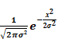
Eq-1: Gaussian function formula

Step – 5 Maximum Principal Curvature:
The black lines/edges on the bright background are picked up by maximum primary curvature. The principal curvature of a pixel can be calculated from the eigenvalues of the Hessian. Biochemical Matrix A Hessian is a square matrix of a scalar function or scalar field's second-order partial derivatives. The maximal primary curvature technique produces better results for blood vessel extraction than the other techniques.
Step – 6 Morphological Opening:
The structural element used in morphological opening concentrates on the size and shape of larger objects while ignoring smaller ones.

Step – 7 Convolution Neural Networks (CNN):
The image input layer receives a file with the dimensions 336*448. After that, it goes through many levels of convolution and max pooling. The process of training involves several layers. Ten 9*9 filters make up the convolution layer's first layer. A 2*2 maximum pooling layer follows. Ten 6*6 filters make up the second convolution layer in total, which is followed by a 3*3 max pooling layer. The output size 2 layer is then fully connected, and both normal and abnormal images are produced. Batch normalization, soft maximum, and finally the classification layer—which employs Re Lu activation—are employed as output layers after that. The model is trained using an 80-20 split, which allocates 80% of the training data and 20% of the validation data. 20 epochs and a network learning rate of 0.00001 are employed during training.
Segmented images with an excessive amount of blood vessel growth are regarded as abnormal; otherwise, they are seen as normal.
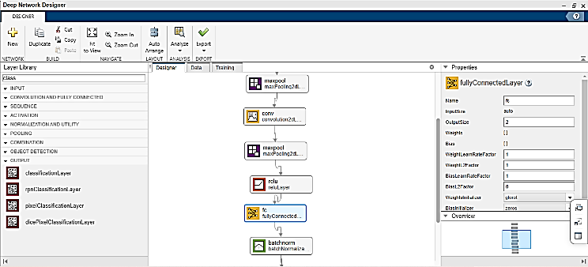
Fig 2: Analysis in MATLAB
The Above Fig 2 gives the model/ analysis of this in the MATLAB. In the Fig 2 gives the Deep network in this paper. In the Fig 3 gives the CNN architecture view which gives complete flow model.
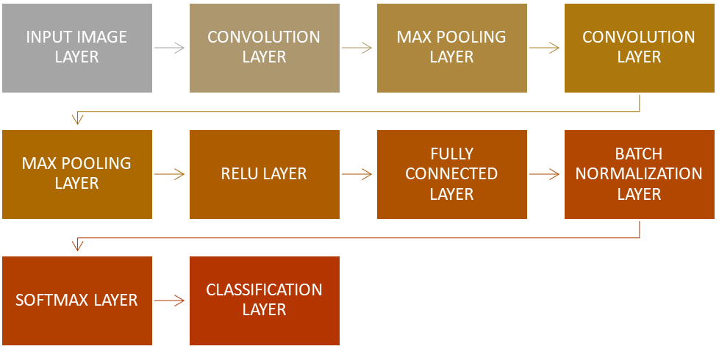
Fig 3: CNN Architecture

Proposed Algorithm
A computer-aided diagnosis (CAD) system includes various stages like detection, segmentation and arrangement of scratches in fundus images. In the first stage we do preprocessing for the fundus image after that segmentation then classification. In this stage we will use CNN algorithm/network compare with the trained data by that we get normal or abnormal output as show in Fig 4 & Fig 5

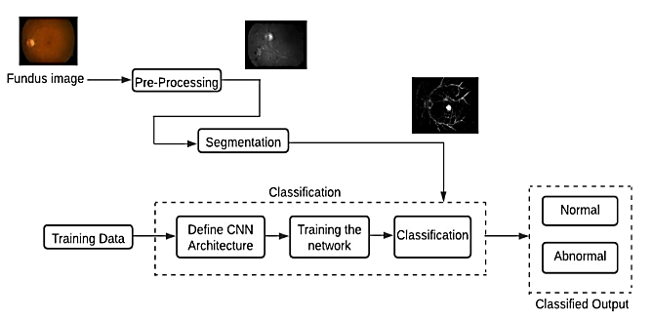

Fig 4: Proposed Methodology

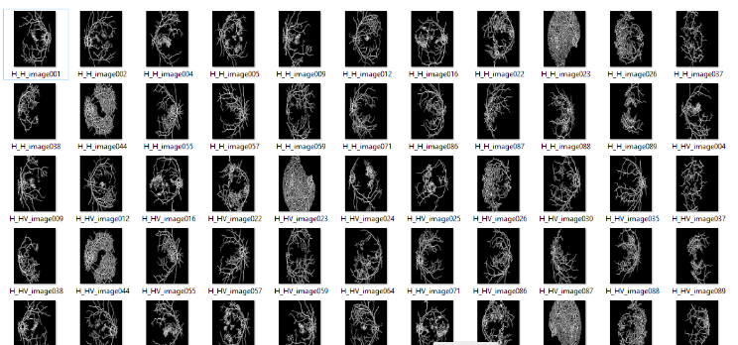
Fig 5: Retinal Fundus Images

Result and Discussions
After training the model for 30 epochs and unseen validation set is loaded into the model for testing. From training and testing, the accuracy, loss and fully connected layers of the model are observed and here are the results obtained.
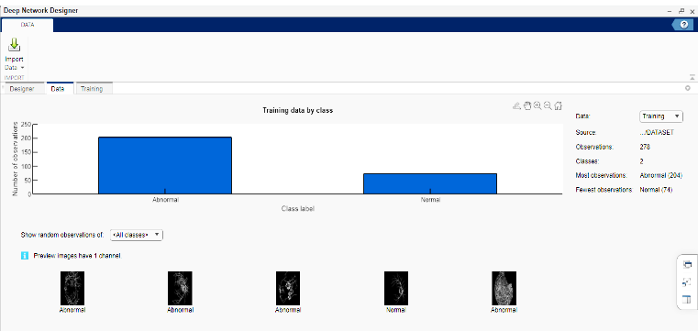
Fig 6: Trained model Output
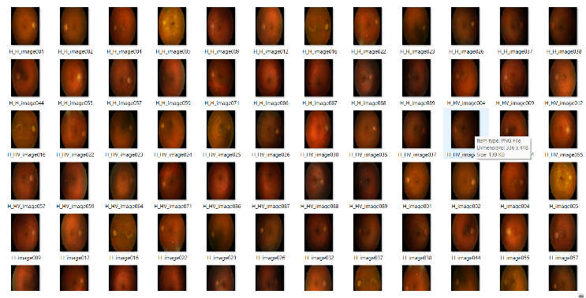
Fig 7: Retinal Fundus Images

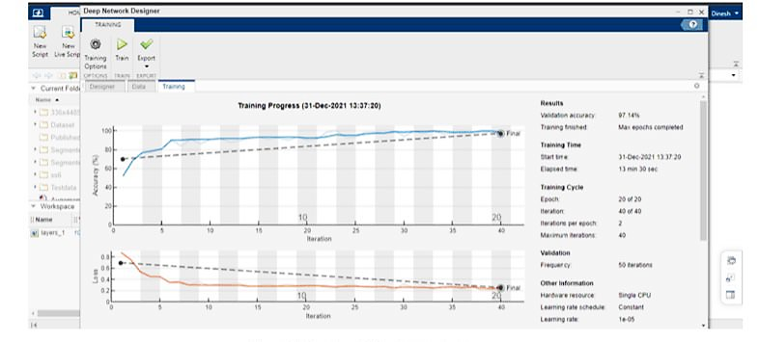
Fig 8: Trained Output

Conclusion and Future Works
We present an automated DR system in this study that can precisely identify diabetic retinal disease. Retinal fundus images from the diaretdb1 dataset make up the dataset. Pre-processing the photos by making them Grayscale images is the first step in the procedure. Following that, the maximum primary curvature approach is used to remove blood vessels. After that morphological opening, adaptive histogram equalization is applied to remove and strengthen incorrectly fragmented regions. Following that, CNN network is used to train the segmented pictures. The number of blood vessels in the image helps the classifier decide whether it is normal or abnormal. The proposed method yields a 97.14% accuracy. By figuring out how long the patient has been afflicted, we hope to increase the scope of our investigation. If anybody is found to have diabetic retinopathy, we will investigate how long they have the condition and how serious it is.

References

- J.I. Orlando, E. Prokofyeva, M.B. Blaschko, “A discriminatively trained fully connected conditional random field model for blood vessel segmentation in fundus images”, IEEE Trans. Biomed. Eng. 64 (1) (2017) 16–27, https://doi.org/10.1109/ TBME.2016.2535311.
- N. Memari, A.R. Ramli, M.I.B. Saripan, et al., “Retinal blood vessel segmentation by using matched filtering and fuzzy C-means clustering with integrated level set method for diabetic retinopathy assessment”, J. Med. Biol. Eng. (2019) 713–731, https://doi.org/10.1007/s40846-018-0454-2.
- S. Selvaperumal, Ramasubramanian Bhoopalan, “An efficient approach for the automatic detection of hemorrhages in colour retinal images”, IET Image Process. (2018) 12, https://doi.org/10.1049/iet-ipr.2017.1036.
- K.M. Adal, P.G. Van Etten, J.P. Martinez, K.W. Rouwen, K.A. Vermeer, L.J. van Vliet, “An automated system for the detection and classification of retinal changes due to red lesions in longitudinal fundus images”, IEEE Trans. Biomed. Eng. 65 (6) (2017) 1382–1390, https://doi.org/10.1109/TBME.2017.2752701.
- D.J. Hemanth, O. Deperlioglu, U. Kose, “An enhanced diabetic retinopathy detection and classification approach using deep convolutional neural network”, Neural Comput. Appl. 32 (2020) 707–721, https://doi.org/10.1007/s00521-018- 03974-0.
- Thomas A. Siji, Titus Geevarghese, “Design of a portable retinal imaging module with automatic abnormality detection”, Biomed. Signal Process. Control 60 (2020), https://doi.org/10.1016/j.bspc.2020.101962.
- N. Yalçin, S. Alver, N. Uluhatun, “Classification of retinal images with deep learning for early detection of diabetic retinopathy disease”, in: 26th Signal Processing and Communications Applications Conference (SIU), Izmir, 2018, pp. 1–4, https://doi. org/10.1109/SIU.2018.8404369.
- Shailesh Kumar, Abhinav Adarsh, Basant Kumar, Amit Singh, “An automated early diabetic retinopathy detection through improved blood vessel and optic disc segmentation”, Opt. Laser Technol. (2020), https://doi.org/10.1016/j. optlastec.2019.105815..

