POWER GENERATION THROUGH HUMAN LOCOMOTION USING PIEZOELECTRIC SENSORS

¹Sumitha Manoj, ²Prathyusha H Kumar ,³Sanjana H, ⁴Sherlin Jagath J

¹Sumitha Manoj, Electronics and Communication Engineering, RajaRajeswari College of Engineering, Karnataka, India

ABSTRACT

The production of electric power from the footstep movement of the peoples and the pressure exerted during walking which is fritter away is the main theme of this paper. The mechanical power transformation into electrical power as the pressure exerted by the footstep and by using transducers is basically called as “Footstep power generation system”. Power is produced by the power generating floor and it is basically the production of electrical energy from kinetic energy. The main aim is to overcome the power crisis throughout the world although it is not enough to fulfill over excessive demand of electrical energy, but it will be able to change and decrease reliance on old method of generating electricity. It can be installed on roadside footpath, parks and jogging tracks and many other public places, airport etc. and have great impact of this and will create great difference in the electrical power generation system. We can produce energy that can be stored in a rechargeable battery, so that we can use it for our later purposes, and it can be also placed in public places like streetlight, mobile charging etc.
Keyword: - Piezo-electric Sensor, Mobile charging, Footstep.

1. INTRODUCTION
The formation of electrical energy from the force exerted by footstep on the floor is illustrated in this research work. It will be surprising to know that the normal footstep movement on the floor can generate how much energy. As thousands of steps per day is taken by each person. Electrical energy is generated by the footstep taken by the peoples because of walking. It is a fact that large amount of energy is lost by each person during routine walk which is the main source for this system. A system is designed which generate power through non-conventional energy source technique such a walking on the gardens, grounds, and floors etc. This system is established in heavy populated areas. A compatible system has been designed to complete the procedure through which the load will run, home appliances will work on alternating current output voltage.

The energy that is produced from a person walking on floor is noise and pollution free. That type of energy is advantageous and even not need any type of fuel or power source to run. renewable energy in today’s world while the demand of energy is increasing day by day is the current solution of this modern world. In this research work a system is designed which generate power through non-conventional energy source technique such a walking on the gardens, grounds, and floors etc. This system is established in heavy populated areas. Basic way of the “Footstep Power Generation” is based on the piezoelectric sensor to apply this system wooden plates up and down will be placed and adjusted on the piezoelectric sensor and moving spring.
The force is applied when the person is walking on that mat and the magnet is fixed on the upper portion of the wooden sheet because of force and moves into the cavity. However, the cavity is fixed on the bottom wooden sheet of the mat. A compatible system has been designed to complete the procedure through which the load will run, home appliances will work on alternating current output voltage. And the task is with the help of direct current to charge battery and then using inverter to convert direct current into alternating current for normal usage. At last, designing for the power generation of such types are very useful as compared to the demand of energy all over the world.

  - Existing Problem
- Increase in use of non-renewable energy which causes pollution.
- Increasing prices of the fuel resources
- Unable to meet demand because of increase in power usage.
- Electricity transmission losses
- Frequent power outages
- Electro mobility
- Grid modernization
- Threat of cyber attacks

  - Proposed Solution
Electrical power energy form by changing mechanical energy into electrical energy by the transform ring i.e., movement of footstep on the floor, piezo plate is placed there and that is the key feature of power produced through footsteps by piezo. The main working of this project depends on piezoelectric effect, which converts pressure into electrical energy. Here we have placed a piezoelectric tile which consists of piezoelectric sensors connected in series. Here, pressure is taken as input, and it is converted into electrical form and stored in a rechargeable battery. The PIC Microcontroller acts as heart of system, which transforms variable voltage into a constant voltage. To prevent current flow in opposite direction, a diode is placed. A RFID reader is placed to check whether the user is authorized and allows 15 minutes of charging time. A Liquid crystal Display is used to display how much voltage is stored in battery.

1.3 Objectives of Project
The main objectives of the project work are:
- To design and implement an ecologically safe way of generating dc voltage using an array of piezo electric sensor.
- To boost the voltage generated from the piezo sensors using DC - DC boost converter.
- To power a mobile for charging.

2. LITERATURE REVIEW
2.1 Introduction
Literature survey is very important to get a knowledge on desired topic. By using the information provided in the several literatures give credit to other researchers to prevent duplication. By surveying the several literatures, we can identify in constancies like gaps in research, conflicts in previous studies, open question left from other research. We referred some of the scholars to know some of the information about the project. The scholars which we have referred is listed below.

2.2 Base Papers
Reference paper [1] Power Generation through footsteps using piezo-electric effect along with GPS Tracking, International Conference for Emerging Technology (INCET).
AUTHOR : Rajendra Prasad, Avala Bhanuja, Bhavani. L, Bhoomika N
YEAR: 2019
Energy utilization is the major key. Piezoelectric effect is utilized by piezoelectric sensor producing output energy in the form of AC voltage. To produce energy in a large extent, in this model implementation of the piezoelectric sensor network along the footpath is carried out which is given to the lane of streetlights along with it the smart shoe is implemented for a small production that consists of GPS tracking. In this proposed work model, GPS tracking has been added and streetlights switching technique comparing with existing model.

Reference paper [2] Reverse electro wetting as a new approach to high-power energy harvesting.
AUTHOR: Tom Krupenkin & J. Ashley Taylor
YEAR: 2011
Over the last decade electrical batteries have emerged as a critical bottleneck for portable electronics development. High-power mechanical energy harvesting can potentially provide a valuable alternative to the use of batteries, but, until now, a suitable mechanical-to-electrical energy conversion technology did not exist. Here we describe a novel mechanical-to-electrical energy conversion method based on the reverse electrowetting phenomenon. Electrical energy generation is achieved through the interaction of arrays of moving microscopic liquid droplets with novel nanometre-thick multilayer dielectric films. Advantages of this process include the production of high power densities, up to 10 3 W m − 2; the ability to directly utilize a very broad range of mechanical forces and displacements; and the ability to directly output a broad range of currents and voltages, from several volts to tens of volts. These advantages make this method uniquely suited for high-power energy harvesting from a wide variety of environmental mechanical energy sources.

Reference paper [3]: Generation of Electricity by Using Footsteps as a Source of Energy
AUTHOR: P. R. Magdum, S. J. Chikhale
YEAR:2017
Electricity is a basic part of nature, and it is one of the most widely used forms of energy across the globe. We get electricity, (which is a secondary energy source) from the conversion of other sources of energy, like coal, natural gas, oil, nuclear power and other natural sources, which are called primary sources. Research show that the world has already had its enough shares of its energy resources. Fossil fuels pollute the environment. Nuclear energy requires careful handling of both raw as well as waste material. Research shows that large amount of power is generated from non-renewable energy resources compared to that of renewable energy resources. The extensive usages of available resources in recent years created a demand for the future generation. To overcome this problem, we need to utilize renewable energy sources for power generation and conservation. Therefore, the focus now is shifting more and more towards the renewable source of energy, which are essential and non-polluting. The goal of this paper is to show the detailed survey of how jumping platform can be now used as a source of power.

Reference paper [4]: FOOTSTEP POWER GENERATION FOR RURAL ENERGY APPLICATION TO RUN A.C. AND D.C. LOADS
AUTHOR: Kethavath Gopal, Adaikkalam Daniel Praneet
YEAR: 2020
Now days, the population of the country increased, and the requirement of the power is also increased. At the same time, the wastage of energy also increased in many ways. This paper presents the production of electric power from the footstep movement of the peoples and the pressure exerted during walking, which is fritter away, is the main theme. electrical power is achieved by transforming the mechanical power as the pressure exerted by the footstep and by using transducers is basically called as "Footstep power generation system". Power is produced by the power generating floor and it is basically the production of electrical energy from kinetic energy. In present days electricity demand is increasing and it is unable to overcome this global issue by using the traditional power generating sources. The main aim is to overcome the power crisis throughout the world although it is not enough to fulfill over excessive demand of electrical energy, but it will be able to change and decrease reliance on old method of generating electricity. To overcome this problem, the energy wastage is converted to usable form using the piezoelectric sensor. This sensor converts the pressure on it to a voltage. By using this energy saving method, footstep power generation system we are generating power.

3. SYSTEM DESIGN

The proposed system, aimed at storing the energy generated during daytime in batteries, and can be used during night. The proposed system is developed using a microcontroller. The output of piezoelectric sensor based micro generator will be a very low power ac voltage signal at random frequency. The power is stored in a battery that can be used to charge a mobile phone using RFID card. This system is powered by Atmega 328 microcontroller, it consists of Arduino IDE, RFID sensor, USB cable and LCD.

3.1 BLOCK DIAGRAM

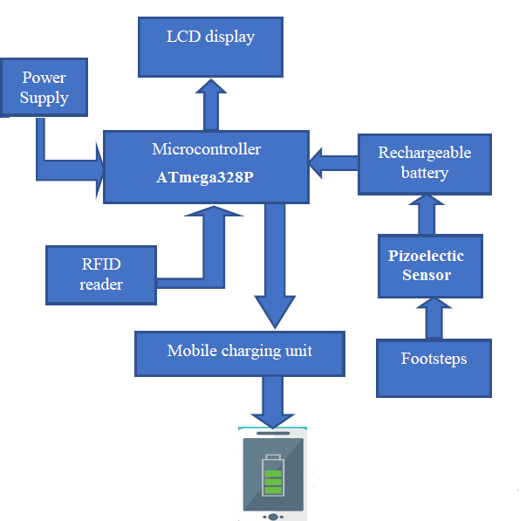

Fig. 3.1 Block Diagram

3.2 METHODOLOGY
These days the Internet of Things (IoT) is the most famous and trending wireless communication model due to its vast applications and reach to access. It involves a simple concept of controlling electronic or electro - mechanical devices using internet. Our smart staircase also has this smart and easy feature of internet of things. Node MCU being a controller that has inbuilt Wi-Fi capability is being used as its range is 15-200 meters and simple to program. Node MCU occupies less space and has the easily understandable architecture reducing efforts of programmer. Other digital pins used for motor driving using the motor driver L2398N.

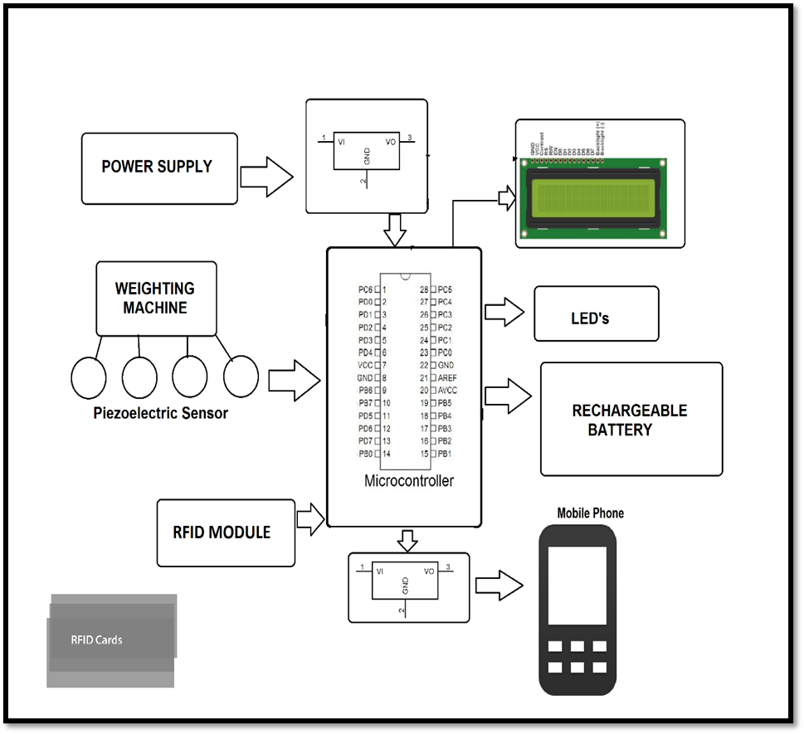

Fig. 3.2 Physical Setup

4. EXPERIMENTAL SETUP

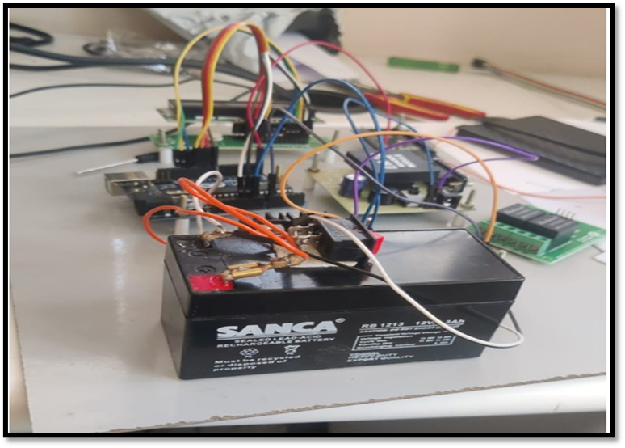
Fig 4. 1 Experimental Setup

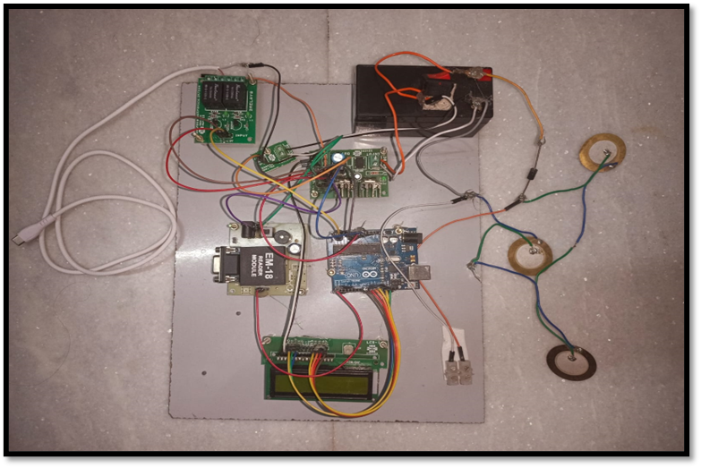
Fig 4.2 Final Circuit

4.3 Charging:

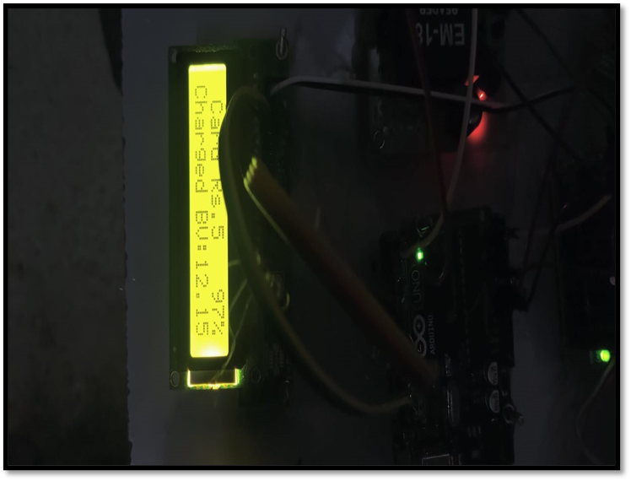

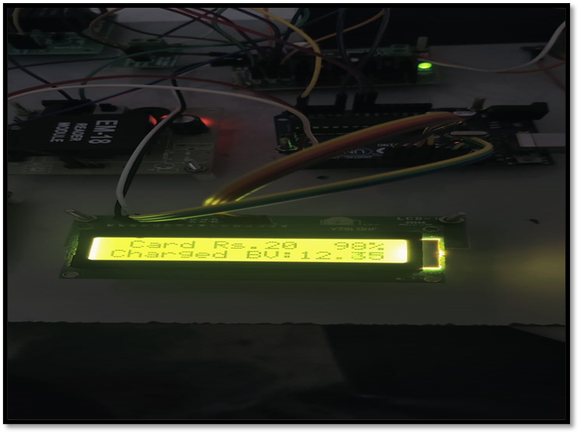
Fig 4.3 Battery Charging
5. IOT APP RESULTS:
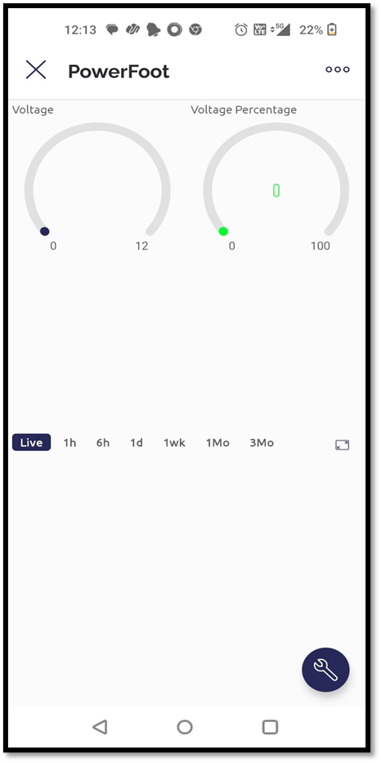

Fig 5. IOT App results

6. CONCLUSION
Footsteps are the main source of power generation. There is no need of energy from conventional source of energy and there is zero percent of pollution in this type of power generation. There is no need of any kind of power from mains and it is important to the areas, all tracks where footsteps are used to generate non-conventional energy such as electricity. The contribution of non-conventional energy to our primary energy is 11% that is a common fact. If this project is activated, it will not only add and overwhelm the energy deficit problems, but this will also form sound global environmental change.

7. REFERENCES
- R.Manasa Veena, B. Harika Reddy “Maximum Energy Harvesting from Electromagnetic Micro Generators by Footsteps Using Photo Sensor in International Conference on Computation of Power, Energy Information and Communication 2016.

- Taliyan.S.S "Electricity from footsteps" in IEEE Trans. On Power Generation, vo1.23. no.4, pp 2521-2530, April 2010.

- Jose Ananth Vino. V,AP,Bharath University "Power Generation Using Foot Step" in International Journal of Engineering Trends and Technology (UETT) -Volume I Issue2-May 20 II ISSN: 2231-5381

- Rama Krishna. K "Generation of electric power through footsteps" in International Journal of Multidisciplinary and Current Research Vol.2, ISSN: 2321-3124, Sep-2014

- Adhithan.A, Vignesh.K, Manikandan.M "Proposed Method of Footstep Power Generation Using Piezo Electric Sensor" International Advanced Research Journal in Science, Engineering and Technology Vol. 2, Issue 4, April 2015.

- Tanvi Dikshit, Dhawal Shrivastava, Abhijeet Gorey, Ashish Gupta, Parag Parandkar, Sumant Katiyal, “Energy Harvesting via Piezoelectricity”, BVICAM’s International Journal of Information Technology 2010.

- Y. C. Shu and I. C. Lien, "Analysis of power output for piezoelectric energy harvesting systems", Smart Materials and Structures 15 (2006), pp. 1499-1512.

- V.Dharmambal, Dr. Nisha KCR, Bhavana C, “Piezo Film based Renewable Energy System “, 2016 International Conference on Circuit, Power, and Computing Technologies [ICCPCT]

- Santhosh Mugali, “Footstep Power Generation Using Piezo-electric Transducers”, International Journal of Latest Technology in Engineering, Management and Applied Science, p. 2-5, Volume 7, May 2018.

- Iqbal Mahmud, “Electrical Power Generation Using Footsteps”, European Scientific Journal, 2018.

