Sherbet: A Traditional Beverage

Senanur DURGUT MALÇOK
Bursa Uludag University, Faculty of Agriculture Department of Food Engineering
Gorukle, Bursa, Turkey
senanurdurgut@uludag.edu.tr

Azime ÖZKAN KARABACAK
Bursa Uludag University, Gemlik Asım Kocabıyık Vocational School,
Department of Food Processing,
Bursa Uludag University
Science and Technology Application and Research Center (BITUAM)
Bursa, Türkiye
azimeozkan@uludag.edu.tr

Canan Ece TAMER
Bursa Uludag University, Faculty of Agriculture
Department of Food Engineering
Gorukle, Bursa, Turkey
etamer@uludag.edu.tr

ABSTRACT
Traditional beverages are of great importance for societies as they reflect local flavors and cultural heritage. These drinks have been preserved and passed down from generation to generation and are still popular today, becoming an important part of local identity. The preparation and presentation of traditional beverages involve rituals that reinforce feelings of unity and solidarity between communities. They are at the center of social interactions, encouraging gathering and sharing. Sherbet, which has a special place among traditional beverages, has long been a preferred and popular drink due to its natural ingredients and health benefits.
Sherbet is prepared with various fruits, spices, herbs, sugar, honey, and water. Traditionally, it is consumed as a cold, sweet drink to refresh and quench thirst during the hot summer. Offering various health benefits, sherbet is a rich source of vitamin C and boost the immune system thanks to the natural fruit juices, plant extracts, or spices it contains. The antioxidant properties of sherbet come from its some ingredients, which can prevent cell damage. In addition, sherbets contribute to slowing down aging processes and reducing the risk of several diseases such as cancer. The spices and herbs can facilitate digestion and help relieve abdominal pain. This chapter emphasizes the cultural significance of traditional sherbets by focusing on its health benefits.

Keywords: Sherbet; traditional beverages; health benefits; functional properties; cultural heritage

INTRODUCTION

The Arabic-origin word "şerbet" derives its origin from the term "şarba". "Şarba" signifies "a drinkable substance" or "beverage" in meaning. During the Ottoman period, the term "şarba" transformed into "şurub" which is defined as a beverage consumed to quench thirst and aid digestion. This term then evolved "şerbet". Şerbet refers to a sugary beverage offered to guests during specific ceremonies [1]. The word "sorbetto", transferred from Turkish to Italian, conveys the meaning of "a beverage made by mixing sherbet, water, wine, or another liquid with snow or ice". Among Italians, the usage of the term "şerbet" is known to have originated towards the end of the 16th century, signifying "a beverage of the Turks" [2]. In French, the term "sorbet," adopted from Turkish, is defined in the gastronomy dictionary "Larousse Gastronomique" as "a refreshing food consisting of fruits, honey, aromatic substances, and ice, with sprinkled sugar, used to quench thirst". The word "sorbet" or "sherbet," borrowed from Turkish, emerged in English in the 17th century, initially denoting "a cold fruit drink” [3].

Sherbet (şerbet) is a common and significant beverage with a rich historical tradition dating back to the 11th century in Anatolia. It has been a customary practice to serve sherbet to guests after important rituals and events, such as circumcision feasts, betrothals, and deliveries [4]. Sherbet is commonly offered at various occasions, such as Islamic memorial service (Mevlid), weddings, iftaar, and visiting of postpartum (lohusa) mothers. Nowadays, serving "lohusa sherbet" (Figure 1) is also a tradition that continues. To announce the birth, sherbet is prepared and sent to neighbors and relatives. In Adana, Mersin, and Antakya, this sherbet is also called as "kaynar". It is also often given to the lohusa to provide health benefits. Offering sherbet to guests after returning from pilgrimage (hajj), and on congratulatory visits is a tradition that continues in Turkish culture [5].

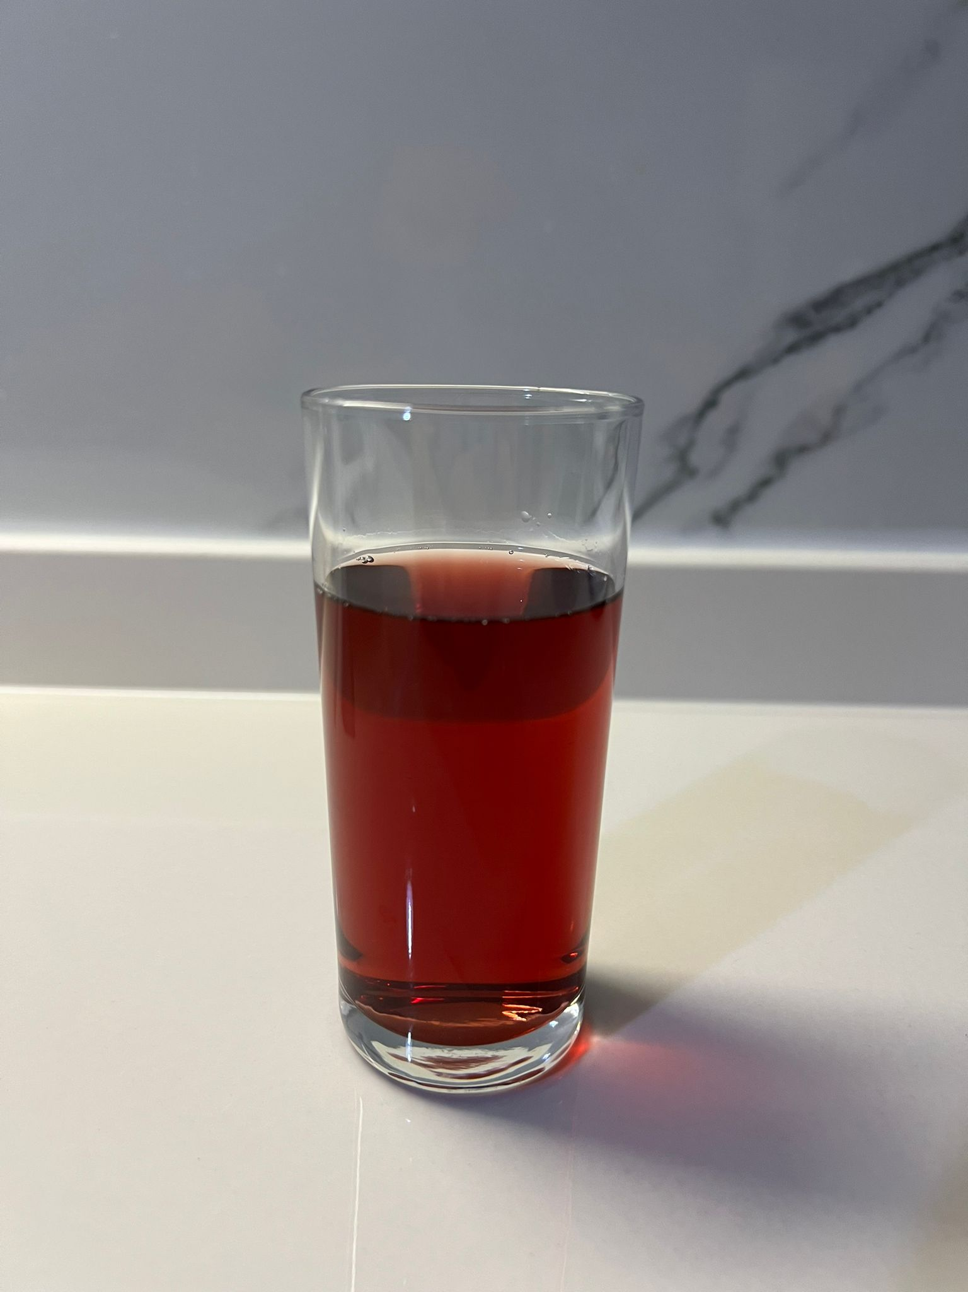
Figure 1. Lohusa Sherbet

Şherbet is known to have been brought along with the food and beverage culture as the Turks migrated from Central Asia to Anatolia [6]. Turkish culinary culture has a history as deep-rooted as the rich history of Anatolia [7]. Throughout history, factors such as interaction with different cultures, the diversity of products due to geography, the emergence of new flavors, and the contribution of Mesopotamian cuisine to Anatolia have enriched Turkish cuisine. Studies have shown that Turkish cuisine is among the richest cuisines in the world. It is evident that Turkish cuisine took shape with the acceptance of Islam [8]. After the adoption in Islam, beverages made from the milk of animals like donkeys, and horses ceased to be used in Turkish cuisine [9]. The extensive rule of the Ottoman Empire across various regions greatly influenced Turkish cuisine. During the Ottoman era, the palace kitchen was the focal point of social events where the sultan and nobles dined together. Sherbets constitute a significant beverage group in Ottoman cuisine. They started to be preferred more in the 16th century [10].
The primary ingredients of sherbet are sugar and water, and it is prepared by combining sugar or honey, water, various fruits (i.e. tamarind, date, pomegranate, cranberry, red grape, rosehip, locust bean, etc.), flowers (i.e. rose petals, poppy, violet, etc.), herbs or plant extracts, and spices (i.e. black cumin, cinnamon, ginger, cardamom, clove, etc.) [4, 11, 12].
Two prominent methods are commonly employed in traditional Turkish sherbet preparation. The first technique entails the extraction of fruit juice, which is then blended with precise quantities of sugar and spices. On the other hand, the second process involves boiling fruit pulp with sugar and other spices, followed by cooling. Subsequently, the desired consistency of the sherbet is achieved by incorporating water into the mixture. Additionally, an alternative approach to sherbet production involves steeping the ingredients in hot water rather than subjecting them to boiling, followed by filtration [13].
Sherbet not only serves as an energizing and tasty beverage but also has gastrointestinal benefits. In addition, it is believed to possess healing properties for various diseases [4]. There are various types of sherbets traditionally consumed. Grape sherbet, for instance, is recognized for its anti-cancer properties. Mint sherbet has been used since ancient times to treat various ailments, particularly to support ocular and respiratory health. Tamarind sherbet, contains 41 different types of spices and is believed to regulate the digestive and intestinal systems [14]. Cinnamon sherbet offers antibacterial, skin-protective, and gas-relieving effects [15]. Carob sherbet is known for its usefulness in treating asthma and shortness of breath and also it is believed as a natural expectorant [16, 17].
In this study, the bioactive components of commonly consumed sherbets and their health benefits are explained in detail.

- Health Benefits of Sherbet
Sherbets can be classified into two main categories based on their usage. These beverages are primarily consumed to reduce the fever and help digestion, but they also serve as medicinal remedies for various ailments [18]. Despite being predominantly consumed in the summer, these sherbets remain popular even during the winter. Sherbets made from fresh seasonal fruits are believed to have positive effects on health. For example, tamarind sherbet is consumed for its health benefits [3]. Even in contemporary times, tamarind is still used for its medicinal properties in many countries [19]. In the Ottoman era, sirkencubin sherbet was consumed to quench thirst and as an alternative treatment for various illnesses [20]. Similarly, liquorice sherbet is renowned for its numerous health benefits and has been utilized in traditional medicine for centuries [21]. The ancient literature demonstrates the health impacts of sherbets. For instance, Mevlâna Celaleddin Rumi mentioned different varieties of sherbets [22]. For example, sherbets derived from violet and pomegranate were utilized as treatments for conditions such as headaches, kidney pain, and cough. In order to gain a comprehensive understanding of the health benefits of sherbets, it is imperative to examine the botanical ingredients, spices, and sweetening agent they include. Sherbets traditionally incorporated spices, sugar, honey, and cinnamon as sweeteners, and flavorings. Honey, which has been employed for centuries, is widely acknowledged for its beneficial properties and positive impact on overall well-being. Its efficacy in promoting wound healing is also a well-established fact. Honey is abundant of vitamins, minerals, amino acids, and enzymes, rendering it easily digestible and advantageous for addressing various ailments [23]. Given the diverse compounds present in different varieties of honey, it is proposed that they can be employed in the treatment of specific diseases, such as linden honey for soothing nerves and mint honey for preventing intestinal gas. Cantaloupe has been recognized for its potential role in promoting eye health as a result of its significant beta-carotene content [17]. Mint has also been utilized in alternative medicine. The medicinal properties of mint are recognized for their efficacy in alleviating respiratory ailments, as well as their high content of provitamin A and C. Additionally, mint exhibits antimicrobial attributes and assists in soothing gastrointestinal discomfort [14]. To conclude, sherbets possess a diverse array of health implications, influenced by their botanical, aromatic, and phytochemical constituents [3].

- Some Sherbet Varieties

B.1. Purple Basil (Ocimum basilicum L.) Sherbet
Ocimum basilicum L., sometimes known as purple basil, is a culinary and therapeutic herb. It includes essential oils (linalool, methyl eugenol, methyl chavicol, and methyl cinnamate from the main essential oil components), phenolic acids (rosmarinic acid, chicoric acid, gallic acid, caffeic acid, caftaric acid, chlorogenic acid, protocatechuic acid, and 4-hydroxybenzoic acid, etc.), flavonoids (quercetin, luteolin, apigenin, kaempferol, etc.) and also anthocyanins (cyanidin 3-glucoside, cyanidin 3,5-diglucoside, peonidin 3,5-diglucoside, etc.), having high antioxidant effects [11, 24-27]. Additionally, anthocyanins provide anti-inflammatory, anti-cancer, and neuroprotective actions [28].
The antioxidant activity of purple basil may reduce the risk of diabetes and cancer while defending against heart disease. Purple basil has historically been used to treat kidney problems, warts, diarrhea, migraines, and coughing. In addition to exhibiting a moderate to high natural preservation capacity, basil types also show antibacterial activity against a wide range of food-borne and human pathogenic microorganisms, suggesting a possible positive impact on human health [29, 30]. Thanks to all these positive health effects, purple basil has been consumed as sherbet for many years (Figure 2).

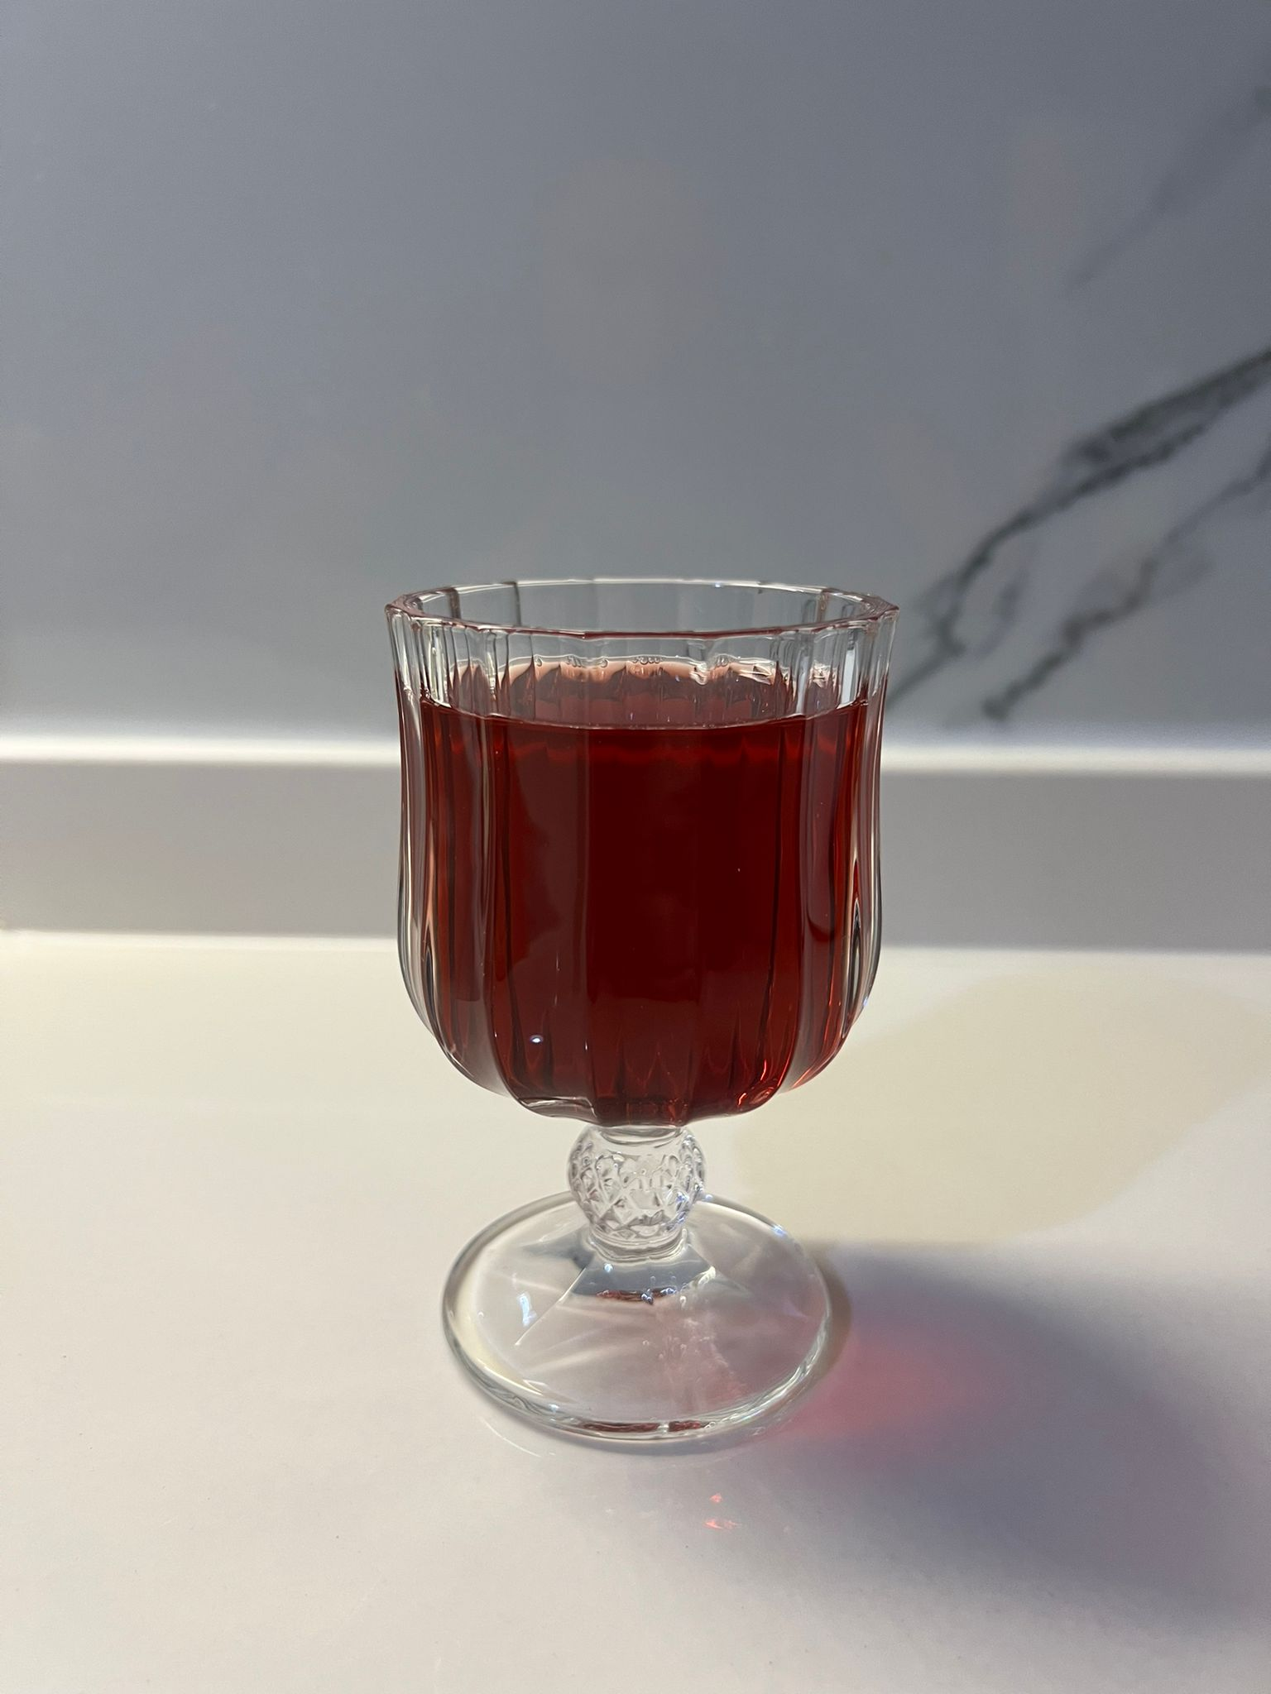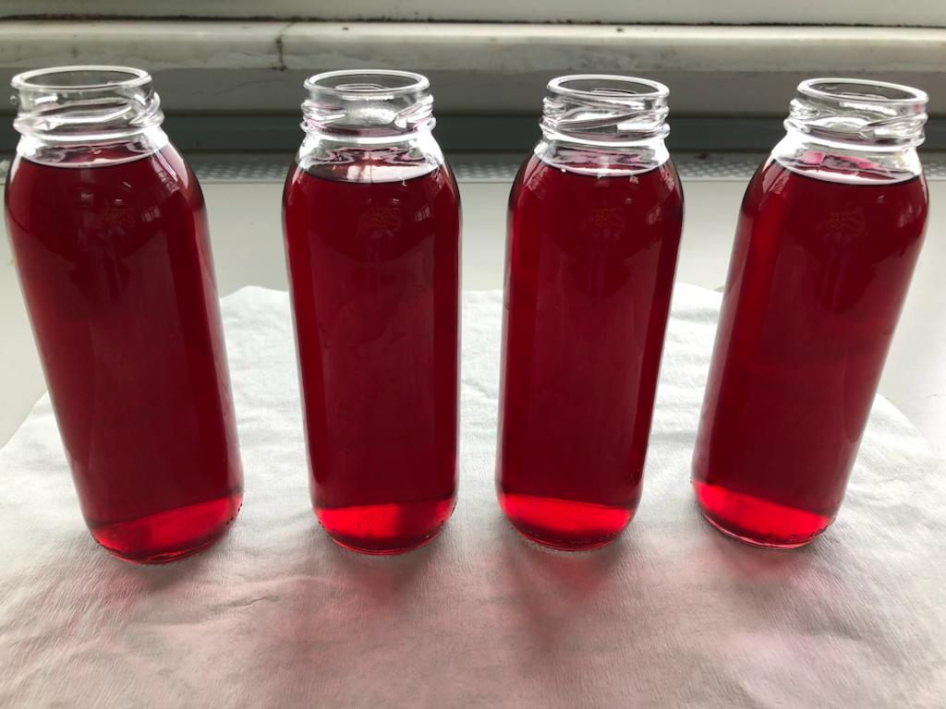
Figure 2. Purple Basil (Ocimum basilicum L.) Sherbet

B.2. Melon (Cucumis melo L.) Seed Sherbet (Subye)
Subye is a traditional sherbet obtained from melon (Cucumis melo L.) seeds. To produce subye, dried melon seeds are initially rehydrated by soaking them in water until they reach the same moisture levels as fresh seeds. Next, the rehydrated seeds are minced and mixed with a specific amount of sugar to form a paste. This subye paste is then diluted with water and filtered to obtain the final beverage known as subye (Figure 3) [31].
Depending on the variety and origin of the melon, the composition of the melon seeds differs. However, as a result of studies conducted on this subject, the contents of moisture, oil, protein, carbohydrate, fiber, and ash have been found to vary between 4.90% and 7.78%, 25.00% and 35.36%, 14.91% and 29.90%, 5.85% and 22.94%, 19.00% and 23.30%, 2.4% and 4.20%, respectively [32].
Özdemirli and Beştepe (2022) [33] produced subye sherbet from melons of the Canpolat and Mimoza varieties. The results indicated that the seeds of different melon varieties exhibited variations in total phenolic content (TPC) and total antioxidant activity (TAC). Specifically, subye sherbets derived from Mimoza melon seeds showed higher TPC values, approximately 15% higher compared to beverages obtained from Canpolat melon, and TAC values were ranged from 24% to 95% higher. Furthermore, the TPC value of subye sherbet was found to be higher than that of certain plant-based milks, such as rice milk, hazelnut milk, and coconut milk.
Additionally, melon seeds have been utilized for medicinal purposes dating back to the Ottoman era, despite being perceived as food waste. It is believed that melon seeds can be beneficial in managing acute or chronic eczema [34]. Subye has the potential to regulate the digestive system, promote restful sleep, and heal effectively diarrhea and constipation [17].

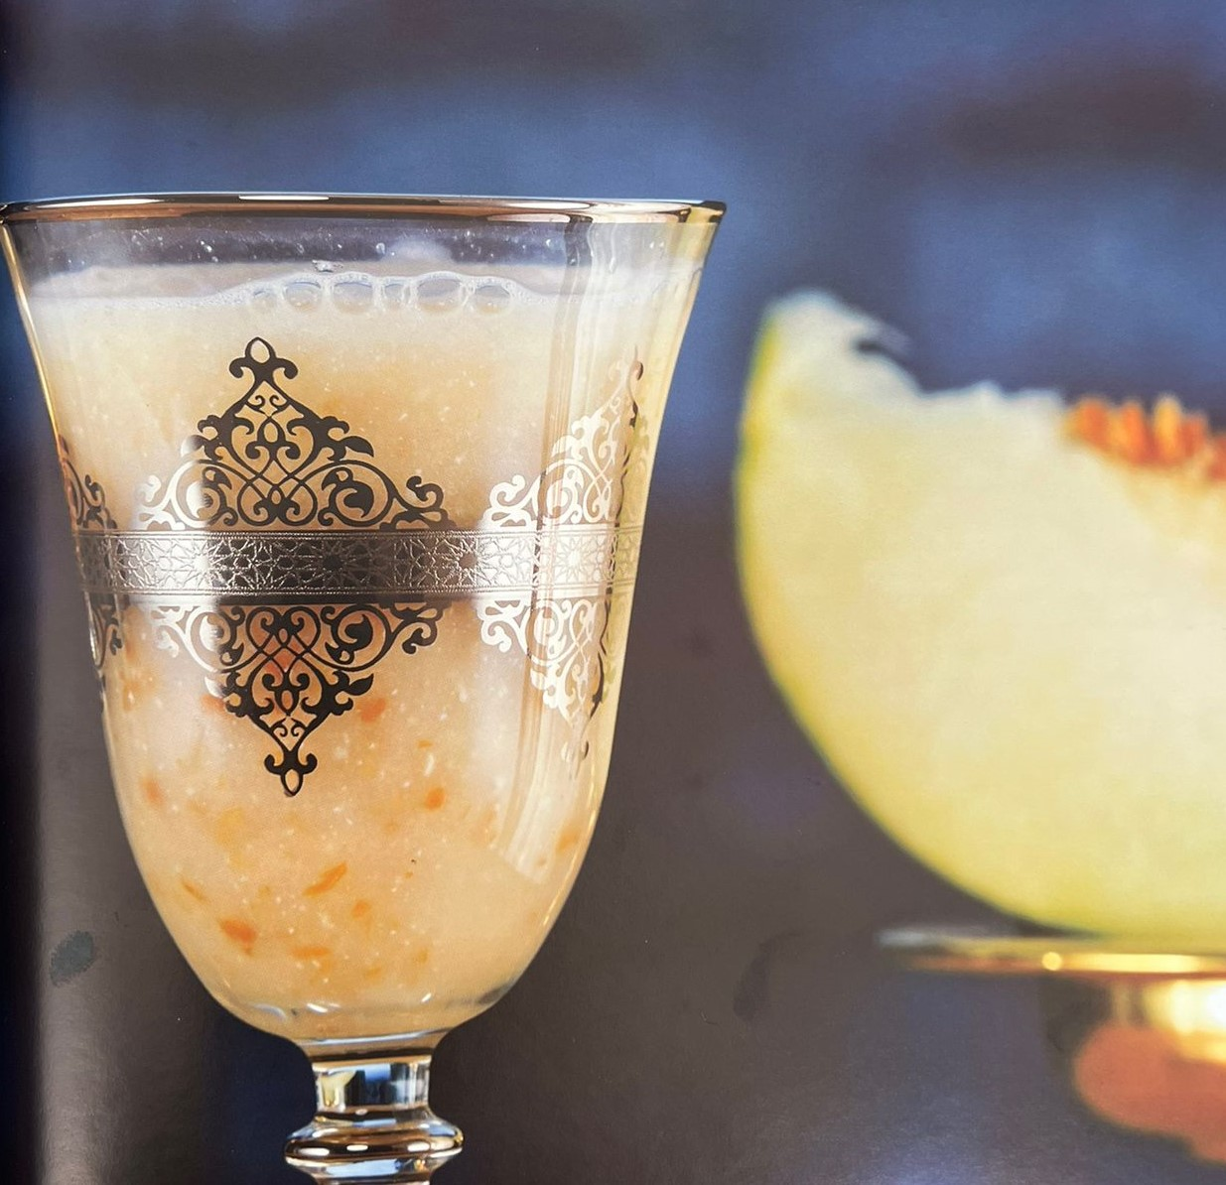

Figure 3. Melon (Cucumis melo L.) Seed Sherbet (Subye) [35]

B.3. Liquorice (Glycyrrhiza glabra L.) Root Sherbet
In certain Mediterranean and Asian nations, including Turkey, Italy, Spain, China, and Syria, the liquorice plant (Glycyrrhiza glabra L.) is grown and cultivated. Saponins, flavanones, flavonoids, amines, glucose, sucrose, amino acids, gums, essential oils, and starch are all present in liquorice roots. The most important saponin is glycyrrhizic acid, which contains one molecule of glycyrrhetinic acid and two molecules of glucuronic acid and is up to 50 times sweeter than sucrose [36, 37]. Glisirrizin is a bioactive component whose medical value has been proven through pharmacological tests. It possesses anti-inflammatory, anti-ulcer, anti-allergic, and anti-viral properties [38].
In the regions of Eastern and Southeastern Anatolia in Turkey, liquorice root extracts are commonly consumed as a summertime cold beverage known as "Liquorice Root Sherbet," which is often sold by street vendors. According to Ariño ve ark. (2007) [39], the process for making this sherbet involves shredding and water extraction of the roots.
In a study conducted by Pala ve ark. (2017) [38], the effects of different temperature applications (25 °C, 40 °C and 75 °C) during the extraction of liquorice roots on the microbial safety (total aerobic viable count, total aerobic mesophilic bacteria, yeast, mold, and total coliform bacteria) and bioactive components (TPC, total flavonoids, and glycyrrhizic acid) of the sherbet were investigated. The research findings indicated that temperature applications in the range of 40-75 °C during the extraction process positively enhanced the microbiological quality of the final product and significantly increased the transfer of bioactive components into the sherbet.

B.4. Cornelian Cherry (Cornus mas L.) Sherbet
The cornelian cherry (Cornus mas L.) is a naturally occurring plant that has historically been used mostly in traditional medicine, especially in Europe and Asia. It is currently starting to gain prominence once more because it can be a great source of bioactive compounds with high antioxidant activity. The bioactive components found in fruits, such as phenolics, anthocyanins, flavonoids, carotenoids, and vitamins, each play a different role in the antioxidant activity of specific fruits [40].
According to Baysal (2001) [41], cornelian cherries have positive effects on health, such as lowering LDL cholesterol and blood lipids and reducing the risk of cancer. Because they are a source of melatonin, cornelian cherries promotes quality of sleep. They also increase urinary acidity because of their benzoic acid content, which helps prevent infections and kidney stones. Due to their sour and tart taste, they are commonly used not only as a fruit, but also in various culinary applications such as jams, marmalades, sherbets syrups, and as an ingredient in dishes like tarhana soup [42].

B.5. Rose (Rosa damascena) Sherbet
Traditionally, flowers play a significant role in the preparation of sherbets. Among them, roses have become particularly preferred in sherbet making due to their intense flavor and aroma [43].
Rose is a flower rich in essential oils, vitamins (A, B, E, K) and minerals (potassium and iron). It has been found to have anti-HIV, antibacterial, antioxidant, antitussive, hypnotic, antidiabetic, and relaxant effects [44].
To prepare rose sherbet, washed rose petals are soaked in boiling water for a day. Afterward, the infused water is mixed with a syrup made by boiling water and sugar after the mixture is cooled. During serving, the syrup obtained is diluted with water (Figure 4) [19].
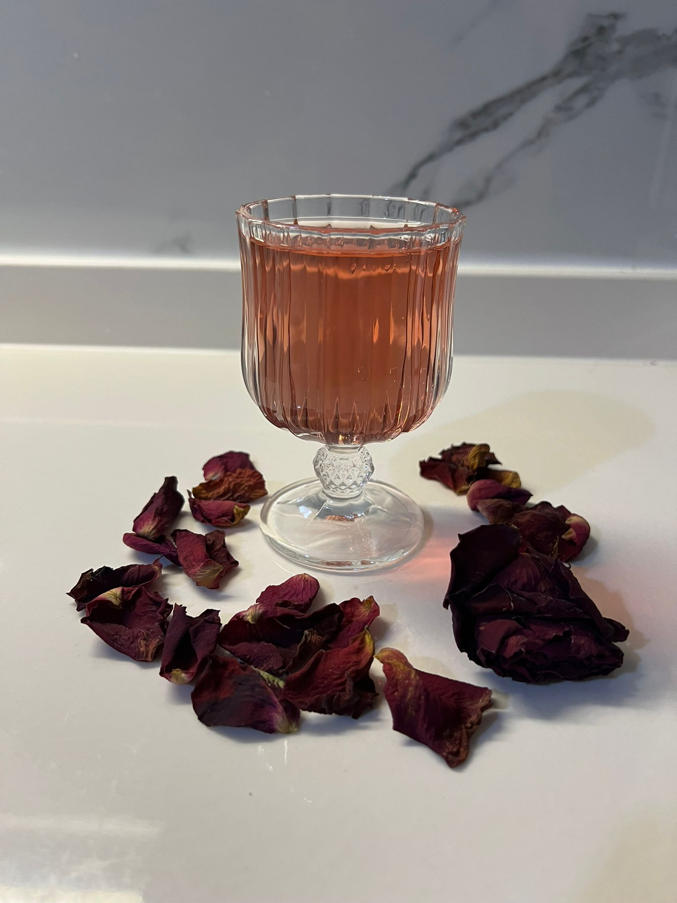

Figure 4. Rose (Rosa damascena) Sherbet

- Innovative sherbets with enhanced functional properties
It is known that musk, rose-water, violet, and/or fruits are added to various types of sherbet in such a way that their sensory properties are compatible with each other. Studies have shown that these ingredients not only improve sensory properties, but also increase functional properties [45].
Karabacak ve ark. (2021) [11] conducted a comprehensive study to investigate the enrichment of purple basil sherbet with propolis extract. The research focused on the impact of various factors on the final product, including the levels of purple basil aerial parts (leaves, flowers and stems) (200-300 g/L), propolis extract (48-72 mg/100 mL), and infusion time (30-40 min), using a Box-Behnken design. The study assessed multiple parameters, including TPC, TAC, color parameters (L*, a*, b*, C*, h°), and sensory properties. Additionally, the antimicrobial activity of the sherbets was thoroughly evaluated. The findings of this study are highly promising and offer an innovative approach to developing a novel purple basil sherbet with enhanced health-promoting properties.
Studies continue on functionally enhanced sherbets by enriching traditional sherbets with vegetable juices (carrot, red cabbage, and cucumber) and using sugar substitutes (stevia or apple juice concentrate) [46].
In another study [47], it was aimed to produce a delicious, appetizing sherbet rich in bioactive components using water, cherry syrup, geranium (Pelargonium graveolens L.), lemongrass (Lippia citriodora L.), medicinal mint (Mentha piperita L.) and marjoram (Origanum majorana L.). The traditional infusion method and the ultrasonic extraction method were compared in this study. As a result, TPC and TAC values measured by the DPPH method were higher in the sherbet samples obtained by ultrasonic extraction (Power 640 W, Frequency 35 kHz) at 80 °C than in other samples. This results indicated that the extraction method preferred in sherbet production was as effective on the final product quality as the ingredients.
Instead of thermal processes such as pasteurization, research is also focusing on the use of high-pressure processing [48] to minimize quality loss during storage. Moreover, microencapsulation studies [49] have recently become intriguing topics for improving sherbet preservation.

CONCLUSION

Traditional beverages are an integral part of cultural heritage and reflect the identity of societies. Sherbets, throughout history, have had a unifying effect in various rituals and encouraged sharing. For centuries, sherbets have been consumed in a wide geographical area, providing a refreshing option to beat the heat during hot summer months and help digestion when consumed alongside meals. These traditional beverages are known to be highly beneficial to health and have been preferred in the prevention and treatment of various diseases.
Sherbets are a rich source of nutrients, containing natural fruit juices, plant extracts, and spices. Especially due to their high content of vitamin C, antioxidants, and other vitamins and minerals, they boost the immune system and protect the body against illnesses. Moreover, traditional sherbets contain natural sugars instead of artificial sweeteners. The point emphasized in this chapter is that preserving traditional sherbets as part of our cultural heritage and increasing their functionality through new research. This approach will enable us to hand down this drink to the next generations.

REFERENCES
[1] P. Yılmaz, "Menengiçten Şuruba: Gaziantep’te Içecek Kültürü," Folklor/Edebiyat, Vol. 18, pp. 25-39, 2012.
[2] Ü. Soylu, "Türk Dilinin Dünya Dilleriyle İlişkisi Bağlaminda Almancaya Geçen Türkçe Sözcükler," Journal Of International Social Research, Vol. 12, 2019.
[3] A. Kayabaşi and T. Bucak, "Şerbetlerin Türk Mutfak Kültüründeki Yeri ve Önemine Dair Bir Araştırma," Ordu Üniversitesi Sosyal Bilimler Enstitüsü Sosyal Bilimler Araştırmaları Dergisi, Vol. 12, pp. 71-96, 2022.
[4] M. Nazir, S. Arif, R. S. Khan, W. Nazir, N. Khalid, and S. Maqsood, "Opportunities And Challenges For Functional And Medicinal Beverages: Current And Future Trends," Trends In Food Science & Technology, Vol. 88, pp. 513-526, 2019.
[5] F. Aydin, "Şairin Mutfağından Şerbet Çeşitleri," Hafiza, Vol. 5, pp. 69-91.
[6] A. Ü. Alçay, S. Yalçin, K. Bostan, And E. Dinçel, "Orta Asya'dan Anadolu'ya Kurutulmuş Gıdalar," Anadolu Bil Meslek Yüksekokulu Dergisi, No. 37, pp. 83-93, 2015.
[7] A. C. Çakici And E. Seçkin, "Yabancı Mutfak Şefleri Gözüyle Türk Mutfağına Ilişkin Bir Değerlendirme," Journal Of Tourism & Gastronomy Studies, Vol. 4, pp. 215-227, 2016.
[8] N. Serçeoğlu, "Yöre Halkının Mutfak Kültürünü Tanıma Durumunun Tespit Edilmesi: Erzurum Ili Örneği," Journal Of Tourism & Gastronomy Studies, Vol. 2, pp. 36-46, 2014.
[9] E. Çetin, "Divanü Lügati’t-Türk’teki Yiyecek İçecek Adlari ve Bu Adlarin Türkiye Türkçesindeki Görünümleri," Çukurova Üniversitesi Sosyal Bilimler Enstitüsü Dergisi, Vol. 14, pp. 185-200, 2005.
[10] M. Tuncel, "Fast-Food (Hızlı Yemek) Sisteminin Türk Mutfağına Uyarlanması ve Bir Uygulama," Anadolu University (Turkey), 2015.
[11] A. Özkan Karabacak, Ö. Özoğlu, S. Durgut, S. R. Bagatirlar, O. Kaçar, C. E. Tamer, M. Korukluoğlu "Development Of Purple Basil (Ocimum Basilicum L.) Sherbet Fortified With Propolis Extract Using Response Surface Methodology," Journal Of Food Measurement And Characterization, Vol. 15, pp. 4972-4991, 2021.
[12] C. E. Tamer, P. Yolci Ömeroğlu, and Ö. U. Çopur, "15 - Functional And Traditional Nonalcoholic Beverages In Turkey," In Non-Alcoholic Beverages, A. M. Grumezescu And A. M. Holban Eds.: Woodhead Publishing, 2019, pp. 483-521.
[13] B. Keskin and E. Güneş, "Social and Cultural Aspects of Traditional Drinks: A Review On Traditional Turkish Drinks," International Journal Of Gastronomy and Food Science, Vol. 25, pp. 100382, 2021.
[14] M. Sarioğlan and G. Cevizkaya, "Türk Mutfak Kültürü: Şerbetler," Ordu Üniversitesi Sosyal Bilimler Enstitüsü Sosyal Bilimler Araştırmaları Dergisi, Vol. 6, pp. 237-250, 2016.
[15] O. Gürson and G. Özçelikay, "Tarçın'ın Tarih Boyunca Ve Günümüzdeki Kullanımı Use Of Cinnamon Throughout The History And Present," Otam Ankara Üniversitesi Osmanlı Tarihi Araştırma Ve Uygulama Merkezi Dergisi, Vol. 18, pp. 171-183, 2005.
[16] A. Batu, "Grape, Pekmez And Human Health," Electr J Food Technol, Vol. 6, pp. 25-35, 2011.
[17] G. T. Bakirci and A. Zeyrek, "The Importance Of Ottoman Sherbets In Today's Turkish Cuisineand Gastronomic Preference For Melon Seed Sherbet (Sübye)," Main Sponsor, pp. 52.
[18] A. Bilgin, "Saray Mutfağı," İçinde A. Bilgin, Ve S. Önçel (Editors), Osmanlı Mutfağı, Ss, pp. 26-48, 2016.
[19] A. C. Sezgin And P. Durmaz, "Osmanlı Mutfak Kültüründe Şerbetlerin Yeri Ve Tüketimi (The Place And Consumption Of Sherbet In Ottoman Cuisine Culture)," Journal Of Tourism & Gastronomy Studies, Vol. 7, No. 2, Pp. 1499-1518, 2019.
[20] S. Güler, "Türk Mutfak Kültürü Ve Yeme Içme Alışkanlıkları," 2010.
[21] İ. Çınar, "Sıcaklık Ve Sürenin Meyan Kökü (Glycyrrhiza Glabra L.) Ekstraksiyonuna Etkisi ve Ekstraksiyon Kinetiğinin Modellenmesi," Gıda Teknolojileri Elektronik Dergisi, Vol. 7, pp. 22, 2012.
[22] M. Tezcan, Türk Yemek Antropolojisi Yazıları. Kültür Bakanlığı, 2000.
[23] N. Özmen and E. Alkin, "Balın Antimikrobiyel Özellikleri Ve Insan Sağlığı Üzerine Etkileri," Uludağ Arıcılık Dergisi, Vol. 6, pp. 155-160, 2006.
[24] J. Lee and C. F. Scagel, "Chicoric Acid Levels In Commercial Basil (Ocimum Basilicum) and Echinacea Purpurea Products," Journal Of Functional Foods, Vol. 2, pp. 77-84, 2010.
[25] I. Telci, E. Bayram, G. Yılmaz, and B. Avcı, "Variability In Essential Oil Composition Of Turkish Basils (Ocimum Basilicum L.)," Biochemical Systematics And Ecology, Vol. 34, pp. 489-497, 2006.
[26] M. Marotti, R. Piccaglia, and E. Giovanelli, "Differences In Essential Oil Composition Of Basil (Ocimum Basilicum L.) Italian Cultivars Related To Morphological Characteristics," Journal Of Agricultural And Food Chemistry, Vol. 44, pp. 3926-3929, 1996.
[27] K. J. Lachowicz et al., "Characteristics Of Plants And Plant Extracts From Five Varieties Of Basil (Ocimum Basilicum L.) Grown In Australia," Journal Of Agricultural And Food Chemistry, Vol. 45, pp. 2660-2665, 1997.
[28] K. R. Mccance, P. M. Flanigan, M. M. Quick, and E. D. Niemeyer, "Influence Of Plant Maturity On Anthocyanin Concentrations, Phenolic Composition, and Antioxidant Properties Of 3 Purple Basil (Ocimum Basilicum L.) Cultivars," Journal Of Food Composition And Analysis, Vol. 53, pp. 30-39, 2016.
[29] N. Eftekhar, A. Moghimi, N. Mohammadian Roshan, S. Saadat, and M. H. Boskabady, "Immunomodulatory and Anti-Inflammatory Effects of Hydro-Ethanolic Extract Of Ocimum Basilicum Leaves And Its Effect On Lung Pathological Changes In An Ovalbumin-Induced Rat Model Of Asthma," Bmc Complementary And Alternative Medicine, Vol. 19, pp. 1-11, 2019.
[30] G. C. Tenore, P. Campiglia, R. Ciampaglia, L. Izzo, and E. Novellino, "Antioxidant and Antimicrobial Properties of Traditional Green and Purple “Napoletano” Basil Cultivars (Ocimum Basilicum L.) From Campania Region (Italy)," Natural Product Research, Vol. 31, pp. 2067-2071, 2017.
[31] M. A. Apan and M. Zorba, "Improvement Of Quality and Shelf-Life Of Subye, A Traditional Beverage Of Turkey," Food Science and Technology, Article Vol. 38, pp. 719-725, 2018.
[32] M. H. Hu and Y. S. Ao, "Characteristics Of Some Nutritional Composition of Melon (Cucumis Melo Hybrid 'Chunli') Seeds," International Journal of Food Science And Technology, Article Vol. 42, pp. 1397-1401, 2007.
[33] N. Özdemirli and S. K. Beştepe, "Kavun Çekirdeği Şerbetinde (Sübye) Fenolik Bileşiklerin Biyoerişilebilirliğinin Değerlendirilmesi," Gıda, Vol. 47, pp. 1130-1139, 2022.
[34] S. Sabancí, C. Celebi, and F. Icier, "Rheological Properties of Sübye, Traditional Beverage," Akademik Gıda, Vol. 12, pp. 11-15, 2014.
[35] N. Tatlı, Geçmişten Günümüze Şerbetler. İstanbul Büyükşehir Belediyesi Kültür A.Ş. Yayınları, 2017.
[36] D. Anilkumar, H. Joshi, and K. Nishteswar, "Review Of Glycyrrhiza Glabra (Yastimadhu)-A Broad Spectrum Herbal Drug," Pharma Science Monitor, Vol. 3, 2012.
[37] S. Aday, C. U. Pala, B. A. Cam, and S. Bulut, "Storage Quality And Microbiological Safety of High Pressure Pasteurized Liquorice Root Sherbet", Lwt-Food Science And Technology, Article Vol. 90, pp. 613-619, 2018.
[38] Ç. U. Pala, C. N. Ekşi, E. Özçelik, and B. A. Çam, "Geleneksel Meyan Kökü Şerbeti Hazırlama Sürecinde Farklı Sıcaklık Uygulamalarının Şerbetin Mikrobiyolojik Kalitesi Ve Biyoaktif Bileşenleri Üzerine Etkisi," Journal Of Tourism & Gastronomy Studies, Vol. 5, pp. 276-286, 2017.
[39] A. Ariño, M. Herrera, G. Estopañan, and T. Juan, "High Levels Of Ochratoxin A In Licorice And Derived Products," International Journal of Food Microbiology, Vol. 114, pp. 366-369, 2007.
[40] R. Dupak, E. Ivanisova, O. Grygorieva, and M. Capcarova, "Antioxidant And Biochemical Characterisation of Cornelian Cherry (Cornus Mas L.)," International Scientific Days, 2022.
[41] A. Baysal, "İşlevsel Besinler," Beslenme ve Diyet Dergisi, Vol. 30, pp. 1-5, 2001.
[42] T. Süren and M. Kizileli, "Geleneksel Türk İçecekleri," Ankara Hacı Bayram Veli Üniversitesi Turizm Fakültesi Dergisi, Vol. 24, pp. 46-71, 2021.
[43] Ş. N. Güneş and T. Akcan, "Yenilebilir Çiçek Olarak Gülün Önemi ve Osmanlı Mutfak Kültüründeki Yeri," Aydın Gastronomy, Vol. 6, pp. 325-334, 2022.
[44] A. Kumar, A. Kaur, V. Tomer, K. Gupta, and K. Kaur, "Effect Of Rose Syrup And Marigold Powder On The Physicochemical, Phytochemical, Sensorial and Storage Properties Of Nutricereals and Milk-Based Functional Beverage," Journal Of The American College Of Nutrition, Vol. 40, pp. 133-140, 2021.
[45] T. Şavkay, Osmanlı Mutfağı. Şekerbank, 2000.
[46] Ş. A. Bakırcı, A. S. Özgören, G. Özcan Sinir, and Ö. U. Çopur, "Geleneksel Şerbetin Sebze Sulari İle Zenginleştirilmesi," Presented At The 5. Geleneksel Gıdalar Sempozyumu, Bursa, Turkey, 2022.
[47] E. Yılmaz, S. Durgut, K. Özdemir, C. E. Tamer, V. Uylaşer, and O. Kaçar, "Ultrasonik Ekstraksiyon ve Geleneksel İnfüzyon Yöntemlerinin Tibbi ve Aromatik Bitkilerden Üretilen Şerbet Üzerine Etkisinin İncelenmesi," Bursa, Turkey, 2022.
[48] A. Serpil, U. P. Çiğdem, B. A. Cam, and S. Bulut, "Combined Effects Of Acidification And High-Pressure Processing On Microbial Inactivation, Bioactive Compounds And Antioxidant Activity of Liquorice Root Sherbet," International Journal Of Agriculture Environment and Food Sciences, Vol. 5, pp. 374-384, 2021.
[49] B. Basyigit and I. Hayoglu, "Liquorice (Glycyrrhiza Glabra L.) Root Sherbet (Extract): Microencapsulation and Storage Stability," Acta Alimentaria, Vol. 48, pp. 76-85, 2019

