SKIN CANCER DETECTION USING SVM AND FCM
Ramasamy.K,Assistant prof,SRC,SASTRA,KUMbakonam

Abstract

Cancer is a serious deadly disease today that is affected by a division that is unable to control the abnormal cells in the human body. Hence, the rapid growth of cancerous is able to invade and to destroy the adjacent structures and also spread in to the distant sites to cause death. Moreover, the cancer is also able to affect all the living cells of all levels of human bodies without gender wise. Even though, the major classifications of skin cancer are melanoma and non-melanoma. Here, the Melanoma is a malignancy of the cells which provide the melanocytes (skin colour) and able to invade the neighbouring tissues. In addition, it is also able to spread throughout the human body and it may lead to cause of death.On the other hand, the non-melanoma spreads in to other parts of the body. For saving the human life and protect the people from the disease skin cancer, this research work introduces new prediction system which is able to predict the type of skin cancer in advance based on theoccurring symptoms in human body. The proposed prediction model carried out three major tasks namely data preprocessing, clustering and the classification.This method aims to introduce a skin cancer detection technique that characterizes which type of cancer it is. The proposed technique includes three stages like Segmentation, Feature Extraction, and Classification. Here, the Fuzzy C-means Clustering (FCM) is used to segment the given input image. GLCM used for feature extraction and SVM for Classification of the given input image.


PROPOSEDMETHOD

Introduction:

Skin cancer is the leading cause of death for people in the modern world. Skin cancer is an abnormal proliferation of skin cells, which can develop anywhere on the body but most frequently does so on areas exposed to sunlight. The majority of skin malignancies can be treated when they are young. Consequently, the patient's life can be saved by a quick and early diagnosis of skin cancer. Skin cancer can now be classified thanks to modern technology. Biopsy is the official procedure for diagnosing skin cancer. Skin cells are removed, and a sample of that is sent for various laboratory tests. The process is tedious and time-consuming.For the classification of skin cancer diseases, we have presented an SVM-based approach for skin cancer detection. For the patients, it is better. Dermoscopy images of skin cancer are captured and put through a variety of pre-processing steps for noise removal and picture improvement. The image is then segmented using the FCM technique. The GLCM method is used to extract the features of a segmented image.

3.1.ProposedMethodology:
The classifier receives these features as input. The Support Vector Machine (SVM) is used to classification As the number of cancers observed worldwide rises daily and these cancers contain various toolscapable of periodically capturing imagery that can be used for a variety of purposes, classifying cancer images is an important task to produce classification maps. As a result, the classification of cancer images is a current research topic, and the classification outcomes can be applied in a variety of real-time applications. By utilising cancer images, this system presented a revolutionary method for classifying five distinct classes, including actinic keratosis, Basel cell carcinoma, cherry nevus, dermatofibroma, and Melanocytic nevus. This method divides its work into different stages in order to produce an effective framework for classifying cancer images; these stages are crucial for providing higher classification accuracy.
The crucial steps that are part of this process are as follows:

    - Segmentation technique using fuzzy c-means clustering (FCM).

    - To extract features, use GLCM.SVM for classifying data.

    - Classification is done using Svm.

Flow Chart:
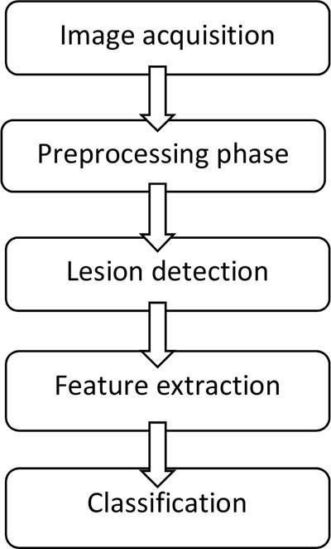

Input Images
Dermoscopic pictures, which are obtained using dermatoscopy, serve as the suggested system's input. An image of a body part's skin lesion can be captured using a form of magnification. Skin disease diagnosis is made significantly easier by the hand-held tool.
Dermoscopy is a useful method for melanocytic lesion diagnosis, particularly nevus and melanoma. Dermoscopy reveals a variety of pigmented structures, such as pigment networks, spots and globules, and streaks. Typically, 2D vertical images are employed to illustrate how dermoscopy and histopathology are related Doctors with dermatoscopy expertise had much higher diagnostic accuracy for melanoma than physicians without such training. In comparison to a naked eye examination, the sensitivity and specificity have thus significantly improved.
When compared to a naked eye examination, the accuracy of dermatoscopy increased by up to 10% for specificity and up to 20% for sensitivity.Dermatoscopy increases specificity, which lowers the frequency of unneeded surgical excisions of benign lesio

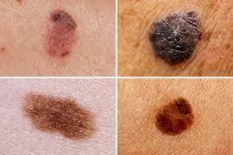

Fig4.1ExampleOfDermoscopic

In this method we are using dermoscopic images for the classification of cancer.

Pre-processing
The main challenge in the CAD system because the transition between the skin lesion and the surrounding skin is smooth, it is to distinguish or detect the skin lesion from healthy skin. In digital dermoscopy, an image is captured in a digital format to obtain a clear image, however the clarity of the image is impacted by the presence of different artefacts, including hair, air bubbles, ruler markings, specular reflections, and interlaced video field misalignment. Due to the lesion's close resemblance to the surrounding skin, these artefacts reduce the quality of the collected image and increase the likelihood that the lesion will not be correctly identified. Preprocessing is therefore the initial step in enhancing the skin image quality by removing noise or artefacts. If the preprocessing is not done correctly, the categorization of the image may be incorrect and the computational time may increase.
The enhancement of the image by adjustment of both Contrast and Brightness (decrease light illumination) is the first step in pre-processing. Contrast is defined as the alteration in colour or luminance that identifies an object in the image, giving it a distinct and individual appearance. The contrast in that area is determined by how much a pixel differs from its neighbours.
Brightness can be defined as the sensitivity brought about by a visual mark's brightness. A bright
pixel has a greater value when it is processed into an image. As a result, we enhanced our photos by adding a scale factor and delta to the scaled values.
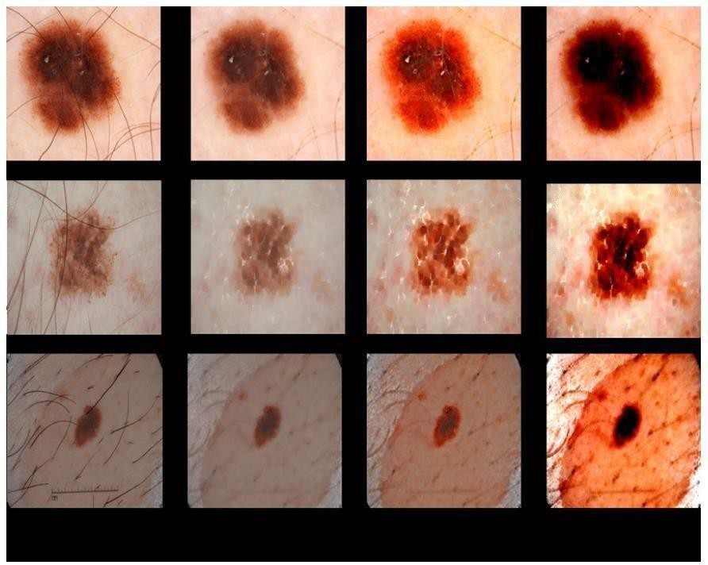

Fig3.3ImageEnhancement

Segmentation:
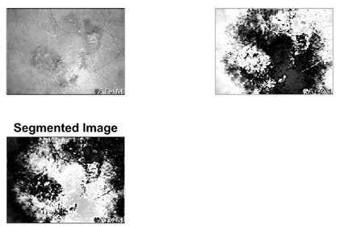
Segmenting the pre-processed photos is the third step. The segmentation procedure is used to determine the precise location of the skin lesion. This sub component is used to perform theimage segmentation task in this data pre-processor of the proposed prediction model. The image segmentation process is used for partitioning an original division of the skin image into various components, such as sets of pixels and super-pixels. The main aim of this segmentation processis for simplifying or changing the representation of an input skin image into useful informativeimage which is easy to analyze. Moreover, it is also used to place the various image objects and the boundaries such as lines, curves, etc. in input images. Finally, it assigned new
labels toall pixels in an image and also covers the entire input skin image.

Fig.3.4.ImageSegmentation

Feature Extraction:

Feature extraction from the segmented skin lesion is the fourth stage. With the use of this retrieved information, feature extraction was carried out to obtain exact information about the skin lesion, including its border, colour, diameter, symmetry, and textural nature. Cancerous skin can be classified with ease.
The dimensionality reduction procedure, which involves splitting and condensing a starting set of raw data into smaller, easier-to-manage groupings, includes feature extraction. As a result, processing will be simpler. The fact that these enormous data sets contain a lot of different variables is their most crucial feature. Processing these variables takes a lot of computing power. By choosing and combining variables into features, feature extraction helps to extract the best feature from those enormous data sets, so significantly lowering the amount of data. These features are simple to use while still accurately and uniquely describing the real data set.
In this proposed methodology we use gabor filter and GLCM algorithm in order to extract feature.
3.5.1.FeatureextractionusingGaborfilter:
The Gabor filter can be tuned with various orientations and scales to extract local/global spatial textural micro-patterns in the region of interest. As a result, it offers strong statistics that are crucial for the identification of cancer. A column vector-like input image is used to extract gabor features. These feature vectors have been normalised to a variance of one and a mean of zero.
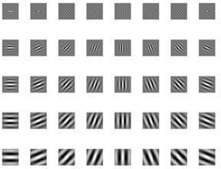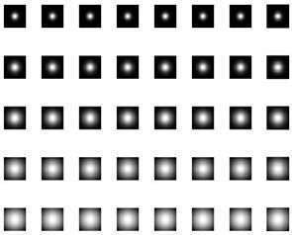
Fig3.5.RealAndMagnitudesPartsOfGaborFilter

3.5.2 Gray-Level Co-Occurrence Matrix (GLCM):

The gray-level co-occurrence matrix (GLCM), often referred to as the gray-level spatial dependence matrix, is a statistical technique for analysing texture that takes into account the spatial relationship of pixels. The GLCM functions determine how frequently pairs of pixels with particular values and in a particular spatial relationship occur in an image, forming a GLCM, and then extracting statistical measures from this matrix to characterise the texture of an image.
The Grey Level Co-Occurrence Matrix (GLCM), which has gained popularity, is a statistical technique for removing textural details from photographs. Haralick defines fourteen textural features, measured from the probability matrix in accordance with the co-occurrence matrix, in order to extract the texture statistics of remote sensing photos.


3.6.Classification:

One of the most common human decision-making activities is the classification of data. In this step, the classifier divides the various disease types into five categories. Choosing a classifier is thus a crucial step. SVM classifier is employed for doing classification for the suggested method. Support vector machines are supervised learning models that are popular in machine learning for categorization. The hyperplane that defines decision boundaries is the foundation of the SVM concept. The items that will distinguish classes are divided by the SVM hyperplane.

3.6.1SupportVectorMachine(SVM):
Support vector machine (SVM) classifiers are the most common type. The main benefit is a uniform framework, meaning that many machine learning architectures may be produced by selecting the right kernel. SVM classifier is used to classify both benign and malignant skin lesions based on their collected attributes..
One of the most used machine learning algorithms for data classification is SVM. It is built on
the idea of decision planes, which establish decision boundaries by dividing objects into different classes.
These element vectors (colour and texture) are used by the Support Vector Machine method to set up and train our suggested structure. Each cancer image's colour and texture properties are kept in a database and used for the subsequent stage of categorization.

The SVM structure that is suggested will classify the cancer images according to their component vectors, Colour and Texture, and organise them into relevant categories.
Support vector machines (SVM) are potent yet adaptable supervised machine learning algorithms used for both regression and classification. Compared to other machine learning methods, support vector machines are implemented in a different way. They are very well-liked because they can manage numerous continuous and categorical variables. A support vector machine model is just a hyperplane in multidimensional space that represents several classes. Support vector machines will iteratively create the hyperplane in an effort to reduce error. The datasets must be divided into classes in order to identify the maximum marginal hyperplane. It creates a hyperplane or set of hyperplanes in a high-dimensional space, and the hyperplane with the greatest distance from the closest training data point for any class achieves good separation between the classes. The kernel function being employed determines the algorithm's true power.
Different distance metrics are used to assess feature similarity for the efficient classification of the image with other images. Here, SVM classifiers were used to compare the similarities between the photos from the database.

The SVM classifier will calculate the feature values of the input image and the database images; using these values, it will determine which class the input image belongs to.
There are five type of diseases which are Actinic Keratosis, Baselcell carcinoma, Cherry nevus, Dermatofibroma, Melanocytic nevus which we are going to classify by the SVMalgorithm.
When the input image is passed through the classification process, the output of the classifier shows the type of cancer image.



Fig3.6.Classification Of Skin Cancer Image

By this proposed methodology, the accuracy is 95% which is more than the existing methodology which helps to classify the cancer image.
RESULTS

4.1 Results
The proposed classification model has been implemented by using MATLAB tool. The class distribution of image dataset was divided into training and testing. Fuzzy c-means clustering method is utilized to perform segmentation process. Support vector algorithm classifies the given skin cancer image with 95% accuracy.

The five types of skin cancer diseases where the proposed method classifies are the melanocytic nevus, cherry nevus, dermatofibroma, actinic keratosis, and Basel cell carcinoma. Actinic Keratosis
Sample1.1
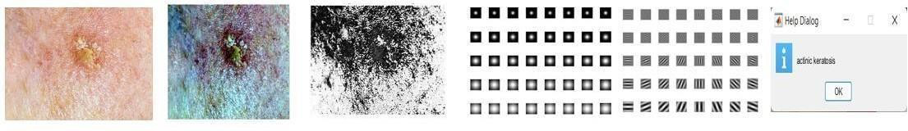

Fig4.1 :Processingofsampleimage1.1
The classifier detects that the given input image 1.1 is Actinitic Keratosis.


Sample1.2

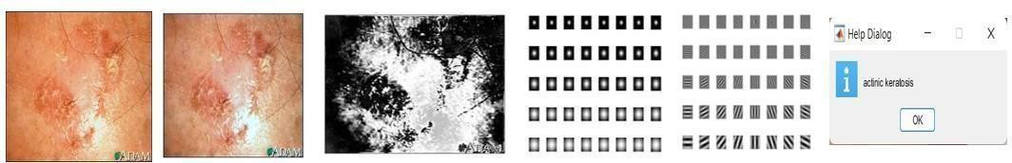

Fig 4.2 : Processing of sample image 1.2 The classifier detects that the given input image 1.2 is actinitic keratosis. Basilcell carcinoma

Sample 2.1
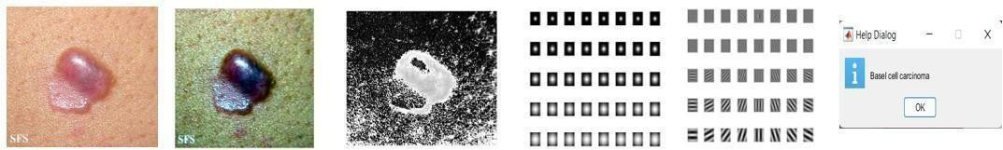
Fig 4.3 : Processing of sample image 2.1
The classifier detects that the given input image 2.1 is Basilcell Carcinoma

Sample 2.2

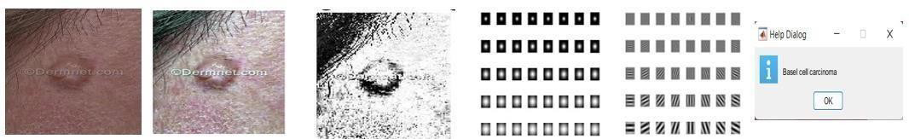
Fig 4.4 : Processing of sample image 2.2

The classifier detects that the given input image 2.2 is Basilcell Carcinoma.

Cherry nevus Sample 3.1
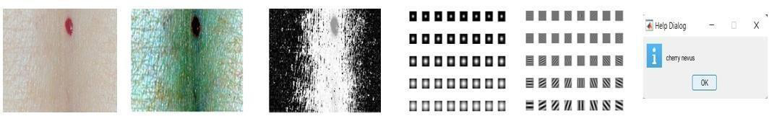

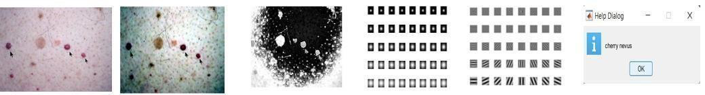
Fig 4.5: Processing of sample image 3.1 The classifier detects that the given input image 3.1 is Cherry nevus Sample 3.2

Fig 4.5: Processing of sample image 3.2
The classifier detects that the given input image 3.2 is Cherry nevus

Dermatofibroma

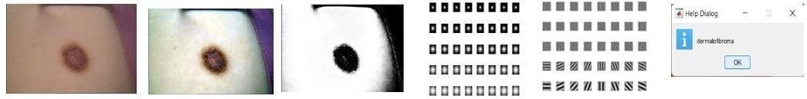
Sample 4.1

Fig 4.6: Processing of sample image 4.1
The classifier detects that the given input image 4.1 is Dermatofibroma

Sample 4.2

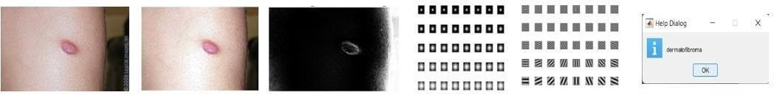

Fig 4.7: Processing of sample image 4.2
The classifier detects that the given input image 4.2 is Dermatofibroma

Melanocyclic nevus Sample 5.1
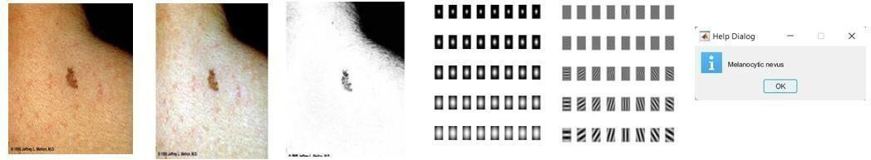

Fig 4.7: Processing of sample image 5.1
The classifier detects that the given input image 5.1 is Melanocyclic nevus

Sample 5.2

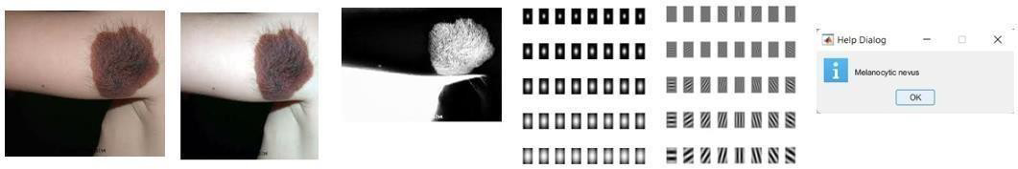

Fig 4.8: Processing of sample image 5.2

The classifier detects that the given input image 5.2 is Melanocyclic nevus

Performance evaluation measures have been used in the evaluation process. All of these performance assessments are used to show how well the classifier performs.
Accuracy = (TP+TN)/ (TP+FP+FN+TN)

Sensitivity = TP / (TP + FN)

Specificity = TN / (FP + TN) Precision =TP / (TP + FP)

100 test photos were used for the testing. Accuracy is determined using the formula below.

Table 4.1: Performance of SVM Classifier for actinic keratosis type skin cancer

Parameters | SVM  classifier
TP | 16
TN | 3
FP | 0
FN | 1
Accuracy | 95%
Sensitivity | 94%
Specificity | 98%
Precision | 100%

Table 4.2: Performance of SVM Classifier for Basel cell carcinoma

Parameters | SVM  classifier
TP | 17
TN | 2
FP | 0
FN | 1
Accuracy | 95%
Sensitivity | 96%
Specificity | 95%
Precision | 100%

Table 4.3: Performance of SVM Classifier for cherry nevus
Parameters | SVM  classifier
TP | 16
TN | 2
FP | 1
FN | 1
Accuracy | 96%
Sensitivity | 94%
Specificity | 96%
Precision | 94%

Table 4.4: Performance of SVM Classifier for dermatofibroma

Parameters | SVM  classifier
TP | 15
TN | 3
FP | 0
FN | 2
Accuracy | 96%
Sensitivity | 93%
Specificity | 97%
Precision | 100%

Table 4.5: Performance of SVM Classifier for Melanocytic nevus
Parameters | SVM  classifier
TP | 15
TN | 4
FP | 0
FN | 1
Accuracy | 95%
Sensitivity | 93%
Specificity | 98%
Precision | 100%
Table 4.6: Comparison of SVM classifier performance for various dermoscopic images
S.no | Type | Accuracy(%) | Sensitivity(%) | Specificity(%) | Precision(%)
1 | Actinic Keratosis | 95 | 94 | 98 | 100
2 | Baselcell carcinoma | 95 | 96 | 95 | 100
3 | Cherry nevus | 96 | 94 | 96 | 94
4 | Dermatofibroma | 96 | 93 | 97 | 100
5 | Melanocytic nevus | 95 | 93 | 98 | 100

Table 4.7 compares the suggested procedures with other strategies using an accuracy parameter. When compared to the other methods, the proposed model has the highest accuracy.

Table 4.7Comparison of proposed techniques with other techniques

Author | Year | Method | Prediction Type | Accuracy
Esteva et. al. | 2017 | Classification of skin cancer using deep neural networks | Multi Class | 60%
Jessica et. al | 2019 | Skin cancer | Multi | 91.8%
Jessica et. al | 2019 | detection | Class | 91.8%
Jessica et. al | 2019 | using mobile |  | 91.8%
Jessica et. al | 2019 | network |  | 91.8%
Jessica et. al | 2019 | CNN |  | 91.8%
Moussa et. al | 2016 | Computer- | Multi | 89%
Moussa et. al | 2016 | Aided | Class | 89%
Moussa et. al | 2016 | Detection of |  | 89%
Moussa et. al | 2016 | Melanoma |  | 89%
Moussa et. al | 2016 | Using |  | 89%
Moussa et. al | 2016 | Geometric |  | 89%
Moussa et. al | 2016 | Features. |  | 89%
Proposed Method |  | Skin cancer detection using FCM And SVM | Multi Class | 95%

Comparison of Accuracy fromdifferent
methods
1

2

3

4
Accuracy
86%
88%
90%
92%
94%
96%

Fig5.12 comparing different method with proposed method

From the analysis When compared to other methods, the suggested method has a high level of accuracy.
Consequently, it is a useful method for identifying the various diseases visible in the provided dermoscopic image.

CONCLUSION

The most frequent cause of death among people is skin cancer. cancer of the skin Skincancer most frequently appears on exposed skin, though it can happen elsewhere on the body.The majority of skin malignancies can be treated when they are young. Consequently, the patient's life can be saved by a quick and early diagnosis of skin cancer. Early identification ofskin cancer at its earliest stages is now achievable thanks to new technology. Biopsy is the official procedure for diagnosing skin cancer. Skin cells are removed, and a sample of that is sent for various laboratory tests. The process is tedious and time-consuming. We have developed a system for early skin cancer illness diagnosis using SVM to address this issue. Forthe patients, it is better. A dermoscopy image of skin cancer is captured, then it is pre-processedusing a variety of techniques to reduce noise and improve the image. The image is then segmented using the FCM technique. By employing the GLCM approach, features from segmented image one were retrieved. The classifier receives these features as input. SVM, or support vector machines, are employed for classification..

Conclusion

In this study, we proposed a segmentation technique and to increase classification accuracy. In preprocessing to eradicate noise imfilter is utilized. Fuzzy c-meansclustering algorithm is proposed for segmentation process. For feature extraction Gabor filter as well as Grey LevelCo-Occurrence Matrix. Static Vector Machine is suggested for the classification process. Performance Metrics is calculated for this method in which Accuracy 95%, Sensitivity 94%, Specificity 98%, Precision 97%.This method is contributed to increasing the segmentation under classification accuracy when compared to other methods.

REFERENCES
    - Andre Esteva, Brett Krupel and Sebastian Thrun, Deep Networks for Early Stage Skin
Disease and Skin Cancer Classification, Stanford University, 2015.

    - Dermatology Education. (n.d.) Homepage. [online] Available at: http://www.dermnet.com
    - P. R. Hill, H. Bhaskar, M. E. Al-Mualla and D. R. Bull, Improved Illumination Invariant Homomorphic Filtering using the Dual Tree Complex Wavelet Transform, 2016 IEEE Internaional Conference on Acoustics, Speech and Signal Processing (ICASSP), Shanghai, 2016, pp. 1214-1218.
    - Gonzalez, R. C. and R. E. Woods, Digital Image Processing, Pearson Education, 2002.

    - Sonali Patil and V. R. Udupi, Using Histogram Specification in a Hybrid Preprocessing Technique for Segmentation of Malignant Skin Lesions from Dermoscopic Images, International Journal of Computer Science Engineering and Information Technology Research, Vol. 5, Issue 4, 71- 82, August 2015.
    - Noboyuki Otsu, A Threshold Selection Method from Gray-Level Histograms, IEEE Transactions On Systems, Man, And Cybernetics, Vol. SMC-9, No. 1, January 1979.
    - Chiranjeev Sagar and Lalit Mohan Saini, Color Channel Based Segmentation of Skin Lesion from Clinical Images for the Detection of Melanoma, 2016 IEEE 1st International Conference on Power Electronics, Intelligent Control and Energy Systems (ICPEICES), Delhi, 2016, pp. 1-5.
    - N. F. M. Azmi, H. M. Sarkan, Y. Yahya and S. Chuprat, ABCD Rules Segmentation on Malignant Tumor and Benign Skin Lesion Images, 2016 3rd International Conference on Computer and Information Sciences (ICCOINS), Kuala Lumpur, 2016, pp. 66-70.
    - Karen Simonyan and Andrew Zisserman, Very Deep Convolutional Networks for Large- Scale Image Recognition, arXiv:1409.155v6, 10th April 2015.
    - R. Moussa, F. Gerges, C. Salem, R. Akiki, O. Falou and D. Azar, Computer-aided detection of Melanoma using geometric features, 2016 3rd Middle East Conference on Biomedical Engineering (MECBME), Beirut, 2016, pp. 125-128.

Masood A., Al-Jumaily A.A., Adnan T., Development of Automated Diagnostic System for Skin Cancer: Performance Analysis of Neural Network Learning Algorithms for Classification, Wermter S. et al. (eds) Artificial Neural Networks and Machine Learning -
ICANN 2014. ICANN 2014. Lecture Notes in Computer Science, vol 8681. Springer, Cham

[12]Miss Hetal J. Vala and Prof. Astha Baxi, A Review on Otsu Segmentation Algorithm, International Journal of Advanced Research in Computer Engineering and Technology, Vol. 2, Issue 2, February 2013.
[13]R. Kasmi and K. Mokrani, Classification of malignant melanoma and benign skin lesions: implementation of automatic ABCD rule, in IET Image Processing, vol. 10, no. 6, pp. 448-455,6 2016.
- Grammatikopoulos, G. and Hatzigaidas, A. and Papastergiou, A. and Lazaridis, P. and Zaharis,

Z. and Kampitaki, D. and Tryfon, G., Automated Malignant Melanoma Detection Using MATLAB, Proceedings of the 5th WSEAS International Conference on Data Networks, Communications and Computers, DNCOCO’06, Bucharest, Romania, 2006.
- Marquardt, D.W., An Algorithm For Least-Squares Estimation of Nonlinear Parameters, Journal of the Society for Industrial and Applied Mathematics, Vol. 11, No. 2, June 1963.

