Development of magnesium and magnesium alloys for biomedical application: A critical review

M. Venkatesh ¹ A.Johnson ^{2, *}

¹ Assistant Professor, ² Sr.Assitant Professor,
Department of Mechanical Engineering, Department of Mechanical Engineering,
Kamala Institute of Technology and Science, Kamala Institute of Technology and Science,
Singapur,Telangana,505468, India Singapur,Telangana,505468, India

ABSTRACT
Owing to their importance in restoring human bony defects and replacing hard tissue, bone repair materials are quickly becoming a hot topic in the field of biomedical materials. Due to their in situ degradation in the body, mechanical properties similar to those of bones, and ability to positively promote the development of new bones, magnesium (Mg) alloys are potentially biocompatible, osteoconductive, and biodegradable metallic materials that can be used in bone repair. Mg alloys have astonishing advantages over the commercially available stainless steel, Co-Cr-Ni alloys, and titanium implants. However, in physiological settings, rapid degradation of these materials can result in gas cavities, hemolysis, and osteolysis, limiting their clinical orthopaedic applications,which attracted many researchers to resolve by developing several strategies which includes new alloys, composites, surface coatings and microstructure modifications. The new study on the use of Mg alloy implants in bone repair is discussed in this article. The most recent research on alloy design, surface modification, and biological performance of Mg alloys is analysed in detail.
Keywords: Magnesium Alloys,Biomedical applications,Biomaterials,Orthopedic implants,Cardivascular implants
- INTRODUCTION
Bones, the body's largest complex biological tissue, are made up of inorganic minerals and metabolically active cells surrounded by a large volume of extracellular matrix, and they form a rigid structure that plays an essential role in sustaining life activities such as body support and organ protection [1, 2]. Surgical treatment of bone injuries has become normal, with millions of bone injury patients presenting to emergency departments around the world each year as a result of participation in strenuous sporting activities, social dysfunction, traffic accidents, and a longer lifespan [3,4]. Bone defects, which are most often caused by traumatic avulsions, infection-induced bony sequestration, congenital malformations, or neoplastic resections, pose a major reconstructive challenge. The need to stimulate bone regeneration in order to repair structural bone defects has led to the creation of a wide range of bone repair materials [2, 5]. Bone repair is a physiological mechanism that is affected by biomechanical, biochemical, cellular, hormonal, and pathological factors. Bone repair is aided by continuous bone deposition, resorption, and remodelling as well as adequate blood supply [7]. Various bone repair materials have been developed based on the fundamental concepts of bone tissue healing. Autograft bones have long been considered the gold standard of bone repair materials when replacing weakened or lost bones because they have all of the osteoconductivity, osteogenicity, and osteoinductivity characteristics needed to promote new bone development. However, resources for these autografts are restricted, and patients' pain is exacerbated by secondary surgeries. Alternative bone replacement products, such as bone replacements, are rapidly being used to replace autograft bones. Calcium (Ca) phosphate ceramics, calcium (Ca) sulphate, bioactive glass, natural materials, and biological/synthetic composites are among the most widely used materials [8]. These products, on the other hand, perform poorly in clinical settings. However, these materials clinical performance is unsatisfactory. Some, for example, have weak mechanical properties and show minimal osteoinduction in the clinic [9, 10]. Another method for restoring or removing diseased or damaged bone tissue is metallic materials. Stainless steel and titanium alloys are currently commonly used in orthopaedics because they are mechanically solid and fracture resistant [11]. However, corrosion and/or wear have the ability to release metallic ions and/or particles, which can cause inflammatory responses, reducing biocompatibility and contributing to tissue loss. Furthermore, metals and bone have substantially different elastic moduli and tensile forces, which can result in stress shielding and weakening of surrounding bone. Once the bone fracture has healed completely, these inert implants must frequently be removed via invasive secondary surgeries. Biodegradable implants may be used to replace conventional metal implants and eliminate the need for secondary procedures, resulting in less pain for patients and lower medical costs [12–14].
Owing to their good biocompatibility, biodegradability, and reasonable mechanical properties, magnesium (Mg) alloys have a reputation for being innovative biodegradable metal materials in orthopaedic applications [15–17]. Mg is the fourth most abundant cation in the human body and is mainly contained in bone tissue. It is an important component of many metabolic processes. Mg is a mineral that is taken into the body in large quantities on a regular basis. It promotes the growth of bone cells and speeds up the healing of bone tissue. Due to the involvement of Cl⁻ in the physiological environment, Mg alloys degrade in vivo, obviating the need for additional surgeries to remove the implant. Since excess Mg cations are easily removed in the urine, Mg2+, a corrosion agent of Mg alloy implants, does not cause unexpected complications [17,18]. Mg alloys also have mechanical properties that are similar to those of bone. Unlike titanium alloys (Ti-6Al-4V 4.47 g/cm³) and stainless steel (about 7.8 g/cm³), magnesium alloys are lightweight, with densities (1.7–1.9 g/cm³) that are very similar to those of human cortical bone (1.75 g/cm³). As compared to the elastic moduli of titanium alloys and stainless steel, the elastic modulus of Mg alloys, about 45 GPa, is comparatively similar to that of natural bone, 3–20 GPa (110 and 200 GPa, resp.). As a result, the stress shielding induced by the substantial mechanical mismatch between natural bone and metal implants should be reduced [19, 20]. As a result, Mg alloys for orthopaedic implants should be biocompatible, biodegradable, lightweight, and load-bearing. [12, 21].
Even though research on Mg alloys as bone implants has progressed significantly over the last 20 years, rapid degradation of these materials within the human body remains a major impediment to their clinical use. As biodegradable materials, it's critical that implant degradation corresponds to the rate of bone tissue healing, which typically includes an early inflammatory stage lasting 3–7 days, a reparative stage leading to a solid healing union lasting 3–4 months, and then a remodelling period lasting months to years [22]. As a result, at least 12 weeks of stability is needed for the implant [12]. The currently available Mg alloys, on the other hand, degrade too rapidly during implantation to be useful.
In the manufacture of magnesium alloys for use in bone repair, there have been a variety of recent opportunities and challenges. As a result, a summary of the findings of researchers in this field is needed. In comparison to recent reviews [15, 23], this paper is more focused and discusses biodegradable Mg alloys for use in bone repair. The in vitro and in vivo biological performance of Mg in bone repair are addressed, as well as the alloying design, surface modifications, and in vitro and in vivo biological performance of Mg. Novel insights are also explored that have been used to improve the compatibility and strength of biomedical Mg alloys in the field of bone reconstruction.
II. MAGNESIUM ALLOYS: ALLOYING DEVELOPMENT
For biodegradable implants to be used in orthopaedic applications, they must have sufficient strength, ductility, fatigue resistance, and biocorrosion resistance. Several Mg alloys have been developed to meet the requirements of bone repair implant materials because adding alloying elements will enhance mechanical properties and decrease Mg corrosion rate by changing the structure and phase distribution [17, 30,].

A. Alloying Elements.
The first step in designing magnesium alloys is to carefully choose alloying components. Adding elements like Al, Zn, Ca, Ag, Ce, and Th to Mg-based materials can result in different microstructures and improved mechanical properties [32, 33]. In terms of corrosion, alloying elements with electrochemical potentials similar to Mg (2.37 V), such as Y (2.37 V), Nd (2.43), and Ce (2.48), as well as those with reasonably high solid solubility in Mg, such as Sc (25.9% limit), Gd (23.5 wt. percent limit), and Dy (25.3 wt. percent limit), will enhance corrosion resistance by minimising internal galvanic corrosion in physiological environments [20, 34, 35]. It's also essential to understand biocompatibility. Previous research has shown that biological nutrients (e.g., Ca, Sr, Zn, Si, and Mn) and trace nontoxic elements (e.g., Zr, Nd, and Y) added to the Mg matrix, either separately or together, do not cause adverse local tissue responses and are easily absorbed by surrounding tissues [16, 19, 36]. Researchers have begun to try to endow Mg alloys with new biomedical functions by alloying, thanks to the development of biodegradable Mg alloys. Ca, Sr, Ag, and Cu have all been shown to facilitate bone cell activation and new bone formation as biofunctional trace metallic components. These components, in addition to promoting osteogenesis, also inhibit bacterial infection after implantation, lowering morbidity and mortality by alkalinizing the environment and releasing antimicrobial metallic ions [37,39].

B. Alloy Structures
Some commercial Mg alloy systems were chosen as biodegradable Mg alloys at an early stage due to their combination of strong mechanical properties and corrosion resistance. The AZ (Mg-Al-Zn), WE (Mg-RE-Zr), and ZK (Mg-Zn-Zr) sequence alloys are commercial Mg alloys used in biological research. In recent years, the AZ series alloys, especially AZ31 (Mg-3Al-1Zn) and AZ91 (Mg-9Al-1Zn), have been extensively studied in vitro and in vivo [40]. In physiological environments, it has been documented that AZ31 and AZ91 alloys release hydrogen, resulting in a substantial increase in pH and Mg ion concentration [41]. The AZ31 alloy degrades more slowly in Hank's solution than the AZ91 alloy, but there is no discernible difference in vivo [42]. A biocompatible Ca phosphate protective film coating covers the surfaces of the AZ31 and AZ91 alloys, which increases the development of new bone mass around the implants, according to short-term in vivo studies[42, 43].
Due to the formation of a rare-earth (RE) oxide film in aqueous environments,WE series alloys have good biocorrosion resistance. WE54 (1.58 Nd, 4.85 Y, 0.28 Zr, 0.08 Ce, 0.13 Gd, 0.16 Er, 0.13 Yb, and balanced Mg in wt. percent) has been shown to have a slightly higher resistance to degradation in vitro than pure Mg, and heat treatment affects its degradation [44]. Witte et al. looked at the biocompatibility of four different Mg alloys in vivo and found that WE43 (4.16 Y, 3.80 RE, 0.36 Zr, 0.20 Zn, and 0.13 Mn, all in wt. percent) is the most biocompatible [43]. However, significant increase in Al ion concentration in the brain has been linked to Alzheimer's disease, and significant hepatotoxicity has been reported following the administration of RE elements including Y, Ce, and Pr [5].
Because of the good biocompatibility of the component elements, ZK series alloys, especially ZK40 (Mg-4Zn-0.5Zr) and ZK60 (Mg-6Zn-0.5Zr), have recently attracted the attention of researchers [45]. Mg-Zn-Zr alloys are more appealing than Mg-Al-Zn and Mg-RE-Zr alloys in terms of element biocompatibility and biosafety, and are candidate biodegradable metals for use in bone repair devices [14]. A daily consumption of 11 mg Zn and 50 µg Zr is permissible, so Mg-Zn-Zr alloys are more desirable than Mg-Al-Zn and Mg-RE-Z .The alarmingly high rates of degradation of Mg-Zn-Zr alloys, on the other hand, limit their potential production.
New Mg alloys, such as Mg-Ca, Mg-Sr, Mg-Zn, and Mg-RE alloy systems, have been developed for use in orthopaedic applications in addition to the above commercial Mg alloy systems.
Ca, when used as a grain-refining agent in Mg alloys, can stabilise grain size up to 0.5 percent of the Ca content and cause minor decreases as more Ca is added [46]. Ca is a major component of human bone, and it is essential for bone cell signalling and healing. Mg-1Ca alloy does not cause cytotoxicity, and osteoblasts and osteocytes are highly active around Mg-1Ca alloy pins implanted in rabbit femoral shafts, suggesting good biocompatibility and bioactivity. [38].
Strontium (Sr) and calcium (Ca) are members of the same family and share physical, chemical, and biological properties. Mg-x wt. percent Sr alloys (x = 0.5, 1.0, and 1.5 wt. percent ) were analysed by Brar et al., who discovered that the Mg-0.5Sr alloy deteriorated the slowest [19]. As-extruded Mg-0.5Sr and as-rolled Mg⁻²Sr alloys had the strongest combination of corrosion resistance, high strength, and in vivo biocompatibility, according to Zhao et al. and Gu et al., respectively [39].
Zinc (Zn) is one of the most available essential nutrients in the human body, and its use in biomedical applications is considered healthy [47]. The rate of Mg corrosion can be reduced by increasing the mass fraction of Zn mixed with Mg, thus strengthening the mechanical properties of Mg through solid solution hardening [48]. Cai et al. reported that a Zn content of up to 5 wt.% in Mg-Zn binary alloys exhibits grain boundary, solid solution, and secondary phase strengthening, resulting in improved resistance to corrosion and mechanical properties [49]. Mg-6Zn alloy has good biocompatibility in vitro based on hemolysis and MC3T3-E1 cell adhesion assays [55].
Because Mg-RE alloys have good mechanical properties and corrosion resistance, new Mg-RE alloys, such as Mg- Y, Mg-Nd, Mg-Gd, Mg-Ce, and Mg-Ld, have been studied. Among these, Mg-Nd alloy has a much slower corrosion rate than the other alloys [33]. Mg-Y alloy was prepared using a zone solidification method and improved corrosion resistance and mechanical properties [56]. Mg-Y-Zn alloy contains an interesting combination of preferred microstruc- tural, mechanical, electrochemical, and biological properties, making it very promising for use as a biodegradable implant material [57].
C. Microstructures of Alloys
In Mg alloys, alloying elements can exist as second-phase particles that precipitate in grains or grain boundaries, dramatically improving mechanical properties by second-phase strengthening. The usual morphologies of second phases for Mg alloys are shown in Figure 1, and the second phases of biodegradable Mg alloys are listed in Table 1. Second phases have higher potentials than Mg matrix, which may promote corrosion and leaching into the physiological environment, as well as matrix degradation. Kannan used electrochemical measurements to investigate the degradability of Mg₁₇Al₁₂ process in simulated body fluid (SBF) and discovered that the degradation rate of Mg₁₇Al₁₂ was lower than that of bare Mg.

Table 1. Typical second phases of biodegradable magnesium alloys [65, 66]
Magnesium alloys that are biodegradable | Second phases of magnesium matrix
AZ31B [61], AZ61D | Mg17Al12
Mg-Ca | Mg17Al12, Al8Mn5
Mg-Sr | Mg2Ca
Mg-Zn | Mg17Sr2, Mg2Sr
Mg-Zn-Ca | MgZn2
Mg-Si | Mg2Zn3
Mg-Al-Si | Mg2Si
WE43 | Mg2Si
WE43 [69] | Mg24Y5, Mg41Nd5, Mg12Nd
ZK60 [70] | MgZn, MgZn2

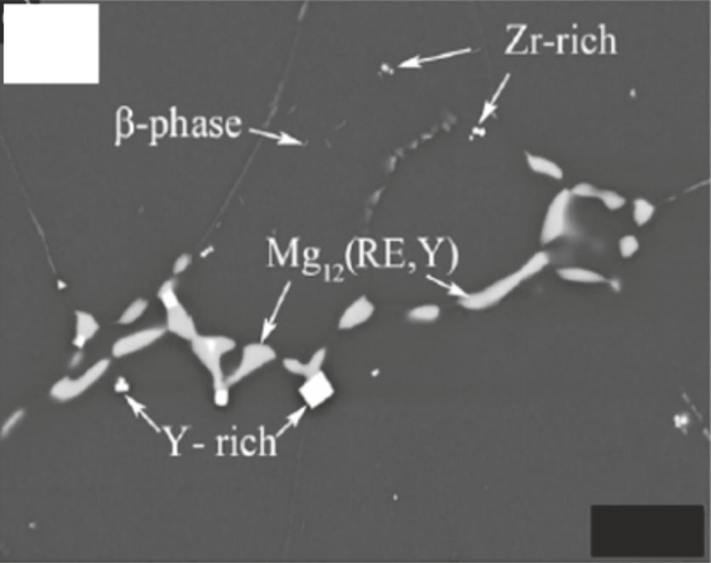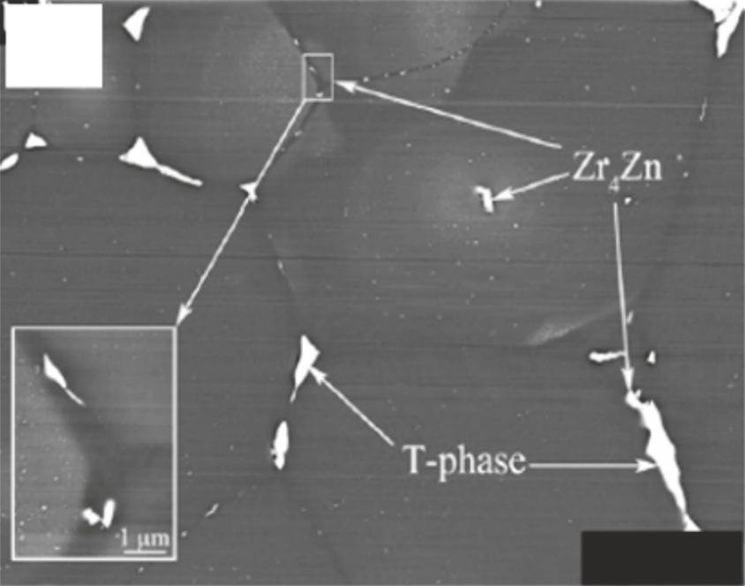
(b)
10 Ｇ
(a)
20 Ｇ
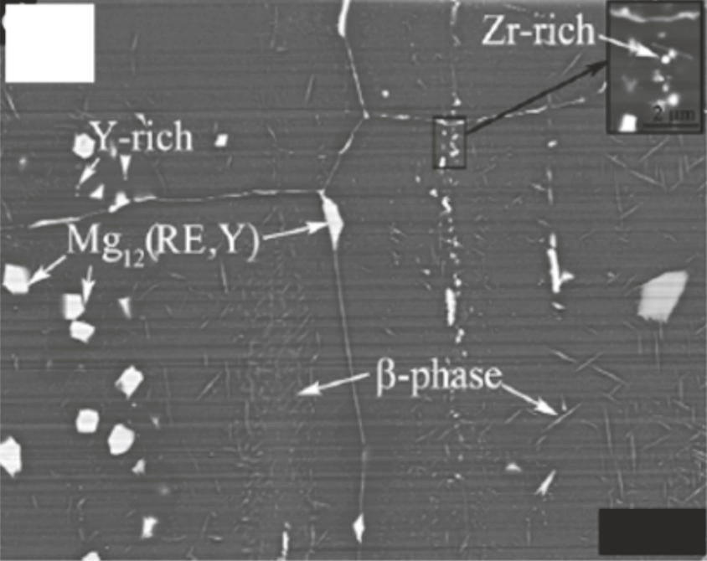
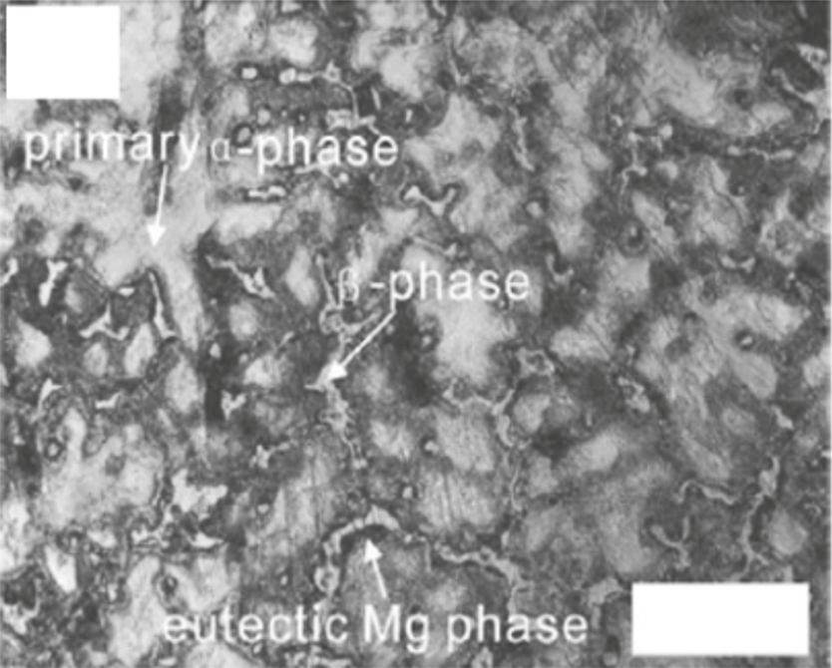
(c)
10 Ｇ
(d)
50 Ｇ

Figure 1. Typical second phase morphologies in (a) as-cast ZE41, (b) as-cast WE43, (c) as-forged WE43 [24], and (d) AZ91D alloys [25].
The durability of second phases and Mg matrix under various conditions may have affected degradation and biological responses to Mg alloy implants in the body when evaluating them for use in bone repair. Using the Dmol³ measurement tool, Yang et al. theoretically investigated the thermodynamic stability of four traditional second phases for Mg-Zn-Zr, Mg-Ca, Mg-Sr, and Mg-Al-Zn alloys, as well as Mg matrix in bioabsorbable Mg alloys. The phase stability of second phases was higher than that of Mg matrix, but it varied greatly for various forms of second phases and second-phase-4H₂O systems [32]. Mg₁₇Al₁₂ second phase from Mg-Al-Zn alloys was investigated for in vitro biocompatibility and phagocytosis by macrophages in order to evaluate the impact of second phases on the bio- logical protection of biodegradable Mg alloy implants. The second step of Mg₁₇Al₁₂ did not cause hemolysis and was cytocompatible. Endolysosomal compartments process Mg₁₇Al₁₂ particles, and lysosomes play a key role in the digestion of Mg₁₇Al₁₂ particles [58].
In Mg alloys, however, not all of the alloying elements form second-phase particles. As previously stated, certain alloy components, such as Y (12 wt. percent limit), Sc (25.9% limit), Gd (23.5 wt. percent limit), and Dy (25.3 wt. percent limit), have relatively high solid solubility in Mg and can occur in the form of solid solutions, resulting in solid solution strengthening. The original crystal structure of magnesium remains unchanged in the solution, but a lattice distortion occurs, obstructing dislocation motion and increasing Mg power. The effects of solid solutions on the mechanical behaviour of binary Mg-Y single-phase alloys were studied by Gao et al. Because of the substantial variations in the atomic radii of Y and Mg and a reasonably broad range of solubilities, they found increased hardness as the Y content increased at room temperature [59]. Furthermore, solid solution alloying has the ability to improve Mg alloy corrosion resistance by reducing internal galvanic corrosion between the second phase and the Mg matrix. Zhang et al. investigated the impact of solid solution treatment on the corrosion and electrochemical behaviours of Mg-15Y alloy and discovered that solution treatment reduced galvanic corrosion due to the dissolution of Mg₂₄Y5 second phase into the matrix [60]. As a result, solid solution may be a viable option for producing a single-phase Mg alloy and may aid in improving the corrosion resistance of Mg alloys used in orthopaedic applications.
D. Magnesium Alloy Impurities: Magnesium often introduces excess quantities of impurity elements during casting and processing. Iron (Fe), nickel (Ni), and copper (Cu) are common impurities in Mg alloys [31]. The impurity element standards for Mg are 35–50 ppm for Fe, 20–50 ppm for Ni, and 100–300 ppm for Cu (wt. percent ). There are no impurity particles produced below the tolerance limits, and therefore no electrochemically active cathodic sites to intensify corrosive attack, resulting in a slow corrosion rate. Due to their low solubility and distinctly more noble role in the electrochemical sequence, Fe, Ni, and Cu in Mg alloys significantly increase the corrosion rate when levels are above tolerance limits [31]. Adding silicon (Si) to the reactive impurity elements Fe, Ni, and Cu has been shown in recent studies to be harmful to corrosion because it promotes the formation and growth of Fe-rich particles. According to Lee et al., the content ratio of impurities, such as the Fe/Mn ratio, is more important than their absolute content in determining the corrosion of Mg. The high rate of corrosion stage extends as the Fe/Mn ratio increases [4.]
Since Mg alloys have such active chemical properties, they produce a lot of nonmetallic inclusions during casting and processing, which serve as major impurities in Mg alloys [62]. MgO, Mg3N2, MgF2, MgS2, and AlF3 are the principal nonmetallic inclusions. The oxidation of magnesium alloys in atmospheric atmospheres produces these nonmetallic impurities. When Mg and O2 react in the air, for example, MgO is formed, a common Mg alloy inclusion. The different morphologies of MgO impurities in the Mg-Gd-Y-Zr alloy are shown in Figure. 2 [26]. Mg₃N₂ is formed when magnesium and nitrogen combine in the atmosphere. Purification technology is constantly evolving because nonmetallic impurities greatly reduce the castability, mechanical properties, and corrosion resistance of Mg alloys [63]. Gas purge, flux purification, filtering purification, RE purification, and electromagnetic purification are all popular methods for purifying Mg alloys [62].
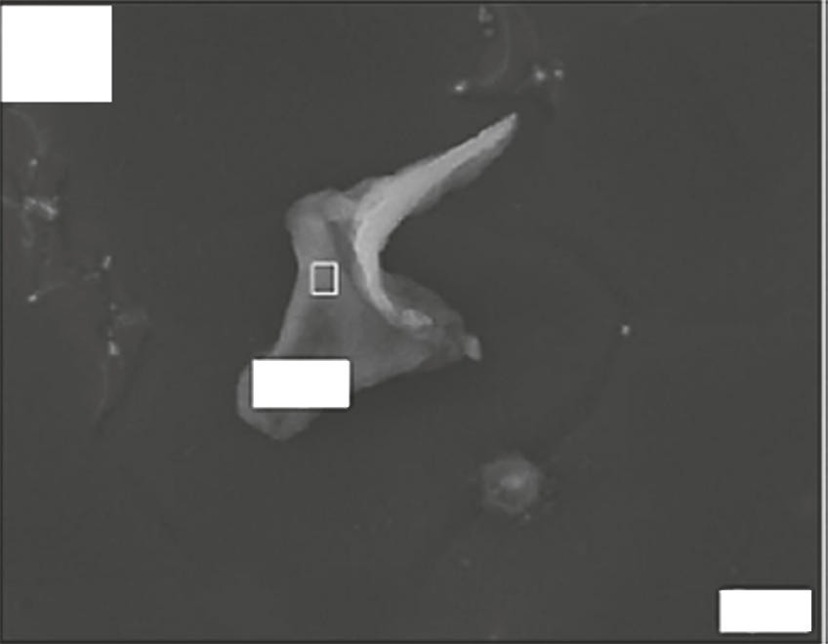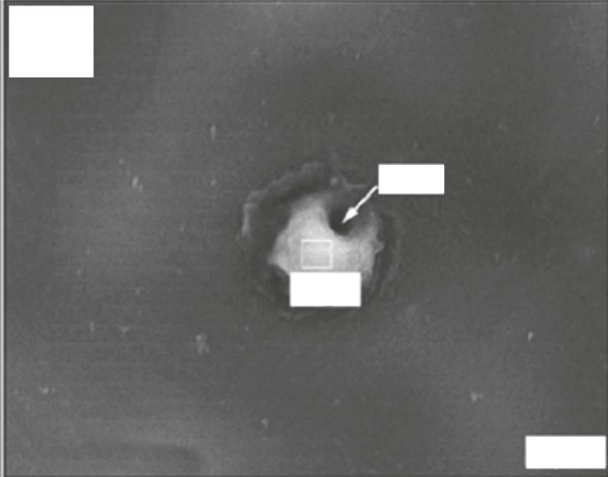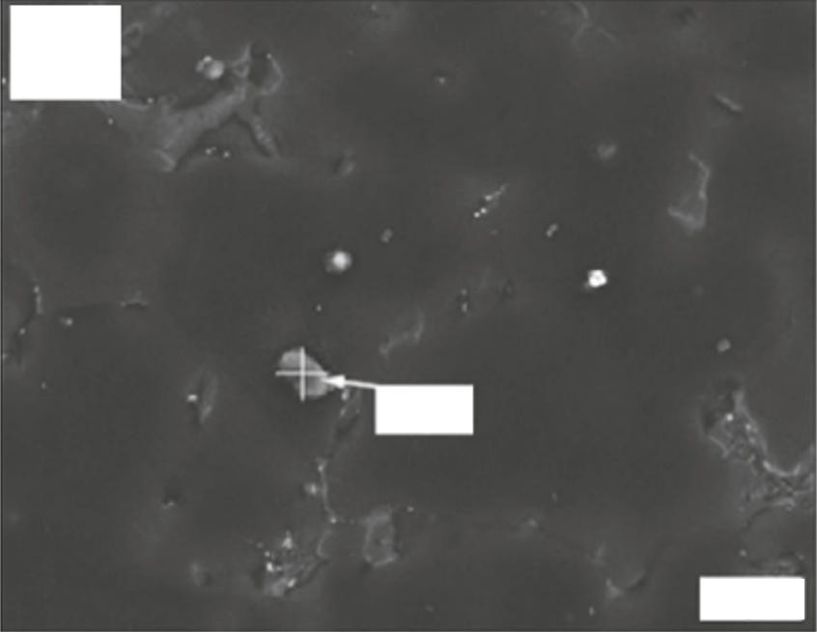
(a)
MgO
5 Ｇ
(b)
Pore
MgO
5 Ｇ
(c)
MgO
10 Ｇ
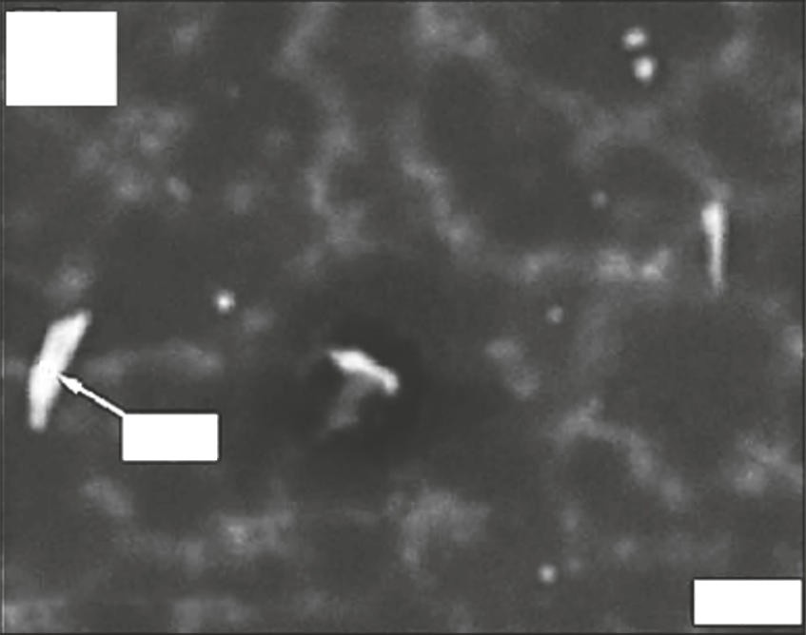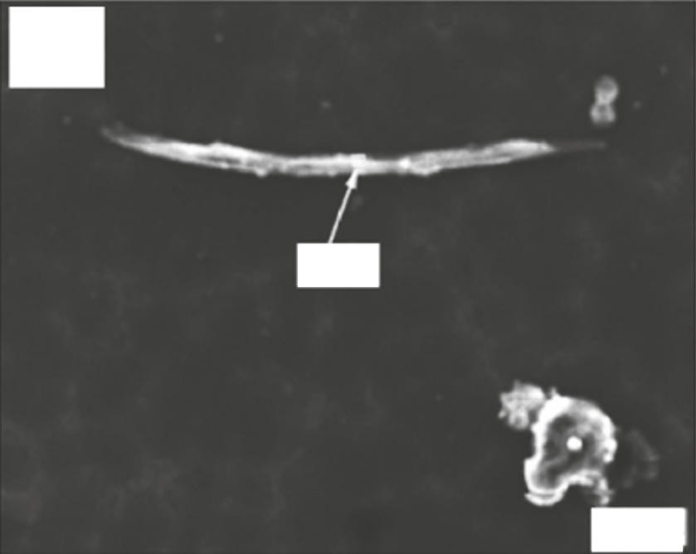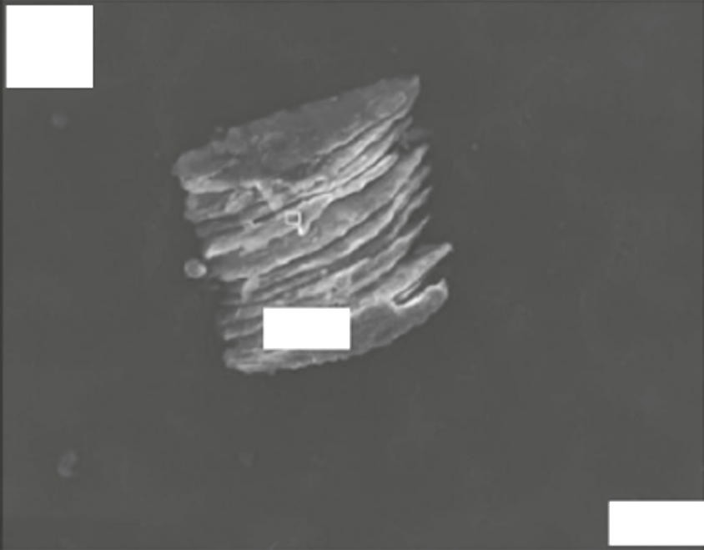
(d)
MgO
20 Ｇ
(e)
MgO
20 Ｇ
(f)
MgO
20 Ｇ
Figure 2. MgO inclusions in Mg-Gd-Y-Zr SEM images: (a) Z-shaped, (b) spherical, (c) block, (d) rod-like, (e) needle-like, and (f) lamellar MgO [26].

III. MAGNESIUM ALLOYS SURFACE MODIFICATIONS
Various surface modifications have been developed to increase the corrosion resistance of Mg alloys in physiological environments, as well as maintain their mechanical integrity and improve interfacial biocompatibility. Surface modifications, unlike alloying methods, explicitly insulate Mg alloys from the biological environment and avoid body fluid penetration into substrates [47, 64]. The methods of surface modification can be divided into three categories based on whether a new phase is produced on the surface of Mg alloys: chemical alterations, physical modifications, and a combination of these two methods [65].
A. Chemical alterations: Chemical alterations are new phases that form on the surface of magnesium alloys as a result of chemical or electrochemical reactions. This method eliminates the native oxide layer, which has less passive properties, such as the inability to effectively protect against corrosion, but forms easily due to the Mg matrix's high reactivity.
Acid etching, alkaline heat treatment, fluoride treatment, anodic oxidation, and microarc oxidation (MAO) are all examples of chemical modifications [65]. Turhan et al. discovered that acid etching with a 2.5 percent H2SO4 solution significantly improves the corrosion resistance of AZ91D alloys [67]. Furthermore, alkaline heat treatment, which is a simple and cost-effective process, produces a Mg(OH)2 barrier layer on the substrate surface, which slows the corrosion rate of Mg alloy [68]. The corrosion rate of Mg has been stated to be reduced by NaOH treatment [68], with a NaOH concentration of 1 M resulting in the slowest corrosion rate. The original oxide film on magnesium alloys is replaced by a thin, homogeneous MgF2 coating with higher polarisation resistance after fluoride treatment.
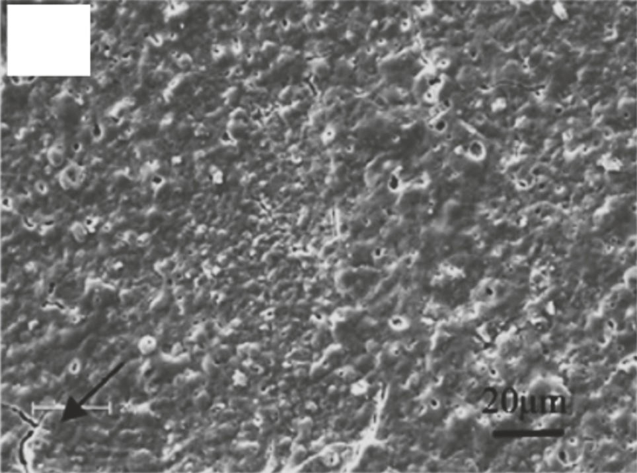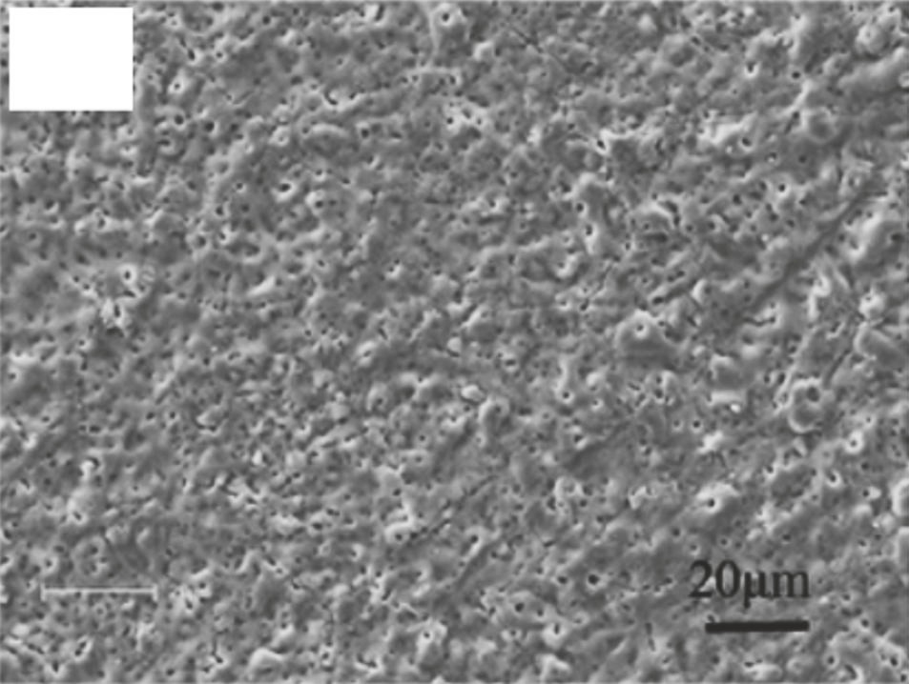
(a)
(b)
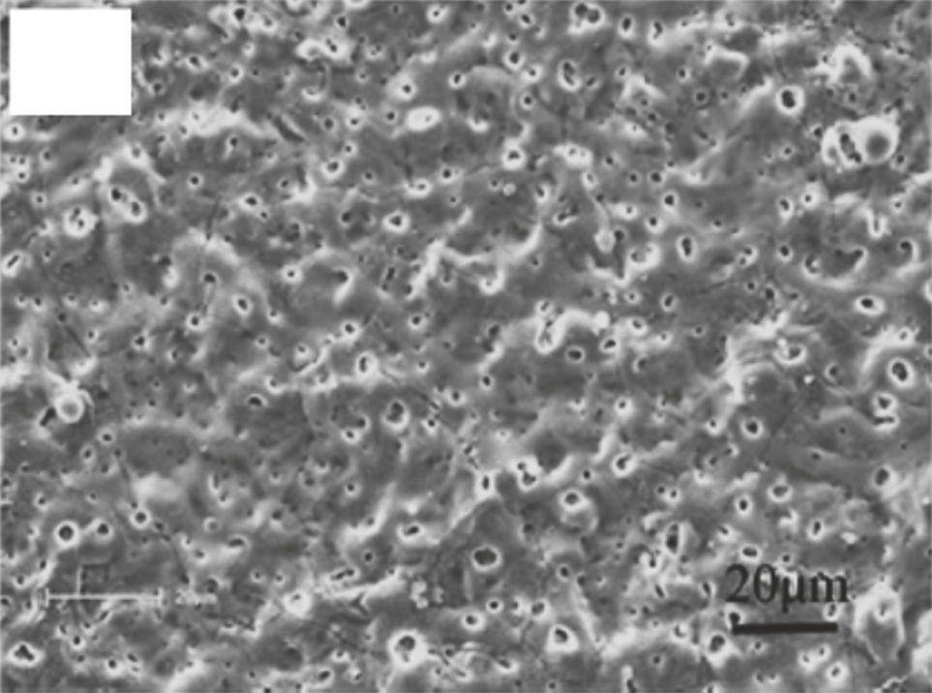
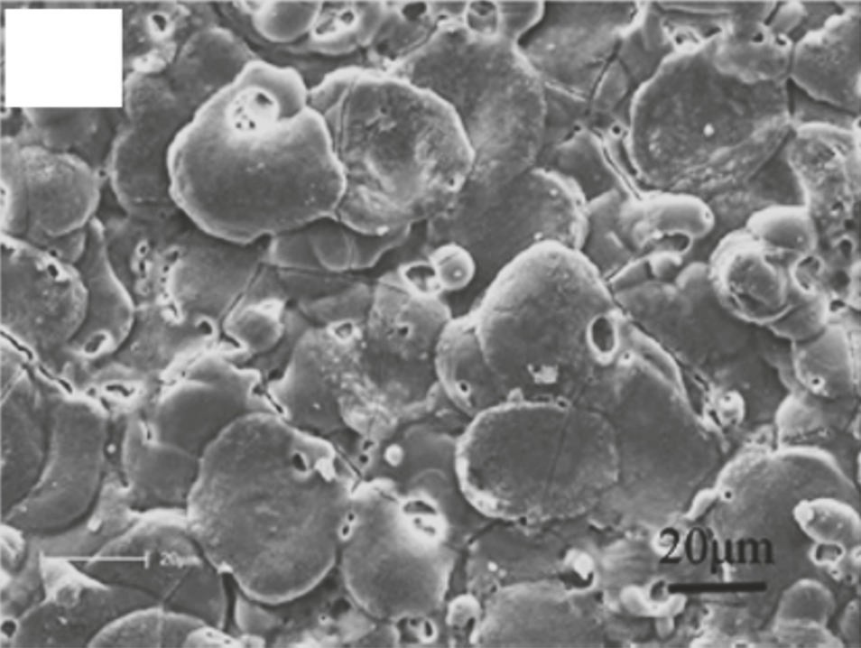
Figure 3.Microarc oxidation surface morphologies of ZK60 alloy coated at voltages of (a) 230 V, (b) 300 V, (c) 370 V, and (d) 450 V [16]. The 230 V coating has several micro cracks, as shown by the black arrow in the diagram (a).
(c)
(d)
Acid etching is a common pretreatment process for removing coarse scale created during manufacturing and replacing it with a more compact passivated layer [66]. High density, low water solubility, and nontoxicity when fluorine ions are released into the host organism are all advantages of the MgF2 sheet. MgF2 coating delays in vivo corrosion of LAE442 alloy without raising fluoride concentrations in the adjacent bone, according to Witte [69]. Furthermore, when fluoride is incorporated into the bone, it may promote osteoblast proliferation, increase new mineral deposition in cancellous bones, and decrease the solubility of bone tissue [70]. Fluoride-modified implant surfaces facilitate osteointegration during the early stages of healing after implant placement, according to an experimental study in dogs [70].
Anodic oxidation is an electrochemical reaction that creates a dense, solid oxide film on metals. Anodic oxidation at a constant current was used by Lei et al. to form a Mg oxide film on AZ31B Mg alloy. This film effectively delays AZ31B Mg alloy degradation without affecting osteoblast proliferation or new bone formation [71]. MAO is a plasma-assisted anodic oxidation technique used to alter the surface of biodegradable magnesium alloys. MAO coatings are extremely stiff, have good wear resistance, moderate corrosion resistance, and improved thermal and dielectric properties [72]. Lin et al. coated ZK60 Mg alloy with forsterite-containing MAO coatings to delay degradation and improve biological properties. As the preparation voltage was raised, the resistance to corrosion from the MAO coating increased. MAO-coated ZK60 Mg alloy has a significantly lower hemolytic ratio and no cytotoxicity in L929 cells as compared to bare ZK60 Mg alloy. The surface morphologies of ZK60 alloy with MAO coatings produced at various voltages are shown in Figure. 3 [16].
B. Physical Modifications. No chemical bonds were formed between the surface and the substrates for physical modifications, unlike chemical methods. The changes are designed to provide a physical barrier that will help magnesium substrates resist corrosion. Apatite coatings, polymer coatings, laser surface processing, and cold spray coatings are some of the physical modifications that can be made [65, 73].
Natural bone contains apatite, which is an inorganic mineral. Due to its high bioactivity, it can significantly speed up the recovery of bone fractures. Furthermore, due to its low solubility and high thermal stability, apatite may increase the degradation resistance of implants as a protective layer [74].
Hydroxyapatite (HA), a key member of the apatite family, has the chemical composition of bone mineral and is commonly used to coat magnesium alloys for bone repair [65]. Wang et al. created a HA coating on ZK60 Mg alloy and discovered that it prevented alloy degradation and improved cytocompatibility for L929 cells, making ZK60 alloy more suitable for orthopaedic applications.
Mg alloy modifications based on polymer coatings are also promising for use in orthopaedic applications. Gray-Munro et al. used PLA, a semicrystalline biodegradable polymer, to investigate the effect of polymer coating on the corrosion rate of AZ31 Mg alloy in SBF, and found that the coating prevented corrosion, particularly during the early stages of implantation [41].
Laser surface processing, which uses a high-energy laser beam to control biodegradation of magnesium alloys, has been found to cause secondary phase dissolution and the formation of a fine-grained structure. When using laser surface processing, Coy et al. found substantial dissolution of the second step of Mg17Al12 in AZ91D [74]. Guo et al. and Khalfaui et al. showed similar findings using laser processing for WE43 and ZE41 alloys [75, 76]. The aforementioned modified alloys have shown significant improvements in corrosion resistance [77].
Surface engineering of Mg alloys using cold spray technology is a viable option. Ballistic impingement of particles, typically varying in size from 1 to 100 m, is used to deposit cold spray coatings. The particles are accelerated by a high-velocity gas stream and sprayed onto the substrate surface. Cold spray is a low-temperature process that can be used to deposit bioactive coatings on Mg alloys while also preventing the substrate from oxidising and changing phases. Noorakma et al. recently investigated the deposition of HA on an AZ51 alloy using a modified cold spray process and discovered that this change improved the retention of HA characteristics.
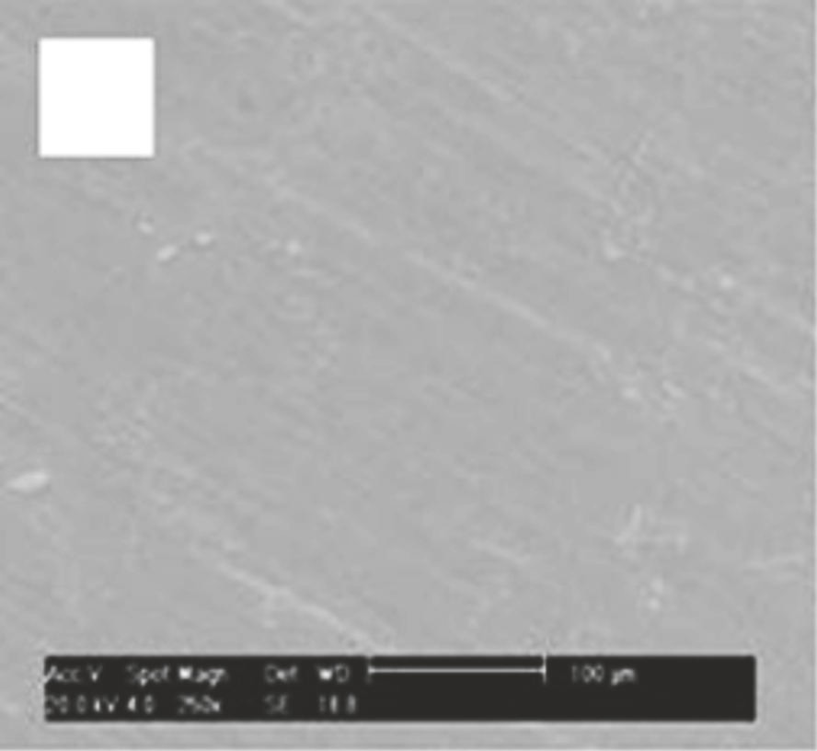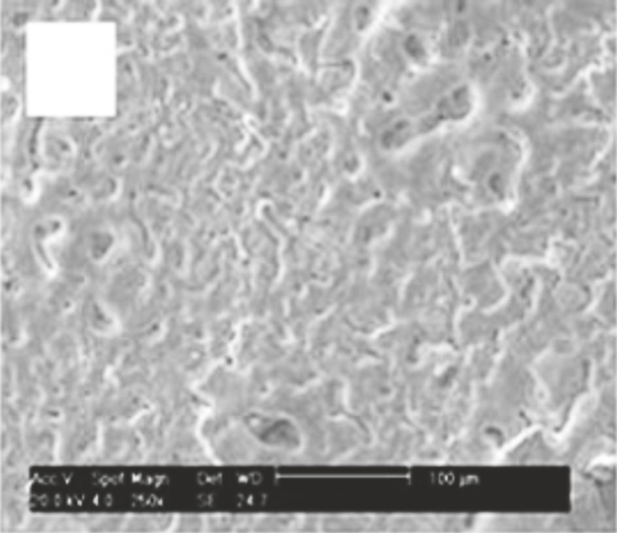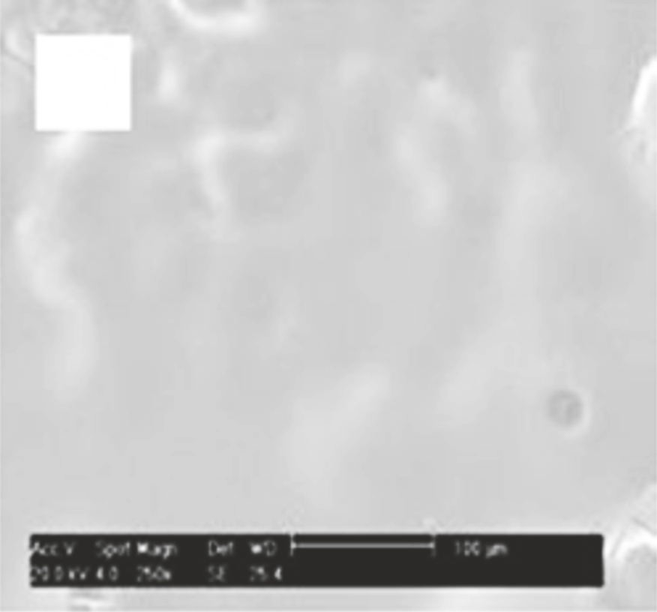
(a)
(b)
(c)

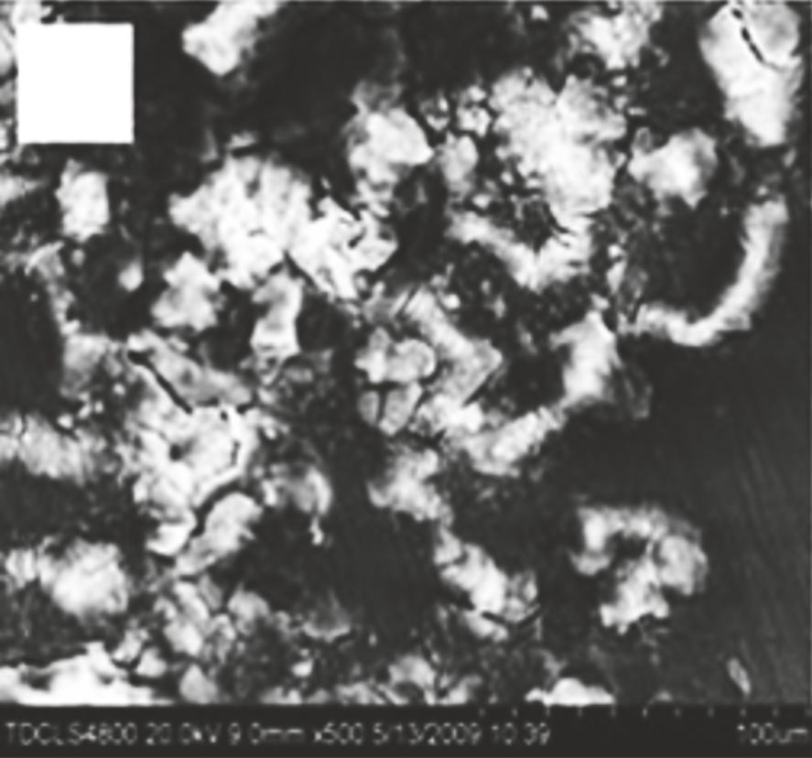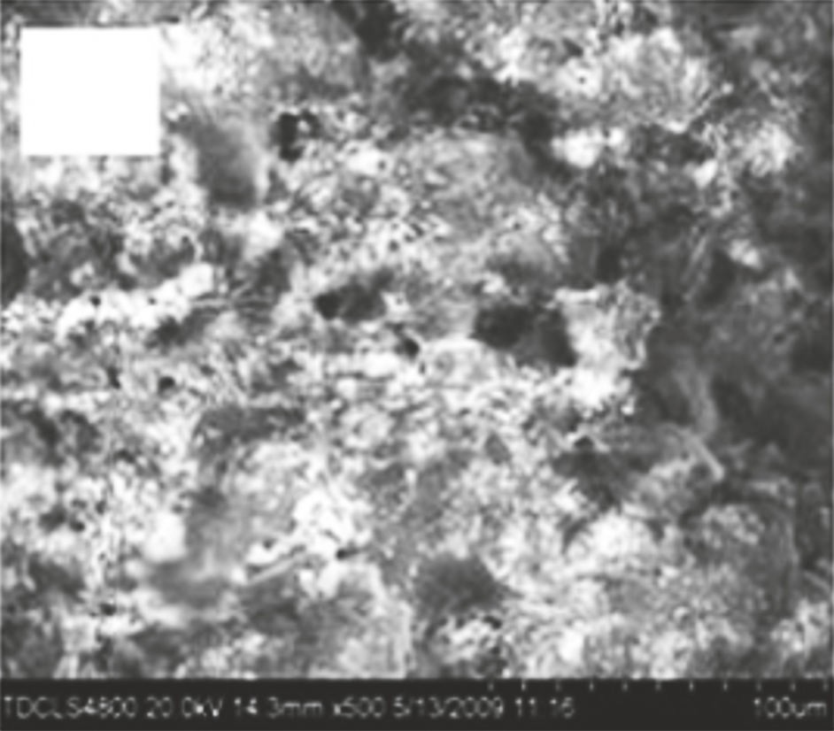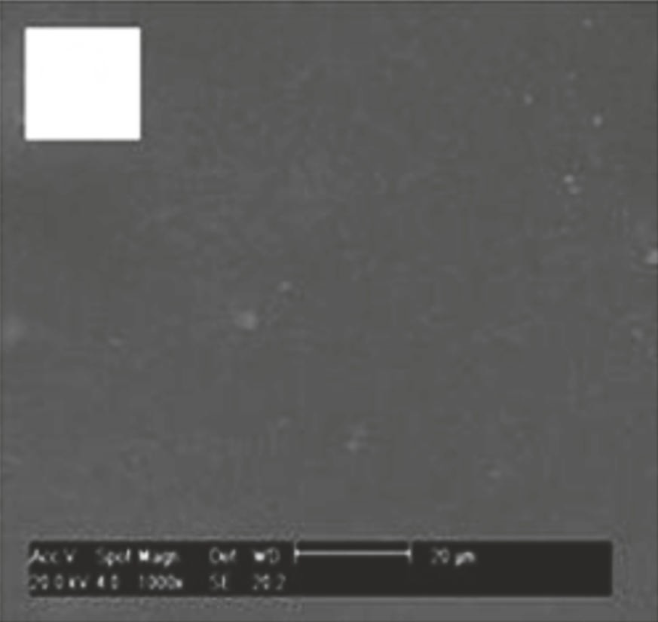
(d)
(e)
(f)

Figure 4. SEM image of sample surface morphology before (a) WE42, (b) WE42-MAO, and (c) WE42-MAO/PLLA were submerged in Hank's solution at 37°C (pH = 7.4) [57] and after (d) WE42, (e) WE42-MAO, and (f) WE42-MAO/PLLA were submerged in Hank's solution at 37°C (pH = 7.4) [27].
C. Modifications in terms of chemical and physical properties:
Because of the drawbacks of single chemical and physical treatments, composite modifications involving both chemical and physical treatments are gaining popularity. Double-modified layers have been shown to increase biodegradation resistance and regulate degradation rates over a wider range of substrates [65]. Guo et al. used physical interlocking to seal PLLA to the MAO coating on WE42 alloy surfaces. The corrosion resistance and cytocompatibility of the MAO/PLLA-modified WE42 alloy were found to be fine. Figure 4. presents the surface morpholo- gies of WE42, WE42-MAO, and WE42-MAO/PLLA before and after being submerged in Hank’s solution for four days [57]. Hank's solution severely corroded the WE42 Mg alloy, as shown in Figures 4(a) and 4(d). Figure 4(d) depicts severe corrosion on the WE42's surface, as shown by deeper and wider cracks and holes, as well as the deposition of white flocculent accumulations. On the surface of the MAO coating, micropores and microcracks were randomly distributed (Figure 4(b)). The MAO coating was corroded after submersion, with small white flocculent deposits on the surface (Figure 4(e)). The biocompatible PLLA sealing layer was smooth and uniform on the MAO coating's surface, covering cracks and pores (Figure 4(c)). The surface of the MAO/PLLA sample did not change significantly, as shown in Figure 4(f), whereas the surface of the WE42-MAO/PLLA sample was covered by an intact layer that showed no signs of corrosion.
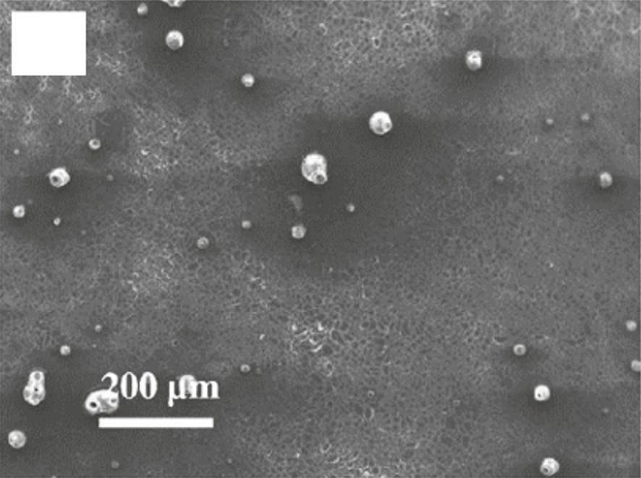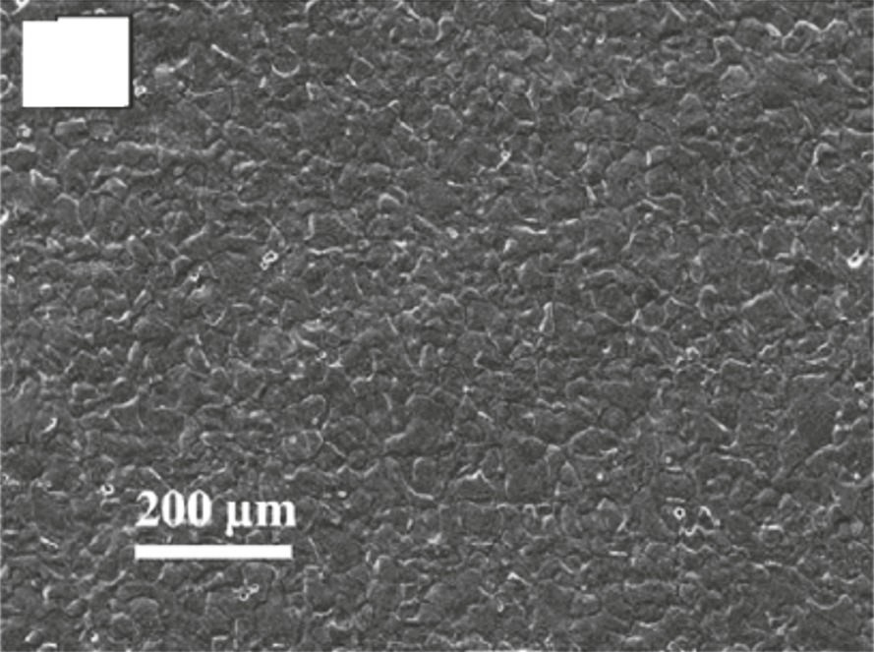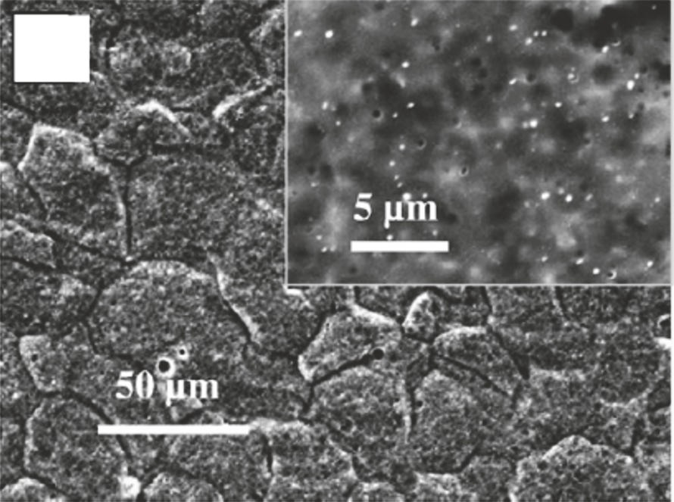
(a)
(b)
(c)

Figure 5. M1A surface morphology after 30 minutes in A-SBF: (a) initial surface, (b) surface after cleaning, and (c) high-magnification image of the surface after cleaning [58].

IV. BIODEGRADABLE MAGNESIUM ALLOYS AS BONE IMPLANTS: BIOLOGICAL PERFORMANCE
For biodegradable Mg alloys to be used in the clinic, they must have sufficient biocompatibility in the body [74]. As a result, the biological efficiency of biodegradable Mg alloys has been studied in vitro and in vivo for several years [28].
A. Biological Performance in Vitro:
In vitro studies can be used to predict Mg alloy corrosion and biocompatibility in vivo [138]. In vitro studies are more convenient than in vivo experiments because they can provide fast and accurate efficacy feedback [81]. SEM, X-ray diffraction, tensile tests, immersion tests, electrochemical corrosion tests, cell culture, and platelet adhesion were used to investigate the in vitro corrosion and biocompatibility of nine binary Mg-1X (wt. percent, X = Al, Ag, In, Mn, Si, Sn, Y, Zn, and Zr) alloys. The strength and corrosion resistance of magnesium were influenced by alloying elements. In both SBF and Hank's solutions, Al, Si, Sn, Zn, and Zr increased Mg's strength while Al, In, Mn, Zn, and Zr slowed the corrosion of as-cast Mg-X alloys. Mg corrosion was inhibited by Si and Y, on the other hand. Mg-1Al, Mg-1Sn, Mg-1Y, Mg-1Zn, and Mg-1Zr alloy extracts have no significant toxicity against fibroblasts (L-929 and NIH3T3), Mg-1Al, Mg-1Si, Mg-1Sn, Mg-1Y, Mg-1Zn, and Mg-1Zr alloy extracts have no significant toxicity against osteoblasts (MC3T3-E1), and Mg (ECV304 and VSMC). Mg-1In, Mg-1Mn, Mg-1Si, and Mg-1Y alloys had low hemolysis ratios of less than 5% in hemolysis assays. Adhered platelets are roughly circular in shape and have a slight spreading of pseudopodia, but there are less adhered platelets for alloys than for pure Mg [82]. In vitro cellular responses and degradation of the Mg alloy M1A (Mg-1.42 wt. percent Mn) in SBF and albumin-containing SBF (A-SBF, 40 g/L) were investigated by Wang et al. They discovered that the presence of albumin had a significant impact on M1A corrosion due to the synergistic effects of albumin adsorption and chelation. M1A Mg alloy samples had well-spread cells and good cell viability, indicating that it could be used in biodegradable implants. Figure 5 shows the surface morphology of M1A after 30 minutes of soaking in A- SBF [28]. Figure 5(a) illustrates that albumin does not have a substantial impact on the development of the passivation layer within the first 0.5 hours of immersion. However, post-cleaning examinations of the surface (Figures 5(b) and 5(c)) show that the grain boundaries remain the favoured sites for corrosion initiation, and the corrosion was relatively uniform across the test surface [83]. In a study of the effects of in vitro and in vivo corrosion conditions on the corrosion rates of gravity-cast AZ91D and LAE442 Mg alloys, Witte et al. discovered that in vivo corrosion is four orders of magnitude slower than in vitro [42].

C. Biological Performance in Vivo:
Prior to clinical trials, in vivo animal studies must be carried out to best replicate the physiological conditions of the human body. Via follow-up monitoring, such as serum analysis, radiographic inspection, micro-CT investigations, histology analysis, and implant examination, in vivo animal studies help characterise local tissue reactions to Mg-based implants [84]. The rate of degradation, corrosion materials, and stability of biodegradable Mg alloys all influence local bone responses.

D. In vivo animal studies:
B. Ratna Sunil et al. implanted into rabbits to investigate the role of grain size generated by equal channel angular pressing (ECAP) on the bioactivity and degradation of commercially available AZ31 Mg alloy by conducting and thorough follow-up monitoring, such as serum analysis, radiographic inspection, micro-CT investigations, histology analysis, and implant examination. The rapid bio-mineralization achieved in ECAPed samples aided in reducing AZ31 Mg alloy degradation. When compared to annealed samples, ECAPed samples showed less in vivo degradation. Early formation of cartilaginous tissue in the rabbit implanted with ECAPed sample suggests the formation of new bone, according to histopathology studies of bone tissue from the rabbit implanted with ECAPed sample. In vivo experiments revealed that the degradation of magnesium had no negative health effects on rabbits, and that magnesium alloys with smaller grain sizes have a major impact on regulating the degradation rate in a physiological setting by encouraging rapid mineralization, which could be useful in the development of magnesium-based degradable implants [50].
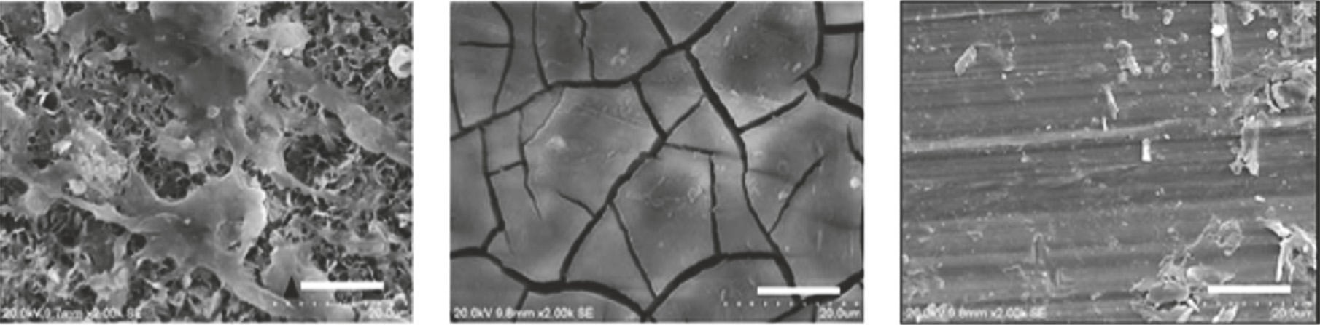
β -TCP-coated Mg alloy Naked Mg alloy Ti alloy

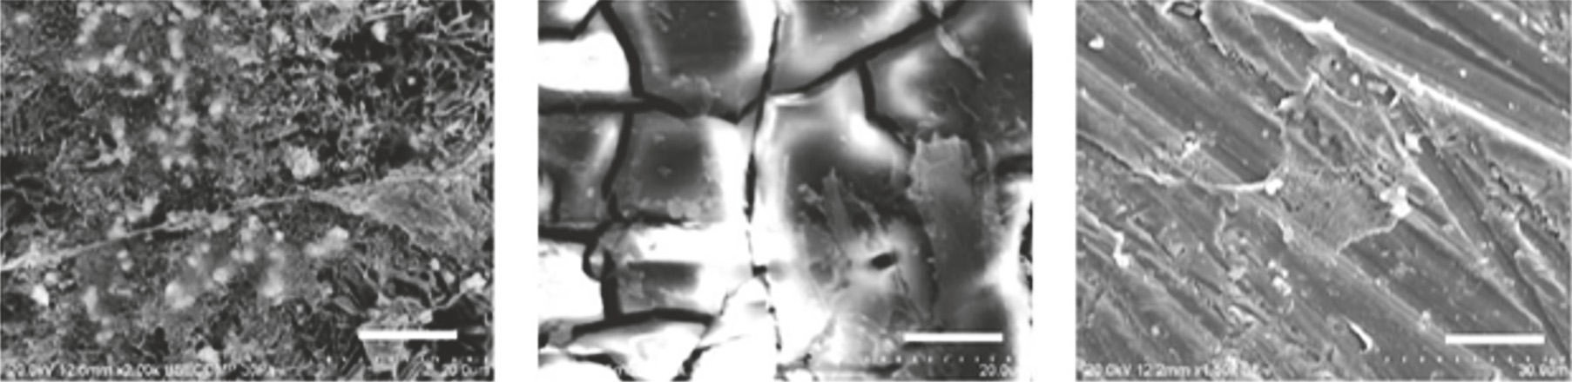

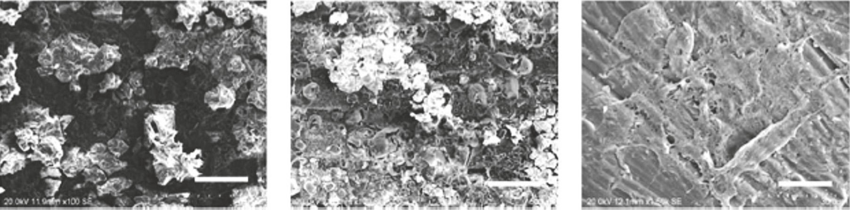

Figure 6. After implantation for 1, 4, and 12 weeks, SEM photographs of β -tricalcium phosphate-coated AZ31, naked AZ31, and Ti-6Al-4V alloy rod samples. [29] Scale bar = 5 m.
Zhang et al. implanted Mg-Zn-Mn alloy into rats to study in vivo Mg alloy degradation, bone reaction to the biodegradable Mg implant, and effects of Mg alloy degradation on blood composition and organs. In the marrow cavity and cortical bone, the Mg-Zn-Mn alloy degrades at various rates. Six weeks after implantation, new bone tissue developed around the Mg implants, but not a fibrous capsule. At 10 and 26 weeks after implantation, more new bone tissue, as well as membrane, was discovered around the implant. The blood chemistry, liver, and kidneys changed little as the Mg-Zn-Mn implant degraded [85]. Dziuba et al. created ZEK100, a new degradable Mg alloy, and tested its biocompatibility and long-term degradation in adult female New Zealand white rabbits. In addition, in vivo, ZEK100 degrades slowly.
However, good in vivo degradation does not always imply good biocompatibility, and the absence of general pathological disorders does not always imply that Mg implants are biocompatible. ZEK100 caused numerous local pathological effects in this sample, including significant bone alterations [84]. To assess implant osteogenesis and biodegradability, Chai et al. implanted β-tricalcium phosphate- (TCP-) coated AZ31 Mg alloys into the femurs of rats after predrilling with 1 mm hand-operated drills. Figure 6 displays the SEM images of rod samples of β -TCP-coated AZ31, naked AZ31, and Ti-6Al-4V alloys after 1, 4, and 12 weeks of implantation [29]. After the first week, cells and cell secretion proteins were discovered on the surface of the β-TCP-coated Mg alloy. The rod implant was coated in a huge amount of organic proteins after 4 weeks. Degradation products and cracks were thicker on the surface after 12 weeks than at the previous timepoint. After 1 week, several cracks were visible on the naked Mg alloy. Cell secretion proteins were discovered on the surface after four weeks. A thin excreted matrix layer nearly covered the naked Mg alloy sample after 12 weeks. In contrast, the Ti alloy surface morphology was consistent over time. This shows that the β-TCP coating delays the deterioration of naked Mg alloy in the early stages of implantation and indicates that the β-TCP coating significantly enhanced osteoconductivity and osteogenesis in the first 12 weeks after surgery.
V. CONCLUSION AND FUTURE RESEARCH
The aim of this review was to present and discuss recent research and developments on Mg alloy for bone repair. Via alloying design and surface modification, significant efforts have been made to enhance the mechanical properties, corrosion resistance, and biocompatibility of magnesium alloys. In conclusion, Mg alloys have a bright future as surgical implant materials in bone repair. Despite the fact that a large number of studies have focused on biodegradable Mg alloy implants, which are expected to minimise the need for follow-up surgeries and contribute to safer, more efficient bone repair, more research is required, and this article offers suggestions for potential research.
Selected animal models must be developed in order to better replicate the performance of Mg alloys in physical environments. An ovariectomized rat model, for example, was developed to investigate the effects of 10% SrHA coatings on implant fixation and postmenopausal osteoporosis prophylaxis [86]. Using a Y-shaped osteotomy of the second and fourth metatarsal bones in horses, Waselau et al. produced triangular fragments of 1 cm long arms and compared the effects of biodegradable Mg phosphate cement, Ca phosphate cement, and no cement on bone repair, biocompatibility, and bone adhesion [87]. Future research on the use of Mg alloys for bone repair could use the above-mentioned animal models, as well as standard bone damage models.
The interlocking of bone implants, such as nails, screws, needles, and plates, into the surrounding bone must be biomechanically tested to determine the viability of using biodegradable Mg alloys in bone repair surgery. It's crucial to compare the implant of interest to widely used implants in order to determine the extent of bone-implant fixation in vivo. Erdmann et al. used uniaxial pull-out tests in an MTS 858 Mini Bionix at a rate of 0.1 mm/s to compare the biomechanical properties of a degradable Mg-0.8Ca alloy and a widely used stainless steel (S316L) screw. For the first 2-3 weeks after implantation, Mg-0.8Ca had similar tolerability and biomechanical properties to S316L. As a result, it's possible that it might be used as a biodegradable implant [13]. Castellani et al. compared a novel biodegradable Mg alloy (Mg-Y-Nd-HRE, based on WE43) to a titanium control to investigate the intensity and osseointegration of the bone-implant interface (Ti-6Al-7Nb). Mg-Y-Nd-HRE alloy, on the other hand, not only improved bone response but also had excellent interfacial ability, meeting two important criteria for use in bone implants [88]. The development of a mechanically stable bone-implant interface is especially important for the clinical use of bone repair implants to be effective. As a result, in the future, further biomechanical research will be needed.
Long-term studies are required to investigate in vivo degradation and biocompatibility of biodegradable Mg alloys due to the complexity of the physiological environment of the human body. Future work should concentrate on the topics mentioned below, in addition to the above suggestions. Controllable degradation of biodegradable Mg alloys must be developed using novel or conventional techniques such as processing control and bionic coating. The creation of biofunctional alloy systems using human essential nutrients as alloying agents is one example [37]. Angiogenesis of Mg-based implants should also be a subject of research since bone vasculature plays such an important role in bone growth, remodelling, and homeostasis [89]. It is important to study the longer-term effects of Mg alloy implants on tissues and organs in order to obtain more reliable biosafety knowledge and to prepare for clinical trials. In the foreseeable future, biodegradable Mg alloy implants' in vivo performance will undoubtedly increase, and Mg alloy implants will play a larger role in the treatment of orthopaedic diseases.
REFERENCES

[1] | I. H. Kalfas,2001 “Principles of bone healing,” Neurosurgical Focus, vol. 10, no. 4, p. E1, .
[2] | K. M. Nuss and B. V. Rechenberg, 2008“Biocompatibility Issues with Modern Implants in Bone - A Review for Clinical Orthopedics,” The Open Orthopaedics Journal , vol. 2, no. 1, pp. 66–78,.
[3] | R. W. Westerman and B. E. Scammell, 2012“Principles of bone and joint injuries and their healing,” Surgery, vol. 30, no. 2, pp. 54– 60, .
[4] | J.-Y. Lee, G. Han, Y.-C. Kim et al.,2009 “Effects of impurities on the biodegradation behavior of pure magnesium,” Metals and Materials International, vol. 15, no. 6, pp. 955–961, .
[5] | L. Tan, X. Yu, P. Wan, and K. Yang,2013 “Biodegradable Materials for Bone Repairs: A Review,” Journal of Materials Science and Technology, vol. 29, no. 6, pp. 503–513, .
[6] | J. G. Stark, 2001 “Use of selective estrogen receptor modulator for joint fusion and other healing,” WO 136956,.
[7] | J. Van der Stok, E. M. M. Van Lieshout, Y. El-Massoudi,G. H. Van Kralingen, and P. Patka, 2011“Bone substitutes in the Netherlands—a systematic literature review,” Acta Biomateri- alia, vol. 7, no. 2, pp. 739–750, .
[8] | J. A. Auer, B. V. Rechenberg, M. Bohner, and M. Hofmann- Amtenbrink, 2012 “Bone Grafts and Bone Replacements,” Equine Surgery, pp. 1081–1096,.
[9] | P. V. Giannoudis, H. Dinopoulos, and E. Tsiridis,2005 “Bone sub- stitutes: an update,” Injury, vol. 36, supplement 3, pp. S20–S27, .
[10] | O. Bo¨stman and H. Pihlajama¨ki,2000 “Clinical biocompatibility of biodegradable orthopaedic implants for internal fixation: a review,” Biomaterials, vol. 21, no. 24, pp. 2615–2621, .
[11] | H. Chai, L. Guo, X. Wang et al., 2011 “Antibacterial effect of 317L stainless steel contained copper in prevention of implant-related infection in vitro and in vivo,” Journal of Materials Science: Materials in Medicine, vol. 22, no. 11, pp. 2525–2535,.
[12] | M. P. Staiger, A. M. Pietak, J. Huadmai, and G. Dias,2006 “Magnesium and its alloys as orthopedic biomaterials: a review,” Biomaterials, vol. 27, no. 9, pp. 1728–1734, .
[13] | N. Erdmann, N. Angrisani, J. Reifenrath et al., 2011“Biomechanical testing and degradation analysis of MgCa0.8 alloy screws: a comparative in vivo study in rabbits,” Acta Biomaterialia, vol. 7, no. 3, pp. 1421–1428, .
[14] | D. Hong, P. Saha, D.-T. Chou et al.,2013 “In vitro degradation and cytotoxicity response of Mg-4% Zn-0.5% Zr (ZK40) alloy as a potential biodegradable material,” Acta Biomaterialia, vol. 9, no. 10, pp. 8534–8547, .
[15] | S. Shadanbaz and G. J. Dias,2012 “Calcium phosphate coatings on magnesium alloys for biomedical applications: a review,” Acta Biomaterialia, vol. 8, no. 1, pp. 20–30, .
[16] | X. Lin, L. Tan, Q. Zhang et al.,2013 “The in vitro degradation process and biocompatibility of a ZK60 magnesium alloy with a forsterite-containing micro-arc oxidation coating,” Acta Biomaterialia, vol. 9, no. 10, pp. 8631–8642, .
[17] | M. Bornapour, M. Celikin, M. Cerruti, and M. Pekguleryuz,2014 “Magnesium implant alloy with low levels of strontium and cal- cium: The third element effect and phase selection improve bio- corrosion resistance and mechanical performance,” Materials Science and Engineering C: Materials for Biological Applications, vol. 35, no. 1, pp. 267–282,
[18] | C. K. Seal, K. Vince, and M. A. Hodgson, 2009“Biodegradable surgical implants based on magnesium alloys - A review of current research,” in Proceedings of the IOP Conference Series: Materials Science and Engineering, IOP Publishing, .
[19] | H. S. Brar, J. Wong, and M. V. Manuel, 2012“Investigation of the mechanical and degradation properties of Mg-Sr and Mg-Zn- Sr alloys for use as potential biodegradable implant materials,” Journal of the Mechanical Behavior of Biomedical Materials, vol. 7, pp. 87–95, .
[20] | Y. Chen, Z. Xu, C. Smith, and J. Sankar, 2014“Recent advances on the development of magnesium alloys for biodegradable implants,” Acta Biomaterialia, vol. 10, no. 11, pp. 4561–4573, .
[21] | Y. Yun, Z. Dong, D. Yang et al.,2009 “Biodegradable Mg corrosion and osteoblast cell culture studies,” Materials Science and Engineering C: Materials for Biological Applications, vol. 29, no. 6, pp. 1814–1821, .
[22] | X. N. Gu, W. Zheng, Y. Cheng, and Y. F. Zheng, 2009 “A study on alkaline heat treated Mg-Ca alloy for the control of the biocorrosion rate,” Acta Biomaterialia, vol. 5, no. 7, pp. 2790– 2799,.
[23] | J. J. Huang and K. Yang,2006 “Research on magnesium alloys for bio-medical applications,” Materials Review, vol. 20, pp. 67–69, .
[24] | A. E. Coy, F. Viejo, P. Skeldon, and G. E. Thompson, 2010 “Sus- ceptibility of rare-earth-magnesium alloys to micro-galvanic corrosion,” Corrosion Science, vol. 52, no. 12, pp. 3896–3906,.
[25] | L. Wang, B.-P. Zhang, and T. Shinohara,2010 “Corrosion behavior of AZ91 magnesium alloy in dilute NaCl solutions,” Materials and Corrosion, vol. 31, no. 2, pp. 857–863, .
[26] | M.-J. Liang, G.-H. Wu, W.-J. Ding, and W. Wang,2011 “Effect of inclusion on service properties of GW103K magnesium alloy,” Transactions of Nonferrous Metals Society of China, vol. 21, no. 4, pp. 717–724, .
[27] | M. Guo, L. Cao, P. Lu, Y. Liu, and X. Xu, 2011“Anticorrosion and cytocompatibility behavior of MAO/PLLA modified magne- sium alloy WE42,” Journal of Materials Science: Materials in Medicine, vol. 22, no. 7, pp. 1735–1740, .
[28] | Y. Wang, C. S. Lim, C. V. Lim, M. S. Yong, E. K. Teo, and L. N. Moh, 2011“In vitro degradation behavior of M1A magnesium alloy in protein-containing simulated body fluid,” Materials Science and Engineering C: Materials for Biological Applications, vol. 31, no. 3, pp. 579–587, .
[29] | H. Chai, L. Guo, X. Wang et al.,2012 “In vitro and in vivo evaluations on osteogenesis and biodegradability of a β-tricalcium phos- phate coated magnesium alloy,” Journal of Biomedical Materials Research Part A, vol. 100, no. 2, pp. 293–304, .
[30] | Q. Li, Q. Wang, Y. Wang, X. Zeng, and W. Ding, 2007 “Effect of Nd and Y addition on microstructure and mechanical properties of as-cast Mg-Zn-Zr alloy,” Journal of Alloys and Compounds, vol. 427, no. 1-2, pp. 115–123,.
[31] | A. D. Su¨dholz, N. T. Kirkland, R. G. Buchheit, and N. Birbilis, 2011 “Electrochemical properties of intermetallic phases and com- mon impurity elements in magnesium alloys,” Electrochemical and Solid-State Letters, vol. 14, no. 2, pp. C5–C7,.
[32] | H. Yang, C. Liu, P. Wan, L. Tan, and K. Yang, 2013“Study of second phase in bioabsorbable magnesium alloys: Phase stability evalu- ation via Dmol3 calculation,” APL Materials, vol. 1, no. 5, Article ID 052104, .
[33] | Y. Zheng and X. Gu,2011 “Research activities of biomedical magne- sium alloys in China,” JOM: The Journal of The Minerals, Metals & Materials Society (TMS), vol. 63, no. 4, pp. 105–108, .
[34] | L. Yang, Y. Huang, F. Feyerabend et al.,2013 “Microstructure, mechanical and corrosion properties of Mg-Dy-Gd-Zr alloys for medical applications,” Acta Biomaterialia, vol. 9, no. 10, pp. 8499–8508, .
[35] | N. Hort, Y. Huang, D. Fechner et al.,2010 “Magnesium alloys as implant materials–principles of property design for Mg-RE alloys,” Acta Biomaterialia, vol. 6, no. 5, pp. 1714–1725, .
[36] | H. R. B. Rad, M. H. Idris, M. R. A. Kadir, and S. Farahany,2012 “Microstructure analysis and corrosion behavior of biodegrad- able Mg-Ca implant alloys,” Materials and Corrosion, vol. 33, no. 1, pp. 88–97, .
[37] | C. Liu, X. Fu, H. Pan et al., 2016“Biodegradable Mg-Cu alloys with enhanced osteogenesis, angiogenesis, and long-lasting antibacterial effects,” Scientific Reports, vol. 6, Article ID 27374,.
[38] | Z. Li, X. Gu, S. Lou, and Y. Zheng,2008 “The development of binary Mg-Ca alloys for use as biodegradable materials within bone,” Biomaterials, vol. 29, no. 10, pp. 1329–1344, .
[39] | C. Zhao, F. Pan, L. Zhang, H. Pan, K. Song, and A. Tang,2017 “Microstructure, mechanical properties, bio-corrosion proper- ties and cytotoxicity of as-extruded Mg-Sr alloys,” Materials Science and Engineering C: Materials for Biological Applications, vol. 70, pp. 1081–1088, .
[40] | T. Yan, L. Tan, D. Xiong, X. Liu, B. Zhang, and K. Yang,2010 “Fluoride treatment and in vitro corrosion behavior of an AZ31B magnesium alloy,” Materials Science and Engineering C: Materials for Biological Applications, vol. 30, no. 5, pp. 740–748, .
[41] | J. E. Gray-Munro, C. Seguin, and M. Strong, 2009 “Influence of sur- face modification on the in vitro corrosion rate of magnesium alloy AZ31,” Journal of Biomedical Materials Research Part A, vol. 91, no. 1, pp. 221–230,.
[42] | F. Witte, J. Fischer, J. Nellesen et al.,2006 “In vitro and in vivo corrosion measurements of magnesium alloys,” Biomaterials, vol. 27, no. 7, pp. 1013–1018, .
[43] | F. Witte, V. Kaese, H. Haferkamp et al.,2005 “In vivo corrosion of four magnesium alloys and the associated bone response,” Biomaterials, vol. 26, no. 17, pp. 3557–3563, .
[44] | R. Walter and M. B. Kannan,2011 “In-vitro degradation behaviour of WE54 magnesium alloy in simulated body fluid,” Materials Letters, vol. 65, no. 4, pp. 748–750, .
[45] | M. Shahzad and L. Wagner, 2009“The role of Zr-rich cores in strength differential effect in an extruded Mg-Zn-Zr alloy,” Journal of Alloys and Compounds, vol. 486, no. 1-2, pp. 103–108, .
[46] | Y. Li, M. Li, W. Hu, P. Hodgson, and C. Wen,2010 “Biodegradable Mg-Ca and Mg-Ca-Y alloys for regenerative medicine,” Materi- als Science Forum, vol. 654-656, pp. 2192–2195, .
[47] | J. Li, Y. Song, S. Zhang et al.,2010 “In vitro responses of human bone marrow stromal cells to a fluoridated hydroxyapatite coated biodegradable Mg-Zn alloy,” Biomaterials, vol. 31, no. 22, pp. 5782–5788, .
[48] | S. Zhang, X. Zhang, C. Zhao et al.,2010 “Research on an Mg-Zn alloy as a degradable biomaterial,” Acta Biomaterialia, vol. 6, no. 2, pp. 626–640, .
[49] | S. Cai, T. Lei, N. Li, and F. Feng, 2012“Effects of Zn on microstruc- ture, mechanical properties and corrosion behavior of Mg- Zn alloys,” Materials Science and Engineering C: Materials for Biological Applications, vol. 32, no. 8, pp. 2570–2577,.
[50] | B. Ratna Sunil, T.S. Sampath Kumar, Uday Chakkingal, V. Nandakumar, Mukesh Doble,V. Devi Prasad , M. Raghunath, 2016, "In vitro and in vivo studies of biodegradable fine grained AZ31 magnesium alloy produced by equal channel angular pressing"Materials Science and Engineering C59,pp.356-367
[51] | B. Ratna Sunil, T.S. Sampath Kumar, U. Chakkingal, V. Nandakumar, M. Doble,2014 "Friction stir processing of magnesium–nanohydroxyapatite composites with controlledin vitro degradation behaviour", Mater. Sci. Eng. C 39 () 315–324.
[52] | B. Ratna Sunil, T.S. Sampath Kumar, U. Chakkingal, V. Nandakumar, M. Doble,2014 " Nanohydroxyapatite reinforced AZ31 magnesium alloy by friction stir processing: a solid state processing for biodegradable metal matrix composites", J. Mater. Sci. Mater.Med. 25 () 975–988.
[53] | B. Ratna Sunil, C. Ganapathy, T.S. Sampath Kumar, U. Chakkingal, "Processing and evaluating mechanical behavior of lamellar structured degradable magnesiumhydroxyapatite"implants, J. Mech. Behav. Biomed. Mater. 40 (2014) 178–189.
[54] | B. Ratna Sunil, A.A. Kumar, T.S. Sampath Kumar, U. Chakkingal, 2013 "Role of biomineralization on the degradation of fine grained AZ31 magnesium alloy processed by groove pressing," Mater. Sci. Eng. C 33 pp.1607–1615 .
[55] | S. Zhang, J. Li, Y. Song et al., 2009“In vitro degradation, hemolysis and MC3T3-E1 cell adhesion of biodegradable Mg-Zn alloy,” Materials Science and Engineering C: Materials for Biological Applications, vol. 29, no. 6, pp. 1907–1912,.
[56] | Q. Peng, Y. Huang, L. Zhou, N. Hort, and K. U. Kainer,2010 “Preparation and properties of high purity Mg-Y biomaterials,” Biomaterials, vol. 31, no. 3, pp. 398–403, .
[57] | A. C. Ha¨nzi, I. Gerber, M. Schinhammer, J. F. Lo¨ffler, andP. J. Uggowitzer, 2010“On the in vitro and in vivo degradation performance and biological response of new biodegradable Mg- Y-Zn alloys,” Acta Biomaterialia, vol. 6, no. 5, pp. 1824–1833, .
[58] | C. Liu, P. He, P. Wan et al., 2015 “The in vitro biocompatibility and macrophage phagocytosis of Mg17Al12 phase in Mg-Al-Zn alloys,” Journal of Biomedical Materials Research Part A, vol. 103, no. 7, pp. 2405–2415,.
[59] | L. Gao, R. S. Chen, and E. H. Han,2009 “Solid solution strengthening behaviors in binary Mg-Y single phase alloys,” Journal of Alloys and Compounds, vol. 472, no. 1-2, pp. 234–240, .
[60] | X. Zhang, K. Zhang, X. Li et al., 2012 “Effect of solid-solution treatment on corrosion and electrochemical behaviors of Mg- 15Y alloy in 3.5 wt.% NaCl solution,” Journal of Rare Earths, vol. 30, no. 11, pp. 1158–1167,.
[61] | A. Atrens, M. Liu, and N. I. Zainal Abidin, 2011 “Corrosion mechanism applicable to biodegradable magnesium implants,” Materials Science and Engineering: B Advanced Functional Solid- State Materials, vol. 176, no. 20, pp. 1609–1636,.
[62] | G. H. Wu, M. Sun, Wang. W. et al., 2010“New research development on purification technology of magnesium alloys,” International Journal of Nonferrous Metallurgy, vol. 20, pp. 1021–1031, .
[63] | H. L. Li, R. Hu, W. T. Qu et al.,2001“The high purification of magnesium and its alloys,” Special Casting & Nonferrous Alloys, 1, pp. 88-89, .
[64] | J.-C. Gao, L.-Y. Qiao, and R.-L. Xin, 2010“Corrosion and bone response of magnesium implants after surface modification by heat-self-assembled monolayer,” Frontiers of Materials Science in China, vol. 4, no. 2, pp. 120–125, .
[65] | J. Wang, J. Tang, P. Zhang et al., 2012“Surface modification of magne- sium alloys developed for bioabsorbable orthopedic implants: a general review,” Journal of Biomedical Materials Research Part B: Applied Biomaterials, vol. 100, no. 6, pp. 1691–1701, .
[66] | J. E. Gray and B. Luan, 2002“ChemInform Abstract: Protective Coatings on Magnesium and Its Alloys - A Critical Review,” ChemInform, vol. 33, no. 26, pp. no–no, .
[67] | M. C. Turhan, R. Lynch, M. S. Killian, and S. Virtanen,2009 “Effect of acidic etching and fluoride treatment on corrosion performance in Mg alloy AZ91D (MgAlZn),” Electrochimica Acta, vol. 55, no. 1, pp. 250–257, .
[68] | M. Assadian, M. H. Idris, M. M. Taheri,2015 M. Rezazadeh Shirdar, and D. Almasi, “Effects of Alkaline Treatment on Corrosion Behavior of Biodegradable Magnesium,” Advanced Materials Research, vol. 1125, pp. 441–444, .
[69] | F. Witte,2010 “The history of biodegradable magnesium implants: a review,” Acta Biomaterialia, vol. 6, no. 5, pp. 1680–1692, .
[70] | T. Berglundh, I. Abrahamsson, J.-P. Albouy, and J. Lindhe,2007 “Bone healing at implants with a fluoride-modified surface: an experimental study in dogs,” Clinical Oral Implants Research, vol. 18, no. 2, pp. 147–152, .
[71] | G. Lei, K. Liu, S. Zhang et al., 2008“Cytotoxicity of AZ31B mag- nesium alloy covering with magnesium oxide,” Rare Metal Materials and Engineering, vol. 37, no. 6, pp. 1027–1031, .
[72] | T. S. N. Sankara Narayanan, I. S. Park, and M. H. Lee,2014 “Strategies to improve the corrosion resistance of microarc oxidation (MAO) coated magnesium alloys for degradable implants: Prospects and challenges,” Progress in Materials Science, vol. 60, no. 1, pp. 1–71, .
[73] | S. N. Tsn, I. S. Park, and H. L. Min, 2015 “Surface modification of magnesium and its alloys for biomedical applications: oppor- tunities and challenges,” in Surface Modification of Magnesium and its Alloys for Biomedical Applications, pp. 29–87,.
[74] | R. Narayanan, S. K. Seshadri, T. Y. Kwon, and K. H. Kim,2007 “Calcium phosphate-based coatings on titanium and its alloys,” Journal of Biomedical Materials Research Part B: Applied Bioma- terials, vol. 85, no. 1, pp. 279–299, .
[75] | A. E. Coy, F. Viejo, F. J. Garcia-Garcia, Z. Liu, P. Skeldon, andG. E. Thompson,2010 “Effect of excimer laser surface melting on the microstructure and corrosion performance of the die cast AZ91D magnesium alloy,” Corrosion Science, vol. 52, no. 2, pp. 387–397, .
[76] | L. F. Guo, T. M. Yue, and H. C. Man,2005 “Excimer laser surface treatment of magnesium alloy WE43 for corrosion resistance improvement,” Journal of Materials Science, vol. 40, no. 13, pp. 3531–3533, .
[77] | M. A. Melia, D. C. Florian, F. W. Steuer et al., 2017 “Investigation of critical processing parameters for laser surface processing of AZ31B-H24,” Surface and Coatings Technology, vol. 325, pp. 157– 165,.
[78] | [A. C. W. Noorakma, H. Zuhailawati, V. Aishvarya, and B. K. Dhindaw,2013 “Hydroxyapatite-coated magnesium-based biodegradable alloy: Cold spray deposition and simulated body fluid studies,” Journal of Materials Engineering and Performance, vol. 22, no. 10, pp. 2997–3004, .
[79] | D. F. Williams, “On the mechanisms of biocompatibility,2008”Biomaterials, vol. 29, no. 20, pp. 2941–2953, .
[80] | F. L. Nie, Y. F. Zheng, S. C. Wei, C. Hu, and G. Yang, 2010“In vitro corrosion, cytotoxicity and hemocompatibility of bulk nanocrystalline pure iron,” Biomedical Materials, vol. 5, no. 6, Article ID 065015, .
[81] | Y. Xin, T. Hu, and P. K. Chu,2009. “In vitro studies of biomedical magnesium alloys in a simulated physiological environment: A review,” Acta Biomaterialia, vol. 7, no. 4, pp. 1452–1459, 2011.
[82] | X. Gu, Y. Zheng, Y. Cheng, S. Zhong, and T. Xi, “In vitro corrosion and biocompatibility of binary magnesium alloys,” Biomaterials, vol. 30, no. 4, pp. 484–498,
[83] | A. H. M. Sanchez, B. J. C. Luthringer, F. Feyerabend, and R. Willumeit, 2015“Mg and Mg alloys: How comparable are in vitro and in vivo corrosion rates? A review,” Acta Biomaterialia, vol. 13, pp. 16–31, .
[84] | D. Dziuba, A. Meyer-Lindenberg, J. M. Seitz, H. Waizy, N. Angrisani, and J. Reifenrath, 2013“Long-term in vivo degradation behaviour and biocompatibility of the magnesium alloy ZEK100 for use as a biodegradable bone implant,” Acta Biomaterialia, vol. 9, no. 10, pp. 8548–8560,.
[85] | E. L. Zhang, L. P. Xu, G. N. Yu et al.,2009 “In vivo evaluation of biodegradable magnesium alloy bone implant in the first 6 months implantation,” Journal of Biomedical Materials Research Part A, vol. 90A, no. 3, pp. 882–893, .
[86] | Y. Li, Q. Li, S. Zhu et al.,2010 “The effect of strontium-substituted hydroxyapatite coating on implant fixation in ovariectomized rats,” Biomaterials, vol. 31, no. 34, pp. 9006–9014, .
[87] | M. Waselau, V. F. Samii, S. E. Weisbrode, A. S. Litsky, and A. L. Bertone,2007 “Effects of a magnesium adhesive cement on bone stability and healing following a metatarsal osteotomy in horses,” American Journal of Veterinary Research, vol. 68, no. 4, pp. 370–378, .
[88] | C. Castellani, R. A. Lindtner, P. Hausbrandt et al.,2011 “Bone- implant interface strength and osseointegration: biodegradable magnesium alloy versus standard titanium control,” Acta Bio- materialia, vol. 7, no. 1, pp. 432–440, .
[89] | U. Saran, S. G. Piperni, and S. Chatterjee,2014 “Role of angiogenesis in bone repair,” Archives of Biochemistry and Biophysics, vol. 561, pp. 109–117, .

