Distributed Consensus Mechanism
D.Geethanjali ¹, N.Umasankari², P.Umamaheswari³, Siddikeshwer Reddy4
¹ Assistant Professor, Department of CSE, Sathyabama Institute of Science and Technoloy, Chennai, Tamilnadu.
²Assistant Professor, Department of CSE, Sathyabama Institute of Science and Technoloy, Chennai, Tamilnadu.
³Assistant Professor, Department of CSE, SASTRA Deemed University, SR, Kumbakonam, Tamilnadu.
⁴Student, Department of CSE, Sathyabama Institute of Science and Technoloy, Chennai, Tamilnadu.
Email: anjali.geetha81@gmail.com, san_june18@yahoo.com, pum@it.sastra.edu,

- Introduction to Consensus Mechanism
- History of Consensus Mechanism
- Why Consensus Mechanism?
- Properties of good Consensus Mechanism
- Types of Consensus Mechanism
- How Consensus algorithms work?
- Applications of Consensus Mechanism
- Pros& Cons of Consensus Mechanism
- Future of Consensus Mechanism
- INTRODUCTION TO CONSENSUS MECHANISM
Every peer in the Blockchain network can agree on the current state of the distributed ledger through the use of a consensus mechanism. Consensus algorithms achieve trustworthiness in the Blockchain network and foster trust amongst anonymous peers in a distributed computing environment. In short, the consensus mechanism makes sure that each new block that is added to the Blockchain is the only one that every node has agreed upon as the absolute truth. Achieving understanding, collaboration, cooperation, granting each node equal rights, and compelling each node to participate in the consensus process are some of the specific objectives of the Blockchain consensus protocol.


Fig.1 Consensus Mechanism

A consensus mechanism in blockchain systems is a program that enables broad agreement on the state of the ledger at the moment. Usually, it is used in a network with a large number of users and operations. It refers to any technique used to establish security, trust, and agreement within a decentralized computer network. By implementing automatic group verification and encryption, it is a crucial component of information security.
2. HISTORY OF CONSENSUS MECHANISM
The techniques of consensus have a lengthy and complex history that dates back several decades. In the 1970s, Researchers started looking into the issue of reaching consensus in distributed systems, which are made up of numerous nodes that interact and work together to accomplish a shared goal.
Due to the fact that they stored data and were networked so that numerous people in various locations could access it, these shared databases came to be known as distributed ledgers. Preventing data manipulation and illegal access, whether intentional or not, was among the most pressing problems that needed to be solved. To prevent data from being modified, a mechanism for automating distributed database maintenance was needed.
This requirement inspired the development of distributed autonomous consensus, in which programs on a network used cryptographic methods to agree on the state of a database. A hash, or lengthy string of alphanumeric numbers, was intended to be produced by encryption methods in order to reach agreement. Programs running on the network would then verify the hash. The programs were made to compare hashes to make sure they matched because a hash can only change if the data entered into the hashing process is altered.
The data was referred to as being agreed upon by the network by consensus when each application executing on the network produced a matched alphanumeric string. Thus, consensus procedures were developed, with Satoshi Nakamoto, the mysterious person who created Bitcoin, receiving the majority of the credit. Before Nakamoto published the whitepaper that made Bitcoin famous, many individuals had spent years developing consensus techniques.

3. WHY CONSENSUS MECHANISM?
Every blockchain for a cryptocurrency uses a consensus process to function. Users of a blockchain network adhere to this approach to determine the validity of transactions. This technique makes sure that each copy of the blockchain contains all valid transactions and that all lawful transactions are recorded on the blockchain.
On the majority of blockchains, new transactions are validated by computers known as miners. These miners compete with one another in a proof-of-work system to validate the subsequent block of transactions. The network's transaction senders fund the mining fee that the successful miner receives as payment.
Each fresh block of transactions is sent to all other miners via the consensus method, which also makes sure that all miners agree on the following block of transactions. Anyone with a device that supports nodes can download a copy of the blockchain. The ledger matches perfectly in every copy. The consensus process makes sure there is always agreement over which assets belong in which wallet.
The Consensus mechanism rule achieves the following
- Consistency or reliability and agreement between nodes.
- Aligning participants’ incentives.
- Prevent the double spending
- It can be able to handle the node failure.

4. PROPERTIES OF A GOOD BLOCKCHAIN CONSENSUS MECHANISM
1. Safety: A solid consensus method allows all nodes to produce results that are valid in accordance with the protocol's requirements.
2. Inclusive: A good consensus blockchain system makes sure that each specific network node takes part in the voting process.
3. Active participation: Good consensus architecture is one where all nodes actively participate and contribute to updating databases on Blockchain.
4. Egalitarian: Giving equal worth and weight to each vote received from the node is another quality of a successful mechanism.
5. Accessibility: Regardless of their computing capacity or financial resources, all network participants should be able to access the consensus process.
When the user must consider the above factors before going to introduce or develop the consensus model. Otherwise poor consensus model may occur in the user development process.
5. TYPES OF CONSENSUS MECHANISM
The basic target of the consensus algorithm is to come to a consensus and guarantee the network's dependability, although it can be developed with a variety of functionalities. The different kinds of consensus algorithms are listed below with the figure:
- Proof of Work (PoW)  - Proof of Stake(PoS)  a. Delegated Proof of Stake (DPoS)  b. Leased Proof of Stake (LPoS)  - Proof of Capacity (PoC)  - Proof of Burn (PoB) | - Proof of Identity (PoI)  - Proof of Importance (PoI)  - Proof of Activity (PoA)  - Proof of Elapsed Time (PoET)  - Practical Byzantine Fault Tolerance (PBFT)  - Delegated Byzantine Fault Tolerance (DBFT)

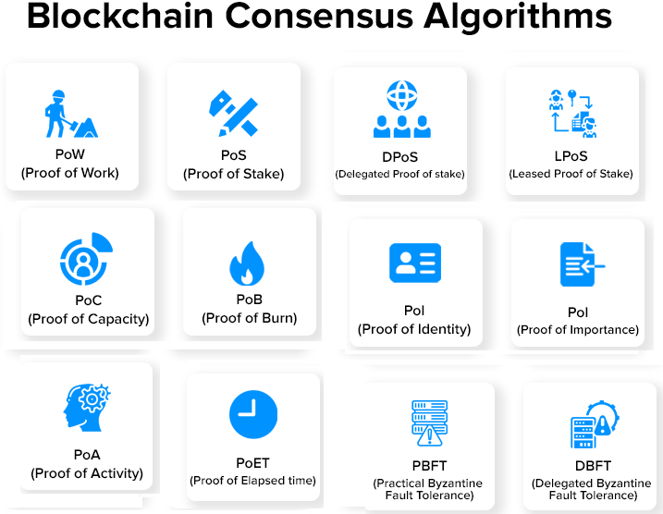

Fig2. Types of Blockchain consensus Algorithms
- Proof of Work
The process of creating fresh blocks of transactions to a cryptocurrency's blockchain is known as proof of work (PoW). Proof of Work, the first consensus mechanism utilized in the blockchain industry, was created by Satoshi Nakamoto. It is also referred to as mining, with miners denoting the participating nodes.

The underlying algorithm used by proof-of-work blockchains determines the rules and level of difficulty for mining operations. The "work" itself is mining. It involves adding legitimate blocks to the chain. This is significant because it enables the network to follow the right blockchain fork because to the length of the chain. The network can be more confident in the condition of the world as long as there is more "work" being done, a longer chain, and a higher block number.

How Proof-of-Work (PoW) works?
- Using powerful computing capacity, the miners in this mechanism must solve challenging mathematical riddles.
- The miners employ a variety of mining techniques, including GPU, CPU, ASIC, and FPGA mining. And as a prize, the one who solves the puzzle first receives a block.
- The procedure is not straightforward, though. A riddle can only be solved by trial and error.
- In addition, the difficulty of the problem rises in proportion to the rate of block mining. In order to keep up with the difficulty level, it is necessary to produce a new block within a set amount of time.
- To find the nonce for a block, miners had to compete in a difficult game of trial and error using the proof-of-work protocol Ethash. To the chain could only be added blocks with a working nonce. The following figure 3 shows the working process of a Proof of Work consensus algorithm.
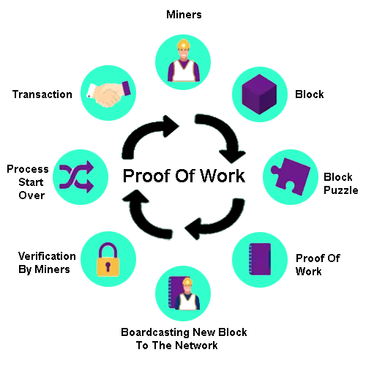

Fig.3 Working process of Proof-of-Work (PoW)

The Proof of Work mechanism is used in the following cryptocurrencies. They are
- Bitcoin,
- Litecoin,
- ZCash,
- Primecoin,
- Monero, and
- Vertcoin.

Advantages and Disadvantages of Proof of Work (PoW)
Sl.No | Advantages of PoW | Disadvantages PoW
1 | High level of security. | ineffective due to high costs and sluggish transaction speeds.
2 | It offers a decentralized means of transaction verification. | High energy usage.
3 | Allows miners to earn crypto rewards. | Costly equipment is frequently required in mining.

- Proof-of-Stake
A consensus process for cryptocurrencies called Proof of Stake is used to verify transactions and add new blocks to the network. In order to lessen the enormous energy consumption of blockchain mining, Sunny King and Scott Nadal originally created the Proof of Stake (PoS) in 2012.
They put out an alternate method termed "staking," in which nodes are selected using a random deterministic mechanism depending on the quantity of coins that each node has staked. To put it simply, the stakers (nodes/users who stake coins) who have more coins "staked" will have a higher likelihood of validating the blockchain and earning transaction fees as compensation.
A network's nodes stake a certain amount of cryptocurrency to qualify as candidates for validating new blocks and receiving a fee. After that, an algorithm selects the node that will validate the new block from a pool of candidates. To ensure that the selection is equitable for everyone on the network, this method combines the stake amount (the total amount of bitcoin) with other variables (such as coin-age-based selection and randomization procedure).
- Coin-age based selection: The algorithm keeps track of how long each validator candidate node remains a validator. The likelihood that a node will replace a validator increases with age.
- Random Block selection: Random Block Selection: Using the criteria of "lowest hash value" and "highest stake," the validator is picked. The new validator is the node with the best weighted combination of these.
How Proof of Stake (PoS) Works?
The figure 4 shows the working process of a Proof of Stake (PoS) consensus mechanism.
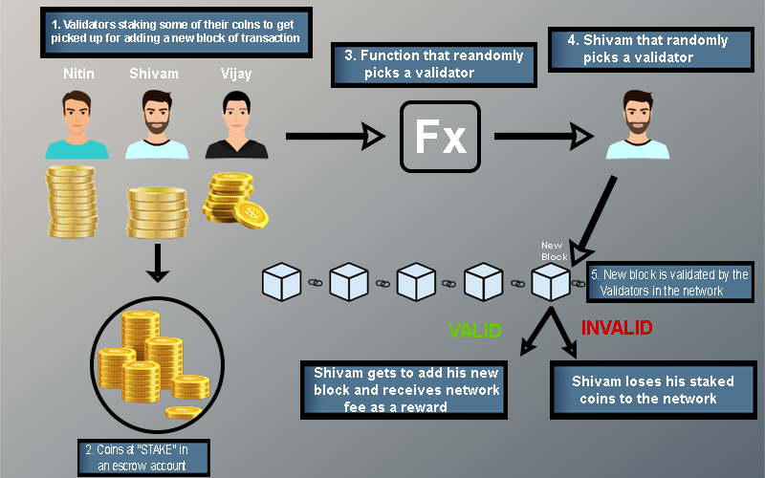

Fig.4: Working process of Proof-of-stake (PoS)

- Nodes carry out transactions. These transactions are all pooled together using the PoS algorithm.
- Every node vying to be the next block's validator raises a stake. To choose the validator, this stake is used with additional criteria like "coin-age" or "randomized block selection."
- The validator confirms each transaction and makes the block public. His stake is still locked, and the forging prize hasn't been given either. This is necessary so that the network's nodes can "OK" the new block.
- The validator receives both the stake and the reward if the block is approved. The validator for the current block gets its coinage reset to 0 if the algorithm chooses validators based on coin age. He now has a low priority for the upcoming validator election as a result.
- The validator forfeits its stake and is labeled as "bad" by the algorithm if the block is not confirmed by other network nodes. The procedure to forge the new block once more begins at step 1.

Currencies that use proof of stake:
There are already more than 80 cryptocurrencies that employ the Proof of Stake mechanism as their way of validation through the consensus mechanism, and PoS is currently becoming increasingly prevalent as a consensus mechanism. Some noteworthy Proof of Stake coins are:
- Ethereum (ETH)  - Cardano (ADA)  - Tron (TRX)  - EOS (EOS)  - Cosmos (ATOM) | - Polkadot (DOT)  - Solana (SOL)  - Polygon (MATIC)  - Avalanche (AVAX)

Advantages and Disadvantages of Proof of Work (PoS)
Sl.No | Advantages of PoW | Disadvantages PoW
1 | Energy: Energy Efficiency and quicker processing. | Complexity: Additional restrictions are required to guard against hypothetical threats like long-range attacks and the nothing at stake problem.
2 | Hardware requirements: Less hardware is needed, and a larger number of people can take part in the consensus process. | Accessibility Limitation: A block validator that controls a higher percentage of staked coins exclusively receives transaction fees and all newly minted coins as payment for his validating labor.
3 | Security: Fraudulent validators must pay a higher price or risk losing more money than they make. It is hence safer. | Lack of decentralization and centralization of power.
4 | Manipulations: Fewer manipulations and flexibility. | Initial distribution: Without coins, no one can become a validator and earn coins to stake.
The Proof of Stake has the following two types of consensus mechanism. They are
- Delegated Proof of Stake
- Leased Proof of Stake
2a. Delegated Proof Of Stake mechanism
It is a one type of Proof of Stake consensus algorithm. The cornerstone for this particular consensus process is the voting delegation. Other users are given the users' votes by the users. The rewards will be given to the users who delegated to that particular vote by whichever user mines the block next.
The DPoS algorithm is developed by Daniel Larimer in 2014. By staking their tokens in the common Proof of Stake algorithm, stakers or validators sign up for a process called mintage in which they add blocks to the blockchain and receive compensation for their truthful work. With Delegated Proof of Stake (DPoS), participants stake their cryptocurrency and cast their votes for a predetermined number of delegates, with the amount of investment determining the voting weight. As an illustration, if user A pays 10 coins for a delegate and user B invests 5 coins, user A's vote will be given greater weight than B's.

Additionally, the delegates are compensated with transaction fees or a fixed number of coins. DPoS is one of the quickest blockchain consensus algorithms and is favored as a digital democracy due to its stake-weighted voting mechanism.

How Delegated Proofof Stake Works?
DPoS algorithm works based on a mechanism of voting or an election system.
- 1. The delegates who validate the blocks are chosen by the network's users. Only a certain number of these delegates are allowed, and they can vary as other delegates can be elected in their place. These nodes are represented as "witnesses" or "block producers."
- 2. Through DPoS, network members can pool tokens into a staking pool and cast a vote for the specific delegate they like. Users of the network can stake using a staking mechanism or service provider rather than sending their tokens to a specific wallet while doing so.
- Delegates are crucial because they guarantee the transactions' accuracy. If they correctly validate the block, they are compensated with transaction fees, which they can then distribute to the people who voted them in. A person can receive a higher allotment the more they are able to stake.
- The amount of the overall stake that a user represents affects the payment they receive from their delegate. For instance, if a user only contributes 10% to the total stake pool, they could still be eligible for up to 10% of the prize.

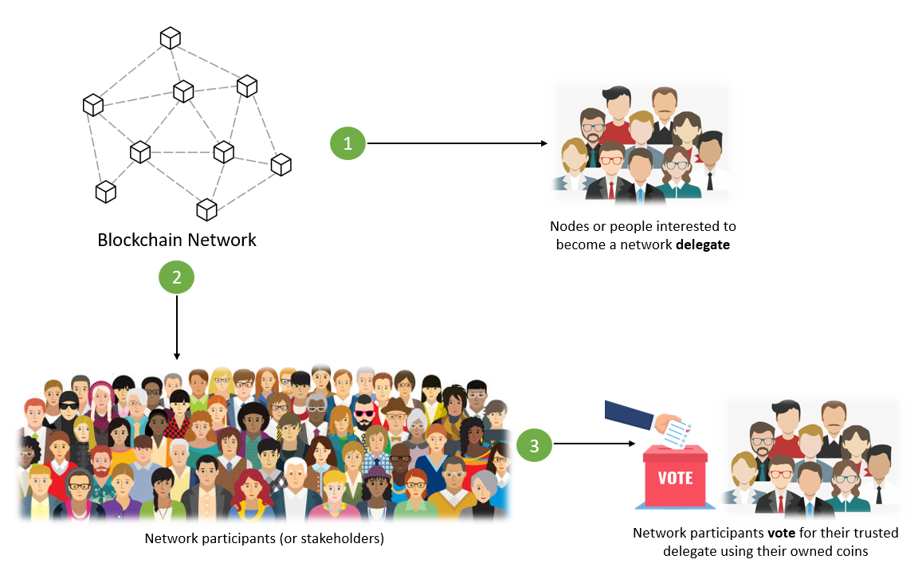

Fig.5: Voting Process of DPoS
Voting:
- In DPoS consensus, users have the option of casting their votes themselves or delegating that responsibility to another party.
- The chosen witness is in charge of building blocks by authenticating transactions.
  - They receive a reward for validating and signing every transaction in a block, which is often distributed among those who voted for witness.
  - If a witness does not complete the required number of transactions in the allotted time, the block is missed, all transactions are left unconfirmed, and the witness receives no reward.
- The next witness who validates that block receives a prize in addition to their own. The next witness collects these transactions, and the block is referred to as stolen.
Each voter's stake is proportionately weighted in the outcome. To join the top tier of witnesses, a user does not need to have a sizable stake. Instead, people with very little stakes may be promoted to the top tier of witnesses as a consequence of votes from users with significant stakes.

Points to keep in mind before Voting:
- Network participants vote using their coins or tokens.
- Each network participant (or stakeholder) receives the same number of votes as the amount of coins they own.
- The stakeholder may also give coins to another stakeholder for that person to cast a vote on their behalf.
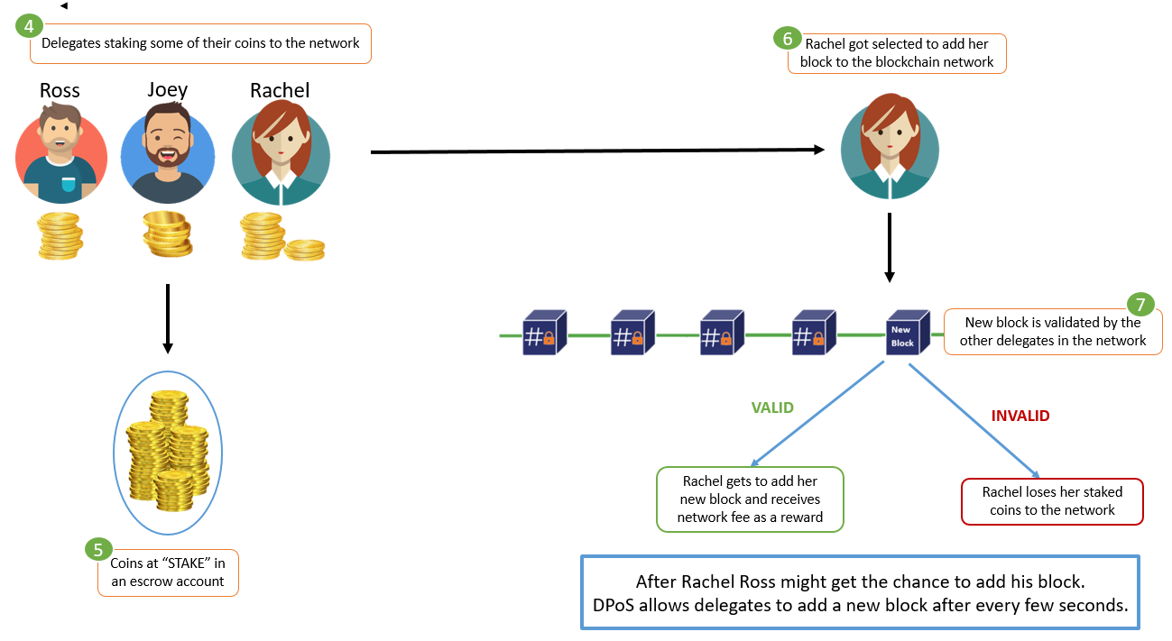
Fig.6: Process of selection a single delegate among selected delegates
Witnesses:
A witness is restrained by threats of financial loss, stake locking, and reputational damage. Witnesses are required to lock a portion of their stake that will be taken away if they commit fraud or attempt to assault the blockchain.
- There is a limit on how many witnesses can be in the first tier; this figure is often between 21 and 101.
- These witnesses are tasked with validating transactions and building blocks, and they are compensated accordingly.
- Witnesses are similar to miners in Proof of Work blockchains in that they can prohibit certain transactions from being included in a block but they cannot change the details of any transaction.
- Each witness in the top tier runs the danger of being replaced by a user who receives more votes and is subsequently regarded as more trustworthy because voting is a continual process.
- As the number of witnesses grows, so does the competition, and each witness's ability to compete depends increasingly on their reputation.
A round robin method is followed in a round of DPoS blockchain with N block producers/witnesses:
- From a field of witnesses candidates, N block producers are chosen.
- Until k=N, each subsequent block is signed by the kth block maker.
- A block is deemed complete when it receives (2/3+1) of the vote from block producers. The longest chain rule is used when there are two chains. Block addition cannot be reversed.
Delegates: In DPoS systems, users may also choose the delegates who will monitor blockchain governance. They have no influence over transaction control. Delegates may suggest altering a block's size or the compensation a witness should receive for validating a block. The blockchain's users vote on whether to embrace these changes when delegates propose them.

Role of Selected Delegates (or Witness):
- The chosen delegates (or witnesses) confirm the adding block's transactions.
- Each delegate has the ability to contribute their own block of transactions to the network.
- Delegates are rewarded for successfully verifying additional blocks or for adding a new, legitimate block.
Block validators : In DPoS, the term "block validator" refers to complete nodes that confirm that blocks generated by witnesses adhere to the consensus rules. Anyone can use a block validator to check the network. A block validator has no incentive to perform their job.
Some of the real-life use cases of this blockchain consensus mechanism are
- Steem, EOS
- BitShares
- Zclassic ZCL
- Bitshares BTS
- Steemdollars SBD

Advantages and Disadvantages of Proof of Work (DPoS)
Sl.No | Advantages of DPoS | Disadvantages DPoS
1 | They are well protected against the risk of using cryptocurrencies more than once, or twice that means double spending.. | If there are only a few witnesses and delegators, the mechanism won't function as it should since it needs highly knowledgeable delegators and witnesses who will tell the truth.
2 | It is more democratic because witnesses and delegates are elected and don't require large stake amounts. Additionally, any node can use a block validator to validate a block. | Due to the mechanism's bias against voters' stakes, votes cast by voters with low stakes in large numbers would be meaningless.

  - Leased Proof of Stake (LPoS)
An improved PoS consensus process known as LPoS runs on the Waves platform. Users can lease their balance to full nodes in this consensus algorithm blockchain, as opposed to the standard Proof-of-Stake technique, where each node having a certain quantity of cryptocurrency is eligible to add the next blockchain. And the likelihood of producing the following block is higher for the one who leases the greater sum to the complete node. The leaser is subsequently compensated with a portion of the transaction fee that the entire node has earned. This PoS variant is a reliable and effective choice for the growth of public cryptocurrencies.

How does Leased Proof of Stake (LPoS) work?

In leased proof-of-stake (LPoS), users rent cryptocurrency to a particular node that aspires to be the blockchain's "block producer." A node has a better probability of getting chosen to add new blocks and receive rewards when the stakes are higher. The lease can be ended at any time by the user.
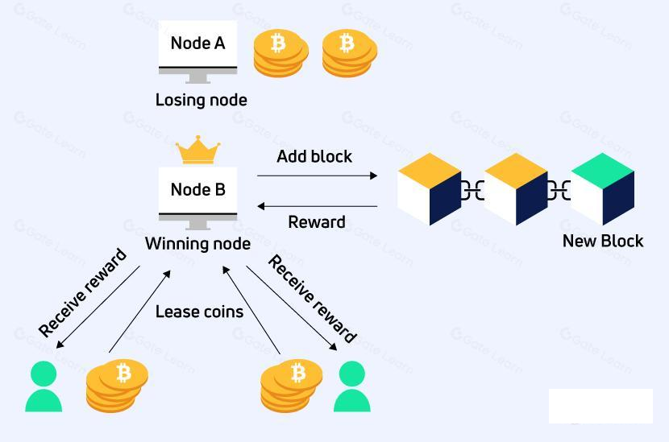

Fig.7: Working process of LPoS

- The coin owner must create a lease transaction and include the recipient node address and the number of coins to be leased in order to begin leasing. Leasing can always be stopped by entering a cancel lease transaction.
- The coin holder/lessor retains complete control over the leased cash. Although the leaser can link the coins to the nodes they want to lease from, the coins never leave their wallet. The coins do not actually go to the node; instead, they simply remain unusable and cannot be exchanged or transferred until the leaser ends the agreement.
- LPoS allows leasers to take part in the consensus mechanism since the more money a node has leased from it, the more likely it is to be chosen to create the next block. For instance, in the Fig. below, node B is the recipient of the monies from two lessees. The node's stake weight is raised by using the tokens that are leased to it, which improves its chances of being chosen to validate transactions and add the next block to the Blockchain.
- The node compiles a block of pending transactions after winning. The transaction fees are subsequently given to the winning node as compensation.
- The node operators distribute a portion of their node rewards to their leasers after receiving them. The leaser will receive more compensation the more is rented.

How to Execute LPoS Transactions?

To construct a lease transaction, the token owner must specify the token amount they desire to lease as well as the destination address (node address).

There are two distinct transaction types used by the LPoS:

The leasing procedure is initiated by the execution of a lease transaction.

The leasing process is terminated by executing a lease cancellation transaction.

Benefits of Leasing to Token Holders

With LPoS, token owners can rent out their tokens to nodes in exchange for a share of the dividend payment.

Because Waves nodes are more likely to be selected to produce the following block when a higher quantity is leased to them, lessees will be able to participate in the process of creating new blocks by using LPoS. The lessor will be paid if that node is selected.

When a user first starts renting tokens, the tokens are locked and retained at the same address under the full ownership of their owner (they are not moved to the node, they simply stay unavailable for use until the lessor cancels the lease).

Benefits of Leasing to the Node Owner
The node owner or lessor receives the mining incentive when nodes use the leased tokens to build blocks.
The leased tokens can be used by nodes to create blocks and the node owner or lessor receives the mining reward.
- The likelihood that a node will add blocks to the blockchain improves as more coins are leased to it, increasing its mining power.
- The node owner may choose the percentage of incentives that the lessor receives according on his criteria.
- Based on the amount leased, the probability that a node will be picked to build the next block rises.

Examples of Blockchains that Utilize LPoS
- Waves
- Nix

Features of Leased Proof of Stake

- Balance Leasing : Users can profit passively from using LPoS by leasing money from their wallets or any other form of cold storage to miners.
- Fixed Tokens: In LPoS, tokens are not created by mining and are instead fixed to the network. Tokens can instead be rented and fixed. Leased tokens are locked in the leaseholders' accounts and cannot be traded or transferred unless the owner cancels the lease.
- Decentralized: Most blockchains incentivize users for signing up for mining pools, which creates a centralized structure. With LPoS, however, rewards are distributed equally based on the amount staked, eliminating the need for a mining pool. Leasing also follows a peer-to-peer protocol to avoid interference from outside parties.
- Rewards in place of transaction fees: Transaction fees are rewarded to miners rather than block rewards on LPoS, in contrast to other blockchains.

Benefits of Leased Proof of Stake (LPoS)
- Each node on a typical proof-of-stake platform has the ability to add a fresh block to the blockchain. Users have the option of running a full node or leasing their stake to a full node while still getting rewards in a Leased Proof-of-Stake environment. Anyone can take part in the Waves network maintenance thanks to this system.
- In a Proof of Stake network, validators are selected based on their stake. This raises concerns about the system's fairness when some nodes are consistently selected. In LPoS, users can, however, potentially improve their selection odds by accepting a lease from another user.
- LPoS enables minor token holders to earn money by renting out their limited tokens to full node owners. So, a portion of the money earned by the entire network goes to minority token owners.
- Leased tokens are automatically locked and cannot be exchanged or transferred. Although the locked money are not usable, the lessor does have the ability to end the lease and release the leased funds for usage.
- A lease can be started using a mobile phone. A work that previously required many nodes with significant computer power can now be completed by a small group of nodes with the help of phone users, saving energy.
- LPoS-based systems are rapid and efficient because only a few nodes are involved in verifying a transaction at once.

Disadvantages of Leased Proof of Stake (LPoS)
On the LPoS, where users lease to a single full node, heinous acts can be planned. This node has an advantage over other nodes because it will always be in front of the validators' pool and favored to validate blocks of transactions.
- Proof of Capacity (PoC)

Proof-of-capacity (PoC), sometimes known as proof-of-space (PoSpace), is a technique for demonstrating one's rightful interest in a service (such sending an email) by dedicating a sizeable quantity of memory or disk space to address a problem posed by the service provider. In 2015, Dziembowski et al. developed the idea, and independently, so did Ateniese et al. Proofs of capacity are extremely similar to proofs of labor, with the exception that storage is used rather than computation.

How Proof of Capacity (PoC) Works?
The two-step proof-of-capacity methodology consists of mining and plotting.
Plotting Process:
- Full nodes or miners must set aside some storage space before mining even begins to store the list of potential solutions. This action is referred to as "plotting."
- The hashing algorithm is used to each nonce kept in the blockchain header during the plotting stage. The results of this hashing are kept in a brand-new file known as a plot file.
- A list of hashes that match the header values may be found in the plot file. Miners can begin mining by validating blocks and adding them to the chain after the plotting procedure is finished.
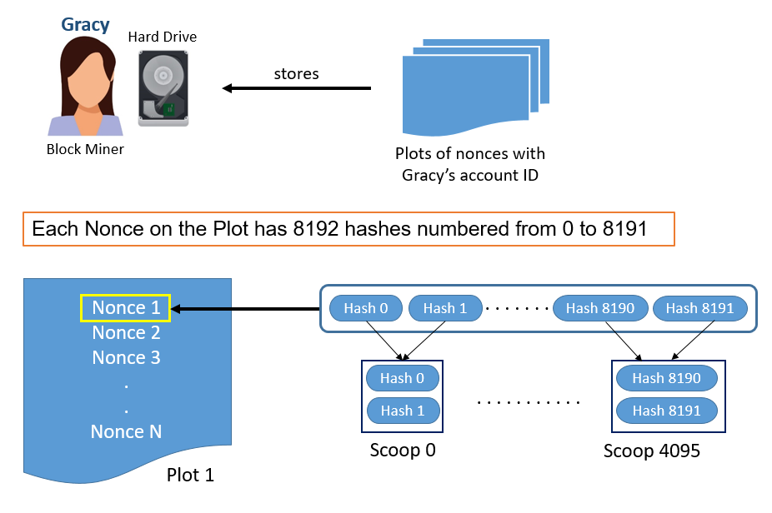

Fig.8: Working process of PoC
- Plotting the Hard drive
- Making use of cryptographic hash methods like SHA-256 to compile a list of all conceivable nonce values.
- The list of potential nonces is a plot, each of which is identified by a different account ID.
- Even with the same nonce numbers, Account ID makes it possible to distinguish between miner plot files.
- Burstcoin (which makes use of PoC) hashes data using the Shabal 256 hash function. A 256-bit (32 byte) hash is produced.
- The 8192 hashes for each nonce on the list range from 0 to 8191.
- A nonce's adjacent hashes are coupled into 4096 scoops. For instance, hash 0 and 1 result in scoop 0, and hash 2 and 3 result in 1 and more.
- Every scoop has 64 bytes of data with 2 hash values. The figure shows the sample created plot value of the PoC.
Mining the block
- Here, the miner uses math to determine the scoop number. Scoop data can then be produced using the scoop number.
- The scoop data is used to assess the value of a deadline.
- Iteratively calculating deadlines continues until every nonce on the hard drive has been used. The miner chooses the minimum deadline as a result.
- The deadline is the amount of time that has to pass since the most recent block was added. A miner is permitted to forge the following block after that time period.
- A miner must therefore establish a minimum deadline. so that they can place their block after it.
- However, he will have the chance to add his block if another miner generates a shorter deadline time and delays the present deadline. He thereby receives the block reward.
Examples for PoC
- Permacoin,
- SpaceMint,
- Burstcoin
- Chia
- Storj
- Safe

Pros of Proof of Capacity
- Compatible: Any standard hard drive, even those used by Android-based systems, is compatible with the PoC.
- Cheap: Storage costs are very cheap.
- ASIC Resistant: It is allegedly up to 30 times more energy efficient than bitcoin cryptocurrency ASIC-based mining.
- Hardware Requirements: There is no requirement for specialized hardware or ongoing hard disk upgrades.
- Data Storage: Mining data may be quickly deleted, allowing the disk to be used for other types of data storage.

Cons of Proof of Capacity
- Few developers have started using the system.
- Susceptible to grinding attacks : Malware has the potential to interfere with mining operations.
- The widespread use of PoC might ignite a "arms race" to create hard drives with greater storage capacities.
- Increased space requirements: • A greater need for space Even though it is inexpensive, if the algorithm doesn't distribute the load appropriately and equally, additional storage may be needed.

- Proof of Burn (PoB)
This algorithm offers a less energy-intensive alternative to PoW and PoS. The idea behind it is to let miners "burn" tokens of digital money. The right to write blocks is then handed to them in accordance with the amount of money burned. In the proof of burn consensus mechanism, users of the network must "burn" (or destroy) a specified number of coins in order to participate. The more coins a user burns, the more likely it is that they will be chosen as a validator. Validators are rewarded with newly created currencies and transaction fees. PoB seeks to emulate the idea of proof of work (PoW), the original consensus method of Bitcoin, without the burdensome hardware and excessive energy consumption.

Why Proof of Burn Required?
The PoW consensus algorithm had some shortcomings that led academics to develop the PoB consensus algorithm.
- The first disadvantage is that PoW consumes a lot of power. Under a POW mechanism, miners receive rewards by upgrading the ledger.
- In exchange for payment, computational power is used to solve a mathematical problem. The more money a miner invests to address the issue, the more likely it is that they will be granted permission to mine blocks.
- PoW demands very significant capital commitments.

Proof of Burn (PoB):
Instead than spending money on pricey hardware equipment, the validators use PoB and take the following approach:
- They destroy money by sending it to a location from which it cannot be recovered.
- Therefore, burning money means that validators have a long-term commitment in exchange for their short-term loss.
- By committing the coins to an unreachable address, validators acquire a privilege to mine on the system based on a random selection procedure.
- Miners may burn either the native money of the Blockchain application or the currency of an alternative chain, such as bitcoin, depending on how the PoB is implemented.
- Validators' chances of getting chosen to mine the upcoming block increase with the amount of money they burn.

How Proof of Burn (PoB) Works?
- As the term already says, something needs to be burned. Since we are discussing virtual cash in this context, it is evident that PoB burns virtual currency. The power of miners to construct blocks increases as more of the currency are burned by them.
- We don't necessarily mean to burn when we say that. In other words, don't use that currency. If it is delivered to a location where it cannot be spent, this may be done. In order to prevent their use, miners transfer these coins to these addresses. It's delivered to a publicly accessible address where it can't be accessed and is therefore useless.
- When a coin is burned, its supply is reduced, potentially increasing the coin's value.
- We must now ask ourselves, "Why do we need to burn the coin?" The fundamental justification for this is that by destroying the money, the customer is demonstrating a strong commitment to the money by forgoing a short-term benefit in favor of a long-term profit.
- The PoB has developed a system that permits the periodic burning of cryptocurrency tokens in order to maintain mining capacity, preventing any unfair advantages for early adopters. When a new block is mined, the energy of burned coins somewhat reduces.
- It is a deflationary theory in which the number of currencies gradually decreases, increasing the deficit and, consequently, the value of the currency holders. On the other hand, coins that increase in quantity over time typically depreciate in value.
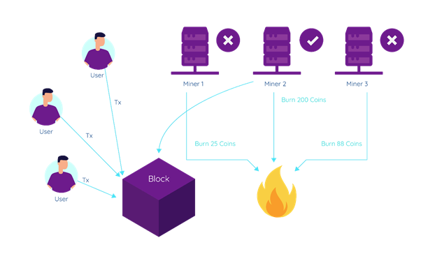
Fig.9: Working process of Proof of Burn

Advantages of PoB
- More long-lasting. decreased use of electricity.
- No demand for mining equipment. Coin burns are fictitious mining equipment.
- Burning coins results in less money in circulation (market scarcity).
- Promotes the miners' continued dedication.
- Coin mining and distribution are typically less centralized.

Disadvantages of PoB

- Some claim that PoB is not really environmentally benign because PoW mining, which uses a lot of energy, creates the Bitcoins that are burned.
- Not shown to be effective on bigger scales. To confirm its effectiveness and security, additional testing is required.
- The verification of the miners' work frequently takes longer than expected. It is slower than in blockchains with proof of work.
- The burning of coins is not always transparent or simple for the typical user to verify.

Example cryptocurrencies used a PoB such as Slimcoin (SLM), Counterparty (XCP), and Factom (FCT).
- Proof of burn has some advantages over proof of stake and proof of work.
- First, it reduces the risk of centralization and collusion, as the validators have to prove their commitment to the network by burning their own coins.
- Second, it eliminates the problem of "nothing at stake", which occurs when validators have no incentive to act honestly and can stake on multiple competing chains.
- Third, it creates a deflationary effect on the coin supply, as the burned coins are permanently removed from circulation.

- Proof of Identity (PoI)
PoI (Proof of Identity) is a notion that is similar to authorized identity. It is a piece of cryptographic evidence that a user's private key is associated with a certain transaction. A block of data can be created and managed by each identifiable user and made available to other network users. The produced data's validity and integrity are guaranteed by the blockchain consensus model. This mechanism mostly used in the permissioned blockchain networks; here the user nodes are already registered nodes. Gavin Wood, a co-founder of Ethereum and Parity Technologies, made the term official in 2017.
How PoI working?
It is works like Proof of Authority (PoA) consensus mechanism.
- In PoA, nodes that have established their legitimacy to do so are granted the right to create new blocks. The "Validators" are the nodes that execute the software that enables them to add transactions to blocks. The process is automated, so validators do not need to keep an eye on their computers all the time, but they do need to keep them secure. PoA is appropriate for both private networks and public networks with distributed trust, such as POA Network.
- The PoA consensus mechanism makes use of the value of identities, so block validators stake their reputations rather than actual money. PoA is protected by confidence in the chosen identities.
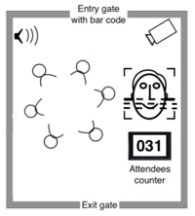
Fig.10: Working of Proof of Authority consensus mechanism
Conditions for PoA consensus:
Although PoA consensus may vary depending on implementation, they are often used in the following circumstances:
- Validators must attest to their true identities.
- A candidate must be prepared to risk both his financial investment and his reputation. A rigorous selection process lowers the likelihood of choosing dubious validators and encourages long-term dedication to the blockchain.
- The method used to choose validators must be fair to all applicants.
- To preserve the integrity of the blockchain, the validators' identities must be confirmed. There should be some sort of procedure in place to choose trustworthy validators.

Advantages of PoA Consensus :
- High risk tolerance provided that 51 percent of the nodes are not operating maliciously.
- Predictable time interval at which new blocks are generated. This period varies for consensuses in PoW and PoS.
- More transactions per second can be processed
- Less processing power is required.
- Far more environmentally friendly than computationally intensive methods like Proof of Work.
Limitations of PoA Consensus :
- PoA is just an attempt to make centralized systems more effective; it is not decentralized.
- PoA validators are open to everyone's view. Knowing the identities of validators may enable third-party tampering.
Application of PoA Consensus :
- The PoA consensus algorithm is a superb choice for logistical applications like supply chains and may be used in a number of situations.
- Businesses may protect their privacy while utilizing the advantages of blockchain technology thanks to the Proof of Authority approach.
- Another example of how PoA is being used is Microsoft Azure. Since there is no requirement for mining, the Azure platform offers options for private networks with a system that does not require local currency like ether 'gas' on Ethereum. Pre-selected Azure nodes are used.
- Proof of Importance

What is Proof of Importance (PoI)?
Proof of Importance (PoI), a new consensus mechanism based on Byzantine Fault Tolerance, is one of many that have been introduced ever since the creation of Blockchain and the Proof of Work (PoW) consensus mechanisms to authenticate a new node or any transaction happening over the blockchain.
Proof-of-Importance (PoI) is a blockchain consensus mechanism introduced by NEM (New Economy Movement) and this concept is a further build-up on the Proof of Stake (PoS) algorithm.
- Prior to being allowed to mine blocks in PoI, nodes must vest a certain number of coins that correspond to the score reflecting the contribution they provided to the network.
- However, unlike Proof of Stake (PoS), the score is based on a number of different factors, including the overall amount, activity clusters, reputation, and transactions performed through a certain address.

How does Proof of Importance (PoI) Work?
'Harvesting' or 'vesting' is the process of determining which nodes in the network are eligible to add a block to the blockchain and is done using the Proof of Importance mechanism.
Nodes can obtain the transaction fees contained in a block, which the validator receives as payment for validating it, in exchange for harvesting that block.
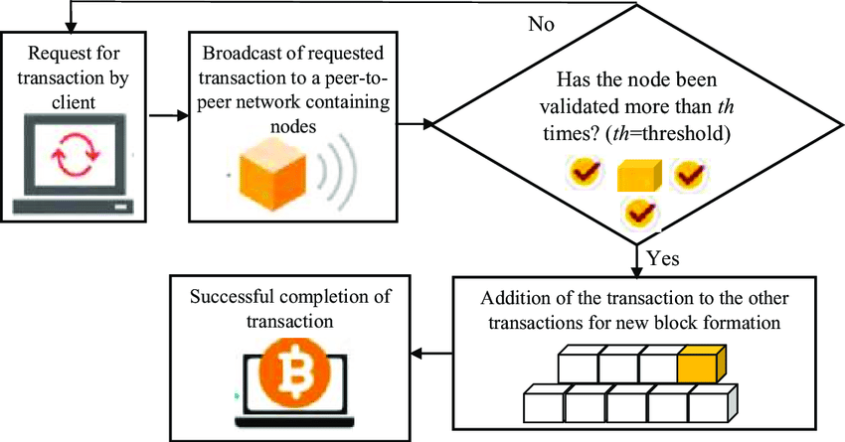
Fig.11: Working process of Proof of Importance (PoI)
NEM evaluates the three crucial factors below to determine an account's overall support for the network or score: -
- Vesting: The most crucial element of this consensus mechanism is vesting, also known as harvesting. Before any node can begin harvesting or vesting, they must first have at least 10,000 XEM coins. For the purpose of determining the node's Proof of Importance score, the consensus mechanism counts the quantity of coins that have been in your account for a predetermined period of time (often 30 days). As a result, the node will score higher the more XEM coins it has.
- Transaction partnership: Proof of importance rewards users who conduct transactions on the network with different NEM accounts and recognizes the two accounts as partners. In order to provide each node a score for importance and prevent the user from forming any fictitious partnerships, the network theory calculation examines transaction behavior.
- Transaction volume and size: Each transaction that is larger than a certain threshold affects the Importance score and raises the possibility of harvesting a block to earn rewards. On the NEM network, larger and more frequent transactions will increase the PoI score, which is based on the transactions a node does over the course of 30 days.

Benefits of Proof of Importance (PoI)
- Energy Efficient
- Avoid coin hoarding and encourages transaction
- Lower Incentive
- Discourages Forks

- Proof of Activity (PoA)
Proof of Activity is a combination proof of work (PoW) and proof of Stake (PoS) mechanism.

How does the Proof of Activity (PoA) Algorithm work?

Process of Mining the Block (by Miners): Similar to PoW, miners attempt to submit their nearly empty block (with header information and miner's reward address) by obtaining the right nonce and block hash by solving a challenging mathematical challenge.

Process of Signing the Block (by Validators)
- The Proof of Stake (PoS) technique is used in this stage to leverage network validators. Validators and miners are independent entities in this case, though.
- The block that the miners have submitted is validated by a group of network users known as validators (or signers). These network validators are chosen according to the network currency they hold. A validator has the greatest probability of having their signed block selected the more bitcoin they have.
- Blocks are classified as signed or unsigned by validators after they have examined the header data and the reward address provided by the miners.
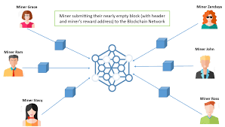
Fig.12. Process of Proof of Activity

Adding transactions
- Once the required amount of validators have signed a block. It designates a legitimate and entire block. The block is then supplemented by fresh transactions from the transaction pool. The block is then included in the blockchain network.
- The miner of the winning block and the validators share the mining reward in appreciation of their network-wide service.
- The most well-known cryptocurrency that makes use of proof of activity is Decred (D-Cred).
Advantages of Proof of Activity
- PoW and PoS's digital signing and hashing systems are combined to form PoA.
- It significantly lowers the likelihood of a 51% attack on the network.
- maintains the network's protection challenge level.
- Due to the fact that the system will never completely shut down, PoA has excellent fault tolerance.
- Give network validators and miners the chance to earn money.
Proof of Activity (PoA) restrictions:
These are the drawbacks of the mechanism for proving activity:
- Excessive energy use when mining bricks.
- The mining process is time-consuming since it requires extensive calculation.
- Costly gear is needed for calculation.
- Internal disagreements and a bad reputation result from the fact that neither miners nor validators have anything to gain.
- Because of a lack of interest, there can be fewer validators.
- Proof of Elapsed Time (PoET)
The network consensus mechanism known as Proof of Elapsed Time (PoET) guards against excessive resource use and power consumption. To maintain the process' efficiency, a fair lottery technique is used. It is introduced in the year 2016 by Intel Corporation.

How PoET works?
This technique, which is based on Byzantine Fault Tolerance, tries to cut down on the energy needed for the mining phase of proof of work.
- Each node in the network receives a random length of time according to this procedure.
- For that arbitrary waiting period, the node must rest or perform some other work.
- The node with the shortest waiting time gets up and joins the network with its block.
- The network's users are inundated with the most recent information.

For PoEt to succeed, these 3 conditions must be met.
- Make sure the node receives the random waiting time in its place.
- Verify that the nodes are not purposefully selecting the smallest wait time.
- Check to see if a node has finished the specified waiting period or not.
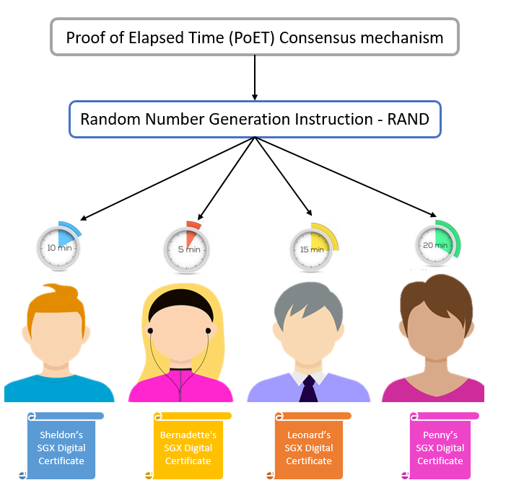
Fig.13 Process of PoET consensus mechanism

With the PoET method, a randomized timed scheme takes the place of the Proof of Work's requirement for mining-intensive rights. Every node is likely to be chosen by a fair lottery system according to the PoET consensus mechanism, which distributes the odds of winning across the greatest number of network users feasible.

Phases 1 and 2 of the PoET consensus method are as follows:

1. Selection Process: The following tasks are included in this process:

By using Intel Software Guard Extension (SGX), every node in the network will share its certificate, ensuring that it is valid to create a new block in the network. The node is then qualified to receive a timer object.

The Intel RAND, or random number generator, assigns the numbers to each node as a timer object. RAND produces erratic statistics that are challenging to identify.

Each participating node's time object becomes active.
2. Generation Process: The following actions are part of this process:
- The node becomes eligible to forge a new block for the network once the timer object expires and the node wakes up.
- The active node creates a hash of the transactions in its block and submits it for approval.
- The network is inundated with the update.

Thus, utilizing the PoET consensus method, mining a new block in a permissioned blockchain network comes to a stop at this point.
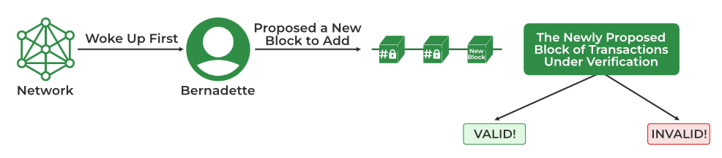
Fig.14 End point of the PoET consensus algorithm

Benefits of PoET
- Less energy use: PoET uses a small amount of electricity, and because nodes can "go to sleep" and move to other duties for the designated period of time, the network is both time and energy efficient.
- Less resource-intensive: PoET offers an excellent solution to the "Random Leader Selection Problem" without consuming a lot of resources or necessitating complicated methods. It is easily scalable because it enables the network to come to agreement more quickly, allowing for quicker transaction processing.
- High Transaction rate: PoET has a high transaction rate that can reach one million per second.
- Equal opportunity: PoET gives network participants with time object and activation the same opportunity.
- Permissioned: As a permissioned blockchain network, network security against cyberattacks is ensured by the selection of validators.

Limitations of PoET:
- Specialized hardware required: Despite being inexpensive, the Proof of Elapsed Time consensus process requires specialized hardware, making it inaccessible to most users.
- Compatibility problems: PoET heavily relies on Intel technology, which could cause problems with other tools.
- Byzantine Fault Tolerance
Byzantine Mistake Byzantine fault, also known as the Byzantine Generals Problem, is a circumstance where the system's actors must agree on an effective strategy to avoid the system failing catastrophically, yet some of them are doubtful. As the name implies, tolerance is employed to deal with this problem.
The two BFT consensus model variants that are most popular in the blockchain space are PBFT and DBFT.
  - Practical Byzantine Fault Tolerance
- By allowing users to confirm the messages that have been transmitted to them by executing a computation to evaluate the decision regarding the message’s legitimacy, PBFT is a simple blockchain algorithm that addresses the issues with the Byzantine General.
- The party then communicates its choice to more nodes, who eventually decide on it. In this manner, the final choice is based on the information gathered from the other nodes.
- Some applications of this blockchain consensus process include Stellar, Ripple, and Hyperledger Fabric.
How pBFT works ?

Byzantine state machine replication that can function even when the system contains malicious nodes is what pBFT aims to offer.
- A pBFT-enabled distributed system's nodes are arranged in a sequential order, with one node serving as the primary (also known as the leader node) and the others serving as secondary (also known as backup nodes).
- It should be noted that any eligible node in the system has the ability to switch from secondary to primary at any time (usually in the event of a primary node failure).
- The objective is for all trustworthy nodes to cooperate in applying the majority rule to come to an agreement on the system's current state.
- A Byzantine Fault that is useful under the restriction that the number of malicious nodes cannot exceed or be equal to one-third of all the nodes in the system, tolerant systems can operate. The system becomes more secure as the number of nodes grows.

pBFT tries to provide a practical Byzantine state machine replication that can work even pBFT consensus rounds are broken into 4 phases(refer with the image below):

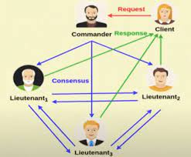
Fig.15. Working process of PBFT

- The client contacts the principal (leader) node with a request.
- All secondary (backup) nodes get the request through broadcast from the primary (leader) node.
- The nodes (main and secondary) carry out the requested service and then respond to the client.
- The request is fulfilled when the client receives'm+1' responses with the same outcome from various network nodes, where m is the maximum number of incorrect nodes permitted.
Every view (pBFT consensus round) involves switching the primary (leader) node, which can be replaced by a view change protocol if a predetermined amount of time has passed without the leading node broadcasting a request to the backups (secondary). The next leading node in line may be selected if necessary by a majority of the honest nodes who vote on the legitimacy of the present leading node.

Limitations of pBFT:
- Communication Overhead: Due to the substantial communication overhead that rises exponentially with each additional node in the network, the pBFT consensus model only functions well when the number of nodes in the distributed network is low.
- Sybil attacks: Sybil attacks, in which one person (party) controls several identities, are a threat to the pBFT mechanisms. Sybil attacks get harder to execute as the number of nodes in the network grows. However, because pBFT mechanisms also have scaling problems, alternative processes are used in addition to the pBFT mechanism.
- Scaling: Because of its communication overhead (with all the other nodes at every step), pBFT does not scale effectively. The time it takes to react to a request increases as the number of nodes in the network does (increases as O(nk), where n is the number of messages and k is the number of nodes).

  - Delegated Byzantine Fault Tolerance
Introduced by NEO, the Delegated Byzantine Fault Tolerance mechanism is similar to the DPoS consensus model. Here also, the NEO token holders get the opportunity to vote for the delegates.
This type of Blockchain consensus protocol is also called ‘Ethereum of China’ and can be a helpful resource in building a ‘smart economy’ by digitising assets and offering smart contracts on the blockchain.

How does the dBFT mechanism works?
Delegated Proof-of-Stake is comparable to the dBFT consensus algorithm. Holders of NEO tokens have the option to choose delegates through a voting mechanism. No matter how much money they have in their possession, this is.
As long as they match the conditions, anyone can serve as a delegate. This entails a dependable internet connection, the appropriate tools, a verified identity, and 1,000 GAS, the incentive users receive for their network activity. A speaker from among the delegates is selected at random.
The speaker creates a fresh block out of the transactions that are awaiting verification. The speaker will then forward the proposal to the chosen delegates. They have a responsibility to monitor all transactions and log them on the network.
Delegates are free to discuss and contrast the proposal they have been given in order to evaluate both the speaker's sincerity and the accuracy of the data. If more than two-thirds of the delegates agree and validate the block, it is put to the blockchain.
In the NEO network, voting takes place in real time.

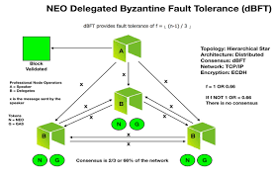
Fig.16 Working of dBFT consensus

dBFT pros:

A new block on the chain needs to be generated every 15 to 20 seconds.

The throughput of transactions is very nearly 1,000 TPS. In order for the network to enable significant commercial applications, NEO intends to attain 100,000 TPS.

No energy expenditure is required (in contrast to the Proof-of-Work consensus technique).

Complete closure of transactions following confirmation.

The NEO blockchain does not have any forks.

dBFT cons:
- There is no anonymity on the blockchain since delegate operations must be conducted using real identities in order to be elected.
- A certain degree of centralization—exactly what blockchains like Bitcoin and Ethereum are aiming for—is a need of the mechanism for regulated blockchains.

Future of Consensus Mechanisms: -
While used by all cryptocurrencies, consensus mechanisms are just as important in distributed ledger networks used by enterprises. Platforms have been created for business and government use, allowing each entity to choose from modules created for their needs, backed by consensus mechanisms. Hyperledger Fabric, one of the more well-known distributed ledger platforms, provides different consensus mechanisms. For example, one entity might not need proof-of-work, considered byzantine fault tolerant, whereas another might not need that level of consensus.
Cryptocurrency's future may be unknown and volatile, but consensus mechanisms remain an essential part of emerging technology. They ensure data safety and integrity and keep those with nefarious intentions locked out of distributed ledgers.
As the blockchain payment platform follows a distributed natured network leaving no central governing authority. This ensures minimum control of central authorities over the systems. As a result, consumers can finally trust the system to offer the full security they deserve.
References:

