Mulching: A Sustainable Technique to Improve the Crop Production
Anushree.^{1*}, Vidya, V. S.², Rekha, B.³

- M. Sc.(Agri) scholar, Department of Agronomy, KeladiShivappa Nayaka University of Agricultural and Horticultural Sciences, Shivamogga, Karnataka, India
- Ph. D. scholar, Department of Agronomy, KeladiShivappa Nayaka University of Agricultural and Horticultural Sciences, Shivamogga, Karnataka, India
- Assistant Professor, Department of Horticulture, College of Agriculture, Hassan, University of Agricultural Sciences, GKVK, Bangalore, Karnataka, India
*Corresponding author Email ID: anushreeg2706@gmail.com
Abstract
As the population of India is continuously rising we have to adopt certain ways of sustaining our agricultural growth and it can be achieved through conservation farming. Mulching has many strategic effects on soil ecosystem, crop growth and climate. It has become an important practice in modern crop production due to benefits such as reduced weed competition, moisture conservation, decrease in certain insect pests, improved yields of crops and more efficient use of soil nutrients. The most common mulching material is plastic, especially black polyethylene, which is used almost everywhere because of its low cost and production-proven benefits. Biodegradable films are also becoming more popular in fieldbecause they can be left there safely after harvesting but are less durable and cost much more than plastics. Generalizations are difficult to make because different mulching materials have been employed for various agricultural and horticultural species in various climatic situations. Results vary depending on the chosen strategy, growth techniques, environmental factors, and species.
Keywords: Mulching, evapo-transpiration, weed control, infiltration rate.
Introduction
The term "mulch" is derived from the German word "molsch," which means "easy to decay." Mulching is the process of applying various covering materials to the soil surface in order to reduce moisture loss, control weed growth and increase crop yield (Kader et al. 2019). Mulches have the potential to reduce water runoff, enhance soil infiltration, control weed growth by shading and act as a barrier to evapo-transpiration (Rathore et al. 1998). Mulching offers other beneficial environmental impacts such as regulating soil and plant root temperature, minimizing nutrient losses, minimizing soil erosion and compaction and improving soil physical conditions (Lamont. 2005). Mulches gained attention in the late 1930’s because they can change the environment around agricultural, forestry and horticultural fields. Furthermore, it has been stated that in rainfed conditions, mulching increases the yield by 50%–60% compared to no mulching (Dilip et al. 1990). Mulching the earth can improve the soil's organic content, inhibit weed growth, and lessen or stop erosion (Bot and Benites 2005). Numerous types of organic mulches are frequently used in landscaping to prevent weed growth and improve plant health. While using organic waste as mulch dates back to early agricultural practises, stone mulches also have a long history. Farmers utilized lithic debris to mulch their dryland fields more than a thousand years ago in both the old and new world to prevent drought and increase crop yield. Other lithic materials, such as stones, gravel, pebbles, volcanic ash and cinder, have also been employed. The approach not only reduces evaporation but also decreases wind erosion and surface runoff from fields (Lightfoot. 1996).
The mulch present on the soil surface receives the impact of beating raindrops. Thus, it protects the breaking down of soil aggregates and subsequent sealing. As rain drops slowly trickles through the mulch, infiltration is more. Mulch slows flow velocity of runoff. As there is more opportunity time, more water enters the soil and thus, reduces runoff. Weed germination and emergence are less under the thick cover of mulch and thus saves water that might have been robbed by weeds. Overall, mulching plays a crucial role in sustainable and efficient agricultural practices.

Types of mulches
1. Organic mulch
Organic mulching is a sustainable gardening and landscaping practice that involves covering the soil around plants with natural, biodegradable andorganic materials such as crop residues, farmyard manure and byproducts of timber industry etc. This organic material serves multiple purposes, including weed suppression, moisture retention, temperature regulation, soil improvement and reduces crusting. But their gradual decomposition adds organic matter to the soil and also promotes beneficial soil micro-organisms.Thus, it is an environmental friendly way, whichhelp the nutrients reach plant roots and promotes healthy gardens.
Types of organic mulches
- Straw mulch: Straw or crop residue is easily accessible after harvest. A light substance that is easy to use and apply is straw mulch. As paddy straw enhances crop cultivation conditions, it is now frequently employed as field mulch. Because they are very combustible and contain grain seeds that might emerge and reduce the amount of nitrogen in the soil as they degrade, straw mulches need to be renewed every year.
- Dry leaves mulch: Dry leaves act as natural mulch, helping to retain soil moisture by reducing evaporation. They can help to smother weeds and prevent their growth, reducing the need for weeding. As leaves decompose they release nutrients into the soil, thus improving its fertility.
- Saw dust mulch: For mulch, sawdust is a common choice in areas where it is easily accessible. During the wood finishing process, it turns out. It contains only half of the nutritional value compared to straw mulch. The high C: N ratio causes the breakdown to proceed very slowly. Because of the nitrogen shortage caused by its degradation, fertilizer needs to be applied often. Low pH soil shouldn't use it because of its acidic character. However, it can hold onto moisture for a long time (Tan et al. 2019).
- Compost mulch: Compost mulching is a sustainable gardening practice where compost is spread over the soil surface around plants. Compost is widely available and is frequently used in agriculture. It increases the soil's characteristics and carbon content, which enhances the soil's ability to hold onto water and the health of the soil. Compost is not advised for use in vegetable fields due to its increased N content because of the possibility of weed development.
- Grass clipping mulch: Grass clipping mulching is a sustainable gardening practice where, we leave the grass clippings on your lawn after mowing rather than bagging and disposing of them. This can help to improve lawn’s health and reduce waste. The clippings breakdown and provide nutrients back to soil, acting as a natural fertilizer.
- Bark clippings mulch: These are efficient mulches because they keep more moisture for a longer period of time and increase the crop's access to water. It is frequently employed for planting and landscaping. However, as it contains acid, vegetable fields shouldn't be treated with it. Nevertheless, this mulch works perfectly to cover the paths in between the beds.
Benefits of Organic Mulching
Conserves soil moisture: Mulch acts as a barrier between the soil and the air, reducing the direct exposure of the soil to sunlight and wind. This limits the evaporation of moisture from the soil surface, helping to maintain a more consistent level of soil moisture. Mulch provides insulation for the soil, preventing extreme temperature fluctuations. This insulation helps to moderate soil temperature, reducing the rate of evaporation, especially during hot weather. Mulch helps to suppress weeds that compete with plants for water.
Reduces infiltration rate: Mulch covers the soil surface, forming a protective layer. When water falls onto the mulch, it often first collects on the surface, forming puddles. Mulch prevents direct contact between raindrops and the soil particles. In natural conditions, raindrops can dislodge soil particles, causing them to seal the soil surface and create pores that enhance infiltration. With mulch in place, this process is slowed down or disrupted.
Maintains soil temperature: Mulch acts as an insulating layer, which can keep the soil warmer in cold weather and cooler in hot weather. It acts like a blanket for the soil, reducing the temperature fluctuations that can stress plants. During the day, mulch absorbs and stores heat from the sun. This stored heat is slowly released into the soil at night, helping to keep it warmer. Mulch also provides shade to the soil surface, which prevents direct sunlight from heating the soil too much in hot weather. This shading effect helps to moderate soil temperature.
Reduced fertilizer leaching: Mulch fasters beneficial microbial communities in the soil. These microbes can break down organic matter and fertilizers, making nutrients more available to plants. This enhances nutrient uptake and reduces leaching. Mulch forms a physical barrier between rainfall or irrigation water and the soil surface. This barrier slows down the movement of water, giving it more time to infiltrate and be absorbed by plant roots, rather than carrying away fertilizers.
Reduces Weed infestation: Mulch acts as a physical barrier, blocking sunlight from reaching weed seeds and preventing them from germinating. In some cases, mulch may give other desirable plants a competitive advantage over weeds. Established plants can outcompete weeds for nutrients and water. Mulch creates a barrier between weed seeds and the soil surface, preventing weed seeds from coming into contact with the soil where they can germinate.
Adds organic matter: Organic mulches such as leaves, straw or woodchips slowly decompose over time. As it breakdowns, it releases organic matter into soil. The presence of mulch on soil surface creates a favorable environment for beneficial micro-organisms. These microbes breakdown the mulch, converting it into nutrient rich organic matter.
Improves quality and yield: Mulching can prevent soil splashing on to fruits and vegetables, reducing the risk of soil-borne pathogens contaminating the crop and leading to higher quality produce. By creating stable and supportive environment for plants, mulching reduces stress on crops, allowing them to focus their energy on growth and fruit production.
2. Synthetic mulches
Inorganic or synthetic mulches refer to inorganic materials such as plastic films. The use of synthetic mulches is necessary due to the natural breakdown of organic mulches. They also go by the name "non-degradable mulches". Mulches made of synthetic materials come in a variety of colors and thicknesses. At the end of the growing season, they should be taken out and disposed of. They cost a lot more than organic mulches.
Types of synthetic mulches
- White plastic mulch: It is a type of mulching material used in gardening and agriculture. It consists of sheets or rolls of white colored plastic film that is spread on soil’s surface around plants. It reflects sunlight, helping to increase the amount of light reaching plant leaves, this can enhance photosynthesis and plant growth. It can help to regulate soil temperature by reflecting heat during the hot weather, keeping the soil cooler, whereas in cooler climates, it can help to warm the soil by trapping heat. It can suppress the weeds by blocking the sunlight and preventing weeds from germinating. It also helps in preventing pests (aphids), diseases (soil borne) and hence enhances the crop yield.
- Black plastic mulch: It is a type of agricultural mulch made from black polyethylene plastic. It is used in farming to control weeds, retains soil moisture and increases soil temperature. The black color absorbs sunlight and warms the soil, which can be beneficial for early planting and improved crop growth. By preventing sunlight from reaching weed seeds, it also inhibits weed development, lowering the need for pesticides and laborious weeding.
- Pebble mulch: It is also known as stone mulch or rock mulch, here the materials are small stones or pebbles that are spread over the soil surface which offers potential benefits for moisture conservation. It serves similar purposes to traditional organic mulch such as retaining soil moisture, suppressing weed growth and regulating soil temperature. It is often chosen for its aesthetic appeal and durability.
- Transparent plastic mulch: It is a type of agricultural mulch made from clear or translucent plastic material. It can raise soil temperatures by trapping heat from sunlight and this is advantageous for crops requiring warm soil condition. It helps to suppress weed growth by blocking sunlight, reducing competition for nutrients and water. It also for early planting in the spring by warming the soil. It also enhances fruit ripening and quality by increasing light reflection and penetration.
- Degradable plastic mulch: It is a type of agricultural mulch film that is designed to break down over time, usually through natural processes such as exposure to sunlight or microbial activity. It’s often used in farming to control weeds, conserves moisture and regulates soil temperature.
- Selectivity permeable mulch: It is a type of mulch that allows certain substances such as water or air to pass through while blocking or inhibiting the passage of others, like weeds or pests. It can be made from various materials including plastic, fabric or organic materials like wood chips or straw.
- Photo-sensitive plastic mulch: It is also known as photodegradable plastic mulch or photodegradable film. It is made from plastic materials that are designed to break down when exposed to sunlight (UV radiation). This type of mulch can be an environmentally friendly option in agriculture, as it reduces the long term presence of plastic waste in agriculture fields.

Methods of Application of Mulching Materials
In agricultural fields, a variety of mulching materials are used in a variety of ways and patterns as shown schematically in figure2.
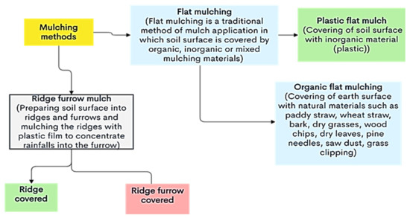
Figure 1. An illustration of the various mulching techniques.

Flat Mulching

Flat mulching is a classic form of mulching. A level layer of mulch, such as woodchips, straw, or leaves, is laid out uniformly over the soil surface surrounding the plants. Flat mulching can maintain the layer thickness in the case of organic mulching materials based on the intended use. This mulching method enhances rainwater penetration and soil aeration.

Ridge Shape Mulching
In this form, the ridge is covered with a plastic film that improves water use efficiency (WUE) by channeling precipitation into furrows or reducing surface runoff. The ridge part of the field, which is mulched, is where crops like maize are commonly planted, although crops are also cultivated in the furrow, which may or may not be mulched (Zhao et al., 2014).
Selection of mulching material
In general, the sort of mulch to choose depends on the crop, the environment, where it will be used, how readily available it is, and how cost-effective it is.
Advantages of mulching
- Mulch insulates the soil, helping to provide a buffer from cold and hot temperature that have a crucial activity in creating beautiful and protected landscapes.
- Mulching minimizes weed infestation, reduces water evaporation, and prevents runoff and soil loss.
- Mulches lower soil temperature, which in turn minimize soil water evaporation.
- Organic mulching is a prominent sustainable agronomic technique used to reduce soil erosion and enhance the general properties of the soil.
- It improves the physical, chemical, and biological properties of soil by facilitating more soil moisture retention and aids in controlling variations in temperature. It also adds nutrients to the soil, enhancing plant growth and productivity.
- Mulch enhanced water-use efficiency of wheat by 21.6% when compared to a non-mulched condition.
- Thus, mulching exerts decisive effects on earliness, yield and quality of the crop.
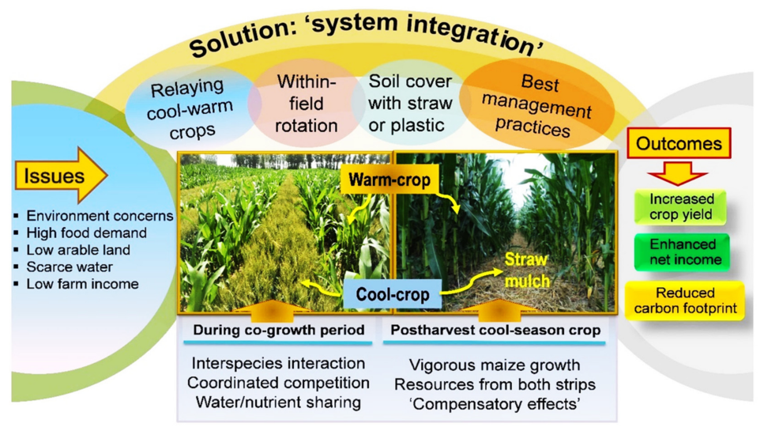
Fig. 2. Effect of different types of mulch on a crop growth, production or nutrition.
Limitations of mulching
- On poorly drained soils, mulches can keep the soil too wet and limit the amount of oxygen that can reach the root zone.
- If mulch is placed next to or in direct touch with the stem, the stored moisture promotes the growth of pathogens and pests.
- Many organic mulches support and act as breeding grounds for pests like mice, snails and slugs that may harm plants.
- Some mulches, like hay and straw, contain seeds that might grow into weeds.

SWOT analysis of mulching:
Strength  - Weed Control: Mulching helps suppress weed growth by blocking sunlight and providing a physical barrier  - Moisture Retention: Mulch conserves soil moisture, reducing the need for frequent watering  - Soil Temperature Regulation: It insulates the soil, keeping it cooler in summer and warmer in winter  - Erosion Prevention: Mulch helps prevent soil erosion by reducing the impact of rain and wind  - Organic Matter Addition: Over time, organic mulches like compost or wood chips break down, enriching the soil  - Aesthetic Appeal: Mulch can enhance the visual appeal of garden beds by providing a neat, uniform appearance. | Weakness  - Initial Cost: Purchasing and installing mulch can be costly, especially for large areas.  - Decomposition: Organic mulches require periodic replacement as they decompose.  - Pest Habitat: In some cases, mulch can provide shelter for pests like slugs or rodents.  - Nutrient Competition: Mulch may compete with plants for nutrients as it decomposes.  - Ineffective on Some Weeds: Mulch may not effectively control all types of weeds, especially perennial weeds with deep roots.
Opportunities  - Environmental Benefits: Mulching aligns with sustainable landscaping practices and can contribute to soil health and conservation efforts.  - Product Innovation: There's room for innovation in mulch materials and application techniques to improve effectiveness and sustainability  - Education and Awareness: There's an opportunity to educate gardeners and landscapers about the benefits of mulching and best practices. | Threats  - Invasive Species: Using mulch made from non-native plants may introduce invasive species to an area.  - Weather Conditions: Extreme weather events like heavy rain or strong winds can disrupt mulch layers.  - Misuse: Improper mulch application, such as piling it too high around plant stems (known as "volcano mulching"), can harm plants.
Conclusion:
Mulching is a sustainable technique that offers a multitude of benefits for improving crop production. It conserves soil moisture, regulates soil temperature, suppresses weeds and enhances soil fertility. Additionally, mulching reduces the need for chemical inputs and promotes healthier ecosystems. Overall, adopting mulching practices can contribute to more sustainable and productive agriculture while, minimizing environmental hazards.
References
Rathore, A. L., Pal, A. R., Sahu, K. K., 1998, Tillage and mulching effects on water use, root growth, and yield of rain-fed mustard and chickpea grown after lowland rice. J. Sci. Food. Agric., 78:149-161.
Lamont, W. J., 2005, Plastics: modifying the microclimate for the production of vegetable crops. Hortic. Technol., 15:477-481.
Kumar, d. G., Sachin, S. S. and Kumar, R., 1990, Importance of mulch in crop production. Indian J. Soil Conserv., 18: 20-26.
Bot, A. & Benites, J. 2005, The importance of soil organic matter. Key to drought-resistant soil and sustained food roduction. FAO Soils Bulletin 80.
Lightfoot, D. R., 1994, Morphology and ecology of lithic-mulch agriculture. Geo. Rev. 25:172–185.
Tan, D., Fan, Y., Liu, J., Zhao, J., Ma, Y. AND Li, Q., 2019, Winter wheat grain yield and quality response to straw mulching and planting pattern. Agric. Res. 1-5.
Gan, J., Zhu, Y., Wilen, C., Pittenger, D. AND Crowley, D., 2003, Effect of planting covers on herbicide persistence in landscape soils. J. Environ. Sci. Tech. 37:2775-2779.
Zhao, Y., Pang, H., Wang, J., Huo, L. AND Li, Y., 2014, Effects of straw mulch and buried straw on soil moisture and salinity in relation to sunflower growth and yield. Field Crop Res., 161:16–25.

