Driving Insights: Dimensionality Reduction with Principal component Analysis on Automobile MPG Dataset
Dr Renuka sagar
Ballari Institute of Technology and Management
renukasagar83@gmail.com
Abstract
Dimensionality reduction is a fundamental technique in machine learning and data analysis to effectively handle high-dimensional datasets. In this study, we focus on applying Principal Component Analysis (PCA) to reduce the dimensionality of the AutoMPG dataset, a popular dataset that contains information about various car models and their fuel efficiency. The objective of this research is to explore the application of PCA for dimensionality reduction in the context of the AutoMPG dataset. PCA works by transforming the original features into a new set of uncorrelated variables called principal components. By selecting a subset of these components, we can retain the most informative aspects of the data while reducing its dimensionality. Through the application of PCA to the AutoMPG dataset, we aim to achieve two primary outcomes. Firstly, we aim to identify the most influential features that contribute significantly to the variation in fuel efficiency across different car models. Secondly, we seek to determine the optimal number of principal components to retain, striking a balance between dimensionality reduction and preserving the information necessary for accurate analysis. By implementing PCA and evaluating its performance on the AutoMPG dataset, we hope to provide insights into the potential benefits of dimensionality reduction techniques for automotive data analysis. The findings of this study could have implications for enhancing fuel efficiency, understanding the key factors affecting it, and improving decision-making processes related to automobile design and engineering.
Keywords: Primary components, PCA object, dataset, data analysis

1. Introduction
Although automobiles have been around for a while, the first one was created in 1769. That occurred more than three centuries ago. The modern automobile is distinctive and special due to its many diverse features. A car's average age can be anywhere from a few to 17 years. There are numerous methods for calculating MPG, one of the key elements of the vehicle. Principal component analysis is one of the most often used approaches to calculating MPG. In this study, fuel consumption is calculated using principal component analysis. A linear algebraic method called principal component analysis (PCA) can be used to decrease the dimensionality of a set of features. The singular value decomposition and other linear combinations of features can be discovered using PCA, which is especially helpful for exploratory data analysis and visualisation. PCA is a versatile tool that is most frequently used for multivariate data processing and visualisation. Each car's mileage over a certain time period is recorded in the automotive dataset MPG. For every car in the dataset, there are a total of 30 variables. Finding the variables that affect an automobile's MPG is the major goal of this investigation. A statistical method known as principal component analysis (PCA) identifies the linear combinations of the original variables that are most beneficial. It is employed in a variety of industries, including marketing, engineering, chemistry, and also biology In order to uncover intriguing patterns and insights, a mathematical methodology known as principal component analysis is used in this study on a dataset of automotive gasoline usage.
2. Literature Review

The literature review for a study on Principal Component Analysis (PCA) applied to an automobile MPG dataset using dimensionality reduction techniques could encompass the following key areas:

1. Dimensionality Reduction^{[ 1]}and PCA is used to define dimensionality reduction and its significance in handling high-dimensional datasets. It also discusses the motivation behind using PCA as a popular linear dimensionality reduction technique. It also highlights the mathematical foundation of PCA and how it captures variance to create new orthogonal features.

2. Applications of PCA in Automotive Domain^{[2]} , It Explores previous studies where PCA has been applied to automotive datasets. This study Discusses instances where PCA led to insights in areas such as vehicle performance analysis, emissions reduction, and fuel efficiency improvement.

3. Analysis of Automobile Datasets^{[3]}, This survey Presents notable studies that have used automobile-related datasets for analysis and modeling. It Discuss the types of data commonly found in automobile datasets, including features related to vehicle specifications, engine performance, and emissions.

4. PCA and Fuel Efficiency Analysis^{[4]}, This paper Showcase research that utilized PCA to analyze vehicle fuel efficiency. It also explains how PCA can identify key features that contribute most to fuel efficiency variations.

5. PCA in Emissions Analysis^{[5]}, This research discusses the literature that employs PCA to analyze emissions data from vehicles. It also Highlight how PCA can reveal underlying emission patterns and identify contributing factors.

6. Dimensionality Reduction for Automotive Insights^{[6]}, This paper discusses other dimensionality reduction techniques beyond PCA that have been applied in the automotive domain. It also Compares PCA with other methods in terms of effectiveness, interpretability, and computational efficiency.

7. Challenges and Considerations^{[7]}, It Explores challenges specific to applying dimensionality reduction techniques to automotive datasets, such as missing data or categorical variables.
It also discusses on how researchers have addressed these challenges and any trade-offs made.

8. Impact on Industry and Research^{[8]}, This research paper analyze the impact of dimensionality reduction techniques on the automotive industry, including areas like vehicle design, optimization, and diagnostics. It also highlights how insights gained from reduced-dimensional datasets have influenced decision-making and innovation.

9. Future Directions^{[9][10]}, This survey paper Propose potential future research directions in applying PCA and other dimensionality reduction techniques to automotive datasets. It Suggests areas for exploration, such as integrating PCA with machine learning models or investigating non-linear dimensionality reduction methods.

3. Methodology
A method for extracting sets of orthogonal (uncorrelated) variables is principal component analysis (PCA), which can subsequently be used to reduce the dimensionality of a data set. A common method in machine learning is PCA. A data set's dimensionality can be decreased using PCA, a linear treatment that extracts orthogonal variables.
I used PCA for the vehicle mpg dataset
1.Data Preprocessing: Start by importing the dataset and performing any necessary data cleaning, handling missing values, and scaling the data if required. Ensure that the dataset is in a suitable format for PCA analysis.

2. Feature Selection: Decide which features from the dataset you want to include in the PCA analysis. Depending on the specific objectives and characteristics of the dataset, you may want to exclude certain features that are irrelevant or redundant.

3. Standardization: Perform standardization on the selected features, which involves scaling them to have zero mean and unit variance. This step is crucial for PCA, as it ensures that the features are on a similar scale and prevents variables with larger ranges from dominating the analysis.

4. PCA Application: Apply PCA to the standardized feature matrix. This can be done using libraries such as scikit-learn in Python. PCA will transform the original feature space into a new set of orthogonal variables called principal components.

5. Explained Variance: Analyze the explained variance ratio associated with each principal component. The explained variance indicates the amount of information retained by each component. Plotting a scree plot or cumulative explained variance plot can help determine the number of principal components to retain.

6. Selecting Components: Based on the explained variance analysis, decide on the number of principal components to retain. You can choose a threshold (e.g., retaining components that explain 95% of the variance) or use domain knowledge to make an informed decision.

7. Dimensionality Reduction: Transform the original dataset into a reduced-dimensional space using the selected principal components. This reduced dataset will have fewer dimensions than the original dataset while still capturing a significant amount of information.

By applying PCA for dimensionality reduction on the AutoMPG dataset, you can reduce the number of features while preserving the most relevant information, facilitating further analysis and interpretation.

4. Experimental Setup

- Dataset Selection
Choose a suitable publicly available automobile MPG dataset that contains relevant attributes such as vehicle specifications, engine details, and fuel efficiency measurements.During Data Preprocessing Handled missing values by imputation or removal, and the rationale for the chosen approach. Performed data normalization or standardization to ensure all features have comparable scales.

- PCA Application
Implement the PCA algorithm on the preprocessed dataset using a programming language like Python
the number of principal components to retain based on an analysis of explained variance. For Visualization Created scree plots or cumulative explained variance plots to visualize the proportion of total variance explained by each principal component. Generate scatter plots or biplots to visualize the distribution of data points in the reduced-dimensional space.

- Analysis and Interpretation
Interpret the principal components in terms of the original features to understand the underlying patterns captured by each component. Analyze the loadings of variables on each principal component to identify which attributes contribute most to the variance.

- Performance Evaluation
The study involves a predictive task, such as regression for predicting MPG, split the dataset into training and testing sets.Trained a regression model (e.g., linear regression) on both the original dataset and the reduced-dimensional dataset obtained from PCA. Evaluate and compare the model performance on the test set using appropriate metrics like Mean Squared Error (MSE) or R-squared. Interpret the results of the regression models to understand how the reduced-dimensional dataset from PCA affects predictive accuracy and model interpretability. compare the results of PCA with a baseline model that does not involve dimensionality reduction (e.g., using all original features). Tthe trade-offs between dimensionality reduction, model performance, and interpretability. The findings from the experiment, including insights gained from the reduced-dimensional dataset and implications for using PCA in analyzing automobile MPG data has been carried out.

5. Results & Discussion
When using PCA for dimensionality reduction on the AutoMPG dataset, several outcomes have been observed :

1. Reduced dimensionality: PCA will transform the original high-dimensional feature space into a lower-dimensional space. The number of dimensions will be determined by the number of principal components we choose to retain.
2. Explained variance: PCA provides information about the amount of variance explained by each retained principal component. This allows us to understand the contribution of each component to the overall dataset variance and identify the most influential features.
3. Feature selection: By examining the weights or loadings of each feature in the principal components, we determine which original features are most relevant for explaining the variation in the AutoMPG dataset. Features with higher absolute loadings in the retained components have a stronger influence on the data.
4. Visualization: With the reduced dimensionality, we created scatter plots or other visualizations to observe the distribution of car models based on their fuel efficiency and the retained principal components. This can help identify patterns or clusters in the data.

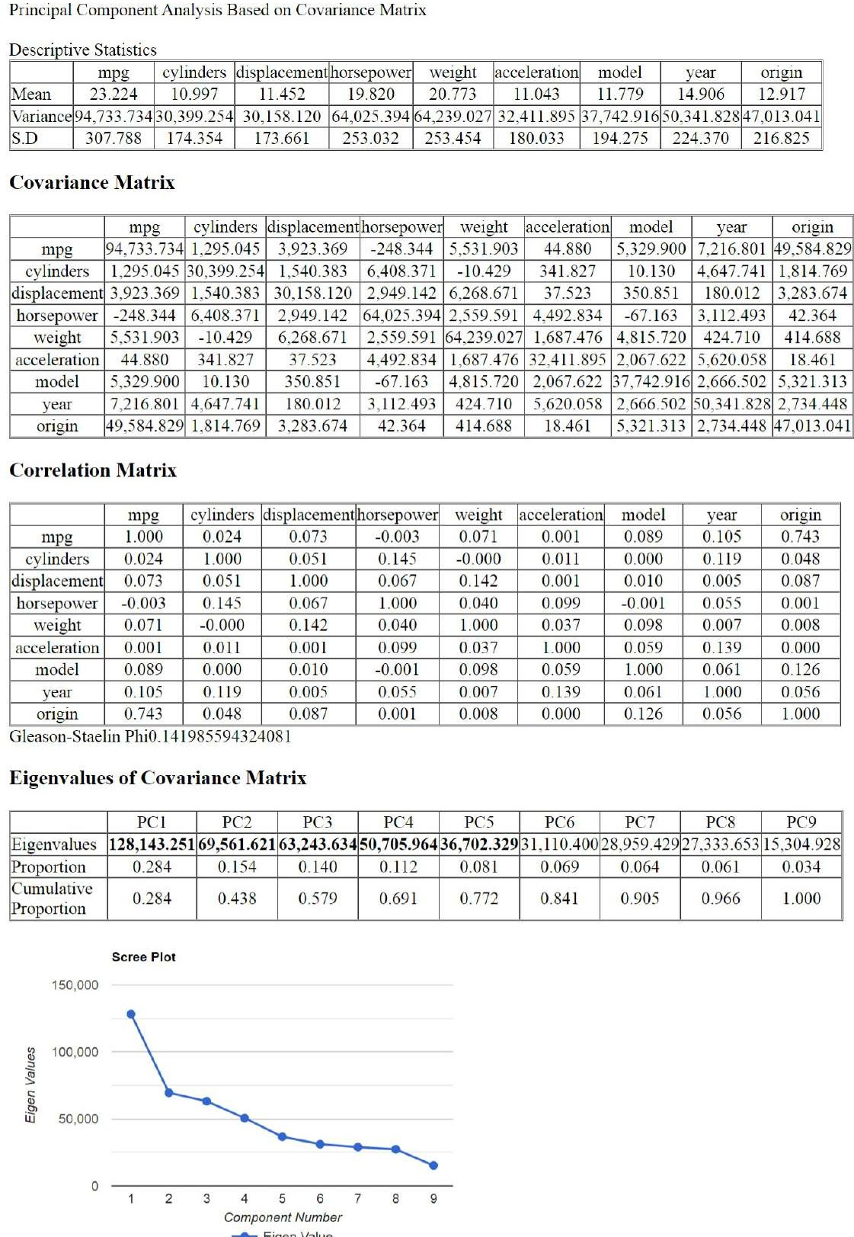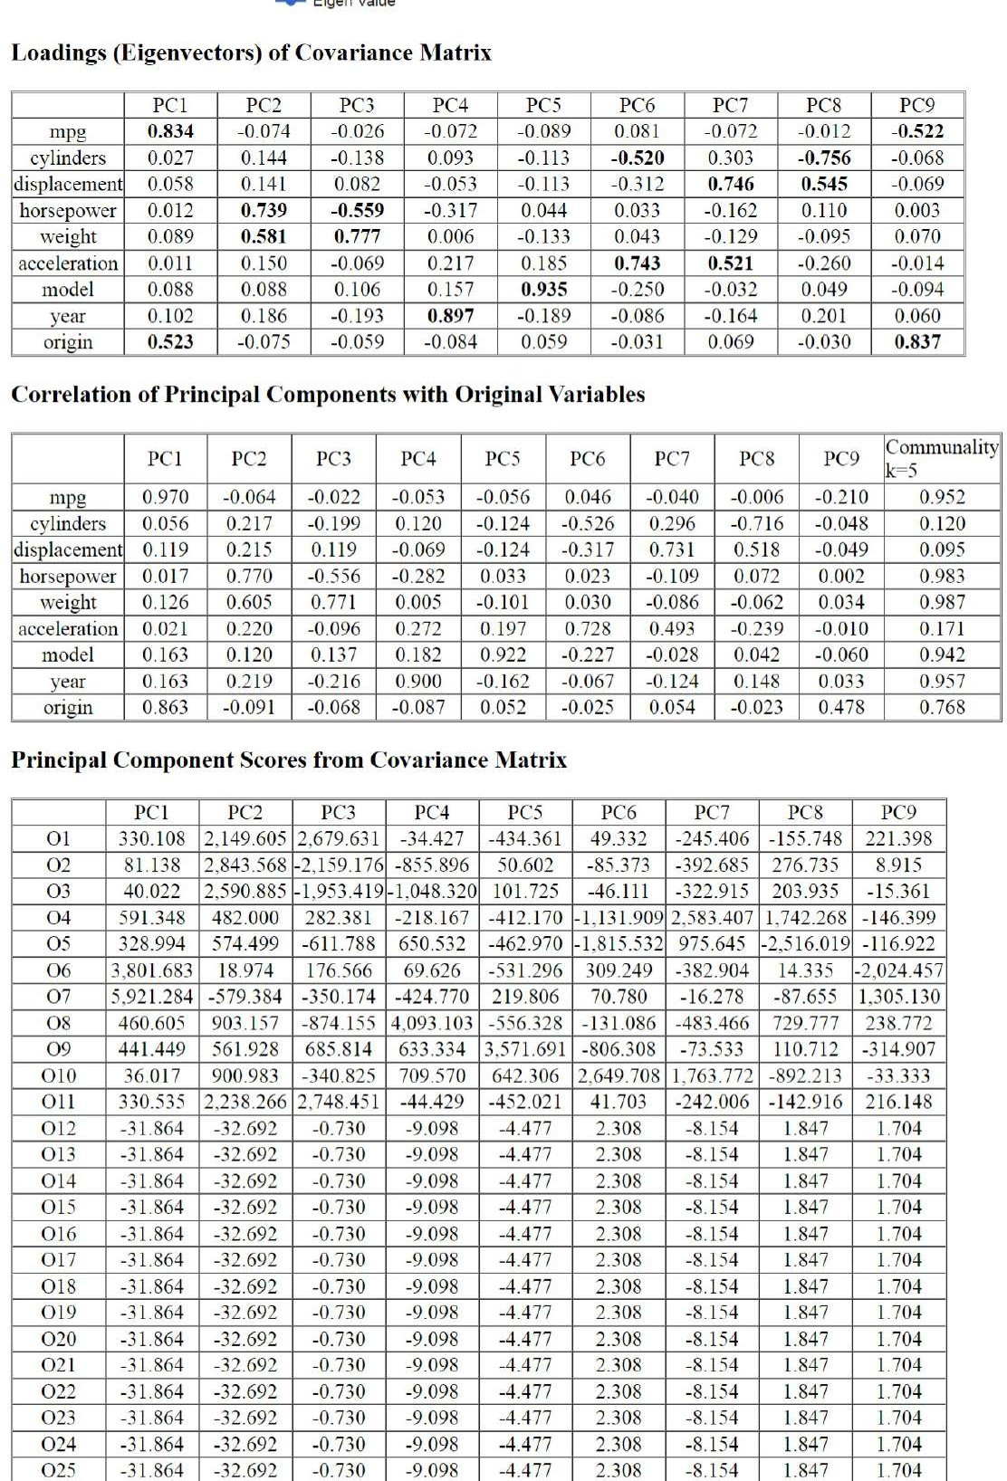

6.Conclusion
A common statistical method for reducing dimensions while retaining as much variance as possible within a given data set is principal component analysis (PCA) (Pearson, 1901; Hotelling, 1933; Ringner, 2008). Principal components analysis (PCA) is simply a straightforward dimensionality reduction technique that converts the columns of the dataset into a new feature group (PCs). We are interested in the features of the data, and PCA, which is closely related to factor analysis, frequently leads to comparable results. The first principal components produced by PCA, as the name implies, are those that capture the most information or variance in the data set. The typical setting for PCA as a tool for data analysis and exploration involves a data. An observational data set containing P distinct variables for each of N entities or individuals and P different variables for each of N entities or individuals constitutes the typical context for PCA as an analysis tool for data exploration. Here, we employ some PCA optimality criteria to select the best subsets of the p output variables—the main variables. Imagine running PCA on a dataset with hundreds of variables and seeing that the first few components represent the majority of the explained variance, the NxP data matrix column choices, X, that capture the most variance. The primary components of a data set are these two linear combinations. First, I initialise a PCA class and call fit transform just on X. to transform X to obtain the new set of X's principle components, then compute the weights of the primary components all at once. the sklearn.decomposition module offers the PCA object that can be simply mapped and converts data to the principle components, i.e., it initialises a PCA object from sklearn and changes the data in accordance with the computed components. When the principal component input features are entered, the customised PCA object's Inverse Transform method returns the original data. A lesser quantity of information, but more nuance, is added to the data set with each subsequent component.
References
- Indirect PCA Dimensionality Reduction Based Machine Learning Algorithms for Power System Transient Stability Assessment, Publisher: IEEE
- Dimensionality Reducti on Techniques to Aid Parallelization of Machine Learning Algorithms,

Publisher: IEEE

- Efficient Machine Learning Model for DDoS Detection System Based on Dimensionality Reduction Saad Ahmed Dheyab 1, Shaymaa Mohammed Abdulameer 2, Salama Mostafa.
- On the Use of Machine Learning Models for Prediction of Compressive Strength of Concrete: Influence of Dimensionality Reduction on the Model Performance Zhi Wan 1,

Yading Xu 1, Branko Šavija 1 PMID: 33546376 PMCID: PMC7913490 DOI 10.3390/ma14040713 Free PMC article
- Hybridized Dimensionality Reduction Method for Machine Learning based Web Pages

Classificat ion, Thabit Sulaiman Sabbah,IJCCCE.

- Jolliffe, I. T. (2002). Principal Component Analysis (2nd ed.). Springer.This article provides an in-depth understanding of PCA, including its concepts, challenges, and considerations.

- Abdi, H., & Williams, L. J. (2010). Principal component analysis. Wiley Interdisciplinary Reviews: Computational Statistics, 2(4), 433-459. A comprehensive review of PCA, covering its applications, challenges, and strategies to address various issues.

- Kumar, N., & Kaur, P. (2019). Principal Component Analysis: A Comprehensive Review. Archives of Computational Methods in Engineering, 26(4), 891-918. An overview of PCA's challenges, along with discussions on its applications and strategies to optimize its usage.

- Wold, S., Esbensen, K., & Geladi, P. (1987). Principal Component Analysis. Chemometrics and Intelligent Laboratory Systems, 2(1-3), 37-52. Insightful exploration of PCA's challenges and considerations, particularly in the context of chemometrics and data analysis.

- Chandramouli, M., & Jeganathan, P. (2015). Principal component analysis and its applications in image compression – A survey. Optik, 126(14), 1135-1145. While focused on image compression, this study discusses challenges and considerations relevant to PCA in the context of data reduction.

