Design and synthesis of highly tunable inhibitor against pathogenic gram-negative bacteria: Salmonella typhimurium and Escherichia coli
Amritendu Chakraborty ^{a,b} Biswaranjan Dalai,ª Pratap K. Chhotaray,ª Srikanta Sahu.^{a⁎} Susanta Kumar Biswal ^{a⁎}

ª Department of chemistry, School of Applied Sciences, Centurion University of Technology and Management, Odisha, India

^{b} Materials Research Center, Indian Institute of Sciences, Bengaluru, Karnataka, India

⁎ Corresponding authors:
Srikanta Sahu & Susanta Kumar Biswal e-mail address: srikanta.sahu@cutm.ac.in & dr.skbiswal@cutm.ac.in

Abstract: Many of the Gram-negative bacteria are known from decades that cause life-threating diseases in human and many other animals. These bacteria have high tendency to survive in the host body rather quickly due to the presence of protective cell wall which defends from invasion of exogenous toxic agent. Therefore, developing new molecular scaffold with appropriate architectural unit that can circumvent the preventive cell wall of such bacteria is a huge challenge. We report herein, a synthetically simple and elegant, small organic molecule, PA-B-ester which endowed with unique molecular scaffold of prerequisite properties that can easily penetrate through the protective cell wall of the bacteria. We also successfully demonstrated antibacterial activity of PA-B-ester molecule against pathogenic gram-negative bacteria such as: Salmonella typhimurium and Escherichia coli.
Keywords: Gram-negative bacteria, Salmonella typhimurium, Escherichia coli, infected diseases, antibacterial activity, small organic molecule, pathogenic bacteria,
Introduction
Gram-negative bacteria such as: Salmonella typhimurium and Escherichia coli are very common pathogens which can infect a broad range of animals. ^{[1, 2]} The toxicity effect of gram-negative bacteria is due to the presence of protective cell wall that protect the bacteria from toxic effect of exogenous agent.¹⁵ The cell wall of these bacteria is made up of lipopolysaccharide coat (LPS) which strictly prevents the foreign invasion. This unique feature of the cell wall in gram-negative bacteria enables to survive in any adverse environment, such as mammalian intestines. However, most of the gram-positive bacteria devoid of such protective cell wall and therefore, they have poor resistivity in hostile environment than gram-negative bacteria.
Among gram-negative bacteria, Salmonella is a major pathogen that infect thousands of lives worldwide even today. ^{[1, 2, 16]} It is a rod-shape bacterium having wide range of size varies from 0.4 to 3 μM. The rod-shape is maintained by an actin-like bacterial cyto-skeleton. ^{[3, 4]} The pathogenic nature of Salmonella species has reported in many scientific literatures. These Salmonella species can cause a broad spectrum of diseases such as: neurological abnormalities, gastroenteritis, and life-threatening Typhoid fever in human being.^{[5, 7, 11-13]} Therefore, Salmonella has been a cause to longstanding worldwide health problem and became a reason for significant mortality globally.^{[6, 11-13]} S. Typhimurium belongs to Salmonella and it infects a wide variety of hosts; but however, there are few class of Salmonella such as: S. Typhi, S. Pullorum, and S. Gallinarum are exquisitely host-restricted.^{[6]} Furthermore, Salmonella enterica serovar Typhimurium is also a primarily responsible for food-borne disease as well.^{[8]} In addition to this, there are another category of gram-negative bacteria, called Escherichia coli which are found in the environment, foods and intestines of people and animal. This is a highly diverse group of bacteria. It has been known in the literature that most of E. coli are not harmful, rather helps to keep our digestive track healthy. However, there are few varieties of E. coli are highly responsible for causing a broad spectrum of infections such as: diarrhea, food poisoning, pneumonia, urinary tract infections etc. There are different categories of E. coli such as: enterotoxigenic E. coli (ETEC), enteropathogenic E. coli (EPEC), enteroinvasive E. coli (EIEC), enterohemorragic E. coli (EHEC) and enteroaggregative E. coli (EAEC) which are responsible for causing diarrhea.^{[14]}
Considering the life-threatening pathogenic effect of gram-negative bacteria, it has been a continuous endeavour from wide spectrum of scientific community to develop novel antibacterial agent. Till today, Most commonly used antibacterial agents are the derivative of quinolones and fluoroquinolones compounds.^{[9]} It is always been a huge challenge for synthetic chemist to develop molecule with well-defined architecture that can strictly inhibit pathogenic gram-negative bacteria. The poor rate of progress is attributed to the protective cell wall of the gram-negative bacteria which demands a precise molecular structure. Therefore, to overcome this difficulty, herein we have developed a new scaffold with stringent architectural component inbuild into the benzene core. We have demonstrated potential antibacterial activity of this molecule against gram-negative bacteria.

Results and discussion
There are numerous coupling reagents (DCC, HATU, HBTU, EDC, SOCl₂ etc.) available now a days to convert acid to corresponding amide or ester. But all these amide or ester coupling reagents such as: 1) DCC, 2) HATU, 3) HBTU, 3) EDC are highly expensive and therefore, difficult to afford them for academic research. But on the other hand, thionyl chloride (SOCl₂) is another robust alternative for the synthesis of an amide or ester from acid. Furthermore, it is comparatively much cheaper than other coupling reagents. This reagent is pretty simple to handle and moreover, it affords high yield. Therefore, this reagent became central to many of the organic transformation for industrial uses. In light of these potential advantages, we have utilized the thionyl chloride (SOCl₂) as a coupling agent to generate a new variety of molecular scaffolds which might inhibit toxic pathogen like Gram (-ve) bacteria such as: Salmonella and E. coli. (Scheme 1).

Scheme 1: Synthetic scheme for the synthesis of PA-B-ester

Scheme 2: Base hydrolysis of PA-B-ester

In search of an ideal molecular scaffold for the precise installation of n-butanol unit in order to have ester-based molecules, we intended to start with semi-rigid backbone like phthalic acid (PA). We envisioned that benzene ring in PA will provide rigidity along with pi-pi stacking interaction with hydrophobic region of the toxic pathogen which in turn could provide good binding efficacy. In addition to that the ester functionality may help in making hydrogen bonding interaction with hydrophilic part of the pathogen. The remaining butane tail may provide flexibility to the core structure and along with that it may enhance the possibility of cell permeability nature of the molecule. Consequently, synthesizing this kind of molecule may inhibit pathogens. Having these anticipations in mind, we wanted to install the ester moiety into a rigid system, Phthalic acid (PA). Therefore, we persuaded to synthesize compound, PA-B-ester (Scheme 1) with an intention that this compound may show better inhibition property towards pathogen. In the beginning, the precursor compound, phthalic acid (PA) converted to corresponding acid chloride, PA-Cl by treating with thionyl chloride under room temperature for 3 hours (Table 1). The mixture of water and tetrahydrofuran was chosen as the solvent system to carry out the reaction. Minimum amount of water was taken to solubilize the precursor compound, phthalic acid. The resulted acid chloride, PA-Cl was further treated with n-butanol in the presence of triethyl amine as a base to get the desired product, PA-B-ester. Reaction kinetics was completely monitored by thin layer chromatography (TLC) techniques. But surprisingly, TLC result analysis showed no new product formation, rater mostly precursor, PA was observed on TLC (Figure 1). We anticipated that the phthalic acid does not convert to corresponding acid chloride due to high transition state energy barrier which may require high temperature rather than room temperature. Therefore, to overcome this challenge we further executed the reaction in the reflux condition keeping all other parameters unaltered. TLC result shows very mild product formation (Figure 1) which is negligible. This experiment clearly indicating that, not only temperature but also protic solvent like water and methanol play a role in inhibiting the reaction. In presence of methanol we observed almost the similar results like water. Therefore, we turn our attention to start the reaction using only aprotic solvent like THF. To overcome this problem, we designed two experiment in parallel by using THF as solvent. In the first experiment, the reaction was carried out at room temperature in presence of THF as a solvent and kept all other parameter constant. However, in the second experiment the reaction was carried out in reflux condition in presence of THF as a solvent without altering any other parameters. TLC analysis clearly shows new product formation (Figure 1, TLC-4) in both cases. The intensity of product spot observed for refluxed reaction is much brighter than room temperature reaction. These results clearly reveal that the reaction must be carry out in aprotic solvent at refluxed condition to get the optimum product formation. With this optimized reaction condition, we observed up to 90 % of product yield (Table-2). The products were further purified by column chromatography in 1% methanol and chloroform system. The desired product, PA-B-ester formation was further confirmed by UV-Visible spectroscopy study (Figure 3) by comparing with commercially available starting material. This data clearly showed the formation of product. Elemental analysis data also support the product formation. Again, to cross verify the product formation we carried out the base hydrolysis reaction (Scheme 2) with sodium hydroxide solution in water as a solvent and isolated the hydrolyzed products using column chromatography techniques. After column purification of crude product, we observed two kinds of material. One material is solid and another one is liquid. The solid material expected to be phthalic acid and liquid material may be n-butanol. The solid material obtained after hydrolysis was analyzed by comparing the TLC with commercially available starting material. The TLC result clearly shows, the hydrolyzed product is a starting material (Figure 2). It was further confirmed by comparing melting point with the starting material. The melting point of the starting material (207 ºC) was found to be same as that of isolated product (207 ºC). This indicated that the hydrolyzed product is PA (Scheme 1). The liquid material obtained after hydrolysis was analyzed using TLC with reference to commercially available n-butanol compound. TLC result clearly showed both have the same retention time. This result indicated the second hydrolysis product may be n-butanol. It further confirmed by determining the boiling point of the liquid material which was similar to n-butanol. This result confirmed that the resulted hydrolysis product is a n-butanol. Therefore, these results strongly support the formation ester derivative, PA-B-ester.

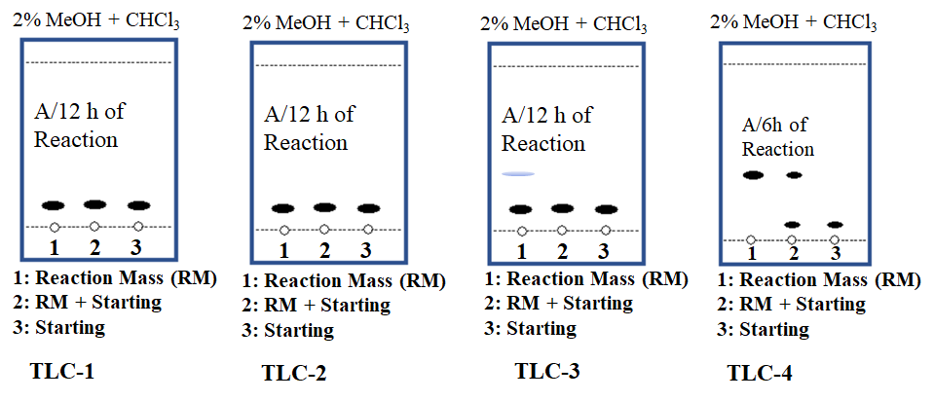
Figure 1: TLC-1-Reaction carried in water+ THF solvent mixture at room temperature; TLC-2-Reaction carried in water as solvent at reflux condition; TLC-3-Reaction carried in methanol as solvent at reflux condition; TLC-4-Reaction carried out in THF at reflux condition

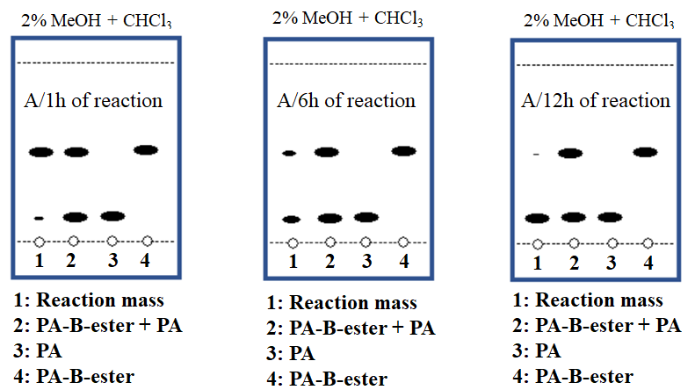
Figure 2: Monitoring the reaction kinetics of PA-B-ester hydrolysis reaction (scheme-2): after 1, 6, and 12 hours of reaction time using TLC.

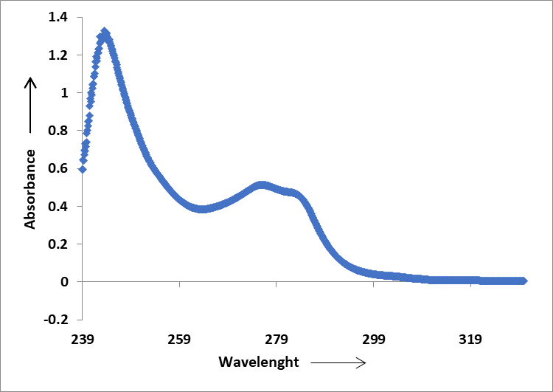

Figure 3: UV-VIS Spectra of the compound, PA-B-ester

Table 1: Chemicals used for the reaction
Chemicals | Molecular Weight  in g/mol | Quantity | Moles
Phthalic acid {C₆H₄(COOH)₂} | 166.13 | 5 gm | 0.03
Thionyl Chloride (SOCl₂) | 118.97 | 6.6 ml. | 0.075
THF  (C₄H₈O) | 72.11 | 100 ml. | 0.09
n-Butanol  (C₄H₁₀O) | 74.121 | 6.04 ml. | 0.81

Table 2: Reaction analysis in different solvent system

Solvents | Temperature | TLC Analysis | Yield | Remark
Water + THF | Room Temp. (RT) | No new spot observed | 0% | The reaction was not progress in aqueous medium.
Water + THF | Reflux Condition | No new spot observed | 1% | The reaction was not progress in aqueous medium.
Methanol +THF | RT | No new spot observed | 2-3% | The acid was not converted into acid chloride in methanol solvent.
Methanol +THF | Reflux Condition | No new spot observed | 10%
Tetrahydrofuran | RT | New spot observed (not clear) | 40% | In RT the rection progress very slowly and is taking long time. Yield is less. But in refluxed condition the rection progress very fast and observed quantitative yield.
Tetrahydrofuran | Reflux Condition (70-80º C) | New clear spot observed | 90%

The antibacterial activities of PA-B-ester against pathogenic bacteria i.e. Salmonella typhimurium and Escherichia coli were checked. A standardized concentration of both the inoculums were evenly spread on the surface of two different agar plates. A 500 µM concentration of PA-B-ester was loaded into both the bore wells and incubated for 24h at 30±2ºC temperature. The results clearly showed a very strong inhibition zone of diameter 30.2 mm size against Salmonella typhimurium after incubation with PA-B-ester for 24 hours (Figure 4a). This result clearly reveals that, PA-B-ester has potential antibacterial activity against Salmonella typhimurium. However, the antibacterial activities of PA-B-ester was found to be relatively lesser for Escherichia coli than Salmonella typhimurium which is evident from the inhibition or clearance zones of both the pathogenic strains (Figure 4 a & b). This antibacterial activity could be due to the presence of well-balanced hydrophobic, hydrophilic and long chain hydrocarbon molecues. Owing to these well-balanced properties of PA-B-ester, might be proficient to cross the bacterial cell membrane resulting in the inhibition of the bacterial strain growth.

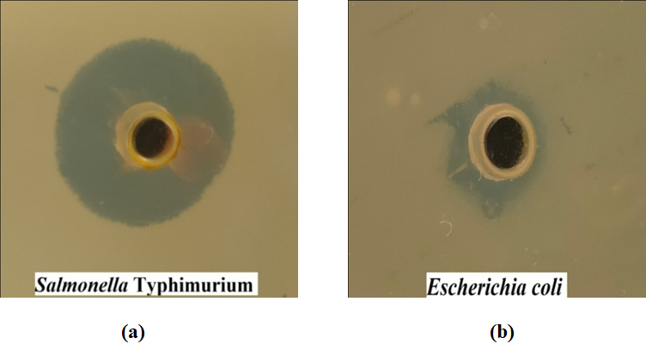
Figure 5: Antibacterial activities of PA-B-ester against pathogenic bacterial stains: (a) Staining of PA-B-ester against Salmonella Typhimurium, (b) Staining of PA-B-ester against Escherichia Coli.

Experimental section
Materials and method
The chemicals and solvents were purchased from Spectro chem Ltd and Sigma Aldrich. All the chemicals were directly used without further purification. Normal phase column chromatography purification was carried out by using MERCK silica gel 60 (particle size: 100-200 mesh). Reactions were monitored wherever possible by thin layer chromatography (TLC). Silica gel G (Merck) was used for TLC and column chromatography was undertaken on silica gel (100–200 mesh) in hexane, hexane–ethyl acetate or chloroform. UV and visible peaks of synthesized organic compound was measured in chloroform as a solvent in the range of 200-400 nm. The walelength (in nm) was taken in X-axis and absorbance in the Y-axis. It shows maximum absorbance at 243.6 nm wavelength. Melting points were recorded in a Fisher-Johns melting point apparatus.
Test organisms
The test bacterial cultures including Escherichia coli (MTCC No.- 614), Salmonella typhimurium (MTCC No.-3224) were collected from IMTECH Chandigarh. All the bacterial cultures were maintained in nutrient agar slants. The slants were kept in refrigerator for use during further experiments.
Antimicrobial Assay
A standardized concentration of inoculums with fixed volume was spread evenly or swabbed on the surface of gelled agar plates. A hole which ranges from 6 - 8 mm in diameter was punched with a sterile cork borer aseptically in plates. A fixed volume (50 µl) of the sample solution was then introduced into the bored agar well and incubated at optimum temperature (Bacteria - 30±2ºC for 24 hrs) depending upon the test microorganism. ^{[17]}

Synthesis of PA-B-ester
Phthalic acid (5g) was taken in a round bottom flask (RBF). To this solid mass, thionyl chloride (6.5 ml) was added dropwise over a period of 1o minutes at 10-15 ºC. The temperature of reaction mass was raised to 70-80 ºC and stirred it for 3 hours. Slowly cooled the reaction mass temperature to 0-5 ºC and added THF (50 ml) into it. To this ice-cold solution, triethylamine was added slowly over a period of 1h. Then n-butanol (6.4 ml) was added into the reaction mass at 0-5 ºC. Slowly raised the reaction mass temperature to room temperature and stirred it for 12h. TLC was checked and reaction was found to be completed. The organic layer was dried over anhydrous Na₂SO₄, ﬁltered and evaporated. Finally, the crude compound was purified using column chromatography.
Conclusion
In conclusion, to our knowledge, it is a very unique example where PA-B-ester molecule strongly inhibit the growth of pathogenic gram-negative bacteria like Salmonella typhimurium and Escherichia coli. We have also thoroughly studied the mechanism of inhibition of this molecule towards these two pathogenic bacteria. This molecule may open up new doorway for the treatment of diseases, causing by these bacteria. To our opinion, this work may provide new insight to design potential molecule of tunable property with respect to protective cell wall of the bacteria which will enhance the cell permeability of the molecule. Thereby, it will inhibit the pathogenic gram-negative bacterial growth.

Acknowledgements
The authors would like to thank DST-New Delhi, DBT- New Delhi, CSIR-New Delhi, IIT-Delhi and CUTM-BBSR for support of this work.

References
- Ochman, H.; Groisman, E. A. EXS, 1994, 69, 479–493.
- Baumler, A. J.; Tsolis, R. M.; Ficht, T. A.; Adams, L. G. Infect. Immun. 1998, 66, 4579–4587.
- Bulmer, D.M.; Kharraz, L.; Grant A. J.; Dean, P.; Morgan F. J. E.; Karavolos, M. H.; Doble, A. C.; McGhie, E. J.; Koronakis, V.; Daniel, R. A.; Mastroeni, P.; Khan, C. M. A. PLOS Pathog. 2012, 8, 1-18.
- Doble, A. C.; Bulmer, D. M.; Kharraz, L.; Karavolos, M. H.; Khan, C.M.A.; Virulence. 2012 3, 446–449.
- Fierer, J.; Guiney, D. G. J. Clin. Investig. 2001, 107, 775–780.
- Spano, S.; and Galan, J. E. Science, 2012, 338, 960–963.
- Rabsch, W.; Tschape, H.; Baumler, A. J. Microbes and Infection, 2001, 3, 237–247.
- Fabrega, A.; Vila, J. Clin. Microbiol. Rev. 2013 26:308-341.
- Asperilla, M.O.; Smego, R.A.; Scott, L.K. Rev. Infect. Dis. 1990,12, 873-889.
- Breen, P.J.; Compadre, C.M.; Fifer, E.K.; Salari, H.; Serbus, D. C.; Lattin, D. L.; J. Food. Sci. 1995, 60, 11-19.
- Nhieu, G.T.; Sansonetti, P. J. Curr. Opin. Microbiol. 1999, 2, 51-57.
- Torres, A. V.; Fang, F.C.; Curr. Opin. Microbiol. 2000, 3, 54-59.
- Pizarro-Cerda J.; Cossart, P. Cell, 2006, 124, 715-727.
- Levine, M.M. J. Infect. Dis. 1987, 155: 377–389.
- Sanderson, K. E.; MacAlister, T.; Costerton, J. W.; Cheng, K-J. Can. J. Microbiol. 1974, 20, 1135-1145.
[16] Chaudhuri, D.; Chowdhury, A. R.; Biswas, B.; Chakravortty, D. Front. Microbiol. 2018, 9, 1-12.
[17] Mahalik, G.; Sahoo, S.; Stapathy, K. B. Evaluation of phytochemical constituents and antimicrobial properties of Mangifera indica L. leaves against urinary tract infection causing pathogens. Asian J. Pharma. Clinical Res. 2017, 10, 169-173.

