ADDRESSING HIGH EMPLOYEE ATTRITION IN BPO INDUSTRY: CASE BASED VIEWPOINTS
Dr. Prashanth Pai M¹, Dr. Ramachandra C G ²

# ¹Faculty, Dept. of Mech. Engg.,
P.A. College of Engineering, Mangaluru, Karnataka State, India – 574153.

^{#2} Faculty, Dept. of Mech. Engg., School of Engineering,
Presidency University, Bengaluru, Karnataka, India – 560064.

Abstract: Business Process Outsourcing (BPO) industry is one of the knowledge based industries which is highly sensitive in terms of employee encouragement and motivation. BPO influences process driven efficiencies in terms of organizational quality, responsiveness & branding, financial effectiveness and customer association. The findings will enable the researchers to do a thorough study on the employee attrition in BPOs by analyzing the attrition factors under specific titles such as critical, non-critical factors, stress related, compensational factors, etc. HR Strategists at the corporate level of the BPO industry have to face a great challenge and they should follow a proactive approach to develop inventive employee retaining policies.
Keywords: Business Process Outsourcing, Employee attrition, Proactive approach, HR strategies.

1. Introduction
Outsourcing is an expedition of 2 establishments, both looking to overcome anticipated challenges” says William B. Bierce, and Kennerson, P.C. Enterprises nowadays are attentive on recognizing new opportunities and modernizations to endure and maximize growth. Human Resource is the most critical resource on which the IT & IT Enabled Services (IT&ITES) depends. Over the past decade, the Indian IT BPO segment has become the nation’s leading growth engine, crossing important milestones in terms of income growth, employment and value creation, in addition to becoming the worldwide brand ambassador for India. BPO is the long term contracting out of non-core business processes to an external supplier to accomplish increased shareholder value. It is the allocation of one or more IT intensive business processes to an outside provider that in turn owns, controls and manages the selected process based on definite and quantifiable performance criteria. .
Outsourcing is an old concept. Adam Smith mentioned about it 200 years ago. The theory of Cost Advantage and Michael Porter’s Value Chain Concept actually cemented the pathway for BPO. According to McKinsey study (2004), gigantic US pharma companies can condense the cost of evolving a new drug estimated between US $ 600 million and $ 900 million by as much as US $200 million, if development work is subcontracted to India. The trend of outsourcing customer support services (call centers) to India originated in 1998, when GE started a facility in Noida. Benefits derived from BPO are productivity improvements, focus on company’s core business, achieve cost reductions, gain greater internal flexibility, achieve world-class standards/benchmarks, achieve revenue enhancements, gain access to advanced technology, meet changing customer demands, obtain outside expertise, maintain competitive edge, improved service quality, improved performance, profitability & shareholder value.

2. Purpose
The study titled “Addressing High Employee Attrition in BPO Industry: Case Based Viewpoints” was carried out with the following objectives:
- Assess the nature and status of employee attrition in BPO units.
- Study the factors causing high employee attrition in BPOs/Call centers.
- Study the difference in perceptions of the reasons of high employee attrition in BPO and call centers.
- Identify the stress related, compensational and non-compensational factors.
- Identify the critical& non-critical factors which cause high attrition in the above sector.
- Suggest workable / suitable measures for addressing the high employee attrition caused by the above factors.
7 Suggest retention strategies for effective and efficient management of BPOs.

3. Research Issue
The growth of BPO Industry in India is at a remarkable speed. BPO companies in India have been developing at a compound annual growth rate (CAGR) of over 50%. The BPO industry estimated to hire millions of people is facing the challenge of finding quality employees, given the current attrition rate of around 20%-40%. The core of a knowledge based industry is the people and its success depends on the quality of available talent. Many establishments do not even recognize what their attrition rates are and those that do often lack sufficient data to identify where the problem is most severe, or to reveal the specific causes of attrition. According to the Corporate Advisory Board of Washington DC, the cost of substituting staff can be anything between 50% and 175% of that person’s yearly salary. The loss of key employees, even in small numbers, can be disappointing to a company. The costs of unintended attrition can be disastrous for an enterprise’s well-being, survival and growth.

4. The Problem of Attrition
Attrition means a gradual decrease in number/strength because of constant stress. Employee attrition is a drop in the number of employees through retirement, resignation or death. NASSCOM ITES BPO forum has recognized HR as one of the main challenges of the sector. There are numerous factors that represent additional costs of attrition that often go unnoticed. They are - the lost productivity of an unoccupied position and successive hiring and training costs for a new employee, as well as the costs of lost opportunities with the company’s clients and the delay time in getting innovative new products and services to the market. The average costs of substituting the defective workforce are consuming the profitability of even the fittest organizations. Of late, worker’s tendency is not to pursue ITES as a full-time career. In this context, a comprehensive study of the factors affecting high employee attrition in the BPO Industry is the need of the hour.

5. Design/Method
The survey has been carried out choosing a sample size of 110 employees employed in Bangalore. The sample size was selected from employees of 4 BPOs namely Cambridge Integrated Services, Axes Online Private Limited, Ocwen Financial Solutions Private Ltd and International Business Machines (IBM), Daksh, located in Bangalore. The population of the study includes 1150 employees chosen from 4 BPOs and a convenient sampling technique was used to select the sample size. A well designed self administered questionnaire had been used for collecting the primary data. Also personal discussions and deliberations with employees within the level starting from entry level to team leader have been conducted for this purpose. Responses on each factor have been taken for all the 30 factors with the chosen sample of 110. The sources of secondary data include different sources such as websites, articles and journals and text books. The tabulation of the data was done and the descriptive analysis was carried out with the help of statistical tools such as percentage bars, pie diagrams, etc. Likert 5 point scale (summated scale) was used in carrying out the survey. The scale contains a number of statements which express either a favorable or unfavorable attitude towards the given entity to which the respondent was requested to respond. The respondent agrees or disagrees with each statement in the instrument. Each response is given a numerical score, representing its favorable or unfavorable nature and the scores are summed to measure the attitude of the respondent. Each factor response was tabulated and descriptive analysis of each factor has been done.

6. Findings and Conclusion
6.1 Data Analysis
The data collected were coded, tabulated and the descriptive analysis was carried out with the help of tools such as percentage bars, pie diagrams, etc. Each factor response was tabulated and descriptive analysis of each factor was completed.
After analysis, the factors have been grouped under the following heads:
1. Critical and non-critical factors
2. Stress related factors
3. Compensational factors
4. Non-Compensational Factors

1. Critical and non-critical factors
Based on the opinion (percentage) of the respondents the factors causing high attrition has been grouped into critical factors and non-critical factors.

Critical factors (Fig. 1) causing high employee attrition in BPO employees

- Job Security
- Lack of stress reduction programmes like yoga, etc.
- Job Satisfaction
- Limited career growth
- Repetitive and monotonous job nature
- Ineffective grievance redressal arrangement
- Inadequate incentives and lack of celebration for achievement
- Odd working hours
- Mismatching of work life with family life

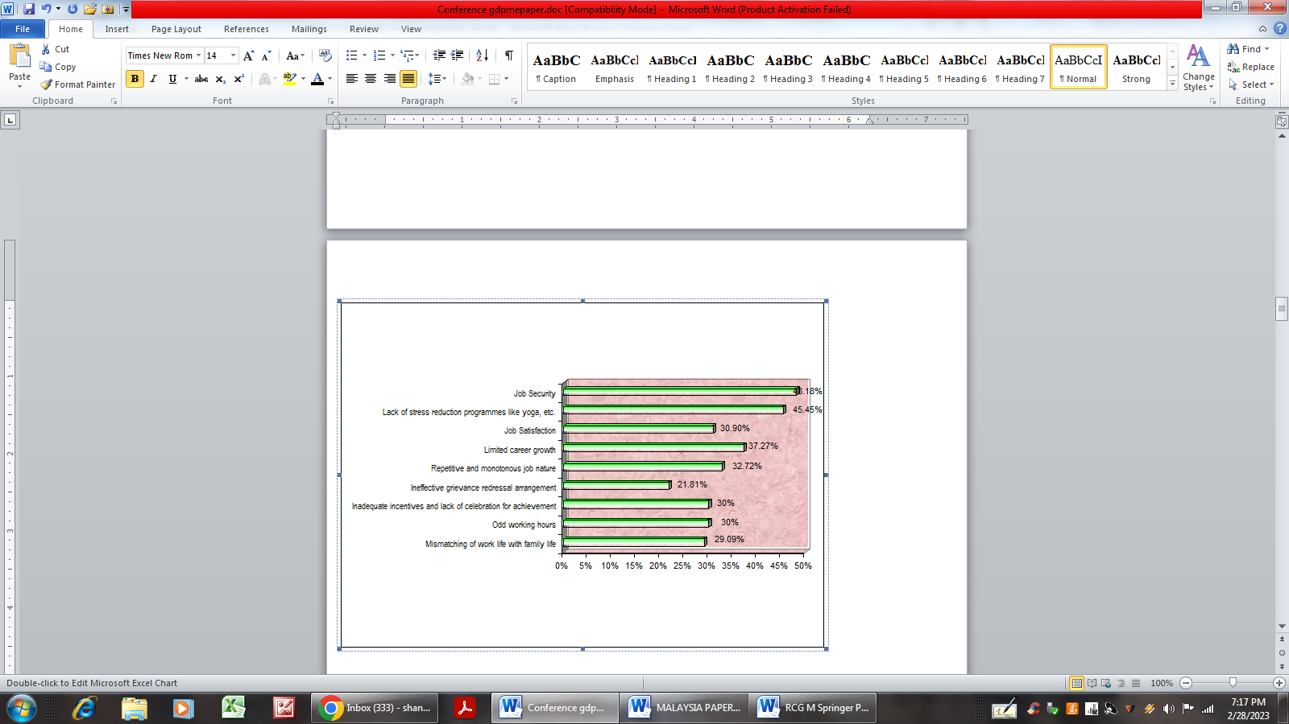
Fig. 1. Diagrammatic presentation of critical factors

Non-critical factors (Fig. 2) causing high employee attrition in BPO employees

- Mismatching of educational qualification with the job
- Absence of effective motivational programmes
- Lack of competency models for recruitment and selection
- Absence of logical, fair, and bias free promotion policy
- Improper compensation and benefits system
- Lack of empowerment in decision making
- Absence of welfare measures like housing schemes, etc.
- Lack of provision for hygienic and timely food to the employee
- Highly stressful job
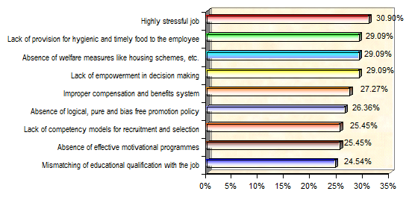
Fig. 2. Diagrammatic presentation of non-critical factors

2. Stress related factors
The study leads to the grouping of the following stress related factors (Fig. 3), which causes high employee attrition.
- Odd working hours
- Repetitive and monotonous job nature
- Absence of stress reduction programmes.
Fig. 3. Diagrammatic presentation of stress related factors

3. Compensational factors
The study leads to the grouping of following compensational factors (Fig. 4):
- Inadequate incentives and lack of celebration for achievement
- Improper compensation and benefits system
- Lack of fair, bias free promotion policy
- Absence of welfare measures like housing schemes etc.
Fig. 4. Diagrammatic presentation of compensational factors

4. Non-Compensational Factors
The study leads to the grouping of the following non-compensational factors (Fig. 5):
- Lack of job security
- Lack of Job satisfaction
- Limited career growth
- Improper redressal arrangement
- Improper selection methods,
- work life – imbalance,
- Mismatch of education al qualification
- Lack of provision for hygiene food
- Lack of empowerment in decision making
- Lack of effective motivational programmes
.
Fig. 5. Diagrammatic presentation of non-compensational factors

7. Conclusion
The problem of addressing high employee attrition in BPOs/call centers can be solved successfully by considering the critical and non-critical factors identified in the study. The grouping and the study of the factors under stress related, compensational and non-compensational categories will lead to an in depth understanding of the problem of high employee attrition. Manage attrition through smart people management tools and scientific approach rather than creating collaborative intra industry agreements. The study reveals that BPO is evolving as a dominant and elastic approach that business leaders can practice to realize a wide range of tactical and strategic objectives. The study provides a cautioning indication to the BPO industry managements and call centers to pay immediate attention on addressing the high employee attrition. The business and human performance experts should not only address the survival and security needs, but also the higher level needs for respect, recognition, achievement and life-long learning.

8. Suggestions
This research work suggests the following points for the effective reduction of the employee attrition in BPOs:
- Bring in inventive and practical policies for the employees concerning to the flexible employment schemes.
- Use behavior based testing method and capability screening to choose the right people in the first place.
- The people must be made aware of what is expected from them, so clearly communicate goals, roles and responsibilities.
- Employees with higher caliber would be attracted in the presence of clear work-life balance policies.
- Inspire and prepare employees to take up higher positions and if not satisfied, they will look outside the organization.
- Treat the employees well and respect them at all times and provide job dignity.
- Reach out to the families of the prospective aspirants with continuous and focused messages in the media about the exceptional growth in the BPO industry.
- Outsource the process of exit interview to outside professionals to get a accurate and impartial feedback. BPO industry must focus on becoming an 'employer of choice'
- Encourage stress management techniques to ensure that the employees remain happy, which will have impact on their services, specifically critical in voice based transactions.
- Employees should feel that they are valued by their managers in the workplace, which will motivate them and also improves their morale.
- Introduce “work from home” option as per the need of the employee.
- Use psychometric tests to acquire people who can work at nights and handle the monotony.
- Granting compassionate and emergency leaves.
- Provide healthcare facilities to the employees, their family and dependents.
- Search for the prospective candidates within the organization and inspire them.
- Hiring should result in only ‘stress hardy’ candidates being chosen for the job.
- Practice organization culture measuring tools such as Adversity Quotient.
- Refer premier establishments such as Indian Army, for their commanding leadership with highly skilled, motivated and high morale troops.

9. Limitations of the study
- The study involves the following limitations:
- The study was limited to only 4 BPO firms in Bangalore.
- Lack of time in conducting the research survey and completion of the project.
- Inability to respond to the questions considering all the view points.
- Inability to contact all the respondents.
- Lack of cooperation in answering sincerely.
- Data analysis focused mainly on descriptive analysis.

References
- S. Nakkiranand D.John Franklin (2005), “Business process outsourcing “Deep & Deep Publications Pvt. Ltd.
- Chetan Bhagat (2005) “ One night @ the call center” Rupa & Co., New Delhi.
- Kothari C.K, (2002) “Research Methodology” Vishwa Prakashan, 3rd Ed., New Delhi.
- Sircar, Nabanita, “Government to Tackle Rising Absenteeism in Call Center”, www.hindustantimes.com, March 6, 2002.
- Subba. Rao P (2003) “Personnel and Human Resource Management”, 3rd Edition, Himalaya Publications, Mumbai.
- Indian ITES-BPO Fact Sheet,<http://www.nasscom.org>.
- ITES Industry Threatened by Attrition , Price Wars,<http://www.ciol.com, Feb.13, 2003.
- Attrition, Absenteeism Bug BPO Cos,<http://www.thehindubusinessline.com, April21, 2004.
- “Comparing India with other BPO Destinations,<http://www.xicom.biz.,13 April, 2004.

