Assessment of Genotoxic Effect of Paris polyphylla

Kshetrimayum Guneshwor¹ and Adhikarimayum Haripyaree²
¹Department of Zoology, G.P. Women’s College, ²Department of Botany, Imphal College, Imphal-795001, India. E-mail: guneshwor@hotmail.com

Abstract
The rhizome of Paris polyphylla Smith is used in number of health problems by the local people of Manipur and adjoining states. In an attempt to determine whether aqueous extract of this part of the plant interact with genetic material was cytogenetically assayed using three testing protocols based on traditional chromosome aberration analysis, micronucleus assay and SC damages analysis. Animals were treated through intraperitonial injections at the dose of 3.6 ml/100g body weight or maximum tolerated dose and at dose of 1.8 ml/100g body weight or less than maximum tolerated dose of aqueous extract of P. polyphylla. Negative control animals received doses of distilled water equivalent to that of plant extract, while the positive control animals received EMS at the dose of 240 mg Kg ^{–1} body weight dissolved in 1ml distilled water. Mice which received intraperitonial injections of different doses of the aqueous extract of the plant did not induce significantly higher frequency of chromosome aberrations, SC damages and micronucleus frequency, indicating negative results of mutagenicity of the plant extract in all the test protocols.

Key words: Mutagenicity, genotoxicity, clastogenecity, cytogenetic assay, LD⁵⁰, maximum tolerated dose, less maximum tolerated dose, intraperitonial.

Introduction
The earliest recorded evidence of using herbal medicine in Indian, Chinese, Egyptian, Greek, Roman and Syrian texts dates back to about 5000 years. Medicinal plants have featured in folklore and tradition throughout the world. Herbal medicines are the synthesis of therapeutic experiences of generation of practicing physician of indigenous system of medicines. Indo-Burma biodiversity region of North- East India is a distinct part and is one of the hottest with 6th rank among the 25 mega biodiversity hotspots (MYERS, 1988; MYERS et al., 2000). Manipur which belongs to north-east India bordering Myamar has explored many species and varieties of medicinal plants. This state is a natural habitat of one of the most useful and costly herb called Paris polyphylla Smith. The rhizome of the herb is used in number of health problems like anti-inflamatory, cancer and bleeding in other parts of world (IUCN, 2004; LEE et al., 2005; SUN et al., 2007; FU, 2007; GUANGLIA et al., 2013; MAN et al., 2017; SONGSONG et al., 2017).
According to World Health Organization (WHO) approximately 80% of world’s population in developing countries depends on traditional medicines for primary health care (WHO, 2016). These escape toxicity testing before they are marketed as traditional medicines due to inadequate drug laws. Yet many reports reveal that drugs of plant origin are not free from toxic effects. Hepatic failure and even death following ingestion of herbal medicine have been reported (Dicken et al. 1994). Traditional eye medicines have been linked to childhood blindness in Nigeria (Harries and Cullinan 1994). Death of 15 persons in USA has been ascribed to a herbal medicine for impotency (Josefson 1996). Several medicinal plants are mutagenic, clastogenic and carcinogenic (Nandi et al. 1998).
Mammalian in vivo tests have several advantages over in vitro tests because the metabolic activation and detoxification of the chemicals in the intact animal are closer to the human system. In vivo mouse chromosome assay has been recognized as one of the sensitive methods to test genotoxicity of plant extract (Chakrabarti 2001). The bone marrow micronucleus (BMM) test is one of the least expensive in vivo assays for genotoxic effects (Heddle 1973; Schmid 1976). However, it has limitations that it only detects chromosome breaks or laggards and not even the mature types of break. Therefore, analysis of traditional chromosome aberration was employed in conjunction with BMM test for comprehensive mutagenicity testing. Synaptonemal complex (SC) analysis holds great promise as an in vivo mammalian germ cell assay for resolving effects of chemical exposure to the gonads and evaluating the risk of genetic damage (Allen et al. 1988; Backer et al. 1988).
The chemical constituents of Paris polyphylla are mainly paris saponins such as diosgenins and polyphyllins (WU et al., 2004). Paris saponin VII suppressed the growth of human cervical cancer Hela cells (ZHANG et al., 2014). Paris polyphylla extract induces Apoptosis and activates Cancer Suppressor Gene (LI et al., 2012). Cytotoxicity of methanolic extract of rhizomes of P. polyphylla was determined by MTT assay on three cancer cell lines: HeLa, HepG2 and PC3 (DAWA et al., 2019). Polyphyllin D and dioscin evade drug resistance and generate Apoptosis in liver cancer HepG2, R-HepG2 cells (CHEUNG et al., 2005; DENG et al., 1999; GAO et al., 2011; LI et al., 2001). Paris saponins I exhibited effective radiosensitivity against gefitinif resistant lung adenocarcinoma cell line (JIANG et al., 2014). Effects of polyphyllin D is a steroidal saponin in growth inhibition of human breast cancer cells and in Xenograft (LEE et al., 2005). Because of the presence of the above compounds in the plant extract some of which are cytotoxic this plant extract was examined for genotoxicity using mammalian in vivo cytogenetic assay.

Materials and Methods
Plant material was collected from different regions of Manipur and identified based on the vegetative and floral characteristics described in “A hand book of Medicinal plants” (Prajapati et al. 2003). Parts of the plant used in traditional medicine (Table 1) were air dried, powdered and extracted with boiling distilled water using Soxhlet apparatus for 3-4 hours, and then filtered through Whatman no. 4, stored at 4ºC and used within 24 hours. The concentration of the extract was expressed as percentage of dry weight of the plant in water. Aqueous extract was tested because decoction of this plant with water only was used in traditional medicine (SINHA 1996) and the primary aim of this study was to determine whether the chemicals present in the preparation of this plant used in traditional medicine interact with genetic material. Inbred Swiss albino mice originated from a single parental pair of sibs were maintained in natural environmental condition with free access food (gram, wheat, milk and bread) and water. Permission of the University Ethics Committee was obtained for animal experiments and the Committee’s guidelines for human treatment of animals were strictly followed. Mice weighing about 25 g and 10-12 weeks old were used. Maximum tolerated doses of the plant extract was determined by range test. LD⁵⁰ doses were serially diluted with distilled water until LDº was achieved. LDº was taken as MTD. Animals were treated through intraperitonial injections with MTD and less than MTD of plant extract. The treatment of same dose of distilled water served as negative control and EMS at the dose of 24 mg/100 g body weight dissolved in 1ml distilled water served as positive control. Each treatment and control group consisted of 5 animals. The treatment protocol is given in Table 1. Animals were sacrificed after 24 hours of treatment and cytological preparations were made. Metaphase chromosomes were prepared from bone marrow cells using standard colchicines - hypotonic – spreading – air drying technique. Synaptonemal complexes (SC) were prepared from spermatocytes following the method of Bhagirath and Kundu (1985). Briefly, one drop of testicular cell suspension in RPMI – 1640 was spread over a large drop of 0.2 M sucrose on a clean slide for 30 seconds, slides were fixed in 4% paraformaldehyde for 5 minutes, washed in 0.2% photoflow for 30 seconds, dried and stained with 70% silver nitrate. SC damages were scored according to Allen et al. (1998) and Backer et al. (1988). Micronuclei were prepared from bone marrow cells following the method of Romagna and Staniforth (1989). Briefly 2-3 drops of bone marrow cell suspension in RPMI-1640 and FCS were put on a clean slide and drawn into a smear with another slide, air dried, fixed in methanol and stored overnight in refrigerator and stained with Giemsa which was filtered through 0.2 μ syringe filter. One slide was prepared from each animal and 1000 PCE were scored from each slide as recommended by two IPCS collaboration studies (Ashby et al. 1983).

Statistical analysis
Standard statistical procedures were used to calculate statistical parameters of the quantitative data. Z-test used for the analysis of chromosome aberrations, micronuclei analysis and synaptonemal complex damages.

Results
Frequencies and representative types of traditional chromosomal aberrations are shown in Table 2 and Figs. 1-6. More than 5000 metaphases were examined from five animals. Total numbers of aberrations of all types were added. Frequencies of aberrations in positive and negative control were 30.12% and 4.08% respectively. Frequencies of aberrations in animals treated with the plant extract were similar with negative control value. Aqueous extract of the plant did not induce significantly higher frequency of chromosome aberrations. SC damages and micronucleus frequency, indicating negative results of mutagenicity of the plant extract in all the test protocols.
. Types of synaptonemal complex damages and their frequencies are shown in Figures 7-12 and Table 3. Types of SC damages are those recommended by Allen et al. (1988) and Backer et al. (1988). EMS (positive control) induced all types of the recommended damages, while distilled water (negative control) induced only some varying types of damages. Mice treated with the plant extract and distilled water (negative control) showed almost similar values. Aqueous extract of the plant did not induce significantly higher frequency of SC damages.

MPCE and their frequencies are shown in Figure 14 and Table 4. NCE having red–orange colour (Fig.13) could be differentiated from bluish coloured PCE (Fig.14). Proportions of MPCE in mice treated with EMS and the plant extract were calculated. There was no significant difference among treatments with distilled water and plant extract. The plant extract did not induce significantly higher micronucleus frequency.

Discussion
In present study, aqueous extract of the plant showed negative results in all three clastogenic testing protocols based on traditional chromosome aberration analysis, micronucleus assay and SC damages analysis. It is recommended that a particular agent proves mutagenic when it shows the mutagenecity at least in more than one test protocols (Sarkar and Manna 1989; Bochkov et al. 1976; Sharma 1984). Although the plant extract showed negative results in all the genotoxicity testing protocols, further specific and reliable mutagenicity tests need to be done as there are cases of point mutation, frame shift mutation which escape detection by methods employed in the present study. Mutagenicity of certain medicinal plants observed in the earlier studies by other investigators (NANDI et al. 1998) compels the necessity of using medicinal plants with specific guidelines, which have a sound basis and relevance to the population concerned.

Table 1. The experimental protocol for the treatment of animals.
Plant (part) | Treatment |  | Treatment period | No. of animals treated
Plant (part) | Volume in ml/100g body weight (Concentration) |  | Treatment period | No. of animals treated
Plant (part) | MTD | Half of the MTD | Treatment period | No. of animals treated
P. polyphylla (Rhizome) | 3.6(10%)* | 1.8 | 24 hrs | 5
* Extract concentration expressed as plant material dry weight/100 ml distilled water. Extracts of different weights of each plant material were subjected to range test for determining MTD. Figures in parenthesis indicate concentrations that provided maximum treatment volume of 0.9ml/animal in MTD range tests.

Table 2. Chromosomal aberrations in bone marrow cells of mice treated with EMS, distilled water and the P. polyphylla extract. | % of  dam. ± SE | *30.12±0.087 | 4.08± 0.026 | 4.16± 0.027  4.08± 0.025 | Abbreviation:Meta.=Metaphase,Centro.= Centromeric, Chrom.= Chromatid, Trans.= Tnanslocation, Attenu.= Attenuation, Frag.= Fragments,Dam.=Damage. *P= <0.01.
 | Total  Dam. | 1600 | 217 | 224  215
 | Frag. | 132 | 0 | 0  0
 | All dot  Like | 61 | 0 | 0  0
 | Ring Chromo | 28 | 3 | 3  4
 | Attenu. | 160 | 13 | 14  12
 | Trans. | 15 | 0 | 0  0
 | Isochro.  Break | 51 | 0 | 0  0
 | Chrom.  Break | 65 | 4 | 7  5
 | Centric  Fission | 541 | 123 | 124  125
 | Centricfusion | 362 | 45 | 50  49
 | Centro.  Gap | 185 | 29 | 26  25
 | No. of  Meta. | 5311 | 5325 | 5376  5261
 | Treatment | EMS  240mg Kg^{–1}. b. wt  (positive control) | Distilled water  (Negative control) | P. polyphylla extract 0.9ml/100g. b. wt  0.45ml/100g. b. wt

Table 3. Synaptonemal complex damages in mouse spermatocytes treated with EMS, distilled water and the P. polyphylla extract. | % of  dam.  ± SE |  | *27.69±0.080 | 4.01± 0.023 | 4.04± 0.021  4.02±0.019 | Abrreviation: SC= Synaptonemal complex, Frag= Fragment, MAC= Multi Axial Complex, Attn.= Attenuation, Asyn.= Asynapsis,  Auto-trans.= Autosome translocation, Elem.= Element, Sepn.= Separation, Pair.= Pairing, Dam.= Damage, *= P<0.01, SE= Standared Error.
 | Total  Dam. |  | 1483 | 215 | 213  211
 | Sex Element Damage | SC  Break  in Y | 13 | 0 | 0  0
 | Sex Element Damage | SC  Break  in X | 27 | 0 | 0  0
 | Sex Element Damage | Y-fold  Back  pair | 11 | 0 | 0  0
 | Sex Element Damage | X-fold back  pair | 138 | 9 | 11  12
 | Sex Element Damage | Y-A  Trans | 12 | 0 | 0  0
 | Sex Element Damage | X-A  Trans | 29 | 7 | 6  5
 | Sex Element Damage | X-Y  Sepn | 108 | 15 | 15  14
 | Sex Element Damage | Attn. in Y Elem | 21 | 0 | 0  0
 | Sex Element Damage | Attn.  inX Elem | 26 | 0 | 0  0
 | Autosome Element Damage | Auto- Trans | 82 | 7 | 8  7
 | Autosome Element Damage | Over all Asyn | 9 | 0 | 0  0
 | Autosome Element Damage | Asyn | 13 | 0 | 0  0
 | Autosome Element Damage | Attn | 251 | 42 | 39  38
 | Autosome Element Damage | MAC | 26 | 0 | 0  0
 | Autosome Element Damage | Frag | 294 | 0 | 0  0
 | Autosome Element Damage | SC break | 423 | 135 | 134  135
 | No. of  cells  scored |  | 5354 | 5343 | 5265  5244
 | Treatment |  | EMS  240mg Kg^{–1} b. wt  (Positive control) | Distilled water  (Negative control) | P. polyphylla extract 0.9ml/100g. b. wt  0.45ml/100g. b. wt
Table 4. Frequency of MPCE in bone marrow cells of mice treated with EMS, distilled water and the P. polyphylla extract.

Treatment | No. of PCE  Scored | No. of MPCE  scored | Ranges of proportion of  MPCE (MPCE/PCE)
EMS  240mgKg^{–1} b. wt  (Positive control) | 5000 | 89 | *0.0178
Distilled water  (Negative control) | 5000 | 9 | 0.0018
P. polyphylla extract  0.9ml/100g. b. wt  0.45ml/100g. b. wt | 5000  5000 | 8  7 | 0.0016  0.0114

* = P<0.01

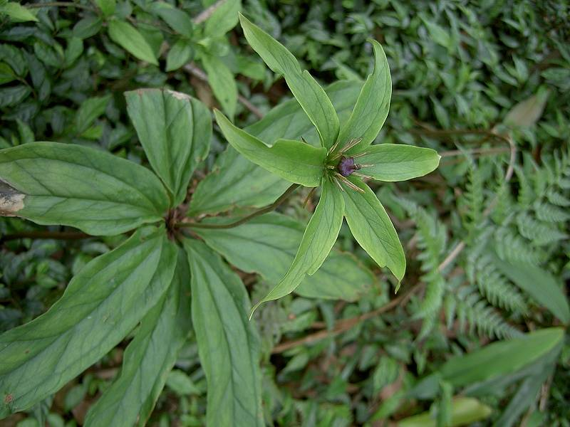
Paris polyphylla

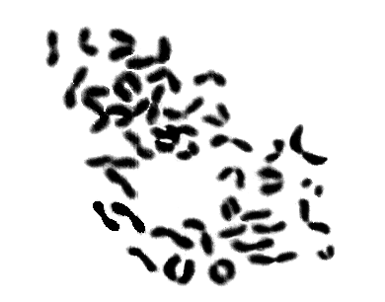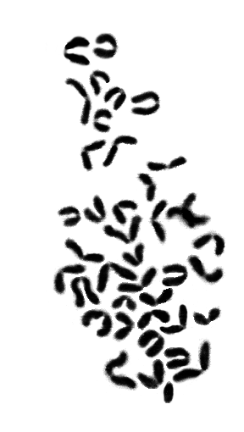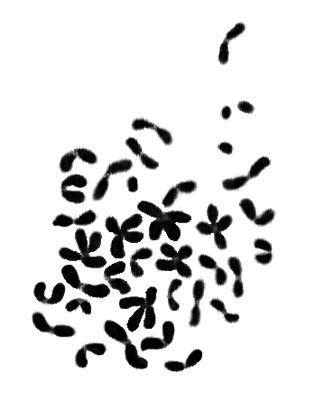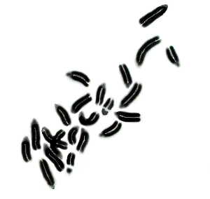
1
2
3
4
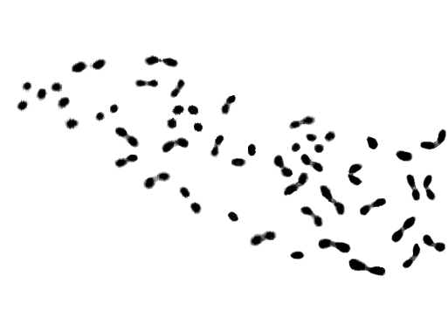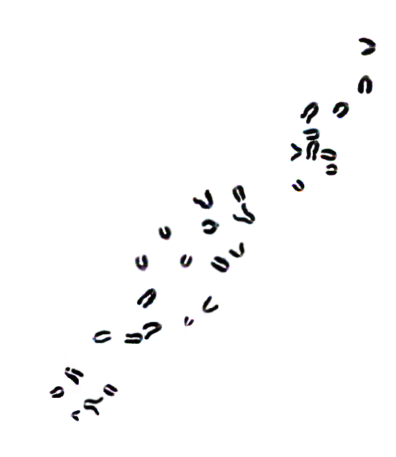
5
6
Figure 1-5. Somatic chromosome aberrations. (1) Ring chromosome (hollow arrow) and Centric fission (solid arrow); (2) Centromeric gap (hollow arrow) and Chromosome fragment (solid arrow); (3) Centric fussion (solid arrows), Centric fission (double head arrow and hollow head); (4) All dot like; (5) Isochromatid break (solid arrow).
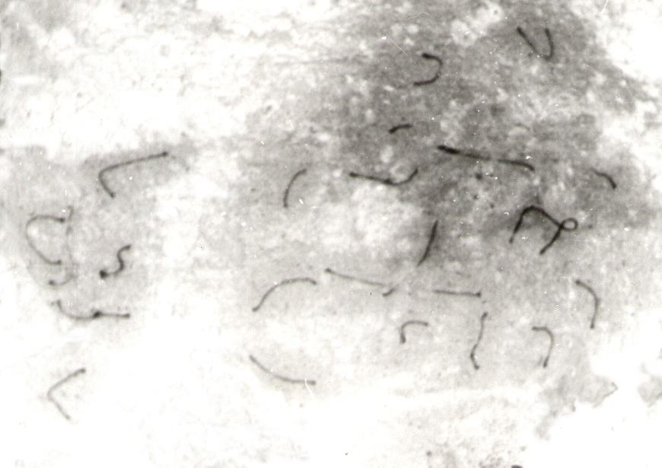 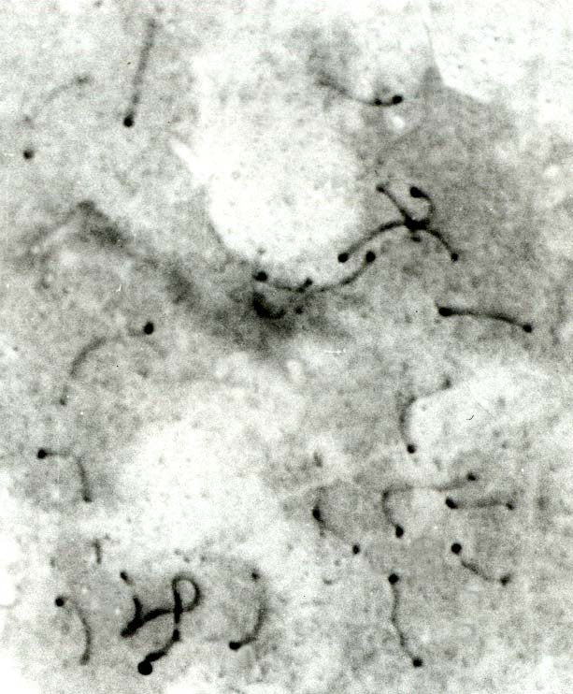 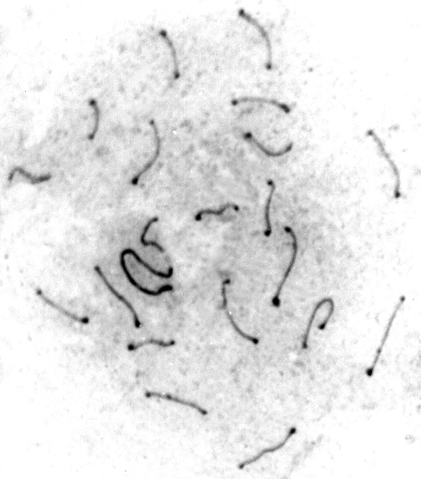 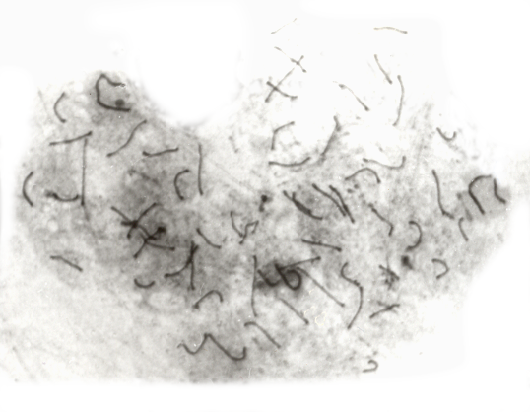 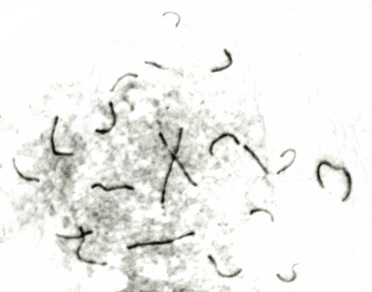 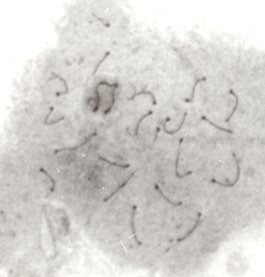 Figure 7-12. Synaptonemal complex damages. (7) Autosome fragment (Hollow arrow) and Autosome translocation (Solid arrow); (8) Y - break (solid arrow); (9) X-Y separation (Double head solid arrow) and X fold back (10) Autosome translocation (solid arrow) and Autosomal attenuation (hollow arrow) ; (11) SC breaks (Solid arrows); (12) Y-fold back (solid arrow) and X-A translocation (hollow arrow).
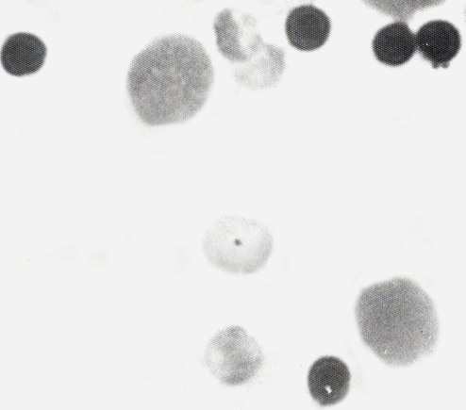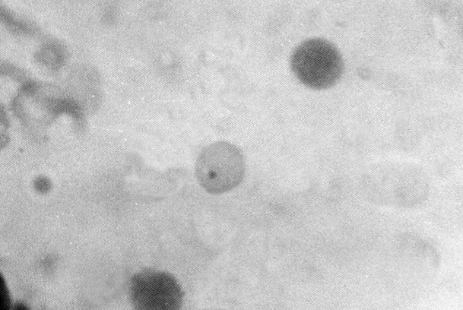
Figure 13. NCE with single micronucleus (solid arrow). Figure 14. PCE with single micronucleus (solid arrow)
References
Alam G., Wahyuono S., Ganjar I.G., Hakim L., Timmerman H. and Verpoorte R., 2002 ― Tracheospasmolytic activity of Vitoeosin A and Vitexicarpin isolated from V. trifolia. Planta Medica., 1047-1049.
Allen J.W., Gibson J.B., POORMAN P.A., Backer L.C. and Moses M.J.,1988 ― Synaptonemal complex damages induced by clastogenic and antimitotic chemical: implications for non-disjunction and aneuploidy. Mut. Res., 301:313-324.
Ashby J., Serres De F.J., DRAPPER M.H., ISHIDATE J.K., MATTER B.I. and Shelby M.D., 1983 ― The two IPCS collaboration studies on short-term test system of genotoxicity and carcinogenicity. Mut. Res., 109: 123-126.
Backer L.C., Gibson J.B., Moses M.J. and Allen J.W., 1988 ― Synaptonemal complex damage in relation to meiotic chromosome aberrations after exposure of male mice to cyclophosphamide. Mut. Res., 203: 317.
Bhagirath TH. and Kundu S.C., 1985 ― Effects of male contraceptive agent gossypol on bone-marrow chromosomes of the male rat. Cytogenet. Cell Genet., 39: 228-230.
Bochkov N.P., Sram R.J., Kuleshov N.P. and Zhurkov V.S., 1976 ― System for the evaluation of the risk from chemical mutagens: basic principles and practical recommendations. Mut. Res., 38: 191-202.
Chakrabarti C.S., 2001 ― Genotoxic effects of Euporatorium extract on the bone-marrow chromosomes of Rat (Rattus norvegicus). Proc. Zool. Soc. Calcutta., 54: 22-26.
DAWA LH. L., ABHIJIT CH and DHANI R. CH., 2019 ― Antioxidant and Cytotoxic Attributes of Paris polyphylla Smith from Sikkim Himalaya. Pharmacognosy journal., 11(4):705-711.
Dickens P., Tai Y.T., But P.P., Tomlison B., Ng H.K. and Yan K.W., 1994 ― Toxicity of complementary therapies: An Eastern perspective. Forensic Sci. Int., 67: 55-58.
DIGRAK M., ALMA M.H., Ilcim A. and Sen S., 1999 ― Antibacterial and antifungal effects of various commercial plant extracts. Pharmaceutical Biology., 37(3):216-220.
FU YL, ZHAO ZH, SHAN YJ, and CONG YW., 2007 ― Inducing effect of total steroid saponins from Paris polyphylla on platelet aggregation in vitro and its potential mechanism. Bulletin Academy Military Med Sci., 31:416-419.
Galvez M., Martin-Cordero C., Lopez-Lazaro M., Cortes F. and Ayuro M.J., 2003 ― Cytotoxic effect of Plantago spp. on cancer cell lines. J. Ethnopharmacol., 88 (2-3):125-130.
GHUANGLIE C., WEISHI G., GAILLING H., and JIANPING C., 2013 ― Effect of paris Saponin on Antitumor and Immune Function in U14 Tumor- Bearing Mice. Afr J Tradit Complement Altern Med., 10:503-507.
Guil J.L., Rodriguez-Garcia I. and Torija E., 1997 ― Nutritional and toxic factors in selected wild edible plant. Plant Foods for human Nutrition., 51 (2):99-107.
Harries A.D and Cullinan T., 1994 ― Herbis et orbis: the dangers of traditional eye medicines. Lancet., 344: 1588.
Heddle J.A., 1973 ― A rapid in vivo test for chromosomal damage. Mut. Res., 18:187-190.
IUCN, Nepal., 2004 ― National Register of Medicinal and Aromatic plants (Revised and updated). IUCN- The World Conservation Union, Kathmandu, Nepal.
Jagadeeswaran R., Trirunavukharasu C., Gunasekaran P., Ramamurty N. and Sakthisekaran D., 2000 ― In vitro studies on the selective cytotoxic effect of crocetin and quercetin. Fitoterapia., 71(4):395-399.
JIANG H., ZHAO P., FENG J., SU D and MA S., 2014 ― Effect of Paris saponin I on radiosensitivity in a gefitinib-resistant lung adenocarcinoma cell line. Oncol Lett., 7:2059-2064.
Josefson D., 1996 ― Herbal stimulant causes US deaths. Br. Med. J., 312: 1378-1379.
Kamat and Singh. , 1994 ― Preliminary chemical in the different parts of the genus Leucas R. Br. Geobios., 21(1):31-33.
Kamboj V. P., 2000 ―Herbal Medicine. Curr. Sci., 78: 35-37.
Kim Y.K., Yoon S.K. and Ryu S.Y., 2000 ― Cytotoxic triterpenes from stem bark of Physocarpus intermedius. Planta Medica., 66(5): 485-486.
LEE, M.S., YUET-WA., J.C., KONG, S.K., YU, B., ENG-CHOON, V.O., NAI-CHING, H.W., CHUNG-WAI, T.M. and FUNG, K.P., 2005 ― Effects of polyphyllin D, a steroidal saponin in Paris polyphylla in growth inhibition of human breast cancer cells and in xenograft. Cancer Biology and Therapy., 4:1248–1254.
LI B., YU B., HUI Y., LI M., HAN X and FU NG KP., 2001 ― An improved synthesis of the saponin, polyphyllin D. Carbohydr Res., 331:1-7.
LI FR., JIAO P., YAO ST., SANG H., QIN SC., ZHANG W., ZHANG YB and GAO LL., 2012 ― Paris polyphylla Smith Extract Induces Apoptosis and Activates Cancer Suppressor Gene Connexin26 Expression. Asia Pac J Cancer Prev., 13:205-209.
MAN, S., CHAI, H., CUI, J., YAO, J., L., MA and GAO, W., 2017 ― Antitumor and anti-metastatic activities of Rhizoma paridis saponins in Lewis mice. Environmental Toxicology., 33(2):149-155,
MYERS, N., 1988 ― Threatened Biotas: “Hot Spots” in the Tropical Forests. The Environmentalists., 8(3):187-208.

MYERS, N., MITTERMEIER, R.A., MITTERMEIER, C.A., DA FONSECA, G.A.B. and KENT, J., 2000― Biodiversity hotspots for conser-vation priorities. Nature, 403:853-858.

Nandi P., Talukdar G. and Sharma A., 1998 ― Plants against cancer-some aspects. Nucleus., 41: 53-86.
Porto Alegre R.S., 1999 ― Mutagenicity of medicinal plant extracts in Salmonella/ microsome assay. Phytotherapy Res., 13: 397-400.
Prajapati N.D., Purohit S.S., Sharma A.K. and Kumar T., 2003 ― A hand book of Medicinal Plants- A Complete Source Book. 1st Edn. Agrobios, India.
Ringbom T., Segura L., Noreen Y., Perera P. and Bohlin L., 1998 ― Ursolic acid from Plantago major, selective inhibitor of cyclooxygenase-2 catalyzed prostaglandin biosynthesis. J. Nat. Products., 61 (10):1212-1215.
Romagna F. and Staniforth C.D., 1989 ― Automated bone-marrow micronucleus test. Mut. Res., 231: 91-104.
Sadhu S.K., Okuyama E., Fujimoto H. and Ishibashi M., 2003 ― Separation of Leucas aspera, a medicinal plant of Bangladesh, guided by prostaglandin inhibitory and antioxidant activities. Chemical & Pharmaceutical Bulletin., 51 (5): 595-598.
Sarkar A.K. and Manna G.K., 1989 ― Mutagenic potentiality of the nitrogen fixing bacterium Beijerinckia acida tested in mice. In: Perspectives in Cytology and Genetics, (G. K. Manna and Sinha, eds)., 6: 633-639.
Schmid W., 1976 ― Chemical Mutagens, Principle and Method for Detection. (Ed. Holaender) Plenum press New York., 4: 31.
Sharma A., 1984 ― In: Indian Nat. Sci. Acad. Golden Jubilee publication. Perspective report., 61.
Sinha S.C., 1996 ― Medicinal Plants of Manipur. Manipur Association for Science and Society, Imphal.
SONGSONG JING., YING WANG., XIA LI., MAN S. and GAO W., 2017 ― Chemical constituents and antitumor activity from Paris polyphylla Smith var. yunnanensis. Natural Product Research., 31(6): 660-666.
SUN J., LIU B.R., HU W.J., YU L.X. and QIAN X.P., 2007 ― In vitro anticancer activity of aqueous extracts and ethanol extracts of fifteen traditional Chinese medicines on human digestive tumor cell lines. Phytotherapy Research., 21:1102–1104.
WHO 2016 ― World Health Organization (WHO) factsheet,
WU SS., GAO WY., DUAN HQ. and WEI J., 2004 ― Advances in studies on chemical constituents and pharmacological activities of Rhizoma Paridis. Chinese Traditional and Herbal Drugs., 35:344-347.
ZHANG L., RAVIPATI AS., KOYYALAMUDI SR., JEONG SC., REDDY N., SMITH PT., BARTLETT J., SHANMUGAM K., MUNCH DG and WU MJ., 2011 ― Antioxidant and Anti-inflammatory Activities of Selected Medicinal Plants Containing Phenolic and Flavonoid compounds. J Agr Food Chem., 59:12361-12367.

