Guardians of Biodiversity: Unveiling the Plant Diversity and Structural Dynamics of Maruthi Mala Hills, Kollam District, Kerala
Dr Sofia S*
* Assistant Professor, Dept. of Botany, Fatima Mata National College (Autonomous), Kollam, Kerala.

ABSTRACT
The field of ecology encompasses the intricate connections that develop between living organisms and their physical environments, accompanied by the complex exchange of matter and energy within biological systems. This interplay between organisms, their surroundings, and one another constitutes the central focus of ecological research. Within a specific habitat, the coexistence of various species, brought together by their shared ability to thrive under similar conditions, gives rise to a unique community. Phytosociological investigations are crucial for preserving biodiversity and maintaining the integrity of natural plant communities. These studies serve as essential tools for understanding historical changes and predicting future developments in ecosystems. The environmental well-being of a nation is closely tied to the health of its forested regions since forest ecosystems house a significant portion of global biodiversity. Phytosociological research plays a pivotal role not only in conserving natural plant communities and biodiversity but also in tracking historical changes and projecting future trends. Many developed nations have established foundational studies in this field, often supported by vegetation maps. However, numerous forests worldwide face significant disruptions caused by human activities, necessitating careful management interventions to ensure the long-term coexistence of biodiversity and sustainability. In a recent exploration, comprehensive studies were conducted on phytosociology and species diversity within Kerala's Kollam district. The primary objective of this phytosociological analysis was to unveil the intricate tapestry of floristic vegetation, estimating the richness and diversity of species thriving in the study area.
Key Words: Phyto sociology, Biodiversity, Species, Density, Frequency

Introduction
Ecology examines the intricate relationships among organisms and their physical environment, as well as the complex flow of matter and energy within biological systems. The interplay between organisms, their surroundings, and each other is a central focus of ecological research. Within a specific habitat, a community of species coexists because they share the ability to thrive in the same conditions. Some invasive species, due to their size and rapid growth, can reshape the habitat and dominate other species in the community. Ecology primarily studies how abiotic and biotic factors affect the growth, distribution, behavior, and survival of organisms (Stone and Frayer, 2018). Ecosystems feature intricate and multifaceted relationships, including predation, competition, symbiosis, and mutualism.
Phytosociological investigations are essential for conserving biodiversity and native plant communities (Rahees et al., 2019). These studies provide critical insights into historical and future transformations (Hamzaoglu, 2006; Rao et al., 2020). In an ecosystem, every living organism interacts with both abiotic and biotic elements of its environment. Abiotic elements include inorganic substances like water, carbon dioxide, oxygen, and organic compounds generated by organisms. Biotic factors encompass plants, animals, and microorganisms, all interconnected through energy exchange.
Phytosociological studies play a crucial role in safeguarding biodiversity and natural plant communities (Rahees et al., 2019). The environmental security of a nation depends on the health of its forested areas, which harbor significant biodiversity (Batles et al., 2001). Sustainable forest management is essential for preserving biodiversity (Gamble, 1936). Research indicates that forest ecosystems' long-term health relies on plant diversity and sociological characteristics. Given human impact on forests, proactive management is crucial for biodiversity and sustainability (Kumar et al., 2019).
The overall richness of forest diversity hinges on the variety of plant life, which serves as sustenance and habitats for organisms (Das et al., 2020). Forest vigor is linked to plant diversity, vital for conservation planning. Tree diversity impacts habitat, vegetation, physiology, species makeup, and community dynamics, aiding forest management (Battles et al., 2018). Baseline data on community changes are crucial for predicting the impact of disturbances on flora (Sarkar, 2021). Some regions have seen declining biodiversity due to human activities (Krishnamoorthy et al., 2019). Studying plant communities, their attributes, taxonomy, and relationships is vital for biodiversity conservation. Developed countries often have foundational studies and use tree maps (Tel et al., 2020). Human-induced impacts require meticulous forest management (Kumar et al., 2020).
This study focuses on phyto-sociological analysis and species diversity in Kerala's Kollam district. It aims to understand the floristic and vegetative characteristics and quantify species richness and diversity. Maruthi mala plants play ecological roles like water purification and wildlife habitat preservation (Chandran et al., 2020). They enhance carbon cycling and soil properties (Santana et al., 2021). Understanding ecological richness and preservation requires knowledge of plant diversity and structural dynamics. The study explores Maruthi Mala Hills, known for their diverse ecosystem in Kollam District, Kerala. The study aims to document predominant plant species, their prevalence, and factors influencing their distribution and coexistence. This study contributes to ecology, biodiversity conservation, and environmental management. It aids in conservation and sustainable land use strategies for Maruthi Mala Hills, preserving plant diversity and structural dynamics.
Safeguarding habitats like Maruthi Mala Hills benefits ecosystems, local communities, and the planet. Recognizing the interplay between plant diversity and structural dynamics promotes harmony between nature and humanity. Ecological communities consist of species living in the same habitat, sharing tolerances. Invasive species, non-natives introduced to new ecosystems, can disrupt native species and alter the environment. Keystone species have a disproportionate impact on ecosystems. Understanding these relationships is vital for conservation and ecosystem management. Ecology combines biology, chemistry, physics, and other sciences to study Earth's life processes.
Maruthi Mala Hills (Muttara Hills)
Maruthi Mala Hills, also known as Muttara Hills, are situated in the charming village of Muttara, located within the Kottarakkara region of Kerala's Kollam district in India. This picturesque village lies 24 kilometers east of Kollam, the district's central hub, and a mere 3 kilometers from Kottarakkara. It is approximately 65 kilometers away from the state capital, Thiruvananthapuram. Covering a vast area of over 37 acres, Maruthi Mala Hills are adorned with a diverse range of trees and are home to a vibrant avian population. Notably, Maruthi Mala Hills are renowned as an eco-tourism destination in the Kollam district of Kerala, showcasing a rich and varied ecosystem.

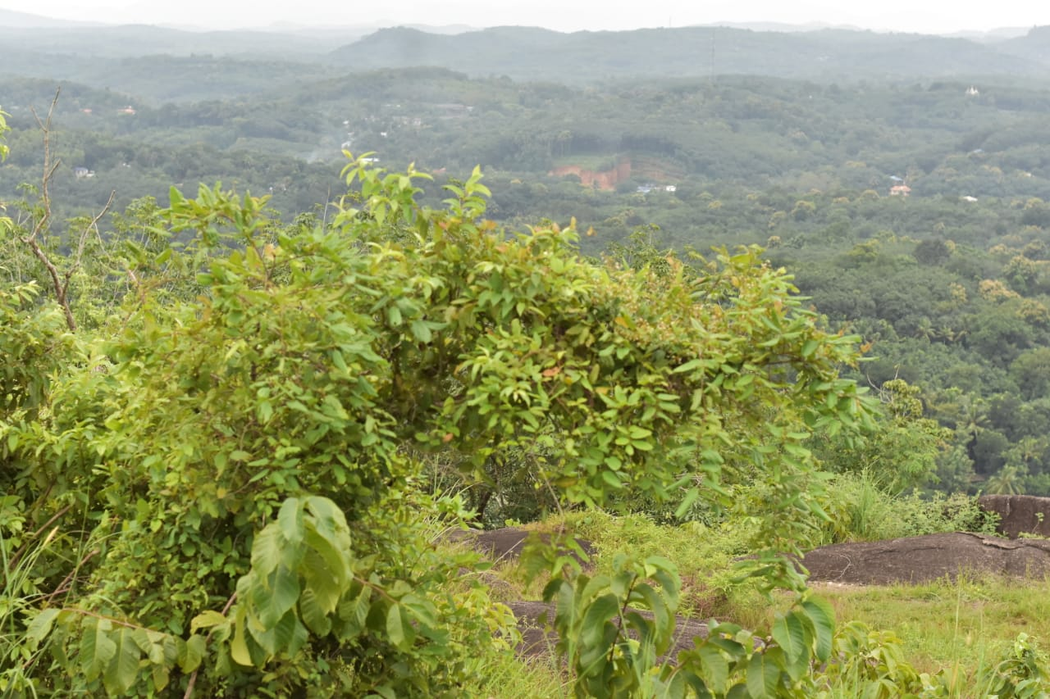
Figure 1.1: Study Site – Maruthi Mala Hills
The prevailing plant species in this region include Phyllanthus emblica, Eupatorium odoratum, Mimosa pudica, Premna odorata, and Leucas aspera. It is evident that these species play a significant role in shaping the dynamics of productive ecosystems. Pollution caused by heavy metals has a detrimental impact on the growth and biochemical processes of soil microorganisms, which, in turn, can have direct or indirect consequences on the surrounding flora and fauna within the ecosystem.

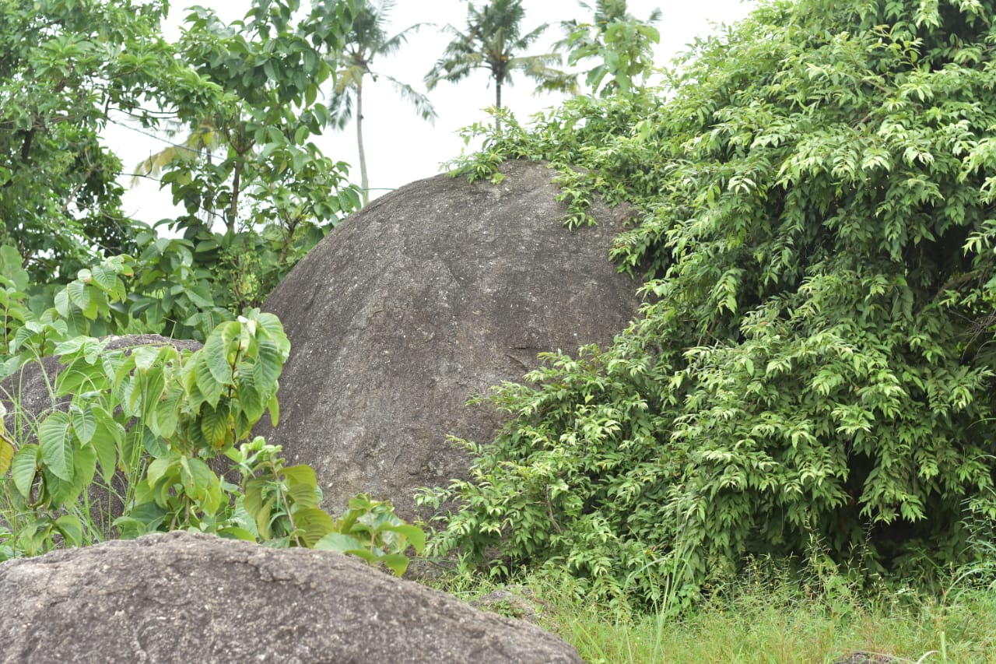
Figure 1.2: Study Site – Maruthi Mala Hills
This research project involves a comprehensive study of the plant life and community structure within Maruthi Mala Hills, located in the Kollam District of Kerala. The botanical analysis encompasses an evaluation of the overall vegetation composition in the specified region. Additionally, the phytosociological investigation employs established phytosociological methods and Diversity Indices to delve into the structure and diversity of the plant community.

1.1. Objectives
1. To analyse the present status of vegetation in Maruthi Mala Hills
2. To develop Phytosociological inventory of the flora

Review of Literature
Hogarth (2019) noted that the plant life in this area consists of diverse entities, spanning various angiosperm families with distinct adaptations. Ecosystems like forests, as highlighted by Alongi (2021), are globally recognized as highly productive and ecologically significant, providing vital shelter for both plant and animal species. To comprehend and promote biodiversity conservation, it is crucial to conduct comprehensive inventories and diversity assessments at various scales worldwide, bridging gaps in our understanding of biodiversity.
Jonathan et al. (2019) conducted a study along the central Kerala coast, focusing on the diversity of economically valuable plants. Their findings highlighted the prevalence of Ocimum tenuiflorum, L. and Capsicum annum, L., indicating the suitability of native plants for cultivation and horticultural production in coastal regions.
Ramya et al. (2020) conducted a phyto-societal investigation in the tropical moist deciduous forest of Manar Beit. They identified nineteen tree species from thirteen families, with Pongamia pinnata, L., and Terminalia arjuna, L., exhibiting high quality index values, signifying their dominance. Notably, Dalbergia latifolia, L., and Santalum album, L., were identified as endangered species through ecological surveys.
Uddin et al. (2020) conducted a phytosociological study in a subtropical forest in Manipura, documenting 79 tree and shrub species across 35 families. Schima wallichii and Lantana camara emerged as dominant tree and shrub species in the natural forest.
Anwar et al. (2020) performed a phytosociological analysis of the Peruvian mountain rainforest, employing the Sorensen index to assess bioclimatic conditions' similarity and identify distinct phytosociological units within Peru.
Usharani et al. (2018) conducted a phytosociological exploration of weed communities in organic and traditional vegetable growing systems in Alagoas state, Brazil. They identified and categorized 299 weed species across 11 botanical families, utilizing various quantitative characteristics such as frequency, density, and importance value index (IVI).
Kunwar et al. (2020) conducted a phytosociological inquiry in Nepal's Kailash Sacred Landscape, examining the alignment of plant resource utilization with plant and habitat availability. They found that ecological and cultural indicators influenced plant use value for various categories, including medicinal and non-medicinal plants.
Kunev et al. (2020) studied the vegetation of Wadi al-Kuf nursery reserve areas in Palestine's Hebron region, documenting 82 species, including 16 endemics, and utilizing the Braun-Blanquet method and phytosociological investigations to analyze climate factors.
Manzoor and Jazeeb (2021) conducted a vegetation analysis in four Village Common Forests (VCF) in Bangladesh, identifying 124 species across 44 families, with Oroxylum indicum as the dominant species according to the Significance Index (IVI).
Timub et al. (2020) conducted a phytosociological examination of wheat crop weeds in Pakistan's Swabi District, identifying 20 weed communities based on the prominence of the three leading species, and assessing the similarity between these communities using Sorensen's index.
Patel (2021) conducted a phytosociological analysis of weeds in agricultural crop fields in Gujarat, India, identifying 47 weed species from 45 genera and 21 families using ecological parameters like abundance, density, and frequency.
Patel (2020) conducted a phytosociological study on tree species in Gujarat's Sebhargog region, Vadgam Taluka, Banaskantha District, India, reporting 34 tree species and utilizing various ecological parameters to determine species distribution.
Huma et al. (2019) classified Peruvian vegetation phytosociologically, identifying 218 associations within 34 phytosociological classes, including four previously undescribed classes, using phytosociological plots and an abundance dominance index for assessment

Materials and Methods
The ecosystems in Kerala possess unique indigenous characteristics when compared to those in other regions. The current study aims to address the ecological imbalances within the Maruthi Mala Hills in Kollam District by examining their structural dynamics and diversity. This endeavor is essential in offering valuable insights for the conservation and scientifically informed management of these areas.
3.1. Ecological Studies
3.1.1 Study Area
The study site Maruthi Mala Hills in Kollam District, Kerala, the southwest cost of India. Sampling location is shown in Fig. 3.1.1. Maruthi Mala Hills is situated between 8⁰57’18” N and 76⁰45’30” E.
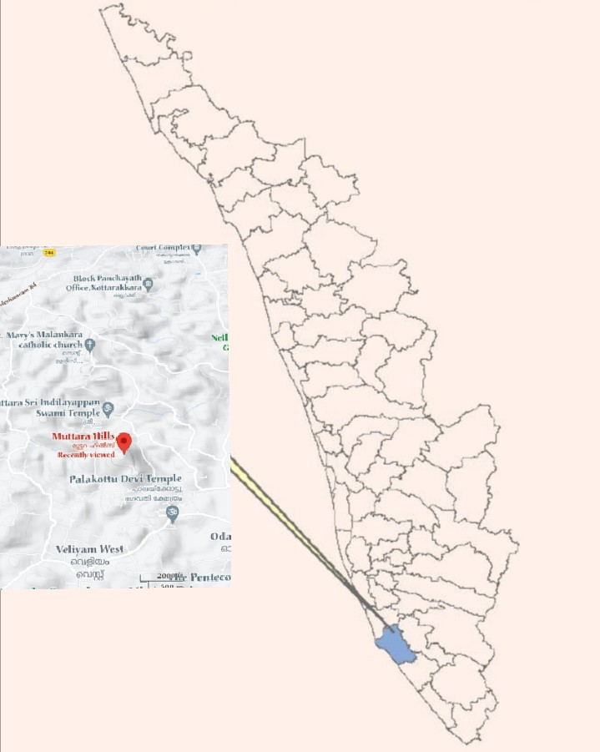
Figure. 3.1.1: Selected Study Site

    - Phytosociology of Plants
The research in Maruthi Mala Hills employed species area estimation and quadrat analysis to examine plant distribution patterns. The primary objective of the phytosociological analysis was to gain insights into the floral composition, estimate species richness and diversity within the study site. The phytosociological investigations were conducted using the quadrat method. Various parameters such as percentage frequency, frequency class, density, abundance, relative frequency, relative density, Importance Value Index (IVI), and several Diversity Indices were computed using the formulas provided by Misra and Puri (1973).

- Density.
Density =Total number of individuals of a species in all quadrats
Total number of quadrats studied
- Frequency (%).
Frequency (%) = Number of quadrats in which the species occurred
Total number of quadrats studied X 100
- Abundance.
Abundance = Total number of individuals of a species in all quadrats
Total number of quadrats in which the species occurred
- Importance Value Index
IVI = Relative frequency + Relative abundance + Relative density

- Relative density.
Relative density = Number of individual of the species
Number of individual of all the species X 100
- Relative frequency.
Relative frequency = Number of occurrence of the species
Number of occurrence of all the species X 100
- Relative abundance.
Relative abundance = = Total no.of species
Total no.of individual of all species recorded x100
Species richness, diversity and dominance indices
Species richness, diversity and dominance were analysed by using the methods of Margalef's index of richness, Shannon's diversity index, Simpson's index of dominance and Pielou’s Evenness Index.

- Margalef’s index of richness
‘Margalef’s index of richness’ (Dmg)
Dmg = (S-1)/ In N
Where,
S = Total number of species.
N = Total number of individuals.
- Shannon–Weaver index of diversity
H’ = – Σ pi In pi
Where, H’ = Shannon index of diversity
pi = the proportion of important value of the ith species ( pi =ni / N, ni is the important value index of ith species and N is the important value index of all the species).
- Simpson index of Dominance
D = Σ ( pi)2
Where, D = Simpson index of dominance
pi = the proportion of important value of the ith species ( pi = ni / N, ni is the important value index of ith species and N is the important value index of all the species).
- Pielou’s Evenness Index

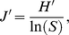
Where, J’ = Pielou’s evenness Index
H′ represents the observed value of Shannon index
S is the total number of species observed.
Observation and Results
Plant diversity assessments within ecosystems have traditionally concentrated on trees, shrubs, and herbs since the diversity of these species plays a pivotal role in shaping forest ecosystem diversity. Over time, long-term ecological research sites have emerged as crucial resources for investigating community and ecosystem dynamics in various ecosystems across the globe. The application of phytosociological analysis to study natural vegetation has gained recognition as an effective and suitable method for identifying valuable plant species within natural communities.

4.1. Plant Vegetation
The Plant vegetation of the studied site was analysed to assess the composition and distribution pattern of species. The common plant species observed in Maruthi Mala Hills was Phyllanthus emblica, L., Mimosa pudica, L., Premna odorata, Franc., Eupatorium odoratum, L.
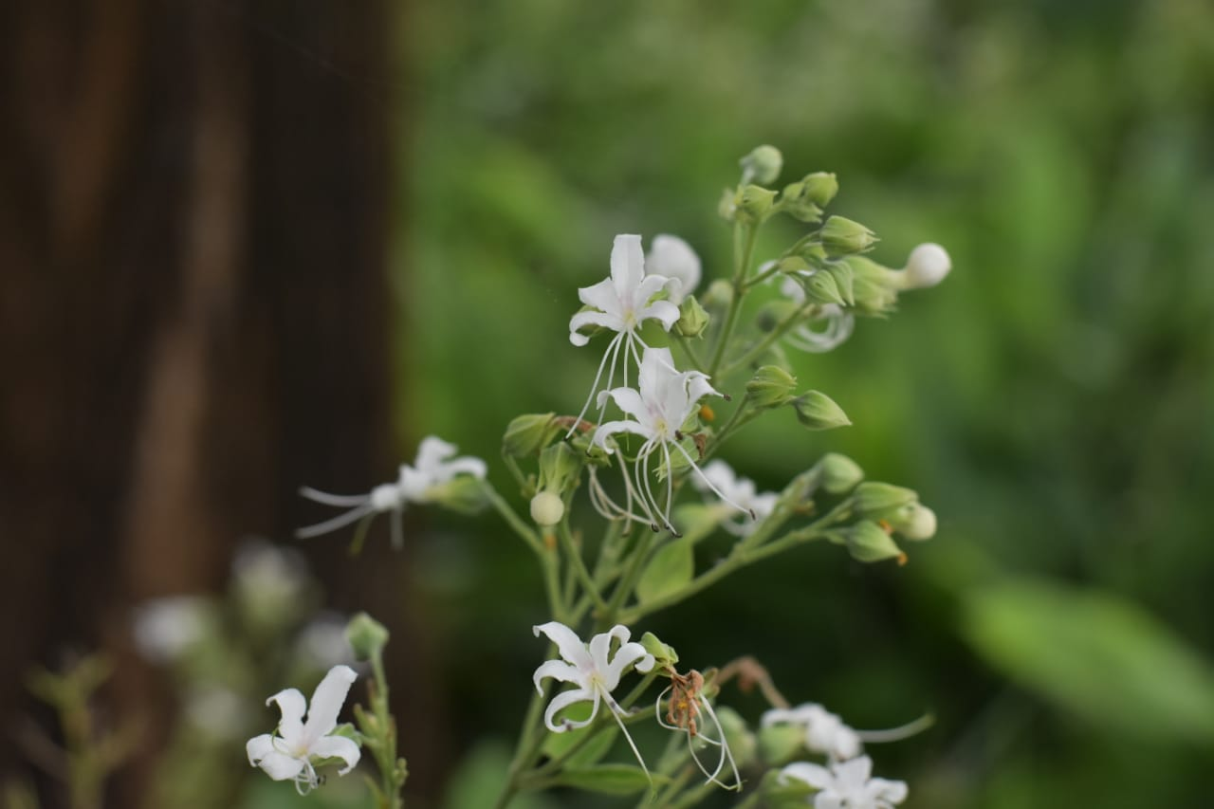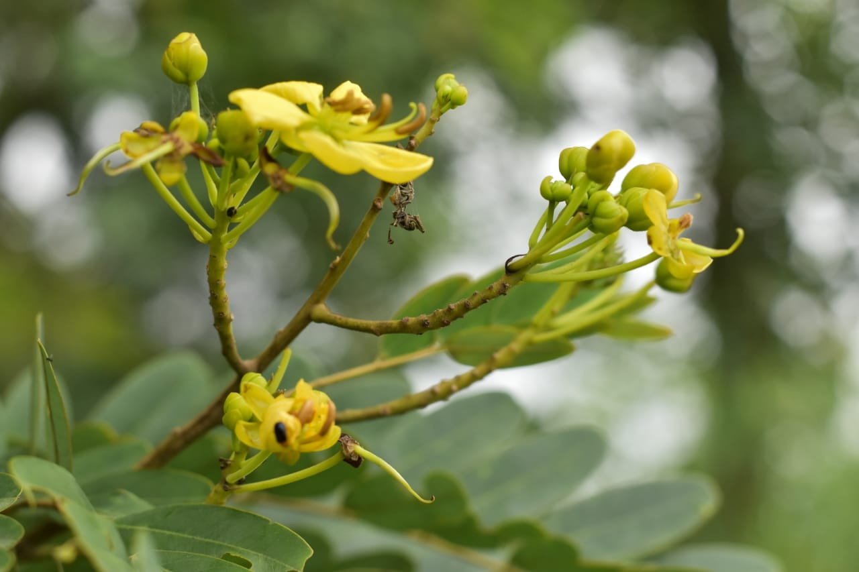
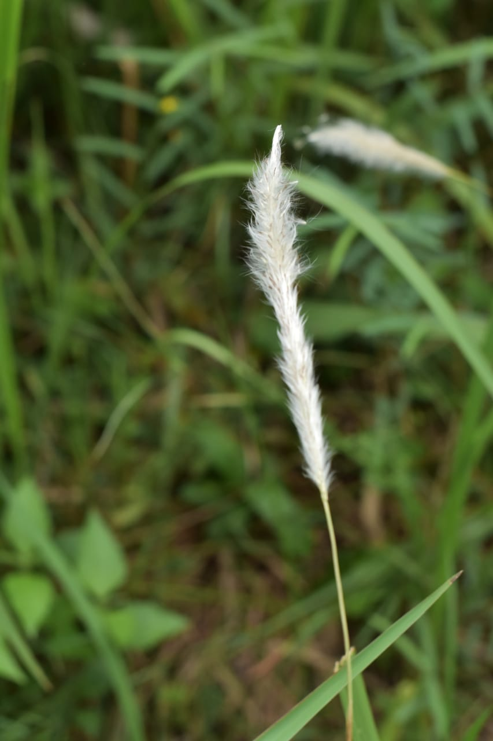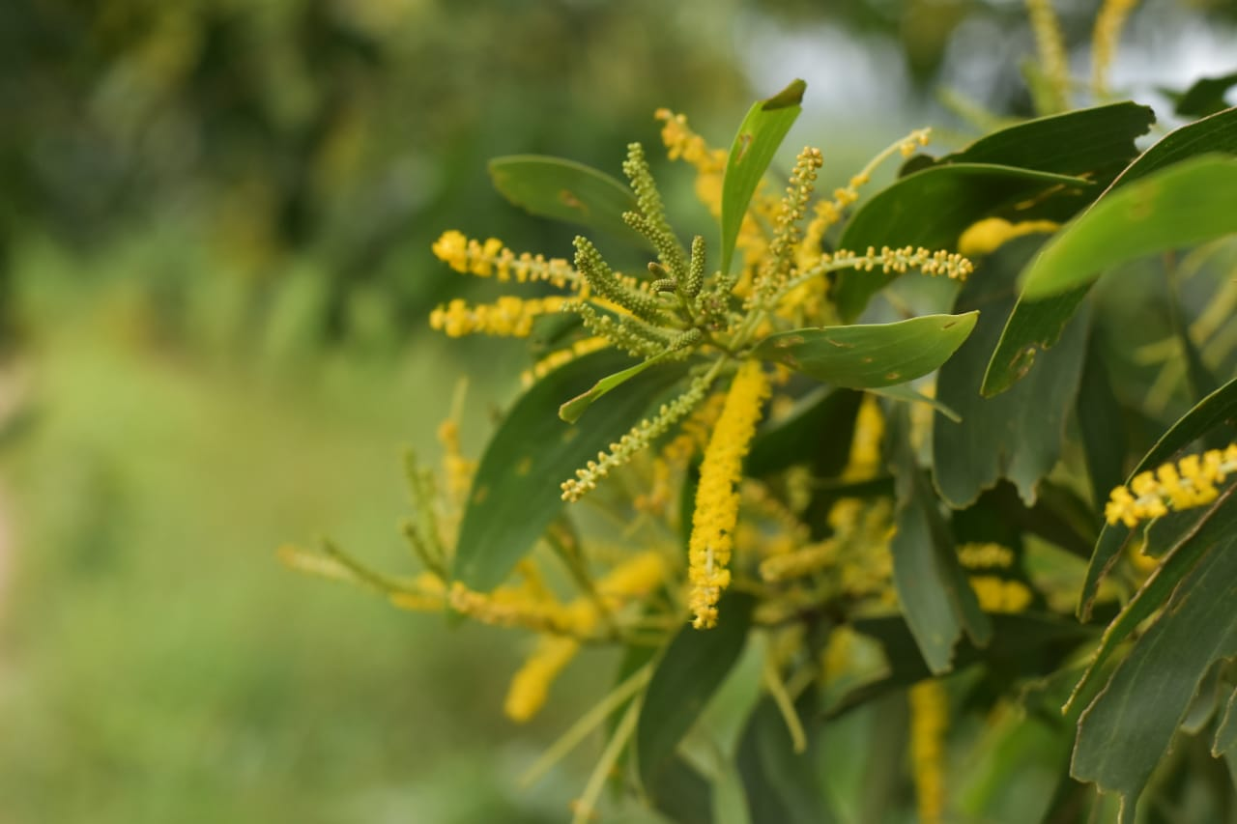
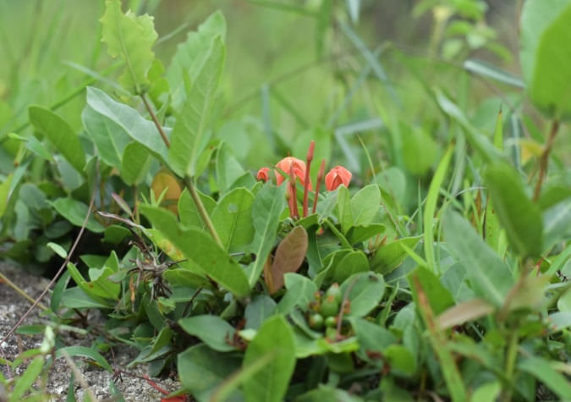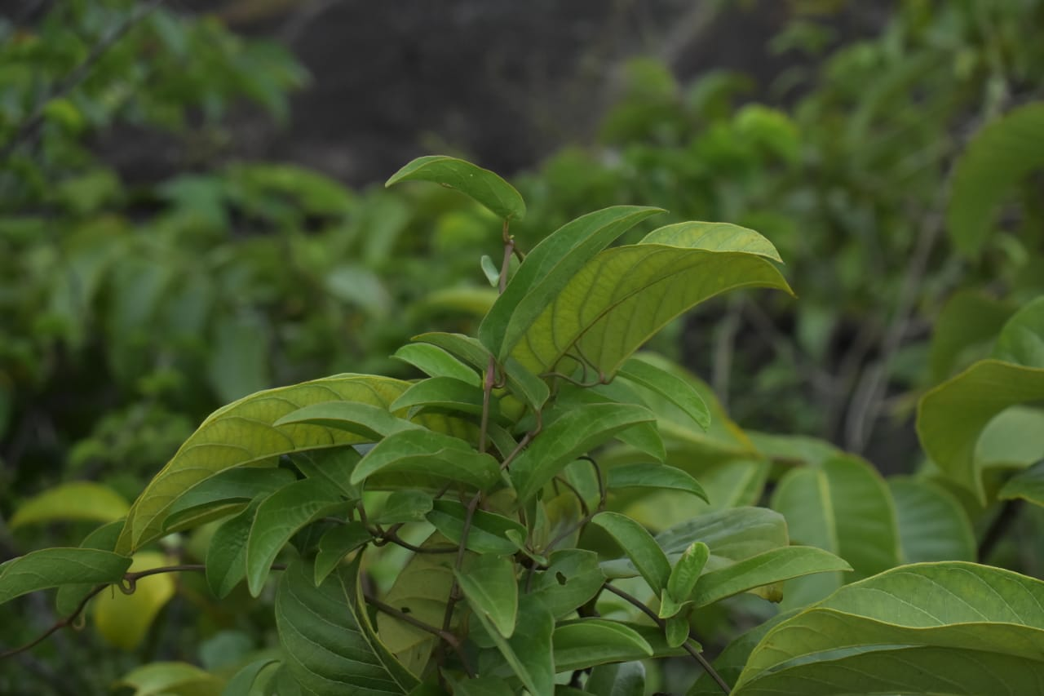
Plate 4.1. Selected plant species of Maruthi Mala Hills

  - Floral Composition
The plant species coexisted with ferns, grasses, and herbaceous weeds from various angiosperm families within the study site. A total of 46 plant species were identified in Maruthi Mala Hills, representing 45 genera and 21 families. Detailed observations and their morphological characteristics are presented in Table 4.2.1.

Table 4.2.1: Plants with their Families and Habit
Sl No. | Botanical Name | Family | Habit
1 | Sesbania spp. (Scop. ) | Fabaceae | Tree
2 | Melastoma malabathricum (Linn) | Melastomataceae | Shrub
3 | Crotalaria retusa(Linn) | Fabaceae | Shrubby herb
4 | Bambusa bambos (Voss ,Linn) | Poaceae | Culms
5 | Alfalfa(Linn) | Fabaceae | Herb
6 | Leucas aspera (Willd) | Lamiaceae | Herb
7 | Calycopteris floribunda (Roxb., Lam.,Poir.) | Combretaceae | Climbing shrub
8 | Wrightia religiosa(Teijsm, Binn., Hook. f.) | Apocynaceae | Shrub
9 | Tephrosia purpurea(Pers.) | Fabaceae | Shrub
10 | Ziziphus jujuba(Mill. ) | Rhamnaceae | Shrub
11 | Adiantum aureum(Linn) | Pteridaceae | Fern
12 | Desmodium paniculatum (Linn,DC.) | Fabaceae | Climber
13 | Eulobus californicus(Nutt.,Torr.,A.Gray) | Ongraceae | Herb
14 | Phyllanthus emblica(Linn) | Phyllanthaceae | Tree
15 | Eupatorium odoratum(Linn,R.M. king,H.Rob) | Asteraceae | Shrub
16 | Mimosa pudica(Linn) | Fabaceae | Herb
17 | Cassia fistula(Linn) | Fabaceae | Tree
18 | Morinda tinctoria(Roxb.) | Rubiaceae | Tree
19 | Ixora coccinea(Linn) | Rubiaceae | Shrub
20 | Diospyros ebenum (J.Koenig) | Ebenaceae | Tree
21 | Terminalia catappa(Linn) | Combretaceae | Tree
22 | Ficus religious(Linn) | Moraceae | Tree
23 | Canthium spinosum (OK) | Rubiaceae | Shrub
24 | Acacia auriculiformis(A.Cunn. ex Benth) | Fabaceae | Tree
25 | Adananthera pavonina(Linn) | Fabaceae | Tree
26 | Millettina pinnata(Panigrahi) | Fabaceae | Tree
27 | Hemidesmus indicum(R.Br.) | Apocynaceae | Shrub
28 | Senna occidentalis(Link.) | Fabaceae | herb
29 | Naregamia alata(Wight&Arm) | Meliaceae | Shrub
30 | Sonneratia alba(Sm.) | Lythraceae | Tree
31 | Ichnocarpus frutescens (W. T.Aiton) | Apocynaceae | Shrub
32 | Premna odorata(Blanco) | Lamiaceae | Shrub
33 | Ficus bengalensis(Linn) | Moraceae | Tree
34 | Psidium guajava(Linn) | Myrtaceae | Tree
35 | Canthium coromandelicum(Linn) | Rubiaceae | Shrub
36 | Gmelina arborea (Roxb.) | Lamiaceae | Tree
37 | Pedalium murex, L.(Linn) | Pedaliaceae | Herb
38 | Cassia mimosoides(Hemsl.) | Fabaceae | Shrub
39 | Memecylon umbellatum (Burm.) | Melastomataceae | Shrub
40 | Ceratotheca sesamoides (Endl.) | Pedaliaceae | Herb
41 | Tuenera ulmifolia(Linn) | Passifloraceae | Shrub
42 | Rhynchosia minima(Linn, DC.) | Fabaceae | Herb
43 | Holarrhena pubescens (Wall., G. Don) | Apocynaceae | Tree
44 | Bignonia peltata, B.Otto & A.Dietr. (Govaerts) | Bignoniaceae | Tree
45 | Bridelia micrantha(Hochst.,Baill) | Phyllanthaceae | Tree
46 | Phyllodium pulchellum(Linn,Desv.) | Fabaceae | Shrub

  - Phytosociological Studies
Phytosociological investigations were conducted in Maruthi Mala Hills, revealing a vegetation composition comprising 45 genera and 46 species spanning 21 families. The families, along with the respective counts of genera and species, are presented in Table 4.3.1. Additionally, Table 4.3.2 provides data on the most prevalent species in the study area, including their percentage frequency, density, abundance, relative frequency, relative density, relative abundance, and Importance Value Index (IVI).
Table 4.3.1: List of families along with the number of genera and species
Sl No. | Name of Family | No. of Genera | No. of Species
1 | Fabaceae | 13 | 14
2 | Rubiaceae | 4 | 4
3 | Lamiaceae | 3 | 3
4 | Poaceae | 1 | 1
5 | Melastomaceae | 2 | 2
7 | Combretaceae | 2 | 2
8 | Apocynaceae | 4 | 4
9 | Rhamnaceae | 1 | 1
10 | Pteridaceae | 1 | 1
11 | Onagraceae | 1 | 1
12 | Phyllanthaceae | 2 | 2
13 | Asteraceae | 1 | 1
14 | Ebenaceae | 1 | 1
15 | Moraceae | 2 | 2
16 | Meliaceae | 1 | 1
17 | Lythraceae | 1 | 1
18 | Myrtaceae | 1 | 1
19 | Pedaliaceae | 2 | 2
20 | Passifloraceae | 1 | 1
21 | Bignoniaceae | 1 | 1

Table 4.3.2: List of most common species of plants at Maruthi Mala Hills
Sl. No. | Plant species | F/RF | A/RA | D/RD | IVI
1 | Sesbania spp. (Scop. ) | 75/6.3 | 4.8/32 | 3.6/0.73 | 69.4
2 | Melastoma malabathricum (Linn) | 87.5/3.69 | 2.4/18 | 2.1/0.47 | 40.5
3 | Crotalaria retusa(Linn) | 75/5.21 | 4/26 | 3/0.64 | 57.3
4 | Bambusa bambos(Voss ,Linn) | 75/5.21 | 4/26 | 3/20.64 | 57.3
5 | Alfalfa(Linn) | 62.5/2.6 | 2.4/13 | 1.5/0.33 | 28.6
6 | Leucas aspera(Willd) | 93/9.13 | 5.25/46 | 5.25/1.06 | 10.5
7 | Calycopteris floribunda (Roxb., Lam.,Poir.) | 62.5/2.6 | 2.4/13 | 1.5/0.33 | 28.6
8 | Wrightia religiosa(Teijsm, Binn., Hook. f.) | 50/3.69 | 4.25/18 | 2.1/0.46 | 40.5
9 | Tephrosia purpurea(Pers.) | 75/2.17 | 1.6/11 | 1.25/0.27 | 23.9
10 | Ziziphus jujuba(Mill. ) | 75/3.04 | 2.3/15 | 1.75/0.42 | 33.4
11 | Adiantum aureum(Linn) | 75/5.06 | 3.8/25 | 2.8/0.6 | 55
12 | Desmodium paniculatum (Linn,DC.) | 62.5/3.04 | 2.8/15 | 1.75/0.42 | 33.4
13 | Eulobus californicus(Nutt.,Torr.,A.Gray) | 78/5.28 | 3.4/26 | 3/0.64 | 57.3
14 | Phyllanthus emblica(Linn) | 97/11.9 | 8.1/60.9 | 6.8/1.42 | 31.68
15 | Eupatorium odoratum(Linn,R.M. king,H.Rob) | 87.5/5.25 | 5/38 | 4.3/1.02 | 83.68
16 | Mimosa pudica(Linn) | 86/10.2 | 6.7/52 | 5.8/1.19 | 22.5
17 | Cassia fistula(Linn) | 62.5/3.69 | 3.4/18 | 2.1/0.45 | 40.5
18 | Morinda tinctoria(Roxb.) | 62.5/3.69 | 3.4/18 | 2.1/0.45 | 40.5
19 | Ixora coccinea(Linn) | 62.5/3.69 | 3.4/18 | 2.1/0.45 | 40.5
20 | Diospyros ebenum (J.Koenig) | 62.5/2.82 | 2.6/14 | 1.6/0.34 | 31.6
21 | Terminalia catappa(Linn) | 75/4.34 | 3.3/22 | 2.5/1.37 | 37.8
22 | Ficus religious(Linn) | 50/1.52 | 1.75/17 | 9.6/2.07 | 16.74
23 | Canthium spinosum (OK) | 62.5/3.91 | 3.6/19 | 2.25/0.48 | 42.9
24 | Acacia auriculiformis(A.Cunn. ex Benth) | 62.5/2.39 | 2.2/12 | 1.37/0.22 | 26.3
25 | Adananthera pavonina(Linn) | 75/3.69 | 2.8/18 | 2.1/0.45 | 40.5
26 | Millettina pinnata(Panigrahi) | 50/2.39 | 2.75/12 | 1.37/0.29 | 26.3
27 | Hemidesmus indicum(R.Br.) | 62.5/2.39 | 2.2/12 | 1.37/0.29 | 26.3
28 | Senna occidentalis(Link.) | 75/2.39 | 1.8/12 | 1.37/0.29 | 26.3
29 | Naregamia alata(Wight&Arm) | 75/3.91 | 3/19 | 2.25/0.27 | 42.9
30 | Sonneratia alba(Sm.) | 62.5/3.69 | 3.4/18 | 2.12/0.48 | 40.5
31 | Ichnocarpus frutescens (W. T.Aiton) | 87.5/4.33 | 2.8/22 | 2.5/0.52 | 47.91
32 | Premna odorata(Blanco) | 100/3.47 | 7.6/67 | 7.6/1.63 | 48.1
33 | Ficus bengalensis(Linn) | 62.5/2.82 | 2.6/14 | 1.62/0.34 | 31
34 | Psidium guajava(Linn) | 75/2.61 | 2/13 | 1.5/0.29 | 28.68
35 | Canthium coromandelicum(Linn) | 62.5/2.82 | 2.8/15 | 1.75/0.38 | 31.2
36 | Gmelina arborea (Roxb.) | 62.5/3.26 | 3/16.6 | 1.87/0.4 | 35.92
37 | Pedalium murex, L.(Linn) | 62.5/3.47 | 5.3/17.7 | 2/3.4 | 38.24
38 | Cassia mimosoides(Hemsl.) | 75/3.91 | 3/19.9 | 2.25/2.19 | 43.08
39 | Memecylon umbellatum (Burm.) | 37.5/1.73 | 2.6/18.8 | 1/0.88 | 19.06
40 | Ceratotheca sesamoides (Endl.) | 75/3.47 | 2.6/17.7 | 2/0.4 | 38.24
41 | Tuenera ulmifolia(Linn) | 62.5/2.61 | 2.4/13.3 | 1.5/0.37 | 28.74
42 | Rhynchosia minima(Linn, DC.) | 62.5/2.82 | 2.6/14.4 | 1.62/0.44 | 31.08
43 | Holarrhena pubescens (Wall., G. Don) | 62.5/2.39 | 2.2/12.1 | 1.37/0.37 | 26.32
44 | Bignonia peltata, B.Otto & A.Dietr. (Govaerts) | 75/4.13 | 3.1/21 | 2.37/0.16 | 45.5
45 | Bridelia micrantha(Hochst.,Baill) | 75/6.52 | 4.6/33.2 | 3.75/0.66 | 71.84
46 | Phyllodium pulchellum(Linn,Desv.) | 75/4.24 | 3.3/22.1 | 2.5/0.48 | 47.82
(A-abundance, F-Frequency, D-Density, RA-Relative Abundance, RF-Relative Frequency, RD-Relative Density, IVI-Important Value Index)
The majority of plant species at the study site were observed within the Fabaceae family, comprising 14 species. Following closely were the Apocyanaceae and Rubiaceae families, each with 4 species. Additionally, the Lamiaceae family was represented by 3 species. Other families, such as Melastomataceae, Phyllanthaceae, Combretaceae, Pedaliaceae, and Moraceae, were each found to have 2 species in the habitat. The Poaceae, Bignoniaceae, Rhamnaceae, Passifloraceae, Pteridaceae, Ongracaeae, Asteraceae, Myrthaceae, Ebenaceae, Meliaceae, and Lyranthraceae families were each represented by one species in the area.
From the collected samples, the frequency was highest in Premna odorata (100), Phyllanthus emblica (97) and lowest in Adiantum aureum (75), Ziziphus jujuba (75). The relative frequency was observed the most in Phyllanthus embilca (11.9), Leucas aspera (10.2) and lowest in Terminalia catappa (4.39), Eupatorium odoratum (5.25).
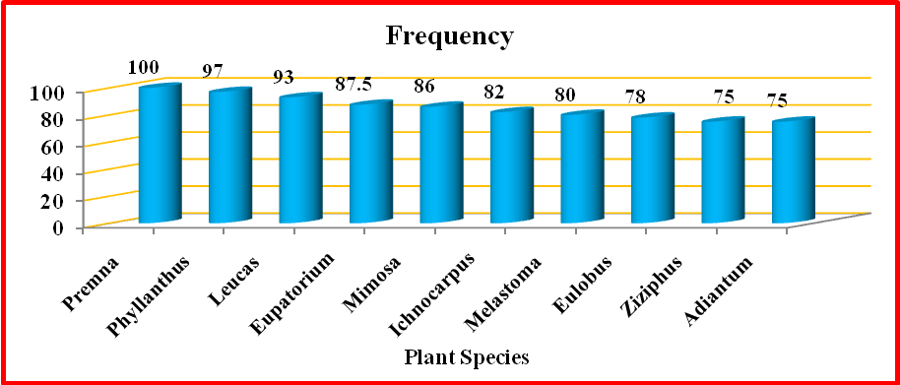
Fig. 4.3.1: Frequency of Selected plant species
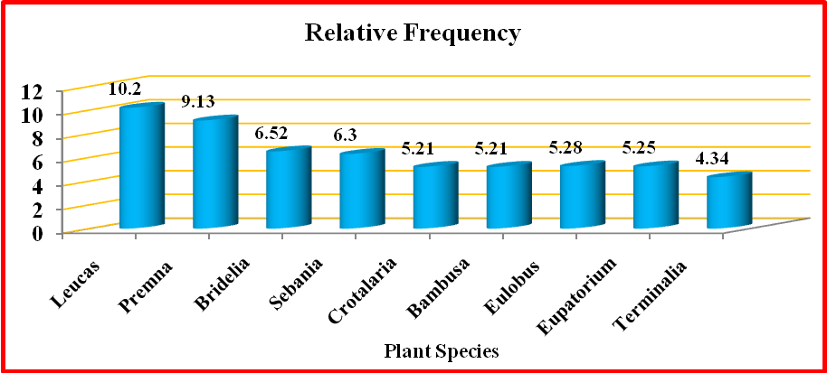
Fig. 4.3.2: Relative Frequency of Selected plant species
Abundance was maximum in Phyllanthus emblica (8.1), Premna odorata (7.6) and minimum in Bambusa bambos (4), Crotalaria retusa (4). Relative abundance of the isolates was most observed in Phyllanthus emblica (60.9), Premna odortata (67) and lowest observed in Adianthum aureum (25), Bambusa bambos (26).
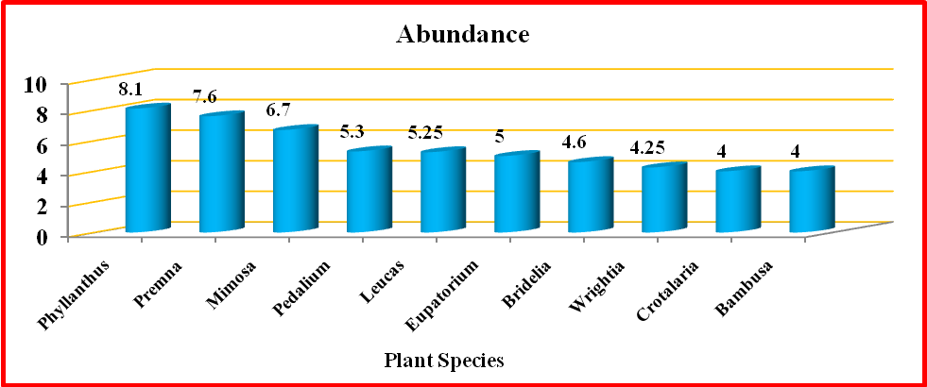
Fig. 4.3.3 : Abundance of Selected plant species
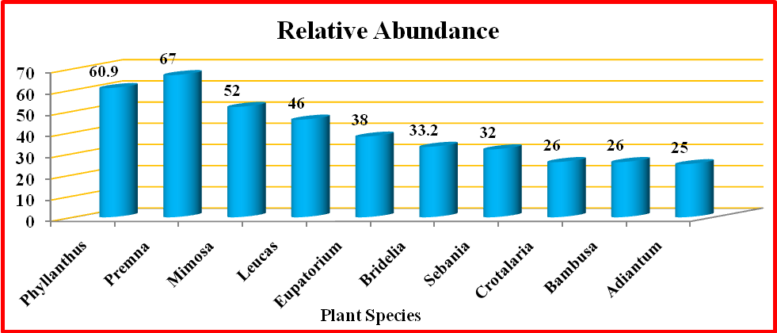
Fig. 4.3.4 : Relative Abundance of Selected plant species
Ficus religiousa (9.6), Premna odorata (7.6) is the most densely seen species in Maruthi Mala Hills. Likewise, Bambusa bambos (3) and Crotalaria retusa (3) with lowest density. Pedalium murex (3.4), Cassia fistula (2.19) have the highest relative density and Bridelia micrantha (0.66) and Eupatorium odortam (1.02) has the lowest relative density.
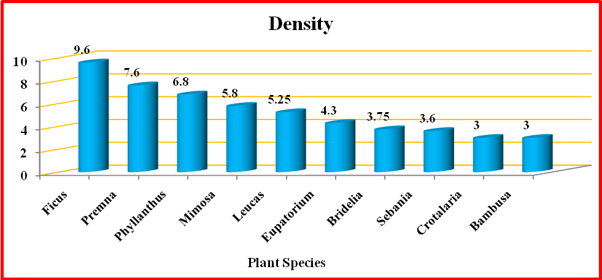
Fig. 4.3.5 : Density of Selected plant species
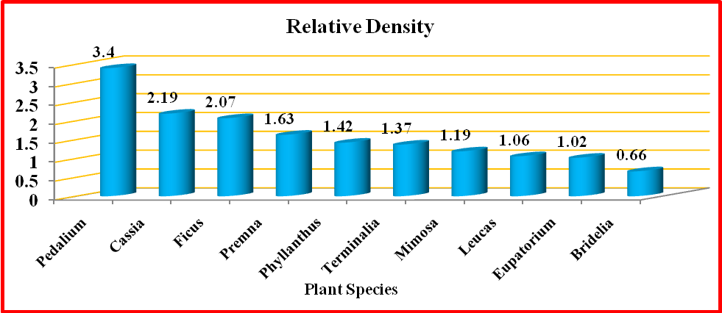
Fig. 4.3.6: Relative Density of Selected plant species
Eupatorium odoratum (83.68) and Bridelia micrantha (71.84) has the most abundant IVI value while Cassia mimosoides (43.08) and Bignonia peltata (45.5) has the lowest IVI value
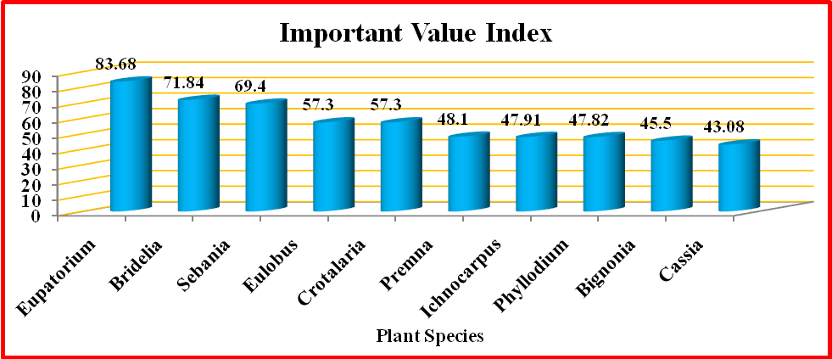
Fig. 4.3.7: Important Value Index of Selected plant species
Diversity indices of plants in the studied site showed that the highest Shannon Weiner index (3.36), Simpson's index (27.73), Margalef's (4.93) and Pielon's (1.46) Indices Diversity indices are shown in Figure 4.2.9.
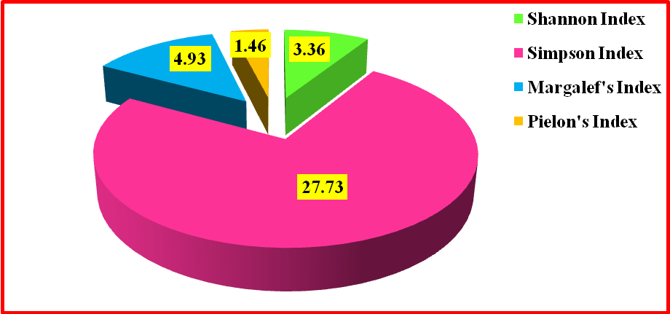
Fig. 4.3.8 : Diversity Indices of Selected plant species

Discussion
The flora within a region plays a crucial role in both environmental ecosystems and human well-being. Proper utilization of plant resources, ranging from national to local scales, is essential to safeguard the availability and diversity of flora. Assessing floral diversity is vital for understanding the existing variety of plant species. The adverse impacts of urbanization on natural flora and fauna necessitate the documentation of biodiversity to prevent species extinction. Factors such as urbanization, habitat fragmentation, human activities, and pollution contribute to the decline of rural and indigenous natural vegetation, which is vital for maintaining a healthy environment.
Several researchers conducted a comprehensive floristic survey in Udumalpet Taluk of Tiruppur District, Tamil Nadu, with a focus on documenting plant species in diverse rural habitats. Prominent species in the area included Selaginella wightii Hieron., Marsilea quadrifolia L., Azolla sp., Marchantia sp., Funaria sp., and various fungi. These species were categorized into herbs, shrubs, climbers, and trees. Notably, the presence of windmills for electricity generation had noticeable effects on both natural vegetation and cultivated fields.
The term "flora" encompasses a complete list of plant species present in a specific geographical region. Different geographical and ecological zones worldwide contribute to the diverse composition of flora. The loss of natural forests is evident, resulting in a decrease in the number of species and genetic diversity within populations. Another study focused on the floristic diversity and ecological characteristics of the flora in Kharawo Talash, Dir Lower, Khyber Pakhtunkhwa, Pakistan. This region boasts a rich diversity of medicinal plants, many of which are wild and belong to various genera and families. Despite this richness, factors like forest cutting, overexploitation, and insufficient awareness have led to significant losses in medicinal resources. The uncontrolled uprooting of valuable medicinal plants by local communities contributes to the extinction of these species. Extinction is also driven by soil erosion, habitat loss, and disruptions in ecosystem functioning.
Biodiversity hotspots are characterized by high counts of endemic species, species richness, and increased habitat loss. Deforestation is primarily caused by agricultural expansion, logging, and mining activities, which have significant impacts on tropical forests. Population fragmentation affects species differently based on various life history traits, such as gene flow, dispersal strategy, mating systems, degree of isolation, and population tree density. Genetic diversity plays a crucial role in the survival of plant species and influences ecosystem structure and dynamics.
A study conducted by Saikat Mondal et al. (2019) explored the inventory, phytosociology, and diversity of vegetation in Gunjan Ecological Park's pit lake in West Bengal, India. The park's diverse plant forms contribute to its unique character, with 100 species spanning 41 families, including trees, herbs, shrubs, and climbers. The aquatic flora comprised 13 families, 13 genera, and 14 species. The study involved quadrats and considered the impact of physico-chemical parameters on species distribution.
Harikesh et al. (2020) assessed floristic diversity and vegetation structure in three community forests in southwest Haryana, highlighting various plant species in each category. These studies emphasize the importance of phytosociological research, which aids in understanding species interactions, ecosystem processes, and the impacts of natural and anthropogenic disturbances. Different indices help assess diversity patterns, although their application requires an understanding of their strengths and limitations.
Human activities, including climate change, air pollution, technological advancements, and land development, have heightened the focus on biodiversity conservation. Rapid deforestation, driven by agriculture, logging, and mining, places numerous species at risk of extinction. Effective conservation management necessitates stringent regulations and international cooperation. Plant ecology underscores the role of climate in global vegetation distribution. Within specific vegetation types, variations in soil properties play a crucial role in controlling plant diversity and distribution. Understanding the relationship between soil factors and plant diversity is essential for predicting responses to environmental changes.
In summary, these studies emphasize the significance of flora in ecosystems and human well-being. They underscore the urgency of effective conservation strategies and highlight the intricate interplay of various ecological factors influencing plant diversity and distribution. Additionally, the results presented provide valuable insights into the plant diversity and structural dynamics of Maruthi Mala Hills in Kollam District, Kerala. The data illustrate the abundance and distribution of various plant species, along with their Importance Value Index (IVI), which is a key metric for assessing the ecological significance of each species within the ecosystem.
Notably, Sesbania spp. emerged as dominant plants with a relatively high IVI of 69.4, highlighting their significant contribution to the ecological structure of Maruthi Mala Hills. Melastoma malabathricum (Linn) also exhibited a substantial IVI of 40.5, signifying its presence in the area. Eupatorium odoratum (Linn, R.M. king, H. Rob) and Bridelia micrantha (Hochst., Baill) were other significant species with high IVI values, emphasizing their ecological importance.
These findings provide a comprehensive understanding of the plant diversity within Maruthi Mala Hills, highlighting specific species that play significant roles in shaping the ecosystem's structure. This information serves as a crucial baseline for conservation efforts and the sustainable management of Maruthi Mala Hills, ensuring the preservation of its rich plant diversity and structural dynamics for future generations.

Summary and Conclusion
The study titled "Plant Diversity and Structural Dynamics of Maruthi Mala Hills, Kollam District, Kerala, India" aimed to assess the current status of floral diversity in Maruthi Mala Hills. Floral diversity is a crucial component of the environment, impacting both ecosystems and human well-being. The diversity of plant species in the area, including erect, spreading plants, ferns, shrubs, herbs, and trees, was analyzed. The study, conducted in a hilly terrain, found that the Fabaceae family had the highest number of observed plant species, with 14 species.
It was evident from the investigation that the plant species in this region were facing significant threats due to population pressure and urbanization. The phytosociological studies indicated that Phyllanthus emblica, L., was the dominant species with the highest abundance in Muttara hills. Biotic stress in the study area had a considerable influence on phytosociological characteristics such as abundance, frequency, and density. These quantitative parameters served as valuable indicators of anthropogenic disturbances, highlighting the impact of human activities on the native plant species of Maruthi Mala Hills.
The analysis of the various plant species in the area provided valuable insights into critical resources that require conservation efforts in the near future. Achieving conservation goals will depend not only on positive community involvement but also on government initiatives to monitor and protect Maruthi Mala Hills, potentially transforming it into an ecologically significant eco-tourism destination.

References
1.Abbas Hussain Shah,Ghulam Mujtaba Shah, Khalid Rasheed Khan, Khanda Amber, Manzoor Hussain, Mujtaba Shah.2019.A Comprehensive Survey of Floristic Diversity Evaluating The Role of Institutional Gardening In Conservation of plant. International Journal of Bioscience,14 (3).325-339
2. Abeysinghe P.D., 2020. Antibacterial Activity of some Medicinal Mangroves against Antibiotic Resistant Pathogenic Bacteria. Indian Journal of Pharmaceutical Sciences. 72 (2):149-282.
3. Abohassan, R.A., Okia, C.A., Agea, J.G., Kimondo, J.M., McDonald, and M.M., 2020. Perennial biomass production in arid mangrove systems on the Red Sea coast of Saudi Arabia. Environ. Res. J. 6 (1), 22—31
4. Alongi, D.M., 2021. Mangrove forests: resilience, protection from tsunamis, and responses to global climate change. Estuarine, Coastal and Shelf Science. 76: 1–13.
5. Ana Cano Ortiz etal2020.Phytosociological study, diversity and conservation status of the cloud forest in the Dominian republic plants 9,741.1-30
6. Ana Claudia Araiyo, Neil Brummit, Timothy Harris.2020. Areas of plant diversity-What do we know Plants, People, Planet,3(1).33-34
7. Anushka shah.2020. Modern Technology For Sustainable Forest Management in India.382.
8. Anwar, M., Akhtar, N., & Khalid, S. 2020. 63. Phytosociological study of weeds of wheat crop under edaphic variation: A case study from district Swabi, Khyber Pakhtunkhwa, Pakistan. Pure and Applied Biology (PAB), 9(1), 640-649.
9. Arun Christy and Binu Thomas. 2020. Phytodiversity of chasmophytic habitats at Olichuchattam Waterfalls, Kerala, India. Journal of Threatened Taxa, 12(9).16099- 16109
10. A.Vel Murugan. 2019. Coastal Floral Diversity and its significance. Coastal Ecosystem of the Tropics – Adaptive Management. 73-89
11. Batles, J.J., A.J. Shlinsky, R.H. Barret, R.C. Heald and B.H. Allen-Diaz. 2018. The effects of forest management on plant species diversity in a Sierran conifer forest. Forest Ecology and Management 146. 211–222
12. Bin Yang etal .2020.Contributions to the flora of Myanmar from 2000 – 2019.plant diversity 42.292-301
13. Biodiversity hotspots . 2021. ENVIS Centre, Ministry of Environmental and Forest, Govt. of India
14. Breidenbach et al. 2018. Genetic Diversity of Dominant PlantSpecies in Tropical Land-Use SystemsIn Sumatra, Indonesia .Tropical Conservation Science,11.1–14
15. Catherine M. Hulshof et al. 2020. The edaphic control of plant diversity. Global Ecol. Bio. Geogr. 00:1–17
16. Chandran, M. V., Gopakumar, S. and Mathews, A. 2020. Comparative phytosociological assessment of three terrestrial ecosystems of Wayanad Wildlife Sanctuary, Kerala, India. Journal of Threatened Taxa, 12(5).15631-15645.
17. Curtis J.T and Mclntosh R.P. 2020. The interrelations of certain analytic and synthetic phytosociological characters. Ecology, 31(3).435-455.
18. Das, D., B.K. Pramanik and S.K. Mollay.2020. A Model Classical Ecological report on Vegetaton dynamics in Gorumara Natonal Park in West Bengal, India. International Journal Pharmacy & Biomedical Research, 2(2).1–14.
19. Debnath Palit, Saikat Mondal.2019.Inventory of Plant Species, Phytosociology and Species Diversity of Gunjan Ecological Park Pit Lake, West Bengal, India. International Journal Of Scientific Research,8(2).1990-2006
20. Dr. Sincy Joseph. 2021.Ethnobotanical Survey of Medicinal Plants in Urdhook hills, Kuttiady, Kozhikode District, Kerala. IJCRT. 9.2320-2882
21. Gamble J.S. 1936. Flora of the presidency of Madras, Adland and Son Ltd. 1-3
22.Guillaume Papuga ORCID Icon. 2019.Variation in floral morphology in a hybrid complex of Cyclamen in Sardinia.51-61
23. Hamzaoglu, E. 2019. Phytosociological studies on the steppe communities of East Anatolia. Ekoloji 15(61): 29–55.
24. Hamzaoglu E. 2018. The steppe vegetation of Dinek Mountain (kirikkale) Gazi University Journal of Science.17.1-13.
25. Harikesh et al. 2020. Floristic diversity and vegetation Analysis of the community forests of South-West Haryana, India.Current Botany, 11. 51-59
26. Harikesh, Himanshi, Somveer Jakhar. 2020. Floristic diversity and vegatation analysis of the community forests of south-west Haryana, India. Research article, 11.51-59
27. Hazrat et al.2020; Floristic diversity and ecological characteristics of Flora of Kharawo Talash, Dir lower, Khyber Pakhtunkhwa, Pakistan. BIOSCIENCE RESEARCH, 17(2).681-687
28. Hogarth, P.J., 2019. The Biology of Mangroves and Sea grasses. – University press Inc. Oxford, New York
29. Huma Qureshi, Muhammed GULBAZ Arshad and Yamin Bibi, (2019). Invasive flora of Pakistan: a critical analysis, Interational Journal of Biosciences, 4(1):407-424.
30. Jashanpreet Kaur, Rajni Sharma, Pushp Sharma. 2020.Florastic Composition and distribution pattern of herbaceous plant diversity in fallow lands of the central district of Punjab, India. Journal of Threatened taxa 12, 15864-15880
31. Jeeshna M V.2020. Floristic and Phytosociological Studies of The Sacred Groove, Kayyath Nagam Kavu, Kannur District Kerala, India. Research in Plant Science,8(1).1-6
32. Jihang Huang et al. 2020. Floristic Composition and plant diversity in distribution areas of native species congeneric with Betulahalophila in Xinjiang, Northwest China. Nature Conservation 42.1–17.
33. Jonathan, M.P., Srinivasalu, S., Thangadurai, N., Ayyamperumal T., Armsrtrong- Altrin, J.S., Ram-Mohan, V., 2019. Contamination of Uppanar River and Coastal Waters off Cuddalore, Southeast Coast of India. Environ. Geol. 53, 139–1404.
34. Kamble, V.V. and R.B. Yele. 2020. Floristic Survey of Monocotyledonous Plants from Man Tehsil of Satara District (Maharashtra) India. Journal of Global Biosciences,9(4).7149-7159
35. Krishnamurthy, Prakash YL, Nanda HM, Krishnappa A, Dattaraja HS, and Suresh HS,. 2019. Vegetation structure and floristic composition of a tropical forests in Bhadra Wildlife Sanctuary , Karnataka, India. Tropical Ecology,51(2). 235-246.
36. Kumar A, Bruce G.M, Ajai S. 2019. Tree species diversity and distribution patterns in tropical forests of Garo Hills. Current Science. 91:1370-81
37. Kunev, G., Tzonev, R., Tsiripidis, I., &Pachedjieva, K. 2020. Phytosociological study of submontane genistoid scrub communities from the South eastern Balkans. Acta Botanica Croatica, 79(2).
38. Kunwar, R. M., Fadiman, M., Thapa, S., Acharya, R. P., Cameron, M., and Bussmann, R. W. 2020. Plant use values and phytosociological indicators: implications for conservation in the Kailash Sacred Landscape, Nepal. Ecological Indicators, 108, 105679.
39. Leandro T. A. Vieira et al.2019.A biogeographic and evolutionary analysis of the flora of the North-eastern cerrado, Brazil. Plant ecology and diversity,12.478-488.
40.Manzoor, J., &Jazib, M. J. (2021). Distribution Pattern and Phytosociological study of Trees Associated with Agroforestry in Poonch District of Jammu and Kashmir, India. Journal of Bioresource Management, 8(1), 8.
41. Md. Ashikur Rahman Laskar, Tahidul Islam.2021.Floral diversity of abandoned mansions and the influence of soil properties on these unique vegetation. Research Square 1,1-23
42. Mehdi Heydari, et al. 2020. Biodiversity, a review of the concept, measurements, opportunities and challenges. Journal of Wildlife and Biodiversity. X-X
43. Minchen,Xue-Yong Zhao,Xiao-An Zuo.2019.Comparative Pollen Limitation And Pollinator Activity Of Carragana Korshinskii Kom In Natural And Fragmen Habitats. Science of The Total Environment,654.1056-1063
44. Mukunda Dev Behera, Soumit Kumar Behera, Subrat Sharna.2019.Recent Advances In Biodiversity And Climate Change Studies In India. Biodiversity and Conservation,28.1943-1951
45. Nikhil Agnihotri, Sippy Dassani, T.K Sharma. 2020. Present status and conservation strategies of biodiversity in India. International Research Journal On Advanced Science Hub,2.2582-4376
46. Nisreen Husain, Touseef Hussain Trak, Deepti Chauhan. 2020. Florastic diversity of Jammu and Kashmir, India. International Journal of Advanced Science and Technology, 29,2358-2386.
47. Pankaj Sharma etal.2014.Floristic Diversity and Distribution Pattern of Plant Communities along Altitudinal Gradient in Sangla Valley, Northwest Himalaya.The scientific world journal.2014, 1-11
48.Patel, A. H. (2021). Phytosociological analysis of tree species of Sebhargog region of reserve forest of Vadgam Taluka in North Gujarat, India. Life sciences leaflets, 132, 1-9.
49. Patel, A. S. (2020). 3. Phytosociological study of some weeds in agriculture crop field in Sami Taluka by S D Patel and HM ANT. Life sciences leaflets, 123, 29-TO.

50. Pathiyil Arabhi, Maya Chandrasekharan Nair. 2019. Seasonal vegetation shift and wetland dynamics inVulnerable granitic rocky outcrops of Palghat Gap of Southern Western Ghats, Kerala, India. Journal of Threatened Taxa11(12) :14518–14526
51. Peter Raven, Mathis Wackernagel.2020.Maintaining biodiversity will define our long term success. Plant Diversity,42.211-220
53. Radha, R. Nagaraj, C. Udhayavani, K. Sivaranjani. 2020.A survey on the floral diversity of rural areas in Udumalpet Thaluk, Tiruppur district, Tamilnadu, India. Bangladesh J. Plant Taxon, 27.137-152
54. Pratikshya Kandel. 2019. Plant diversity of the Kangchenjunga Landscape, Eastern Himalayas. Plant Diversity,41.153-165
55. Qing Tang. 2019. Full-Length Reference Floral Transcriptome of Boehmeria tricuspis Provides Insights into Apomeiosis and Polyploidy Genomics. International journal of genomics.1-13
56. Radha .2020. A survey on the floral diversity of rural areas in Udumalpet Taluk, Tirupur District, Tamil Nadu, India. Bangladesh J. Plant Taxon, 27(1): 137‒152
57. Rahees N, Kiran M, and Vishal V. 2019. Phytosociological analysis of mangrove forest at Kadalundi-Vallikkunnu community reserve, Kerala. Inter J Sci Tech Vol. 3:2154–2159
58. Ramya, E. K., and Mownika, S. S. S. 2020. Phytosociological assessment of tree vegetation in tropical moist deciduous forest of veerakkal area, Nilgiris, Western Ghats, India. Indian Journal of Ecology, 47(2), 480-484.
59. Rao, S.D., P.P. Murthy and O.A. Kumar 2020. Plant biodiversity and phytosociological studies on tree species diversity of Khammam District, Telangana State, India. Journal of Pharmaceutcal Sciences and Research 7(8): 518–522.
60. Richard T. Corlett. 2016. Plant Diversity in a Changing World: Status, Trends, and Conservation Needs. Plant Diversity 38.10-16
61. Richard T. Corlett.2020. Safeguarding our future by protecting biodiversity. Plant Diversity 42.221-228
62. Saikat Mondal et al. 2019.Inventory of Plant Species, Phytosociology and Species Diversity ofGunjan Ecological Park Pit Lake, West Bengal, India. IJSRR 2019, 8(2).1990-2006
63. Sanjay Singh Chauhan. 2018. Phytosociological Analysis Of The Flora Of Madhav National Park, Shivpuri [M.P.]. Original Research Paper,School of Studies in Botany, Jiwaji University, Gwalior. (M.P), India 7: 2277 – 8160
64. Sanjeet kumar, Raj kumari, Supriya devi. 2020.Floral diversity of Sambhav, Nayagrah, Odisha, India, Ambika Prasad. Research foundation.
65. Santana, J. P., da Rocha, P. A., da Silva Oliveira, E. V., Prata, A. P. N., and Ribeiro, A. S. 2021. Phytosociology of the shrub-arboreal stratum of the Ibura National Forest, North eastern Brazil: are 35 years sufficient to promote the regeneration of a forest fragment?. Neotropical Biology and Conservation, 15, 89.
66. Sarkar, A.K. 2021. Ecological Studies of Tree Vegetaton of Ramshai Forest Range, Gorumara Natonal Park, India. Research Journal of Biological Sciences 5(7): 53–59.
67. Saujanendra Swain, Suhita Chakrabarty, Zomuankima, Vanlalh Mangaia. 2020. Domestication of wild plant diversity in home gardens for culinary and curative use by the tribal women farmers in Mizoram, India. Biodiversity international journal, 4.155-159
68. Shanmugam et al. 2016. Floral Diversity of Vaigai River in Thiruppuvanam Region of Sivagangai District, Tamil Nadu, Southern India. Int. J. Curr. Res. Biosci. Plant Biol. 2016, 3(2): 96-105
69.Sukumaran et al. 2018. Phytosociological studies of the sacred groove of Kanyakumari district, Tamilnadu, India. Tropical plant research, 5(1). 29 – 40
70. Stone W. C and Frayer J. R. A., 2018. A Botanical study of pasture mixtures. Sci., Aric., Vol. 15:777-805.
71. Sukumaran, S., Brintha, T.S.S. &Jeeva, S. 2019. Diversity of flowering plants in Kurusumala of Thiruvananthapuram district, Kerala, India. I3 Biodiversity. 3, 303.
72.Taranisen Panda, Bikram Kumar Pradhan, Rabindra Kumar Mishra, SrustiDhar Rout, Raj Ballav Mohanty. 2020.Angiosperm diversity in Bhadrak region of Odisha, India. Journal of threatened taxa 12.15326-15354
73.Tarun Kumar Thakur . 2020.Land use land cover change detection through geospatial analysis in an Indian Biosphere Reserve. Trees, Forests and People, 2.100018
74. Tel AZ, TatliA.and Varol,O. 2020. Phytosociological structure of Nemrut Mountain (Adiyaman/Turkey). Turkish Journal of Botany. 34: 417-434.
75.Tiimub, B. M., Kuffour, R. A., Tiimob, R. W., Kuuyeni, C. A., Tiimob, E. L., and Tiimob, E. N. 2020. Sacred groves as potential ecotourism sites at Tolon and Diare in Northern Region, Ghana. Journal of Sustainable Tourism and Entrepreneurship, 1(3), 195-215.
76. Uddin, M. N., Hossain, M. M., Karim, M. S., Siriwong, W., & Boonyanuphap, J. 2020. The phytosociological attributes of village common forests in Chittagong Hill Tracts, Bangladesh. Songklanakarin Journal of Science & Technology, 42(4).
76. Usharani, L., Sophia, M., Behera, N., & Gupta, A. (2018). Studies on the life form and biological spectrum of Konthoujam Sacred Grove in Manipur, India.
77. Velmurugan Ayyamet al .2019.Coastal Ecosystems of the Tropics – Adaptive Management.Costal region of tropics .80-599.

