Leveraging ERP way for Crafting World class excellence Organizations.

Author 1: Dr. Jaya Yadav
Designation: Professor, Amity Business School
Institutional Address: Amity Business School, F-3 Block, Amity University Campus, Sector-125, Noida-201313, Gautam Budh Nagar, U.P. (India)
e-mail Id: jyadav2@amity.edu

Author 2: Dr. Anshu Singh
Designation: Associate Professor
Institutional Address: Amity Business School, F-3 Block, Amity University Campus, Sector-125, Noida-201313, Gautam Budh Nagar, U.P. (India)
e-mail Id: asingh42@amity.edu

ABSTRACT
Enterprise Resource Planning is among the main high technology tool that reinforces organizations excellence. It supports by integrating the core functional domains of any business enterprise processes. This study aims towards analyzing a conventional, yet smart ERP system, which is critical to a business and also supports a perspective to the skills and benefits of the ERP software. Required data was collected via interviewing the employees to determine their experiences of using ERP which was then analyzed via content analysis to derive SWOT Analysis. The findings revealed that the corporate gain a global recognition with the help of ERP system by strengthening their internal and external environment, hence providing smooth functioning of organization especially during expansions, collaborations and mergers. The benefits of ERP system were found to be both tangible and intangible. Therefore, in a nutshell it can be stated that the ERP has proven to be one of the most effective tools in managing the organizations. It has been found to support all aspects of process management thereby benefitting both organization as well as employee which is evident from its outreach to even public sector firms.

Keywords: Enterprise resource planning, Information and Communication technology, SAP, Software

1. INTRODUCTION
Technology has always been important for the business world. Technology provides us with innumerable benefits which help corporates in making money and satisfy customers’ needs and demands. Regardless of the corporates’ size, technology affects the internal and external environment of a business. In the business world where everyone believes in staying connected to each other, companies have realized the importance of having the ERP system. ERP will primarily help to increase the efficiency of the corporates, and it will simultaneously increase the overall business decisions in the future.

  - SIGNIFICANCE OF THE STUDY:
This study contributes to theoretic information of ERP and highlights the excellent internal and external flow of data in the organizations. The readers will be able to understand why a conventional, yet smart ERP system is important to their business. It also provides an explanation to the skills and benefits of the ERP software- SAP. Specifically, readers can get the insight information about the functioning of the SAP software in leading PSU.

2. LITERATURE REVIEW
The Enterprise Resource Planning system evolved in 1960, beginning with material requirement planning (MRP). After that there was advancement in the system, and it was transformed into MRP II (Basoglu et al., 2007).

The MRP II system was a useful tool for planning for all types of resources present in an organization. It was logical for the planning of materials and production processes, but organizations realized the need for the incorporation of customer satisfaction and profitability (Wallace and Kremzar, 2002). In early 1980s, government throughout the world started to attempt with numerous methods of governmental reform. A number of these efforts have tried to implement the principal of management concepts in private sectors into the public sectors (Rosacker and Rosacker, 2010).

The latest form of the ERP system present today is capable of handling with various business units covering management of customer relationship, human resource, purchasing, finance and accounting, manufacturing, processing of the order, management of materials and planning of operation and sales (Botta-Genoulaz and Millet, 2006). Due to the tremendous benefits from the utilization of ERP, public sector has begun to make a move by adopting this automation system in their organizations (Rosacker and Rosacker, 2010). As a result, a large number of organizations have already adopted ERPs, and its implementation is fast increasing in the services sector (Acharyulu, 2012).

Instead of developing IT system in-house, more and more companies are turning to off-the-shelf ERP solutions to plan their IT resources more effectively and manage their legacy systems (Holland and Light, 1999). Various figures have pointed to the fact that ERP systems have become one of the largest IT investments in the 1990s (Chung and Snyder, 1999). The most important part of adopting an ERP system is the selection part and the selection process should be specific to organization as it considers the requirements of the organization and should be an analytical method based on criteria. (Radut and Codreanu, 2012).

There are many benefits that companies realize through transforming their old un-integrated systems to ERP systems; including reduction of cycle time, faster processing of information, enablement of e-commerce, better information and knowledge management (KM), improved reporting, (Davenport, 2000; Ross and Vitale, 2000). ERP system provides a unified view of business enterprise by combining all functions and departments together with integrated and unified database for data collection, processing, monitoring, and reporting (Dillon, 1999; Davenport, 2000; Al-Mudimigh et al., 2001; Murray and Coffin, 2001).

Rouhani and Mehri (2018) classified ERP benefits into 4 groups including informative, communicative, growth and learning, and strategic benefits. The results indicated that the communicative, strategic and informative empowering benefits are significant advantages. Tasevska et al. (2014) established that most of the reasons for success of the ERP implementations is due to its usefulness regarding client satisfaction and perceived quality measures. Successful implementations of the ERP system have also been linked with the management of the project, support of top management, teamwork, program of change management, and composition of ERP system team. The culture of an organization, economic environment, and regulation of the government also offer challenges for the implementation of Enterprise Resource Planning system (Ward and Peppard, 2016).

3. OBJECTIVES
- To evaluate the significant success factors of the ERP system and their implications.
- To identify the supporting factors which lead to the increasing demand of ERP system in the business world.
- To comprehend the overall business performance of SAP, the principal ERP software in the selected Organization.
- To analyze the impact of the functioning of the SAP in the organization’s strategic benefits.

4. RESEARCH METHODOLOGY:
A pilot study was undertaken with a sample size of 30 strategic leaders across domains of a leading PSU, from its various branches across the country. As the research design was descriptive in nature, the primary sources of data collection include the data provided by the concerned officials, survey, personal interview, observations, and descriptive questionnaire.The moderate number of respondents could be attributed due to the constrained time schedule. Content analysis has been be used to infer the conclusion

5. DATA ANALYSIS AND INTERPRETATION:

5.1 Content analysis

Statement 1: ERP covers all departments of an organization

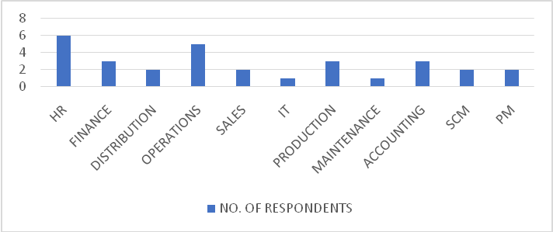
Figure 1: Usage of ERP across departments

Interpretation: The above statement can be analyzed from the responses collected via the questionnaire. The sample population includes employees from various departments of the organization- Oil India Limited. The departments are distribution, finance, human resource, production, operations, maintenance, sales, information technology, accounting, supply chain management, project management etc.

Statement 2: SAP is widely used ERP software

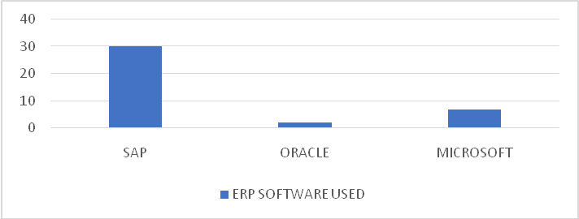
Figure 2: Most used ERP software

Interpretation: Almost all the respondents have used SAP as their ERP software. SAP (Systems, Applications and Products) is enterprise software as well as the name of its company. It was developed in 1972 in Germany by 5 IBM employees namely, Wellenreuther, Hopp, Hector, Plattner and Tschira. It has been recognized as the number one leader with more than 50 percent of the ERP market. Recently, there are over 75,000 customers running the SAP software systems today; this equals to 140,000 successful implementations. Other competitive products of SAP software are Oracle, Microsoft Dynamics, etc.

Statement 3: ERP is effective for corporate related works

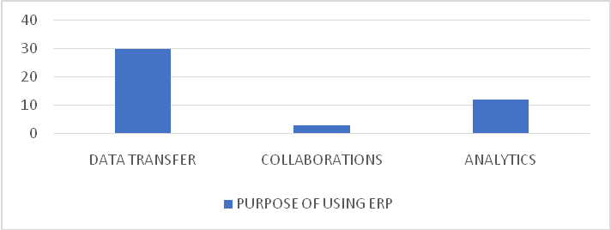
Figure 3: Purposes of using ERP

Interpretation: Almost all the respondents have used ERP during his/her office work. It means for any organizational work ERP is very effective. Apart from the day-to-day data transfer tasks, respondents agreed to use ERP for various collaborations and analytical work. As a whole it can be implemented that there are various purposes of using ERP, regardless of the software used.

Statement 4: ERP system can be customized

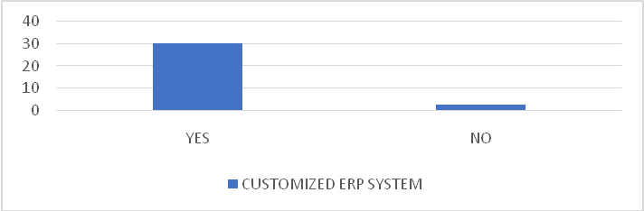
Figure 4: Customized ERP systems

Interpretation: 24 out of 30 respondents have agreed that their ERP systems were customized. The customization can be done to any desired module without making changes to the whole ERP software.

Statement 5: SAP has various modules

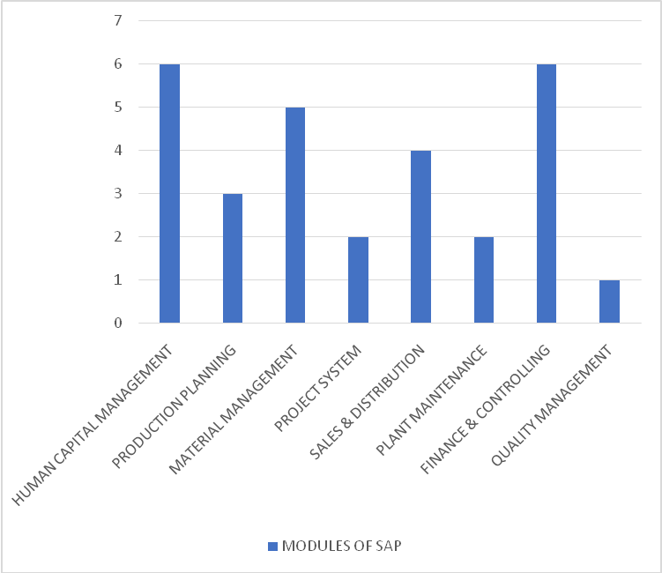
Figure 5: Different types of SAP

Interpretation: The sample population includes respondents specialized in different modules of the SAP software. The term “module” means any business-related process in SAP software. SAP’s 2 types of modules are the functional and technical modules.

Statement 6: ERP users are satisfied with the software

Table 1: Respondents’ Satisfactory Statements About ERP
Respondents | Statements
1 | The ERP database has played an important role in building an organized management .
2 | By using SAP HCM, high demand is experienced.
3 | After using ERP, the work process became smoother.
4 | SAP helps in managing the training cost.
5 | I have been using ERP for 5 years now and the experience is good.
6 | While using the ERP system at office, my workloads have lessened.
7 | I daily use SAP at my workplace, and this has created a connection among all departments.

Interpretation: Some of the statements provided by the respondents are stated above. All the respondents described their experiences of using ERP positively. The respondents have used SAP as the ERP software. They briefly shared their experiences of using the ERP system.

Statement 7: Effective factors of ERP implementation

Table 2: Different Factors for Selecting ERP
Respondents | Factors for Selecting ERP
1 | Flexibility and easy-to-use.
2 | Top-leading software.
3 | The software is robust and cost-efficient.
4 | The software can store a huge amount of data.
5 | The software easily integrates with other components of the organization.
6 | The software is an on-premises system.
7 | The SAP software also comes with a DR site.

Interpretation: Respondents provided various successful factors leading to ERP implementation. The responses mostly incline to the effectiveness of the SAP software. Some given factors are- flexibility, easy-to-use, robust, cost efficient, high storage capacity, on-premise system, top-leading software, easily integrates all components of an organization, smoother functioning, better communication, various analytical features, great enterprise mobility, supports global solutions, etc.

Statement 8: ERP is better than paperwork

Table 3: Statements from Respondents Regarding ERP vs Paperwork
Respondents | Reasons for choosing ERP over paperwork
1 | Save time, reduce paper use.
2 | It makes the recruitment process quicker and easily manageable.
3 | There is complete time and cost efficiency.
4 | Writing everything on paper is time consuming.
5 | ERP helps in communicating with other components of the organization.
6 | The data doesn’t get lost in the ERP unlike in the paperwork.
7 | Urgent data can be easily transferred.

Interpretation: Respondents are in favor of using ERP over traditional paperwork. The reasons are stated as – reduction of paper use, easily manageable, time and cost efficiency, latest trending method, less duplicity, easily accessible, user-friendly, etc.

Statement 9: Failure factors of ERP implementation can be ignored

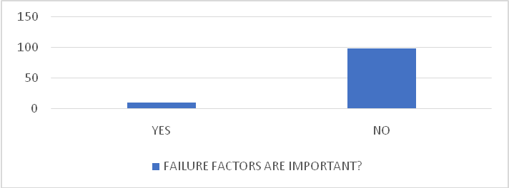
Figure 6: Importance of failure factors for considering ERP implementation

Interpretation: Many respondents agreed to the above statement. The critical factors such as high cost and complex structure of the software can be ignored because there are many advantages of the ERP system. Once the critical factors are handled, the ERP system provides smooth functioning to the organization. Some of the statements provided by the respondents are- “the critical factors are less important in comparison to the profit gained by the ERP implementation”, “too many advantages than disadvantages in the system”, “there are very less critical factors but many successful factors”.

5.2 SWOT analysis

5.2.1 Strengths:
Some of the strengths of SAP are:
- It has successfully integrated with organizations, ERP systems were earlier only implemented in private sectors , however now has been an integral part of public services & Government Organizations.
- There is complete transparency in all the business processes, across various departments in an organization.
- SAP has become a skillful software when it comes to new markets. The software has been able to expand its market demand in new places.
- No doubt SAP is a user- friendly software. But there are certain tools that are only for professionals. So, while implementation of SAP, the company makes sure the users are well trained to all the tools for their future work.
- Improvements have been made in the modules of productivity, order management cycle, cash management and online delivery.

5.2.2 Weaknesses:
Some of the weaknesses of SAP that needs to be taken care of are as follows:
- SAP is not able to integrate firms with different work culture. No doubt SAP is successfully integrating small companies, but there is a huge failure when it comes to merging firms with different work culture.
- Competitors may be able to have an upper hand if this product range is not balanced.
- No doubt about SAP being one of the most successful ERP software, but still it has trouble in proper segmentation of its products. The software has been circulating around its few products and need to expand for more products.

5.2.3 Opportunities:
There are certain areas where SAP can definitely increase its value. Some of them are:
- The market development will lead to dilution of competitor’s advantage and enable SAP to increase its competitiveness compare to the other competitors.
- The investment of huge sum of money into the online version of SAP has opened new sales channel.
- Lower inflation rate- The low inflation rate brings more stability in the market, enable credit at lower interest rate to the customers of SAP.
- The new technology provides an opportunity to SAP to practices differentiated pricing strategy in the new market. As a result, users will show more interest in comparison to competitors.

5.2.4 Threats:
In spite of being one of the top ERP software, SAP faces lot of threats such as:
- There has been an increase in the number of low-cost products similar to SAP. Users are in preference of such products due to the cut of implementation and functioning cost.
- Competitors of SAP have increased in the industry over last two years which has put downward pressure on not only profitability but also on overall sales.
- The company has developed numerous products, but the supply of new innovative products is not regular thus leading to high and low swings in the sales number over period of time.
- Another threat is the increase of local distributors in some markets. The local distributors are swaying away the profit amount of SAP.
- The demand of the highly profitable products is seasonal in nature and any unfortunate circumstances in that season can affect the profits of the company.
- The company operates in multiple countries. Therefore, there are frequent currency fluctuations according to the political environment of the markets.
- Changing consumer buying behavior from online channel could be a threat to the existing physical infrastructure driven supply chain model.

6. FINDINGS
The findings on the basis of analysis of the responses shown and received in the questionnaire and through interview of customers are as under:

- ERP systems are derived from a true business need and requirement, their purpose is clearly defined through the IT vision/mission, their role is fundamentally to support all aspects of process management. The role itself is very encompassing and will cover strategic, tactical and operational aspects and the benefits to be accrued will therefore be very diverse.
- The study has discussed the concept of ERP as a pioneering, enabling and support system that is compatible with the requirements of modules business and that can help the effective implementation of the business process management principles.
- The study agreed that the ERP systems can yield to a wide array of benefits that are of a tangible and intangible nature. The development of ERP systems is for improving all the business processes.
- An ERP implementation is considered to be a success if it achieves a substantial proportion of its potential benefits. These benefits might include personnel reductions, a decrease in the cost of information technology, better inventory control, and an improvement in order and cash management.
- One of the most fundamental elements of ERP system in business improvement is having a clearly defined the formulation of the right policies/strategies that can serve as the blueprint for any organizational success.
- On the benefit side, there is evidence that labor savings and increased profitability have been achieved subsequent to the ERP implementation. Transaction levels in the core business have increased due to the ERP system. A significant and somewhat unexpected improvement was in the area of inventory control. The finished goods warehouse was converted from zone storage to assigned, random storage using standard features of the new system.
- The non-financial improvements of ERP system are probably the most significant. The company is then positioned to continue to grow and to pursue new partnership opportunities that would not have been possible using the old information system technology. The company has survived implementation, consolidation, and record growth. Now it can develop new strategies and techniques to manage the business with a powerful and, yet, relatively underutilized tool.
- In addition to the usefulness of the ERP system, the major advantages of the SAP software have been executed from the study. Some of the benefits of the SAP software are stated below.
- The extensive capability of the software’s functionality.
- It provides flexibility to the companies to create their own rules within the SAP structure.
- It has various analytical features to meet the needs of complex businesses and government organizations.
- New versions of SAP provide great enterprise mobility.
- SAP users’ groups offer an outstanding opportunity for customers to collaborate and get more value from their software investment.
- SAP supports global solutions with 45 standard country versions and 8 add-on country editions.
- SAP is a market share leader and able to retain most of its customer base.

7. RECOMMENDATIONS AND SUGGESTIONS:

Seven areas of concern should be identified to get full effectiveness of the ERP system -implementation, post-implementation, organizational change and managerial implications, the ERP market and industry, education and training, supply-chain management and the ERP system itself, issues that have implications for both managers and researchers. Managers can assist the ERP systems in creating an understanding of the broad spectra issues of concern that one has to take into consideration in regard to ERP systems and the questions one needs to deal with and be aware of when involved with ERP systems. Researchers with an interest in ERP systems can also use the conceptual knowledge of ERP for positioning their own research and interests, and in creating an understanding of the broader context of ERP-related research.

8. CONCLUSIONS AND LIMITATIONS:

From this study, certain key points can be concluded regarding the effectiveness of the ERP system. The primary purpose of this study is to pin-point the successful factors responsible for the increasing demand of the ERP system. SAP has been the central ERP software in this study. Many advantages of implementing SAP in the organization have been drawn. The corporates create an interconnected network with the help of the ERP system. Apart from the internal environment, the external environment of an organization such as the expansions, collaborations, mergers greatly depend on the ERP system for its smooth functioning. The corporates gain a global recognition with the help of their ERP software. In a nutshell, the business process management of an organization greatly depends on their management tool and ERP has proven to be one of the most effective tools in managing the organizations.

First, the results obtained from this study cannot be generalized due to the fact that only a considerable sample size was taken. But the results provide valuable intuitions for managers, researchers and executives associated with the ERP systems. Second, we identified lesser items which were loaded amongst eight factors. For a more comprehensive study, more items should be included in the survey to assess the successful issues of the ERP system. Furthermore, organizations vary in their initial learning capability, and their ability to acquire it, which can explain the varying degrees of success of an IT implementation. A possible explanation is that firms need a certain level of learning capability in advance to acquire the new knowledge necessary to carry out the implementation; on the other hand, the outcomes of the adoption of the new IT system and its integration into the firm’s business processes also enhance the firm’s knowledge stock.

Also, it was confined to a particular geographic region, although we have no reason to believe that businesses in the region are not analogous to other similar companies in terms of their approach to ERP implementation. Another possible explanation for our weak effect if that we sampled only one organization that was well into and had completed their ERP implementation process. They possessed the ERP system from 2005 and have successfully developed during their ERP implementation process. Measuring responses before ERP implementation might show stronger effects on the likely outcome for the organization in the future. It seems that most organizations with “mature” ERP implementations (>1-year-old) are achieving this to varying degrees, as all paths between the dimensions of ERP implementation scope and IC were significant.

9. SCOPE OF FUTURE RESEARCH
Further researches should be done in order to understand the usefulness of the ERP system. Also, the SAP software can be further research for gaining in-depth knowledge of it.

REFERENCES:
- Alaskari, O., Ahmad, M. M., Dhafr, N., and R. Pinedo-Cuenca (2012). Critical Success Factors (CSFs) for successful implementation of lean tools and ERP systems. In Proceedings of the World Congress on Engineering, Vol III, WCE: London, 1627-1632.
- Alves, M., Matos, S., Alves, M. and S. Matos (2012), ERP Adoption by Public and Private Organizations– A Comparative Analysis of Successful Implementations. Journal of Business Economics and Management, 14(3), 500-19.
- Basoglu, Nuri, Tugrul Daim, and Onur Kerimoglu. 2007. Organizational Adoption of Enterprise Resource Planning Systems: A Conceptual Framework. The Journal of High Technology Management Research 18: 73–97.
- Chung, S.H. and Snyder, C.A. (2000), “ERP adoption: a technological evolution approach”, International Journal of Agile Management Systems, Vol. 2 No. 1, pp. 24-32.
- Elisabeth J. Umble, Ronald R. Haft, M. Michael Umble, (2003). Enterprise resource planning: Implementation procedures and critical success factors. European Journal of Operational Research, 146, 241- 57.
- Farzaneh Amani Adam Fadlalla, (2016). Organizing ERP research: a knowledge-centric approach. Journal of Enterprise Information Management, 29(6), 919- 40.
- Gargeya, V., and C. Brady (2005). Success and failure factors of adopting SAP in ERP system implementation. Business Process Management Journal, 11(5), 501-16.
- Holland, C. R., and B. Light (1999). A critical success factors model for ERP implementation. IEEE Software, 16(3), 30- 36.
- Law, C., Chen, C., and B. Wu (2010). Managing the full ERP lifecycle: Considerations of maintenance and support requirements and IT governance practice as integral elements of the formula for successful ERP adoption. Computers in Industry, 61, 297- 30.
- Mitra, P., & Mishra, S. (2016). Behavioral aspects of ERP implementation: A conceptual review. Interdisciplinary Journal of Information, Knowledge, and Management, 11, 17-30.
- Radut, C. and Codreanu, D-E. (2012) ‘Selection of an organization specific ERP system’, Ideas REPEC Journal, Vol. 18, No. 2, Supplement, pp.384–389.
- Rosacker, K. M., & Rosacker, R. E.,“Information technology project management within public sector organizations”, Journal of Enterprise Information Management, Vol. 23, No. 5, pp. 587-594, 2010.
- Rouhani, Saeed, and Mobin Mehri. 2018. Empowering Benefits of Erp Systems Implementation: Empirical Study of Industrial Firms. Journal of Systems and Information Technology 12: 54–72.
- Tasevska, F., Damij, T., & Damij, N. (2014). Project planning practices based on enterprise resource planning systems in Small and Medium Enterprises — A Case Study From the Republic of Macedonia. International Journal of Project Management, 32(3), 529–539.
- Wallace, Thomas F., and Michael H. Kremzar. 2002. Erp: Making It Happen: The Implementers’ Guide to Success with Enterprise Resource Planning. Hoboken: John Wiley & Sons, vol. 14.
- Ward, John, and Joe Peppard. 2016. The Strategic Management of Information Systems: Building a Digital Strategy. Hoboken: John Wiley & Sons.
- Murray, M.G. & Coffin, G.W. 2001, 'A Case-Study Analysis of Factors for Success in ERP System Implementations', Seventh Americas Conference on Information Systems, pp.l012-IOI8. Retrieved: March 15,2003, from Association for Information System Electronic Library (AISeL) database.

