BIOMARKERS

Dr. Suchitra S. Mishra (Corresponding Author)
( M. Pharm, Ph.D.)
Assistant professor and Research Associate (Pharmaceutics)
Dadasaheb Balpande College of Pharmacy, Besa, Nagpur. 440037
( M.S.) India
9146945512
suchitramishra36@yahoo.com

Dr. Sachin Kumar Jain ( M. Pharm, Ph.D.)
Professor (Pharmacognosy)
Oriental College of Pharmacy and Research Oriental University,
Indore, ( M.P.) India
9424443869
ABSTRACT
Biomarkers possess significant scientific and clinical importance, garnering substantial interest within the medical profession. They find utility throughout the course of an illness. These indicators can serve for pre-diagnostic screening and risk assessment. Upon diagnosis, they have the capacity to predict the extent, magnitude, and choice of initial therapeutic interventions based on symptomatic manifestations. Furthermore, during treatment, they enable monitoring, therapy selection, and assessment of disease recurrence status. Recent advancements in genomics, proteomics, and molecular pathology have yielded a multitude of biomarkers in the therapeutic domain. In the foreseeable future, technologically enhanced biomarkers will be integrated into medical practice to tailor treatments and prevent diseases in a personalized manner. The utilization and recognition of biomarkers in the medical field exert substantial influence on the landscape of clinical practice. This section provides an exploration of the origins, definitions, classifications, properties, and identification methods of biomarkers. Additionally, it delves into the pivotal role of biomarkers in the diagnosis and therapeutic management of diverse medical conditions, as reviewed over the preceding decade.
Keywords: Biomarkers, epidemiology, medicine, monitoring, pharmacology/toxicology

- INTRODUCTION
Currently, the biomarkers have secured great importance in medical and pharmaceutical field, determining drug action mechanisms, examining early performance indicators of toxicity and development, and identifying patients who will respond to treatment. In addition, many tools capable of determining this complexity have emerged throughout science and the use of such information in perticular medicine is increasing [1]. Biomarkers are currently used in personal drug or therapy treatment and to evaluate the safety of drugs. [2,3]. Chapter of the National Academy of Sciences Report (USA NRC, 1989b) uses the term "biomarker" broadly to include virtually any measure that indicates that it may be biological and potentially hazardous, chemical or toxic.The measured response can be functional, physical, biochemical or molecular interactions at the cellular level. [4] Biomarkers produced by diseased organs (such as tumors) or by the body in response to disease. Biomarkers can be used throughout the disease process.The markers can be used for screening and risk assessment prior to diagnosis. Once diagnosed, symptoms can determine the level, degree, and choice of initial treatment. They can then be used to monitor treatment, select additional treatments, or monitor disease recurrence [5]. Therefore, identification of biomarkers includes all diagnostic tests, imaging procedures, and other objective measurements of the patient. Biomarkers can also change clinical endpoints, reducing the time and cost of Phase I and II clinical trials. Biomarkers cover a wide spectrum of human health and have been used since the dawn of understanding of human anatomy, physiology and pathological conditions. So why are biomarkers getting so much importance today ? Genetics, genomics, proteomics, modern imaging techniques and other high-throughput techniques permits to analyse number of markers than ever before. In addition, we gain a better understanding of the disease, the goals of intervention, and the impact of pharmacological agents. [6]

- HISTORY OF BIOMARKERS

The term "biomarker" was first used in 1973 by Rho et al. With or without special biological properties. However, the term is older, being used by Mundcourt in 1949 for "biochemical marker" and Porter in 1957 for "biomarker". The term "surrogate" has been used as alternative word for biomarker from 1980s. The concept of “representative” means “without a doubt” [7,8,9]. Representative endpoints or surrogate markers are defined as biomarkers of disease progression [10]. Studies have shown that the importance of using a "biomarker" increases over other concepts [11]. Biomarkers were defined by the National Institutes of Health Biomarker in 2000, As biomarkers are indicators of biological processes and pathogenic organisms or reactions of drugs that are frequently measured. It is widely accepted as the universal definition of pharmacological biomarkers [12]. Also, as the US Food and Drug Administration (FDA) states, a biomarker, is a measurable indicator that can play a role throughout disease; treatment; disease, diagnosis and provision of care; or disease progression [13]. Thus, biomarkers are the specific substances associated with normal biological processes, pathogenic processes, or biological responses to external influences or chemicals or drugs, but do not include drugs or their metabolites present in the body tissue [6,14]. The concept of using biomarkers to diagnose disease and modify therapy dates back to the early days of medicine. The use of urethroscopy - examining a patient's urine for signs of infection - dates back to the 14th century or earlier, when doctors routinely examined patients' urine for color and deposits [15].In the 1960s, researchers observed that some patients with chronic myeloid leukemia (CML), a type of leukemia in which adult myeloid cells multiply in the bone marrow, had a cancer-related genetic mutation, a short version of chromosome 22. is is. It is called the Philadelphia Chromosome, which is due to mutation between chromosomes 9 and 22. Researchers used this chromosome as a biomarker in patients shows benefit from drugs (tyrosine kinase inhibitor) that target abnormal proteins [16]. In the late 1980s, researchers fou that HIV could be used as a marker of infection and subsequently to measure the effectiveness of antiretroviral therapy. Viral load indicates that patients receiving the combination therapy have a lower viral load than those receiving immunosuppressive therapy, thus again having a positive effect in slowing the disease.Finally, viral load biomarkers are used to design and evaluate highly active antiretroviral drugs (HAART), which are among the many drugs used by many people living with HIV today. Perhaps the most famous biomarker in recent drug development history is the discovery of the HER-2 gene and its receptor in the mid-1980s. The HER-2 receptor is overexpressed on cancer cells in 20-30% of cancer patients. The anticancer drug trastuzumab (Heretic) was prepared to target the HER-2 receptor in overexpressing patients and has been successful in reducing the risk of breast cancer in many women [5]. People with diabetes can check their blood sugar levels with a glycated hemoglobin (HbA1c) test, which shows blood sugar levels over the past some weeks. Liver function tests (LFT) to evaluate liver toxicity and prostate specific antigen (PSA) to assess cancer and disease risk. These historical biomarkers have been used as part of clinical practice from decades. [17,18]

III. CHARACTERISTICS OF AN IDEAL BIOMARKER [4, 6, 19]
- An ideal biomarker should be accurate, reproducible and superior
- Easy to sample
- Should be safe and easy to measure.
- Clinical trials should be cost-effective and a good treatment should be found to update biomarkers.
- Biomarkers should provide evidence supporting a reasonable basis for their use. Evidence indicates that some measure or change occurs in a physiological or pathological process within a short period of time. ➢
- Reliable, capable analysis for measuring biomarkers. Changes in biomarkers should be detected with accuracy, precision, robustness, and reproducibility; ➢
- Energy efficiency means no interference or adverse effects to avoid inconvenience or inconvenience to healthy people or ill. ➢
- Simplicity means easy to use and low cost of equipment. The simplicity makes it widely accepted in medicine and medicine.

IV.CLASSIFICATION OF BIOMARKERS
Biomarkers have been classified on the basis of different parameters, as follows
A. Based on genetic biology: Type 0 - Natural history markers, Type 1 - Drug activity markers, Type 2 - Surrogate markers.
B. Based on characteristics: Imaging biomarker, Cellular biomarker, Molecular biomarker
C. Based on Clinical applications:, Diagnostic biomarker, Prognostic biomarker, Therapeutic biomarker [15,19]

- Based on genetic biology (Genetic Biomarker):[15,20,21,22]
Biomarkers with biophysical properties that allow measurement in pathological samples (such as plasma, serum, cerebrospinal fluid, bronchoalveolar dissection and tissues), nucleic acid-based biomarkers such as gene changes or polymorphisms, and many gene expression molecules. Over the years, genetic (DNA mutations, DNA single nucleotide polymorphisms, karyotype) changes have been used as diagnostic biomarkers. The MarkerDB database contains 26374 genetic biomarkers and 154 karyotype biomarkers. DNA biomarkers are the largest collection of biomarkers associated with more than 319 diseases. Genetic biomarkers can be measured in the DNA of all nucleated cells extracted from biological samples, specially cancer cells, because cancerous cells are capable of altering the change.
(Type 0) - Natural history markers:
A disease's natural history marker that longitudinally corresponds with recognised clinical parameters.
(Type 1) - Drug activity markers:
A marker that accurately reflects the impact of a therapeutic intervention based on how it works.
Type 2) - Surrogate markers:
A surrogate end point is a marker created to act as a stand-in for a clinical end point. It is believed to forecast whether there will be clinical benefit or not based on epidemiology, therapeutics, pathophysiology, or other scientific information.

- Based on Characteristics

a. Imaging Biomarkers:[23]
Biomarkers are indicators that measure biological processes in the body, pathological processes, or the body's response to treatment. Imaging-based biomarkers use various techniques to capture images of anatomical and physiological changes in the body. They are generally non-invasive and produce intuitive, multidimensional results. They can produce good and valuable information and are generally good for patients.

X-Ray: X -ray technology has been in use for over 100 years and almost in biomedicine to identify markers.
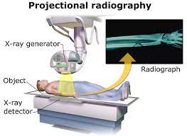
Figure 1: X-ray Machine

Computed Tomography (CT): Also known as computed axial tomography. The 2D image is then converted to a 3D image. Introduced in the 1970s, CT expanded its use.
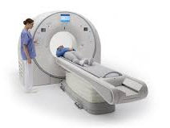
Figure 2: CT Scanner

Magnetic Resonance Imaging (MRI): MRI can distinguish soft tissues better than tomography.The first MR image was released in 1973. Additionally, optical imaging is often used more and more in drug discovery and preclinical evaluations, and in human clinical applications such as treating CT scans.
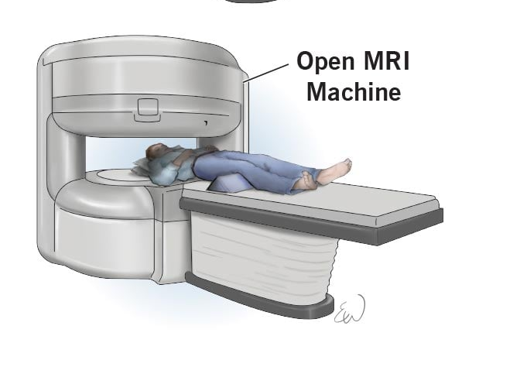
Figure 3: MRI ScannerV

Positron Emission Tomography (PET): It provides 3D images of the region of interest. The first PET machine was introduced in the early 1970s.
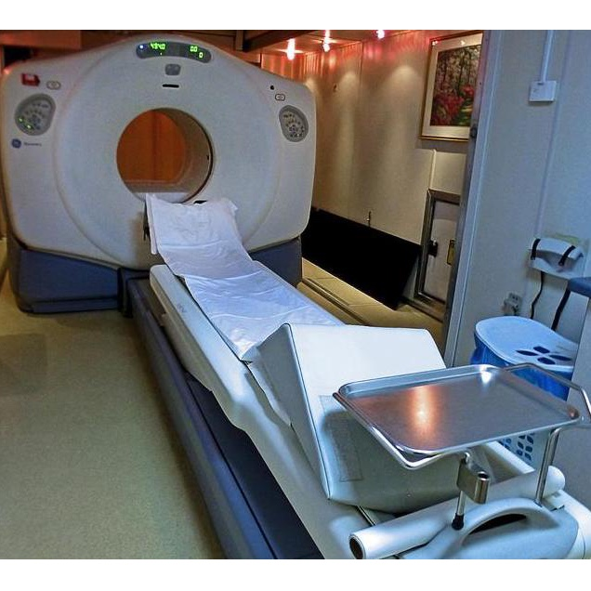
Figure 4: PET Scanner

b. Cellular Biomarkers
Biomarkers that can be measured biologically are known as cellular biomarkers, and they may be employed in both clinical and laboratory investigations. Blood, bodily fluids, or soft tissue cellular biomarkers are frequently examined and assessed for prognosis or likelihood of responding to a particular treatment. With the use of these biomarkers, it is possible to separate, group, count, and characterise cells according to their morphological and physiological characteristics. [24, 25].

c. Molecular Biomarkers [26,27,28,29]
Molecular biomarkers are indicators based on proteomic and genomic methods.They are important for diagnosis and have applications in epidemiological screening, randomized clinical trials, disease prevention, surveillance and control. Molecular biomarkers are characterized by their biophysical properties, which can be quantified in biological samples, including plasma, plasma-like fluid (Cervical), broncho-vascular lavage fluid (BVL), and biopsy samples. These biomarkers contain molecules ranging in size from small molecules (peptides) to large molecules (proteins), such as proteins and lipid metabolites, as well as nucleic acids such as DNA and RNA, among others. There are three main types of molecular biomarkers: chemical, lipid, and protein.

Chemical biomarkers: Chemical biomarkers contain information about birth through metabolic or genetic diseases such as cancer, disability and metabolic diseases, infectious diseases, nutritional foods, drugs, chemicals, and pollution.In total, 1089 drug biomarkers were associated with 448 diseases and 106 outcomes in the Molecular Biomarkers Online Database (MarkerDB). Many biomarkers can be measured quantitatively and accurately with efficacy and safety [30,32].

Protein biomarkers: Protein biomarkers are useful for identifying many biological changes. They can be used as indicators of changes in inflammation, immunity and stress or other diseases such as cancer, diabetes, heart disease, neurological disease and other conditions. The MarkerDB database represents 142 protein biomarkers covering more than 160 diseases [30,31,33]

- Based on Clinical Applications:
Disease-related biomarkers may indicate whether the disease is already present, whether there is a threat of disease, or how the disease arose in a patient.

- Diagnostic biomarker:
It serve as a way to identify a disease. ( For example, cardiac troponin myocardial infarction). These biomarkers are used to identify diseases such as use of cardiac troponin for diagnosis of myocardial damage, 3-hydroxy fatty acid profile for Planctomyces, glycans as cancer biomarkers, visceral fat and change metabolism Glutamate, catechin challenge, mortality in patients with heart disease, cystatin-C for glomerular filtration, liver-type fatty acid-binding protein (L-FABP) as a diagnostic biomarker to predict kidney damage.[31, 34, 35, 36, 37].

- Prognostic biomarker:
Prognostic biomarkers are associated with results like, overexpression of Her-2 in breast cancer or EGFR in cancer indicates a poor prognosis. Such markers are often the basis for designing clinical trials to include or identify patients. Prognostic biomarkers provide information about the disease by screening and monitoring the disease and measuring the increase or decrease in the internal precursors that the disease may reach. For example, blood pressure and cholesterol (for heart disease), N-acetyl-beta-D-glucosaminidase (for heart failure and kidney failure), D-serine (for ketamine for antidepressants), and osteocalcin (for bone and healthy bone metastases). have been used as prognostic biomarkers [31,38,39,40,41].

- Therapeutic biomarker:Vani et. al.,
These are useful in the treatment of illness and show importance in monitoring the response and treatment of stress or illness. Clinical biomarkers are proteins such as miRNAs and exosomes that can be used for therapy. Takamura et al. using malondialdehyde-modified LDL. As a good indicator of clinical outcome in patients after endovascular intervention for peripheral arterial disease. Clinical studies of D-serine demonstrate its effectiveness as a clinical biomarker in patients with schizophrenia and depression. As a tumor biomarker, Ca15-3 can be used to monitor breast cancer therapy. [39, 42-48]

V.APPLICATIONS OF BIOMARKER
Biomarkers have found extensive applications in the field of medicine, primarily in disease diagnosis and treatment, with significant expansion in recent years. These biomarkers encompass various types, including physical, physiological, and histological markers. Among these, biochemical biomarkers hold particular relevance in early clinical research, as they are derived from bodily fluids and prove suitable for early-stage investigations. Molecular biomarkers related to safety have been integral to both preclinical and clinical research efforts for an extended period [51].
Accurate disease diagnosis assumes paramount importance, especially in chronic conditions necessitating long-term drug therapies, often fraught with serious side effects. In such scenarios, biomarkers have gained prominence by confirming intricate diagnoses and rendering them feasible. Many diseases, such as Alzheimer's disease or rheumatoid arthritis, frequently commence asymptomatically in their early stages. Biomarkers prove instrumental in identifying individuals at high risk in a timely and dependable manner, enabling prompt treatment either before or after the onset of symptoms. These biomarkers may entail samples like blood drawn by a healthcare professional, urine or saliva specimens, or even small blood drops obtained from a patient's fingertip to facilitate frequent blood sugar monitoring [49, 50]
- Covid-19 [51 - 63]
The emergence of the novel coronavirus (SARS-CoV-2 or COVID-19) originated in Wuhan, China, in December 2019. Regrettably, this newfound virus has afflicted and caused fatalities in excess of one million individuals globally. In a study conducted by Pu et al., advanced deep learning techniques in conjunction with high-resolution tomography were employed as biomarkers to investigate factors unrelated to COVID-19. The findings indicate that certain biomarkers in the scan may exhibit no significant differences between individuals with COVID-19 and those suffering from community-acquired pneumonia. Nonetheless, the imaging process may distinguish a small subset of COVID-19 patients due to the presence of distinctive image features compared to non-COVID-19 cases.
Biomarkers indicative of myocardial damage or heart-related conditions, specifically cTnI (cardiac troponin I), cardiac troponin T (cTnT), and D-dimer, have demonstrated their utility in predicting, diagnosing, and managing COVID-19 cases. Moreover, elevated levels of serum amyloid A, C-reactive protein, urea, creatinine (biomarkers associated with kidney function), ferritin, and lactate dehydrogenase have been employed as diagnostic biomarkers for COVID-19.

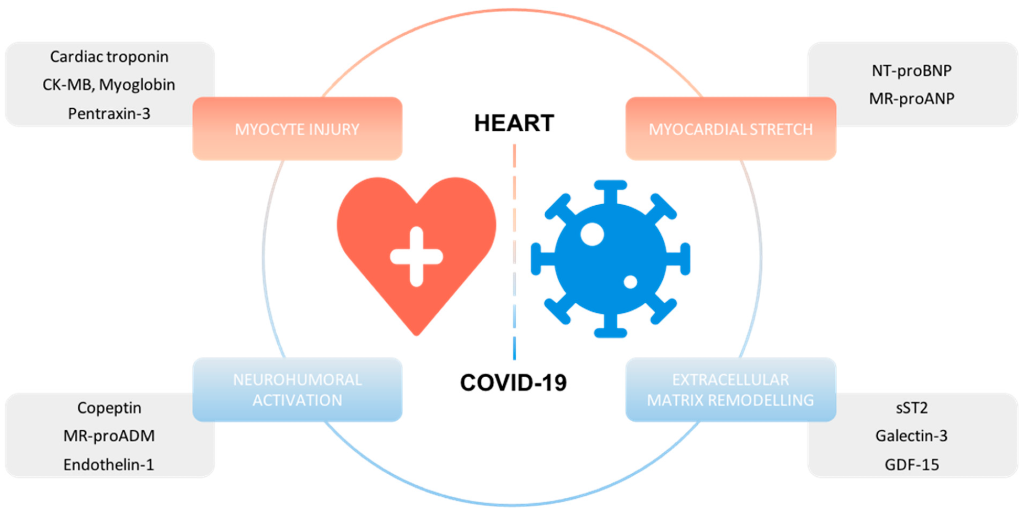

Figure 5: biomarkers of COVID-19
- Cancer [10, 64 -77]
Cancer stands as the primary global cause of mortality, characterized by its invasive nature when it spreads to other organs within the body. Cancer biomarkers hold significant relevance in advancing our comprehension of cancer processes within clinical contexts. Their utility extends to enhancing diagnostic capabilities and minimizing the occurrence of severe adverse effects associated with cancer treatments. These biomarkers are specifically crafted to evaluate cancer susceptibility, investigate tumor interactions, and impact the vitality of both tumors and cells. Notably, various biological components, including proteins, metabolites, nucleic acids, and extracellular vesicles, can be detected within urine, a crucial component of biopsy fluid.

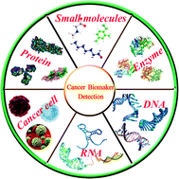

Figure 6 : Cancer Biomarkers

- Disorders of Skeletal Muscles and Bone [78 - 84]
Skeletal muscles are susceptible to perturbations over the course of aging, which can be attributed to factors such as physical exercise, contractures, injuries, immune deficiencies, or muscular atrophy. Various diagnostic modalities, including magnetic resonance imaging (MRI) and proton magnetic resonance spectroscopy, have been employed to assess GNE myopathy, a rare form of skeletal muscle dystrophy. Furthermore, MRI and biomarkers serve as essential tools for detecting alterations in adipose and fibrous tissues. The quantification of pyridinoline, deoxypyridinoline, and osteocalcin has been employed to predict prospective bone diseases based on clinical outcomes.
One well-established biomarker, plasma interleukin-6, has found utility in inflammation assessment and holds potential for predicting chronic changes associated with growth retardation, joint pain, and hip dysplasia. Fourier-transform infrared spectroscopy has been explored as a biomarker for primary mitochondrial myopathy and other mitochondrial disorders. This technology offers a swift, non-invasive, non-destructive, sensitive, and specific biomarker assessment, requiring minimal sample volumes. Amino acids such as cysteine, methionine, taurine, and glutathione, integral constituents of skeletal muscle, can be employed for both therapeutic purposes and the identification of skeletal muscle dystrophy.
Research objectives seek to leverage MRI technology for the evaluation of osteoarthritis and to assess cartilage and its response to osteoarthritis treatments. In this context, MRI has exhibited promise in the diagnosis of soft tissue inflammation and cartilage damage in rheumatoid arthritis. If MRI is established as a reproducible biomarker, it could contribute to the identification of new treatment potentials, determination of appropriate dosages, and stratification of patients based on their risk profiles through early assessments.

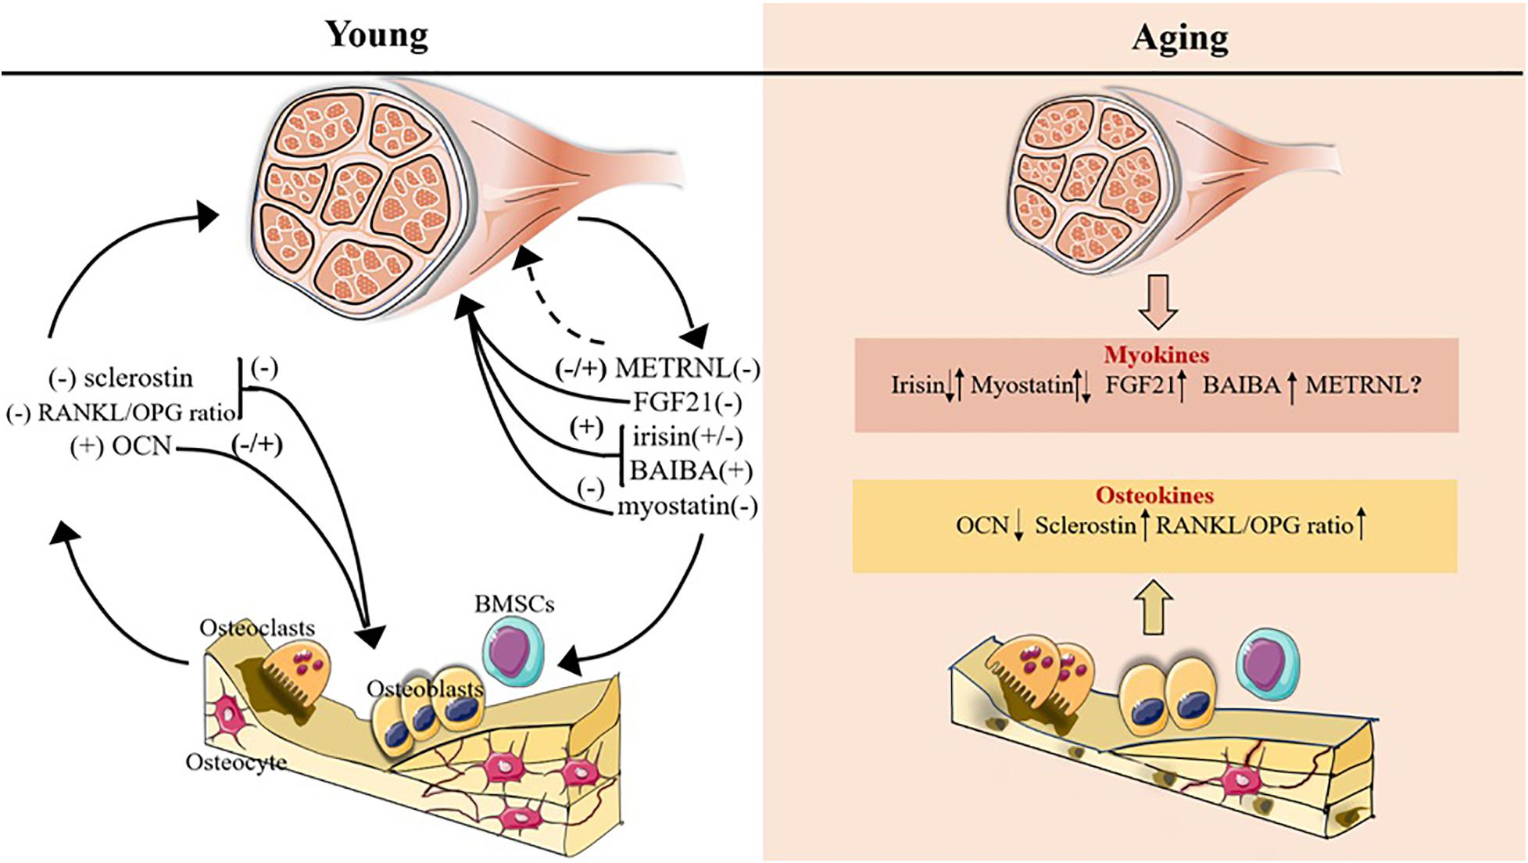

Figure 7: Biomarkers of arthritis

- Heart failure [23, 85 - 99]
Novel strategies are imperative for the assessment and treatment of heart disease to foster the development of innovative therapeutic approaches. Intravenous ultrasound (IVUS), magnetic resonance imaging (MRI), or multislice computed tomography (CT) can be harnessed to evaluate key central parameters of cardiac function, thereby enabling the monitoring of atherosclerosis progression and the prevention of heart failure. The refinement of these methodologies to track disease progression necessitates a comprehensive evaluation of the current understanding of measurement techniques, standardized metrics, and suitable testing to gauge their association with treatment responses.
Heart failure (HF) is a complex condition exhibiting various phenotypes driven by multiple pathophysiological mechanisms originating from both cardiac and extracardiac sources. Rapid "diagnosis" of heart failure can be crucial in emergency settings, necessitating specialized testing in the emergency department. Image-based biomarkers provide valuable insights into cardiac function and aberrations but may not identify subclinical or incipient stages of heart failure. Protein biomarkers, currently employed to predict heart failure prognosis, are released from the heart and reflect tissue-specific damage or other neural responses associated with heart failure. For instance, measurements of brain natriuretic peptide (BNP), BNP N-terminal prohormone, and cardiac troponin are recommended by both the American Heart Association and the European Society of Cardiology for heart disease management and diagnosis due to their well-established efficacy.
Exploration of additional diagnostic biomarkers, such as those related to oxidative stress (e.g., growth factor-15), cardiovascular function (e.g., galectin-3), and inflammation (e.g., soluble ST2 receptor), may enhance heart disease treatment strategies. Recent advancements in genetic analysis have opened new avenues for investigating the pathophysiology of cardiovascular diseases and the development of gene-based biomarkers. A pioneering approach involves the identification of DNA/RNA-based biomarkers utilizing omics technology capable of genome-wide (GW) and transcriptome-wide (TW) genetic variant detection. Omics analyses offer insights into the molecular mechanisms underpinning the disease and facilitate the identification of genes that could aid in patient stratification for heart failure.
The emergence of new heart failure biomarkers holds promise for their widespread adoption, ultimately improving disease identification, treatment, and overall patient care. Interest in multifaceted methodologies stems from their potential to surpass individual biomarkers by enhancing risk stratification accuracy and refining cardiovascular disease diagnostics.
- Chronic Obstructive Pulmonary Diseases [15]
High-resolution computed tomography (HRCT) of the thorax has potential utility in the assessment of diseases, notably chronic obstructive pulmonary disease (COPD), wherein emphysema constitutes a significant component, particularly in cases linked to complications arising from alpha-1 antitrypsin deficiency. Though existing data suggest that HRCT can offer a dependable evaluation of pulmonary structures, this reliability applies to a subset of patients, rendering it insufficient for distinguishing between diagnoses such as pneumonia or fatal conditions in a timely manner, thus introducing uncertainty.
Neurocognitive Diseases: [100, 101]
Presently, the management of chronic neurological disorders such as Parkinson's and Alzheimer's relies on assessing recent symptomatic changes, a process that may necessitate several years of continuous observation. Utilizing functional imaging techniques such as FDG-PET to gauge glucose metabolism offers a potential avenue for the quantification of subtle early-stage disease alterations. Exploring innovative methodologies for assessing and responding to measurements related to neurocognitive diseases and depression could pave the way for novel approaches to treatment monitoring. For instance, the concurrent assessment of amyloid content through PET scans in conjunction with MRI measurements may represent the most effective means of elucidating the impact of Alzheimer's disease treatments. The utilization of markers capable of providing early disease insights holds the potential to enhance the efficacy of preventive interventions.

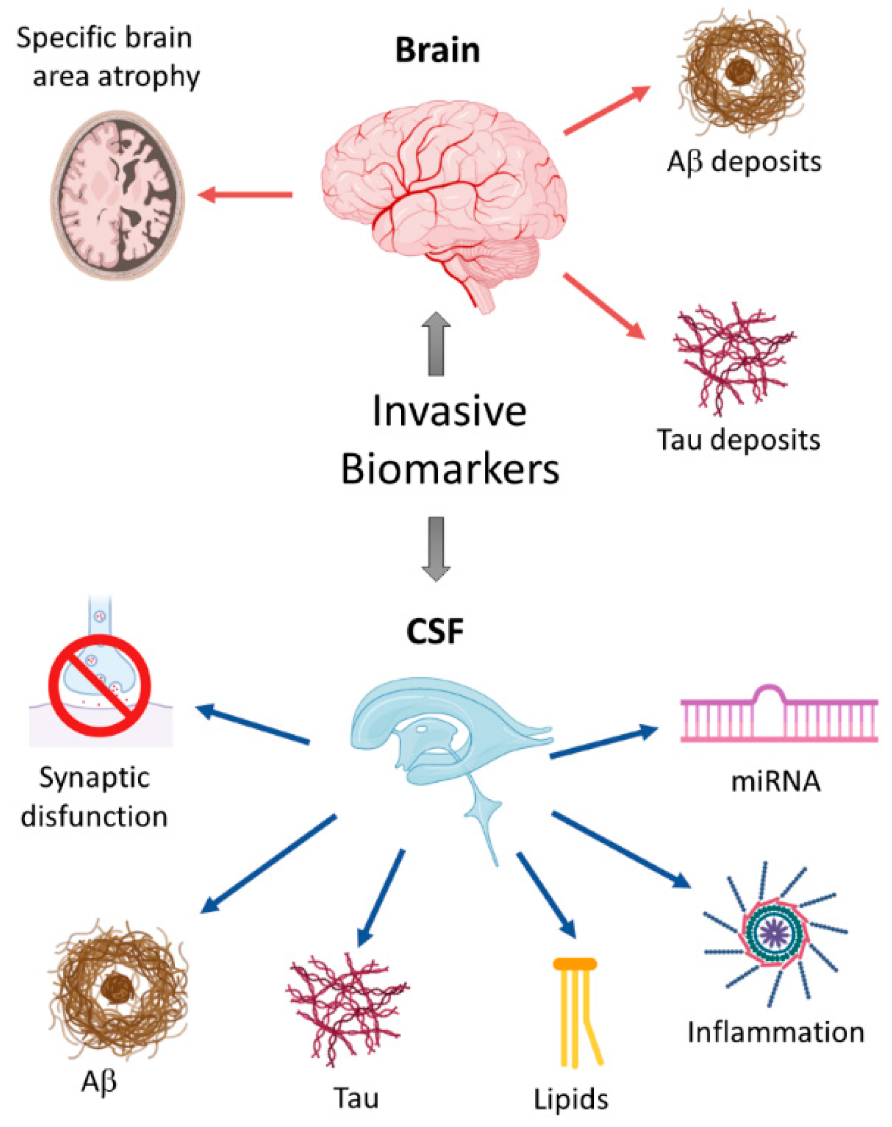

Figure 8: Biomarkers of Alzheimer's Disease

- Kidney Disease [102 - 106]
The kidney serves the crucial role of blood filtration, urine production, toxin removal, and regulation of fluid volumes within the body. Successful utilization of microalbumin, N-acetyl-β-glucosaminidase, fatty acid-binding protein, and cysteine-rich protein as biomarkers has been documented in the context of kidney disease. Hepcidin-25, an iron-binding protein linked to acute kidney injury, presents a potential novel kidney biomarker, applicable in both blood and urine assessments for diagnosing renal dysfunction post-cardiac surgery. A recent development involves the FDA's approval of a panel comprising 6 established biomarkers for preclinical acute kidney injury detection. This panel incorporates clusterin, urinary creatinine, cystatin C, kidney injury molecule 1, N-acetyl-β-D-glucosaminidase, intermediate granulocyte gelatinase-associated lipocalin, and osteopontin. These biomarkers have been validated for diagnosing induced kidney pathology. Additionally, D-serine levels in blood and urine are commonly employed as dual biomarkers for assessing kidney function and disease status.

- Liver disease [107 - 112]
The liver stands as a vital organ within the human body, undertaking a multitude of critical functions. These include the digestion of food, the distribution and conversion of nutrients into energy, as well as the pivotal role in filtering and detoxifying the bloodstream. It actively aids in removing toxins from the blood, thereby contributing significantly to overall health. Within the realm of liver health, a spectrum of diseases exists, encompassing conditions such as hepatitis, liver cancer, cirrhosis, hemochromatosis, Wilson's disease, fascioliasis, liver failure, and autoimmune disorders. Diverse factors and conditions, ranging from diseases and medications to alcohol consumption and exposure to toxins, can precipitate liver diseases.
The manifestations of hepatitis can vary in accordance with the timing and severity of infection, often presenting symptoms that can be easily mistaken for other medical conditions. Common indications include jaundice (characterized by yellowing of the skin and sclera), dark-colored urine, abdominal and leg swelling, increased susceptibility to bruising, and vomiting. Accurate diagnosis of liver diseases can be challenging, but biomarkers have emerged as valuable tools to aid in both diagnosis and disease monitoring.
Liver damage can be corroborated through various liver function tests, which assess parameters such as albumin, alanine aminotransferase, lactate dehydrogenase, aspartate aminotransferase, alkaline phosphatase, and gamma-glutamyltransferase. Among these, alanine aminotransferase stands out as a surrogate biomarker with high specificity for liver diseases, and it can be readily detected in blood samples. Moreover, biomarkers like hyaluronic acid, bilirubin, cytokines, laminin, and fibroblast growth factors have been identified as valuable indicators for assessing liver health and function. These biomarkers aid in refining our understanding of liver diseases, their progression, and the efficacy of treatments, ultimately contributing to better patient care in the realm of hepatic disorders.
- Gastrointestinal Disorders [113 - 121]
Gastrointestinal disorders encompass maladies affecting the entirety of the human digestive system, spanning from the oral cavity to the rectum. In the realm of non-invasive diagnostics, metabolic intermediates serve as valuable biomarkers for intestinal disease detection. Organic compounds like acetone, ammonia, ethanol, indole, carbon disulfide, 2,3-butanedione, and acetic acid have emerged as potential biomarkers. These low-molecular-weight compounds are generated within the digestive tract, traverse the bloodstream, reach the pulmonary system, and manifest in the respiratory tract. They are subsequently subjected to analysis via Gas Chromatography-Mass Spectrometry (GC-MS) techniques. In the context of non-invasive biomarkers, calprotectin is employed for the evaluation and management of active inflammatory bowel disease (IBD) and other gastrointestinal disorders. Lactoferrin serves as a laboratory biomarker for the diagnosis of Clostridium difficile infections. Additionally, electronic noses employing microRNA, surface acoustic waves, carbon black polymer composites, and metal oxide semiconductors have been employed for the identification of intestinal diseases. Fatty acid-binding proteins have undergone assessment as diagnostic biomarkers for inflammatory bowel disease. Urine metabolomics, encompassing tricarboxylic acids and amino acids, display distinct profiles in IBD patients compared to healthy individuals, offering potential as non-invasive biomarkers for gastrointestinal diseases.
Nevertheless, the majority of the candidate biomarkers under current investigation have not yet undergone validation and approval for real-world clinical applications in the screening or diagnosis of specific gastrointestinal disorders. The outlook for biomarkers remains uncertain. While some studies have reported favorable outcomes with different biomarkers, the heterogeneity of findings raises questions. Consequently, substantial research efforts and clinical trials, employing methodologies developed by multicenter consortia, are warranted to elucidate the potential and limitations of these biomarkers fully.
Specific Organ Biomarkers Tests [51]
Liver Function: Transaminases , bilirubin, alkaline phosphates.
Kidney Function Serumcreatinine, creatinine clearence, cystatinC.
Skeletal Muscle Marker: Myoglobin.
Cardiac Muscle Injury: CK-MB, teroponinI (or) T.
Bone markers: Bone specific alkaline phosphates.
VI. BIOMARKER AS AN EMERGING TOOL [122 - 125]
Throughout the entire process of developing new drugs, biomarkers are helpful. Biomarkers have historically been used in drug development projects as a time taking method that uses residual samples and funds, frequently producing partial or insufficient data.

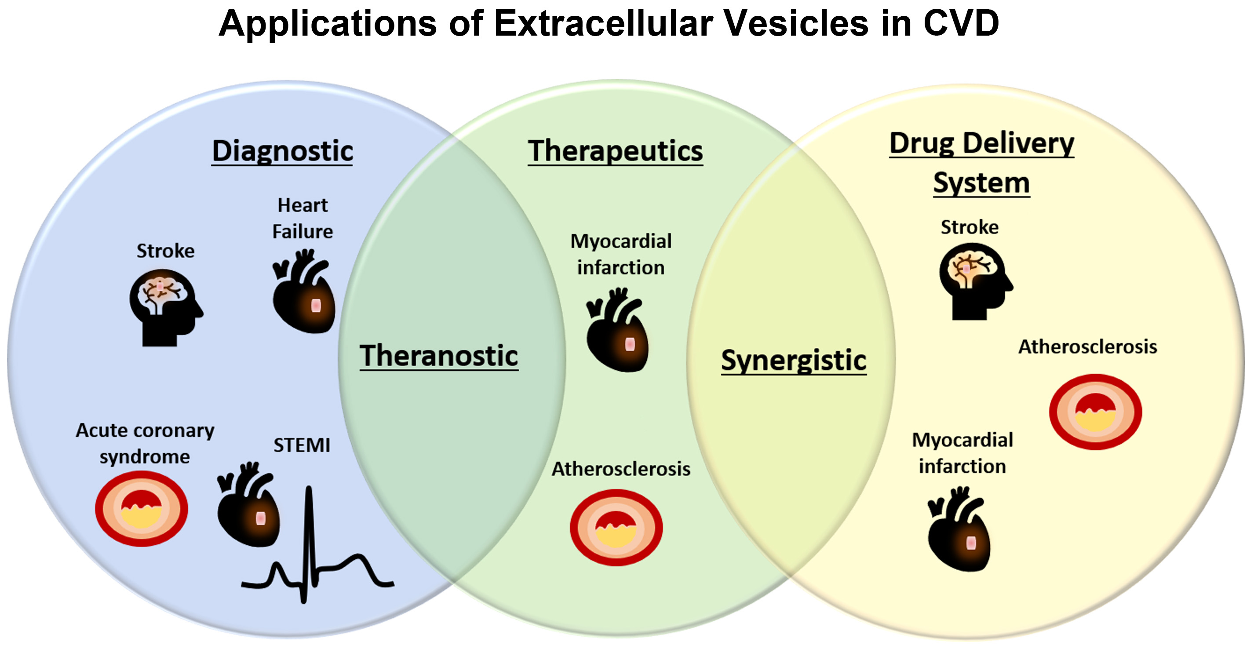

Figure 9: Biomarkers in Drug Research

Nevertheless, they are now being incorporated into every level of drug discovery, from:Vt. al.,
- ✓ Target drug delivery
- ✓ Monitoring of drug efficacy
- ✓ Studying mode of action
- ✓ Toxicological studies
- ✓ Internal decision making
- ✓ Protocol designing for clinical study
- ✓ Diagnosis of disease
- ✓ Studying menifestation of disease
Research focused on biomarkers is poised to assume a pivotal role in the evolution of novel therapeutics. Over time, biomarker research is anticipated to become an indispensable component of the drug development process. The ultimate objective is to enhance therapeutic efficacy while reducing costs. Although we are in the early stages of this endeavor, the potential of biomarkers shines brightly. The clinical development of gefitinib, an orally administered epidermal growth factor receptor tyrosine kinase inhibitor (EGFR TKI), serves as a challenging exemplar of biomarker development. Within the context of extensive randomized trials, alterations in biomarkers are expected to become commonplace rather than rare. While the initial candidate biomarker undergoes early evaluation during the developmental phase, knowledge accumulates exponentially as research findings and clinical insights are widely disseminated and integrated into clinical practice. The translational aspect of this work intensifies.
Biomarkers capable of identifying prodromal manifestations can facilitate early disease diagnosis or enable the prediction of outcomes of interest during the initial stages of the ailment. These biomarkers serve as indicators for subclinical symptoms, disease progression stages, or surrogate endpoints for diseases. Biomarkers employed for screening or diagnosis often correlate with disease outcomes. They contribute to the identification of individuals requiring intervention, especially those in the early disease stages. Biomarkers have the potential to reduce disease heterogeneity in clinical trials and epidemiological studies and can influence the course of the disease, encompassing stages such as induction, incubation, and detection. The advantages of utilizing biomarkers, despite the challenges associated with obtaining patient tissue samples, outweigh the inherent difficulties.
In both research and clinical practice, diagnostic tests for diseases are increasingly prevalent. The aggregation of diagnostic data from diverse sources reporting on diagnoses aligns with the primary objective of enhancing diagnostic accuracy. Diagnostic tests may be performed less frequently for other purposes, such as assessing disease severity, predicting disease onset, or monitoring treatment responses. Notably, the accurate diagnosis of severe diseases contributes to predicting disease severity. Additionally, this diagnostic approach reduces disease heterogeneity in clinical trials or epidemiological surveys, leading to a more coherent understanding of the disease's natural history, including its induction, incubation, and detection phases.
VII. BIOMARKER DEVELOPMENT PROCESS [19]
The process of biomarker development commences with the identification of biomarkers in both healthy and diseased samples, and it proceeds through several iterative stages. The imperative need for an inclusive development protocol, encompassing various regulatory integration components, remains to ensure the efficient and evidence-based progress of biomarker development for clinical and research purposes. This field is experiencing rapid evolution attributed to the ongoing and swift advancements in computing, analytics, and measurement techniques. The biomarker development process encompasses the subsequent phases: preanalytical and analytical validation, clinical validation, regulatory approval, and clinical verification. During the pre-evaluation phase, standardization of biomarkers and scrutiny of qualitative procedures, storage, and collection methods are undertaken. Analytical validation of a biomarker aims to ascertain that the analytical methodology is reproducible, reliable, and exhibits appropriate specificity and sensitivity enhancements.
Biomarkers are linked to clinical and biological products based on their relevance, as determined by the level of supporting evidence. Nevertheless, the development of biomarkers presents certain challenges, including:
- Insufficient investigation of the scientific underpinnings of biomarkers, rendering it challenging to identify and embrace forthcoming biomarkers. Moreover, it is imperative to avoid misinterpreting biomarker observations and unwarranted associations between biomarkers and diseases.
- Prolonged clinical studies and analysis contribute to an escalation in the cost associated with biomarker development.
- The formulation and characterization of biomarkers often demand substantial time and resources. Consequently, additional evidence for benefit-risk analysis is frequently mandated for valid reasons, in comparison to their inclusion in the authorization process for medicinal products.

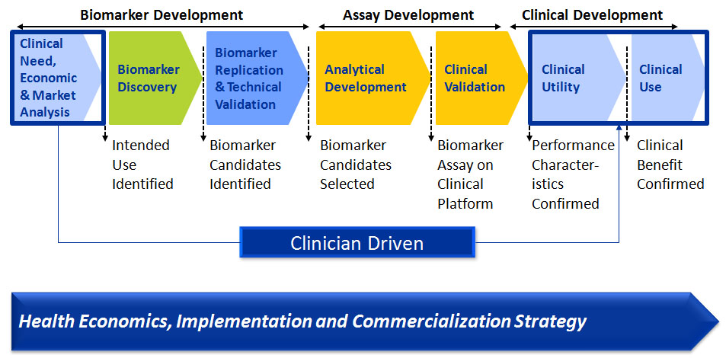

Figure 10. Biomarker Development Process

VIII. CONCLUSION
Biomarkers are integral components of emerging medical tools and play a pivotal role in the diagnosis and treatment of various clinical medical conditions. They offer numerous advantages in investigating diverse facets of diseases, facilitating drug development, and monitoring therapeutic outcomes. Biomarkers hold the potential to deliver heightened sensitivity and specificity in comparison to existing measurement techniques, thereby enhancing decision-making processes and contributing to treatment advancements. Ongoing endeavors are dedicated to scrutinizing the characteristics of biomarkers to unearth novel indicators that can enhance healthcare and the development of more efficacious treatments.
Nevertheless, due to the intricate nature of mechanisms underpinning disease pathogenesis, the identification of valuable biomarkers for monitoring drug responses, diagnosing illnesses, and tracking disease progression, as well as comprehending disease-associated anomalies and biochemical processes, remains a formidable challenge for healthcare practitioners and professionals involved in biomarker analysis. The critical distinction between potential biomarkers and dependable biomarkers, capable of guiding significant clinical and commercial decisions on a global scale, constitutes one of the principal hurdles in the field of biomarker research.
Biomarkers, which manifest as alterations in tissues or bodily fluids, offer a potent avenue for comprehending chronic diseases and find utility in at least five critical domains, including screening, diagnosis, disease monitoring, prognostication of disease occurrence, and clinical care. Biomarkers that identify prodromal signs can lead to early diagnosis or enable the determination of the desired outcomes in the initial stages of the disease. Biomarkers serve as proxies for subclinical symptoms, disease stages, or surrogate disease endpoints. It is crucial to acknowledge that biomarkers exhibit specificity either toward a particular drug or a specific disease, necessitating meticulous consideration of development costs. Effective biomarkers should exert a tangible influence on clinical assessments to enhance patient care. Decisions regarding treatment based on accurate test results hold superior value compared to those reliant on false positive or negative outcomes. Biomarkers should contribute to cost reduction, mitigate adverse effects, and aid in mortality prevention within a risk management context. The validity of a biomarker is established through comparison with an ideal biomarker while assessing its inherent properties.

IX. REFERENCES

[1] A. De Gramont, S. Watson, L.M. Ellis, J. Rod´on, J. Tabernero, A. De Gramont, S.R. Hamilton, Pragmatic issues in biomarker evaluation for targeted therapies in cancer, Nat. Rev. Clin. Oncol.2015; 12 197–212, https://doi.org/10.1038/nrclinonc.2014.202.
[2] V.R. Beasley, J.M. Levengood, Principles of Ecotoxicology, Veterinary Toxicology, Elsevier Inc., 2012, pp. 831–855.
[3] A. Godfrey, B. Vandendriessche, J.P. Bakker, C. Fitzer-Attas, N. Gujar, M. Hobbs, Q. Liu, C.A. Northcott, V. Parks, W.A. Wood, Fit-for-purpose biometric monitoring technologies: leveraging the laboratory biomarker experience, Clin. Transl. Sci. 14 (2021) 62–74, https://doi.org/10.1111/cts.12865.
[6] International Programme on Chemical Safety, Environmental Health Criteria 155. Biomarkers And Risk Assessment: Concepts And Principles. Published by United Nations Environment Programme, the International Labour Organlaation, and the World Heanh Organization
[5]Thomson R. Nature Reviews Drug Discovery. FDA drug approvals: a year of flux. 2008; 7: 107.
[6] Kumar M, Sarin S. Biomarkers of diseases in medicine. Current trends in science.2009; 403-417.
[7] M.S. García-Guti´errez, F. Navarrete, F. Sala, A. Gasparyan, A. Austrich-Olivares, J. Manzanares, Biomarkers in psychiatry: concept, definition, types and relevance to the clinical reality, Front. Psychiatr.2020; 11, 432, https://doi.org/10.3389/fpsyt.2020.00432.
[8] K. Porter, Effect of homologous bone marrow injections in x-irradiated rabbits, Br. J. Exp. Pathol.1957; 38. 401–412.
[9] B.D. Mundkur, Evidence excluding mutations, polysomy, and polyploidy as possible causes of non-Mendelian segregations in Saccharomyces, Ann. Mo. Bot. Gard. 36 (1949) 259–280, https://doi.org/10.2307/2394394.
[10] J.K. Aronson, Biomarkers and surrogate endpoints, Br. J. Clin. Pharmacol.2005; 59. 491, https://doi.org/10.1111/j.1365-2125.2005.02435.x.
[11] J.K. Aronson, R.E. Ferner, Biomarkers—a general review, Curr. Protoc. 2017 76. 9, https://doi.org/10.1002/cpph.19.
[12] B.D.W. Group, A.J. Atkinson Jr., W.A. Colburn, V.G. DeGruttola, D.L. DeMets, G.J. Downing, D.F. Hoth, J.A. Oates, C.C. Peck, R.T. Schooley, Biomarkers and surrogate endpoints: preferred definitions and conceptual framework, Clin. Pharmacol. Ther.2001; 69. 89–95, https://doi.org/10.1067/mcp.2001.113989.
[13] J. MacNamara, D.J. Eapen, A. Quyyumi, L. Sperling, Novel biomarkers for cardiovascular risk assessment: current status and future directions, Future Cardiol.
2015; 11: 597–613, https://doi.org/10.2217/fca.15.39.
[14] F. Gil, A. Pla, Biomarkers as biological indicators of xenobiotic exposure, J. Appl. Toxicol.2001; 21: 245–255.
[15] Vani M, Harathi P , Khantamneni P. Biomarkers In Disease Diagnosis. American Journal of PharmTech Research. 2016; 6(2); 38-53.6(
[16]Thompson ML, Zucchini W. On the statistical analysis of ROC curves. Stat Med. 1989;
8: 1277-1290.
[17] Bang H, Egerer K, Gauliard A, Lüthke K, Rudolph PE and Fredenhagen G. Mutation
and citrullination modifies vimentin to a novel autoantigen for rheumatoid arthritis.
Arthritis Rheum. 2007; 56 (8): 2503-2511.
[18] Mathsson L, Mullazehi M, Wick MC, Sjöberg O, van Vollenhoven R, Klareskog L and
Rönnelid J. Antibodies against citrullinated vimentin in rheumatoid arthritis: higher
sensitivity and extended prognostic value concerning future radiographic progression as
compared with antibodies against cyclic citrullinated peptides. Arthritis Rheum. 2008;
58(1): 36-45.
[19] Bodaghi A, Fattahi N, Ramazani A. Biomarkers: Promising and valuable tools towards diagnosis,
prognosis and treatment of Covid-19 and other diseases. Heliyon. 2023; 9 e-13323.
[20] D.S. Wishart, B. Bartok, E. Oler, K.Y. Liang, Z. Budinski, M. Berjanskii, A. Guo, X. Cao, M. Wilson, MarkerDB: an online database of molecular biomarkers, Nucleic Acids Res. 2021; 49: D1259–D1267.
[21] D. Corella, J.M. Ordovas, Biomarkers: background, classification and guidelines for applications in nutritional epidemiology, Nutr. Hosp. 2015: 31: 177–188.
[22] J. Sharifi-Rad, A. Sureda, G.C. Tenore, M. Daglia, M. Sharifi-Rad, M. Valussi, R. Tundis, M. Sharifi-Rad, M.R. Loizzo, A.O. Ademiluyi, Biological activities of essential oils: from plant chemoecology to traditional healing systems, Molecules 2017; 22: 70.
[23] Wong DF. Imaging in drug discovery preclinical, and early clinical development. J
Nucl Med. 2008; 49(6): 26N-28N.
[24] J. Sharifi-Rad, A. Sureda, G.C. Tenore, M. Daglia, M. Sharifi-Rad, M. Valussi, R. Tundis, M. Sharifi-Rad, M.R. Loizzo, A.O. Ademiluyi, Biological activities of essential oils: from plant chemoecology to traditional healing systems, Molecules 22 (2017) 70.
[25] S.E. Eggener, R.B. Rumble, A.J. Armstrong, T.M. Morgan, T. Crispino, P. Cornford, T. van der Kwast, D.J. Grignon, A.J. Rai, N. Agarwal, Molecular biomarkers in localized prostate cancer: ASCO guideline, J. Clin. Oncol. 2020; 38: 1474–1494.
[26] M. Pospelova, V. Krasnikova, O. Fionik, T. Alekseeva, K. Samochernykh, N. Ivanova, N. Trofimov, T. Vavilova, E. Vasilieva, M. Topuzova, Potential molecular biomarkers of central nervous system damage in breast cancer survivors, J. Clin. Med. 11 (2022) 1215.
[27] C. Pico, F. Serra, A.M. Rodríguez, J. Keijer, A. Palou, Biomarkers of nutrition and health: new tools for new approaches, Nutrients 11 (2019) 1092.
[28] A. Rosenwald, G. Wright, W.C. Chan, J.M. Connors, E. Campo, R.I. Fisher, R.D. Gascoyne, H.K. Muller-Hermelink, E.B. Smeland, J.M. Giltnane, The use of molecular profiling to predict survival after chemotherapy for diffuse large-B-cell lymphoma, N. Engl. J. Med. 346 (2002) 1937–1947.
[29] A. Lukas, A. Heinzel, B. Mayer, Biomarkers for Capturing Disease Pathology as Molecular Process Hyperstructure, bioRxiv, 2019, 573402.
[30] D.S. Wishart, B. Bartok, E. Oler, K.Y. Liang, Z. Budinski, M. Berjanskii, A. Guo, X. Cao, M. Wilson, MarkerDB: an online database of molecular biomarkers, Nucleic Acids Res. 49 (2021) D1259–D1267.
[31] K. Dhama, S.K. Latheef, M. Dadar, H.A. Samad, A. Munjal, R. Khandia, K. Karthik, R. Tiwari, M. Yatoo, P. Bhatt, Biomarkers in stress related diseases/disorders: diagnostic, prognostic, and therapeutic values, Front. Mol. Biosci. 91 (2019).
[32] J. Patron, A. Serra-Cayuela, B. Han, C. Li, D.S. Wishart, Assessing the performance of genome-wide association studies for predicting disease risk, PLoS One 14 (2019), e0220215.
[33] E.W. Karlson, S.-C. Chang, J. Cui, L.B. Chibnik, P.A. Fraser, I. De Vivo, K.H. Costenbader, Gene–environment interaction between HLA-DRB1 shared epitope and heavy cigarette smoking in predicting incident rheumatoid arthritis, Ann. Rheum. Dis. 69 (2010) 54–60.
[34] O.F. Laterza, R.C. Hendrickson, J.A. Wagner, Molecular biomarkers, Drug Inf. J. 41 (2007) 573–585.
[35] J.J. Brocks, A. Pearson, Building the biomarker tree of life, Rev. Mineral. Geochem. 59 (2005) 233–258.
[36] O. Aizpurua-Olaizola, J.S. Torano, J.M. Falcon-Perez, C. Williams, N. Reichardt, G.-J. Boons, Mass spectrometry for glycan biomarker discovery, Trends Anal. Chem. 100 (2018) 7–14.
[37] M.J. Kailemia, D. Park, C.B. Lebrilla, Glycans and glycoproteins as specific biomarkers for cancer, Anal. Bioanal. Chem. 409 (2017) 395–410.
[38] C.G. Jungbauer, C. Birner, B. Jung, S. Buchner, M. Lubnow, C. von Bary, D. Endemann, B. Banas, M. Mack, C.A. Boger,
Kidney injury molecule-1 and N-acetyl- ß-d-glucosaminidase in chronic heart failure: possible biomarkers of cardiorenal syndrome, Eur. J. Heart Fail. 13 (2011) 1104–1110.
[39] M.-A.B. MacKay, M. Kravtsenyuk, R. Thomas, N.D. Mitchell, S.M. Dursun, G.B. Baker, D-Serine, Potential therapeutic agent and/or biomarker in schizophrenia and depression? Front. Psychiatr. 10 (2019) 25.
[40] S.T. Anderson, L.J. Kidd, A.J. Barton, R.M. Greer, Serum bone biomarkers osteocalcin and pyridinoline in mares during pregnancy and lactation, and in foals during early post-natal life, Res. Vet. Sci. 118 (2018) 34–40.
[41]Szodoray P, Szabó Z, Kapitány A, Gyetvai A, Lakos G, Szántó S Szücs G and Szekanecz Z. Anti-citrullinated protein/peptide autoantibodies in association with genetic and environmental factors as indicators of disease outcome in rheumatoid arthriti Autoimmun Rev. 2009.
[42] N. Carlomagno, P. Incollingo, V. Tammaro, G. Peluso, N. Rupealta, G. Chiacchio, M.L. Sandoval Sotelo, G. Minieri, A. Pisani, E. Riccio, Diagnostic, predictive, prognostic, and therapeutic molecular biomarkers in third millennium: a breakthrough in gastric cancer, BioMed Res. Int. 2017 (2017).
[43] N.S. Verber, S.R. Shepheard, M. Sassani, H.E. McDonough, S.A. Moore, J.J. Alix, I.D. Wilkinson, T.M. Jenkins, P.J. Shaw, Biomarkers in motor neuron disease: a state of the art review, Front. Neurol. 10 (2019) 291.
[44] K. Sidhom, P.O. Obi, A. Saleem, A review of exosomal isolation methods: is size exclusion chromatography the best option? Int. J. Mol. Sci. 21 (2020) 6466.
[45] L.-L. Lin, H.-C. Huang, H.-F. Juan, Discovery of biomarkers for gastric cancer: a proteomics approach, J. Proteome Res. 75 (2012) 3081–3097.
[46] T. Takamura, T. Tsuchiya, M. Oda, M. Watanabe, R. Saito, R. Sato-Ishida, H. Akao, Y. Kawai, M. Kitayama, K. Kajinami, Circulating malondialdehyde modified low-density lipoprotein (MDA-LDL) as a novel predictor of clinical outcome after endovascular therapy in patients with peripheral artery disease (PAD), Atherosclerosis 263 (2017) 192–197.
[47] U. Manne, R.-G. Srivastava, S. Srivastava, Keynote review: recent advances in biomarkers for cancer diagnosis and treatment, Drug Discov, Today Off. 10 (2005) 965–976.
[48] R. Gupta, S. Soni, An overview on inflammatory biomarkers for diabetes mellitus, Madridge J. Diabetes 3 (2019) 64–66.
[49] Waaler E. On the occurrence of a factor in human serum activating the specific
agglutintion of sheep blood corpuscles. APMIS. 2007; 115 (5): 422–438.
[50] Bang H, Egerer K, Gauliard A, Lüthke K, Rudolph PE, Fredenhagen G, Berg W, Feist
E, Burmester GR. Mutation and citrullination modifies vimentin to a novel autoantigen
for rheumatoid arthritis. Arthritis Rheum. 2007 ; 56(8):2503-11.
[51] Häupl T, Stuhlmüller B, Grützkau A, Radbruch A and Burmester GR. Does gene
expression analysis inform us in rheumatoid arthritis. Ann Rheum Dis. 2010; 69: 37-42.
[52] M. Aboughdir, T. Kirwin, A. Abdul Khader, B. Wang, Prognostic value of cardiovascular biomarkers in COVID-19: a review, Viruses 12 (2020) 527.
[53] M.T. Huyut, F. Ilkbahar, The effectiveness of blood routine parameters and some biomarkers as a potential diagnostic tool in the diagnosis and prognosis of Covid-19 disease, Int. Immunopharm. 98 (2021), 107838.
[54] M. Huyut, Automatic Detection of Severely and Mildly Infected COVID-19 Patients with Supervised Machine Learning Models, IRBM, 2022.
[55] A. Zarei, S.T. Fardood, F. Moradnia, A. Ramazani, A review on coronavirus family persistency and considerations of novel type, COVID-19 features, Eurasian Chem. Commun. (2020) 798–811.
[56] J. Pu, J. Leader, A. Bandos, J. Shi, P. Du, J. Yu, B. Yang, S. Ke, Y. Guo, J.B. Field, Any unique image biomarkers associated with COVID-19? Eur. Radiol. 30 (2020) 6221–6227.
[57] T. Guo, Y. Fan, M. Chen, X. Wu, L. Zhang, T. He, H. Wang, J. Wan, X. Wang, Z. Lu, Cardiovascular implications of fatal outcomes of patients with coronavirus disease 2019 (COVID-19), JAMA Cardiol 5 (2020) 811–818.
[58] R.M. Inciardi, L. Lupi, G. Zaccone, L. Italia, M. Raffo, D. Tomasoni, D.S. Cani, M. Cerini, D. Farina, E. Gavazzi, Cardiac involvement in a patient with coronavirus disease 2019 (COVID-19), JAMA Cardiol 5 (2020) 819–824.
[59] W. Ji, G. Bishnu, Z. Cai, X. Shen, Analysis Clinical Features of COVID-19 Infection in Secondary Epidemic Area and Report Potential Biomarkers in Evaluation, MedRxiv, 2020.
[60] T.T. Yip, J.W. Chan, W.C. Cho, T.-T. Yip, Z. Wang, T.-L. Kwan, S.C. Law, D.N. Tsang, J.K. Chan, K.-C. Lee, Protein chip array profiling analysis in patients with severe acute respiratory syndrome identified serum amyloid a protein as a biomarker potentially useful in monitoring the extent of pneumonia, Clin. Chem. 51 (2005) 47–55.
[61] B.M. Henry, G. Lippi, Chronic kidney disease is associated with severe coronavirus disease 2019 (COVID-19) infection, Int. Urol. Nephrol. 52 (2020) 1193–1194.
[62] K. Kaushal, H. Kaur, P. Sarma, A. Bhattacharyya, D.J. Sharma, M. Prajapat, M. Pathak, A. Kothari, S. Kumar, S. Rana, Serum ferritin as a predictive biomarker in COVID-19. A systematic review, meta-analysis and meta-regression analysis, J. Crit. Care 67 (2022) 172–181.
[63] Y. Han, H. Zhang, S. Mu, W. Wei, C. Jin, C. Tong, Z. Song, Y. Zha, Y. Xue, G. Gu, Lactate dehydrogenase, an independent risk factor of severe COVID-19 patients: a retrospective and observational study, Aging (Albany N.Y.) 12 (2020), 11245
[64] N. Fattahi, M.-A. Shahbazi, A. Maleki, M. Hamidi, A. Ramazani, H.A. Santos, [64]Emerging insights on drug delivery by fatty acid mediated synthesis of lipophilic prodrugs as novel nanomedicines, J. Contr. Release 326 (2020) 556–598.
[65] S. Kalave, N. Hegde, K. Juvale, Applications of nanotechnology-based approaches to overcome multi-drug resistance in cancer, Curr. Pharmaceut. Des. 28 (2022) 3140–3157.
[66] M. Dadar, K. Dhama, H. Iqbal, A. Munjal, R. Khandia, K. Karthik, S. Sachan, S.K. Latheef, H.A. Samad, S.K. Joshi, Molecular signatures of biomarkers in cancer development, diagn osis, and its prognostic accuracy, Curr. Biomark. 6 (2016) 89–96.
[67] M. Gion, M. Daidone, Circulating biomarkers from tumour bulk to tumour machinery: promises and pitfalls, Eur. J. Cancer 40 (2004) 2613–2622.
[68] F. Bray, J. Ferlay, I. Soerjomataram, R.L. Siegel, L.A. Torre, A. Jemal, Global cancer statistics 2018: GLOBOCAN estimates of incidence and mortality worldwide for 36 cancers in 185 countries, CA, Cancer J. Clin. 68 (2018) 394–424.
[69] V. Kulasingam, E.P. Diamandis, Strategies for discovering novel cancer biomarkers through utilization of emerging technologies, Nat. Clin. Pract. Oncol. 5 (2008) 588–599.
[70] C. Paoletti, D.F. Hayes, Molecular testing in breast cancer, Annu. Rev. Med. 65 (2014) 95–110.
[71] M.J. Duffy, Tumor markers in clinical practice: a review focusing on common solid cancers, Med. Princ. Pract. 22 (2013) 4–11.
[72] R. Scatena, Advances in Cancer Biomarkers: from Biochemistry to Clinic for a Critical Revision, Springer, 2015.
[73] T. Li, Y. Zheng, H. Sun, R. Zhuang, J. Liu, T. Liu, W. Cai, K-Ras mutation detection in liquid biopsy and tumor tissue as prognostic biomarker in patients with pancreatic cancer: a systematic review with meta-analysis, Med. Oncol. 33 (2016) 1–16.
[74 L. Giovanella, M.L. Garo, L. Ceriani, G. Paone, A. Campenni’, F. D’Aurizio, Procalcitonin as an alternative tumor marker of medullary thyroid carcinoma, J. Clin. Endocrinol. 106 (2021) 3634–3643.
[75] S. Li, X. Yang, J. Yang, J. Zhen, D. Zhang, Serum microRNA-21 as a potential diagnostic biomarker for breast cancer: a systematic review and meta-analysis, Clin. Exp. Med. 16 (2016) 29–35.
[76] B. Ye, D.W. Cramer, S.J. Skates, S.P. Gygi, V. Pratomo, L. Fu, N.K. Horick, L.J. Licklider, J.O. Schorge, R.S. Berkowitz, Haptoglobin-α subunit as potential serum biomarker in ovarian cancer: identification and characterization using proteomic profiling and mass spectrometry, Clin. Cancer Res. 9 (2003) 2904–2911.
[77] D. Fernandez-Lazaro, J.L. García Hernandez, A.C. García, A. Cordova Martínez, J. Mielgo-Ayuso, J.J. Cruz-Hernandez,
Liquid biopsy as novel tool in precision medicine: origins, properties, identification and clinical perspective of cancer’s biomarkers, Diagnostics 10 (2020) 215.
[78] M. Tabebordbar, E.T. Wang, A.J. Wagers, Skeletal muscle degenerative diseases and strategies for therapeutic muscle repair, Annu. Rev. Pathol. 8 (2013) 441–475.
[79] C.-Y. Liu, J. Yao, W.C. Kovacs, J.A. Shrader, G. Joe, R. Ouwerkerk, A.K. Mankodi, W.A. Gahl, R.M. Summers, N. Carrillo, Skeletal muscle magnetic resonance biomarkers in GNE myopathy, Neurology 96 (2021) e798–e808.
[80] J.R. Dahlqvist, P. Widholm, O.D. Leinhard, J. Vissing, MRI in neuromuscular diseases: an emerging diagnostic tool and biomarker for prognosis and efficacy, Ann. Neurol. 88 (2020) 669–681.
[81] T.C. Lund, T.M. Doherty, J.B. Eisengart, R.L. Freese, K.D. Rudser, E.B. Fung, B.S. Miller, K.K. White, P.J. Orchard, C.B. Whitley, Biomarkers for prediction of skeletal disease progression in mucopolysaccharidosis type I, JIMD rep 58 (2021) 89–99.
[82] J. Gervasoni, A. Primiano, F. Marini, A. Sabino, A. Biancolillo, R. Calvani, A. Picca, E. Marzetti, S. Persichilli, A. Urbani, Fourier-transform infrared spectroscopy of skeletal muscle tissue: expanding biomarkers in primary mitochondrial myopathies, Genes 11 (2020) 1522.
[83] T. Rehman, M.A. Shabbir, M. Inam-Ur-Raheem, M.F. Manzoor, N. Ahmad, Z.W. Liu, M.H. Ahmad, A. Siddeeg, M. Abid, R.M. Aadil, Cysteine and homocysteine as biomarker of various diseases, Food Sci. Nutr. 8 (2020) 4696–4707.
[84]Egerer K, Feist E and Burmester G. The Serological Diagnosis of Rheumatoid Arthritis
– Antibodies to citrullinated Antigens. Dtsch Arztebl Int 2009; 106(10): 159-163.
[85] M.A. Esteve-Pastor, V. Roldan, J.M. Rivera-Caravaca, I. Ramirez-Macias, G.Y. Lip, F. Marin, The use of biomarkers in clinical management guidelines: a critical appraisal, Thromb. Haemostasis 119 (2019) 1901–1919.
[86] S.T. DeKosky, P.M. Kochanek, A.B. Valadka, R.S. Clark, S.H.-Y. Chou, A.K. Au, C. Horvat, R.M. Jha, R. Mannix, S.R. Wisniewski, Blood biomarkers for detection of brain injury in COVID-19 patients, J. Neurotrauma 38 (2021) 1–43.
[87] K. Inai, Biomarkers for heart failure and prognostic prediction in patients with Fontan circulation, Pediatr. Int. 64 (2022), e14983.
[88] C.L. Heslop, J.J. Frohlich, J.S. Hill, Myeloperoxidase and C-reactive protein have combined utility for long-term prediction of cardiovascular mortality after coronary angiography, J. Am. Coll. Cardiol. 55 (2010) 1102–1109.
[89] M.B. Rivara, C.K. Yeung, C. Robinson-Cohen, B.R. Phillips, J. Ruzinski, D. Rock, L. Linke, D.D. Shen, T.A. Ikizler, J. Himmelfarb, Effect of coenzyme Q10 on biomarkers of oxidative stress and cardiac function in hemodialysis patients: the CoQ10 biomarker trial, Am. J. Kidney Dis. 69 (2017) 389–399.
[90] A.T.F. Members, J.J. McMurray, S. Adamopoulos, S.D. Anker, A. Auricchio, M. Bohm, K. Dickstein, V. Falk, G. Filippatos, C. Fonseca, ESC guidelines for the diagnosis and treatment of acute and chronic heart failure 2012: the task force for the diagnosis and treatment of acute and chronic heart failure 2012 of the European society of Cardiology. Developed in collaboration with the heart failure association (HFA) of the ESC, Eur. Heart J. 33 (2012) 1787–1847.
[91] R.R. van Kimmenade, J.L. Januzzi Jr., Emerging biomarkers in heart failure, Clin. Chem. 58 (2012) 127–138.
[92] R. De Caterina, V. Dean, K. Dickstein, G. Filippatos, M. Tendera, P. Widimsky, J.L. Zamorano, ESC Guidelines for the diagnosis and treatment of acute and chronic heart failure 2008, Eur. J. Heart Fail. 10 (2008) 933–989.
[93] S. Masson, R. Latini, I.S. Anand, S. Barlera, L. Angelici, T. Vago, G. Tognoni, J.N. Cohn, V.-H. Investigators, Prognostic value of changes in N-terminal pro-brain natriuretic peptide in val-HeFT (valsartan heart failure trial), J. Am. Coll. Cardiol. 52 (2008) 997–1003.
[94] P. Bettencourt, A. Azevedo, J. Pimenta, F. Frioes, S. Ferreira, A. Ferreira, N-terminal–pro-brain natriuretic peptide predicts outcome after hospital discharge in heart failure patients, Circulation 110 (2004) 2168–2174.
[95] F. Hartmann, M. Packer, A.J. Coats, M.B. Fowler, H. Krum, P. Mohacsi, J.L. Rouleau, M. Tendera, A. Castaigne, S.D. Anker, Prognostic impact of plasma N terminal pro–brain natriuretic peptide in severe chronic congestive heart failure: a substudy of the Carvedilol Prospective Randomized Cumulative Survival (COPERNICUS) trial, Circulation 110 (2004) 1780–1786.
[96] D. Logeart, G. Thabut, P. Jourdain, C. Chavelas, P. Beyne, F. Beauvais, E. Bouvier, A.C. Solal, Predischarge B-type natriuretic peptide assay for identifying patients at high risk of re-admission after decompensated heart failure, J. Am. Coll. Cardiol. 43 (2004) 635–641.
[97] D. Stolfo, E. Stenner, M. Merlo, A. Porto, C. Moras, G. Barbati, A. Aleksova, A. Buiatti, G. Sinagra, Prognostic impact of BNP variations in patients admitted for acute decompensated heart failure with in-hospital worsening renal function, Heart Lung Circ. 26 (2017) 226–234.
[98] C.W. Yancy, M. Jessup, B. Bozkurt, J. Butler, D.E. Casey Jr., M.M. Colvin, M.H. Drazner, G.S. Filippatos, G.C. Fonarow, M.M. Givertz, ACC/AHA/HFSA focused update of the 2013 ACCF/AHA guideline for the management of heart failure: a report of the American college of Cardiology/American heart association task force on clinical practice guidelines and the heart failure society of America, J. Am. Coll. Cardiol. 70 (2017) 776–803.
[99] Z. Liu, C. Ma, J. Gu, M. Yu, Potential biomarkers of acute myocardial infarction based on weighted gene co-expression network analysis, Biomed. Eng. Online 18 (2019) 1–12.
[100] Craig-Schapiro R, Fagan AM and Holtzman DM. Biomarkers of Alzheimer's disease.
Neurobiol Dis. 2009; 35(2): 128-140.
[101] Galasko D. New approaches to diagnose and treat Alzheimer‘s disease: a glimpse of the
future. Clin Geriatr Med. 2001; 17: 393-410.
[102] P.R. Baker, Pathophysiology of Inherited Metabolic Disease, Nutrition Management of Inherited Metabolic Diseases, Springer, 2015, pp. 35–45.
[103] S.Y. Cho, M. Hur, Hepcidin-25 as a novel kidney biomarker for cardiac surgery-associated acute kidney injury, J. Lab. Med. 41 (2021) 355.
[104] R.S. Gomes, B.A. Gomez-Rodríguez, R. Fernandes, M.G.F. Sales, F.T. Moreira, R.F. Dutra, Plastic antibody of polypyrrole/multiwall carbon nanotubes on screen-printed electrodes for cystatin C detection, Biosensors 11 (2021) 175.
[105] Å. Sandelius, J. Basak, M. Holtta, S. Sultana, G. Hyberg, A. Wilson, P. Andersson, M. Soderberg,
Urinary kidney biomarker panel detects preclinical antisense oligonucleotide-induced tubular toxicity, Toxicol. Pathol. 48 (2020) 981–993.
- A. Hesaka, S. Sakai, K. Hamase, T. Ikeda, R. Matsui, M. Mita, M. Horio, Y. Isaka, T. Kimura, D-Serine reflects kidney function and diseases, Sci. Rep. 9 (2019) 1–8.
[107] T. Watanabe, Physiological and Pathological Interactions between Liver and Kidney, the Liver in Systemic Diseases, Springer, 2016, pp. 221–249.
[108] S. Fu, D. Wu, W. Jiang, J. Li, J. Long, C. Jia, T. Zhou, Molecular biomarkers in drug-induced liver injury: challenges and future perspectives, Front. Pharmacol. (2020) 1667.
[109] D.R. Dufour, J.A. Lott, F.S. Nolte, D.R. Gretch, R.S. Koff, L.B. Seeff, Diagnosis and monitoring of hepatic injury. II. Recommendations for use of laboratory tests in screening, diagnosis, and monitoring, Clin. Chem. 46 (2000) 2050–2068.
[110] I. Arsik, J.K. Frediani, D. Frezza, W. Chen, T. Ayer, P. Keskinocak, R. Jin, J.V. Konomi, S.E. Barlow, S.A. Xanthakos, Alanine aminotransferase as a monitoring biomarker in children with nonalcoholic fatty liver disease: a secondary analysis using TONIC trial data, Children 5 (2018) 64.
[111] O.A. Gressner, C. Gao, Monitoring fibrogenic progression in the liver, Clin. Chim. Acta 433 (2014) 111–122..
[112] M. Paquette, D. Gauthier, A. Chamberland, A. Prat, E.D.L. Rolfe, J.J. Rasmussen, L. Kaduka, N.G. Seidah, S. Bernard, D.L. Christensen, Circulating PCSK9 is associated with liver biomarkers and hepatic steatosis, Clin. Biochem. 77 (2020) 20–25.
[113] F. Kong, R. Singh, Disintegration of solid foods in human stomach, J. Food Sci. 73 (2008) R67–R80.
[114] M. Rondanelli, F. Perdoni, V. Infantino, M.A. Faliva, G. Peroni, G. Iannello, M. Nichetti, T.A. Alalwan, S. Perna, C. Cocuzza, Volatile organic compounds as biomarkers of gastrointestinal diseases and nutritional status, J. Anal. Chem. (2019)..
[115] A. Amann, B. de Lacy Costello, W. Miekisch, J. Schubert, B. Buszewski, J. Pleil, N. Ratcliffe, T. Risby, The human volatilome: volatile organic compounds (VOCs) in exhaled breath, skin emanations, urine, feces and saliva, J. Breath Res. 8 (2014), 034001.
[116] C.W. McMahon, R. Chhabra, The role of fecal calprotectin in investigating digestive disorders, J. Lab Precis. Med 3 (2018) 1–6.
[117] A.L. Shane, R.K. Mody, J.A. Crump, P.I. Tarr, T.S. Steiner, K. Kotloff, J.M. Langley, C. Wanke, C.A. Warren, A.C. Cheng, Infectious Diseases Society of America clinical practice guidelines for the diagnosis and management of infectious diarrhea, Clin. Infect. Dis. 65 (2017) e45–e80.
[118] S. Kumstel, H. Janssen-Peters, A. Abdelrahman, G. Tang, K. Xiao, N. Ernst, E.H.U. Wendt, R. Palme, N. Seume, B. Vollmar, MicroRNAs as systemic biomarkers to assess distress in animal models for gastrointestinal diseases, Sci. Rep. 10 (2020) 1–14.
[119] A.D. Wilson, Application of electronic-nose technologies and VOC-biomarkers for the noninvasive early diagnosis of gastrointestinal diseases, Sensors 18 (2018) 2613.
[120] S.S. Ho, J.I. Keenan, A.S. Day, The role of gastrointestinal-related fatty acid-binding proteins as biomarkers in gastrointestinal diseases, Dig. Dis. Sci. 65 (2020) 376–390.
[121] I. Sarosiek, R. Schicho, P. Blandon, M. Bashashati, Urinary metabolites as noninvasive biomarkers of gastrointestinal diseases: a clinical review, World J. Gastrointest. Oncol. 8 (2016) 459.
[122]Loukopoulos P, Shibata T, Katoh H, Kokubu A, Sakamoto M, Yamazaki K, Kosuge T, Kanai Y, Hosoda F, Imoto I, Ohki M, Inazawa J , Hirohashi S. Genome-wide array based comparative genomic hybridization analysis of pancreatic adenocarcinoma: Identification of genetic indicators that predict patient outcome. Cancer Science 2007; 98: 392-400.
[123] Mittleman B. The Biomarkers Consortium: Advancing Medical Science. Foundation for the National Institutes of Healthttp://www.fnih.org/Biomarkers%20Consortium/ Biomarkers_home.shtml. Accessed June 15, 2007.
[124] Caldwell GW. The new pre-clinical paradigm: compound optimisation in early and late phase drug discovery, Curr. Top. Med. Chem. 2001; 1: 353-366.
[125] Gordis L. Epidemiology and public policy. In: Epidemiology (Gordis L, Ed), Philadelphia. 1996. pp 247–256a

2)

