INTEGRATED FARMING SYSTEM: NEED OF THE SCENARIO
Alok Kumar Singh, Nasam Midhun Kumar*
Department Silviculture and Agroforestry, Dr. Yashwant Singh Parmar University of Horticulture and Forestry, Solan, Himachal Pradesh- 173230
Corresponding author Mail address: midhunkumar234@gmail.com
Introduction
Integrated Farming System (IFS) refers to a harmonious amalgamation of diverse farm enterprises and strategies accessible to farmers to enhance their profitability. This approach not only upholds a delicate ecological equilibrium but also preserves the synergy between ecology and socio-economics. Furthermore, IFS strives to align its objectives with national aspirations. Essentially, this approach plays a pivotal role in bolstering a nation's agricultural economy and elevating the living standards of its farming community as a cohesive unit. Various definitions shed light on the concept:
According to Lal and Miller (1990), the Integrated Farming System is a prudent resource management strategy that seeks to attain sustainable and economically viable agricultural production. This strategy caters to the multifaceted requirements of farm livelihoods while safeguarding natural resources and upholding environmental quality. In the words of Sharma et al. (1991), a Farming System represents an interconnected network of diverse agricultural and economic activities within a specific agricultural context. This assemblage comprises an assortment of farm pursuits where farming families channel their resources to optimize established initiatives, enhancing both the profitability and efficiency of the farm. This assortment encompasses agriculture, dairy, aquaculture, agro-horticulture, livestock, and agro-forestry. Integrated Farming, as described by Jayanthi et al. (2002), entails the fusion of various farming components, encompassing cropping systems for horticulture, livestock, fisheries, forestry, and poultry. It encompasses diverse strategies through which farmers can augment their productivity. This integrated approach operates in symbiotic concert with nature and the environment, adeptly maintaining socio-economic and ecological equilibrium while concurrently fulfilling national objectives.
Specialized v/s Integrated Farming system
- Specialized Farming System (SFS): Specialization includes the intensification of the agricultural activities which seeks to maximize the production per unit area per unit time including the improvement of operational efficiency and upgrading the speed of operation at each level. The specialized farming systems are focused on mono-cropping systems or another sequence of farming commodities like animal breeding, dairying, etc., to attain the maximum value of precision with minimal deviation of resources or attention towards the diverse crops and commodities.
- Integrated Farming System: It is a component of the Farming System that brings change in the farming practice for achieving the aim of obtaining the maximum outputs well as taking good care of natural resources. IFS, also, helps in better recycling of the waste produced on the farm. Instead of SFS’s mono-cropping approach, IFS is more focused on a few selected, inter-depending, inter-relating, and interlinking production systems that are based upon a few crops, livestock, or other related subsidiary professions. IFS confronts harnessing the support and co-operative among various agricultural sub-systems or enterprises and in the augmentation of the total productivity, sustainability, and profitable employment.
Key principles
- Cyclic
- Rational
- Ecologically sustainable
Cyclic
The farming systems are fundamentally cyclic (organic resources –> livestock –> land –> crops). Therefore, management decisions taken for one component might affect the other.
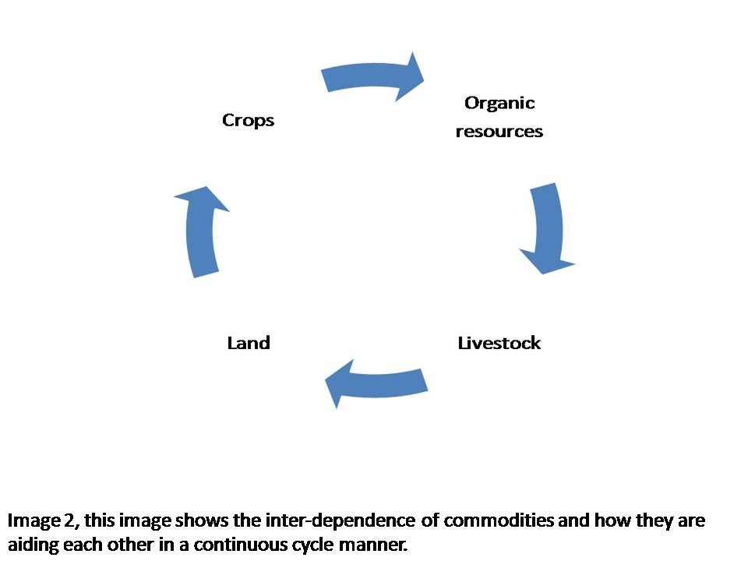
Figure 1: Inter-dependence of commodities in a cyclic manner
Rational
An effective way out of poverty is to use the crop residues rationally. The poor farmers, lacking adequate capital, the fair management of crop residues along an efficient allocation of scarce resources provide them with sustainable production.

Ecological sustainable
Integration the livestock with farming in an IFS is economically viable and ecologically sustainable. This maintains an ecological and economic balance, enhances agricultural productivity, and reduces the negative impact on the environment.
Scope of Farming System
- Various farming businesses include crops, livestock, poultry, fisheries, sericulture, etc.
- A careful planning and execution of combining one or more commodities with cropping gives a better income than a single commodity, especially to the farmers who are small and marginal.
- For a fruitful integration of the commodities that are to be integrated with cropping, the farm should be considered as one single unit.
Principles of the farming system
• Risk management.
• Recycling the wastes and residuals.
• Integrating two or more commodities.
• Rational utilization of resources.
• Maximizing productivity, output, and profitability.
• Ecological& Economical balance.
• Generation of potential for employment.
• Improving input use efficiency.
• Usage of end products from one commodity as an input in another.

Factors Influencing Integration of Farm Enterprises
- Soil and climatic conditions of the area.
- Easy and convenient availability of the resources, land, capital, and handiness of laborers.
- Current utilization of resources.
- Economics of the concerned IFS.
- Management skills of farmers.
Benefits or Advantages of Integrated Farming System
- High Productivity
- Highly Profitable
- Potentially sustainable
- Stabilized food
- Embracing the new technologies
- Managing and saving the energy
- Boon in fodder crises
- Solving the problems of fuel and timber
- Environmental safety
- Recycling
- Income generation around the year
- Increasing Employment potential
- Agriculture based industries
- Increased Input efficiencies
Farming System Concept
A farming system has
- INPUTS,
- PROCESSES and
- OUTPUTS
- Variability of the above-said processes depends upon the variability of the commodities in the farming.
- Income, alone from the arable farming itself, is insufficient for the majority of the small & and marginal farmers.
- Including the other systems in farming such as dairying, poultry, sericulture, fisheries, etc. is important in augmenting the farm income of the farmers.
Time and space concept
- Time concept depicts the increase in crop intensification under such situations where there are no limited inputs.
- In the areas, that are rain-fed, the possible increase in the cropping intensity is negligible. So, the modern concept i.e. space concept is applied in that area.
- Space concept depicts the arranging of crops in a tier system. In this, two or more crops with different field durations are inter-cropped by some modified panting methods.
- Income, alone from the arable farming itself, is insufficient for the majority of the small & and marginal farmers. Including the other systems in farming such as dairying, poultry, sericulture, fisheries, bio-gas production, etc. is important in augmenting the farm income of the farmers. It should be well fitted in with the farm infrastructure and should ensure the complete utilization of the by-products. IFS are the solution to various problems such as increasing food production, increasing the income of farms, and improving the nutritional quality and quantity for small & and marginal farmers with limited amount of resources.
Specific Objectives
- To identify the already existing farming system in specified areas and their access to relative viability.
- To delineate the models of various farming systems including main and allied commodities for varying farming situations.
- To ensure the optimum utilization and conservation of accessible resources and efficacious recycling of residues within the farm in a system.
- To maintain a system productive and sustainably without causing any damage to the resources or environment.
Goals of Integrated Farming System
- Providing consistent and stable income.
- To enhance the productivity off-arming system.
- To attain agroecological balance by reducing the proliferation of diseases and pests using managing the cropping system naturally and by the reduced use of chemicals (such as herbicides, in-organic fertilizers, and pesticides) (Kumar et al. 2018).

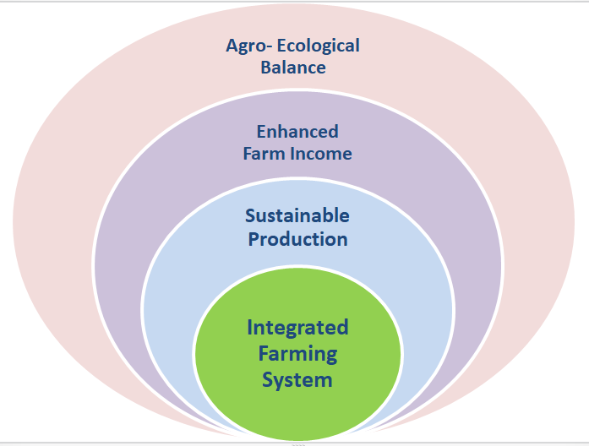
Figure 2: Goals of Integrated Farming System
Objectives of the farming system
1. High Productivity – The farming system does provide an opportunity to enhance economic yield per unit area per unit time through crop intensification and allied commodities. The Crop intensification through time concept and building up the vertical dimension through space concept encourages the economic yield in crops and allied commodities.
2. Highly Profitable – Farming systems also provide an opportunity for one commodity to use the by-product or waste produced from the other commodity as input at a very negligible cost. Therefore, due to the reduction in the cost of production, the benefit-cost ratio increases and leads to a highly profitable system.
3. Potential of sustainability –To achieve high sustainability, good soil health is required. However due to the unreasonable usage of agricultural practices viz., using chemicals excessively, intensive farming practices, etc., the soil health is deteriorating and thus sustainability. But in farming systems use of organic supplements such as manures and recycling of waste is effectively managed which provides a possibility to potentially sustain the production base relatively for a longer time.
4. Balanced & stabilized food – In farming systems, various enterprises are properly combined which leads to the production of different sources of nutritional values named proteins, carbohydrates, vitamins, fats &minerals, etc., on the same unit of land, this helps to solve the malnutrition problems prevailing among the small scale and marginal farming households.
5. Environmental safety – The primary essence of farming systems is to utilize or conserve the by-products or wastes produced in one commodity as input for another commodity and also use bio-control measures for controlling pests and diseases. These practices are eco-friendly and lessen the application of large quantities of chemicals, which are causing soil water and environmental pollution up to a fearsome level. Thus, IFS greatly reduces environmental pollution.
6. Liquid flow round the whole year- Unlike the mono-cropping conventional farming, it enables the liquid i.e. cash flow round the whole year to the farmers by providing the products for sale from various commodities like eggs from poultry, milk & and other dairy products from dairy, honey from apiculture, etc. This enables the increase in power of purchasing of the farmer and also creates an opportunity for them to invest in better and improved technologies ultimately, to enhanced production.
7. Manage and save energy –Fossil fuels are being exploited in excess from a better time now. If the exploitation continues at the same pace, there will be a great shortage of them by 2030 AD. The only way to cut this shortage is the adoption of the IFS. In IFS, organic wastes are effectively recycled to produce energy from the bio-gas plants. This mitigates the crisis to some extent.
8. Meeting the fodder crises –Various IFS include Alley Cropping or crop intensification with the fodder legume crops in it. This leads to the production of the fodder to the required extent and thus, the problems like nonavailability problems of fodder to various farming components such as livestock get reduced.
9. Aids in timber and fuel crisis –Currently the production of fuel wood and timber wood are 20mm³ and 11mm³ respectively which is much less than the estimated demand for fuel wood(360mm³) & and timber wood(64.4mm³). To meet the demand for wood the production needs to be increased severalfold. Adopting agro-forestry practices, and performing afforestation programs, in an IFS, helps in meeting the demand more effectively while conserving our natural ecosystem without any deteriorating effect on the main crop production and will reduce deforestation as well.
10. Generates Employment –Various farming systems and allied commodities significantly increase the requirements of the laborers. Thus, IFS aids in employment problems by creating enough potential for employment generation.
11. Scope for establishing agriculture-based industries –When IFS has reached the potential of commercial-level production, this leads to surplus value addition to the farm income which leads to the set-up of various agriculture-based industries.
12. Enhances input use efficiency –An IFS utilizes the resources of different components which leads to an enhanced input use efficiency and benefit-cost ratio.
Characteristics of integrated farming system
- Problem solving.
- Holistic Approach.
- Acknowledgement of the location-specific solutions of technology.
- Law weight on the technological knowledge systems that are native to India.
- Related to ‘bottom-up’ research Ideology.
- Law weight on the extensive on-farm practices & and it can be repetitive.
- Dynamic &have focus majorly on sustainable production.
Components of integrated farming system
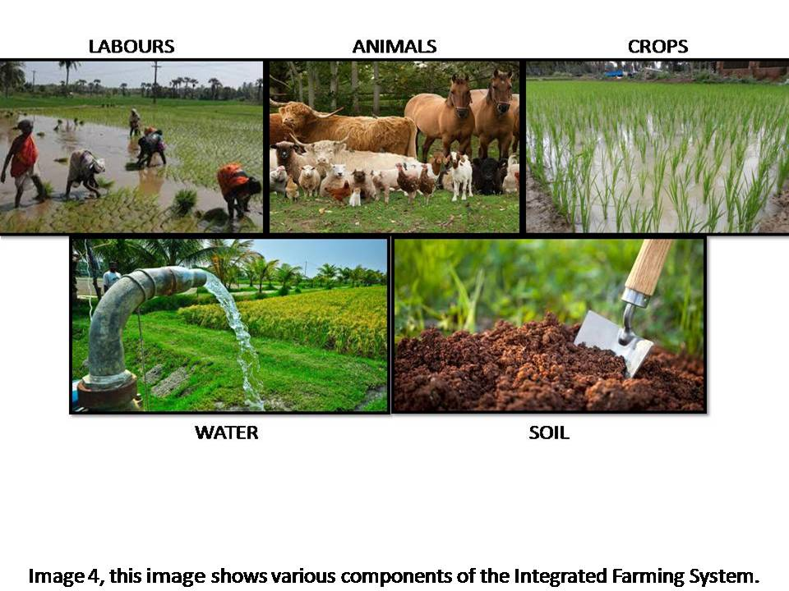
Figure 3: Various Components of the Integrated Farming System
- Major components are Crops, livestock, labor, birds, and trees.
- Crops might have sub-systems like mono-cropping, mixed or inter-cropping, and multi-tier cropping of cereals, legumes, oilseeds, etc. Livestock components are milch cows, goats, apes, poultry sheep, etc.
- Tree components include timber & and fuel wood, fodder trees fruit trees, etc.
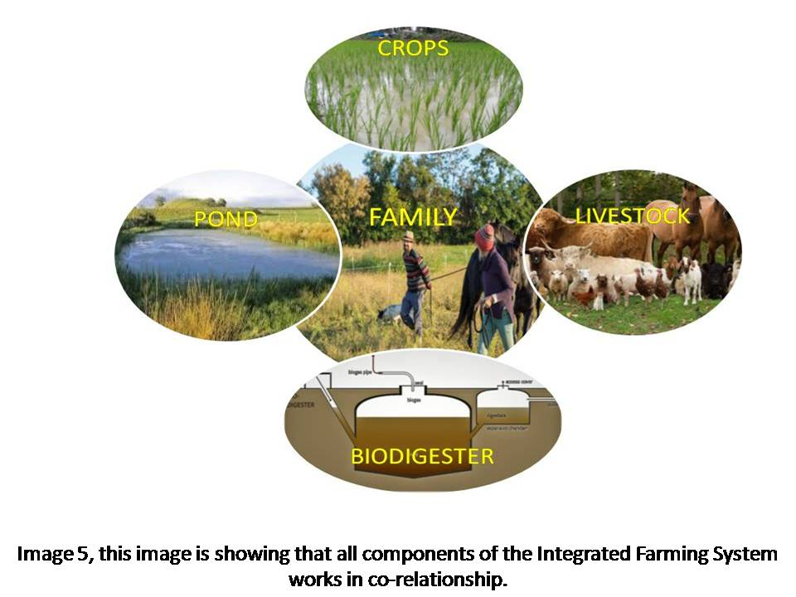
- These components are interrelated.

Figure 4: Co-relationship between the components of IFS

Farming systems:
Table: 1, various kinds of Farming Systems and their proposed integrated components.
Sr. No | Farming systems | Proposed components
1 | Crop + livestock | Crop + livestock/poultry/apiary/mushroom cultivation/seed production/fishery/horticulture/geometry/duckery/piggery/turkey/silviculture/lac culture/floriculture/agroforestry.
2 | Vegetable +livestock + crop | Olericulture + livestock+horticulture/Silviculture/sheep/rabiatry/apiary/mushroom cultivation.
3 | Silvipasture + livestock | Silviculture + livestock + crop + water management.
4 | Crop + poultry + livestock | Crop + poultry + livestock/fishery/poultry/piggery/horticulture/floriculture/geometry/duckery/rabiatry/apiary/piggery
5 | Fishery + crop +livestock | Fishery + crop + livestock +duckery/poultry/olericulture/horticulture/piggery.
6 | Fish + livestock | Fish + crop + vegetables + livestock + aromatic and medicinal plants
7 | Crop + livestock + agro forestry | Crop + livestock + agro forestry/apiary/goatry/poultry/orchard/floriculture/horticulture/olericulture.
8 | Plantation + Spices | Plantation +poultry spices/livestock/horticulture/multitier/high density Cropping/poultry/plantation + crop/agro forestry/duckery/fishery/piggery.
9 | Agro forestry + forage | Silvipasture + crop + livestock + rainwater harvesting
10 | Crop + livestock + horticulture | Crop + livestock +horticulture/goatry/poultry/olericulture/mushroom cultivation/seed production.
11 | Crop + horticulture | Crop + horticulture/goatry/mushroom cultivation/seed production.
12 | Crop + poultry + horticulture | Crop + poultry +horticulture/poultry/olericulture/crop/livestock/aromatic and medicinal plants/fishery/mushroom cultivation.
13 | Fishery + crop + horticulture | Fishery + crop + horticulture/poultry/olericulture/poultry
14 | Horticulture – based | Coconut + spices/crop/livestock/aromatic and medicinal plants.
15 | Livestock – based | Livestock + crop/poultry/olericulture/seed production/spices/goatry/horticulture/silviculture.
1. Suitable grain crops:
Crops should be selected based on the area and type of soil;
Red soil
Pulses: Greengram, Horse gram, Red gram, Cowpea, Soybean
Oilseeds: Castor, Groundnut, Sesame
Millets: Sorghum
Black soil:
Pulses: Horse gram, Red gram, Green gram, Soybean, Black gram, Chickpea
Cereals: Maize
Oilseeds: Safflower, Sunflower
Millets: Pearlmillet, Sorghum
Other crops: Chilli, Coriander
2. Suitable forage crops
Red soils
Fodder Pearl millet, fodder ragi, fodder cowpea, fodder cholam, vetiver, marvel grasses, curator, spear grass,
Black soils
Fodder Pearl millet, fodder sorghum, desmanthus, fodder cowpea, grassMayilkondaipul, Elusine sp.
- Suitable tree species
Red soils
Hardwickia, Tamarind, Neem, Simarouba, Casuarina, Kodaivel, Ber, Silk cotton, Indian gooseberry, Vagai (Ladies tongue), Acacia tortili, A.mellifera.
Black soils
Casuarina, Neem,Chilbil,Hibiscus, Gamhar, Karam (Haldu), Subabool, Karuvel,Acacia albida, A.tortilis.
4. Suitable livestock
Poultry, Goat, Black cattle, White cattle, Sheep, Pigeon, Quail and Rabbit.
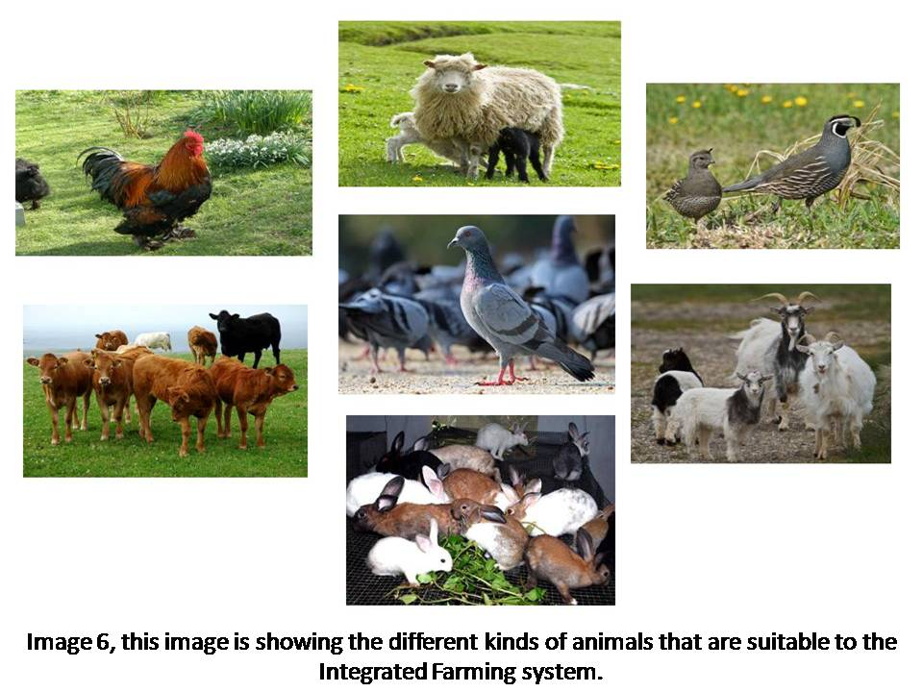
Figure 5: Different suitable livestock for the Integrated Farming System
The various agronomical approaches to make IFS overall highly productive and sustainable are:
- Adopting the new & and improved cropping systems based on the available rainfall and soil moisture.
- Select suitable food grain crop species and tree species that supply pods or leaves for a great period or around the whole year.
- The surfeit fodder leaves & crop residues etc. should be kept in preservation as silage or hay for the summer season through the rainy season.
The country is divided into different agro-ecological zones based on the site-specific resources available in the natural conditions of the different zones. IFS models are proposed with little modifications according to the conditions prevalent in the different zones and are also based on various research executed.
Difference between mixed and integrated farming
The difference between mixed farming and an Integrated Farming System is that components in the IFS are dependent on and supportive of each other. A mixed farming system includes components such as livestock and agriculture that coexist independently of each other. In this system integrating livestock and agriculture works to minimize the risk and not for recycling of resources whereas in an Integrated Farming System agriculture and livestock deal to create a symbiotic relationship with each other like recycling allows the maximum use of available resources. Residues from crops can be used for animal feeding whereas livestock and their production and processing of by-products can enhance the productivity of agriculture by improving the fertility of soil as well as reducing the use of chemical fertilizers(Csavas1992). High integration of livestock and crops is often seen as a step forward, but small farmers need adequate access to information, inputs, and assets to manage the system in a manner that is long-term ecologically sustainable as well as economically balanced (FAO, 2001). Tipraqsa (2006) reported that the difference between the IFS and the commercial farming system is not absolute, but instead it is a matter of the degree to which resources are incorporated into the farming system.
Mixed farming v/s Integrated farming system
Table 2: Difference between the Mixed Farming and Integrated Farming System
Difference | Mixed farming | Integrated Farming system
Aim | Subsistence and  welfare of mankind | Highly profitable and balances the environment and resources
Emphasis | On gross output | on system
Determinants of the farming system
Farming systems, in which farmers are to be engaged in, are determined majorly by the three groups of factors (A, B& C) of that specific site. These are;
Factor A: Depicts the Physical and biological constituents. These constituents set the limit according to the agricultural produce that is to be produced in the specific area. Physical constituents include topography, weather or climate, land quality & and soil health, water, etc. Biological constituents include cropping types and patterns, livestock physiology, etc Based on these constituents potential farm commodities are determined. These constituents can also be modified by the little mediation of farmers and scientists. For example, a new production technology evolved by scientists can be adopted by the farmers fully or partially.
Factor B: Depicts Endogenous human constituents. The type of FS, to be adopted, in the specific areas is chosen according to these. This system mainly concerns the farmer who works in his field with his family as laborers. The whole family controls and adjusts the quality and quantity of the available production resources which are land, capital labor, and their management. The adjustments are made according to the family characteristics viz. size, age, education, managerial skills, attitude, and the aim of the family. The type of FS is determined mainly by the aims and attitudes of the family specifically on the region having a wide range of different practices and commodities which further leads to an increase in the productivity of the farm. The available resources have to be used in such a combination that the maximum aims of the farmer are fulfilled.
Factor C: Illustrates the exogenous human constituents to which site-specific production resources are allotted to the farmers. Farm producers are motivated to adopt the changes in their traditional farming practices and production design to move in the better & beneficial directions.
Global trends related to Integrated Farming system
Industrialization of Agriculture
The build-up of industrialized single cropping Systems of agriculture at large scales often happens at the cost of an integrated farming system. Industrialization of single cropping system of agriculture started from the plantings by the European colonies between 1500 and 1800s (McMichael 2009, Perfecto et al. 2009), and went on expanding via agricultural mechanization in the late 1800s till the synthetic chemical introduction in agriculture in of 20th century. But later with the “Green Revolution” in the 1960s, new inventions were made in agricultural technologies which introduced the integrated system of using different chemicals (fertilizers, pesticides, etc.) and modified crop varieties having high yields and got promoted by the government and non-government agencies around the world (Evenson and Gollin 2003, Smil 2004). This continuous agricultural industrialization, in the next 50 years, resulted in increased use of nitrogen (eightfold) and phosphorus (tri-fold) ultimately the increased global production of fertilizers and pesticides(eleven-fold) (Tilman et al. 2001; Ramkumar et al. 2022; Dhole et al. 2023). The indiscriminate usage of pesticides created many hazards such as the development of resistance, residues on food crops, and contamination of the environment (Dhanapal et al. 2021; Dhanapal et al. 2022). This paves the way for the entry of biological control concepts that utilize predators (Dhanapal et al. 2019a; Dhanapal et al. 2019b; Murugasridevi et al. 2022), parasitoids, and entomopathogens (Dhanapal et al. 2019; Dhanapal et al. 2020a; Dhanapal et al. 2020b; Velavan et al. 2022). Synthetic plant growth regulators are also used to evade the moisture stress in crop plants, especially in rice (Ajaykumar et al. 2023). Bio-fuel production is also expedited by official directives for using bio-fuel as transport fuels, and land use systems and subsidies in developed and developing countries (Borras et al. 2011). Instead of all the difficulties, an estimate of 36 Mha land under use for bio-fuel production (specifically maize, cane, and oil crops) was made in 2008 by the World Bank, which was twice that in 2004 (Deininger 2011). Even after this many global plantations of bio-fuels, smallholder farming generated ten times greater employment (Holt-Gimenez 2007).
Smallholder agriculture
Regardless of the commercialization and industrialization of agriculture at a large scale, out of approximately 525 M farms around the world, 85% are smallholders. Even though they comprise most of the agricultural population most of the arable land is not under their possession and because of intensifying land disparities, the mean size of the farm is being decreased. This is putting them in more poor and more vulnerable conditions (Nagayets 2005). Regardless of poverty small farms contribute significantly to food production around the globe that is the integration of mixed crops and livestock produces 50% of cereal, meat 60% of, and dairy production 75% of the world's production. Much of which provides food to the 1 billion poor of the world (Herrero et al. 2010). Qualitative research shows the execution of “sustainable agriculture” or conservational practices in an integrated farming system (Netting 1993, Pretty et al. 2006). From IFS or such farms, 60-100% more productivity can be obtained, which potentially contributes to food security (local and global) (Pretty et al. 2006, Badgley et al. 2007). Organically produced local fruits, vegetables, and meat are high in demand in European countries, which encourages small-scale farms (Kristiansen et al. 2006, Pollan 2006).
SPECIAL FEATURE
The integrated farming system provides various critical inputs while maintaining a balance with the ecosystem, to farming such as soil quality, weed control, control over diseases and pests, pollination services, sequestration of carbon, mitigating climate change, production of food, and biodiversity. Kremen and Miles (2012) compared the integrated farming system with the conventional industrial system. This shows the significance of IFS in enhancing the ecosystem resources. He redressed the fact that the currency spent on the IFS is very small as compared to the conventional system and this gap can be filled by the investment which will result in more yield production and enhanced environmental benefits. Thus, there is a need for holistic research for integrating the various components of farming for the better management of the systems.
A crucial role of government policy, integrating the market demand and governance, in various farming systems, is depicted in a case study from California’s Central Valley, Mesoamerican. The findings of the study are that the IFS will provide better quality social benefits such as enhanced food security, healthier diets, and decreased exposure to pesticides. Certain market and political frameworks and economic policies for agriculture are needed to ensure a socially sustainable expedition of IFS and to attain environmental benefits by reducing costs.
There are certain barriers to adopting the IFS in modernized agriculture systems. Many examples have been taken into account that hasten the farmers’ choice to move toward IFS such are; the wider political context for industrialized agriculture, marketing conditions, and lack of knowledge in farmers. To even the odds, some new policies have to be made regarding the transformation of agricultural sciences and research, vast and deep learning of the processes, supporting farmers by providing subsidy and recruitment, starting new conservation programs for agriculture, and maintaining direct contact between the markets and the consumer. A meat industry in the U.S. was examined, in which ranching was found to be a sustainably ecological part of the industry. This illustrated certain important characteristics of integrated farming systems (Sayre et al. 2012). Rangelands are also seen as the best opportunity for its services such as habitat to wildlife, watershed management activity, recreation, and tourism. Thus, new incentives must look forward towards integrating the several components and easement of marketing programs to enhance the ranch income and to have cooperative behavior among the ranchers that will provide great support to the diversification. This special feature enables the integration and incorporation of different fields, thus, enabling a vaster analysis of various obstacles and opportunities that will, lately, impact sustainable farming and its multiple dimensions (Iles and Marsh 2012).
References
Ajaykumar, R., Murali Krishnasamy, S., Dhanapal, R., Ramkumar, G., Megaladevi, P., Manjubala, M., Chandrasekaran, P., Pradeeshkumar, T., Navinkumar, C. and Harishankar, K., 2023. Mitigation of abiotic and biotic stress using plant growth regulators in rice. Agronomy, 13(9), p.2226.
Badgley, C., Moghtader, J., Quintero, E., Zakem, E., Chappell, M.J., Aviles, K.-Vazquez, Samulon, A. and Perfecto, I. (2007). Organic agriculture and the global food supply. Renewable Agriculture and Food Systems, 22(02): 86-108.
Borras, S., Hall, R., Scoones, S., White, B., and Wolford, W. (2011). Towards a better understanding of global land grabbing: an editorial introduction. Journal of Peasant Studies, 38 (2): 209-216.
Csavas, I. (1992). Regional review on livestock-fish production systems in Asia. In: Mukherjee, T.K., Moi, P.S., Panandam, J.M., and Yang, Y.S. (eds.), Proceedings of the FAO/IPT Workshop on integrated livestock-fish production systems, Institute of Advance Studies, University of Malaya, Kuala Lumpur, Malaysia.
Deininger, K. (2011). Challenges posed by the new wave of farmland investment. Journal of Peasant Studies, 38(2): 217-247.
Dhanapal R, Kumar DVSR, Lakshmipathy R, Sandhya Rani C, Manoj Kumar R (2020a) Exploration of indigenous strains of the green muscardine fungus from soils and their pathogenicity against the tobacco caterpillar, Spodoptera litura (Fabricius) (Lepidoptera: Noctuidae). Egyptian Journal of Biological Pest Control 30:34. https://doi.org/10.1186/s41938-020-00239-8
Dhanapal R, Kumar DVSR, Lakshmipathy R, Sandhya Rani C, Manoj Kumar R (2020b) Isolation of indigenous strains of the white halo fungus as a biological control agent against 3rd instar larvae of tobacco caterpillar, Spodoptera litura (Fabricius) (Lepidoptera: Noctuidae). Egyptian Journal of Biological Pest Control 30:89. https://doi.org/10.1186/s41938-020-00286-1
Dhanapal R, Kumar DVSR, Lakshmipathy R, Sandhya Rani C, Manoj Kumar R (2019) Pathogenicity testing of indigenous isolates of the entomopathogenic fungus, Lecanicillium lecanii against tobacco caterpillar, Spodoptera litura. Journal of Experimental Zoology India. 22(2):753–756
Dhanapal, R., Babu, S. R., Kumar, A. (2019b). Predatory potential of lady bird beetle, Coccinella septempuntata (Linnaeus) on wheat aphid, Macrosiphum miscanthi (Takahashi). Journal of Experimental Zoology India, 22(2): 567-571.
Dhanapal, R., Kumar, A., Babu, S. R. (2019a). Coccinellid species complex in different crops at Varanasi region. Journal of Experimental Zoology India, 22(2): 521-525.
Dhanapal, R., Singh, R.N., Raghuraman, M., Mohan, M., Subaharan, K. (2021). Evaluation of predatory potential and prey stage preference of mirid bug, Nesidiocoris tenuis on tomato pinworm, Tuta absoluta. Biologia 76, 2965–2971. https://doi.org/10.1007/s11756-021-00786-x
Dhanapal, R., Sravika, A., Sekar, S., Ramesh Babu, S., & Gajalakshmi, M. (2022). Improving Insect Control Using Genetically Modified Entomopathogens. In New and Future Development in Biopesticide Research: Biotechnological Exploration, Springer Nature Singapore, pp. 223-242.
Dhole, R.R., Singh, R.N., Dhanapal, R., Singla, S., Ramkumar, G., Muthuusamy, R., Salmen, S.H., Alharbi, S.A., Narayanan, M. and Karuppusamy, I. (2023). Impact assessment of natural variations in different weather factors on the incidence of whitefly, Bemisia tabaci Genn. and yellow vein mosaic disease in Abelmoschus esculentus (L.) Moench. Environmental Research, 231, p.116209.
Evenson, R. E., and Gollin, D. (2003). Assessing the impact of the Green Revolution, 1960 to 2000. Science, 300(5620): 758.
Holt-Giménez, E. (2007). The biofuel myths. International Herald Tribune 10(July 10).
Herrero, M., Thornton, P. K., Notenbaert, A. M., Wood, S., Msangi, S., Freeman, H. A., Bossio, D., Dixon, J., Peters, M., van de Steeg, J., Lynam, J., Rao, P. P., Macmillan, S., Gerard, B., McDermott, J., Sere, C., and Rosegrant, M. (2010). Smart investments in sustainable food production: revisiting mixed crop-livestock systems. Science, 327(5967):822-825.
FAO. (2001). Recycling of organic wastes in agriculture. FAO Soil Bull., 40 - Rome. 13. Food and Agriculture Organization of the United Nations. Mixed Crop Livestock Farming: A Review of Traditional Technologies based on Literature and Field Experience. Animal Production and Health Papers, 152. Rome, 1977.
Iles, A., and Marsh, R. (2012). Nurturing diversified farming systems in industrialized countries: how public policy can contribute. Ecology and Society, 17(4): 42.

Jayanthi, C., Mythili, S. and Chinaasamy, C. (2002). Integrated farming system – A viable approach for sustainable productivity, profatibality and resource recycling under low land forms. Journals of Eco biology, 14(2): 143-148.
Kremen, C., and Miles, A. (2012). Ecosystem services in biologically diversified versus conventional farming systems: benefits, externalities, and trade-offs. Ecology and Society, 17(4): 40.
Kristiansen, P., Taji, A. and Reganold, J. (2006). Organic agriculture: a global perspective. CSIRO Publishing, Collingwood, Australia.
Kumar, S., Bhatt, B., Dey, A., Shivani, Kumar, U., Idris, M. and Mishra, J. S. (2018). Integrated farming system in India: Current status, scope and future prospects in changing agricultural scenario. Indian Journal of Agricultural Sciences, 88: 1661-1675.
Lal, R. and Miller, F. P. (1990). Sustainable farming system for tropics. In: Sustainable agriculture: Issues and Prospective. Vol. I (eds.) R. P. Singh., Indian Society of Agronomy, 68-89.
McMichael, P. (2009). A food regime analysis of the ‘world food crisis'. Agriculture and Human Values, 26(4): 281.
Murugasridevi, K., Dhanapal, R., Sekar, S., Tamilselvan, R. and Aravind, J. (2022). Biointensive Integrated Pest Management (BIPM) Approaches in Orchards. In Handbook of Research on Principles and Practices for Orchards Management, IGI Global. pp. 249-276.
Nagayets, O. (2005). Small farms: current status and key trends. In Research workshop and information brief for future small farms. International Food Policy Research Institute and Overseas Development Institute. Pp. 355-367.
Netting, R. (1993). Smallholders, householders: farm families and the ecology of intensive, sustainable agriculture. Stanford University Press, Stanford, CA, USA.
Perfecto, I., Vandermeer J. and Wright A. (2009). Nature's matrix: linking agriculture, conservation and food sovereignty. Earthscan, London, UK.
Pollan, M. (2006). The omnivore’s dilemma: a natural history of four meals. Penguin Books, New York, USA.
Pretty, J., Noble, A., Bossio, D., Dixon, J., Hine, R., F. W. T. P. De Vries and Morison, J. (2006). Resource-conserving agriculture increases yields in developing countries. Environmental Science & Technolology, 40(4): 1114-1119.
Ramkumar, G., Muthusamy, R., Narayanan, M., Dhanapal, R., Karthik, C., Shivakumar, M.S., Malathi, G. and Kariyanna, B., 2022. Pretreatment of mosquito larvae with ultraviolet-B and nitropolycyclic aromatic hydrocarbons induces increased sensitivity to permethrin toxicity. Heliyon, 8(10).
Sayre, N. F., Carlisle, L., Huntsinger, L., Fisher, G., and Shattuck, A. (2012). The role of rangelands in diversified farming systems: innovations, obstacles, and opportunities in the USA. Ecology and Society, 17(4): 43.
Sharma, L. R., Bhati, J. P. and Singh, R. (1991). Emerging farming systems in Himachal Pradesh: Key issues in sustainability. Indian Journal of Agricultural Economics, Bombay, 46(3): 422-427.
Smil, V. (2004). Enriching the earth: Fritz Haber, Carl Bosch, and the transformation of world food production. MIT Press, Cambridge, MA, USA.
Tilman, D., Fargione J., Wolff, B., D'Antonio, C., Dobson, A., Howarth,R., Schindler, D., Schlesinger, W.H., Simberloff, D. and Swackhamer, D. (2001). Forecasting agriculturally driven global environmental change. Science, 292(5515): 281-284.
Tipraqsa, P. (2006). Opportunities and constraints of integrated farming system in Northeast Thailand.A case study of the HuaiNong Ian catchment, KhonKaen Province.Ecology Development Series No. 35. University of Bonn.CuvillierVerlag, Göttingen, Germany.
Velavan, V., Dhanapal, R., Ramkumar, G., Karthi, S., Senthil-Nathan, S., Ndomba, O. A., & Kweka, E. J. (2022). Characterization and Evaluation of Metarhizium spp.(Metsch.) Sorokin Isolates for Their Temperature Tolerance. Journal of Fungi, 8(1), 68.

