Technical Sustainability of Rhinoceros in Kaziranga National Park
Ankit Mishra¹, Rajendra Kumar², C. S. Raghuvanshi¹*,
¹Department of Computer Science, FET Rama University, Kanpur-209217, U.P., India
²Department of Applied Physics, FET Rama University, Kanpur-209217, U.P., India

Abstract

Kaziranga is one and only great shelter of Indian one horned rhino. Which is an extinct species wild animal in India. Due to mismanagement & negligence, the growth rate of rhinos is very less in last few years. According to the census, 15-20 rhinoceros are hunted every year. A major tourism and wild attraction in kaziranga is one horned Indian rhinoceros. To sustain the tourism in Kaziranga, it is more important to maintain and preserve the growth of rhinos in future. To enhance the tourism continue in Kaziranga National Park, the various factors that effects the growth of rhino like poaching, flood, urbanization, drought & destruction of habitat have to be considered. A new emerging technology, Sensor network may play a prominent role in protection of rhino from above factors and will help to preserve the rhinos with several secure layers.
This paper recommends ways to improve the protection of rhino in Assam by using latest technology that determines the location & analyses the alive status of rhino. Updated information with reliable network can help to conserve this great tourism heritage.

Key words: Rhinoceros, Kaziranga National Park, Ping & Pulse sensor

Introduction
Kaziranga National Park is one of the biggest habitats of one horned rhinoceros in state Assam of India. Its latitude is 26°33’ N - 26°45’N and longitude is 93°9’E - 93°36’E. The park is spread in 430 Square Km. in Golaghat and Nagoan districts of the Assam. Kaziranga is approximately 40 km. from East to West and 13 Km from North to South. The temperature of Kaziranga in summer reaches more than 38 °C, and lowest is 7°C in winter. The annual rain fall is about 1,320 mm (87 in). During the rainy season three-fourth of the western area of park is being submerged in water. Due to rising water level of Brahmaputra, animals migrate towards southern region of Kaziranga. Kaziranga park has been granted protection & wild life conservation under the Assam Forest Regulation Act 1891 and Biodiversity Conservation Act 2002 [3]. Poaching of Rhinos for its horn is a major concern from last many decades. Kaziranga Park hosts two –third of the world’s great one-horned rhinoceros
In rhino family there are only five species – white rhinos & black rhinos are in Africa, one horned, Javan & Sumatran rhinos are in Asia. Horn is the distinction of the rhino but some time it may a salient cause of death especially in South Africa and Assam in India. Rhino horn has been used in medicine from last hundreds of years. Demand of horn in china, Japan & South Korean market is as a medicine, in Yemen used for carving of traditional dagger handles and used as body detoxifier from excessive consumption of alcohol drinks & junk food in Vietnam.
Due to paramount use of rhino horn is a root cause of high rate poaching, represent a serious case for concern and need for urgent action against it.
- Poaching of Rhinoceros -
Poaching is a major issue inside the Kaziranga National Park. Poaching of rhino was at high peak from year 1980 to year 2000. Average more than 40 rhinos were killed every year, in which more than 80% are killed in various protected areas due to devastating flood, and 20% are killed by poachers. The poacher kills the rare one horned rhino only for its costly horn, whose price in the international market varies from Rs. 40 lakhs to Rs. 90 lakhs. According to the report, from 1980 and continued up to 1990, more that 700 rhinos were killed by poachers. Poachers are acted not only in one region but also in all other protected rhino habitat like Pobitora Wildlife Sanctuary, Manas National Park and Rajiv Gandhi Orang National Park in Assam.

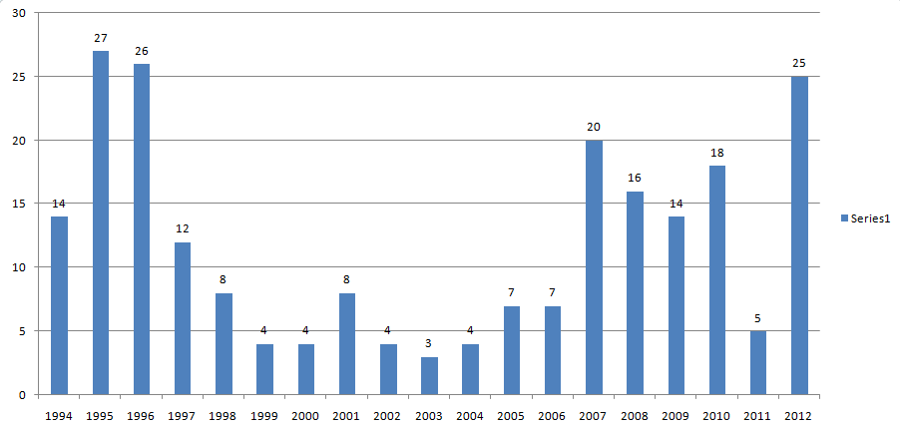
Figure 1: Rhino poaching in Kaziranga National Park from year 1994 to year 2012
Poaching of the Rhinos is a major issue not only in India but also in South Africa. In South Africa white rhinoceros and black rhinoceros or hook lipped rhinoceros are found. Before year 2006 poaching of rhinos was at very low level. But from 2008 onwards poaching of rhino in South Africa is at its extreme. Total 448 rhinos were killed in 2011.

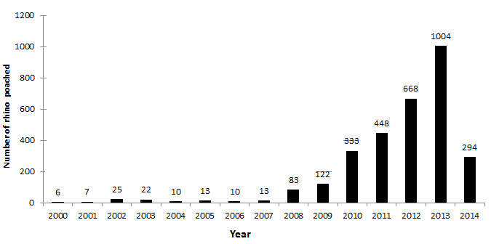
Figure 2: Record number of Rhinos poached in South Africa [2]

Horn of Rhino
In Greek, literally the mean of rhinoceros is “Nose Horn”. Rhino eats succulent leaves of the sparse plants and able to persist days without drinking water. Rhinoceros eyesight is very weak and is undetectable to any object at more than 100 ft. distance. But rhino’s hearing is very sensitive. In all extant species, black & white rhino’s have long horn. Black rhinos, white rhino and Sumatran rhino have two horns, but Indian rhino and Javan rhino have one horn. In two horn rhino’s, one horn can be 130 cm long and other one can be in between 2 to 55 cm long. Basically rhino’s horn grows maximum 7 cm per year from the base continually. It can be broken and regrows over a time period. Rhino horn is not a true horn because it has no bony core.
Rhino’s horn forms the conical shape due to high concentration of melanin & calcium salts in its center. Melanin increases the hardness & strength of the horn [4]. Rhino horn is used as ingredient in16 different medicines over the world. It is combined with other ingredients to prepare medicines for eye diseases, stomach ulcers and mental disorders. Water buffalo horn can be used as a substitute for Rhino horn because it is cheaper and easily available [2].
Horn of Rhinoceros is consisting of keratinized tubules of cells that is similar to the protein used in fingernails and hairs [4]. Horn can be easily operated in the upper portion or in middle part. So sensor can be placed inside the horn.
.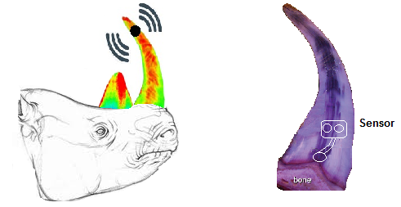
Figure 3: Sensor device placed on Rhino’s horn

- Deployment of sensors in Rhino’s horn
Poaching of rhino’s horn is seriously considered as misdemeanor offence. Many anti-poaching authorities have focused towards the protection of rhinoceros in Kaziranga National Park. Centre for Wild Life Rehabilitation and Conservation (CWRC) and State Forest Department of Assam is some of them. But having all these regardless efforts, the poaching of rhino is at extreme in last few years. To protect and conserve this inestimable and extinct species of the world, sensor technology may be used as a biggest mile stone. By using this methodology, not only poaching of rhinoceros can be under control but also other cause of death can be limited.
In this methodology, a small sensor device is placed in the horn of the rhinoceros that consist of two separate sensors. One is Ping Sensor and other is Pulse Sensor. Both sensor devices are connected to each other and work together. In this combined circuit device, the upper portion is Ping Sensor and lower portion is Pulse Sensor. Both sensors are connected within the circuit and placed in rhino’s horn. Device is kept inside the rhinos horn through the drill in middle of the horn.
A network will be maintained in all over the Kaziranga National Park or specified areas where rhinoceros migrates and poached. To maintain the network in the park, small transceivers would be placed at a certain distance through the poles and able to receive the pings send by the Ping sensor. These transceivers are connected to the Network Monitoring Office through wire or wireless. Every transceiver will have a IP address, that will be send to NMO with message and will help to detect the current location of horn by received pings. In this way a path can be traced through which the horn is carried by poachers.

  - Pulse Sensor –
Pulse sensor is self powered, sensitive electronic blood pulse sensor that is mounted on the pulse of living species. It emits the infra-red light by emitters, which is absorbed by blood constituents and detected by light detectors. It Combines the light detectors with light emitters in paired relationship that have angular & distance value for high signal output. It compensates the variation in flesh translucency and senses the blood pulse and provides the signals to the next function.
This Pulse Sensor will be in directly contact with the lower portion of the horn where pulse could be measured & being self charged by the pulse of the Rhino. Until the pulse is detected by the Pulse Sensor it would be in sleep state and will not pass any signal to the Ping Sensor.
When the rhino is poached and Pulse Sensor is being disconnected with the nerving system of rhino, Pulse is not detected by the Pulse Sensor; It becomes active and pass the signal to the Ping Sensor. As the input signals are received by the Ping Sensor, it will start functioning.
  - Ping Sensor –

Ping sensor is used to send the ping to the network. It is operated by a mall battery that can supply the power to Ping sensor for next 24 hours. Until the input signals are not received by the Pulse Sensor, Ping Sensor will be in dead condition. Battery will not be used in this dead condition.
As the rhino is poached and pulse is not detected by the Pulse Sensor, It will send the signal to the Ping Sensor. When input signal will received at Ping Sensor It will start to send the ping to the network maintained inside the park, at certain time intervals, by help of the battery that is connected once.
Table 1: Specifications of Ping Sensor [6]
Supply voltage | 5 VDC
Supply current | 30 mA
Range | 2cm to 3 m
Burst Frequency | 40 KHz for 200µs
Size | 0.84 in × 1.8 in × 0.6 in
Input trigger | Positive TTL pulse,115uS to 18.5 ms
Delay before next measurement | 200 µs

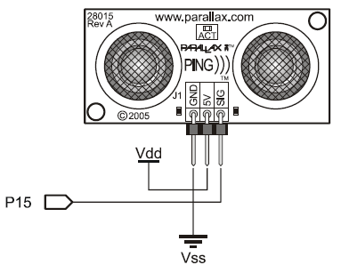
Figure 4: Circuit of Ping Sensor

In this circuit, sensor is connected to the breadboard, has three pins, one is GND pin connect to the Ground Vss, Vdd pin connect to the 5 volt and signal pin connect to the I/O pin 15. Black cable is used for GND, Red for 5 Volt and white for SIG [6].

- Preservation of Rhino from National Highway 37

National highway 37 starts from Golpara of the Assam and leads to Roing of Arunachal Pradesh. Total length of highway is 740 km and also known as Assam Trunk Road. Length of National Highway 37 inside Kaziranga park is 54 km & goes through the southern region and parallel to the park from Bokhaghat to Ghorakati.
Kaziranga National Park has heavy rain perennially and major flood. Due to which Rhinos migrates to elevated regions across the park boundaries and escape themselves by water logged regions. The annual rain fall is about 1,320 mm (87 in). During the rainy season three-fourth of the western area of park is being submerged in water. Due to rising water level of Brahmaputra, animals migrate towards southern region of Kaziranga curvy Anglong hills by crossing this National highway 37.
By the cause of heavy traffic moment on National highway 37, passing through Kaziranga National Park, several species of animal are hit ruthlessly. One horned rhino is one of them. Vehicular Ad- hoc Network technology can play a prominent role in the protection of rhinos in National Highway 37, passing through Park. In this process, Road Side Sensors are placed along with the road. Vehicles are embedded with sensor network devices connecting with Road Side Sensors. The location of rhino is detected by RSS and send to the vehicle. A warning message is send to other vehicles through vehicle to vehicle or RSS to vehicle communication.

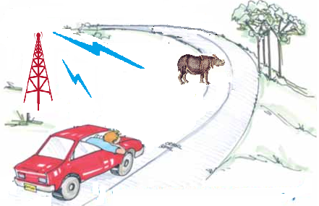
Figure 5: VANET in Kaziranga National Park

Conclusions and Recommendations
In Kaziranga National Park, Indian one horned rhino is a big attraction for Indian as well as foreign tourists. Poaching of the rhino is restrictly prohibitive according to the regulating authorities. Various protection agencies and local security teams are giving their best efforts to save the rhinoceros from illegal poaching. For that, number of security guards, advance self loaded weapons, and required facility is provided in last many years. But poaching of rhino is at its extreme level in last few years. So now, beside all these controlling issues, latest sensor technology should be implemented in coming years. This will help to protect the rhino not only from poachers but also other causes of death like road accidents, flood and drought.
References
[1] Mohammad J. P., G. Rama Murthy2, G. Praveen Babu, (2011) “VEHICULAR AD HOC AND SENSOR NETWORKS; PRINCIPLES AND CHALLENGES”, International Journal of Ad hoc, Sensor & Ubiquitous Computing, No.2, Vol.2.

[2] Cecilia Song and Tom Milliken, “The Rhino horn Trade in South Koria: still cause for concern” Pachyderm A publication of the African elephantsand Rhino specialist group, 1990

[3] "State of Conservation of the World Heritage Properties in the Asia-Pacific Region –Kaziranga National Park", UNESCO. Retrieved 2008-08-23.

[4] Tobin L. Hieronymus, Lawrence M. Witmer, and Ryan C. Ridgely, “Structure of white Rhinoceros Horn Investigated by X-ray Computed Tomography and Histology with Implications for Growth and External Form”. Journal of Morphology, pp. 1172-1176, 2006

[5] Rakesh soud, Simi Talukdar, “Contemporary Crisis of Rhinoceros in Assam”, Asian Journal of Conservation Biology,Vol. 2 No.1, pp. 82-83, July 2013.

[6] Ping Ultrasonic Distance Sensor (#28015),v1.3, PARALLAX, June 2006.

