Pro-drug developments and its Scope-
An Overview

Shilpa Kale¹, Kaveri M. Nannor² & Sachin B. Somwanshi³

- Research Scholar, Department of Pharmaceutics, PRES’s, College of Pharmacy (For Women), Chincholi, Nashik, MH, India-422102
E-mail: shilpakale2626@gmail.com
- Assistant Professor, Department of Pharmaceutical Chemistry, PRES’s, College of Pharmacy (For Women), Chincholi, Nashik, MH, India-422102
E-mail: kaverivaditake2014@gmail.com
- Associate Professor, Department of Pharmaceutics, PRES’s, College of Pharmacy (For Women), Chincholi, Nashik, MH, India-422102
E-mail: sachinsomwanshi27@gmail.com

Abstract
Prodrugs are bio reversible, inactive drug derivatives, which have the ability to convert into a parent drug in the body. Traditional prodrug approach aims to improve physicochemical/biopharmaceutical drug properties; modern prodrugs also include cellular and molecular parameters to accomplish desired drug effect and site-specificity. The prodrug approach is a powerful tool to decrease the time/costs of developing new drug entities and improve overall drug therapy. The development of prodrugs is presently well established as a strategy for improving the physicochemical, biopharmaceutical or pharmacokinetic properties of pharmacologically potent compounds and thereby overcoming barriers to a drug's developability and usefulness. Clinically, the majority of prodrugs are used with the aim of enhancing drug permeation by increasing drug lipophilicity and more recently to improve drug water solubility. In both drug discovery and development, prodrugs have become an established tool for improving physicochemical, biopharmaceutical or pharmacokinetic properties of pharmacologically active agents.

Keywords: Prodrugs, Biopharmaceutics, Drug absorption, Oral administration, Drug targeting.

INTRODUCTION

Powerful modern drug discovery techniques, such as combinatorial chemistry and high-throughput screening, enable the discovery of novel chemical entities with high pharmacological efficacy [1]. These techniques have also created a new challenge, as many of the new drug candidates have unfavourable physicochemical features and still require chemical modification or use of formulation technologies to achieve adequate performance and pass the rigorous drug development process successfully [2]. Targeted prodrugs have also been explored in oncology in order to minimize side effects and improve the tolerability of chemotherapy [3]. Prodrugs are also used to increase the duration of action of medicines, acting as chemical sustained release forms.[4]

CONTINUED NEED FOR PRODRUGS

Although the prodrug approach is advancing and reaching successes in providing effective medications to a variety of diseases it still needs the utilization of the sophisticated computational methods used for the design of drugs. Kinetics and thermodynamics for biological systems (active sites of receptors and enzymes, and etc.) that have bio medicinal interests have been intensively researched and have been proved to be fruitful. Today, quantum mechanics, such as ab initio, semi-empirical, and density functional theory (DFT), and molecular mechanics (MM) including docking are increasingly being utilized to characterize active sites of receptors and enzymes. These widely used methods have proven as successful tools for providing structure-energy calculations for an accurate prediction of potential drugs. [5]

THE PRODRUG CONCEPT

The prodrug concept is showed in figure No. 1. A drug whose usefulness is limited by adverse physicochemical properties, such that it is not capable of overcoming a particular barrier, is chemically modified via the attachment of a promoiety to generate a new chemical entity, the prodrug, whose properties are such that it is capable of traversing the limiting barrier. [6] Prodrugs can be developed for many routes of administration: oral, intravenous, intramuscular, inhalation, transdermal, and more. Numerous prodrug advantages and the number of registered prodrugs in the last decades demonstrate how invaluable this approach has grown to be.[7] Another exciting approach to prodrug targeting to specific tissues is the directed enzyme prodrug therapy (DEPT), which uses enzymes artificially brought into the body to activate the prodrug and release the active moiety. The chemical alteration of the parent compound is such that the change in physicochemical properties will affect the absorption, distribution and enzymatic metabolism. Such compounds have also been called bio reversible derivatives and congeners, but 'prodrug' is now the most commonly accepted term. [8]
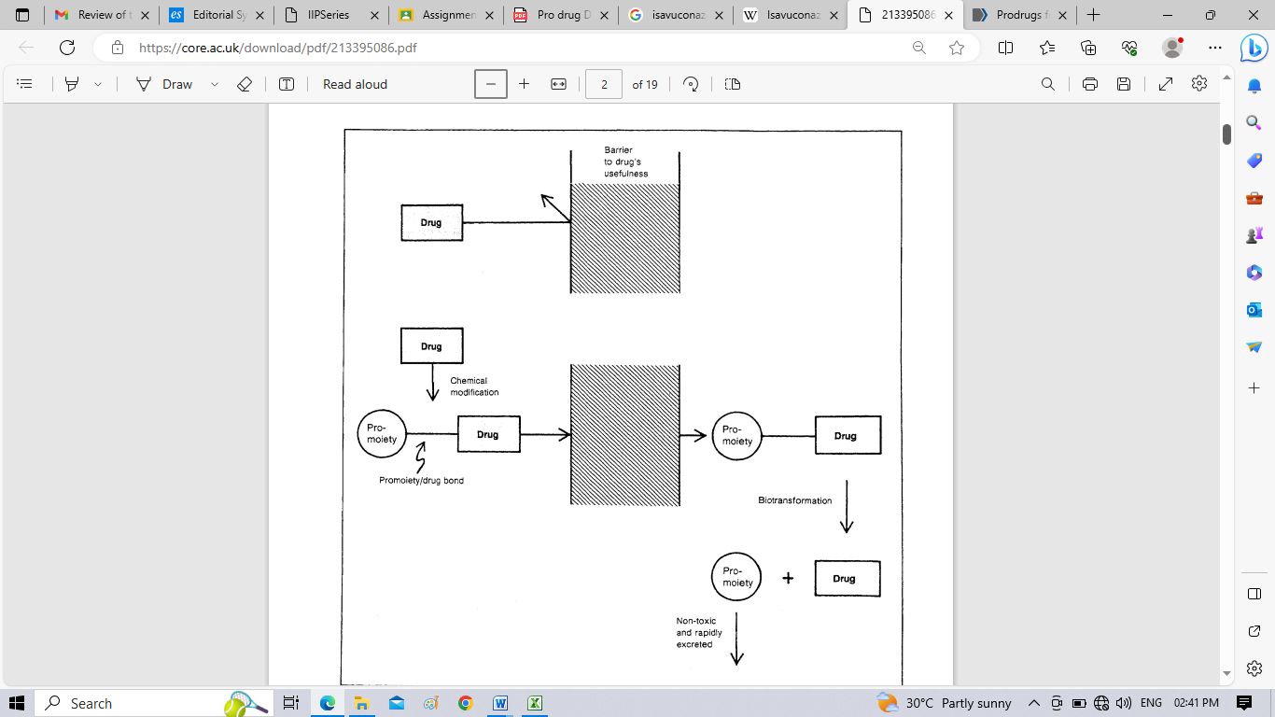
Figure No. 1: Schematic representation of the 'Prodrug' concept [9]

PRODRUG STRUCTURE

Table 1. Prodrug structures and their therapeutic uses [10]
Prodrug | Structure | Therapeutic Uses
Valacyclovir | 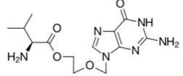 | Herpesvirus
Tenofovir alafenamide | 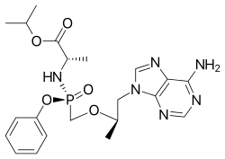 | HIV/AIDS and chronic hepatitis B
Isavuconazonium sulfate | 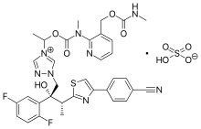 | Invasive Aspergillosis/Mucormycosis

Gabapentin enacarbil

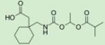
Restless leg syndrome, postherpetic neuralgi
Selexipag

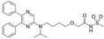
Pulmonary arterial hypertension
_{Prasugrel} Prevention of thrombotic and cardiovascular events
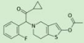

PRODRUG ACTIVATION

In oral prodrug delivery, significant challenges are the numerous absorption barriers and consecutive sites of potential metabolism on the way to the systemic blood circulation. A key issue with oral prodrugs is whether the prodrug will be activated before or after absorption and reaching the systemic circulation. Here, we present two examples of each approach and the importance of choosing the pre/post-absorption activation approach.[11] The most common of which is making a prodrug susceptible to abundant enzymes by functionalization with a group that can be cleaved to produce the active form of the drug. The prodrug approach to drug optimization offers chemical stability such as an inactive oral prodrug can be stable in the gastrointestinal tract and only be bioconverted by CYP450 in the liver, plasma, or GIT mucosal esterase, or other enzymes. Examples of this include phosphate groups which are susceptible to alkaline phosphatase, ester groups which are susceptible to esterases, and carbamates or amidine groups which are susceptible to amidases. Newer strategies include pegylation, which is used to increase cellular uptake, and dimer prodrugs, which are cleaved to two active moieties.[12, 13]

CLINICAL PRODRUGS FOR ORAL DRUG DELIVERY

Prodrugs are derivatives of active drug moieties, designed to undergo conversion in the body, thereby releasing the active parent drug. The prodrug approach is taken in order to overcome pharmaceutical, pharmacokinetic, or pharmacodynamic obstacles, such as low oral absorption, inadequate site specificity, poor stability, etc. In recent years, prodrugs have become increasingly popular and successful; to date, ~10% of the global marketed medications are prodrugs, 20% of all small molecular medicines approved between 2000 and 2008 were prodrugs, and when focusing on 2008, it emerges that over 30% of drugs approved in this year were prodrugs .[13]An interesting example of increased permeability (through increasing lipophilicity), as well as prodrug targeting, is demonstrated in recently approved antiviral drugs—tenofovir and sofosbuvir. Both prodrugs have been developed using a novel ProTide technology. The ProTide technology allows nucleotide analog delivery to the cells by masking the monophosphate/monophosphonate hydroxyl groups by an aromatic group of amino acid ester [14]. The prodrug approach is frequently utilized to increase drug absorption following oral administration. For that, the traditional/classic prodrug approach may be taken, e.g., to mask charged moieties and enhance drug lipophilicity and passive diffusion by various carboxylic acid esters, which release the active carboxylic acid after hydrolysis [15]

BARRIERS TO DRUG DEVELOPMENT

There are various other barriers that are not always recognised by endusers of a drug product that must be resolved before a new chemical entity can become a useful drug. Aliens and Simonis (1974) described the process of drug development as occurring in three phases: the pharmaceutical, pharmacokinetic, and pharmacodynamic phases. The pharmacodynamic phase, which involves the drug/receptor interaction, is not a phase where prodrugs are usually considered to act, although Bey (1978) has suggested that suicide substrates or Kc at inhibitor (compounds containing latent reactive groupings which are specifically unmasked by the action of target enzymes) can be considered as prodrugs [10, 16]. The pharmaceutical phase can be considered as the phase of development which occurs between the identification of a new chemical entity with measured or proposed therapeutic potential and its incorporation into a drug delivery system. The delivery system may be one of the traditional forms such as tablets, capsules, injections, creams/ointments etc., or one of the new drug delivery modes, e.g., transdermal delivery patches or implanted devices.
Two barriers in this phase to the development of a commercially usable drug product are:
1. The aesthetic properties of the new molecule may limit its usefulness, e.g., odour, taste, pain upon injection, gastrointestinal irritability, etc.
2. Formulation problems may become apparent, e.g., the drug is unstable, or because of its physicochemical properties, cannot be incorporated into a particular type of dosage form [17].

USE OF PRODRUGS TO OVERCOME PHARMACEUTICAL BARRIERS

The formulation of a new chemical entity with suspected therapeutic benefits requires that the drug be formulated into a delivery form that is chemically stable, free from taste and odour problems (particularly if it is for paediatric use or intended for parenteral administration), and the drug/formulation must be relatively free of irritation on administration. For intravenous usage, the drug should have adequate water solubility and remain in solution for sufficient time to permit administration of the complete dose [18].
The way in which alterations in the physicochemical properties of a drug, in the form of a prodrug can be used to prolong or control the drug action.
They include alterations in:
1. The degree and rate of absorption
2. The rate and extent of conversion of the prodrug to the active species 3. The rate and extent of protein or tissue binding
4. The degree of tissue or organ localisation, distribution and subsequent release from such sites. The development of prodrugs for the prolongation of therapeutic action has generally been avoided due to the inability to rationally predict the effect of the prodrug structural modification on the resulting pharmacokinetics. Future research will no doubt attempt to 'match' the delivery system with the drug or, if not possible, a prodrug to prolong drug action. The one area that has had some qualitative and predictive successes has been in the area of hormonal steroid and depot antipsychotic drug injections [19]

CONCLUSIONS

Prodrug design and synthesis are expected to change in the future through the use of different ingredients, which can significantly improve drug delivery, targeting or controlling the rate of prodrug activation and release of the active parent drug. There is large scope for prodrug development so that ease of formulation delivery can be done.

REFERENCE

1.Lipinski C.A., Lombardo F., Dominy B.W., Feeney P.J. Experimental and computational approaches to estimate solubility and permeability in drug discovery and development settings. Adv. Drug Deliv Rev. 2001; 46: 3–26.
2.Knittel J.J., Zavod R.M. Drug design and relationship of functional groups to pharmacologic activity. In: Lemke T., Williams D.A., Roche V.F., Zito S.W., editors. Foye’s Principles of Medicinal Chemistry. 7th ed. Wolters Kluwer Lippincott Williams and Wilkins; London, UK: 2013. p.51.
3. Najjar A, Rajabi N, Karaman R. Recent approaches to platinum(iv) prodrugs: a variety of strategies for enhanced delivery and efficacy. Curr Pharm Des. 2017;23(16):2366–2376.
4.Brams M, Mao AR, Doyle RL. Onset of efficacy of long-acting psychostimulants in pediatric attention-deficit/hyperactivity disorder. Postgrad Med. 2008 Sep;120(3):69–88.
5. 10. Karaman R. Prodrugs design: a new era. New York, USA: Nova Science Publishers, Incorporated; 2014.
6. Davies, G.E.; Driver, G.W.; Hoggarth, E.; Martin, A.R.; Paige, M.F.C.; Rose, F.L. and Wilson, B.R.: Studies in the chemotherapy of tuberculosis: Ethyl mercaptan and related compounds. British Journal of Pharmacology 11: 351-356 (1956)
7. Yang Y.-h., Aloysius H., Inoyama D., Chen Y., Hu L.-q. Enzyme-mediated hydrolytic activation of prodrugs. Acta Pharm. Sin. B. 2011;1:143–159.
8. Ho, N.F.H.; Park, J.Y.; Morozowich, W. and Higuchi, W.L: Physical model approach to the design of drugs with improved intestinal absorption; in Roche (Ed.) Design of Biopharmaceutical Properties through Prodrugs and Analogs, pp. 136-227 (American Pharmaceutical Association, Washington, DC 1977).
9. VJ. Stella, W.N A. Charman and V.H. Naringrekar, Prodrugs Do They Have Advantages in Clinical Practice? Drugs 29: 455-473 (1985)
10. Milica Markovic † , Shimon Ben-Shabat and Arik Dahan, Prodrugs for Improved Drug Delivery: Lessons Learned from Recently Developed and Marketed Products, Pharmaceutics 2020, 12, 1031
11. Sun J., Dahan A., Amidon G.L. Enhancing the intestinal absorption of molecules containing the polar guanidino functionality: A double-targeted prodrug approach. J. Med. Chem. 2010;53:624–632.
12. Karaman R. Prodrugs design: a new era. New York, USA: Nova Science Publishers, Incorporated; 2014.
13. Alanazi A.S., James E., Mehellou Y. The protide prodrug technology: Where next? ACS Med. Chem. Lett. 2019;10:2–5.
14. Bildstein L., Dubernet C., Couvreur P. Prodrug-based intracellular delivery of anticancer agents. Adv. Drug Deliv. Rev. 2011;63:3–23.
15. Beaumont K., Webster R., Gardner I., Dack K. Design of ester prodrugs to enhance oral absorption of poorly permeable compounds: Challenges to the discovery scientist. Curr. Drug Metab. 2003;4:461–485.
16. Ariens, E.J.: Molecular pharmacology, a basis for drug design; in Jucker (Ed.) Progress in Drug Research, Vol. 10, pp. 429-529 (Birkhauser Verlag, Basel 1966)
17. Roche, E.B. (Ed.): Design of Biopharmaceutical Properties through Prodrugs and Analogs (American Pharmaceutical Association, Washington, DC 1977a).
18. Bodor, N.: Novel approaches in prodrug design; in Bundgaard et al. Optimization of Drug Delivery, pp. 156-177 (Munksgaard, Copenhagen 1982).
19. Ho, N.F.H.; Park, J.Y.; Morozowich, W. and Higuchi, W.L: Physical model approach to the design of drugs with improved intestinal absorption; in Roche (Ed.) Design of Biopharmaceutical Properties through Prodrugs and Analogs, pp. 136-227 (American Pharmaceutical Association, Washington, DC 1977)

