EXPERIMENTAL ESTIMATION OF MINIMUM FLUIDIZATION VELOCITY FOR SILICA SAND BED AND ITS THEORETICAL VERIFICATION
Vishnu Prasad S¹ , Lenin Lal P¹, Sathish S^{1*}, Supriya S²**
¹Department of Chemical Engineering, Sathyabama Institute of Science and Technology, Chennai.
²Department of Chemistry, Sathyabama Institute of Science and Technology, Chennai.
*sathish.chemical@sathyabama.ac.in

ABSTRACT
In this report experimental estimation of minimum fluidisation velocity, carryover velocity, and pressure drop across the experimental setup for silica sand of different sizes (0.0003m, 0.0004m, 0.0005m) has been done. An experimental setup consisting of two glass column in which one filled with silica sand of bed height 30cm has been used. The medium used for the fluidisation was air at ambient conditions .The pressure drop and air flow rates were measured using pressure gauges at inlet and outlet of the column and rota meter respectively. The velocity (Air flow rate/cross sectional area) of the air passed was slowly increased. The corresponding pressure gauge readings were noted. At a certain velocity, the bed height of 30 cm height was observed to be increasing. This velocity at which maximum pressure drop was obtained was noted as the minimum fluidization velocity. The velocity was further increased to up to the silica sand getting carried over to the next column. This velocity has been noted as carry over velocity. The experiment was repeated for above mentioned particle sizes to obtain the same parameters. Theoretical validations of the above parameters were done using four correlations to examine which correlation is more or less matching with the experimental results.

Keywords: Fluidization; Minimum fluidization velocity; Carry over velocity; Pressure drop

INTRODUCTION
When a gas or liquid is passed through a solid bed at very low velocity, the particles will not move, and the pressure drop across the bed is given by the following equations
Kozeny-Carman equation

It is applicable for flow through solid bed at Reynolds numbers up to about 1.0
Burke-Plummer equation

An empirical at Reynolds number >1000 for pressure drop in packed beds


Ergun equation

An equation covering entire range of flow rates
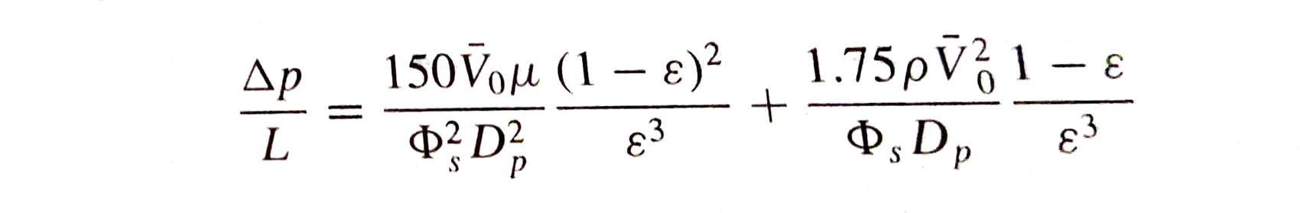
If the velocity of fluid across the bed is steadily increased, both the drag force acting on the particle and pressure drop across it will increase, and bed particles will start to move and eventually will get suspended in the fluid. Thus the fluidisation term is used to represent the particles in fully suspended condition, and the suspension will behave like a dense fluid.

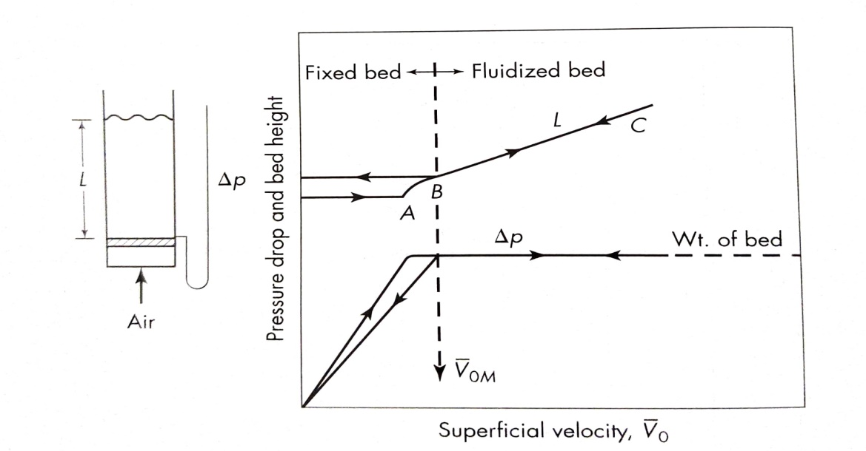
Fig.1 Superficial velocity versus Pressure drop and bed height for a solid bed

In Fig.1 we can see that the pressure drop across the solid bed is directly proportional to the superficial velocity and it increases as the velocity increases. But there will not be any change in bed height and the particles will not move. At a point, the pressure drop across the bed will become equal to the weight of the bed or the force of gravity on the particles.
From this point onwards, further increase in velocity will make the particle to move, this is represented by point A in the figure. The particles become separated from each other and will start to move about in the bed with further increase in velocity. This is represented by point B and is called as the point of fluidisation.
Once the bed is fluidised, the pressure drop across the bed will remain constant and at the same time bed height will continue to increase with the increase in velocity. The bed which is once fluidised will have a greater bed height than the initial once the velocity is reduced. This is because the solids dumped in a column will have more tightly packing than that of the fluid settling from fluidised state.
Minimum Fluidisation Velocity
The superficial gas velocity at which the particles are just suspended by the upward flowing fluid is called as minimum fluidisation velocity. It is represented as ͞V_{om.}
For Reynolds Number < 1, the equation for minimum fluidisation velocity is

For Reynolds Number >1000, the equation for minimum fluidisation velocity is


Correlations used
Wen and Yu

V͞_{om} = µ / ρ_{g} Dp * ((33.7²+0.0408 Ar) – 33.7)
Ar = g ρ_{g} (ρ - ρ_{g})Dp³ / µ²

Doichev &Akhamov

V͞_{om} = µ / ρ_{g} Dp * (1.08 * 10⁻³ * Ar^{0.947})
Saxena & Vogel
V͞_{om} = µ / ρ_{g} Dp * ((25.28²+0.0571 Ar) – 25.28)
Grace
V͞_{om} = µ / ρ_{g} Dp * ( (27.2²+0.0408 Ar) – 27.2
MATERIALS AND METHODS
The experimental set up consists of two identical cylindrical columns (Length-60cm, Dia-10cm, Thickness-0.5cm), in which one of the column is filled with silica sand up to a height of 30cm (50% of column height). Motive fluid used in the experiment was air which is admitted to the packed bed column through a rota meter. The outlet of the first column is connected to the second column which is open to atmosphere. Pressure gauges were provided at the inlet and outlet of the first column to obtain the pressure drop across it.
Experiment was started with low air flow rates, and it was gradually increased. Change in pressure drop across the bed was noted down from the pressure gauges provided. Air flow rate was further increased up to a point were bed height started to increase. This velocity was noted down and the velocity increased up to a point where the material got carried away to the next column. The experiment was repeated for three different particle sizes (0.0003m, 0.0004m, and 0.0005m).
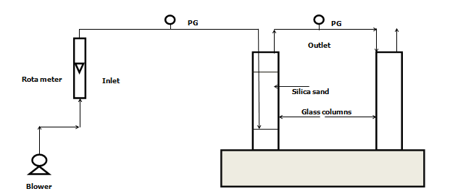
Fig.2 Schematic representation of experimental set up

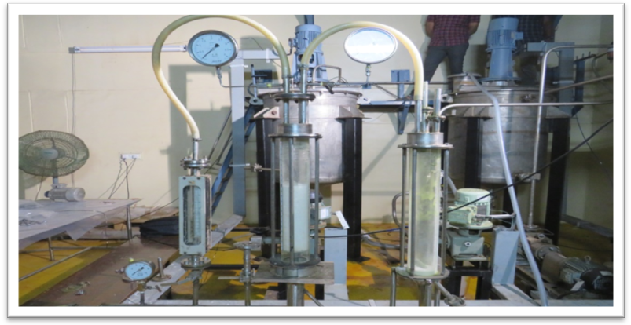
Fig.3 Experimental set up
Table.1 Typical Characteristics of Silica Sand
S. No. | Characteristics | Silica Sand
 | Specific gravity | 2.2 – 2.5
 | Bulk density | 2.4 - 2.6 gm/cc
 | Moisture content in the cake | 0.1 %
 | Sizes | 0.0003,0.0004,0.0005
 | Appearance | White crystalline
 | Chemical purity | Silica > 95% SiO₂
 | Hardness | 7-8 moh
 | Strength | 25 kg/cm²
Table.2 Sand Composition
S. No. | Component | Percentage (%)
 | Silica as SiO₂ | 97.48
 | Magnesium as MgCO₃ | 0.63
 | Iron as Fe₂O₃ | 1.14
 | Calcium as CaO | 0.14
 | Alumina as Al₂O₃ | 0.2

RESULTS AND DISCUSSIONS
Experimental outcomes
Three experimental runs for different particle sizes (0.0003m, 0.0004m, and 0.0005m) were conducted. As the air flow rate increased from zero, the pressure drop across the column started to increase with the same. At a certain flow rate the pressure drop across the bed became steady and the column bed height started to increase. This was noted as the point of fluidisation. This condition shows the point at which the gas velocity becomes high enough that the drag force becomes equal to the weight of the particle. Experimentally obtained results of minimum fluidisation velocity (V͞_{om}), pressure drop across the bed(Δ p), and carry over velocity were tabulated as below
Table.4 Experimental results of minimum fluidisation velocity and carry over velocity
Material | Dia  (m) | Minimum fluidisation velocity  (m/s) | Carry Over Velocity  (m/sec)
Silica Sand | 0.0003 | 0.0891 | 0.160
Silica Sand | 0.0004 | 0.155 | 0.283
Silica Sand | 0.0005 | 0.246 | 0.376

Table.5 Experimental results of pressure drop

Material | Diameter  (m) | Velocity  (m/sec) | Pressure drop  (kg/cm²)
SILICA | 0.0003 | 0.0445 | 0.021
SILICA | 0.0004 | 0.0775 | 0.036
SILICA | 0.0005 | 0.123 | 0.055

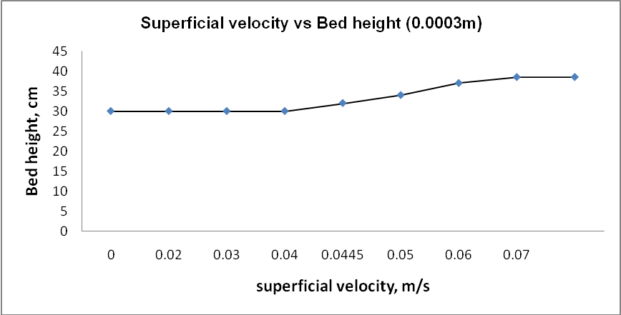
Fig.4 Superficial velocity vs Bed height (0.0003m
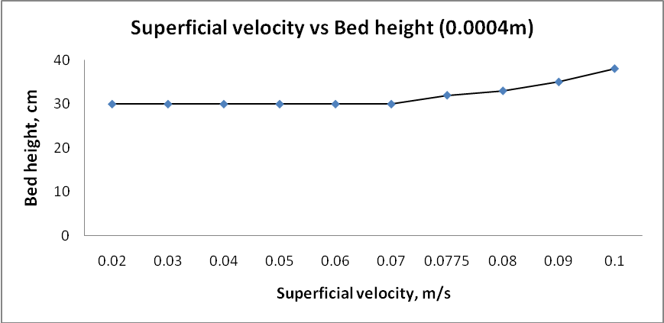
Fig.5 Superficial velocity vs Bed height (0.0004m)
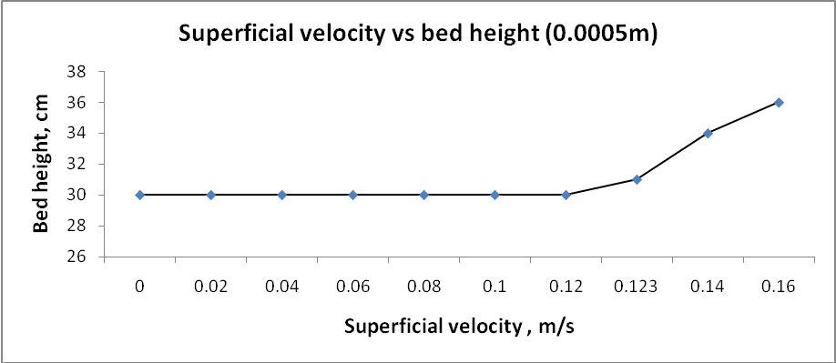
Fig.6 Superficial velocity vs bed height (0.0005m)
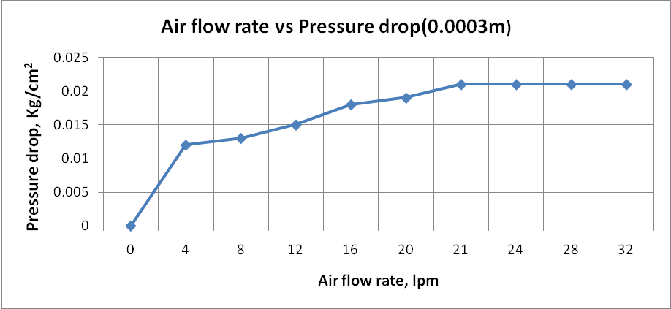
Fig.7 Air flow rate vs Pressure drop (0.0003m)
Fig.8 Air flow rate vs Pressure drop (0.0004m)

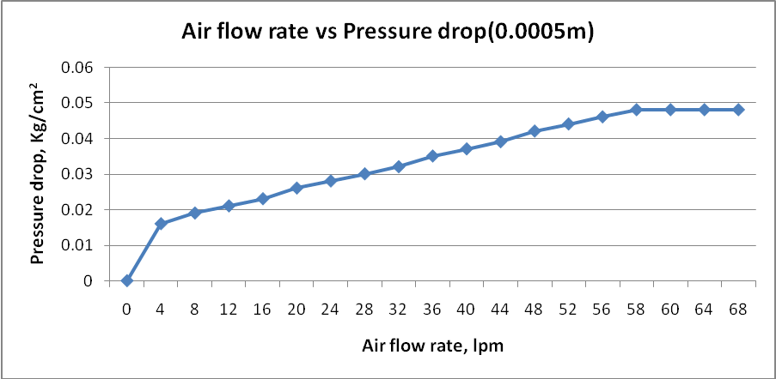
Fig.9 Air flow rate vs Pressure drop (0.0005m)

3.3.1 Pressure Drop
Table.7 Pressure drop theoretical vs practical
DIAMETER  (M) | THEORETICAL  (Kg/cm2) | PRACTICAL  (Kg/cm2)
0.0003 | 0.0257 | 0.021
0.0004 | 0.0259 | 0.0312
0.0005 | 0.0271 | 0.048

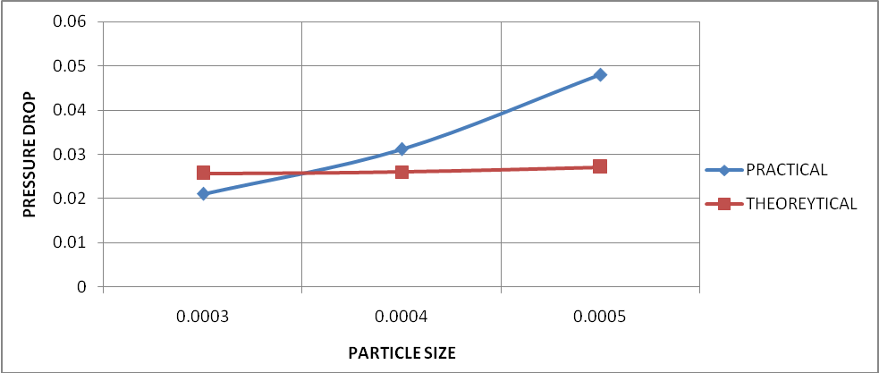
Fig10. Pressure drop theoretical vs practical

Minimum fluidisation velocity
Table.8Minimum fluidisation velocity Theoretical vs practical
DIAMETER  (M) | Theoretical models |  |  |  | PRACTICAL  (m/s)
DIAMETER  (M) | GRACE  (m/s) | WEN & YU  (m/s) | DOICHEV&  AKHMAKOV (m/s) | SAXENA&VOGEL  (m/s) | PRACTICAL  (m/s)
0.0003 | 0.0866 | 0.0706 | 0.0853 | 0.1280 | 0.0891
0.0004 | 0.148 | 0.1224 | 0.1449 | 0.2150 | 0.1550
0.0005 | 0.2194 | 0.1840 | 0.2185 | 0.3114 | 0.2460

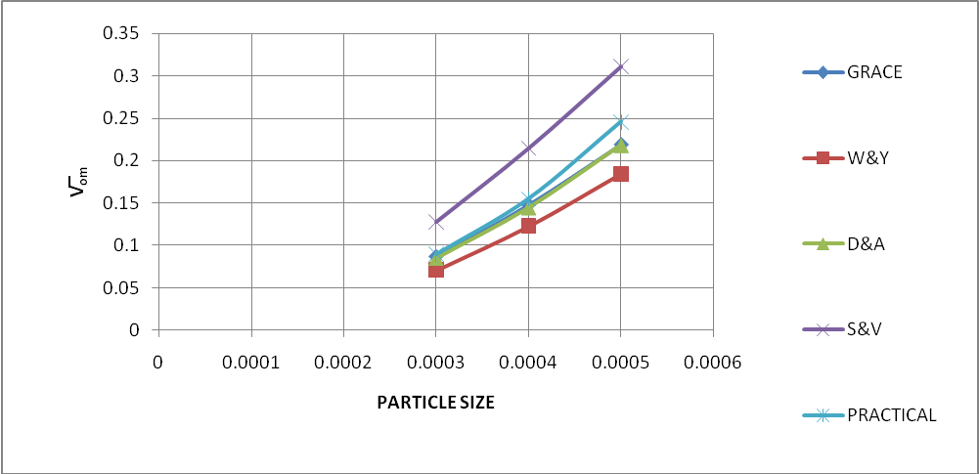
Fig 11. Minimum fluidisation velocity Theoretical vs practical

CONCLUSIONS
The experimental results show that the minimum fluidisation velocity (V͞_{om}) as well as the pressure drop (Δp) across the column increases with the increasing particle geometric mean size. This validates the nature of the theoretical results obtained. Out of four theoretical correlations used, experimental values of minimum fluidisation velocity (V͞_{om}) is more closely matching with Doichev & Akhmakov, Grace Correlations with a deviation of ~5%. It has been observed that the theoretical result obtained by Saxena & Vogel correlation is showing more deviation with the experimental results when compared with the other correlations. Practical values of pressure drop (Δp) obtained is observed to be having large deviation when it is compared with the theoretical results. This deviation may be due to the fact that a small change in porosity (ε) of the bed will have very large impact on ΔP. This makes it difficult to predict ΔP accurately and to reproduce experimental values after the bed is repacked. From the studies we can come to a conclusion that Doichev& Akhmakov, Grace Correlations are preferred for the plant scale minimum fluidisation velocity (V͞_{om}) calculations.
REFERENCES
- D. Kunii , A. Levenspiel , Fluidization engineering second edition, Elsevier, 2005
- D.C. Sau, S. Mohanty, K.C. Biswal, Experimental studies and empirical models for the prediction of bed expansion in gas–solid tapered fluidized beds,Chemical Engineering and Processing: Process Intensification, 49(4), (2010), 418-424.
- D.C. Sau, S. Mohanty, K.C. Biswal, Minimum fluidization velocities and maximum bed pressure drops for gas–solid tapered fluidized beds, Chemical Engineering Journal, 132(1–3), (2007), 151-157
- Depypere F., Pieters J.G., Dewettinck K. - Expanded bed height determination in a tapered fluidised bed reactor, Journal of Food Engineering 67 (2005) 353–359
- Epstein N., Pruden B.B. - Liquid fluidization of binary particle mixtures—III Stratification by size and related topics, Chemical Engineering Science 54 (1999) 401—415.
- Escudiéa. R., Epsteina. N., Gracea. J.R., Bi. H.T. - Effect of particle shape on liquid-fluidized beds of binary (and ternary) solids mixtures: segregation vs. mixing, Journal of Chemical Engineering Science 61 (2006) 1528 – 1539.
- Jena, H.M., 2009. - Hydrodynamic of Gas-Liquid-Solid Fluidized and Semi-Fluidized Beds, PhD thesis. National Institute of Technology, Rourkela
- Maureen A. Howley, Benjamin J. Glasser. - Hydrodynamics of a uniform liquid-fluidized bed containing a binary mixture of particles, Chemical Engineering Science 57 (2002) 4209 – 4226.
- Nidal Hilal, The dependence of solid expansion on bed diameter, particles material, size and distributor in open fluidized beds, Advanced Powder Technology,16(1),2005,73-86.
- S. Jing, Q. Hu, J.Wang, Y. Jin, Fluidization of coarse particles in gas–solid conical beds, Chem. Eng. Process.39 (2000) 379–387.
- S.H. Schaafsma, T. Marx, A.C. Hoffmann,Investigation of the particle flowpattern and segregation in tapered fluidized bed granulators, Chemical Engineering Science,61(14),(2006), 4467-4475
- Trambouze, P., Euzen, J., 2004. Chemical Reactor, from Design to Operation. Technip, Paeis.

