Exploring the Characterization of cantilever behaviour at its Fundamental Frequency Modes.

Dr. Sarita B. Dhoble
Department of E&C Engineering
Priyadarshini Bhagwati College of Engineering Nagpur,Maharashtra
saraj.rinke5@gmail.com

Dr.K.D.Ganvir
Assistant professor. Mechanical Engineering Department
Priyadarshini Bhagwati college of Engineering
Email: kanchan.ganvir100@gmail.com

Abstract — This paper presents micro-cantilevers characteristics when it targeted at multi-frequency signals . This is performed by keeping the cantilever beam at multiples of the frequency range. The analysis is carried out by putting a load at the end of a beam and study a moment, produced stress, and strain on the beam. The cantilever’s strain and stress measurement are useful to analyse various parameters of beam at the varying frequencies. The experimentation shows that the cantilever behaviour are changes with respect to change in frequency mode and shows different effect at low and high frequency.

Keywords — Cantilever, frequency, optimization,beam,characteristics.

- Introduction
Cantilevers is one of the useful part of mechanical engineering and have many applications, from the springboard at the pool to the structures in machine design & buildings. A cantilevered beam is a constructed by keeping a one end fixed and across the other a load is applied to measure a moment, strain and stress.The stress and the moment measurements are calculated based on the length of the beam, L, weight and the forced applied at the beam.

The aim of the optimization routine is to place several range of frequencies at integer multiples of the fundamental frequency. The proposed optimization routine provides a number of benefits over existing routines for cantilever designs. It provides the flexibility to place multiple modal frequencies simultaneously.

This includes both flexural and torsional modes of opeartion. To ensure that the design is feasible before carrying out the analysis, an image processing routine is applied to the cantilever topology. A region identification routine is applied to the binary matrix to find all the separate structures in the topology.
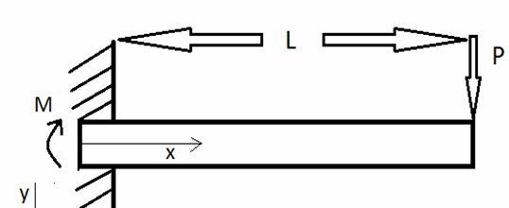

Figure 1: Cantilevered Beam with a length of L, applied force of P at the end of the beam, and the moment M.

- OBJECTIVE AND APPROACH

In this work, we report a very soft probe, which comprises a polymer-based cantilever with a sharp tip at its free end. To obtain biological parameters,we requred cellular characteristics in the model. A reliable three-mask surface- micromachining process that incorporates a low-cost assembly method and bio-compatible materials is developed to implement polymer-based cantilever probes. The physical properties of fabricated beam such as effective spring constant, resonant frequency, and quality factor are determined experimentally .

- DESIGN AND STRUCTURE

Figure 2 shows an isometric schematic, design parameters and values, and scanning electron micrographs (SEMs) of polymer-based triangular and rectangular cantilever probes. Fabricated rectangular prototype cantilever probes were integrated into the piezoelectric actuator of a commercial system.
The distance between the ridges and valleys was designed to be 2 μm, which is the minimum feature size that can be resolved by the contact printer used for this work. The width and length of Au and Cr at the tip
region were designed to be greater than 20 μm in order to reflect the laser light to the photodetector to track the cantilever motion.

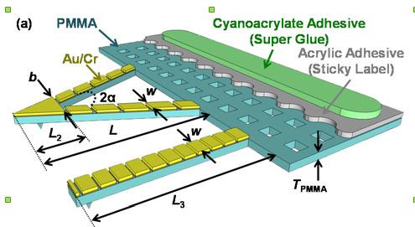

Figure 2: Isometric view of rectangular polymer-based cantilever probes.

IV. EXPERIMENTAL SETUP AND METHOD

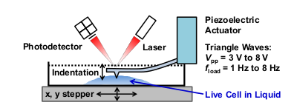

Figure 3: Experimental setup

A fabricated cantilever probes (with k eff ≌ 0.08 N/m) was employed in the nanoindentation measurements of live HeLa cells in a liquid culture medium using the testing setup .

Cantilever designs using optimization: Material properties used to model the cantilever are those of the silicon layer that are used to form the topology are 10 μm long and 10 μm wide. The dimension of the optimized cantilever model of the initial cantilever design is shown in figure 4. The algorithm is applied to demonstrates the initial cantilever
design at different range of frequencies. In the first model, it is difficult tofabricate cantilever due to its checkerboard
pattern. As a result, modifications are made in the next model where an area is preserved and allow to operate at different model frequencies.

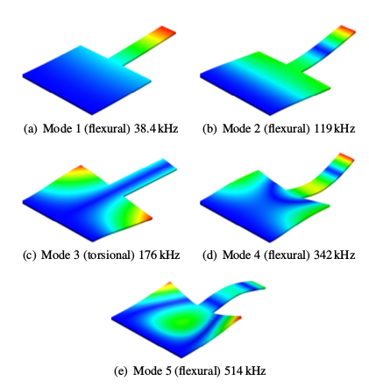

Figure 4: The cantilever modes of the initial cantilever topology

V. OBSERVATION

In order to analyse different charactristics and properties of the materials composing the cantilever,
simulation software is used to
calculated Coefficient values is shown in figure 5. The difference between the predicted and experimental values
has to process produced motion and strength parameters for analysis and to study performance behaviour.

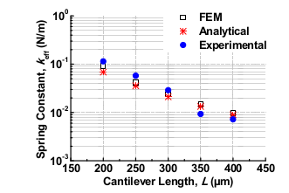

Figure 5: Experimental, analytical, and simulated k eff values of fabricated
cantilevers

VI.CONCLUSION
This work has outlined the design and characterization of cantilevers for multi-frequency applications. These cantilevers amplify the motion produced during the nonlinear probe-sample interaction forces. This work has used to demonstrates about behavioral routine for several modal frequencies simultaneously. Furthermore, the routine is simple to implement and it can be used to place both torsional and flexural modes. The experimental results show the accurate placement of mode 2, 3 and 4 in the first cantilever design and mode 2 and 4 in the second cantilever design.
At first it was difficult to get devices that are reliable. The devices had gone through dry etching, and releasing. fully experienced stress testing for prolonged periods without affecting their performance.

References

- [1] D. Müller and Y. Dufrene, “Atomic force microscopy as a multifunctional molecular toolbox in nanobiotechnology,” Nature nanotechnology, vol. 3, no. 5, pp. 261–269, 2008.
- [2] J. K. H. Hörber and M. J. Miles, “Scanning probe evolution in biology,” Science, vol. 302, pp. 1002– 1005, 2003.
- [3] D. Müller and Y. Dufrene, “Atomic force microscopy: a nanoscopic window on the cell surface,” Trends in cell biology, vol. 21, no. 8, pp. 461–469, 2011.
- [4] T. G. Kuznetsova, M. N. Starodubtseva, N. I. Yegorenkov, S. A. Chizhik, and R. I. Zhdanov, “Atomic force microscopy probing of cell elasticity,” Micron, vol. 38, no. 8, pp. 824–833, 2007.
- [5] K. Tomankova, P. Kolar, J. Malohlava, and H. Kolarova, “Mechanical characterization of HeLa cells
- using atomic force microscopy,” in Current Microscopy Contributions to Advances in Science and Technology, A. Méndez-Vilas, Ed. Badajoz: Formatex Research Center, 2012, pp. 549–554.
- [6] Q. S. Li, G. Y. H. Lee, C. N. Ong, and C. T. Lim, “AFM indentation study of breast cancer cells,” Biochemical and Biophysical Research Communications, vol. 374, no. 4, pp. 609–613, 2008.
- [7] H. J. Butt, B. Cappella, and M. Kappl, “Force measurements with the atomic force microscope: Technique, interpretation, and applications,” Surface Science Reports, vol. 59, no. 1, pp. 1–152, 2005.
- [8] S. A. S. Asif, K. J. Wahl, R. J. Colton, and O. L. Warren, “Quantitative imaging of nanoscale mechanical properties using hybrid nanoindentation and force modulation,” Journal of Applied Physics, vol. 90, no. 3, pp. 1192–1200, 2001.
- [9] J. Skommer, Z. Darzynkiewicz, and D. Wlodkowic, “Cell death goes LIVE: technological advances in real-time tracking of cell death,” Cell Cycle, vol. 9, no. 12, pp. 2330–2341, 2010. Wiesendanger R.: ‘Scanning probe microscopy and spectroscopy’, 1994, Cambridge University Press
- [10] Yong Y. K., et al.: ‘Invited Review Article: High-speed flexure-guided nanopositioning: Mechanical design and control issues’, Review of Scientific Instruments, 2012, 83, (12), 121101
- [11] Devasia S., Eleftheriou E., Moheimani S. O. R.: ‘A Survey
- of Control Issues in Nanopositioning’, Control Systems Technology, IEEE Transactions, 2007, 15, (5), pp. 802–823

