***Alternative System Of Health And Complementary Therapies..***

**Ruqeeb jan(Msc.Mental Health Nursing) tutor college of nursing ,GMC ,Srinagar,ruqeeb1235jan@gmail.com,8491864279/9622755489.**

**INTRODUCTION**

* Alternative/Supportive method of care have been defined as treatment techniques whose goals are to bring healing, taking into account the body mind spirit connection of every individual

(DOSSEY 1995)

* Complementary and Alternative Medicine is a diverse group of medical and health care system, practices & products that are not presently considered to be part of conventional medicine. ***Complementary therapies*** are those used in conjunction with conventional medical practices while ***Alternative therapies*** are used instead of conventional medicine.

National Center for Complementary and Alternative Medicine (NCCAM)

**ALTERNATIVE SYSTEM OF HEALTH**

* It is a complete system of theory and practice that evolved independently of Medical Intervention. It includes Ayurveda, Siddha, Unani, Homeopathy, Neuropathy, Traditional Chinese medicine, American Indian medicine.

1. **AYURVEDA**:

* It is a traditional medical system of India based on homeopathy & naturopathy with an extensive use of herbs. The word Ayurveda comes from Sanskrit word Ayur means ‘life’ & Veda means ‘knowledge’. According to it, disease results from the accumulation of toxins in the body and due to emotional imbalance. It uses individualized diets, detoxification, cleaning from orifices, meditation & yoga to remove the cause of disorders, prevent illness and harmonize body, mind and consciousness.
* Alternative Ayurveda treatments include nutrition, herbal remedies, aromatherapy, lifestyle modifications, messaging, meditation, and rejuvenation therapies.

**Tri-Dosha**

* Human beings are part of nature, Three fundamental energies that govern our inner and outer environments are responsible for the characteristics of our mind and body.These energies in Sanskrit are Known as Vata (Wind), Pitta (Fire), and Kapha (Earth).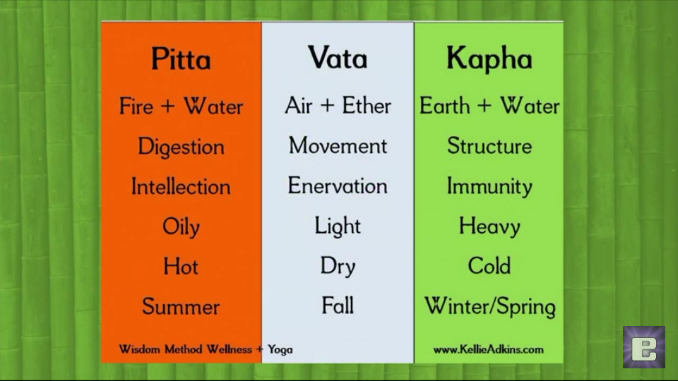

**Body Types**

Each of us has a unique proportion of these three forces that shapes our nature.

* Vata:- It’s predomination means,person tend to be thin, light, enthusiastic, energetic, and changeable.
* Pitta :- If it predominates person, tend to be intense, intelligent, and goal-oriented and tend to have a strong appetite for life.
* Kapha: If it prevails, person tend to be easy-going, methodical, and nurturing.

Each of us has all three forces, most people have one or two elements that predominate.

Each element, has balanced and imbalance expression. If Vata is balanced, a person is lively and creative, but too much movement in the system means, a person tends to have anxiety, insomnia, dry skin, constipation, and difficulty focusing. When Pitta is functioning in a balanced way, a person is warm, friendly, disciplined, and good leader. Pitta not balanced means a person tends to be compulsive and irritable and may suffer from indigestion or an inflammatory condition. Kapha balanced means a person will be sweet, supportive, and stable but imbalance means person may experience sluggishness, weight gain, and sinus congestion.

1. **YOGA**:

* Yoga is derived from Sanskrit word Yuj means to unite or to control. It is an ancient Indian practice that includes postures(asana) breathing exercises(pranayama) & cleansing practices (kriyas) to obtain a harmony of mind, body & spirit. Main branches of yoga are:

1. **HATHA YOGA**: Purifying physique and mind.
2. **KARMA YOGA**: Action.
3. **JHANA YOGA**: knowledge.
4. **BHAKTI YOGA**: Devotion.
5. **RAJA YOGA**: Controlling mind.

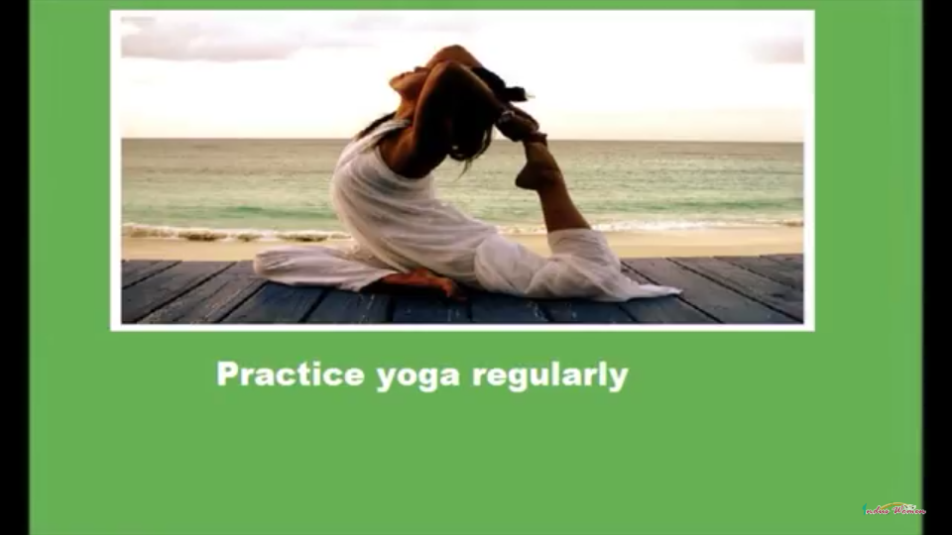

It is basically identification of soul(Atman) with its union with supreme being(Paramatma). Following eight steps are used for this purpose:

1. **Yama, means Self-control** which **is** obtained by chastity, non- stealing, non-violence, truthfulness & avoidance of greed.
2. **Niyama means Religious observance** through chanting of Vedic hymns, austerity, & purity.
3. **Aasana means Assumption of certain positions.**
4. **Pranayama means Regulation of breath** with controlled rhythmic exhalation, inhalation & temporary suspension of breathing.
5. **Pratyahara means Restrain of the senses.**
6. **Dharana means Steadying of mind ,** through fixation on some body part, such as nose.
7. **Dhayana means Meditation** on true object of knowledge, the supreme spirit.
8. **Samadhi means Profound contemplation**, with such complete detachment that there is insensitivity to heat & cold, pain & pressure.

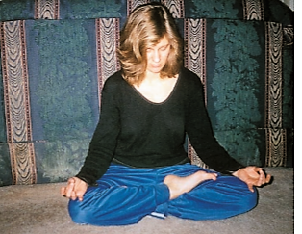

1. **UNANI AND TIBBI:**

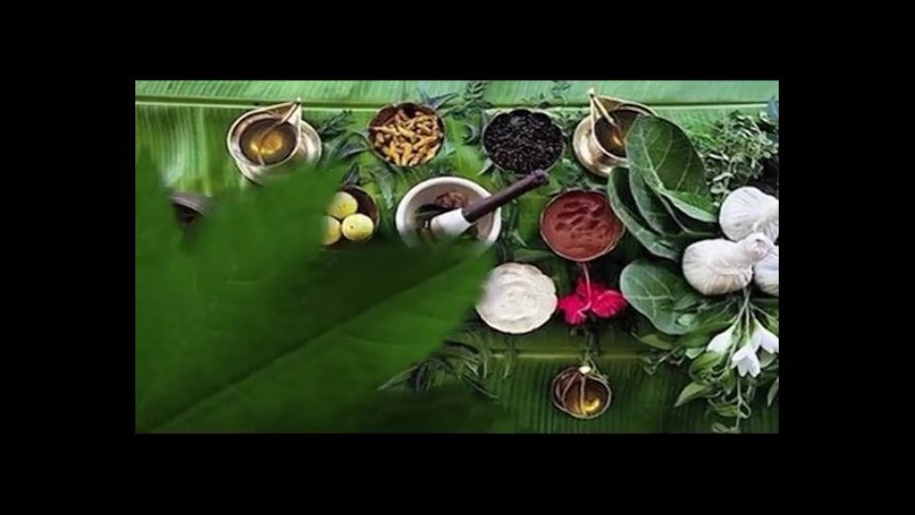

Unani Medicine has found approval in Asia especially India. Indian government approves Unani practitioners to practice as qualified doctor. Unani medicine is based on theory of the presence of the elements (fire, water, earth & air) in human body, and these elements are present in different fluids and their balance leads to health and their imbalance results in disease. This explanation is built on the basic Hippocratic theory of four humors( body of blood, phlegm, yellow bile & black bile). Each person’s unique mixture of these substances determine his temperament: Dominant of blood gives a sanguine temperament; Dominant of phlegm makes one phlegmatic; yellow bile, choleric & black bile, melancholic.

1. **SIDDHA:**

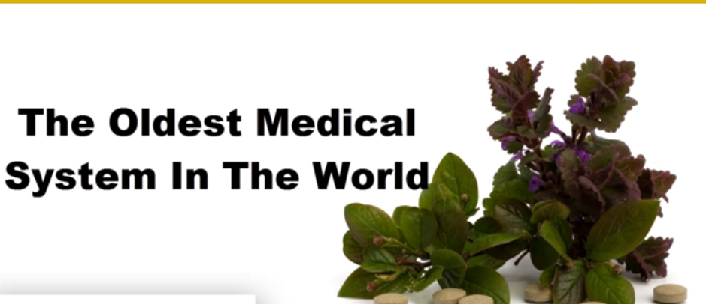

* Siddha medicine is an oldest, south India Tamil traditional medicine. It is a part of the trio Indian medicines Ayurveda, siddha &unani. Healthy soul can only be developed through a healthy body was concept of Saddharas. So they focused on strengthening person’s physical body and thereby their soul. The treatment is aimed at keeping the three humors in equilibrium and maintenance of seven elements. Focus is on diet, medicine & a disciplined regimen of life for a healthy living & to restore humors in diseased condition.

Four requisites of successful treatment are explained by Thiruvalluvar. These are the patient, the attendant, physician and medicine. Physician should be well qualified and the other agents should possess the necessary qualities, so that severe disease can be cured easily.

Siddha medicines could be further categorized into purgative therapy, emetic therapy, fasting therapy, steam therapy, physical therapy, solar therapy, yoga therapy etc.

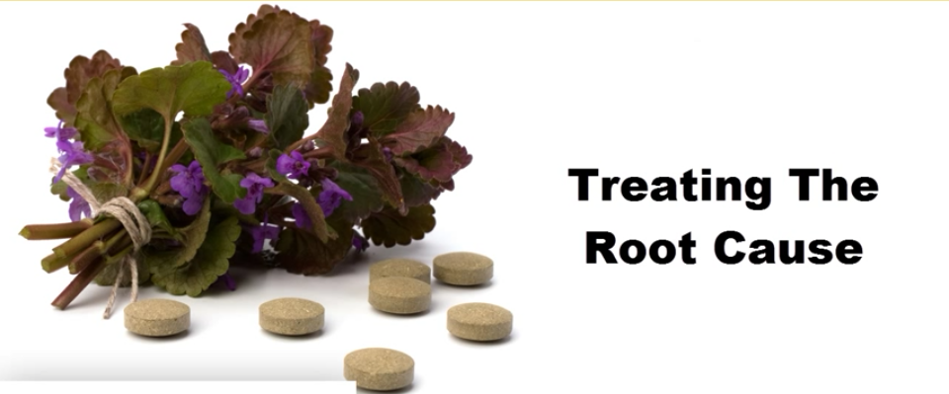

1. **HOMEOPATHY:**

This system of therapy was developed in Germany and is based on the concept that disease can be treated with drugs in minute doses which are capable of producing the same symptoms in healthy people as the disease itself, that means it is based on principal that “like cures like”. This system of medicine are taking original substance from plants, animals and minerals and highly diluting them. These medicines are used to stimulate body’s own healing ability. These remedies mobilize the body’s vital force to arrange co-ordinated healing responses throughout the body system. There is Rare risks of allergic or toxic reaction.

1. **NATUROPATHY**

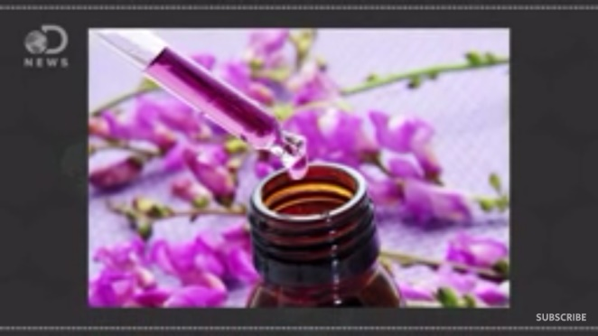

This system of medicine began as formal healthcare system in US in early 1990s and is based on preventive care. It uses heat, water, light, air, and massage as primary therapies for disease.It utilizes the body’s own natural healing powers to cure disease.It stresses the restorative powers of nature and reject synthetic drugs and invasive procedures . It believes that If body is in a healthy environment it will heal by itself.The body will repair itself & recover from illness spontaneously

**The following therapies are considered to be of primary importance in naturopathic treatment of disease.**

* **NUTRITION AND DIETETIC**: Naturopathic treatment of disease and hence includes the prescription of a balanced wholesome, natural diet.
* **FASTING**: It helps in utilizing the stored carbs and fats for energy. Digestive system gets rest and it helps body to fight infection, and remove toxins..
* **STRUCTURAL ADJUSTMENT**: the naturopathic practitioner seeks to balance and integrate the spine, muscles, ligaments and joints of the whole body by methods such as osteopathy, chiropractic, neuromuscular technique, postural re-education and remedial exercises.
* **HYDROTHERAPY**: Means use of water, both internally & externally in the form of baths, packs, compresses, sprays &douches. If rightly applied can give remarkable results in the treatment of both acute & chronic disease conditions.
* **HEALTHY LIFESTYLE**: This includes the general care of one’s body, the use of moderate physical exercise, the cultivation of a positive approach to life & health, relaxation technique, etc.
* **EDUCATION**: In naturopathic philosophy patient is given responsibility for his or her health. It focus to educate patient why disease occurs & what patient can do for himself or herself to maintain the new improved level of health given to them by naturopathic treatment
* **TRADITIONAL CHINESE MEDICINE:**

Chinese medicine is based on the theory that disease results from improper flow of life force (qi), that is restored by balancing the opposing forces, which manifest in body as heat & cold, external & internal & deficiency & excess. Various practices used to preserve & restore health are acupuncture, herbal remedies, massage, meditation.

1. **AMERICAN INDIAN MEDICINE:**

* Physical illness is attributed to spiritual cause or spirit. Healing involves getting individual rid of the impurities & restore to a healthful, spiritually pure state.
* **CHIROPRACTICE**: In chiropractic, the relationship between the structure of the spine & function of nervous system is thought to be the key in maintaining or restoring health. The main method for achieving balance is spinal manipulation. It is often useful in treating low back pain, headaches, & nerve impingement syndrome.

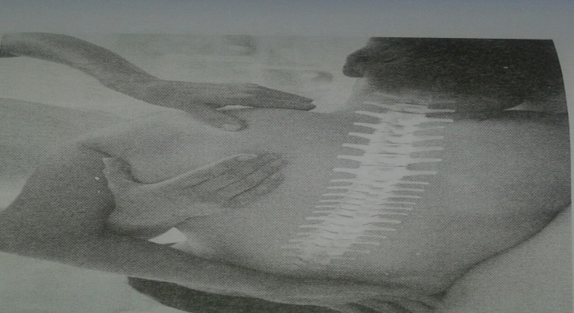

* **Tai Chi Qigong**: The discovery has big implication for patients who are suffering from chronic hypertension. Meditation, including Tai Chi Qigong therapy, leads to a relaxation response.
* **COMLEMENTARY THERAPIES:**

A wide range of treatments exist under the umbrella term Complementary Therapy. Some of the Complementary Therapies are as follows:

1. **HERBAL MEDICINE:**

* Herbal medicine has always attached some scientific interest & many well-known drugs are plant derived, e.g. digoxin foxgloves and morphine from poppies.

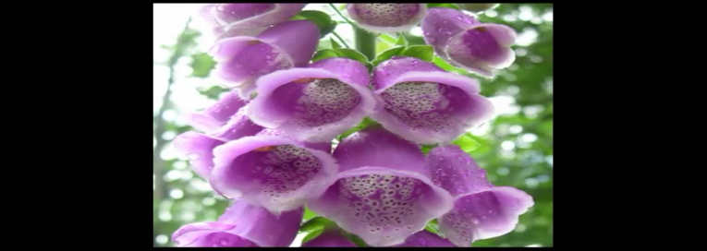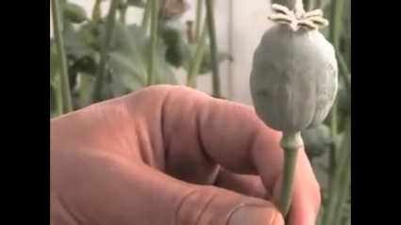

* **Here are some of the herbs commonly thought to be effective:**
* St johnswort (Hypericumperforatum) is a safe & effective treatment for mind to moderate depression.

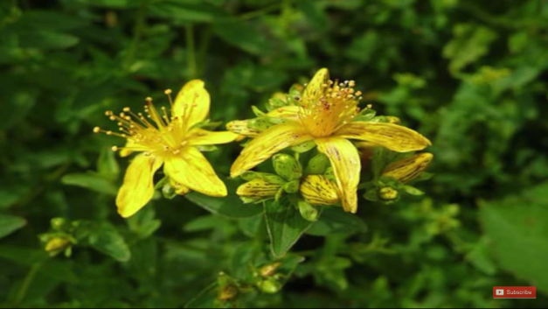

* Ginkgo Bilobia may be effective in relieving the symptoms of dementia.

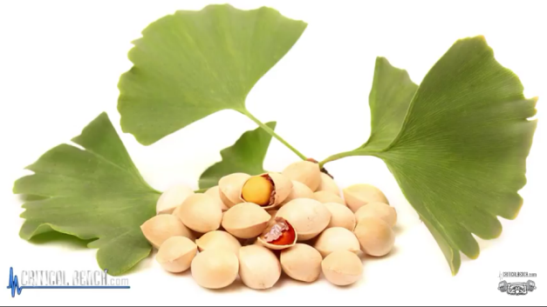

* Horse chestnut seed extract can alleviate the symptoms of varicose veins.

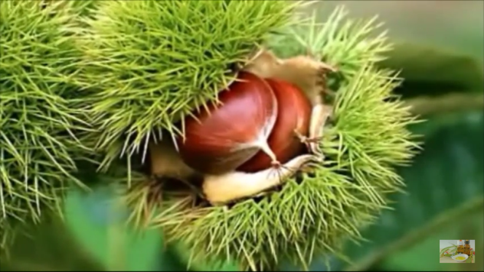

1. **MIND-BODY TECHNIQUES:**

* Mental & emotional factors can influence physical health. Behavioral, Psychological, social, spiritual methods are used to preserve health & prevent or cure disease. It includes the following methods.
* **MEDITATION:** Usually involves sitting or resting quietly, often with the eyes closed. Sometimes it involves the repetitive sounding of a phrase meant to help the person to focus.
* **RELAXATION TECHNIQUES**: bring out body’s relaxation response.. The specific technique may be aimed at reducing activity of the nerves that control stress response, lowering BP, easing muscle tension etc.
* **HYPNOTHERAPY**: People are guided into an advanced state of relaxation & heightened attention, people become absorbed in the images suggested by the Hypnotherapist & are able to suspend disbelief. It can be used to help people change their behavior & thus improve health or help treat purely psychological symptoms.

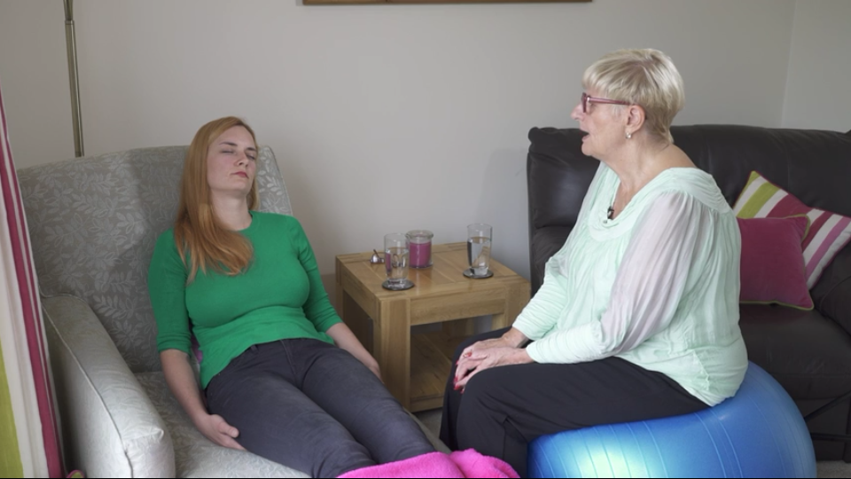

* **BIOFEEDBACK**: It is a method of bringing unconscious biologic process under conscious control. Biofeedback involves the use of electronic devices to measure & report back to the conscious mind information such as heart rate, BP, muscle tension, brain surface electrical activity. It has shown to be clinically effective in treating certain problems e.g. headaches, incontinence & attention deficit disorder.
* **ENERGY THERAPIES:**
* **MASSAGE THERAPY**: Manipulate body tissue to promote wellness & reduce pain & stress. Massage has been shown to help relieve muscle soreness, pain due to back injuries, & fibromyalgia & to help relieve anxiety in cancer patients.
* **ACUPUNCTURE**: A therapy within traditional Chinese medicine. Specific points on body are stimulated, usually by inserting thin needles into the skin & underlying tissues to unblock the flow of qi along energy pathway. Sometimes additional stimulation is added by using low voltage current. 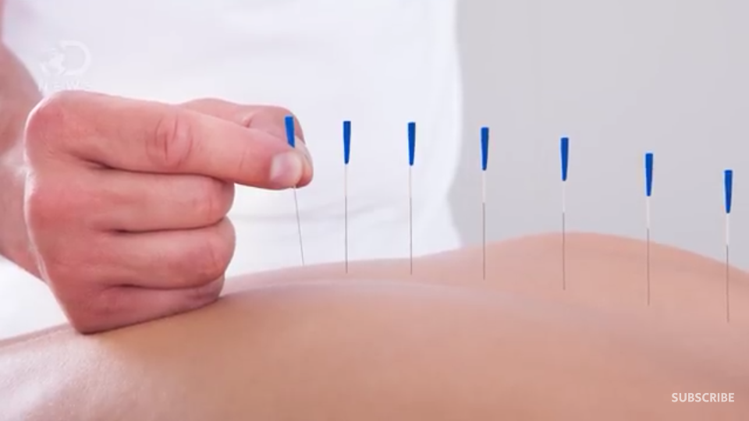
* **ACUPRESSURE**: A variation of acupuncture, called acupressure uses localized massage instead of needles to stimulate acupuncture points. It is used as an adjunct therapy to relieve pain & stress in a particular area of the body.
* **REFLEXOLOGY**: A variant of massage therapy relies on manual pressure applied to specific area of foot; these areas are believed to correspond to different organs or body systems via meridians. Stimulation of these areas is believed to eliminate blockage of energy responsible for pain or disease in the corresponding body part.

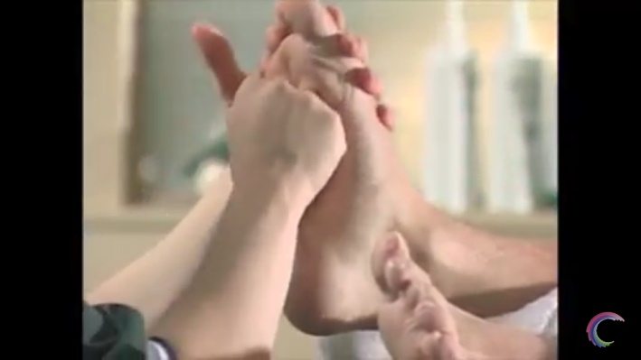

* **OTHER THERAPIES:**
* **AROMA THERAPY**: It is based on the healing power of plant oils which may be massaged into the skin, inhaled or used in the bath. This therapy massage relieves tension & improves circulation & can reduce anxiety.
* **SPIRITUAL THERAPY**: It treats the whole being especially the spirit to promote a healthy whole person. It includes faith & prayer.
* **MUSIC THERAPY**: It is an interpersonal process in which a trained music therapist uses music & all of its facets physically, emotionally, mentally, socially & spiritually to help clients to improve or maintain their health.
* **BIOELECTROMEGNATIC THERAPY**: It is the application of electromagnetic field to treat & prevent disease & promote health & longevity. Some of the documented effects of electromagnetic therapy include accelerated healing, greater cellular energy, increased blood flow, reduced inflammation &edema reduces stress etc.

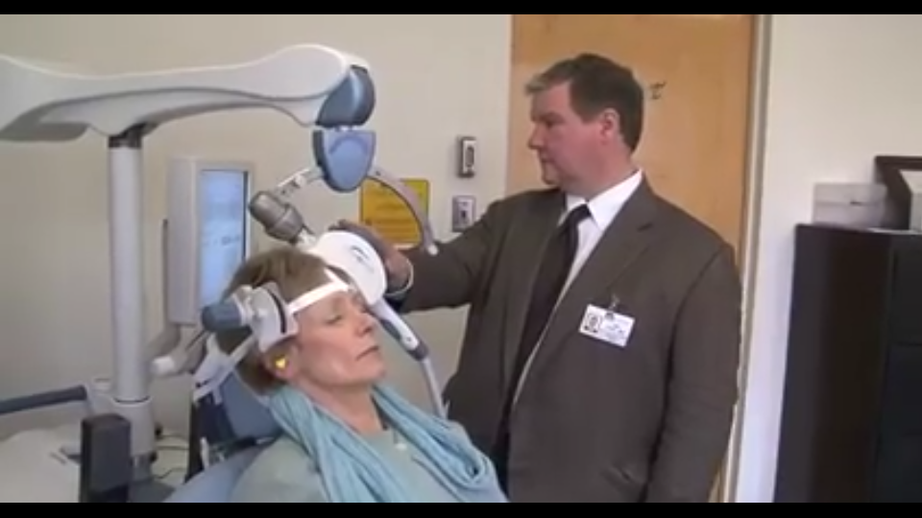

* **PHOTO ENERGY THERAPY**: Photo energy therapy devices emit near infrared light typically at a wavelength of 880nm. This wavelength is believed to stimulate the release of nitric oxide, an endothelium derived releasing factor into the blood stream, thus vasodilating the capillaries &vacuoles in the microcirculatory system. This increase in circulation has been effective to decrease pain in diabetic & non-diabetic patients.

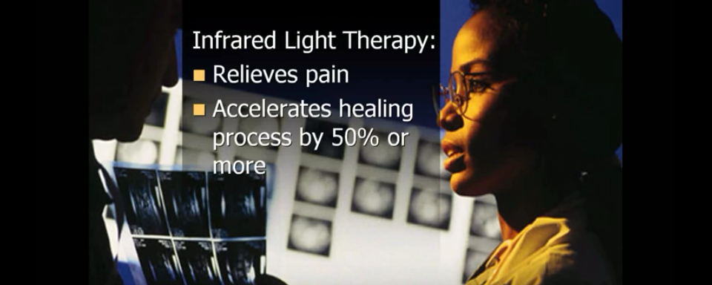

* **DETOXIFICATION THERAPY**: It involves the removal of toxic substances. Some of the methods of detoxification are colonic irrigation, fasting, special diets, hyperthermia, lymphatic stimulation & nutritional supplements like vitamin A, vitamin B&C, & minerals like magnesium.
* **ANIMAL ASSISTED THERAPY**: It is a type of therapy that involves an animal with specific characteristics becoming a fundamental part of a person’s treatment. It is designed to improve the physical, social, emotional, & other cognitive functioning of patient, as well as provide educational & motivational effectiveness of participants. This therapy improves fine motor skills, lower BP, decrease depression, increase self-esteem, reduce anxiety, develop leisure, reduce loneliness etc.

**BIBLIOGRAPHY**

* www.wikipedia.com
* www.medicinenet.com>main>mobileart
* Sreevani R. A Guide To Mental Health And Psychiatric Nursing.3rded.NewDelhi:jaypee brothers;2010:121-125
* Basheer S P,Yaseen S. A textbook of Advanced Nursing Practice.2nded. New Delhi:EMMESS medical publishers;2017:625-638 & 116-119