Advancements in Cancer Treatment: A Comprehensive Overview of Drug Delivery Methods
Stalin Arulsamy¹, Aswin James¹, Vaishnavi Vallinayagam¹, Rajaram Gayathri¹, Natarajan Kiruthiga^{1*}
^{a*}Natarajan Kiruthiga, Department of Pharmaceutical Chemistry, Faculty of KMCH College of Pharmacy, The Tamilnadu Dr. MGR. Medical university, Chennai, Tamil Nadu, India. E.mail: kiruthiga@kmchcop.ac.in, Orcid ID: https://orcid.org/0000-0002-7230-2003, Ph.No: 99941 43588.
Co Authors:
^{b}Stalin Arulsamy Department of Pharmaceutical Chemistry, KMCH College of Pharmacy, The Tamilnadu Dr. MGR. Medical university, Chennai, Tamil Nadu, India. E.mail: www.stalinpeter123@gmail.com, Ph.No: +91 6379330893
^{c}Aswin james, Department of Pharmaceutical Chemistry, KMCH College of Pharmacy, The Tamilnadu Dr. MGR. Medical university, Chennai, Tamil Nadu, India. E. Mail: aswin200801@gmail.com; Mob.No: +91 9843257807.
^{d}Vaishjnavi Vallinayagam, Department of Pharmaceutical Chemistry, KMCH College of Pharmacy, The Tamilnadu Dr. MGR. Medical university, Chennai, Tamil Nadu, India. E. Mail: vaish24103@gmail.com ; Mob.No: +91 9443246359
Abstract
Despite traditional chemotherapy has demonstrated certain levels of success, it is accompanied by several significant limitations. These include suboptimal absorption, high dosage demands, unpleasant side effects, low therapeutic indices, the emergence of multiple drug resistance, and non-specific targeting. The primary objective in the advancement of drug delivery systems is to effectively tackle these issues associated with drug administration and transport medications to the intended locations of therapeutic efficacy, while minimizing undesirable side effects. This chapter aims to examine the various materials employed as carriers for chemotherapeutic agents, focusing on their structural attributes that enhance the therapeutic effectiveness of the drugs. Additionally, recent scientific advancements in the field of chemotherapy will be discussed, with a particular emphasis on the challenges encountered in cancer treatments.
I. Introduction:
In modern medicine, drug delivery systems play a crucial role in revolutionizing the way medications are administered and enhancing the effectiveness of treatments for various medical conditions. These systems offer a range of benefits, from targeted drug delivery to improved patient compliance and controlled release of medications. By optimizing drug delivery, these advancements have paved the way for personalized medicine, tailoring treatments to individual patient needs and genetic profiles. Pharmacokinetics and pharmacodynamics are essential concepts in drug delivery, helping to understand how the body affects drugs and how drugs exert their effects on the body. Drug absorption, distribution, metabolism, and excretion are key aspects studied in pharmacokinetics to determine the appropriate drug dosage and dosing intervals for optimal therapeutic outcomes. Various routes of drug administration are utilized in medical practice, each offering unique advantages and implications. Oral, parenteral, topical, transdermal, and inhalation routes are some of the common methods used for drug delivery, each suited to specific medical conditions and patient needs. In the realm of cancer treatment, drug delivery systems have emerged as powerful tools to improve the efficacy of anticancer agents while minimizing side effects on healthy tissues.
Among the groundbreaking drug delivery methods are Radioactive Drug Delivery, Inhalable Drug Delivery, Gold Nanoparticle Drug Delivery, dendrimer drug delivery, folate receptor-targeted drug delivery, hyperthermia drug delivery, photodynamic therapy (PDT), ultrasound-mediated drug delivery, intra-arterial drug delivery, intralesional drug delivery, intrathecal drug delivery, nanorobots for drug delivery, magnetic drug delivery, viral vectors, drug-eluting devices, targeted therapies, antibody-drug conjugates (ADCs), polymer-based drug delivery, liposomes, and nanoparticle-based drug delivery.
Each of these methods harnesses cutting-edge technologies and scientific advancements to optimize drug delivery, making it more precise, effective, and patient-friendly. By understanding and utilizing the unique characteristics of these approaches, medical researchers and practitioners continue to pave the way for a new era of cancer treatment that holds the promise of improved therapeutic outcomes and a better quality of life for cancer patients.
In this comprehensive overview, we explore various drug delivery methods used in cancer treatment, including nanorobots, targeted therapies, antibody-drug conjugates, and more. Each approach holds the potential to revolutionize cancer treatment, offering new avenues for precision medicine and improved patient care.
II. Significance of Drug Delivery Systems in Modern Medicine: In modern medicine, drug delivery systems have become indispensable due to their numerous advantages. One of the key benefits is enhanced therapeutic efficacy through targeted drug delivery, which enables medications to be directed to specific sites in the body, maximizing their effectiveness while minimizing adverse effects on healthy tissues. Additionally, these systems promote improved patient compliance by offering convenient and patient-friendly methods of drug administration, such as extended-release formulations, which reduce dosing frequency and enhance treatment adherence. Controlled-release drug delivery systems further contribute to patient welfare by providing sustained therapeutic effects, decreasing the need for frequent dosing and maintaining stable drug levels. They also play a crucial role in protecting labile drugs from degradation, ensuring drug stability and activity until they reach their intended targets. Moreover, drug delivery advancements have ushered in the era of personalized medicine, allowing treatments to be tailored to individual patient needs and genetic profiles, thus optimizing therapeutic outcomes and providing more patient-centric healthcare solutions. These multifaceted advantages collectively underscore the significance of drug delivery systems in modern medical practice [1,2].
III. Pharmacokinetics and Pharmacodynamics: Pharmacokinetics and pharmacodynamics form the foundation of drug delivery, governing how the body processes medications and how they interact with their targets. Pharmacokinetics involves drug absorption, distribution, metabolism, and excretion (ADME), guiding optimal dosing intervals and dosages for desired therapeutic effects. Drug absorption depends on factors like formulation, route of administration, and physicochemical properties. Following absorption, drugs are distributed throughout the body, influenced by blood flow, tissue binding, and solubility. Drug metabolism, primarily occurring in the liver, transforms drugs into metabolites, affecting their activity (Fig.1). Subsequently, drug excretion eliminates drugs and metabolites from the body, often through urine, feces, or breath. [3,4].
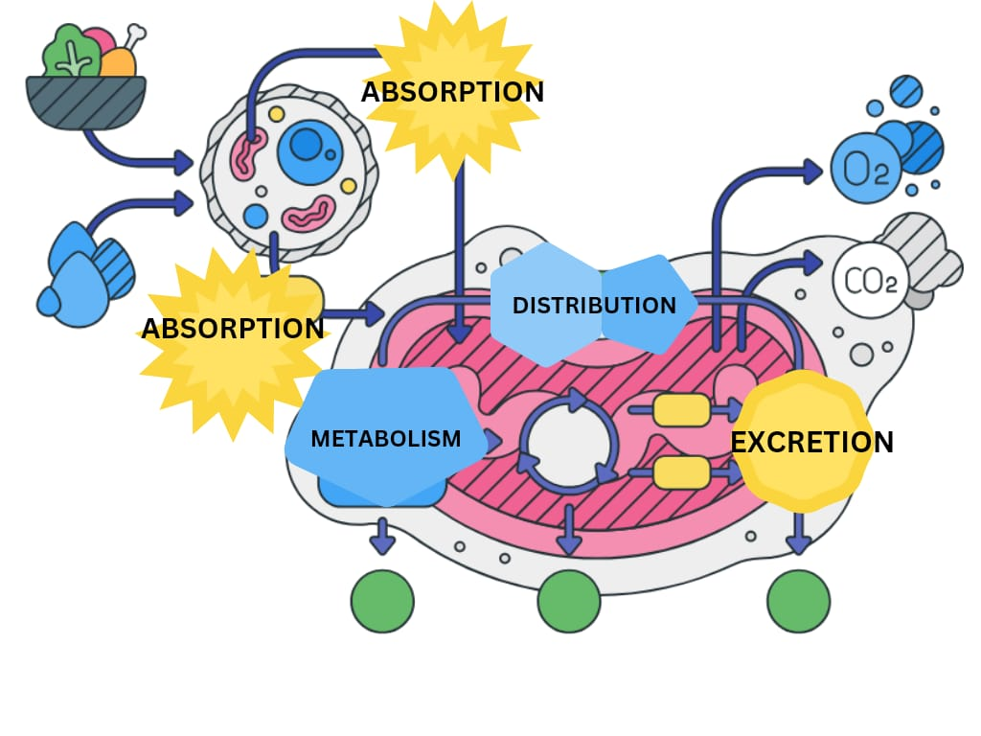
Fig.1. Pharmacokinetics of Drug core
IV. Routes of Drug Administration: Various routes of drug administration such as oral, parenteral, topical, transdermal and inhalation routes each offering unique advantages and implications are some of the common methods used for drug delivery. Various routes of drug administration are crucial for delivering medications effectively, with each method offering distinct advantages and implications. The oral route is the most common and convenient, involving the ingestion of medications in the form of tablets, capsules, or liquids. However, drug absorption can be influenced by factors such as gastrointestinal pH, enzymatic activity, and first-pass metabolism in the liver, affecting bioavailability. On the other hand, parenteral routes, which include intravenous, intramuscular, and subcutaneous injections, deliver drugs directly into the body, bypassing the gastrointestinal tract and ensuring rapid absorption. This route is particularly useful for patients who cannot take medications orally or require immediate effects. Topical administration involves applying medications directly to the skin or mucous membranes, providing localized effects and minimizing systemic side effects. Transdermal drug delivery, through patches applied to the skin, offers the advantage of controlled and sustained drug release into the bloodstream over an extended period, making it suitable for drugs with poor oral bioavailability. Inhalation route, on the other hand, delivers drugs directly to the respiratory system, which is highly effective for treating respiratory conditions, and allows rapid absorption through the extensive capillary network in the lungs Each of these drug administration routes offers a valuable contribution to the arsenal of drug delivery methods, catering to diverse patient needs and therapeutic objectives [5].
V. Influential Factors in Drug Delivery and Bioavailability: Several factors exert significant influence on drug delivery and its bioavailability. One key determinant is the drug formulation, encompassing solubility, particle size, and stability. A well-designed formulation can enhance drug absorption and bioavailability, while poorly formulated drugs may have limited efficacy. Physicochemical properties of drugs, such as solubility, ionization, molecular weight, and lipophilicity, significantly influence drug absorption and distribution within the body. These characteristics affect how drugs interact with biological membranes and barriers, influencing their overall pharmacokinetic behavior. Moreover, gastrointestinal factors like pH and gastric emptying rate impact drug solubility, dissolution and absorption. Gastric emptying rate influences the time it takes for a drug to leave the stomach and enter the intestine for further absorption. Drug-drug interactions present another critical consideration, as concomitant administration of multiple medications can affect each drug's absorption, metabolism and excretion altering the drug bioavailability resulting in unexpected therapeutic outcomes. First-pass metabolism is a crucial aspect of drug delivery, especially for orally administered drugs. When drugs are absorbed from the gastrointestinal tract, they pass through the liver before reaching systemic circulation. The liver may metabolize a significant portion of the drug during this first-pass, reducing its bioavailability and limiting its therapeutic potential. Drug transporters located in various tissues govern the movement of drugs across cell membranes, affecting their overall fate in the body. Furthermore, the presence of specific disease states or medical conditions can significantly impact drug absorption, metabolism, and excretion, leading to alterations in drug bioavailability. Understanding these various factors is crucial in optimizing drug delivery strategies and designing effective therapeutic regimens [6]
2. Drug delivery methods used in cancer treatment
Drug delivery methods used in cancer treatment refer to the various techniques and approaches employed to administer therapeutic drugs specifically to cancerous cells or tumors in a targeted and efficient manner. The primary goal of these methods is to enhance the drug's efficacy while minimizing damage to healthy tissues, reducing side effects, and improving overall patient outcomes. There are several drug delivery methods used in cancer treatment. (Fig 2)
A) Radioactive Drug Delivery: Radioactive drug delivery, also known as radiopharmaceutical drug delivery, is a specialized approach in which radioactive isotopes are incorporated into pharmaceutical agents or carriers to deliver targeted radiation therapy for the treatment of various diseases, including cancer. This method combines the therapeutic benefits of radiation therapy with the precision of targeted drug delivery, aiming to deliver radiation specifically to the tumor site while minimizing damage to surrounding healthy tissues [8]. Example: SIR-Spheres® (Yttrium-90 microspheres) is a form of selective internal radiation therapy (SIRT) used for treating liver cancer (hepatocellular carcinoma) and colorectal cancer that has spread to the liver [9].
B) Inhalable Drug Delivery: Inhalable drug delivery systems typically involve the use of inhalers or nebulizers. Inhalers are handheld devices that deliver a precise dose of medication in the form of a fine mist or aerosol that can be easily inhaled into the lungs. Nebulizers, on the other hand, are devices that convert liquid medications into a fine mist, allowing patients to inhale the medication more slowly over a few minutes.For respiratory diseases, inhalable drug delivery can improve patients' overall quality of life by providing quick relief of symptoms and allowing them to better manage their condition. Additionally, inhalable drug delivery has also been explored for systemic drug delivery, where medications are delivered through the lungs and absorbed into the bloodstream for treating conditions beyond the respiratory system [10]. Example: Alecensa® (TABLE 1) (Alectinib) (Fig 3) is an oral drug used to treat ALK-positive non-small cell lung cancer. It comes in the form of capsules for oral administration [11].
C) Gold Nanoparticle Drug Delivery: Gold nanoparticle drug delivery is an innovative approach that utilizes gold nanoparticles as carriers to deliver therapeutic agents, such as drugs or biomolecules, to specific targets in the body. Gold nanoparticles have unique properties, including their small size, biocompatibility, and ability to be functionalized with various molecules, making them promising candidates for drug delivery applications.In this drug delivery system, drugs or therapeutic agents are attached or encapsulated onto the surface of gold nanoparticles. The functionalization of gold nanoparticles allows for specific targeting of the drug to certain cells or tissues, enhancing the drug's effectiveness and reducing potential side effects on healthy tissues.Gold nanoparticle drug delivery has been explored in various medical fields, including cancer treatment, where the nanoparticles can accumulate preferentially in tumor tissues due to the enhanced permeability and retention effect (EPR effect). This passive targeting allows for improved drug delivery to the tumor site, increasing the drug concentration in cancer cells and minimizing damage to surrounding healthy tissues.Additionally, gold nanoparticles have unique optical properties that can be utilized for image-guided drug delivery and therapy. They can be combined with other imaging agents to monitor drug distribution and efficacy in real-time, providing valuable feedback for personalized treatment strategies [12]. Example: CYT-6091 (AuroShell™) is a gold nanoparticle-based drug used for targeting solid tumors, and it is currently being studied in clinical trials [13].
D) Dendrimer Drug Delivery: Dendrimers for drug delivery are employed using two approaches: (i) formulation and (ii) nanoconstruct. In the formulation approach, drugs are physically entrapped in a dendrimer using non-covalent interactions, whereas drugs are covalently coupled on dendrimers in the nanoconstruct approach. Dendrimer platforms can be engineered to attach targeting ligands and imaging molecules to create a nanodevice and has the potential to create next generation nanodevices [14]. Example: Genexol-PM® (TABLE 1)(Paclitaxel-loaded polymeric micelle) (Fig 3) is a dendrimer-based drug delivery system used for treating breast cancer and other solid tumors [15].
E) Folate Receptor-Targeted Drug Delivery: The folate receptor is a highly selective tumor marker overexpressed in greater than 90% of ovarian carcinomas. Two general strategies have been developed for the targeted delivery of drugs to folate receptor-positive tumor cells: by coupling to a monoclonal antibody against the receptor and by coupling to a high affinity ligand, folic acid [16]. Example: Vynfinit® (Vintafolide) (Fig 3) is a folate receptor-targeted drug used in combination with docetaxel to treat certain types of advanced cancer, such as non-small cell lung cancer [17].
F) Hyperthermia Drug Delivery: The basic concept of hyperthermia drug delivery involves raising the temperature of the tumor region or cancer cells using various methods, such as radiofrequency, microwaves, or ultrasound. The increased temperature can improve the blood flow to the tumor site and alter the tumor's physiology, making it more susceptible to the effects of certain drugs [18]. Example: Thermodox® (Lyso-thermosensitive liposomal doxorubicin) is designed to release doxorubicin under hyperthermic conditions. It is being investigated for the treatment of hepatocellular carcinoma [19].
G) Photodynamic Therapy (PDT): Photodynamic therapy (PDT) is a medical treatment that uses a combination of a photosensitizing agent, light, and oxygen to selectively destroy or damage abnormal cells, such as cancer cells or certain microbial pathogens. It is a minimally invasive and targeted therapy that has found applications in various medical fields, including oncology, dermatology, and ophthalmology [20]. Example: Photofrin (porfimer sodium) is a photosensitizing agent that is administered intravenously and accumulates in cancer cells. Upon activation with light of a specific wavelength, Photofrin generates reactive oxygen species, leading to the destruction of cancer cells. PDT is used in the treatment of various cancers, including esophageal cancer, lung cancer, and certain types of skin cancer [21].
H) Ultrasound-Mediated Drug Delivery: Ultrasound-mediated drug delivery is a non-invasive and innovative technique that uses ultrasound waves to enhance the delivery and penetration of therapeutic agents into targeted tissues or cells. This approach has gained considerable interest in recent years as it offers a promising means to improve the efficiency and effectiveness of drug delivery while minimizing side effects [22]. Example: Sonodynamic therapy (SDT) is a developing technique that uses ultrasound in combination with certain drugs, known as sonosensitizers, to enhance their anticancer effects. Ultrasound activates the sonosensitizers, leading to the generation of reactive oxygen species and promoting cancer cell death. SDT is being investigated as a potential treatment for various types of cancer [23].
I) Intra-Arterial Drug Delivery:Intra-arterial drug delivery is a specialized method of administering medications or therapeutic agents directly into a specific artery that supplies blood to a targeted area of the body. This approach allows for targeted treatment of diseases or conditions affecting specific organs or regions while minimizing the exposure of the rest of the body to the drug.Intra-arterial drug delivery is commonly used in interventional radiology and interventional oncology to treat various conditions, including cancer, stroke, peripheral artery disease, and certain liver diseases [24].Example: Intra-arterial chemotherapy involves delivering anticancer drugs directly into the artery that supplies blood to the tumor. This technique allows for higher drug concentrations at the tumor site while reducing systemic side effects. It is commonly used for the treatment of liver cancer (hepatocellular carcinoma) and retinoblastoma [25].
J) Intralesional Drug Delivery: Intralesional drug delivery is a therapeutic approach that involves directly administering medications or therapeutic agents into a localized lesion or specific area of disease. This method allows for targeted treatment of the affected tissues, bypassing systemic circulation and minimizing potential side effects on healthy tissues.Intralesional drug delivery is commonly used in various medical fields, including dermatology, oncology, orthopedics, and rheumatology, to treat conditions such as skin disorders, cancers, joint diseases, and inflammatory conditions [26]. Example: Intralesional drug delivery involves injecting anticancer drugs directly into tumor lesions. This approach is commonly used for certain skin cancers, melanoma, and other localized tumors [27].
K) Intrathecal Drug Delivery: Intrathecal (IT) drug delivery systems (IDDS) are well-established as an effective therapeutic approach to patients with chronic non-malignant or malignant pain and as a tool for management of patients with severe spasticity and to deliver therapeutics that address a myriad of spinal pathologies directly to the site of action bypassing the first pass metabolism [28]. Example: Intrathecal drug delivery involves administering anticancer drugs directly into the cerebrospinal fluid through a catheter or reservoir system. This method is used for the treatment of central nervous system cancers and brain metastases [29].
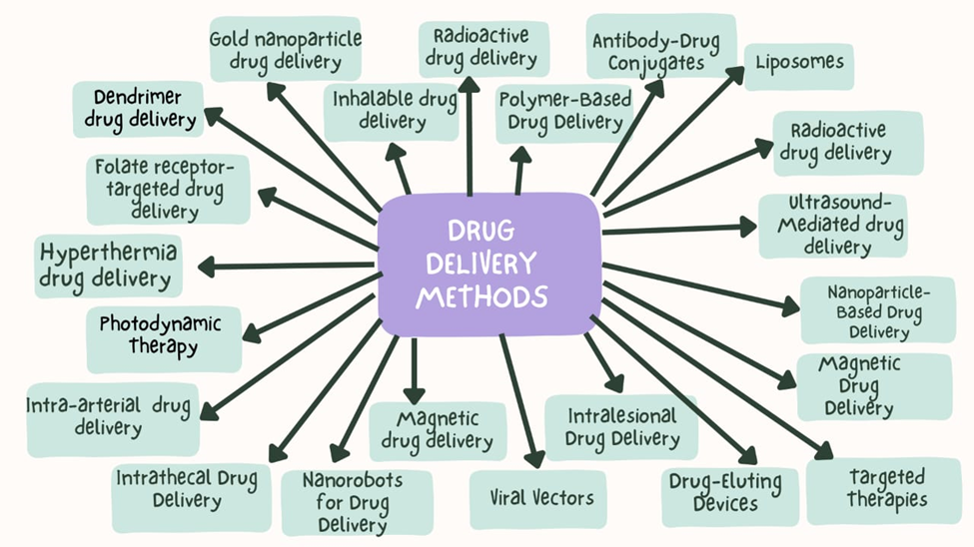
Fig 2: Mind Map For Drug Delivery Methods Employed In Cancer Treatment
L) Nanorobots for Drug Delivery: Nanorobots for drug delivery, also known as nanomedicine or nanorobotics, refers to the use of nanoscale robots or nanodevices for targeted and precise delivery of therapeutic agents, such as drugs or other bioactive molecules, to specific sites within the body. These nanorobots are engineered with precision at the nanoscale level to navigate through biological environments and deliver drugs with high specificity to the intended targets, such as cancer cells or diseased tissues [30]. Example: Nanorobots are miniature devices designed to deliver drugs precisely to cancer cells. They are still in the early stages of development but hold promise for targeted drug delivery in the future [31].
M) Magnetic Drug Delivery: Magnetic drug delivery is a targeted drug delivery approach that uses magnetic fields to guide and concentrate therapeutic agents to specific regions or target sites within the body. This method utilizes magnetic nanoparticles as carriers for drugs or therapeutic agents and external magnetic fields to control their movement and accumulation at the desired location [32]. Example: MagForce'sNanoTherm therapy uses magnetic nanoparticles to heat tumor cells and is being investigated for the treatment of brain tumors [33].
N) Viral Vectors: Viral vectors are modified viruses used as vehicles to deliver genetic material (DNA or RNA) into cells for therapeutic or research purposes. These vectors are widely used in gene therapy and gene editing applications to treat genetic disorders, cancers, and other diseases, as well as in research to study gene function and regulation.Viral vectors are engineered in a way that removes the viral genes responsible for replication and pathogenicity while retaining the necessary components for efficient gene transfer. The genetic material of interest, such as a therapeutic gene or a gene-editing tool like CRISPR/Cas9, is then inserted into the viral vector [34]. Example: T-VEC (talimogenelaherparepvec) is an oncolytic virus therapy used for the treatment of advanced melanoma. It is injected directly into tumors, where it replicates and lyses cancer cells [35].
O) Drug-Eluting Devices :Drug-eluting devices are medical devices that are coated or impregnated with drugs or therapeutic agents. These devices are used to deliver drugs locally to specific tissues or sites within the body, providing targeted therapy and reducing systemic side effects.Common drug-eluting devices include drug-eluting stents, drug-eluting catheters, drug-eluting balloons, and drug-eluting implants. Each type of device is designed to release therapeutic agents in a controlled manner over time to achieve the desired therapeutic effect [36]. Example: Gliadel Wafer (TABLE 1) (carmustine implant) (Fig 3) is an implantable wafer that delivers carmustine to the tumor site after surgical resection of glioblastoma multiforme [37].
P) Targeted Therapies: Targeted therapies refer to a class of medical treatments that specifically target certain molecules or cellular components involved in the growth, progression, or survival of diseased cells, while sparing healthy cells to a greater extent than traditional, non-targeted therapies. These therapies are designed to be more precise and selective, aiming to improve treatment efficacy while reducing adverse effects.The targets of these therapies can be various molecules, receptors, enzymes, or signaling pathways that are overexpressed or mutated in diseased cells, such as cancer cells. By understanding the specific molecular alterations driving the disease, researchers and medical professionals can develop drugs that directly inhibit or modulate these targets [38]. Example: Herceptin (trastuzumab) is a targeted therapy that specifically targets the HER2 protein and is used in the treatment of HER2-positive breast cancer [39].
Q) Antibody-Drug Conjugates (ADCs): Antibody-drug conjugates (ADCs) are a class of targeted cancer therapies that combine the specificity of monoclonal antibodies with the cytotoxic effects of potent anti-cancer drugs. ADCs are designed to selectively deliver the cytotoxic drug payload directly to cancer cells expressing specific surface antigens, thereby reducing systemic toxicity and enhancing therapeutic efficacy [40]. Example: Adcetris (brentuximab vedotin) is an ADC used to treat Hodgkin lymphoma and systemic anaplastic large-cell lymphoma by targeting the CD30 antigen on cancer cells [41].
R) Polymer-Based Drug Delivery: Polymer-based drug delivery is a strategy that utilizes synthetic or natural polymers to create drug carriers for targeted and controlled release of therapeutic agents. These polymers can be designed to form nanoparticles, microparticles, hydrogels, or other structures that can encapsulate or conjugate drugs. The selection of polymers depends on factors such as biocompatibility, biodegradability, and the desired drug release profile [42]. Example: Abraxane (TABLE 1)(albumin-bound paclitaxel) (Fig 3) uses albumin nanoparticles to deliver paclitaxel and is used to treat breast cancer, pancreatic cancer, and other solid tumors [43]
S) Liposomes: Liposomes are a type of nanoparticle-based drug delivery system that consists of spherical vesicles made up of lipid bilayers. These lipid bilayers mimic the structure of cell membranes, making liposomes biocompatible and well-suited for drug delivery applications.To create liposomes, lipids (fatty molecules) are dispersed in an aqueous solution, and under certain conditions, they spontaneously self-assemble into closed vesicles with an aqueous core. The hydrophilic (water-loving) drug molecules can be encapsulated within the core, while hydrophobic (water-repellent) drugs can be incorporated into the lipid bilayers [44]. Example: DaunoXome (liposomal daunorubicin) is a liposomal formulation of daunorubicin used to treat Kaposi's sarcoma, a cancer commonly seen in HIV/AIDS patients [45].
T) Nanoparticle-Based Drug Delivery: Nanoparticle-based drug delivery refers to a technology that utilizes nanoparticles as carriers to deliver therapeutic agents, such as drugs or genes, to specific target sites in the body. These nanoparticles are engineered to encapsulate or attach the therapeutic payload, protecting it from degradation, improving its stability, and enabling controlled release at the desired location. The nanoscale size of these carriers (usually between 1 and 100 nanometers) allows them to interact with cells and tissues at the molecular level, making them ideal for targeted and efficient drug delivery. Nanoparticles used in drug delivery can be composed of various materials, including lipids, polymers, metals, or inorganic substances. The choice of materials depends on factors such as biocompatibility, stability, and the desired release profile of the drug [46]. Example: Doxil (liposomal doxorubicin) is a nanoparticle-based drug that delivers doxorubicin to cancer cells and is used in the treatment of various cancers, including breast cancer and ovarian cancer [47]

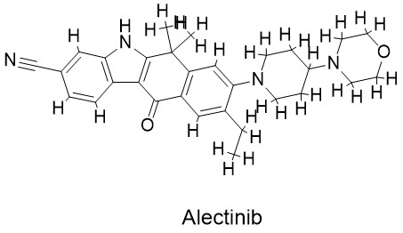
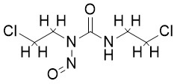
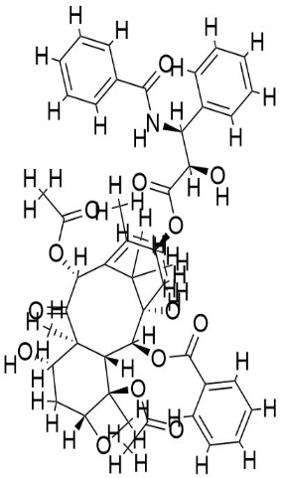
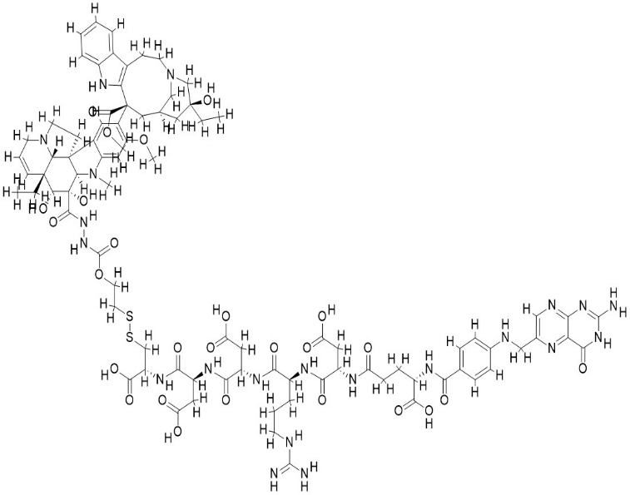
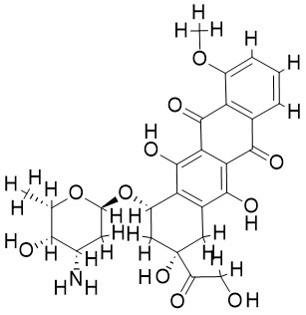
c.
d.
a.
b.
e.

Fig 2. a) Genexol, b) Gliadel wafer, c) Alectinib, d) Vintafolide, e) Abraxane

Table 1 . Physicochemical properties of anti-cancer drug involved in various drug delivery system.
Drugs | Formula | Molecular weight  (g/mol) | Number of rotatable bonds | Number of H-bond acceptors | Number of H-bond donors | Molar refractivity
Genexol | C₄₇H₅₁NO₁₄ |  | 15 | 14 | 4 | 218.96
  853.91
Gliadel wafer | C₅H₉CL₂N₃O₂ | 214.05 | 7 | 3 | 1 | 46.77
Alectinib |  |  | 3 | 4 | 1
  C₃₀H₃₄N₄O₂
  482.62
  149.63
Abraxane | C₄₇H₅₁NO₁₄ |  | 15 | 14 | 4
  853.91
  218.96

Conclusion
The chapter provides a comprehensive overview of several materials that are being employed or have the potential to be utilised as drug delivery systems in the context of cancer therapy. The utilisation of drug delivery systems has brought about substantial advancements in the field of cancer treatment and the broader domain of modern medicine. The field of oncology has been significantly transformed by the implementation of advanced techniques, including radioactive drug delivery, inhalable drug delivery, gold nanoparticle drug delivery, dendrimer drug delivery, and other innovative approaches. These technologies have revolutionized the field by improving the accuracy and effectiveness of drug administration, as well as enhancing patient adherence to treatment protocols. These methodologies, in conjunction with focused therapies, antibody-drug conjugates, and nanorobots for pharmaceutical administration, present customised therapy alternatives that are specifically designed to align with the unique patient profiles and genetic attributes of individuals. The distinctive characteristics of these entities have enabled medical practitioners to present them as novel therapeutic options, either as standalone treatments (monotherapy) or as supplementary components to current treatments (combined therapy), with the aim of enhancing therapeutic efficacy. While several materials have not achieved success in their clinical translation, there are several emerging materials that are currently being developed and exhibit significant potential. These materials provide good prospects for the development of new therapeutic alternatives in the foreseeable future.
References:
1. Allen L, Ansel HC. Ansel's pharmaceutical dosage forms and drug delivery systems. Lippincott Williams & Wilkins; 2013 Dec 23..
2. Desai PP, Date AA, Patravale VB. Overcoming poor oral bioavailability using nanoparticle formulations–opportunities and limitations. Drug Discovery Today: Technologies. 2012 Jun 1;9(2):e87-95.
3. Rowland M, Tozer TN. Clinical Pharmacokinetics and Pharmacodynamics: Concepts and Applications. 2010..
4. Benet LZ, Hoener BA. Changes in plasma protein binding have little clinical relevance. Clinical Pharmacology & Therapeutics. 2002 Mar 1;71(3):115-21.
5. Routes of Drug Administration and Their Implications: Gisbert, A. G., & Piqué, N. (2003). Should we still use the oral route for proton pump inhibitor administration? Inflammopharmacology, 11(4), 385-390. doi:10.1163/156856003322699777
6. Amidon GL. LennernÃ¤ s H, Shah VP, Crison JR. A theoretical basis for a biopharmaceutic drug classification: the correlation of in vitro drug product dissolution and in vivo bioavailability. Pharm Res. 1995;12(3):413-20.
7. Torchilin, V. P. (2011). Multifunctional and stimuli-sensitive pharmaceutical nanocarriers. European Journal of Pharmaceutical Sciences, 43(3), 303-315. DOI: 10.1016/j.ejps.2011.04.008
8. Lambrecht, F. Y., Deckers, N., Smeets, P., & Mottaghy, F. M. (2019). Radiopharmaceuticals in Oncology: Role in Therapy. In Molecular Imaging in Oncology (pp. 123-154). Springer, Cham. DOI: 10.1007/978-3-030-27604-3_6
9. Kennedy, A. S., Ball, D., Cohen, S. J., Cohn, M., Coldwell, D. M., Drooz, A., ... & Savin, M. (2016). Multicenter evaluation of the safety and efficacy of radioembolization in patients with unresectable colorectal liver metastases selected as candidates for 90Y resin microspheres. Journal of Gastrointestinal Oncology, 7(5), 670-677. DOI: 10.21037/jgo.2016.06.05.
10.Cushing, K., & Smith, G. (2019). Inhalation Drug Delivery: Challenges and Solutions. In Respiratory Drug Delivery Europe 2019 (Vol. 2, p. 105). RDD Online. [PDF available at: https://www.rddonline.com/index.php/rdd/article/view/1155/1199]
11. Peters, S., Camidge, D. R., Shaw, A. T., Gadgeel, S., Ahn, J. S., Kim, D. W., ... & Ou, S. H. I. (2017). Alectinib versus crizotinib in untreated ALK-positive non-small-cell lung cancer. New England Journal of Medicine, 377(9), 829-838. DOI: 10.1056/NEJMoa1704795.
12. Chen, Q., Wang, C., & Chen, G. (2013). Gold nanoparticles: from nanomedicine to nanosensing. Nanotechnology, Science, and Applications, 6, 209. DOI: 10.2147/NSA.S31576
13. O'Neill, A. T., Monteiro-Riviere, N. A., & Walker, G. M. (2017). A review of gold and silver nanoparticle-based cancer therapeutics: a game changer in drug delivery. Current Drug Targets, 19(18), 2155-2173. DOI: 10.2174/1389450117666160810145241
14. De Andres J, Hayek S, Perruchoud C, Lawrence MM, Reina MA, De Andres-Serrano C, Rubio-Haro R, Hunt M, Yaksh TL. Intrathecal Drug Delivery: Advances and Applications in the Management of Chronic Pain Patient. Front Pain Res (Lausanne). 2022 Jun 16;3:900566. doi: 10.3389/fpain.2022.900566. Erratum in: Front Pain Res (Lausanne). 2023 Apr 11;4:1190014. PMID: 35782225; PMCID: PMC9246706.

15. Kim, T. Y., Kim, D. W., Chung, J. Y., Shin, S. G., Kim, S. C., & Heo, D. S. (2004). Phase I and pharmacokinetic study of Genexol-PM, a cremophor-free, polymeric micelle-formulated paclitaxel, in patients with advanced malignancies. Clinical Cancer Research, 10(11), 3708-3716. DOI: 10.1158/1078-0432.CCR-03-0652
16. Sudimack J, Lee RJ. Targeted drug delivery via the folate receptor. Advanced drug delivery reviews. 2000 Mar 30;41(2):147-62.
17. Reddy, J. A., Dorton, R., Westrick, E., Dawson, A., Smith, J., Khan, S., ... & Chari, R. V. J. (2007). Preclinical evaluation of EC145, a folate-vinca alkaloid conjugate. Cancer Research, 67(10), 4434-4442. DOI: 10.1158/0008-5472.CAN-06-4216
18. Paulides MM, Trefna HD, Curto S, Rodrigues DB. Recent technological advancements in radiofrequency-andmicrowave-mediated hyperthermia for enhancing drug delivery. Advanced drug delivery reviews. 2020 Jan 1;163:3-18.
19. Wang, D., Zhang, G., Li, W., Xin, H., Wang, Y., Lee, H., & Zhang, Q. (2014). Combining targeted therapy with hyperthermia for an enhanced antitumor effect. Journal of Controlled Release, 196, 96-105. DOI: 10.1016/j.jconrel.2014.08.023
20. Dolmans, D. E., Fukumura, D., & Jain, R. K. (2003). Photodynamic therapy for cancer. Nature Reviews Cancer, 3(5), 380-387. doi: 10.1038/nrc1071.
21. Hopper, C., & Niziol, C. (2015). Photodynamic therapy in head and neck cancer: 2015 update. Current Oncology Reports, 17(6), 23. DOI: 10.1007/s11912-015-0461-6.
22. Yudina, A., Lepetit-Coiffé, M., Moonen, C., & Frenkel, V. (2019). Ultrasound-mediated drug delivery to the brain: principles, progress and prospects. Drug Discovery Today: Technologies, 31, 83-93. doi: 10.1016/j.ddtec.2019.05.005
23. Wang, H., Jiang, Y., Zhou, H., Yu, Y., Yu, Y., Zhang, D., ... & Lu, J. (2017). Ultrasound-targeted microbubble destruction: a new strategy for drug delivery. Molecular Pharmaceutics, 14(6), 1897-1906. DOI: 10.1021/acs.molpharmaceut.6b01193
24. Sze, D. Y., & Razavi, M. K. (2010). Intra-arterial therapies for liver cancer: assessing tumor response. Expert Review of Anticancer Therapy, 10(11), 1677-1691. doi: 10.1586/era.10.161.
25. Shields, C. L., Bianciotto, C. G., Jabbour, P., Griffin, G. C., Ramasubramanian, A., Rosenwasser, R., & Shields, J. A. (2017). Intra-arterial chemotherapy for retinoblastoma: the beginning of a long journey. Clinical Ophthalmology, 11, 1719-1728. DOI: 10.2147/OPTH.S145532.
26. Berman, B., & Flores, F. (2018). Intralesional treatment of keloids and hypertrophic scars: A review. Dermatologic Surgery, 44(6), 826-835. doi: 10.1097/DSS.0000000000001447
27. Urosevic, M., Dummer, R., & Conrad, C. (2016). Intralesional targeted therapy for skin cancer: rationale and perspectives. American Journal of Clinical Dermatology, 17(3), 251-259. DOI: 10.1007/s40257-016-0186-1.
28. De Andres J, Hayek S, Perruchoud C, Lawrence MM, Reina MA, De Andres-Serrano C, Rubio-Haro R, Hunt M, Yaksh TL. Intrathecal Drug Delivery: Advances and Applications in the Management of Chronic Pain Patient. Front Pain Res (Lausanne). 2022 Jun 16;3:900566. doi: 10.3389/fpain.2022.900566. Erratum in: Front Pain Res (Lausanne). 2023 Apr 11;4:1190014. PMID: 35782225; PMCID: PMC9246706
29. Chamberlain, M. C., & Glantz, M. J. (2017). Intrathecal chemotherapy: therapeutic agents, treatment procedures, and complications. Oncology & Hematology Review, 13(2), 71-77. DOI: 10.17925/OHR.2017.13.2.71.
30. Tyagi P, Subramony JA. Nanotherapeutics in oral and parenteral drug delivery: Key learnings and future outlooks as we think small. Journal of Controlled Release. 2018 Feb 28;272:159-68
31. Patra, J. K., Das, G., Fraceto, L. F., Campos, E. V. R., & Rodriguez-Torres, M. D. P. (2018). Nano based drug delivery systems: recent developments and future prospects. Journal of Nanobiotechnology, 16(1), 71. DOI: 10.1186/s12951-018-0392-8
32. Alexiou, C., Janko, C., & Pöhlmann, C. (2018). Development of magnetic drug targeting: nanomagnets and beyond. European Biophysics Journal, 47(8), 877-883. doi: 10.1007/s00249-018-1306-y
33. Maier-Hauff, K., Ulrich, F., Nestler, D., Niehoff, H., Wust, P., Thiesen, B., ... & Jordan, A. (2011). Efficacy and safety of intratumoral thermotherapy using magnetic iron-oxide nanoparticles combined with external beam radiotherapy on patients with recurrent glioblastoma multiforme. Journal of Neuro-Oncology, 103(2), 317-324. DOI: 10.1007/s11060-010-0389-0.
34. Ginn, S. L., Amaya, A. K., Alexander, I. E., & Edelstein, M. L. (2018). Gene therapy clinical trials worldwide to 2017: An update. Journal of Gene Medicine, 20(5), e3015. doi: 10.1002/jgm.3015
35. Andtbacka, R. H., Kaufman, H. L., Collichio, F., Amatruda, T., Senzer, N., Chesney, J., ... & Coffin, R. S. (2015). Talimogene laherparepvec improves durable response rate in patients with advanced melanoma. Journal of Clinical Oncology, 33(25), 2780-2788. DOI: 10.1200/JCO.2014.58.3377.
36. Wijns, W., Kolh, P., Danchin, N., Di Mario, C., Falk, V., Folliguet, T., ... & Windecker, S. (2010). Guidelines on myocardial revascularization: the Task Force on Myocardial Revascularization of the European Society of Cardiology (ESC) and the European Association for Cardio-Thoracic Surgery (EACTS). European Heart Journal, 31(20), 2501-2555. doi: 10.1093/eurheartj/ehq277
37. Brem, H., Piantadosi, S., Burger, P. C., Walker, M., Selker, R., Vick, N. A., & Sisti, M. (1995). Placebo-controlled trial of safety and efficacy of intraoperative controlled delivery by biodegradable polymers of chemotherapy for recurrent gliomas. The Lancet, 345(8956), 1008-1012. DOI: 10.1016/S0140-6736(95)90761-1.
38. Bianchini, G., Balko, J. M., Mayer, I. A., Sanders, M. E., & Gianni, L. (2016). Triple-negative breast cancer: Challenges and opportunities of a heterogeneous disease. Nature Reviews Clinical Oncology, 13(11), 674-690. doi: 10.1038/nrclinonc.2016.
39. Hudis, C. A. (2007). Trastuzumab—mechanism of action and use in clinical practice. New England Journal of Medicine, 357(1), 39-51. DOI: 10.1056/NEJMra043186.
40. Beck, A., Goetsch, L., Dumontet, C., & Corvaïa, N. (2017). Strategies and challenges for the next generation of antibody-drug conjugates. Nature Reviews Drug Discovery, 16(5), 315-337. doi: 10.1038/nrd.2016.268.
41. Younes, A., Bartlett, N. L., Leonard, J. P., Kennedy, D. A., Lynch, C. M., Sievers, E. L., & Forero-Torres, A. (2010). Brentuximab vedotin (SGN-35) for relapsed CD30-positive lymphomas. New England Journal of Medicine, 363(19), 1812-1821. DOI: 10.1056/NEJMoa1002965
42. Kumari, A., Yadav, S. K., & Yadav, S. C. (2010). Biodegradable polymeric nanoparticles-based drug delivery systems. Colloids and Surfaces B: Biointerfaces, 75(1), 1-18. doi: 10.1016/j.colsurfb.2009.09.001
43. Gradishar, W. J., & Gradishar, W. J. (2005). Albumin-bound paclitaxel: a next-generation taxane. Expert Opinion on Pharmacotherapy, 6(7), 1177-1185. DOI: 10.1517/14656566.6.7.1177.
44. Torchilin, V. P. (2005). Recent advances with liposomes as pharmaceutical carriers. Nature Reviews Drug Discovery, 4(2), 145-160. doi: 10.1038/nrd1632
45. Gill, P. S., Wernz, J., Scadden, D. T., Cohen, P., Mukwaya, G. M., von Roenn, J. H., ... & Levine, A. (1996). Randomized phase III trial of liposomal daunorubicin versus doxorubicin, bleomycin, and vincristine in AIDS-related Kaposi's sarcoma. Journal of Clinical Oncology, 14(8), 2353-2364. DOI: 10.1200/JCO.1996.14.8.2353
46. Peer, D., & Karp, J. M. (2010). Nanocarriers for the delivery of combinational therapeutics. Nature Reviews Drug Discovery, 6(12), 987-997. doi: 10.1038/nrd2053
47. Drummond, D. C., Noble, C. O., Guo, Z., Hong, K., & Park, J. W. (2011). Liposomal cytarabine (DepoCyt) for lymphomatous meningitis: a phase II clinical trial. Journal of Clinical Oncology, 29(6), 695-701. DOI: 10.1200/JCO.2010.32.8191

