RNA SEQUENCING : AN ADVANCE TRANSCRIPTOMICS TECHNOLOGY FROM UNPROCESSED DATA TO INSIGHTFUL INTERPRETATION
Komal G Lakhani¹, Poojaben M Prajapati² and G. V. Marviya³

¹Department of Biotechnology, College of Agriculture,
Junagadh Agricultural University, Junagadh-362 001
²Department of Botany, Bioinformatics, Climate Change and Impact Management ,
School of Science, Gujarat University, Ahemdabad-380 009
³Krishi Vigyan Kendra, Junagadh Agricultural University, Targhadia (Rajkot)- 360 023
Email: komallakhani2706@gmail.com

Abstract:

Transcriptomics are methods for examining an organism's transcriptome, which is the totality of all of its RNA transcripts. Transcription is the process through which an organism's information is expressed and stored in the DNA of its genome. In order to gain knowledge about a cell's transcriptome, RNA sequencing (RNA-Seq) makes advantage of the capabilities of high-throughput sequencing techniques. RNA-seq analysis can be used to investigate genes and the transcripts that accompany them for a variety of purposes, including discovering novel exons or complete transcripts and assessing the expression of genes. The functional complexity of transcription has been further understood thanks to recent improvements in the RNA-Seq methodology, which include sample preparation, library creation, and data analysis. We go over every significant stage in RNA-seq data analysis, including experimental design, quality assurance, read alignment, measurement of gene and transcript levels, and differential gene expression. We also emphasise the difficulties that each phase presents. We outline a general bioinformatics workflow for the quantitative analysis of RNA-seq data as well as a few recently released computational tools that can be used at different stages of this workflow. These tools are part of a pipeline for RNA-seq data quality assessment and quantification that starts with raw sequencing files and is targeted at finding and analysing genes that exhibit differential expression under various biological situations.

Keywords: RNA-seq, bioinformatics, quantitative analysis of gene expression, differentially expressed genes

Introduction:
The development of genetic sequencing technology has exploded during the past few decades (Shendure et al., 2017). Over the past 20 years, the number of genomic sequence databases has grown exponentially due to improvements in throughput, accuracy, and cost (Lathe et al., 2008; Heather and Chain, 2016; Levy and Myers, 2016; Ardui et al., 2018; Karsch-Mizrachi et al., 2018). The intricate mapping of the same genome to multiple phenotypes in various tissue types, developmental stages, and environmental situations, however, continues to be a significant challenge in molecular biology. It is not only difficult but also at the core of this challenge to have a deeper understanding of the transcripts and expression of gene regulation. Numerous organisms have been extensively researched for transcriptomics, which provides significant insights into the structure, expression, and regulation of genes (Jain, 2012; Casamassimi et al., 2017; Lowe et al., 2017).

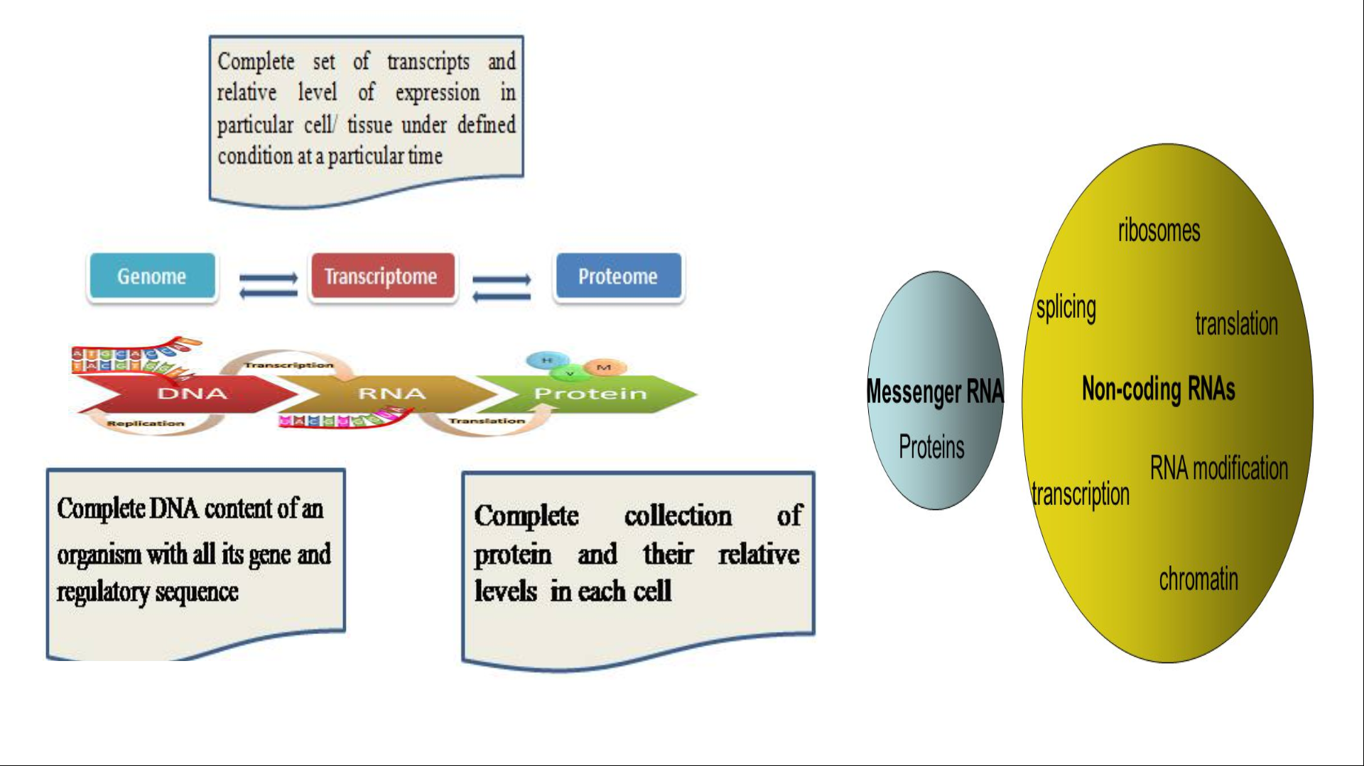
Fig.1: Central dogma of molecular biology

What is Transcriptomics:

The study of the "transcriptome" is known as transcriptomics, and it refers to the entire collection of all the ribonucleic acid (RNA) molecules (also known as transcripts) expressed in a specific entity, such as a cell, tissue, or organism. The main goals of transcriptomics are to catalogue every type of transcript, including mRNAs, non-coding RNAs, and small RNAs; to identify the transcriptional structure of genes, including the start sites, 5′ and 3′ ends, splicing patterns, and other post-transcriptional modifications; and to measure how each transcript's expression levels change over time and in different environments. Transcriptomics have ability to investigate both functional and differentially expressed genes (DEGs), and received the most attention (Jia et al., 2015). Transcriptome analysis will eventually provide some advice in disease diagnosis, clinical care, and crop improvement by revealing more about the network of biological processes that are regulated.

What is Transcriptome:

The total set of transcripts present in a cell for a particular developmental stage or physiological condition is known as the transcriptome. To interpret the functional components of the genome, expose the molecular components of cells and tissues, and to comprehend development and illness, one must have a thorough comprehension of the transcriptome. The transcriptome can be used to track the entire transcriptional activity of an organism without a reference genome, whereas genome assembly is more difficult and expensive in plant research. In addition to reflecting the changes in gene expression at various temporal and spatial points, the transcriptome also contains information about auxiliary metabolic pathways, which causes it to change depending on the time and location of observation. Studies have demonstrated that due to the various growing conditions and growth phases of medicinal plants, even within the same species, gene expression patterns reflect time- and space-based changes, leading to the distinctive patterns of accumulation of medicinal components. The transcriptome is therefore more suited for locating genes linked to therapeutic elements in medicinal plants (Wang et al., 2009). For research on plant functional genome mining, the formation of gene regulatory domains, genetic diversity (dominant and recessive genes), and bioactive compounds, these distinctions are crucial (Tyagi and Ranjan, 2021; Tyagi et al., 2022).

History of Transcriptomics:

In the past, it was difficult to analyse the behaviour of the genome due to the intricacy of the transcriptome of living cells. However, numerous studies of individual transcripts were being conducted before the development of transcriptomics to examine the genes. Before the era of sequencing, different approaches such as chromosome walking genetic and QTL mapping and were used for the identification of genes. These methods aid in understanding the molecular and cellular alterations that various variables cause in various tissues and cells.
The first attempt to compile a portion of the human transcriptome was made in 1991 and 609 mRNA sequences from the human brain were reported. In 2008, two human transcriptomes with 16,000 genes and millions of sequences obtained from transcripts were published. The routine generation of transcriptomes for various disease states, tissues, and even single cells has become common (Kolodziejczyk et al., 2014; Mele et al., 2015; Sandberg, 2015). The quick advancement of technologies with increased sensitivity and economy has been the driving force behind this expansion in transcriptomics (Wang et al., 2009; Ozsolak and Milos, 2011; McGettigan, 2013). In order to construct expressed sequence tags (ESTs) a short sequences of nucleotide with use of cDNA (Adams et al., 1991; Marra et al., 1998). The random transcripts were sequenced in the 1980s using low-throughput Sanger method of sequencing to classify expressed genes and gene fragments (Putney et al., 1983). Microarrays and RNA-Seq, the two main modern methods, were created in the middle of the 1990s and the 2000s, respectively (Schena et al., 1995; Pozhitkov et al., 2007). The first microarrays, which use a fixed set of transcripts hybridised to a variety of complementary probes, were reported in 1995. Massively parallel signature sequencing (MPSS), used for idetification of mRNA expression levels of by counting the number of individual mRNA molecules produced by each gene. This technique were used to confirm the expression of roughly 10,000 genes in Arabidopsis thaliana and about 20,000 genes in 32 different human tissues (Meyers et al., 2004; Jungeneel et al., 2005). According to Brenner et al. (2000), MPSS is based on sequencing reads of 16–20 bp. Later, reverse transcriptase quantitative PCR (RT-qPCR) gained popularity (Becker-Andre and Hahlbrock, 1989) and scientists began quantifying individual transcripts using northern blotting, nylon membrane arrays, and other methods. These techniques were challenging, though, and they only managed to record a small portion of the transcriptome. During the year 2006, the 454 technology was used for RNA-sequencing with 105 transcripts with a appropriate coverage for quantification of relative transcript abundance (Bainbridge et al., 2006). After the year 2008, the sequencing of RNA became in popular using new Solexa/Illumina technologies and recorded 10⁹ transcript to be recorded.

Why need of Transcriptomics:

During early 2000s, to study biology of plant traditional breeding methods is mainly used and it is focused on to single genes identification of within a biological context. Numerous organisms have been extensively researched for transcriptomics, which provides significant insights into the structure, expression, and regulation of genes (Jain, 2012; Casamassimi et al., 2017; Lowe et al., 2017). The rapid development of the underlying sequencing technology has allowed the transcriptomics investigations to advance significantly (Abdel-Ghany et al., 2016; Wang et al., 2016). Transcriptomics have become an important tool in the field of plant breeding for the assembly of crop reference genome. Conventional breeding in agriculture is solely based on phenotypic selection, and in traditional QTL analysis, linkage maps lead to the detection of genomic regions that are associated with phenotypic variations within a population (Kumpatla et al., 2012). The whole genome information is available in only few plant spp. as well as it is very tedious and costlty. So, in the absence of reference genome, transcriptomics study is an alternative tool to identify overall transcriptional activity in plant spp. with complex genomes, including coffee, wheat, sugarcane, and several "orphan crops," including sweet potato, chickpea, and minor millets to unravel genes and regulatory regions and provides a variety of molecular markers to identify diversity (Perez-de-Castro et al., 2012).
The main threats to sustainable agricultural production and global food security are global climate change such as drought, salinity, high temperature and several biotic stress. In plant, metabolic activity and expression of genes is over the time at different growth period and spatial condition. The intricate mapping of the same genome to multiple phenotypes in various tissue types, developmental stages, and environmental situations, however, continues to be a significant challenge in molecular biology. It is not only difficult but also at the core of this challenge to have a deeper understanding of the transcripts and expression of gene regulation. Transcriptomics strategies used to identify the plasticity of gene expression that are activated or inactive under any specific external or developmental stimulus, and is required to reduce the negative effects of these threats to agricultural productivity, enhance crop yield and stress-tolerance in plants. Transcriptome research methods have changed from the conventional chip hybridization platform to RNA sequencing technology (RNA-Seq) in recent years because to the continual developments in sequencing technology (Mironova et al., 2015).

Transcriptomics Techniques:
To determine and quantify the transcriptome, numerous technologies have been created, such as hybridization- or sequence-based methods.
1. Hybridization based Methods

- Fluorescently labelled cDNA with custom-made microarrays
- Commercial high-density oligo microarrays

2. Sequence based Methods

- Sanger sequencing of cDNA or EST libraries
- Serial analysis of gene expression (SAGE)
- Cap analysis of gene expression (CAGE)
- Massively parallel signature sequencing (MPSS)
- RNA-Sequencing

RNA-Sequencing:
RNA sequencing has made great advancements in recent years and is now a crucial method for transcriptome profiling. RNA-Seq is based on next generation high-throughput sequencing of nucleic acids to determine the nucleotide sequence of RNA molecules as well as the quantities of specific RNA species within populations of RNA molecules (Margulies, 2005). The transition from bulk RNA sequencing to single-molecular, single-cell, and spatial transcriptome techniques has made it possible to resolve individual cells with ever-greater accuracy while also including spatial data. RNA-seq analysis requires specialized computational tools that can account for the shortcomings of sequencing technologies, including the generation of sequencing errors (Le et al., 2013), length biases, and fragmentation (Oshlack and Wakefield, 2009; Tuerk et al., 2017).

Principe of RNA sequencing:
In general, a population of RNA (total or fractionated, such as poly(A)+) is converted to a library of cDNA fragments with adaptors attached to one or both ends (FIG. 1). Each molecule, with or without amplification, is then sequenced in a high-throughput manner to obtain short sequences from one end (single-end sequencing) or both ends (pair-end sequencing). After sequencing, the obtained reads are either matched to a reference genome or transcripts, or they are constructed from scratch without the aid of the genomic sequence to create a genome-scale transcription map that includes the transcriptional organisation and/or level of expression for each gene. The transition from bulk RNA sequencing to single-molecular, single-cell, and spatial transcriptome techniques has made it possible to resolve individual cells with ever-greater accuracy while also including spatial data. Computational analysis of RNA-seq data has led to many scientific advances, including novel therapeutic discoveries, detailed understanding of genetic regulatory regions, and identification of biomarkers and pathogenic mutations (Han et al., 2015).
The 454 technology from Roche, the Solexa technology from Illumina, SOLiD technology from ABI are examples of NGS, or high-throughput sequencing (Barbazuk et al., 2007; Cloonan et al., 2008; Emrich et al., 2007; Holt et al., 2008; Lister et al., 2008; Morin et al., 2008; Vera et al., 2008). Depending on the DNA-sequencing method being employed, the reads are typically between 30 and 400 bp. RNA sequencing overcomes microarray's limitations and provides better understanding for transcriptome study.
Types of RNA Sequencing

A. On the basis of the formation of cDNA
- Direct RNA Sequencing:
` Bypassing the process of turning extracted RNAs into cDNA, this approach directly sequences RNAs. Compared to DNA, RNAs are more unstable, making them more challenging to work with. The process of turning RNAs into cDNAs, however, generates a number of biases, error sites, and disruptions that obstruct precise sequencing. In addition, making cDNA requires a multi-step, difficult process, and cDNAs aren't even appropriate for sequencing short RNAs.

- Indirect RNA Sequencing:
All of the RNA types present in the sample are sequenced using a process called whole transcriptome sequencing (WTS). It gives all the necessary information on a cell's nucleotide and gene expression because it profiles the complete transcriptome.

B. On the basis of types of RNA sequenced

1. Whole Transcriptome RNA-Sequencing (Total RNA-Seq)
All of the RNA types present in the sample are sequenced using a process called whole transcriptome sequencing (WTS). It gives all the necessary information on a cell's nucleotide and gene expression because it profiles the complete transcriptome.

2. mRNA-Sequencing
Only mRNAs are sequenced using this technique. First, mRNAs are separated using poly-A chromatography or poly-A magnetic beads, and a poly-A library is created. The library is then either directly or indirectly sequenced to obtain an mRNA sequence.

3. tRNA-sequencing and rRNA-sequencing
This is rarely used technique of sequencing which is used for sequencing of tRNAs and rRNA.

4. Targeted RNA-Sequencing
It is a technique for sequencing a particular transcript of interest.
5. Small RNAs Sequencing
This kind of sequencing involves the sequencing of a non-coding RNAs such as miRNA, siRNA, and piRNA.
6. Single Cell RNA Sequencing
This technique involves sequencing RNAs that have been isolated from just one type of cell or cell line. Transcript libraries are created, all the transcripts from a single cell are collected, and then the entire library is sequenced.

Steps in RNA Sequencing:
The most popular RNA-Seq approach is the indirect method, which relies on the cDNA production process. In this article, we will outline a general step in the indirect RNA-Seq method. The overall RNA-Seq workflow can be summed up as follows:
1. RNA isolation:
Cell lysis and full transcriptome extraction are the first steps in RNA-Seq. Cell lysis and RNA extraction frequently involve the use of RNA lysis buffer and organic solvent-based RNA isolation techniques. Following extraction, the RNAs are cleaned, purified as DNA-free RNAs, and stored in buffer or RNase-free water.
2. RNA Selection
A cell contains enormous amounts of RNA, including the three most prevalent types: rRNA, tRNA, and mRNA. Certain types of RNAs that we need to sequence from the extracted transcriptome are chosen using a variety of techniques, including affinity chromatography, electrophoresis, filtration (size exclusion), enzymatic depletion, target enrichment/depletion, etc. In case of whole transcriptome RNA-Seq. there is no need to choose a specific RNA.
Since mRNAs are the direct transcripts of genes that contain coding sequences, they are frequently chosen and sequenced. The method that is most frequently used to separate mRNAs from the entire collection of RNAs is poly-A library creation.
3. Synthesis of cDNA
Reverse transcription is used to convert the isolated and chosen RNAs into first-strand cDNAs, which are more stable than sample RNAs. The second-strand cDNAs are created by amplifying the first-strand cDNAs with Taq DNA polymerases and nucleotides.
4. Selection
It is an optional procedure used to get rid of globin, other smaller RNAs, and rRNA molecules, which make up around 80% to 90% of the total amount of cellular RNA.. This phase will streamline the RNA sequencing procedure, increasing its effectiveness and resulting in a reduction in costs, time, and reagent usage. The required cDNA can be chosen via enzymatic depletion, probe-based depletion, rRNA depletion, target enrichment and other approaches.
5. Library preparation:
A collection of complete cDNA synthesised for sequencing is known as a cDNA library. A library Preparation includes following steps:
i) Size Selection and Fragmentation:
The procedure of improving the sequencing of targeted RNAs and cDNAs is also optional. The cDNAs are broken apart, and only pieces of a particular size are chosen. Chemical, enzymatic, or physical processes, such as sonication, can fragment materials.
ii) Ligation of Adaptors:
Adaptors are ligated at the end of fragmented and/or chosen cDNAs. Short synthetic oligonucleotides called adaptors bind to transcripts and act as sequencing primer sites.
iii) Indexing and Amplification
During PCR amplification of the cDNAs, a particular sequence (also known as a barcode) is added to the transcripts following adaptor ligation known as indexing. The concentration of the created library is raised by amplifying these adaptors and barcode-ligated cDNAs.
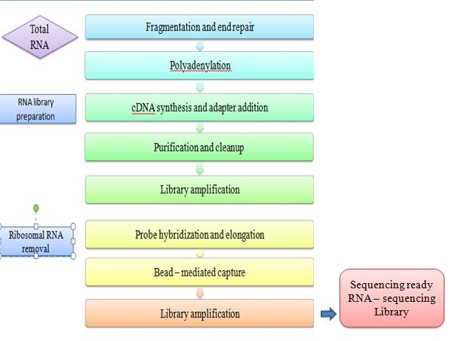
Fig. 2: RNA- Sequencing library preparation workflow

6. Sequencing:
The high throughput next generation sequencing (NGS) technique is used in the high throughput NGS machine to sequence the final cDNAs in the cDNA library. The sequencing procedure is comparable to DNA sequencing. The acquired data are analyzed using bioinformatics methods after each cDNA fragment is read separately.

In siilico analysis of RNA sequencing:
From raw data to smart analysis with RNA-seq data science:

RNA-seq technique used for identification of a dysregulated gene or defective protein that affects downstream processes and leads to a disease state (Deshpande et al., 2023). Computational analysis of RNA-seq data is crucial to unravelling the biological complexity of the transcriptomes of living organisms, including humans (Costa et al., 2010). For these processes, hundreds of computational tools and resources have been created, and it has been demonstrated that each one produces outcomes that are unique and superior to those of its predecessors. Evethough, some studies compared the primary tools available for any given step, and combinations of steps in an exhaustively viz., read alignment and quantification, to more clearly demonstrate choosing each pipeline and show potential features of step interaction (Teng et al., 2016; Baruzzo et al., 2017). From the compilation of the raw data through the identification of biological insights, we here detail the essential steps of computational RNA-seq data analysis.

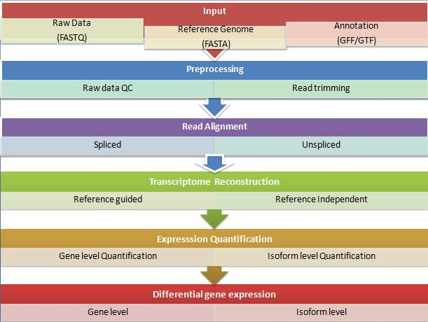
Fig. 3: RNA-Sequencing data analysis workflow

1. Preprocessing of Raw Data:

RNAseq data is formatted in FASTQ (sequence and base quality), which is similar to whole genome or exome sequencing. The analysis in FastQc was performed by a series of analysis modules. FastQC is a java-based tool that provides a simple way to perform quality control checks on raw sequence data coming from high throughput sequencing pipelines and give a quick impression of whether data has any problems of which should be aware before doing any further analysis.
The library preparation, sequencing, and imaging stages can introduce a lot of incorrect sequence variations, which need to be found and eliminated in the data analysis step (Robasky et al., 2014). After the reads have been generated, it is crucial to perform read trimming and data quality control to filter and evaluate the quality of raw readings (Yang et al., 2013). A low PHRED quality score indicates that read trimming removes adaptor sequences and fragements of reads with low precision (Martin, 2011; Dodt et al., 2012; Bolger et al., 2014).

The criteria for trimming were given as under
1) Removal of low-quality sequence (limit=0.05)
2) When an adapter is found trim 3’end, for reads without adapters: keep the reads.

The first phase of a typical RNA-seq workflow should involve doing quality control on the raw data. In this step, the quality of the raw data can be evaluated using tools like FastQC and HTQC allowing evaluation of the overall and per-base quality for each read in each sample. Prior to aligning the RNA-seq data, read trimming of some kind may be advised depending on the method used to build the RNA-seq library.

Fast QC report spots the problems which originate either in the sequencer or in the starting library material.

The trimmomatic tool is a more flexible and efficient preprocessing tool, which could correctly handle paired-end data. The main processing steps performed by trimmomatic are identification of adapters and quality filtering.

Therefore, the fast Q file containing the filtered, high-quality reads were further pre-processed using trimmomatic for adapter removal, PCR primer sequences or fragments removal and quality filtering. The high-quality reads were assembled into contigs/transcripts by trinity assembler.

2. Read alignment:
The read alignment stage of RNA-seq downstream analysis is crucial. The order and origin of the reads, including the specific region, homolog, or strand of the genome from which they originate, are often not disclosed in RNA-seq data. A genome or transcriptome can be used as a reference in two different ways for the read alignment step. The reads are normally mapped to either a genome or a transcriptome. The percentage of reads that are mapped is a crucial measurement of mapping quality since it serves as a general indicator of both DNA contamination and overall sequencing accuracy.
The coverage, or number of reads that overlap each place on the reference sequence, is also revealed by alignment of the reads to a reference sequence. The various bioinformatics tools such as GenomeScope, smudgeplot and merqury an calculate coverage without mapping reads to a reference sequence because the majority of read overlap is conserved with or without the reference sequence (Vurture et al., 2017; Ranallo-Benavidez et al., 2020; Rhie et al., 2020). The expression levels and types of transcripts can be determined by aligning RNA-seq reads to a complementary reference sequence, however this method is not well suited for identifying transcripts that are absent from the reference sequence (Deshpande et al., 2023).

Strategies of read alignment:
A genome or transcriptome can be used as a reference in two different ways for the read alignment step (Garber et al., 2012). The transcriptome is made up of all the transcripts found in a certain specimen that have undergone splicing by incorporating the exons and excluding the introns. For accurate read mapping when a transcriptome is the reference, unspliced aligners that don't permit big gaps may be the best option. In this situation, you can make use of Bowtie (Langmead 2009), Stampy , Mapping and Assembly with Quality (MAQ) (Li et al., 2008) and Burrow-Wheeler Aligner (BWA) (Li et al., 2009). Because it does not identify splicing events involving novel exons, this alignment can only be used to identify known exons and junctions.
Because it does not identify splicing events involving novel exons, this alignment can only be used to identify known exons and junctions. Spliced aligners that permit a broad range of gaps should be used if the genome is used as a reference, though, as reads matched at exon-exon junctions would split into two fragments. By using this method, the likelihood of discovering novel transcripts produced by alternative splicing may improve. There have been many spliced aligners created, such as TopHat, MapSplice, STAR and GSNAP (Trapnell et al., 2009; Wang et al., 2010; Wu et al., 2010; Dobin et al., 2013).
Challenges of read alignment:
Aligning RNA-seq reads to a reference genome is challenging due to spliced junctions, where one part maps to the end of one exon and the rest to another exon. Spliced junctions result from the removal of introns and splicing together of exons, generating multiple transcripts. Alternative splicing is advantageous for producing protein variants from the same genetic information. Existing exon structures can be used to map reads across known splice junctions, but this knowledge-guided approach may be biased towards mapping only known junctions. Splice alignment software packages aim to minimize multi-mapping by correctly aligning reads across the exon-intron junctions of the reference genome. This is a crucial first step in reference-guided assembly, where transcripts not annotated in the reference are assembled using the spliced read alignments. The consistency of read coverage on exons and the mapped strand are additional crucial factors. It may be a sign of poor RNA quality in the starting material if readings in poly(A)-selected samples preferentially accumulate at the 3' end of transcripts. A mapped read's GC content may show PCR biases. Several tools such as Picard, RSeQC and Qualimap are among the mapping quality control tools (García-Alcalde et al., 2012; Wang et al., 2012; http://picard.sourceforge.net/).

3. Quality assurance:
The RNA-seq data samples with low quality or quantity may have a number of intrinsic biases and restrictions, such as nucleotide composition bias, GC bias, and polymerase chain reaction bias. Several metrics, including the percentage of exonic or rRNA reads, accuracy and biases in gene expression estimations, GC bias, evenness of coverage, 5'-to-3' coverage bias, and coverage of 5' and 3' ends, may be investigated to assess the biases from RNA-seq data (Adiconis et al., 2013).
Once the actual transcript quantification values have been determined, it is important to examine them for biases in GC content and gene length so that corrective normalisation techniques can be used as needed. Researchers could examine the biotype composition of the sample, which is a sign of how successfully the RNA purification process was done, assuming the reference transcriptome is comprehensively annotated. For instance, standard polyA longRNA preparations shouldn't contain rRNA or short RNAs. Several R tools, such NOISeq (Tarazona et al., 2015) and EDASeq offer helpful graphs for quality assurance of count data. RNA-SeQC (Deluca et al., 2012), RSeQC (Wang et al., 2012), and Qualimap 2 (Okonechnikov et al., 2015) for the purposes, which typically accept BAM files as input.
Apart from this, it is also essential to evaluate the overall quality of the RNA-seq dataset by looking for batch effects and repeatability between repetitions. Technical replicates should normally have good reproducibility (Spearman R2 > 0.9), but there is no set criteria for biological replicates because they depend on the variability of the experimental system. It should be anticipated that biological replicates of the same condition will cluster together in a principal component analysis (PCA) if gene expression variations occur between experimental conditions.

4) Reconstrution of Transcript:

The identification of all transcripts expressed in a specimen is known as transcriptome reconstruction. The reference-guided technique and the reference-independent approach are the two methods utilised for transcriptome reconstruction.

1) Reference guided method:
If reference genome is available, RNA-seq analysis often entails mapping readings onto the transcriptome or reference genome to determine which transcripts are expressed (Conesa et al., 2016). The study is limited to quantification when only mapping to the reference transcriptome of a known species. This prevents the detection of novel, unannotated transcripts.

2) Reference-independent approach:
The analysis path is to first assemble reads into longer contigs and then to treat these contigs as the expressed transcriptome to which reads are mapped back again for quantification. In either scenario, transcript expression level can be calculated using read coverage (Fig. 1b). The decision of whether to do transcript identification and quantification sequentially or simultaneously is a fundamental one (Yang and Kim, 2015). Direct consensus transcript construction from short reads without reference is accomplished using a de novo assembly algorithm. This can be achieved via Trinity, Oases and transABySS (Robertson et al., 2010; Grabherr et al., 2011; Schulz et al., 2012).

Table 1: RNA Seq denovo assembly software
Software | Resource load | Features
Velvet Oases | heavy | Shord read assembler
SOAPdenovo-trans | Moderate | Early short read assembler, updated for transcript assembly.
Trans-ABySS | Moderate | Short reads, large genomes, MPI-parallel version available.
Trinity | Moderate | Short reads, large genomes, memory intensive
Newbler | Heavy | Specialised for Roche 454 sequence, homo-polymer error handling.
CLC genomics workbench (Qiagen—Venlo, Netherlands | Light | Graphical user interface, hybrid data

Source: Lowe et al., 2017
RNA SEQ MAPPING:

A quantification of alignment with the number of reads that mapped to transcript Read representation was determined by mapping the reads back to their corresponding assemblies for each of the six species individually. This mapping number depends on several factors, such as the actual expression level, the library size, percentage of reads aligning, transcript length, and GC content.
A high percentage of reads mapping back to the transcriptome assembly is desirable for accurate differential gene expression analysis, because more reads mapped back to the assembly will result in increased statistical power for performing these analyses. Then a large portion of those reads should map back to the assembly. In addition to the proportion of reads that map back to an assembly, a measure of completeness, in terms of the number of genes detected, is necessary. When reads were mapped against the transcriptome, slightly lower total mapping percentages were observed because poor quality reads after assembly were lost, and significantly more reads because of reads falling onto exons that are shared by different transcript isoforms of the same gene.

5) ANALYSIS OF DIFFERENTIAL EXPRESSION OF GENES (DEGs)
One of the goals of RNA-seq data analysis is differential expression analysis. Whether directly or by taking into consideration the amount of transcripts, which might differ greatly between samples, RPKM, FPKM, and TPM normalise away the most crucial aspect for comparing samples, which is sequencing depth. When samples have heterogeneous transcript distributions—that is, when strongly and differentially expressed features can skew the count distribution—these approaches, which rely on normalising methods based on total or effective counts, tend to underperform (Bullard et al., 2010; Hansen et al., 2010). For differential expression analysis, a number of software packages and pipelines have been developed including edgeR (Robinson et al., 2010a), DESeq (Anders et al., 2010), NOIseq (Tarazona et al., 2010), SAMseq (Li et al., 2013), Cuffdiff (Trapnell et al., 2010), and EBSeq (Leng et al., 2013).
One such tool, DESeq2 was created to identify differentially expressed genes (DEGs) in control and stress samples. DESeq2 is a software program that is used to test the differential expression using a negative binomial distribution model. It requires a raw read count collected with HTSeq as an input. Also obtained were a heat map, MA plot, and volcano plot. Differentially expressed transcripts had an absolute fold-change of >2 at an FDR corrected p-value of 0.05. TMM, DESeq, PoissonSeq and UpperQuartile are normalisation techniques that take this into consideration and neglect highly variable and/or strongly expressed features (Andres et al., 2010; Robinson et al., 2010b; Li et al., 2012). Changes in transcript length between samples or conditions and positional biases in coverage along the transcript (which are compensated for) are additional considerations that prevent intra-sample comparisons (Trapnell et al., 2012).

Table 2: Software for differential expression of genes
Primary category | Tool name | Notes
Splice-aware read alignment | GEM | Filtration-based approach to approximate string matching for alignment
Splice-aware read alignment | GSNAP | Based on seed and extend alignment algorithm aware of complex variants
Splice-aware read alignment | MapSplice | Based on Burrows-Wheeler Transform (BWT) algorithm
Splice-aware read alignment | RUM | Integrates alignment tools Blat and Bowtie to increase accuracy
Splice-aware read alignment | STAR | Based on seed searching in an uncompressed suffix arrays followed by seed clustering and stitching procedure; fast but memory-intensive
Splice-aware read alignment | TopHat | Uses Bowtie, based on BWT, to align reads; resolves spliced reads using exons by split read mapping
Transcript assembly and quantification | Cufflinks | Assembles transcripts to reference annotations or de novo and quantifies abundance
Transcript assembly and quantification | FluxCapacitor | Quantifies transcripts using reference annotationsiReckonModels novel isoforms and estimates their abundance
Transcript assembly and quantification | iReckon | Models novel isoforms and estimates their abundance
 | BaySeq | Count-based approach using empirical Bayesian method to estimate posterior likelihoods
 | Cuffdiff212 | Isoform-based approach based on beta negative binomial distribution
 | EdgeR | Count-based approach using empirical Bayes method based on the negative binomial model
 | DEseq2 | Exon-based approach using the negative binomial model
 | DEGseq2 | Isoform-based approach using the Poisson model
 | MISO | Isoform-based model using Bayes factors to estimate posterior probabilities
Other tools | HCP | Normalizes expression data by inferring known and hidden factors with prior knowledge

6) Functional annotation:
Annotations are made to facilitate the extraction of the biological significance of sequence data. This contributes to a better understanding of biological processes and the identification of genes in specific sequence data whose function in the associated gnomes is known. The workflow shown in Figure 3.3 was used for functional annotation of all transcripts retrieved after assembly. The assembled transcripts were subjected to the BLASTx algorithm (Altschul et al., 1990) against NCBI non-redundant.
The annotation procedure is divided into two parts: mapping and annotation. In mapping B2G plugging retrieves all Gene Ontology (GO) terms linked with results found during a BLAST search. When the mapping is finished, the results can be seen in the form of mapping statistics. Three evaluation charts summarize mapping results: db resources of mapping, which reveal which database was utilized to obtain annotation, and evidence code distribution for blast hits and sequences. Mapping leads to the creation of a pool and annotation pricing; those GO keywords are then chosen and allocated to the query sequence. The Blastx and Blast2GO parameter used are
e-value, = 10-e6
Similarity. = 35%
Annotation cutoff >=55
GO weight cutoff >= 5
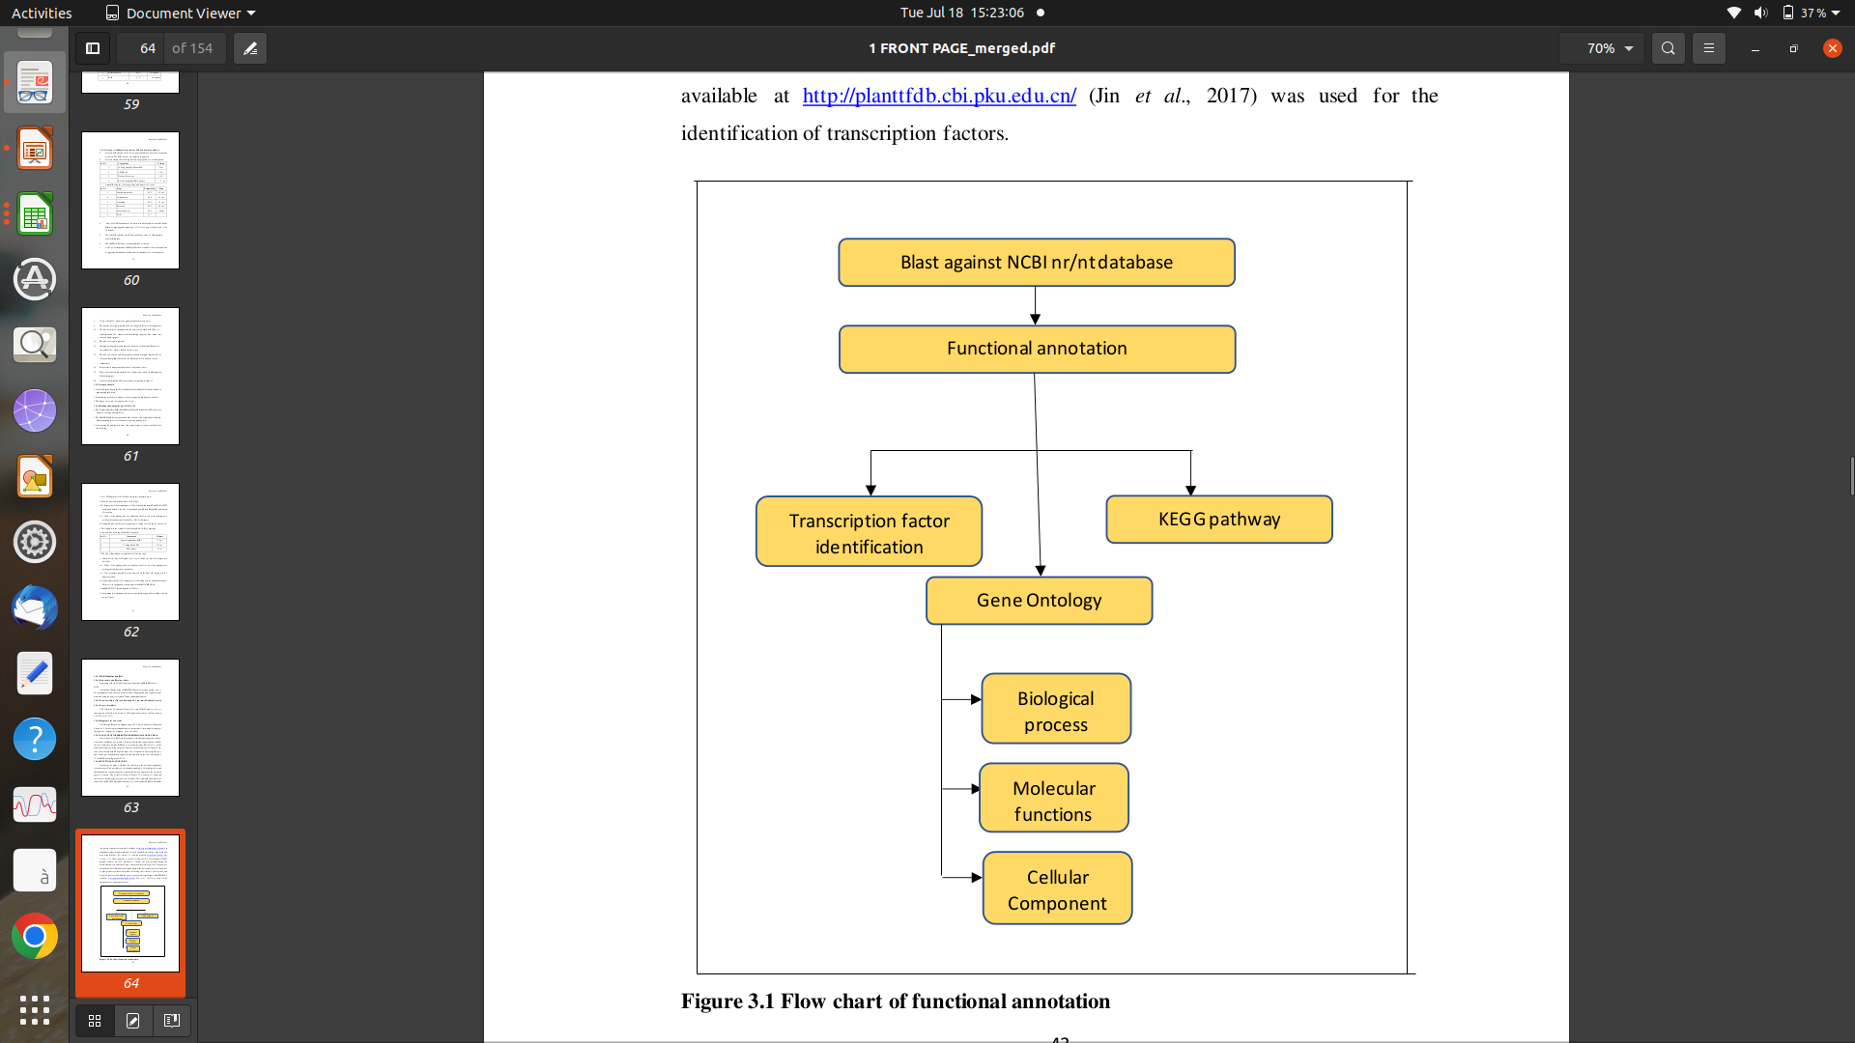
Fig. 4: Flow chart of functional annotation

For the de novo assembly, Trinity (v2.5.1) was used to the clean readings (Grabherr et al., 2011). The duplicate sequences were removed using the CD-HIT-EST programme, with the settings set to a similarity of 0.95 and a sequence length of 10 bases (Li and Godzik, 2006). By choosing the parameters E-value 1e-5 and E-value 1e-10 for BLAST (Altschul et al., 1997) and Hmmer (Finn et al., 2014), annotation information was eventually collected. The functions of new genes and DEGs by performing a blast search against the COG (Tatusov et al., 2000), GO (Ashburner et al., 2000), KEGG pathway (Minoru et al., 2004), Swiss-Prot (Rolf et al., 2004) and Non-redundant protein (NR) databases (Deng et al., 2006).

7) GENE ONTOLOGY (GO) enrichment analysis:

The use of the Gene Ontology (GO) analytic approach is expanding for broad functional analyses employing genomic or transcriptome data. Genes are categorized by some shared biological characteristic in order to do this analysis. Then, it is determined which categories are overrepresented among the differentially expressed genes. There are many programmes with GO-related analytic features, new tools are still required to meet the demands for data produced by recently emerging technologies or for advanced analysis purposes (Zheng et al., 2008). It is usual practise to employ Gene Ontology (GO) categories in this technique, and there are numerous programmes available for GO analysis, including EasyGO (Zhou and Su, 2007), GOminer (Zeeberg et al., 2003), GOstat (Beissbarth et al., 2004), GOToolBox (Martin et al., 2003), topGO (Alexa et al., 2006), GSEA (Subramanian et al., 2006 ), and DAVID (Huang da et al., 2006).

Top DEGs were identified with GO terms and this GO analysis was performed to identify significantly enriched GO terms of differentially expressed genes. GO classification done by software such as WEGO 2.0 to identify differences in functional categories. WEGO (Web Gene Ontology Annotation Plot) is a tool for visulizing, comparing and plotting to GO annotation results (Ye et al., 2018). GO is further divided into three sub-ontologies: Biological Process (BP), Cellular Component (CC) and Molecular Functions (MF). The text file containing merged data of dormant and non-dormant genotype having significant gene ID and its respective up and down-regulated annotated GO terms were uploaded to WEGO 2.0 and by keeping native file format enrichment was performed which classified enriched GO to different categories. Analysis of their further distribution into various sub-categories revealed the majority of GO terms were enriched from all the stages.

8) KEGG pathways :

The functional annotation of individual genes is still mostly unfinished, despite the genome sequencing project quick ability to identify gene catalogues for an expanding number of organisms. In an effort to connect genomic data with higher order functional data, KEGG (Kyoto Encyclopaedia of Genes and Genomes) standardize gene annotations and computerize current understanding of cellular process (Kanehisa and Goto, 2000). KEGG is made up of mainly three databases.The key gene involved in the biological and metabolic pathway could be identified through KEGG (Kyoto Encyclopaedia of genes and genomes database. LIGAND collect information related to chemical compounds in cells, enzyme molecules, and enzymatic reactions. The GENES collect catalogues of gene for all the fully as well as partially sequenced genomes. These genes are involved in various function and expressed at different location, at different stress condition like temperature stress, drought stress and salinity stress etc. To understand functions and utilities of DEGs, KOBAS software to test the statistical enrichment of DEGs in KEGG (InterPro scan and the Kyoto Encyclopedia of Genes and Genomes) pathways (Xiong et al., 2017).

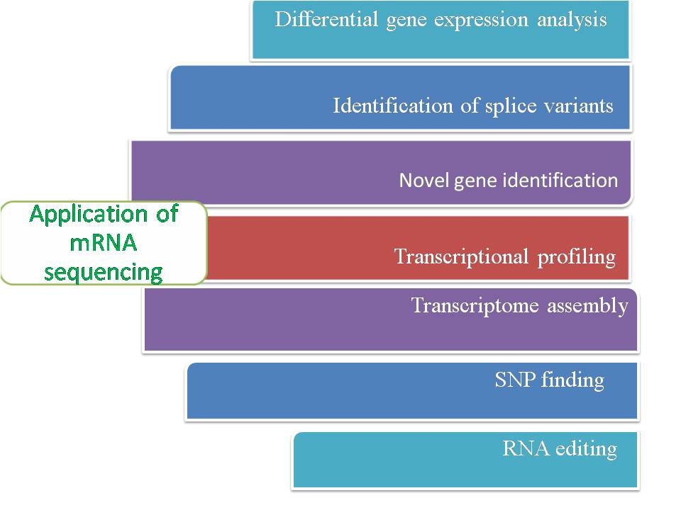
References:

Adams, M. D., Kelley, J. M., Gocayne, J. D., Dubnick, M., Polymeropoulos, M. H., Xiao, H., Merril, C. R., Wu, A., Olde, B., & Moreno, R. F. (1991). Complementary DNA sequencing: expressed sequence tags and human genome project. Science (New York, N.Y.), 252(5013), 1651–1656. https://doi.org/10.1126/science.2047873.

Adiconis, X., Borges-Rivera, D., Satija, R., DeLuca, D. S., Busby, M. A., Berlin, A. M., Sivachenko, A., Thompson, D. A., Wysoker, A., Fennell, T., Gnirke, A., Pochet, N., Regev, A., & Levin, J. Z. (2013). Comparative analysis of RNA sequencing methods for degraded or low-input samples. Nature methods, 10(7), 623–629. https://doi.org/10.1038/nmeth.2483.

Alexa, A., Rahnenfuhrer, J., & Lengauer, T. (2006). Improved scoring of functional groups from gene expression data by decorrelating GO graph structure. Bioinformatics, 22(13), 1600-1607. https://doi.org/10.1093/bioinformatics/btl140.

Anders, S. & Huber, W. (2010). Differential expression analysis for sequence count data. Genome Biology, 11, R106. https://doi.org/10.1186/gb-2010-11-10-r106.

Ardui, S., Ameur, A., Vermeesch, J. R., & Hestand, M. S. (2018). Single molecule real-time (SMRT) sequencing comes of age: applications and utilities for medical diagnostics. Nucleic Acids Research, 46(5), 2159–2168. https://doi.org/10.1093/nar/gky066.

Ashburner, M., Ball, C. A., Blake, J. A., Botstein, D., Butler, H., Cherry, J. M., Davis, A. P., Dolinski, K., Dwight, S. S., Eppig, J. T., Harris, M. A., Hill, D. P., Issel-Tarver, L., Kasarskis, A., Lewis, S., Matese, J. C., Richardson, J. E., Ringwald, M., Rubin, G. M., & Sherlock, G. (2000). Gene Ontology: Tool for the unification of biology. The gene Ontology consortium. Nature Genetics, 25(1), 25–29. https://doi.org/10.1038/75556.

Bainbridge, M. N., Warren, R. L., Hirst, M., Romanuik, T., Zeng, T., Go, A., Delaney, A., Griffith, M., Hickenbotham, M., Magrini, V., Mardis, E. R., Sadar, M. D., Siddiqui, A. S., Marra, M. A., & Jones, S. J. (2006). Analysis of the prostate cancer cell line LNCaP transcriptome using a sequencing-by-synthesis approach. BMC Genomics, 7, 246. .https://doi.org/10.1186/1471-2164-7-246.

Barbazuk, W. B., Emrich, S. J., Chen, H. D., Li, L., & Schnable, P. S. (2007). SNP discovery via 454 transcriptome sequencing. The Plant journal : for cell and molecular biology, 51(5), 910–918. https://doi.org/10.1111/j.1365-313X.2007.03193.x.

Baruzzo, G., Hayer, K., Kim, E., Camillo, B. D., FitzGerald, G. A., & Grant, G. R. (2017). Simulation-based comprehensive benchmarking of RNA-seq aligners. Nature Methods,14, 135–139. https://doi.org/10.1038/nmeth.4106.

Becker-Andre, M., & Hahlbrock, K. (1989). Absolute mRNA quantification using the polymerase chain reaction (PCR). A novel approach by a PCR aided transcript titration assay (PATTY). Nucleic Acids Research, 17(22), 9437–9446. https://doi.org/10.1093/nar/17.22.9437.

Beissbarth, T., & Speed, T. P. (2004). GOstat: find statistically overrepresented Gene Ontologies within a group of genes. Bioinformatics (Oxford, England), 20(9), 1464–1465. https://doi.org/10.1093/bioinformatics/bth088.

Bolger, A. M., Lohse, M., & Usadel, B. (2014). Trimmomatic: A flexible trimmer for Illumina sequence data. Bioinformatics, 30(15), 2114–2120. https://doi.org/10.1093/bioinformatics/btu170.

Brenner, S., Johnson, M., Bridgham, J., Golda, G., Lloyd, D. H., Johnson, D., Luo, S., McCurdy, S., Foy, M., Ewan, M., Roth, R., George, D., Eletr, S., Albrecht, G., Vermaas, E., Williams, S. R., Moon, K., Burcham, T., Pallas, M., DuBridge, R. B., Kirchner, J., Fearon, K., Mao, J., & Corcoran, K. (2000). Gene expression analysis by massively parallel signature sequencing (MPSS) on microbead arrays. Nature Biotechnology, 18(6), 630–634. https://doi.org/10.1038/76469.

Bullard, J. H., Purdom, E., Hansen, K. D., & Dudoit, S. (2010). Evaluation of statistical methods
for normalization and differential expression in mRNA-Seq experiments. BMC Bioinformatics, 11, 94. https://doi.org/10.1186/1471-2105-11-94.

Casamassimi, A., Federico, A., Rienzo, M., Esposito, S., & Ciccodicola A. (2017). Transcriptome profiling in human diseases: new advances and perspectives. International journal of molecular sciences, 18(8), 1652. https://doi.org/10.3390/ijms18081652.

Cloonan, N., Forrest, A., Kolle, G., Gardiner, B. B. A., Faulkner, G. J., Brown, M. K., Taylor, D. F., Steptoe, A. L., Wani, S.,Bethel, G., Robertson, A. J., Perkins, A. C., Bruce, S. J., Lee, C. C., Ranade, S. S., Peckham, H. E., Manning, J. M., McKernan, K. J., & Grimmond, S. M. (2008). Stem cell transcriptome profiling via massive-scale mRNA sequencing. Nature Methods, 5(7), 613–619. https://doi.org/10.1038/nmeth.1223.
Conesa, A., Madrigal, P., Tarazona, S., Gomez-Cabrero, D., Cervera, A., McPherson, A., Szcześniak, M. W., Gaffney, D. J., Elo, L. L., Zhang, X., & Mortazavi, A. (2016). A survey of best practices for RNA-seq data analysis. Genome Biology, 17, 13. https://doi.org/10.1186/s13059-016-0881-8.

Costa, V., Angelini, C., De Feis, I., & Ciccodicola, A. (2010). Uncovering the complexity of transcriptomes with RNA-seq. Journal ofBiomedicine and Biotechnology, 2010(5757), e853916. https://doi.org/10.1155/2010/853916.
DeLuca, D. S., Levin, J. Z., Sivachenko, A., Fennell, T., Nazaire, M. D., Williams, C., Reich, M., Winckler, W., & Getz, G. (2012). RNA-SeQC: RNA-seq metrics for quality control and process optimization. Bioinformatics (Oxford, England), 28(11), 1530–1532. https://doi.org/10.1093/bioinformatics/bts196.
Deng, Y., Jianqi, L. I., Songfeng, W. U., Zhu, Y., Chen, Y., & He, F. C. (2006). Integrated nr database in protein annotation system and its localization. Computer Engineering, 32 (5), 71–72. https://doi.org/10.1109/INFOCOM.2006.241.
Deshpande, D., Chhugani, K., Chang, Y., Karlsberg, A., Loeffler, C., Zhang, J., Muszyńska, A., Munteanu, V., Yang, H., Rotman, J., Tao, L., Balliu, B., Tseng, E., Eskin, E., Zhao, F., Mohammadi, P., P Łabaj, P., & Mangul, S. (2023). RNA-seq data science: From raw data to effective interpretation. Frontiers in Genetics, 14, 997383. https://doi.org/10.3389/fgene.2023.997383.
Dobin, A., Davis, C. A., Schlesinger, F., Drenkow, J., Zaleski, C., Jha, S., Batut, P., Chaisson, M., & Gingeras, T. R. (2013). STAR: ultrafast universal RNA-seq aligner. Bioinformatics (Oxford, England), 29(1), 15–21. https://doi.org/10.1093/bioinformatics/bts63.
Dodt, M., Roehr, J., Ahmed, R., & Dieterich, C. (2012). FLEXBAR—flexible barcode and adapter processing for next-generation sequencing platforms. Biology, 1(3), 895–905. https://doi.org/10.3390/biology1030895.
Emrich, S. J., Barbazuk, W. B., Li, L., & Schnable, P. S. (2007). Gene discovery and annotation using LCM-454 transcriptome sequencing. Genome Research, 17(1), 69–73. https://doi.org/10.1101/gr.5145806.
Finn, R. D., Alex, B., Jody, C., Penelope, C., Eberhardt, R. Y., Eddy, S. R., Heger, A., Hetherington, K., Holm, L., Mistry, J., Sonnhammer, E. L. L., Tate, J., & Punta, M. (2014). Pfam: The protein families database. Nucleic Acids Research, 42 (D1), D222–D230. https://doi.org/10.1093/nar/gkt1223.
Garber, M., Grabherr, M. G., Guttman, M., & Trapnell, C. (2011). Computational methods for transcriptome annotation and quantification using RNA-seq. Nature Methods, 8, 469–477. https://doi.org/10.1038/nmeth.1613.
García-Alcalde, F., Okonechnikov, K., Carbonell, J., Cruz, L. M., Götz, S., Tarazona, S., Dopazo, J., Meyer, T. F., & Conesa, A. (2012). Qualimap: evaluating next-generation sequencing alignment data. Bioinformatics (Oxford, England), 28(20), 2678–2679. https://doi.org/10.1093/bioinformatics/bts50.

Grabherr, M. G., Haas, B. J., Yassour, M., Levin, J. Z., Thompson, D. A., Amit, I., Adiconis, X., Fan, L., Raychowdhury, R., Zeng, Q., Chen, Z., Mauceli, E., Hacohen, N., Gnirke, A., Rhind, N., di Palma, F., Birren, B. W., Nusbaum, C., Lindblad-Toh, K., Friedman, N., & Regev, A. (2011). Full-length transcriptome assembly from RNA-Seq data without a reference genome. Nature Biotechnology, 29(7), 644–652. https://doi.org/10.1038/nbt.1883.

Hansen, K. D., Brenner, S. E., & Dudoit, S. (2010). Biases in Illumina transcriptome sequencing caused by random hexamer priming. Nucleic Acids Research, 38(12), e131. https://doi.org/10.1093/nar/gkq224.

Han, Y., Gao, S., Muegge, K., Zhang, W., & Zhou, B. (2015). Advanced Applications of RNA Sequencing and Challenges. Bioinformatics and Biology Insights, 9(Suppl 1), 29–46. https://doi.org/10.4137/BBI.S28991.

Heather, J. M., & Chain, B. (2016). The sequence of sequencers: the history of sequencing DNA. Genomics, 107(1), 1–8 . https://doi.org/10.1016/j.ygeno.2015.11.003.
Holt, R. A., & Jones, S. J. (2008). The new paradigm of flow cell sequencing. Genome Resrarch, 18(6), 839–846. https://doi.org/10.1101/gr.073262.107.
Huang, daW., Sherman, B. T., & Lempicki, R. A. (2009). Systematic and integrative analysis of large gene lists using DAVID bioinformatics resources. Nature Protocols, 4(1), 44-57. https://doi.org/10.1038/nprot.2008.211.

Jain M. (2012). Next-generation sequencing technologies for gene expression profiling in plants. Briefings in Functional Genomics, 11(1), 63–70. https://doi.org/10.1093/bfgp/elr038.
Jongeneel, C. V., Delorenzi, M., Iseli, C., Zhou, D., Haudenschild, C. D., Khrebtukova, I., Kuznetsov, D., Stevenson, B. J., Strausberg, R. L., Simpson, A. J., & Vasicek, T. J. (2005). An atlas of human gene expression from massively parallel signature sequencing (MPSS). Genome Research, 15(7), 1007–1014. https://doi.org/10.1101/gr.4041005.

Kanehisa, M., & Goto, S. (2000). KEGG: kyoto encyclopedia of genes and genomes. Nucleic Acids Research, 28(1), 27-30. https://doi.org/10.1093/nar/28.1.27.

Karsch-Mizrachi, I., Takagi, T., Cochrane, G., and International Nucleotide Sequence Database Collaboration (2018). The international nucleotide sequence database collaboration. Nucleic Acids Research, 46, D48–D51. https://doi.org/10.1093/nar/gkx1097.
Kolodziejczyk, A. A., Kim, J. K., Svensson, V., Marioni, J. C., & Teichmann, S. A. (2015). The technology and biology of single-cell RNA sequencing. Molecular Cell, 58, 610–620. https://doi.org/10.1016/j.molcel.2015.04.005.
Kumpatla, S. P., Buyyarapu, R., Abdurakhmonov, I. Y., & Mammadov, J. A. (2012) Genomics-assisted plant breeding in the 21st century: technological advances and progress. In: Ab-durakhmonov I (ed) Plant breeding. InTech publishers, Available from http://www.intechopen.com/books/plant-breeding/genomics-assisted-plant-breeding-in-the-21st-centurytechnological-advances-and-progress.
Langmead, B., Trapnell, C., Pop, M., & Salzberg, S. L. (2009). Ultrafast and memory-efficient alignment of short DNA sequences to the human genome. Genome Biology, 10, R25. https://doi.org/10.1186/gb-2009-10-3-r25.
Lathe, W., Williams, J., Mangan, M., & Karolchik, D. (2008). Genomic data resources: challenges and promises. Nature Education, 1(3), 2.
Le, H. S., Schulz, M. H., McCauley, B. M., Hinman, V. F., & Bar-Joseph, Z. (2013). Probabilistic error correction for RNA sequencing. Nucleic Acids Research, 41(10), e109. https://doi.org/10.1093/nar/gkt215.
Leng, N., Dawson, J. A., Thomson, J. A., Ruotti, V., Rissman, A. I., Smits, B. M., Haag, J. D., Gould, M. N., Stewart, R. M., & Kendziorski, C. (2013). EBSeq: an empirical Bayes hierarchical model for inference in RNA-seq experiments. Bioinformatics (Oxford, England), 29(8), 1035–1043. https://doi.org/10.1093/bioinformatics/btt087.
Levy, S. E., & Myers, R. M. (2016). Advancements in Next-Generation Sequencing. Annual Review of Genomics and Human Genetics, 17, 95–115. https://doi.org/10.1146/annurev-genom-083115-022413.
Li, H., Ruan, J., & Durbin, R. (2008). Mapping short DNA sequencing reads and calling variants using mapping quality scores. Genome Research, 18(11), 1851–1858. https://doi.org/10.1101/gr.078212.108.
Li, H., & Durbin, R. (2009). Fast and accurate short read alignment with Burrows-Wheeler transform. Bioinformatics (Oxford, England), 25(14), 1754–1760. https://doi.org/10.1093/bioinformatics/btp324.
Li, J., & Tibshirani, R. (2013). Finding consistent patterns: a nonparametric approach for identifying differential expression in RNA-Seq data. Statistical methods in medical research, 22(5), 519–536. https://doi.org/10.1177/0962280211428386.
Li, J., Witten, D. M., Johnstone, I. M., & Tibshirani, R. (2012). Normalization, testing, and false discovery rate estimation for RNA-sequencing data. Biostatistics (Oxford, England), 13(3), 523–538. https://doi.org/10.1093/biostatistics/kxr031.
Lister, R., O'Malley, R. C., Tonti-Filippini, J., Gregory, B. D., Berry, C. C., Millar, A. H., & Ecker, J. R. (2008). Highly integrated single-base resolution maps of the epigenome in Arabidopsis. Cell, 133(3), 523–536. https://doi.org/10.1016/j.cell.2008.03.029.
Li, W., & Godzik, A. (2006). Cd-hit: a fast program for clustering and comparing large sets of protein or nucleotide sequences. Bioinformatics (Oxford, England), 22(13), 1658–1659. https://doi.org/10.1093/bioinformatics/btl15.
Lowe R., Shirley N., Bleackley M., Dolan S., & Shafee T. (2017). Transcriptomics technologies. PLoS Computational Biolology, 13, e1005457. https://doi.org/10.1371/journal.pcbi.1005457.
Margulies, M., Egholm, M., Altman, W. E., Attiya, S., Bader, J. S., Bemben, L. A., Berka, J., Braverman, M. S., Chen, Y. J., Chen, Z., Dewell, S. B., Du, L., Fierro, J. M., Gomes, X. V., Godwin, B. C., He, W., Helgesen, S., Ho, C. H., Irzyk, G. P., Jando, S. C., Rothberg, J. M. (2005). Genome sequencing in microfabricated high-density picolitre reactors. Nature, 437(7057), 376–380. https://doi.org/10.1038/nature03959.
Marra, M. A., Hillier, L., & Waterston, R. H. (1998). Expressed sequence tags: ESTablishing bridges between genomes. Trends in Genetics, 14(1), 4–7. https://doi.org/10.1016/S0168-9525(97)01355-3.
Martin, M. (2011). Cutadapt removes adapter sequences from high-throughput sequencing reads. EMBnet Journal, 17(1), 10–12. https://doi.org/10.14806/ej.17.1.200.
Martin, D., Brun, C., Remy, E., Mouren, P., Thieffry, D., & Jacq, B. (2004). GOToolBox: functional analysis of gene datasets based on Gene Ontology. Genome Biology, 5(12), R101. https://doi.org/10.1186/gb-2004-5-12-r101.
McGettigan, P. A. (2013). Transcriptomics in the RNA-seq era. Current Opinion in Chemical Biology, 17(1), 4–11. https://doi.org/10.1016/j.cbpa.2012.12.008.
Melé, M., Ferreira, P. G., Reverter, F., DeLuca, D. S., Monlong, J., Sammeth, M., Young, T. R., Goldmann, J. M., Pervouchine, D. D., Sullivan, T. J., Johnson, R., Segrè, A. V., Djebali, S., Niarchou, A., GTEx Consortium, Wright, F. A., Lappalainen, T., Calvo, M., Getz, G., Dermitzakis, E. T., Ardille, K.G., & Guigó, R. (2015). Human genomics. The human transcriptome across tissues and individuals. Science (New York, N.Y.), 348(6235), 660–665. https://doi.org/10.1126/science.aaa0355.
Meyers, B. C., Vu, T. H., Tej, S. S., Ghazal, H., Matvienko, M., Agrawal, V., Ning, J., & Haudenschild, C. D. (2004). Analysis of the transcriptional complexity of Arabidopsis thaliana by massively parallel signature sequencing. Nature Biotechnology, 22(8), 1006–1011. https://doi.org/10.1038/nbt992.

Minoru, K., Goto, S., Kawashima, S., Okuno, Y., & Hattori, M. (2004). The KEGG resource for deciphering the genome. Nucleic Acids Research, 32(Database issue), D277–D280. https://doi.org/10.1093/nar/gkh063.

Mironova, V. V., Weinholdt, C., & Grosse, I. (2015). “RNA-seq data analysis for studying abiotic stress in horticultural plants,” in Abiotic Stress Biol. Hortic. Plants, eds Y. Kanayama and A. Kochetov Tokyo: Springer.197–220. https://doi.org/10.1007/978-4- 431-55251- 2_14.

Morin, R., Bainbridge, M., Fejes, A., Hirst, M., Krzywinski, M., Pugh, T., McDonald, H., Varhol, R., Jones, S., & Marra, M. (2008). Profiling the HeLa S3 transcriptome using randomly primed cDNA and massively parallel short-read sequencing. BioTechniques, 45(1), 81–94. https://doi.org/10.2144/000112900.
Okonechnikov, K., Conesa, A., & García-Alcalde, F. (2016). Qualimap 2: advanced multi-sample quality control for high-throughput sequencing data. Bioinformatics (Oxford, England), 32(2), 292–294. https://doi.org/10.1093/bioinformatics/btv566.
Oshlack, A. and Wakefield, M. J. (2009). Transcript length bias in RNA-seq data confounds systems biology. Biology Direct, 4, 14. https://doi.org/10.1186/1745-6150-4-14.
Ozsolak, F., & Milos, P. M. (2011). RNA sequencing: advances, challenges and opportunities. Nature Reviews. Genetics, 12(2), 87–98. https://doi.org/10.1038/nrg2934.
Pérez-de-Castro, A. M., Vilanova, S., Cañizares, J., Pascual, L., Blanca, J. M., Díez, M. J., Prohens, J., & Picó, B. (2012). Application of genomic tools in plant breeding. Current Genomics, 13(3), 179–195. https://doi.org/10.2174/138920212800543084.
Picard. http://picard.sourceforge.net/.
Pozhitkov, A. E., Tautz, D., & Noble, P. A. (2007)."Oligonucleotide microarrays: widely applied—poorly understood". Briefings in Functional Genomics & Proteomics, 6(2), 141–148. https://doi.org/10.1093/bfgp/elm014.
Putney, S., Herlihy, W. & Schimmel, P. A new troponin T and cDNA clones for 13 different muscle proteins, found by shotgun sequencing. Nature, 302, 718–721 (1983). https://doi.org/10.1038/302718a0.
Ranallo-Benavidez, T. R., Jaron, K. S., & Schatz, M. C. (2020). GenomeScope 2.0 and Smudgeplot for reference-free profiling of polyploid genomes. Nature Communication, 11
(1), 1432. https://doi.org/10.1038/s41467-020-14998-3.
Rhie, A., Walenz, B. P., Koren, S., & Phillippy, A. M. (2020). Merqury: reference-free quality, completeness, and phasing assessment for genome assemblies. Genome Biology, 21(1), 245. https://doi.org/10.1186/s13059-020-02134-9.
Robasky, K., Lewis, N. E., & Church, G. M. (2014). The role of replicates for error mitigation in next-generation sequencing. Nature reviews. Genetics, 15(1), 56–62. https://doi.org/10.1038/nrg3655.
Robertson, G., Schein, J., Chiu, R., Corbett, R., Field, M., Jackman, S. D., Mungall, K., Lee, S., Okada, H. M., Qian, J. Q., Griffith, M., Raymond, A., Thiessen, N., Cezard, T., Butterfield, Y. S., Newsome, R., Chan, S. K., She, R., Varhol, R., Kamoh, B., & Birol, I. (2010). De novo assembly and analysis of RNA-seq data. Nature Methods, 7(11), 909–912. https://doi.org/10.1038/nmeth.1517.
Robinson, M. D., McCarthy, D. J., & Smyth, G. K. (2010a). edgeR: a Bioconductor package for differential expression analysis of digital gene expression data. Bioinformatics (Oxford, England), 26(1), 139–140. https://doi.org/10.1093/bioinformatics/btp616.
Robinson, M. D., & Oshlack, A. (2010b). A scaling normalization method for differential expression analysis of RNA-seq data. Genome Biology, 11(3), R25. https://doi.org/10.1186/gb-2010-11-3-r25.

Rolf, A., Bairoch, A., Wu, C. H., Barker, W. C., Boeckmann, B., Ferro, S., Gasteiger, E., Huang, H., Lopez, R., Magrane, M., Martin, M. J., Natale, D. A., O'Donovan, C., Redaschi, N., & Yeh, L. S. (2004). UniProt: the Universal Protein knowledgebase. Nucleic Acids Research, 32(Database issue), D115–D119. https://doi.org/10.1093/nar/gkh131.
Sandberg, R. (2014). Entering the era of single-cell transcriptomics in biology and medicine. Nature Methods, 11(1), 22–24. https://doi.org/10.1038/nmeth.2764.
Schena, M., Shalon, D., Davis, R. W., & Brown, P. O. (1995). Quantitative monitoring of gene expression patterns with a complementary DNA microarray. Science (New York, N.Y.), 270(5235), 467–470. https://doi.org/10.1126/science.270.5235.467.
Schulz, M. H., Zerbino, D. R., Vingron, M., & Birney, E. (2012). Oases: robust de novo RNA-seq assembly across the dynamic range of expression levels. Bioinformatics (Oxford, England), 28(8), 1086–1092. https://doi.org/10.1093/bioinformatics/bts094.
Shendure, J., Balasubramanian, S., Church, G. M., Gilbert, W., Rogers, J., Schloss, J. A., & Waterston, R. H. (2017). DNA sequencing at 40: past, present and future. Nature, 550(7676), 345–353. https://doi.org/10.1038/nature24286.
Subramanian, A., Tamayo, P., Mootha, V. K., Mukherjee, S., Ebert, B. L., Gillette, M. A., Paulovich, A., Pomeroy, S. L., Golub, T. R., Lander, E. S., & Mesirov, J. P. (2005). Gene set enrichment analysis: a knowledge-based approach for interpreting genome-wide expression profiles. Proceedings of the National Academy of Sciences of the United States of America, 102(43), 15545–15550. https://doi.org/10.1073/pnas.0506580102.
Tarazona, S., Furió-Tarí, P., Turrà, D., Pietro, A. D., Nueda, M. J., Ferrer, A., & Conesa, A. (2015). Data quality aware analysis of differential expression in RNA-seq with NOISeq R/Bioc package. Nucleic Acids Research, 43(21), e140. https://doi.org/10.1093/nar/gkv711.
Tatusov, R. L., Galperin, M. Y., Natale, D. A., & Koonin, E. V. (2000). The COG database: a tool for genome-scale analysis of protein functions and evolution.Nucleic Acids Research, 28(1), 33–36. https://doi.org/10.1093/nar/28.1.33.
Teng, M., Love, M. I., Davis, C. A., Djebali, S., Dobin, A., Graveley, B. R., Li, S., Mason, C. E., Olson, S., Pervouchine, D., Sloan, C. A., Wei, X., Zhan, L., & Irizarry, R. A. (2016). A benchmark for RNA-seq quantification pipelines. Genome Biology, 17, 74. https://doi.org/10.1186/s13059-016-0940-1.
Trapnell, C., Hendrickson, D. G., Sauvageau, M., Goff, L., Rinn, J. L., & Pachter, L. (2013). Differential analysis of gene regulation at transcript resolution with RNA-seq. Nature Biotechnology, 31(1), 46–53. https://doi.org/10.1038/nbt.2450.
Trapnell, C., Pachter, L., & Salzberg, S. L. (2009). TopHat: discovering splice junctions with RNA-Seq. Bioinformatics (Oxford, England), 25(9), 1105–1111. https://doi.org/10.1093/bioinformatics/btp120.
Trapnell, C., Williams, B. A., Pertea, G., Mortazavi, A., Kwan, G., van Baren, M. J., Salzberg, S. L., Wold, B. J., & Pachter, L. (2010). Transcript assembly and quantification by RNA-Seq reveals unannotated transcripts and isoform switching during cell differentiation. Nature Biotechnology, 28(5), 511–515. https://doi.org/10.1038/nbt.1621.
Tuerk, A., Wiktorin, G., & Güler, S. (2017). Mixture models reveal multiple positional bias types in RNA-Seq data and lead to accurate transcript concentration estimates. PLoS Computational Biology, 13(5), e1005515. https://doi.org/10.1371/journal.pcbi.1005515.
Tyagi, P., & Ranjan, R. (2021). Comparative study of the pharmacological, phytochemical, and biotechnological aspects of Tribulus terrestris Linn. and Pedalium murex Linn: An overview. Acta Ecologica Sinica, 43(2), 223-233. https://doi.org/ 10.1016/j.chnaes.2021.07.008.
Tyagi P., Singh A., Gupta A., Prasad M. and Ranjan R. (2022). Mechanism and function of salicylate in plant toward biotic stress tolerance. In book: Emerging Plant Growth Regulators in Agriculture, chapter 4, 131–164. https://doi.org/10.1016/B978-0-323-91005-7.00018-7.
Vera, J. C., Wheat, C. W., Fescemyer, H. W., Frilander, M. J., Crawford, D. L., Hanski, I., & Marden, J. H. (2008). Rapid transcriptome characterization for a nonmodel organism using 454 pyrosequencing. Molecular Ecology, 17(7), 1636–1647. https://doi.org/10.1111/j.1365-294X.2008.03666.x.
Vurture, G. W., Sedlazeck, F. J., Nattestad, M., Underwood, C. J., Fang, H., Gurtowski, J., & Schatz, M. C. (2017). GenomeScope: fast reference-free genome profiling from short reads. Bioinformatics (Oxford, England), 33(14), 2202–2204. https://doi.org/10.1093/bioinformatics/btx153.
Wang, B., Tseng, E., Regulski, M., Clark, T. A., Hon, T., Jiao, Y., Lu, Z., Olson, A., Stein, J. C., & Ware, D. (2016). Unveiling the complexity of the maize transcriptome by single-molecule long-read sequencing. Nature Communications, 7, 11708. https://doi.org/10.1038/ncomms11708.
Wang, K., Singh, D., Zeng, Z., Coleman, S. J., Huang, Y., Savich, G. L., He, X., Mieczkowski, P., Grimm, S. A., Perou, C. M., MacLeod, J. N., Chiang, D. Y., Prins, J. F., & Liu, J. (2010). MapSplice: accurate mapping of RNA-seq reads for splice junction discovery. Nucleic Acids Research, 38(18), e178. https://doi.org/10.1093/nar/gkq622.
Wang, L., Wang, S., & Li, W. (2012). RSeQC: quality control of RNA-seq experiments. Bioinformatics (Oxford, England), 28(16), 2184–2185. https://doi.org/10.1093/bioinformatics/bts356.

Wang, Z., Gerstein, M., & Snyder, M. (2009). RNA-Seq: a revolutionary tool for transcriptomics.Nature Reviews Genetics, 10(1), 57–63. https://doi.org/10.1038/nrg2484.
Wu, T. D., & Nacu, S. (2010). Fast and SNP-tolerant detection of complex variants and splicing in short reads. Bioinformatics (Oxford, England), 26(7), 873–881. https://doi.org/10.1093/bioinformatics/btq057.

Xiong, H., Guo, H., Xie, Y. et al. (2017). RNAseq analysis reveals pathways and candidate genes associated with salinity tolerance in a spaceflight-induced wheat mutant. Sci Rep, 7, 2731 https://doi.org/10.1038/s41598-017-03024-0.

Yang, I. S., & Kim, S. (2015). Analysis of Whole Transcriptome Sequencing Data: Workflow and Software. Genomics Inform,13(4), 119-125. https://doi.org/10.5808/GI.2015.13.4.119.

Ye, J., Zhang, Y., Cui, H., Liu, J., Wu, Y., Cheng, Y., Xu, H., Huang, X., Li, S., Zhou, A., Zhang, X., Bolund, L., Chen, Q., Wang, J., Yang, H., Fang, L., & Shi, C. (2018). WEGO 2.0: a web tool for analyzing and plotting GO annotations. Nucleic Acids Research, 46(W1), W71–W75. https://doi.org/10.1093/nar/gky400.

Zeeberg, B. R., Feng, W., Wang, G., Wang, M. D., Fojo, A. T., Sunshine, M., Narasimhan, S., Kane, D. W., Reinhold, W. C., Lababidi, S., Bussey, K. J., Riss, J., Barrett, J. C., & Weinstein, J. N. (2003). GoMiner: a resource for biological interpretation of genomic and proteomic data. Genome Biology, 4, R28. https://doi.org/10.1186/gb-2003-4-4-r28.

Zheng, Q., Xiu-Jie Wang, (2008). GOEAST: a web-based software toolkit for Gene Ontology enrichment analysis. Nucleic Acids Research, 36(2), W358–W363. https://doi.org/10.1093/nar/gkn276.

Zhou, X., & Su, Z. (2007). EasyGO: Gene Ontology-based annotation and functional enrichment analysis tool for agronomical species. BMC Genomics, 8, 246. https://doi.org/10.1186/1471-2164-8-246.

