Biosynthesis and Characterization of Encapsulated Chitosan-Iron oxide (Fe₃O₄) hybrid nanocomposite beads – Its dual potential as fertilizer for Vigna radiata and pesticide against Meloidogyne incognita
JK. Alphonsa Juliet Helina*,
Department of Chemistry,
St. Joseph’s College (Autonomous),
Affliated to Bharathidasan University,
Tiruchirappalli, Tamilnadu, India.
alphochem@gmail.com

ABSTRACT
In virtue of the advanced characteristics of the chitosan derived iron oxide nanocomposites (Fe₃O₄) fascinated the attentions in diverse applications owing to their exclusive physico-chemical properties. Additionally, owed to their exceptional surface area, compatible size in nanoscale, spherical shape and ecological synthesis pathway make them preferable and sensible in industrial, agricultural and pharmacological area of research. Based on this scrutiny, it aims to the bio-synthesis of chitosan derived iron oxide nanocomposites (Ch-Fe₃O₄) hybrid beads. The reports expose that the nanocomposite hybrid beads have effective agricultural applications as fertilizer for Vigna radiate and pesticide against Meloidogyne incognita. Exceedingly cost-effective and environmentally benign methodology ropes the fabrication (Ch-Fe₃O₄) nanocomposites in high yield. The SEM image reveals that, the chitosan-iron nanocomposites possess spherical shape and the size of 81.7nm. The resultant Fe-O band at 551.86 cm⁻¹ indicates the formation of the nanocomposites. The EDX signals for iron and oxygen atoms only obtained supplementary confirms the formation of nanocomposites. The absorbance peak at 395.05nm in UV-Visible spectrum evidently proves the synthesis of (Ch-Fe₃O₄) nanocomposites. The synthesized (Ch-Fe₃O₄) nanocomposites were encapsulated and converted to hybrid beads. The (Ch-Fe₃O₄) nanocomposites hybrid beads effectively acts as a good fertilizer which enhances the growth of Vigna radiate seeds. The (Ch-Fe₃O₄) nanocomposites hybrid beads as pesticide extremely disrupts the growth of Meloidogyne incognita isolated from the root of the Musa acuminata.

Keywords: Iron nanocomposites, chitosan, SEM, Fertilizer, EDAX, pesticide.

I. INTRODUCTION
The iron oxide nanocomposites have achieved pre-emin by desirable quality of biocompatibility, wider surface area, desirable nanosize, extremely stable, electrical, magnetic and optical properties [1-3]. Due to their tremendous properties than other metal oxide nanocomposites, they have drawn attention in various industrial, agriculture, electronics [4], biomedicine [5] and pharmaceutical applications [6]. Fascinatingly, the iron oxide nanocomposites synthesized by green method are non-toxicity and ecofriendly have the capability to undergo an admirable photocatalytic degradation for the amputation of various dyes [7]. Furthermore, due to the massive surface area the iron oxide nanocomposites have greater efficacy prohibiting corrosion [8], adsorbent and exclusion of impurities and toxic particles [9]. Notably, the green pathway utilized for the synthesis is superior to the other chemical methods. Nanotechnology applications are highly suitable for biological molecules and industrial fields, because of their exclusive properties. The synthesis of metal and semiconductor nanoparticles is a vast area of research due to its potential applications[10] which was implemented in the development of novel technologies. Similarly the chosen modifier Chitosan (Biopolymer) is biodegradable, non-toxic and has vast applications in different sectors. Chitosan is a linear polysaccharide composed of randomly distributed β-(1→4)-linked D-glucosamine (deacetylated unit) and N-acetyl-D-glucosamine (acetylated unit). This bio-polymer is used in various fields such as bio-pesticide in agriculture, fining agent in wine making, biocontroller and elicitor, bandages and antibacterial agent in medical fields. Chitosan is derived from the de-acetlylation of chitin. Commercial chitosan is naturally obtained from the excrete matter of prawns [11]. Dye effluents from textile and dyeing industries leads to ecological problems in drinking water system. It is estimated that up to 20% of the total dyes produced is vanished during the dyeing process and released into the water bodies [12]. Iron nanoparticles have significant catalytic property which is used for the effective removal of dye molecules[13,14]. Significantly the active functional groups present in the biopolymer chitosan acts as capping and stabilizing agents over the metal ion (Fe³⁺) in synthesizing iron oxide nanocomposites [15-19]. Recent studies have shown that nano bio-pesticides have the capability to reduce the toxic impact of chemical pesticides and provide target-specific control of crop pests. These nano systems have shown great capability of controlled-release patterns of active ingredients that make them more efficient for long durability. They can be helpful in the development of intelligent nano systems for the minimization of adverse problems to agriculture such as environmental imbalance, food security, food productivity. They can also solve eutrophication and residual pesticide accumulation problems. An intense research strategy needs to be developed for the formulation, characterization, morphology, and application of nano bio-pesticides. Thus in this eloquent research, the novel progress of exploration of iron oxide nanocomposites as fertilizer and pesticide will be discussed. Development of this possibility will promote the growth of the crops and prevents the attacks of pests.

II. Experimental Methods
Materials
The commercial bio-polymer material is chitosan, analytical grade ferric chloride (FeCl₃) and sodium hydroxide (NaOH) were used for the synthesis of chitosan derived iron oxide nanocomposites.

Synthesis of Nanocomposites hybrid beads
Accurately weighed quantity of Ferric chloride (FeCl₃) was dissolved in (100ml) water in standard flask [13]. The solution was transferred into burette and then 0.2g of chitosan is dissolved in 20ml of distilled water and stirred with heating constantly for 1 hour using magnetic stirrer at a constant temperature (80⁰C). Stir until the chitosan becomes homogeneous gel then add FeCl₃ solution (20mL) drop by drop solution in small increments into the biopolymer solution and continue the constant stirring and heating for 2 hours. The pH of the homogeneous metal polymeric solution is altered by adding few drops of NaOH solution. The metal polymeric nanocomposite solution is solvent evaporated and incinerated at 600°C for 6 hours. The metal oxide nanocomposites thus, formed was ground well, stored and taken for further characterization[17]. The synthesized
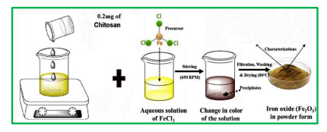
Figure-1: Graphical abstract of synthesis of (Ch-Fe₃O₄) nanocomposites
Characterization
The synthesized (Ch-Fe₃O₄) nanocomposites were evidently characterized by spectral techniques, surface morphology, particle size measurements and elemental analysis. The functional groups of the prepared (Ch-Fe₃O₄) nanocomposites were analyzed using Fourier Transform Infra-Red Spectroscopy (model: Perkin Elmer Spectrum Two) [20]. The absorbance peak for iron oxide nanocomposites was studied using Ultraviolet-Visible Spectroscopy (model: Perkin Elmer Lambda 35) [21]. The particle size of the nanoparticles was studied using Dynamic Light Scattering studies (model: Micromeritics Nano Plus). The surface morphology and shape of the nanoparticles were studied using Scanning Electron Microscopy (model: CAREL ZEISS EVO 18). The elemental composition of the prepared nanocomposites was examined using an Energy Dispersive X-ray analyzer (model: Thermo Scientific Model Noron).
Bio-fertilizer - Seed Germination
The seeds were washed and submerged in 70% alcohol for 40s, later the alcohol was decanted. The seeds were transferred into a flask containing 20% commercial sodium hypochlorite solution and left there for 20 min for surface sterilization. Later they were rinsed thrice with sterile distilled water. 2-3 seeds were placed on the surface of Murashige and Skoog basal medium and incubated at 25ºC for 16 hrs hot period with 250 μE/m²/ slight intensity for 2 weeks. Regular observation for germination has been made.

Bio-pesticide - Isolation of M.incognita & Nematicidal activity
M. incognita was isolated from the root of the Musa acuminata. Egg masses of M. incognita were collected using sterile forceps from the roots of heavily infected roots. The egg masses were washed three times with sterile distilled water. Inoculated for every 24 Hours and freshwater was added to the 24 well plate to prevent the hatched juveniles were harvested from the beaker eggs from drying. The nematicidal activity of (Ch-Fe₃O₄) nanocomposites against M. incognita was carried out by maintaining the nematode numbers as constant, but with various concentrations of (Ch-Fe₃O₄) nanocomposites from10mg/ml to 0.1mg/ml. The 24 well plates with each concentration were maintained at 28ºC for 2 days. The death rate of nematodes readings were noted with 2 day intervals. The live and dead analyses were carried out using Graph pad Prism software.
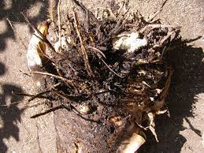
Figure-2: Rotten roots of Musa acuminata

III. RESULTS AND DISCUSSION
FT-IR
FT-IR spectrum of the synthesized (Ch-Fe₃O₄) nanocomposites reveals the functional groups involved. The broad band endorsed at 3848.17cm⁻¹, 3419cm⁻¹, 2923.03cm⁻¹, 1532cm⁻¹, 1020.31cm⁻¹, 824.51cm⁻¹ may be due to the involvement of -NH2, OH, C-H alkanes, -C=C-, NH stretching, C-H bending respectively. The Fe-O stretching frequency was endorsed at 557.90cm⁻¹.
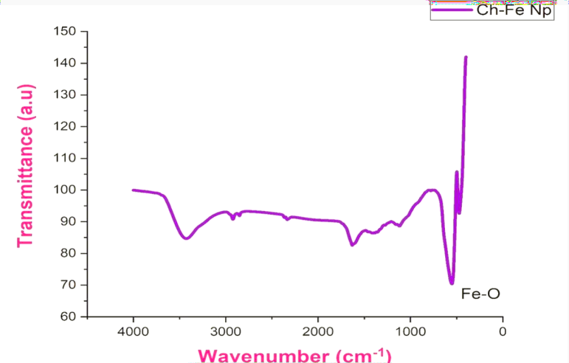
Figure-3: FTIR spectrum of (Ch-Fe₃O₄) nanocomposites

Particle Size Analysis
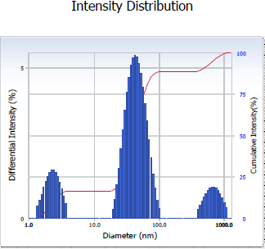
The average size of the nanoparticles and the statistical distribution of the size are determined using the particle size analyzer. The diameter of the fabricated (Ch-Fe₃O₄) nanocomposites is found to be 66nm.
Figure-4: DLS graph of (Ch-Fe₃O₄) nanocomposites

Scanning Electron Microscopy
The SEM images clearly depict the shape and size of the (Ch-Fe₃O₄) nanocomposites. The size was found to be 81.00 nm and the shape was found to be spherical in shape.

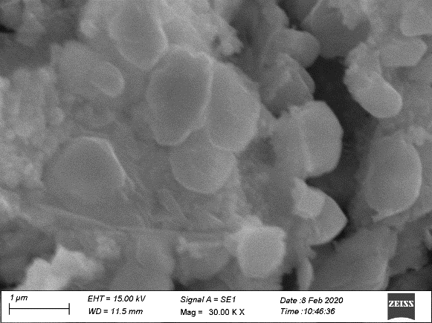 a | 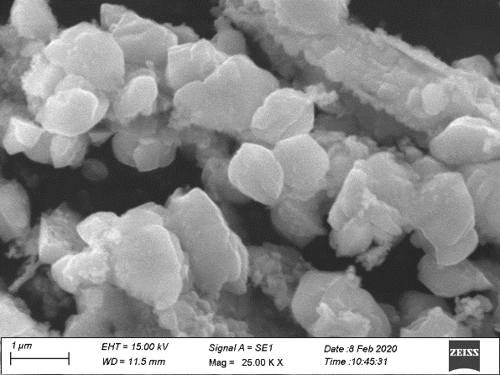 b
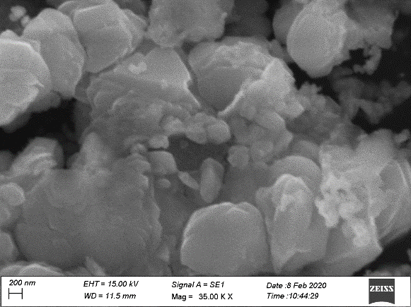 c | 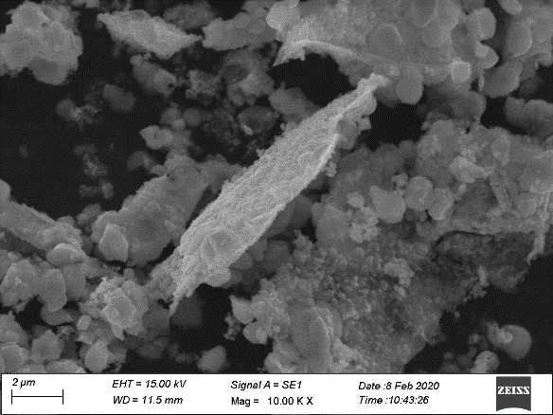 d
Figure-5: SEM images of (Ch-Fe₃O₄) nanocomposites
Energy Dispersive X-Ray Analysis (EDX)
The EDX signals observed for Fe and O atoms indicates the formation of the (Ch-Fe₃O₄) nanocomposites. The weight percentages of oxygen and iron atoms were 25.33 % and 74.67 % respectively. The atomic percentages of oxygen and iron atoms were 54.21% and 45.79 % respectively. The presence of only two signals attributes that the synthesized composites were free from impurities.
Table-1. EDX data of the (Ch-Fe₃O₄) nanocomposites

Element | Weight % | Atom %
O | 25.33 | 54.21
Fe | 74.67 | 45.79
Total | 100.00 | 100.00
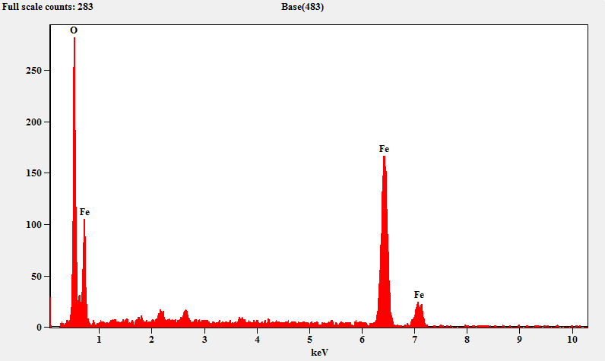

Figure-6. EDX signals of the (Ch-Fe₃O₄) nanocomposites
Bio-fertilizer - Seed Germination

Table-2: Seed Germination Analysis of Vigna radiata by the Bio-fertilizer (Ch-Fe₃O₄) nanocomposites
S.No | (Ch-Fe₃O₄) nanocomposites | Number of seeds per  Pots | Seed germinated | Growth % OF SEEDVIABILITY
1 | Control | 10 | 8 | 80
2 | 10mg | 10 | 10 | 100
3 | 5mg | 10 | 9 | 90
4 | 1mg | 10 | 8 | 80
5 | 0.5mg | 10 | 9 | 90
6 | 0.1mg | 10 | 7 | 70

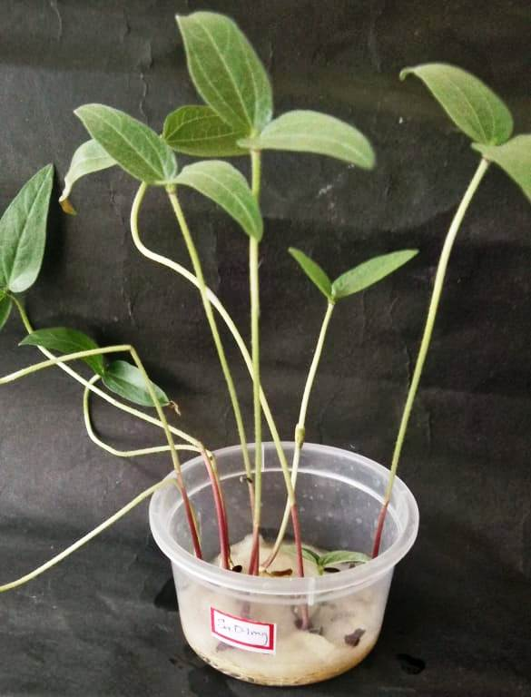  Control | 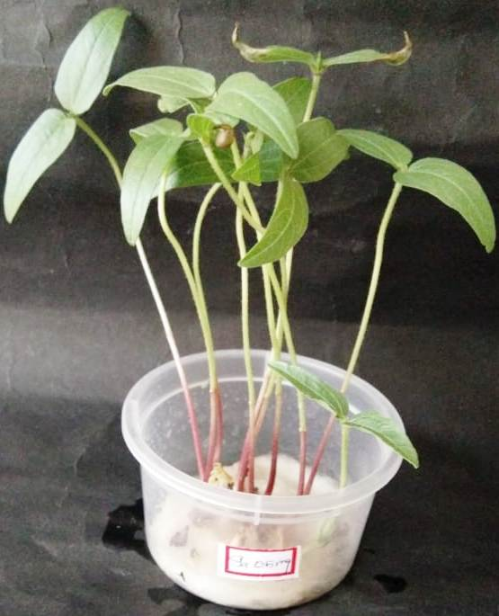  0.5 mg | 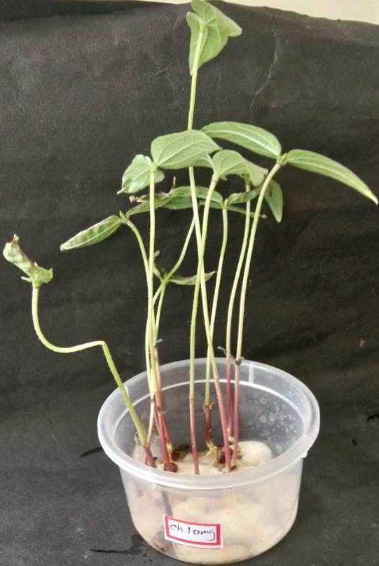  10 mg
Figure-7: Seed Germination Analysis of Vigna radiata by the Bio-fertilizer (Ch-Fe₃O₄) nanocomposites

The potential of the synthesized (Ch-Fe₃O₄) nanocomposites as growth enhancer of Vigna radiata. The plant growth enhanced at the concentration 0.5mg of (Ch-Fe₃O₄) nanocomposites hybrid beads. The nanocomposites were encapsulated and converted into microbeads. Since iron is a micronutrient, the synthesized (Ch-Fe₃O₄) nanocomposites releases the required amount of iron micronutrient to the plant through the roots and helps in increasing the growth of the Vigna radiate seeds. These microbeads are good fertilizer which enhanced growth factor in plant.

Bio-pesticide- Nematicidal activity against Meloidogyne incognita
The synthesized (Ch-Fe₃O₄) nanocomposites act as a pesticide against spiral nematode and root-knot nematode. The (Ch-Fe₃O₄) nanocomposites have effective pesticide activity against Meloidogyne incognita isolated from the root of the Musa acuminata. At the higher concentration 10 mg/ml the nematodes has been completely killed

Table-3: Nematicidal activity against Meloidogyne incognita by the Bio-fertilizer (Ch-Fe₃O₄) nanocomposites

Concentration of (Ch-Fe₃O₄) nanocomposites | No. of Nematodes
Concentration of (Ch-Fe₃O₄) nanocomposites | Live | Dead
Control | 5 | 0
10 | 1 | 4
5 | 2 | 3
1 | 5 | 0
0.5 | 5 | 0
0.1 | 5 | 0

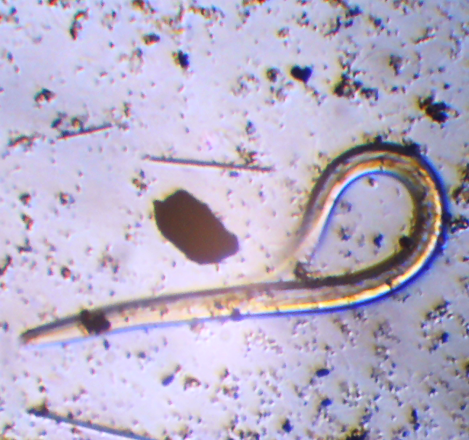  Control | 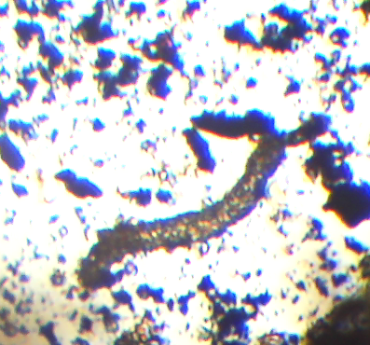  10 mg/ml | 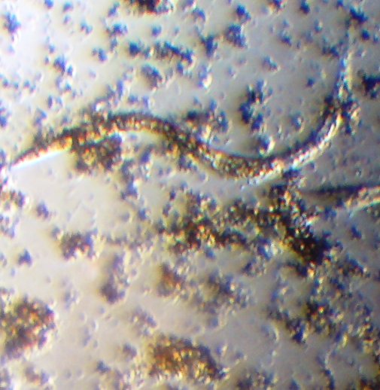  5 mg/ml
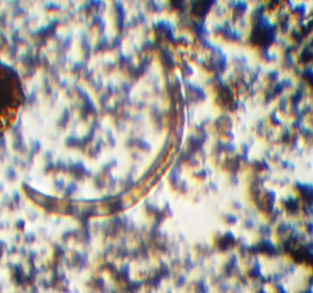  1 mg/ml | 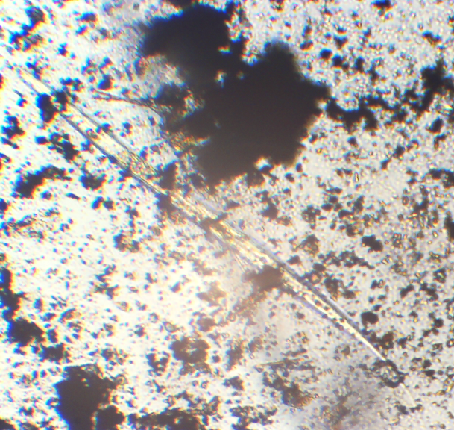  0.5 mg/ml | 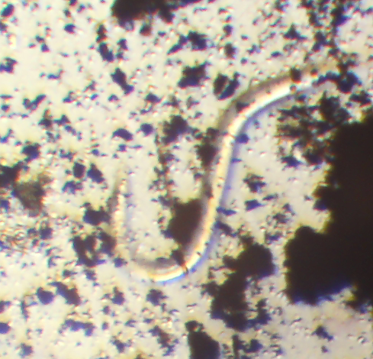  0.1 mg/ml

Figure-8: (Ch-Fe₃O₄) nanocomposites as Bio-pesticide- Nematicidal activity against Meloidogyne incognita

IV. Conclusion
The results of the analysis concludes that the (Ch-Fe₃O₄) nanocomposites hybrid beads was bio-synthetically prepared from the biopolymer chitosan as bio-reductant and encapsulater and characterized by various spectral analyses. The corresponding bands endorsed in FTIR spectra evidently confirms the formation of (Ch-Fe₃O₄) nanocomposites. The SEM images clearly depicts the size 81.00 nm and the shape of the iron oxide nanoparticles were of spherical and flakes like structures. The DLS and EDX results indicated the size of the (Ch-Fe₃O₄) nanocomposites 66 nm and the presence of only Fe and O atoms which further adds the supportive evidence for the formation of the nanoparticles respectively. The synthesized (Ch-Fe₃O₄) nanocomposites hybrid beads plays a dual role with the active agricultural efficacy as bio-fertilizer and bio-pesticide. Thus it is concluded that the (Ch-Fe₃O₄) nanocomposites hybrid beads effectively enhances the growth of Vigna radiate seeds and effectively kills the Meloidogyne incognita isolated from the root of the Musa acuminata.

V. References
- B. Bhushan, Introduction to nanotechnology, in Springer Hand. Nanotechnol., Springer, (2017) 1–19.
- D. L. Huber, Synthesis, properties, and applications of iron nanoparticles, Small 1 (2005) 482–501.
- S. Iravani, Green synthesis of metal nanoparticles using plants, Siavash Iravani, Green Chem., 13 (2011) 2638–2650.
- Padma, Sharmila Ranju, Yeshas , Sri Lakshmi Kavya , S.K. Sukrutha, M.R. Anil Kumar, A. Naveen Kumar, M Kumaraswamy , B. Purushotham , Satish Babu Boppana, Applied Surface Science Advances 12 (2022) 100318.
- Nour F. Attia, Eman M. Abd El-Monaem, “Iron oxide nanoparticles and their pharmaceutical applications” Applied Surface Science Advances 11 (2022) 100284.
- Q. Li, C.W. Kartikowati, S. Horie, T. Ogi, T. Iwaki, K. Okuyama, Correlation between particle size/domain structure and magnetic properties of highly crystalline Fe₃O₄ nanoparticles, Sci. Rep. 7 (2017) 1–7.
- M. Rui, C. Ma, Y. Hao, J. Guo, Y. Rui, X. Tang, Q. Zhao, X. Fan, Z. Zhang, T. Hou, Iron oxide nanoparticles as a potential iron fertilizer for peanut (Arachis hypogaea), Front. Plant Sci. 7 (2016) 815.
- N.F. Attia, J. Park, H. Oh, Facile tool for green synthesis of graphene sheets and their smart free-standing UV protective film, Appl. Surf. Sci. 458 (2018) 425–430.
- J. Kudr, Y. Haddad, L. Richtera, Z. Heger, M. Cernak, V. Adam, O. Zitka, Magnetic Nanoparticles: From Design and Synthesis to Real World Applications, Nanomaterials, 7 (2017) 243.
- 1. Introduction to Nanotechnology, Bhushan B. (2017) Introduction to Nanotechnology. In:
- Bhushan B. (eds) Springer Handbook of Nanotechnology. Springer Handbooks. Springer, Berlin, Heidelberg
- Synthesis, properties, and applications of iron nanoparticles, Huber DL; Small, 1, No. 5, 2005, 482–501.
- Green Synthesis of Iron Oxide Nanoparticles and Their Catalytic and In Vitro Anticancer Activities, P. C. Nagajyothi, Muthuraman Pandurangan, Doo Hwan Kim, T. V. M. Sreekanth &amp; Jaesool Shim, Journal of Cluster Science volume 28, pages245–257(2017)
- Iron oxide nanoparticles for targeted cancer imaging and diagnostics, Nanomedicine: Nanotechnology, Biology and Medicine, Volume 8, Issue 3, April 2012, Pages 275-290
- Anjali, C.H., Khan, S.S., Margulis-Goshen, K., Magdassi, S., Mukherjee, A., Chandrasekaran, N., 2010. Formulation of water-dispersible nanopermethrin for larvicidal applications.
- Bordes, P., Pollet, E., Avérous, L., 2009. Nano-biocomposites: biodegradable polyester/nanoclay systems. Prog. Polym. Sci. 34, 125–155.
- Bouwmeester, H., Dekkers, S., Noordam, M.Y., Hagens, W.I., Bulder, A.S., de Heer, C., ten Voorde, S.E.C.G.S., Wijnhoven, W.P., Marvin, H.J.P., Sips, A.J.A.M., 2009. Review of health safety aspects of nanotechnologies in food production. Regul. Toxicol. Pharmacol. 53, 52–62.
- Carvalho, S.S., Vendramim, J.D., Pitta, R.M., Forim, M.R., 2012. Efficiency of neem oil nanoformulations to Bemisia tabaci (GENN.) biotype B (Hemiptera: Aleyrodidae). Semin. Cienc. Agrar. 33, 193–202.
- Chakravarthy, A.K., Chandrashekharaiah, M., Khandakoor, S.B., Bhattacharyya, A., Dhanabala, K., Gurunatha, K., Ramesh, P., 2012. Bio efficacy of inorganic nanoparticles, Nano-Ag and Nano-TiO2 against Spodoptera litura (Fabricius) (Lepidoptera: Noctuidae). Curr. Biot. 6, 271–281.

