Empowering Farmers and Consumers Blockchain Innovations in
Agricultural Supply Chains

Dr.P.V.Siva Kumar¹
G.Manish reddy²
Samala Rajesh³
Ravella Sai Abhiroop⁴
Shivesh Jaiswal⁵
- Associate Professor, Department of CSE & CSBS, VNR VJIET, Hyderabad, India, sivakumar_pv@vnrvjiet.in
- B.Tech (CSBS), Department of CSE & CSBS, VNR VJIET, Hyderabad, India, manishreddy.2302@gmail.com
- B.Tech (CSBS), Department of CSE & CSBS, VNR VJIET, Hyderabad, India, rajeshsamala142@gmail.com
- B.Tech (CSBS), Department of CSE & CSBS, VNR VJIET, Hyderabad, India, abhiroop.ravella@gmail.com
- B.Tech (CSBS), Department of CSE & CSBS, VNR VJIET, Hyderabad, India, shivesh10jaiswal@gmail.com

Abstract— In recent times, numerous instances have come to light concerning farmer suicides attributed to mounting debts and meager agricultural yields. This poses a significant predicament for countries like India, which are grappling with burgeoning populations and an escalating reliance on land for residential and industrial expansion. The diminishing availability of fertile land for farming necessitates heightened agricultural output to meet the nation's demands. Despite this increasing demand, farmers continue to grapple with formidable challenges.
Concurrently, consumers are also grappling with concerns over escalating commodity prices and the quality of produce available in the market. They often find themselves compelled to purchase available goods at prices dictated by sellers. Unscrupulous practices such as black market activities, hoarding, and adulteration, perpetuated by intermediaries, serve to further inflate the costs of agricultural products. Although the desire for organic products is on the rise, the absence of a robust system to trace the various stages of organic cultivation and guarantee authenticity poses a significant hurdle. Perhaps the most glaring issue in the agricultural markets is the palpable disconnect that exists between farmers and consumers.
We have introduced an innovative marketplace built upon blockchain technology [1], designed to foster collaborative farming practices between farmers and consumers. This platform allows farmers to showcase their potential crops and projected yields on a decentralized public ledger. Consumers, in turn, gain access to this information and can assess the credibility of farmers based on their past cultivation and supply records. This pioneering approach establishes a transparent and tamper-proof digital marketplace exclusively for agricultural products.
Within this framework, a consensus is established through mutual agreement between farmers and consumers. This consensus enables consumers to financially support individual crops or entire fields, in exchange for a share of the farm's yield or a percentage of the market value profit. A rating system has been implemented to enhance the credibility of both farmers and consumers, drawing from their prior interactions and experiences within the agro-market domain.
Keywords—Blockchain technology, Transparency, Traceability, Smart contracts, Decentralization, Digital market place, Market information, Cooperative farming
- Introduction

Agriculture is one of the areas where blockchain technology could bring a revolution by solving the existing problem of Agri-product fraud, its traceability, price manipulation, and lack of customer trust in the product. This paper aims to demonstrate the potential application of blockchain technology in the agriculture industry and how it could address the existing issues by surveying the existing paper and following case studies of the blockchain start-up companies. Blockchain technology shows a promising approach to fostering a safer, better, more sustainable, and dependable agri-foods system in the future. While the application of blockchain in agriculture[2] is in the initial phase and faces various issues like cost of implementation, privacy, security scalability, performance, and infancy, it can bring a revolution in the agriculture industry
An Agricultural Supply Chain[3] tracks a farm product from the farmer to the consumer. Farmers in developing countries are heavily dependent on bank loans. Due to this heavy debt , farmers can't maintain a steady production of agriculture. Micro-finance can help these farmers out of debt.
This decentralized application regulates the agriculture supply chain by allowing the stakeholders to update and read the farm product status on Ethereum Blockchain.
The application is designed to enable easy and error-proof tracking of farm products from the farmer to the consumer.
Objectives:
1. Eliminating Dependency on Bank Loans: The platform aims to liberate farmers from the reliance on traditional bank loans or lending mechanisms for initial investments. Instead, consumers have the opportunity to contribute funds at zero interest, offering a novel way to support farmers.
2. Affordable High-Quality Products: Consumers stand to benefit from accessing superior quality products at more affordable rates. By financially backing crops or fields from the cultivation stage, consumers can enjoy cost-effective pricing.
3. Inclusive Opportunity for Small-Scale Farmers: The platform seeks to empower even small-scale and household farmers by enabling them to sell their produce, thus unlocking greater profit potential for them.
4. Enhanced Supply Chain Efficiency: Through real-time updates on immutable blockchain ledgers, the platform ensures an efficient supply chain, enabling customers to selectively choose specific farmers for particular products.
5. Fostering Farmer-Consumer Loyalty: Farmers have the chance to cultivate consumer loyalty through product quality and unique farming practices, ultimately leading to improved profitability.
6. Financial Accessibility for Low-Income Consumers: The platform offers a means for low-income consumers to financially support crops aligned with their needs, providing a shield against market price fluctuations.
7. Guaranteeing Organic Farming and Quality: The platform establishes a system for frequent quality checks conducted by relevant authorities, ensuring the integrity of organic farming practices. The use of an immutable ledger enhances transparency and minimizes fraudulent activities.
8. Secure Smart Contracts: Leveraging smart contracts, the platform facilitates equitable agreements between farmers and consumers, especially in cases involving unforeseen events like natural disasters or crop losses due to climate fluctuations.
Eventually, the Agrochain will build a decentralized agro-market where the farmers can easily raise fund for cultivation along with the customers in his hand for buying his produce. On the other hand the customers can ensure quality products at lesser price with an early investment on the crops. Both the customers and farmers could yield profit and build a loyal environment for future cooperation. The best farmer will get the maximum profit on the produce and the best investor (consumer) can ensure good quality food for his home.
Potential Block-chain Technology Benefits for Agriculture
The agricultural sector, contributing 18% to India's Gross Domestic Product and employing 50% of the workforce, is marred by inefficiencies in its supply chain. This is characterized by information asymmetry between intermediaries, resulting in a lack of transparency, trust, and centralized authority [1]. To address this challenge, a pioneering solution named FARMAR (FARMer And Rely) has been introduced, leveraging Blockchain Technology (BCT) to revolutionize agricultural supply chain management.
Blockchain: A Decentralized Game-Changer:
Blockchain, a decentralized Distributed Ledger Technology (DLT), has emerged as a pivotal tool in agricultural supply chain management. It ensures secure, tamper-proof storage of supply chain data. Each block contains a hash and pre-hash Signature Value, interconnecting transactions within a distributed system of fully decentralized servers. Once data is entered into a block, it becomes immutable and cryptographically secure.
The Power of Blockchain for Agriculture:
Blockchain's potential in agriculture is undeniable, offering a unique blend of cryptography, peer-to-peer architecture, and collective governance. It establishes heightened trust, transparency, and fluidity within multi-stakeholder systems. This technology is particularly attractive due to its ability to guarantee data integrity, permanence, and accessibility for both agribusiness and consumers.
Key Applications of Blockchain in Agriculture:
1. Food Safety: Blockchain provides a robust solution for product traceability and supply chain control. By recording product information at every stage of the supply chain, redundant processes are eliminated, quality control is ensured, and storage conditions are monitored. Coupled with IoT devices, blockchain reinforces data sensing and verification.
2. Agricultural Insurance: Self-executing smart insurance contracts on distributed ledgers enhance insurance programs for farmers and supply chain actors. These smart contracts expedite and simplify claims processes while reducing the risk of fraud and corruption.
3. Environmental Sustainability: Climate change's impact on agriculture necessitates stringent environmental monitoring, verification, and reporting. Blockchain assists agribusinesses in meeting sustainability requirements, demonstrating eco-friendly practices to stakeholders and investors.
Through thorough research and practical experimentation, the agricultural industry can unearth valuable blockchain use cases to optimize the supply chain. Blockchain's transformative potential ranges from ensuring food safety to streamlining insurance processes and advancing environmental sustainability. This technology not only addresses existing challenges but also paves the way for a more efficient, transparent, and resilient agricultural sector.
2. Agrochain: Concept and Functionality

2.1 Cooperative Farming Model:
Agrochain operates on a cooperative farming model, enabling collaboration between farmers and consumers. This model encourages direct participation and investment from consumers in agricultural activities. Consumers have the opportunity to fund specific crops or fields based on their preferences and financial capabilities. By participating in cooperative farming, consumers develop a sense of ownership and connection to the agricultural process, fostering a closer relationship between farmers and consumers.

2.2 Listing Potential Crops and Expected Yields:
Farmers using Agrochain can list their potential crops and provide details regarding expected yields on the distributed public ledger. This information helps consumers make informed decisions about the crops they wish to support. By having access to such data, consumers can assess the viability and potential profitability of different crops and align their investment accordingly. This transparency empowers consumers to make informed choices and contribute to the growth of specific crops that align with their interests.

2.3 Farmer Credibility Assessment:
Agrochain incorporates a farmer credibility assessment mechanism to ensure trust and reliability in the cooperative farming process. Consumers can evaluate the credibility of farmers based on their previous cultivation and supply records, which are stored on the blockchain. This assessment can include factors such as the quality of crops, adherence to organic farming practices, reliability in fulfilling agreements, and overall customer satisfaction. By assessing farmer credibility, consumers can make informed decisions when selecting farmers to support, building trust and accountability within the Agrochain ecosystem.

2.4 Transparent and Tamper-Proof Digital Market Platform:
Agrochain serves as a transparent and tamper-proof digital market platform[6] for farm products. Through the use of blockchain technology, all transactions and activities related to crop funding, yield acquisition, and profit sharing are recorded on the blockchain. This transparency ensures that all participants have access to accurate and unalterable information about the market, including crop details, funding records, and distribution processes. By providing a tamper-proof record of transactions, Agrochain enhances trust and reduces the potential for fraudulent activities in the market.

2.5 Consensus-Based Agreements:
Agrochain enables the formation of consensus-based agreements between farmers and consumers. Through the use of smart contracts, which are automatically executed when specific conditions are met, agreements regarding crop funding, yield acquisition, and profit sharing are established. These agreements are transparent, self-executing, and enforceable, reducing the need for intermediaries and streamlining the cooperative farming process. Consensus-based agreements ensure that the interests of both farmers and consumers are considered, promoting fairness and mutual benefit.

2.6 Rating Mechanism for Farmers and Consumers:
To further enhance transparency and accountability, Agrochain incorporates a rating mechanism for both farmers and consumers. Participants can provide ratings and feedback based on their experiences in the agromarket, including crop quality, timeliness of delivery, adherence to agreements, and overall satisfaction. These ratings contribute to the credibility and reputation of farmers and consumers within the Agrochain ecosystem. By encouraging a rating system, Agrochain promotes a culture of excellence, incentivizes good practices, and helps participants make informed decisions when selecting partners for cooperative farming activities.
By integrating the cooperative farming model, listing potential crops and expected yields, farmer credibility assessment, a transparent and tamper-proof digital market platform, consensus-based agreements, and a rating mechanism, Agrochain revolutionizes the agricultural supply chain, fostering trust, transparency, and collaboration between farmers and consumers.
3.Blockchain Implementation in Agrochain
3.1 Distributed Public Ledger for Transparency:
The implementation of blockchain technology in Agrochain utilizes a distributed public ledger to ensure transparency in the agricultural marketplace. The ledger is maintained and shared across multiple nodes in the network, eliminating the need for a centralized authority. Each transaction related to crop listings, agreements, and ratings is recorded on the blockchain, making it transparent and accessible to all participants. By leveraging the distributed nature of the blockchain, Agrochain provides a transparent view of the entire supply chain, allowing farmers and consumers to verify the authenticity and traceability of products.
3.2 Smart Contracts for Automated Agreements: Smart contracts play a vital role in Agrochain by enabling automated and self-executing agreements between farmers and consumers. Smart contracts are programmable and self-enforcing contracts that execute predefined conditions and actions when specific criteria are met. In Agrochain, smart contracts[7] are used to facilitate agreements between farmers and consumers regarding crop funding, yield acquisition, and profit sharing. These contracts are transparent, tamper-proof, and executed automatically, eliminating the need for intermediaries and ensuring the agreed-upon terms are met.
3.3 Data Security and Privacy Considerations:
Data security and privacy are crucial aspects of implementing blockchain in Agrochain. As sensitive data such as farmer information, crop details, and transaction records are stored on the blockchain, appropriate security measures must be implemented. This includes encryption techniques, access controls, and cryptographic algorithms to protect data from unauthorized access or tampering. Additionally, mechanisms such as permissioned blockchains can be employed to restrict access to authorized participants, enhancing privacy and data confidentiality.
3.4 Decentralization and Tamper-Proof Record-Keeping:
Decentralization is a fundamental characteristic of blockchain technology implemented in Agrochain. By distributing the ledger across multiple nodes, Agrochain eliminates the reliance on a central authority, ensuring that no single entity has complete control over the data or the market. This decentralization enhances the transparency and integrity of the system. Moreover, the immutability of the blockchain ensures tamper-proof record-keeping, preventing unauthorized modifications or deletions of transactions. Once recorded on the blockchain, data cannot be altered, providing an auditable and reliable history of all transactions and activities within Agrochain. By leveraging a distributed public ledger, smart contracts, robust security measures, decentralization, and tamper-proof record-keeping, Agrochain establishes a trustworthy and transparent platform for cooperative farming, fostering trust and collaboration between farmers and consumers in the agricultural supply chain.

4 .The Proposed Blockchain-Based Transparent Marketplace

4.1 Cooperative Farming Model:
The proposed blockchain-based transparent marketplace for agriculture, referred to as Agrochain, embraces a cooperative farming model[8]. This model encourages collaboration and direct participation between farmers and consumers. Consumers have the opportunity to actively engage in the agricultural process by providing financial support for specific crops or fields. This cooperative approach fosters a stronger connection and sense of ownership for consumers, as they become stakeholders in the farming process.

4.2 Listing Potential Crops and Expected Yields:
Farmers using Agrochain can list their potential crops and provide detailed information about the expected yields on the distributed public ledger. This transparent approach enables consumers to make informed decisions regarding the crops they wish to support. By accessing this information, consumers can assess the feasibility and potential profitability of different crops, aligning their investments with their preferences and objectives. This transparency empowers consumers to actively contribute to the growth of specific crops that resonate with their interests.

4.3 Consumer Assessment of Farmer Credibility:
Agrochain incorporates a mechanism for consumers to assess the credibility of farmers based on their previous cultivation and supply records, which are securely stored on the blockchain. Consumers can evaluate factors such as crop quality, adherence to sustainable farming practices, reliability in fulfilling agreements, and overall customer satisfaction. This assessment enables consumers to make well-informed decisions when selecting farmers to support, establishing a foundation of trust and accountability within the Agrochain ecosystem.

4.4 Transparent and Tamper-Proof Digital Market Platform:
Agrochain serves as a transparent and tamper-proof digital market platform for agricultural products. Leveraging blockchain technology, all transactions and activities related to crop funding, yield acquisition, and profit sharing are recorded on the blockchain. This transparency ensures that all participants have access to accurate and unalterable information about the market, including crop details, funding records, and distribution processes. The tamper-proof nature of the blockchain enhances trust and reduces the potential for fraudulent activities in the marketplace.

4.5 Agreements and Funding Mechanisms:
Agrochain facilitates the formation of agreements between farmers and consumers through the use of smart contracts. These self-executing contracts are automatically enforced when predefined conditions are met. The smart contracts govern various aspects of the cooperative farming process, including crop funding, yield acquisition, profit sharing, and other terms and conditions. By utilizing smart contracts, Agrochain eliminates the need for intermediaries, streamlines the agreement process, and ensures transparency and fairness for all parties involved.

4.6 Rating System for Farmers and Consumers:
To further enhance transparency and accountability, Agrochain incorporates a rating system for both farmers and consumers. Participants can provide ratings and feedback based on their experiences in the marketplace, including crop quality, timeliness of delivery, adherence to agreements, and overall satisfaction. This rating system contributes to the credibility and reputation of farmers and consumers within the Agrochain ecosystem. It incentivizes good practices, fosters a culture of excellence, and assists participants in making informed decisions when selecting partners for cooperative farming activities.

By implementing the cooperative farming model, enabling the listing of potential crops and expected yields, facilitating consumer assessment of farmer credibility, providing a transparent and tamper-proof digital market platform, establishing agreements and funding mechanisms through smart contracts, and incorporating a rating system, Agrochain creates a robust and trustworthy marketplace for agriculture. This innovative approach promotes transparency, collaboration, and mutual benefit for farmers and consumers, revolutionizing the agricultural supply chain.

5. Benefits of the Proposed Solution

5.1 Increased Transparency and Trust:
The proposed solution, Agrochain, leverages blockchain technology to create a transparent marketplace for agricultural products. The use of a distributed public ledger ensures that all transactions and activities are recorded and accessible to all participants. This transparency builds trust among farmers and consumers by providing verifiable information about crop listings, agreements, funding, and ratings. By eliminating information asymmetry and hidden practices, Agrochain promotes trust and fosters a more open and accountable agricultural ecosystem.

5.2 Fair Pricing and Reduced Middleman Intervention:
Agrochain enables direct interaction between farmers and consumers, reducing the need for intermediaries and minimizing their influence on pricing. Farmers can list their crops and expected yields, while consumers can evaluate and choose which crops to support based on their preferences. This direct connection allows for fair pricing based on market demand and supply dynamics, ensuring that farmers receive a reasonable return for their produce. By eliminating unnecessary intermediaries, Agrochain reduces transaction costs and enhances the profitability for both farmers and consumers.

5.3 Market Information and Trends for Farmers:
Agrochain provides valuable market information and trends to farmers, empowering them to make informed decisions about crop selection, cultivation techniques, and production planning. Through the transparent marketplace, farmers can access data on consumer preferences, demands, and market dynamics. This information equips farmers with insights that enable them to align their farming practices with market needs, improve productivity, and optimize their yield. By accessing market information, farmers can make more strategic decisions, reducing wastage and maximizing profitability.

5.4 Improved Supply Chain Efficiency and Quality Assurance:
The implementation of Agrochain streamlines the agricultural supply chain and ensures quality assurance. By utilizing blockchain technology, the entire supply chain process, including production, storage, transportation, and distribution, can be recorded and tracked. This enhances supply chain efficiency by reducing delays, improving logistics, and minimizing losses due to spoilage or mishandling. Moreover, the tamper-proof nature of the blockchain ensures the integrity and authenticity of product information, providing consumers with confidence in the quality and origin of the agricultural products they purchase.
Overall, the proposed solution offers several benefits for the agriculture industry:
Increased transparency and trust among farmers and consumers.
Fair pricing and reduced middleman intervention, benefiting both farmers and consumers.
Access to market information and trends, empowering farmers to make informed decisions.
Improved supply chain efficiency, reducing wastage and ensuring quality assurance.
By addressing these key aspects, Agrochain revolutionizes the agricultural supply chain, fostering a more efficient, transparent, and sustainable marketplace for farmers and consumers alike.

6.Implementation Considerations

6.1 Technical Infrastructure and Blockchain Integration:
The successful implementation of Agrochain requires robust technical infrastructure to support the distributed ledger system. This includes the establishment of a secure and scalable blockchain network, integration with existing agricultural systems, and the development of user-friendly interfaces for farmers and consumers. The selection of appropriate blockchain platforms, consensus mechanisms, and data storage solutions is crucial to ensure the efficiency and reliability of Agrochain. Additionally, adequate resources and expertise must be allocated to maintain and upgrade the technical infrastructure as the platform evolves.

6.2 Data Privacy and Security:
Protecting the privacy and security of data is paramount in the implementation of Agrochain. Confidential information such as farmer and consumer identities, financial transactions, and crop-related data need to be securely stored and encrypted on the blockchain. Access controls and permission mechanisms should be implemented to restrict data access to authorized participants only. Compliance with relevant data protection regulations, such as GDPR (General Data Protection Regulation), is essential. Regular security audits, vulnerability assessments, and proactive measures should be in place to identify and address any potential security risks or breaches.

6.3 Farmer and Consumer Adoption:
The success of Agrochain relies on the adoption and active participation of farmers and consumers. Training and awareness programs should be conducted to educate farmers about the benefits and functionalities of the platform. Farmers need to be onboarded onto the system and provided with necessary support to navigate the technology effectively. Similarly, consumers should be educated about the advantages of cooperative farming, transparent pricing, and the traceability of agricultural products. Building trust and incentivizing participation through rewards or discounts can encourage early adoption and sustained engagement from both farmers and consumers.

6.4 Legal and Regulatory Framework:
Implementing Agrochain requires consideration of the legal and regulatory framework governing agricultural practices and digital platforms. It is crucial to assess and comply with relevant laws, such as those related to contracts, intellectual property rights, data protection, and agricultural regulations. Collaborating with regulatory authorities and seeking their guidance can ensure compliance and address any legal challenges. Additionally, establishing clear terms of service, privacy policies, and dispute resolution mechanisms can help manage legal and contractual obligations within the Agrochain ecosystem.

By addressing these implementation considerations, Agrochain can be successfully deployed and integrated into the agriculture supply chain, creating a transparent and efficient marketplace. Careful planning, collaboration with stakeholders, and a proactive approach to technical, privacy, adoption, and legal aspects are essential for the smooth implementation and long-term sustainability of Agrochain.

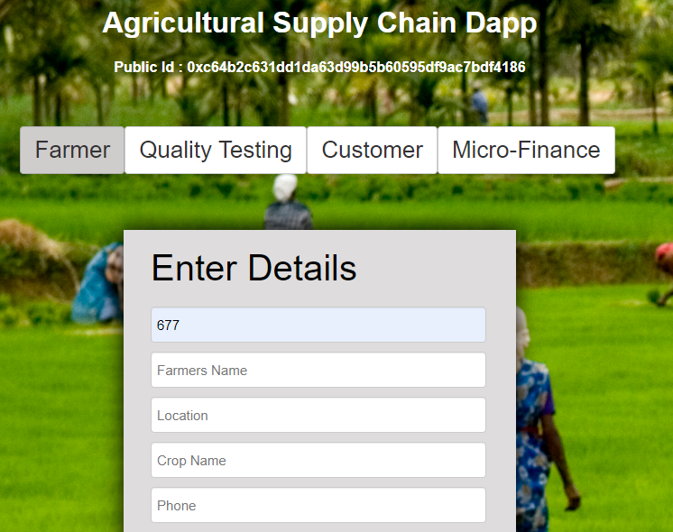
The above figure shows the registration form for the farmer in the supply chain application. The entered details are stored directly onto the blockchain. The underlying technology uses Truffle for the deployment and go-ethereum(geth) as the backend blockchain. We use the Web3 Javascript provider API to interact with the blockchain.
Approve Details button click will redirect to this Product details page. This is also part of the quality testing where we enter the lot number, grade, price, test date and expiry date. These details are also stored in the blockchain as a structure

The above figure shows the microfinance option to fund any farmers we wish to fund

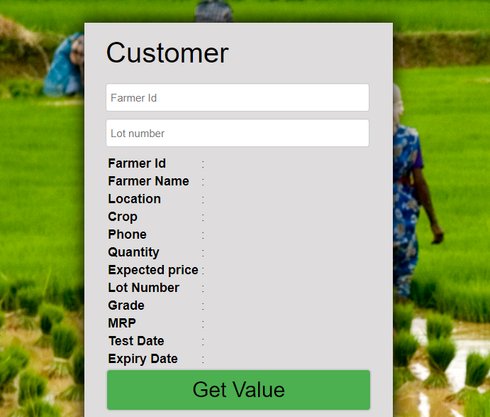

The above figure shows the customer’s page where customer’s can register in the website by entering their details
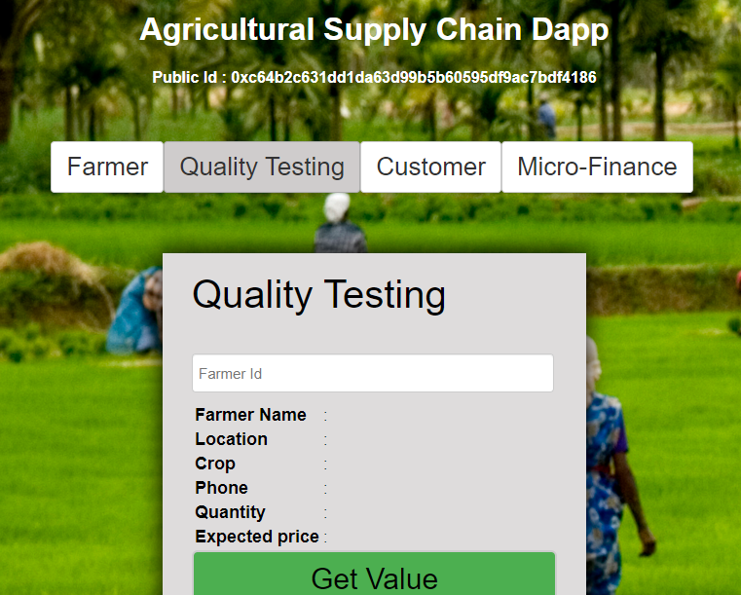

The next page is for quality testing, here we can get the farmer details by Farmer Id. These details are stored as a structure using solidity code onto the blockchain. The Farmer details are retrieved using a special data structure called mapping by Farmer Id.

7.Potential Challenges and Mitigation Strategies

7.1 Connectivity and Infrastructure:
One of the challenges in implementing Agrochain is ensuring reliable connectivity and adequate infrastructure, especially in rural and remote areas. Limited internet access or unstable network connections may hinder the participation of farmers and consumers. To mitigate this challenge, efforts should be made to improve connectivity in agricultural regions through initiatives such as expanding internet coverage or utilizing alternative connectivity options like mobile networks. Additionally, developing offline capabilities or mobile applications that can sync with the blockchain when connectivity is available can enhance accessibility and usability.

7.2 Financial Literacy and Access to Technology:
Financial literacy and access to technology are crucial for effective participation in Agrochain. Some farmers and consumers may have limited knowledge and experience with digital platforms and blockchain technology. Providing training and educational programs that focus on digital literacy, financial management, and the benefits of Agrochain can empower participants and bridge the knowledge gap. Collaborating with local agricultural organizations, cooperatives, and government agencies can help in delivering targeted educational initiatives and ensuring widespread adoption.
To address the issue of access to technology, efforts should be made to make smartphones or low-cost devices available to farmers and consumers. Additionally, providing support in terms of technical assistance and help centers can facilitate the use of technology and ensure a smooth user experience.

7.3 Resistance to Change and Cultural Factors:
Resistance to change and cultural factors can pose challenges to the adoption of Agrochain. Some farmers and consumers may be accustomed to traditional agricultural practices or may be hesitant to embrace new technologies. Overcoming this challenge requires engaging with stakeholders and involving them in the decision-making process. Conducting awareness campaigns, workshops, and field demonstrations can help demonstrate the benefits of Agrochain and address concerns or misconceptions.

Working closely with local agricultural communities and influencers can help build trust and credibility. It is essential to understand the cultural nuances and tailor the implementation approach accordingly. Collaborating with agricultural cooperatives and community leaders can provide a platform for showcasing successful case studies and encouraging peer-to-peer learning and adoption.

Overall, addressing these challenges requires a comprehensive approach that combines infrastructure development, education and training, and cultural sensitivity. By actively engaging stakeholders and implementing targeted strategies, the potential challenges can be mitigated, and the adoption of Agrochain can be facilitated effectively.

8.Conclusion:

8.1 Summary of Proposed Solution:
The proposed solution, Agrochain, is a blockchain-based transparent marketplace that enables cooperative farming, listing of potential crops and expected yields, farmer credibility assessment, and consensus-based agreements between farmers and consumers. By leveraging blockchain technology, Agrochain provides transparency, tamper-proof record-keeping, and a rating mechanism for farmers and consumers. The solution addresses key challenges in the agriculture supply chain, such as lack of transparency, middleman intervention, market information asymmetry, and supply chain inefficiencies.

8.2 Potential Impact on Indian Agriculture:
The implementation of Agrochain has the potential to revolutionize the agricultural sector in India. It can increase transparency and trust among stakeholders, ensure fair pricing, provide market information and trends to farmers, and improve supply chain efficiency and quality assurance. By empowering farmers and consumers, Agrochain can enhance profitability, reduce dependency on intermediaries, optimize production, and foster sustainable agricultural practices. Moreover, it can contribute to addressing issues like farmer suicides, land scarcity, and the disconnect between farmers and consumers in the Indian agricultural landscape.

8.3 Recommendations for Further Research and Implementation:
To further enhance the implementation of Agrochain and its impact on Indian agriculture, several areas of research and implementation can be explored:

a. Scalability and Integration: Research on scalability solutions and integration with existing agricultural systems can ensure the seamless adoption and widespread use of Agrochain across different regions and farming practices in India.

b. Sustainability and Organic Certification: Further research can focus on integrating sustainability practices and organic certification mechanisms into Agrochain, catering to the growing demand for organic products and promoting environmentally friendly farming methods.

c. Traceability and Quality Assurance: Investigating technologies like Internet of Things (IoT) and sensors can provide real-time data on crop conditions, storage conditions, and transportation, ensuring traceability and quality assurance throughout the supply chain.

d. Policy and Regulatory Framework: Collaboration with policymakers and regulatory authorities can help shape supportive policies, regulations, and standards that promote the adoption of blockchain technology and facilitate the implementation of Agrochain in the Indian agricultural sector.

e. Socio-economic Impact Assessment: Conducting studies to assess the socio-economic impact of Agrochain on farmers' livelihoods, consumer behavior, and the overall agricultural ecosystem can provide valuable insights and inform future improvements and refinements.

In conclusion, Agrochain has the potential to revolutionize the Indian agriculture supply chain by leveraging blockchain technology to create a transparent, efficient, and equitable marketplace. Through increased transparency, fair pricing, market information access, and supply chain optimization, Agrochain can contribute to the growth and sustainability of the Indian agricultural sector, benefiting farmers, consumers, and the overall economy. Continued research, collaboration, and implementation efforts are crucial to realizing the full potential of Agrochain and addressing the challenges faced by the Indian agricultural industry.

References:
[1]. Sedlmeir, J., Lautenschlager, J., Fridgen, G. et al. ﻿The transparency challenge of blockchain in organizations. Electron Markets 32, 1779–1794 (2022). https://doi.org/10.1007/s12525-022-00536-0
[2]. Bhat, S.A.; Huang, N.-F.; Sofi, I.B.; Sultan, M. Agriculture-Food Supply Chain Management Based on Blockchain and IoT: A Narrative on Enterprise Blockchain Interoperability. Agriculture 2022, 12, 40. https://doi.org/10.3390/agriculture12010040
[3]. Routroy, S. and Behera, A. (2017), "Agriculture supply chain: A systematic review of literature and implications for future research", Journal of Agribusiness in Developing and Emerging Economies, Vol. 7 No. 3, pp. 275-302. https://doi.org/10.1108/JADEE-06-2016-0039
[4]. Shalika Vyas et al 2021 Environ. Res. Lett. 16 103003DOI 10.1088/1748-9326/ac263d
[5]. Ahmed, N., Thompson, S., and Glaser, M. (2019b). Global aquaculture productivity, environmental sustainability, and climate change adaptability. Environ. Manage. 63, 159–172. doi: 10.1007/s00267-018-1117-3
[6]. Borrero, J.D.; Mariscal, J. A Case Study of a Digital Data Platform for the Agricultural Sector: A Valuable Decision Support System for Small Farmers. Agriculture 2022, 12, 767. https://doi.org/10.3390/agriculture12060767
[7]. L.B., K. Survey on the Applications of Blockchain in Agriculture. Agriculture 2022, 12, 1333. https://doi.org/10.3390/agriculture12091333
[8]. J K J Kalangi et al 2020 IOP Conf. Ser.: Earth Environ. Sci. 478 012009DOI 10.1088/1755-1315/478/1/012009

