An Empirical Evaluation of Technologies
And Applications in Robotics Industry 4.0

Dr.P.Thangavel
Assistant Professor
Department of Computer Science
SRM Trichy Arts and Science College
velmcaccet@gmail.com

Abstract
The new industrial model industry 4.0 characterizes the fourth industrial revolution. In the recent years, there have been dynamic changes in the industrial an environment as result of further new innovations called Industry 4.0. Robotics is a field of science that deals with creating machines that can behave like human begins called humanoids. The proposed approach explains about the researches and robotics applications that can implement the Industry 4.0 in enterprises.
Introduction
The modern world economy has entered the fourth industrial revolution through it is at an early stage and revolutionary digital technologies are still being developed and posted. In the past few years, the global industrial environment has changed deeply due to successive technological developments and innovations in manufacturing process.
The Industry 4.0 is a string combination of operational technology (OT) and information Technology then robotics in production. The outcome of the technological progress of the fourth Industrial revolution is the industry 4.0. It is a technological system with many innovations and also called as technology 4.0. Robotics and Automation, 3D printing, Collaborative robots (cobots), Cloud computing and interact of things to be implemented on a large scale in the smart factories in the future.
The recent years can act like humans in certain situations but can they think like human. This is where artificial intelligence comes to AI allows robots to act intelligently in certain situations. These kinds of robot are used to solve problems in a limited area and to even learn in controlled environments. One such example for this type of robot is a social interaction robot “kismet” developed at M.I.T’s Artificial Intelligence lab.
History:
The history of robotics is has paved the way and inspiration to convert fantasy in to reality. The major fundamental aspects that contributed to the emergence of industry are knowledge, experimentation and enterprise neural innovation.
The first aspects, knowledge refers to the range of understanding of scholars and inventors of decades ago, who researched, and investigated sought possibilities for great new discoveries at the time and was able to increase their ability to understand the concept.
The second aspects, experimentation is the process for making explicit the knowledge of scholars and collaborators in order to prove the possibility.
The third aspects, entrepreneurial innovation is the confidence of employers of the time to believe in and invest in new discoveries and work models and ways of providing and an expanding their business and sales never before imagined.
The science fiction version of a robot is typically, one of a human form, an android or humanoid with features in ISO. Robot is defined as an automatically controlled, reprogrammable, multipurpose manipulator with three or more axes by ISO. The robot institute of America specifies robot as a programmable and multifunctional manipulator designed to move material, parts, tools or specialized devices through various programmed motions for the performance of various tasks.
Insight of Industry 4.0:
Industry 4.0 is a new industrial revolution that stresses on the importance of latest technological innovations and facilitates fast customized production. The objective of promoting manufacturing and automation consequently increases productivity through Smart Factories which are still imminent. Fourth industrial revolution can be distinguished by the integration between the interaction and production process.
The industry 4.0 is not only a technical challenge as it will significantly change the organizational structure of companies. New level of socio technical interaction, autonomous and self-organized production resources carries out planning process in value chains between organizations.
Smart Products:
The products and the tolerable operating parameter of a certain production process are mutually known. These products can be grouped together to mainly optimize production.
Smart plats

Mixed Materials Raw Materials

Smart
Production
Smart
Logistics

Products

Individualized production:
Flexible configuration enables industries to consider the specific characteristics of customer demand and produces design, planning, production and recycling phase.
Autonomous control:
Employee’s control and configure intelligent production resources based on targets sensitive to the present context.
Product design controls:
Product related data becomes a central feature in managing its product life cycle.
Design of Industry 4.0:
The industry 4.0 consists of six stages of design principles which are called decentralization, Virtualization, interoperability, Modularity, real time capability and service orientation. These principles are called “Design Principles” because they contribute to the design process of common Industry to Industry 4.0.
Decentralization:
The first design principle decentralization is the ability of local companies and specific operations, as well as those carried out by machines, to make their own decisions on their own. Instead of using central computers or passing a decision through hierarchy, allowing local operators to respond to changes and readjust is the main aim of this principle. It provides more flexibility and makes it easier to use expertise.
Virtualization
The key concept of virtualization is that by using machine-to-machine (M2M) monitoring and communication, a virtual twin can be created. The sensor data is linked to both virtual plant models and simulation models. Thus it creates a virtual copy of the physical world.
Interoperability:
The principle of interoperability in the industry 4.0 manufacturing environment is that facilities capable of automatically exchanging information, initiating actions and controlling each other independently. The embedded manufacturing systems are vertically with business process internal to industries by connecting software and programs.
Modularity:
The main aim of modularity is to create modular systems that can easily adapt to changing requirements by replacing or expanding individual production modules and also to make the process of adding or removing modules much easier.
Real time capability:
The real time capability systems mainly focuses on manufacturing process intelligent machines with specific software that will automatically adapt to the process and decision making by CPS to the productive needs and the product quality is monitored in order to make decisions at every moment of need.
Service Orientation:
Service orientation can be characterized by the availability, through internet of human business services and CPS which can be used by other stakeholders facilitating the creation of product service systems also known as product services.
Robotics in Industry:
After historic meeting of Engr Berger and devol’s, blossomed the development in research laboratories the use of robotics in real points in industry. In 1954 Plant Corporation developed the first commercially available robot which was controlled by limit switches and cams. The machines have moved out of research labs to volunteer into new spheres. They are expected to continue this migration towards automotive sector and more. Robots are already contributing to higher quality products in the manufacturing sector. It also reduces turnaround time.
Aspects of robot:
Brawn – It deals with the strength relating to physical-to-physical payload that can be moved by a robot.
Bone – This aspect tells the physical structure of a robot relative to the work it does. Also this determines the size and weight of the robot in relation to its physical payload.
Brain – This is nothing but intelligence of robot. It describes the thinking capacity and independent actions of robot.
Work at Industrial robots:
The number of robots in the world today has approached million. Two decades ago 60% of robots where used only in manufacturing sectors particularly cars, where robots are placed in assembly lines to perform a variety of repetitive tasks. Today only 50% of them are in automobile units while the other half has spread out among other factories such as laboratories, warehouses, energy plants, hospitals and many such industries. Industry 4.0 robots are also used for assembling and hadling products which contain dangerous materials like spray painting, cutting and polishing inspection of products.
The latest innovations in robotics:
These robots are providing to be effective at basic tasks and jobs. The following are some of the latest innovations of robots and these robots need a mechatronics engineer to help repair and maintain all of these great robots.
(i) Google worker robots:
Google is in the process of producing worker robots with personalities of industry 4.0 technology. It also won a patent for the ambitions project. The robots will have the capacity to store and display multiple personalities while interacting with humans.
(ii) Multi-tasking bots:
The momentum machines developed a multitasking bot capable of preparing a government fiam burger in as little as 10 seconds. It all goes well, the robot could eventually be used in fast load restaurants.
(iii) UR3 arm:
It is an automated device created by universal robots which has the capability to build its own replacement parts on the fly. The cute and nimble robot can handle a variety of tasks, such as painting, soldering and grapping.
(iv) Saul Robot:
Saul robot is designed to help fight deadly diseases like that Ebola Virus. The machine was developed by the Air-force to eliminate the virus in rooms while quarantine procedures are conducted an aid worker. These robots developed by Xenex; Sail eradicates traces of EBOLA using powerful pulses of highly energetic ultraviolet rays.

(v) Asus Zenbo:
This is a low-cost robot capable of rolling around automatically and understands verbal commands. The device help individuals remember daily tasks such as exercise and medication schedule as well as doctor’s appointments.
(vi) Paro:
Paro is therapeutic robot with the appearance of a baby harp seal. The fairy device is intended to help lower stress levels and stimulate interaction between caregivers and patients. It comes with five different sensors including light, tactile, audition and temperature sensors.
(vi) Pepper:
Pepper is a humanoid robot that can talk and adapts its attitude based on how it senses the mood of humans around it. This feature allows it to accurately understand emotional situation. The developers have embedded up to 20 engines in the neck, back and arms to regulate movements.

Comparison of Industry versions:

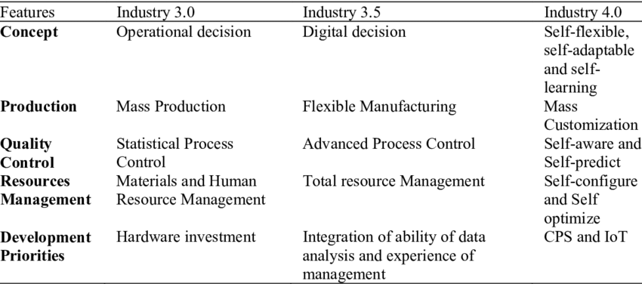

Industry Processes:
In Industry 3.0, processes are automated using logic processors and information technology. These processes can even operate largely without human interference, but still there is a human aspect behind it. Industry 4.0 brings in new opportunity with the availability and use of vast quantities of data on the production floor.
To understand in detail let us consider a CNC machine as example of the old way (Industry 3.0). While it is automated largely, it still depends on input from a human controller. The automation of process is based on human input, not by data. But when the new principles and techniques of Industry 4.0 are applied, the same CNC machine would not only follow a set of programming parameters but can also use data to streamline production processes.

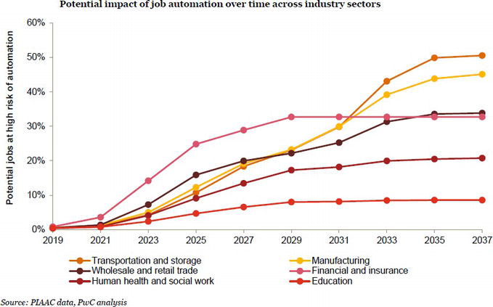

Conclusion:
Industry 4.0 is used to be compatible with the fourth industrial revolution and it signifies a new stage in the organization and control of the industrial value chain. Robotics is an innovative technology of science which is used for development in various industries. It is because of this technology which helps the floor employees effectively perform their duties, and reduces or almost removes all physical stress. Network and connectivity are the two most important critical considerations in facilitating Industry 4.0. A wide variety of advances in technology such as edge-to-cloud, gigabit Ethernet time-sensitive networks, wide-area low-power networks, 5G technology machine-to-machine connectivity, real-time determinist Ethernet networking, omnipresent radio access, unified IoT platform, and zero-touch networks are enabling factories to introduce IoT to turn facilities for Industry 4.0.
References:
- http://www.oemupdate.com/technology/top-robotic-applications-in-automotive-industry/
- https://www.popsci.com/hitachi-hires-artificial-intelligence-bosses-for-their-warehouses
- https://www.rfidjournal.com/articles/view?12083
- https://qz.com/672708/siemens-is-building-a-swarm-of-robot-spiders-to-3d-print-objects-together/
- https://wiprodigital.com/2018/11/13/the-rise-of-industrial-autonomous-vehicles/
- https://newatlas.com/boeing-echo-voyager-trials/50010/
- https://wiprodigital.com/2018/11/13/the-rise-of-industrial-autonomous-vehicles/
- https://compliancenavigator.bsigroup.com/en/medicaldeviceblog/robotics-in-healthcare/
- https://www.industrialpackaging.com/blog/why-robotic-packaging-automation-is-the-future
- https://www.nbcnews.cshiom/mach/science/robots-are-replacing-humans-world-s-mines-here-s-why-ncna83163
- https://www.investopedia.com/articles/markets/011216/4-industries-robots-are-revolutionizing.asp
- https://edition.cnn.com/2018/12/07/business/walmart-robot-janitors-dotcom-store/index.html
- Abele, E.; Reinhart, G. (2011): Zukunft der Produktion. Herausforderungen, Forschungsfelder, Chancen. München: Hanser, Carl
- Ammon, U. (2009): Delphi-Befragung In: Kühl, S. (Ed.): HandbuchMethoden der Organisationsforschung. Quantitative und qualitative Methoden. Wiesbaden: VS, Verlag fürSozialwissenschaften, pp. 458–476
- Atzori, L.; Iera, A.; Morabito, G. (2014): From "smart objects" to "social objects": The next evolutionary step of the internet of things. In: IEEE Communications Magazine, 1 (2014), pp. 97–105
- Kagermann, H.; Wahlster, W.; Helbig, J. (Eds.) Recommendations for Implementing the Strategic Initiative Industrie 4.0: Final Report of
- the Industrie 4.0Working Group. Industrie 4.0: Mit dem Internet der Dinge auf demWegzur 4. Industriellen Revolution; VDI-Nachrichten:Frankfurt, Germany, 2011.
- 2. Kagermann, H.; Helbig, J.; Hellinger, A.; Wahlster,W. Recommendations for Implementing the Strategic Initiative Industry 4.0:
- Securing the Future of German Manufacturing Industry. Final Report of the Industry 4.0 Working Group Forschungsunion. 2013.
- Available online: https://www.din.de/blob/76902/e8cac883f42bf28536e7e8165993f1fd/recommendations-for-implementingindustry-4-0-data.pdf (accessed on 2 February 2020).
- 3. Kagermann, H.; Wahlster, W.; Helbig, J. Final Report of the Industrie 4.0 Working Group; Acatech-National Academy of Science
- and Engineering: München, Germany, 2013. Available online: https://en.acatech.de/publication/recommendationsfor-
- implementing-the-strategic-initiative-industrie-4-0-final-report-of-the-industrie-4-0-working-group/ (accessed on10 January 2020).
- 4. Kagermann, H. Change through Digitization—Value Creation in the Age of Industry 4.0. In Management of Permanent Change;
- Springer: Berlin/Heidelberg, Germany, 2015.

