NANO PARTICLES OF NEEM –AZADIRACHTA INDICA A. JUSS TWIGS POWDER AGAINST ORAL MICROBIOME
Poonam Sethi* and ** Yuva Srinivasan
*Assistant Professor Department of Plant Biology and Plant Biotechnology, Guru Nanak College (Autonomous), Chennai, India
**Scholar of Department of Plant Biology and Plant Biotechnology, Guru Nanak College (Autonomous), Chennai, India

ABSTRACT
A dental plaque is a home for many harmful bacteria which reside in causing cavities and disease aggregation. Microscopic evaluation of these plaque forming a biofilm from samples- clinical isolates indicated that Streptococcus mutans accounts for nearly 80% of the colonization. Chew sticks - twigs of neem (Azadirachta indica) were tried and later nanoparticles were screened and nanoparticles are more promising against Streptococcus at a concentration of 10 µg.An ancient remedy for tooth ache and other infections, nanoparticles of these chew stick powder was more promising than the powder itself.

Key words: biofilm, chew sticks, oral microbiome, neem, Streptococcus.
INTRODUCTION
Joshua Lederberg “ coined the term microbiome to signify the community of symbiotic pathogenic microorganisms in the humans that can cause diseases and ailments in the mouth [1].
Enormous screening of plant-derived products are reported to be effective against the oral microbial pathogens thus preventing the onset of diseases. Oils form the base for beneficial activity for the delivery being specific with easy entry to target pathogen. The general antimicrobial activities of medicinal plants and plant products, , have been reviewed earlier [2and3].
The experimental plant Neem a significant signature of spirituality in India Azadirachta indica or powder of neem twigs was extracted with aqueous (distilled water) and later silver nanoparticles were extracted and tested against Streptococcus isolated from oral mouth swabs.
MATERIALS AND METHOD
Antibacterail activity was screened using Disc diffusion method against Streptococcus mutans against the neem twigs and its nanoparticles. The minimum inhibitory concentration MIC or the concentration that showed minimum inhibition against the bacteria was detected and compared with the positive control Naringin, a polymethoxylated flavonoid an FDA-approved health supplement [4]

RESULTS
The efficacy of the neem nanoparticles was more effective than the positive control Naringin. (Table1)
DISCUSSION
Neem bark powder usually applied for skin ailments henceforth this study which fights not against the skin ailments but also against dental caries and gum diseases and strengthen teeth. The bark being useful but the neem twigs more efficient than bark powder.Further, because of its anti-microbial and anti-fungal nature,but the nanoparticles of the twigs was more promising .Sensodyne a toothpaste can boast of its nanopaste likewise this can be a one with better activity.

REFERENCES
1] Lederberg, J., and A. T. Mccray.2001. 'Ome sweet 'omics—a genealogical treasury of words. Scientist15:8-10.

2] Cowan MM. Plant products as antimicrobial agents. Clinical Microbiology Reviews. 1999;12(4):564–582. [

3]. Kalemba D, Kunicka A. Antibacterial and antifungal properties of essential oils. Current Medicinal Chemistry. 2003;10(10):813–829.

4] Tsui VWK, Wong RWK, Rabie A-BM. The inhibitory effects of naringin on the growth of periodontal pathogens in vitro . Phytotherapy Research. 2008;22(3):401–406.

Figure1: Experimental plant
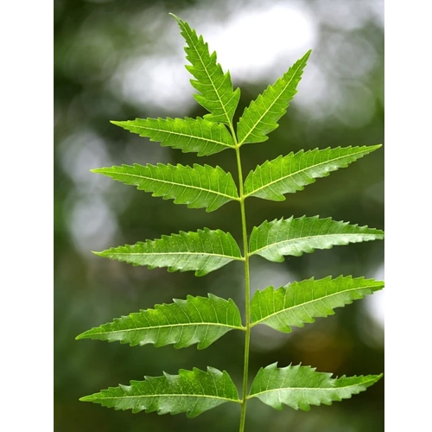

Figure2: Chew sticks of Neem

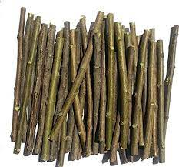

Table1: EFFICACY OF NEEM STICKS ON ORAL MICROBIOME

S.No | Concentration of the extract  µL | Zone of inhibition for twig powder of neem (mm) | Zone of inhibition for nanoparticles of neem (mm) | Positive Control Naringin
1 | 1 | 24 | 35 | 30
2 | 2 | 38 | 45 | 40
3 | 4 | 48 | 55 | 50
4 | 6 | 72 | 80 | 80
5 | 8 | 75 | 82 | 80
6 | 10 | 78 | 85 | 80

