EFFECT OF TRANSGENIC PLANTS ON NON TARGET ORGANISMS
¹POORNIMA V. MATTI and ²M.V. MATTI
SCIENTIST, ARS DHARWAD
UNIVERSITY OF AGRICULTURAL SCIENCES, DHARWAD
Ph.D, AGRICUITURAL ENTOMOLOGY,
UNIVERSITY OF AGRICULTURAL SCIENCES, DHARWAD
Editor ID: IIPER1676108001
Subject: Applications with Technology Support

INTRODUCTION
The use of biotechnology has led to changes in medicine, industrial and agriculture processes. The application of gene technology as in science has greatly expanded the genetic variation in different organisms. This process involves isolating of nucleic acid molecules from one organism and their introduction into another organism permanently altering the genetic make up of the recipient and ensuring them to be inherited by offspring.
Agricultural biotechnology is used to make crops resistant to pests, diseases, environmental stress and nutritional quality. The use of biotechnology to improve pest resistance or nutrition raises many questions, such as the effect of seed placement, the spread of resistant seeds to surrounding plants, antibiotics, allergies and some changes in the immune system. In principle, genetic technology can use the genetic information contained in all DNA and genetic material can be modified to work in different species. The success of GMOs containing foreign genes is partly due to the effects of animals, humans being, pollinators, natural enemies, soil arthropods, soil microflora etc lies in their safety against non-target organisms that any be exposed to commercial products such as any living organism microorganisms, crops, insects, animals as well as humans that have been genetically modified for certain traits.
Global demand for food is increasing with the growing world population and decreasing arable land. Food and agricultural systems have to respond to several changes with increasing international competition, globalization and rising consumer demands for improved food quality, safety, health enhancement and convenience. Modern biotechnology involving the use of RDNA technology/genetic engineering emerged as a powerful tool for improving the quantity and quality of food supply. Available worldwide with aim of enhancing productivity, decreasing the use of certain agricultural chemicals, modifying the inherent properties of crops, improving the nutritional value or even increasing shelf life. Concerns about the potential risks associated with their impact to human health, environment and biological diversity.
As the world’s population grows and arable land shrinks, the world’s demand for food is increasing. With increased global competition, global trade, and consumer demand for improved food quality, safety, improved health and convenience, food and agriculture must respond to changes. Modern biotechnology, which includes the use of RDNA technology/genetic engineering has become a powerful tool for improving the quantity and quality of food.It is available worldwide and is designed to increase productivity, reduce the use of agrochemicals, alter the characteristics of crops, increase nutritional value and even extend shelf life. Concerns about risks arising from impacts on human health, the environment and biodiversity.

What is GMO’s?
A genetically modified organism (GMO) or genetically engineered organism (GEO) is an organism whose genetic elements have been altered using genetic engineering techniques. These techniques, generally known as recombinant DNA technology, use DNA molecules from different sources, which are combined into one molecule to create a new set of genes.
History of GMO’s
The general principle of creating a GMO is to add new genetic material to the organism's genome. This is called genetic engineering and was made possible by discovery of DNA in 1973 and the creation of the first recombinant bacteria, i.e., E .coli expressing a Salmonella gene. Then Herbert Boyer founded the first company to use recombinant DNA technology. In 1978 the company announced the creation of a strain of E. coli that produces the human insulin protein. In 1986, field tests of bacteria genetically engineer protect plants from frost damage at advanced genetic Sciences of Oakland, California, in the same year, a proposed field test of a microbe genetically engineered for a pest resistance protein by Monsanto Company was dropped. In 1981 first cloning of crystal protein of Bt, Use of monoclonal antibodies through GMO’s. Recently in 1996 commercial cultivation transgenic crop in USA and whereas in India it is in 2002.
Effects on Non-Target organisms
For the currently commercially cultivated GM crops, it is generally accepted that toxic effects on non-target organisms are restricted to GM crops expressing insecticidal proteins. There are concerns that insect-resistant GM crops could harm resistance conferred via expression of Cry-proteins organisms other than the pest(s) targeted by the toxin. Insect from Bacillus thuringiensis (Bt) is by far the most common trait that has been engineered into plants. To date Bt-toxins represent the only insecticidal proteins expressed in commercial GM crops. Several authors have proposed procedures on how to assess the risks that insect resistant GM crops may pose to non-target organisms. Effects of Bt-crops expressing Cry1-proteins on non-target arthropods (moths and butterflies) Lepidoptera.
Transgenic Plants
Transgenic plants have been engineered to possess several desirable traits, including resistance to insects, herbicides or harsh environmental conditions, proved product shelflife, and increased nutritional quality.
History
10,000 years ago humans began domestication using selective breeding. During 1700s farmers and scientists started cross breeding plants. In 1980s researchers develop the more precise and controllable methods of genetic engineering to create plants with desirable traits. The first genetically modified crop plant was produced in 1982, an antibiotic resistant tobacco plant. The first GM crop was produced in 1982, an antibiotic resistant tobacco plant. The first field trials occurred in France and the USA in 1986, when tobacco plants were engineered for herbicide resistance. In 1987, Plant Genetic Systems (Ghent, Belgium), founded by Marc Van Montagu and Jeff Schell, was the first company to genetically engineer insect resistant (tobacco) plants by incorporating genes that produced insecticidal proteins from Bacillus thuringiensis (Bt). The first genetically modified crop approved for sale in the U.S., in 1994, was the FlavrSavr tomato. In 1994, the EU approved tobacco engineered to be resistant to the herbicide bromoxynil, making it the first commercial GM crop marketed in Europe. In 1995, Bt maize (CibaGeigy), bromoxynil resistant cotton (Calgene), Bt cotton (Monsanto), glyphosate resistant soybeans (Monsanto), virus resistant squash (Asgrow), and additional delayed ripening tomatoes (DNAP, Zeneca/Peto, and Monsanto) were approved. In 2000, Vitamin A enriched golden rice was developed. In 2013, the leaders of the three research teams that first applied genetic engineering to crops, Robert Fraley, Marc Van Montagu and MaryDell Chilton were awarded the World Food Prize for improving the "quality, quantity or availability" of food in the world.

Positive impacts
- Increased yield
- Resistance to diseases and pests
- Bioremediation of contaminated soils,
- Salt tolerant to plants
Negative impacts
- Gene flow to wild relatives
- Pollen transfer to Wild relatives and hybrid formation
- Survival and Reproduction of Hybrids
- Survival &reproduction outside of cultivated areas
- Persistence, degradation and spread of transgenic products
- Accumulation of Transgenic products in soil.
- Emission of transgenic products into water
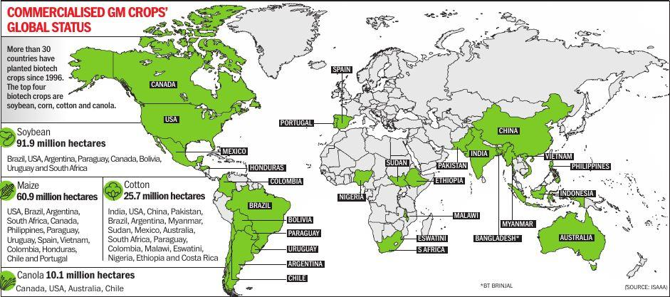
Fig. 1: Global area of biotech crops

Table 1: Gene transferred and expressed in rice
S.No. | Genes and sources
1. | Fungal Disease resistance
a. | Xa21 from Oryza longistaminata
b. | Rice and Manduca sexta Chitinase
c. | Glucanase from Barley and tobacco
d. | Rips (Ribosomes inactivating proteins) from barley
e. | Wheat peroxidase
f. | Thamutin like proteins from Rice
2. | Viral Disease Resistance
 | Rice tungro bacilliform Virus (RTBV)
b. | Rice ragged stunt Virus (RRSV)
c. | Rice yellow stunt virus (RYSV)
 | Bacterial Disease
a. | Bacterial blight resistance gene from Oryza longistaminata
b. | Bacterial blight and streak
c. | Cecrosin B from silkworm
 | Insects Resistance
a. | Cry 1A(b) and Cry1A (c) from Bacillus thuringensis
b. | Codon modified synthesized gene
c. | Serine proteinase inhibitor
d. | Snow drop lectin gene
e. | Cowpea trypsin inhibitor (CpTi)
f. | PINII potato protease inhibitor

Positive Impact
Pollinators
Bees fed Cry1Ba did not differ significantly from control bees in terms of time to first flight, time of flight, or estimated lifespan. But bees fed aprotinin started flying and died about three days earlier than bees fed Cry1Ba or controls. Their flught time is similar to other bees. Therefore, the effect of transgenic aprotinin plants on bees will depend on the level of gene expression in the pollen (Malone et. al., 2001)
Nacchappa, 2004 reported that mean brood area in Bt cotton was significantly high (5813.30 cm² and 4428.00 cm²) than in non-Bt cotton (3140.00 cm²). Nachappa and Viraktamath in 2004 from Dharwad reported no significant difference out going foraging activity of Apis cerena (Fig: 6) colony kept in Bt and non- Bt RCH-2 cotton hybrids respectively.
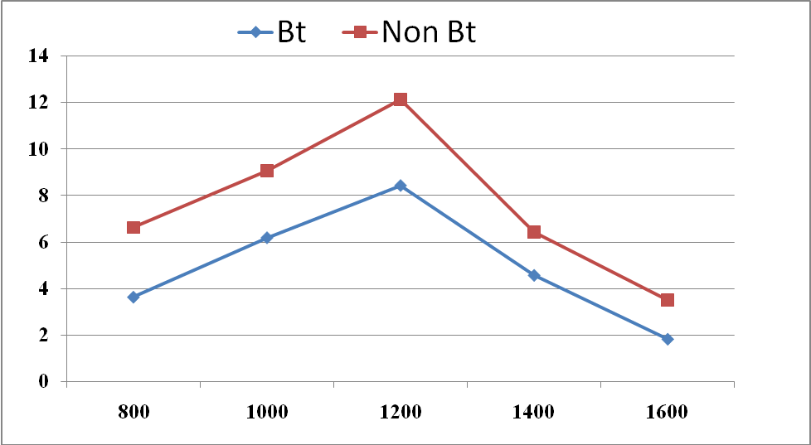
X-axis- Hours
Y-axis-Mean out going foragers per minute in the colony

Figure 2: Comparison of outgoing foraging activity of Apis cerena colony kept in Bt and non- Bt RCH-2 cotton hybrids.

Natural enemies
Duan et al 2002 reported that the pollen from bt maize contained Cry 3Bb gene but did not express the protein at measurable levels in pollen did not effect the fitness of the lady beetle Coleomegilla maculata. The effect of potato expressing Bt Cry 3A on predatory beetle Harmonia axyridis and carabid beetle Nebria brevicollis resulted no significant effects upon survival or overall body mass and no detrimental effects on reproductive fitness of beetles as well as fecundity or subsequent egg viability (Ferry et al., 2007)
Silkworm - No significant effect on larval mortality and weight of Chinese tussar silkworm (Antheraea pernyi) when food is contaminated with Bt corn pollens (Li, 2005).
Soil biota
No effect on oviposition, egg production of Folsomia candida (collembola) when fed on leaf litter of Bt cotton and Bt potato (Yu et al., 1997). No adverse effect of maize which contain active Bt toxin on field populations of collembola and soil mites Deeb et al. (2003).
Evaluation of Propylaea japonica Thunberg ingesting Bt-cotton bollworm
Zhang et al., 2006 reported that Propylaea japonica is an important predatory insect of common cotton pests. life history parameters of P. japonica for two generations by feeding them with Bt-resistant Helicoverpa armigera. After ingesting Bt-resistant H. armigera larvae in the third and fourth instar, larval survivorship and development in these larval development and number of eggs per female of P. japonica were not affected in both the generations. These results suggest that ingesting Bt-cotton pests in advanced larval stage might have no significant effect on the fitness of predator P. japonica (Table 2).
Table 2: Larval development and number of eggs per female of P. japonica ingesting Bt-cotton bollworm in the third and fourth larval stage
Treatments | Larval Development | Number of eggs per female
Control | 97.95 ± 0.89 B | 607.13 ± 88.79 B
Bt cotton bollworm | 101.83 ± 1.54 A | 610.69 ± 73.29 A

Insects of cultural or asthetic value
National research council, 2002 reported that the Bt maize pollen would not threaten the endangered karner blue butterfly (Lucaeides melissa samuelis).
Negative Impact
Pollinators
Serine protein inhibitors effect honey bees and bumble bees causing changes in bee digestive proteases and some reductions in survival when ingested at high concentrations. Bees were fed either Bt-transgenic maize pollen (MON 810) or a sugar solution containing either purified Bt-toxin (Cry1Ab, 0.0014% w/v) or Kunitz soybean Trypsin inhibitor (SBTI) at two concentrations (0.1% and 1% w/v). Neither the Bt maize pollen nor the Bt toxin showed any effect on bee survival or on the development of hypopharyngeal glands after a period of 10 days’ feeding. In contrast, treatment of newly emerged bees with SBTI (0.1 and 1%) for 10 days significantly reduced the mean weights of the hypopharyngeal glands and the mean diameter of the glands’ acini. While small amounts of Bt toxin were detected by ELISA in the hypopharyngeal glands of bees fed the Bt-sugar solution, SBTI could not be detected in gland samples by Western blotting (Fig. 3) Babendreier et al. (2005).
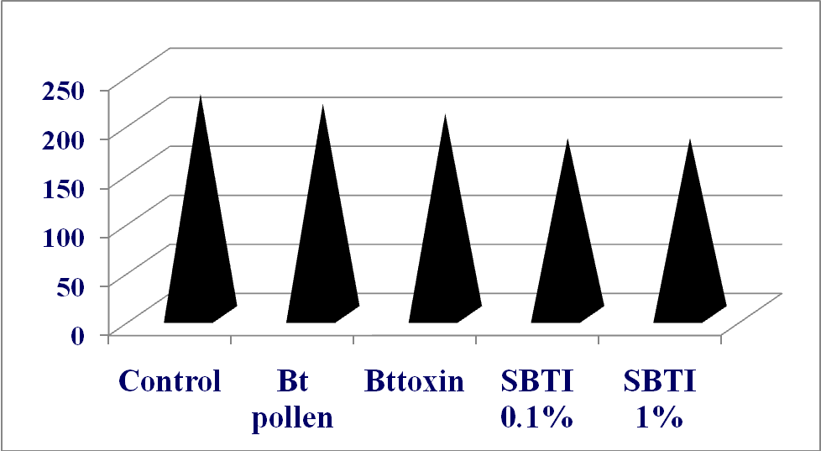
Fig. 3: Diameter hypopharyngeal glands acini of 10 days old honey bees fed with different pollen mix
Natural enemies
Green lacewings experienced delayed development and reduced survival when fed Bt maize fed Spodoptera littoralis caterpillars, which were sublethaly affected and carried measureable quantities of Cry1Ab in their bodies (Dutton et al., 2002). Reduced growth have been recorded for the predators P. mauliventris on tomato moth caterpillars with GNA potato reduced fecundity. Ferry et al., 2007 reported that there is significant reduced prey consumption in Bt maize fed pests than control (Fig. 4).
Fig. 4: Prey consumption (mg) by N. brevicollis in fed on Bt maize fed pests
Insects of cultural or asthetic value
Losey et al, 1999 reported that the Bt corn pollen may fall on milkweed plants that serve as hosts for monarchs. Survival rate of butterfly (56%) when fed milkweed “dusted” with Bt corn pollen than control (100%).
Soil biota
A 200-day study was carried out to investigate the impact of transgenic Bacillus thuringiensis (Bt) corn on immature and adult Lumbricus terrestris in the field and in the laboratory. Adult Lumbricus terrstris lost 18% of their initial weight after 200 days when fed Bt maize compared with a 4% weight gain when fed non-GM maize but there is no significant difference in the mortality (Zwahlen et al., 2003).
Herbicide tolerant crops
Risk of flow of herbicide resistant genes to wild relatives and they showed negative impact on animal populations through reduction of food supplies. Glyphosate resistant crop (soybean) increases rat Kupffer cells, deposition of reticulin fibres and increases leakage of hepatic transferases and liver damage (Pusztai and Bardocz, 2006) Larson et al. (2006) reported that more number of fusarium colonies (cfu 100 cm⁻1 root) recorded in glyphosate resistant than that non glyphosate crops grown plots (Fig. 9).
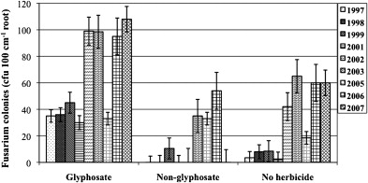
Fig. 5: Presence of increased number of Fusarium colonies in glyphosate resistant grown crop plots
Fungus-resistant crops
Vierheilig et al. (1992) reported that the ch5B gene encodes for chitinase from Phaseolus vulgaris engineered into strawberry which leads to high levels of resistance to gray mould disease (Botrytis cinerea). Chitinase and glucanase genes inserted into cotton genome which resulted in resistance to Verticillium dahliea (Tennant et al., 2010).
Positive impact - Increased yield, resistance to diseases and reduced fungicide use
Negative impact - Antibiotic resistance genes will causes resistance to antibiotics leading to super organisms thus makes difficult to control them.
Virus-resistant crops: e.g. papaya (for papaya ring spot virus) and squash
Positive impact- Increased yield, resistance to diseases and reduced cost of protection
Negative impact- Greene and Allison, 1994 reported that the development of more virulent strains Recombination is a common process which leads to genetically unique viruses that may be difficult to control. Alteration in host range by the viruses and host range will be expanded.
GM Papaya
There are several human food safety issues concerning GE PRSV resistant papaya commercialized in Hawaii and regulated by US agencies, including whether it may cause life-threatening allergic responses, may contain less vitamin C and vitamin A, may contain increased levels of benzyl isothiocyanate BITC, a toxin (abortifactant) that occurs naturally in green papaya, or may contain genes for resistance to antibiotics that are used in human medicines. Recent study found that aqueous extracts of the epicarp of ripe papaya fed to pregnant mice induced embryonic resorption, an effect not seen in green papaya. Papaya ring spot virus coat protein may be allergen (Anur et al., 2008).
Gene flow
Transgenes are inherited and have the potencial to disperse may be crop to crop or crop to wild. Crop to wild gene flow has enhanced the weediness in sorghum. Bt gene resulted in increased seed production in wild sunflowers (Snow et al., 2003).
Impact on soil and soil organisms
Gene transferred | Crop | Target | Negative effect | Reference
Bacillus thuringiensis  Cry gene | Cotton, Brinjal | Bollworms, Brinjal shoot and fruit borer | Accumulation of transgene and protein in the soil persisted long | Tapp and Stotzky, 1998 (USA)
Bacillus thuringiensis  Cry 1Ab | Corn | Ostrinia nubilalis | Toxin incorporation in collembolan, saprophytic fungi, earthworms, bacteria | Saxena and Stoztky, 2001 (USA)
Bacillus thuringiensis  Cry gene | Corn, Potato, tobacco | Ostrinia nubilalis  M. Sexta | Slow rate of decomposition | Flores et al. 2005

Change in modified plants
Gene  transferred | Crop | Negative effect | Reference
Herbicide Resistant | Soybean | Less chlorophyll and increased susceptibility to stem splitting at high temperature | (Gertz et al., 1999)
MdPG1 gene | Apple | Change in cell wall composition containing less pectin with malformed stomata - more transpiration and more water uptake | Atkinson et al. (2002)
Beta glucanase gene | Barely | Lowered grain weight and yield | Horvath et al. (2001)
Zinc transport protein gene | Barley | More uptake of zinc from soils | (Ramesh et al., 2004) Australia
Glyphosate resistant gene | Cotton | cellular abnormalities and increased distance anthers and stigma | (Pine et al., 2002)

HEALTH EFFECTS – WHAT ARE THE ISSUES?
Potential benefits from GM technology
- Increased in food availability
- Improved shelf-life
- Improvement in nutritional quality and health benefits
- Improved protein quality
- Increased in food carbohydrate content
- Improvement in quantity and quality of meat, milk and livestock
- Increased crop yield
- Manufacture of edible vaccines and drugs
- Biological defense against disease, stresses, pests,weeds, herbicides and viurses
Nutrition and theraptic use
Golden rice à Provitamin A enrichment
GM soya à 12–14% lower amounts of cancer fighting isoflavones than non-GM soya.
Rice à high lactoferrin (iron binding protein) to increase Fe content especially for infants and Glutine protein modification
Maize à Beeta-glucuronidase (diagnostic kits)
Tomato and Potato à Antigen for viruses viz., rabies, herpes
Tobacco à edible vaccines

Impact on mammals
GM Crop | Negative effect | Reference
Maize | Changes in Immune system - change in number of a special types of lymphocytes | Finamore et al.  (2008) Italy
Pea | Structural variants possessing altered immunogenicity in mice | Prescott et al  (2005) Australia
Maize | Significant variation of both sexes and female suffered from hepatorenal toxicity and males excreted less amount of P and sodium in the urine | Seralini et al.  (2007) France
Maize | Significant disturbance in the function of kidney, liver and some effects on heart, adrenal spleen and blood cells in both male and female rats | Vendomois  et al.(2009)
Potato | Proliferative cell growth in both the stomach and intestinal walls (cell proliferation is a precursor to cancer) | Stanley et al.  (2004)
 | Enzyme production in heart is altered in mice | Tubisco et al.  (2006) Italy

Allergenicity: Some allergens from genetically modified tobacco viz., Art v1, Bet v 1 (mugwort and birch pollen allergen in tobacco) and Mal d 2 (thaumatin-like allergen - apple) responsible for allergy (Schmidt et al., 2011). According to research by the Brown University, resent genetically modified foods can pose significant allergy risks to people. It states that genetic modification often adds or mixes proteins that were not indigenous to the original animal or plant, which might cause new allergic reactions in our body. In some cases, proteins from organisms that you are allergic to might be added to organisms that you were not originally allergic to. This means your range of food choices will be lessened (Sparrow et al 2010).
GM tomato
Pusztai et al. (2003) reported that a product of ‘antisense’ technology i.e FLAVR-SAVRTM Tomato. It was claimed that the insertion of Flavr-Savr^{tm} and kanr genes caused no changes in gross fruit composition or the contents of potentially toxic glycoalkaloids. However, daily incubation of normally fed rats with GM tomato homogenates led to serious health problems. In humans glandular stomach erosions can lead to life-threatening haemorrhage, particularly in the elderly and patients. Necrosis may also be serious because seven out of forty rats eating GM tomatoes died within two weeks without any explanation.
GM POTATO
Fares and El-Sayed, 1998 reported that Bt-potatoes and Bt-toxin caused the disruption, multinucleation, swelling, increased degradation of ileal surface cells in rats and showed that Bt-toxin survives in functionally and immunologically active form in the gut and had strong effects on gut metabolism. Ewen & Pusztai, 1999 reported that feeding rats GNA-potato-diets induced proliferative growth in their stomach, small and large intestines and lymphocyte infiltration and suppression of the humoral immune system that was not shown by controls fed non-GM potatoes. These effects were not due to transgene expression but to its genomic insertion. Fig. 6 shows marked thickening due to hypertrophy mucosal cells in comparison with rats fed with non-GM.
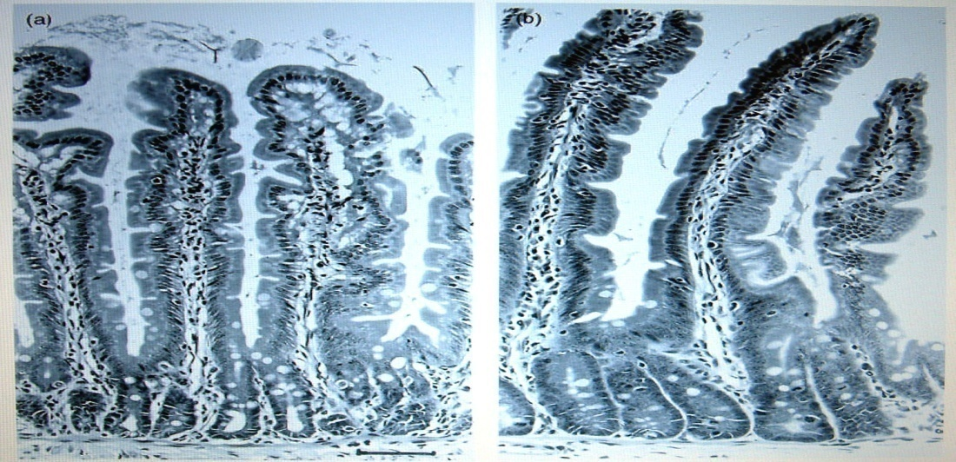
Fig. 6: Histology of jejanum and ileum of rat a) control, b) GM potato
GM Brinjal
Seralini et al., (2009) reported that for Bt transformation two antibiotic marker genes are used i.e. NPTII (neomycin phosphate II) and streptomycin (aad). A significant lower consumption of hay in goat when fed with Bt group, loss in weight. Cow showed resistance to kanamycin and less feed conversion. Milk production and its composition were changed by 10-14% in cow fed with GM Brinjal fruits.

GM pea
Prescott et al. (2005) reported that the development of α-amylase inhibitor-1-specific IgG1 and transfer of a protein gene from donor plant even to a closely related species in test animals. It also resulted in the synthesis of structural variants possessing altered immunogenicity. Fig. 11 shows lung tissue of rat indicating inflammation and more mucosal secretion in GM pea fed rats as compared with the non GM pea fed rats.
Figure 7: Lung tissue of GM Pea fed mice
F) Control G) GM pea
GM soya
Increases index of metabolic rate in hepatocyte nuclei and reduced digestive enzyme synthesis in pancreas and pancreatic adenoma in rat (Malatesta et al., 2002b). There was evidence of horizontal gene transfer to gut bacteria. Horizontal gene transfer of antibiotic resistance and Bt insecticide genes from GM foods into gut bacteria is an extremely serious issue. This is because the modified gut bacteria could become resistant to antibiotics (Netherwood et al., 2004).

Table 4: The reproductive performance of rat fed with laboratory chow, traditional soybeans and GM soybean
Pusztai and Bardocz, 2011 found that rats fed on GM soy showed altered morphology of the uterus and the ovaries: had greater volume density of endometrial glanular epithelium, reduced follicle number and increased corpus luteum numbers (a tendency to 29 abort or less of a chance to get pregnant). Although the GM diet was not supplemented with cysteine as the other diets, and it is difficult to assess if the results were due to consumption of the transgenic soy itself or were due to the presence of glyphosate (and/or AMPA), always present in GM seeds, the findings are disturbing and warrant further studies (Table 4). Testicles of rats fed GM soy were of a darker color and the cells showed significant differences compared to those of rats non-GM soy (Fig. 8).
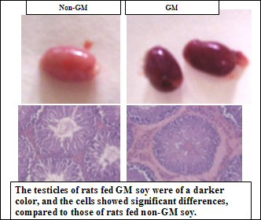
Fig. 8: Testicles of rats fed GM soy and non GM soy

Transgene survival in humans
Human volunteers fed a single GM soybean meal showed that GM DNA can survive processing and detectable in the digestive tract (Heritage, 2004). Specific IgA and IgG antibodies in sera suggest that individual has been exposed to antigen (Bt-toxin), during its lifetime. (Fig. 9) (Pusztai et al., 2003).

Analyzed sera
Fig. 9: Detection of transgene survival in humans
Cry1Ac binds to the mouse jejunal surface
Brush Border Membrane Vesicles isolated from mouse small intestine Cry1Ac showed 6 binding proteins. High antibody levels were detected in the fluids of both small and large intestines. Cry1Ac can survive intestinal passage in immunologically active form. Monsanto’s 90-day rat feeding studies with Bt corn showed vital organ damage and signs of toxicity (Vazquez et al., 2000a; Vazquez et al., 1999).
Transgene survival in pigs and rabbits
Chowdhury et al. (2003) reported that fragments of recombinant Cry1Ab gene were found in the GI tract, duodenal juice, lymphocytes and liver of Bt maize-fed pigs (Fig. 10) No GM DNA was found in liver, muscle, kidneys and heart in rabbits fed GM soybean diets but there was significant differences in enzyme levels found in heart and kidneys (Tudisco et al., 2006).

Fig. 10: Fragments of recombinant Cry1Ab gene found in S- stomach, I- Illeum, R- rectum, C- Coleum, D- Dudenol of pig
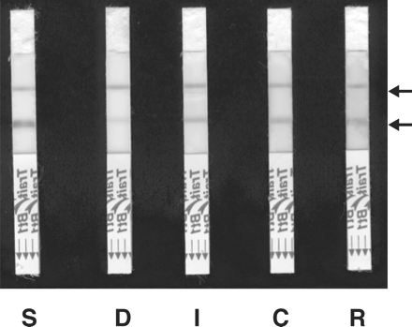
GM DNA and proteins in milk
Agodi, (2006) conducted experiment to detect presence of GM DNA in milk and gel photographs indicates the presence of GM DNA in milk samples. Presence of Cry1Ab toxin in milk from Bt maize-fed cows was established (Fig. 15).
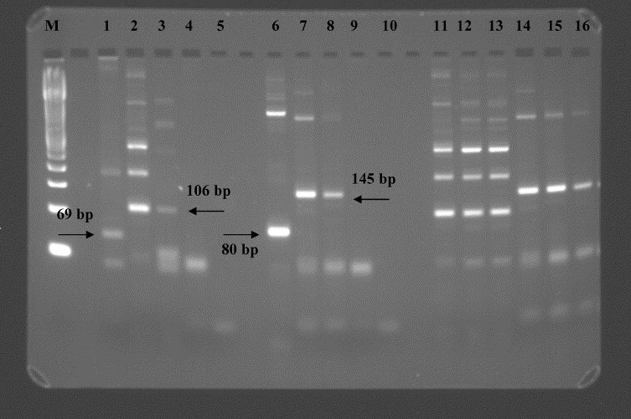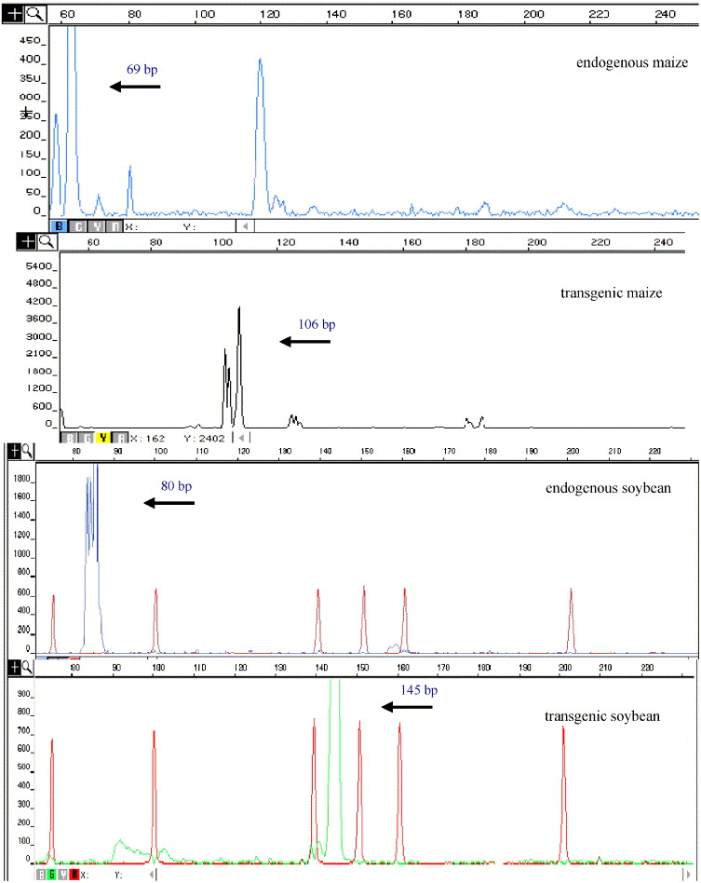
Fig. 15: Detection GM DNA in milk samples
Economic Concerns
Bringing a genetically modified food to market can be a costly and lengthy process, and of course, agricultural biotechnology companies want to ensure a profitable ROI. So, many new plant genetic engineering technologies and products have been patented, and patent infringement is a big concern within the agribusiness. Also, consumer advocates are worried that this will raise seed prices to very high levels that third-world countries and small farmers cannot afford them, thus widening the gap between the rich and the poor.
Risk assessment
In general, the risks associated with transgenic crops are potential risks. However, research results provide emerging parameters to evaluate the relative magnitude of the potential risk. For example, good evidence is emerging that the combination of natural promiscuity regarding gene flow among crop varieties and engineered herbicide resistance is a serious concern. Likewise, it is becoming clearer that herbicide tolerant crops will probably not create ‘superweeds’ through crop-wild flow of genes that enable plants to tolerate particular herbicides. Rather weed problems will be enhanced by the selection of resistant weed populations through increased use of herbicides tied to particular transgenic crops, such as glyphosate-resistant soybeans. Research efforts should concentrate on the latter potential risks. Also of concern is the enhanced weediness of wild relatives of crops from the flow of genes enabling plants to resist insects and viruses. However, the research to evaluate the extent of these risks is incomplete (Sparrow, 2010) [19] . More study is needed to assess the potential for the widespread adoption by farmers of insect-resistant sunflower and virus-resistant squash to promote the development of wild ~ 2410 ~ Journal of Pharmacognosy and Phytochemistry plants with improved fitness relative to other wild plants. The improved fitness of particular plants in wild populations could alter plant and animal ecosystems. The controversy over the potential for Bt corn to harm monarch butterfly populations also illustrates the need to move beyond laboratory studies to comprehensive field scale when assessing the potential negative impact on susceptible but beneficial populations. That is, studies that account for the temporal and spatial interaction between the introduced technology and the organism of interest.
Conclusion
It is inevitable that application of this technology has raised a number of fundamental concerns. The possible benefits of GMOs are enormous such as hunger alleviation and medical care and also some major concerns raised by the public relates to the impact of the GM crops on the near relative wild plants or other elements of biodiversity in the environment in which they are introduced causing genetic contamination and potential loss of genetic diversity, development of pest(s) and disease(s) and herbicide resistance which may likely to affect the human health through the food chain. GM technology is a major weapon against hunger to meet the growing global population.The commercial applications of GM to horticultural crops lag far behind those of agronomic crops. In some respects this is to be expected, since the majority of research and investment has been directed to commodities with the commercial value. For consumer and quality traits, however, many of the most interesting applications will be in horticultural crops (Clark et al., 2004). However, the major impediment to horticultural biotechnology is the reluctance of the market to accept and actively promote these products. The development of products having compelling benefits for producers, marketers and consumers must be required to overcome this situation.

References:
Atkinson, R. G., Hallett, S. R., Cohen, I. D., MacRae, E. A., 2002, Overexpression of Polygalacturonase in Transgenic Apple Trees Leads to a Range of Novel Phenotypes Involving Changes in Cell Adhesion. Plant Physiol. 129: 122-133.
Agodi, A. N., 2006, Detection of genetically modified DNA sequences in milk from The Italian market. Int. J. Hygiene Envi. Health, 209, 81-88.
Anuar, N. S., 2008, Effect of green and ripe Carica papaya epicarp extracts on wound healing and during pregnancy. Food Chemistry Toxicology, 46 (7): 2384-2389.
Babendreier, D., Kalberer, N. M.,Romeis, P. F., E. N. Mulligan. and Franz B., 2005, Influence of Bt-transgenic pollen, Bt-toxin and protease inhibitor (SBTI) ingestion on development of the hypopharyngeal glands in honeybees, Apidologie 36 :585–594.
Boughton, A. J., John J. O. and Bryony, C. B., 2003, Effects of a protease expressing recombinant baculovirus on nontarget insect predators of Heliothis virescens. Bio. Cont. 28:101–110
Clark D, Klee H, Dandekar A. Despite benefits, commercialization of transgenic horticultural crops lags. California agriculture. 2004; 58(2):89-98.
Chowdhury, E. H., Kuribara, H., Hino, A., Sultana, P., Mikami, O., Shimada, N., Guruge, K.S. and S. M, Nakajima., 2003, Detection of corn intrinsic and recombinant DNA fragments and Cry l Ab protein in the gastrointestinal contents of pigs fed genetically modified corn Bt11. J. Anim. Sci. 81: 2546-2551.
Deeb-Al Mohammad A., Gerald, E., Wilde, John, M., Blair, T. and Todd, C., 2003, Effect of Bt Corn for Corn Rootworm Control on Nontarget Soil Microarthropods and Nematodes. Environmental Entomology, Volume 32(4): 859–865,
Ewen, S. W. and A. Pusztai., 1999, Effects of diets containing genetically modified potatoes expressing Galanthus nivalis lectin on rat small intestine. Lancet 354: 1727-1728.
Fares, N. H. and El-Sayed, A. K., 1998, Fine structural changes in the ileum of mice fed on delta-endotoxin-treated potatoes and transgenic potatoes. Natural Toxins 6, 219-233.
Ferry, N., E. A. Mulligan., Michael, E. N., M. Angharad. and M. R. Gatehouse., 2007, Bitrophic and tritrophic effects of Bt Cry3A transgenic potato on beneficial, non-target, beetles.Transgenic Res. 16:795–812
Finamore, A., Roselli, M., Britti, S., Monastra, G., Ambra, R., Turrini, A. and Mengheri, E., 2008, Intestinal and peripheral immune response to MON810 maize ingestion in weaning and old mice. J. Agric. Food Chem. 56: 1533-1539.
Flores, S., Saxena, D., Stotzky, G., 2005, Transgenic Bt plants decompose less in soil than non-Bt-plants. Soil Biol. Biochem. 37: 1073-1082.
Gertz, J. M., Vencill, W.K. and Hill, N.S., 1999, Tolerance of transgenic soybean (Glycine max) to heat stress. The 1999 Brighton Confer. Weeds. Farnham, Surrey, UK, pp. 835-840
Heritage, J., 2004, The fate of transgenes in the human gut. Nat Biotech. 22: 170-172
Horvath, H., Jensen L. G, Wong, O. T., Kohl E, Ullrich S. E., Cochran J, Kannangara C. G, Von Wettstein D (2001). Stability of transgene expression, field performance and recombination breeding of transformed barley lines. Theor. Appl. Gene.102:1-11.
Larson, R. L., Hill, A. L., Fenwick, A., Kniss, A. R., Hanson, L. E. and Miller, S. D., 2006, Influence of glyphosate on Rhizoctonia and Fusarium root rot in sugar beet. Pest Manage. Sci. 62: 1182-1192.

Li, W. Wu., K. Wang., X. Wang., G. G. Yuyuan., 2005, Impact of Pollen Grains from Bt transgenic corn on the growth and development of Chinese Tussah Silkworm, Antheraea pernyi (Lepidoptera: Saturniidae). Envi. Entomol. 34(4) pp. 922-928

Losey, J. E., Rayor, L. S. and M. E. Carter., 1999, Transgenic pollen harms monarch larvae. Nature 399:214
Malone, L. A., Burgess, P.J., Gatehouse, H.S., Voisey, C. R., Tregidga , L. M., Philip, B.A., 2000, Effects of ingestion of a Bacillus thuringiensis toxin and a trypsin inhibitor on honey bee flight activity and longevity. Apidologie : 57–68.
Malatesta, M., 2002b, Ultrastructural analysis of pancreatic acinar cells from mice fed on genetically modified soybean. J. Anatomy, 20(1): 409-446.
Nachappa, M. S., 2004, Effect of Bt cotton on the performance of A.mellifera and A. cerana F. colonies. M. Sc. (Agri) Thesis, Uni. of Agric. Sci., Dharwad.
Nachappa, M. S. and Virktamath, S., 2004, Foraging activity and performance of European bee, Apis mellifera (L.) in Bt and non Bt cotton hybrids. Proc. Int. Symp. on Strat Sust. Cotton prod. – A G Vis, Uni. of Agric. Sci., Dharwad.
Netherwood, T., Martin-Orue, S. G., Gockling, S., Graham, J., Mathers, J. C., 2004, Assessing the survival of transgenic plant DNA in the human gastrointestinal tract. Nat. Biotech. 22: 204-209.
Pine, W. A., Viator, R., Wilcut, J.W., Edmisten, K. L., Thomas, J.F., Wells, R., 2002, Reproductive abnormalities in glyphosate-resistant cotton due to lower CP4– EPSPS levels in male reproductive tissue. Weed Sci. 50: 438-477.
Prescott, V. A., 2005, Transgenic expression of bean α-amylase inhibitor in peas resulted in altered structure and immunogenecity. J. Agril. Food Chemi. 53: 9023-9030.
Pusztai, A. and Bardocz, S., 2006, GMO in animal nutrition: potential benefits and risks. In: Biology of Nutrition in Growing Animals pp. 513-540.
Pusztai, A., Bardocz, S. and S. W. B. Ewen., 2003, Genetically Modified Foods: Potential Human Health Effects. In: Food Safety: Contaminants and Toxins. pp. 347-372. CAB International,Wallingford Oxon, UK.
Pusztai, A. and Bardocz, S., 2011, Potential Health Effects of Foods Derived from Genetically Modified Plants: What Are the Issues?. TWN Biotechnology and Biosafety series 14 Norsk institutt for genøkologi pp: 28-29

Ramesh, S., Choimes, A. S. and Schachtman, D. P., 2004, Over-expression of an Arabidopsis zinc transporter in Hordeum vulgare increases short term zinc uptake after zinc deprivation and seed zinc content. Plant Mol. Biol. 54:373- 85.
Saxena, D. and Stoztky, G., 2001, Bacillus thuringiensis toxin released from root exudates and biomass of Bt corn has no apparent effect on earthworms, nematodes, protozoa, bacteria, and fungi in Soil. Soil Biol. Biochem, 33:1225-1230.
Schmidt, K., Christine, H., Mandy B., Kristin, E., Patricia H., Andre K., Udo K., Peter L., Heike M., Wenke, M., Elmar, M., Katja, N., André, S., Jörg, S., Alain, S., Carla, S., Ralf, W., Annette, Z., Angelika, Z., Inge, B., 2011, BioOK – a Comprehensive System for Analysis and Risk Assessment of Genetically Modified Plants. J. für Kulturpflanzen, 63 (7). S. 232–248, 2011,
Seralini, G. E., Cellier, D. and Vendomois, J., 2009, Effects on health and environment of transgenic (or GM) Bt brinjal. University of Caen, France, Sci. Council Comm. Ind. Res. and Info. Gen. Eng. (CRIIGEN), p. 19.
Seralini, G. E., Cellier, D. and Vendomois, J., 2007, New analysis of a rat feeding study with genetically modified maize reveals signs of hepatorenal toxicity. Arch. Environ. Conta. Toxicol. 52: 596-602
Snow, A. A., D. Pilson, L. H. Rieseberg, M. J. Paulsen, N. Pleskac, M. R. Reagon, D. E. Wolf and S. M. Selbo, 2003, A Bt transgene reduces herbivory and enhances fecundity in wild sunflowers. Ecological Applications, 13(2), 2003, pp. 279–286.
Stanley W, Ewen B, Pusztai A (1999). Effect of diets containing genetically modified potatoes expressing Galanthus nivalis lectin on rat small intestine, Lancet. 354:1353-1354.
Tapp, H. and Stotzky, G., 1998, Persistence of the insecticidal Toxin from Bacillus thuringensis subsp. kurstaki in Soil. Soil Biol. Biochem. 30:471-476.
Tennant, P.F., Fisher, L.C. and McLaughlin, W.A., 2010, Disease-resistant transgenic crops: priorities and strategies for the Caribbean. www.biote,mht.com.
Tudisco, R., 2006, Genetically modified soya bean in rabbit feeding: detection of DNA fragments and evaluation of metabolic effects by enzymatic analysis. Animal Sci. 82, 193-199.
Vazquez-Padron, R. I., L. Moreno-Fierros., L. Neri-Baza., N. G. Reva. and R. Lopez- Revilla.,2000a, Characterization of the mucosal and systemic immune response induced by Cry1Ac protein from Bacillus thuringiensis HD 73 in mice. Brazilian J. Medical Biolo. Res. 33, 147-155.
Vazquez-Padron, R. I., L. Moreno-Fierros., L. Neri-Baza., N. G. Reva. and R. Lopez- Revilla., 1999, Intragastric and intraperitoneal administration of Cry1Ac protoxin from Bacillus thuringiensis induces systemic and mucosal antibody responses in mice. Life Sci. 64, 1897-1912.

Vendômois, J. S. François R., Dominique C. and Gilles-Eric S., 2009, A Comparison of the Effects of Three GM Corn Varieties on Mammalian Health. Int J Biol Sci. 2009; 5(7): 706–726.
Vierheilig, H., Monica, Alt., Jean-Marc, N., Thomas, B. and Anders, W., 1992, Colonization of transgenic Nicotiana sylvestris plants, expressing different forms of Nicotiana tabacum Chitinase by the root pathogen Rhizoctonia solani and by the mycorrhizal symbiont Glomus mossae. Mole. Plant microbe interactions. 6(2):261-264
Yu, L., Berry, R.E., Croft, B.A. (1997): Effects of Bacillus thuringiensis toxins in transgenic cotton and potato on Folsomia candida (Collembola: Isotomidae) and Oppia nitens (Acari: Orbatidae). - Journal of Economic Entomology 90: 113–118.
Zhang, S.Y., D.M. Li., J. Cui. and B.Y. Xie.,2006, Effects of Bt-toxin Cry1Ac on Propylaea japonica Thunberg (Coleoptera: Coccinellidae) by feeding on Bt-resistant Helicoverpa armigera (Hubner) (Lepidoptera:Noctuidae) larvae. J. Appl. Entomol. 130(4): 206–212
Zwahlen, A.C., H. R. Howald. and W. Nentwig., 2003, Effects of transgenic Bt corn litter on the earthworm Lumbricus terrestris. Mol. Eco. 12:1077–1086.

