Power Quality Improvement of Induction Motor Drive Using Active Filter

Kanungo Barada Mohanty
Department of Electrical Engineering
National Institute of Technology
Rourkela- 769008, INDIA
Email: kbmohanty@nitrkl.ac.in

ABSTRACT
This article presents a new power electronic circuit for a three phase active filter used to compensate variable reactive power and source current harmonics in a three phase induction motor drive application. The active filter consists of a group of series filters of fifth order, seventh order and eleventh order and a Thyristor Switch Capacitor (TSC) designed to compensate variable reactive power. A model reference adaptive control scheme for TSC is developed to obtain transient free TSC switching with improved stability. Performance of the proposed filter is obtained by simulation, when connected to an ac-dc-ac power converter fed induction motor drive for variable external load application at the point of common coupling. The scheme uses a 3-phase uncontrolled ac-dc rectifier at the front-end. The simulated results show that proposed scheme can effectively compensate current harmonics and variable reactive power.

KEYWORDS
Power quality, passive shunt filter, passive series filter, passive hybrid filter, Lyapunov function

NOMENCLATURE
,, Three phase supply voltages
,, Three phase supply currents
,, Three phase motor currents
f Supply frequency
Supply angular frequency
Source Impedance
Impedance of the parallel passive filter
Impedance of the series passive filter
Admittance of the series passive filter
n Harmonic order of the filter
Resonant frequency for the harmonic
H Order of fundamental frequency
, , Inductance of passive series filter tuned for 5th , 7th and 11th harmonics
,, Resistance, inductance and capacitance of shunt passive filter
,, Resistance, inductance and capacitance of shunt passive filter tuned for 11th harmonics
, , Capacitance of passive series filter tuned for 5th , 7th and 11th harmonics
, , Resistance of passive series filter tuned for 5th , 7th and 11th harmonics
,, Resistance, inductance and capacitance of shunt passive filter
,, Resistance, inductance and capacitance of series passive filter
,, Impedances 5th,7th and 11th order series passive filters
,, Resistance, inductance and capacitance of thyristor switched capacitor
, Reactance of shunt capacitance and reactance of shunt inductance at fundamental frequency
, Reactance of series capacitance and reactance of series inductance at fundamental frequency
DC-Link voltage
, Inductance of DC link inductor and capacitor of DC link capacitor
P Three phase active Power
Q Three phase reactive power
Reactive power of passive shunt filter
Reactive power of passive series filter
Reactive power of TSC branch
Q_{F} Quality factor

INTRODUCTION

Extreme use of power electronic equipment has made power management smart, flexible and efficient but degraded power quality due to injection of current and voltage harmonics and power pollution with more reactive power and poor power factor. This generates disturbances like sag or swell in voltage with fluctuations and power interruptions, in the integrated electrical system [1]-[2]. Reduction in the Total Harmonic Distortion (THD) and power factor improvement are the main goals in distributed power system and industries. Power electronics researchers and engineers have made significant effort to counter the increased cost for solving the above power quality issues.
To improve the quality of power has become a prudent goal. Reputed organizations like the Institute of Electrical and Electronics Engineers (IEEE) and International Electrotechnical Commission (IEC) have set some standards as IEEE Std. 519 [3], IEEE Std. 1531 [4], IEEE Std.1159 [5] and IEC Std. 61000-4-30 [6]. Guidelines are given to limit the power pollution and prevent other drawbacks or disturbances. To meet the set standards and limit the power pollution more and more research are being done. Improved performance, high efficiency, energy saving power electronics technology is thus evolving.
Induction motor drive is common, and extensively used and its control is a challenge [7], [8]. Several techniques have come up [9]-[15] to improve its performance. Field orientation control [9]-[10], linearization through feedback control, input-output linearization are developed [13]-[15]. The induction motor drive has a front-end ac-dc converter connected to a pulse width modulated (PWM) voltage source inverter (VSI) that provides the motor variable voltage, variable frequency supply. The uncontrolled ac-dc converter requires series and shunt passive (LC) filters to reduce harmonic currents and thereby improve input power factor. In [16]-[20] authors have provided design technique for the passive series, shunt and hybrid power filters for decreasing the THD in input current. Phipps [16] has used transfer function approach for design of passive filter. Peeran and Cascadden have reported design and specification of harmonic filters for adjustable speed AC drives. Peng et. al. [18] have reported improved performance adjustable speed AC drives with passive series filter. It presents transient behavior of each filter. Das [19] has reported in 2004 some constraints and problems in design and application of passive filter. B. Singh et. al. [20] presented in 2005 the design of hybrid filter combining passive series filter and higher order passive shunt filter. This filter combination meets the IEEE 519 standard even for changing load, but they have many problems like resonance, larger size, inability to compensate variable harmonic current and reactive power, tuning problems, and possession of fixed compensation characteristics. So, the control techniques using power electronics have become an important topic in recent time. The active filters are frequently used for adjustable load due to its flexibility and better performance characteristics and ease of implementation [21]-[22]. As the active filters are costly, their use in larger power rating system is limited. In [23] authors reported use of hybrid power filter comprising of a lower rating active filter with passive filter tuned for specific harmonic mitigation. The demerits of hybrid power filters still persist. It may not work satisfactorily for adjustable load and variable reactive power supply.
Many works have reported use of FACTS devices to compensate reactive power [24]-[30]. The FACTS devices using thyristor switched capacitor (TSC) and thyristor switched reactor with fixed capacitors (TSR/FC) [12] are structurally similar. In many cases parameters of FACT devices are tuned for particular harmonic frequency and designed for changing reactive power compensation [29]-[30].
The TSC is capable of absorbing inductive VAr from the distribution system and improving the power factor. The TSC consists of a two thyristors in reverse parallel for bidirectional current and series RLC circuit. It is a variant of static VAr compensator (SVC) placed in shunt to the line. TSC has many advantages like simplicity of design and ease of installation. Besides, the proposed TSC can be used in several applications like supply voltage regulation, adjustable reactive power supply and harmonics filtration.
Thyristor switched capacitor is in use since early seventies [24], [25]. It improves the transient stability and provides the inductive VAr effectively. To reduce the high in-inrush current of the capacitor at the instant of switching-on, a lot of research work has been reported to obtain a transient-free switching [24], [25] and [26]. Many applications for different purpose have been reported by researchers. It is used for voltage regulation application, arc suppression [27] and reactive power compression [29]-[30].
In this work, at first a passive hybrid filter with series and shunt filter is designed. It is connected across the ac supply of three phase diode rectifier feeding power to the induction motor drive. The hybrid passive filter compensate reactive power as well as current harmonic mitigation upto some level. This result is acceptable to IEEE 510 standard. But due to constant filter parameter it fails to cop-up with smooth compensation of changing reactive power. To overcome this problem, a novel active hybrid filter is proposed which is consists of a group of passive series filters and a thyristor switch capacitor (TSC). A control method based on model reference adaptive scheme is used for the thyristor switch capacitor (TSC). The special features of the proposed control scheme are as follows. The TSC is designed to meet two purposes, first is to compensate variable reactive power and second to sink fifth order harmonic of the ac mains current. A model adaptive control law is developed to compensate variable reactive power. The proposed TSC based filter performance is validated by simulation. Finally, a comparison of different power quality indices between hybrid passive filter and TSC based active passive filter are presented.

DESIGN OF PASSIVE HYBRID FILTER

The passive shunt filter gives leading power factor and hence makes the voltage at PCC higher under light load condition whereas passive series filter gives lagging power factor operation and voltage drop across the filter. The disadvantage of individual passive series and passive shunt filter can be eliminated or reduced by the passive hybrid power filter using the combined passive series and passive shunt filter. Schematic diagram of a 3-phase diode rectifier fed induction motor and passive hybrid filter connected at the PCC is shown in Fig. 1. The passive hybrid filter in Fig.1, connected across ac input of the diode rectifier supplying to IM drive, uses two series filters for blocking 5th and 7th harmonic frequencies and a series filter for blocking 11th harmonic frequency and a passive shunt filter for reducing/ grounding the 11th harmonic current. The passive series filter has a parallel circuit of high impedance LCR each tuned for a particular harmonic frequency. Fig. 2 (a) and Fig. 2 (b) show the circuit arrangement for a low frequency eliminator and high frequency series passive filter. The harmonic reduction is obtained by blocking specific harmonic currents with the parallel LCR arrangement which gives high impedance at the particular frequency. The impedance of first order filter is represented as [20]:
(1)

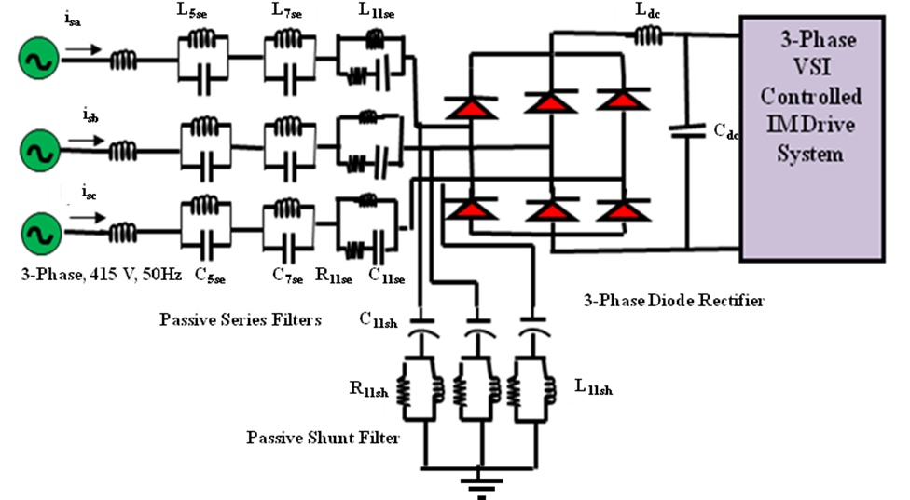
Fig.1. Schematic diagram of a 3-phase diode rectifier fed induction motor drive with passive filter at PCC

Where, Q_{se} is the VAr of the series filter. The admittance of the circuit is expressed as [20]:
(2)
where,
(3)
The n-th order resonant frequency is:
(4)
Quality factor is defined as
(5)
The RLC parameters of the filter is designed from above equations. So, the effective impedance of the series filter is given by eqn. (6).
(6)
The passive series filter is made to give least impedance at the rated frequency. There should be least voltage drops across series passive filter. If voltage drop across series passive filter increases, then input voltage regulation becomes poor. The single phase circuit for a high frequency passive shunt filter consists of CLR (C_{sh,} L_{sh}, R_{sh}) is shown in Fig. 2 (c). The series tuned high pass filters have the impedance at resonant frequency for the n-th order harmonic is [20]:
(7)
(8)
(9)
where, Q_{sh} is the VAr obtained from the passive shunt filter, n is the order of harmonic filter; X_{shL} is the inductive reactance from L_{sh}, X_{shc} is the capacitive reactance of the C_{sh} at rated supply frequency. Quality factor is defined as [20]:
(10)
The VAr requirement is first taken to be 25% of the load rating [17]. This is shared equally by different filter branch circuits. The parameters of series and shunt branches are obtained using above equations. In this work, the Q-factor of filter, (Q_{F} =X_{shL}/R), is taken to be 30 to obtain the value of R. The hybrid filter circuit element values are given in Table 1.

C_{se}
(a)
R_{se} C_{se}
(b)
R_{sh}
L_{sh}
C_{sh}
(c)
Fig.2 Circuit representation of filters: (a) low frequency series filter, (b) high frequency series filter and (c) high pass shunt filter

Table 1: Parameters of Hybrid Filters
Order/  type of filter | Capacitance | Inductance | Resistance
5th Order Series | 40e-6F | 10e-3H | 0.32Ω
7th Order Series | 51.7e-6F | 4e-3H | 0.29Ω
11th Order Series | 14e-6F | 10e-3H | 12 Ω
11th Order Shunt | 14e-6F | 6e-3H | 18.6 Ω

DESIGN OF PROPOSED ACTIVE HYBRID FILTER

Instead of using either passive shunt filter or passive series filter, it is better to use hybrid passive filter but only for constant reactive power load. If the VAr is variable (reactive power), hybrid passive filter also fails. So, static VAR compensator (SVC) should be used. Thyristor switched capacitor (TSC) is a variant of SVC. General structure of a TSC is shown in Fig. 3. TSC consists of two SCRs connected back to back a with series RLC circuit. TSC provides VAr (like capacitor) to neutralize inductive VAr and thus to improve the lagging power factor of series passive filters. This is possible due to the control of power flow into TCS through SCRs. The hybrid of passive series filter and TSC is more capable of harmonic reduction and variable VAr compensation. The series passive filter draws variable lagging current, which is provided by TSC. The schematic diagram of this method is shown in Fig.4. TSC requires better control method for fast response and exact VAr compensation. The control strategy is discussed in Section-IV in detail.

V_{s}
I_{sp}
C_{PF}
R_{PF}
L_{PF}

Fig.3.General structure of TSC system

The 1-phase TSC is a LPF consisting of CLR (C_{PF}, L_{PF}, and R_{PF}) as shown above Fig.3. The impedance for this circuit is [20]:
(11)
TSC should act as a sink for n-th harmonic for which corresponding reactance should be zero. This leads to:
(12)
where, Q_{PF} is VAr from the TSC branch, n is the passive filter frequency order; X_{PFL} is inductive reactance from L_{PF} at rated supply frequency, X_{PFC} is capacitive reactance of the C_{PF} at supply frequency. The VAr requirement is assumed as 25% of the load power rating [17]. The parameters of series elements are obtained from section-II. In this work, the Q-factor (Q_{F} =X_{PFL}/R_{PF} ), for LPF is taken to be 30 to calculate R. The active hybrid filter’s circuit element values are given in Table 2.

Table 2: Parameters of Series Filters and TSC
Order/type of filter | Capacitance | Inductance | Resistance
5th Order Series | 40e-6F | 10e-3H | 0.32Ω
7th Order Series | 51.7e-6F | 4e-3H | 0.29Ω
11th Order Series | 14e-6F | 10e-3H | 12 Ω
TSC | 25e-6F | 16.8e-3H | 0.8 Ω

The TSC circuit current, voltage and hence reactive power are controlled by firing delay angle α. The dominating current in the TSC is 5th, but the presence of other harmonic components cannot be ignored. TSC is designed to compensate for harmonic current and give leading reactive power. A look-up table is prepared from the charateristic plot and firing angle is generated from that for required reactive power compensation.

MODEL REFERENCE ADAPTIVE CONTROL OF THE TSC

Transient modeling of the TSC is first done in the fixed a-b-c reference frame and then changed to the synchronously rotating d-q frame. A model reference adaptive scheme is used for instantaneous VAr compensation and harmonic reduction. Control scheme is implemented in synchronously rotating reference frame.

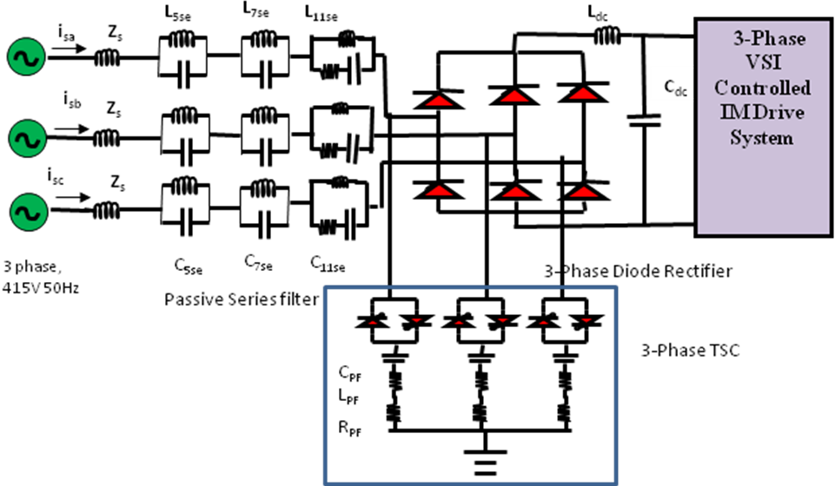
Fig.4. Scheme diagram of three phase diode rectifier fed induction motor with passive series filter and thyristor switched capacitor connected at PCC

A. Dynamic Modeling of Thyristor Switched Capacitor
Transient model of TSC in the synchronous reference frame (d-q) is given below. Kirchhoff’s circuit law for TSC is written as:
(13)
where, k stands for generalization of three phases individually (a, b, c). Differentiation of (13) results in:
(14)
Transformation matrices for two consecutive conversions are given in (15) and (16) for a-b-c to d-q.
(15)
(16)
where, α-β represent the stationary two phase references frame. Transient model of TSC in the synchronous frame (d-q ) is obtained from (14) to (16). These equations are used for obtaining the control law for TSC. It is derived in next sub-section.

B. Model Reference Adaptive Controller
A model reference adaptive scheme is developed to assure stablity and instantaneous response of reactive power and harmonic mitigation. It utilizes Lyapunov’s stability theorem and Barbalat’s lemma [7]. The VAr is controlled by the current i_{q} and the active power is varied by current i_{d}. Resistance of TSC is negligible. So, current i_{d.} is also very small.
Further, substituting i_{d} =0 and , we have the linearized q-axis dynamic equation
(17)

where,
(18)
The state space representation of (17) is given as:
(19)
where,
'
A model reference adaptive control law is [7]:
(20)
where, and are feedback gains; is the bounded external reference input. For VAr compensation,, the equal and opposite of measured VAr. For the best control, a linear 2nd order reference model is used and compared with the actual. Controller is developed for making the steady-state error zero (tracking of the reference model). The TF of 2nd order reference model is taken with the damping ratio ζ as unity and the natural frequency as 225 rad/s.
$G(s)=\frac{ω_{n^{2}}}{s^{2}+2{\text{ξω}}_{n}s+ω_{n^{2}}}$ (21)
The dynamics of system error between actual model (19), (20) and reference model obtained from (22) is given as:
(22)
Next, for designing the controller positive definite Lyapunov function is taken as defined in equation (23).
(23)
where, γ is a positive number, P is symmetric positive definite matrix satisfying:
where
,
,
Here the adaption law is chosen as:
(24)
The derivative Lyapunov function is then expressed as:
So, above adaptive control law is stable. is obtained from (20) to (24). is obtained by substituting into (18) and then through integration. Then the equivalent α-β voltage component in stationary axes are obtained through change of reference frame. This voltage is used to obtain reference reactive power. Then it is passed through the firing angle generator to generate to gate pulse for thyristor switches. The schematic block of model adaptive control scheme for TSC is shown in Fig.5.

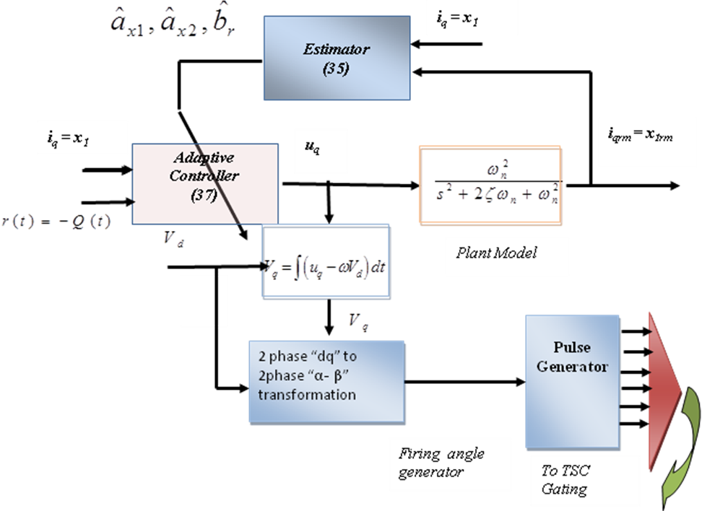
Fig.5 Proposed model reference adaptive control scheme of the TSC

RESULTS AND DISCUSSIONS

To compare the performance of the passive hybrid filter and proposed TSC with hybrid filter, discussed in the previous sections, a three phase 10 kVA uncontrolled rectifier supplying power to a three phase voltage source inverter (VSI) fed induction motor drive is simulated in MATLAB Simulink. The induction motor whose ratings and parameters are given in Table-3 is subjected to load variations, and complete system is simulated.

Table 3: Specifications and Parameters of Three Phase Induction Motor
Parameters | Symbol | Values
Rated power | P | 3.7 kW
Rated voltage | V | 415 V
Rated speed | ω _{m} | 1445 rpm
Stator resistance | R_{s} | 7.34 Ω
Rotor resistance | R_{r} | 5.64 Ω
Stator leakage inductance | L_{ls} | 0.021 H
Rotor leakage inductance | L_{lr} | 0.021 H
Mutual inductance | L_{m} | 0.5 H
Number of pole pair | p | 2
Moment of Inertia | J | 0.16 kg-m²
Frictional constant | B | 0.035 kg-m²/s

The simulation study is carried in three different cases and results are compared. Those three cases are:
- Three phase diode rectifier supplies three phase Voltage Source Inverter fed induction motor without filter.
- Three phase diode rectifier with passive hybrid filter connected at PCC supplying three phase Voltage Source Inverter fed induction motor.
- Three phase diode rectifier with passive series filter and proposed TSC connected at PCC supplying 3-phase VSI fed induction motor drive
Simulation results are shown in Fig. 6 to Fig. 8 for case-1, in Fig. 9 to Fig. 11 for case-2 and in Fig. 12 to Fig. 15 for case-3. A set of responses consisting of: (a) desired speed ω_{r}*(rpm), motor speed ω_{r} (rpm), (b) motor torque T_{e} (N.m), load torque T_{l} (N.m), (c) active power P (kW), reactive power Q (kVAR), (d) dc link voltage V_{dc} (V), (e) three phase supply voltages V_{sabc} (V), (f) three phase supply current i_{sabc} (A) are shown in Fig. 6 for case-1, in Fig. 9 for case-2, and in Fig. 12 for case-3. Zoomed waveforms of supply phase voltage V_{sa} and phase current i_{sa} are shown in Fig. 7 for case-1, in Fig. 10 for case-2 and in Fig. 13 for case-3 corresponding to full load Fig. 7(a), Fig. 10(a), Fig. 13(a); half load, Fig. 7(b), Fig. 10(b), Fig. 13(b) and no load Fig. 7(c), Fig. 10(c), Fig. 13(c). Total harmonic distortion (THD) of supply current i_{sa} is shown in Fig. 8 for case-1, in Fig. 11 for case-2 and in Fig. 14 for case-3 corresponding to full load Fig. 8(a), Fig. 11(a), Fig. 14(a); half load, Fig. 8(b), Fig. 11(b), Fig. 14(b) and no load Fig. 8(c), Fig. 11(c), Fig. 14(c).

A. Three Phase Diode Rectifier and 3-Phase Inverter Fed Induction Motor Without Filter
Fig.6 to Fig. 8 show the simulation results of the above system without any filter, under different loading conditions of the induction motor drive. The motor desired speed is set at 500rpm and it reaches steady speed of 500rpm at 0.39s. In the transient interval motor draws rated load current. So, in this interval active power drawn by the motor is more and nearly equal to the 7.2 kW (Fig.6). When the motor reaches desired speed of 500 rpm without load, active power reduces to 2 kW. Again after motor is loaded to full load, the active power increases to 7.2 kW and after load on induction motor is made half at 1.0 s, the active power is decreases to 3.5 kW. Power factor at full load, at half load and at no load are 0.98, 0.88 and 0.801, in that order as seen in Fig.7. Fig.8. shows supply current harmonic spectrum for different load conditions. Harmonic distortion, THD is 33.24% at full load, 48.23% at half load and 74.89% at no load. Therefore, it is essential to improve the power quality in terms of improvement in power factor and reduction in the harmonic distortion of supply current.

(a)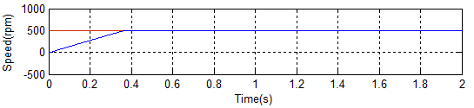
(b)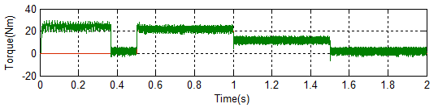
(c)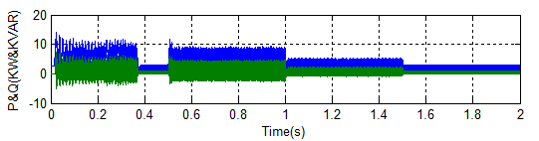
(d)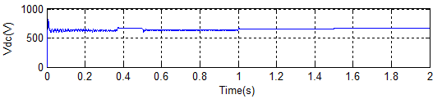
(e)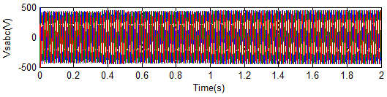
(f)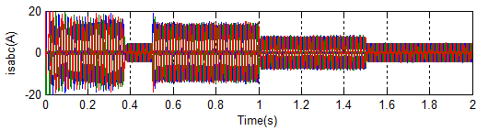
Fig. 6 Simulation responses of 3-phase diode rectifier supplying 3-Ф VSI fed induction motor with variable load: (a) rotor speed, (b) load torque, electromagnetic torque, (c) active power and VAr, (d) dc link voltage, (e) stator voltages, (f) stator currents

(a)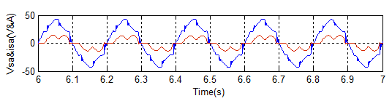
(b)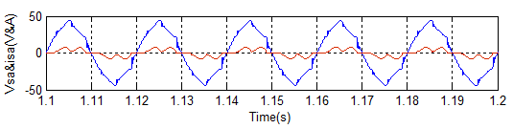
(c)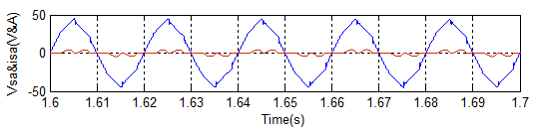
Fig.7 Inverter voltage and supply current waveforms for 3-phase diode rectifier supplying 3-Ф VSI fed induction motor at full, half and no load: (a), (b), (c)

(a)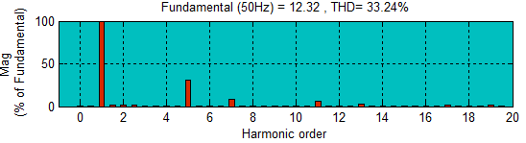
(b)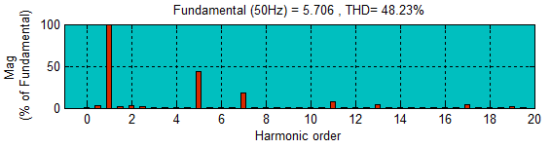
(c)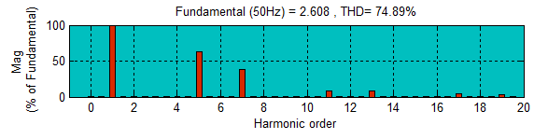
Fig.8 Three phase diode rectifier supplying 3-Ф VSI with induction motor: AC input current harmonic spectrum for full, half and no loads: (a), (b), (c)

B. Three Phase Diode Rectifier With Hybrid Passive Filter Connected at PCC, Supplying 3-Phase VSI Fed Induction Motor Drive
The responses of hybrid passive filter connected at Point of Common Coupling with diode rectifier supplying power to 3-phase VSI fed induction motor is depicted in Fig.9 to Fig.11. With this filter harmonic distortion of AC input current reduces to 3.28% at full load, 4.75% at half load and 5.34% at no load as observed in Fig.11. The power factor and THD indices are given in the Table 4. This hybrid filter circuit complies with the IEEE standard 519 for power quality for the variable load application. Reactive power at full load is positive and at low load it is negative. This hybrid filter circuit has constant parameters. So, VAr is of variable nature and can’t be exactly compensated. Hence, there is a need for variable VAr compensation and harmonic removal.

(a)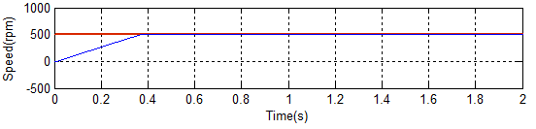
(b)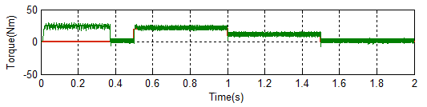
(c)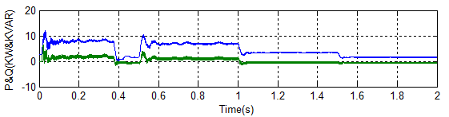
(d)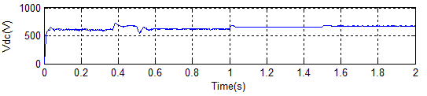
(e)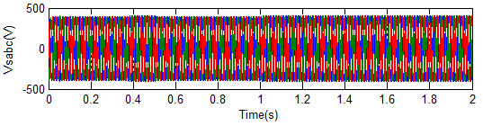
(f)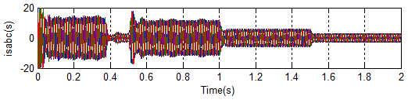
Fig. 9 Simulation responses of three-phase diode rectifier with hybrid passive filter connected to PCC supplying 3-Ф VSI fed induction motor with variable load: (a) rotor speed, (b) load torque, electromagnetic torque, (c) active power, VAr (d) dc link voltage, (e) stator voltages, (f) stator currents

(a)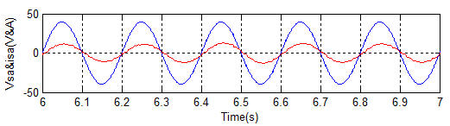
(b)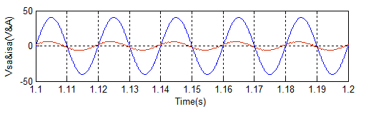
(c)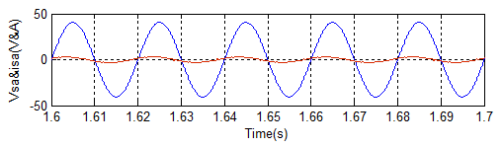
Fig.10 Input AC voltage and current waveforms for three-phase diode rectifier with hybrid passive filter supplying 3-Ф VSI fed induction motor at full, half and no loads: (a), (b), (c)

(a)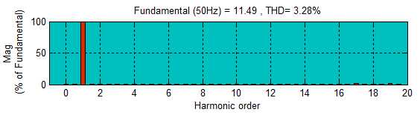
(b)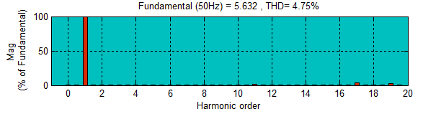
(c)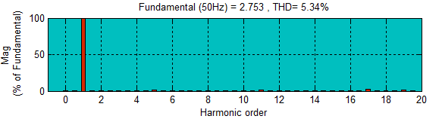
Fig.11 Three-phase diode rectifier with hybrid passive filter supplying 3-Ф VSI fed induction motor: Input current harmonic spectrum for full, half and no loads: (a), (b), (c)

C. Three-Phase Diode Rectifier With Series Passive Filter and Proposed TSC to PCC, Supplying 3-Phase VSI Fed Induction Motor Drive
In this case the three phase VSI fed induction motor is supplied from uncontrolled converter with proposed TSC and series filter. Fig.12 to Fig.15 show the simulation results of the system for the variable load application. When motor runs at steady state at no load active power and reactive power both are less. During the change of load from full load to no load the system with TSC maintains almost unity power factor (Fig.13). The THD of supply current is 3.83% at full load, 3.81% at half load and 3.49% at no load (Fig.14). The results confirm proposed scheme gives better performance than hybrid filter based scheme. Fig. 15(b) shows the thyristor voltage and current waveform. At the instant when thyristor is switched on current starts from zero. The phase difference between thyristor current and voltage is almost 90˚. It is observed that there are phase difference between supply voltage and TSC voltage too. The gate pulse is applied at angle α. During this period thyristors switch on-off according to presence of dominating harmonic contents (Fig. 15(a)).

(a)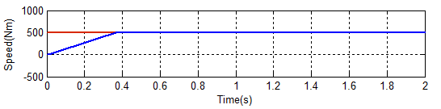
(b)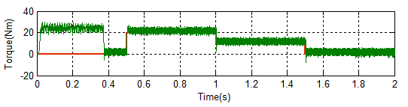
(c)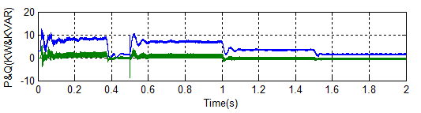
(d)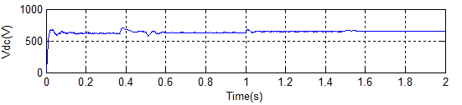
(e)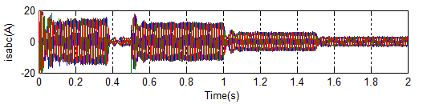
(f)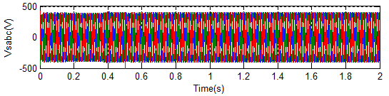
Fig. 12 Simulation responses of 3-phase diode rectifier with series passive filter and TSC connected to PCC supplying 3-Ф VSI fed induction motor with variable load: (a) rotor speed, (b) load torque, electromagnetic torque, (c) active power, VAr (d) dc link voltage, (e) stator voltages, (f) stator currents

(a)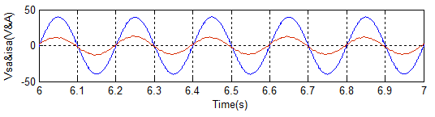
(b)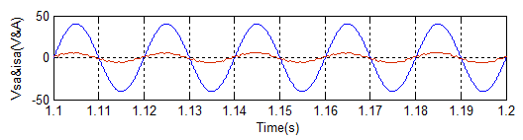
(c)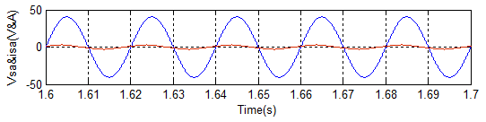
Fig.13 Input voltage and current waveforms for three-phase diode rectifier with series passive filter and TSC supplying 3-Ф VSI fed induction motor: (a) full load, (b) half load, (c) no load

(a)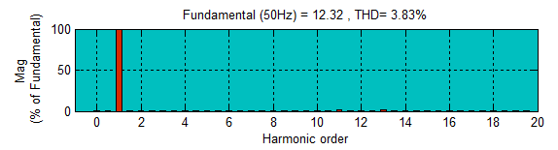
(b)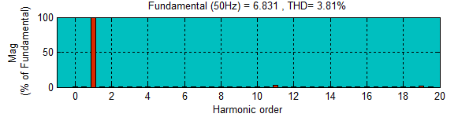
(c)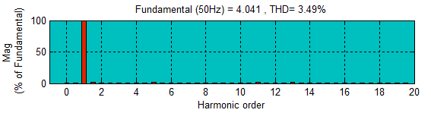
Fig.14 AC input current harmonic spectrum of Three-phase diode rectifier with series passive filter and TSC supplying 3-Ф VSI fed induction motor: (a) full load, (b) half load and (c) no load
(a)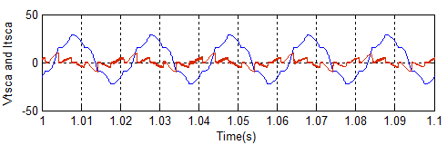
(b)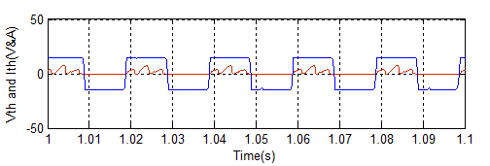

(c)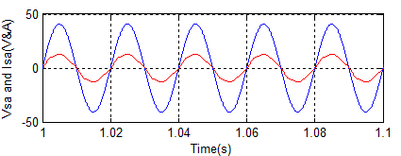
(d)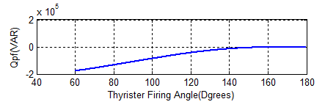
Fig. 15 (a) TSC voltage and current waveform for fifth order harmonic (b) thyristor gate pulse and current (c) TSC reactive power vs firing angle alpha

Performance comparison of above three schemes is carried out, and results are tabulated in Table 4. Reactive power and total harmonic distortion in the three cases are compared and shown in bar diagram of Fig. 16.

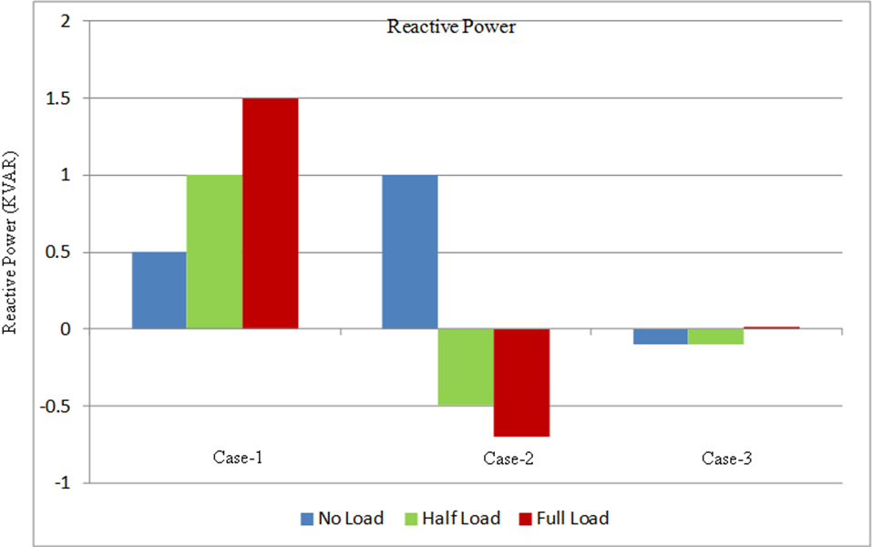
(a)
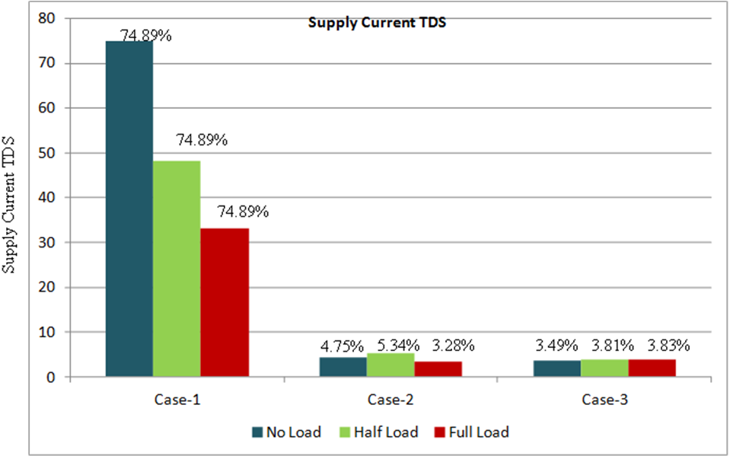
(b)

Fig.16 Performance comparative chart for (a) reactive power (b) total harmonic distortion

Table 4 : Performance Comparison for 3-Phase Diode Rectifier With Filters and Variable Load

Configuration | Load on IM | THD(%)  Supply Current | THD(%) Supply Voltage | PF | P  (kW) | Q  (kVAr) | DC link Voltage Vdc (V)
Case-1 | Full Load | 33.24 | 4.72 | 0.98 | 7 | 1.5 | 635
Case-1 | Half Load | 48.23 | 2.99 | 0.88 | 3.5 | 1.0 | 655
Case-1 | No load | 74.89 | 1.18 | 0.801 | 2 | 0.5 | 670
Case-2 | Full Load | 3.28 | 1.14 | 0.99 | 6.5 | 1.0 | 625
Case-2 | Half Load | 4.75 | 0.85 | 0.99 | 3.5 | -0.5 | 640
Case-2 | No load | 5.34 | 0.55 | 0.91 | 1.52 | -0.7 | 675
Case-3 | Full Load | 3.83 | 1.03 | 1 | 6.0 | 0.00 | 630
Case-3 | Half Load | 3.81 | 0.7 | 1 | 3.0 | -0.2 | 645
Case-3 | No load | 3.49 | 0.42 | 1 | 1.25 | -0.2 | 655

CONCLUSION

A 3-phase ac-dc diode rectifier supplying 3-phase VSI IM drive system is considered for power quality study. Performance is compared in terms of THD and supply power factor of input current. At first performance of the 3-phase DBR with 1% source impedance is investigated. Under this condition, the characteristic harmonics of current are 5th (20%), 7 ^{th} (14%) and 11th (9%) [20]. Reactive power is around 25% the apparent power. For VAr compensation and THD reduction a hybrid passive filter is used, and simulated. It is well known that [22] shunt passive filter makes power factor leading and increases voltage at light load, whereas series passive filter makes power factor lagging and increases voltage drop across the filter as the load current increases [20]. Performance of shunt passive filter is unsatisfactory under light load condition, whereas performance of series passive filter is unsatisfactory at full load. The hybrid passive filter consisting of suitable series and shunt filter combination is used to overcome this drawback up to a remarkable level. The THD of the supply current under full load is 3.28% and power factor close to unity. But due to fixed filter parameters, it is also not suitable for changing VAr. The proposed TSC along with passive series filter not only gives less THD of supply current but also able to compensate variable reactive power with fast response of reactive power over the entire opearating range.

REFERENCES
- A. Kusko and M. T. Thompson, Power Quality in Electrical Systems, McGraw-Hill, New York, 2007.
- R. S. Vedam and M. S. Sharma, Power Quality: VAR Compensation in Power Systems, CRC Press: Taylor and Francis, Florida, 2009.
- IEEE Std. 519-1992, “IEEE recommended practices and requirements for harmonics control in electric power systems,” © IEEE, Inc., 1993.
- IEEE Std. 1531-2003, “IEEE guide for application and specification of harmonic filters,” © IEEE- Power Engineering Society, Nov. 2003.
- IEEE Std. 1159-1995, “IEEE recommended practice for monitoring electric power quality,” © IEEE, June, 1995.
- International Std. IEC 61000-4-30, “Electromagnetic Compatibility (EMC)-Part 4-30: Testing and measurement techniques- Power quality measurement methods,” © IEC, First ed., Feb. 2003.
- J. J. E. Slotine, and W. Li, Applied Nonlinear Control, Prentice Hall International, Englewood Cliffs, New Jersey, 1991.
- A. Isidori, Nonlinear control Systems, Springer Verlag, Berlin, Germany, 1995.
- F. Blaschke, “The principle of field orientation as applied to the new TRANSVEKTOR closed- loop control system for rotating-field machines,” Siemens Review, vol. 39, pp. 217-220, May 1972.
- K. Hasse, “On the dynamic behavior of induction machine driven by variable frequency and voltage source,” ETZ Arch. Bd. 89, H.4, pp. 77-81, 1968.
- W. Leonard, Control of Electrical Drives, Spinger Verlag, Berlin, Germany, 1990.
- B. K. Bose, Modern Power Electronics and AC Drives, Prentice Hall Of India, New Delhi, 2008.
- R. Marino, S. Peresada, and P.Valigi, “Adaptive input-output linearizing control of induction motors,” IEEE Trans. Automatic Control, vol. 38, no. 2, pp. 208-221, 1993.
- R. J. Wai and W. K. Liu., “Nonlinear decoupled control for linear induction motor servo-drive using the sliding mode technique,” IEE Proc. Control Theory and Applications, vol. 148, no. 3, pp. 217–231, May 2001.
- K. B. Mohanty, Madhu Singh, “Performance improvement of induction motor drive using feedback linearization and fuzzy torque compensator with RTDS implementation,” International Review of Electrical Engineering, vol. 7, no. 3, June 2012, pp. 4374-4382.
- J. K. Phipps, “A transfer function approach to harmonic filter design,” IEEE Industry Applications Magazine, vol. 3, no.2, pp. 68-82, 1997.
- Syed M. Peeran and C.W.P. Cascadden, “Application, design and specification of harmonic filters for variable frequency drives,” IEEE Trans. on Industry Applications, vol. 31, no. 4, pp. 841-847, July/ August 1995.
- F. Z. Peng, G. J. Su, and George Farquharson, “A series LC filter for harmonic compensation of AC drives,” Proc. 30th Ann. IEEE Power Electronics Specialists Conf., July 1999, Charleston, vol. 1, pp. 213-218.
- J.C. Das, “Passive filters-potentialities and limitations,” Conf. Record 2003 Ann. Pulp and Paper Industry Technical Conf., 16-20 June 2003, pp. 187-197.
- B. Singh, V. Verma, A. Chandra and K. Al. Haddad, “Hybrid filters for power quality improvement,” IEE Proc. Generation, Transmission and Distribution, vol. 152, no. 3, pp. 365-378, May 2005.
- S. Rahmani, N. Mendalek, and K. AI-Haddad, “Experimental design of a nonlinear control technique for three-phase shunt active power filter,” IEEE Trans. Industrial Electronics, vol. 57, no. 10, pp. 3364-3375, Oct. 2010.
- B. Singh and J. Solanki, “An implementation of an adaptive control algorithm for a three-phase shunt active filter,” IEEE Trans. Industrial Electronics, vol. 56, no. 8, pp. 2811–2820, Aug. 2009.
- S. Rahmani, A. Hamadi and K. Al-Haddad, “A Lyapunov-function-based control for a three-phase shunt hybrid active filter,” IEEE Trans. Industrial Electronics, vol. 59, no. 3, pp. 1418–1429, March 2012.
- L. Gyugyi, “Reactive power generation and control by thyristor circuits,” IEEE Trans. on Industry Applications, vol. 15, no.5, Sept./Oct. 1979, pp. 521-532.
- I. R. Smith, G. K. Creighton, “Reactive current compensation by switched capacitors,” IEEE Trans. on Industrial Electronics and Control Instrumentation, vol. 22, no. 1, pp.75-78, February 1975.
- A. Olwegard, K. Walve, G. Waglund, H. Frank, S. Torseng, “Improvement of transmission capacity by thyristor controlled reactive power,” IEEE Power Engineering Review, vol. 1, no. 8, pp. 50-51, August 1981.
- G. G. Karady, “Continuous regulation of capacitive reactive power,” IEEE Trans. on Power Delivery, vol. 7, no. 3, pp. 1466-1473 , July 1992.
- X. Yuqin, W. Zengping, Z. Hai, “The automatic following control of arc suppression coil with thyristor switched capacitors,” 1st IEEE Conf. on Industrial Electronics and Applications, 24-26 May 2006, pp. 1-5.
- A. Kallaste, L. Kutt, V. Bolgov, K. Janson, “Reactive power compensation for spot welding machine using thyristor switched capacitor,” Power Quality and Supply Reliability Conference, 27-29 Aug. 2008, pp. 241-245.
- An Luo, Xianyong Xu, Lu Fang, Houhui Fang, Jingbing Wu, and Chuanping Wu, “Feedback-feedforward PI-type iterative learning control strategy for hybrid active power filter with injection circuit,” IEEE Trans. on Industrial Electronics, vol. 57, no. 11, pp. 3767–3779, November 2010.

